Supplementary data

Table S1. Summary information of the 24 libraries obtained with Illumina sequencing. Total RNA was extracted from 24 soil samples collected from J. vulgaris rhizospheres (2 treatments (control/SA application) × 4 generations × 3 replicates). The mapped reads are the percentage of properly paired reads that mapped back to the assembled metatranscriptome by Bowie2 are presented.

Generation | Treatment | No. Raw reads | No. filtered reads (percentage) | No. rRNA reads (percentage) | No. Non (rRNA reads (percentage) | Mapped reads (percentage)
Generation | (replicate)
1st | Con-1 | 33,319,926 | 31,883,498 | 29,931,407 | 1,952,091 | 961,492
1st |  |  | (95.6) | (93.9) | (6.1) | (49.3)
1st | Con-2 | 47,464,976 | 45,550,842 | 43,003,695 | 2,547,147 | 1,260,216
1st |  |  | (96.0) | (94.4) | (5.6) | (49.5)
1st | Con-3 | 38,074,824 | 35,977,802 | 33,611,532 | 2,366,270 | 1,072,164
1st |  |  | (94.5) | (93.4) | (6.6) | (45.3)
1st | Sa-1 | 36,891,926 | 35,557,542 | 33,148,711 | 2,408,831 | 1,046,220
1st |  |  | (96.4) | (93.2) | (6.8) | (43.4)
1st | Sa-2 | 29,685,378 | 28,640,038 | 27,053,138 | 1,586,900 | 644,792
1st |  |  | (96.5) | (94.5) | (5.5) | (40.6)
1st | Sa-3 | 41,699,758 | 39,325,110 | 36,398,366 | 2,926,744 | 1,445,924
1st |  |  | (94.3) | (92.6) | (7.4) | (49.4)
2nd | Con-1 | 51,523,968 | 46,908,512 | 43,467,604 | 3,440,908 | 1,682,552
2nd |  |  | (91.0) | (92.7) | (7.3) | (48.9)
2nd | Con-2 | 36,922,306 | 33,800,864 | 30,217,009 | 3,583,855 | 1,198,916
2nd |  |  | (91.6) | (89.4) | (10.6) | (33.5)
2nd | Con-3 | 36,098,466 | 34,487,094 | 31,687,996 | 2,799,098 | 1,360,320
2nd |  |  | (95.5) | (91.9) | (8.1) | (48.6)
2nd | Sa-1 | 34,498,252 | 33,458,636 | 30,528,949 | 2,929,687 | 1,122,652
2nd |  |  | (97.0) | (91.2) | (8.8) | (38.3)
2nd | Sa-2 | 30,828,960 | 29,287,310 | 25,812,484 | 3,474,826 | 1,215,556
2nd |  |  | (95.0) | (88.1) | (11.9) | (35.0)
2nd | Sa-3 | 30,241,370 | 29,244,564 | 27,187,397 | 2,057,167 | 724,424
2nd |  |  | (96.7) | (92.9) | (7.0) | (35.2)
3rd | Con-1 | 32,336,630 | 31,153,526 | 28,690,779 | 2,462,747 | 1,652,708
3rd |  |  | (96.3) | (92.1) | (7.9) | (67.1)
3rd | Con-2 | 32,877,082 | 31,698,262 | 25,792,802 | 5,905,460 | 2,090,760
3rd |  |  | (96.4) | (81.4) | (18.6) | (35.4)
3rd | Con-3 | 31,458,902 | 30,142,612 | 24,823,022 | 5,319,590 | 2,182,264
3rd |  |  | (95.8) | (82.4) | (17.7) | (41.0)
3rd | Sa-1 | 25,035,684 | 24,001,844 | 22,402,014 | 1,599,830 | 866,692
3rd |  |  | (95.9) | (93.3) | (6.7) | (54.2)
3rd | Sa-2 | 29,313,124 | 27,093,298 | 24,721,628 | 2,371,670 | 1,293,100
3rd |  |  | (92.4) | (91.2) | (8.8) | (54.5)
3rd | Sa-3 | 52,080,670 | 48,472,384 | 43,560,075 | 4,912,309 | 2,907,372
3rd |  |  | (93.1) | (89.9) | (10.1) | (59.2)
4th | Con-1 | 40,952,998 | 37,197,048 | 33,471,054 | 3,725,994 | 1,727,084
4th |  |  | (90.8) | (90.0) | (10.0) | (46.4)
4th | Con-2 | 40,803,576 | 37,914,816 | 34,101,981 | 3,812,835 | 1,641,020
4th |  |  | (92.9) | (89.9) | (10.1) | (43.0)
4th | Con-3 | 46,249,750 | 42,340,292 | 39,136,920 | 3,203,372 | 1,100,132
4th |  |  | (91.6) | (92.4) | (7.6) | (34.3)
4th | Sa-1 | 39,495,864 | 36,597,750 | 34,868,480 | 1,729,270 | 814,560
4th |  |  | (92.7) | (95.3) | (4.8) | (47.1)
4th | Sa-2 | 41,678,588 | 39,339,896 | 36,363,915 | 2,975,981 | 1,552,592
4th |  |  | (94.4) | (92.4) | (7.6) | (52.2)
4th | Sa-3 | 38,834,084 | 36,852,408 | 35,344,564 | 1,507,844 | 580,832
4th |  |  | (94.9) | (95.9) | (4.1) | (38.5)

Table S2. A list of all bacterial genera present in the different generations in the SA and control treatment. “+” represents present and “-” absent. When a genus is present in at least two out of three replicates within a treatment it is recorded as “+”.

 | 1SA | 2SA | 3SA | 4SA | 1C | 2C | 3C | 4C
Acidovorax | + | + | + | + | + | + | + | +
Acinetobacter | + | + | + | + | + | + | + | +
Aeromicrobium | + | + | + | + | + | + | + | +
Afipia | + | + | + | + | + | + | + | +
Aminobacter | + | + | + | + | + | + | + | +
Aquabacterium | + | + | + | + | + | + | + | +
Arenimonas | + | + | + | + | + | + | + | +
Arthrobacter | + | + | + | + | + | + | + | +
Azohydromonas | + | + | + | + | + | + | + | +
Bosea | + | + | + | + | + | + | + | +
Bradyrhizobium | + | + | + | + | + | + | + | +
Caenimonas | + | + | + | + | + | + | + | +
Cellvibrio | + | + | + | + | + | + | + | +
Chryseolinea | + | + | + | + | + | + | + | +
Cupriavidus | + | + | + | + | + | + | + | +
Curvibacter | + | + | + | + | + | + | + | +
Devosia | + | + | + | + | + | + | + | +
Dongia | + | + | + | + | + | + | + | +
Ensifer | + | + | + | + | + | + | + | +
environmental Bacteria | + | + | + | + | + | + | + | +
Flavobacterium | + | + | + | + | + | + | + | +
Fluviicola | + | + | + | + | + | + | + | +
Gemmatimonas | + | + | + | + | + | + | + | +
Herbaspirillum | + | + | + | + | + | + | + | +
Herminiimonas | + | + | + | + | + | + | + | +
Hydrogenophaga | + | + | + | + | + | + | + | +
Ideonella | + | + | + | + | + | + | + | +
Janthinobacterium | + | + | + | + | + | + | + | +
Lacibacter | + | + | + | + | + | + | + | +
Lacunisphaera | + | + | + | + | + | + | + | +
Luteimonas | + | + | + | + | + | + | + | +
Lysobacter | + | + | + | + | + | + | + | +
Marmoricola | + | + | + | + | + | + | + | +
Massilia | + | + | + | + | + | + | + | +
Mesorhizobium | + | + | + | + | + | + | + | +
Methylibium | + | + | + | + | + | + | + | +
Methylotenera | + | + | + | + | + | + | + | +
Microbacterium | + | + | + | + | + | + | + | +
Mycobacterium | + | + | + | + | + | + | + | +
Niastella | + | + | + | + | + | + | + | +
Nitrospira | + | + | + | + | + | + | + | +
Nocardioides | + | + | + | + | + | + | + | +
Noviherbaspirillum | + | + | + | + | + | + | + | +
Opitutus | + | + | + | + | + | + | + | +
Pelomonas | + | + | + | + | + | + | + | +
Phenylobacterium | + | + | + | + | + | + | + | +
Phycicoccus | + | + | + | + | + | + | + | +
Polaromonas | + | + | + | + | + | + | + | +
Pseudarthrobacter | + | + | + | + | + | + | + | +
Pseudomonas | + | + | + | + | + | + | + | +
Pseudoxanthomonas | + | + | + | + | + | + | + | +
Ramlibacter | + | + | + | + | + | + | + | +
Reyranella | + | + | + | + | + | + | + | +
Rhizobacter | + | + | + | + | + | + | + | +
Rhizobium | + | + | + | + | + | + | + | +
Rhodoferax | + | + | + | + | + | + | + | +
Rivibacter | + | + | + | + | + | + | + | +
Rubrivivax | + | + | + | + | + | + | + | +
Solimonas | + | + | + | + | + | + | + | +
Sphingomonas | + | + | + | + | + | + | + | +
Sphingopyxis | + | + | + | + | + | + | + | +
Sporichthya | + | + | + | + | + | + | + | +
Staphylococcus | + | + | + | + | + | + | + | +
Streptomyces | + | + | + | + | + | + | + | +
unclassified Acidobacteria | + | + | + | + | + | + | + | +
unclassified Actinobacteria (class) (miscellaneous) | + | + | + | + | + | + | + | +
unclassified Alphaproteobacteria (miscellaneous) | + | + | + | + | + | + | + | +
unclassified Bacteroidetes (miscellaneous) | + | + | + | + | + | + | + | +
unclassified Betaproteobacteria (miscellaneous) | + | + | + | + | + | + | + | +
unclassified Burkholderiaceae | + | + | + | + | + | + | + | +
unclassified Burkholderiales (miscellaneous) | + | + | + | + | + | + | + | +
unclassified Chitinophagaceae | + | + | + | + | + | + | + | +
unclassified Chloroflexi (miscellaneous) | + | + | + | + | + | + | + | +
unclassified Comamonadaceae | + | + | + | + | + | + | + | +
unclassified Cytophagaceae | + | + | + | + | + | + | + | +
unclassified Deltaproteobacteria (miscellaneous) | + | + | + | + | + | + | + | +
unclassified Gammaproteobacteria (miscellaneous) | + | + | + | + | + | + | + | +
unclassified Gemmatimonadales | + | + | + | + | + | + | + | +
unclassified Gemmatimonadetes | + | + | + | + | + | + | + | +
unclassified Myxococcales (miscellaneous) | + | + | + | + | + | + | + | +
unclassified Planctomycetes | + | + | + | + | + | + | + | +
unclassified Proteobacteria | + | + | + | + | + | + | + | +
unclassified Rhizobiales (miscellaneous) | + | + | + | + | + | + | + | +
unclassified Sphingobacteriaceae | + | + | + | + | + | + | + | +
unclassified Sphingobacteriales | + | + | + | + | + | + | + | +
unclassified Verrucomicrobia (miscellaneous) | + | + | + | + | + | + | + | +
unclassified Xanthomonadaceae | + | + | + | + | + | + | + | +
Variovorax | + | + | + | + | + | + | + | +
Vulcaniibacterium | + | + | + | + | + | + | + | +
Azospira | + | + | + | + | - | + | + | +
Candidatus Thermofonsia Clade 2 | + | + | + | + | - | + | + | +
Clostridioides | + | + | + | + | - | + | + | +
Collimonas | + | + | + | + | - | + | + | +
Escherichia | + | + | + | + | - | - | + | +
Hassallia | + | + | + | + | + | + | - | +
Ohtaekwangia | + | + | + | + | + | + | - | +
Pedobacter | + | + | + | + | + | + | - | +
Pedosphaera | + | + | + | + | + | + | - | +
Ralstonia | + | + | + | + | + | + | - | +
Rhodobacter | + | + | + | + | - | + | - | +
Shigella | + | + | + | + | + | - | - | +
Sinorhizobium | + | + | + | + | + | - | - | +
Tabrizicola | + | + | + | + | + | + | + | -
unclassified Acidimicrobiaceae | + | + | + | + | + | + | + | -
unclassified Flavobacteriales (miscellaneous) | + | + | + | + | + | - | + | -
unclassified Oxalobacteraceae | + | + | + | + | + | - | + | -
unclassified Sphingomonadales | + | + | + | + | + | - | - | -
Acidobacterium | - | + | + | + | + | + | + | +
Algoriphagus | - | + | + | + | + | + | + | +
Altererythrobacter | - | + | + | + | + | + | + | +
Paeniglutamicibacter | + | - | + | + | + | + | + | +
Piscinibacter | + | - | + | + | + | + | + | +
Rhodococcus | + | - | + | + | + | + | + | +
Rhodoplanes | + | + | - | + | + | + | + | +
Sphingobium | + | + | + | - | + | + | + | +
unclassified Anaerolineaceae | + | + | + | - | + | + | + | +
unclassified Opitutae | + | + | - | - | + | + | + | +
unclassified Sinobacteraceae | + | + | - | - | + | + | + | +
unclassified Xanthomonadales | + | - | - | - | + | + | + | +
Actinomycetales | + | - | + | + | - | + | + | +
Actinoplanes | + | - | + | + | - | + | + | +
Agromyces | + | - | + | + | + | - | + | +
Alistipes | + | - | + | + | + | - | + | -
Anaerobutyricum | + | - | + | + | + | - | - | -
Anaerostipes | + | - | + | + | + | - | - | -
Aquimonas | + | - | + | + | + | - | - | -
Aquincola | + | - | + | + | + | - | - | -
Azotobacter | + | + | - | + | + | + | - | +
Bacteriovorax | + | + | - | + | + | + | - | +
bacterium | + | + | - | + | + | + | - | +
Bacteroides | + | + | - | + | + | + | - | -
Batrachochytrium | + | + | - | + | - | - | - | -
Bdellovibrio | + | + | - | + | - | - | - | -
Bifidobacterium | + | - | - | + | + | + | - | +
Blautia | + | - | - | + | + | - | - | +
Brevundimonas | + | - | - | + | + | - | - | -
Bryobacter | + | + | + | - | - | - | + | +
Burkholderia | + | + | + | - | - | + | - | +
Caballeronia | + | + | + | - | + | + | + | -
Candidatus Kaiserbacteria | + | + | + | - | + | + | - | -
Candidatus Kapabacteria | + | - | + | - | + | + | - | -
Candidatus Nitrosocosmicus | + | - | + | - | - | - | - | -
Candidatus Rokubacteria | + | + | - | - | + | + | - | +
Catellatospora | + | + | - | - | + | + | - | +
Chitinophaga | + | + | - | - | + | + | - | +
Clostridium | + | + | - | - | + | + | + | -
Collinsella | + | + | - | - | + | + | - | -
Comamonas | + | + | - | - | + | - | - | -
Coprococcus | + | + | - | - | + | - | - | -
Crinalium | + | + | - | - | + | - | - | -
Crocinitomix | + | + | - | - | + | - | - | -
Cutibacterium | + | + | - | - | - | - | - | -
Dorea | + | + | - | - | - | - | - | -
Duganella | + | + | - | - | + | - | - | -
Dyadobacter | + | - | - | - | - | - | + | -
Dyella | + | - | - | - | + | + | - | -
environmental samples <bacteria,phylum Gemmatimonadetes> | + | - | - | - | + | + | - | -
environmental samples <crenarchaeotes,phylum Crenarchaeota> | + | - | - | - | + | + | - | -
environmental samples <firmicutes,phylum Firmicutes> | + | - | - | - | + | - | - | -
environmental samples <GNS bacteria,phylum Chloroflexi> | + | - | - | - | + | - | - | -
Erythrobacter | + | - | - | - | + | - | - | -
Eubacterium | + | - | - | - | + | - | - | -
Faecalibacterium | + | - | - | - | + | - | - | -
Flavihumibacter | + | - | - | - | - | - | - | -
Fontimonas | + | - | - | - | - | - | - | -
Gemmatirosa | + | - | - | - | - | - | - | -
Gemmobacter | - | + | + | + | - | + | + | +
Glaciecola | - | + | + | + | - | + | + | +
Herpetosiphon | - | + | + | + | - | + | + | +
Holdemanella | - | + | + | + | - | + | + | +
Hylemonella | - | + | + | + | - | + | + | +
Hyphomicrobium | - | + | + | + | - | - | + | +
Ilumatobacter | - | + | + | + | - | + | - | +
Inhella | - | + | + | + | - | + | - | +
Klebsiella | - | + | + | + | - | - | - | +
Knoellia | - | - | + | + | - | + | + | +
Kouleothrix | - | - | + | + | - | + | + | +
Kribbella | - | - | + | + | - | + | + | +
Lachnoclostridium | - | - | + | + | + | - | + | +
Leptolyngbya | - | - | + | + | - | - | + | +
Leptothrix | - | - | + | + | - | - | + | +
Leptothrix | - | - | + | + | - | - | - | +
Limnobacter | - | - | + | + | - | + | + | -
Limnohabitans | - | - | + | + | - | - | + | -
Listeria | - | + | - | + | - | - | + | +
Longispora | - | + | - | + | - | - | + | +
Methylobacteriaceae | - | + | - | + | + | + | - | +
Microcoleus | - | + | - | + | - | + | - | +
Micromonospora | - | + | - | + | + | - | - | +
Nitrobacter | - | + | - | + | + | - | - | +
Nitrosomonas | - | + | - | + | + | - | - | +
Nitrososphaera | - | + | - | + | + | - | - | +
Novosphingobium | - | + | - | + | + | - | - | +
Oscillochloris | - | + | - | + | + | - | - | +
Paenarthrobacter | - | + | - | + | + | - | - | +
Panacagrimonas | - | + | - | + | + | - | - | +
Parabacteroides | - | + | - | + | + | - | - | +
Paracoccus | - | + | - | + | + | - | - | +
Paucibacter | - | + | - | + | + | - | - | +
Paucimonas | - | + | - | + | + | - | - | +
Phormidium | - | + | - | + | + | - | - | +
Phyllobacterium | - | + | - | + | + | - | - | +
Pirellula | - | + | - | + | + | - | - | +
Planomicrobium | - | + | - | + | - | - | - | +
Prevotella | - | + | - | + | - | - | - | +
Pseudolabrys | - | + | - | + | - | + | + | -
Pseudonocardia | - | + | - | + | + | - | - | -
Pseudorhodobacter | - | + | - | + | + | - | - | -
Rheinheimera | - | + | - | + | - | - | - | -
Rickettsia | - | - | - | + | - | + | + | +
Roseateles | - | - | - | + | - | + | + | +
Roseburia | - | - | - | + | + | - | + | +
Roseiflexus | - | - | - | + | - | - | + | +
Ruminococcus | - | - | - | + | - | - | + | +
Sandaracinus | - | - | - | + | - | - | + | +
Sediminibacterium | - | - | - | + | - | - | - | +
Simplicispira | - | - | - | + | - | - | - | +
Sinimarinibacterium | - | - | - | + | - | - | - | +
Sphingorhabdus | - | - | - | + | - | - | - | +
Sporocytophaga | - | - | - | + | - | - | + | -
Stella | - | - | - | + | - | - | + | -
Stenotrophomonas | - | - | - | + | + | - | - | -
Streptococcus | - | - | - | + | - | - | - | -
Streptosporangiaceae | - | - | - | + | - | - | - | -
Subdoligranulum | - | - | - | + | - | - | - | -
Thermomonas | - | - | - | + | - | - | - | -
Thermomonosporaceae | - | - | - | + | - | - | - | -
unclassified Acidobacteriia | - | - | - | + | - | - | - | -
unclassified Actinobacteria | - | + | + | - | - | - | - | -
unclassified Anaerolineae | - | + | + | - | - | - | - | -
unclassified Bradyrhizobiaceae | - | - | + | - | - | + | + | +
unclassified Caulobacteraceae | - | - | + | - | + | - | + | +
unclassified Clostridiales (miscellaneous) | - | - | + | - | - | - | + | +
unclassified Crocinitomicaceae | - | - | + | - | + | + | + | -
unclassified Cyanobacteria (miscellaneous) | - | - | + | - | - | - | - | -
unclassified Cyclobacteriaceae | - | - | + | - | - | - | - | -
unclassified Firmicutes sensu stricto (miscellaneous) | - | + | - | - | - | - | - | +
unclassified Frankiales (miscellaneous) | - | + | - | - | + | + | - | -
unclassified Hyphomicrobiaceae | - | + | - | - | - | + | - | -
unclassified Ignavibacteriae | - | + | - | - | - | - | - | -
unclassified Lachnospiraceae | - | - | - | - | - | - | - | +
unclassified Nitrosomonadales | - | - | - | - | - | - | - | +
unclassified Nitrosopumilales | - | - | - | - | - | - | - | +
unclassified Parcubacteria group | - | - | - | - | - | - | - | +
unclassified Phyllobacteriaceae | - | - | - | - | - | -- | + | -
unclassified Pseudomonadales | - | - | - | - | - | - | + | -
unclassified Rhodobacteraceae | - | - | - | - | - | - | + | -
unclassified Rhodobacterales | - | - | - | - | - | - | + | -
unclassified Rhodospirillaceae | - | - | - | - | - | - | + | -
unclassified Rhodospirillales (miscellaneous) | - | - | - | - | - | - | + | -
unclassified Ruminococcaceae | - | - | - | - | - | + | - | -
unclassified Sphingomonadaceae | - | - | - | - | - | + | - | -
unclassified Thaumarchaeota (miscellaneous) | - | - | - | - | + | - | - | -
unclassified Thermomicrobiales | - | - | - | - | + | - | - | -
unclassified Verrucomicrobia subdivision 3 | - | - | - | - | + | - | - | -
unclassified Verrucomicrobiaceae | - | - | - | - | + | - | - | -
Undibacterium | - | - | - | - | + | - | - | -
Xanthomonas | - | - | - | - | + | - | - | -
Xenophilus | - | - | - | - | + | - | - | -

Table S3. Genera, of which the relative abundance was significantly positively or negatively correlated with generation number within the SA or control treatment. The correlation is based on a Spearman’s rank correlation test. R_{s} represent Spearman’s rank correlation coefficient. P values less than 0.05 were selected.

Genus Name | SA |  | Control
Genus Name | R_{s} value | P | R_{s} value | P
Agromyces | 0.85 | *** | -0.68 | *
Arthrobacter | 0.93 | *** | -0.84 | **
Candidatus Kaiserbacteria | -0.74 | ** | 0.59 | *
Crocinitomix | 0.81 | ** | -0.83 | **
Ensifer | 0.89 | *** | -0.62 | *
environmental samples <crenarchaeotes, Crenarchaeota> | 0.77 | ** | -0.82 | *
Erythrobacter | -0.83 | ** | 0.70 | *
Flavihumibacter | -0.81 | ** | 0.86 | ***
Flavobacterium | 0.73 | ** | -0.64 | *
Gemmobacter | -0.83 | ** | 0.69 | *
Lacibacter | -0.60 | * | 0.68 | *
Leptothrix | 0.77 | ** | -0.72 | *
Listeria | 0.60 | * | -0.82 | **
Lysobacter | -0.76 | ** | 0.64 | *
Mycobacterium | -0.74 | ** | 0.74 | **
Opitutus | 0.84 | ** | -0.82 | **
Phyllobacterium | 0.75 | ** | -0.62 | *
Piscinibacter | 0.95 | *** | -0.81 | **
Polaromonas | -0.76 | ** | 0.62 | *
Pseudorhodobacter | -0.63 | * | 0.90 | ***
Pseudoxanthomonas | -0.73 | ** | 0.67 | *
Ramlibacter | 0.81 | ** | -0.77 | **
Rheinheimera | -0.87 | *** | 0.62 | *
Rhodobacter | 0.82 | ** | -0.85 | ***
Rhodococcus | 0.78 | ** | -0.69 | *
Rhodoferax | 0.60 | * | -0.82 | **
Rickettsia | -0.70 | * | 0.76 | **
Sporichthya | -0.89 | *** | 0.66 | *
Tabrizicola | -0.60 | * | 0.59 | *
unclassified Acidobacteria | -0.73 | ** | 0.80 | ***
unclassified Alphaproteobacteria (miscellaneous) | -0.78 | ** | 0.72 | *
unclassified Betaproteobacteria (miscellaneous) | -0.71 | * | 0.73 | *
unclassified Chloroflexi (miscellaneous) | -0.95 | *** | 0.76 | ***
unclassified Deltaproteobacteria (miscellaneous) | -0.63 | * | 0.79 | **
unclassified Gemmatimonadales | -0.70 | * | 0.64 | *
unclassified Myxococcales (miscellaneous) | -0.81 | ** | 0.80 | **
unclassified Parcubacteria group | -0.77 | ** | 0.72 | *
unclassified Rhodobacteraceae | 0.63 | * | -0.72 | *
unclassified Rhodobacterales | -0.69 | * | 0.69 | *
Undibacterium | -0.69 | * | 0.66 | *
Vulcaniibacterium | 0.67 | * | -0.61 | *
Afipia | -0.82 | ** | 0.57 | ns
Aquabacterium | 0.82 | ** | -0.42 | ns
Arenimonas | -0.81 | ** | 0.55 | ns
Azotobacter | -0.80 | ** | 0.59 | ns
Bosea | -0.78 | ** | 0.58 | ns
Bradyrhizobium | 0.78 | ** | -0.31 | ns
Bryobacter | 0.73 | ** | -0.40 | ns
Caenimonas | 0.72 | * | -0.40 | ns
Dyella | -0.72 | * | 0.54 | ns
environmental Bacteria | -0.60 | * | -0.02 | ns
Gemmataceae | -0.71 | * | -0.08 | ns
Hassallia | 0.78 | ** | -0.31 | ns
Herpetosiphon | 0.67 | * | -0.36 | ns
Inhella | -0.69 | * | -0.36 | ns
Limnobacter | 0.67 | * | -0.36 | ns
Luteimonas | -0.65 | * | 0.55 | ns
Methylotenera | -0.65 | * | 0.48 | ns
Novosphingobium | 0.65 | * | -0.32 | ns
Oscillochloris | 0.64 | * | -0.53 | ns
Paracoccus | 0.63 | * | -0.54 | ns
Pirellula | -0.60 | * | 0.35 | ns
Pseudarthrobacter | -0.60 | * | 0.32 | ns
Rhizobium | -0.60 | * | 0.29 | ns
Rhodoplanes | -0.60 | * | 0.13 | ns
Roseiflexus | -0.60 | * | 0.40 | ns
Sandaracinus | 0.95 | *** | -0.59 | ns
Sphingobium | 0.87 | *** | -0.50 | ns
unclassified Actinobacteria | 0.86 | *** | -0.43 | ns
unclassified Cytophagaceae | -0.60 | * | 0.25 | ns
unclassified Flavobacteriales (miscellaneous) | 0.60 | * | -0.14 | ns
unclassified Rhodospirillaceae | -0.60 | * | -0.02 | ns
unclassified Xanthomonadaceae | 0.61 | * | -0.50 | ns
Variovorax | -0.60 | * | 0.08 | ns
Acidovorax | -0.59 | ns | 0.88 | ***
Algoriphagus | 0.36 | ns | -0.85 | ***
Azohydromonas | 0.19 | ns | -0.83 | **
Bdellovibrio | 0.10 | ns | -0.82 | **
Brevundimonas | -0.36 | ns | -0.82 | **
Burkholderia | -0.41 | ns | 0.82 | **
Candidatus Nitrosocosmicus | 0.02 | ns | 0.81 | **
Candidatus Thermofonsia Clade 2 | 0.56 | ns | 0.80 | **
Collimonas | -0.48 | ns | 0.78 | **
Cupriavidus | -0.41 | ns | 0.78 | **
Dongia | -0.37 | ns | 0.78 | **
Herbaspirillum | -0.07 | ns | -0.77 | **
Hyphomicrobium | -0.37 | ns | 0.76 | **
Klebsiella | -0.50 | ns | 0.76 | **
Mesorhizobium | 0.30 | ns | -0.75 | **
Microbacterium | -0.52 | ns | 0.73 | **
Nitrososphaera | -0.23 | ns | -0.72 | *
Noviherbaspirillum | -0.04 | ns | -0.72 | *
Paeniglutamicibacter | -0.36 | ns | 0.71 | *
Parabacteroides | -0.17 | ns | 0.69 | *
Pedosphaera | -0.24 | ns | 0.69 | *
Pelomonas | -0.29 | ns | 0.68 | *
Planomicrobium | 0.35 | ns | -0.67 | *
Sediminibacterium | -0.21 | ns | 0.67 | *
Sinorhizobium | 0.40 | ns | -0.67 | *
Stenotrophomonas | -0.58 | ns | 0.66 | *
Streptomyces | -0.45 | ns | 0.65 | *
unclassified Anaerolineae | 0.32 | ns | -0.65 | *
unclassified Caulobacteraceae | -0.47 | ns | 0.65 | *
unclassified Comamonadaceae | -0.52 | ns | 0.64 | *
unclassified Gemmatimonadetes | -0.16 | ns | 0.63 | *
unclassified Nitrosopumilales | -0.17 | ns | -0.62 | *
unclassified Opitutae | 0.17 | ns | -0.61 | *
unclassified Oxalobacteraceae | -0.41 | ns | 0.61 | *
unclassified Phyllobacteriaceae | 0.45 | ns | -0.61 | *
unclassified Planctomycetes | -0.38 | ns | 0.61 | *
unclassified Sphingomonadales | 0.26 | ns | -0.61 | *
unclassified Thaumarchaeota (miscellaneous) | -0.26 | ns | 0.60 | *
unclassified Thermomicrobiales | 0.39 | ns | 0.60 | *
unclassified Verrucomicrobia (miscellaneous) | -0.57 | ns | 0.59 | *
unclassified Verrucomicrobiaceae | 0.00 | ns | -0.59 | *
* P < 0.05, ** P < 0.01, *** P < 0.001, ns not significant.

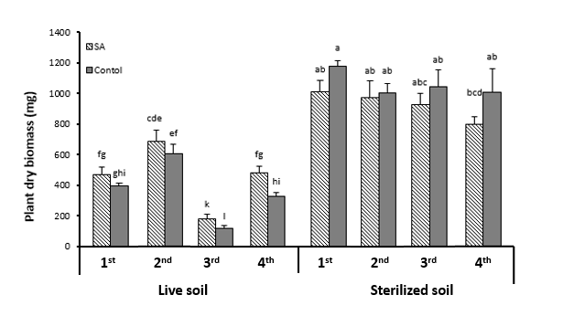
Fig. S1 Total plant dry weight during the four generations of J. vulgaris. Plants were treated with salicylic acid and were grown in live soil or sterilized soil. Bars indicate mean ± SE biomass (n = 10). Different letters above bars denote significant differences among groups compared by GLMs, using the linear distribution and identity link function, followed by Fisher’s LSD post-hoc test at P ≤ 0.05.

Fig. S2 Total number of raw reads (mean ± SE) (left) and non-rRNA reads (mean ± SE) (right) in the metatranscriptomic datasets for the four generations for the SA treatment and control.
48
Phylum

23.4% of the reads
were used
(22 bacteria, 99.4%
of the total reads)
208 Family
23.4% of the reads were used
(283 bacteria, 99.4% of the total reads )
472 Genus
20.4% of the reads were used
(382 bacteria, 99.6% of the total reads)
1113 Species
14.9% of the reads were used
(1081 bacteria, 99.6% of the total reads)

Fig. S3 Heinrich's triangle visualizing information on microbial composition at different classification levels of all 24 rhizosphere soil samples identified with MEGAN against NCBI. The numbers of identified phyla, families, genera and species are shown and the percentage of reads used for each classification level is noted. At phylum level, 2 Archaea, 22 bacteria, 22 eukaryotes and 2 viruses were found; at family level, 3 Archaea, 134 bacteria, 69 eukaryotes (only fungi were counted) and 2 viruses were found; at genus level, 4 Archaea, 382 bacteria, 83 eukaryotes (9 fungi, 27 nematodes, 27 algae and 20 others) and 3 viruses were found; at species level, 12 Archaea, 1086 bacteria, 12 eukaryotes and 3 viruses were found. In the heinrich’s triangle, only the information of bacteria is listed, this includes numbers of bacteria and their read percentage against all the reads in that taxonomic level.
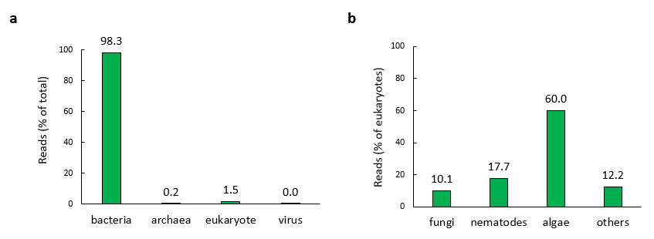

Fig. S4 The percentage of reads at different taxonomic levels. (a) The percentage of bacteria, archaea, eukaryote and virus reads of the total mapped reads. (b) The percentage of fungi, nematodes, algae and others in the total eukaryote reads.

Fig. S5 Scatter plot showing log ₁₀ transformed abundance of all 408 genera in rhizosphere soil samples of SA-treated and control plants against genus abundance. Rank number was based on the number of the total read counts in SA and control treatments. The genus with highest abundance corresponds to the rank number 1. The cut-off line is based on < 0.01% of the total reads.
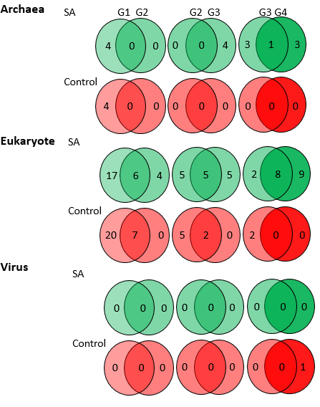

Fig. S6 Immigration and extinction numbers at genus level for Archaea, eukaryotes and viruses at each generation in the rhizosphere soil samples of SA-treated or control plants.

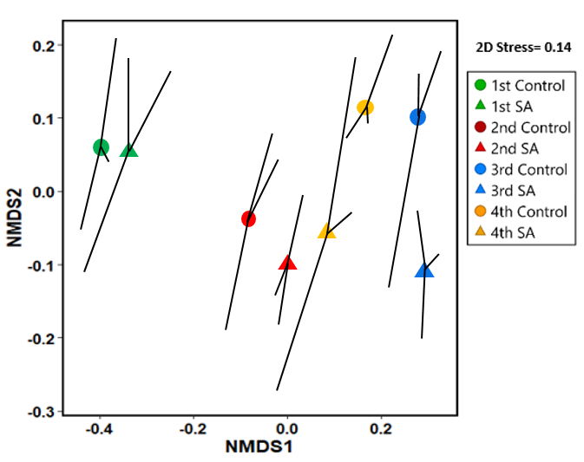

Fig. S7 Nonmetric multidimensional scaling (NMDS) spider plot based on Bray-Curtis distance, representing the taxonomic information from the genera of 24 rhizosphere soil samples. For each treatment combination, the centroid is connected to the three replicates.

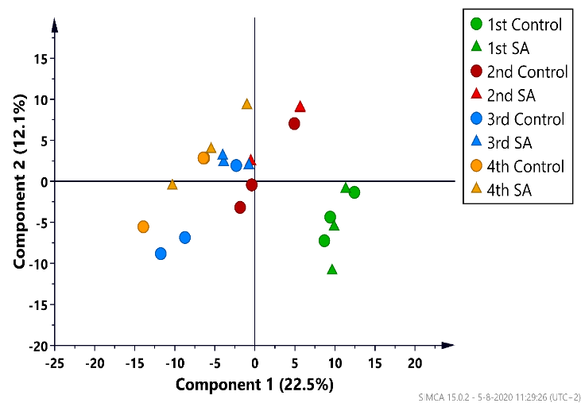

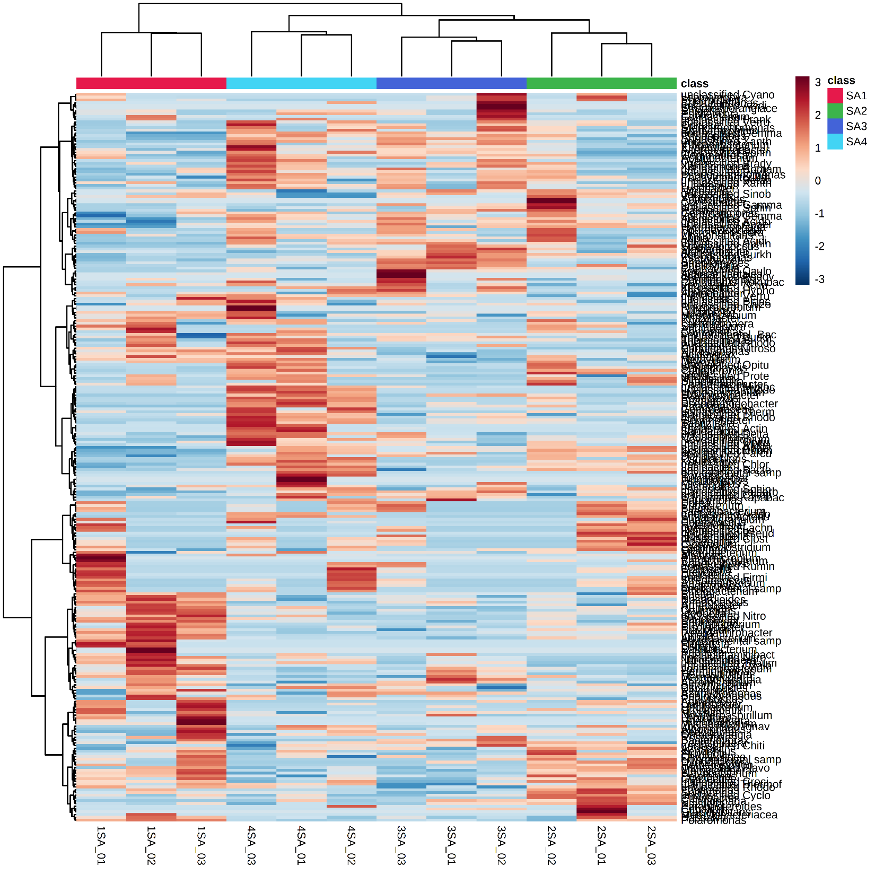
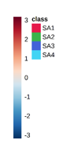
Fig. S8 Principal component analysis (PCA) representing the taxonomic information on the genera of 24 rhizosphere soil samples of SA-treated and control plants. PCA scores are based on relative abundance at genus level.
a

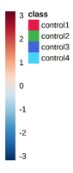
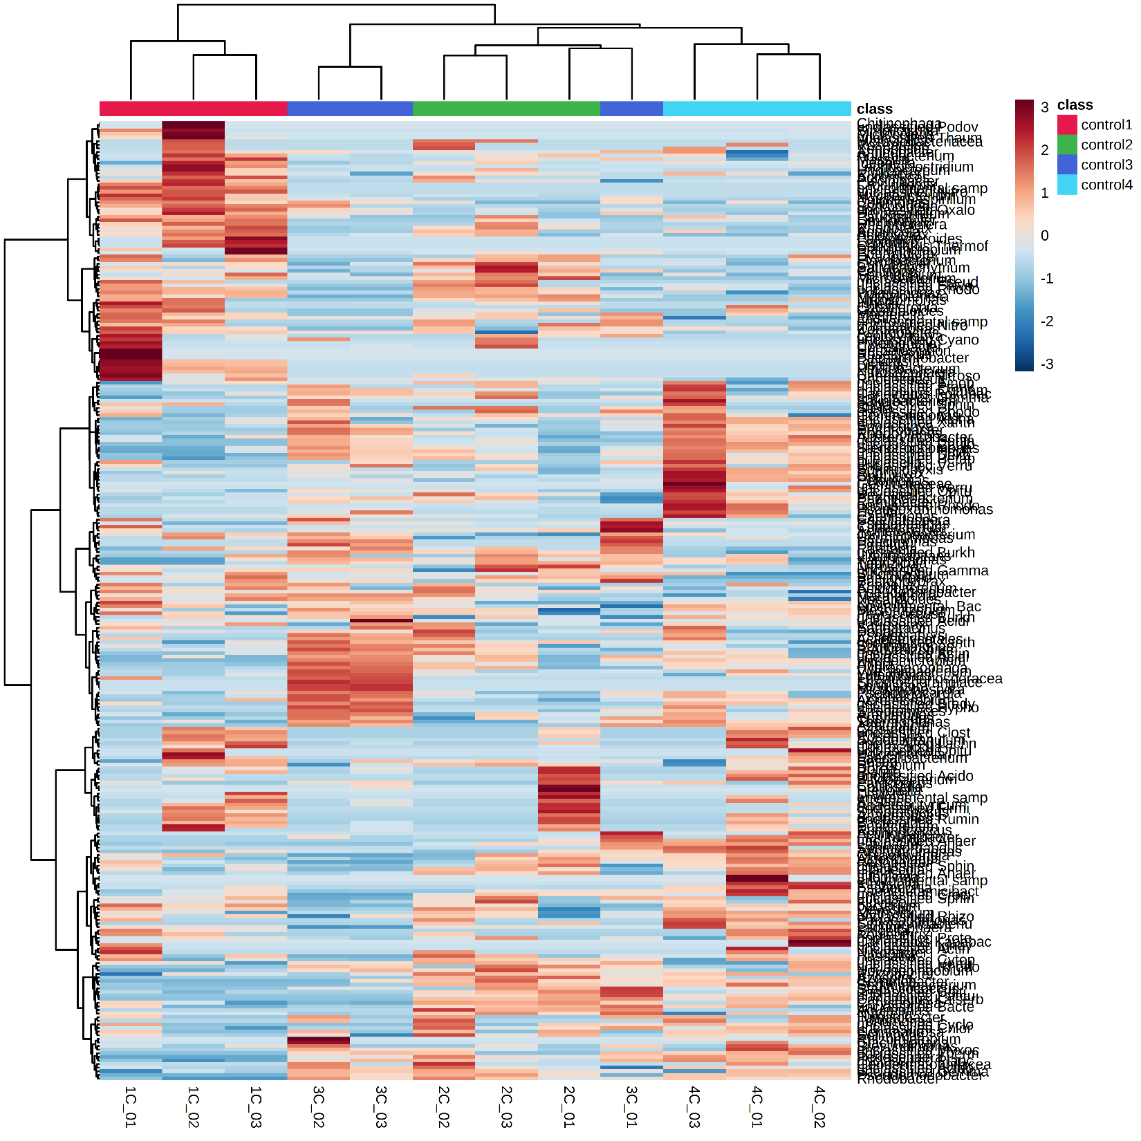
b
b

Fig. S9 Heatmap with a hierarchical clustering analysis of 264 genera of rhizosphere soil of SA-treated plants (a), and 270 genera of soil samples of control plants (b). The hierarchical clustering analysis was calculated with Pearson distance and the Ward clustering algorithm based on the relative hit numbers of each genus. The color code represents the row-centered relative hit numbers. SA1, SA2, SA3 and SA4 represent SA treatments from the 1st generation, 2nd generation, 3rd generation and 4th generation. Control1, control2, control3 and control4 represent control treatments from the 1st generation, 2nd generation, 3rd generation and 4th generation.

