Supplementary information
Benefits of silicon-enhanced root nodulation in a model legume are contingent upon rhizobial efficacy
Rocky Putra^{1,2*}, Jamie M. Waterman^{1,3}, Ulrike Mathesius⁴, Dominika Wojtalewicz¹, Jeff R. Powell¹, Susan (Sue) E. Hartley^{5,6} and Scott N. Johnson¹
¹Hawkesbury Institute for the Environment, Western Sydney University, Richmond, NSW, Australia
²Department of Chemical Ecology, Faculty of Biology, Bielefeld University, Bielefeld, Germany
³Institute of Plant Sciences, University of Bern, Bern, Switzerland
⁴Division of Plant Sciences, Research School of Biology, the Australian National University, Canberra, Australia
⁵York Environmental Sustainability Institute, Department of Biology, University of York, York, UK
⁶School of Biosciences, University of Sheffield, Sheffield, UK
*Corresponding author: R.Putra@westernsydney.edu.au

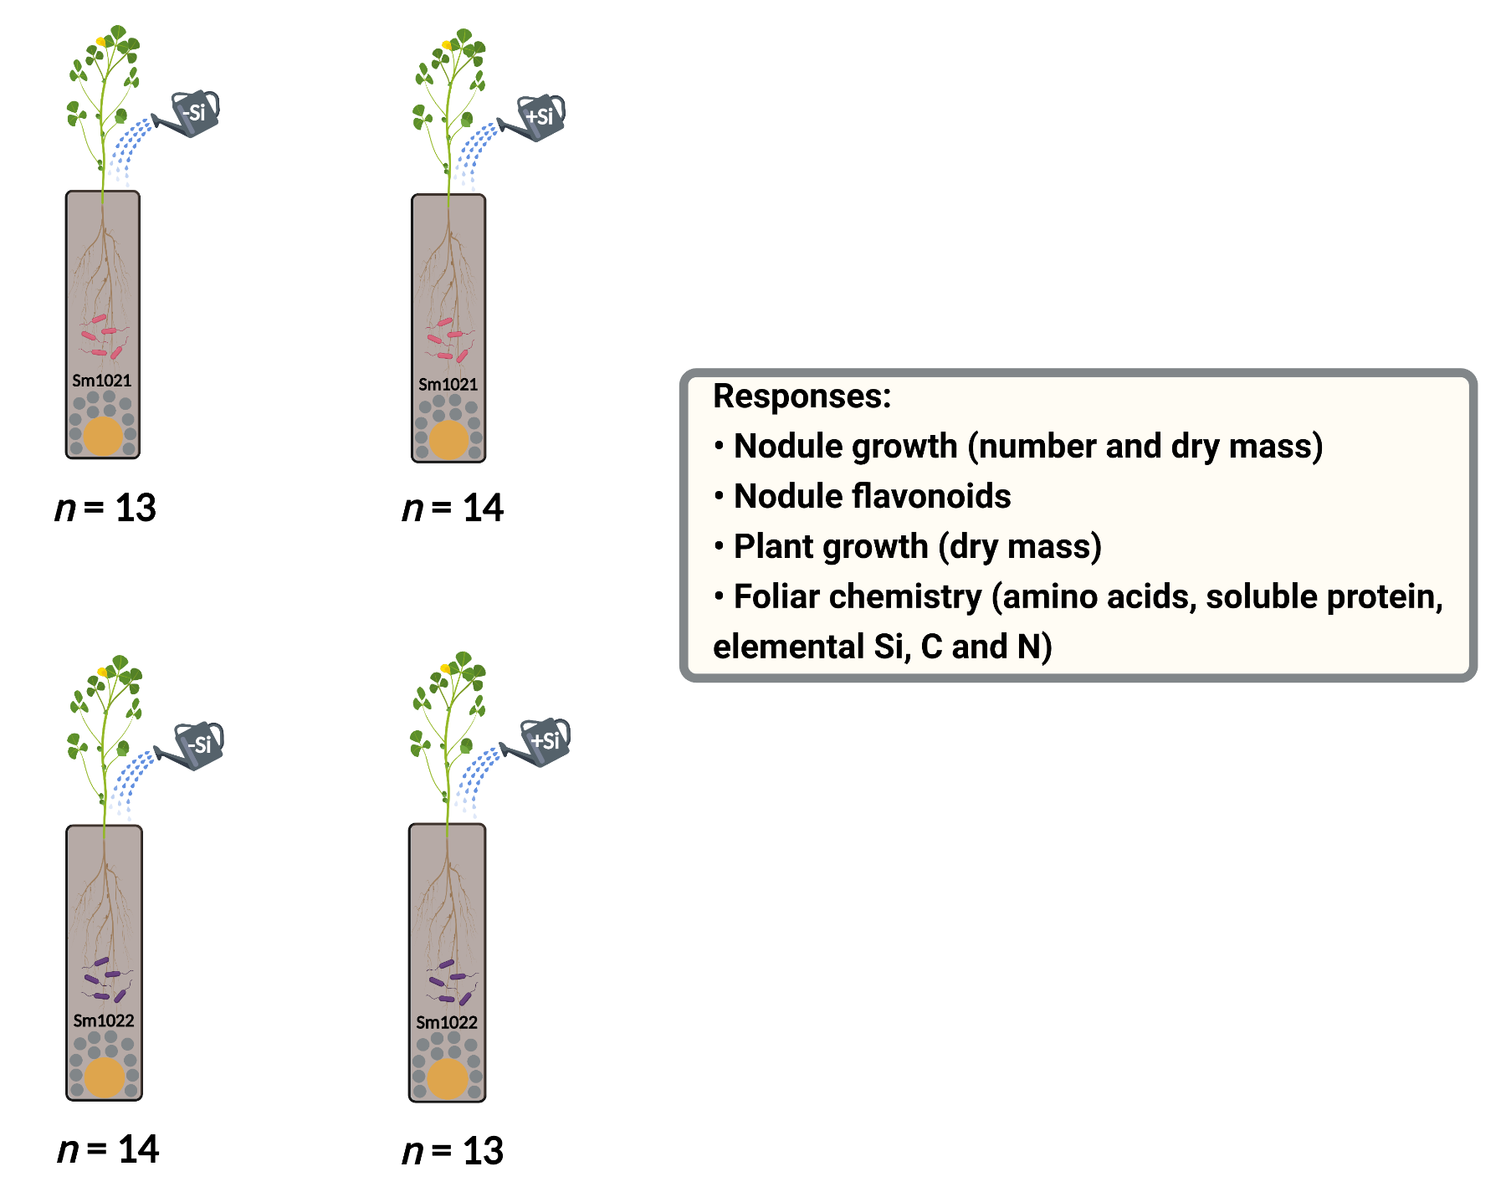
Fig. S1 Illustration of the set-up of experiment to examine the effects of Si supply on multiple traits (responses shown in the box) in a model legume barrel medic Medicago truncatula grown in irradiated soils associated either with rhizobia Ensifer meliloti Sm1021 (shown in pink: ‘low-efficiency’ strain) or Sm1022 (shown in purple: ‘high-efficiency’ strain).Dimension of the pot is 356 mm (height) and 69 mm (diameter). Some pebbles (shown in grey) and ping-pong ball (shown in orange) are used to cover perforation at the bottom of the pot. Irrigation is indicated by -Si (control) and +Si with potassium chloride and potassium silicate, respectively. Biological replicates (individual plants) are shown as n.
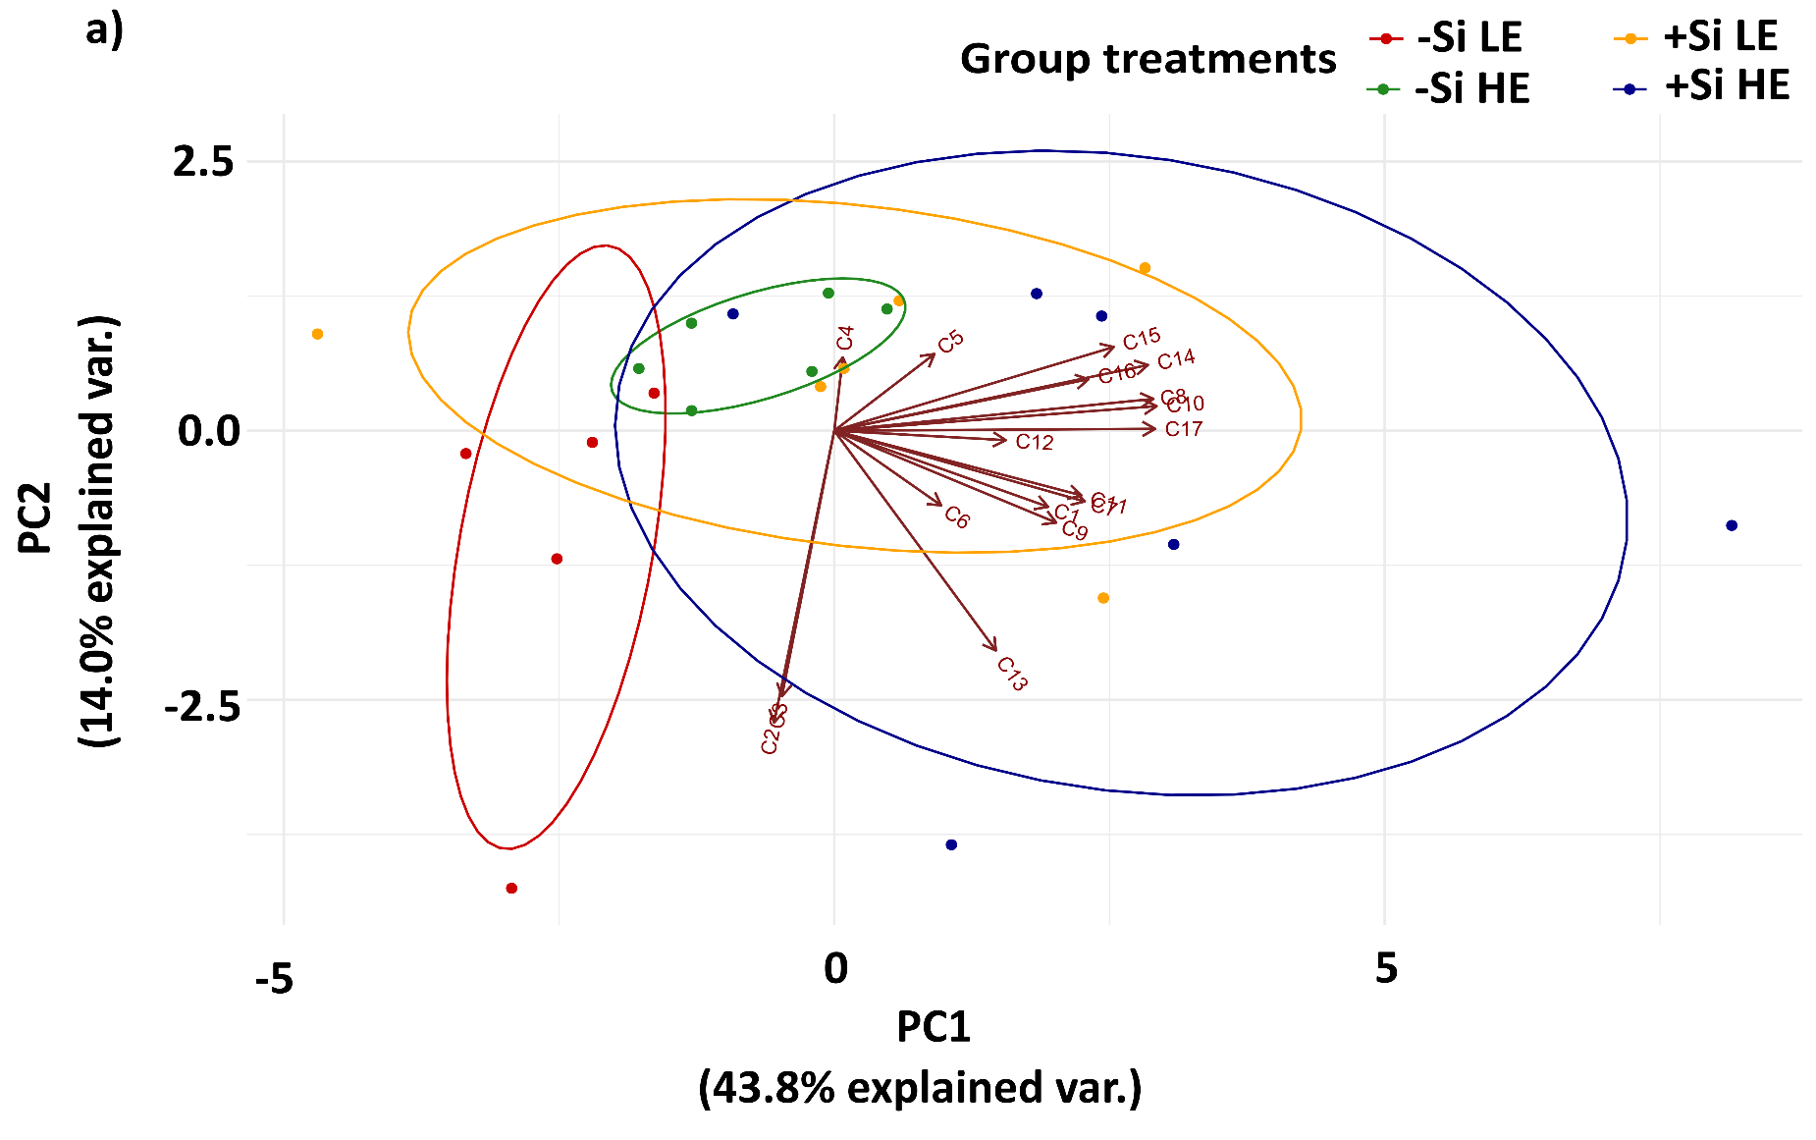
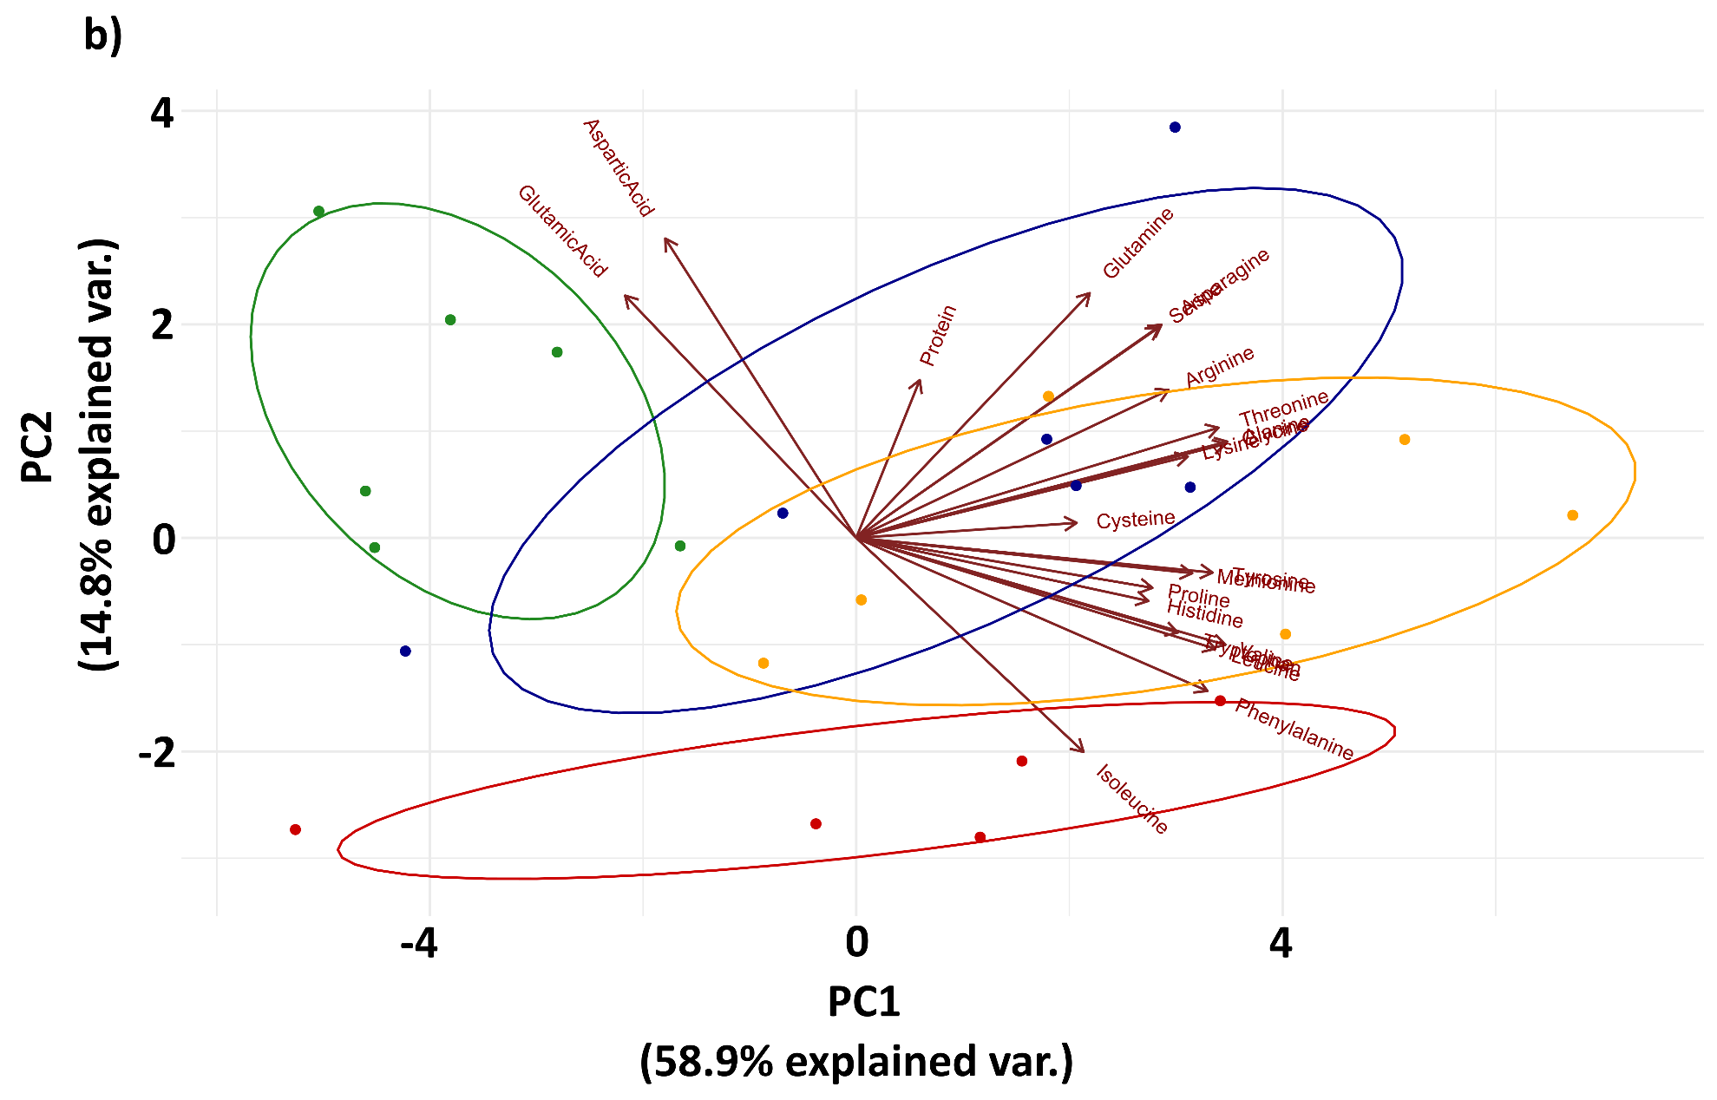
Fig. S2 Principal component analysis (PCA) of: a) the nodule flavonoids and b) foliar primary metabolites in response to different group treatment plants, namely -Si LE (red), -Si HE (green), +Si LE (yellow) and +Si HE (blue). Clustering of samples based on the first two principal components (PC1 and PC2) with confidence regions shown by ellipses. Covariation is shown by overlapped arrows between traits.
Explanation of Fig. S2: Emerging patterns from Si effects on nodule flavonoids and foliar primary metabolites (AAs and soluble protein) of the host plant associated with different rhizobial strains
The principal component analysis (PCA) on nodule flavonoids generated different 17 principal components (PCs). The PC1 and PC2 explained 43.80% and 14.00% variance, respectively. There was a tendency that Si-supplemented plants had more nodule flavonoids (towards PC1) relative to untreated plants (towards PC2) regardless of rhizobia, although Si-supplemented plants associated with HE (Sm1022) rhizobial strain seemed to produce higher flavonoids compared to those with LE (Sm1021) rhizobial strain (Fig. S2a). Abbreviations (C1-C17) shown in Fig. S2a indicate individual flavonoid compounds: C1 (Resveratrol), C2 (2’-hydroxyflavone), C3 (3’-hydroxyflavone), C4 (Daidzein), C5 (7,4-dihydroxyflavone), C6 (5,7-dihydroxyflavone), C7 (Liquiritigenin), C8 (Formononetin), C9 (7,3’,4’-trihydroxyisoflavone), C10 (6,7,4-trihydroxyisoflavone), C11 (2’-O-methylliquiritigenin), C12 (Medicarpin), C13 (Naringenin), C14 (Glycitein), C15 (Afromosin), C16 (Daidzein-7-O-glucoside) and C17 (Formononetin-7-O-glucoside).
Unlike nodule flavonoids, the PCA on foliar primary metabolites (AAs and soluble protein) generated different 21 PCs. The PC1 explained 58.90% variance and PC2 explained 14.80% variance. It was shown that within Si-untreated plants (-Si), association with different rhizobial strains clearly separated foliar primary metabolites whereas the plants associated with LE had lower primary metabolites compared to that with HE (Fig. S2b). In contrast, Si treatment shifted foliar primary metabolites to a greater extent and thus, there was an overlap pattern between +Si LE and +Si HE plants (Fig. S2b). Generally, +Si plants had higher foliar primary metabolites relative to -Si plants.
To confirm patterns emerged from PCA on nodule flavonoids as well as foliar primary metabolites, the multivariate analysis of variance (MANOVA) was conducted. Si alone did not significantly affect the overall nodule flavonoids (F_{1,22} = 4.5; p = 0.1; Table S2), but an interactive effect between Si and rhizobial strains on nodule flavonoids were found marginally non-significant (F_{1,22} = 7; p = 0.07; Table S2). In terms of foliar primary metabolites, Si (F_{1,22} = 5.4; p = 0.01; Table S2) and the interaction between Si and rhizobial strains (F_{1,22} = 4.8; p = 0.01; Table S2) significantly altered non-essential AAs. Moreover, Si alone significantly affected essential AAs and soluble protein (F_{1,22} = 8.4; p = 0.001; Table S2).
b)
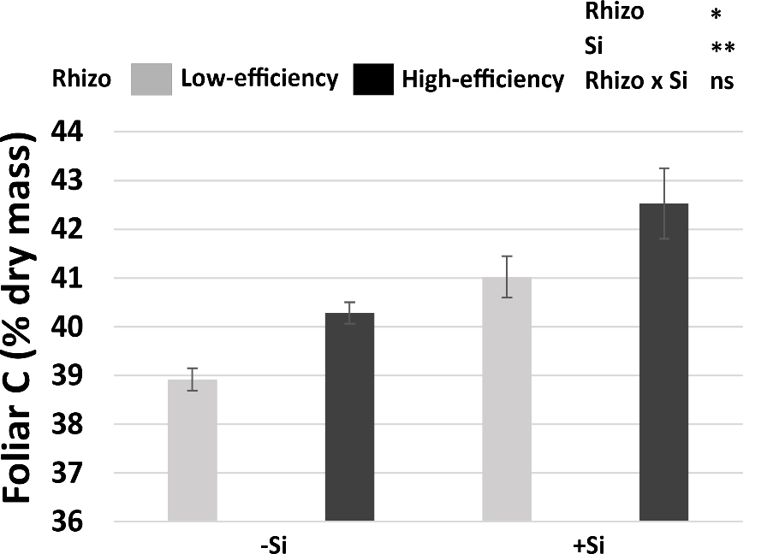
***
***
Rhizo
Si
Rhizo x Si
a)
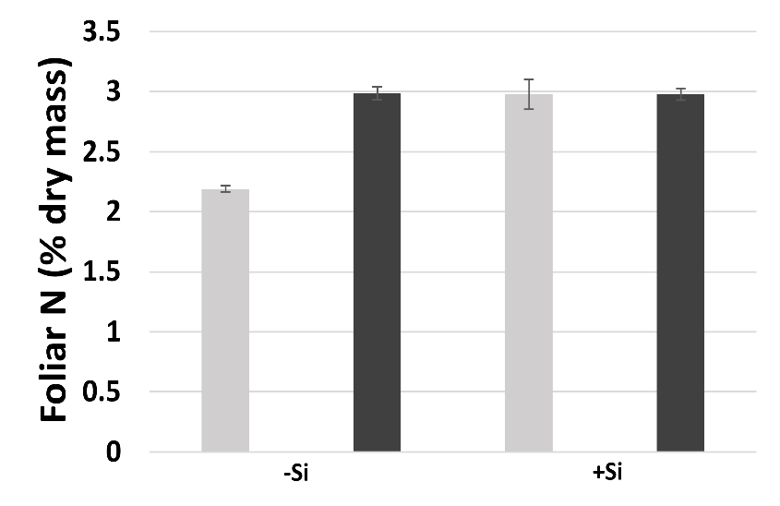
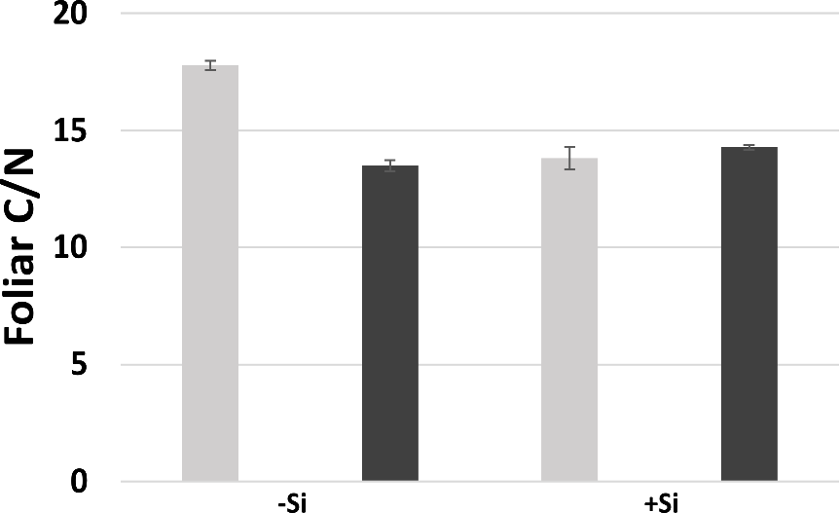
b
b
b
b
a
Si supply
Si supply
Si supply
c)
***
***
***
Rhizo
Si
Rhizo x Si
a
a
a
***
b
a
Fig. S3 Impact of Si supply on mean ± SE of a) foliar C, b) foliar N and c) foliar C/N on the plants associated with low-efficiency and high-efficiency rhizobial strains. Statistically significant factors, namely rhizobial strain (Rhizo), Si, and their interactions are indicated as: ns (non-significant), *p < 0.05, **p < 0.01 and ***p < 0.001. Different letters and the horizontal lines indicate significance at p < 0.05.
Table S1 Soil chemical properties used in the experiment. Value is the mean with standard error (n = 3). Some elements were below the detection limit shown with an asterisk (*). Shortly, soils were finely sieved, and oven dried prior to chemical analyses by Environmental Analysis Laboratory, Southern Cross University, Australia. The methods followed Rayment and Lyons (2011).
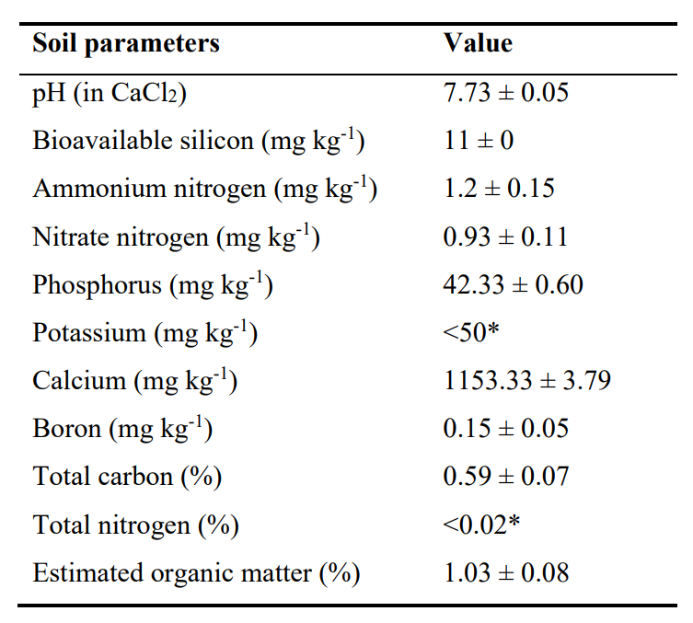
Rayment GE, Lyons DJ (2011) Soil Chemical Methods - Australasia. Australian soil and land survey handbooks; vol 3. Accessed from https://nla.gov.au/nla.cat-vn4854518. CSIRO Publishing, Collingwood, VIC
Table S2 Effects of rhizobial strain (Rhizo), Si and their interactions on combined traits, such as nodule growth (number and dry mass), nodule flavonoids, plant growth (shoot and root dry biomass), foliar non-essential AAs, foliar essential AAs and soluble protein, and foliar elements (C, N, C/N and Si) based on MANOVA test. p-values highlighted in bold indicate statistical significance at p < 0.05.
Combined traits | df | Rhizo |  | Si |  | Rhizo x Si
Combined traits | df | F | p | F | p | F | p
Nodule growth | 1,52 | 11 | < 0.001 | 8.8 | < 0.001 | 0.2 | 0.8
Nodule flavonoids | 1,22 | 4.7 | 0.1 | 4.5 | 0.1 | 7 | 0.07
Plant growth | 1,53 | 4.1 | 0.02 | 1.7 | 0.2 | 8.1 | < 0.001
Foliar non-essential AAs | 1,22 | 7 | 0.003 | 5.4 | 0.01 | 4.8 | 0.01
Foliar essential AAs and protein | 1,22 | 24.3 | < 0.001 | 8.4 | 0.001 | 2.6 | 0.07
Foliar elements | 1,11 | 22.8 | 0.002 | 21.7 | 0.002 | 22.5 | 0.002

Table S3 Significant percentage of increase (↑) of Si impacts on detected individual and total flavonoid concentrations in the nodule. Non-significant impact of Si (p ≥ 0.05) on flavonoids is indicated by ‘ns’ whereas initial undetected compounds in -Si plants are shown with ‘na’.
Flavonoids | Rhizobia
Flavonoids | Sm1021 (low-efficiency strain) | Sm1022 (high-efficiency strain)
Afromosin | ns | ns
Daidzein | ns | ns
Daidzein-7-O-glucoside (Daidzin) | ↑100% | ↑100%
Formononetin | ↑200% | ↑53%
Formononetin-7-O-glucoside (Ononin) | ↑76% | ↑75%
Glycitein | ↑157% | ↑17%
6,7,4-trihydroxyisoflavone | ↑75% | ↑67%
7,3',4'-trihydroxyisoflavone | ↑50% | ↑140%
5,7-dihydroxyflavone (Chrysin) | ns | ns
7,4’-dihydroxyflavone | ns | ns
2'-hydroxyflavone | ns | ns
3'-hydroxyflavone | ns | ns
Liquiritigenin | ↑33% | ↑167%
Medicarpin | ns | ns
Naringenin | ns | ns
2'-O-methylliquiritigenin | ↑33% | ↑150%
Resveratrol | ↑21% | ↑na
Total | ↑131% | ↑47%

Table S4 Significant percentage of increase (↑) or decrease (↓) of Si impacts on detected individual, non-essential, essential, aromatic and total free amino acids in the foliage. Non-significant impact of Si (p ≥ 0.05) on amino acids is indicated by ‘ns’.
Amino acids | Rhizobia
Amino acids | Sm1021 (low-efficiency strain) | Sm1022 (high-efficiency strain)
Alanine | ↑48% | ↑81%
Arginine | ↑69% | ↑33%
Asparagine | ↑119% | ↑82%
Aspartic acid | ↑35% | ↓51%
Cysteine | ns | ns
Glutamic acid | ↑18% | ↓62%
Glutamine | ↑43% | ↑45%
Glycine | ↑38% | ↑82%
Proline | ↑97% | ↑2521%
Serine | ↑91% | ↑47%
Tyrosine | ns | ns
Histidine | ↑71% | ↑395%
Isoleucine | ns | ns
Leucine | ns | ns
Lysine | ↑98% | ↑110%
Methionine | ns | ns
Phenylalanine | ↑23% | ↑157%
Threonine | ↑40% | ↑72%
Tryptophan | ↑33% | ↑179%
Valine | ↑34% | ↑334%
Non-essential | ↑90% | ↑141%
Essential | ↑23% | ↑161%
Aromatic | ↑29% | ↑132%
Total | ↑73% | ↑144%

Table S5 Mean and standard error values of nodule flavonoids (ng g⁻¹ dry mass) in response to Si and rhizobial treatments.
Si supply | Rhizobial treatment | Afromosin | Daidzein | Daidzein-7-O-glucoside | Formononetin
-Si | Sm1021 (low-efficiency strain) | 0.1 ± 0.009 | 0.003 ± 0.003 | 0.005 ± 0.0003 | 0.15 ± 0.04
-Si | Sm1022 (high-efficiency strain) | 0.2 ± 0.02 | 0.01 ± 0.007 | 0.005 ± 0.0005 | 0.44 ± 0.03
+Si | Sm1021 (low-efficiency strain) | 0.2 ± 0.04 | 0.005 ± 0.004 | 0.009 ± 0.002 | 0.44 ± 0.07
+Si | Sm1022 (high-efficiency strain) | 0.24 ± 0.03 | 0.000 ± 0.000 | 0.01 ± 0.003 | 0.67 ± 0.1
Si supply | Rhizobial treatment | Formononetin-7-O-glucoside | Glycitein | 6,7,4-trihydroxyisoflavone | 7,3',4'-trihydroxyisoflavone
-Si | Sm1021 (low-efficiency strain) | 0.1 ± 0.005 | 0.007 ± 0.001 | 0.004 ± 0.0001 | 0.002 ± 0.001
-Si | Sm1022 (high-efficiency strain) | 0.15 ± 0.013 | 0.02 ± 0.001 | 0.006 ± 0.0006 | 0.004 ± 0.001
+Si | Sm1021 (low-efficiency strain) | 0.18 ± 0.03 | 0.02 ± 0.003 | 0.007 ± 0.001 | 0.003 ± 0.003
+Si | Sm1022 (high-efficiency strain) | 0.25 ± 0.05 | 0.02 ± 0.003 | 0.009 ± 0.001 | 0.012 ± 0.001
Si supply | Rhizobial treatment | 5,7-dihydroxyflavone | 7,4-dihydroxyflavone | 2'-hydroxyflavone | 3'-hydroxyflavone
-Si | Sm1021 (low-efficiency strain) | 0.01 ± 0.006 | 0.006 ± 0.001 | 0.004 ± 0.002 | 0.005 ± 0.001
-Si | Sm1022 (high-efficiency strain) | 0.02 ± 0.007 | 0.006 ± 0.001 | 0.0005 ± 0.0005 | 0.003 ± 0.0005
+Si | Sm1021 (low-efficiency strain) | 0.000 ± 0.000 | 0.01 ± 0.003 | 0.0008 ± 0.0008 | 0.003 ± 0.0007
+Si | Sm1022 (high-efficiency strain) | 0.02 ± 0.010 | 0.007 ± 0.004 | 0.001 ± 0.001 | 0.002 ± 0.001
Si supply | Rhizobial treatment | Liquiritigenin | Medicarpin | 2'-O-methylliquiritigenin | Naringenin
-Si | Sm1021 (low-efficiency strain) | 0.009 ± 0.003 | 0.014 ± 0.001 | 0.003 ± 0.0003 | 0.002 ± 0.0007
-Si | Sm1022 (high-efficiency strain) | 0.006 ± 0.002 | 0.03 ± 0.001 | 0.002 ± 0.0001 | 0.001 ± 0.0004
+Si | Sm1021 (low-efficiency strain) | 0.012 ± 0.003 | 0.011 ± 0.004 | 0.004 ± 0.001 | 0.002 ± 0.0007
+Si | Sm1022 (high-efficiency strain) | 0.015 ± 0.003 | 0.03 ± 0.005 | 0.005 ± 0.0005 | 0.003 ± 0.001
Si supply | Rhizobial treatment | Resveratrol | Total
-Si | Sm1021 (low-efficiency strain) | 0.084 ± 0.006 | 0.24 ± 0.03
-Si | Sm1022 (high-efficiency strain) | 0.000 ± 0.000 | 0.52 ± 0.03
+Si | Sm1021 (low-efficiency strain) | 0.102 ± 0.03 | 0.55 ± 0.08
+Si | Sm1022 (high-efficiency strain) | 0.144 ± 0.02 | 0.77 ± 0.12
Table S6 Mean and standard error values of foliar free amino acids (µg g⁻¹ dry mass) in response to Si and rhizobial treatments.
Si supply | Rhizobial treatment | Alanine | Arginine | Asparagine | Aspartic acid
-Si | Sm1021 (low-efficiency strain) | 136.4 ± 25.9 | 23.7 ± 7.8 | 412.3 ± 83.7 | 33.7 ± 5.7
-Si | Sm1022 (high-efficiency strain) | 96.6 ± 15.5 | 30.5 ± 0.8 | 457.06 ± 61.02 | 107.07 ± 19.03
+Si | Sm1021 (low-efficiency strain) | 201.1 ± 22.5 | 40.1 ± 2.6 | 902.3 ± 163.71 | 45.7 ± 7.3
+Si | Sm1022 (high-efficiency strain) | 174.6 ± 31.1 | 40.7 ± 4.1 | 832.05 ± 144.8 | 52.1 ± 7.8
Si supply | Rhizobial treatment | Cysteine | Glutamic acid | Glutamine | Glycine
-Si | Sm1021 (low-efficiency strain) | 22.6 ± 0.7 | 134.7 ± 45.5 | 65.6 ± 11.97 | 18.03 ± 3.4
-Si | Sm1022 (high-efficiency strain) | 21.9 ± 0.49 | 436.5 ± 87.2 | 62.5 ± 6.7 | 12.85 ± 1.98
+Si | Sm1021 (low-efficiency strain) | 22.9 ± 0.7 | 160.1 ± 55.1 | 94.03 ± 11.6 | 24.9 ± 3.46
+Si | Sm1022 (high-efficiency strain) | 22.7 ± 1.07 | 164.8 ± 23.1 | 90.3 ± 17.01 | 23.3 ± 4.03
Si supply | Rhizobial treatment | Proline | Serine | Tyrosine | Histidine
-Si | Sm1021 (low-efficiency strain) | 1931.98 ± 240.89 | 62.688 ± 9.544 | 57.610 ± 14.832 | 21.050 ± 2.07
-Si | Sm1022 (high-efficiency strain) | 68.8 ± 11.1 | 74.179 ± 8.900 | 31.078 ± 10.295 | 6.041 ± 0.663
+Si | Sm1021 (low-efficiency strain) | 3811.3 ± 691.7 | 119.75 ± 17.11 | 75.5 ± 14.6 | 36.03 ± 6.3
+Si | Sm1022 (high-efficiency strain) | 1803.21 ± 326.8 | 108.9 ± 14.45 | 55.09 ± 12.5 | 29.86 ± 4.8
Si supply | Rhizobial treatment | Isoleucine | Leucine | Lysine | Methionine
-Si | Sm1021 (low-efficiency strain) | 182.97 ± 27.5 | 208.1 ± 43.4 | 12.3 ± 4.3 | 19.6 ± 3.7
-Si | Sm1022 (high-efficiency strain) | 33.4 ± 7.5 | 59.5 ± 21.97 | 10.2 ± 2.8 | 8.9 ± 1.8
+Si | Sm1021 (low-efficiency strain) | 187.003 ± 45.2 | 229.28 ± 35.3 | 24.4 ± 6.13 | 19.7 ± 3.4
+Si | Sm1022 (high-efficiency strain) | 89.6 ± 33.1 | 149.2 ± 25.6 | 21.4 ± 5.5 | 18.1 ± 3.6
Si supply | Rhizobial treatment | Phenylalanine | Threonine | Tryptophan | Valine
-Si | Sm1021 (low-efficiency strain) | 169.5 ± 28.97 | 92.2 ± 15.3 | 37.03 ± 5.6 | 213.01 ± 29.8
-Si | Sm1022 (high-efficiency strain) | 43.5 ± 12.9 | 77.2 ± 8.4 | 12.7 ± 0.9 | 40.3 ± 9.6
+Si | Sm1021 (low-efficiency strain) | 209.5 ± 26.1 | 128.5 ± 13 | 49.3 ± 8.9 | 284.9 ± 30.5
+Si | Sm1022 (high-efficiency strain) | 112.1 ± 16.5 | 132.6 ± 20.1 | 35.4 ± 6.2 | 174.7 ± 24.3
Si supply | Rhizobial treatment | Non-essential | Essential | Aromatic | Total
-Si | Sm1021 (low-efficiency strain) | 2899.5 ± 358.4 | 949.5 ± 158.4 | 258 ± 50.4 | 3849.003 ± 465.26
-Si | Sm1022 (high-efficiency strain) | 1399.1 ± 162.1 | 291.8 ± 64.5 | 87.3 ± 23.2 | 1690.86 ± 165.82
+Si | Sm1021 (low-efficiency strain) | 5497.8 ± 849.9 | 1168.6 ± 133.2 | 334 ± 46.5 | 6666.4 ± 923.99
+Si | Sm1022 (high-efficiency strain) | 3367.7 ± 463.06 | 763.1 ± 105.8 | 203 ± 30 | 4130.8 ± 565.5

