SUPPLEMENTAL INFORMATION

Air and water temperature
Air and water temperatures were recorded every minute throughout the experiment using waterproof 1-Wire DS18B20 Digital temperature sensors.
Mean weekly air and water temperatures during the experiment are shown below.
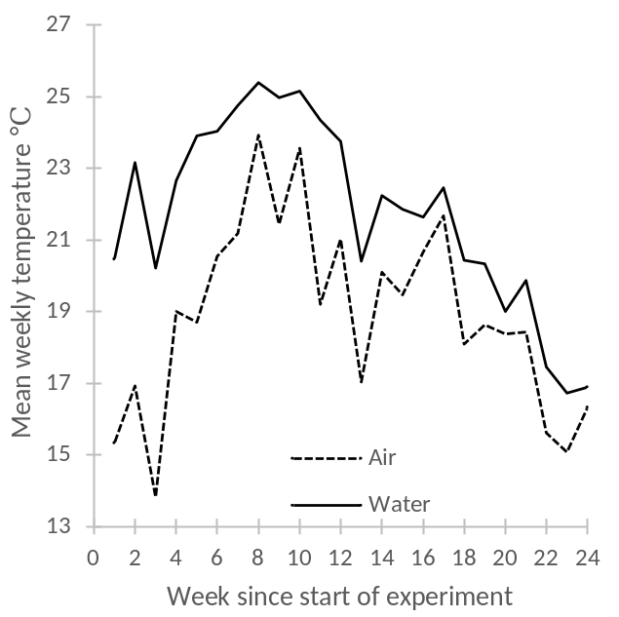
Mean weekly air and water temperatures during the experiments.
As we used tropical waterlilies in this study, we expected a significant correlation between water temperature and flower production once plants were ‘established’ - arbitrarily from week 10 (mid to late January) onwards. From week 10 to the end of the experiment, the coefficient of determination for mean fortnightly flower production versus mean water temperature was highly significant (n=8; r² 0.85; P<0.001). A substantial decline in temperatures from week 12 to week 13 (mean air temperatures 21.0 vs 17.0℃ and mean water temperatures 23.8 vs 20.4℃ respectively; decline associated with heavy unseasonal rainfall), partly explains the sizable decline in flower production around that time. However, the decline was much more pronounced in Experiment 2 (mean 38%) than in Experiment 1 (mean 23%). We also observed a decline in flower production at that same time in our waterlily plants used for commercial flower production (around 20%; results not shown). These plants recovered over the next three weeks to reach a peak in flower production in early March (equivalent to week 17 of the experiment). Although the experimental plants also showed a recovery in flower production after week 13, this never exceeded levels reached in week 12.

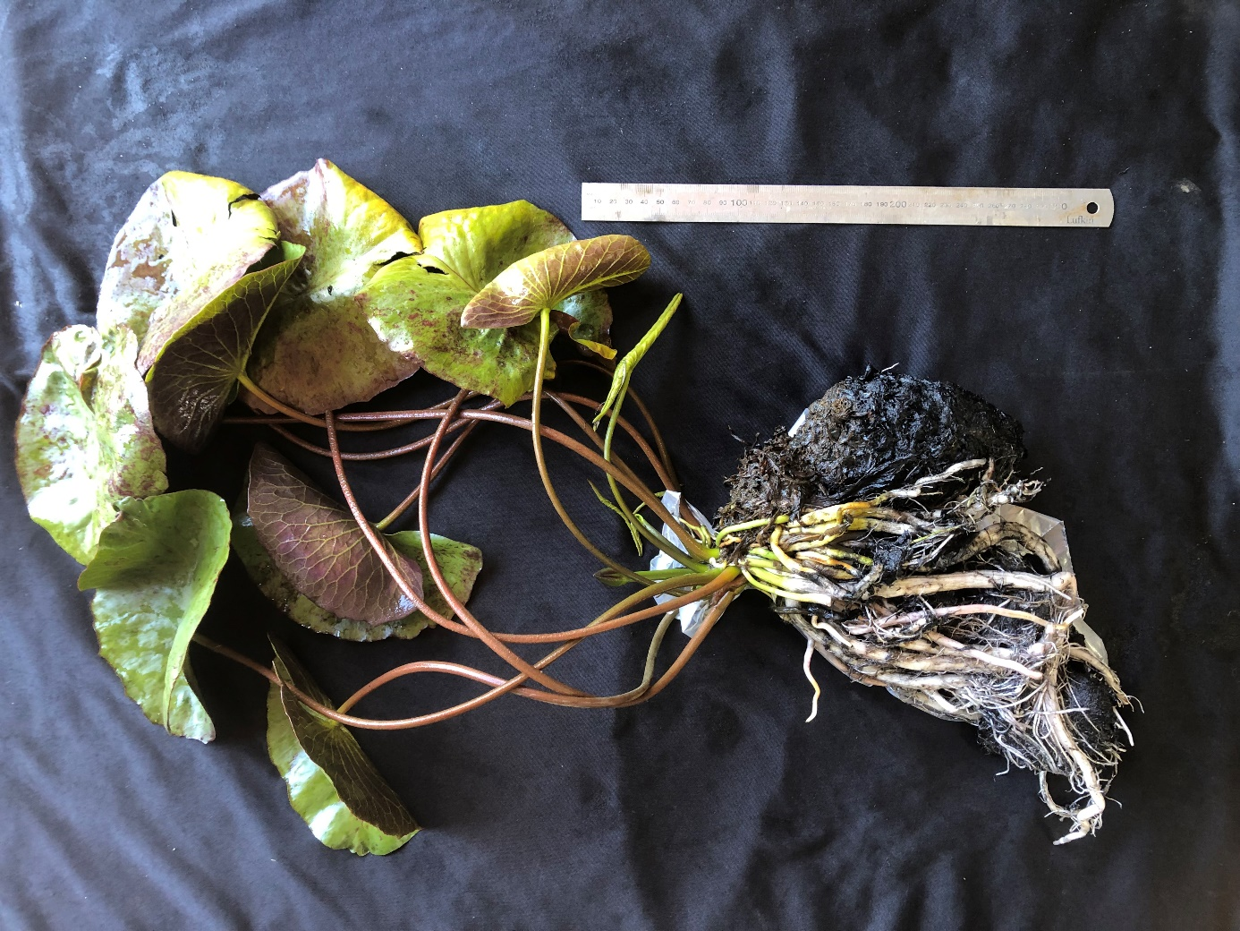

Fig. S1 Typical morphology of Nymphaea cv Cowara Purple.
Note this is a plant used in the experiments described in this paper.
This plant was grown in a 4.5 litre pot from Nov 2020 to December 2021.
Photographed 30 November 2021, 7 months after completion of the experiment
(early in new growing season).
Note ruler for scale (30 cm).

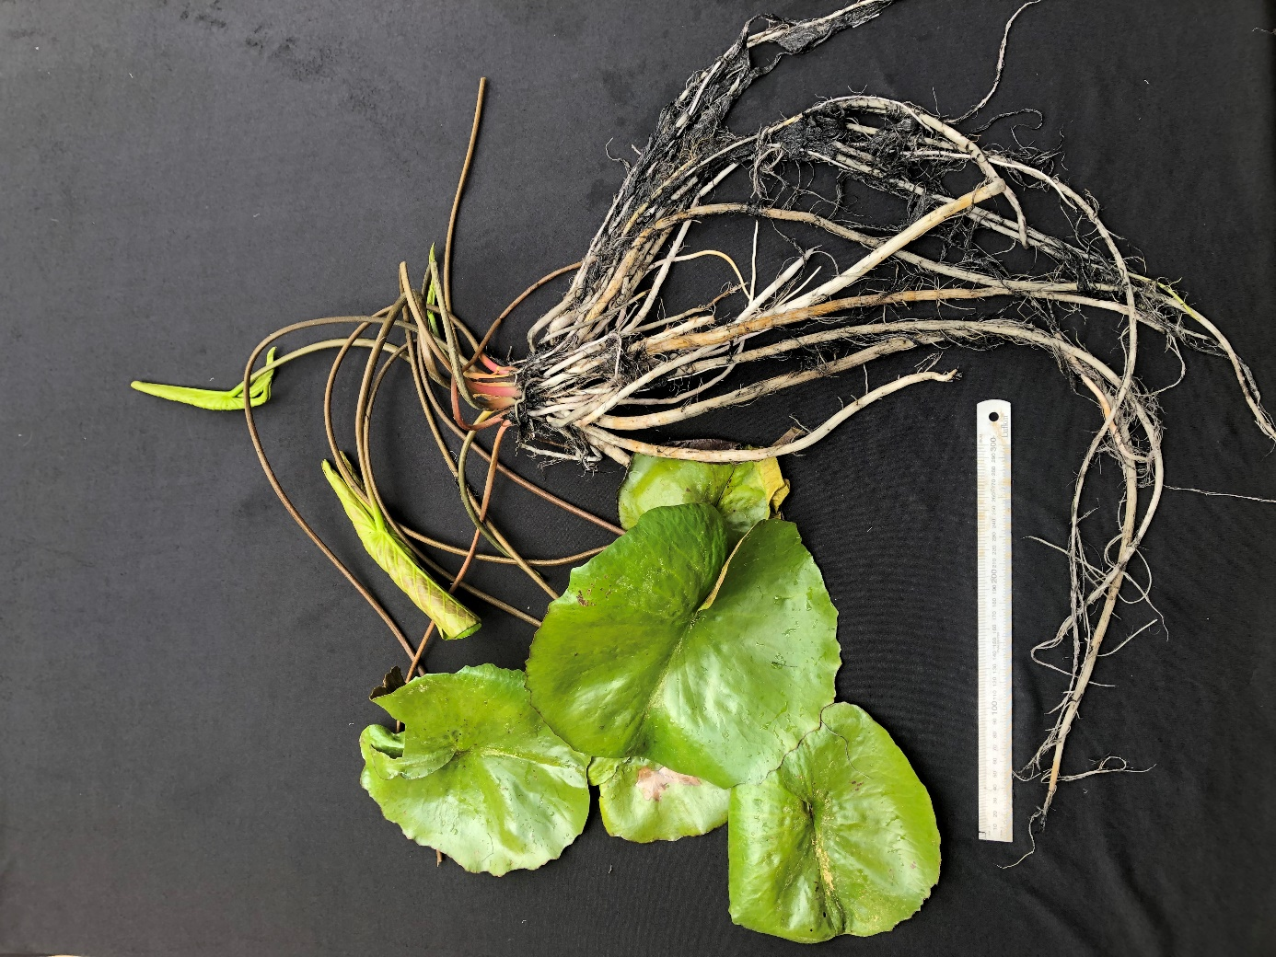
Fig. S2 Typical morphology of Nymphaea cv Cowara Purple.
Note this is a plant NOT associated with the experiments described in this paper.
This plant was grown in ‘full soil’ (4 m² per plant). Some roots did break off during plant extraction.
Photographed 30 November 2021, early in new growing season.
Note ruler for scale (30 cm).

