Supplementary Information Fig. S1

A cool spot in a biodiversity hotspot: why do tall Eucalyptus forests in southwest Australia exhibit low diversity?

Plant and Soil

Xue Meng Zhou^{1,2}, Kosala Ranathunge¹, Marion L. Cambridge¹, Kingsley W. Dixon^{1,3}, Patrick E. Hayes¹, Miroslav Nikolic⁴, Qi Shen¹, Hongtao Zhong^{1,3}, Hans Lambers^{1,3}.

¹School of Biological Sciences, University of Western Australia, Crawley, Perth, WA 6009, Australia
²Permanent address: Guangxi Key Laboratory of Forest Ecology and Conservation, College of Forestry, Guangxi University, Nanning, 530004, Guangxi, PR China
³Centre for Mine Site Restoration, School of Molecular and Life Sciences, Curtin University, Kent Street, Bentley, WA 6102, Australia
⁴Institute for Multidisciplinary Research, University of Belgrade, Belgrade, Serbia

Author for correspondence:
Hans Lambers
Email: hans.lambers@uwa.edu.au

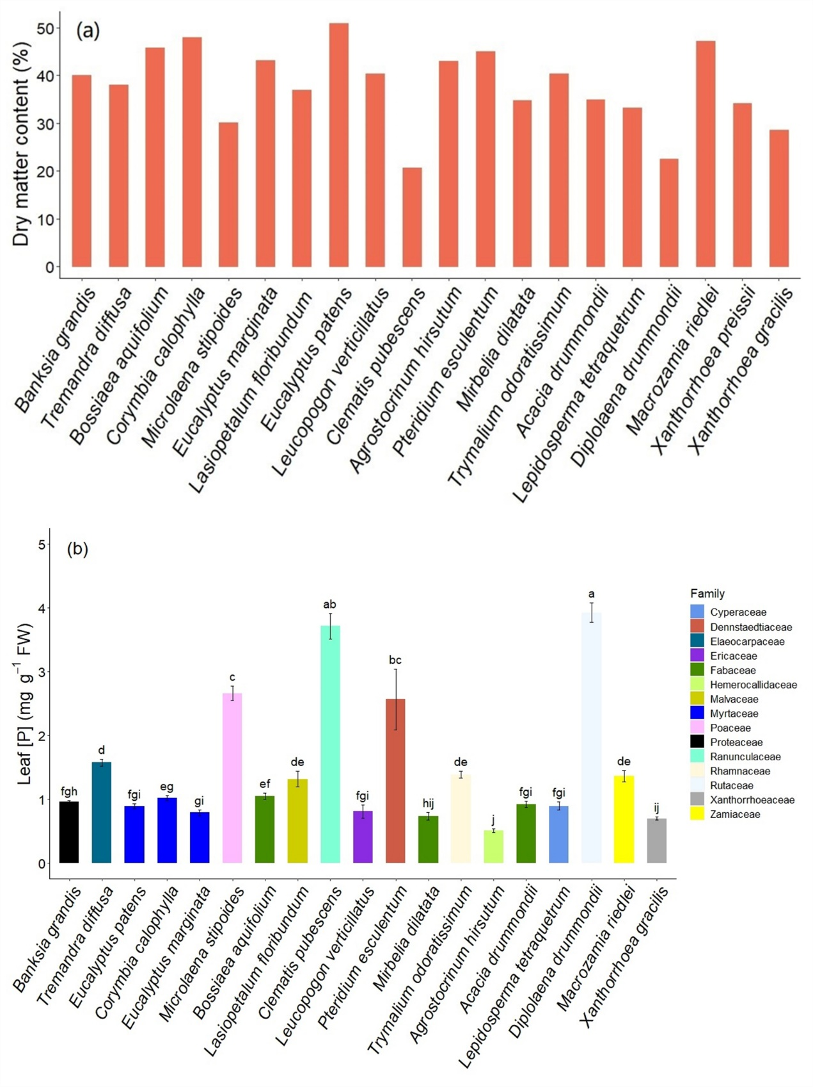
Fig. S1 (a) Values of dry matter content (%) are based on pooled independent samples collected from five individuals, and hence no errors bars are included, and (b) leaf phosphorus concentrations ([P]) on a fresh weight (FW) basis for a range of species co-occurring with Eucalyptus patens, yarri (Myrtaceae) at Cypress Form, Waroona. Data are means ± SE (n =5-10). Different letters indicate statistically significant differences among species (P ≤ 0.05).

