Supplementary information (SI)

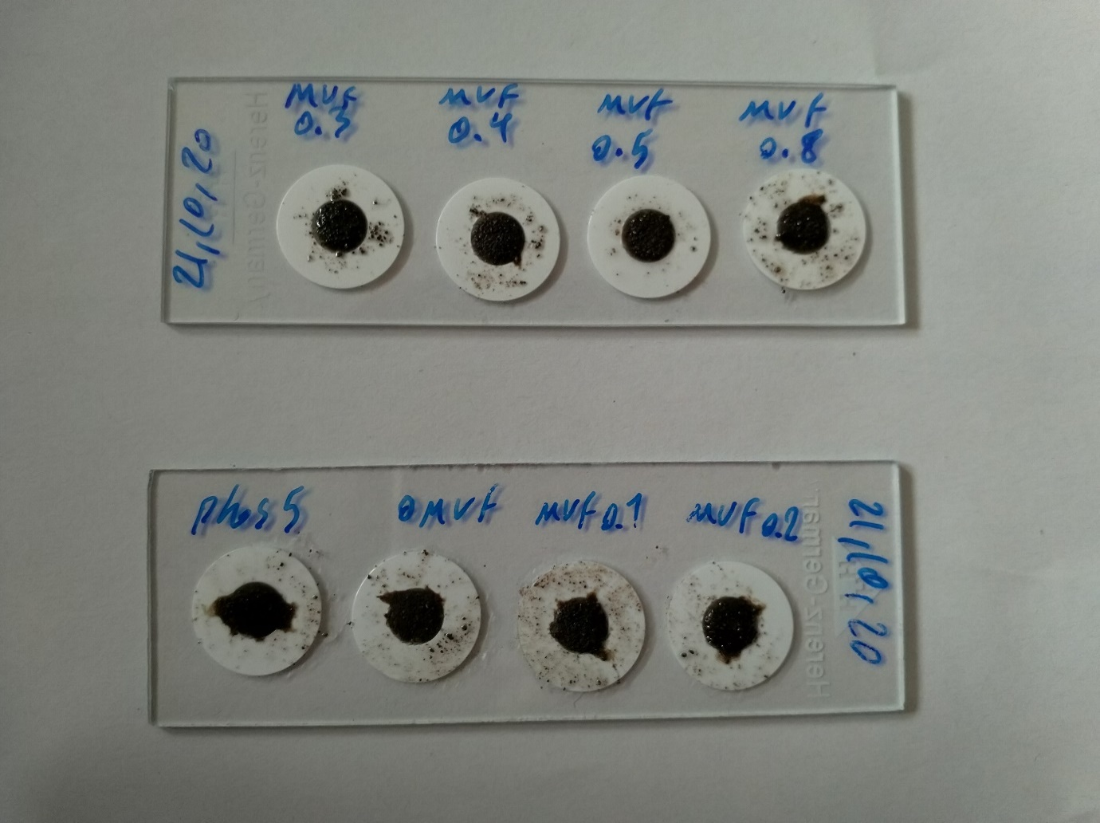
13 mm
5 mm
Fig. S1. An example of a thin layer of homogeneous soil aggregates in a plastic ring saturated by 10 µl of MUF-P solution (5 mM) and covered by 10 µl of super transparent silicon on a glass slide.

Fig. S2. Intensities of different concentrations of MUF-P on soil aggregates 30 min after application. The top row images are in bright field. The bottom row shows fluorescent images (under DAPI filter). Scale bar: 50 µm.

Fig. S3. Controls of super transparent silicon without soil aggregates under DAPI filter at an exposure time of 3000 ms. The bottom row images are in pseudocolor to help distinguish small differences. Magnification level: 10×; a) glass slide. Average grayscale value: 15.5 ± 0.17, b) supper transparent silicon. Average grayscale value: 22 ± 0.14, c) super transparent silicon with 0.1 M MES buffer. Average grayscale value: 18.5 ± 0.29.

Fig. S4. Controls of super transparent silicon on a thin layer of soil aggregates under bright field and fluorescence conditions at an exposure time of 3000 ms. The bottom row images are in pseudocolor to help distinguish small differences; a) autoclaved soil aggregates before application of MUF-P. Average grayscale value: 15.5 ± 0.04. Scale bar: 200 µm, b) autoclaved soil aggregates 30 min after application of MUF-P. Average grayscale value: 16.3 ± 0.09. Scale bar: 100 µm, c) non-autoclaved soil aggregates before application of MUF-P. Average grayscale value: 15.8 ± 0.15. Scale bar: 200 µm.

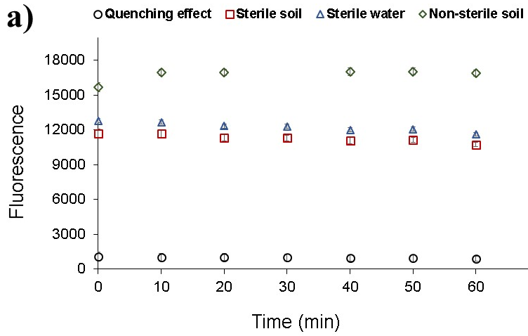
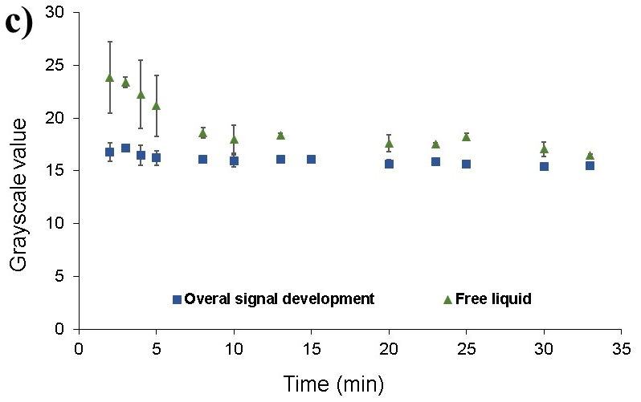
Fig. S5. Development of auto-fluorescent signals in soil aggregates in both microplate and micro-zymography approaches over time; a) fluorescent signals in sterile water, sonicated sterile and non-sterile soil suspension after application of 5 mM MUF-P over time in microplate. Given are means ± standard deviations. Quenching effect is the difference between sterile water and sterile soil which demonstrates the amount of substrate quenched by sterile soil sggregates, b) signal intensity at two exposure times (3000, and 10000 ms) after application of 5 mM MUF-P to a thin layer of homogeneous autoclaved soil aggregates (shown in pseudocolor). Red squares demonstrate examples of free liquid phase. Scale bar: 200 µm, c) changes of fluorescent intensity in the overall image, and liquid phase in a thin layer of homogeneous autoclaved soil aggregates. Given are means ± standard deviations.

Fig. S6. Controls of super transparent silicon on a thin layer of quartz particles (sieved to ≤ 500 µm) under bright field and fluorescent light at exposure time 3000 ms. The bottom row images are in pseudocolor to help distinguish small differences. Scale bar: 100 µm; a) autoclaved quartz particles before application of water. Average grayscale value: 21.9 ± 0.7, b) autoclaved quartz particles after application of water at 3-60 min. Average grayscale value: about 28 ± 0.29, 28 ± 0.96, 27 ± 1.04, respectively.

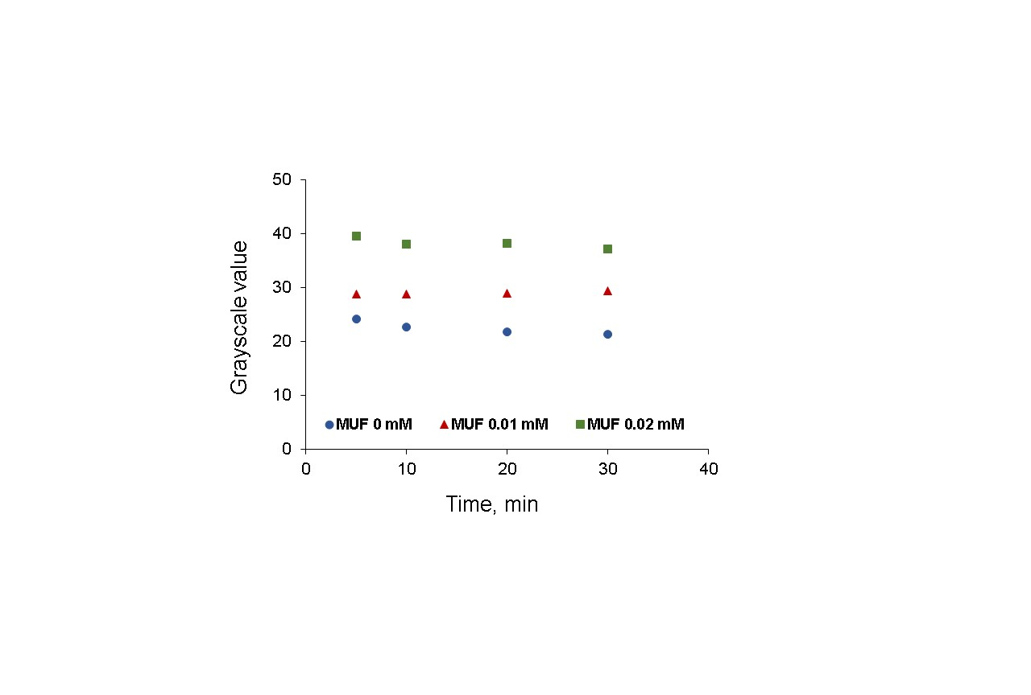
Fig. S7. Stability of different concentrations of MUF in individual soil aggregates over time.

Fig. S8. Comparing fluorescent homogeneity of liquid phase between MUF-P and MUF under bright field and fluorescence conditions at an exposure time of 3000 ms. The bottom row images are in pseudocolor to help distinguish small differences. The background (before application of MUF-P / MUF) is subtracted from the absolute fluorescent signals. Scale bar: 50 µm; a) individual soil aggregates 30 min after application of 5 mM MUF-P. Average grayscale value in liquid phase (green color): 42.16, b) individual soil aggregates 30 min after application of 0.1 mM MUF. Average grayscale value in liquid phase (green color): 42.44.

Fig. S9. Replications (rhizoboxes 2 and 3) of development of fluorescence over time (shown in pseudocolor) after application of 5 mM MUF-P to individual soil aggregates. The background (before application of MUF-P) is subtracted from the fluorescent signals. Scale bar: 50 µm.

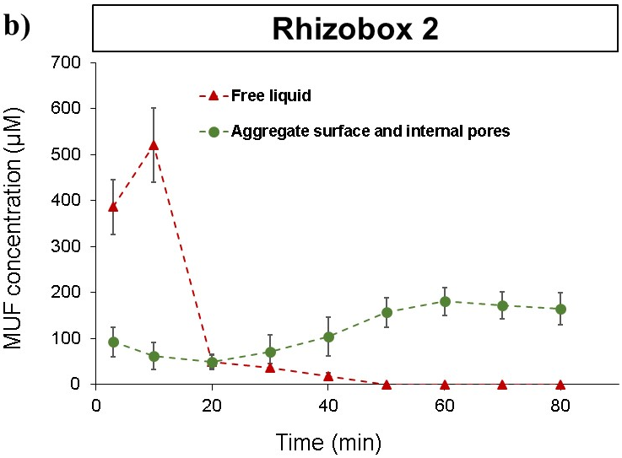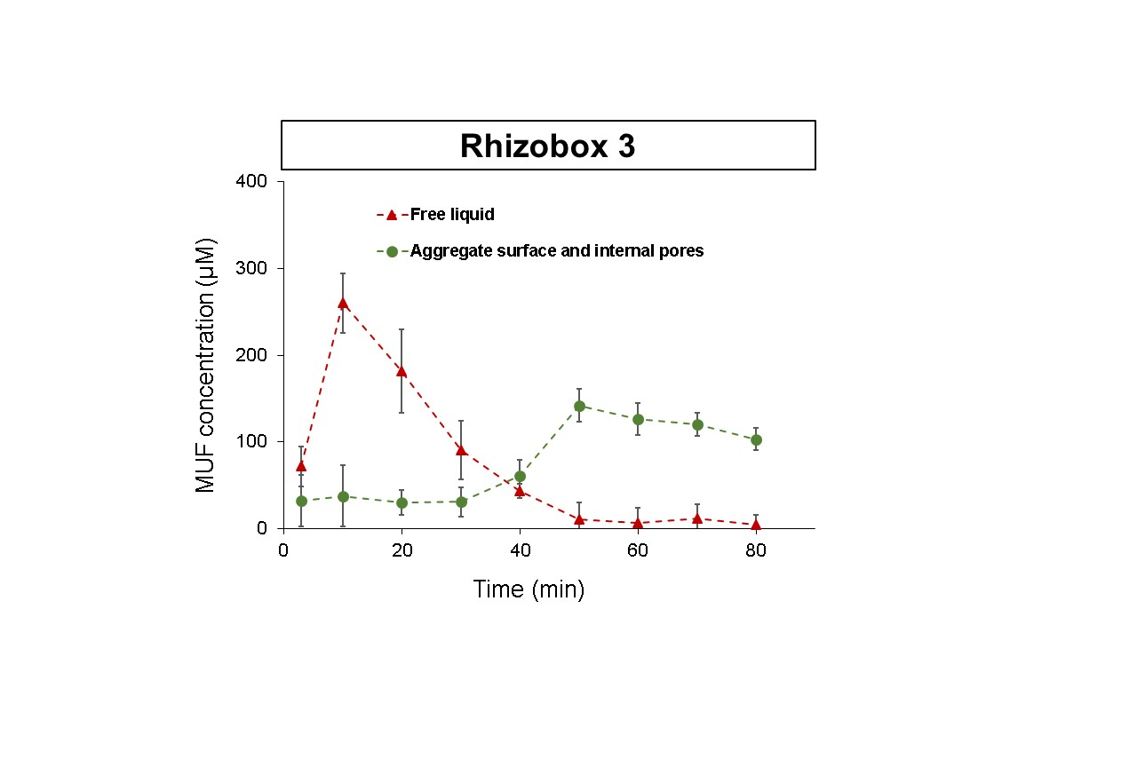
Fig. S10. Replications (rhizoboxes 2 and 3) of development of fluorescence over time after application of 5 mM MUF-P to a thin layer of homogeneous loamy soil aggregates. The background (before application of MUF-P) is subtracted from the fluorescent signals; a) pseudocolor example images were assumed showing the phosphatase activity in time. Scale bar: 200 µm, b) changes of the enzymatic activity based on MUF concentrations (µM) in aggregate surfaces and liquid phase presented as mean values of 3 technical replicates in each rhizobox. Given are means ± standard deviations.

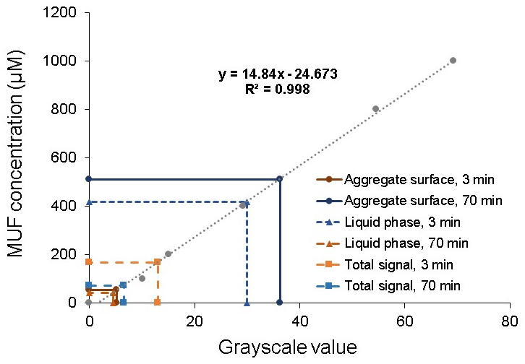
Fig. S11. Interpolated MUF concentration of MUF-P from calibration line in a thin layer of soil aggregates in rhizobox 1.

