Physico-chemical properties of maize (Zea mays L.) mucilage differ with the collection system
Plant and Soil
Lena M. Werner¹; Matthilde Knott²; Dörthe Diehl²; Mutez Ahmed³; Callum Banfield⁴; Michi Dippold⁴; Doris Vetterlein^{5,6}; Monika A. Wimmer^{1*}
¹University of Hohenheim, Dpt. Quality of Plant Products, Stuttgart, Germany
*corresponding author: m.wimmer@uni-hohenheim.de

Supplementary Figure S1

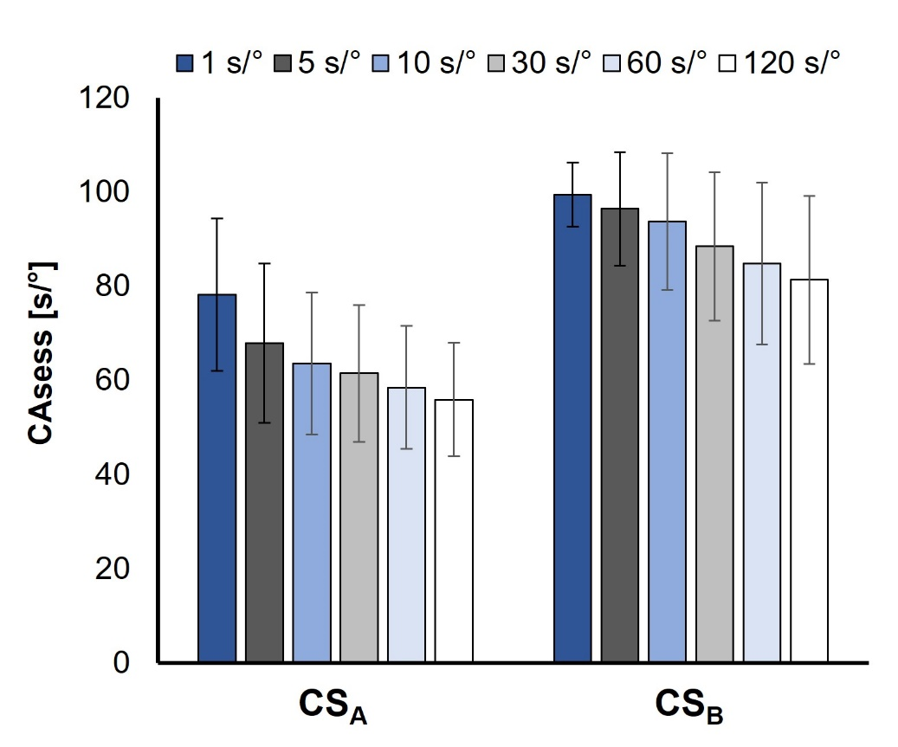
Supplementary Fig. S1 Sessile water drop contact angle (CA_{sess}) at a drop age of 1, 5, 10, 60 and 120 sec on dried mucilage, of CS_{A} and CS_{B-pot} of maize (Zea mays L.). Error bars indicate standard deviations of ten to nineteen technical replicates

