Supplementary Information

Combination of humic biostimulants with a microbial inoculum improves lettuce productivity, nutrient uptake, and primary and secondary metabolism

Claudia Savarese¹, Vincenza Cozzolino^{1,}2, Mariavittoria Verrillo², Giovanni Vinci², Antonio de Martino¹, Antonio Scopa³, *, Alessandro Piccolo^{1,2*}

¹ Department of Agricultural Sciences, Università di Napoli Federico II, Via Università 100, 80055 Portici, Italy
² Interdepartmental Research Centre on Nuclear Magnetic Resonance for the Environment, Agri-Food and New Materials (CERMANU). Università di Napoli Federico II, Via Università 100, 80055 Portici, Italy
³ Scuola di Scienze Agrarie, Forestali, Alimentari ed Ambientali (SAFE), Università della Basilicata, Viale dell’Ateneo Lucano, 10, 85100 Potenza, Italy

* Corresponding authors. E-mail addresses vincenza.cozzolino@unina.it; alessandro.piccolo@unina.it

Table S1.
List of primary metabolites from lettuce leaves identified by GC-MS. The identification of compounds was carried out by analyzing standard compounds (STD) as well as by evaluating the mass spectra reported in the library (NIST 11).

N° | Metabolites | R.T.ª | MS fragmentation (m/z) | References
1 | Alanine | 14.31 | 73-116-147-190 | NIST
2 | Oxalic acid | 15.47 | 73-74-147-148-149 | NIST
3 | Valine | 17.74 | 73-144-147-218 | NIST
4 | Glycerol TMS | 19.52 | 73-117-147-205-299 | NIST
5 | Isoleucine | 19.97 | 73-147-158-218 | NIST
6 | Succinic acid | 20.57 | 73-147-172-247 | NIST
7 | Glyceric acid | 21.03 | 73-103-147-189-292 | NIST
8 | Fumaric acid | 21.58 | 73-133-147-245 | NIST
9 | Serine | 21.84 | 73-147-204-218 | NIST
10 | Threonine | 22.51 | 73-117-147-218-219 | NIST
11 | Malic acid | 25.18 | 73-147-233-245 | NIST
12 | Proline | 25.82 | 73-147-156-157 | NIST
13 | Aspartic acid | 25.95 | 73-100-147-232 | NIST
14 | 4-aminobutyric acid | 26.14 | 73-130-147-230 | NIST
15 | Threonic acid | 27.19 | 73-147-205-220-292 | NIST
16 | Glutaric acid | 27.66 | 73-147-198-304 | NIST
17 | Glutamic acid | 29.32 | 73-128-147-246 | NIST
18 | Tartaric acid | 30.13 | 73-147-219-292 | NIST
19 | Xylose | 30.88 | 73-103-147-217-307 | NIST , STD
20 | Asparagine | 31.19 | 73-116-147-132-188-231 | NIST
21 | Ribitol | 32.78 | 73-103-147-217-319 | IS^{b}
22 | Glutamine | 33.72 | 73-147-156-245 | NIST
23 | Citric acid | 34.59 | 73-147-273-347-363 | NIST
24 | Fructose | 35.44 | 73-103-133-147-217-307 | NIST , STD
25 | Fructose | 35.60 | 73-103-133-147-217-308 | NIST , STD
26 | Galactose | 35.82 | 73-147-205-217-319 | NIST , STD
27 | Glucose | 36.05 | 73-147-160-205-319 | NIST , STD
28 | Myo-Inositol | 36.55 | 73-147-191-217-305-318 | NIST , STD
29 | Hexose | 36.90 | 73-147-191-204-205 | NIST
30 | Myo-Inositol | 38.11 | 73-147-191-217-305-318 | NIST , STD
31 | Cinnamic acid | 38.62 | 73-147-219-396 | NIST
32 | Cellobiose | 40.22 | 73-147-204-217-361 | NIST , STD
33 | Glucuronic acid | 40.78 | 73-147-205-217-292-375 | NIST
34 | Trehalose | 42.49 | 73-147-191-204-217-362 | NIST , STD
35 | Sucrose | 42.90 | 73-169-217-361-362 | NIST , STD
36 | D-Turanose | 43.22 | 73-147-217-361-450 | NIST
37 | D-Turanose | 43.35 | 73-147-217-361-450 | NIST
38 | Maltose | 46.40 | 73-147-204-217-305-361 | NIST , STD
39 | Melibiose | 46.75 | 73-103-129-204-217-361 | NIST , STD
ª Retention Time (min)
^{b} IS = Internal Standard.

Table S2.
List of lipids from lettuce leaves identified by GC-MS. The identification of compounds was carried out by evaluating the mass spectra reported in the library (NIST 11).

N° | Metabolites | R.T.ª | MS fragmentation (m/z) | References
1 | Dodecanoic acid | 24.75 | 73-75-117-129-132-257 | NIST
2 | 3,7,11,15-Tetramethyl-2-hexadecen-1-ol | 26.48 | 55-57-68-81-82-95-123 | NIST
3 | Tetradecanoic acid | 26.61 | 73-75-117-129-132-145-285 | NIST
4 | Phytol acetate | 27.01 | 57-68-82-95-123 | NIST
5 | Palmitic acid | 28.82 | 73-75-117-129-132-145-313 | NIST
6 | 11-Octanedecanoic acid | 29.37 | 55-69-74-83-97-264 | NIST
7 | Linoleic acid | 30.39 | 67-73-75-81-95-129-337 | NIST
8 | Linolenic acid | 30.45 | 75-79-95-108-129-335 | NIST
9 | Stearic acid | 30.69 | 73-75-117-129-132-145-341 | NIST
10 | Dodecanedioic acid, bis(tert-butyldimethylsilyl) ester | 31.94 | 73-75-129-401-402 | IS ^{b}
11 | Erucic acid | 32.79 | 55-69-83-97-111 | NIST
12 | 1-Docosanol | 33.21 | 57-75-83-103-383 | NIST
13 | Docosanoic acid | 33.89 | 73-75-117-129-132-145-397 | NIST
14 | Linoleic acid, 2,3-bis-(O-trimethylsilyl)-propyl ester | 35.19 | 73-75-129-147-207-221 | NIST
15 | Tetracosanoic acid | 35.31 | 73-75-117-129-132-145-425 | NIST
16 | 1-Hexacosanol | 36.05 | 57-75-83-439-440 | NIST
17 | Hexacosanoic acid | 36.68 | 73-75-117-129-132-145-453 | NIST
18 | Sigmasterol | 38.93 | 55-69-73-83-129-255 | NIST
19 | beta-Sitosterol | 39.61 | 73-129-357-381-396-486 | NIST
20 | Pregn-5-en-20-one, 3,16-bis[(trimethylsilyl)oxy]-, (3β,16α)- | 39.79 | 73-75-129-172-296-386 | NIST
21 | beta-Amyrin TMSE | 39.96 | 73-190-203-218-219 | NIST
22 | Germanicol (Olean-18-en-3-ol ) | 40.06 | 131-177-189-204-205 | NIST
23 | alfa-Amyrin TMSE | 40.55 | 73-189-190-218-219 | NIST
24 | Lup-20(29)-en-3-ol, acetate, (3β)- | 41.85 | 73-95-109-189 | NIST
ªRetention Time (min)
^{b} IS = Internal Standard.

Table S3.
List of polyphenolic metabolites from lettuce leaves identified by UHPLC-MS-IT-TOF. The identification of compound was performed by the LCMSsolution software (Version 3, Shimadzu), the Formula Predictor software (Version 1.2, Shimadzu) and MetID solution software (Version 1.2, Shimadzu).

N° | RTª  (min) | Observed m/z  ([M-H]⁻) | Calculated m/z  ([M-H]⁻) | Empirical formula | Error (ppm) | Major fragments m/z  ([M-H]⁻) | Proposed compound
1 | 5.49 | 343.1036 | 343.1035 | C15H20O9 | 0.13 | 181.0506, 164.0404 | Dihydrocaffeic acid hexose
2 | 5.79 | 315.0726 | 315.0722 | C13H16O9 | 1.41 | 153.0201, 108.0233 | Dihydroxybenzoic acid hexose
3 | 5.80 | 313.0927 | 313.0929 | C14H18O8 | -0.61 | 151.0409 | 4-hydroxyphenylacetyl glucoside
4 | 5.88 | 299.0776 | 299.0772 | C13H16O8 | 1.11 | 137.027 | Hydroxybenzoic acid derivative
5 | 6.04 | 359.0982 | n.d.^{c} | C15H20O10 | n.d.^{c} | 197.0454, 153.0165 | Syringic acid hexose
6 | 6.05 | 341.0892 | n.d.^{c} | C15H18O9 | n.d.^{c} | 179.033, 135.0455 | Caffeoyl hexose
7 | 6.10 | 329.0872 | 329.0878 | C14H18O9 | -1.99 | 167.0333 | Vanillic acid glucoside
8 | 6.85 | 339.0721 | 339.0714 | C15H16O9 | -0.31 | 177.0188 | Esculetin 6-O-glucoside
9 | 6.87 | 311.0409 | n.d.^{c} | C13H12O9 | n.d.^{c} | 149.0078 | Caffeoyltartaric acid
10 | 7.15 | 325.0925 | 325.0929 | C15H18O8 | -1.28 | 163.0384, 119.0532 | P-Coumaroyl glucoside
11 | 7.53 | 353.0877 | 353.0878 | C16H18O9 | -0.23 | 191.0545, 179.0366, 135.0401 | Caffeoylquinic acid  (Chlorogenic acid)
12 | 7.75 | 295.0460 | 295.0459 | C13H12O8 | 0.28 | 163.0405, 119.0504 | Coumaroyltartaric acid  (Coutaric acid)
13 | 7.71 | 639.124 | n.d.^{c} | C27H28O18 | n.d.^{c} | 463.0866, 535.1141, 343.0450 | Quercetin hexose glucuronide
14 | 8.08 | 325.0565 | 325.0565 | C14H14O9 | 0.29 | 163.2930 | Feruloyl tartaric acid
15 | 8.18 | 337.0925 | 337.0929 | C16H18O8 | -1.08 | 163.0378 | p-Coumaroylquinic acid 1
16 | 8.42 | 337.0925 | 337.0929 | C16H18O8 | -1.08 | 163.0378 | p-Coumaroylquinic acid 2
17 | 8.46 | 367.1032 | 367.1035 | C17H20O9 | -0.76 | 179.1910 | Feruloylquinic acid
18 | 8.52 | 609.1456 | 609.1461 | C27H30O16 | -0.92 | 285.0397 | Luteolin diglucoside
19 | 8.75 | 161.0244 | 161.0244 | C9H6O3 | 0.1 | - | Umbelliferone (IS^{b})
20 | 9.05 | 447.0938 | 447.0933 | C21H20O11 | 1.32 | 285.0382 | Luteolin 7-glucoside
21 | 9.11 | 463.0887 | 463.0882 | C21H20O12 | 0.97 | 301.0346, 300.0278 | Quercetin 3-O-glucoside
22 | 9.32 | 461.0723 | 461.0725 | C21H18O12 | -0.54 | 285.039, 271.0214, 299.0192 | Luteolin 7-glucuronide
23 | 9.35 | 477.0672 | 477.0675 | C21H18O13 | -0.66 | 301.0347 | Quercetin 3-glucuronide
24 | 9.48 | 549.0888 | 549.0886 | C24H22O15 | 0.29 | 505.0981 | Quercetin malonylglucoside
25 | 9.56 | 435.0931 | 435.0933 | C20H20O11 | -0.54 | 315.0732, 153.0205, 152.0130 | Hydroxybenzoyl dihydroxybenzoyl hexose
26 | 9.59 | 515.1196 | 515.1195 | C25H24O12 | 0.15 | 353.0876, 191.0551 | Dicaffeoylquinic acid
27 | 9.64 | 445.0728 | n.d.^{c} | C21H18O11 | n.d.^{c} | 269.0451 | Apigenin 7-O-glucuronide
28 | 9.75 | 475.0880 | n.d.^{c} | C22H20O12 | n.d.^{c} | 284.0353, 299.0574 | Hispidulin glucuronide
29 | 9.89 | 473.0720 | 473.0725 | C22H18O12 | -1.16 | 311.0387, 293.0324, 170.0375 | Dicaffeoyltartaric acid  (Chicoric acid)
30 | 10.60 | 457.0780 | 457.0776 | C22H18O11 | 0.80 | 295.0498, 277.0364 | Caffeoyltartaric-p-coumaroyl acid
31 | 12.53 | 499.1241 | n.d.^{c} | C25H23O11 | n.d.^{c} | 353.0706,  191.0504, 337.087 | p-Coumaroyl-Caffeoylquinic acid
32 | 14.60 | 491.0826 | n.d.^{c} | C22H20O13 | n.d.^{c} | 271.3010 | Isorhamnetin 3-O-glucuronide
ª Retention Time (min)
^{b} Internal Standard
^{c} Not determined.

Figure S1.
GC-MS chromatogram of the polar fraction of metabolic extract from lettuce leaves (control sample). Numbers refer to the identified compounds listed in Table S1.
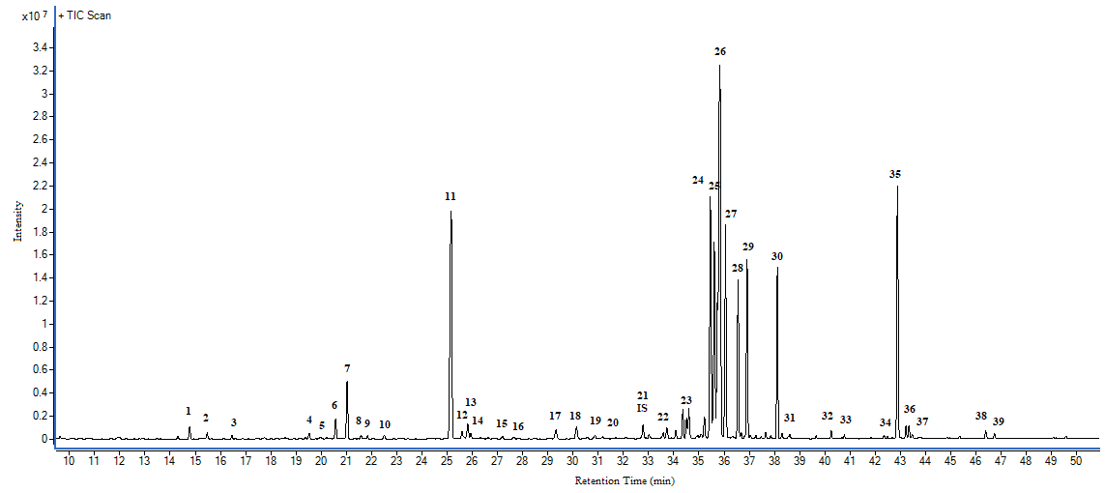

Figure S2.
GC-MS chromatogram of the apolar fraction of metabolic extract from lettuce leaves (control sample). Numbers refer to the identified compounds listed in Table S2.
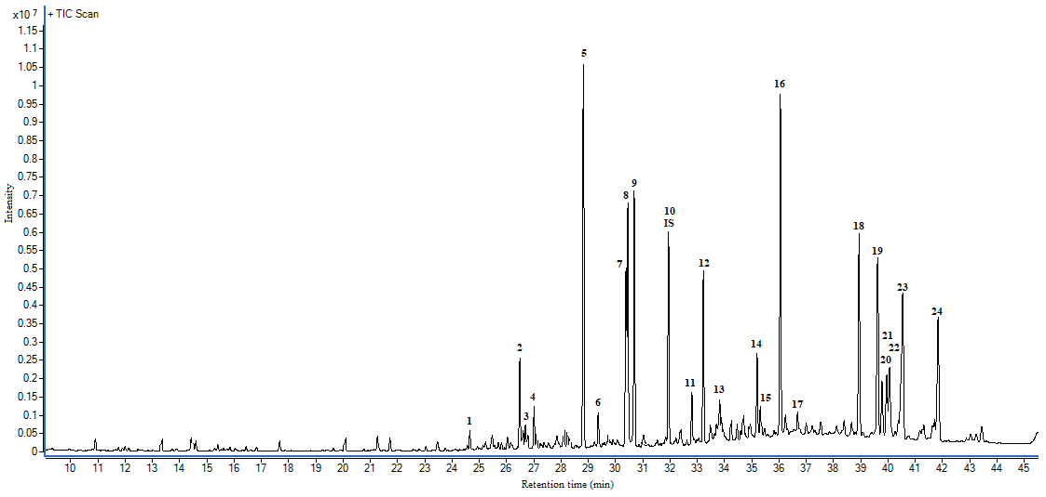

Figure S3.
UHPLC-MS-IT-TOF total ion chromatogram (a) and extracted ion chromatogram (b) of polyphenolic compounds detected in the metabolic extract from lettuce leaves (control sample). Numbers refer to the identified compounds listed in Table S3.
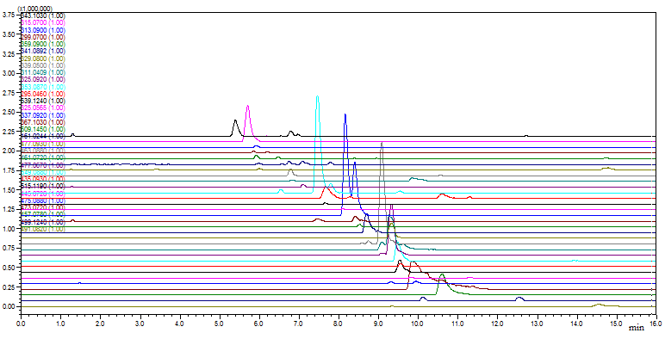
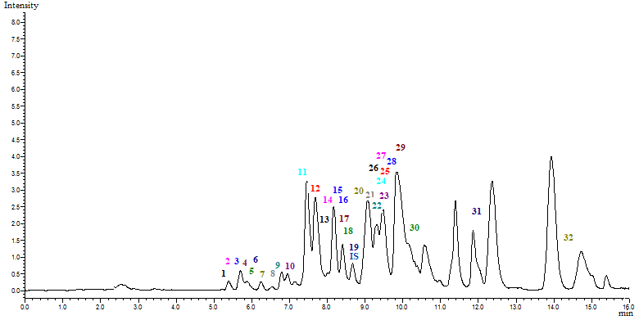
a
b

Figure S4.
Relative abundance (a/is = metabolite-to-internal standard total area ratio) of amino acids identified by GC-MS in the polar fraction of leaves extracts from lettuce plants treated with different biostimulants. CTRL: Control; KH: Potassium Humates from leonardite; CT: Compost Tea from green compost; MIX: KH plus CT; M+: plus microbial inoculum (Micosat TabPlus). Dark grey indicates the microbial inoculation. Bars indicate standard deviation of means (n = 9). Different letters above the bars indicate significantly different means according to LSD test (p < 0.05).

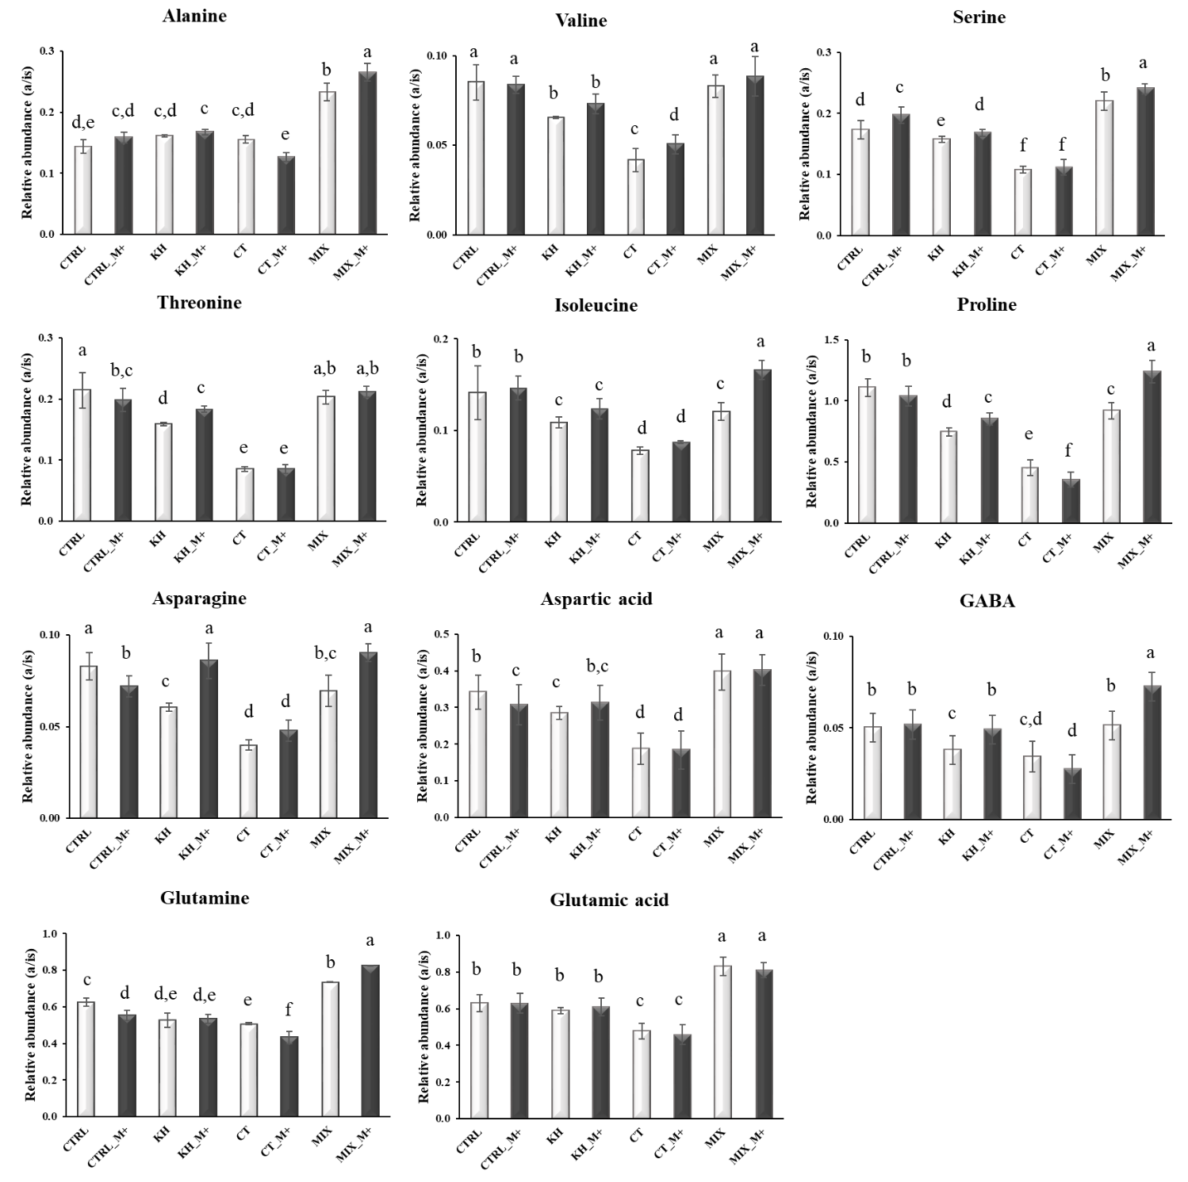

Figure S5 .
Relative abundance (a/is = metabolite-to-internal standard total area ratio) of organic acids identified by GC-MS in the polar fraction of leaves extracts from lettuce plants treated with different biostimulants. CTRL: Control; KH: Potassium Humates from leonardite; CT: Compost Tea from green compost; MIX: KH plus CT; M+: plus microbial inoculum (Micosat TabPlus). Dark grey indicates the microbial inoculation. Bars indicate standard deviation of means (n = 9). Different letters above the bars indicate significantly different means according to LSD test (p < 0.05).

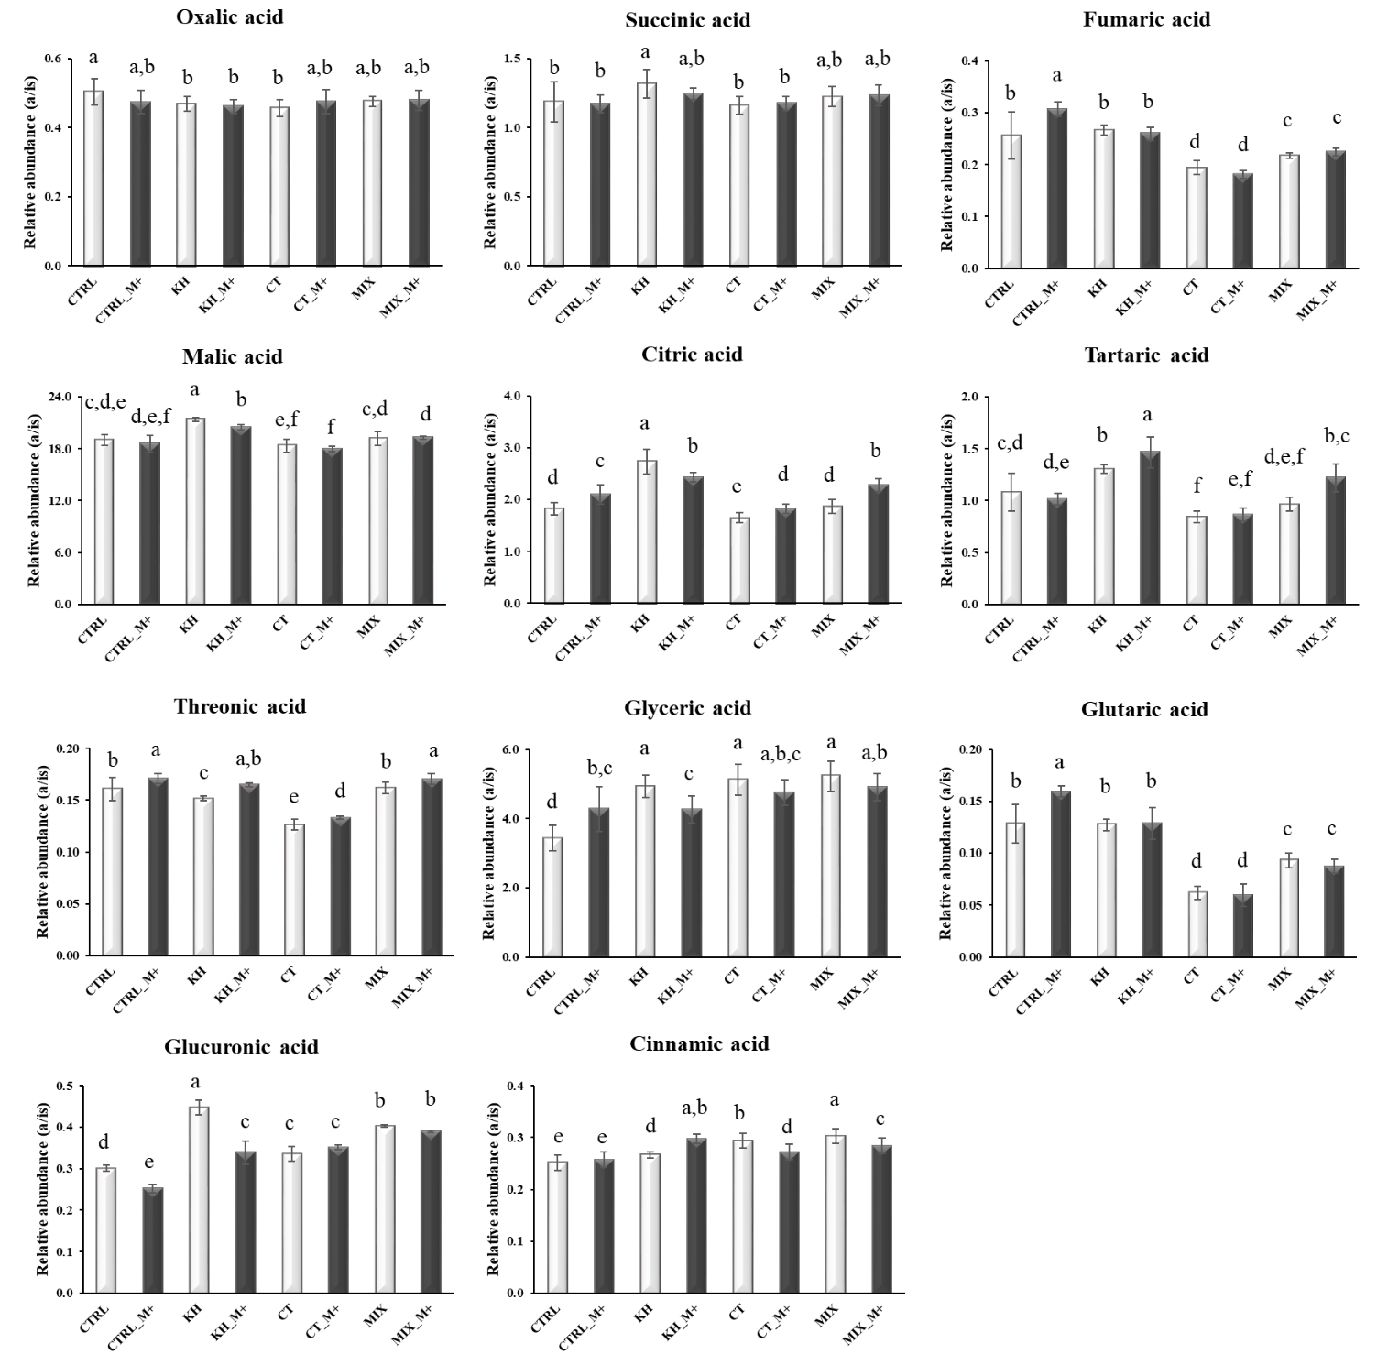

Figure S6 .
Relative abundance (a/is = metabolite-to-internal standard total area ratio) of saccharides identified by GC-MS in the polar fraction of leaves extracts from lettuce plants treated with different biostimulants. CTRL: Control; KH: Potassium Humates from leonardite; CT: Compost Tea from green compost; MIX: KH plus CT; M+: plus microbial inoculum (Micosat TabPlus). Dark grey indicates the microbial inoculation. Bars indicate standard deviation of means (n = 9). Different letters above the bars indicate significantly different means according to LSD test (p < 0.05).

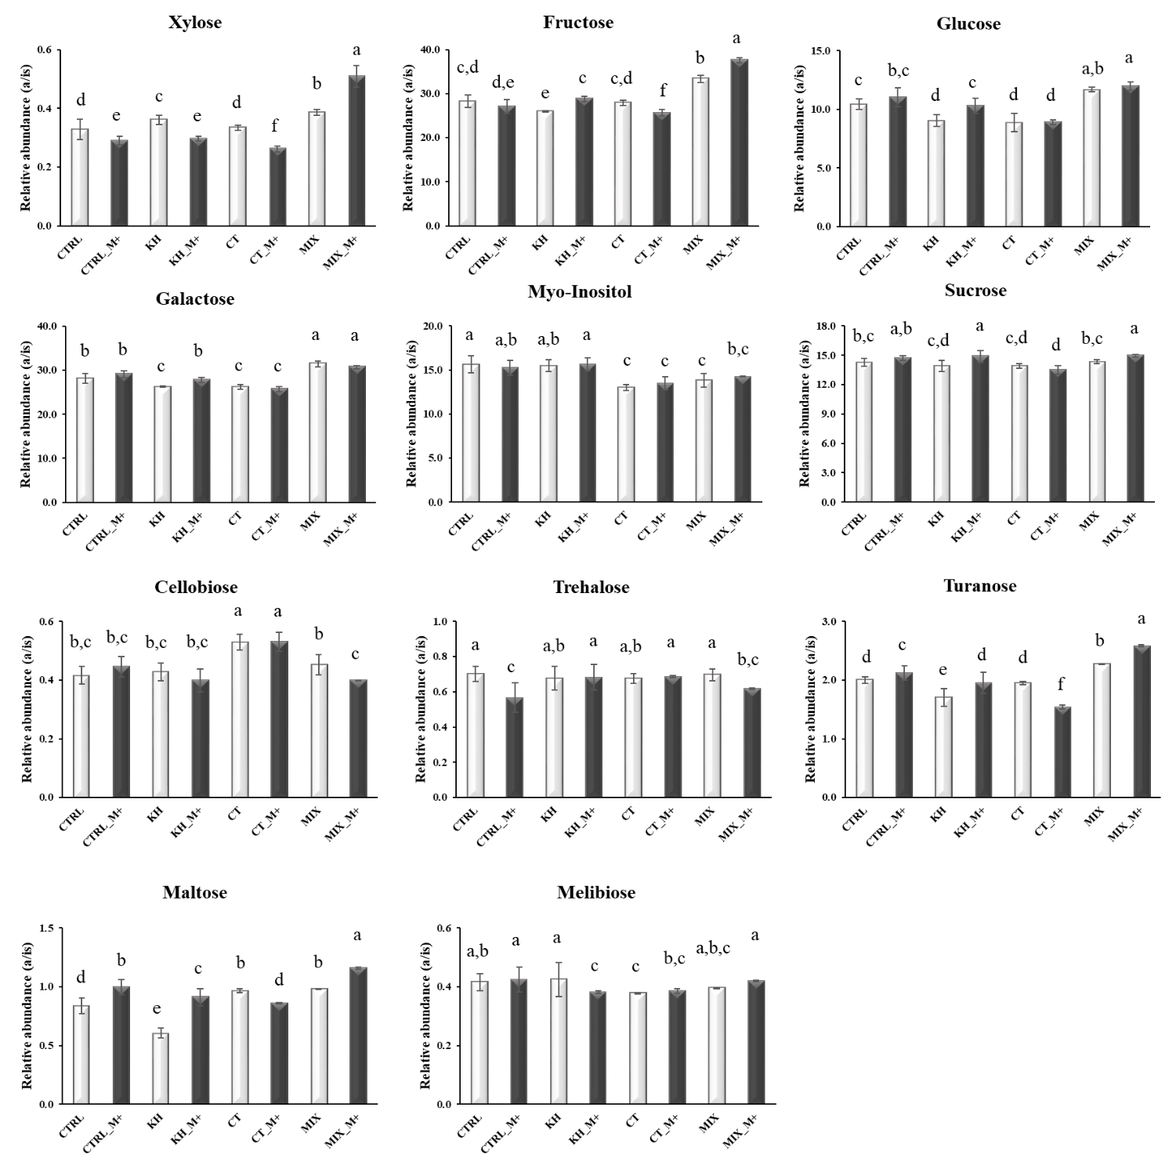

Figure S7.
Relative abundance (a/is = metabolite-to-internal standard total area ratio) of fatty acids identified by GC-MS in the apolar fraction of leaves extracts from lettuce plants treated with different biostimulants. CTRL: Control; KH: Potassium Humates from leonardite; CT: Compost Tea from green compost; MIX: KH plus CT; M+: plus microbial inoculum (Micosat TabPlus). Dark grey indicates the microbial inoculation. Bars indicate standard deviation of means (n = 9). Different letters above the bars indicate significantly different means according to LSD test (p < 0.05).

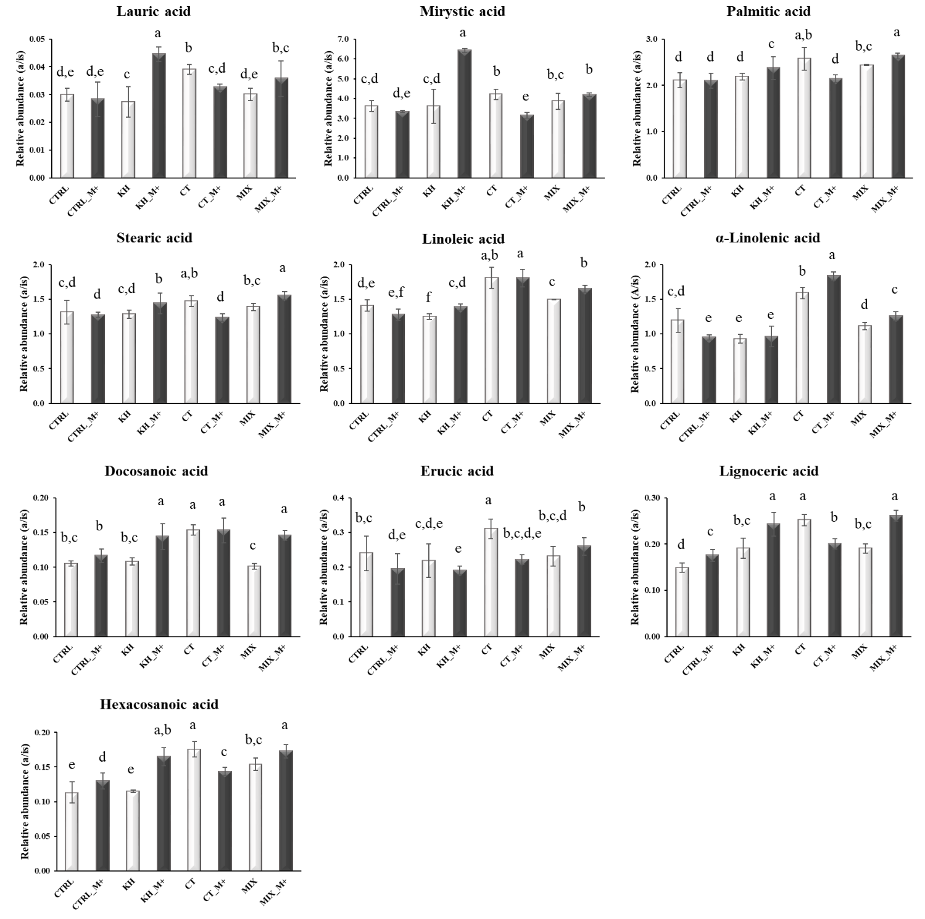

Figure S8.
Relative abundance (a/is = metabolite-to-internal standard total area ratio) of fatty alcohols, sterols and terpenes identified by GC-MS in the apolar fraction of leaves extracts from lettuce plants treated with different biostimulants. CTRL: Control; KH: Potassium Humates from leonardite; CT: Compost Tea from green compost; MIX: KH plus CT; M+: plus microbial inoculum (Micosat TabPlus). Dark grey indicates the microbial inoculation. Bars indicate standard deviation of means (n = 9). Different letters above the bars indicate significantly different means according to LSD test (p < 0.05).

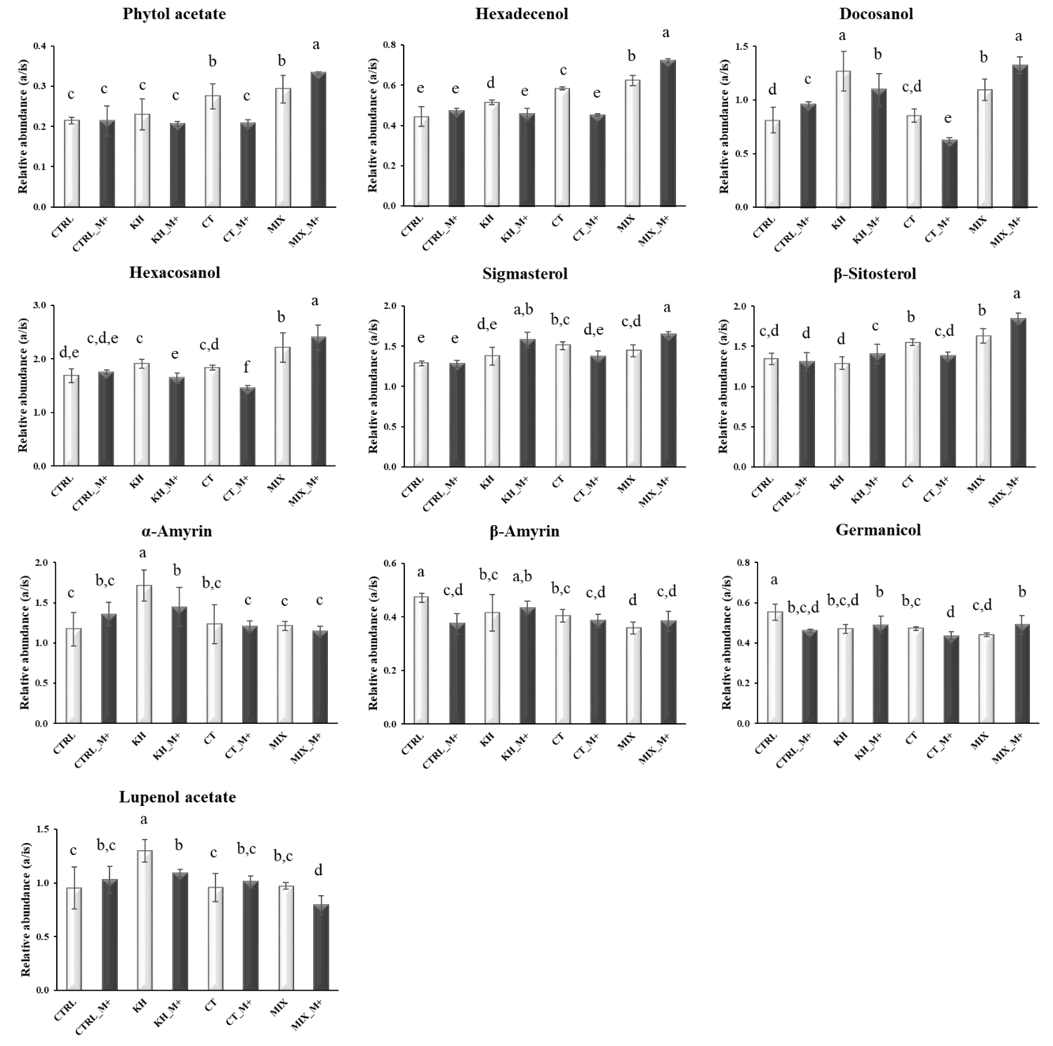

Figure S9.
Relative abundance (a/is = metabolite-to-internal standard total area ratio) of hydroxybenzoic and hydroxycinnamic acids identified by UHPLC-MS-IT-TOF in the leaves extracts from lettuce plants treated with different biostimulants. CTRL: Control; KH: Potassium Humates from leonardite; CT: Compost Tea from green compost; MIX: KH plus CT; M+: plus microbial inoculum (Micosat TabPlus). Dark grey indicates the microbial inoculation. Bars indicate standard deviation of means (n = 9). Different letters above the bars indicate significantly different means according to LSD test (p < 0.05).

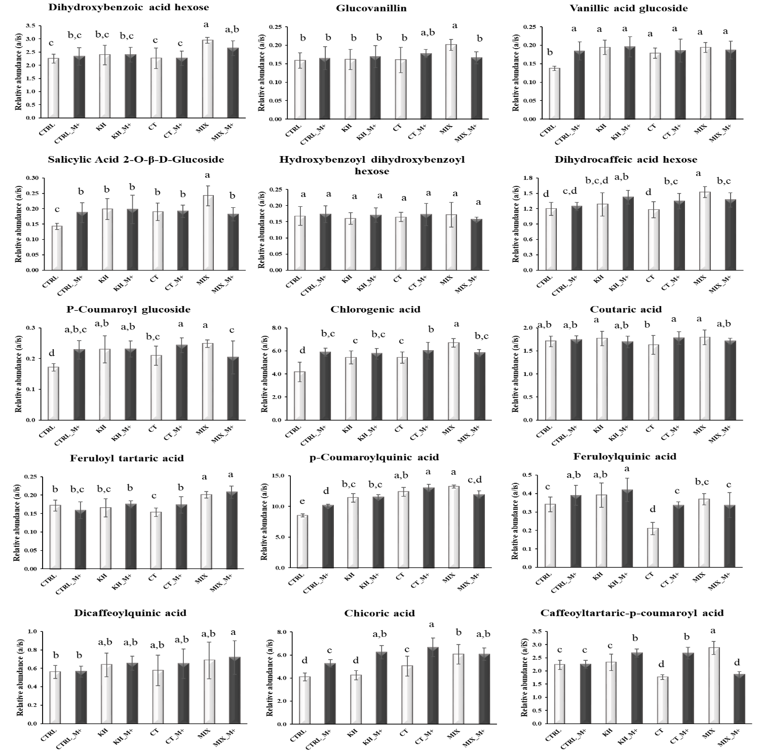

Figure S10.
Relative abundance (a/is = metabolite-to-internal standard total area ratio) of flavones, flavonols and coumarins by UHPLC-MS-IT-TOF in the leaves extracts from lettuce plants treated with different biostimulants. CTRL: Control; KH: Potassium Humates from leonardite; CT: Compost Tea from green compost; MIX: KH plus CT; M+: plus microbial inoculum (Micosat TabPlus). Dark grey indicates the microbial inoculation. Bars indicate standard deviation of means (n = 9). Different letters above the bars indicate significantly different means according to LSD test (p < 0.05).

