Supporting information
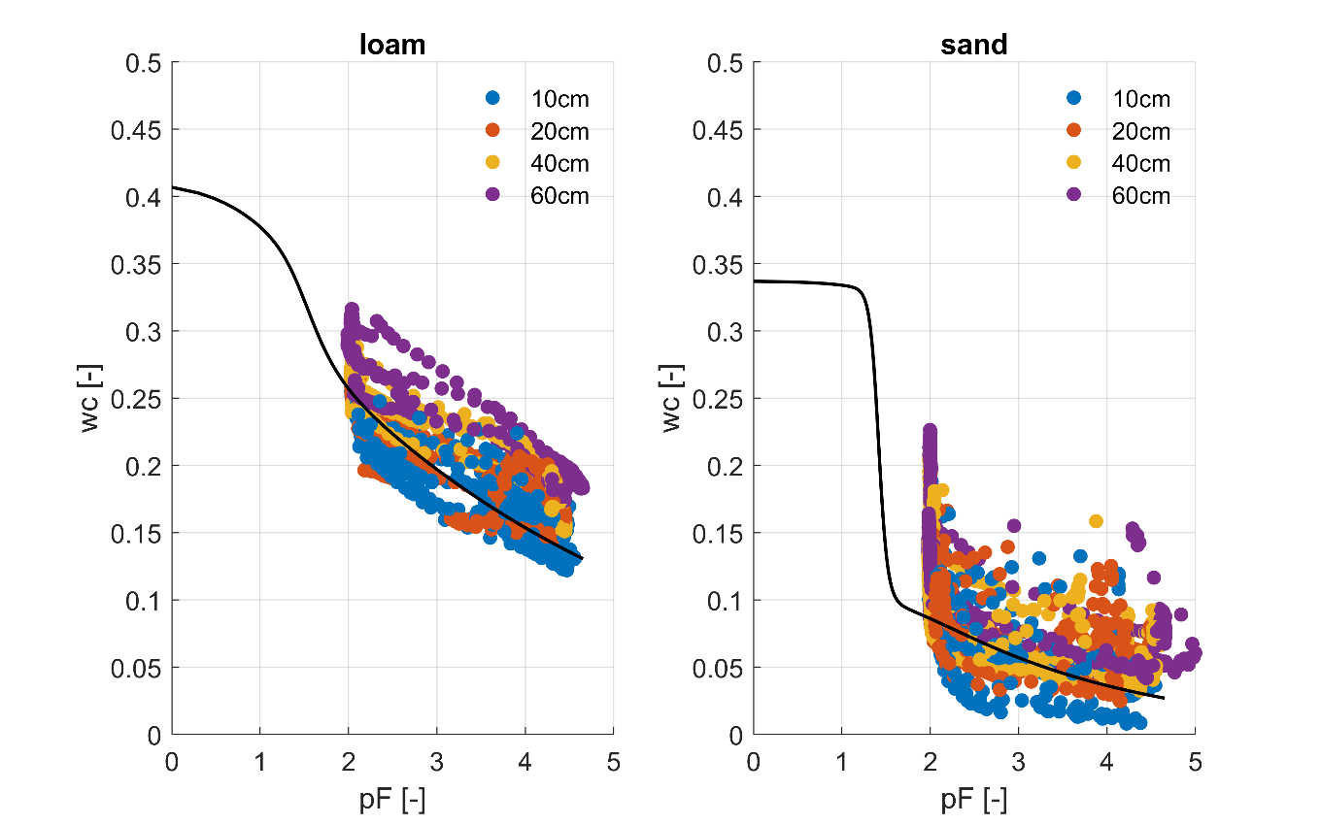
Figure S1. Measured soil water content and soil water potential obtained from TEROS 21 sensors (midnight values). Black line indicates parameterization used in the simulations (see Table 1). Data is colored according to soil depth.
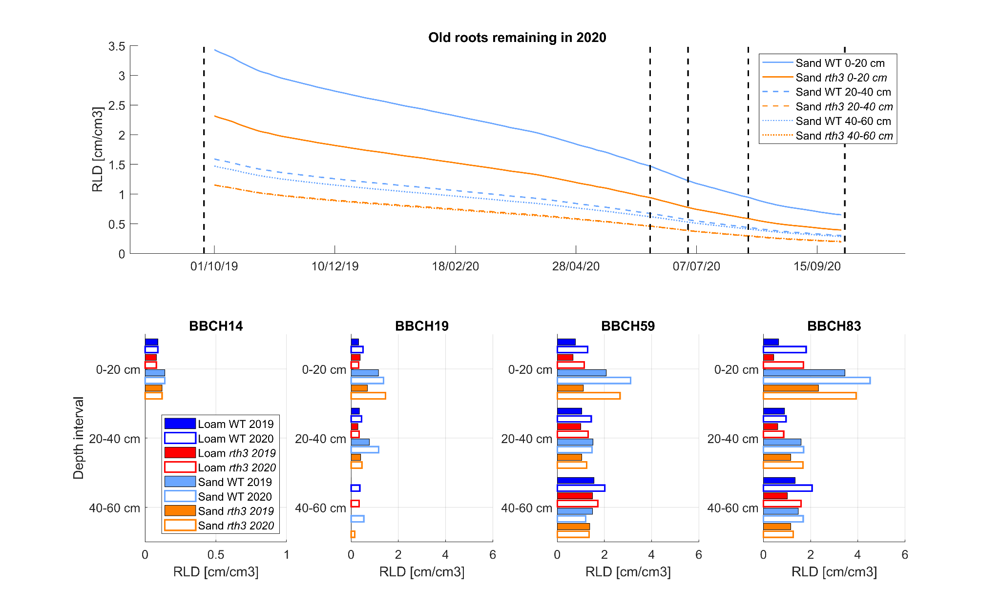
Figure S2. Estimated RLD of old 2019 roots remaining in the sandy treatments during 2020 after degradation (top plot). Dashed vertical lines mark dates at which BBCH sampling took place. Measured or estimated RLD of new roots present at different depths during the BBCH campaign measurements for the 4 treatments (bottom plots). In 2020, the RLD in both sand treatments for BBCH14 is estimated to be the same as in 2019.

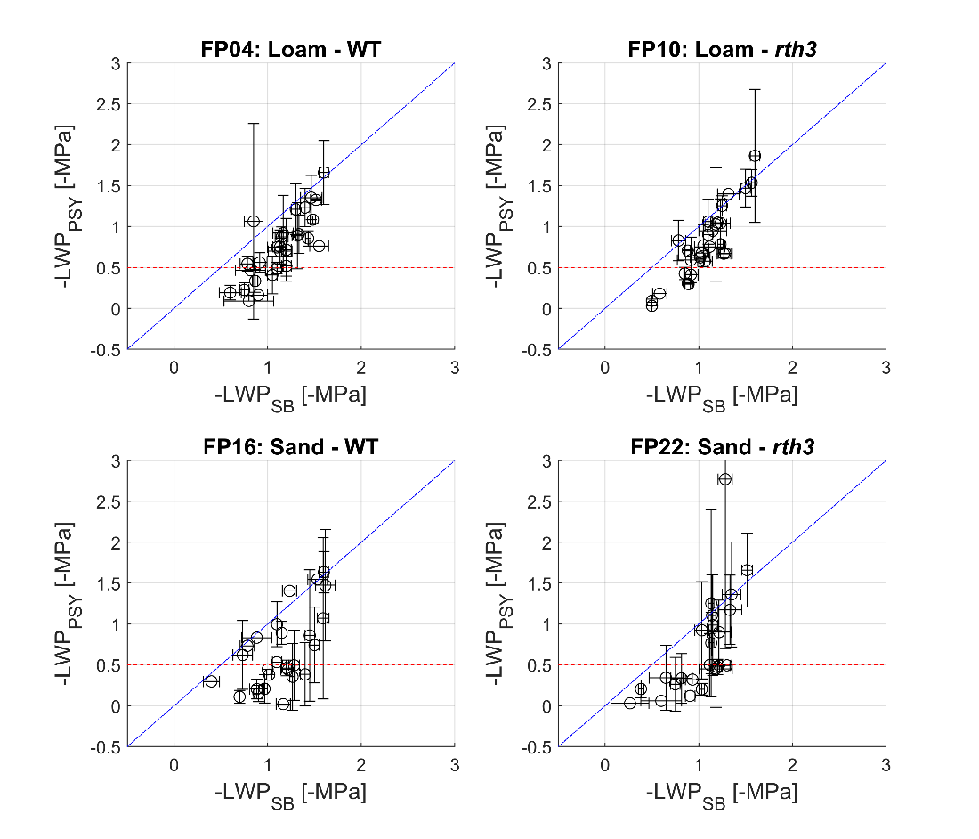
Figure S3. Comparison between leaf water potential data measured in 2020 with psychoremeters (LWP_{PSY}) and with Scholander bomb (LWP_{SB}). Blue line is the one-one line and red dashed horizonal line indicates the (absolute) LWP below which the accuracy of the psychrometer measurements is low. Vertical and horizontal bars show +/- the standard error of the individual measurements.

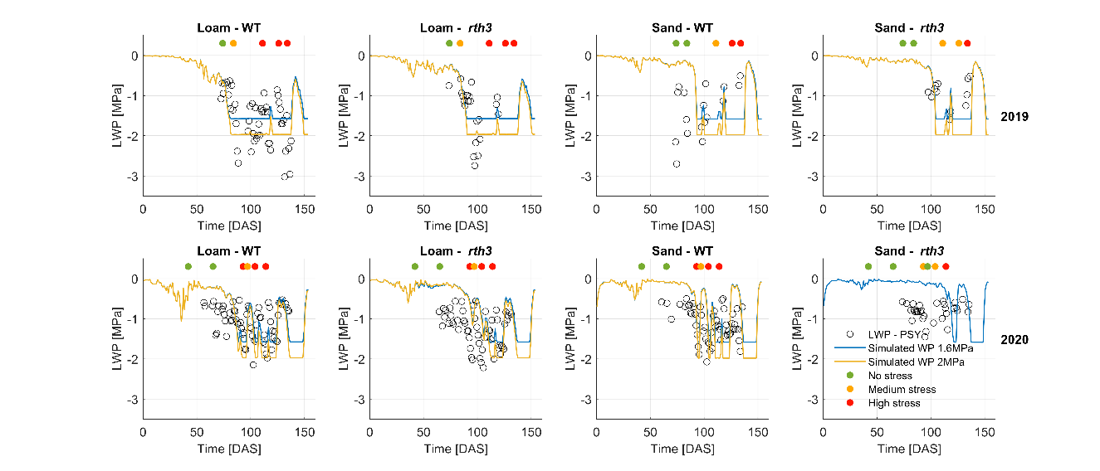
Figure S4. Impact of critical treshold water potential at the collar on the simulated leaf water potentials. Simulations with a critical threshold of –1.6 MPa is plotted in blue, whereas simulations with a critical threshold of –2 MPa is depicted in yellow.

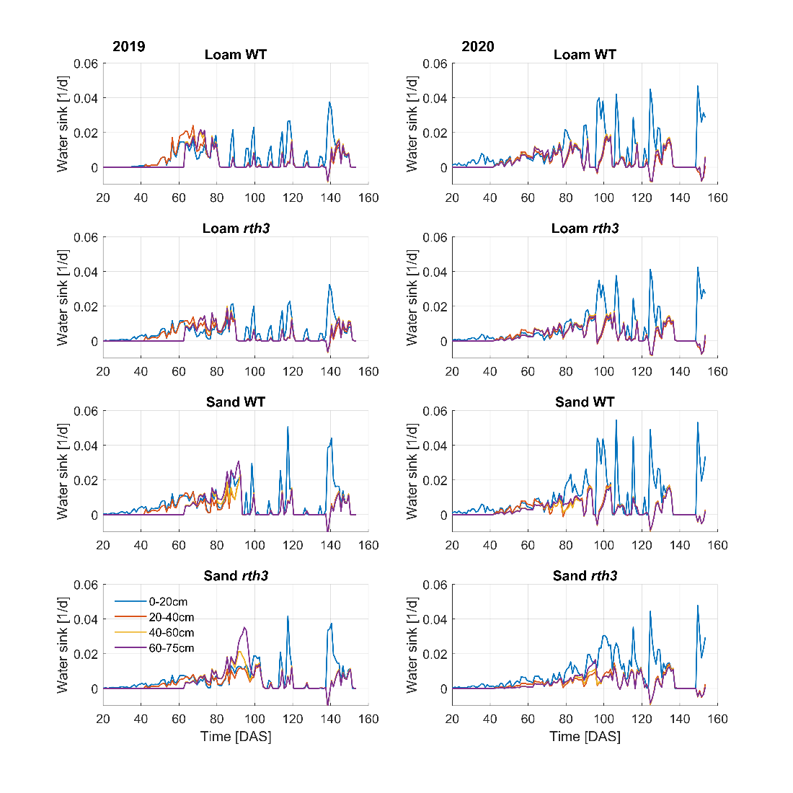
Figure S5. Simulated midday water sink for 4 soil layers (0-20, 20-40, 40-60 and 60-75 cm) and all treatments.

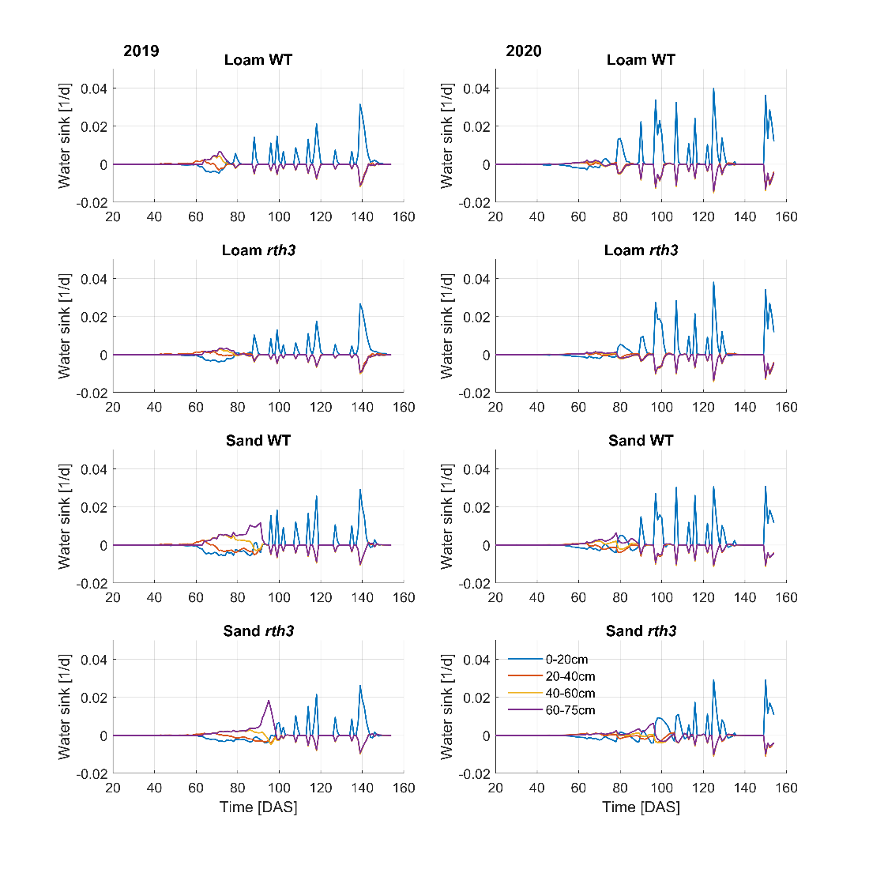
Figure S6. Simulated midnight water sink for 4 soil layers (0-20, 20-40, 40-60 and 60-75 cm) and all treatments.

