Plant and Soil Supporting Information
Article title: Richness of arbuscular mycorrhizal fungi increases with ecosystem degradation of temperate eucalypt woodlands
Authors: Felipe E. Albornoz, Rachel J. Standish, Andrew Bissett, Suzanne M. Prober

The following Supporting Information is available for this article:
Table S1 Vegetation attributes and soil chemistry of each Ground-layer states × Canopy state
Table S2 Squared correlation coefficient and significance of correlation with 3D-NMDS of AMF communities and explanatory variables
Table S3 Summary of unique zOTUs in each Ground-layer states × Canopy state, grouped by taxonomic family of AMF.
Table S4 Summary of indicator species analysis of each Ground-layer states × Canopy state, grouped by taxonomic family of AMF.
Figure S1 Rarefaction curves of (a) unrarefied zOTU matrix and (b) rarefied zOTU matrix
Figure S2 Correlation among vegetation and soil chemistry variables
Figure S3 Effects of Ground-layer states × Canopy state on zOTU richness of individual families of arbuscular mycorrhizal fungi
Figure S4 Post-hoc pairwise comparisons among Ground-layer states in canopy gaps by ANOSIM analysis
Figure S5 Two-way table of AMF from samples from under trees
Figure S6 Effects of Ground-layer states × Canopy state on zOTU relative sequence abundance of individual families of AMF
Figure S7 Observed number of unique zero-radius operational taxonomic units (zOTUs) among Ground-layer states × Canopy state

Table S1. Vegetation attributes and soil chemistry of each Ground-layer and Canopy states. Ground-layer states are reference state (Ref), CN-depleted states (Aris = Aristida ramosa, Ryt = Rytidosperma spp. – Austrostipa scabra), intermediate state (Bothr = Bothriochloa macra), and CN-enriched state (AE = annual exotics). Cover of native grasses, annual exotics, and bare ground in each plot was estimated using a point-intercept technique (Prober, Thiele, Lunt, & Koen, 2005). An 8 mm-diameter dowel was placed vertically at each of 50 points at regular spacing across each plot; the relative abundance for any plant group was the percentage of points at which any leaves, stems or inflorescences from the relevant life-form intercepted the dowel (hereafter ‘cover’). Note that since more than one plant group could occur at each point, total cover can exceed 100%. Values are mean ± standard error reproduced from (Prober et al. 2014).

 | 1. Ref |  | 2. Aris | 3. Ryt |  | 4. Bothr | 5. AE
 | Canopy gap | Under trees | Canopy gap | Canopy gap | Under trees | Canopy gap | Canopy gap | Under trees
Plant cover
Rytidosperma spp. (% points) | 0.4 ± 0.4 | 3.6 ± 2.0 | 9.8 ± 3.8 | 40.0 ± 9.5 | 56.1 ± 8.5 | 11.0 ± 4.0 | 9.0 ± 8.6 | 4.1 ± 2.3
Austrostipa scabra (% points) | 0.2 ± 0.2 | 0 ± 0 | 3.5 ± 2.4 | 41.4 ± 12.6 | 23.1 ± 12.7 | 0.7 ± 0.5 | 2.7 ± 2.7 | 1.1 ± 0.9
Themeda spp. (% points) | 94.2 ± 2.2 | 49.9 ± 10.8 | 0.5 ± 0.5 | 0.4 ± 0.4 | 0 ± 0 | 1.6 ± 1.6 | 0.7 ± 0.7 | 0 ± 0
Poa spp. (% points) | 20.6 ± 7.5 | 50.2 ± 5.9 | 0 ± 0 | 0 ± 0 | 2 ± 1.5 | 0 ± 0 | 0 ± 0 | 0 ± 0
Aristidia ramosa (% points) | 0 ± 0 | 0.4 ± 0.3 | 85.5 ± 5.1 | 1.0 ± 0.6 | 2.0 ± 1.7 | 0.4 ± 0.3 | 0 ± 0 | 0 ± 0
Bothriochloa macra (% points) | 0 ± 0 | 0.2 ± 0.2 | 8.3 ± 4.2 | 8.3 ± 3.1 | 1.7 ± 1.1 | 93.0 ± 1.3 | 2.7 ± 1.4 | 0.6 ± 0.6
Native annual forbs (% points) | 2.3 ± 1.6 | 0.7 ± 0.5 | 1.0 ± 0.7 | 1.0 ± 0.5 | 3.1 ± 2.2 | 0.2 ± 0.2 | 0.7 ± 0.7 | 0.6 ± 0.6
Native perennial forbs (% points) | 17.9 ± 4.2 | 34.4 ± 6.1 | 14.5 ± 6.6 | 8.1 ± 2.4 | 22.1 ± 4.9 | 2.4 ± 1.3 | 6.3 ± 3.2 | 6.9 ± 1.5
Native grasses (% points) | 97.6 ± 1.2 | 84.6 ± 4.2 | 91.0 ± 4.1 | 79.5 ± 7.4 | 79.7 ± 3.5 | 98.3 ± 0.8 | 22.3 ± 9.0 | 16.7 ± 5.6
Total native plants (% points) | 117.8 ± 5.3 | 119.7 ± 6.5 | 106.5 ± 8.0 | 88.6 ± 7.5 | 105.0 ± 7.4 | 101.0 ± 1.1 | 29.3 ± 7.7 | 24.1 ± 6.0
Exotic annual forbs (% points) | 1.6 ± 0.6 | 0.9 ± 0.7 | 3.8 ± 2.0 | 3.2 ± 1.8 | 3.9 ± 1.9 | 5.2 ± 1.6 | 38.3 ± 13.3 | 16.7 ± 4.9
Exotic grasses (% points) | 2.2 ± 1.6 | 4.8 ± 3.0 | 9.5 ± 4.5 | 1.1 ± 0.5 | 3.7 ± 1.9 | 22.8 ± 6.5 | 69.3 ± 14.1 | 73.0 ± 8.5
Total exotic plants (% points) | 3.8 ± 2.1 | 5.7 ± 2.9 | 13.3 ± 5.3 | 4.3 ± 2.0 | 7.6 ± 3.0 | 28.0 ± 7.6 | 107.7 ± 10.6 | 89.7 ± 10.4
Soil properties
soil pH (CaCl₂) | 5.0 ± 0.1 | 5.7 ± 0.3 | 4.6 ± 0.2 | 4.5 ± 0.1 | 5.0 ± 0.2 | 4.9 ± 0.2 | 4.9 ± 0.2 | 5.5 ± 0.1
OM (%) | 5.6 ± 0.4 | 7.9 ± 0.4 | 4.1 ± 0.4 | 4.1 ± 0.3 | 6.8 ± 0.5 | 6.0 ± 0.5 | 7.2 ± 0.6 | 12.3 ± 0.9
Total N (%) | 0.16 ± 0.01 | 0.22 ± 0.02 | 0.12 ± 0.02 | 0.12 ± 0.01 | 0.2 ± 0.04 | 0.19 ± 0.03 | 0.21 ± 0.02 | 0.35 ± 0.05
Ammonium N (mg/kg) | 14.6 ± 1.7 | 14.3 ± 2.4 | 7.9 ± 1.4 | 7.8 ± 1.2 | 11.8 ± 1.9 | 13.9 ± 2.7 | 9.3 ± 0.9 | 23.4 ± 2.1
Nitrate N (mg/kg) | 2.1 ± 0.2 | 3.1 ± 0.5 | 3.1 ± 1.4 | 1.7 ± 0.1 | 2.4 ± 0.3 | 7.6 ± 3.3 | 8.9 ± 3.0 | 16.6 ± 3.8
Colwell P (mg/kg) | 7.1 ± 0.7 | 13.9 ± 2.2 | 6.6 ± 1.4 | 8.5 ± 0.9 | 10.8 ± 2.3 | 20.4 ± 11.3 | 15.7 ± 2.8 | 19.6 ± 1.9
Bare ground (% points) | 3.6 ± 2.1 | 0.7 ± 0.5 | 20.5 ± 6.3 | 24.7 ± 4.5 | 3.7 ± 1.5 | 5.1 ± 3.7 | 7.7 ± 3.5 | 1.7 ± 1.7
Soil density (g/cm³) | 1.12 ± 0.02 | 0.97 ± 0.03 | 1.37 ± 0.03 | 1.39 ± 0.04 | 1.11 ± 0.08 | 1.24 ± 0.03 | 1.16 ± 0.05 | 0.91 ± 0.04

Table S2. Squared correlation coefficient (R²) and significance of correlation with 3D-NMDS. Samples collected from under canopy gaps and under tree canopies were analysed independently. Vectors with R² of at least 0.1 are shown. Asterix show significant adjusted P (P ≤ 0.05; Bonferroni adjustment; Wright, 1992).
 | R² | P-value | Adjusted p-value
Canopy gaps
Soil pH (CaCl2) | 0.44 | <0.001 | 0.002*
Total native plants (% points) | 0.40 | <0.001 | 0.002*
Themeda spp. (% points) | 0.37 | <0.001 | 0.007*
Total N (%) | 0.36 | <0.001 | 0.002*
Total exotic plants (% points) | 0.34 | <0.001 | 0.002*
Exotic annual grasses (% points) | 0.30 | <0.001 | 0.021*
Nitrate N (mg/kg) | 0.26 | 0.002 | 0.044*
Poa spp. (% points) | 0.21 | 0.006 | 0.152
Native grasses (% points) | 0.23 | 0.007 | 0.159
Organic matter (%) | 0.28 | 0.009 | 0.235
Colwell P (mg/kg) | 0.24 | 0.005 | 0.120
Soil density (g/cm3) | 0.26 | 0.003 | 0.062
Bare ground (% points) | 0.22 | 0.007 | 0.163
Ammonium N (mg/kg) | 0.18 | 0.018 | 0.419
Exotic annual forbs (% points) | 0.17 | 0.023 | 0.536
Under trees
Poa spp. (% points) | 0.64 | <0.001 | 0.002*
Soil pH (CaCl2) | 0.58 | <0.001 | 0.020*
Total exotic plants (% points) | 0.26 | 0.078. | 0.999

Table S3. Number of unique zero-radius operational taxonomic units (zOTUs) found in each Ground-layer state of each AMF family
 | Ref | Aris | Ryt | Bothr | AE
Canopy gaps
Acaulosporaceae | 3 | 1 | 6 | 4 | 4
Ambisporaceae |  |  | 2
Archaeosporaceae |  | 3 | 2 | 2 | 5
Claroideoglomeraceae | 2 |  | 1 |  | 6
Diversisporaceae | 7 | 5 | 5 | 10 | 4
Gigasporaceae |  | 2 |  |  | 3
Glomeraceae | 30 | 10 | 16 | 6 | 13
Paraglomeraceae | 1 | 2 | 2 | 3 | 5
Unclassified Glomeromycota | 4 | 7 | 4 | 7 | 3
Total | 47 | 30 | 38 | 32 | 43
Under trees
Acaulosporaceae | 8 |  |  |  | 4
Ambisporaceae | 1 |  |  |  | 2
Archaeosporaceae | 3 |  | 2 |  | 9
Claroideoglomeraceae | 4 |  | 4 |  | 1
Diversisporaceae | 43 |  | 3 |  | 12
Gigasporaceae | 1 |  | 1 |  | 1
Glomeraceae | 33 |  | 26 |  | 32
Paraglomeraceae | 2 |  | 2 |  | 12
Unclassified Glomeromycota | 15 |  | 1 |  | 8
Total | 110 |  | 39 |  | 81

Table S4. Summary of indicator species analyses of each Ground-layer state, grouped by AMF family, from canopy gaps and under trees. Only zero-radius operational taxonomic units (zOTUs) with an indicator value > 0.5 and a P < 0.05 were retained. Indicator values ranged between 0.53 and 0.93.
 | Ref | Aris | Ryt | Bothr | AE
Canopy gaps
Ambisporaceae |  |  |  | 2
Archaeosporaceae |  |  |  | 1
Claroideoglomeraceae | 1
Diversisporaceae |  |  |  | 17 | 5
Gigasporaceae |  | 1
Glomeraceae | 4 | 1 |  | 1 | 15
Paraglomeraceae |  | 1
Unclassified Glomeromycota |  | 1 |  | 7 | 1
Total | 5 | 4 | 0 | 28 | 21
Under trees
Acaulosporaceae |  |  |  |  | 1
Ambisporaceae |  |  |  |  | 3
Archaeosporaceae |  |  |  |  | 4
Claroideoglomeraceae |  |  | 1
Diversisporaceae | 2 |  | 1 |  | 5
Glomeraceae | 1 |  | 1 |  | 6
Unclassified Glomeromycota |  |  |  |  | 1
Total | 3 |  | 3 |  | 20

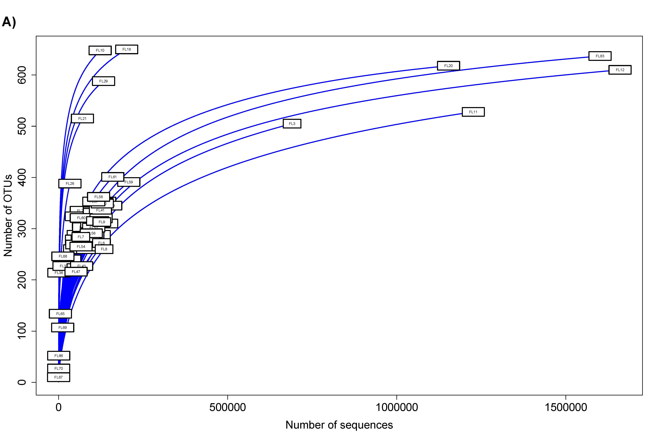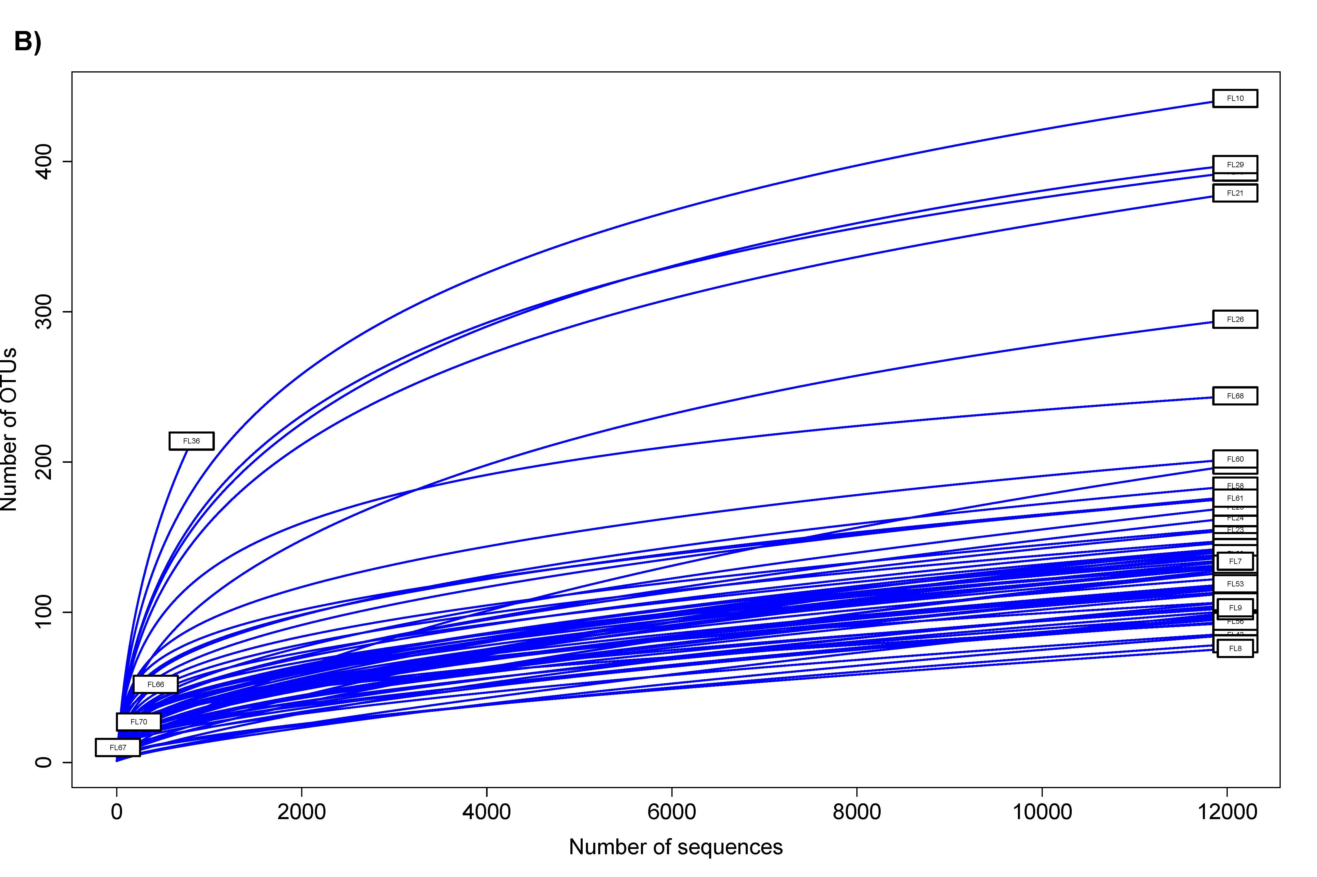
Figure S1 Rarefaction curves of (A) unrarefied matrix of zero-radius operational taxonomic units (zOTUs) and (B) rarefied zOTU matrix. Matrix was rarefied to 12,088 sequences per sample. Four samples did not amplify correctly and were removed from further analyses (N = 62).

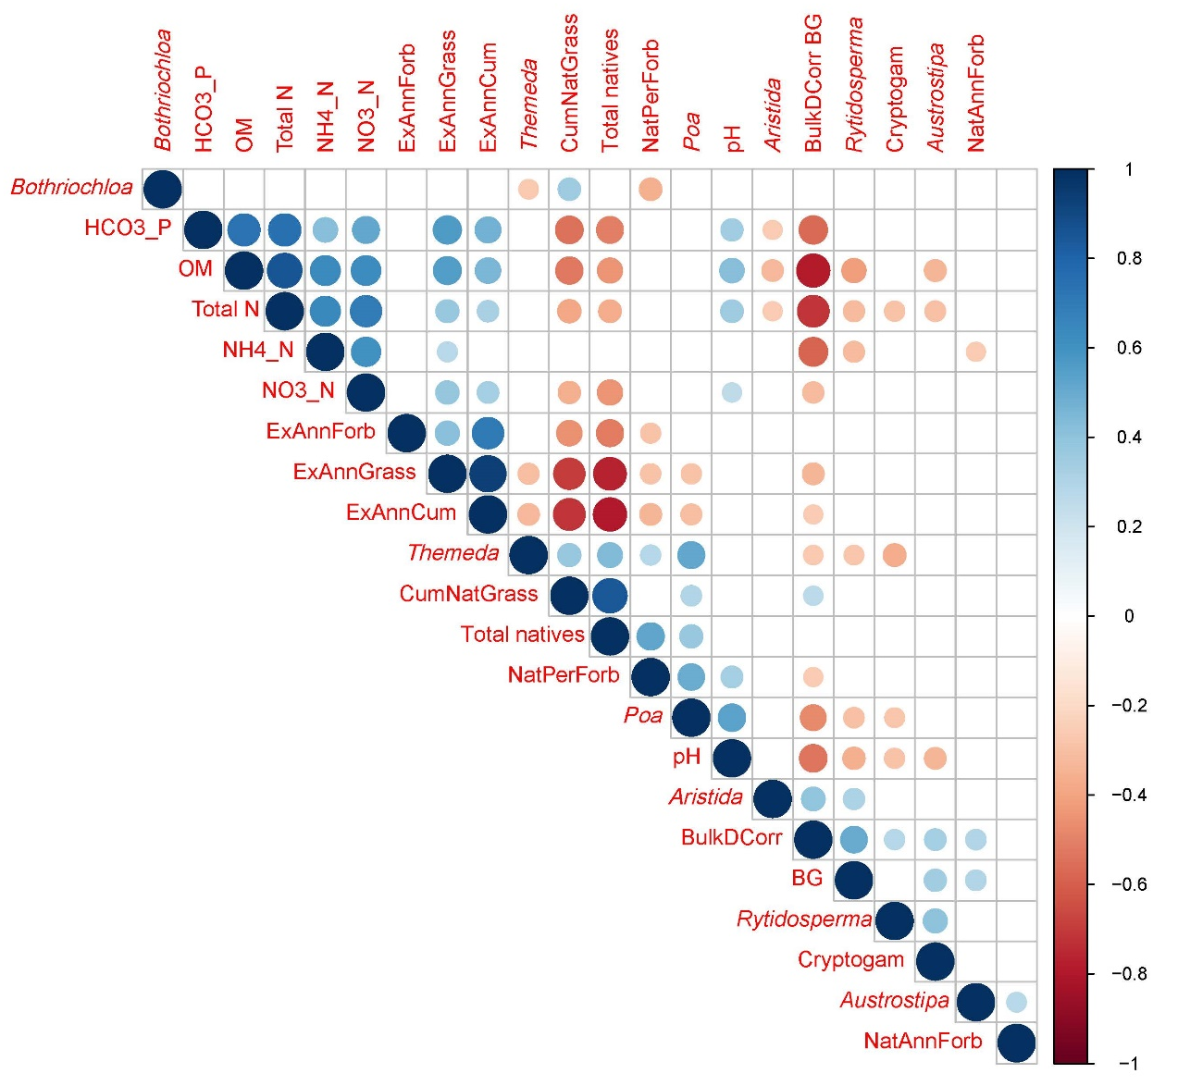
Figure S2. Correlation plot among vegetation and soil chemistry variables. Empty boxes represent non-significant correlations (P ≥ 0.05). Variables are: Bothriochloa cover, available phosphorus (HCO3_P), organic matter (OM), total nitrogen (N), ammonium-N (NH4_N), nitrate-N (NO3_N), exotic annual forbs (ExAnnForb), exotic annual grasses (ExAnnGrass), all exotic annuals (ExAnnCum), Themeda cover, native grasses (CumNatGrass), cover of all native plants (Total natives), native perennial forbs (NatPerForb), Poa cover, soil pH, Aristida cover, soil bulk density (BulkDCorr), bare ground (BG), Rytidosperma cover, cryptogams, Austrostipa cover, and native annual forbs (NatAnnForb).

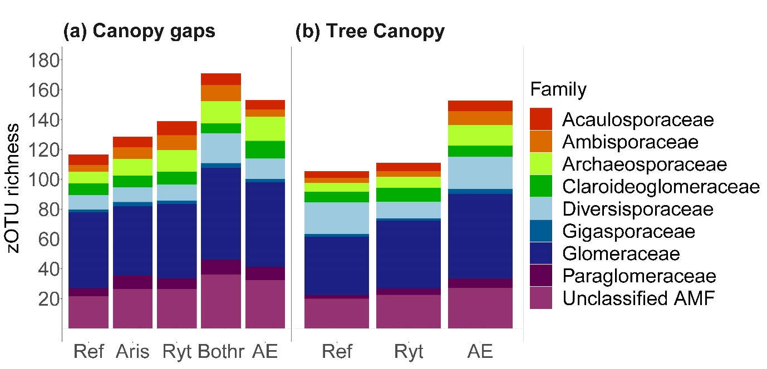Figure S3. Effects of Ground-layer states on zero-radius operational taxonomic units (zOTUs) richness of individual families of arbuscular mycorrhizal fungi from (a) samples from canopy gaps, and (b) under trees. The X axis is ordered by Ground-layer states: reference state (Ref), CN-depleted states (Aris = Aristida ramosa, Ryt = Rytidosperma spp. – Austrostipa scabra), intermediate state (Bothr = Bothriochloa macra), and CN-enriched state (AE = annual exotics).

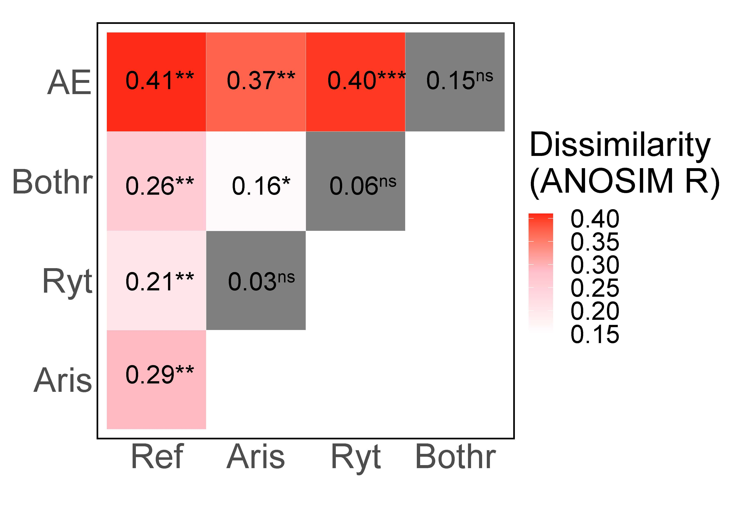
Figure S4. Post-hoc pairwise comparisons among Ground-layer states in canopy gaps by ANOSIM analysis. Ground-layer states are reference state (Ref), CN-depleted states (Aris = Aristida ramosa, Ryt = Rytidosperma spp. – Austrostipa scabra), intermediate state (Bothr = Bothriochloa macra), and CN-enriched state (AE = annual exotics). Asterix shows significant differences between pairs of groups (ns, > 0.05; *, P ≤ 0.05; **, P ≤ 0.01; ***, P ≤ 0.001).

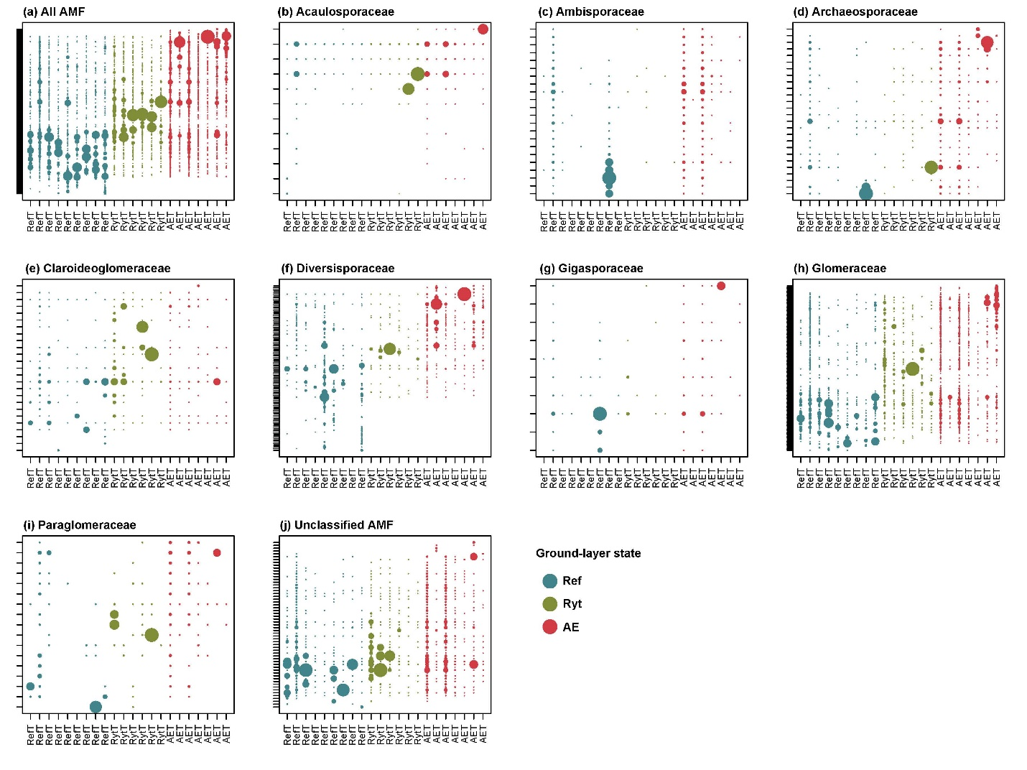Figure S5. Two-way table of arbuscular mycorrhizal fungi (AMF) from samples from under trees. Samples are coloured and ordered in the X axis by Ground-layer states: reference state (Ref), CN-depleted state (Ryt = Rytidosperma spp. – Austrostipa scabra), and CN-enriched state (AE = annual exotics). First panel (a) shows all AMF, while all other panels (b-j) show individual taxonomic families of AMF. Y-axis was compressed to show full dataset on each panel.

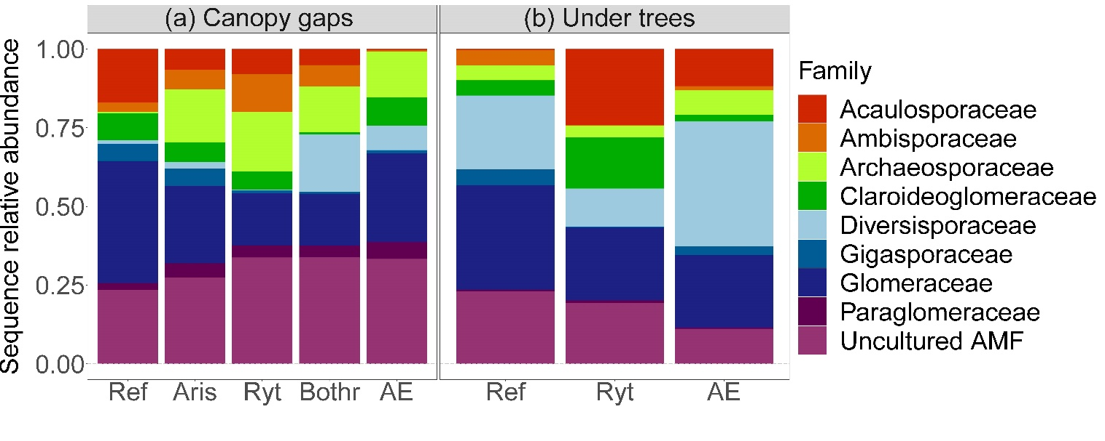
Figure S6. Effects of Ground-layer states on zero-radius operational taxonomic units (zOTUs) sequence relative abundance of individual families of arbuscular mycorrhizal fungi in canopy gaps (left panel), and under trees (right panel). The X axis is ordered by Ground-layer states: reference state (Ref), CN-depleted states (Aris = Aristida ramosa, Ryt = Rytidosperma spp. – Austrostipa scabra), intermediate state (Bothr = Bothriochloa macra), and CN-enriched state (AE = annual exotics).

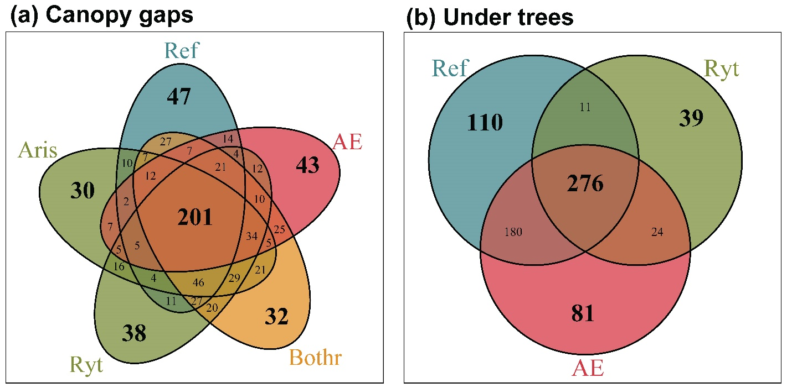
Figure S7. Observed number of unique zero-radius operational taxonomic units (zOTUs) among Ground-layer states in (a) canopy gaps and (b) under trees. Ground-layer states are reference state (Ref), CN-depleted states (Aris = Aristida ramosa, Ryt = Rytidosperma spp. – Austrostipa scabra), intermediate state (Bothr = Bothriochloa macra), and CN-enriched state (AE = annual exotics).

