Plant and Soil

IMPACT OF CLIMATE CHANGE ON PASTURE QUALITY IN MEDITERRANEAN DEHESAS SUBJECTED TO DIFFERENT GRAZING HISTORIES
Maria Dolores Hidalgo-Galvez^{a*}, Luis Matías^{b}, Jesús Cambrollé^{b}, Eduardo Gutiérrezª, Ignacio Manuel Pérez-Ramosª
ªInstitute of Natural Resources and Agrobiology of Sevilla (IRNAS-CSIC), 10 Reina Mercedes avenue, 41012 Seville, Spain.
^{b}Department of Plant Biology and Ecology, Faculty of Biology, University of Seville, 6 Reina Mercedes avenue, 41012 Seville, Spain.
*Corresponding author: mdhidalgogalvez@gmail.com

Supplementary information
Table S1 Factor coordinates of the variables that characterize soil fertility (organic matter, OM; pH; carbon, C; phosphorus, P; nitrate, NO₃⁻; ammonium, NH₄⁺; calcium, Ca²⁺; magnesium, Mg²⁺; potassium, K⁺)

 | Factor 1 | Factor 2
OM | -0.66 | 0.43
pH | -0.29 | -0.54
C | -0.74 | 0.07
P | -0.69 | 0.40
NO₃⁻ | -0.27 | 0.29
NH₄⁺ | -0.46 | 0.10
Ca²⁺ | -0.70 | -0.59
Mg²⁺ | -0.51 | -0.68
K⁺ | -0.83 | 0.22

Table S2 Differences in plant nutrients according to the habitat type. The mean (%) and standard deviation of the two sampling years (2017 and 2019) is shown. Superscript letters are the result of one-way ANOVA for plant nutrients and subsequent post-hoc Tukey analyses to compare the two habitat types

Plant nutrients | Under tree |  | Open grassland |  | p
Plant nutrients | Mean | ± SD | Mean | ± SD | p
Carbon | 43.66ª | 2.16 | 41.97^{b} | 3.36 | <0.001
Nitrogen | 1.36ª | 0.41 | 0.90^{b} | 0.33 | <0.001
Phosphorus | 0.14ª | 0.04 | 0.13^{b} | 0.04 | 0.002
Calcium | 0.65ª | 0.23 | 0.56^{b} | 0.24 | 0.004
Magnesium | 0.18ª | 0.04 | 0.15^{b} | 0.04 | <0.001
Potassium | 1.34ª | 0.38 | 1.02^{b} | 0.27 | <0.001

Table S3 Response of plant C, N, P, Ca²⁺ and Mg²⁺ to thermal and water stress. Results of the relationships in the two sampling years (2017 and 2019) are shown

Stress | Plant nutrients | p | R²
Thermal | Calcium | 0.17 | 0.02
Water | Carbon | 0.09 | 0.04
Water | Nitrogen | 0.08 | 0.05
Water | Phosphorus | 0.62 | -0.02
Water | Calcium | 0.66 | -0.02
Water | Magnesium | 0.10 | 0.04

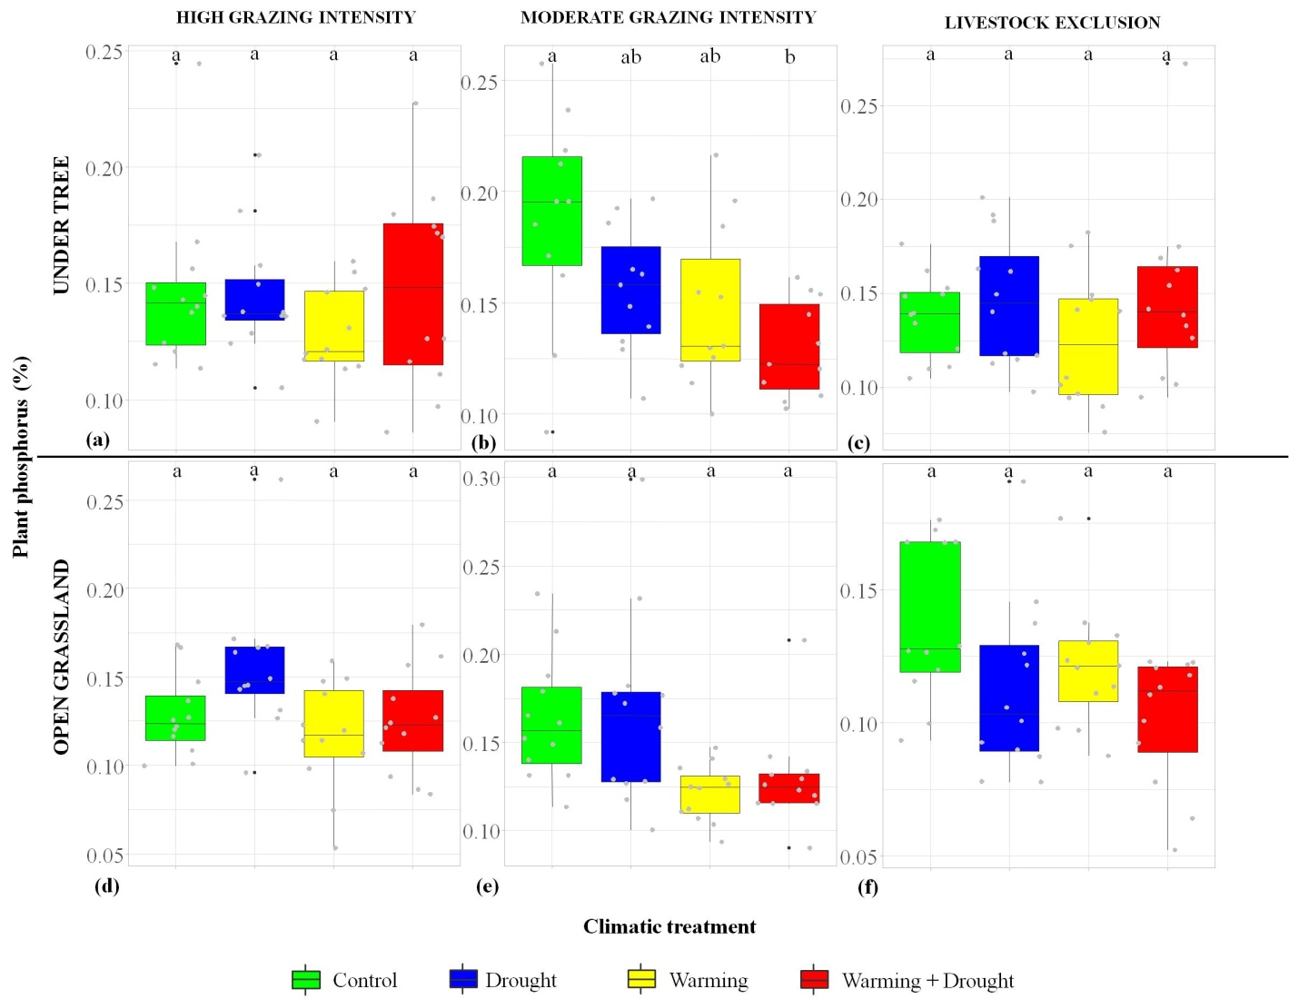
Fig. S1 Effects of climatic treatments on plant P (in %) according to management history [high grazing intensity (panels a and d), moderate grazing intensity (panels b and e) and livestock exclusion (panels c and f)] and habitat types [under tree (panels a-c) and open grassland (panels d-f)]. Two sampling years (2017 and 2019) are represented. Different letters denote significant differences between climatic treatments after a Tukey post-hoc test

