- Supplementary Materials

- Field inoculation by arbuscular mycorrhizal fungi with contrasting life-history strategies differently affects tomato nutrient uptake and residue decomposition dynamics
- Myriam Arcidiacono^{1,a}, Elisa Pellegrino^{1,*,a}, Marco Nuti¹, Laura Ercoli¹,
¹Crop Science Research Center, Scuola Superiore Sant'Anna, Pisa, Italy
*Corresponding author: Elisa Pellegrino elisa.pellegrino@santannapisa.it
ªThe authors contributed equally to this work

Table S1 Arbuscular mycorrhizal fungal (AMF) species and family, isolate codes, donor, geographical origin and original isolate supplier
AMF species | AMF family | CCS isolate codeª | Donor | INVAM isolate code^{b} | Geographic origin | Original isolate supplier
Gigaspora gigantea | Gigasporaceae | MFGS05 | Giusto Giovannetti | PA125 | Pennsylvania | INVAM, Morgantown, West Virginia
Scutellospora pellucida | Gigasporaceae | MFGS12 | Giusto Giovannetti | MN408A | Minnesota | INVAM, Morgantown, West Virginia
Funneliformis mosseae | Glomeraceae | - | Joseph B. Morton | MD118 | Maryland | INVAM, Morgantown, West Virginia
Sclerocystis sinuosa | Glomeraceae | MFGS06 | Giusto Giovannetti | MD126 | Maryland | INVAM, Morgantown, West Virginia
ªCCS: Centro Colture Sperimentali, Quart (Aosta, Italy)
^{b}INVAM: The International Collection of (Vesicular) Arbuscular Mycorrhizal Fungi

Table S2 P-values of linear orthogonal contrasts on arbuscules, vesicles and arbuscular mycorrhizal fungal (AMF) colonization, and total yield of plants of Solanum lycopersicum var. Pisanello inoculated with four AMF species: Gigaspora gigantea (G.giga) and Scutellospora pellucida (S.pellu) belonging to the family Gigasporaceae (Giga), and Funnelliformis mosseae (F.mos) and Sclerocystis sinuosa (S.sin) belonging to the family Glomeraceae (Glome). Sampling at BBCH 62 growth stage
 | Arbusculesª | Vesicles | AMF root colonization | Total yield plant⁻¹
-M vs +M ^{b} | 0.024 ^{c} | 0.024 | 0.005 | 0.037
Giga vs Glome | 0.517 | 0.237 | 0.438 | 0.964
G.giga vs S.pellu | 0.885 | 0.736 | 0.688 | 0.039
F.mos vs S.sin | 0.250 | 0.445 | 0.046 | 0.276
ª BBCH 62 - 2nd inflorescence with first flower open
^{b} -M, mock inoculation (control); +M, inoculation
^{c} In bold statistically significant values (P < 0.05), three replicate plots per treatment

Table S3 P-values of linear orthogonal contrasts on arbuscules, vesicles, arbuscular mycorrhizal fungal (AMF) colonization, shoot dry weight and total yield of plants of Solanum lycopersicum var. Rio Grande inoculated with four AMF species: Gigaspora gigantea (G.giga) and Scutellospora pellucida (S.pellu) belonging to the family Gigasporaceae (Giga), Funnelliformis mosseae (F.mos) and Sclerocystis sinuosa (S.sin) belonging to the family Glomeraceae (Glome). Sampling dates at BBCH 22, BBCH 62 and BBCH 89 growth stages
 | BBCH 22 ª |  |  |  |  | BBCH 62 |  |  |  | BBCH 89
 | Arbuscules | Vesicles | AMF root colonization | Shoot dry weight |  | Arbuscules | Vesicles | AMF root colonization |  | Arbuscules | Vesicles | AMF root colonization | Total yield plant⁻¹
-M vs +M ^{b} | <0.001 ^{c} | 0.422 | 0.007 | 0.006 |  | 0.019 | 0.469 | 0.012 |  | 0.828 | 0.006 | 0.116 | 0.050
Giga vs Glome | 0.005 | 1.000 | 0.510 | 0.216 |  | 1.000 | 0.643 | 0.605 |  | 0.176 | 0.007 | 0.369 | 0.979
G.giga vs S.pellu | 0.545 | 0.209 | 0.338 | 0.387 |  | 0.279 | 0.623 | 0.369 |  | 0.482 | 0.001 | 0.041 | 0.475
F.mos vs S.sin | 0.418 | 1.000 | 0.403 | 0.050 |  | 0.433 | 0.080 | 0.698 |  | 0.742 | 0.110 | 0.432 | 0.141
ª BBCH 22 - ^{2nd} primary apical side shoot visible; BBCH 62 - ^{2nd} inflorescence with first flower open; BBCH 89 - Fully ripe: all fruits have typical fully ripe color
^{b} -M, mock inoculation treatment (control); +M, inoculation
^{c} In bold statistically significant values (P < 0.05), three replicate plots per treatment

Table S4 P-values of linear orthogonal contrast on fruit concentration of nutrients of plants of Solanum lycopersicum var. Pisanello and var. Rio Grande inoculated with four arbuscular mycorrhizal fungal (AMF) species: Gigaspora gigantea (G.giga) and Scutellospora pellucida (S.pellu) belonging to the family Gigasporaceae (Giga), and Funnelliformis mosseae (F.mos) and Sclerocystis sinuosa (S.sin) belonging to the family Glomeraceae (Glome). Sampling dates in var. Pisanello: 22nd July 2019 (1st harvest) and 1st August 2019 (2nd harvest); in var. Rio Grande: 10th August 2020
 | [P] ª | [N] | [K] | [Ca] | [Mg] | [Zn] | [Fe] | [Cu] | [Mn]
 | var. Pisanello ª
 | 1st harvest
-M vs +M ^{b} | 0.147 ^{c} | 0.024 | 0.323 | 0.555 | 0.389 | 0.015 | 0.407 | 0.873 | 0.293
Giga vs Glome | 0.229 | 0.640 | 0.905 | 0.139 | 0.096 | 0.398 | 0.171 | 0.213 | 0.650
G.giga vs S.pellu | 0.097 | 0.791 | 0.309 | 0.157 | 0.095 | 0.401 | 0.740 | 0.025 | 0.461
F.mos vs S.sin | 0.176 | 0.014 | 0.168 | 0.200 | 0.833 | 0.759 | 0.760 | 0.056 | 0.280
 | 2nd harvest
-M vs +M | 0.011 | 0.086 | 0.639 | 0.003 | 0.022 | 0.749 | 0.333 | 0.038 | 0.005
Giga vs Glome | 0.222 | 0.774 | 0.109 | 0.440 | 0.012 | 0.058 | 0.864 | 0.080 | 0.019
G.giga vs S.pellu | 0.682 | 0.069 | 0.277 | 0.329 | 0.524 | 0.494 | 0.884 | 0.777 | 0.686
F.mos vs S.sin | 0.094 | 0.714 | 0.022 | 0.685 | 0.011 | 0.485 | 0.546 | 0.118 | 0.045
 | var. Rio Grande
-M vs +M | 0.016 | 0.754 | 0.048 | 0.684 | 0.328 | 0.003 | 0.044 | <0.001 | 0.002
Giga vs Glome | 0.150 | 0.001 | <0.001 | 0.029 | 0.097 | 0.014 | 0.453 | <0.001 | 0.038
G.giga vs S.pellu | 0.222 | 0.402 | 0.420 | 0.410 | 0.237 | 0.914 | 0.274 | 0.809 | 0.252
F.mos vs S.sin | 0.550 | 0.973 | 0.003 | 0.524 | 0.915 | 0.007 | 0.430 | 0.952 | 0.159
ª BBCH 89 - Fully ripe: all fruits have typical fully ripe color
^{b} -M, mock inoculation (control); +M, inoculation
^{c} In bold statistically significant values (P < 0.05), three replicate plots per treatment

Table S5 P-values of linear orthogonal contrast on fruit content of nutrients of plants of Solanum lycopersicum var. Pisanello inoculated with four arbuscular mycorrhizal fungal (AMF) species: Gigaspora gigantea (G.giga) and Scutellospora pellucida (S.pellu) belonging to the family Gigasporaceae (Giga), and Sclerocystis sinuosa (S.sin) and Funnelliformis mosseae (F.mos) belonging to the family Glomeraceae (Glome). Sampling dates: 22nd July 2019 (1st harvest) and 1st August (2nd harvest)
 | P ª | N | K | Ca |  | Mg | Zn | Fe | Cu | Mn
 | 1st harvest ª
-M vs +M ^{b} | 0.080 ^{c} | 0.080 | 0.130 |  | <0.001 | 0.146 | 0.298 | 0.272 | 0.116 | 0.205
Giga vs Glome | 0.056 | 0.133 | 0.035 |  | 0.029 | 0.336 | 0.150 | 0.357 | 0.169 | 0.494
G.giga vs S.pellu | 0.015 | 0.015 | 0.001 |  | <0.001 | 0.030 | 0.021 | 0.022 | 0.012 | 0.097
F.mos vs S.sin | 0.010 | 0.008 | 0.005 |  | <0.001 | 0.017 | 0.008 | 0.001 | <0.001 | 0.007
 | 2nd harvest
-M vs +M | 0.318 | 0.287 | 0.992 |  | 0.031 | 0.346 | 0.727 | 0.745 | 0.536 | 0.258
Giga vs Glome | 0.059 | 0.069 | 0.021 |  | 0.538 | 0.018 | 0.046 | 0.818 | 0.058 | 0.019
G.giga vs S.pellu | 0.082 | 0.248 | 0.311 |  | 0.360 | 0.575 | 0.879 | 0.882 | 0.640 | 0.403
F.mos vs S.sin | 0.207 | 0.904 | 0.576 |  | 0.757 | 0.342 | 0.818 | 0.359 | 0.471 | 0.190
ª BBCH 89 - Fully ripe: all fruits have typical fully ripe color
^{b} -M, mock-inoculated treatment (control); +M, inoculation treatment
^{c} In bold statistically significant values (P < 0.05), three replicate plots per treatment

Table S6 Nutrient content in fruits of Solanum lycopersicum var. Pisanello inoculated with four arbuscular mycorrhizal fungal (AMF) species: Gigaspora gigantea MGFS05 (G.giga) and Scutellospora pellucida MGFS12 (S.pellu) belonging to the family Gigasporaceae (Giga), and Sclerocystis sinuosa MFGS06 (S.sin) and Funnelliformis mosseae MD118 (F.mos) belonging to the family Glomeraceae (Glome). Sampling dates: 22nd July 2019 (1st harvest) and 1st August (2nd harvest)
 | P ª | N | K |  | Ca | Mg |  | Zn | Fe | Cu | Mn
 | % |  |  |  | g kg⁻¹ |  |  | mg kg⁻¹
 | 1st harvest
-M ^{b} | 0.09 ± 0.03 ^{c} | 0.47 ± 0.14 | 1.22 ± 0.35 |  | 0.07 ± 0.02 | 0.05 ± 0.01 |  | 0.65 ± 0.20 | 1.05 ± 0.37 | 0.27 ± 0.08 | 0.33 ± 0.11
G.giga | 0.09 ± 0.01 | 0.45 ± 0.01 | 1.00 ± 0.07 |  | 0.06 ± 0.01 | 0.03 ± 0.00 |  | 0.46 ± 0.19 | 0.80 ± 0.01 | 0.19 ± 0.00 | 0.22 ± 0.01
S.pellu | 0.31 ± 0.03 | 1.52 ± 0.14 | 3.57 ± 0.06 |  | 0.23 ± 0.01 | 0.13 ± 0.02 |  | 1.57 ± 0.17 | 2.56 ± 0.27 | 0.81 ± 0.07 | 0.94 ± 0.24
F.mos | 0.24 ± 0.02 | 1.36 ± 0.11 | 3.03 ± 0.22 |  | 0.20 ± 0.01 | 0.11 ± 0.01 |  | 1.33 ± 0.10 | 2.47 ± 0.08 | 0.72 ± 0.02 | 0.80 ± 0.06
S.sin | 0.06 ± 0.01 | 0.28 ± 0.03 | 0.67 ± 0.08 |  | 0.05 ± 0.00 | 0.03 ± 0.00 |  | 0.34 ± 0.02 | 0.57 ± 0.02 | 0.15 ± 0.01 | 0.17 ± 0.01
 | 2nd harvest
-M | 0.18 ± 0.02 | 1.66 ± 0.04 | 3.89 ± 0.20 |  | 0.23 ± 0.02 | 0.12 ± 0.01 |  | 1.90 ± 0.14 | 3.35 ± 0.28 | 0.82 ± 0.07 | 0.88 ± 0.95
G.giga | 0.24 ± 0.04 | 1.54 ± 0.19 | 4.11 ± 0.63 |  | 0.15 ± 0.01 | 0.15 ± 0.02 |  | 2.06 ± 0.29 | 3.58 ± 0.50 | 0.96 ± 0.15 | 1.10 ± 0.14
S.pellu | 0.24 ± 0.03 | 1.72 ± 0.01 | 4.64 ± 0.20 |  | 0.19 ± 0.03 | 0.16 ± 0.01 |  | 2.02 ± 0.17 | 3.71 ± 0.27 | 1.02 ± 0.06 | 1.24 ± 0.12
F.mos | 0.21 ± 0.01 | 1.41 ± 0.06 | 3.55 ± 0.10 |  | 0.16 ± 0.01 | 0.13 ± 0.01 |  | 1.58 ± 0.13 | 3.09 ± 0.40 | 0.84 ± 0.10 | 0.98 ± 0.11
S.sin | 0.16 ± 0.02 | 1.43 ± 0.10 | 3.26 ± 0.38 |  | 0.15 ± 0.01 | 0.11 ± 0.01 |  | 1.64 ± 0.18 | 3.91 ± 1.12 | 0.74 ± 0.06 | 0.77 ± 0.56
ª BBCH 89 - Fully ripe: all fruits have typical fully ripe color
^{b} -M, mock-inoculated treatment (control)
^{c} Mean and SE of three replicate plots per treatment

Table S7 P-values of linear orthogonal contrast on fruit content of nutrients of plants of Solanum lycopersicum var. Rio Grande inoculated with four arbuscular mycorrhizal fungal (AMF) species: Gigaspora gigantea (G.giga) and Scutellospora pellucida (S pellu) belonging to the family Gigasporaceae (Giga), Funnelliformis mosseae (F.mos) and Sclerocystis sinuosa (S.sin) belonging to the family Glomeraceae (Glome). Sampling date: 10th August 2020
 | P ª | N | K | Ca | Mg | Zn | Fe | Cu | Mn
-M vs +M ^{b} | 0.820 ^{c} | 0.691 | 0.778 | 0.993 | 0.831 | 0.333 | 0.444 | 0.364 | 0.448
Giga vs Glome | 0.958 | 0.109 | 0.387 | 0.024 ^{c} | 0.138 | 0.623 | 0.555 | 0.063 | 0.644
G.giga vs S.pellu | 0.307 | 0,589 | 0.200 | 0.137 | 0.970 | 0.188 | 0.703 | 0.345 | 0.511
F.mos vs S.sin | 0.488 | 0.642 | 0.288 | 0.704 | 0.746 | 0.626 | 0.750 | 0.744 | 0.522
ª BBCH 89 - Fully ripe: all fruits have typical fully ripe color
^{b} -M, mock-inoculated treatment (control); +M, inoculation treatment
^{c} In bold statistically significant values (P < 0.05), three replicate plots per treatment

Table S8 Nutrient content in fruits of Solanum lycopersicum var. Rio Grande inoculated with four arbuscular mycorrhizal fungal (AMF) species: Gigaspora gigantea MGFS05 (G.giga) and Scutellospora pellucida MGFS12 (S.pellu) belonging to the family Gigasporaceae (Giga), Funnelliformis mosseae MD118 (F.mos) and Sclerocystis sinuosa MFGS06 (S.sin) belonging to the family Glomeraceae (Glome). Sampling date: 10th August 2020
 | P ª | N | K |  | Ca | Mg |  | Zn | Fe Cu |  |  | Mn
 | % |  |  |  | g kg⁻¹ |  |  | mg kg⁻¹
-M ^{b} | 0.14 ± 0.02 ^{c} | 0.96 ± 0.20 | 2.02 ± 0.12 |  | 0.09 ± 0.02 | 0.08 ± 0.01 |  | 0.90 ± 0.06 | 1.53 ± 0.34 | 0.31 ± 0.03 |  | 0.32 ± 0.02
G.giga | 0.15 ± 0.02 | 1.06 ± 0.19 | 2.25 ± 0.33 |  | 0.06 ± 0.02 | 0.07 ± 0.01 |  | 0.97 ± 0.15 | 1.66 ± 0.25 | 0.44 ± 0.07 |  | 0.41 ± 0.07
S.pellu | 0.14 ± 0.02 | 0.97 ± 0.11 | 1.85 ± 0.32 |  | 0.07 ± 0.01 | 0.07 ± 0.01 |  | 1.15 ± 0.28 | 1.83 ± 0.54 | 0.41 ± 0.08 |  | 0.36 ± 0.09
F.mos | 0.13 ± 0.02 | 0.71 ± 0.11 | 1.58 ± 0.27 |  | 0.09 ± 0.02 | 0.09 ± 0.02 |  | 0.85 ± 0.12 | 1.86 ± 0.28 | 0.28 ± 0.03 |  | 0.33 ± 0.05
S.sin | 0.16 ± 0.02 | 0.82 ± 0.06 | 2.07 ± 0.15 |  | 0.13 ± 0.02 | 0.09 ± 0.00 |  | 1.08 ± 0.06 | 2.06 ± 0.34 | 0.35 ± 0.03 |  | 0.39 ± 0.04
ª BBCH 89 - Fully ripe: all fruits have typical fully ripe color
^{b} -M, mock inoculation (control)
^{c} Mean and SE of three replicate plots per treatment

Table S9 Results of PERMANOVA and variation partitioning of the effect of arbuscular mycorrhizal fungal (AMF) inoculation (Inoc) [Gigaspora gigantea (G.giga) and Scutellospora pellucida (S.pellu) belonging to the family Gigasporaceae, and Funnelliformis mosseae (F.mos) and Sclerocystis sinuosa (S.sin) belonging to the family Glomeraceae] on total yield and fruit concentration of nutrients, and on AMF root traits (arbuscules, vesicles, AMF root colonization) of Solanum lycopersicum L. var. Pisanello and var. Rio Grande. Analysis of homogeneity of multivariate dispersion (PERMDISP) of Inoc.
 | df | Pseudo-F | P (perm) | Variance explained (%) |  |  | df | Pseudo-F | P (perm) | Variance explained (%)
var. Pisanello ª |  |  |  |  |  | var. Rio Grande
Inoc ^{b} | 4 | 2.3 | 0.001 ^{c} | 30.2 |  | Inoc | 4 | 2.9 | 0.001 | 39.0
PERMDISP Inoc |  |  | 0.268 |  |  | PERMDISP Inoc |  |  | 0.684
Pair-wise tests |  |  | P(MC) ^{d} |  |  | Pair-wise tests |  |  | P(MC)
F.mos, S.pellu |  |  | 0.666 |  |  | F.mos, S.pellu |  |  | 0.169
F.mos, G.giga |  |  | 0.115 |  |  | F.mos, G.giga |  |  | 0.046
F.mos, S.sin |  |  | 0.102 |  |  | F.mos, S.sin |  |  | 0.265
F.mos, -M |  |  | 0.036 |  |  | F.mos, -M |  |  | 0.045
S.pellu, G.giga |  |  | 0.292 |  |  | S.pellu, G.giga |  |  | 0.355
S. pellu, S. sin |  |  | 0.177 |  |  | S.pellu, S.sin |  |  | 0.118
S.pellu, -M |  |  | 0.073 |  |  | S.pellu, -M |  |  | 0.017
G. giga, S. sin |  |  | 0.114 |  |  | G.giga, S.sin |  |  | 0.047
G.giga, -M |  |  | 0.033 |  |  | G.giga, -M |  |  | 0.022
S.sin, -M |  |  | 0.083 |  |  | S.sin, -M |  |  | 0.180
ª Response data were fourth-root transformed and normalized, and the resemblance matrix was calculated using the Euclidean distance between samples
^{b} PERMANOVA was performed following a completely randomized design with AMF inoculation (Inoc) as fixed factor and with three replicate plots per treatment
^{c} In bold statistically significant values (P ≤ 0.05)
^{d} Pair-wise comparisons among levels of the factor Inoc and significance obtained by Monte Carlo permutations [Monte Carlo P-values, P(MC)]

Table S10 P-values of linear orthogonal contrast on the abundance of bacteria and fungi and on the fungal:bacterial ratio (F:B) in soil of Solanum lycopersicum var. Pisanello and var. Rio Grande inoculated with four arbuscular mycorrhizal fungal (AMF) species: Gigaspora gigantea (G.giga) and Scutellospora pellucida (S.pellu) belonging to the family Gigasporaceae (Giga), and Funnelliformis mosseae (F.mos) and Sclerocystis sinuosa (S.sin) belonging to the family Glomeraceae (Glome). Sampling dates at BBCH 89 (Meier et al., 2001): var. Pisanello 30st August 2019; var. Rio Grande 27th August 2020.
 |  | var. Pisanello ª |  |  |  | var. Rio Grande
 | Bacteria ^{b} |  | Fungi ^{c} | F:B |  | Bacteria | Fungi | F:B
-M vs +M ^{d} | <0.001 ^{e} |  | <0.001 | <0.001 |  | 0.024 | <0.001 | <0.001
Giga vs Glome | 0.268 |  | 0.021 | 0.037 |  | 0.003 | <0.001 | 0.015
G.giga vs S.pellu | 0.337 |  | 0.338 | 0.921 |  | 0.269 | 0.534 | 0.009
F.mos vs S.sin | 0.117 |  | 0.480 | 0.998 |  | 0.212 | 0.084 | 0.670
ª BBCH 89 - Fully ripe: all fruits have typical fully ripe color
^{b} Abundance of soil bacteria based on qPCR analysis using the 16 rRNA gene region as bacterial target and expressed as gene copies g⁻¹ dry soil. DNA was extracted in triplicate for each soil sample and then pooled; three technical qPCR replicates were run per sample
^{c} Abundance of soil fungi based on qPCR analysis using the ITS1 region as fungal target and expressed as gene copies g⁻¹ dry soil
^{d} -M, mock inoculation (control); +M, inoculation
^{e} In bold statistically significant values (P < 0.05), three replicate plots per treatment.

Table S11 Abundance of bacteria and fungi and fungal:bacterial ratio (F:B) in soil of Solanum lycopersicum var. Pisanello and var. Rio Grande inoculated with four arbuscular mycorrhizal fungal (AMF) species: Gigaspora gigantea (G.giga) and Scutellospora pellucida (S.pellu) belonging to the family Gigasporaceae (Giga), and Funnelliformis mosseae (F.mos) and Sclerocystis sinuosa (S.sin) belonging to the family Glomeraceae (Glome). Sampling dates at BBCH 89: var. Pisanello 30th August 2019; in var. Rio Grande 27th August 2020
 | var. Pisanello ª |  |  |  | var. Rio Grande
 | Bacteria ^{b} | Fungi ^{c} | F:B |  | Bacteria ^{b} | Fungi ^{c} | F:B
 | RNA gene copies g⁻¹ dry soil |  |  |  | ITS1 gene copies g⁻¹ dry soil
-M ^{d} | 3.82∙10¹⁰± 2.8∙10^{9 e} | 1.49∙10¹⁰± 6.4∙10⁹ | 0.37 ± 0.16 |  | 1.05∙10¹¹± 3.7∙10¹⁰ | 4.15∙10¹⁰± 5.2∙10⁹ | 0.504 ± 0.01
G.giga | 1.44∙10¹¹± 1.2∙10¹⁰ | 1.97∙10¹¹± 2.3∙10¹⁰ | 1.39 ± 0.08 |  | 1.99∙10¹¹± 2.2∙10¹⁰ | 2.60∙10¹¹± 2.8∙10¹⁰ | 1.330 ± 0.01
S.pellu | 1.84∙10¹¹± 3.2∙10¹⁰ | 2.42∙10¹¹± 3.0∙10¹⁰ | 1.37 ± 0.08 |  | 2.37∙10¹¹± 2.2∙10¹⁰ | 2.79∙10¹¹± 3.0∙10¹⁰ | 1.180 ± 0.02
F.mos | 1.53∙10¹¹± 1.0∙10¹⁰ | 1.60∙10¹¹± 2.0∙10¹⁰ | 1.11 ± 0.08 |  | 1.51∙10¹¹± 1.3∙10¹⁰ | 1.76∙10¹¹± 1.4∙10¹⁰ | 1.130 ± 0.02
S.sin | 1.26∙10¹¹± 8.4∙10⁹ | 1.44∙10¹¹± 1.1∙10¹⁰ | 1.17 ± 0.01 |  | 1.08∙10¹¹± 1.1∙10¹⁰ | 1.19∙10¹¹± 1.7∙10¹⁰ | 1.110 ± 0.05
ª BBCH 89 - Fully ripe: all fruits have typical fully ripe color
^{b} Abundance of soil bacteria based on qPCR analysis using the 16 rRNA gene region as bacterial target and expressed as gene copies g⁻¹ dry soil. DNA was extracted in triplicate per each soil sample and then pooled; three technical qPCR replicates were run per sample
^{c} Abundance of soil fungi based on qPCR analysis using the ITS1 region as fungal target and expressed as gene copies g⁻¹ dry soil
^{d} -M, mock inoculation (control)
^{e} Mean and SE of three replicate plots per treatment

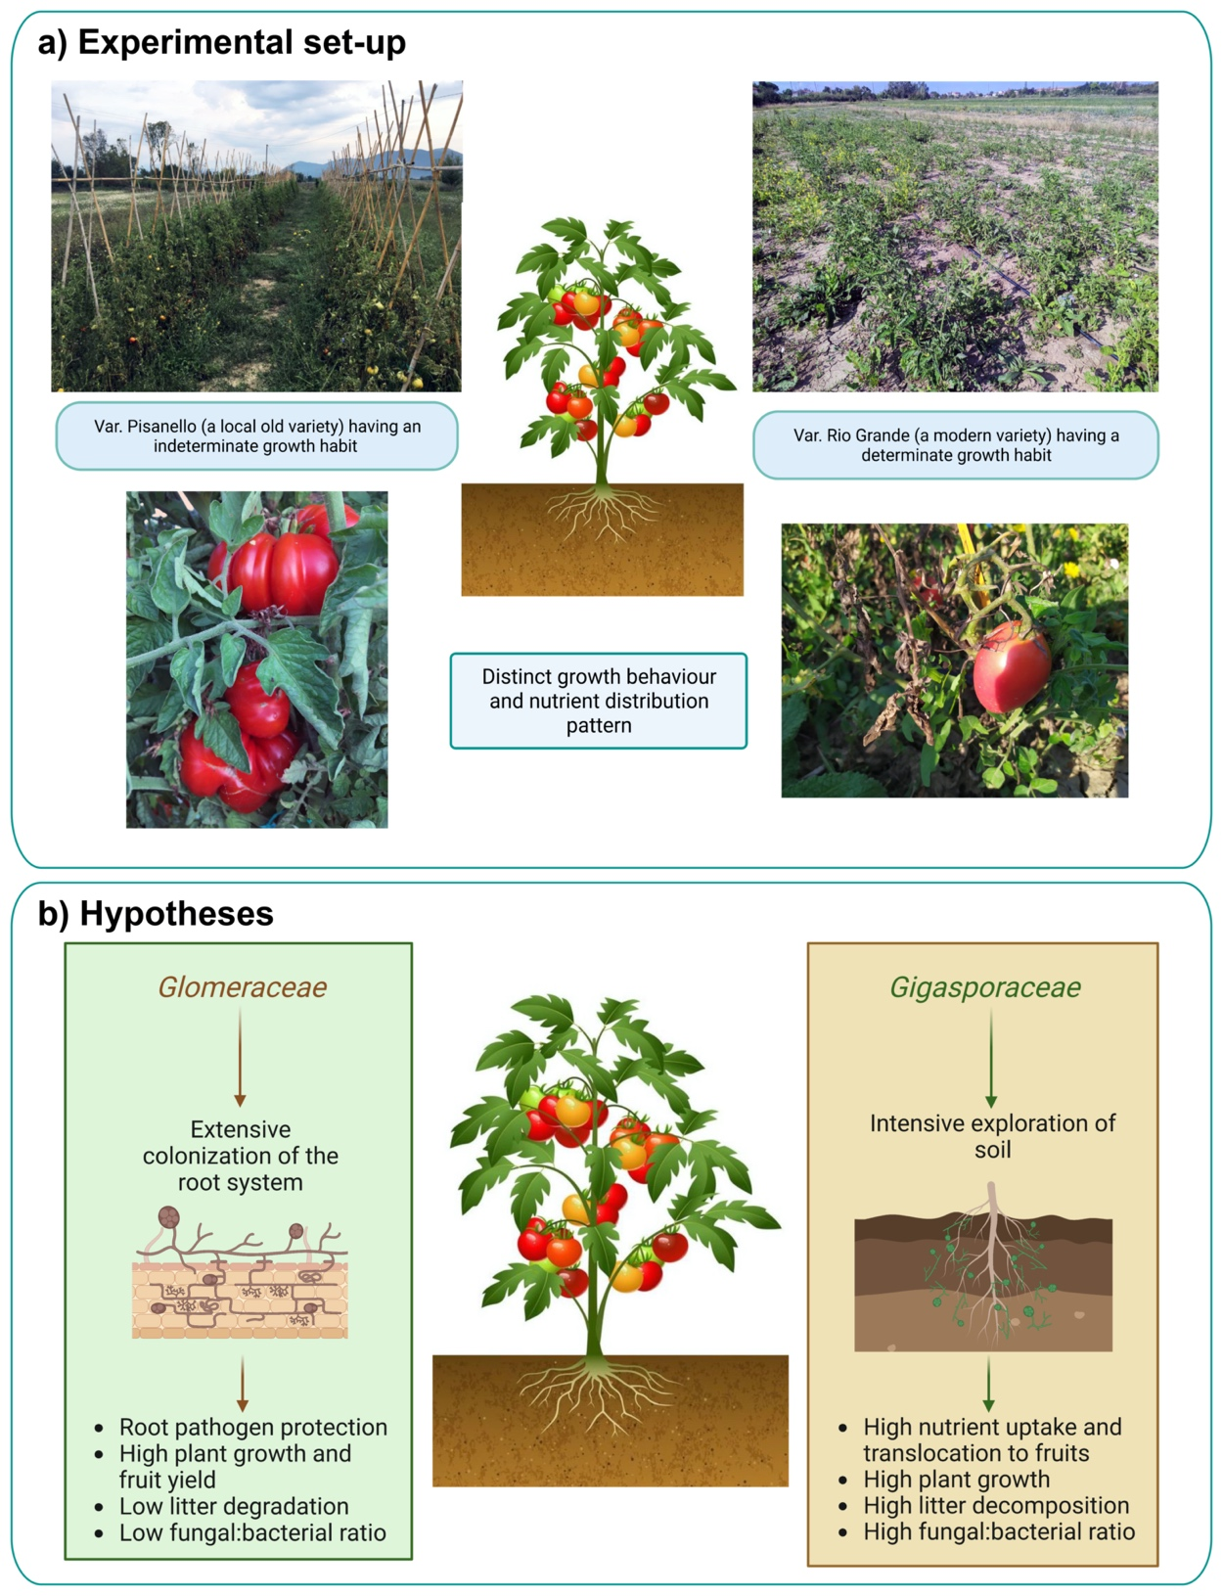

Fig. S1 Graphical scheme of Solanum lycopersicum varieties used in the experiments of arbuscular mycorrhizal fungal (AMF) inoculation (a); research hypotheses for Gigasporaceae (Gigaspora gigantea and Scutellospora pellucida) and Glomeraceae (Funnelliformis mosseae and Sclerocystis sinuosa) (b).

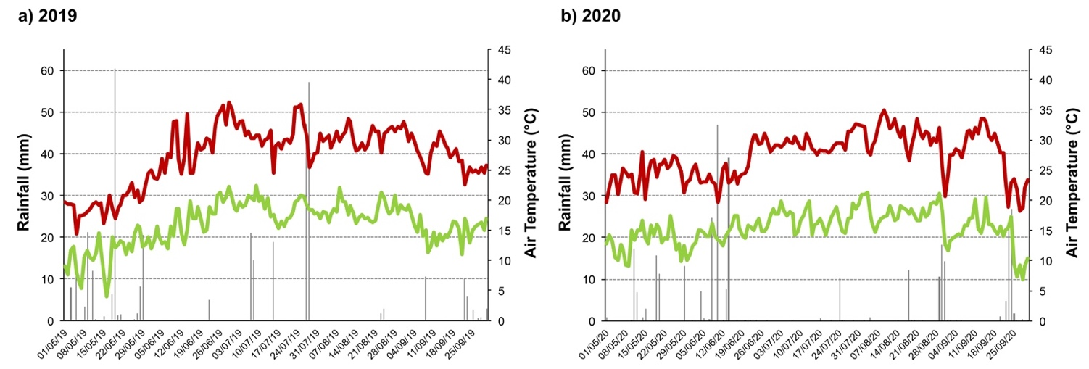
Fig. S2 Daily rainfall data and air maximum and minimum temperature during the growth cycle of tomato (Solanum lycopersicum L.) in 2019 (a) and 2020 (b) at the experimental site in the organic farm “Fattoria Le prata”, Pisa, Italy. The rainfall gauge is located in Metato, San Giuliano Terme, Pisa (E 16° 11’40’’ N48° 47’ 38’’).

(a) | 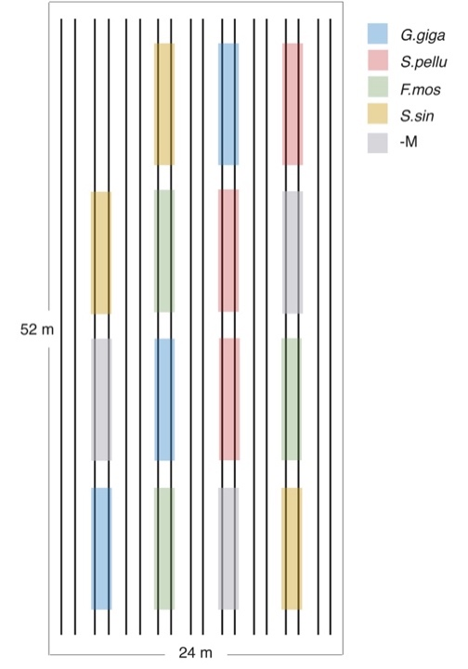 | (b) | 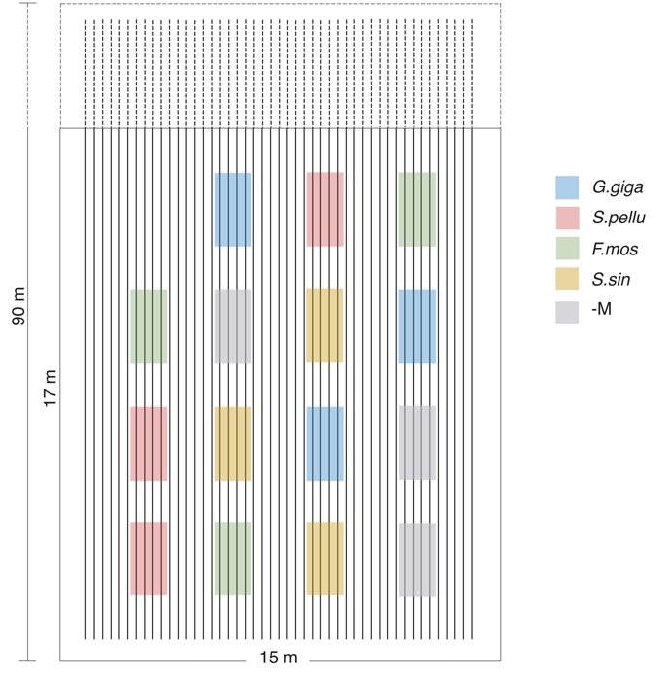

Fig. S3 Schematic overview of the completely randomized design of 2019: Solanum lycopersicum L. var. Pisanello (a). Treatments were: mock inoculation (control, -M) and inoculation with single AMF species: Gigaspora gigantea (G.giga) and Scutellospora pellucida (S.pellu) belonging to the family Gigasporaceae; Funnelliformis mosseae (i) and Sclerocystis sinuosa (S.sin) belonging to the family Glomeraceae Schematic overview of the completely randomized design of 2020: Solanum lycopersicum L. var. Rio Grande (b). The layouts are drawn to scale within each field.

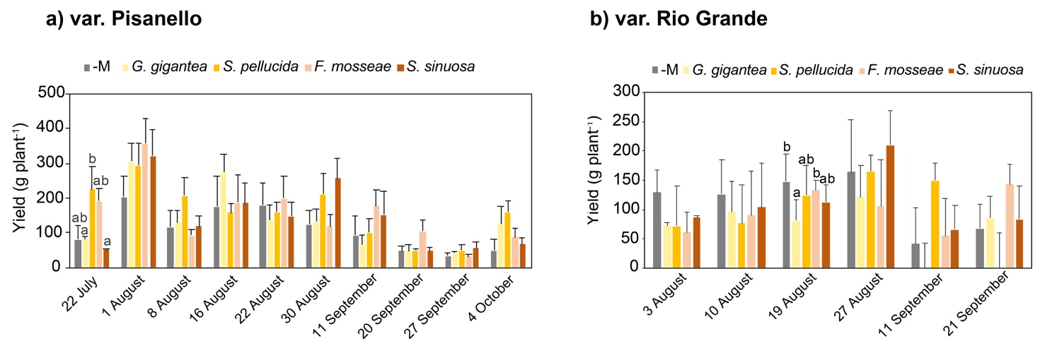

Fig. S4 Yield (fruit fresh weight per plant) of Solanum lycopersicum L. var. Pisanello mock-inoculation (control, -M) and inoculation with single AMF species: Gigaspora gigantea and Scutellospora pellucida belonging to the family Gigasporaceae; Funnelliformis mosseae and Sclerocystis sinuosa belonging to the family Glomeraceae. For the var. Pisanello the experiment was carried out in 2019, while for the var. Rio Grande the experiment was carried out in 2020. For each harvest, values followed by different letters are significantly different among treatments, according to one-way ANOVAs (P < 0.05), while values without letters did not show any significant differences.

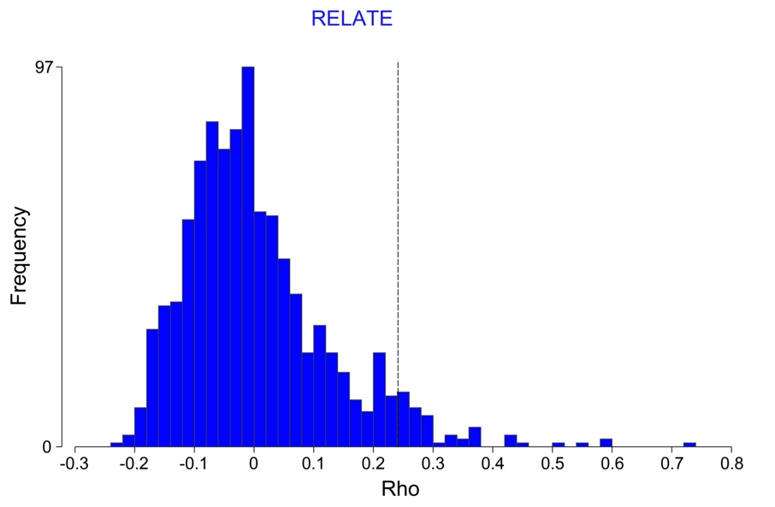

Fig. S5 RELATE analysis based on Spearman rank and 999 permutations for testing the significance of the relationship between the two matrices: the matrix of percentages of remaining mass of litter bags at the four sampling times and the matrix of soil fungal and bacterial abundances (ρ = 1 perfect relationship) (Clarke and Warwick 2001). The analysis was carried out using PRIMER 7 and PERMANOVA + software (Anderson et al. 2008; Clarke and Gorley 2015).

References
Anderson MJ, Gorley RN, Clarke RK (2008) Permanova+ for Primer: guide to Software and Statistical Methods. Plymouth: PRIMER-E
Clarke KR, Gorley RN (2015) Getting Started with PRIMER v7. Plymouth: PRIMER-E
Clarke KR, Warwick R (2001) Change in marine communities: an approach to statistical analysis and interpretation. Plymouth: PRIMER-E

