Precipitation data of field trial locations
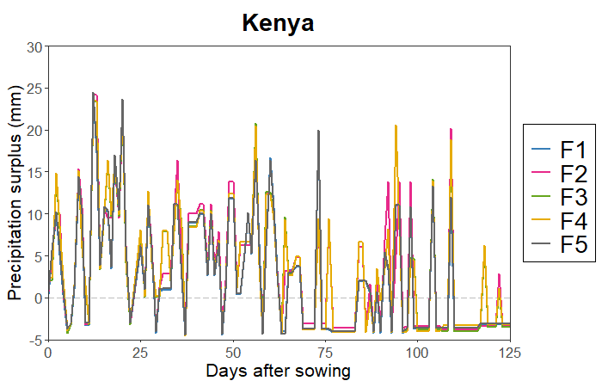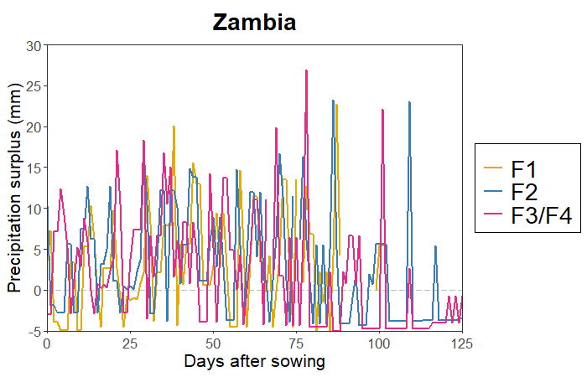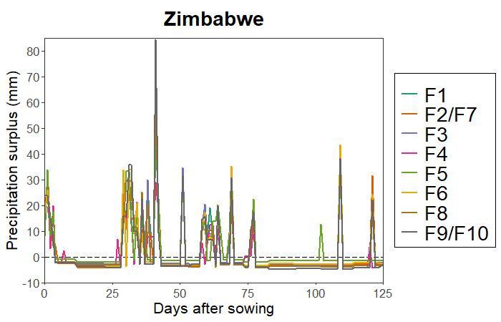
Figure S1: Precipitation surplus or deficit shown for the different farm locations (F1-F10) in Kenya, Zambia and Zimbabwe. The precipitation surplus or deficit was calculated as the difference between the daily precipitation and the average dekadal actual evapotranspiration that were extracted from the WaPOR portal (Food and agriculture organization of the united Nations, 2020).

Correlation Table
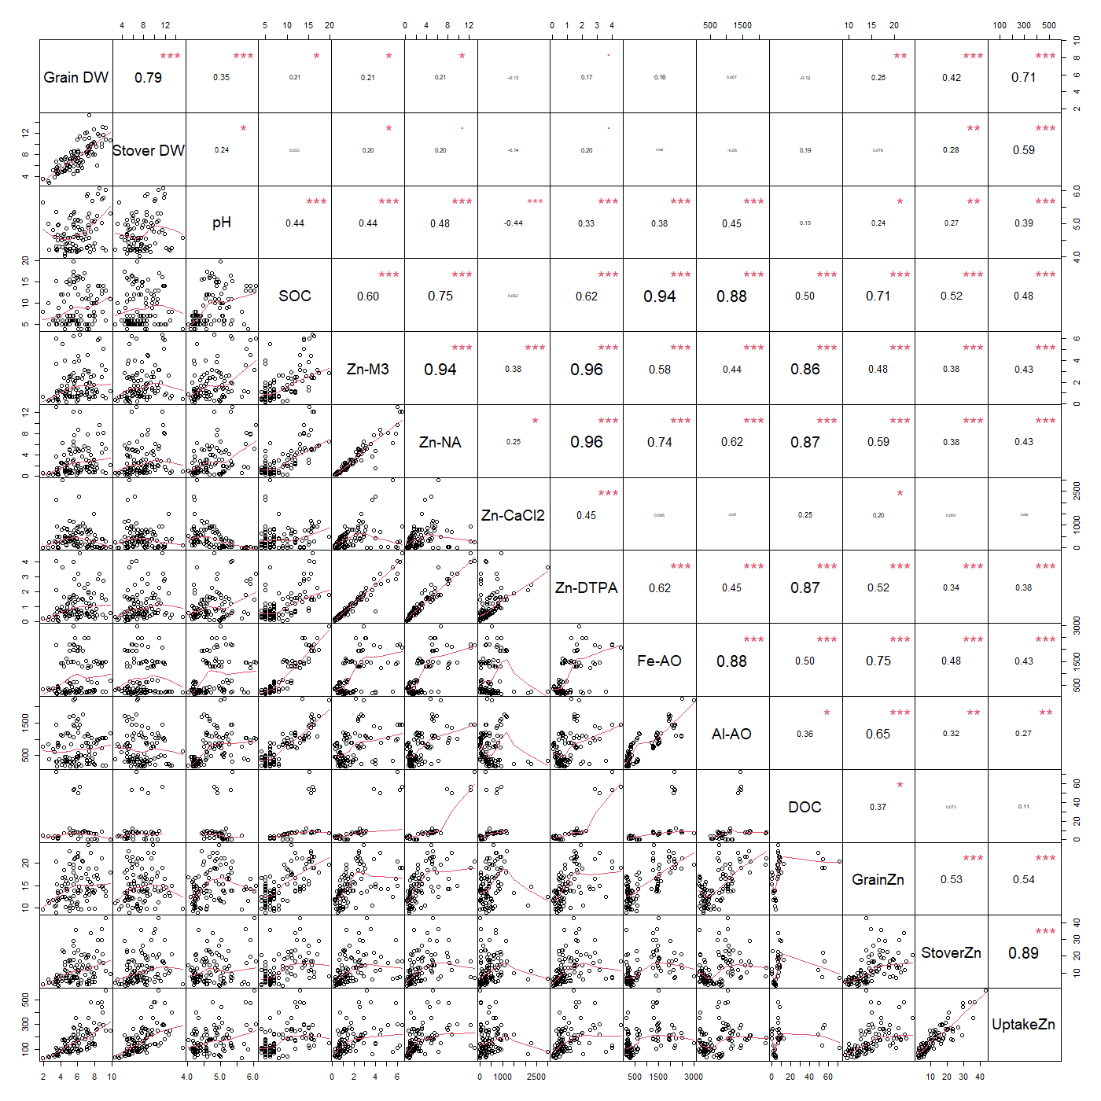
Figure S2: Correlation table of soil and maize variables for the plots receiving no Zn fertilizer. The numbers refer to the pearson correlation coefficients, and the asterisks show the level of significance (*: p < 0.05, **: p < 0.01, ***: p < 0.001).

Response in biomass

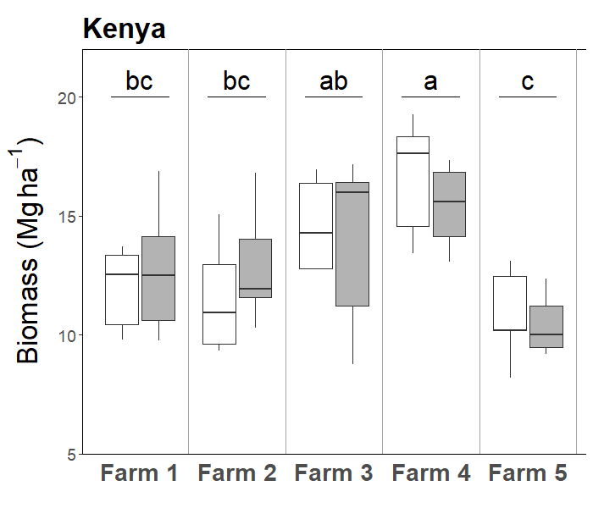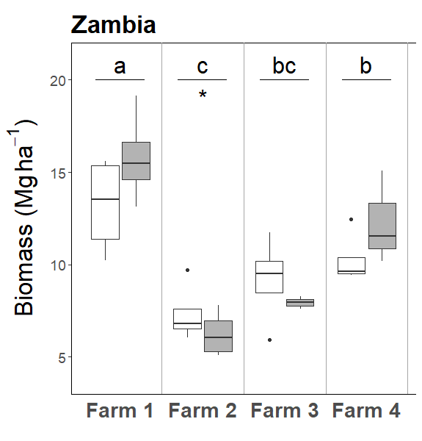
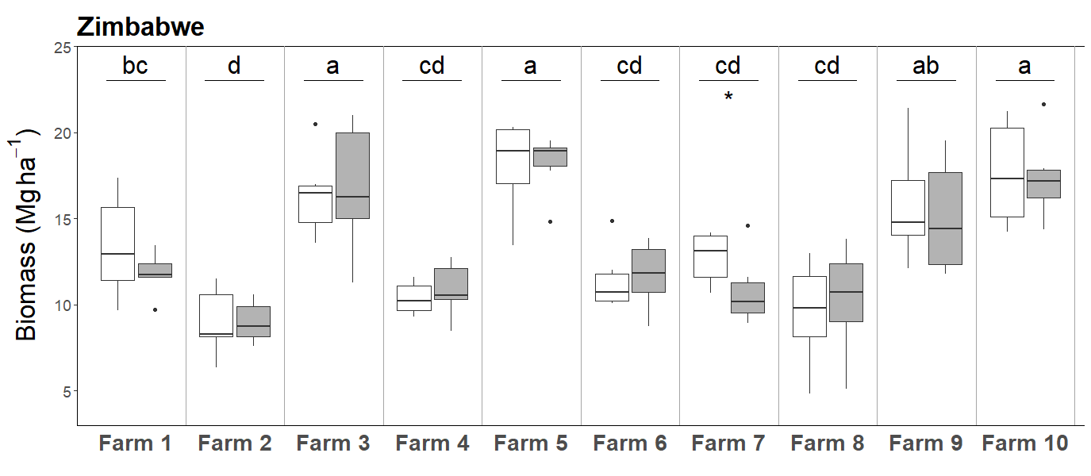
Figure S3: Total biomass in the full (white) and the -Zn (grey) treatments at five locations in Kenya, four locations in Zambia and ten locations in Zimbabwe. The boxplots show the median (line), first and third quartiles (hinges), the minimum and maximum based on the interquartile range (whiskers) and the outliers (markers). Asterisks indicate a significant treatment effect. Locations within a country with the same letter do not differ significantly (P<0.05; n=5 for Kenya, n=4 for Zambia, n=6 for Zimbabwe).

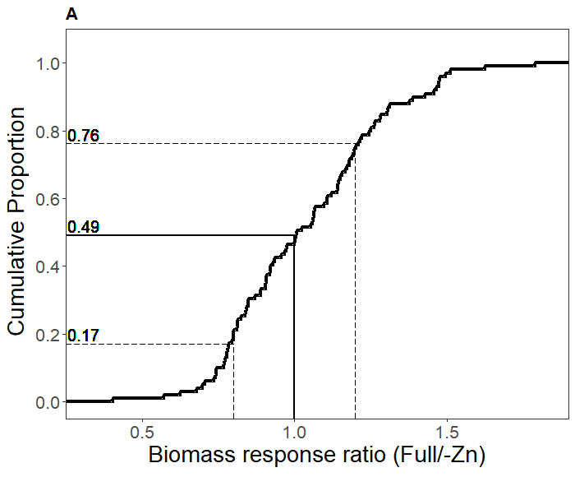
Figure S4: The cumulative proportion of blocks in all three countries for the response ratio of biomass (i.e. stover and grains), calculated as the ratio of the full treatment over the -Zn treatment. A response ratio >1 means a positive response of maize to Zn fertilisation. The horizontal lines and accompanying numbers show the cumulative proportion of all blocks with a response ratio of 0.8 (dashed), 1 (solid), and 1.2 (dashed), respectively.

Response in stover Zn concentrations

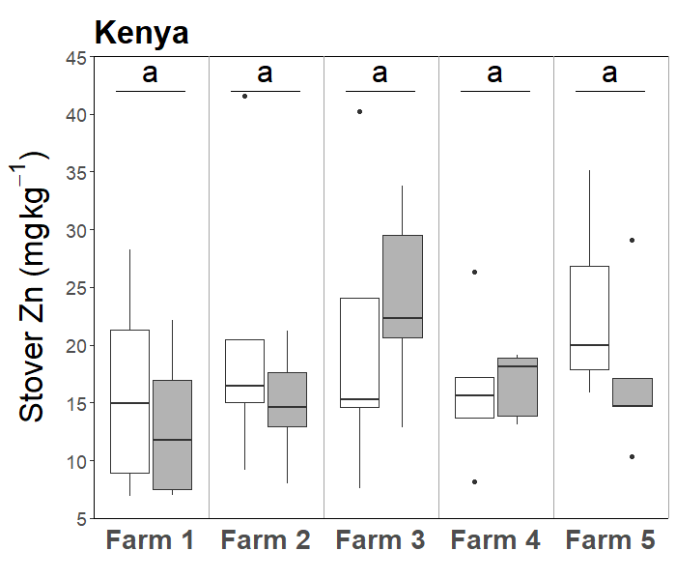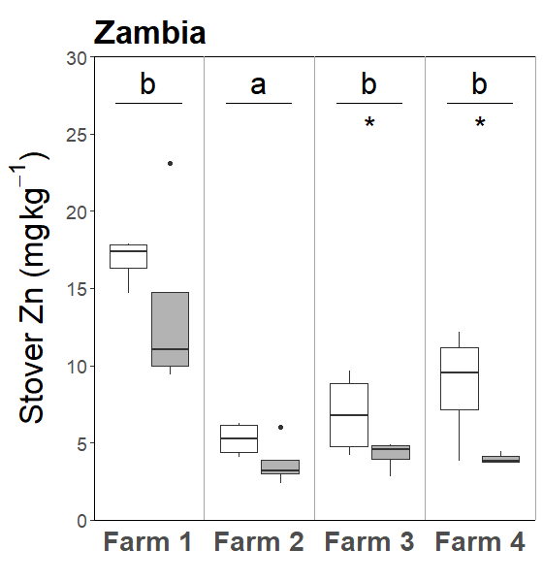
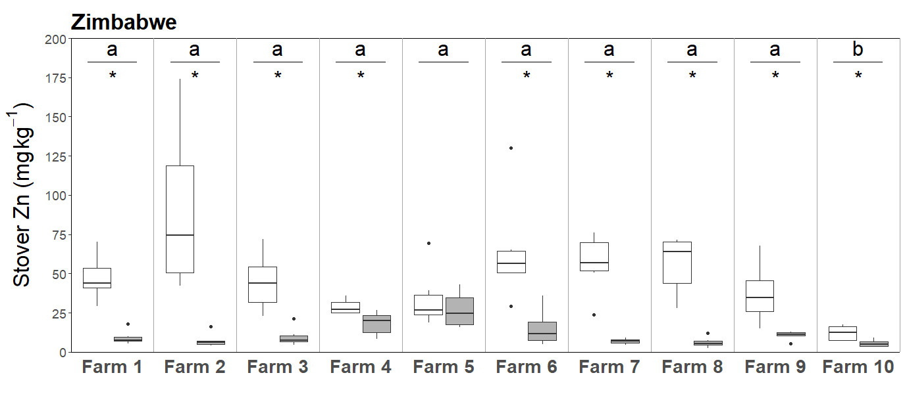
Figure S5: Stover Zn concentrations in the full (white) and the -Zn (grey) treatments at five locations in Kenya, four locations in Zambia and ten locations in Zimbabwe. The boxplots show the median (line), first and third quartiles (hinges), the minimum and maximum based on the interquartile range (whiskers) and the outliers (markers). Asterisks indicate a significant treatment effect. Locations within a country with the same letter do not differ significantly (P<0.05; n=5 for Kenya, n=4 for Zambia, n=6 for Zimbabwe).

Internal efficiency of zinc in maize
Table S1: The parameters extracted from the data shown in Figure S5 to assess the maximum and minimum internal efficiency of Zn in maize. The a and d parameters represent the minimum and maximum internal efficiency of Zn in maize respectively, and are shown by the slope values of the lines shown in Figure S5. The r parameter represent the minimal Zn uptake, and is shown by the intercept with the x-axis of the two lines in Figure S5.
a (kg g⁻¹) | d (kg g⁻¹) | r (g ha⁻¹)
8 | 71 | 6.1

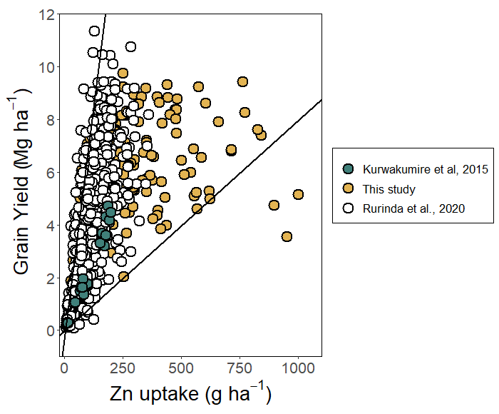
Figure S6: The relation between maize grain yield and Zn uptake measured in various field trials in sub-Saharan Africa. The datapoints were taken from the study by Kurwakumire et al. (2015) who did field trials in Zimbabwe in which maize was grown on three sites with NPKS alone or in combination with lime, manure and micronutrients. In addition, data was taken from the nutrient omission TAMASA trials, and more specifically from the trials in Nigeria which have been conducted in 2015, in which maize was grown with various fertilization treatments and for which aboveground Zn measurements were done (Rurinda et al., 2020). The TAMASA data was downloaded from https://data.cimmyt.org/ (November 2021). These data from literature was combined with the data from this study. For all datasets, all available fertilizer treatments were included. The lines represent the maximum and minimum international efficiency (IE, Mg grains g⁻¹ Zn) with the parameters from Table S1. These parameters were derived based on the data in this figure, excluding the upper and lower 2.5 % of the datapoints based on their internal efficiency.

TAMASA and AFSIS trials data

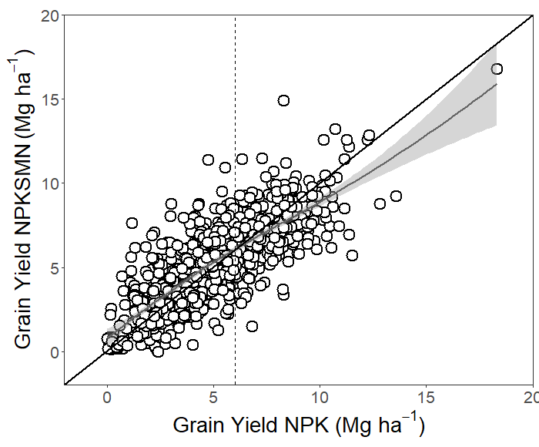
Figure S7: Large-scale nutrient omission field trials have been done recently in various sub-Saharan African countries with maize as a test crop. The results of these trials have been reported in literature (Kihara et al., 2016, 2017; Rurinda et al., 2020). In these field trials, maize yields obtained with only nitrogen (N), phosphorus (P) and potassium (K) fertilization were compared with maize yields from NPK + secondary + micronutrients (NPKSMN) treatments. This figure includes data from the Taking Maize Agronomy to Scale in Africa (TAMASA) project with field trials in Nigeria (2015, 2016), Ethiopia (2015, 2016) and Tanzania (2016). These data was downloaded from https://data.cimmyt.org/ (November 2021)and have been discussed by Rurinda et al. (2020). In addition, datapoints from the Africa Soil Information Service (Afsis) project were included, with field trial data from Mali, Kenya, Malawi, Tanzania and Nigeria. These data was download from https://dataverse.harvard.edu/dataset.xhtml?persistentId=doi:10.7910/DVN/C6DIIC (November 2021) and have been discussed by Kihara et al. (2016, 2017).

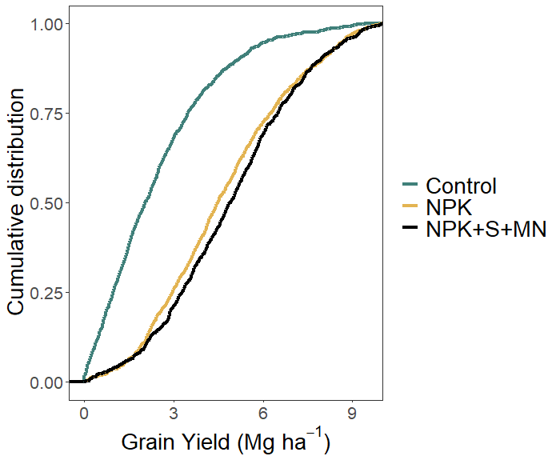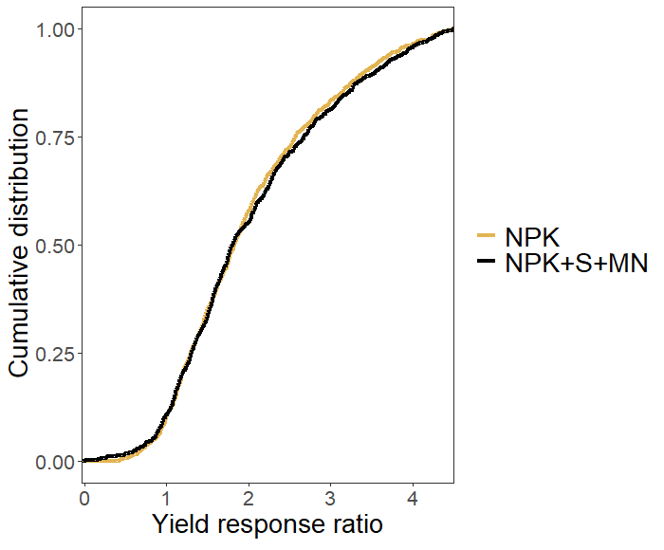
Figure S8: The cumulative distribution of maize grain yield and the grain yield response ratio observed in the control (no fertilizer), NPK and NPK in combination with secondary (S) and micronutrients (MN) for the Tamasa trials (Nigeria, 2015 and 2016; Tanzania, 2016; Ethiopia, 2015 and 2016) (Rurinda et al., 2020) and the Afsis trials (between 2009 and 2012 on various locations in Kenya, Malawi, Nigeria, 2010 and Tanzania) (Kihara et al., 2017). The yield response ratio in figure b was calculated as the grain yield in the NPK or the NPK+S+MN treatment divided by the grain yield in the control treatment.

REFERENCES
Food and agriculture organization of the united Nations (2020) WAPOR DATABASE METHODOLOGY : version 2 release, april 2020.
Kihara J., Nziguheba G., Zingore S., Coulibaly A., Esilaba A., Kabambe V., Njoroge S., Palm C. and Huising J. (2016) Understanding variability in crop response to fertilizer and amendments in sub-Saharan Africa. Agric. Ecosyst. Environ. 229, 1–12.
Kihara J., Sileshi G. W., Nziguheba G., Kinyua M., Zingore S. and Sommer R. (2017) Application of secondary nutrients and micronutrients increases crop yields in sub-Saharan Africa. Agron. Sustain. Dev. 37, 25.
Kurwakumire N., Chikowo R., Zingore S., Mtambanengwe F., Mapfumo P., Snapp S. and Johnston A. (2015) Nutrient management strategies on heterogeneously fertile granitic-derived soils in subhumid Zimbabwe. Agron. J. 107, 1068–1076.
Rurinda J., Zingore S., Jibrin J. M., Balemi T., Masuki K., Andersson J. A., Pampolino M. F., Mohammed I., Mutegi J., Kamara A. Y., Vanlauwe B. and Craufurd P. Q. (2020) Science-based decision support for formulating crop fertilizer recommendations in sub-Saharan Africa. Agric. Syst. 180, 102790.

