Supporting Information
Article title: Soil amendment with insect frass and exuviae affects the rhizosphere bacterial community, shoot growth and carbon/nitrogen ratio of a brassicaceous plant.
Journal: Plant and Soil
Authors: Els M. van de Zande, Max Wantulla, Joop J.A. van Loon, Marcel Dicke
Affiliation: Laboratory of Entomology, Wageningen University & Research, PO Box 16, 6700 AA, Wageningen, the Netherlands
Corresponding authors: els.vandezande@wur.nl (Els M. van de Zande) and marcel.dicke@wur.nl (Marcel Dicke)
Article acceptance date: Click here to enter a date.

The following Supporting Information is available for this article:
Figure S1, Main effects (a) and interaction effects (b) of soil amendments on fresh shoot biomass of Brassica oleracea after 2, 4 and 8 weeks of plant growth.
Figure S2, Main effects (a) and interaction effects (b) of soil treatments on carbon/nitrogen ratio in Brassica oleracea shoots.
Figure S3, Root carbon/nitrogen ratio of Brassica oleracea upon soil amendment.
Table S1, Insect species and companies from which the soil amendments originated.
Table S2, Composition of the synthetic fertiliser.
Table S3, Advised amendment concentration of insect residues

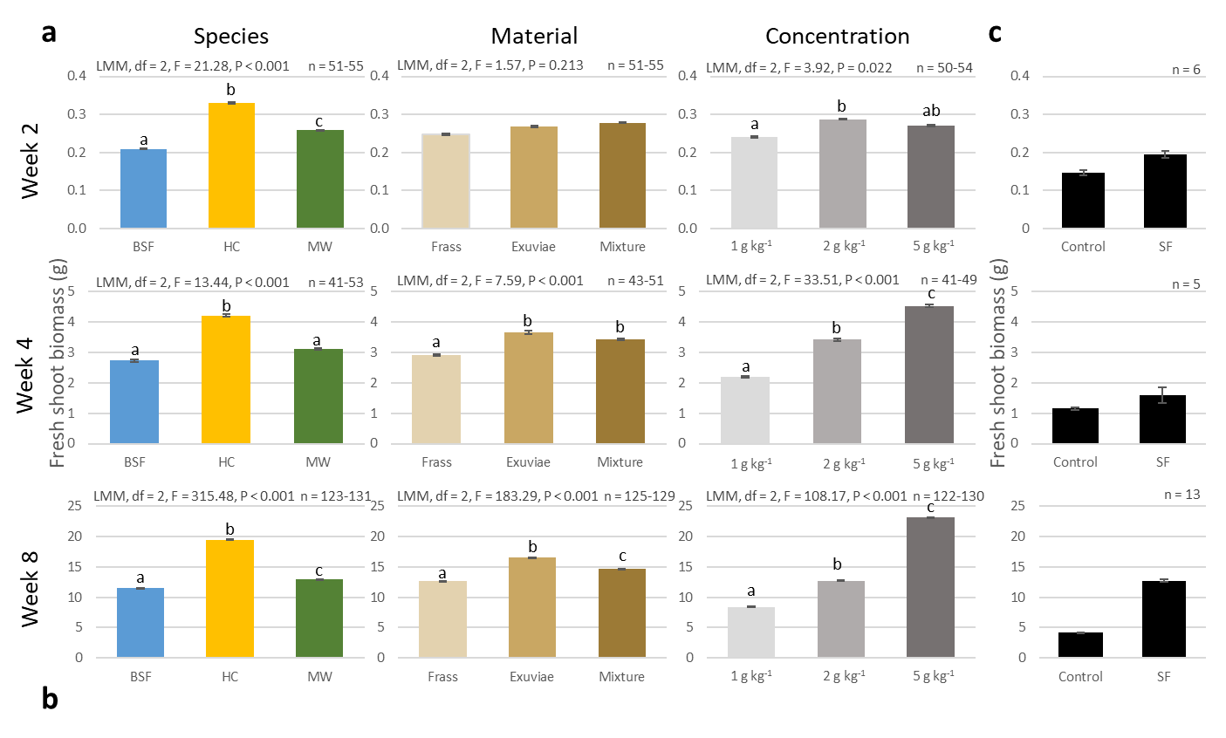
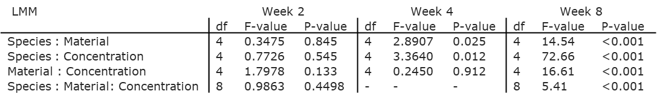
Fig. S1. Main effects (a) and interaction effects (b) of soil amendments on fresh shoot biomass of Brassica oleracea after 2, 4 and 8 weeks of plant growth. Soil amendments were grouped by insect species from which the residues originated (Species; black soldier fly larvae (BSF, Hermetia illucens), house cricket (HC, Acheta domesticus) and mealworm (MW, Tenebrio molitor)), by type of material that was used (Material), and by concentration of material in grams per kg of soil (Concentration). Treatment groups denoted with the same letter do not significantly differ (EMM, α = 0.05). Fresh shoot biomass (c) of B. oleracea growing in untreated (control) soil, or soil that was treated with synthetic fertiliser (SF). Bars represent the average and error bars the SE. Range of number of replicates per treatment are indicated at the top of each panel by n.

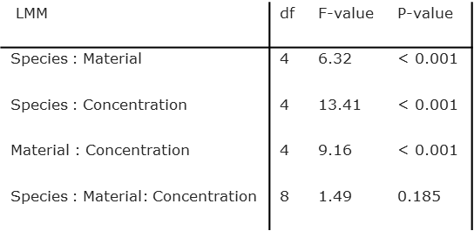
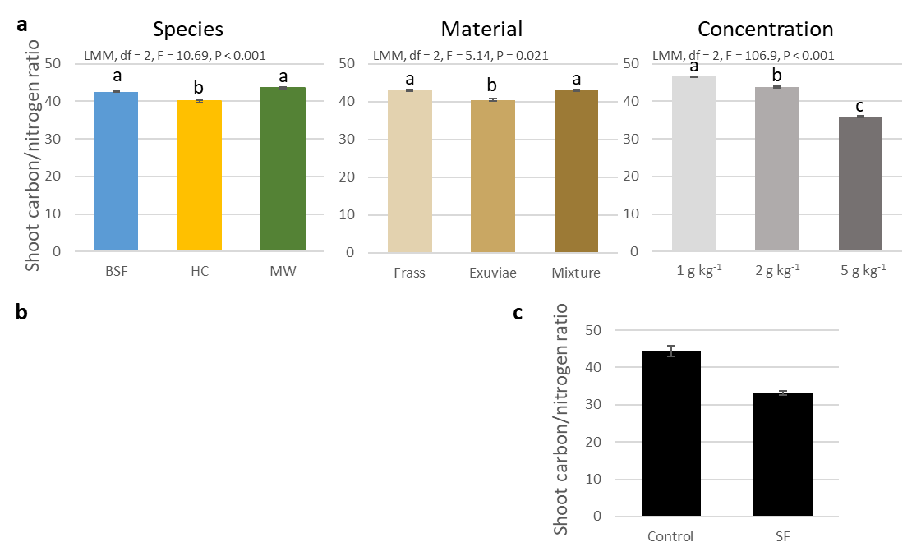
Fig. S2. Main effects (a) and interaction effects (b) of soil treatments on carbon/nitrogen ratio in Brassica oleracea shoots. Soil amendments were grouped by insect species from which the residual streams originated (Species; black soldier fly larvae (BSF, Hermetia illucens), house cricket (HC, Acheta domesticus) and mealworm (MW, Tenebrio molitor)), by type of material that was used from the residual streams (Material), and by concentration in grams per kg of soil (Concentration). Treatment groups denoted with the same letter do not significantly differ (EMM, α = 0.05). Carbon/nitrogen ratio (c) of B. oleracea growing in untreated (control) soil, or soil that was treated with synthetic fertiliser (SF). Bars represent the average and error bars the SE, n = 27.

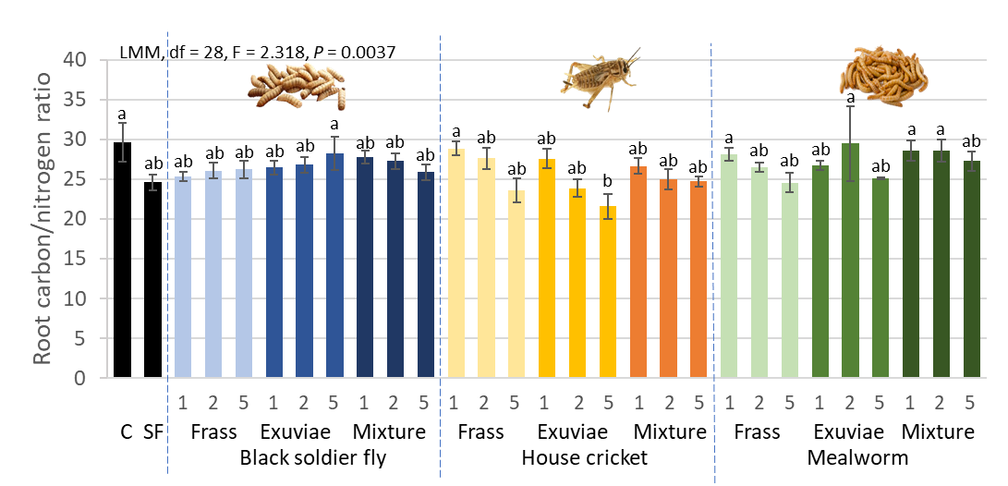
Fig. S3. Carbon/nitrogen ratio in the roots of Brassica oleracea grown for 8 weeks in untreated soil (control; C), soil treated with synthetic fertiliser (SF), or soil amended with residues derived from black soldier fly larvae (Hermetia illucens), house crickets (Acheta domesticus) and mealworms (Tenebrio molitor). Numbers underneath the bars indicate the residue concentration in grams per kg of soil. Treatments denoted with the same letter do not significantly differ (EMM, α = 0.05). Error bars represent standard error, n = 6

Table S1. Insect species and companies from which the frass and exuviae originated.
Insect species | Scientific name | Producing company
Black soldier fly | Hermetia illucens | Bestico BV, Berkel en Rodenrijs, the Netherlands
House cricket | Acheta domesticus | Nostimos B.V., Deurne, the Netherlands
Mealworm | Tenebrio molitor | Nijenkamp voederdieren, Hellendoorn, the Netherlands

Table S2. Composition of the synthetic fertiliser.
Chemical | Concentration | Unit
NH₄ | 1.2 | mmol/l
K | 7.2 | mmol/l
Ca | 4.0 | mmol/l
Mg | 1.82 | mmol/l
NO₃ | 12.4 | mmol/l
SO₄ | 3.32 | mmol/l
P | 1.0 | mmol/l
Fe | 35.0 | µmol/l
Mn | 8.0 | µmol/l
Zn | 5.0 | µmol/l
B | 20.0 | µmol/l
Cu | 0.5 | µmol/l
Mo | 0.5 | µmol/l

Table S3. Advised amendment concentration of insect residues. Advice is based on a nitrogen (N) fertilisation advice for cabbage of 230 kg ha⁻¹ provided by Eurofins Agro (Wageningen, the Netherlands), assuming a topsoil depth of 35 cm (0.066 N kg⁻¹ soil) and taking into account the nitrogen release per insect residue (Nurfikari, 2022) for the duration of the experiment (8 weeks).

Insect species | Material | Total mineral N release in soil amended with 10 g kg⁻¹ after 8 weeks (g kg⁻¹) | Total mineral N release per g of amendment (g kg⁻¹) | Advised amendment concentration (g kg⁻¹)
Black soldier fly | Exuviae | 0.139 | 0.0105 | 6.3
Black soldier fly | Frass | 0.101 | 0.0067 | 9.8
House cricket | Exuviae | 0.155 | 0.0121 | 5.4
House cricket | Frass | 0.204 | 0.0170 | 3.9
Mealworm | Exuviae | 0.158 | 0.0124 | 5.3
Mealworm | Frass | 0.124 | 0.0090 | 7.3
Calculations |  | As measured by Nurfikari (2022) | (N release amendment – N release Control) / 10 | N release 1 g of amendment / advised N per kg soil

Table S4 (in separate document). Brassica oleracea growth parameters per time-point, for the control, synthetic fertilizer and insect residue treatments. Insect residue amendments consisted of frass, exuviae and a 1:1 mixture originating from black soldier fly larvae (Hermetia illucens), house crickets (Acheta domesticus), or mealworms (Tenebrio molitor) and were mixed through the soil at a concentration of 1, 2 and 5 grams per kg of soil. Numbers indicate average ± SE. Treatments denoted with the same letter do not differ (EMM, α = 0.05). The last row depicts the LMM statistics, or GLMM for leaf number, per plant growth parameter.

Table S5 (in separate document). Relative abundances of bacterial genera in the Brassica oleracea rhizosphere that were significantly different from the control after 2, 4 or 8 weeks of plant growth following soil amendment with exuviae from black soldier fly larvae (BSFE, Hermetia illucens), house crickets (HCE, Acheta domesticus) or mealworms (MWE, Tenebrio molitor) or frass from black soldier fly larvae (BSFF), house crickets (HCF) or mealworms (MWF) at 5 g kg⁻¹ (% ± standard error).

Cited references:
Nurfikari A, Leite MFA, Kuramae E, de Boer W (2023) Microbial Community Dynamics During Decomposition of Insect Exuviae and Frass in Soil. SSRN. doi.org/10.2139/ssrn.4422505

