Supplementary data
Article Title: Soil water availability modulates the response of grapevine leaf gas exchange and PSII traits to a simulated heatwave.
Journal name: Plant &Soil
Author names: W. Shtai¹, D. Asensio^{1*}, A. Kadison², M. Schwarz³, B. Raifer², C. Andreotti¹, A. Hammerle³, D. Zanotelli¹, F. Haas², G. Niedrist⁴, G. Wohlfahrt³, M. Tagliavini¹
Affiliations: 1. Free University of Bolzano, Bolzano, Italy; 2. Research Centre Laimburg, Institute for Fruit Growing and Viticulture, Bolzano, Italy; 3. University of Innsbruck, Department of Ecology, Innsbruck, Austria; 4. Institute for Alpine Environment, Eurac Research, Bolzano, Italy
* Corresponding author: dolores.asensio@unibz.it

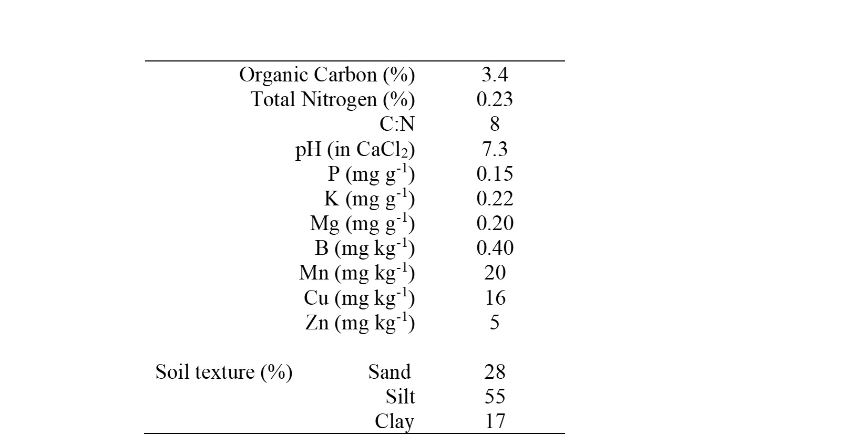
Supplementary Table S1. Soil physicochemical properties

Supplementary Table S2. Irrigation schedule and quantities (ml/pot) during the experiment.

Supplementary Table S3. Maximum, minimum and mean soil temperature (Tmax, Tmin and Tmean) during the peak of the heat wave (days 6 to 11). Values are daily means ± SE.

Treatment | T_{max} | T_{min} | T_{mean}
CD | 28.51 ± 0.05 | 21.50 ± 0.11 | 25.00 ± 0.04
CW | 27.79 ± 0.12 | 21.84 ± 0.06 | 24.86 ± 0.07
HD | 38.72 ± 0.19 | 29.51 ± 0.12 | 34.03 ± 0.17
HW | 37.77 ± 0.24 | 29.94 ± 0.15 | 33.83 ± 0.18

Supplementary Figure S1. Photosynthetically active radiation (PAR), air temperature (Tair) and vapor pressure deficit (VPD) in control (black) and heat (red) treatments during the experiment.
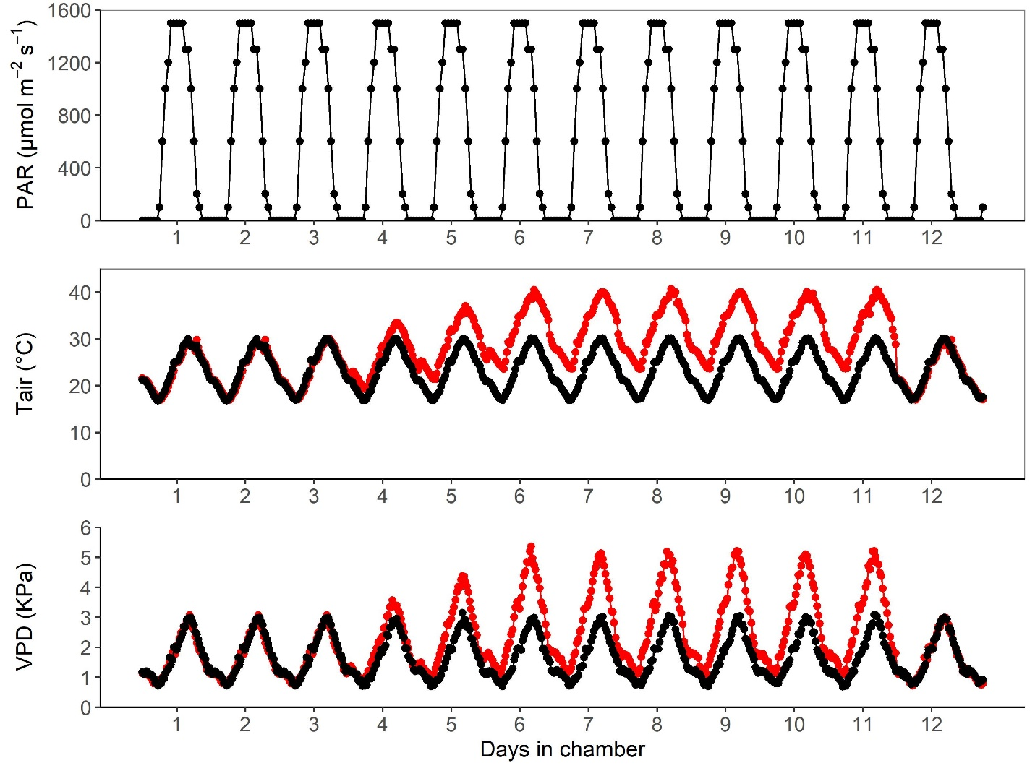

Supplementary Figure S2. Soil temperature and water potential at 25 cm. Each line represents the hourly average in control/heat treatments (black/red) and well-watered/drought treatments (solid/dashed lines) during the experiment.
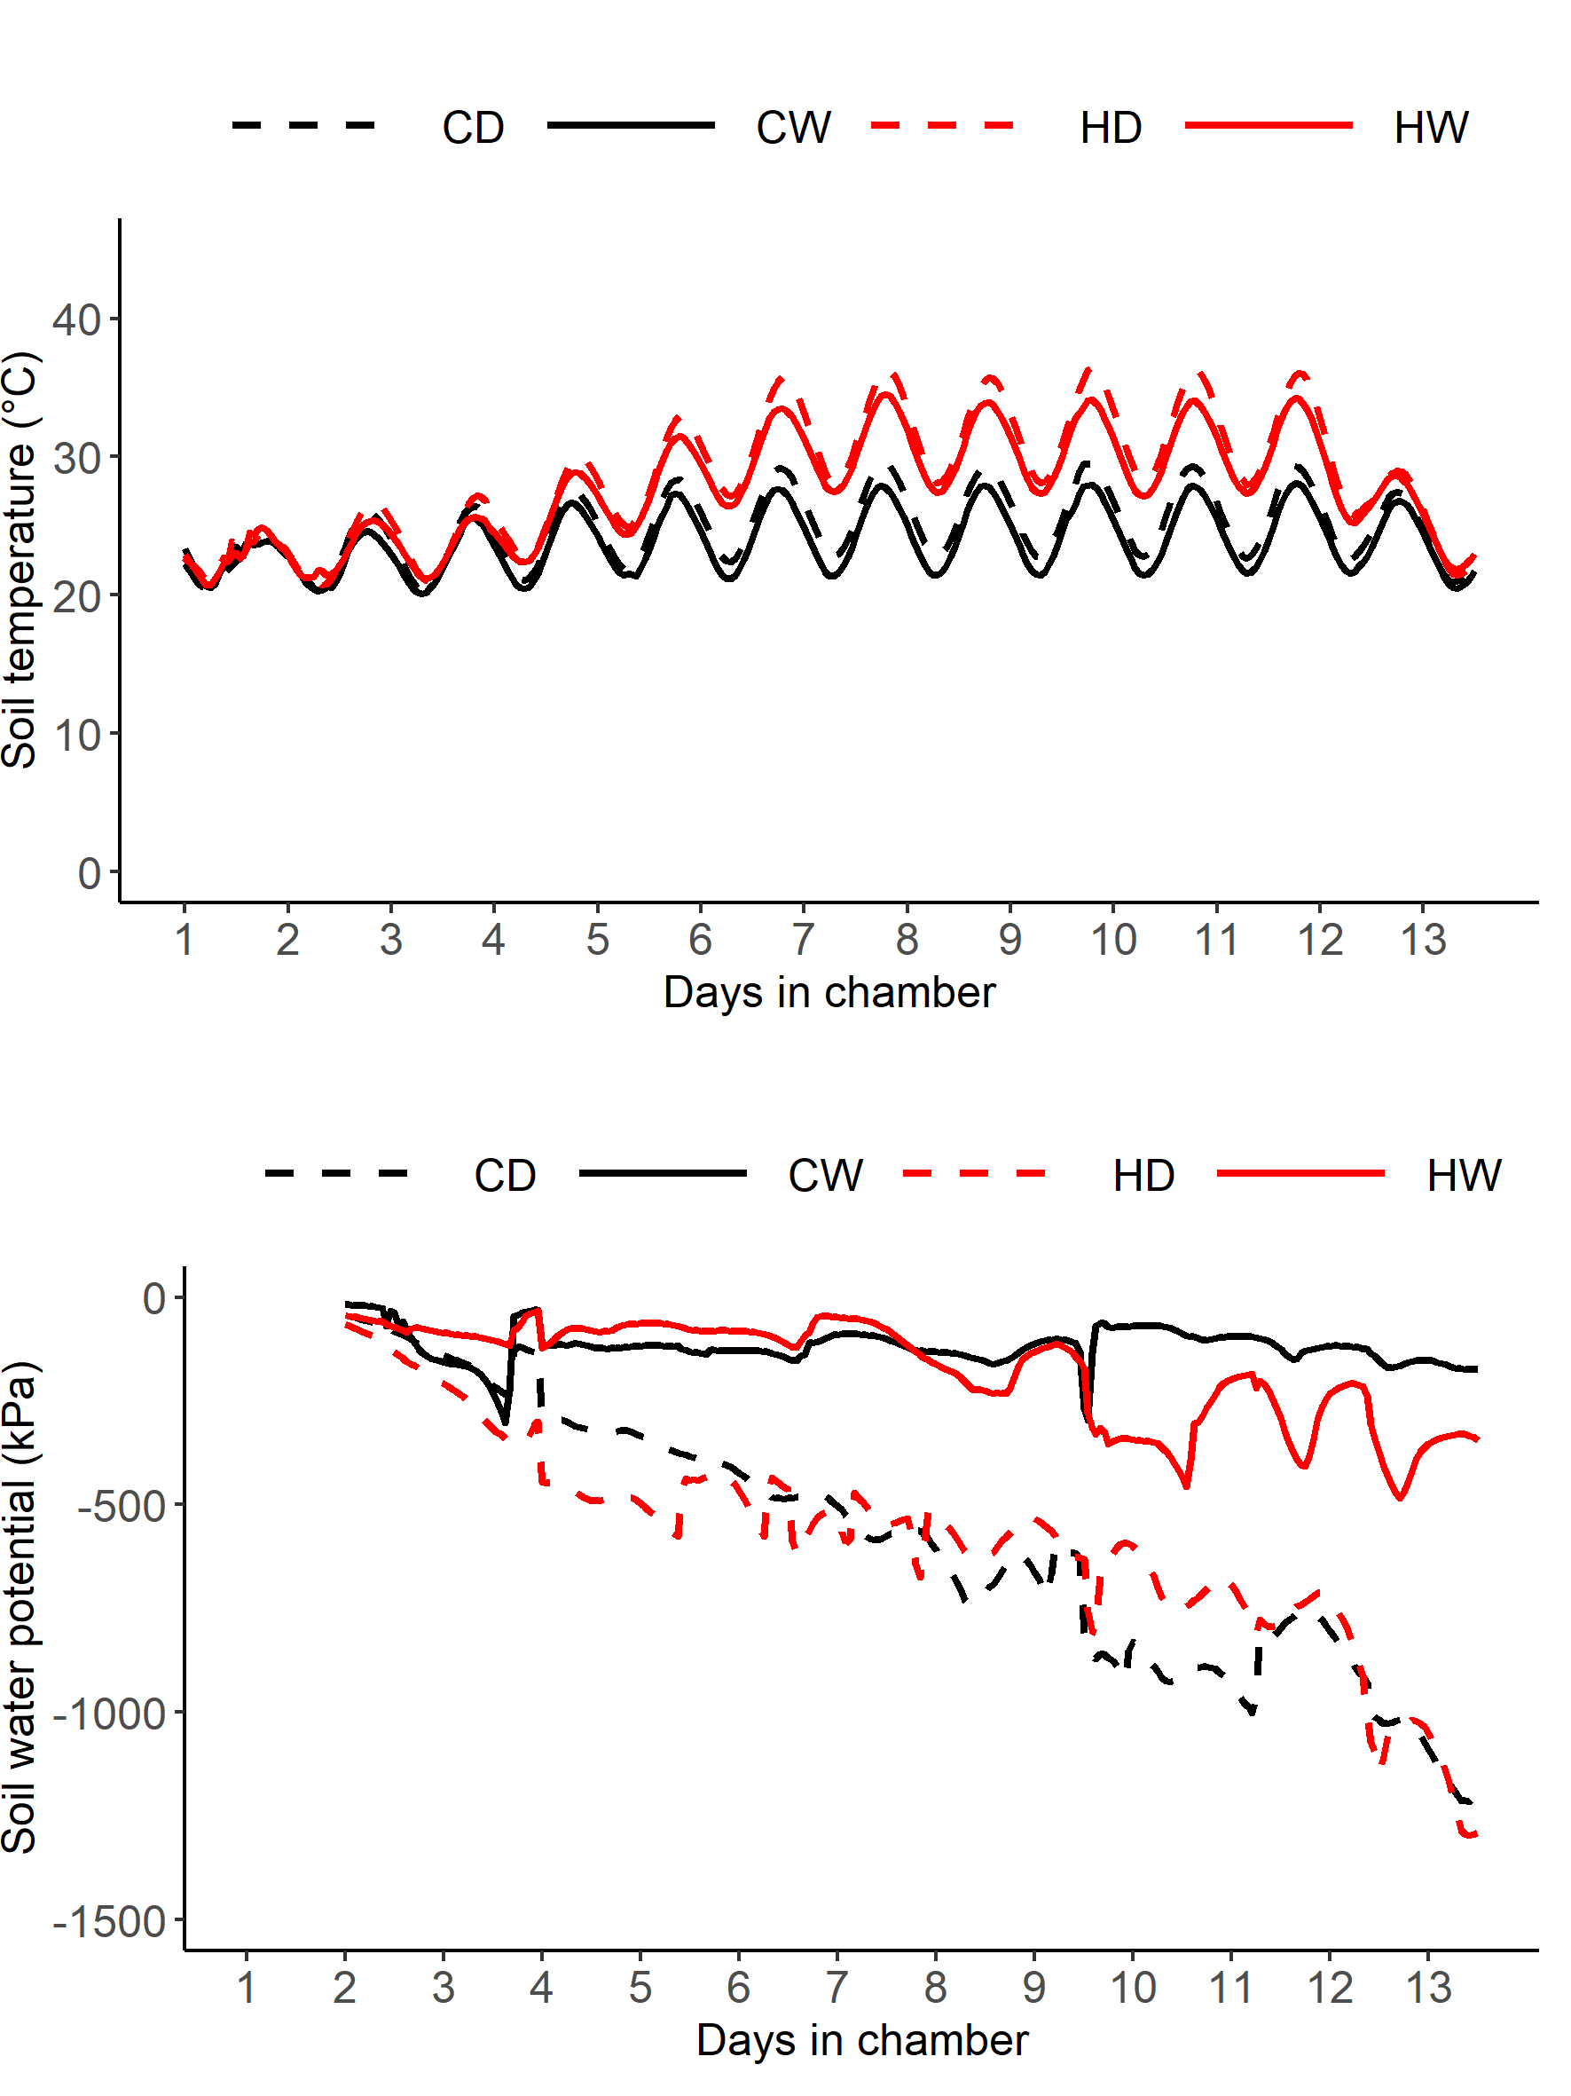

Supplementary Figure S3. Volumetric soil water content in control/heat treatments (black/red) and well-watered/drought treatments (solid/dashed lines) during the experiment; values are daily means ± SE.
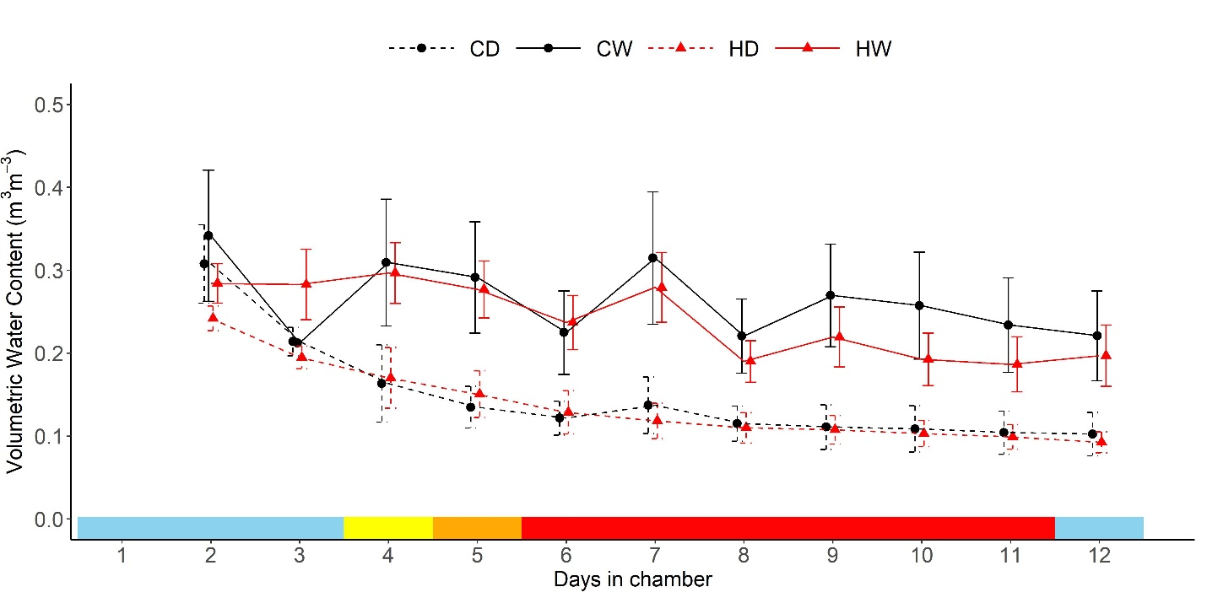

Leaf temperature
Leaf canopy and leaf temperature were recorded every 30 min simultaneously in one well-watered and drought-stressed plant during the heat wave using a FLIR T640 (Teledyne FLIR LLC) camera placed at approximately 1 meter horizontally from the two plants. Camera accuracy was of ± 2% of reading and was equipped with an angular field of view of 25° × 19°. Infra-red resolution was 640 × 480 pixels with an uncooled microbolometer sensor sensitive in the spectral range of 7.8–14 μm. The value used for the emissivity was 1, otherwise a factor was applied to correct images. Thermal image analysis was performed in four steps. (i) In the first step, manual filtering was performed and all images with mainly disturbing elements (people, devices, ...) were excluded from further analysis. (ii) In the second step, overlapping points in the thermal and visual images were manually defined and the parallax error between these two images was corrected by aligning the visual image with the thermal image. The functions cpselect.m, cpcorr.m, fitgeotrans.m and imwarp.m in MATLAB version: 9.13.0 (R2022b), (The MathWorks Inc.; Natick, Massachusetts, USA) were used for this purpose. In the third step, image regions were defined for the two treatments and isolated regions with interfering elements were excluded. (iv) In the fourth and final step, the leaf pixels were selected based on the green values in the image and assigned to the respective treatment. Based on these selected pixels statistics on leaf temperatures were calculated for the two treatments.

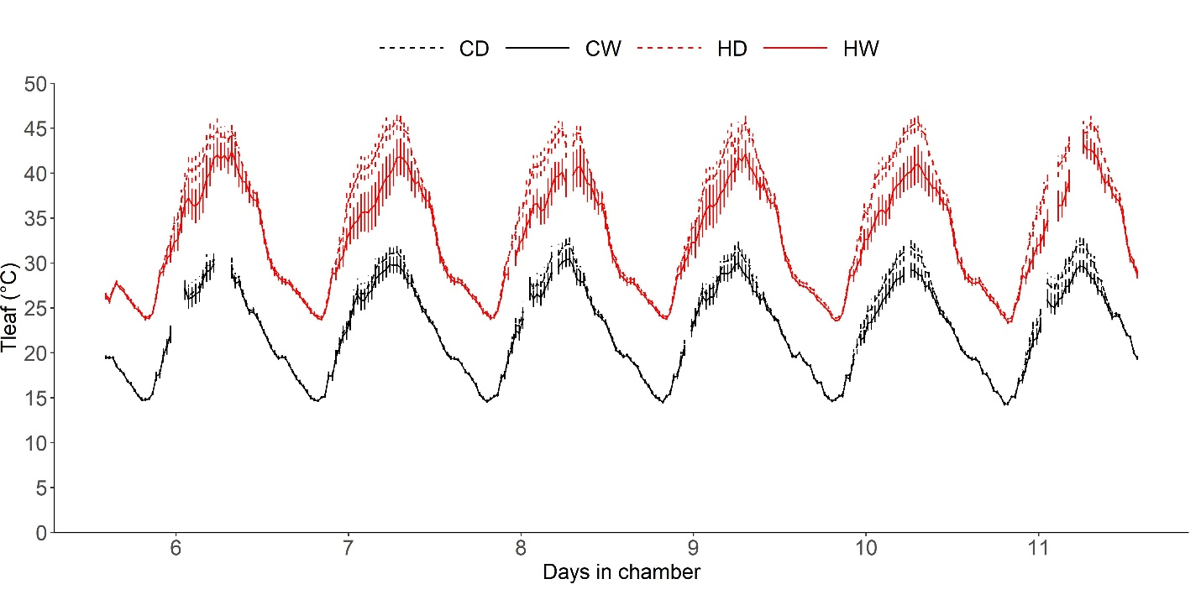
Supplementary Figure S4. Mean leaf temperature (°C) in control well-watered (CW), control dry (CD), heat well-watered (HW) and heat dry (HD) treatments from days 6 to 11 (peak of the heat wave).

Supplementary Figure S5. Photosynthesis (A), leaf transpiration (B) and stomatal conductance (C) during the peak of the heat wave (days 6 to 11) in dry and well-watered plants in the heat treatment, in the morning and the afternoon. The letters indicate the results of the repeated measures analysis within each HD and HW set of vines; different letters refer to significant differences among days. Values are means ± standard error.
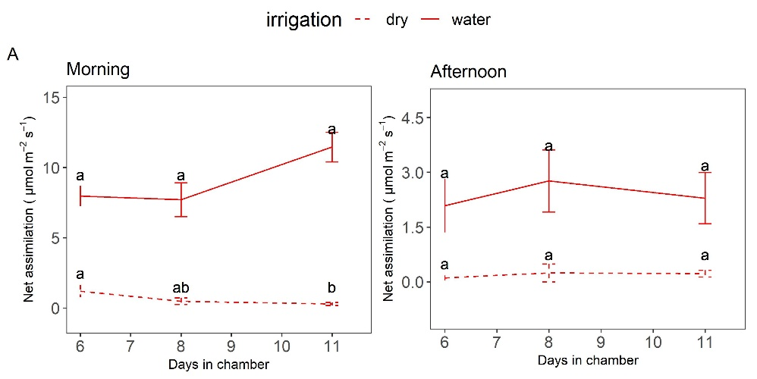

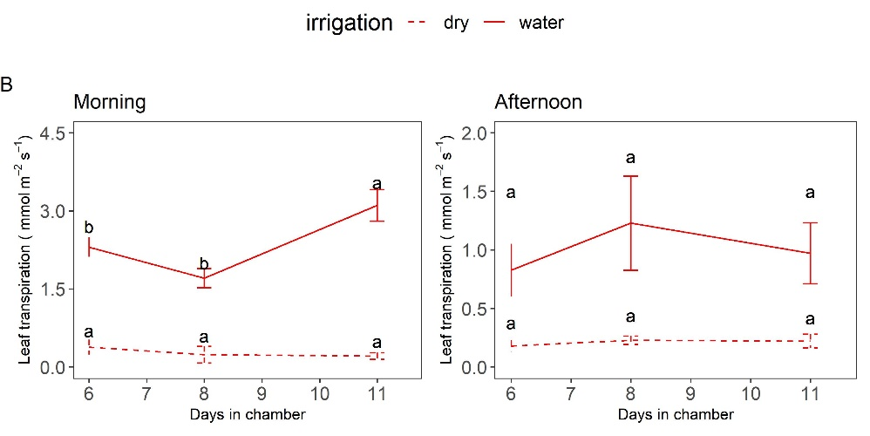

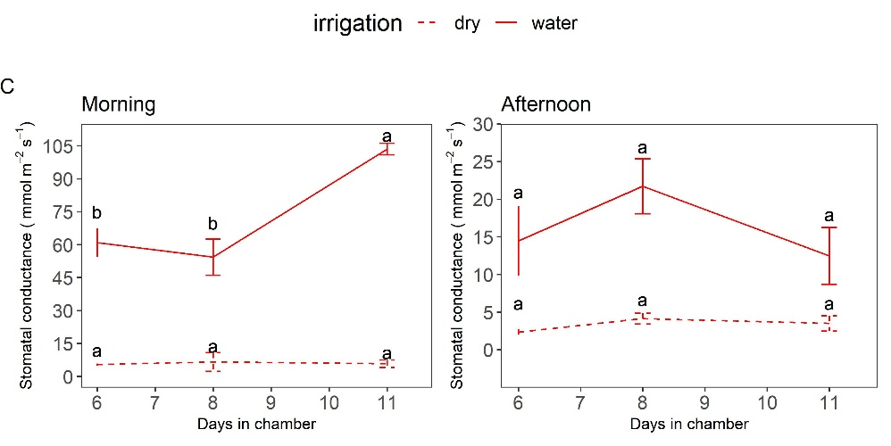

Supplementary Figure S6. Photosynthesis (A), leaf transpiration (B) and stomatal conductance (C) measured on the last day of the heat wave (day 11) and the day after (day 12) in dry and well-watered plants in the heat treatment, in the morning and the afternoon; different letters refer to significant differences between days within the same irrigation treatment. Values are means ± standard error.
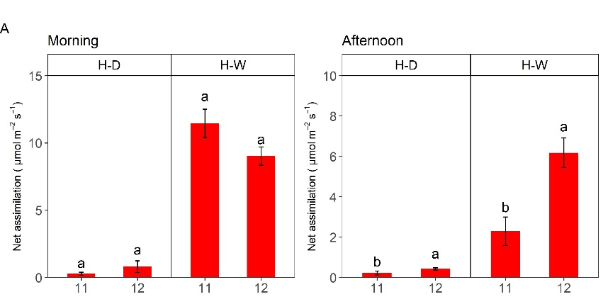

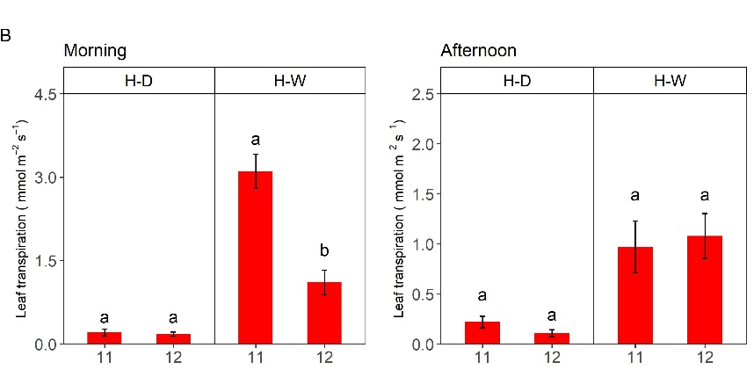

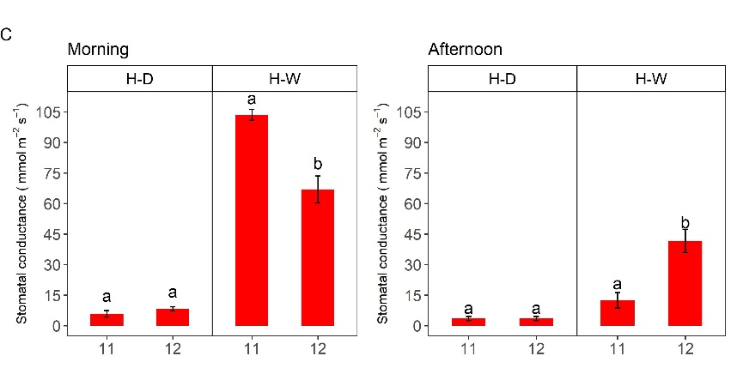

Supplementary Figure S7. Soil temperature and water potential at 25 cm on day 11 of the experiment (last day of the heat wave). Each line represents the hourly average in control/heat treatments (black/red) and well-watered/drought treatments (solid/dashed lines).

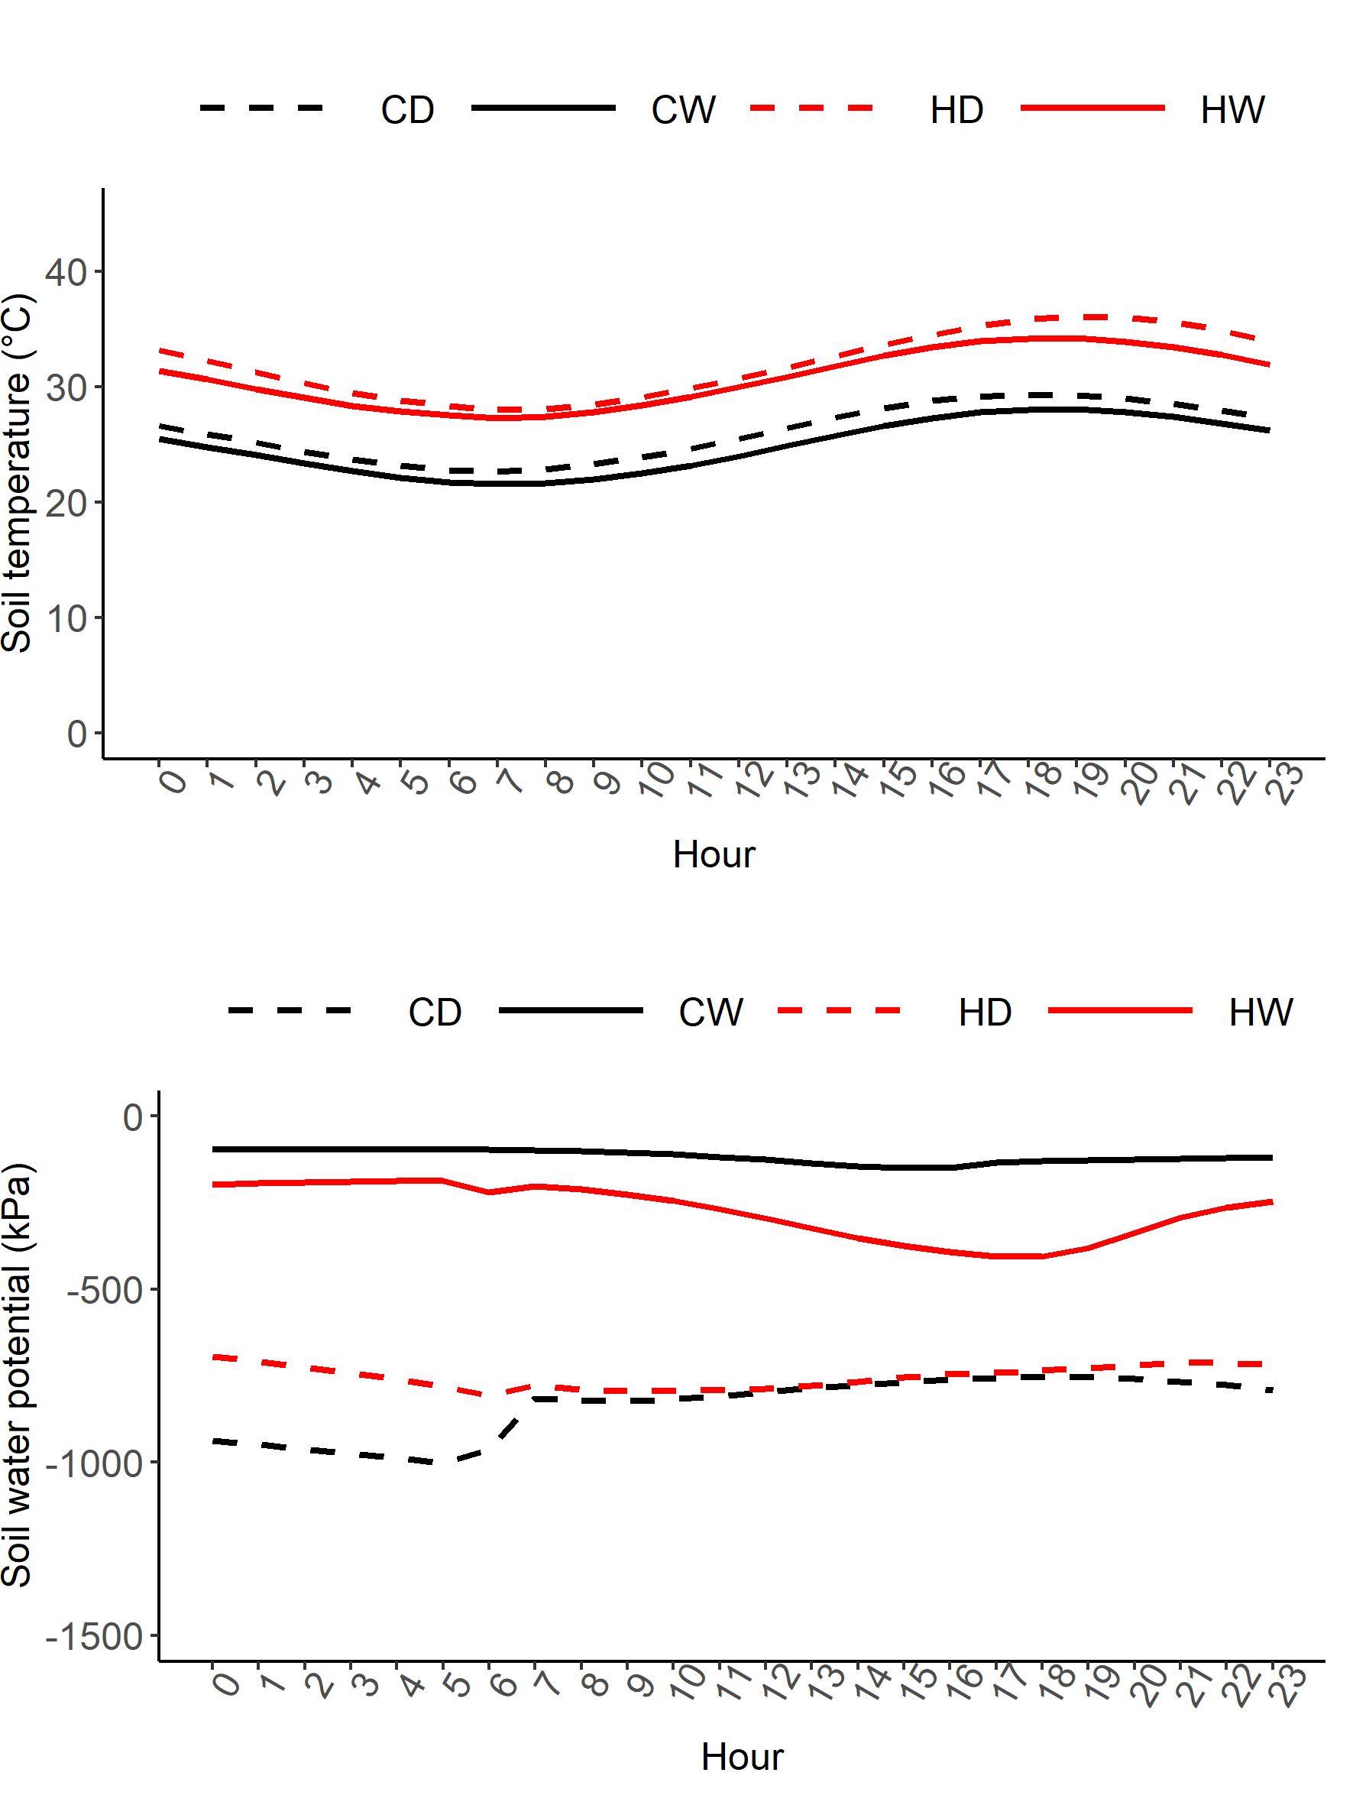

Supplementary Figure S8. Correlation between soil water potential and whole plant transpiration. Values are averages for each treatment (n=4-6) in the morning and afternoon sampling periods.

