Supplementary Information
Title: Exploring the potential of topsoil pellets to improve native seedling establishment on degraded agricultural land
Journal: Plant and Soil
Authors: Thomas P. Munro, Todd E. Erickson, Dale G. Nimmo, Frederick A. Dadzie, Miriam Muñoz- Rojas, Jodi N. Price
* Corresponding author: thomasmuro17@gmail.com, Gulbali Institute, Charles Sturt University, Albury, New South Wales, Australia.

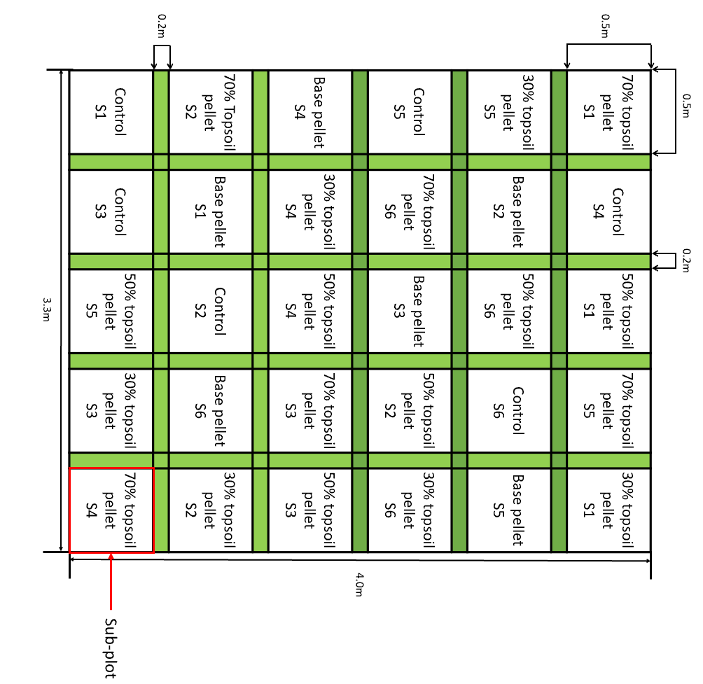

Fig. S1. Experimental design showing one replicate block with five seed enhancement treatments: control (non-enhanced seeds), base pellet and three topsoil pellets and six native plant species (S1-S6) randomly arranged. The block (4 x 3.3 m) is divided into 30 nested sub-plots (five treatments x six species). The treatment sub-plots were 0.5 x 0.5 m (with a 0.2 x 0.2 m buffer between each sub-plot), within each treatment sub-plot, there were 20 units (pellets or non-enhanced seed clustered to mimic the pellet seed density). The blocks were replicated 8 times, giving a total of 240 units/species/treatment.

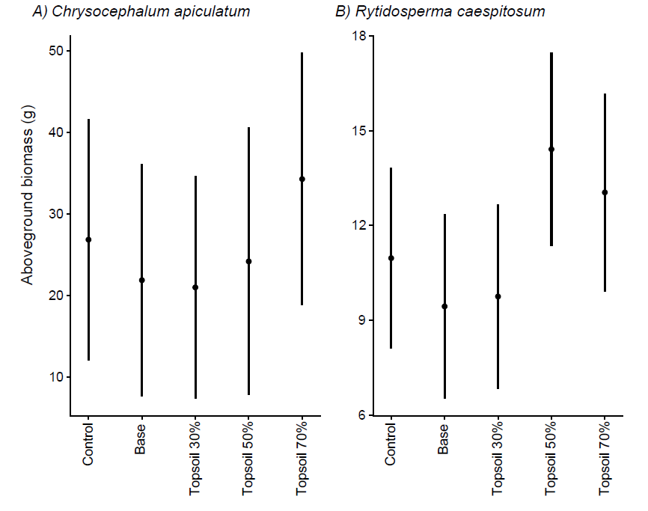
Fig. S2. Aboveground biomass (g) for R. caespitosum and C. apiculatum from all SET treatments and control (non-enhanced seeds) with means and error bars representing 95% confidence intervals.
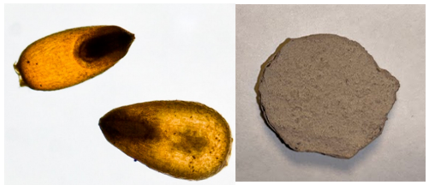

3 cm mm
4 mm

Figure S3. Rytidosperma caespitosum seeds removed from florets (left) and the base pellet containing Rytidosperma caespitosum seeds (right) with approximate graphical scale.

Species | Predictors | Odds Ratio | Confidence intervals | p-value
Chrysocephalum apiculatum | (Intercept) | 26.83 | 12.04 – 41.62 | 0.001**
 | Base pellet | -4.98 | -25.22 – 15.27 | 0.623
 | Topsoil 30% pellet | -5.86 | -25.62 – 13.91 | 0.554
 | Topsoil 50% pellet | -2.67 | -24.23 – 18.89 | 0.804
 | Topsoil 70% pellet | 7.43 | -13.70 – 28.57 | 0.483
Rytidosperma caespitosum | (Intercept) | 10.97 | 8.11 – 13.83 | <0.001***
 | Base pellet | -1.53 | -5.41 – 2.35 | 0.437
 | Topsoil 30% pellet | -1.21 | -5.09 – 2.67 | 0.537
 | Topsoil 50% pellet | 3.44 | -0.53 – 7.42 | 0.089
 | Topsoil 70% pellet | 2.08 | -1.96 – 6.11 | 0.310
Table S1. Summary table of LMM analysis for aboveground biomass for C. apiculatum and R. caespitosum in all SET treatments and control (non-enhanced seeds). Significance levels are denoted with asterisks: * indicates p-value < 0.05, ** <0.01, and *** <0.001.

