Genetic variation in Zea mays influences nitrification and denitrification diversity and potential function in conventional agroecosystem

Alonso Favela^{a,}, Martin O. Bohn^{c}, Angela D. Kent^{b,d}
Author Affiliation:
ªSchool of Plant Sciences, University of Arizona, Tucson, AZ, 85721
^{b}Program in Ecology, Evolution, and Conservation Biology, University of Illinois at Urbana-Champaign, Urbana, IL 61801
^{c}Department of Crop Sciences, University of Illinois at Urbana-Champaign, Urbana, IL 61801
^{d}Department of Natural Resources and Environmental Sciences, University of Illinois at Urbana-Champaign, Urbana, IL 61801

Supplemental Information and Materials
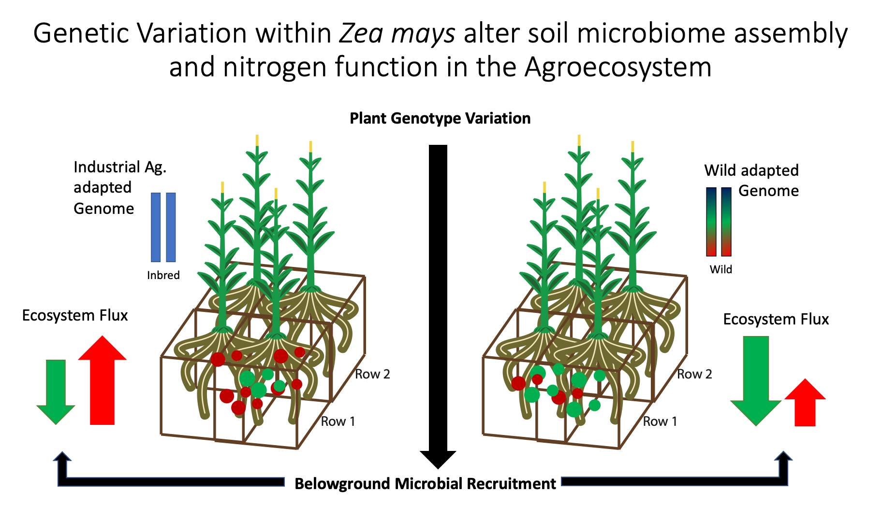
Figure S1. Graphical abstract. It has been shown that plant genotype plays a role in microbial recruitment. Here we were interested in understanding if genotype-driven differential recruitment of the rhizosphere microbiome will result in alterations to microbially-mediated ecosystem functions. To assess this question, we used extremely contrasting genetic models: modern agricultural inbred lines of maize and wild teosinte progenitors. This gives us a potential ceiling to the role plant genetics can play in shaping the microbiome.
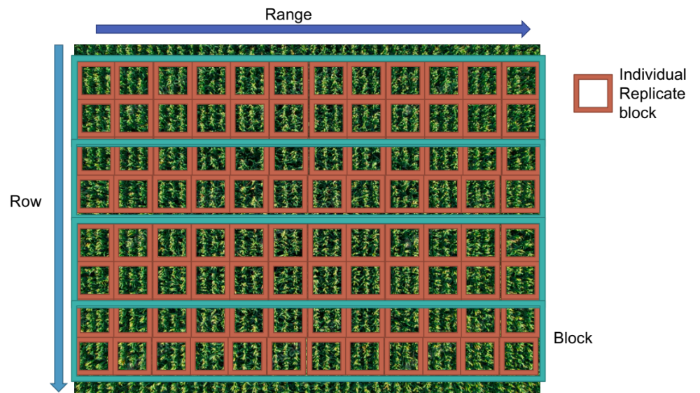
Figure S2. Physical structure of the field setting. Replicate rectangular blocks are colored in teal and include all the genotypes included in the study. Individual genotype blocks are colored in brown and are randomized within the block. Range and row factors were included in model as continuous factors to represent space within the field. This scheme allowed us to control for stochastic spatial effects within our experiment.

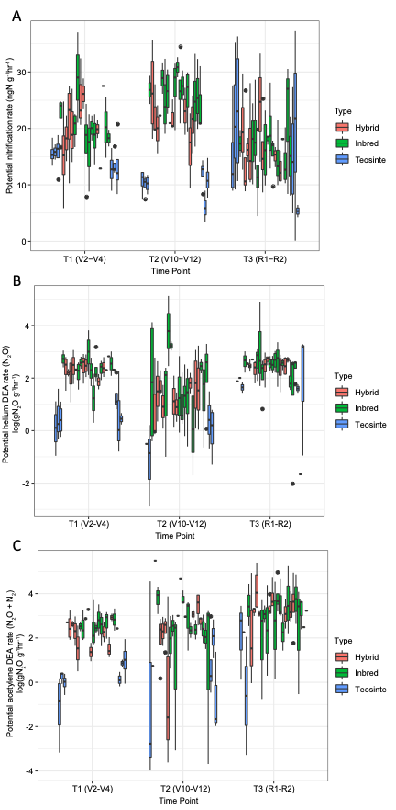
Figure S3. Rates of potential nitrification (ng N g d.w soil ⁻¹ hr ⁻¹), potential (N₂O) DEA rate (log (ng N g d.w soil ⁻¹ hr ⁻¹)), and potential (N₂O + N₂) DEA rate (log (ng N g d.w soil ⁻¹ hr ⁻¹)) as influenced by plant genotype and classification. A. Potential nitrification rate (ng N g⁻¹ hr⁻¹) of all genotypes included in the study across our three sampling time points colored by plant classification. Teosinte genotypes were observed to have the lowest nitrification rates in the T1 and T2 time points. No differences were present at the T3 sampling time point. B. Potential (N₂O) DEA rate (log (ng N g d.w soil ⁻¹ hr ⁻¹)) of all genotypes included in the study across our three sampling time points colored by plant classification. C. Potential (N₂O + N₂) DEA rate (log (ng N g d.w soil ⁻¹ hr ⁻¹)) of all genotypes included in the study across our three sampling time points colored by plant classification.

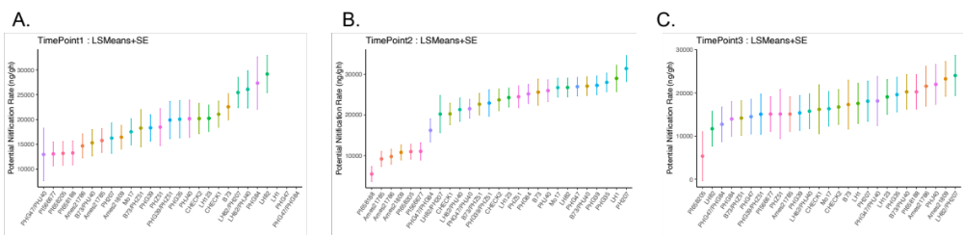
Figure S4. Potential nitrification of individual genotypes in study across different sampling timepoints. LS Means and Standard Error were calculated using ASREML-r. Supplemental statistics are presented in Table S7. A. Genotypic mean of potential nitrification at time point 1. B. Genotypic mean of potential nitrification at time point 2. C. Genotypic mean of potential nitrification at time point 3.
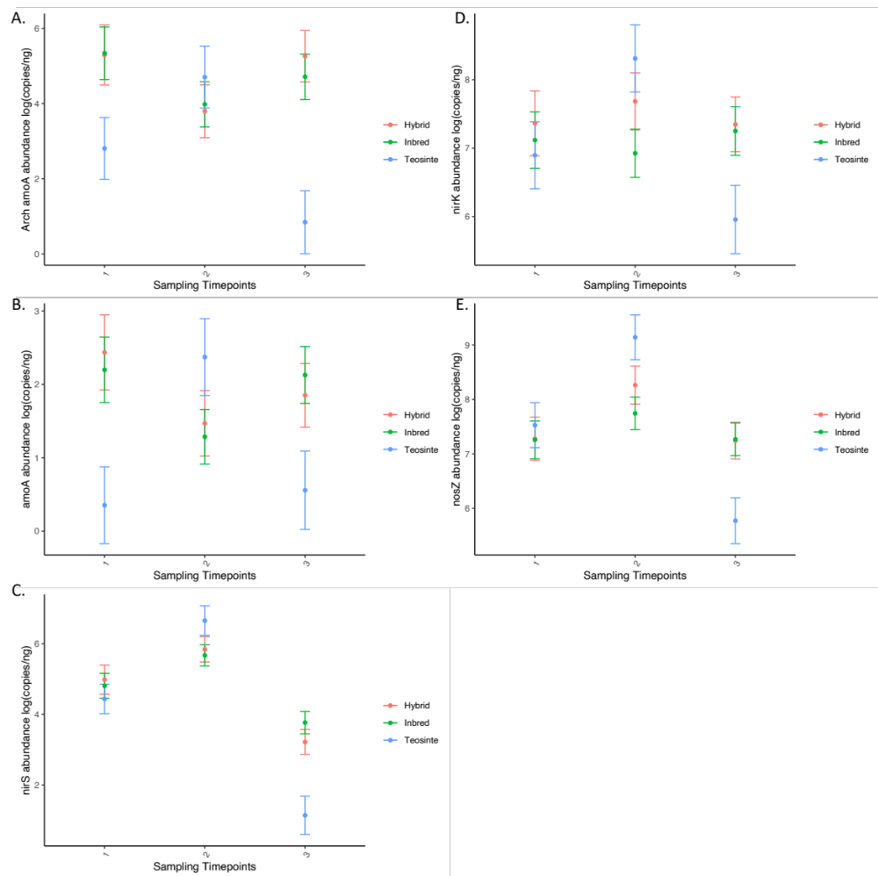
Figure S5. Quantitative PCR results for functional genes surveyed in the study across different timepoints over the season across plant classification. LS Means and Standard Error were calculated using ASREML-r. Supplemental Statistic are present in Table S6. A. Log of archaeal amoA qPCR abundance across timepoints. B. Log of bacterial amoA qPCR abundance across timepoints. C. Displays the log of nirS qPCR abundance across timepoints. D. Log of nirK qPCR abundance across timepoints. E. Log of nosZ qPCR abundance across timepoints.
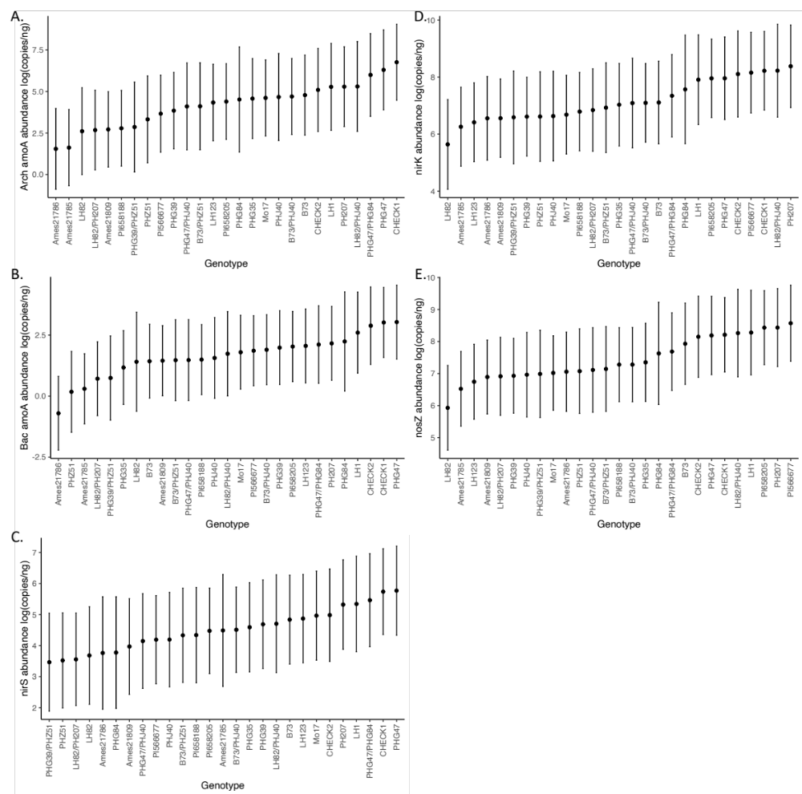
Figure S6. Quantitative PCR Results for functional genes surveyed in the study averaged cross different timepoints displayed as genotypic means. LS Means and Standard Error were calculated using ASREML-r. Supplemental Statistic are present in Table S6. A. Log of archaeal amoA qPCR abundance across genotypes. B. Log of bacterial amoA qPCR abundance across genotypes. C. Log of nirS qPCR abundance across genotypes. D. Log of nirK qPCR abundance across genotypes. E. Log of nosZ qPCR abundance across genotypes.

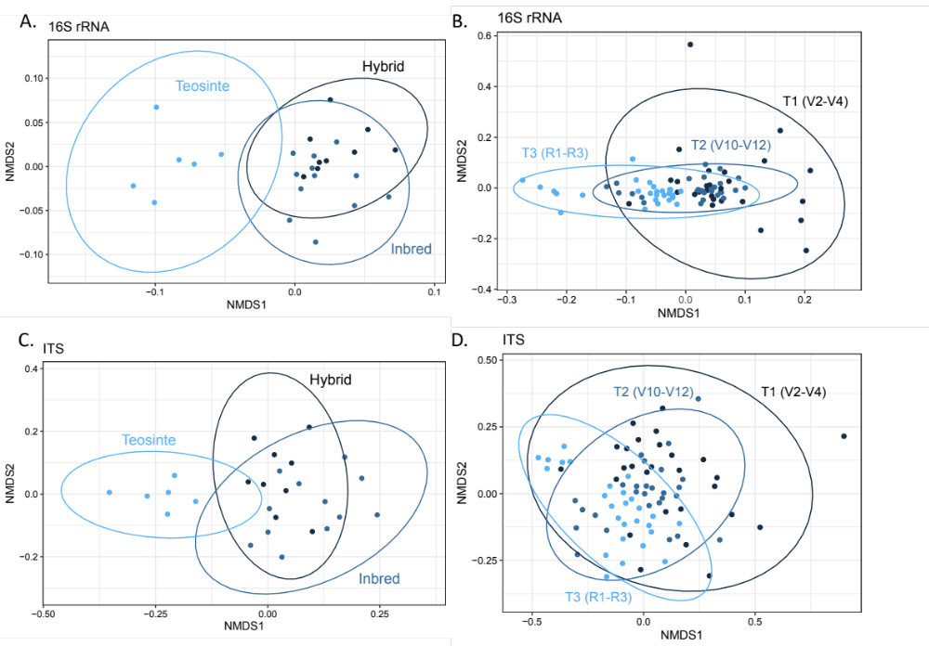
Figure S7. NMDS ordinations based on Bray-Curtis dissimilarity among prokaryotic 16S rRNA (A-B) and fungal ITS (C-D) displaying that genetic (A, C) and temporal (B, D) effects are driving changes in composition of the root zone microbiome. (A, C) shows that inbred, hybrid, and teosinte maize lines host different microbial taxa in the root zone under the same environmental conditions. Each point represents a genotypic mean (within mean n= 12) of the microbial community across the three different sampling time points. (B, D) highlights the temporal effects of the rhizosphere microbiome timepoint 1 (young plants V2-V4), 2 (Fast growing approaching flowering V10-V12), 3 (Reproductive R1-R3). (Within mean n=4). Statistics for ordinations present in Table S10.

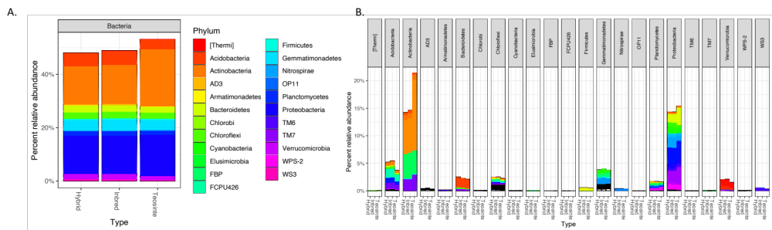Figure S8. OTUs that differed significantly based on DESeq2 analysis of microbiomes associated with teosinte and inbred maize. A. Relative abundance of bacterial OTUs colored by phylum. The most contrasting differences were seen in Acidobacteria, Actinobacteria, and Proteobacteria as seen in S9. B. This panel shows the same relative abundance data as in A but faceted by phylum and colored by taxonomic classification to improve clarity. These taxa were major contributors to the microbiome differences displayed in Figs. S6-7

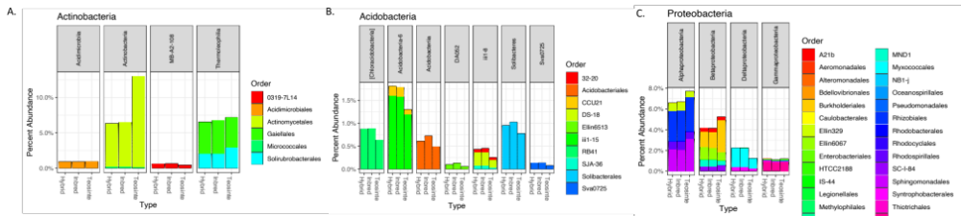
Figure S9. Differentially abundant OTUs based on DESeq2 determined by teosinte and inbred maize comparison. A. OTUs within order Actinobacteria that differ among teosinte and inbred maize. B. OTUs within order Acidobacteria that differ among maize classifications. C. OTUs within order Proteobacteria that differ among maize classifications. These OTUs contribute to differences in microbiome assemblages displayed in Figures S7.

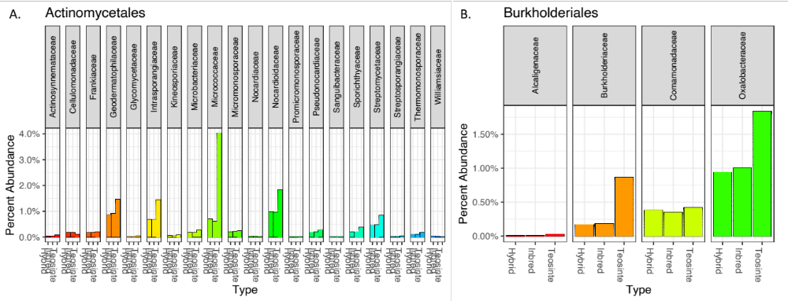
Figure S10. OTUs with significantly different relative abundance, based on DESeq2 analysis comparing the microbiomes of teosinte and inbred maize. These taxa were major contributors to the microbiome differences displayed in Figs. S6-7. A. OTUs within the Actinomycetales that were significantly different between teosinte and inbred maize. B. OTUs within the order Burkholderiales that were significantly different between teosinte and inbred maize.

Figure S11. NMDS ordinations based on Bray-Curtis dissimilarity among nitrification (A-B) and denitrification (C-E) functional genes. Highlights the temporal effects of the rhizosphere microbiome timepoint 1 (young plants V2-V4), 2 (Fast growing approaching flowering V10-V12), 3 (Reproductive R1-R3). (Within mean n=4). Statistics presented in the plot are from PerMANOVA for time.

Supplemental Information: Tables
Tables S1. Accession table of lines grown in this experiment. Hybrid genotypes were generated from previous crosses in the field.
Genotypes | Classification | Accession #
B73 | Inbred | PI 550473
LH1 | Inbred | PI 644101
LH123 | Inbred | PI 601079
LH82 | Inbred | PI 601170
Mo17 | Inbred | PI 558532
PH207 | Inbred | PI 601005
PHG35 | Inbred | PI 601008
PHG39 | Inbred | PI 600981
PHG47 | Inbred | PI 601318
PHG84 | Inbred | PI 601320
PHJ40 | Inbred | PI 601321
PHZ51 | Inbred | PI 601322
B73/PHJ40 | Hybrid | NA
B73/PHZ51 | Hybrid | NA
CHECK1 | Hybrid | NA
CHECK2 | Hybrid | NA
LH82/PH207 | Hybrid | NA
LH82/PHJ40 | Hybrid | NA
PHG39/PHZ51 | Hybrid | NA
PHG47/PHG84 | Hybrid | NA
PHG47/PHJ40 | Hybrid | NA
PI566677 | Teosinte: Z. M. Mexicana | PI566677
PI658188 | Teosinte: Z. M. Mexicana | PI658188
PI658205 | Teosinte: Z. M. Mexicana | PI658205
Ames21809 | Teosinte: Z. M. Parviglumis | Ames21809
Ames21785 | Teosinte: Z. M. Parviglumis | Ames21785
Ames21786 | Teosinte: Z. M. Parviglumis | Ames21786

Table S2. Primers used in amplicon sequencing and qPCR characterization of rhizosphere microbial community.
Target | Encodes | Primer Name | Sequence | Reference
16S rRNA | Ribosomal RNA | 515F | 5'-GTGYCAGCMGCCGCGGTAA-3' | Fierer et al. 2011
16S rRNA | Ribosomal RNA | 806R | 5'-GGACTACVSGGGTATCTAAT-3' | Fierer et al. 2011
ITS | Internal Transcribed Spacer | ITS1F | 5'-TTCGTAGGTGAACCTGCGG-3' | White et al. 1990
ITS | Internal Transcribed Spacer | ITS4R | 5'-TCCTCCGCTTATTGATATGC-3' | White et al. 1990
bacterial amoA | Ammonia Monooxygenase | amoA-1F | 5'-GGGGTTTCTACTGGTGGT-3' | Oakley et al. 2005
bacterial amoA | Ammonia Monooxygenase | amoA-2R | 5'-CCCCTCKGSAAAGCCTTCTTC-3' | Oakley et al. 2005
archeal amoA | Ammonia Monooxygenase | CrenamoA23f | 5'-ATGGTCTGGCTWAGACG-3' | Francis et al. 2005
archeal amoA | Ammonia Monooxygenase | CrenamoA616r | 5'-GCCATCCATCTGTATGTCCA-3' | Francis et al. 2005
Typical nosZ | Nitrous oxide reductase | nosZ1F | 5'-WCSYTGTTCMTCGACAGCCAG-3' | Henry et al. 2006
Typical nosZ | Nitrous oxide reductase | nosZ1R | 5'-ATGTCGATCARCTGVKCRTTYTC-3' | Henry et al. 2006
nirK | Nitrite Reductase | nirK876 | 5'-ATYGGCGGVCAYGGCGA-3' | Henry et al. 2004
nirK | Nitrite Reductase | nirK1040 | 5'-GCCTCGATCAGRTTRTGGTT-3' | Henry et al. 2004
nirS | Nitrite Reductase | nirSCd3aF | 5'-AACGYSAAGGARACSGG-3' | Kandeler et al. 2006
nirS | Nitrite Reductase | nirSR3cd | 5'-GASTTCGGRTGSGTCTTSAYGAA-3' | Kandeler et al. 2006
norB | Nitric Oxide Reductase | cnorB2F | 5'-GACAAGNNNTACTGGTGGT-3' | Braker et al. 2003
norB | Nitric Oxide Reductase | cnorB6R | 5'-GAANCCCCANACNCCNGC-3' | Braker et al. 2003

Tables S3. Quality of amplicon sequencing for all genes in this study.
Amplicon | Raw Reads | Quality Filtered Reads | Rarefaction Level
16S rRNA gene | 79,484,164 | 74,085,411 | 100000
fungal ITS | 8,531,066 | 7,766,289 | 10000
bacterial amoA | 1,613,336 | 1,478,539 | 337
archaeal amoA | 3,561,327 | 3,257,457 | 2500
nirK | 23,143,193 | 23,066,482 | 1948
nirS | 6,239,375 | 5,661,656 | 1164
nosZ | 9,306,149 | 7,071,538 | 2202

Table S4. Functional gene summary of amplicon functional composition gene and qPCR abundance data from PerMANOVA and ASREML statistical analysis. S4.1 displays the genotype summary. S4.2 displays the plant classification summary. Full statistical model presented in S5-6.

Table S4.1. Overview of statistical analysis for genotypes effects on different functional genes.
Ecosystem Process | Gene | Significant Composition Across Genotype (p<0.05) | Significant Composition Genotype:Time Interaction (p<0.05) | qPCR Abundance Significance in Relation to Genotype (p<0.05 ) | qPCR Abundance Significance Genotype:Time Interaction (p<0.05)
Nitrification | Bacterial amoA | Non-Significant | Significant | Non-Significant | Non-Significant
Nitrification | Archeal amoA | Significant | Non-Significant | Non-Significant | Non-Significant
Denitrification | nirK | Significant | Non-Significant | Non-Significant | Non-Significant
Denitrification | nirS | Significant | Non-Significant | Non-Significant | Non-Significant
Denitrification | nosZ | Significant | Non-Significant | Non-Significant | Non-Significant

Table S4.2 Overview of statistical analysis for classification (inbred, hybrid, teosinte) effects on different functional genes. (Class shorten from Classification).
Ecosystem Process | Gene | Significant Composition Across Class (p<0.05) | Significant Composition Class:Time Interaction (p<0.05) | qPCR Abundance Significance in Relation to Class (p<0.05 ) | qPCR Abundance Significance Class:Time Interaction (p<0.05)
Nitrification | Bacterial amoA | Non-Significant | Significant | Non-Significant | Significant
Nitrification | Archeal amoA | Significant | Significant | Non-Significant | Non-Significant
Denitrification | nirK | Significant | Non-Significant | Non-Significant | Significant
Denitrification | nirS | Significant | Non-Significant | Non-Significant | Significant
Denitrification | nosZ | Significant | Significant | Significant | Significant

Table S5. Functional Gene Summary of amplicon functional from PerMANOVA models. 999 permutations were used in analysis. All factors in the model were run as fixed effect: Microbial Community Matrix = Genotype (or Classification) x Sampling Time + Row x Range + Residuals. Interactions between plant classification (inbred, hybrid, teosinte) and time were incorporated to understand plant growth changes, while row and range interactions were used to understand spatial effects. Row and Range factors were stratified as they were random factors

Table S5.1. Bacterial amoA Classification (inbred, hybrid, teosinte) model
 | Df | SumsOfSqs | MeanSqs | F.Model | R2 | Pr(>F)
Classification | 2 | 0.594 | 0.29722 | 0.86977 | 0.0056 | 0.661
Time | 2 | 1.691 | 0.84538 | 2.47386 | 0.01593 | 0.001 | ***
Row | 1 | 0.533 | 0.53302 | 1.55979 | 0.00502 | 0.102
Range | 1 | 0.413 | 0.41304 | 1.20869 | 0.00389 | 0.256
Block | 91 | 35.427 | 0.38931 | 1.13926 | 0.3337 | 0.007 | **
Classification:Time | 4 | 1.897 | 0.4742 | 1.38768 | 0.01787 | 0.028 | *
Residuals | 192 | 65.611 | 0.34172 | 0.618
Total | 293 | 106.166 | 1

Table S5.2 Bacterial amoA Genotype Model
 | Df | SumsOfSqs | MeanSqs | F.Model | R2 | Pr(>F)
Genotype | 26 | 9.403 | 0.36164 | 1.0811 | 0.08857 | 0.158
Time | 2 | 1.73 | 0.86514 | 2.5862 | 0.0163 | 0.001 | ***
Row | 1 | 0.533 | 0.53267 | 1.5923 | 0.00502 | 0.087 | .
Range | 1 | 0.396 | 0.39591 | 1.1835 | 0.00373 | 0.274
Block | 72 | 28.34 | 0.39362 | 1.1767 | 0.26694 | 0.007 | **
Genotype:Time | 52 | 19.266 | 0.3705 | 1.1076 | 0.18147 | 0.042 | *
Residuals | 139 | 46.499 | 0.33452 | ng
Total | 293 | 106.166 | 1

Table S5.3 Bacterial amoA Nested Genotype/Classification Model
 | Df | SumsOfSqs | MeanSqs | F.Model | R2 | Pr(>F)
Classification | 2 | 0.594 | 0.29722 | 0.88849 | 0.0056 | 0.623
Time | 2 | 1.691 | 0.84538 | 2.52712 | 0.01593 | 0.001 | ***
Row | 1 | 0.533 | 0.53302 | 1.59338 | 0.00502 | 0.066 | .
Range | 1 | 0.413 | 0.41304 | 1.23471 | 0.00389 | 0.242
Block | 91 | 35.427 | 0.38931 | 1.16378 | 0.3337 | 0.001 | ***
Classification:Genotype | 5 | 1.743 | 0.34868 | 1.04231 | 0.01642 | 0.38
Classification:Time | 4 | 1.897 | 0.4742 | 1.41756 | 0.01787 | 0.033 | *
Classification :Genotype:Time | 48 | 17.369 | 0.36186 | 1.08171 | 0.1636 | 0.101
Residuals | 139 | 46.499 | 0.33452 | 0.43798
Total | 293 | 106.166 | 1

Table S5.4 Archeal amoA Classification Model
 | Df | SumsOfSqs | MeanSqs | F.Model | R2 | Pr(>F)
Classification | 2 | 0.464 | 0.232 | 2.452 | 0.01165 | 0.008 | **
Time | 2 | 6.806 | 3.403 | 35.955 | 0.17089 | 0.001 | ***
Row | 1 | 3.224 | 3.2242 | 34.066 | 0.08096 | 0.001 | ***
Range | 1 | 0.387 | 0.3867 | 4.086 | 0.00971 | 0.003 | **
Block | 91 | 9.43 | 0.1036 | 1.095 | 0.23678 | 0.123
Classification:Time | 4 | 1.154 | 0.2886 | 3.049 | 0.02898 | 0.001 | ***
Residuals | 194 | 18.361 | 0.0946 | 0.46103
Total | 295 | 39.827 | 1

Table S5.5 Archeal amoA Genotype Model
 | Df | SumsOfSqs | MeanSqs | F.Model | R2 | Pr(>F)
Genotype | 26 | 3.346 | 0.1287 | 1.374 | 0.08401 | 0.007 | **
Time | 2 | 6.798 | 3.3989 | 36.285 | 0.17068 | 0.001 | ***
Row | 1 | 2.708 | 2.7076 | 28.905 | 0.06799 | 0.001 | ***
Range | 1 | 0.406 | 0.4062 | 4.337 | 0.0102 | 0.002 | **
Block | 72 | 7.812 | 0.1085 | 1.158 | 0.19614 | 0.027 | *
Genotype:Time | 52 | 5.55 | 0.1067 | 1.139 | 0.13935 | 0.075 | .
Residuals | 141 | 13.208 | 0.0937 | 0.33163
Total | 295 | 39.827 | 1

Table S5.6 Archeal amoA nested Genotype/ Classification Model
 | Df | SumsOfSqs | MeanSqs | F.Model | R2 | Pr(>F)
Classification | 2 | 0.464 | 0.232 | 2.477 | 0.01165 | 0.005 | **
Time | 2 | 6.806 | 3.403 | 36.329 | 0.17089 | 0.001 | ***
Row | 1 | 3.224 | 3.2242 | 34.42 | 0.08096 | 0.001 | ***
Range | 1 | 0.387 | 0.3867 | 4.129 | 0.00971 | 0.003 | **
Block | 91 | 9.43 | 0.1036 | 1.106 | 0.23678 | 0.101
Classification:Genotype | 5 | 0.758 | 0.1516 | 1.618 | 0.01903 | 0.024 | *
Classification:Time | 4 | 1.154 | 0.2886 | 3.081 | 0.02898 | 0.001 | ***
Classification:  Genotype:Time | 48 | 4.396 | 0.0916 | 0.978 | 0.11037 | 0.591
Residuals | 141 | 13.208 | 0.0937 | 0.33163
Total | 295 | 39.827 | 1

Table S5.7 nirK Classification Model
 | Df | SumsOfSqs | MeanSqs | F.Model | R2 | Pr(>F)
Classification | 2 | 1.11 | 0.555 | 1.43 | 0.00933 | 0.004 | **
Time | 2 | 3.188 | 1.59391 | 4.1068 | 0.0268 | 0.001 | ***
Row | 1 | 0.688 | 0.68803 | 1.7727 | 0.00578 | 0.002 | **
Range | 1 | 0.472 | 0.47213 | 1.2165 | 0.00397 | 0.09 | .
Block | 91 | 36.562 | 0.40178 | 1.0352 | 0.30733 | 0.042 | *
Classification:Time | 4 | 1.654 | 0.41339 | 1.0651 | 0.0139 | 0.21
Residuals | 194 | 75.295 | 0.38812 | 0.6329
Total | 295 | 118.968 | 1

Table S5.8 nirk Genotype Model
 | Df | SumsOfSqs | MeanSqs | F.Model | R2 | Pr(>F)
Genotype | 26 | 10.984 | 0.42248 | 1.0986 | 0.09233 | 0.003 | **
Time | 2 | 3.142 | 1.57106 | 4.0854 | 0.02641 | 0.001 | ***
Row | 1 | 0.556 | 0.55561 | 1.4448 | 0.00467 | 0.011 | *
Range | 1 | 0.483 | 0.48293 | 1.2558 | 0.00406 | 0.064 | .
Block | 72 | 29.081 | 0.4039 | 1.0503 | 0.24444 | 0.019 | *
Genotype:Time | 52 | 20.5 | 0.39424 | 1.0252 | 0.17232 | 0.162
Residuals | 141 | 54.222 | 0.38455 | 0.45577
Total | 295 | 118.968 | 1

Table S5.9 nirK Genotype/ Classification Model
 | Df | SumsOfSqs | MeanSqs | F.Model | R2 | Pr(>F)
Classification | 2 | 1.11 | 0.555 | 1.4432 | 0.00933 | 0.001 | ***
Time | 2 | 3.188 | 1.59391 | 4.1448 | 0.0268 | 0.001 | ***
Row | 1 | 0.688 | 0.68803 | 1.7892 | 0.00578 | 0.001 | ***
Range | 1 | 0.472 | 0.47213 | 1.2277 | 0.00397 | 0.089 | .
Block | 91 | 36.562 | 0.40178 | 1.0448 | 0.30733 | 0.024 | *
Classification:Genotype | 5 | 2.226 | 0.44521 | 1.1577 | 0.01871 | 0.027 | *
Classification:Time | 4 | 1.654 | 0.41339 | 1.075 | 0.0139 | 0.159
Classification:Genotype:Time | 48 | 18.847 | 0.39264 | 1.021 | 0.15842 | 0.206
Residuals | 141 | 54.222 | 0.38455 | 0.45577
Total | 295 | 118.968 | 1

Table S5.10 nirS Classification Model
 | Df | SumsOfSqs | MeanSqs | F.Model | R2 | Pr(>F)
Classification | 2 | 1.303 | 0.65133 | 1.7675 | 0.01149 | 0.001 | ***
Time | 2 | 1.415 | 0.70762 | 1.9202 | 0.01248 | 0.001 | ***
Row | 1 | 1.224 | 1.22417 | 3.3219 | 0.0108 | 0.003 | **
Range | 1 | 0.799 | 0.79936 | 2.1691 | 0.00705 | 0.001 | ***
Block | 91 | 35.535 | 0.3905 | 1.0597 | 0.31342 | 0.001 | ***
Classification:Time | 4 | 1.609 | 0.40222 | 1.0915 | 0.01419 | 0.185
Residuals | 194 | 71.492 | 0.36851 | 0.63056
Total | 295 | 113.377 | 1

Table S5.11 nirS Genotype Model
 | Df | SumsOfSqs | MeanSqs | F.Model | R2 | Pr(>F)
Genotype | 26 | 10.581 | 0.40697 | 1.08047 | 0.09333 | 0.031 | *
Time | 2 | 1.409 | 0.70462 | 1.8707 | 0.01243 | 0.001 | ***
Row | 1 | 1.015 | 1.01503 | 2.69481 | 0.00895 | 0.001 | ***
Range | 1 | 0.798 | 0.79755 | 2.11741 | 0.00703 | 0.001 | ***
Block | 72 | 28.471 | 0.39543 | 1.04984 | 0.25112 | 0.054 | .
Genotype:Time | 52 | 17.994 | 0.34603 | 0.91868 | 0.15871 | 0.998
Residuals | 141 | 53.109 | 0.37666 | 0.46843
Total | 295 | 113.377 | 1

Table S5.12 nirS Nested Genotype/ Classification Model
 | Df | SumsOfSqs | MeanSqs | F.Model | R2 | Pr(>F)
Classification | 1 | 0.34 | 0.3401 | 0.8887 | 0.00364 | 0.677
Time | 3 | 2.347 | 0.78227 | 2.04408 | 0.02512 | 0.001 | ***
Row | 1 | 0.98 | 0.97993 | 2.56059 | 0.01049 | 0.001 | ***
Range | 1 | 0.818 | 0.81839 | 2.13847 | 0.00876 | 0.002 | **
Block | 80 | 31.504 | 0.39379 | 1.029 | 0.33723 | 0.171
Classification:Time | 2 | 0.748 | 0.37406 | 0.97742 | 0.00801 | 0.541
Classification:  Genotype:Time | 43 | 14.967 | 0.34808 | 0.90954 | 0.16022 | 0.999
Residuals | 109 | 41.714 | 0.3827 | 0.44653
Total | 240 | 93.418 | 1

Table S5.13 nosZ Classification Model
 | Df | SumsOfSqs | MeanSqs | F.Model | R2 | Pr(>F)
Classification | 2 | 1.288 | 0.64412 | 1.407 | 0.00935 | 0.001 | ***
Time | 2 | 1.857 | 0.92856 | 2.0283 | 0.01347 | 0.001 | ***
Row | 1 | 0.805 | 0.80456 | 1.7574 | 0.00584 | 0.001 | ***
Range | 1 | 0.581 | 0.58138 | 1.2699 | 0.00422 | 0.001 | ***
Block | 91 | 42.41 | 0.46604 | 1.018 | 0.30771 | 0.001 | ***
Classification:Time | 4 | 2.07 | 0.51758 | 1.1306 | 0.01502 | 0.013 | *
Residuals | 194 | 88.813 | 0.4578 | 0.64439
Total | 295 | 137.825 | 1

Table S5.14 nosZ Genotype Model
 | Df | SumsOfSqs | MeanSqs | F.Model | R2 | Pr(>F)
Genotype | 26 | 12.225 | 0.4702 | 1.0274 | 0.0887 | 0.011 | *
Time | 2 | 1.856 | 0.92801 | 2.0277 | 0.01347 | 0.001 | ***
Row | 1 | 0.786 | 0.78573 | 1.7168 | 0.0057 | 0.151
Range | 1 | 0.546 | 0.54594 | 1.1929 | 0.00396 | 0.057 | .
Block | 72 | 33.931 | 0.47126 | 1.0297 | 0.24619 | 0.034 | *
Genotype:Time | 52 | 23.951 | 0.4606 | 1.0064 | 0.17378 | 0.271
Residuals | 141 | 64.53 | 0.45766 | 0.4682
Total | 295 | 137.825 | 1

Table S5.15 nosZ Genotype/ Classification Model
 | Df | SumsOfSqs | MeanSqs | F.Model | R2 | Pr(>F)
Type | 2 | 1.288 | 0.64412 | 1.40742 | 0.00935 | 0.006 | **
Time | 2 | 1.857 | 0.92856 | 2.02893 | 0.01347 | 0.001 | ***
Row | 1 | 0.805 | 0.80456 | 1.75799 | 0.00584 | 0.003 | **
Range | 1 | 0.581 | 0.58138 | 1.27033 | 0.00422 | 0.008 | **
Block | 91 | 42.41 | 0.46604 | 1.01831 | 0.30771 | 0.008 | **
Classification:Genotype | 5 | 2.403 | 0.4805 | 1.04992 | 0.01743 | 0.193
Classification:Time | 4 | 2.07 | 0.51758 | 1.13093 | 0.01502 | 0.018 | *
Classification:  Genotype:Time | 48 | 21.881 | 0.45585 | 0.99605 | 0.15876 | 0.468
Residuals | 141 | 64.53 | 0.45766 | 0.4682
Total | 295 | 137.825 | 1

Table S6. Mixed effect models comparing qPCR of functional genes and genotype, plant classification, space, and time. Genotype and time of sampling were run as a fixed effect, while sampling block, range, and row were run as random factors. Wald tests performed on statistical models to calculate significance. Statistical models were run in ‘asreml-r’.

Table S6.1 Bacterial amoA qPCR Classification Model
Factor | Df | Sum of Sq | Wald | Pr(Chisq)
(Intercept) | 1 | 167727 | 135.24 | 2.20E-16 | ***
Classification | 2 | 157 | 0.127 | 0.93856
Time | 2 | 10205 | 8.229 | 0.01634 | *
Classification:Time | 4 | 35000 | 28.221 | 1.13E-05 | ***
residual |  | 1240

Table S6.5 Bacterial amoA qPCR Genotype Model
Factor | Df | Sum of Sq | Wald | Pr(Chisq)
(Intercept) | 1 | 159311 | 120.66 | 2.00E-16 | ***
Classification | 26 | 15361 | 11.634 | 0.99305
Time | 2 | 9378 | 7.103 | 0.02868 | *
Classification:Time | 52 | 83863 | 63.517 | 0.13144
residual |  | 1320

Table S6.6 Arch amoA qPCR Classification Model
Factor | Df | Sum of Sq | Wald | Pr(Chisq)
(Intercept) | 1 | 468689956 | 37.761 | 8.00E-10 | ***
Classification | 2 | 35436473 | 2.855 | 0.2399
Time | 2 | 43443468 | 3.5 | 0.1738
Classification:Time | 4 | 76664810 | 6.177 | 0.1863
residual |  | 12412117

Table S6.7 Arch amoA qPCR Genotype Model
Factor | Df | Sum of Sq | Wald | Pr(Chisq)
(Intercept) | 1 | 772154049 | 59.269 | 1.38E-14 | ***
Genotype | 26 | 305307733 | 23.435 | 0.6082
Time | 2 | 42938857 | 3.296 | 0.1924
Genotype:Time | 52 | 669965740 | 51.426 | 0.4964
residual |  | 13027864

Table S6.8 nirK qPCR Classification Model
Factor | Df | Sum of Sq | Wald | Pr(Chisq)
(Intercept) | 1 | 3191339410 | 494.32 | 2.20E-16 | ***
Classification | 2 | 4872529 | 0.75 | 0.6856658
Time | 2 | 59666289 | 9.24 | 0.0098429 | **
Classification:Time | 4 | 137359821 | 21.28 | 0.0002791 | ***
residual |  | 6455991

Table S6.9 nirK qPCR Genotype Model
Factor | Df | Sum of Sq | Wald | Pr(Chisq)
(Intercept) | 1 | 3085673717 | 472.49 | 2.20E-16 | ***
Genotype | 26 | 113556098 | 17.39 | 0.896892
Time | 2 | 61635999 | 9.44 | 0.008925 | **
Genotype:Time | 52 | 448758443 | 68.72 | 0.060059 | .
residual |  | 6530707

Table S6.10 nirS qPCR Classification Model
Factor | Df | Sum of Sq | Wald | Pr(Chisq)
(Intercept) | 1 | 142927550 | 50.098 | 1.46E-12 | ***
Classification | 2 | 12327195 | 4.321 | 0.115275
Time | 2 | 91423589 | 32.045 | 1.10E-07 | ***
Classification:Time | 4 | 39142572 | 13.72 | 0.008244 | **
residual | (MS) | 2852939

Table S6.11 nirS qPCR Genotype Model
Factor | Df | Sum of Sq | Wald | Pr(Chisq)
(Intercept) | 1 | 3085673717 | 472.49 | 2.20E-16 | ***
Genotype | 26 | 113556098 | 17.39 | 0.896892
Time | 2 | 61635999 | 9.44 | 0.008925 | **
Genotype:Time | 52 | 448758443 | 68.72 | 0.060059 | .
residual |  | 6530707

Table S6.12 nosZ qPCR Classification Model
Factor | Df | Sum of Sq | Wald | Pr(Chisq)
(Intercept) | 1 | 294866123 | 20.09 | 7.39E-06 | ***
Classification | 2 | 295357031 | 20.124 | 4.27E-05 | ***
Time | 2 | 1221569930 | 83.23 | 2.20E-16 | ***
Classification:Time | 4 | 719736962 | 49.038 | 5.73E-10 | ***
residual |  | 14677047

Table S6.13 nosZ qPCR Genotype Model
Factor | Df | Sum of Sq | Wald | Pr(Chisq)
(Intercept) | 1 | 5127618121 | 308.503 | 2.00E-16 | ***
Genotype | 26 | 607829600 | 36.57 | 0.08167 | .
Time | 2 | 1227441338 | 73.849 | 2.00E-16 | ***
Genotype:Time | 52 | 1118209396 | 67.277 | 0.07547 | .
residual |  | 16620956

Table S7. Mixed effect models comparing potential nitrification and genotype, plant classification, space, and time. Genotype and growth stage were run as a fixed effect, while sampling block, sampling date, range, and row were run as random factors. Wald tests performed on statistical models to calculate significance. Statistical models were run in ‘asreml-r’.

Table S7.1 Log of Nitrification Rate Per Genotype
Terms | DF | Sum of Sq | Wald Statistic | Pr (Chisq) | Significant
(Intercept) | 1 | 25085.9 | 92498 | <2.2E-16 | ***
Genotype | 26 | 14.9 | 55 | 0.001 | **
Growth Stage | 2 | 2.6 | 10 | 0.007 | **
Genotype:Growth | 49 | 12.9 | 47 | 0.54
residual |  | 0.3

Table S7.2 log of Nitrification Rate per Classification
Terms | DF | Sum of Sq | Wald Statistic | Pr (Chisq) | Significant
(Intercept) | 1 | 7099.4 | 29956.9 | <2.2E-16 | ***
Classification | 2 | 4.7 | 19.8 | 5.11E-05 | ***
Growth Stage | 2 | 0.4 | 1.8 | 0.40
Classification:Growth | 4 | 3.1 | 13.2 | 0.01 | *
residual |  | 0.2

Table S8. Mixed effect models comparing potential denitrification and genotype, plant classification, space, and time. Genotype and growth stage were run as a fixed effect, while sampling block, range, sample date, and row were run as random factors. Wald tests performed on statistical models to calculate significance. Statistical models were run in ‘asreml-r’.

Table S8.1 Log of potential (N₂O + N₂) DEA rate Genotype Model
Terms | DF | Sum of Sq | Wald Statistic | Pr (Chisq) | Significant
(Intercept) | 1 | 22.01 | 16.539 | 4.77E-05 | ***
Genotype | 26 | 64.33 | 48.338 | 0.007 | **
Growth Stage | 2 | 0.43 | 0.322 | 0.85
Genotype:Growth | 52 | 56.602 | 42.53 | 0.82
residual |  | 1.33

Table S8.3 Log of potential (N₂O + N₂) DEA rate (N₂O + N₂) Classification Model
Terms | DF | Sum of Sq | Wald Statistic | Pr (Chisq) | Significant
(Intercept) | 1 | 11.27 | 8.84 | 2.9E-03 | **
Classification | 2 | 22.02 | 17.28 | 2.7E-04 | ***
Growth Stage | 2 | 2.57 | 2.01 | 0.36
Classification:Growth | 4 | 4.89 | 3.84 | 0.43
residual |  | 1.27

Table S8.4 Log of potential (N₂O) DEA rate Genotype Model
Terms | DF | Sum of Sq | Wald Statistic | Pr (Chisq) | Significant
(Intercept) | 1 | 1.71 | 0.96 | 0.32
Genotype | 26 | 56.32 | 31.55 | 0.24
Growth Stage | 2 | 6.58 | 3.689 | 0.16
Genotype:Growth | 52 | 119.30 | 66.24 | 0.09 | .
residual |  | 1.79

Table S8.6 Log of potential (N₂O) DEA rate Classification Model
Terms | DF | Sum of Sq | Wald Statistic | Pr (Chisq) | Significant
(Intercept) | 1 | 3.49 | 1.91 | 0.166
Classification | 2 | 22.46 | 12.33 | 0.002 | ***
Growth Stage | 2 | 13.90 | 13.89 | 0.022 | *
Classification:Growth | 4 | 10.48 | 5.75 | 0.22
residual |  | 1.82

Table S8.7 Log of Complete DEA rate (N₂) Genotype Model
Terms | DF | Sum of Sq | Wald Statistic | Pr (Chisq) | Significant
(Intercept) | 1 | 0.94 | 0.01 | 0.92
Genotype | 26 | 80.1 | 20.71 | 0.8
Growth Stage | 2 | 43.27 | 2.39 | 0.3
Genotype:Growth | 52 | 88.94 | 48.6 | 0.61
residual |  | 1.4

Table S8.8 Log of Complete DEA rate (N₂) Classification Model
Terms | DF | Sum of Sq | Wald Statistic | Pr (Chisq) | Significant
(Intercept) | 1 | 15.93 | 11.44 | 7.20E-04 | ***
Classification | 2 | 42.19 | 6.04 | 4.88E-02 | *
Growth Stage | 2 | 37.52 | 15.16 | 5.10E-04 | ***
Classification:Growth | 4 | 10.21 | 5.71 | 0.22
residual |  | 1.3

Table S9. Genotype effect calculations for potential nitrification, potential (N2O) DEA rate , and potential (N₂O + N₂) DEA rate. Table includes genotype mean, variance, genotype effects which was calculated as the difference between the genotypes mean – the population mean, and the percent change which is the genotypic effects divided by the population mean. These metrics were adapted from Bernardo et al. Breeding for Quantitative Traits in Plants.

Table S9.1 Potential Nitrification
Genotypes | Classification | Mean | Variance | Genotype Effect | Percent Change
Ames21785 | Teosinte | 3223.202 | 1081182.57 | -691.15308 | -0.176568847
Ames21786 | Teosinte | 2774.953 | 88433.44 | -1139.40144 | -0.291082838
Ames21809 | Teosinte | 3133.105 | 746022.14 | -781.24917 | -0.199585692
B73 | Inbred | 3932.59 | 2127444.5 | 18.23587 | 0.004658717
B73/PHJ40 | Hybrid | 4063.868 | 2198144.3 | 149.51344 | 0.038196191
B73/PHZ51 | Hybrid | 3307.112 | 1437775.21 | -607.24263 | -0.155132249
CHECK1 | Hybrid | 3795.58 | 2885350.12 | -118.77462 | -0.030343348
CHECK2 | Hybrid | 3889.966 | 1355353.96 | -24.38811 | -0.006230428
LH1 | Inbred | 4412.906 | 1914200.4 | 498.55092 | 0.127364782
LH123 | Inbred | 4243.162 | 675978.9 | 328.80741 | 0.084000415
LH82 | Inbred | 4265.879 | 3109219.15 | 351.52435 | 0.089803911
LH82/PH207 | Hybrid | 5856.937 | 28458139.93 | 1942.58205 | 0.496271353
LH82/PHJ40 | Hybrid | 2983.589 | 3277029.92 | -930.76514 | -0.237782532
Mo17 | Inbred | 4000.014 | 1853836.7 | 85.6593 | 0.021883378
PH207 | Inbred | 4369.633 | 3803350.28 | 455.27798 | 0.116309845
PHG35 | Inbred | 3714.55 | 3813926.52 | -199.8045 | -0.051044047
PHG39 | Inbred | 3401.902 | 2167152.55 | -512.45228 | -0.130916162
PHG39/PHZ51 | Hybrid | 3243.783 | 4451418.24 | -670.57131 | -0.171310824
PHG47 | Inbred | 3825.386 | 3776140.43 | -88.96846 | -0.02272877
PHG47/PHG84 | Hybrid | 4195.987 | 5260178.39 | 281.63267 | 0.071948687
PHG47/PHJ40 | Hybrid | 3163.181 | 1001909.37 | -751.17393 | -0.191902373
PHG84 | Inbred | 4927.571 | 3589665.08 | 1013.2166 | 0.258846401
PHJ40 | Inbred | 4235.362 | 2139689.2 | 321.00759 | 0.082007795
PHZ51 | Inbred | 3673.76 | 1545063.7 | -240.595 | -0.061464796
PI566677 | Teosinte | 2987.754 | 1989648.34 | -926.60081 | -0.23671867
PI658188 | Teosinte | 4287.181 | 26627889.28 | 372.82631 | 0.095245921
PI658205 | Teosinte | 4870.039 | 26617163.44 | 955.68488 | 0.244148777

Table S9.2 Potential (N₂O + N₂) DEA rate Genotype Mean
Genotypes | Classification | Mean | Variance | Genotype Effect | Percent Change
Ames21785 | Teosinte | 12.225411 | 779.658009 | -6.063614 | -0.33154387
Ames21786 | Teosinte | 1.418217 | 7.923932 | -16.870808 | -0.92245529
Ames21809 | Teosinte | 20.975168 | 4754.027636 | 2.686142 | 0.14687182
B73 | Inbred | 26.411203 | 950.937289 | 8.122178 | 0.4441012
B73/PHJ40 | Hybrid | 20.062967 | 1457.794312 | 1.773942 | 0.09699487
B73/PHZ51 | Hybrid | 12.719734 | 120.740613 | -5.569291 | -0.30451545
CHECK1 | Hybrid | 38.901194 | 4490.550549 | 20.612169 | 1.12702391
CHECK2 | Hybrid | 11.884273 | 274.847049 | -6.404752 | -0.3501965
LH1 | Inbred | 11.165771 | 161.450221 | -7.123254 | -0.38948243
LH123 | Inbred | 12.949991 | 113.369208 | -5.339034 | -0.29192559
LH82 | Inbred | 15.97309 | 642.964529 | -2.315935 | -0.12662977
LH82/PH207 | Hybrid | 21.952365 | 250.834562 | 3.663339 | 0.20030261
LH82/PHJ40 | Hybrid | 41.578123 | 1951.876885 | 23.289098 | 1.27339201
Mo17 | Inbred | 25.755179 | 860.418624 | 7.466154 | 0.4082314
PH207 | Inbred | 27.86796 | 1651.695357 | 9.578935 | 0.52375319
PHG35 | Inbred | 23.894519 | 927.46544 | 5.605494 | 0.30649493
PHG39 | Inbred | 8.609285 | 73.497137 | -9.67974 | -0.52926496
PHG39/PHZ51 | Hybrid | 14.804714 | 201.503919 | -3.484311 | -0.19051378
PHG47 | Inbred | 27.369599 | 2933.639208 | 9.080574 | 0.49650398
PHG47/PHG84 | Hybrid | 25.585344 | 457.123644 | 7.296319 | 0.39894523
PHG47/PHJ40 | Hybrid | 34.053087 | 1716.381409 | 15.764062 | 0.86194108
PHG84 | Inbred | 24.404597 | 2230.25515 | 6.115572 | 0.3343848
PHJ40 | Inbred | 15.48927 | 355.858064 | -2.799755 | -0.15308389
PHZ51 | Inbred | 15.445163 | 208.991664 | -2.843862 | -0.15549553
PI566677 | Teosinte | 3.194778 | 37.371736 | -15.094247 | -0.82531722
PI658188 | Teosinte | 6.021103 | 68.286632 | -12.267923 | -0.67078056
PI658205 | Teosinte | 1.354084 | 5.715189 | -16.934941 | -0.92596192

Table S9.3 Potential (N2O) DEA rate Genotype Mean
Genotypes | Classification | Mean | Variance | Genotype Effect | Percent Change
Ames21785 | Teosinte | 0.9733998 | 3.854093 | -7.98603912 | -0.891354826
Ames21786 | Teosinte | 1.3051623 | 6.296865 | -7.6542766 | -0.85432544
Ames21809 | Teosinte | 1.6059257 | 4.038354 | -7.35351324 | -0.820755999
B73 | Inbred | 16.8188358 | 405.154126 | 7.85939689 | 0.877219763
B73/PHJ40 | Hybrid | 7.4729687 | 48.611804 | -1.48647024 | -0.165911086
B73/PHZ51 | Hybrid | 8.1838818 | 32.706687 | -0.7755571 | -0.086563133
CHECK1 | Hybrid | 7.8783329 | 35.574311 | -1.08110598 | -0.120666705
CHECK2 | Hybrid | 8.4449126 | 45.474519 | -0.51452636 | -0.057428413
LH1 | Inbred | 8.6419164 | 55.18519 | -0.31752254 | -0.035440003
LH123 | Inbred | 37.2180497 | 3699.631325 | 28.25861081 | 3.154060322
LH82 | Inbred | 11.6609163 | 102.192998 | 2.70147736 | 0.301523051
LH82/PH207 | Hybrid | 10.7900266 | 38.394728 | 1.83058766 | 0.204319454
LH82/PHJ40 | Hybrid | 11.4109879 | 39.199536 | 2.45154898 | 0.273627512
Mo17 | Inbred | 12.0360989 | 190.165106 | 3.07665997 | 0.343398733
PH207 | Inbred | 8.5943683 | 34.988491 | -0.36507061 | -0.040747039
PHG35 | Inbred | 8.2722852 | 49.910295 | -0.68715377 | -0.076696072
PHG39 | Inbred | 9.8503228 | 80.708558 | 0.89088383 | 0.099435225
PHG39/PHZ51 | Hybrid | 6.9874882 | 20.942325 | -1.97195076 | -0.220097573
PHG47 | Inbred | 9.0023327 | 35.816546 | 0.04289375 | 0.004787548
PHG47/PHG84 | Hybrid | 10.5552713 | 38.582969 | 1.59583234 | 0.178117441
PHG47/PHJ40 | Hybrid | 9.0040367 | 74.346892 | 0.04459775 | 0.004977739
PHG84 | Inbred | 9.5751494 | 39.744606 | 0.61571051 | 0.068721995
PHJ40 | Inbred | 9.184837 | 40.428247 | 0.22539803 | 0.025157606
PHZ51 | Inbred | 12.2326943 | 46.872466 | 3.27325542 | 0.365341563
PI566677 | Teosinte | 2.7090858 | 8.303989 | -6.25035314 | -0.697627741
PI658188 | Teosinte | 1.0254465 | 8.225691 | -7.93399238 | -0.885545674
PI658205 | Teosinte | 5.9606611 | 106.052389 | -2.99877777 | -0.334705979

Tables S10. Permutational multivariate ANOVA model results at the genotypic level for 16S rRNA genes, and fungal ITS. Standard model was run on all amplicon sequence data. Bray-Curtis distance was used to calculate dissimilarity between microbiomes. 999 permutations were used in analysis. All factors in the model were run as fixed effect: Microbial Community Matrix = Classification x Sampling Time + Row x Range + Residuals. This model was used to all other nitrogen cycling genes compositional changes. Interactions between plant classification and time were incorporated to understand plant growth changes, while row and range interactions were used to understand spatial effects. Row and Range factors were stratified as they were random factors.

Table 10.1 Classification (inbred, hybrid, teosinte) x Time Prokaryotic 16S rRNA Model

Factor | Df | SumsOfSqs | MeanSqs | F.Model | R2 | Pr(>F)
Classification | 2 | 1.8712 | 0.93559 | 12.4209 | 0.06447 | 0.001 | ***
Time | 2 | 2.0925 | 1.04623 | 13.8897 | 0.07209 | 0.001 | ***
Row | 1 | 1.0681 | 1.06807 | 14.1797 | 0.0368 | 0.001 | ***
Range | 1 | 0.3445 | 0.34454 | 4.5741 | 0.01187 | 0.001 | ***
Block | 91 | 8.3838 | 0.09213 | 1.2231 | 0.28884 | 0.001 | ***
Classification:Time | 4 | 1.1803 | 0.29507 | 3.9174 | 0.04066 | 0.001 | ***
Residuals | 187 | 14.0856 | 0.07532 | 0.48528
Total | 288 | 29.026 | 1

Table 10.2 Genotype x Time Prokaryotic 16S rRNA Model (included all genotypes)

Factor | Df | SumsOfSqs | MeanSqs | F.Model | R2 | Pr(>F)
Genotype | 26 | 4.2653 | 0.16405 | 2.2087 | 0.14695 | 0.001 | ***
Time | 2 | 2.0737 | 1.03683 | 13.9596 | 0.07144 | 0.001 | ***
Row | 1 | 0.8968 | 0.89683 | 12.0748 | 0.0309 | 0.001 | ***
Range | 1 | 0.3204 | 0.32043 | 4.3142 | 0.01104 | 0.001 | ***
Block | 72 | 6.6467 | 0.09231 | 1.2429 | 0.22899 | 0.001 | ***
Genotype:Time | 52 | 4.8705 | 0.09366 | 1.2611 | 0.1678 | 0.001 | ***
Residuals | 134 | 9.9526 | 0.07427 | 0.34289
Total | 288 | 29.026 | 1

Table 10.3 Nested Genotype-Type x Time Prokaryotic 16S rRNA Model

Factor | Df | SumsOfSqs | MeanSqs | F.Model | R2 | Pr(>F)
Type | 2 | 1.8712 | 0.93559 | 12.5966 | 0.06447 | 0.001 | ***
Time | 2 | 2.0925 | 1.04623 | 14.0862 | 0.07209 | 0.001 | ***
Row | 1 | 1.0681 | 1.06807 | 14.3803 | 0.0368 | 0.001 | ***
Range | 1 | 0.3445 | 0.34454 | 4.6388 | 0.01187 | 0.001 | ***
Block | 91 | 8.3838 | 0.09213 | 1.2404 | 0.28884 | 0.001 | ***
Type:Genotype | 5 | 0.4428 | 0.08855 | 1.1922 | 0.01525 | 0.069 | .
Type:Time | 4 | 1.1669 | 0.29174 | 3.9279 | 0.0402 | 0.001 | ***
Type:Genotype:Time | 48 | 3.7036 | 0.07716 | 1.0388 | 0.1276 | 0.164
Residuals | 134 | 9.9526 | 0.07427 | 0.34289
Total | 288 | 29.026 | 1

Table 10.4 Classification (inbred, hybrid, teosinte) x Time Fungal ITS Model

Factor | Df | SumsOfSqs | MeanSqs | F.Model | R2 | Pr(>F)
Classification | 2 | 3.731 | 1.86552 | 6.0405 | 0.03629 | 0.001 | ***
Time | 2 | 2.267 | 1.13329 | 3.6696 | 0.02205 | 0.001 | ***
Row | 1 | 0.955 | 0.95467 | 3.0912 | 0.00929 | 0.001 | ***
Range | 1 | 0.527 | 0.52721 | 1.7071 | 0.00513 | 0.003 | **
Block | 91 | 30.989 | 0.34054 | 1.1027 | 0.30143 | 0.001 | ***
Classification:Time | 4 | 4.423 | 1.10563 | 3.58 | 0.04302 | 0.001 | ***
Residuals | 194 | 59.914 | 0.30883 | 0.58279
Total | 295 | 102.805 | 1

Table 10.5 Genotype x Time Fungal ITS Model (included all genotypes)

Factor | Df | SumsOfSqs | MeanSqs | F.Model | R2 | Pr(>F)
Genotype | 26 | 12.028 | 0.4626 | 1.5136 | 0.11699 | 0.001 | ***
Time | 2 | 2.246 | 1.12316 | 3.675 | 0.02185 | 0.001 | ***
Row | 1 | 0.995 | 0.99467 | 3.2546 | 0.00968 | 0.001 | ***
Range | 1 | 0.536 | 0.53647 | 1.7553 | 0.00522 | 0.007 | **
Block | 72 | 24.303 | 0.33754 | 1.1044 | 0.2364 | 0.001 | ***
Genotype:Time | 52 | 19.604 | 0.377 | 1.2336 | 0.19069 | 0.001 | ***
Residuals | 141 | 43.093 | 0.30562 | 0.41917
Total | 295 | 102.805 | 1
Table 10.6 Nested Genotype-Type x Time Fungal ITS Model
 | Df | SumsOfSqs | MeanSqs | F.Model | R2 | Pr(>F)
Classification | 2 | 3.731 | 1.86552 | 6.1041 | 0.03629 | 0.001 | ***
Time | 2 | 2.267 | 1.13329 | 3.7082 | 0.02205 | 0.001 | ***
Row | 1 | 0.955 | 0.95467 | 3.1237 | 0.00929 | 0.001 | ***
Range | 1 | 0.527 | 0.52721 | 1.7251 | 0.00513 | 0.002 | **
Block | 91 | 30.989 | 0.34054 | 1.1142 | 0.30143 | 0.001 | ***
Classification:Genotype | 5 | 1.64 | 0.32795 | 1.0731 | 0.01595 | 0.191
Classification:Time | 4 | 4.423 | 1.10563 | 3.6176 | 0.04302 | 0.001 | ***
Classification:  Genotype:Time | 48 | 15.181 | 0.31628 | 1.0349 | 0.14767 | 0.155
Residuals | 141 | 43.093 | 0.30562 | 0.41917
Total | 295 | 102.805 | 1

Table S11. The ASREML least-square means of significantly different soil chemistry analysis. Statistical significance was calculated using Wald’s test p<0.05 and comparison was across plant classification.

 | Hybrid | Inbred | Teosinte
Buffer pH | 6.69±0.02 | 6.68±0.03 | 6.62±0.02
Nitrate | 23.8± 4.75 | 27.89± 4.53 | 39.26± 3.20
Phosphorus | 60.5±6.32 | 52.18±6.03 | 73.81±4.26
Potassium | 184.9±36.56 | 189±34.86 | 348.04±24.65
Sulfur | 8.1±0.65 | 8.09±0.62 | 10±0.44
Manganese | 35.2±1.71 | 31.27±1.63 | 36.68±1.15
Copper | 1.29±0.05 | 1.5±0.05 | 1.38±0.03

