Organic matter decomposition in mountain peatlands: effects of substrate quality and peatland degradation
Charuni Jayasekara*ª, Catherine Leigh^{b}, Jeff Shimeta^{c}, Ewen Silvester^{d}, Samantha Groverª

Table S1: Weight loss data of the filter paper mesh bags used as a control experiment
Mesh bag  number | Peatland | Depth | Initial weight of the filter papers (g) | Oven-dried weight after retrieval (g)W1 | Weight loss after  incubation (g) W0-W1 | W0-W1/W0 | Percentage weight loss (%)  W0-W1/W0*100
F1 | Intact | 5 | 3.000 | 2.3680 | 0.632 | 0.211 | 21.07
F2 | Intact | 15 | 3.004 | 2.1188 | 0.885 | 0.295 | 29.47
F3 | Intact | 30 | 3.002 | 2.7659 | 0.236 | 0.079 | 7.86
F4 | Degraded | 5 | 3.001 | 2.7992 | 0.202 | 0.067 | 6.72
F5 | Degraded | 15 | 3.004 | 2.4838 | 0.520 | 0.173 | 17.32
F6 | Degraded | 30 | 3.003 | 2.6545 | 0.349 | 0.116 | 11.61

Table S2: Results of the PERMANOVA analysis. Significant interactions are denoted by *.
Variables | Degrees of freedom | Sum of Squares | Mean Sum of Squares | Pseudo-F | P(perm)  values
Site | 1 | 0.077 | 0.077 | 143.55 | 0.001*
Substrate | 1 | 0.117 | 0.117 | 218.64 | 0.001*
Depth | 2 | 0.014 | 0.007 | 13.519 | 0.001*
Time | 3 | 0.015 | 0.005 | 9.3558 | 0.001*
Site x Substrate | 1 | 0.045 | 0.044 | 82.349 | 0.001*
Site x Depth | 2 | 0.014 | 0.007 | 12.817 | 0.001*
Site x Time | 3 | 0.017 | 0.006 | 10.836 | 0.001*
Substrate x Depth | 2 | 0.027 | 0.013 | 24.915 | 0.001*
Substrate x Time | 3 | 0.038 | 0.012 | 23.071 | 0.001*
Depth x Time | 6 | 0.006 | 0.001 | 1.995 | 0.073
Site x Substrate x Depth | 2 | 0.006 | 0.003 | 5.448 | 0.005*
Site x Substrate x Time | 3 | 0.008 | 0.003 | 4.676 | 0.003*
Site x Depth x Time | 6 | 0.005 | 0.001 | 1.404 | 0.219
Substrate x Depth x Time | 6 | 0.002 | 0.001 | 0.576 | 0.750
Site x Substrate x Depth x Time | 6 | 0.002 | 0.001 | 0.486 | 0.822
Residuals | 87 | 0.047 | 0.001
Total | 134 | 0.484

Table S3: Pairwise tests for the factor Site in the interaction Site × Substrate × Depth for decomposition rates (HS1 = Heathy Spur – 1, CSH = Cope Saddle Hut)
Substrate | Depth | Site | t value | p-value | Unique Perms
Fresh peat | 5 cm | CSH, HS1 | 8.1043 | 0.001 | 981
 | 15 cm | CSH, HS1 | 7.9642 | 0.001 | 999
 | 30 cm | CSH, HS1 | 25.833 | 0.001 | 968
Degraded peat | 5 cm | CSH, HS1 | 0.57248 | 0.582 | 993
 | 15 cm | CSH, HS1 | 2.9128 | 0.013 | 996
 | 30 cm | CSH, HS1 | 0.93406 | 0.353 | 998

Table S4: Pairwise tests for the factor Substrate in the interaction Site × Substrate × Depth for decomposition rates.
Site | Depth | Substrate group | t value | p-value | Unique Perms
Intact Heathy Spur - 1 | 5 cm | Fresh peat, Degraded peat | 26.343 | 0.001 | 998
 | 15 cm | Fresh peat, Degraded peat | 10.817 | 0.001 | 996
 | 30 cm | Fresh peat, Degraded peat | 5.5426 | 0.001 | 994
Degraded Cope Saddle Hut | 5 cm | Fresh peat, Degraded peat | 10.217 | 0.001 | 985
 | 15 cm | Fresh peat, Degraded peat | 4.3898 | 0.003 | 996
 | 30 cm | Fresh peat, Degraded peat | 2.6459 | 0.008 | 998

Table S5: Pairwise tests for the factor Depth in the interaction Site × Substrate × Depth for decomposition rates.
Site | Substrate | Depth | t value | p-value | Unique Perms
Intact, Heathy Spur - 1 | Fresh peat | 5,15 | 1.0976 | 0.298 | 972
 |  | 5,30 | 3.3607 | 0.005 | 888
 |  | 15,30 | 1.3728 | 0.175 | 976
 | Degraded peat | 5,15 | 2.6169 | 0.024 | 998
 |  | 5,30 | 1.3028 | 0.233 | 995
 |  | 15,30 | 0.21913 | 0.842 | 997
Degraded, Cope Saddle Hut | Fresh peat | 5,15 | 4.9793 | 0.001 | 998
 |  | 5,30 | 19.467 | 0.001 | 981
 |  | 15,30 | 14.241 | 0.001 | 990
 | Degraded peat | 5,15 | 1.176 | 0.254 | 994
 |  | 5,30 | 0.057 | 0.961 | 996
 |  | 15,30 | 0.51013 | 0.657 | 997

Table S6: Pairwise tests for the factor Site in the interaction Site × Substrate × Time for decomposition rates (HS1 = Heathy Spur – 1, CSH = Cope Saddle Hut).
Substrate | Time | Site | t value | p-value | Unique Perms
Fresh peat | T1 | CSH, HS1 | 10.724 | 0.001 | 995
 | T2 | CSH, HS1 | 12.779 | 0.001 | 995
 | T3 | CSH, HS1 | 13.276 | 0.001 | 993
 | T4 | CSH, HS1 | 8.7412 | 0.001 | 984
Fresh peat | T1 | CSH, HS1 | 1.0632 | 0.325 | 995
 | T2 | CSH, HS1 | 1.0786 | 0.31 | 999
 | T3 | CSH, HS1 | 0.87519 | 0.407 | 807
 | T4 | CSH, HS1 | 0.22056 | 0.86 | 971

Table S7: Table S5: Pairwise tests for the factor Substrate in the interaction Site × Substrate × Time for decomposition rates.
Site | Time | Substrate | t value | p-value | Unique Perms
Heathy Spur - 1 | T1 | Fresh peat, Degraded peat | 7.7139 | 0.001 | 998
 | T2 | Fresh peat, Degraded peat | 10.05 | 0.001 | 990
 | T3 | Fresh peat, Degraded peat | 12.213 | 0.001 | 982
 | T4 | Fresh peat, Degraded peat | 10 | 0.002 | 519
Cope Saddle Hut | T1 | Fresh peat, Degraded peat | 4.5803 | 0.003 | 988
 | T2 | Fresh peat, Degraded peat | 6.7202 | 0.001 | 993
 | T3 | Fresh peat, Degraded peat | 3.3589 | 0.007 | 998
 | T4 | Fresh peat, Degraded peat | 0.56854 | 0.673 | 996

Table S8: Table S4: Pairwise tests for the factor Time in the interaction Site × Substrate × Time for decomposition rates.
Site | Substrate | Time groups | t value | p-value | Unique Perms
Intact, Heathy Spur - 1 | Fresh peat | T1, T2 | 5.0252 | 0.001 | 985
 |  | T1, T3 | 8.8141 | 0.001 | 989
 |  | T1, T4 | 12.402 | 0.001 | 995
 |  | T2, T3 | 6.2075 | 0.001 | 991
 |  | T2, T4 | 12.944 | 0.001 | 982
 |  | T3, T4 | 8.00 | 0.001 | 978
 | Degraded peat | T1, T2 | Negative
 |  | T1, T3 | Negative
 |  | T1, T4 | 0.35768 | 0.746 | 994
 |  | T2, T3 | Negative
 |  | T2, T4 | 0.647 | 0.538 | 870
 |  | T3, T4 | 1.2247 | 0.232 | 615
Degraded, Cope Saddle Hut | Fresh peat | T1, T2 | 0.83934 | 0.41 | 997
 |  | T1, T3 | 0.30343 | 0.79 | 997
 |  | T1, T4 | 2.8062 | 0.014 | 981
 |  | T2, T3 | 1.7553 | 0.103 | 996
 |  | T2, T4 | 4.7178 | 0.003 | 998
 |  | T3, T4 | 3.9081 | 0.003 | 998
 | Degraded peat | T1, T2 | 2.2544 | 0.047 | 996
 |  | T1, T3 | 2.2399 | 0.048 | 987
 |  | T1, T4 | 1.4834 | 0.151 | 984
 |  | T2, T3 | 0.82606 | 0.464 | 995
 |  | T2, T4 | 0.94174 | 0.433 | 997
 |  | T3, T4 | 0.62404 | 0.593 | 980

Table S9: ¹³C NMR analysis results for moss-dominated and partially decomposed peat substrate
Carbon Group | Alkyl  (0-45ppm) | Methoxyl and N-alkyl  (45-60ppm) | O-alkyl  (60-95 ppm) | Di-O-alkyl C  (95-110 ppm) | Aryl and unsaturated C (110-145 ppm) | O-aryl C (145-165 ppm) | Carbonyl and amide C (165-190 ppm) | Ketone C (190-215 ppm) | Alkyl/O-alkyl ratio
Fresh peat | 19 | 22 | 100 | 16 | 10 | 8 | 3 | 2 | 0.14
Degraded peat | 70 | 33 | 100 | 27 | 41 | 13 | 11 | 4 | 0.44

Table S10: The calculated k values for fresh and degraded peat substrate incubated at 5, 15, and 30 cm depths in the intact and the degraded peatlands
Site | Depth (cm) | Substrate type | k value (d⁻¹)
Intact Peatland – Heathy Spur 1 | 5 | Fresh | 1.6 × 10⁻³
Intact Peatland – Heathy Spur 1 | 5 | Degraded | 2.6 × 10⁻⁴
Intact Peatland – Heathy Spur 1 | 15 | Fresh | 1.6 × 10⁻³
Intact Peatland – Heathy Spur 1 | 15 | Degraded | 4.8 × 10⁻⁴
Intact Peatland – Heathy Spur 1 | 30 | Fresh | 1.4 × 10⁻³
Intact Peatland – Heathy Spur 1 | 30 | Degraded | 5.8 × 10⁻⁴
Degraded Peatland – Cope Saddle Hut | 5 | Fresh | 1.1 × 10⁻³
Degraded Peatland – Cope Saddle Hut | 5 | Degraded | 3.9 × 10⁻⁴
Degraded Peatland – Cope Saddle Hut | 15 | Fresh | 9.6 × 10⁻⁴
Degraded Peatland – Cope Saddle Hut | 15 | Degraded | 4.0 × 10⁻⁴
Degraded Peatland – Cope Saddle Hut | 30 | Fresh | 0
Degraded Peatland – Cope Saddle Hut | 30 | Degraded | 2.6 × 10⁻⁴

Table S11: Details of the initial wet weight of the peat substrate, oven dry peat mass after incubation, and the amount of mass loss during the incubation period
Mesh bag  number | Mesh bag  name | Initial weight of the peat sample (g) | Oven-dried weight after retrieval (g)W1 | Oven-dried weight of the initial sub-sample(g) W0 | Weight loss after  incubation (g) W0-W1
1 | DCA5T1S1 | 5.003 | 0.2873 | 0.3721 | 0.0848
2 | DCA5T2S1 | 4.998 | 0.2741 | 0.3721 | 0.098
3 | DCA5T3S1 | 4.999 | 0.2674 | 0.3721 | 0.1047
4 | DCA5T4S1 | 4.999 | 0.2358 | 0.3721 | 0.1363
5 | DCA15T1S1 | 5.001 | Bag lost
6 | DCA15T2S1 | 5.004 | 0.2864 | 0.3721 | 0.0857
7 | DCA15T3S1 | 4.998 | 0.2732 | 0.3721 | 0.0989
8 | DCA15T4S1 | 4.996 | 0.2626 | 0.3721 | 0.1095
9 | DCA30T1S1 | 5.004 | 0.3716 | 0.3721 | 0.0005
10 | DCA30T2S1 | 4.997 | 0.3724 | 0.3721 | -0.0003
11 | DCA30T3S1 | 4.995 | 0.373 | 0.3721 | -0.0009
12 | DCA30TS1 | 5.003 | 0.3691 | 0.3721 | 0.003
13 | DCB5T1S1 | 5.005 | 0.2956 | 0.3721 | 0.0765
14 | DCB5T2S1 | 4.999 | 0.2902 | 0.3721 | 0.0819
15 | DCB5T3S1 | 5.004 | 0.2741 | 0.3721 | 0.098
16 | DCB5T4S1 | 5.004 | 0.266 | 0.3721 | 0.1061
17 | DCB15T1S1 | 5.003 | Bag lost
18 | DCB15T2S1 | 5.002 | Bag lost
19 | DCB15T3S1 | 4.999 | 0.3866 | 0.3721 | -0.0145
20 | DCB15T4S1 | 5.004 | 0.3224 | 0.3721 | 0.0497
21 | DCB30T1S1 | 5.004 | 0.3694 | 0.3721 | 0.0027
22 | DCB30T2S1 | 5.004 | 0.372 | 0.3721 | 1E-04
23 | DCB30T3S1 | 5.005 | 0.3714 | 0.3721 | 0.0007
24 | DCB30T4S1 | 4.996 | 0.368 | 0.3721 | 0.0041
25 | DCC5T1S1 | 5.005 | 0.2653 | 0.3721 | 0.1068
26 | DCC5T2S1 | 5 | 0.2499 | 0.3721 | 0.1222
27 | DCC5T3S1 | 5 | 0.2486 | 0.3721 | 0.1235
28 | DCC5T4S1 | 4.996 | 0.2434 | 0.3721 | 0.1287
29 | DCC15T1S1 | 5.004 | 0.3561 | 0.3721 | 0.016
30 | DCC15T2S1 | 4.999 | 0.2962 | 0.3721 | 0.0759
31 | DCC15T3S1 | 4.999 | 0.2685 | 0.3721 | 0.1036
32 | DCC15T4S1 | 5.003 | 0.2495 | 0.3721 | 0.1226
33 | DCC30T1S1 | 4.997 | 0.3699 | 0.3721 | 0.0022
34 | DCC30T2S1 | 4.996 | 0.3687 | 0.3721 | 0.0034
35 | DCC30T3S1 | 4.999 | 0.373 | 0.3721 | -0.0009
36 | DCC30T4S1 | 5 | 0.3741 | 0.3721 | -0.002
37 | IWA5T1S1 | 4.998 | 0.2446 | 0.3721 | 0.1275
38 | IWA5T2S1 | 5 | 0.2352 | 0.3721 | 0.1369
39 | IWA5T3S1 | 5.001 | 0.2256 | 0.3721 | 0.1465
40 | IWA5T4S1 | 5.005 | 0.2215 | 0.3721 | 0.1506
41 | IWA15T1S1 | 4.995 | 0.2747 | 0.3721 | 0.0974
42 | IWA15T2S1 | 4.998 | 0.2452 | 0.3721 | 0.1269
43 | IWA15T3S1 | 4.998 | 0.2296 | 0.3721 | 0.1425
44 | IWA15T4S1 | 5.005 | 0.2242 | 0.3721 | 0.1479
45 | IWA30T1S1 | 4.997 | 0.2559 | 0.3721 | 0.1162
46 | IWA30T2S1 | 5.005 | 0.2372 | 0.3721 | 0.1349
47 | IWA30T3S1 | 4.997 | 0.2285 | 0.3721 | 0.1436
48 | IWA30T4S1 | 5 | 0.2152 | 0.3721 | 0.1569
49 | IWB5T1S1 | 4.997 | 0.2273 | 0.3721 | 0.1448
50 | IWB5T2S1 | 4.996 | 0.2196 | 0.3721 | 0.1525
51 | IWB5T3S1 | 5.005 | 0.2165 | 0.3721 | 0.1556
52 | IWB5T4S1 | 5.001 | 0.1708 | 0.3721 | 0.2013
53 | IWB15T1S1 | 5.001 | 0.2248 | 0.3721 | 0.1473
54 | IWB15T2S1 | 4.995 | 0.2244 | 0.3721 | 0.1477
55 | IWB15T3S1 | 4.997 | 0.2169 | 0.3721 | 0.1552
56 | IWB15T4S1 | 4.998 | 0.2115 | 0.3721 | 0.1606
57 | IWB30T1S1 | 5 | 0.268 | 0.3721 | 0.1041
58 | IWB30T2S1 | 5 | 0.2652 | 0.3721 | 0.1069
59 | IWB30T3S1 | 4.996 | 0.2644 | 0.3721 | 0.1077
60 | IWB30T4S1 | 4.999 | 0.2397 | 0.3721 | 0.1324
61 | IWC5T1S1 | 5.004 | 0.2227 | 0.3721 | 0.1494
62 | IWC5T2S1 | 5.004 | 0.2193 | 0.3721 | 0.1528
63 | IWC5T3S1 | 5.002 | 0.2169 | 0.3721 | 0.1552
64 | IWC5T4S1 | 5.001 | 0.2126 | 0.3721 | 0.1595
65 | IWC15T1S1 | 4.996 | 0.2284 | 0.3721 | 0.1437
66 | IWC15T2S1 | 4.997 | 0.2217 | 0.3721 | 0.1504
67 | IWC15T3S1 | 4.996 | 0.213 | 0.3721 | 0.1591
68 | IWC15T4S1 | 5.004 | 0.2113 | 0.3721 | 0.1608
69 | IWC30T1S1 | 4.995 | 0.2373 | 0.3721 | 0.1348
70 | IWC30T2S1 | 5.003 | 0.234 | 0.3721 | 0.1381
71 | IWC30T3S1 | 5.003 | 0.2209 | 0.3721 | 0.1512
72 | IWC30T4S1 | 5 | 0.2096 | 0.3721 | 0.1625
73 | IWA5T1S2 | 5.004 | 2.1521 | 2.3099 | 0.1578
74 | IWA5T2S2 | 5.002 | 2.091 | 2.3099 | 0.2189
75 | IWA5T3S2 | 5 | 2.0663 | 2.3099 | 0.2436
76 | IWA5T4S2 | 5 | 1.9679 | 2.3099 | 0.342
77 | IWA15T1S2 | 4.997 | 2.3245 | 2.3099 | -0.0146
78 | IWA15T2S2 | 5.003 | 2.2165 | 2.3099 | 0.0934
79 | IWA15T3S2 | 5.003 | 2.063 | 2.3099 | 0.2469
80 | IWA15T4S2 | 5.004 | 1.6211 | 2.3099 | 0.6888
81 | IWA30T1S2 | 5.004 | 2.2941 | 2.3099 | 0.0158
82 | IWA30T2S2 | 4.999 | 2.154 | 2.3099 | 0.1559
83 | IWA30T3S2 | 5.003 | 2.0661 | 2.3099 | 0.2438
84 | IWA30T4S2 | 5.004 | 1.6436 | 2.3099 | 0.6663
85 | IWB5T1S2 | 4.996 | 2.2441 | 2.3099 | 0.0658
86 | IWB5T2S2 | 4.999 | 2.2091 | 2.3099 | 0.1008
87 | IWB5T3S2 | 5.003 | 2.197 | 2.3099 | 0.1129
88 | IWB5T4S2 | 5.005 | 1.7922 | 2.3099 | 0.5177
89 | IWB15T1S2 | 5.002 | 2.2441 | 2.3099 | 0.0658
90 | IWB15T2S2 | 5.003 | 2.0042 | 2.3099 | 0.3057
91 | IWB15T3S2 | 4.996 | 1.8915 | 2.3099 | 0.4184
92 | IWB15T4S2 | 5.003 | 1.5791 | 2.3099 | 0.7308
93 | IWB30T1S2 | 5.005 | 1.7535 | 2.3099 | 0.5564
94 | IWB30T2S2 | 4.999 | 1.7507 | 2.3099 | 0.5592
95 | IWB30T3S2 | 4.997 | 1.7815 | 2.3099 | 0.5284
96 | IWB30T4S2 | 4.999 | 1.6998 | 2.3099 | 0.6101
97 | IWC5T1S2 | 5.002 | 2.3568 | 2.3099 | -0.0469
98 | IWC5T2S2 | 4.996 | 2.1645 | 2.3099 | 0.1454
99 | IWC5T3S2 | 5.001 | 2.0951 | 2.3099 | 0.2148
100 | IWC5T4S2 | 4.995 | 1.8691 | 2.3099 | 0.4408
101 | IWC15T1S2 | 4.999 | 2.072 | 2.3099 | 0.2379
102 | IWC15T2S2 | 4.997 | 1.988 | 2.3099 | 0.3219
103 | IWC15T3S2 | 5.002 | 1.9511 | 2.3099 | 0.3588
104 | IWC15T4S2 | 4.999 | 1.7465 | 2.3099 | 0.5634
105 | IWC30T1S2 | 4.995 | 2.2586 | 2.3099 | 0.0513
106 | IWC30T2S2 | 5.005 | 2.2376 | 2.3099 | 0.0723
107 | IWC30T3S2 | 4.996 | 1.8315 | 2.3099 | 0.4784
108 | IWC30T4S2 | 4.999 | 1.8203 | 2.3099 | 0.4896
109 | DCA5T1S2 | 5.004 | 2.2117 | 2.3099 | 0.0982
110 | DCA5T2S2 | 4.995 | 2.0817 | 2.3099 | 0.2282
111 | DCA5T3S2 | 5.002 | 1.9462 | 2.3099 | 0.3637
112 | DCA5T4S2 | 5.003 | 1.8984 | 2.3099 | 0.4115
113 | DCA15T1S2 | 4.996 | 2.3179 | 2.3099 | -0.008
114 | DCA15T2S2 | 5.001 | 2.2067 | 2.3099 | 0.1032
115 | DCA15T3S2 | 4.998 | 2.0404 | 2.3099 | 0.2695
116 | DCA15T4S2 | 4.998 | 1.8367 | 2.3099 | 0.4732
117 | DCA30T1S2 | 5.002 | 2.306 | 2.3099 | 0.0039
118 | DCA30T2S2 | 5.001 | Bag lost
119 | DCA30T3S2 | 4.999 | 2.14 | 2.3099 | 0.1699
120 | DCA30T4S2 | 5.004 | 0.448 | 2.3099 | 1.8619
121 | DCB5T1S2 | 4.999 | 2.4102 | 2.3099 | -0.1003
122 | DCB5T2S2 | 4.997 | 2.0769 | 2.3099 | 0.233
123 | DCB5T3S2 | 5.005 | 2.0645 | 2.3099 | 0.2454
124 | DCB5T4S2 | 5.001 | 1.9405 | 2.3099 | 0.3694
125 | DCB15T1S2 | 5.003 | 2.2559 | 2.3099 | 0.054
126 | DCB15T2S2 | 5 | 2.2309 | 2.3099 | 0.079
127 | DCB15T3S2 | 4.998 | 2.1506 | 2.3099 | 0.1593
128 | DCB15T4S2 | 4.999 | 2.0951 | 2.3099 | 0.2148
129 | DCB30T1S2 | 5 | 2.3104 | 2.3099 | -0.0005
130 | DCB30T2S2 | 4.995 | 2.2022 | 2.3099 | 0.1077
131 | DCB30T3S2 | 4.999 | 2.166 | 2.3099 | 0.1439
132 | DCB30T4S2 | 5 | 2.0632 | 2.3099 | 0.2467
133 | DCC5T1S2 | 5.001 | 2.4779 | 2.3099 | -0.168
134 | DCC5T2S2 | 4.999 | 2.1542 | 2.3099 | 0.1557
135 | DCC5T3S2 | 5.001 | 2.0717 | 2.3099 | 0.2382
136 | DCC5T4S2 | 5 | 2.0222 | 2.3099 | 0.2877
137 | DCC15T1S2 | 5.002 | 2.3063 | 2.3099 | 0.0036
138 | DCC15T2S2 | 5.001 | 2.2025 | 2.3099 | 0.1074
139 | DCC15T3S2 | 5.005 | 1.797 | 2.3099 | 0.5129
140 | DCC15T4S2 | 4.999 | 1.531 | 2.3099 | 0.7789
141 | DCC30T1S2 | 5.001 | 2.208 | 2.3099 | 0.1019
142 | DCC30T2S2 | 4.995 | 2.0929 | 2.3099 | 0.217
143 | DCC30T3S2 | 5.004 | 2.0865 | 2.3099 | 0.2234
144 | DCC30T4S2 | 5.004 | 2.0377 | 2.3099 | 0.2722

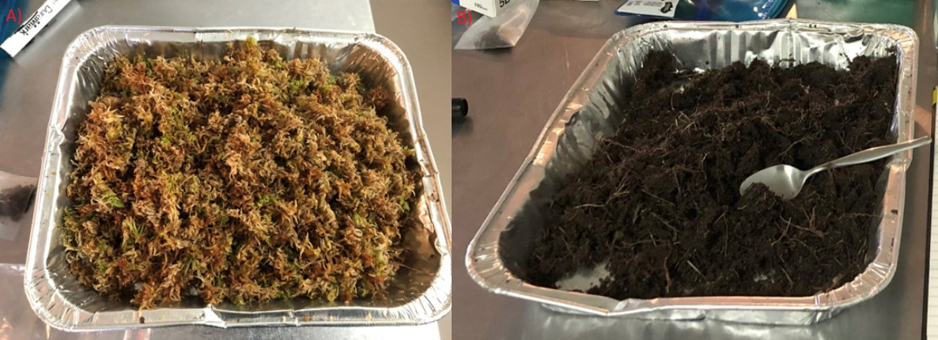
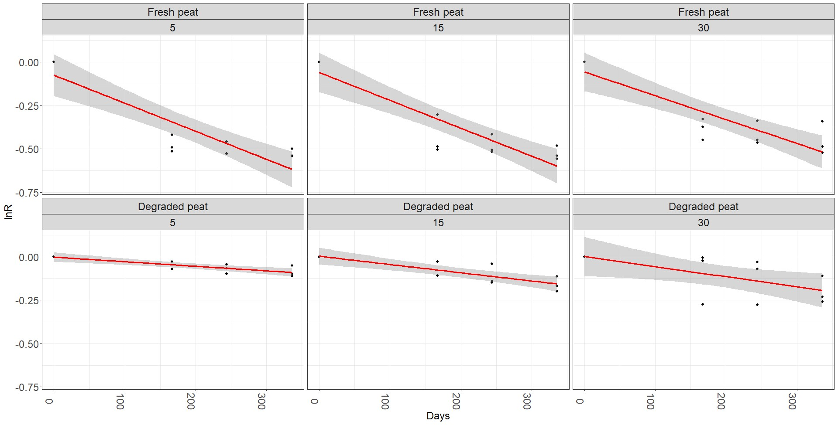
Figure S1: Prepared fresh (A) and degraded (B) peat substrate for making mesh bags.
Figure S2: Exponential decay curves for fresh and degraded peat incubated at the 5, 15, and 30 cm depths in the intact, Heathy Spur-1 peatland

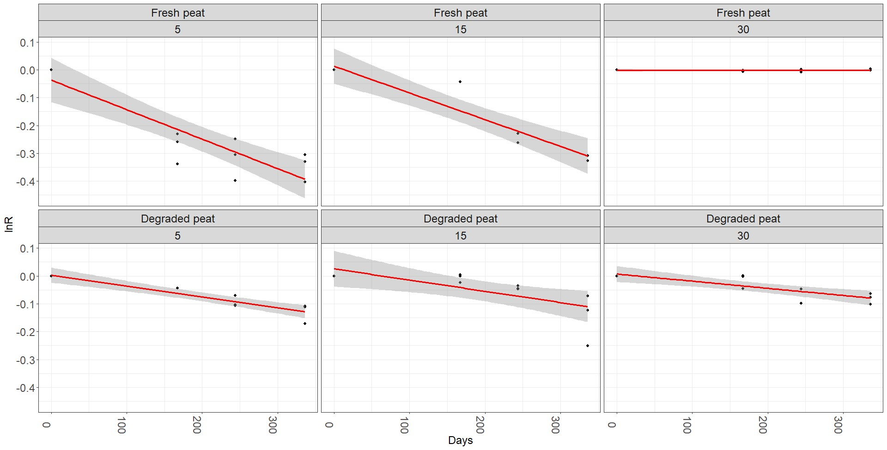
Figure S3: Exponential decay curves for fresh and degraded peat incubated at the 5, 15, and 30 cm depths in the degraded, Cope Saddle Hut peatland

