Supplementary Materials for

Salix species and varieties affect the molecular composition and diversity of soil organic matter

Louis J.P. Dufour*, Johanna Wetterlind, Naoise Nunan, Katell Quenea, Andong Shi, Martin Weih, Anke M. Herrmann

*Corresponding author. Email: louis.dufour@slu.se

This file includes:

Fig. S1. Between-class analysis (BCA) carried out on the entire mid-infrared spectra of the soil from beneath the different Salix varieties in the fertilised treatment.
Fig. S2. Between-class analysis (BCA) carried out on the entire mid-infrared spectra of the soil from beneath the different Salix varieties in the control treatment.
Fig. S3. Between-class analysis (BCA) of identified pyrolysis products of soil organic matter among different Salix varieties in fertilised treatment.

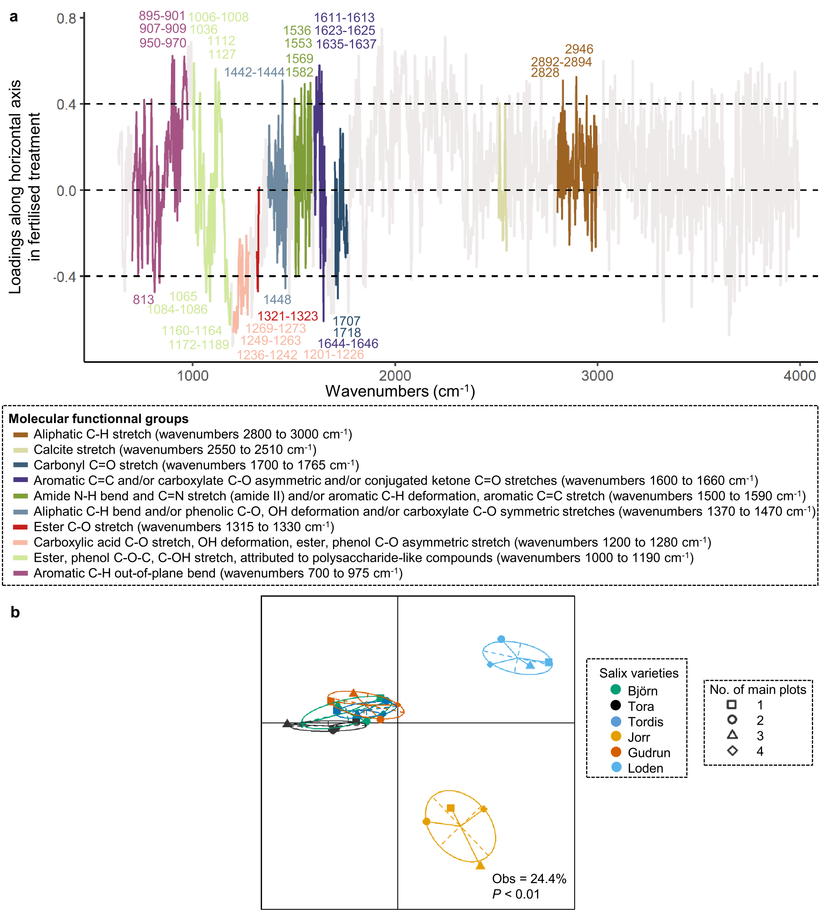

Fig. S1. Between-class analysis (BCA) carried out on the entire mid-infrared spectra of the soil from beneath the different Salix varieties in the fertilised treatment. (a) The loadings of wavenumbers (cm⁻¹) along the horizontal axis where the projected unconstrained inertia of the principal component analysis explained by the variable “Salix varieties” was 9%. (b) The graph of individuals. The wavenumbers associated with the gray line were not mentioned in the results sections as they were dominantly influenced by minerals or had a lower weight to discriminate varieties.

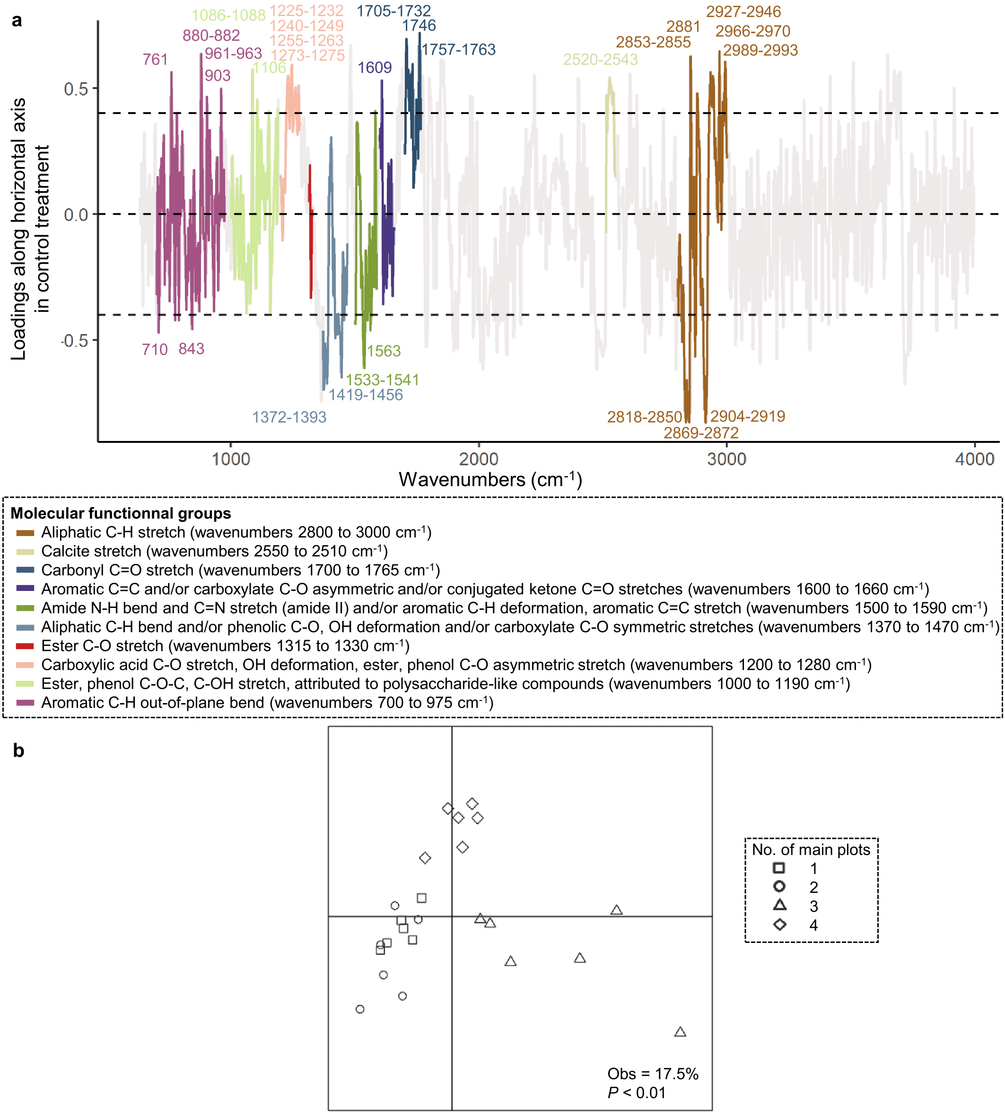

Fig. S2. Between-class analysis (BCA) carried out on the entire mid-infrared spectra of the soil from beneath the different Salix varieties in the control treatment. (a) The loadings of wavenumbers (cm⁻¹) along the horizontal axis where the projected unconstrained inertia of the principal component analysis explained by the variable “No. of main plots” was 8.7%. (b) The graph of individuals. The wavenumbers associated with the gray line were not mentioned in the results sections as they were dominantly influenced by minerals or had a lower weight to discriminate varieties.

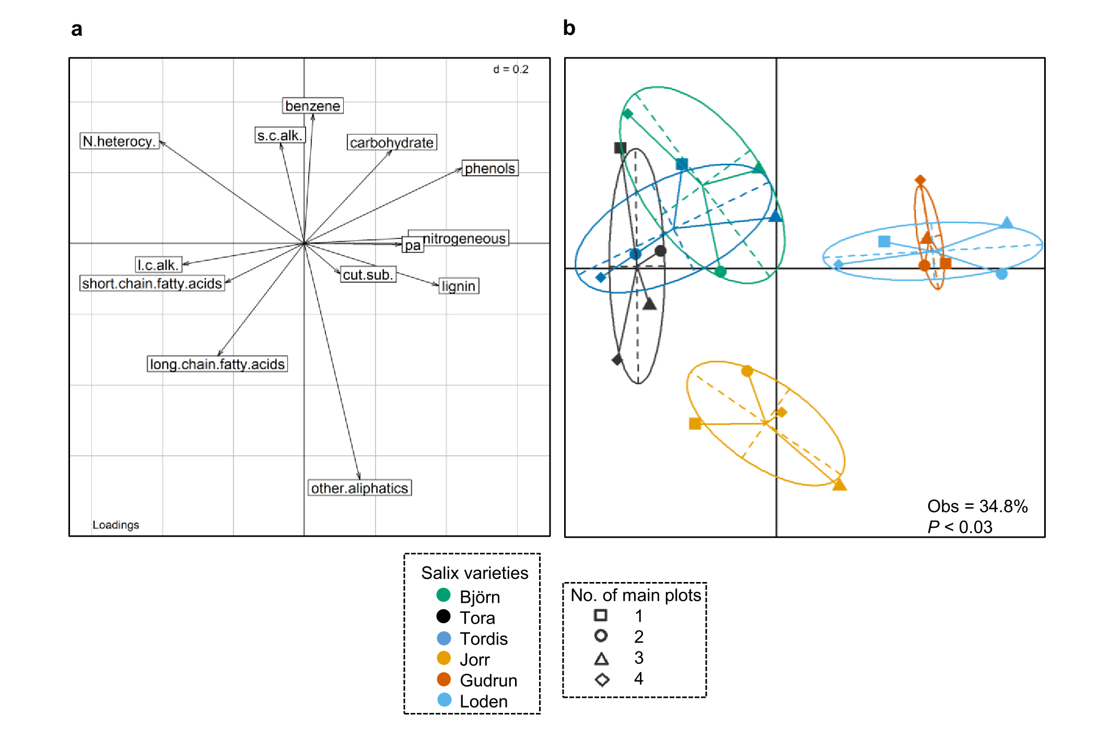

Fig. S3. Between-class analysis (BCA) of identified pyrolysis products of soil organic matter among different Salix varieties in fertilised treatment. (a) The loadings of biochemical categories. (b) The graph of individuals. Abbreviations of biochemical categories: lignin that originated from higher plant (lignin), long chain fatty acids that originated from higher plant (long.chain.fatty.acids), short chain fatty acids that originated from microbial community (short.chain.fatty.acids), nitrogeneous compounds of multiple origins (nitrogeneeous), carbohydrates of multiple origins (carbohydrate), other aliphatics of multiple origins (other.liphatics), phenols of multiple origins (phenols), benzene derivatives of multiple origins (benzene), N-heterocyclic compounds of multiple origins (N.heterocyclic), polyaromatic compounds of multiple origines (pa), cutin and/or suberine originated compounds from higher plant origin (cut.sub.), short chain alkane from microbial origin (s.c.alk.), long chain alkane from higher plant origin (l.c.alk.).

