Plant-specific microbial diversity facilitates functional redundancy at the soil-root interface

Wisnu Adi Wicaksono^{1*}, Martina Köberl^{1,2*}, Richard Allen White III^{3,4}, Janet K. Jansson², Christer Jansson⁶, Tomislav Cernava¹, Gabriele Berg¹
¹Graz University of Technology, Institute of Environmental Biotechnology, Graz, Austria
²Pacific Northwest National Laboratory, Earth and Biological Sciences Division, Richland, WA, USA
³North Carolina Research Campus (NCRC), Department of Bioinformatics and Genomics, The University of North Carolina at Charlotte, Kannapolis, North Carolina, USA
⁵Computational Intelligence to Predict Health and Environmental Risks (CIPHER), Department of Bioinformatics and Genomics, The University of North Carolina at Charlotte, Charlotte, North Carolina, USA
⁶Pacific Northwest National Laboratory, Environmental Molecular Sciences Laboratory, Richland, WA, USA

Supplementary Materials

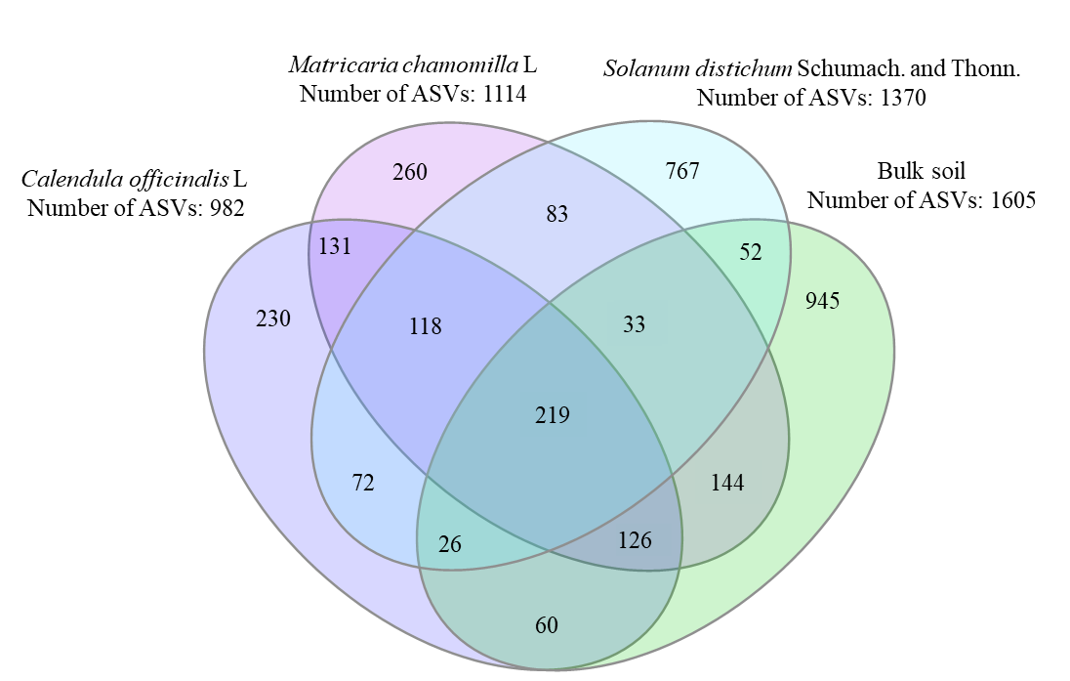
Supplementary Figure S1 Venn diagram showing the unique and shared ASVs between rhizosphere and bulk soil samples.

Supplementary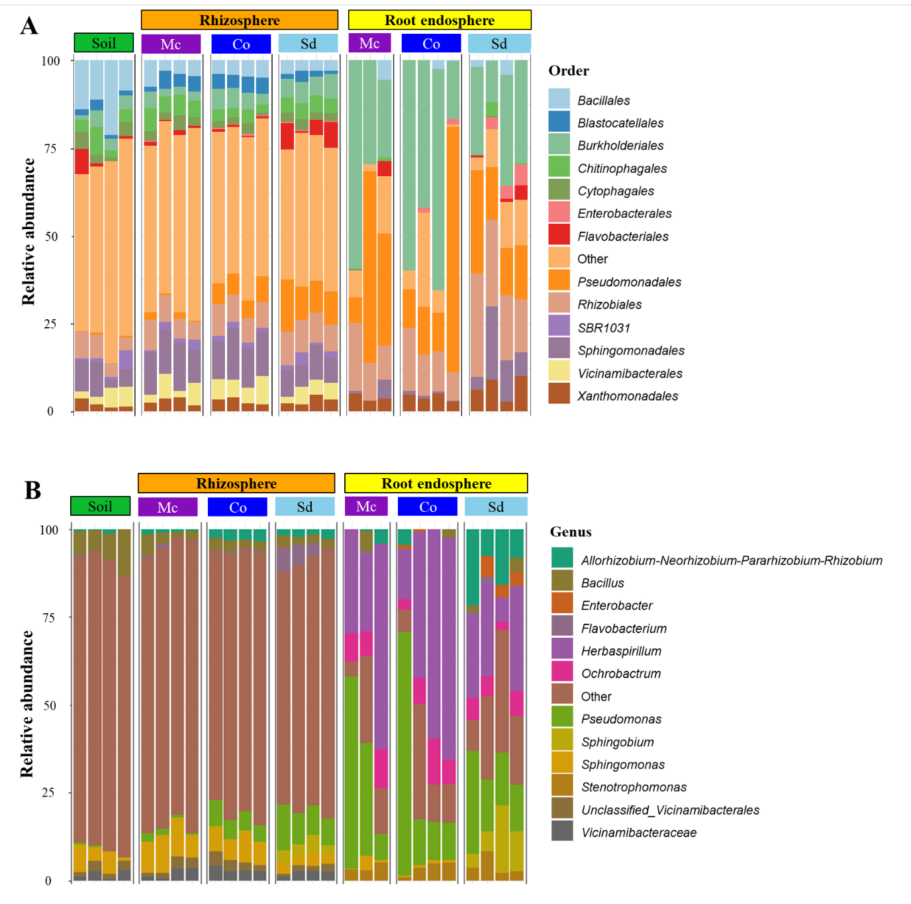 Figure S2. Bacterial community composition and structure in bulk soil, rhizosphere, and endosphere of chamomile (Mc - Matricaria chamomilla L.), marigold (Co - Calendula officinalis L.), and night shade (Sd - Solanum distichum Schumach. and Thonn.). The bacterial community composition is shown at the order (A) and genus level (B).

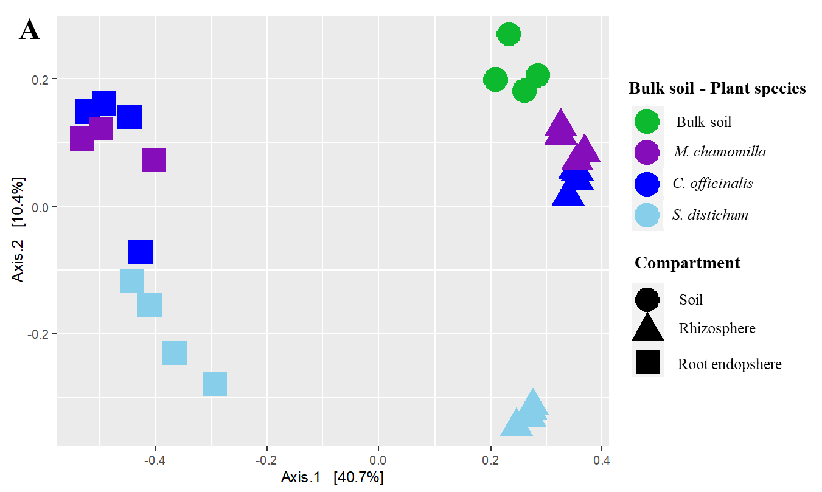
Supplementary Figure S1. Bacterial community clustering in bulk soil, rhizosphere, and root endosphere was visualized in a two-dimensional PCoA plot based on a Bray–Curtis matrix.

Supplementary Table S1 Analysis of significantly enriched bacterial taxa in each plant species by using Linear Discriminant Analysis Effect Size (LEfSe). This analysis was conducted to determine bacterial biomarkers specific to each plant species at the genus level.
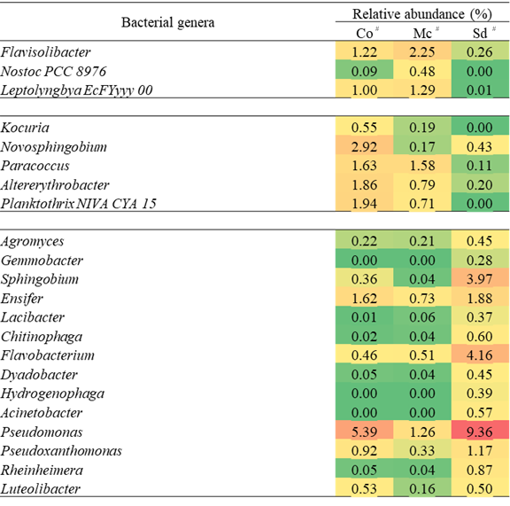

#Plant species - German chamomile (Mc - Matricaria chamomilla L.), marigold (Co - Calendula officinalis L.), and night shade (Sd - Solanum distichum Schumach. and Thonn.).

