Supplement for the paper “No saturation of soil carbon under long-term extreme manure additions”
Supplementary Table 1 Soil pH values of different fertilisation treatments
Site | Meckenheim |  |  | Kiel |  |  | Bad Lauchstädt
Land use | crop rotation |  |  | grassland |  |  | crop rotation |  |  |  | bare fallow
C fertiliser inputs  (Mg C ha⁻¹ yr⁻¹) | 0 | 2.8 | 5.6 | 0 | 1.7 | 3.3 | 0 | 4.7 | 9.4 | 18.8 | 0 | 4.7 | 9.4 | 18.8
Soil pH (CaCl₂) | 5.9 | 5.9 | 6.2 | 6.1 | 6.3 | 6.4 | 7.1 | 7.0 | 7.0 | 7.0 | 6.9 | 7.1 | 6.8 | 6.8

Supplementary Table 2 Average yield for all years of cultivation per crop and treatment at each experimental site, and corresponding C inputs into the soil from residues
Site | C fertiliser inputs (Mg C ha⁻¹ yr⁻¹) | Average yield  (Mg C ha⁻¹ yr⁻¹) | C input from residues (Mg C ha⁻¹ yr⁻¹) | Average  yield  (Mg C ha⁻¹ yr⁻¹) | C input from residues (Mg C ha⁻¹ yr⁻¹) | Average  yield  (Mg C ha⁻¹ yr⁻¹) | C input from residues (Mg C ha⁻¹ yr⁻¹)
Crop |  | Potato |  | Maize |  | Sugar beet
Bad Lauchstädt | 0 | 8.1 | 0.2 | 18.6 | 2.4 | 18.2 | 0.5
 | 4.7 | 10.8 | 0.3 | 20.5 | 2.6 | 18.3 | 0.5
 | 9.4 | 9 | 0.2 | 20.1 | 2.6 | 16.8 | 0.4
 | 18.8 | 7.6 | 0.2 | 19.3 | 2.5 | 17.3 | 0.4
Crop |  | Grassland
Kiel | 0 | 7.4 | 2.9
 | 1.7 | 8.9 | 3.1
 | 3.3 | 10.1 | 3.2
Crop |  | Sugar beet |  | Winter wheat
Mecken-heim | 0 | 47.8 | 1.2 | 6.2 | 1.1
 | 2.8 | 84.9 | 2.1 | 9.4 | 1.6
 | 5.6 | 93.4 | 2.3 | 10.3 | 1.8

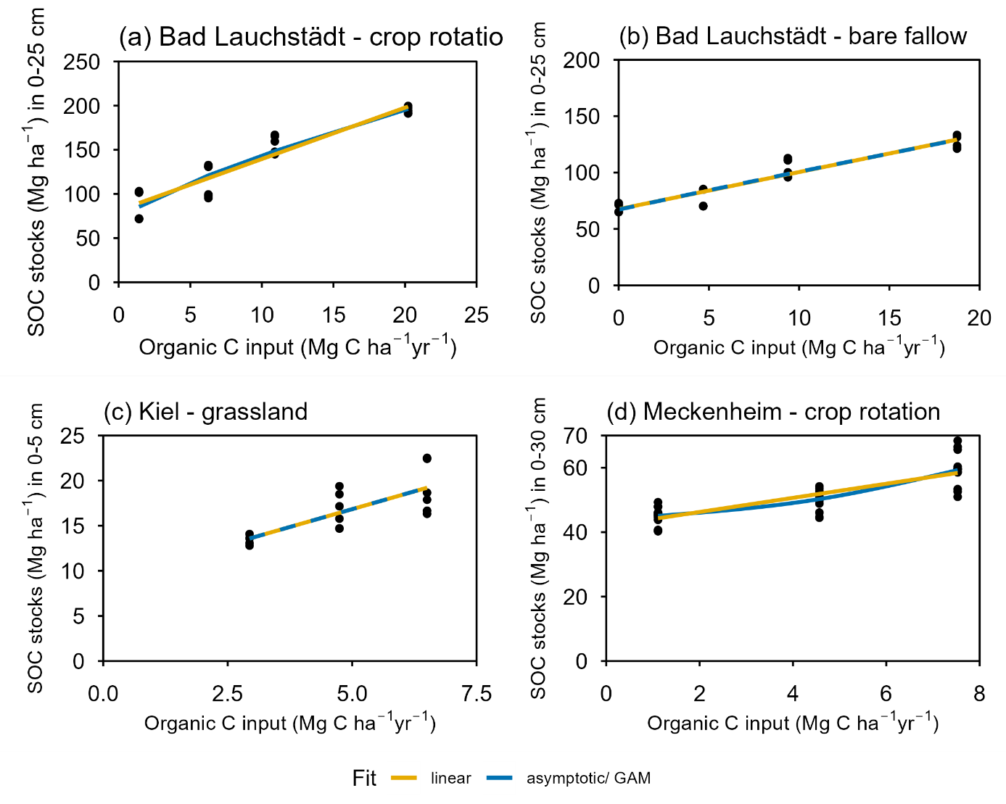
Supplementary Figure 1 SOC stocks at each sampling site with fitted linear, asymptotic and generalised additive models (GAM). Scales vary due to different SOC stocks and organic C inputs
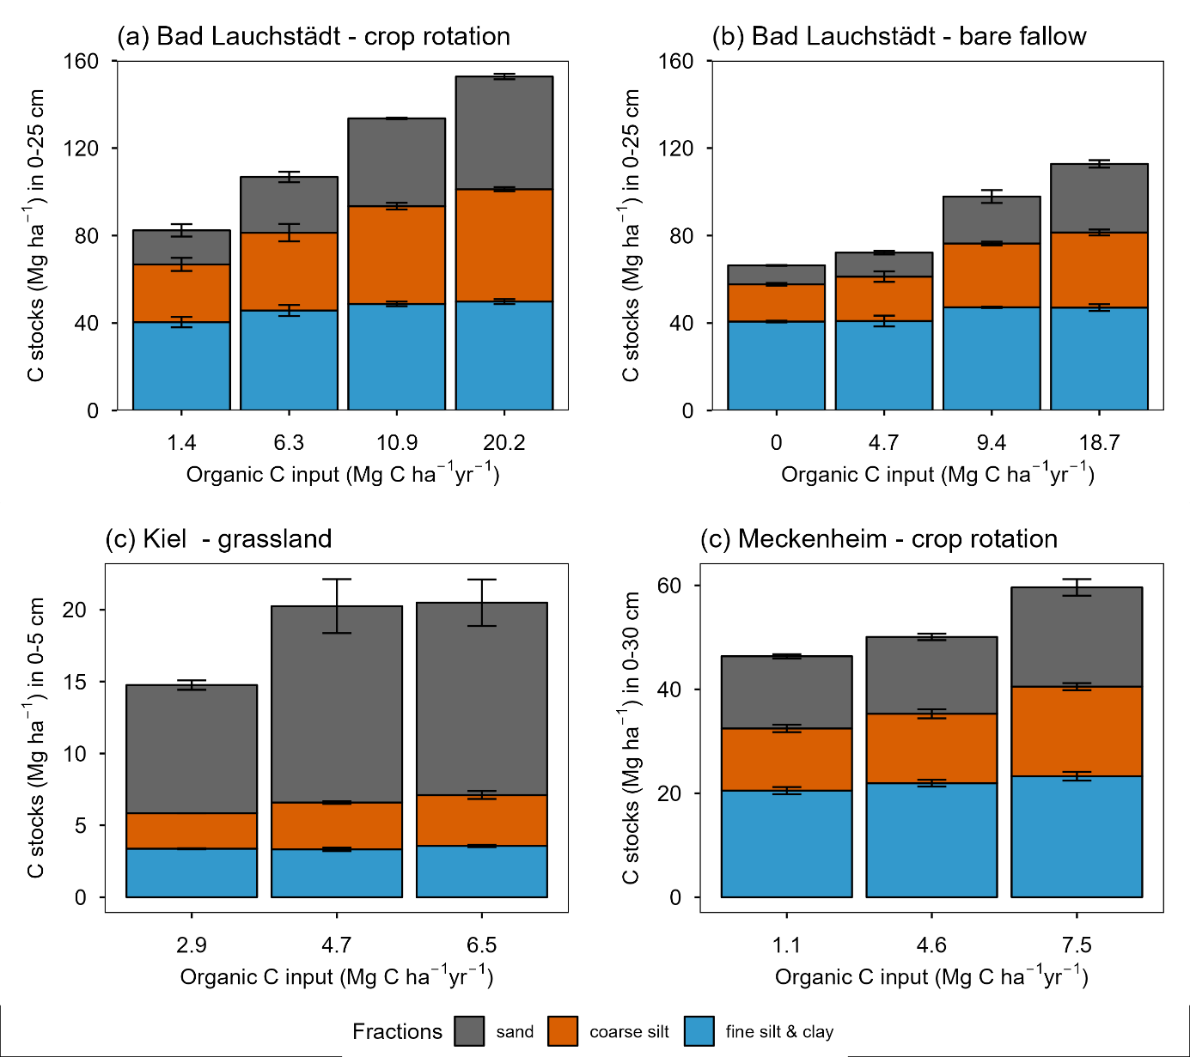
Supplementary Figure 2 Soil C stocks of different size fractions, with standard errors shown as whiskers

