Supplementary files

Methods S1
Here is a detailed description of how we handled the literature review, including a PRISMA flow chart depicting the selection process of relevant papers (Figure S1).
We used the Web of Science and Scopus databases to identify relevant papers (downloaded: 30th April 2024). As input criterion, we used the DOI of the original paper reporting the root economics space (RES, Bergmann et al., 2020; doi: 10.1126/sciadv.aba3756). After removing duplicates, 376 items remained. Of those, 11 were excluded: due to language barriers (one article in Spanish, 8 articles in Mandarin); being wrongly annotated (one article did not contain a Bergmann et al., 2020, reference); and one article not being accessible. 365 articles remained and were screened for number of Bergmann et al., 2020 citations. Any paper with (1) three or more citations in the main text (excluding bibliography, figure and table captions, and supplementary materials) or (2) “root economics space” or “root economic space” in title or abstract was considered to be handling the RES in more detail. This amounted to 134 articles (including some reviews, viewpoints and editorials) which were assessed in the qualitative synthesis. For a full list, see Supplementary Table S1.

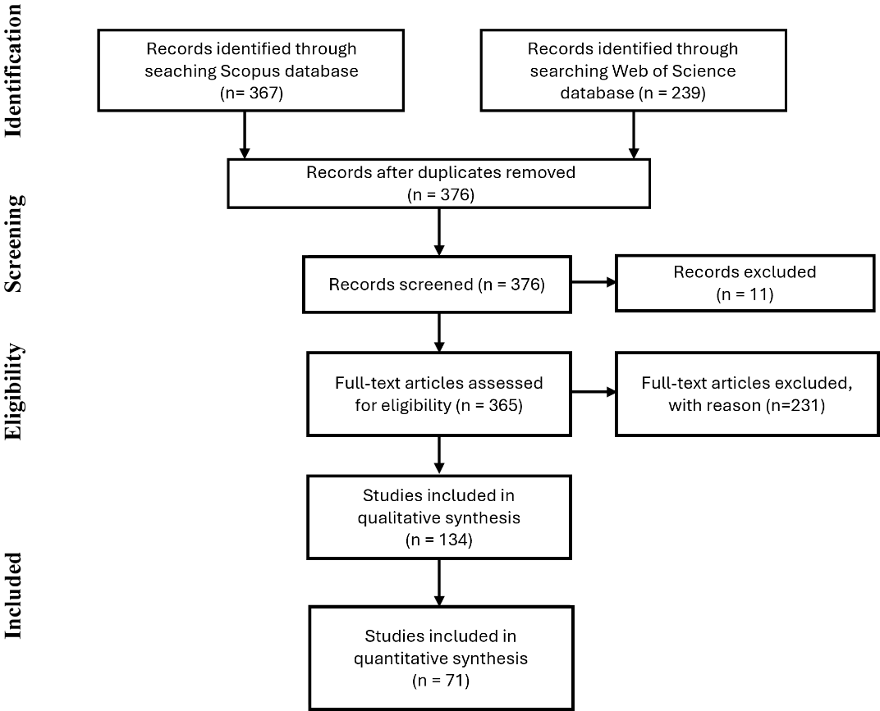
Supplementary Figure S1. PRISMA flow chart depicting compilation of articles analysed in this literature review (according to Moher et al. (2009)).

For the qualitative synthesis, we extracted data from full text (and where necessary from supplementary files) using the following criteria:
“Growth forms” (woody/non-woody/shrubs/herbaceous) and “plant functional types” (PFT: forbs, grasses and legumes) were annotated based on species composition stated in the article. We employed taxonomic classification (this is particularly relevant in the case of legumes – as taxonomically, there are leguminous trees. Thus, we did not consider legumes to be merely a sub-category of herbaceous plants).
For reviews, meta-analyses, viewpoints etc, we assumed all growth forms/PFT were included in the proposed framework etc., unless explicitly stated otherwise.
“Organizational levels” (intraspecific/interspecific/community) were annotated based on the level at which root traits were measured and analyzed. Studies at the intraspecific level measured traits of multiple individuals, potentially including different genotypes or breeding lines. Trait coordination is tested within species. Studies at the interspecific level measured traits of multiple species and trait coordination is based on a comparison among species. Studies that included multiple species but also multiple trait measurements within a species (e.g. due to replication of an experimental treatment, measurement in multiple locations, etc.) were also categorized as ‘interspecific’ as the number of species is usually higher than the number of measurements within a species and the trait coordination is likely much more strongly affected by interspecific than intraspecific variation. Studies at the community level either measured root traits of a community without species separation, i.e. collected a mixed-species root sample, or calculated community root traits based on community composition data (e.g. community-weighted mean traits).
“Habitats” were annotated as forest, grassland, cropland, wetland or mix (if grassland and forest were assessed in a study). Annotation was based on the authors declaration of studied habitat or - if missing - reported species composition.
Structured scoring of support for the RES concept, as well as support for the two gradients of the RES (collaboration gradient, conservation gradient) were assessed following these criteria:
- Articles reported a multidimensional reduction analysis (e.g. principal component analysis (PCA), etc.). We did not assess articles that reported pairwise trait correlations only.
- We considered the collaboration gradient to be supported, if:
  - Specific root length (SRL) and average fine-root diameter (AD) correlate negatively.
  - In case of reported mycorrhization data, it loads with AD.
- We considered the conservation gradient to be supported, if:
  - Root tissue density (RTD) and root nitrogen concentration (RN) correlate negatively.
- We considered the overall RES to be supported, if collaboration and conservation gradient were both supported and independent of each other, i.e. sat orthogonal to each other (Figure S2A).
- We rejected the overall RES, the collaboration gradient or conservation gradient if the above rules were violated.
- In the case that not all four core traits were included in the analysis, we adjusted our scoring. In approximately one third of the studies, RN was not included in the analysis, a couple of studies did not include RTD or AD. As the conservation gradient (RTD-RN) has been well known for some time, we considered alternative traits in case RTD or RN were missing and other slow/fast traits could be used as proxies. I.e.:
  - for RN, we considered root growth rate as an acceptable proxy;
  - for RTD, we considered root dry matter content (RDMC) as an acceptable proxy;
  - If no alternative trait proxies were available, and we did not have four traits to describe the RES and its two gradients, we scored the respective gradient and the overall RES as “not applicable” (NA) (see Figure S2 C and D).
- It did not matter to our evaluation where the traits loaded in the trait space. I.e. it did not matter if they clearly aligned with any axis of the PCA, or on which axis of the PCA the two gradients loaded (e.g. the collaboration gradient spanning SRL-AD could load onto principal component 1, or on principal component 2. Same goes for the conservation gradient RTD-RN).
- If more than one PCA is presented because several species are tested intraspecifically, we consider analysis of each species separately. Contradicting results within one study would score as “not applicable” (NA).
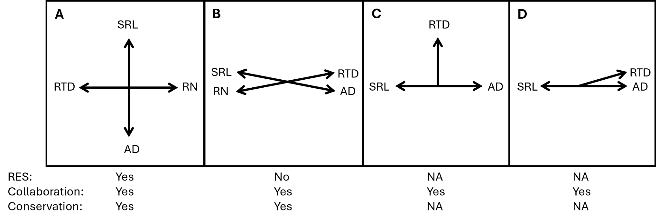
Figure S2: Schematic for structured scoring of support for the root economics space (RES) concept, collaboration gradient and conservation gradient as carried out in our literature review. SRL - specific root length, AD - average fine-root diameter, RTD - root tissue density, RN - root nitrogen concentration, NA - not applicable.

Scoring environmental factor effects on the collaboration and conservation gradient. A subset of studies reported effects of environmental factors on the RES (see Figure 3, based on studies reported in Supplementary Table S3). We assessed the effects of environmental factors similar to how we assessed support with the RES, i.e. we screened the respective paper for PCAs or reported effect sizes. We only considered the effect of environmental factors on the collaboration or conservation gradient if reported as significant in at least one study. Wherever possible, we evaluated if an environmental factor shifted trait values along the two gradients of the RES, denoting it as “positive”, “negative” or “no” (= no significant) effect. For example, if trait values shifted towards higher RTD, we called this a positive effect on the conservation gradient (i.e. tissue conservation increased). If trait values shifted towards higher RN, we called this a negative effect on the conservation gradient. If trait values shifted towards higher AD, we called this a positive effect on the collaboration gradient (i.e. outsourcing to mycorrhizal fungi increased). If trait values shifted towards higher SRL, we called this a negative effect on the collaboration gradient (see also Figure 1A for a schematic of the RES trait space, spanning SRL-AD and RN-RTD). We only mapped environmental factors to collaboration or conservation gradient, if the respective SRL-AD and RTD-RN gradient was confirmed in the given study.
Supplementary References
Moher D, Liberati A, Tetzlaff J, Altman DG, The PRISMA Group (2009) Preferred Reporting Items for Systematic Reviews and MetaAnalyses: The PRISMA Statement. PLoS Med 6(7): e1000097. doi:10.1371/journal.pmed.1000097.
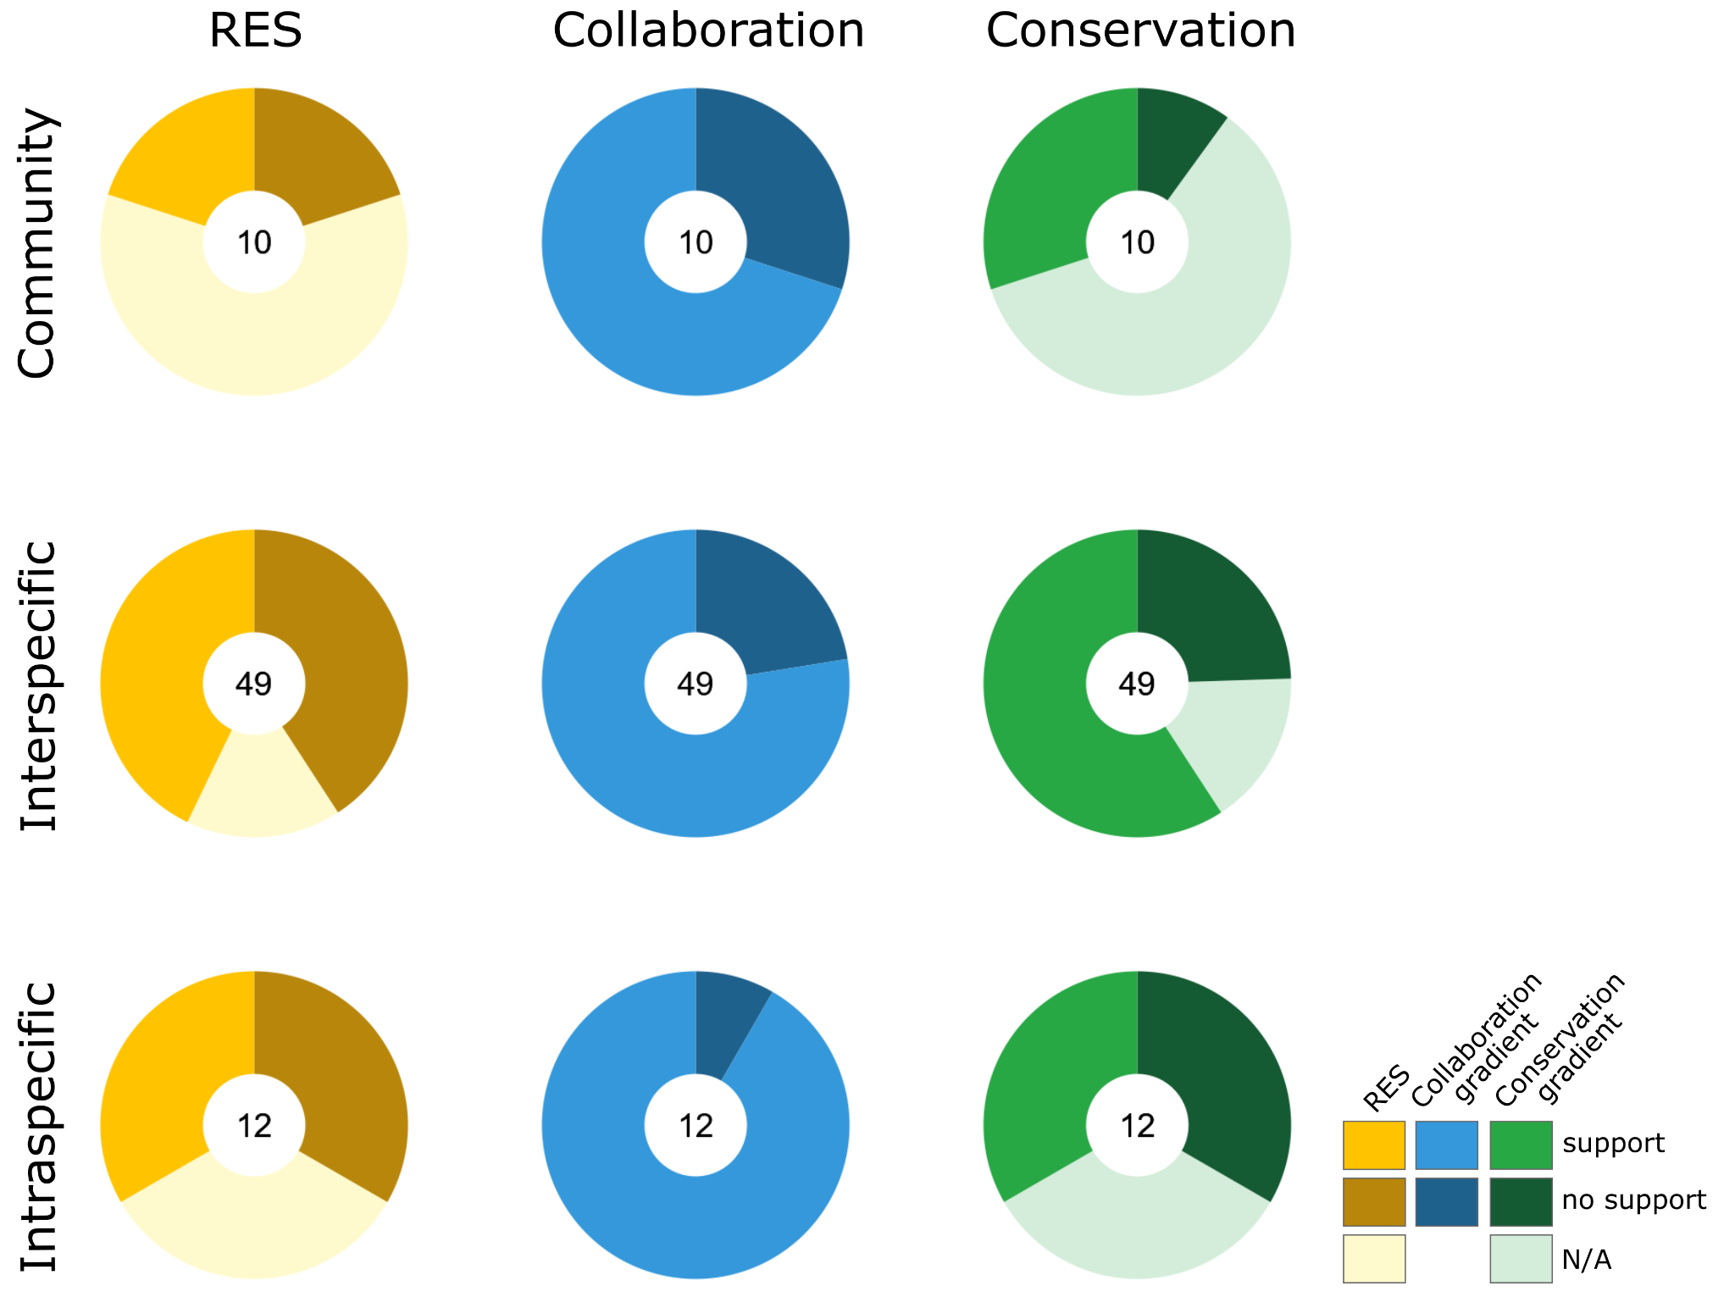
Supplementary Figure S3: Support for the root economics space (RES), collaboration gradient and conservation gradient as assessed in our literature review, split by organizational level. N/A – no trait data was available to score the conservation gradient, leading to N/A annotation of overall RES in the respective study. Number of studies considered is stated in the center of each pie chart.

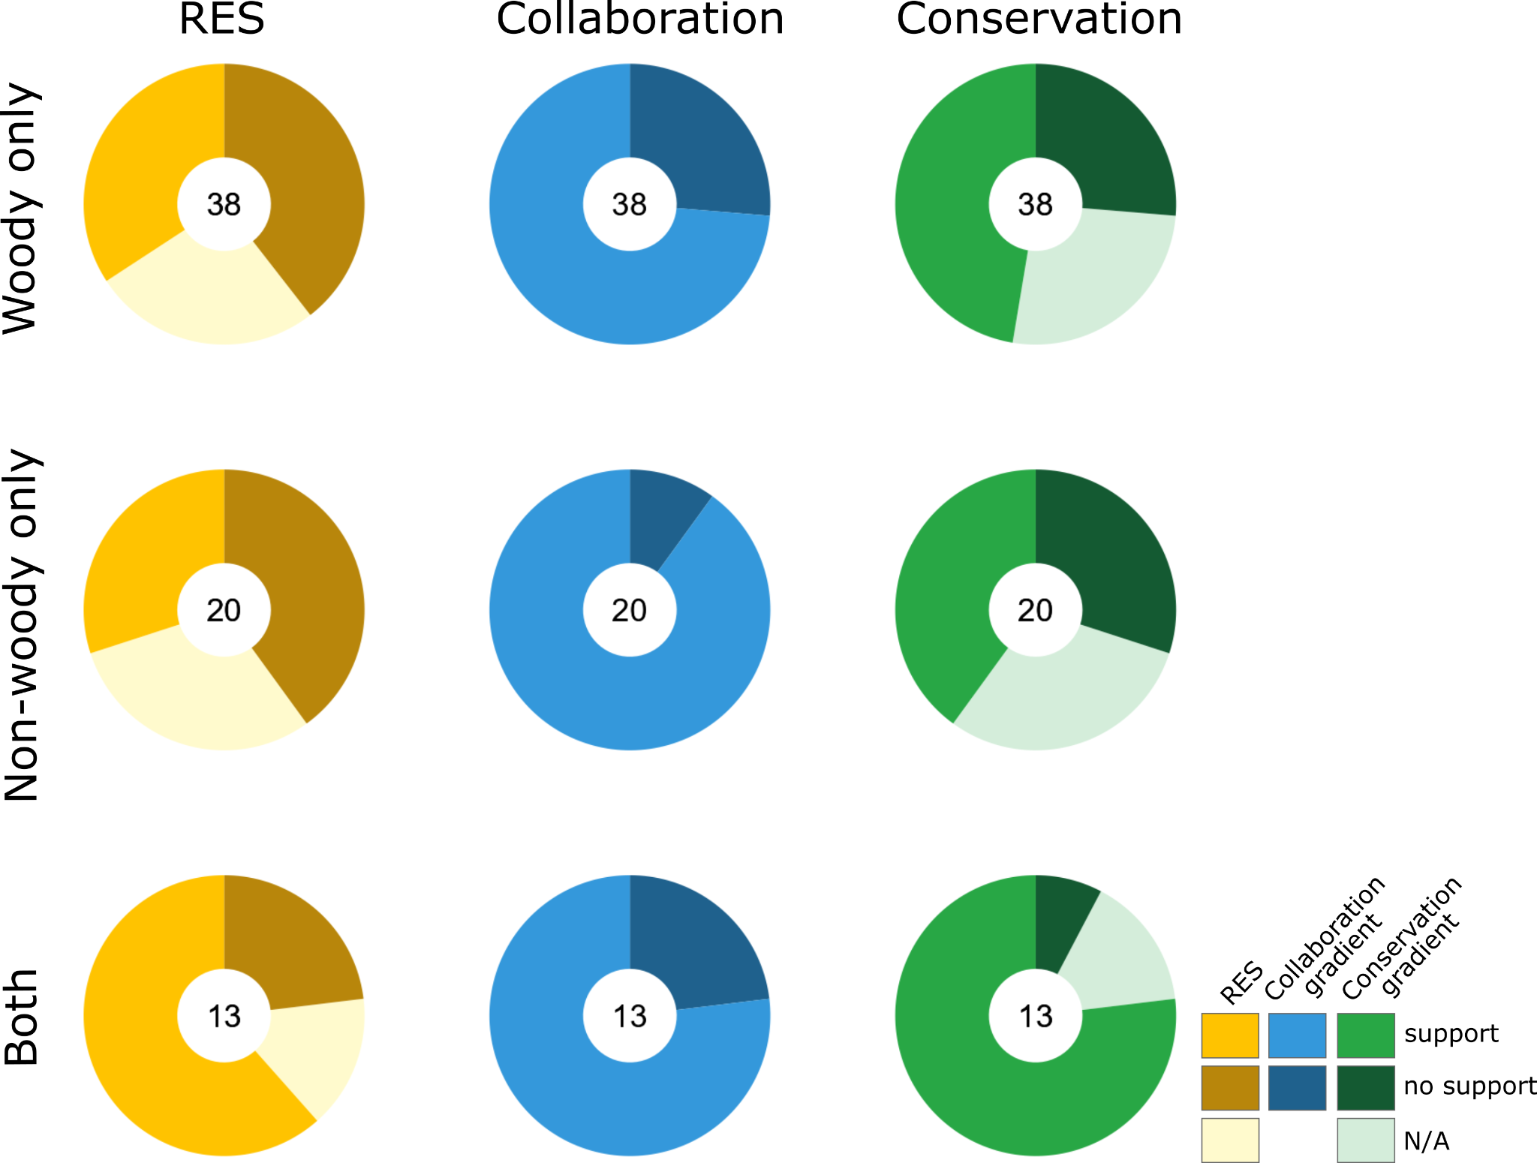
Supplementary Figure S4: Support for the root economics space (RES), collaboration gradient and conservation gradient as assessed in our literature review, split by growth form (woody only, non-woody only, both woody and non-woody). N/A – no trait data was available to score the conservation gradient, leading to N/A annotation of overall RES in the respective study. Number of studies considered is stated in the center of each pie chart.

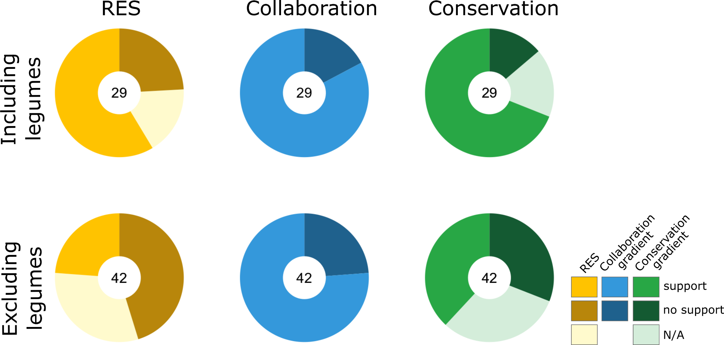
Supplementary Figure S5: Support for the root economics space (RES), collaboration gradient and conservation gradient as assessed in our literature review, split by studies including legumes and excluding legumes. N/A – no trait data was available to score the conservation gradient, leading to N/A annotation of overall RES in the respective study. Number of studies considered is stated in the center of each pie chart.

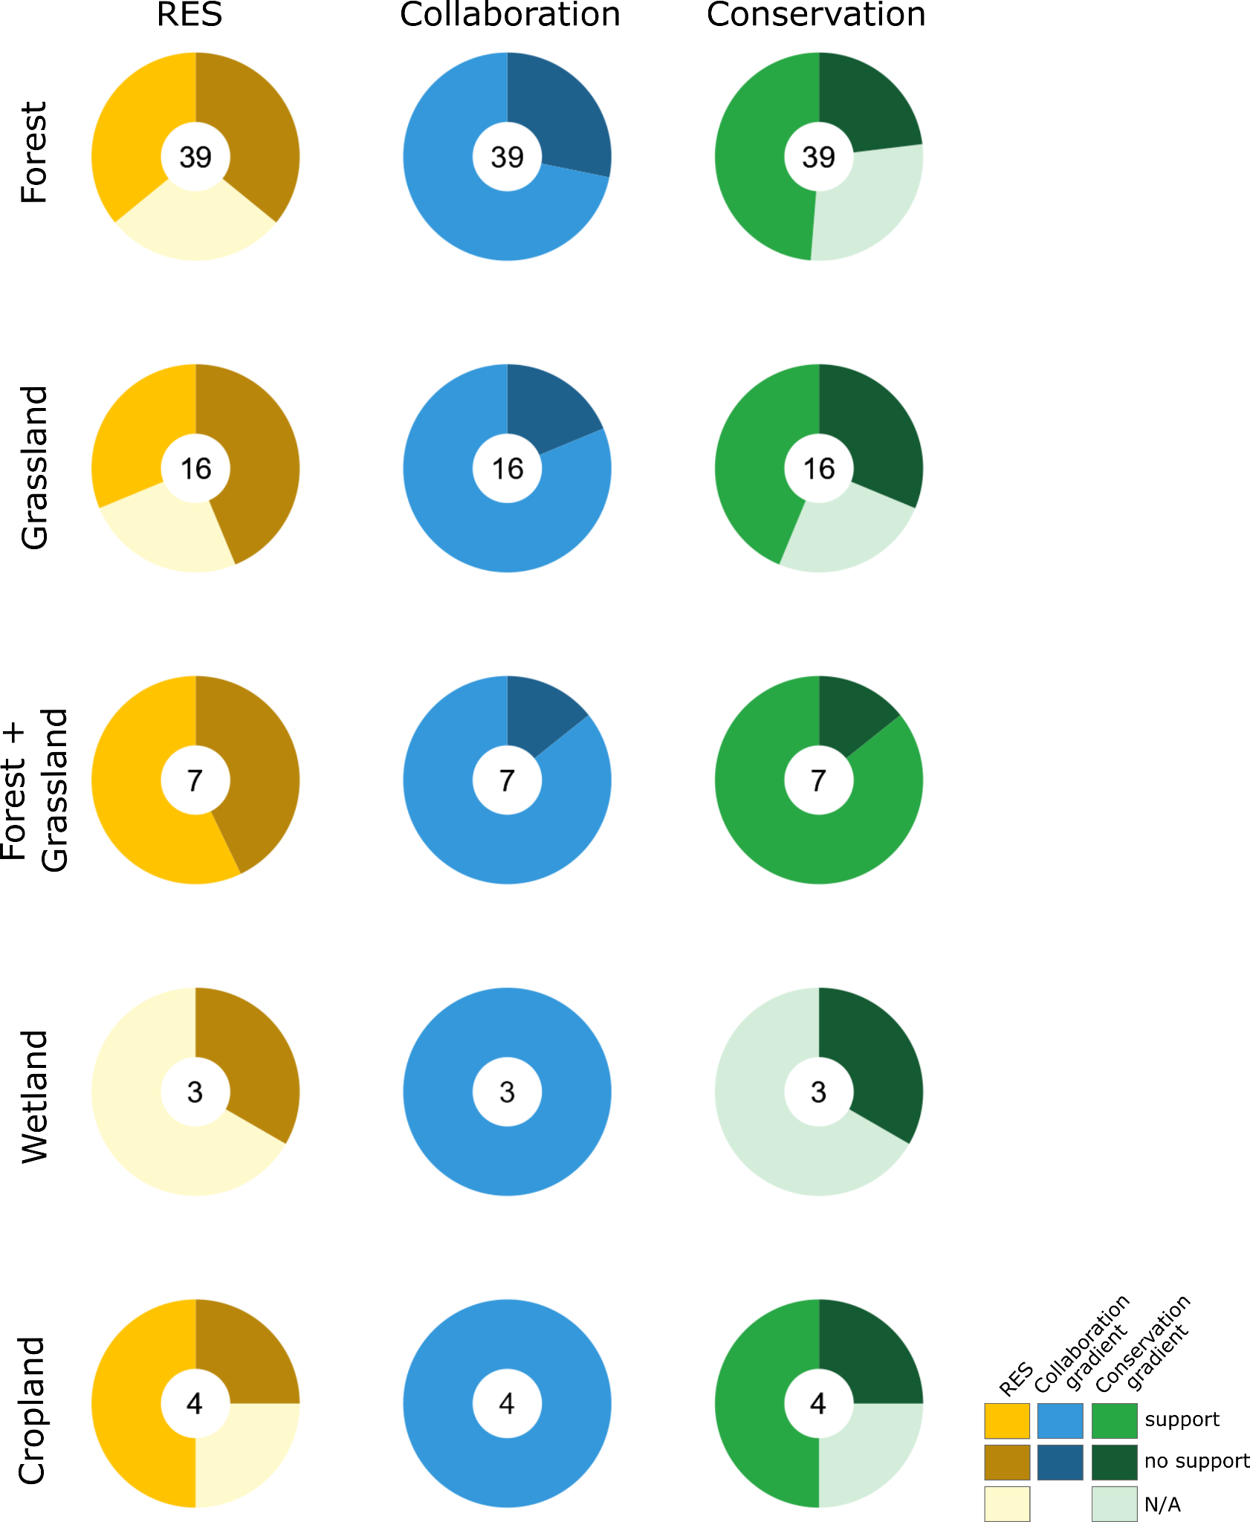
Supplementary Figure S6: Support for the root economics space (RES), collaboration gradient and conservation gradient as assessed in our literature review, split by habitat type. Habitats included forest, grassland, mix of forest and grassland (forest + grassland), wetland and cropland. N/A – no trait data was available to score the conservation gradient, leading to N/A annotation of overall RES in the respective study. Number of studies considered is stated in the center of each pie chart.

Supplementary Table S1
List and annotation of all 134 studies screened in the quantitative and qualitative synthesis of this review.

Supplementary Table S2
List of all studies that were compiled to produce Figure 2, “Trait extensions of the root economics space”.

Supplementary Table S3
List of all studies that were compiled to produce Figure 3, “Effects of environmental factors on the two gradients of the root economics space, the collaboration and conservation gradient, split by organizational level”.

