Supplementary information
Species establishing beyond their introduced range are not always released from belowground enemies

Supplementary Information 1
We used QGIS 3.22.3 (QGIS Development Team, 2021) for spatial analyses. We loaded the occurrence records for Plantago lanceolata downloaded from Atlas of Living Australia (ala.org.au) on December 12, 2021. For display purposes, we created a kernel density estimation map from the occurrence records, with radius 0.15° and a uniform kernel shape. We then simplified the heatmap by considering only the presence of P. lanceolata using the command “reclassify by table”.

Supplementary Information 2
Table S1: Study site coordinates (WGS84, EPSH: 4326) and category.
Transect | Distribution position | Site | Latitude | Longitude
A | Established | Grenfell | -34.050 | 148.233
A | Just outside | Miandetta | -31.564 | 146.954
A | Well beyond | Canbelego | -31.549 | 146.436
B | Established | Bundaberg | -24.870 | 152.345
B | Just outside | Gin Gin | -24.951 | 152.061
B | Well beyond | New Moonta | -25.054 | 151.710
C | Established | Hermitage | -28.206 | 152.102
C | Just outside | Dalby | -27.162 | 151.287
D | Established | Leeton | -34.533 | 146.397
D | Just outside | Merriwagga | -33.759 | 145.600
D | Well beyond | Hillston | -33.428 | 145.373
E | Established | Emu Point | -34.966 | 117.926
E | Just outside | Bluff Creek | -34.759 | 118.300
E | Well beyond | Wellstead | -34.495 | 118.603
F | Established | Lake Leschenaultia | -31.859 | 116.245
F | Just outside | Clackline | -31.721 | 116.523
F | Well beyond | Meckering | -31.645 | 117.003
G | Established | Bellenden Ker | -17.264 | 145.854
G | Just outside | DRO | -16.103 | 145.449
G | Well beyond | Rossville | -15.756 | 145.271
H | Established | Queens Domain | -42.867 | 147.329

Supplementary Information 3
Excluding later-germinated seeds left us with data for 539 of the 652 plants harvested, and did not have a qualitative effect on the results of the analyses. When grouped according to site × treatment × seed origin × seed population, the original dataset had an average of 3.9 replicates from 168 elements, while the filtered one had an average of 3.3 from 165 elements. Ten of 165 elements contained only one replicate, but it did not significantly affect the analyses as we were looking for general patterns. E.g., the sterilization effect from the contrast would go from 0.659 with a 95% CI [0.59, 0.73] (p < 0.001) to 0.643 with a 95% CI [0.58, 0.71], both contrasts with p < 0.001.

Supplementary Information 4
We included all three level of distribution positions (established, just outside, well beyond) here. We found no evidence that belowground enemy release is correlated with latitude, either considering established vs. well beyond nor established vs. just outside (both cases p = 0.50). There was also no statistical effect of latitude in belowground enemy release with just outside vs. well beyond (p = 0.99).
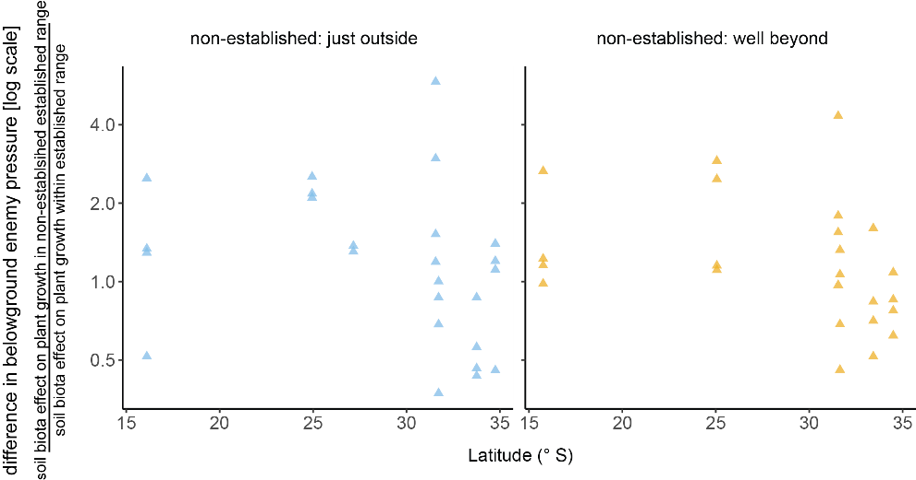
Figure S1: Patterns in belowground enemy release along a latitudinal gradient for different non-established ranges. Each triangle (▲) represents the mean for each transect-seed population combination.

Supplementary Material 5
When including all 3 levels of distribution position in analyses that considered Australian vs. European seed sources, it resulted that P. lanceolata grown from European seeds was less affected by soil biota compared to Australian seeds at the just outside position (soil biotic effects Australia vs. Europe = 0.58, 95% CI [0.44, 0.78], p < 0.001, Fig. S3A), but there was no evidence of a difference for the other positions (at established = 0.90, p = 0.4; at well beyond = 1.02, p = 0.9). We found no evidence that belowground enemy release was correlated with seed origin even when including all 3 levels of distribution position (both p = 0.3, Fig. S3B).
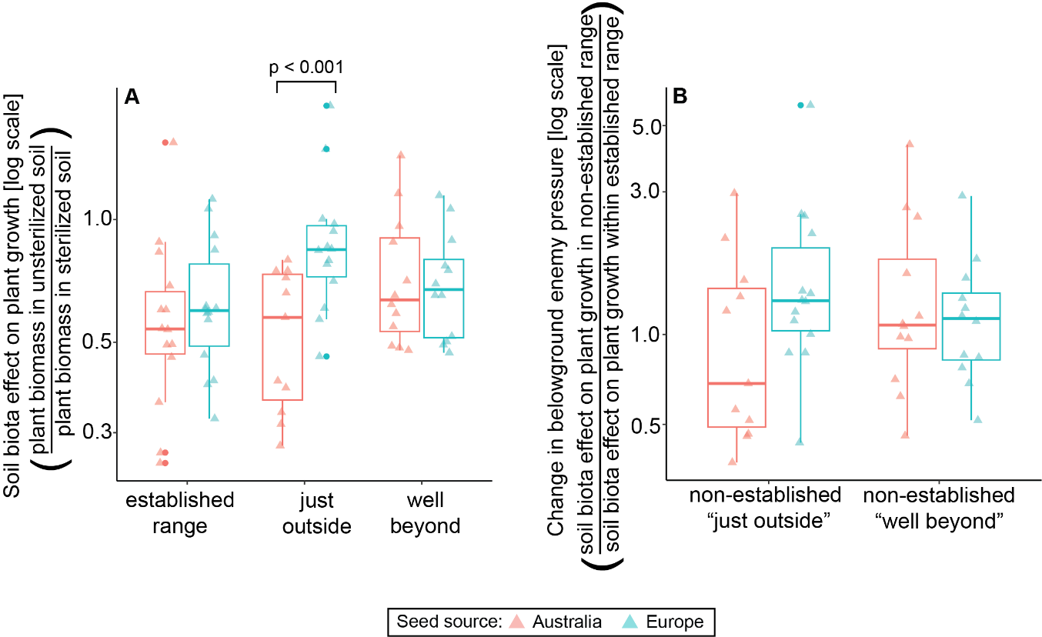
Figure S3: Differences in soil microbial effects on plant growth between populations of different origins (A), and belowground enemy release effects between populations of different origins (B). Each triangle (▲) represents the mean soil biota effects for each site × seed population combination.

Supplementary Information 6
To understand how soil biotic effects relate to all soil variables together, we ran a mixed model with the structure [soil biota effect ~ seed provenance + latitude + log₁₀(oc) + log₁₀(nitrogen) + poly(phw, 2) + distribution position + (1| site)]). In addition, we calculated the Variance Inflation Index (VIF) to quantify the interrelationships between explanatory variables. We found that none of the soil variables was statistically correlated with soil biota effect (P_{oc} = 0.4, P_{nitrogen} = 0.4, P_{pH} = 0.4 and 0.6 for linear and quadratic term). There was no collinearity in the model, with all VIFs < 3 (VIF_{oc} = 2.0, VIF_{nitrogen} 1.7, VIF_{pH} = 2.5).

Supplementary Information 7
We created conditional plots (Fig. S3) to enhance the display of the relationships between soil biotic effects on plant growth and the selected soil variable, while keeping other covariates constant. For this we used “visreg” 2.7.0.3 (Breheny & Burchett, 2017). We maintained the standard setting for visreg, i.e., holding covariates to median level, and assigning the level for seed source to “Australia”. The slope of the relationship between the response and independent variables calculated by visreg and emmeans packages is the same. For coherence, we displayed the same trend as in the standard plots, i.e., calculated with emmeans.
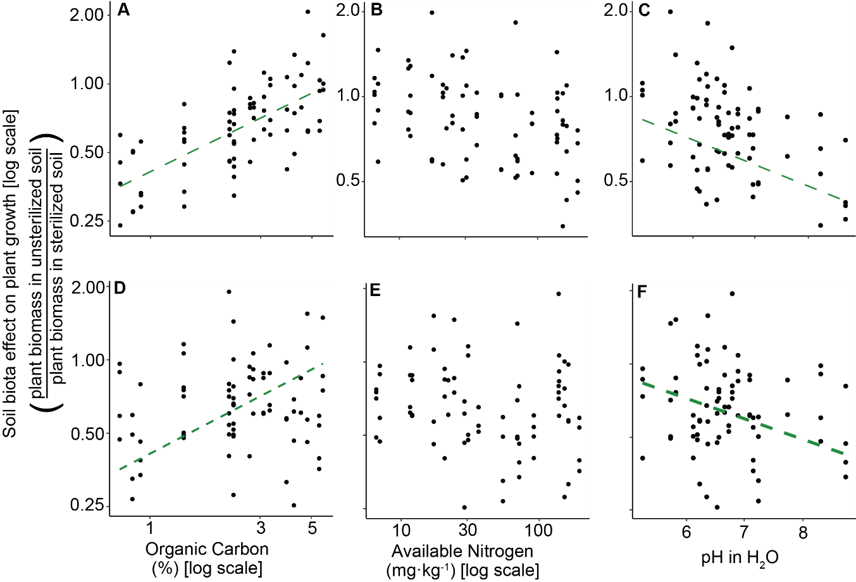
Figure S4: Relationships between soil biota effects on plant growth and organic carbon (A, D), soil available nitrogen (B, E), and soil pH (C, F). Plots A–C are conditional plots and are shown in the manuscript, holding other covariates set to median and seed source to Australia. Plots D–E are standard plots with no covariates held constant. Dashed lines represent significant relationships (p < 0.05). Each dot (●) represents the mean soil biota effect for each site × seed population combination.

References

Breheny, P., & Burchett, W. (2017). Visualization of Regression Models Using visreg. R Journal, 9(2), 56-71. doi:Doi 10.32614/Rj-2017-046
QGIS Development Team. (2021). QGIS Geographic Information System (Version 3.18): Open Source Geospatial Foundation Project. Retrieved from http://qgis.osgeo.org

