Supplementary Figures: Medicago truncatula supernodulation mutants sunn4 and lss show enhanced seed yield and seed nitrogen allocation from nitrogen fixation under low nitrogen availability, Plant and Soil, Giel van Noorden, Adrienne Nicotra, Ulrike Mathesius; Australian National University; ulrike.mathesius@anu.edu.au

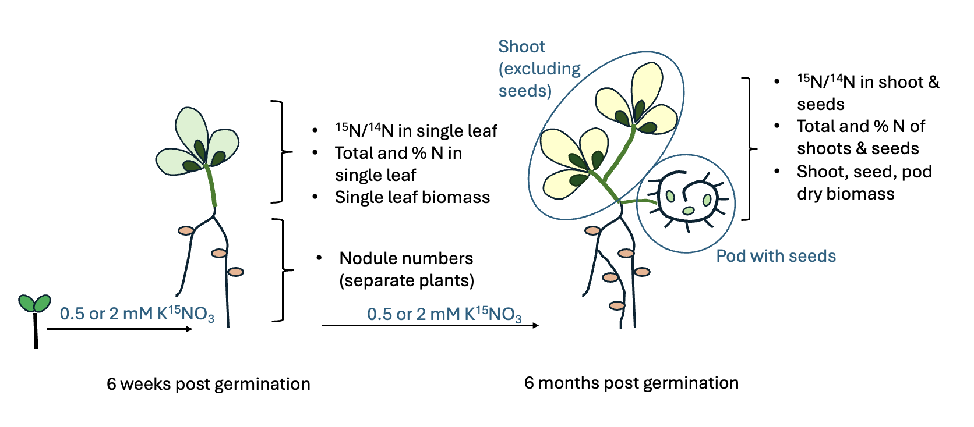

Supplement Figure 1: Schematic diagram of experimental setup and harvesting times and phenotypes measured. Leaf measurements at six weeks post germination were done on the same plant as the measurements done at maturity (six months post germination); nodules were counted at six weeks in a separate set of plants. Shoot and seed biomass were defined as our fitness proxies.

