PLANT AND SOIL
Special Issue S120 – Mediterranean ecosystems

Differences in nutrient content between heterospecific plant neighbours affect respiration rates of rhizosphere microbiota

SUPPLEMENTARY MATERIAL

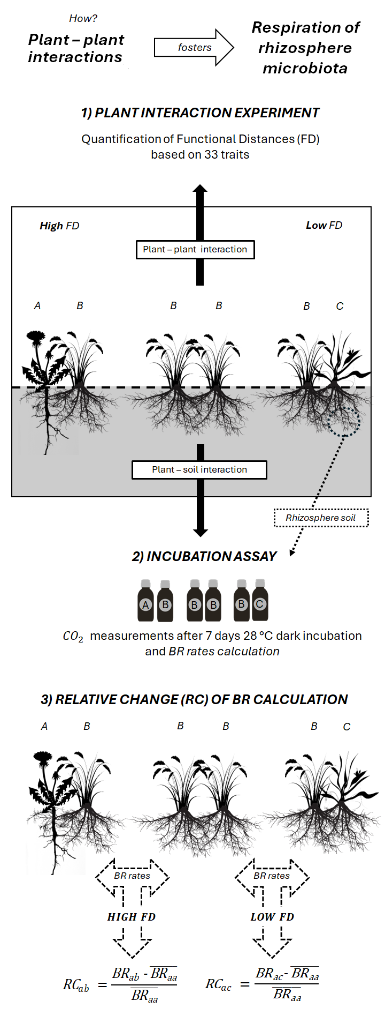
Fig S1. Schematic representation illustrating the methodological procedures followed in this study to address the influence of Functional Distance (FD) of heterospecific plant-plant interactions on respiration rates (BR). 1) PLANT INTERACTION EXPERIMENT: We established a greenhouse experiment where pairs of individuals belonging to 10 species of herbs and shrubs were grown together. The FD between each pair of individuals growing together was characterized with 33 traits quantified in each individual at the end of the experiments (Tables S1, S2). 2) INCUBATION ASSAY: After harvesting the plants, rhizosphere soil was sampled and incubated in the dark for 7 days at 28 °C to measure accumulated CO2-C, to calculate microbial basal respiration, a measurement of heterotrophic respiration. 3) RELATIVE CHANGE (RC) OF BR, which reflects the amount of change experienced by BR rates in the rhizosphere of a focal plant species due to the influence of a heterospecific neighbour compared with a conspecific one, was calculated after Equation 1 (main text). The relationship between RC and FD was tested with LMER models.

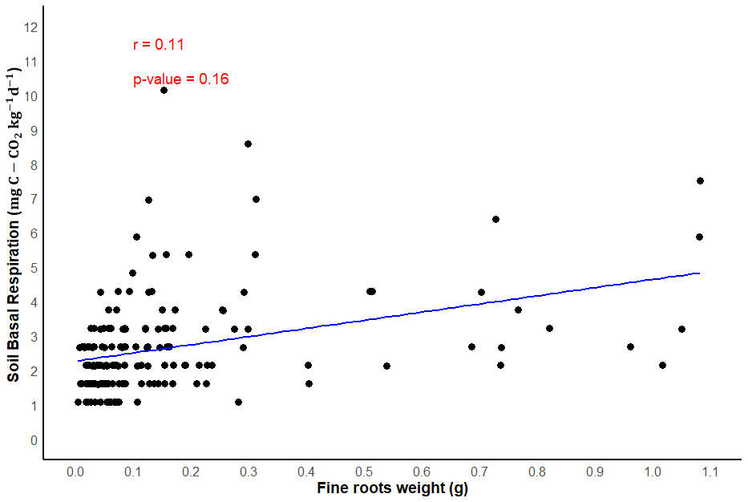
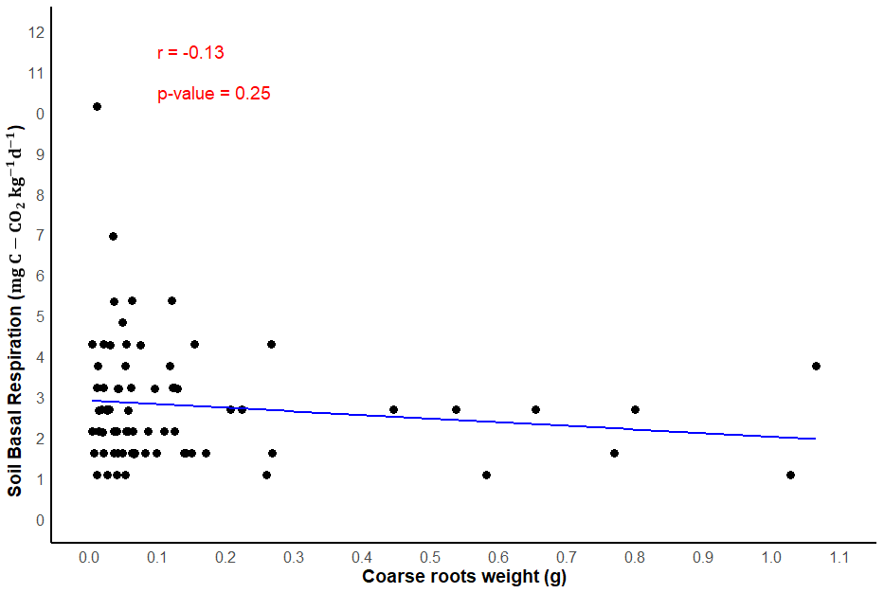
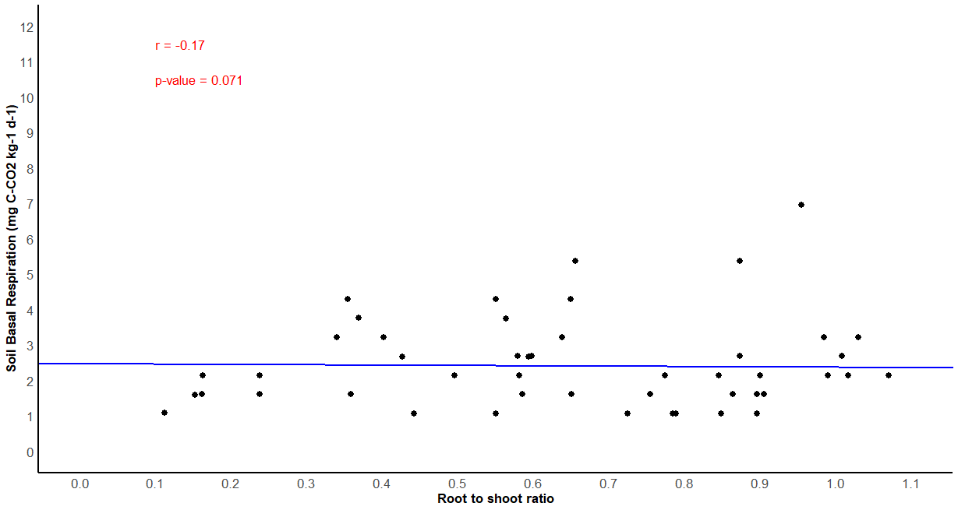
a)
b)
c)

Figure S2. Relationship between a) fine roots weight (diameter below 1 mm), b) coarse root weight (diameter below 1 mm), and c) root to shoot ratio with rhizosphere basal respiration. Pearson´s correlation estimate, and its p-value are given.
Table S1. Number of initial pairwise combinations used in the interaction experiment (top), the surviving combinations after the experiment (middle) and final pairs which rhizosphere samples presented enough material for measuring basal respiration (bottom). Paired combinations of individuals of the same species were replicated three times, while those pairs of different species were replicated six times. Although basal respiration was measured in 324 individuals, only 110 pairs have measurements for both individuals. Acronyms correspond to the name of the species: TRAN Trifolium angustifolium; VIVI Vicia villosa; BRTE Bromus tectorum; HOMU Hordeum murinum; ANIN Andryala integrifolia; HEST Helichrysum stoechas; THMA Thymus mastichina; MIER Micropus erectus; HIIN Hirschfeldia incana; PLCO Plantago coronopus

 | TRAN | VIVI | BRTE | HOMU | ANIN | HEST | THMA | MIER | HIIN | PLCO
TRAN | 3
VIVI | 6 | 3
BRTE | 6 | 6 | 3
HOMU | 6 | 6 | 6 | 3
ANIN | 6 | 6 | 6 | 6 | 3
HEST | 6 | 6 | 6 | 6 | 6 | 3
THMA | 6 | 6 | 6 | 6 | 6 | 6 | 3
MIER | 6 | 6 | 6 | 6 | 6 | 6 | 6 | 3
HIIN | 6 | 6 | 6 | 6 | 6 | 6 | 6 | 6 | 3
PLCO | 6 | 6 | 6 | 6 | 6 | 6 | 6 | 6 | 6 | 3
 | TRAN | VIVI | BRTE | HOMU | ANIN | HEST | THMA | MIER | HIIN | PLCO
TRAN | 3
VIVI | 6 | 3
BRTE | 3 | 6 | 3
HOMU | 2 | 6 | 6 | 3
ANIN | 4 | 5 | 3 | 1 | 3
HEST | 6 | 5 | 2 | 3 | 6 | 2
THMA | 6 | 6 | 4 | 5 | 6 | 6 | 3
MIER | 6 | 6 | 3 | 2 | 6 | 6 | 6 | 3
HIIN | 6 | 3 | 3 | 5 | 6 | 6 | 5 | 6 | 2
PLCO | 6 | 6 | 4 | 6 | 4 | 6 | 6 | 6 | 6 | 3
 | TRAN | VIVI | BRTE | HOMU | ANIN | HEST | THMA | MIER | HIIN | PLCO
TRAN | 3
VIVI | 4 | 3
BRTE | 0 | 0 | 3
HOMU | 0 | 4 | 4 | 3
ANIN | 0 | 2 | 0 | 0 | 2
HEST | 3 | 0 | 0 | 0 | 3 | 2
THMA | 3 | 3 | 0 | 0 | 4 | 0 | 2
MIER | 3 | 4 | 0 | 0 | 3 | 0 | 4 | 3
HIIN | 4 | 0 | 0 | 0 | 3 | 3 | 4 | 3 | 2
PLCO | 3 | 4 | 2 | 4 | 0 | 2 | 4 | 4 | 0 | 3

Table S2. Spatial arrangement of all pots in the plant interaction experiment. 300 pots were seeded, and 6 pots were named as “CONTROL” pots were left unseeded to compare soil conditions with and without plants. Each cell corresponds to one pot with two individuals. Pots are named with a three-part code: acronym 1 represents the name of one species of the pair, acronym 2 represents the name of the other species of the pair and the number represents the replica. For example, pot coded “ANIN TRAN 4” is composed by individuals of the species ANIN and TRAN and replicate; is replicate number 4 of this combination. Species acronyms are given in Table S1.
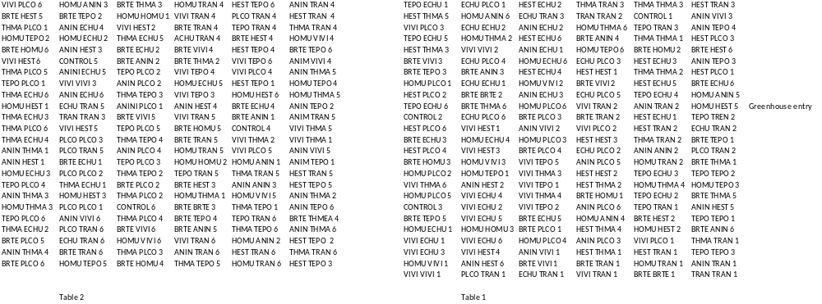

Table S3. Trait classifications and ecological importance for fifteen traits measured in our experiment and leaves and roots macro- and micronutrient contents. CLASS 1 characterizes each trait according to the plant part where it is located whereas CLASS 2 classifies each trait as morphological if it corresponds to a structure; nutrient if it is directly associated with a physiological component; or reproductive if participates in any reproductive function. References: 1: Bjorkman et al. 2018; 2: Hanisch et al. 2020; 3 Cornelissen et al. 2003; 4: Navarro-Cano et al. 2018; 5: Wezel et al. 2000; 6: Bardgett et al. 2014; 7: De Long et al. 2019; 8: De Deyn et al. 2008; 9: Chen et al. 2019; 10: Lavorel et al. 2007; 11: Averill et al. 2014; 12: Legay et al. 2014; 13: Cong et al. 2014; 14: Carrillo et al. 2017; 15: Grigulis et al. 2013; 16: Garnier & Navas, 2012; 17: Reich, 2014; 18: Wright et al. 2004; 19: Tang et al. 2019; 20: Burton et al. 2002; 21: Reich et al. 2008; 22: Sun et al. 2017; 23: Faucon et al. 2017; 24: Fry et al. 2019; 25: Roumet et al. 2016; 26: Pei et al. 2016; 27: Barel et al. 2011; 28: Oreja et al. 2020; 29: Aerts & Caluwe, 1997; 30: Liu et al. 2018; 31: Ferlian et al. 2017; 32: Corneo et al. 2013; 33 Goldbach et al. 2007; 34: Yruela, 2009; 35: Black et al. 2019; 36: Salam & Varma, 2019; 37: Tao et al. 2023; 38: Niu et al. 2015; 39: Lee et al. 2019; 40: Alam et al. 2015; 41: Bechtaoui et al. 2021; 42: Zeng et al. 2022; 43: Han et al. 2022.

PLANT TRAIT | UNITS | CLASS 1 | CLASS 2 | ECOLOGICAL RELEVANCE | REFERENCES
Plant height | mm | WHOLE PLANT | MORPHOLOGICAL | Proxy of biomass production. Influence in nutrient acquisition and fertility. Influence in light interception and competitive ability and fecundity | 1, 2, 10, 16
Aboveground weight (fresh) | g | ABOVEGROUND | MORPHOLOGICAL | Proxy of aboveground biomass and nutrient metabolism | 7, 15, 17, 18
Leaf dry area | cm² | ABOVEGROUND | MORPHOLOGICAL | Proxy of nutrient acquisition, plant biomass, and fertility. Influence in canopy structure | 1, 2, 3,4
Number of leaves | n | ABOVEGROUND | MORPHOLOGICAL | Proxy of photosynthetic metabolism, influence in aboveground nutrient storage, biomass production, and leaf energy. Related to canopy structure. | 1, 2, 3,4
Canopy area | cm² | ABOVEGROUND | MORPHOLOGICAL | Proxy of photosynthetic metabolism, influence in aboveground nutrient storage, biomass production, and leaf energy. | 1, 2, 3, 4
Trunk diameter | mm | ABOVEGROUND | MORPHOLOGICAL | Proxy of aboveground biomass. | 7, 15, 17, 18
Leaf dry weight | g | ABOVEGROUND | MORPHOLOGICAL | Proxy of nutrient acquisition, plant biomass, and fertility. Influence in canopy structure | 1, 2, 3,4
Leaf diameter | mm | ABOVEGROUND | MORPHOLOGICAL | Proxy of nutrient acquisition, plant biomass, and fertility. Influence in canopy structure | 1, 2, 3,4
Number of flowers | n | ABOVEGROUND | REPRODUCTIVE | Influence in fertility. | 10
Number of fruits | n | ABOVEGROUND | REPRODUCTIVE | Influence in fertility. | 10
Maximum root length | mm | BELOWGROUND | MORPHOLOGICAL | Proxy of belowground biomass. Influence in soil exploration and erosion resistance. | 2, 4, 6, 7, 8, 9, 10, 12, 13, 14, 16
Coarse roots weight | g | BELOWGROUND | MORPHOLOGICAL | Roots bigger than 1 mm in diameter. Proxy of belowground biomass. Influence in nitrogen fixation and nutrient acquisition Proxy of belowground biomass. Influence in soil exploration and erosion resistance. | 2, 4, 6, 7, 8, 9, 10, 12, 13, 14, 16
Fine root weight | g | BELOWGROUND | MORPHOLOGICAL | Roots under 1 mm in diameter. Proxy of belowground biomass. Influence in nitrogen fixation and nutrient acquisition | 2, 4, 6, 7, 8, 9, 10, 12, 13, 14, 16, 6, 7, 8, 9, 11
Root weight (fresh) | g | BELOWGROUND | MORPHOLOGICAL | Proxy of belowground biomass and nutrient metabolism | 7, 15, 25
Number of root nodules | n | BELOWGROUND | MORPHOLOGICAL | Influence in nitrogen fixation and nutrient acquisition.  *Only in T. angustifolium and V. villosa. | 6, 7, 8, 9, 11
Leaf carbon (C) content | g/100g | ABOVEGROUND | NUTRIENT | Proxy of plant biomass, fertility, and nitrogen metabolism. Influence in competitive strength. | 2, 3, 9, 27, 9
Leaf nitrogen (N) content | g/100g | ABOVEGROUND | NUTRIENT | Influence in plant biomass, fertility. Influence on carbon metabolism and competitive strength of the plant. | 1, 2, 3, 6, 7, 9, 13, 17, 24, 26, 27, 28
Root carbon (C) content | g/100g | BELOWGROUND | NUTRIENT | Proxy of nitrogen metabolism and biogeochemical cycles. | 3, 6, 12, 13, 21, 23, 29, 31
Root nitrogen (N) content | g/100g | BELOWGROUND | NUTRIENT | Influence on nitrogen cycling and carbon fluxes, decomposition, fertility, and microbial community composition. | 2, 6, 7, 8, 9, 13, 19, 20, 21, 22, 23, 24
Leaf boron (B) content | mg/Kg | ABOVEGROUND | NUTRIENT | Influence in plant growth and cell wall development | 32, 33
Root boron (B) content | mg/Kg | BELOWGROUND | NUTRIENT | Influence in soil microbiome by promoting root tips and root nodules development | 32
Leaf copper (Cu) content | mg/Kg | ABOVEGROUND | NUTRIENT | Crucial for photosynthesis and carbon metabolism | 32,34
Root copper (Cu) content | mg/Kg | BELOWGROUND | NUTRIENT | Impact on soil microbial community diversity and abundance | 32,35
Leaf iron (Fe) content | mg/Kg | ABOVEGROUND | NUTRIENT | Crucial for photosynthesis and nitrogen and carbon metabolism | 32
Root iron (Fe) content | mg/Kg | BELOWGROUND | NUTRIENT | Influence in nitrogen cycling rates and decomposition processes | 36
Leaf manganese (Mn) content | mg/Kg | ABOVEGROUND | NUTRIENT | Crucial for photosynthesis and nitrogen metabolism | 32
Root manganese (Mn) content | mg/Kg | BELOWGROUND | NUTRIENT | Influence in nitrogen and carbon cycling rates | 37
Leaf magnesium (Mg) content | mg/Kg | ABOVEGROUND | NUTRIENT | Structural modulator, involved with phosphate transportation and photosynthesis processes | 32, 38
Root magnesium (Mg) content | mg/Kg | BELOWGROUND | NUTRIENT | Influence in stability and metabolism of soil microorganisms | 39
Leaf molybdenum (Mo) content | mg/Kg | ABOVEGROUND | NUTRIENT | Necessary for nitrogen fixation, promotes plant nodules | 40
Root molybdenum (Mo) content | mg/Kg | BELOWGROUND | NUTRIENT | Influence in nutrient cycling and bacterial N fixation | 40
Leaf phosphorous (P) content | mg/Kg | ABOVEGROUND | NUTRIENT | Influence in plant growth, root growth, and photosynthesis | 41
Root phosphorous (P) content | mg/Kg | BELOWGROUND | NUTRIENT | Influence in mineralization of P from organic matter and nutrient cycling | 42
Leaf zinc (Zn) content | mg/Kg | ABOVEGROUND | NUTRIENT | Influence in photosynthesis and enzyme activation | 32
Root zinc (Zn) content | mg/Kg | BELOWGROUND | NUTRIENT | Related to microbial metabolism as an activator and influence in mycorrhizal association | 43

Table S4: Mean values (± standard error) of 33 traits: plant height (PLANTHEIGHT), canopy area (CANOPYAREA), trunk diameter (DIAMTRUNK), number of leaves (NLEAF), number of flowers (NFLOWERS), number of fruits (NFRUITS), maximum root length (LONGROOT), fine roots weight (FINEROOTS), coarse roots weight, (COARSEROOTS), root weight (BLWG), number of root nodules (NNODULES), leaf diameter (LEAFDIAM), aboveground weight (ABVG), leaf dry weight (LEAFDW), leaf dry area (LEAFDA), carbon content in roots (C_ROOT), nitrogen content in roots (N_ROOT), nitrogen content in leaves (N_LEAF), carbon content in leaves (C_LEAF), boron content in roots (B_ROOT), copper content in roots (Cu_ROOT), iron content in roots (Fe_ROOT), magnesium content in roots (Mn_ROOT), molybdenum content in roots (Mo_ROOT), phosphorus content in roots (P_ROOT), Zinc content in roots (Zn_ROOT), copper content in roots (Cu_LEAF), iron content in leaves (Fe_LEAF), magnesium content in leaves (Mn_LEAF), molybdenum content in leaves (Mo_LEAF), phosphorus content in Leaves (P_LEAF), Zinc content in leaves (Zn_LEAF). Acronyms correspond to the name of the species: TRAN Trifolium angustifolium; VIVI Vicia villosa; BRTE Bromus tectorum; HOMU Hordeum murinum; ANIN Andryala integrifolia; HEST Helichryum stoechas; THMA Thymus mastichina; MIER Micropus erectus; HIIN Hirschfeldia incana; PLCO Plantago coronopus.

 |  | Units | n | ANIN | BRTE | HEST | HIIN | HOMU | MIER | PLCO | THMA | TRAN | VIVI
PLANTHEIGHT |  | mm | 597 | 69.5±6.6 | 482.8±21.3 | 42.9±3 | 95.7±8.3 | 367.5±9.8 | 41.7±4.6 | 238.6±15.7 | 112.1±8.5 | 145.4±14 | 785.4±31.4
ABVG |  | g | 428 | 2.3±0.4 | 6.7±0.6 | 0.6±0.1 | 4±0.5 | 6.8±0.4 | 2.3±0.3 | 5.3±0.6 | 1.2±0.2 | 2.7±0.3 | 4.8±0.5
LEAFDA |  | cm2 | 411 | 5.3±0.7 | 4.1±0.4 | 0.9±0.1 | 7.2±0.8 | 2.8±0.3 | 0.5±0 | 2.4±0.2 | 0.2±0 | 2.8±0.2 | 0.2±0
NLEAF |  | n | 535 | 55.6±8.7 | 56.6±9.5 | 62.5±9.7 | 59.6±9.9 | 60.7±9.6 | 64.9±10.4 | 59.9±9.8 | 101.4±12.7 | 58.2±10.4 | 66.4±9.6
CANOPYAREA |  | cm2 | 414 | 1130.7±201.6 | 942.3±170.2 | 848.4±113.3 | 614.2±107 | 994.3±143.3 | 737.1±149.7 | 587.1±113.7 | 524.1±87.4 | 525.4±91.9 | 1073.3±190
DIAMTRUNK |  | mm | 545 | 3.8±0.5 | 3.5±0.5 | 3±0.4 | 2.9±0.4 | 4.2±0.6 | 2.7±0.4 | 4.1±0.5 | 2.2±0.3 | 2.5±0.3 | 3.6±0.5
LEAFDW |  | g | 433 | 0±0 | 0±0 | 0±0 | 0.1±0 | 0±0 | 0±0 | 0±0 | 0±0 | 0±0 | 0±0
LEAFDIAM |  | mm | 400 | 95±6.2 | 130.1±7.9 | 28±0.8 | 103.4±6.4 | 145.6±8.9 | 20.4±0.8 | 99.5±4.8 | 12±0.6 | 56.9±3 | 41.9±1.8
NFLOWERS |  | n | 514 | 1.3±0.4 | 1.4±0.3 | 3.9±2.3 | 1.7±0.5 | 1.2±0.3 | 1.2±0.5 | 2.6±0.6 | 1.5±0.5 | 2.2±0.5 | 1.7±0.5
NFRUITS |  | n | 342 | 0.1±0.1 | 0.3±0.3 | 0.6±0.4 | 0±0 | 0±0 | 0.2±0.2 | 0±0 | 0.2±0.1 | 0±0 | 0.3±0.2
LONGROOT |  | mm | 317 | 103.8±6.7 | 244.8±13.8 | 137.4±7.3 | 130.8±9.9 | 266.9±16.1 | 121.1±6.6 | 154±8 | 128.3±10.6 | 174.1±8.5 | 199.1±18.8
COARSEROOTS |  | mm | 145 | 0.1±0 | 1.9±0.3 | 0.1±0.1 | 0.1±0 | 1.5±0.3 | 0.1±0 | 0.1±0 | 0±0 | 0.1±0 | 0.1±0
FINEROOTS |  | mm | 427 | 0.4±0.1 | NA | 0±0 | 0.1±0 | 0.2±0.1 | 0±0 | 0.1±0 | 0±0 | 0.1±0 | 0±0
BLWG |  | g | 420 | 0.4±0.1 | 2.1±0.3 | 0±0 | 0.2±0 | 1.6±0.2 | 0.1±0 | 0.1±0 | 0±0 | 0.2±0 | 0.1±0
NNODULES |  | n | 46 | NA | NA | NA | NA | NA | NA | NA | NA | 3.6±0.9 | 5.6±0.7
C_LEAF |  | g/100g | 190 | 37.7±0.6 | 38.7±0.2 | NA | 36.7±0.5 | 37.9±0.3 | 39.1±0.6 | 38.4±0.4 | 43.8±0.4 | 39.2±0.2 | 40.4±0.1
N_LEAF |  | g/100g | 192 | 2±0.2 | 0.9±0.1 | NA | 2.3±0.1 | 1.2±0 | 2.1±0.3 | 1.4±0.1 | 1.8±0.1 | 1.9±0.1 | 1.9±0.1
C_ROOT |  | g/100g | 180 | 39.6±0.2 | 27.2±2 | NA | 39.8±0.6 | 32.6±1.3 | 36.2±2.4 | 39.9±0.4 | 41.8±0.6 | 39.2±0.4 | 37.3±0.7
N_ROOT |  | g/100g | 182 | 1±0.1 | 0.8±0.1 | NA | 1.5±0.1 | 0.8±0.1 | 1.6±0.3 | 1±0.1 | 1.2±0.1 | 1.5±0.1 | 2±0.1
B_LEAF |  | mg/kg | 150 | 19.3±1.9 | 11.7±0.8 | NA | 40.4±3.7 | 16.4±1.5 | 27.4±13.1 | 23±1.6 | 17±1.8 | 39.3±4.3 | 18.6±1.4
B_ROOT |  | mg/kg | 68 | 5±1.2 | 2.5±0.3 | NA | 5.6±1 | 2±0.2 | 9±6.6 | 9.3±2.4 | 5.9±NA | 4.9±2.3 | 5.7±1.4
Cu_LEAF |  | mg/kg | 153 | 12.9±1.3 | 5.8±0.3 | NA | 9.5±1.5 | 5.7±0.3 | 25.7±8.3 | 9.6±0.6 | 10.9±0.2 | 13.6±1.2 | 5.1±0.3
Cu_ROOT |  | mg/kg | 145 | 11.9±2 | 24.3±1.9 | NA | 14.7±4.1 | 20±1.9 | 22.6±6.5 | 15.2±1.7 | 20.4±3.7 | 31.4±4.5 | 23.7±1.9
Fe_LEAF |  | mg/kg | 145 | 1124.4±266.7 | 338.6±63.4 | NA | 254±35.6 | 377.5±52.3 | 2102.3±1056.8 | 380.3±60.3 | 399.5±99.3 | 190.9±18.4 | 165.1±27.2
Fe_ROOT |  | mg/kg | 148 | 1593.61±369.91 | 3583.32±346.84 | NA | 1414.75±151.57 | 2966.65±240.94 | 3531.66±993.73 | 1706.57±312.24 | 1903.49±349.61 | 3063.79±330.24 | 3830.86±337.91
Mn_LEAF |  | mg/kg | 144 | 166.1±21.9 | 209±14.4 | NA | 66.9±5.2 | 116.7±5.7 | 163.1±45.7 | 72.5±6.5 | 112.6±14.1 | 68.3±5.3 | 27.3±1.3
Mn_ROOT |  | mg/kg | 150 | 57.3±10.5 | 128.6±9.8 | NA | 45.4±3.4 | 91.4±4.7 | 82±12.3 | 60.2±7.1 | 71±0.6 | 86.4±8 | 104.4±4.9
Mo_LEAF |  | mg/kg | 153 | 12.3±3.1 | 1.6±0.5 | NA | 2.9±0.6 | 1.8±0.3 | 37.3±20.1 | 1.6±0.5 | 1.6±0.8 | 7.8±0.7 | 0.8±0.2
Mo_ROOT |  | mg/kg | 145 | 4.1±0.7 | 2.8±0.4 | NA | 9.6±3.8 | 3.2±1.2 | 7.8±1.5 | 11±3.4 | NA | 6.2±1.8 | 7.6±3.6
P_LEAF |  | mg/kg | 158 | 0.2±0 | 0.1±0 | NA | 0.3±0 | 0.2±0 | 0.2±0 | 0.2±0 | 0.1±0 | 0.2±0 | 0.1±0
P_ROOT |  | mg/kg | 98 | 0.2±0 | 0.1±0 | NA | 0.4±0 | 0.1±0 | 0.1±0 | 0.1±0 | 0.1±0 | 0.2±0 | 0.1±0
Zn_LEAF |  | mg/kg | 161 | 25.1±2.5 | 19.1±1.5 | NA | 42.2±3.6 | 20.6±0.9 | 24.2±4.2 | 21.6±1.9 | 32±7.8 | 29.6±3 | 18.2±2.2
Zn_ROOT |  | mg/kg | 155 | 16.3±1.9 | 39.9±4.3 | NA | 29.5±1.9 | 49.2±4.2 | 23.1±4 | 46.6±11 | 16.2±3.1 | 25.6±3.3 | 22.7±1.5

Table S5. Number individuals considered in the incubation assay (n= 234). Ten species were combined with each other in pairs of individuals. The ID of the individual is an acronym that corresponds to the name of the species of the pair: TRAN Trifolium angustifolium; VIVI Vicia villosa; BRTE Bromus tectorum; HOMU Hordeum murinum; ANIN Andryala integrifolia; HEST Helichrysum stoechas; THMA Thymus mastichina; MIER Micropus erectus; HIIN Hirschfeldia incana; PLCO Plantago coronopus
ANINMIER | ANINANIN | ANINANIN | ANINHIIN | ANINHIIN | ANINVIVI | ANINHEST | ANINTHMA | ANINMIER | ANINMIER | ANINTHMA | ANINANIN
ANINANIN | ANINTHMA | ANINHEST | ANINTHMA | ANINHIIN | ANINHEST | ANINVIVI | BRTEHOMU | BRTEBRTE | BRTEBRTE | BRTEHOMU | BRTEPLCO
BRTEBRTE | BRTEBRTE | BRTEHOMU | BRTEBRTE | BRTEBRTE | BRTEPLCO | BRTEHOMU | HESTTRAN | HESTHIIN | HESTTRAN | HESTHEST | HESTHEST
HESTHEST | HESTHEST | HESTHIIN | HESTHIIN | HESTANIN | HESTPLCO | HESTPLCO | HESTTRAN | HESTMIER | HESTMIER | HESTMIER | HESTMIER
HESTANIN | HESTANIN | HESTANIN | HIINTRAN | HIINHEST | HIINMIER | HIINHEST | HIINMIER | HIINHEST | HIINANIN | HIINHEST | HIINANIN
HIINTRAN | HIINHIIN | HIINHIIN | HIINHIIN | HIINHIIN | HIINHIIN | HIINHIIN | HIINMIER | HIINMIER | HIINTRAN | HIINTHMA | HIINTHMA
HIINANIN | HIINTHMA | HIINTRAN | HIINTHMA | HOMUBRTE | HOMUBRTE | HOMUVIVI | HOMUPLCO | HOMUPLCO | HOMUVIVI | HOMUHOMU | HOMUHOMU
HOMUBRTE | HOMUPLCO | HOMUPLCO | HOMUVIVI | HOMUHOMU | HOMUHOMU | HOMUHOMU | HOMUHOMU | HOMUVIVI | MIERANIN | MIERMIER | MIERMIER
MIERMIER | MIERMIER | MIERMIER | MIERMIER | MIERHIIN | MIERHIIN | MIERTRAN | MIERVIVI | MIERHIIN | MIERANIN | MIERHEST | MIERANIN
MIERHEST | MIERHEST | MIERVIVI | MIERHEST | MIERTHMA | MIERTRAN | MIERTHMA | MIERVIVI | MIERVIVI | MIERTRAN | MIERPLCO | MIERPLCO
MIERPLCO | MIERTHMA | MIERPLCO | MIERTHMA | PLCOTRAN | PLCOVIVI | PLCOBRTE | PLCOHOMU | PLCOBRTE | PLCOHOMU | PLCOVIVI | PLCOHEST
PLCOHEST | PLCOHOMU | PLCOHOMU | PLCOTRAN | PLCOVIVI | PLCOVIVI | PLCOTHMA | PLCOMIER | PLCOMIER | PLCOPLCO | PLCOPLCO | PLCOTRAN
PLCOPLCO | PLCOPLCO | PLCOPLCO | PLCOPLCO | PLCOMIER | PLCOMIER | PLCOBRTE | PLCOTHMA | PLCOTHMA | PLCOTHMA | THMATHMA | THMATHMA
THMATHMA | THMATHMA | THMATRAN | THMAVIVI | THMATRAN | THMAANIN | THMAVIVI | THMAVIVI | THMAANIN | THMATRAN | THMAMIER | THMAMIER
THMAPLCO | THMAHIIN | THMAANIN | THMAHIIN | THMAANIN | THMAHIIN | THMAHIIN | THMAMIER | THMAMIER | THMAPLCO | THMAPLCO | THMAPLCO
TRANHEST | TRANPLCO | TRANTRAN | TRANTRAN | TRANVIVI | TRANHEST | TRANTHMA | TRANMIER | TRANTRAN | TRANTRAN | TRANVIVI | TRANVIVI
TRANPLCO | TRANHIIN | TRANHIIN | TRANHEST | TRANTHMA | TRANTHMA | TRANPLCO | TRANMIER | TRANHIIN | TRANVIVI | TRANMIER | TRANTRAN
TRANTRAN | TRANPLCO | TRANHIIN | VIVITRAN | VIVITRAN | VIVIPLCO | VIVITRAN | VIVIHOMU | VIVIANIN | VIVIMIER | VIVIVIVI | VIVIVIVI
VIVIHOMU | VIVIPLCO | VIVITHMA | VIVIVIVI | VIVIVIVI | VIVIHOMU | VIVITHMA | VIVITHMA | VIVIMIER | VIVIPLCO | VIVIMIER | VIVIMIER
VIVITRAN | VIVIPLCO | VIVIVIVI | VIVIVIVI | VIVIANIN | VIVIHOMU

Table S6. Results of Linear Mixed models testing the effects of Functional Distance (FD) between pairs of plant individuals on the Relative Change (RC) of rhizosphere basal respiration (BR) of the focal species. Each row represents a model in which FD has been calculated with all traits as classified in Table S1. The identity of focal and neighbour species was included in the model as random factors.

RC FOCAL |  |  |  | Marginal R² / Conditional R²
Predictors | Estimates | CI | p-value
All traits FD | 0.62 | -0.31 – 1.55 | 0.191 | 0.027 / 0.294
Aboveground trait FD | 0.92 | 0.13 – 1.71 | 0.022 | 0.005 / 0.253
Belowground trait FD | -0.35 | -1.21 – 0.51 | 0.427 | 0.099 / 0.844
Nutrient trait FD | 2.55 | 0.02 – 5.08 | 0.048 | 0.002 / 0.255
Morphological trait FD | 0.27 | -0.59 – 1.12 | 0.542 | 0.027 / 0.294

Table S7. Results of Linear Mixed models testing the effects of Functional Distance (FD) between pairs of plant individuals on the Relative Change (RC) of rhizosphere basal respiration (BR) of the focal species. Each row represents a model in which FD has been calculated with above- and belowground traits without including nutrients (all aboveground except nutrient traits FD and all belowground except nutrient traits FD) and including only nutrients (aboveground nutrient traits FD and belowground nutrient traits FD). The identity of focal and neighbour species was included in the model as random factors.

RC (BR) FOCAL |  |  |  | Marginal R² / Conditional R²
Predictors | Estimates | CI | p-value
All aboveground except nutrient traits FD | 0.86 | 0.10 – 1.62 | 0.026 |  | 0.025 / 0.289
All belowground except nutrient traits FD | 1.89 | 0.59 – 3.18 | 0.006 |  | 0.145 / 0.842
Aboveground nutrient traits FD | -0.22 | -1.05 – 0.60 | 0.597 |  | 0.002 / 0.250
Belowground nutrient traits FD | -1.54 | -3.69 – 0.62 | 0.152 |  | 0.071 / 0.757

Table S8. Mean and SE of aboveground (leaves and shoots) and belowground (roots) values of nutrient concentrations and dry weight. Differences between above and belowground trait values are tested with a paired t-test. Significant differences between above- and belowground traits are highlighted in bold type.

Trait | Aboveground  (leaves and shoots) | Belowground (roots) | t | p-value | D.F.
Carbon (C) content (g/100g) | 38.71±0.15 | 35.69±0.59 | -5.01 | <0.001 | 168
Nitrogen (N) content (g/100g) | 1.56±0.05 | 1.19±0.05 | -8.52 | <0.001 | 172
Boron (B) (mg/kg) | 22.09±2.11 | 4.33±0.48 | -9.05 | <0.001 | 59
Copper (Cu) (mg/kg) | 8.88±0.52 | 20.72±1.09 | 9.82 | <0.001 | 135
Iron (Fe) (mg/kg) | 456.13±60.99 | 2658.25±138.18 | 14.47 | <0.001 | 131
Magnesium (Mg) (mg/kg) | 110.52±6.26 | 84.95±3.46 | -3.90 | <0.001 | 138
Molybdenum (Mo) (mg/kg) | 6.3±1.71 | 6.26±1.09 | -0.02 | 0.99 | 46
Phosphorus (P) (mg/kg) | 0.19±0.01 | 0.16±0.01 | -2.57 | 0.01 | 140
Zinc (Zn) (mg/kg) | 23.93±1.02 | 35.39±2.45 | 4.37 | <0.001 | 135
Weight (g) | 3.66±0.17 | 0.40±0.044 | 19.87 | <0.001 | 354

R Code for reproducing the analysis conducted in this study.
################################################################################################
############## Differences in nutrient content between heterospecific plant neighbours affect respiration rates of rhizosphere microbiota###################
################# Jimeno-Alda et al. 2025
############################################################################
library(tidyr)
library(dplyr)
library(readxl)
library(FD)
library(lme4)
library(lmerTest)
library(sjPlot)
library(ggplot2)
library(DHARMa)
library(equatiomatic)
library(ggfortify)
library(ggrepel)

# Set the working directory

setwd("C:\\set\\your\\working\\directory")
data<- read_excel("BR_DATA.xlsx", col_types = c(rep("numeric", 5), rep("text", 3)))
##################################################################################################
####### TABLE 1 BASAL RESPIRATION MEASURES DEPENDING ON FOCAL / NEIGHBOUR SPECIES ###########
###################################################################################################
result <- data %>%
group_by(FOCAL, NEIGHBOUR) %>%
summarise(mean_BASALRESP = mean(BASALRESP , na.rm = T))# GROUP BY FOCAL/NEIGHBOUR SPECIES AND CALCULATE MEAN VALUES
mm_br<-as.data.frame(result)
focal_matrix_BASAL <- mm_br %>%
pivot_wider(names_from = FOCAL, values_from = mean_BASALRESP) # ARRAY MATRIX
focal_matrix_BASAL #VISUALIZ

result_count <- data %>%
group_by(FOCAL, NEIGHBOUR) %>%
summarise(COUNT_RC = sum(!is.na(BASALRESP))) #
mm_count <- as.data.frame(result_count)

mm_count<-as.data.frame(result_count)
#VISUALIZE AS DATA FRAME
n_matrix <- mm_count %>%
pivot_wider(names_from = FOCAL, values_from = COUNT_RC) # ARRAY MATRIX
n_matrix #VISUALIZE MATRIX

#################################################################################################################################
####################### TABLE 2: MEAN VALUES OF RELATIVE CHANGE OF BR RATES OF FOCAL SPECIES VS. NEIGHBOUR SPECIES ##############
#########################################################################################################################################

#CALCULATE MEAN RC BR PER FOCAL SPECIES
result <- data %>%
group_by(FOCAL, NEIGHBOUR) %>%
summarise(MEAN_RC = mean(RC_FOCAL, na.rm = T))# GROUP BY FOCAL/NEIGHBOUR SPECIES AND CALCULATE MEAN VALUES
mm<-as.data.frame(result)
#VISUALIZE AS DATA FRAME
focal_matrix <- mm %>%
pivot_wider(names_from = FOCAL, values_from = MEAN_RC) # ARRAY MATRIX
focal_matrix #VISUALIZE MATRIX
## TABLE T-TEST RC BASAL RESP FOCAL
#SELECT COLUMNS
t_data<-data[, c(5,6)] #SELECT COLUMNS
#PREPARE DATA TO APPLY T TEST
t_data2<-na.omit(t_data) #DELETE NA´S
# T TEST PER COMBINATION OF SPECIES
t_data3 <- t_data2 %>%
group_by(COMBINATION) %>%
filter(n() >= 4) %>% #DELETE COMBINATIONS WITHOUT ENOUGHT OBSERVATIONS
ungroup()
test_result <- t_data3 %>%
group_by(COMBINATION) %>%
summarise(test_pvalue = t.test(RC_FOCAL, na.rm = TRUE)$p.value)
test_result #VISUALIZE TEST RESULTS

###################################################################################################
################## TABLE 3: EFFECT OF FUNCTIONAL DISTANCE ON BR RC RATES ############################
##################################################################################################

base <- read_excel("TRAITS.xlsx", col_types = c("numeric", "text", "text", "text", rep("numeric",33)))
## LOG INDIVIDUAL TRAIT VALUES
s<-base[, 5:37]#SELECT NUMERIC VARIABLES
for (i in 1:33 ){
s[,i]<-log(s[,i]+1.00001) #LOG TRAITS
}
str(base)
### SUBSET OF TRAITS
str(s)
above_nonut<-s[,c(1:6,12:15)]
above_onlynut<-s[,c(18,19,27:33)]
below_nonut<-s[,c(7:11)]
below_onlynut<-s[,c(16, 17,20,21:26)]
all<-s
above<-s[,c(1:6, 12:15,18,19,27:33)]
below<- s[,c(7:11, 16, 17,20,21:26)]
nut<-s[,16:33]
morpho<-s[,c(1:4, 7:15)]
## FD CHARACTERIZATION ACCORDING SUBSETS OF TRAIT
#GOWDIS FD FOR EACH SUBSET OF TRAITS
#ALL TRAITS
gowdis_all<-gowdis(all)
#SELECT THE VALUES OF EACH INDIVIDUAL
matrix<-as.matrix(gowdis_all) # REPLACE "GOWDIST" WITH THE NAME OF A GOWDIST CALCULATED ABOVE (gowdis_all;gowdis_above;gowdis_below;gowdis_nut;gowdis_morpho)
val_select <- numeric(300) #create a list
for (i in 1:300) {
col <- 2 * i
row <- 2 * i - 1
val <- matrix[row, col]
val_select[i] <- val
} # fill the list with FD values selected with the loop
ALL_FD<- rep(val_select, each = 2) # Duplicate FD values (two species share the same FD)
#REPLACE "FD" WITH THE NAME OF SUBSET OF TRAITS (ALL_FD;ABOVE_FD;BELOW_FD;NUT_FD;MORPHO_FD)
#ADD ID TO FD VALUES
z<-cbind(ALL_FD, base)

all_fd_traits <- z[,c(1,2)]

##ADD FD CALCULATED IN VECTOR "f" to a csv and create "PHENO_BR_DATA.csv" by ID of INDIVNUM column
######ABOVEGROUND TRAITS
gowdis_above<-gowdis(above)
#SELECT THE VALUES OF EACH INDIVIDUAL
matrix<-as.matrix(gowdis_above)
val_select <- numeric(300) #create a list
for (i in 1:300) {
col <- 2 * i
row <- 2 * i - 1
val <- matrix[row, col]
val_select[i] <- val
}
ABOVE_FD<- rep(val_select, each = 2) # Duplicate FD values (two species share the same FD)
#ADD ID TO FD VALUES
z<-cbind(ABOVE_FD, base)
above_fd_traits<-z[, c(1,2)]
######BELOWGROUND TRAITS
gowdis_below<-gowdis(below)
#SELECT THE VALUES OF EACH INDIVIDUAL
matrix<-as.matrix(gowdis_below)
val_select <- numeric(300) #create a list
for (i in 1:300) {
col <- 2 * i
row <- 2 * i - 1
val <- matrix[row, col]
val_select[i] <- val
}
BELOW_FD<- rep(val_select, each = 2) # Duplicate FD values (two species share the same FD)
#ADD ID TO FD VALUES
z<-cbind(BELOW_FD, base)
below_fd_traits<-z[, c(1,2)]
######NUTRIENT TRAITS
gowdis_nut<-gowdis(nut)
#SELECT THE VALUES OF EACH INDIVIDUAL
matrix<-as.matrix(gowdis_nut)
val_select <- numeric(300) #create a list
for (i in 1:300) {
col <- 2 * i
row <- 2 * i - 1
val <- matrix[row, col]
val_select[i] <- val
}
NUT_FD<- rep(val_select, each = 2) # Duplicate FD values (two species share the same FD)
#ADD ID TO FD VALUES
z<-cbind(NUT_FD, base)
nut_fd_traits<-z[, c(1,2)]
#### MORPHOLOGICAL TRAITS
gowdis_morpho<-gowdis(morpho)
#SELECT THE VALUES OF EACH INDIVIDUAL
matrix<-as.matrix(gowdis_morpho)
val_select <- numeric(300) #create a list
for (i in 1:300) {
col <- 2 * i
row <- 2 * i - 1
val <- matrix[row, col]
val_select[i] <- val
}
MORPHO_FD<- rep(val_select, each = 2) # Duplicate FD values (two species share the same FD)
#ADD ID TO FD VALUES
z<-cbind(MORPHO_FD, base)
morpho_fd_traits<-z[, c(1,2)]
#### ABOVEGROUND NO NUTRIENT TRAITS
gowdis_abovenonut<-gowdis(above_nonut)
#SELECT THE VALUES OF EACH INDIVIDUAL
matrix<-as.matrix(gowdis_abovenonut)
val_select <- numeric(300) #create a list
for (i in 1:300) {
col <- 2 * i
row <- 2 * i - 1
val <- matrix[row, col]
val_select[i] <- val
}
ABOVENONUT_FD<- rep(val_select, each = 2) # Duplicate FD values (two species share the same FD)
#ADD ID TO FD VALUES
z<-cbind(ABOVENONUT_FD, base)
abovenonut_fd_traits<-z[, c(1,2)]
#### ABOVEGROUND ONLY NUTRIENT TRAITS
gowdis_aboveonlynut<-gowdis(above_onlynut)
#SELECT THE VALUES OF EACH INDIVIDUAL
matrix<-as.matrix(gowdis_aboveonlynut)
val_select <- numeric(300) #create a list
for (i in 1:300) {
col <- 2 * i
row <- 2 * i - 1
val <- matrix[row, col]
val_select[i] <- val
}
ABOVEONLYNUT_FD<- rep(val_select, each = 2) # Duplicate FD values (two species share the same FD)
#ADD ID TO FD VALUES
z<-cbind(ABOVEONLYNUT_FD, base)
aboveonlynut_fd_traits<-z[, c(1,2)]

#### BELOWGROUND ONLY NUTRIENT TRAITS
gowdis_belowonlynut<-gowdis(below_onlynut)
#SELECT THE VALUES OF EACH INDIVIDUAL
matrix<-as.matrix(gowdis_belowonlynut)
val_select <- numeric(300) #create a list
for (i in 1:300) {
col <- 2 * i
row <- 2 * i - 1
val <- matrix[row, col]
val_select[i] <- val
}
BELOWONLYNUT_FD<- rep(val_select, each = 2) # Duplicate FD values (two species share the same FD)
#ADD ID TO FD VALUES
z<-cbind(BELOWONLYNUT_FD, base)
belowonlynut_fd_traits<-z[, c(1,2)]

#### BELOWGROUND NO NUTRIENT TRAITS
gowdis_belownonut<-gowdis(below_nonut)
#SELECT THE VALUES OF EACH INDIVIDUAL
matrix<-as.matrix(gowdis_belownonut)
val_select <- numeric(300) #create a list
for (i in 1:300) {
col <- 2 * i
row <- 2 * i - 1
val <- matrix[row, col]
val_select[i] <- val
}
BELOWNONUT_FD<- rep(val_select, each = 2) # Duplicate FD values (two species share the same FD)
#ADD ID TO FD VALUES
z<-cbind(BELOWNONUT_FD, base)
belownonut_fd_traits<-z[, c(1,2)]

str(morpho_fd_traits)
str(data)
# ADD FD VALUES TO DATA BASE
models<-merge(morpho_fd_traits,data, by="INDIVNUM", all=T)#Add FD to data base
models<-merge(all_fd_traits,models, by="INDIVNUM", all=T)#Add FD to data base
models<-merge(above_fd_traits,models, by="INDIVNUM", all=T)#Add FD to data base
models<-merge(below_fd_traits,models, by="INDIVNUM", all=T)#Add FD to data base
models<-merge(nut_fd_traits,models, by="INDIVNUM", all=T)#Add FD to data base
models<-merge(abovenonut_fd_traits,models, by="INDIVNUM", all=T)#Add FD to data base
models<-merge(aboveonlynut_fd_traits,models, by="INDIVNUM", all=T)#Add FD to data base
models<-merge(belownonut_fd_traits,models, by="INDIVNUM", all=T)#Add FD to data base
models<-merge(belowonlynut_fd_traits,models, by="INDIVNUM", all=T)#Add FD to data base

######## LMER MODELS TO TEST FD EFFECTS ON BR RATES AT VARYING FUNCTIONAL DISTANCES ###########
m<-lmer(RC_FOCAL ~ ALL_FD + (1|FOCAL) + (1|NEIGHBOUR) , data=models)#run the model
summary(m)#check the model
ranova(m)#check random factors analysis
r<-simulateResiduals(m)

m1<-lmer(RC_FOCAL ~ ABOVE_FD + (1|FOCAL) + (1|NEIGHBOUR) , data=models)
summary(m1)
ranova(m1)
r1<-simulateResiduals(m1)

m2<-lmer(RC_FOCAL ~ BELOW_FD + (1|FOCAL) + (1|NEIGHBOUR) , data=models)
summary(m2)
ranova(m2)
r2<-simulateResiduals(m2)

m3<-lmer(RC_FOCAL ~ NUT_FD + (1|FOCAL) + (1|NEIGHBOUR) , data=models)
summary(m3)
ranova(m3)
r3<-simulateResiduals(m3)

m4<-lmer(RC_FOCAL ~ MORPHO_FD + (1|FOCAL) + (1|NEIGHBOUR) , data=models)
summary(m4)
ranova(m4)
r4<-simulateResiduals(m4)

m5<-lmer(RC_FOCAL ~ ABOVENONUT_FD + (1|FOCAL) + (1|NEIGHBOUR) , data=models)
summary(m5)
ranova(m5)
r5<-simulateResiduals(m5)

m6<-lmer(RC_FOCAL ~ ABOVEONLYNUT_FD + (1|FOCAL) + (1|NEIGHBOUR) , data=models)
summary(m6)
ranova(m6)
r6<-simulateResiduals(m6)

m7<-lmer(RC_FOCAL ~ BELOWNONUT_FD + (1|FOCAL) + (1|NEIGHBOUR) , data=models)
summary(m7)
ranova(m7)
r7<-simulateResiduals(m7)

m8<-lmer(RC_FOCAL ~ BELOWONLYNUT_FD + (1|FOCAL) + (1|NEIGHBOUR) , data=models)
summary(m8)
ranova(m8)
r8<-simulateResiduals(m8)

###############################################################################################################################################3
######################## SUPPLEMENTARY TABLE 2: EXTENDED VERSION OF TABLE 4
#############################################################################################################################
str(r8)

sup1<-tab_model(m, m1,m2,m3,m4,p.val = "kr")

##### GRAPHICS

#############################################################################################
################## FIGURE 3: OVERALL EFFECT OF FD ON RC BR RATES ############################
#############################################################################################

### BOXPLOT WITH MEAN RC(BR) OF FOCAL SPECIES, SE AND SIGNIFICANCE

#MEAN VALUES OF RC(BR) PER FOCAL SPECIES

# Calculate mean RC_FOCAL and number of observations per FOCAL
mean_focal <- data %>%
group_by(FOCAL) %>%
summarise(
MEANRC = mean(RC_FOCAL, na.rm = TRUE), # Calculate mean of RC_FOCAL
n_obs = n()

) # GROUP BY FOCAL/NEIGHBOUR SPECIES AND CALCULATE MEAN VALUES

#STANDARD ERROR OF RC(BR) PER FOCAL SPECIES
se_focal <- data %>%
group_by(FOCAL) %>%
summarise(SE_RC = sd(RC_FOCAL, na.rm = TRUE) / sqrt(n()))

#T TEST OF RC(BR) PER FOCAL SPECIES

t_focal <- data %>%
group_by(FOCAL) %>%
summarise(mean_RC_FOCAL = mean(RC_FOCAL, na.rm = TRUE),
t_statistic = t.test(RC_FOCAL, na.rm = TRUE)$statistic,
p_value = t.test(RC_FOCAL, na.rm = TRUE)$p.value,
df=t.test(RC_FOCAL, na.rm = TRUE)$parameter)

View(t_focal) # species with p value < 0.05 were BRTE HEST AND VIVI

# Merge the mean and SE data
box <- merge(mean_focal, se_focal, by = "FOCAL")

n_obs_text <- paste("", paste(mean_focal$n_obs))

boxplot <- ggplot(box, aes(x = FOCAL, y = MEANRC)) +
geom_bar(stat = "identity", fill = "darkblue", alpha = 0.7) +
geom_errorbar(aes(ymin = MEANRC - SE_RC, ymax = MEANRC + SE_RC),
width = 0.4, colour = "black", alpha = 0.9, size = 1.3) +
geom_hline(yintercept = 0, linetype = "dashed", color = "black", size = 1) +
geom_text(aes(label = n_obs_text),
y = max(box$MEANRC + box$SE_RC) + 0.1,
size = 4, color = "black", hjust = 0.5) +
theme_bw() +
theme(panel.grid.major = element_blank(),
panel.grid.minor = element_blank(),
panel.background = element_rect(fill = "white", colour = "white"),
axis.text.x = element_text(angle = 60, vjust = 1, hjust = 1,
size = 14, colour = "black", face = "bold",
margin = margin(t = 5, b = 10)),
axis.text.y = element_text(size = 14, colour = "black",
margin = margin(r = 10)),
axis.title.y = element_text(size = 16, face = "bold",
margin = margin(r = 15)),
axis.title.x = element_text(size = 16, face = "bold",
margin = margin(t = 10))) +
labs(y = "Relative Change of BR rates", x = "") +
scale_x_discrete(labels = c(expression(italic("Andryala integrifolia")),
expression(italic("Bromus tectorum")),
expression(italic("Helichrysum stoechas")),
expression(italic("Hirschfeldia incana")),
expression(italic("Hordeum murinum")),
expression(italic("Plantago coronopus")),
expression(italic("Micropus erectus")),
expression(italic("Thymus mastichina")),
expression(italic("Trifolium angustifolium")),
expression(italic("Vicia villosa")))) +
coord_cartesian(ylim = c(-0.6, 0.4))

boxplot

#create asterisks
names<-unique(data$FOCAL)
label<- data.frame(FOCAL = names,
MEANRC = c(-0.3,-10, -10,-10,-10,-10,-0.5,-10,-0.5,-10))
#open new window
dev.new()
#Add asterisks
boxplot + geom_text(data = label, label = "*", size=7)

