Supplementary material

Wheat growth and phosphorus uptake from polyculture algal biofilms are synergistically modulated by arbuscular mycorrhizal fungi and Serendipita vermifera
Xinyu Gan, Jennifer Janus, Sabine Willbold, Vitalij Dombinov, Arnd J. Kuhn, Wulf Amelung, Diana Reinecke, Dean Calahan, Ladislav Nedbal, Holger Klose, Silvia D. Schrey*
*Corresponding author: s.schrey@fz-juelich.de

Table S1: Physical properties and nutritional composition of Null Erde substrate.
 | Unit | Sand | Null Erde
Bulk Density (Dry) | g L⁻¹ | 1510 | 266
pH (in CaCl₂) |  | 6.94 | 6
Nitrogen | mg g⁻¹ | <0.10 | < 0.01
Phosphorus (P₂O₅) | mg g⁻¹ | <0.05 | < 0.01
Potassium (K₂O) | mg g⁻¹ | 13.4 | < 0.02
Magnesium | mg g⁻¹ | 1.02 | 0.22

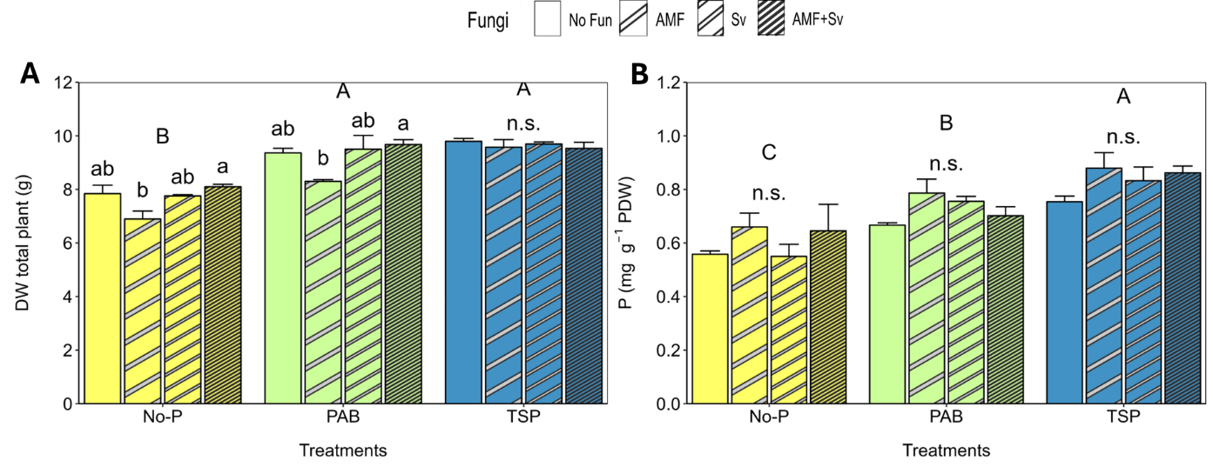

Figure S1: Wheat total dry biomass (A), and relative P content (B) of no-P fertilized wheat plants (No-P), algal biofilm (PAB) fertilized, and triple-superphosphate (TSP) fertilized plants; non-inoculated (No-Fun), arbuscular mycorrhizal fungi inoculated (AMF), Sebacina vermifera inoculated (Sv) and AMF + S. vermifera double (AMF+Sv). Wheat was harvested after 6 weeks of growth. (Tukey’s HSD test, p ≤ 0.05, n = 3)

