Multispecies swards improve nitrogen use efficiency and reduce nitrogen surplus in agricultural grasslands
Authors: *Omotola Obasoro^{1,2}, Jane Shackleton^{2,3}, Cornelia Grace², Jean Kennedy^{2,5}, Natalie J. Oram⁴, Helen Sheridan³, Olaf Schmidt³, Ron de Goede¹, Ellis Hoffland¹
Affiliations: 1. Soil Biology Group, Wageningen University and Research, The Netherlands
2. Global Innovation Centre, Devenish Research Development and Innovation, County Meath, Ireland
3. School of Agriculture and Food Science, University College Dublin, Belfield, Dublin 4, Ireland
4. Institute for Biodiversity and Ecosystem Dynamics, University of Amsterdam, Amsterdam, The Netherlands
5. Advanced Manufacturing and Training Centre of Excellence, Louth Meath Education and Training Board, Dundalk, Ireland

*Corresponding author: Soil Biology Group, Wageningen University and Research, The Netherlands.
E-mail address: omotola.odetayo@wur.nl

Supplementary information
List of supplementary tables
Table S1: Fertilizer application rates (kg/ha) and timing (months) in 2021 and 2022. “Chem” and “Org” denote chemical and organic N fertilizer treatments, respectively. “PRG”, “PP”, “6S” and “12S” denote perennial ryegrass, permanent pasture, six-species and twelve-species swards, respectively.
Sward type | Fertilizer type | Mar | Apr | May | June | Aug | Sept | Total N (kg/ha/yr)
PRG | Chemical | 42.5 | 21.25 | 42.5 | 21.25 | 21.25 | 21.25 | 170
PRG | Organic | 85 |  | 85 |  |  |  | 170
PRG | Chemical + Organic | 42.5 (Org) | 21.25 (Chem) | 42.5 (Org) | 21.25 (Chem) | 21.25 (Chem) | 21.25 (Chem) | 170
6S | Chemical | 35 |  | 35 |  |  |  | 70
6S | Organic | 35 |  | 35 |  |  |  | 70
6S | Chemical + Organic | 35 (Org) |  | 35 (Chem) |  |  |  | 70
12S | Chemical | 35 |  | 35 |  |  |  | 70
12S | Organic | 35 |  | 35 |  |  |  | 70
12S | Chemical + Organic | 35 (Org) |  | 35 (Chem) |  |  |  | 70
PP | Chemical | 35 |  | 35 |  |  |  | 70
PP | Organic | 35 |  | 35 |  |  |  | 70
PP | Chemical + Organic | 35 (Org) |  | 35 (Chem) |  |  |  | 70

Table S2: Average proportional contribution of legume to aboveground biomass and amount of biological N fixation (BNF) for each of the legume-containing sward type in 2021 and 2022. “PP”, “6S” and “12S” denote permanent pasture, six-species and twelve-species swards, respectively.
Sward type | *Average legume proportion | Average BNF (kg/ha/yr) |  | *Average legume proportion |  | Average BNF (kg/ha/yr)
 | Year 2021 |  |  | Year 2022
PP | 0.06 | 19.8 |  | 0.06 |  | 14.0
6S | 0.33 | 92.9 |  | 0.34 |  | 81.1
12S | 0.37 | 103.0 |  | 0.35 |  | 83.5
* Average proportional contribution of legume to cumulative aboveground biomass

Table S3: Effect of sward type, fertilizer treatment and year on aboveground biomass and herbage N yield. “df” denotes degrees of freedom. Significant P-values are in bold. Interaction terms that were not statistically significant (P > 0.05) were excluded from the final model and denoted as “NS”.
 |  |  | Aboveground biomass (kg/ha/yr) |  |  | Herbage N yield  (kg N/ha/yr)
 | df |  | F-value | P-value |  | F-value | P-value
 |  |  | Year 2021
Sward type | 3 |  | 21.77 | < 0.001 |  | 48.54 | < 0.001
Fertilizer treatment | 2 |  | 13.90 | < 0.001 |  | 19.01 | < 0.001
Sward:Fertilizer | NS |  | NS | NS |  | NS | NS
 |  |  | Year 2022
Sward type | 3 |  | 20.28 | < 0.001 |  | 36.47 | < 0.001
Fertilizer treatment | 2 |  | 2.07 | 0.14 |  | 5.83 | < 0.01
Sward:Fertilizer | NS |  | NS | NS |  | NS | NS

Table S4: Effect of sward type, fertilizer treatment on NUE_{total}, partial N balance and partial factor productivity in 2022. “df” and “NUE_{total}” denote degrees of freedom and nitrogen use efficiency, respectively. Significant P-values are in bold. Interaction terms that were not statistically significant (P > 0.05) were excluded from the final model and denoted as “NS”. Partial factor productivity values were log-transformed.
 |  |  | NUE_{total}  (kg N yield/kg N input) |  |  | Partial N balance (kg/ha) |  |  | Partial factor productivity (kg yield/kg N fertilizer)
 | df |  | F-value | P-value |  | F-value | P-value |  | F-value | P-value
 |  |  |  | Year 2021
Sward type | 3 |  | 31.61 | < 0.001 |  | 26.96 | < 0.001 |  | 212.82 | < 0.001
Fertilizer | 2 |  | 27.70 | < 0.001 |  | 29.17 | < 0.001 |  | 13.67 | < 0.001
Sward:Fertilizer | 6 |  | 2.67 | 0.032 |  | NS | NS |  | NS | NS
 |  |  |  | Year 2022
Sward type | 3 |  | 42.49 | < 0.001 |  | 52.55 | < 0.001 |  | 210.99 | < 0.001
Fertilizer | 2 |  | 22.32 | < 0.001 |  | 20.85 | < 0.001 |  | 2.18 | 0.13
Sward:Fertilizer | NS |  | NS | NS |  | NS | NS |  | NS | NS

List of supplementary figures
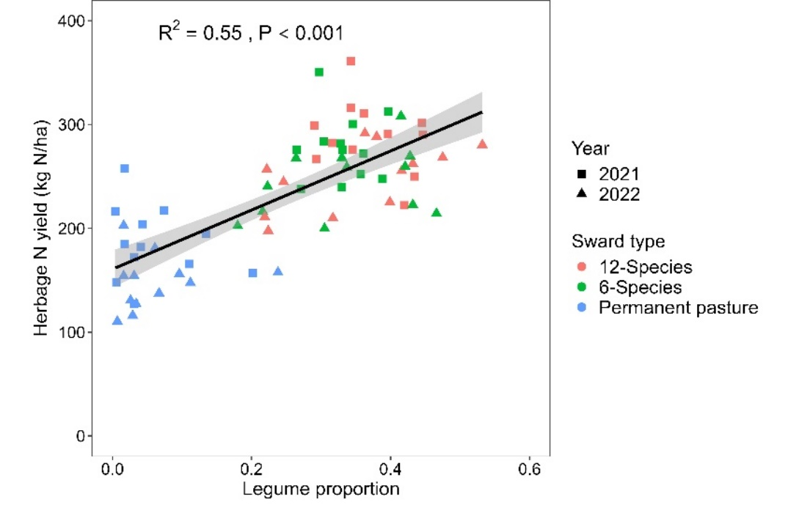
Fig. S1: Relationship between herbage N yield and legume proportion in 2021 and 2022. Line (+ SE) indicate significant relationship (P < 0.05). Perennial ryegrass data were removed from the analysis as the sward did not contain legumes.

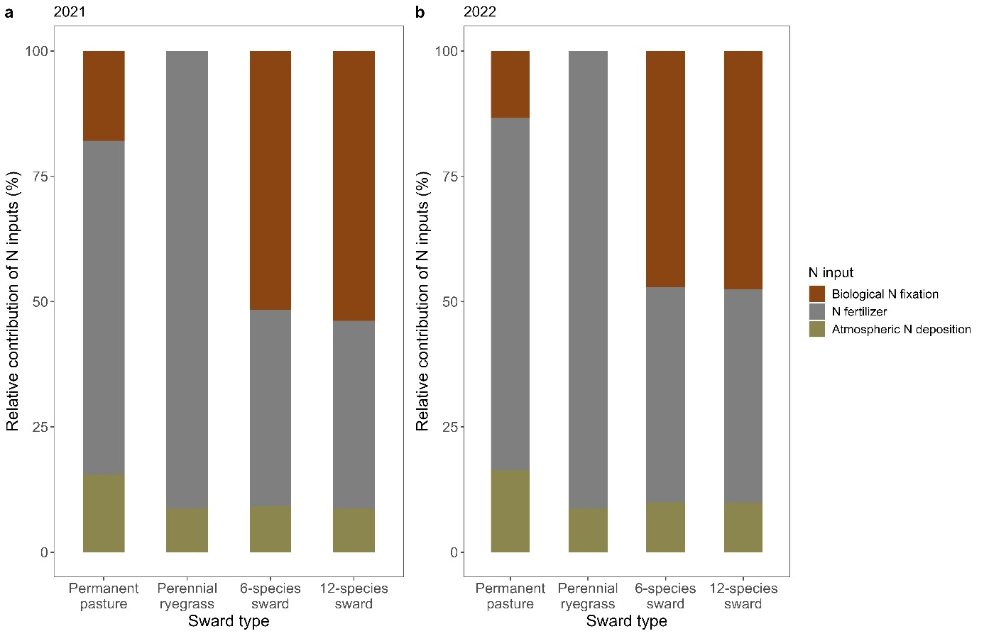Fig. S2: Contribution of each N input to the total N applied to each sward in a) 2021 and b) 2022

