Impact of mycorrhizal inoculation on the fungal root and rhizosphere communities, growth and salinity tolerance of Alnus glutionosa Gaertn. seedlings

Dominika Thiem^{1,2*}, Marcin Gołębiewski^{2,3}, Jarosław Tyburski^{2,3}, Tomasz Kowalkowski^{2,4}, Christel Baum⁵, Katarzyna Hrynkiewicz^{1,2}
¹ Department of Microbiology, Faculty of Biological Sciences and Veterinary, Nicolaus Copernicus University (NCU), Lwowska 1, 87-100 Torun, Poland
² Centre of Modern Interdisciplinary Technologies, NCU, Wilenska 4, 87-100 Torun, Poland
³ Chair of Plant Physiology and Biotechnology, Faculty of Biology and Environmental Protection, NCU, Lwowska 1, 87-100 Torun, Poland
⁴ Department of Environmental Chemistry and Bioanalysis, Faculty of Chemistry, NCU, Gagarina 7, 87-100 Torun, Poland
⁵ Soil Science, Faculty of Agriculture and Environmental Sciences, University of Rostock, Justus-von-Liebig-Weg 6, 18059 Rostock, Germany

Corresponding author: Dominika Thiem, thiem@umk.pl

Sequencing statistics
After sequencing of ITS library we did not obtained: two reads for root samples for variant: R-ST-NS2-AM+EM-2, and one of the read for soil variants – S-LT-S2-AM-3 and S-LT-NS1-AM-1. 2 690 490 ITS read pairs were obtained of which 2 505 080 met quality criteria. After denoising with Dada2 left 2 247 818 reads and they were merged. 100 459 putative chimeras were removed from the datasets, leaving 2 147 359 sequences in the analysis. Obtained ITS sequences were assigned to 11 317 ASVs in total for all variants of pot experiment.
898 512 SSU read pairs were obtained of which 649 690 met quality criteria. After denoising with Dada2 left 637 866 reads and they were merged. 4 235 putative chimeras were removed from the datasets, leaving 633 631 sequences in the analysis. Obtained SSU sequences were assigned to 171 ASVs in total for all variants of pot experiment.

Table 1. Results of SSU amplicon analysis showing variants in which Rhizophagus irregularis were identified shared for two types of salinity: long-term (LT) and short-term (ST).

salinity | soil | Inoculum
salinity | soil | control | AM | AM+EM
LT | NS1 | S |  | R
LT | S1 | S |  | S
LT | S2 |  |  | R,S
ST | NS2 | S | R
ST | NS2 10× |  | R | R
ST | NS2 20× |  | R,S | R,S

Abbreviations: R - presence of DNA in roots, S - presence of DNA in soil, NS1 – control LT, nonsaline soil 1; S1 – experimental LT saline soil 1; S2 - experimental LT saline soil 2; NS2 – control ST, nonsaline soil 2; NS2 10× - experimental ST saline soil with a salinity 10 times higher than that of the NS2 variant; NS2 20× - experimental ST saline soil with a salinity 20 times higher than that of the NS2 variant.

Figure 1 Effects mycorrhizal inoculation (control, AM – arbuscular, AM+EM – arbuscular-ectomycorrhizal) on (a) length of shoots, (b) and roots of A. glutinosa seedlings for two types of salinity: long-term (LT) and short-term (ST). Stars denote significant differences between inoculated variants (AM or AM+EM) and uninoculated control variants on the basis of ANOVA and Newman–Keuls tests.
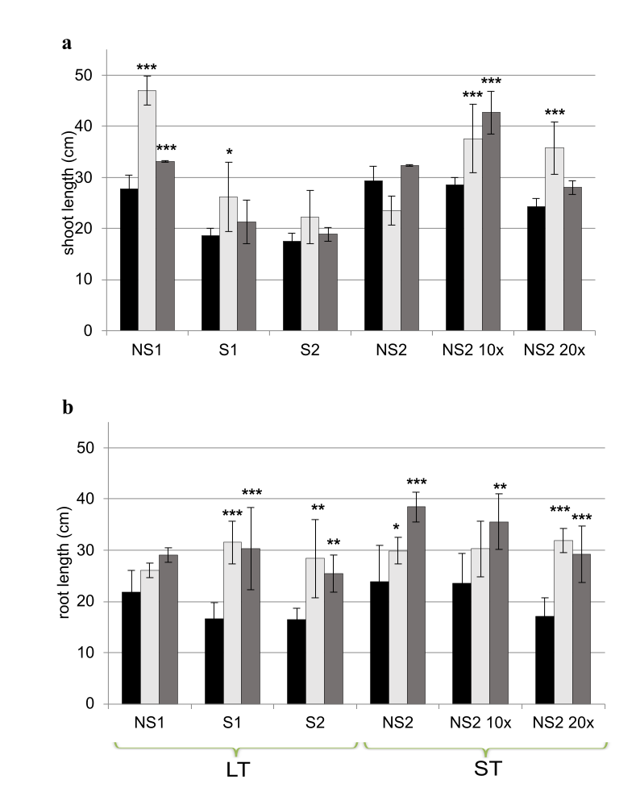
Abbreviations: NS1 – control LT, nonsaline soil 1; S1 – experimental LT saline soil 1; S2 - experimental LT saline soil 2; NS2 – control ST, nonsaline soil 2; NS2 10× - experimental ST saline soil with salinity 10 times higher a salinity than that of the NS2 variant; NS2 20× - experimental ST saline soil with a salinity 20 times higher than that of the NS2 variant; * – p ≤ 0.05, ** – p ≤ 0.01, *** – p ≤ 0.001.
Figure 2 The relative abundance of fungal genera in the seedlings roots and soils (NS1, S1, S2, NS2) before pot experiments.
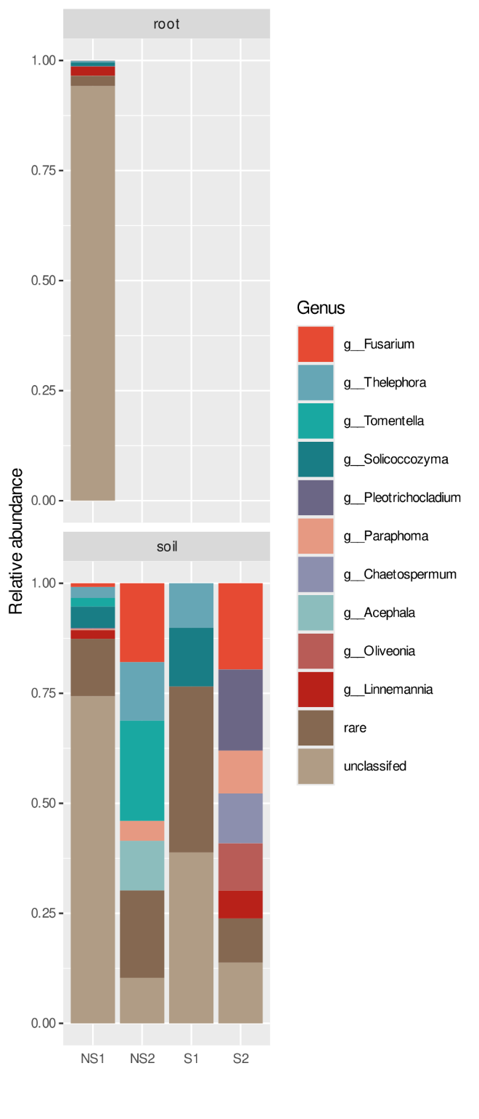

Figure 3 dbRDA (distance-based redundancy analysis) showing the effect of mycorrhizal inoculation (control, AM – arbuscular, AM+EM – arbuscular-ectomycorrhizal) on fungal beta-diversity (a, b) in roots and (c, d) in the rhizosphere samples for two types of salinity: long-term (LT) and short-term (ST). Circles represent ASVs, and their fill colour denotes consensus taxonomy at the class level, their diameter denotes the abundance of the class. Squares, circles and triangles represent variant of inoculation (control, AM, AM+EM). Green, red and blue shapes represent soil types.
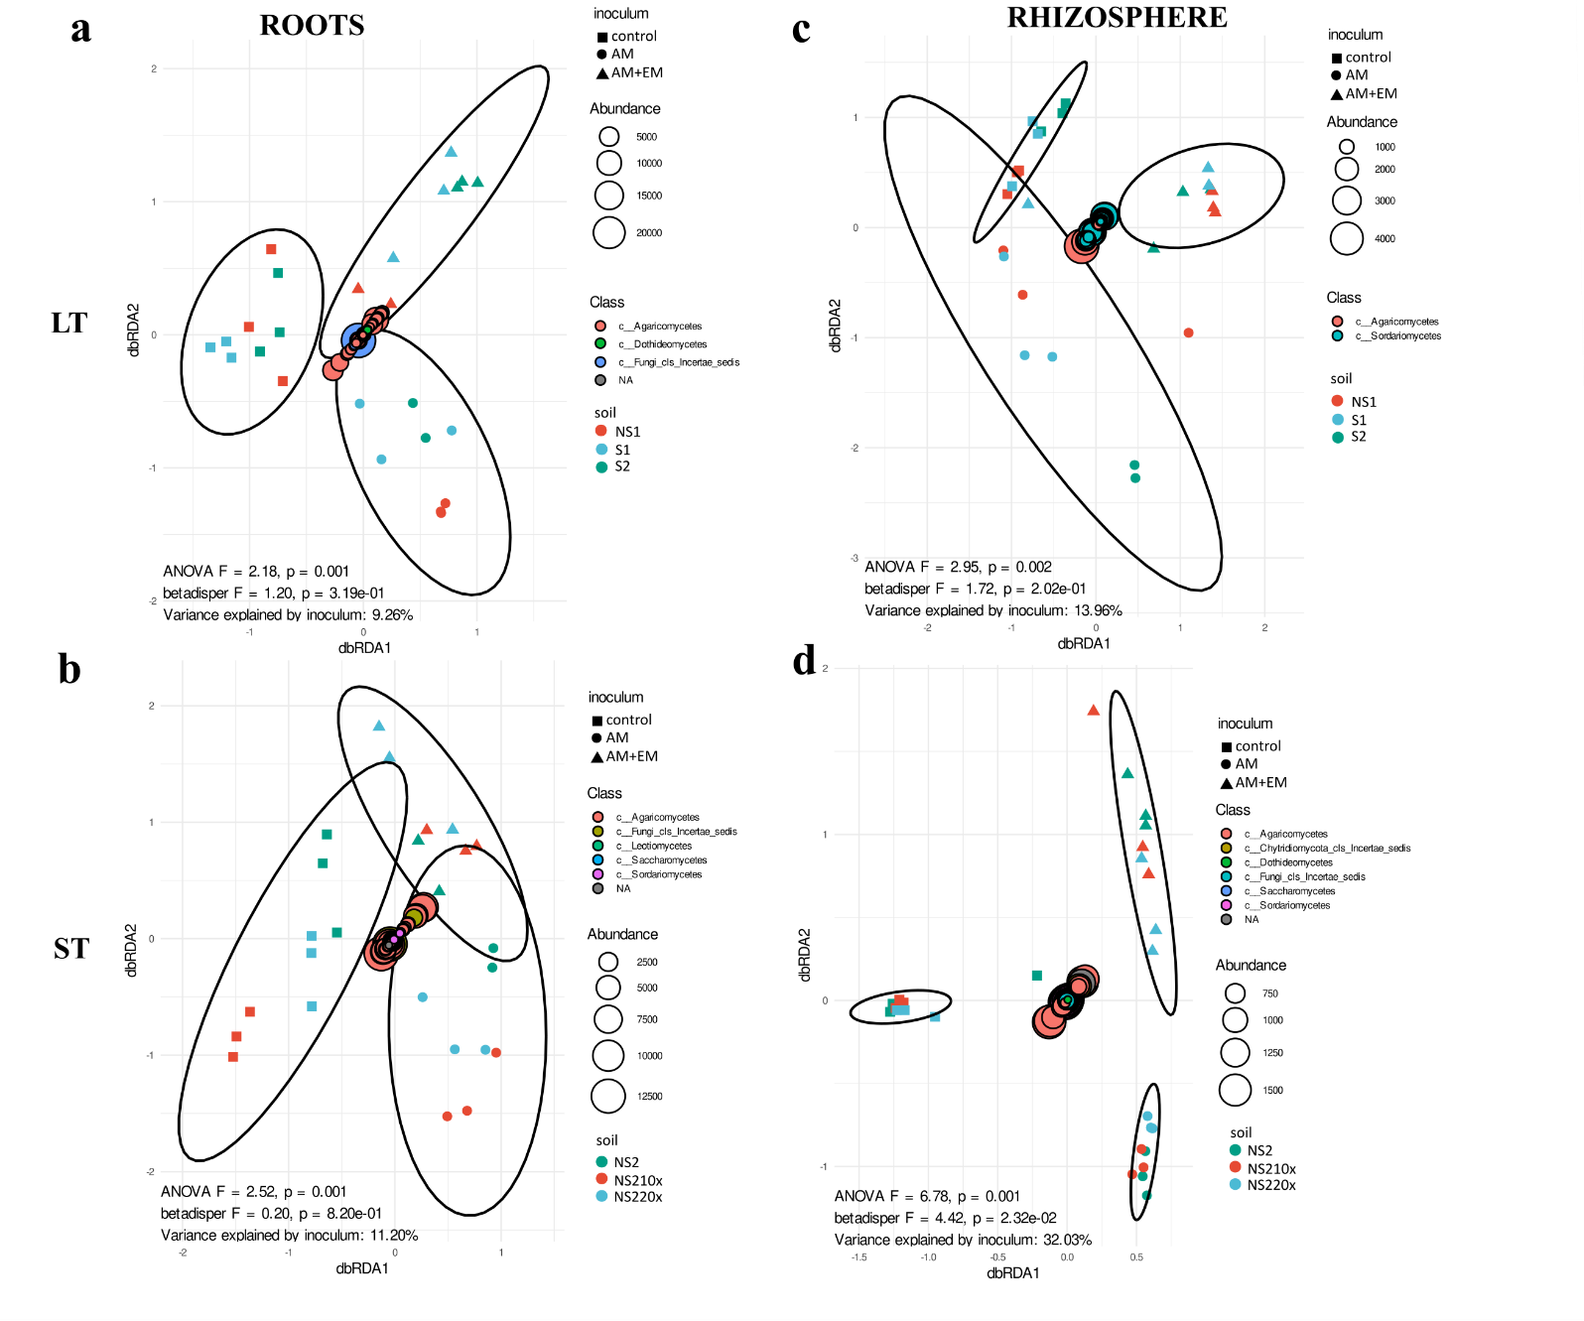
Abbreviations: NS1 – control LT, nonsaline soil 1; S1 – experimental LT saline soil 1; S2 - experimental LT saline soil 2; NS2 – control ST, nonsaline soil 2; NS2 10× - experimental ST saline soil with salinity 10 times higher a salinity than that of the NS2 variant; NS2 20× - experimental ST saline soil with a salinity 20 times higher than that of the NS2 variant

