Supplementary Materials
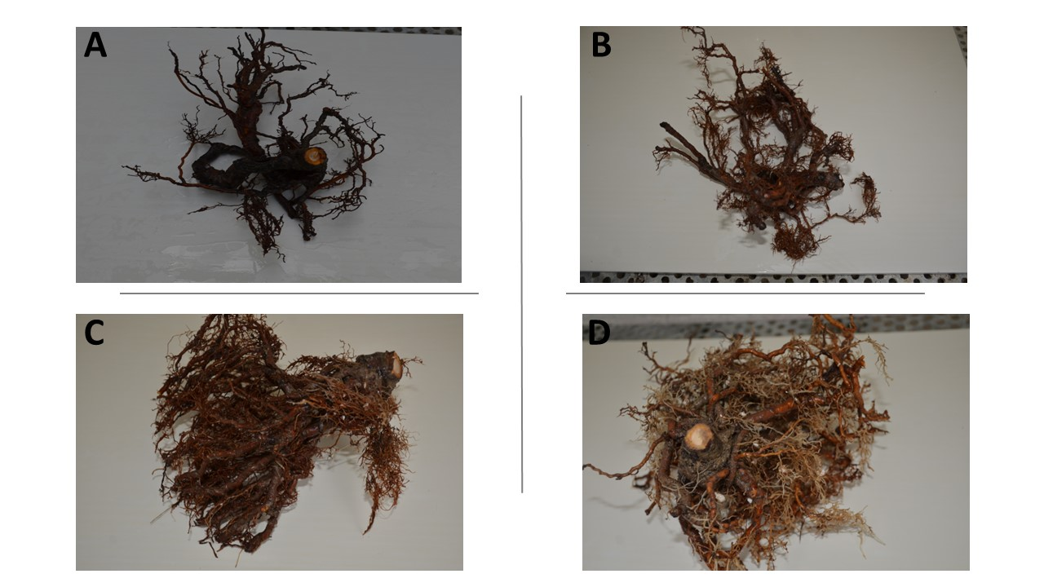
Figure 1S. Root symptoms at the moment of analysis. A: treatment NTC, B: treatment T1, C: treatment T2, D: treatment T3.
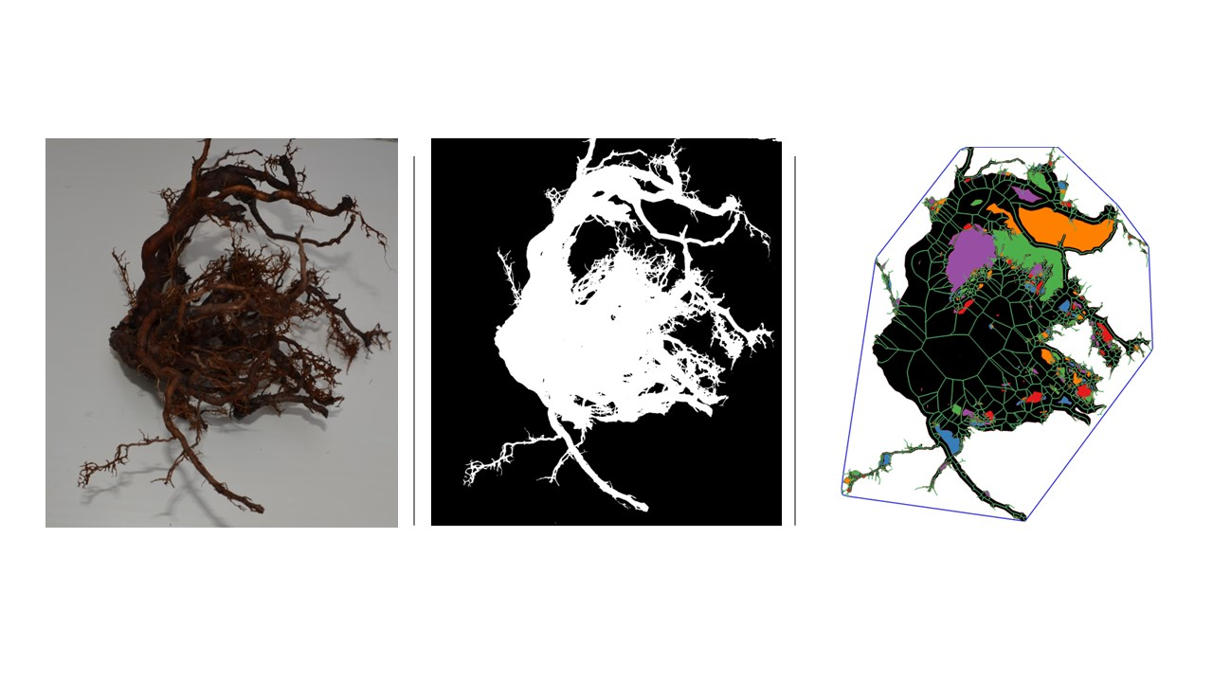
Figure 2S. Example of workflow by using RhizoVision explorer.

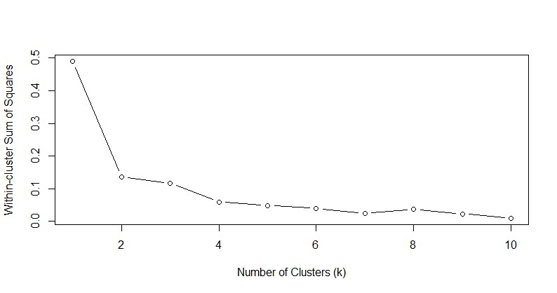
Figure 3S. Elbow curve plotted with R to determine the number of cluster based on the Sum of Squares.

