Supplementary Information
Localized fertilizer co-applied with biochar suspension can increase phosphorus uptake by maize while enabling carbon-sequestration benefits
Iryna Loginova¹*, Nataliya Bilyera¹, Callum Banfield¹, Yakov Kuzyakov², Michaela A. Dippold¹
¹Geo-Biosphere Interactions, Department of Geosciences, University of Tübingen, 72076, Tübingen, Germany
²Agricultural Soil Sciences, University of Göttingen, 37073 Göttingen, Germany
*Corresponding author: iryna.loginova@outlook.com
Table of Contents:
Section S1. Pyrolysis and biochar analysis 4
Table S1. Biochar characteristics 4
Section S2. Preparation of suspensions 5
Fig. S1 The principal steps in the application of suspensions. (a) Tools used to inject the suspensions into the soil: spatula (1) and syringe (2). (b) The process of injecting suspensions into the soil simulating “band” application. (c) Application of the second portion of the suspensions onto the soil surface 5
Fig. S2 The procedure of soil sampling and root harvesting. (a) The band soil with applied suspensions is separated from the bulk soil using metal cylinder of 5 cm diameter. (b) The maize roots of each plant shacked out of the soil and washed using sonication bath 6
Fig. S3 Soil pH in bulk and band soil of five treatments (Control, phosphorus (P), biochar (BC), jointly applied biochar and phosphorus with plants (BC+P) and without plants (BC+P (w/o)). Means of four replicates are reported (whiskers indicate standard errors), with different lowercase letters denoting the difference between each treatment at p < 0.05 determined with two-way ANOVA followed by post-hoc test . Effect sizes (ƞ²) shows the contribution of each factor to the total variation 6
Fig. S4 The percentage of Olsen-P and Resin-P to the total phosphorus (total P) (a), relative recovery of applied ³³P-labelled fertilizer in the extracted Olsen-P and Resin-P (b), and a proportion of phosphorus applied as ³³P-labelled fertilizer in the total P, Olsen-P and Resin-P pools (c) in band soil. Data are presented for the band soil (n=4, whiskers indicate standard errors) in five treatments (Control, phosphorus (P), biochar (BC), jointly applied biochar and phosphorus with plants (BC+P) and without plants (BC+P (w/o)). Capital letters indicate one-way ANOVA differences between treatments for each parameter (p < 0.05) 7
Fig. S5 The ³³P phosphor images (top) and normal light (NL) photos (bottom) of soil and root surface in the rhizoboxes with only P application (Replication 1) at five growth stages of maize: Emergence to 1 fully extended leaf (V1), two leaves (V2), three leaves (V3), four leaves (V4) and five leaves (V5) 8
Fig. S6 The ³³P phosphor images (top) and normal light (NL) photos (bottom) of soil and root surface in the rhizoboxes with only P application (Replication 2) at five growth stages of maize: Emergence to 1 fully extended leaf (V1), two leaves (V2), three leaves (V3), four leaves (V4) and five leaves (V5) 9
Fig. S7 The ³³P phosphor images (top) and normal light (NL) photos (bottom) of soil and root surface in the rhizoboxes with only P application (Replication 3) at five growth stages of maize: Emergence to 1 fully extended leaf (V1), two leaves (V2), three leaves (V3), four leaves (V4) and five leaves (V5) 10
Fig. S8 The ³³P phosphor images (top) and normal light (NL) photos (bottom) of soil and root surface in the rhizoboxes with only P application (Replication 4) at five growth stages of maize: Emergence to 1 fully extended leaf (V1), two leaves (V2), three leaves (V3), four leaves (V4) and five leaves (V5) 11
Fig. S9 The ³³P phosphor images (top) and normal light (NL) photos (bottom) of soil and root surface in the rhizoboxes with BC+P application (Replication 1) at five growth stages of maize: Emergence to 1 fully extended leaf (V1), two leaves (V2), three leaves (V3), four leaves (V4) and five leaves (V5) 12
Fig. S10 The ³³P phosphor images (top) and normal light (NL) photos (bottom) of soil and root surface in the rhizoboxes with BC+P application (Replication 2) at five growth stages of maize: Emergence to 1 fully extended leaf (V1), two leaves (V2), three leaves (V3), four leaves (V4) and five leaves (V5) 13
Fig. S11 The ³³P phosphor images (top) and normal light (NL) photos (bottom) of soil and root surface in the rhizoboxes with BC+P application (Replication 3) at five growth stages of maize: Emergence to 1 fully extended leaf (V1), two leaves (V2), three leaves (V3), four leaves (V4) and five leaves (V5) 14
Fig. S12 The ³³P phosphor images (top) and normal light (NL) photos (bottom) of soil and root surface in the rhizoboxes with BC+P application (Replication 4) at five growth stages of maize: Emergence to 1 fully extended leaf (V1), two leaves (V2), three leaves (V3), four leaves (V4) and five leaves (V5) 15
Fig. S13 The ³³P phosphor images (top) and normal light (NL) photos (bottom) of rhizoboxes with BC+P application kept without plants (Replication 1) at five time points corresponding to the growth stages of maize in other treatments with plants: Emergence to 1 fully extended leaf (V1), two leaves (V2), three leaves (V3), four leaves (V4) and five leaves (V5) 16
Fig. S14 The ³³P phosphor images (top) and normal light (NL) photos (bottom) of rhizoboxes with BC+P application kept without plants (Replication 2) at five time points corresponding to the growth stages of maize in other treatments with plants: Emergence to 1 fully extended leaf (V1), two leaves (V2), three leaves (V3), four leaves (V4) and five leaves (V5) 17
Fig. S15 The ³³P phosphor images (top) and normal light (NL) photos (bottom) of rhizoboxes with BC+P application kept without plants (Replication 3) at five time points corresponding to the growth stages of maize in other treatments with plants: Emergence to 1 fully extended leaf (V1), two leaves (V2), three leaves (V3), four leaves (V4) and five leaves (V5) 18
Fig. S16 The ³³P phosphor images (top) and normal light (NL) photos (bottom) of rhizoboxes with BC+P application kept without plants (Replication 4) at five time points corresponding to the growth stages of maize in other treatments with plants: Emergence to 1 fully extended leaf (V1), two leaves (V2), three leaves (V3), four leaves (V4) and five leaves (V5) 19
Fig. S17 Normal light photos of rhizoboxes in Control treatment (Replication 1) at five time points corresponding to the growth stages of maize in other treatments with plants: Emergence to 1 fully extended leaf (V1), two leaves (V2), three leaves (V3), four leaves (V4) and five leaves (V5) 20
Fig. S18 Normal light photos of rhizoboxes in Control treatment (Replication 2) at five time points corresponding to the growth stages of maize in other treatments with plants: Emergence to 1 fully extended leaf (V1), two leaves (V2), three leaves (V3), four leaves (V4) and five leaves (V5) 20
Fig. S19 Normal light photos of rhizoboxes in Control treatment (Replication 3) at five time points corresponding to the growth stages of maize in other treatments with plants: Emergence to 1 fully extended leaf (V1), two leaves (V2), three leaves (V3), four leaves (V4) and five leaves (V5) 21
Fig. S20 Normal light photos of rhizoboxes in Control treatment (Replication 4) at five time points corresponding to the growth stages of maize in other treatments with plants: Emergence to 1 fully extended leaf (V1), two leaves (V2), three leaves (V3), four leaves (V4) and five leaves (V5) 21
Fig. S21 Normal light photos of rhizoboxes with only BC application (Replication 1) at five time points corresponding to the growth stages of maize in other treatments with plants: Emergence to 1 fully extended leaf (V1), two leaves (V2), three leaves (V3), four leaves (V4) and five leaves (V5) 22
Fig. S22 Normal light photos of rhizoboxes with only BC application (Replication 2) at five time points corresponding to the growth stages of maize in other treatments with plants: Emergence to 1 fully extended leaf (V1), two leaves (V2), three leaves (V3), four leaves (V4) and five leaves (V5) 22
Fig. S23 Normal light photos of rhizoboxes with only BC application (Replication 3) at five time points corresponding to the growth stages of maize in other treatments with plants: Emergence to 1 fully extended leaf (V1), two leaves (V2), three leaves (V3), four leaves (V4) and five leaves (V5) 23
Fig. S24 Normal light photos of rhizoboxes with only BC application (Replication 4) at five time points corresponding to the growth stages of maize in other treatments with plants: Emergence to 1 fully extended leaf (V1), two leaves (V2), three leaves (V3), four leaves (V4) and five leaves (V5) 23
Fig. S25 Phosphorus sorption isotherms for untreated and biochar-treated soil fitted to the Langmuir model (R²=0.98, p < 0.001) 24
Fig. S26 The proportion of P in plants derived from applied ³³P-labelled fertilizer (a) in shoots and root of two treatments: phosphorus (P) -blue bar and jointly applied biochar and phosphorus with plants (BC+P) – green bar, and zinc (Zn) stock in maize plants (b) at the five-leaf growth stage of four treatments (Control, phosphorus (P), biochar (BC), jointly applied biochar and phosphorus with plants (BC+P)). All data are presented as a means of four replicates; whiskers indicate standard errors. Capital letters indicate one-way ANOVA differences between treatments for each parameter (p < 0.05) 24
Table S2. The plant P and Zn concentrations and ratio between the zinc absorbed by the plant and the phosphorus content in maize plants 25
Fig. S27 Maize plants height (A), leaf area (B) and specific leaf area (SLA) (C) at five leaves growth stage of four treatments (Control, phosphorus (P), biochar (BC), jointly applied biochar and phosphorus with plants (BC+P)). All data are presented as a means of four replicates with whiskers indicating standard errors. Capital letters indicate one-way ANOVA differences for each parameter (p < 0.05) 25
Fig. S28 Maize plant root surface area (a) and specific root area (SRA) (b) of four treatments (Control, phosphorus (P), biochar (BC), jointly applied biochar and phosphorus with plants (BC+P)). All data are presented as a means of four replicates with whiskers indicating standard errors. Capital letters indicate one-way ANOVA differences for each parameter (p < 0.05) 26
Fig. S29 Specific root length (SRL) (a) and root tissue density (RTD) (b) of four treatments (Control, phosphorus (P), biochar (BC), jointly applied biochar and phosphorus with plants (BC+P)). All data are presented as a means of four replicates with whiskers indicating standard errors. Capital letters indicate one-way ANOVA differences for each parameter (p < 0.05) 26
References 27

Section S1. Pyrolysis and biochar analysis
Pyrolysis. Corncob biochar was produced from 2 mm corncob granules in a furnace (Nabertherm©, Germany) through low-temperature slow pyrolysis at 350 ºC (heating rate of 0.2-0.3ºC s⁻¹) in a N₂ environment. After 60 min of heating, the biochar was cooled to room temperature under N₂. The biochar yield, based on air-dried weight, was 30-32%. The pyrolysis conditions were chosen to increase labile C fraction, ash content, CEC, and overall yield as estimated in the previous studies (Cao, 2004; Gabhane et al., 2020; Ippolito et al., 2020; Shariff et al., 2016; Tenic et al., 2020).
Biochar analysis was conducted according to Singh et al. (2017). Proximate analysis included moisture, volatile matter, ash and fixed carbon (Table S1). Moisture was measured by weight loss after drying at 105ºC for 18 hours. Volatile matter was assessed by combusting 1 g of biochar in a crucible at 950ºC for 10 min. Ash content was determined by combusting of about 1 g of biochar at 750ºC for 6 hours. Fixed carbon content that represents the non-volatile fraction of biochar was calculated as the difference between dry matter and the sum of volatile matter and ash. pH was measured with pH-meter (SenTix, WTW, Germany), and electrical conductivity (EC) was determined using the inoLab© Cond 7110 electrical conductivity meter (Xylem Analytics, Germany) at a 1:10 w/v biochar-to-water ratio after1 hour of shaking and 0.5 hours of equilibration. Carbon, nitrogen, and hydrogen contents were measured with an elemental analyser (Elementar vario EL Cube CNHS, Elementar Analysensysteme GmbH, Germany), and the corresponding C/N and H/C ratios were derived from the elemental data.
To determine dissolved organic carbon (DOC), dissolved nitrogen (DN), and water-soluble phosphorus (P), grinded biochar was mixed with water at a 1:10 w/v ratio, shaken at 250 rpm for 1 h, and filtered twice through a 0.45 µm syringe filter. DOC and DN were analysed using a multi N/C 2100S combustion analyzer (Analytik Jena, Germany), while water soluble P was measured spectrophotometrically at 630 nm using a malachite green method with NanoPhotometer NP80 (Implen, Germany).

Table S1. Biochar characteristics
Property | Valueª | Property | Valueª
Proximate analysis (wt.%)
Moisture content | 2.72±0.03 | C/N ratio | 163±2
Volatile matter (VM) | 30.3±0.13 | H/C ratio | 0.058±0.003
Ash | 3.20±0.07
Fixed carbon (FC) | 66.5±0.14 | pH H₂O (1:10) | 8.67±0.01
VM/FC | 0.46 | EC (1:10) (mS/cm) | 1.54±0.01
Ultimate analysis (wt.%) |  | Nutrients content
C | 71.2±0.2 | Dissolved organic C (mg kg⁻¹) | 232±3
H | 4.09±0.02 | Dissolved N (mg kg⁻¹) | 8±0.06
N | 0.43±0.01 | Water-soluble P (mg kg⁻¹) | 104±2
ªValues presented as mean (n= 5) ± standard error.
P sorption kinetics. To study phosphate sorption on biochar, a P sorption kinetic experiment was performed. Four replicates of 0.25 g of dry ground biochar were places in 100 ml centrifuge tubes, followed by 50 ml of a 500 mg L⁻¹ P monopotassium phosphate solution spiked with ³³P phosphoric acid to achieve 50 kBq per tube, matching the biochar-to-P ratio. The tubes were sealed and shaken at 160 rpm at room temperature in a reciprocal shaker (RS-OS 20, Phoenix Instrument, Germany). After 2, 4, 6, 8, and 24 h the tubes were centrifuged at 4000 rpm for 5 min (Heraeus Biofuge Primo, Heraeus Instruments, Germany), and 0.1 ml aliquots were taken from the supernatant to measure ³³P radioactivity using liquid scintillation counter (Hidex 300 SL, Finland). P sorption kinetics was assessed via the changes in radioactivity over time.

Section S2. Preparation of suspensions
The procedure for suspension preparation was developed during preliminary experiments conducted in collaboration with the R&D Department of the Research and Production Company KVADRAT (Kharkiv, Ukraine) (Loginova et al. 2024).
A pre-calculated amount of xanthan gum in app. 0.2% final concentration was mixed with a portion of heated to 50-55ºC water (for the Control and BC suspensions) or with KH₂PO₄ solution (for P and BC+P suspensions) on a magnetic stirrer at 600 rpm for 10 min. For BC and BC+P, biochar was gradually added to water/KH₂PO₄ solution correspondingly and mixed for 20-30 min at 600 rpm, then combined with xanthan gel. In the Control and P suspension, xanthan gum was mixed into the remaining water/KH₂PO₄ solution. The total BC concentration in BC and BC+P suspensions was around 12%. The suspensions were applied to the rhizoboxes in two portions as shown in the Figure S1.
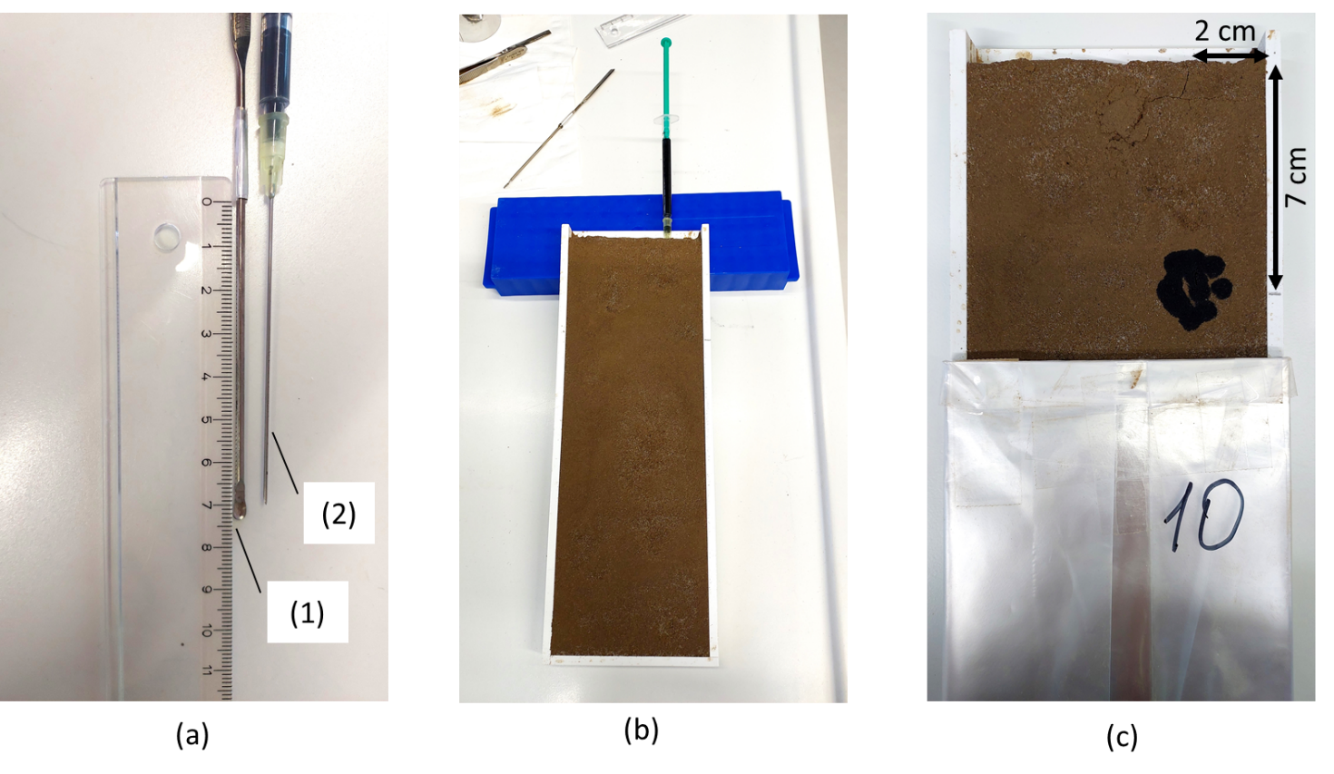

Fig. S1 The principal steps in the application of suspensions. (a) Tools used to inject the suspensions into the soil: spatula (1) and syringe (2). (b) The process of injecting suspensions into the soil simulating “band” application. (c) Application of the second portion of the suspensions onto the soil surface

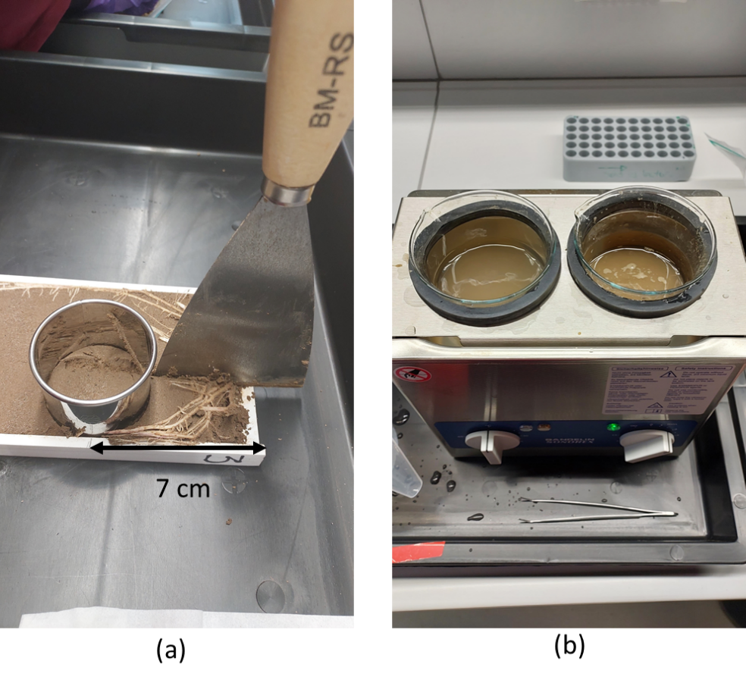

Fig. S2 The procedure of soil sampling and root harvesting. (a) The band soil with applied suspensions is separated from the bulk soil using metal cylinder of 5 cm diameter. (b) The maize roots of each plant shacked out of the soil and washed using sonication bath

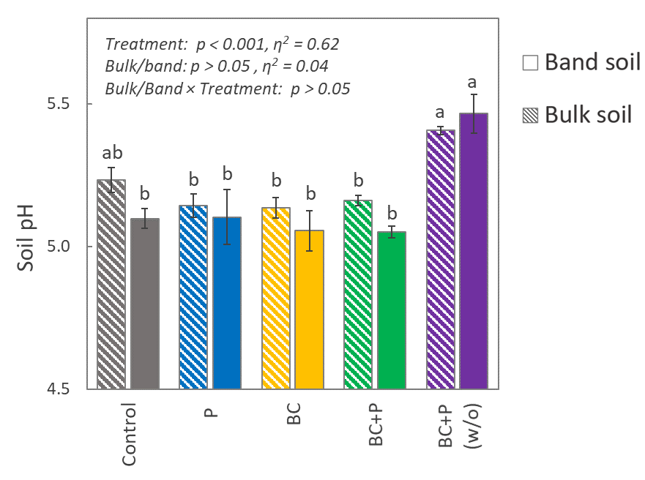

Fig. S3 Soil pH in bulk and band soil of five treatments (Control, phosphorus (P), biochar (BC), jointly applied biochar and phosphorus with plants (BC+P) and without plants (BC+P (w/o)). Means of four replicates are reported (whiskers indicate standard errors), with different lowercase letters denoting the difference between each treatment at p < 0.05 determined with two-way ANOVA followed by post-hoc test . Effect sizes (ƞ²) shows the contribution of each factor to the total variation

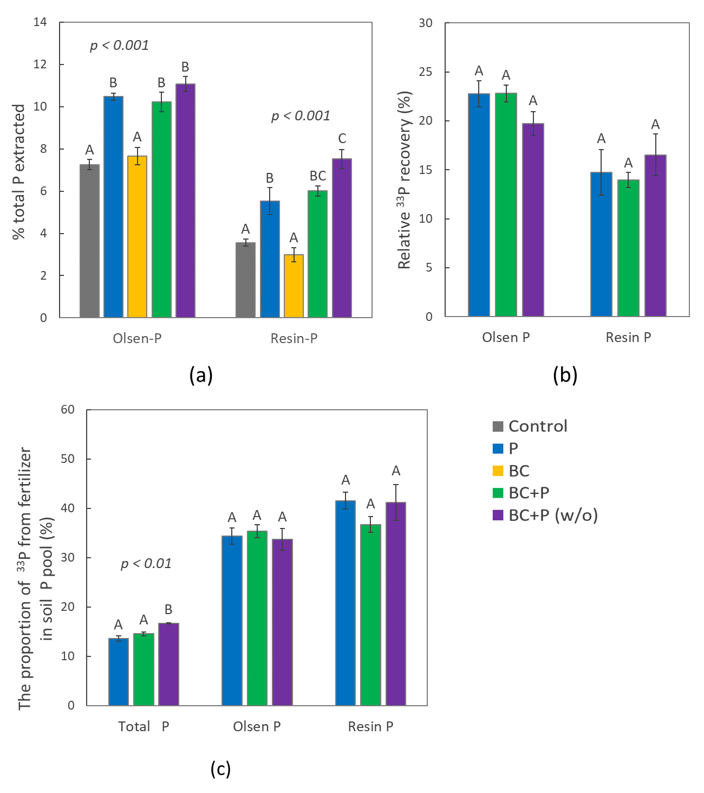

Fig. S4 The percentage of Olsen-P and Resin-P to the total phosphorus (total P) (a), relative recovery of applied ³³P-labelled fertilizer in the extracted Olsen-P and Resin-P (b), and a proportion of phosphorus applied as ³³P-labelled fertilizer in the total P, Olsen-P and Resin-P pools (c) in band soil. Data are presented for the band soil (n=4, whiskers indicate standard errors) in five treatments (Control, phosphorus (P), biochar (BC), jointly applied biochar and phosphorus with plants (BC+P) and without plants (BC+P (w/o)). Capital letters indicate one-way ANOVA differences between treatments for each parameter (p < 0.05)

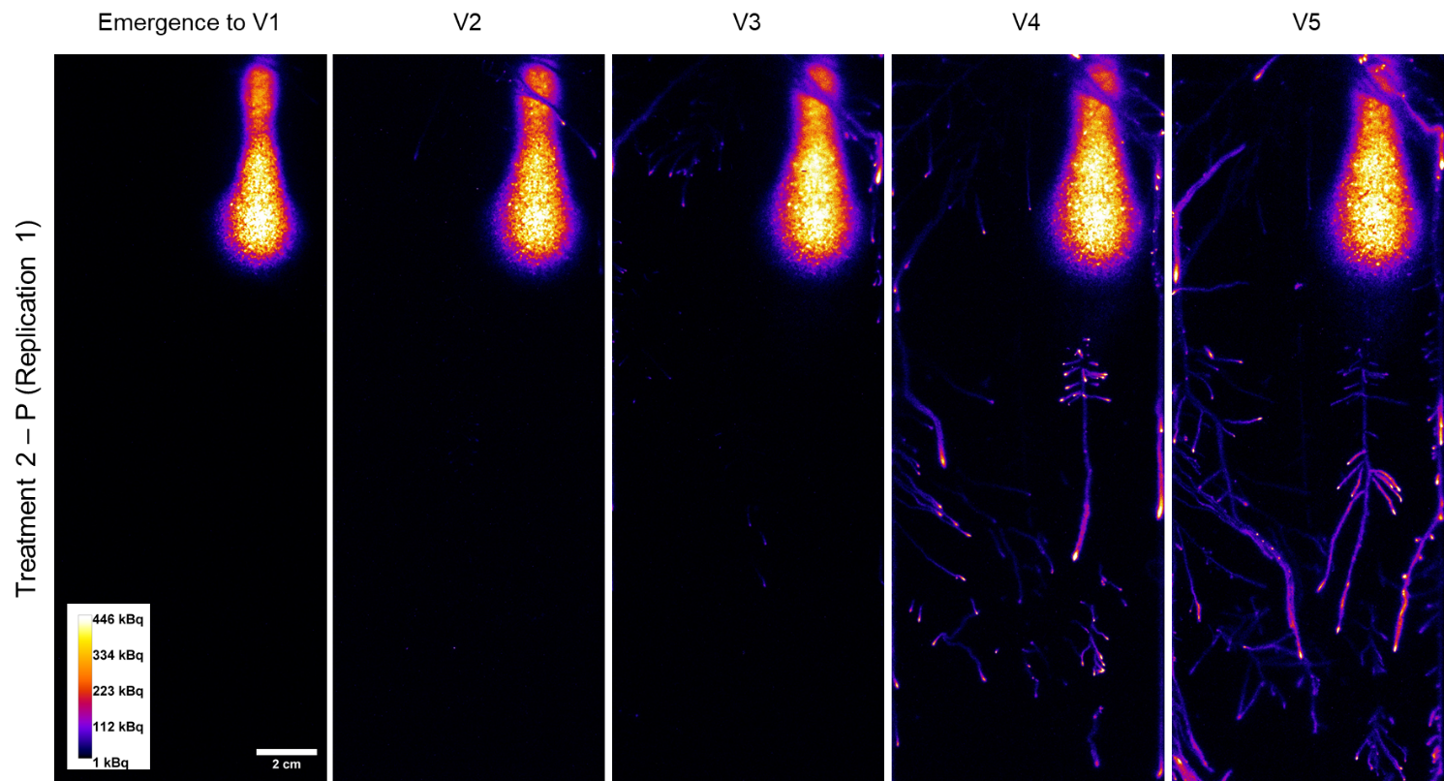

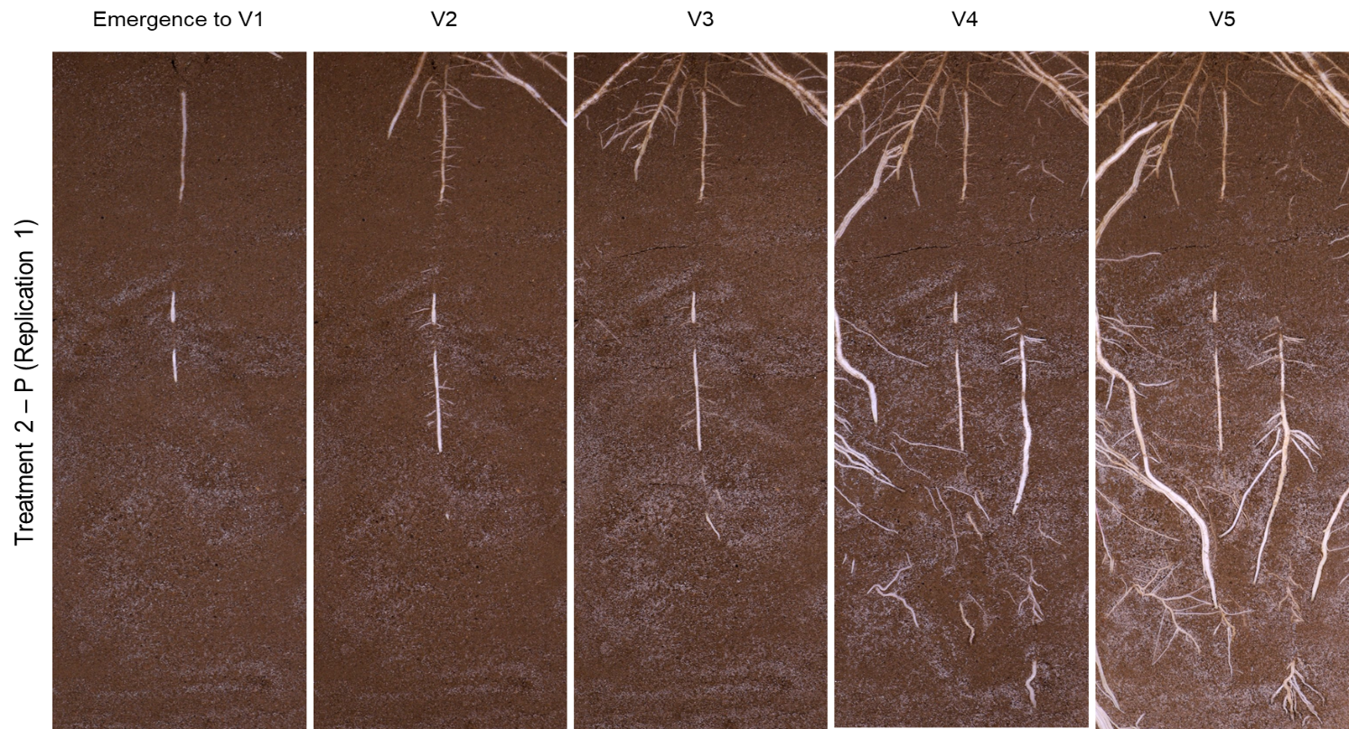

Fig. S5 The ³³P phosphor images (top) and normal light (NL) photos (bottom) of soil and root surface in the rhizoboxes with only P application (Replication 1) at five growth stages of maize: Emergence to 1 fully extended leaf (V1), two leaves (V2), three leaves (V3), four leaves (V4) and five leaves (V5)

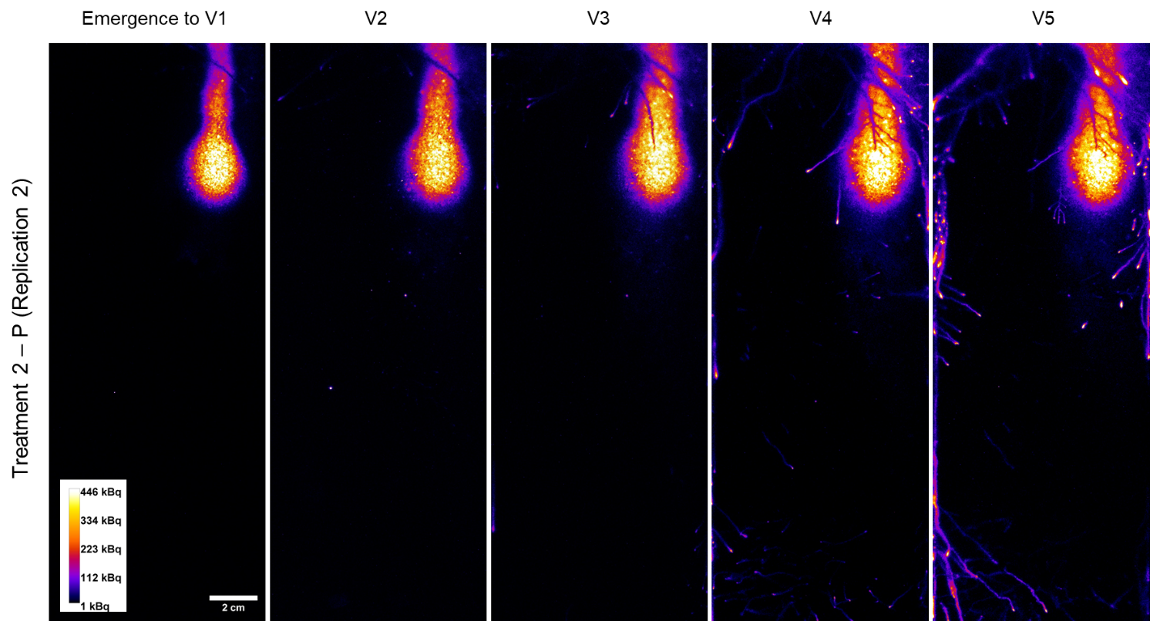

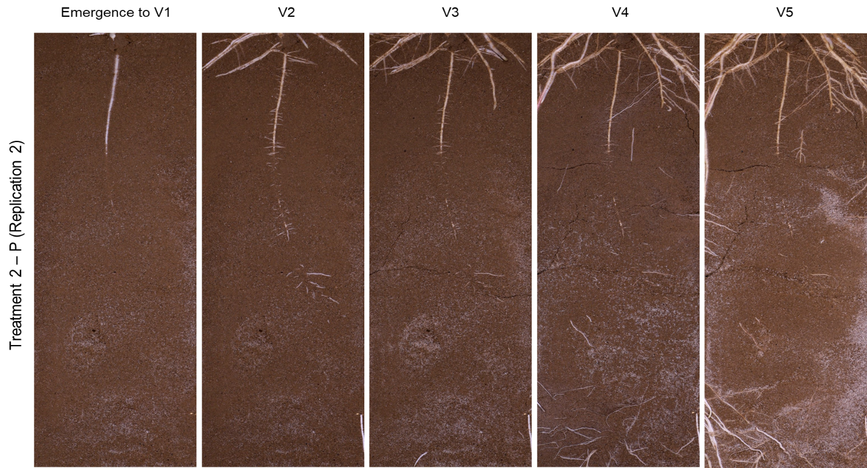

Fig. S6 The ³³P phosphor images (top) and normal light (NL) photos (bottom) of soil and root surface in the rhizoboxes with only P application (Replication 2) at five growth stages of maize: Emergence to 1 fully extended leaf (V1), two leaves (V2), three leaves (V3), four leaves (V4) and five leaves (V5)

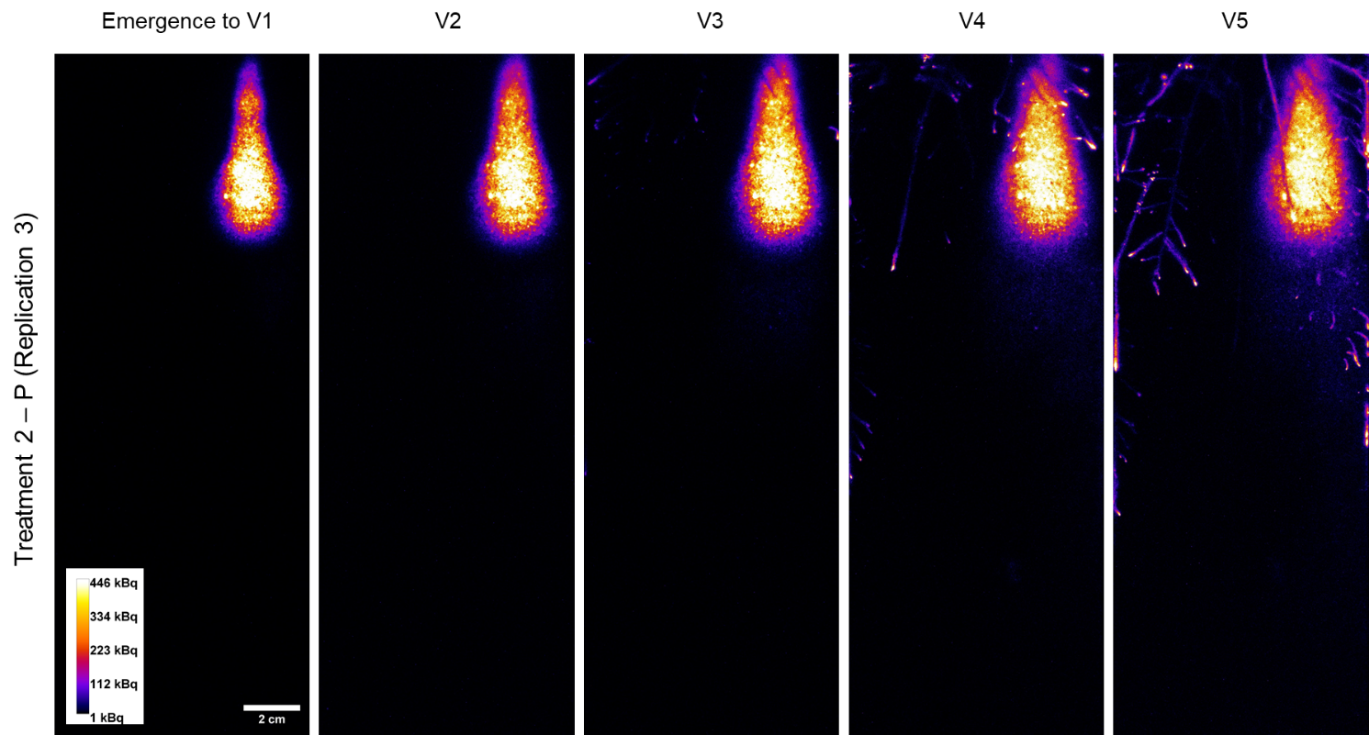

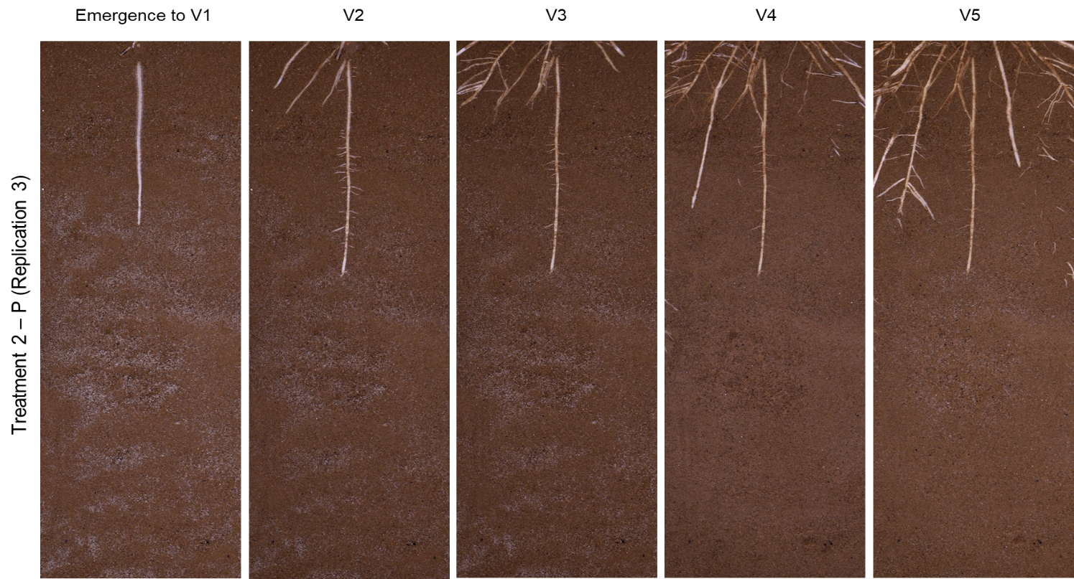

Fig. S7 The ³³P phosphor images (top) and normal light (NL) photos (bottom) of soil and root surface in the rhizoboxes with only P application (Replication 3) at five growth stages of maize: Emergence to 1 fully extended leaf (V1), two leaves (V2), three leaves (V3), four leaves (V4) and five leaves (V5)

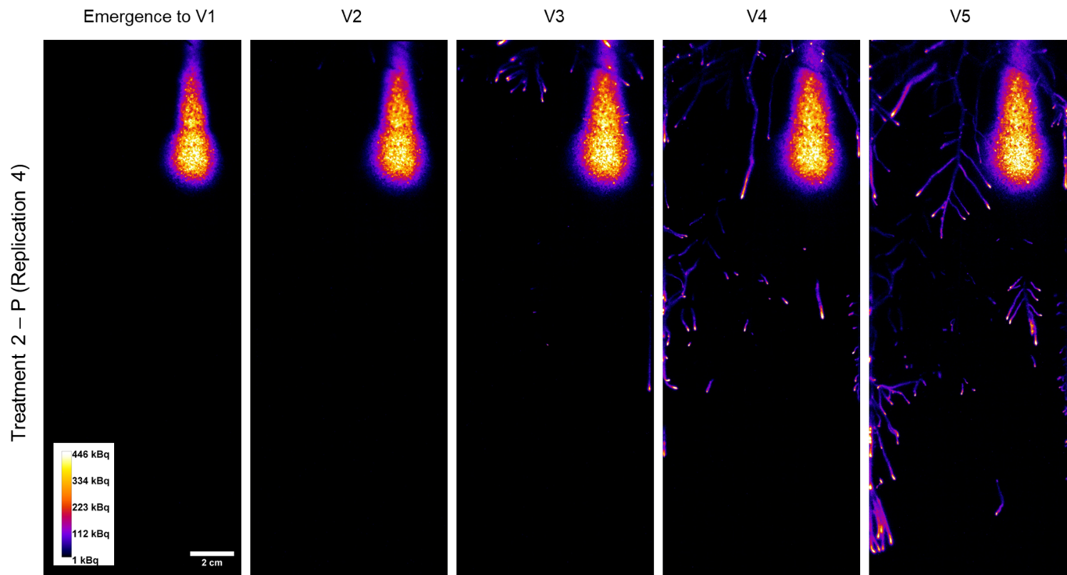

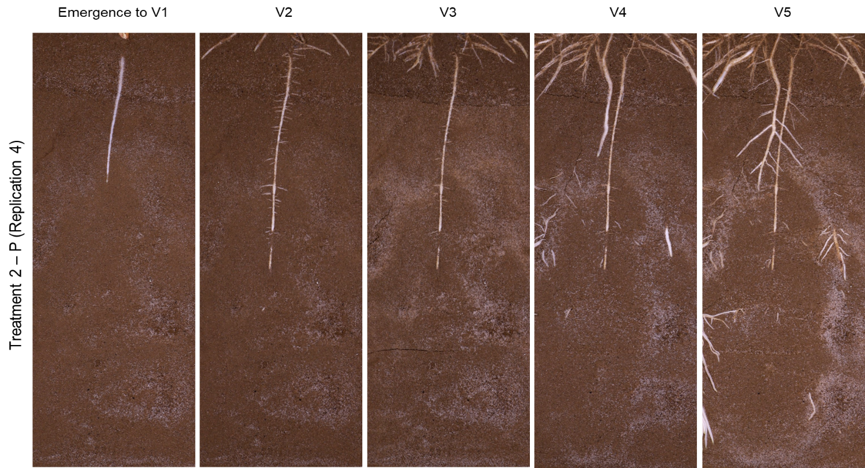

Fig. S8 The ³³P phosphor images (top) and normal light (NL) photos (bottom) of soil and root surface in the rhizoboxes with only P application (Replication 4) at five growth stages of maize: Emergence to 1 fully extended leaf (V1), two leaves (V2), three leaves (V3), four leaves (V4) and five leaves (V5)

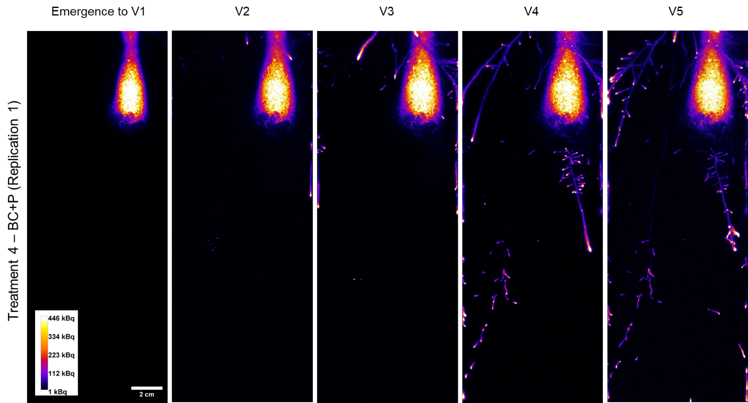

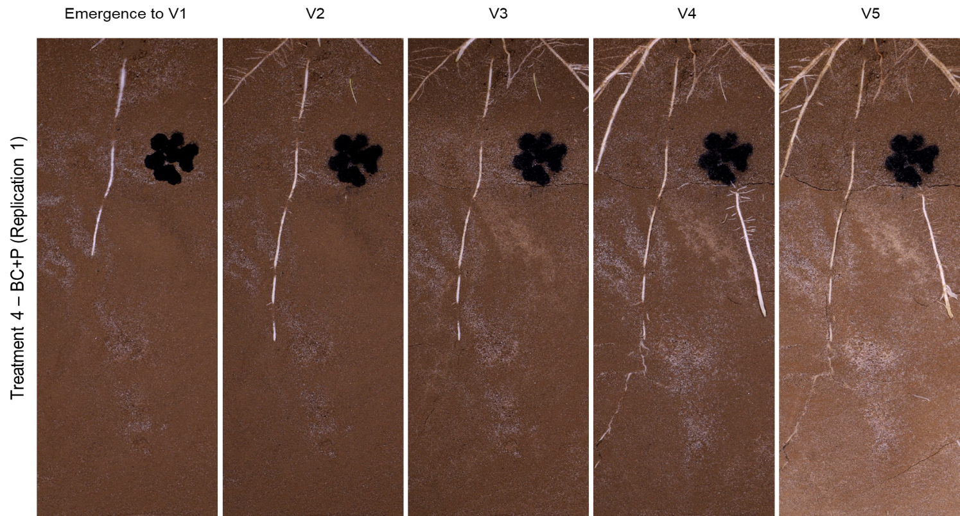

Fig. S9 The ³³P phosphor images (top) and normal light (NL) photos (bottom) of soil and root surface in the rhizoboxes with BC+P application (Replication 1) at five growth stages of maize: Emergence to 1 fully extended leaf (V1), two leaves (V2), three leaves (V3), four leaves (V4) and five leaves (V5)

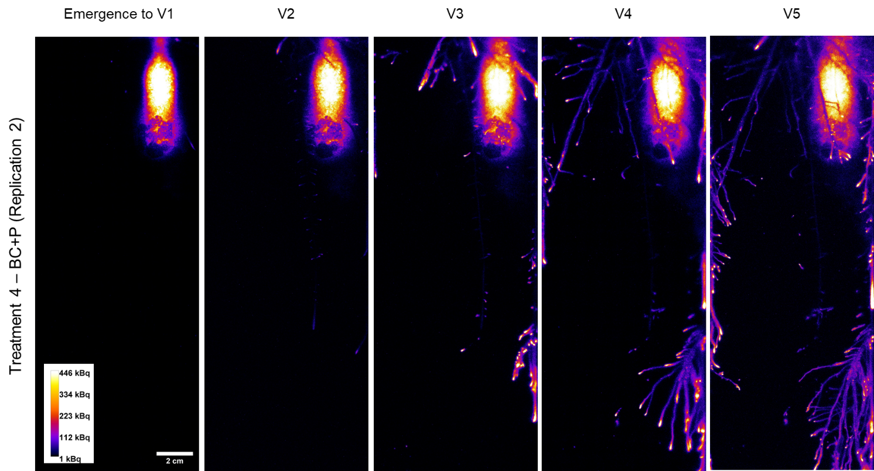

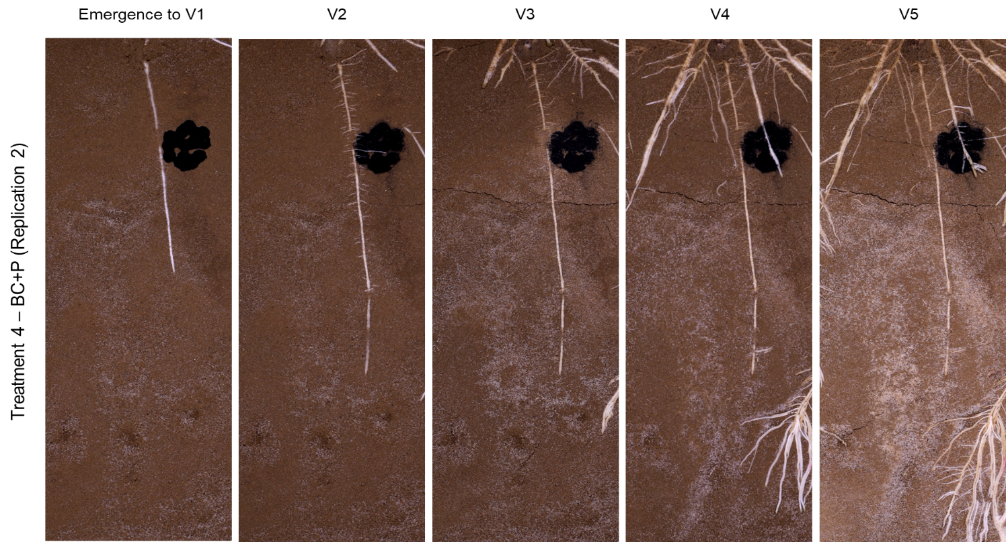

Fig. S10 The ³³P phosphor images (top) and normal light (NL) photos (bottom) of soil and root surface in the rhizoboxes with BC+P application (Replication 2) at five growth stages of maize: Emergence to 1 fully extended leaf (V1), two leaves (V2), three leaves (V3), four leaves (V4) and five leaves (V5)

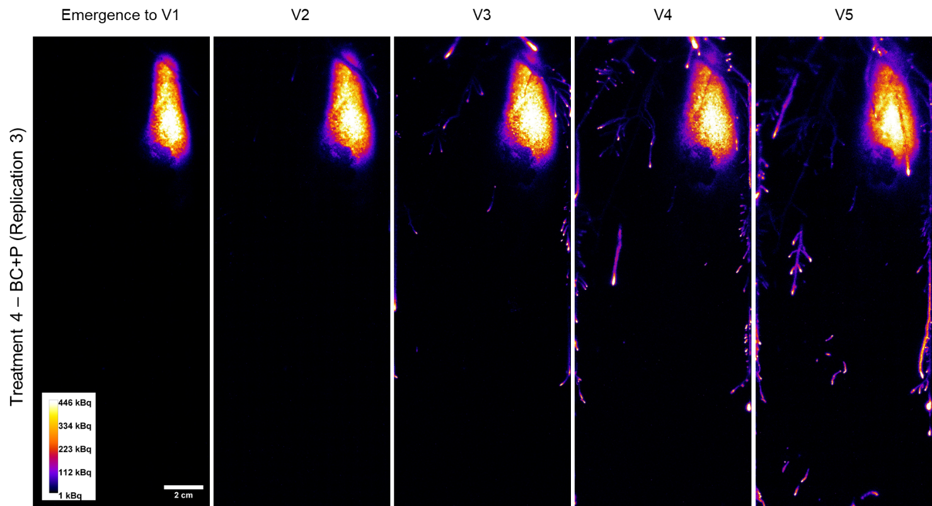

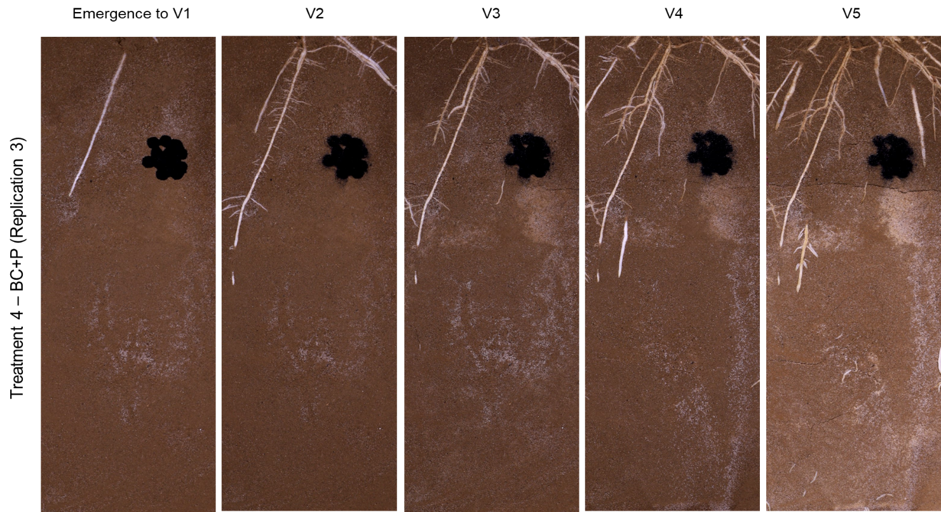

Fig. S11 The ³³P phosphor images (top) and normal light (NL) photos (bottom) of soil and root surface in the rhizoboxes with BC+P application (Replication 3) at five growth stages of maize: Emergence to 1 fully extended leaf (V1), two leaves (V2), three leaves (V3), four leaves (V4) and five leaves (V5)

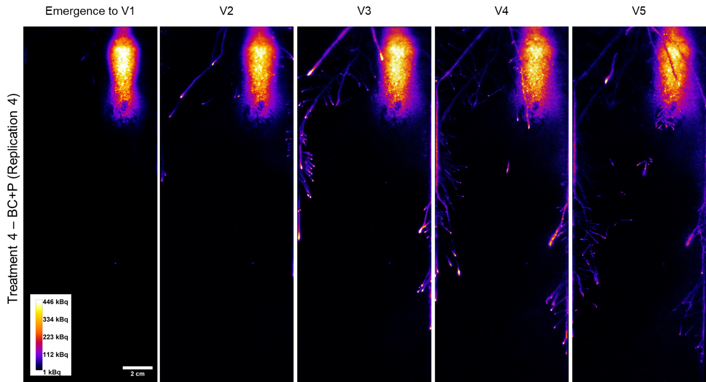

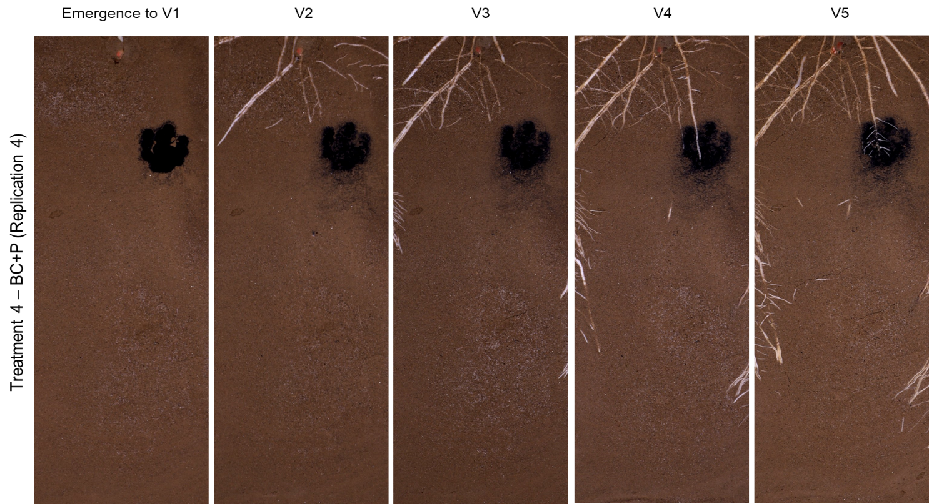

Fig. S12 The ³³P phosphor images (top) and normal light (NL) photos (bottom) of soil and root surface in the rhizoboxes with BC+P application (Replication 4) at five growth stages of maize: Emergence to 1 fully extended leaf (V1), two leaves (V2), three leaves (V3), four leaves (V4) and five leaves (V5)

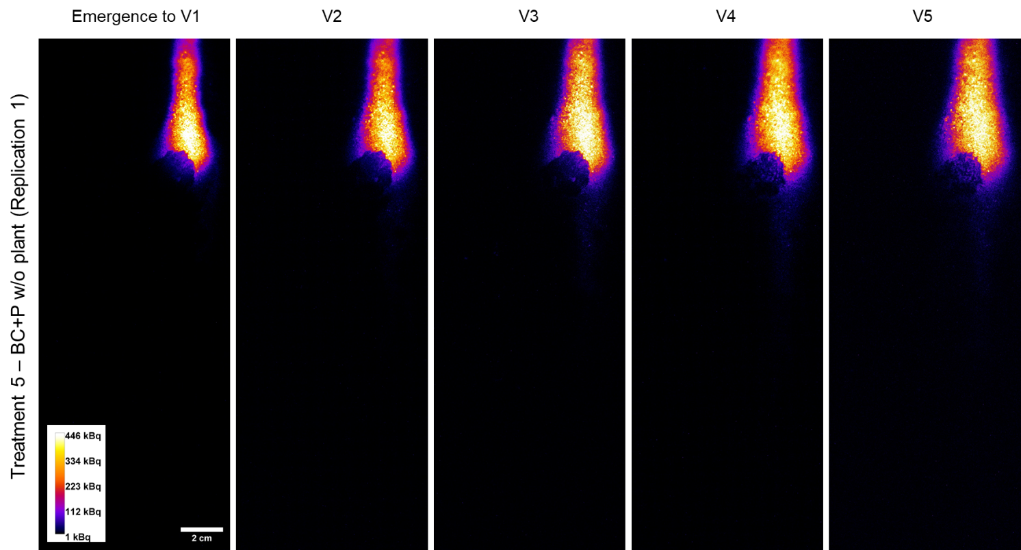

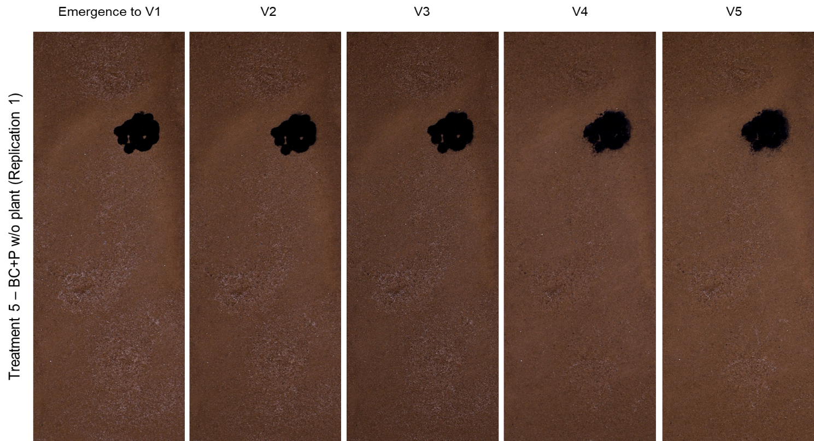

Fig. S13 The ³³P phosphor images (top) and normal light (NL) photos (bottom) of rhizoboxes with BC+P application kept without plants (Replication 1) at five time points corresponding to the growth stages of maize in other treatments with plants: Emergence to 1 fully extended leaf (V1), two leaves (V2), three leaves (V3), four leaves (V4) and five leaves (V5)

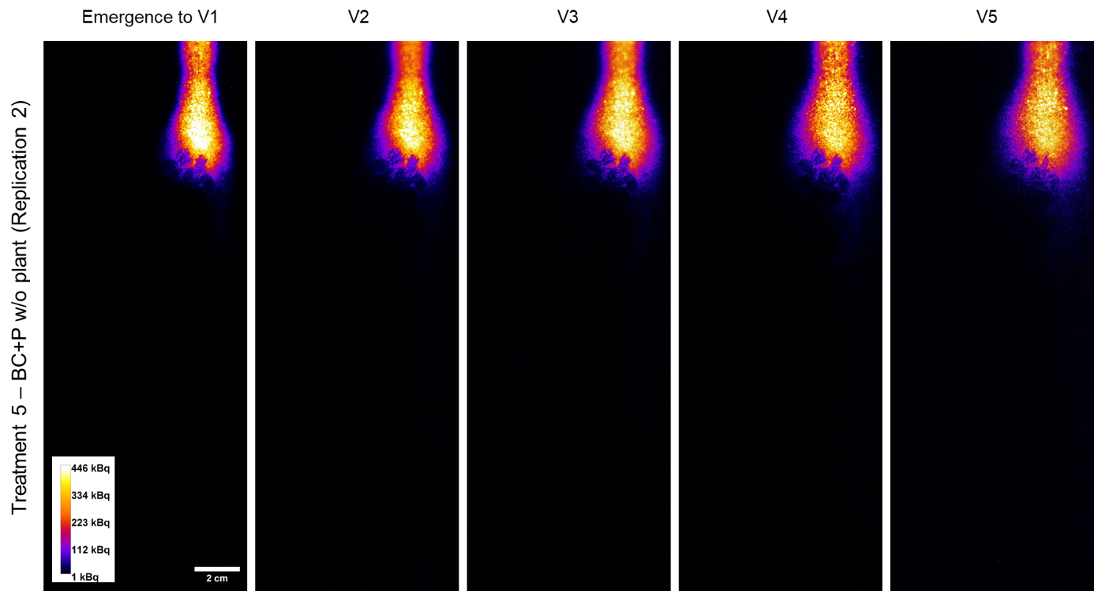

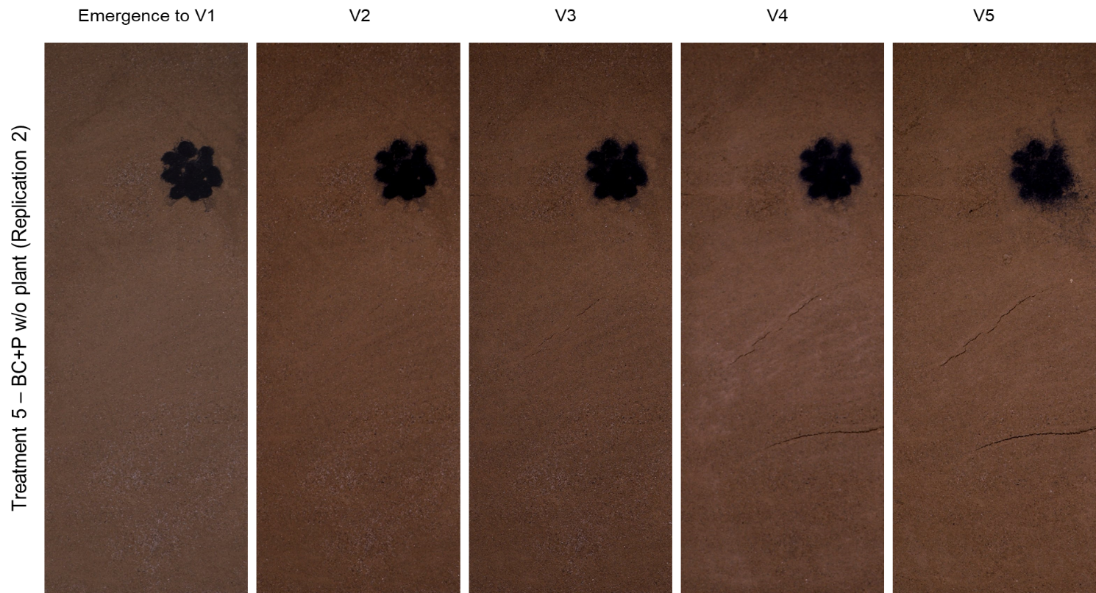

Fig. S14 The ³³P phosphor images (top) and normal light (NL) photos (bottom) of rhizoboxes with BC+P application kept without plants (Replication 2) at five time points corresponding to the growth stages of maize in other treatments with plants: Emergence to 1 fully extended leaf (V1), two leaves (V2), three leaves (V3), four leaves (V4) and five leaves (V5)

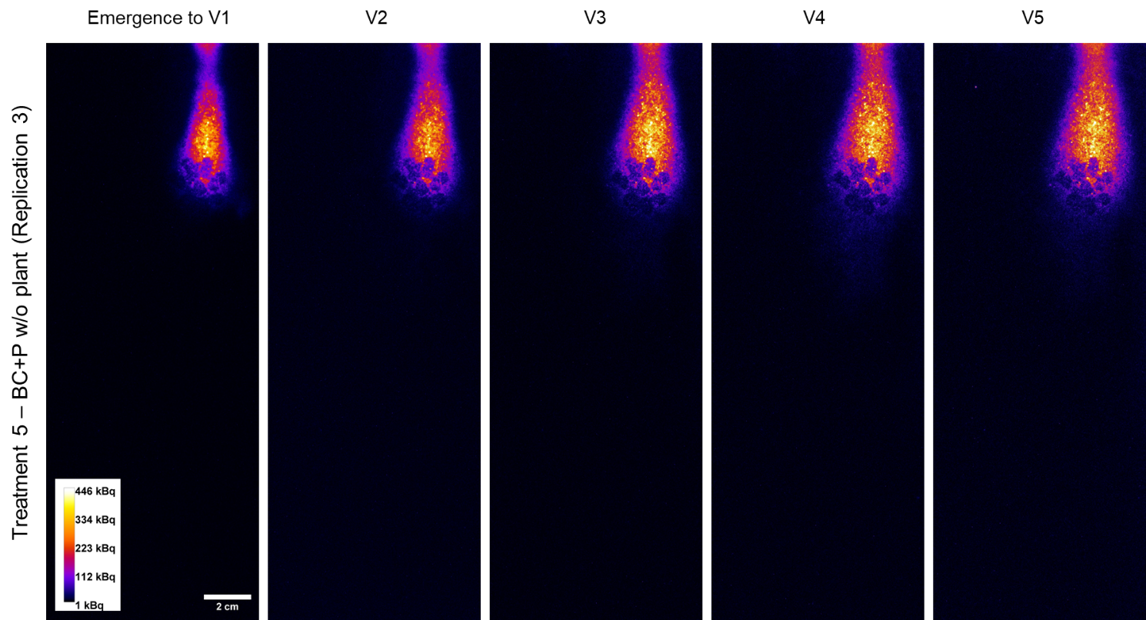

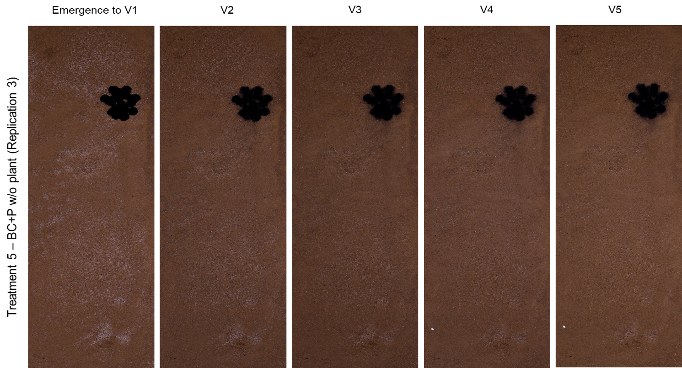

Fig. S15 The ³³P phosphor images (top) and normal light (NL) photos (bottom) of rhizoboxes with BC+P application kept without plants (Replication 3) at five time points corresponding to the growth stages of maize in other treatments with plants: Emergence to 1 fully extended leaf (V1), two leaves (V2), three leaves (V3), four leaves (V4) and five leaves (V5)

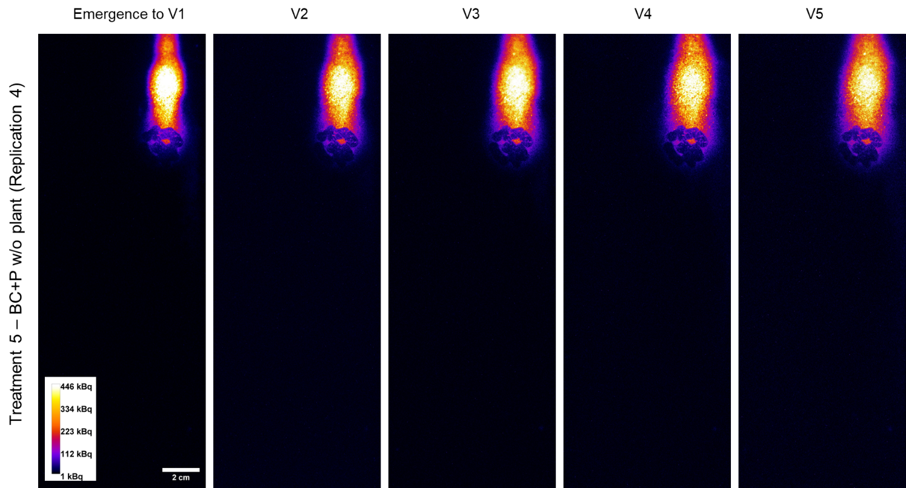

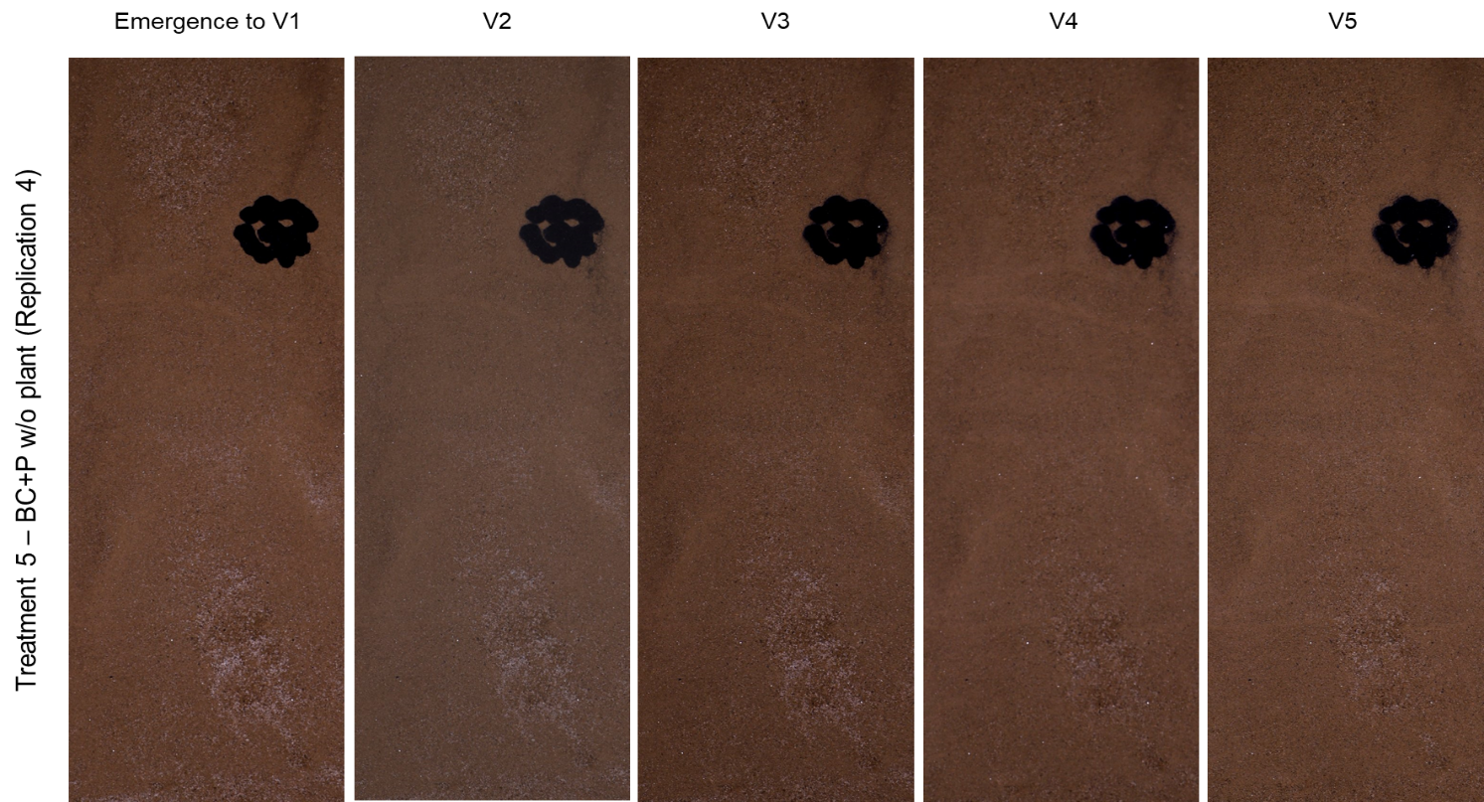

Fig. S16 The ³³P phosphor images (top) and normal light (NL) photos (bottom) of rhizoboxes with BC+P application kept without plants (Replication 4) at five time points corresponding to the growth stages of maize in other treatments with plants: Emergence to 1 fully extended leaf (V1), two leaves (V2), three leaves (V3), four leaves (V4) and five leaves (V5)

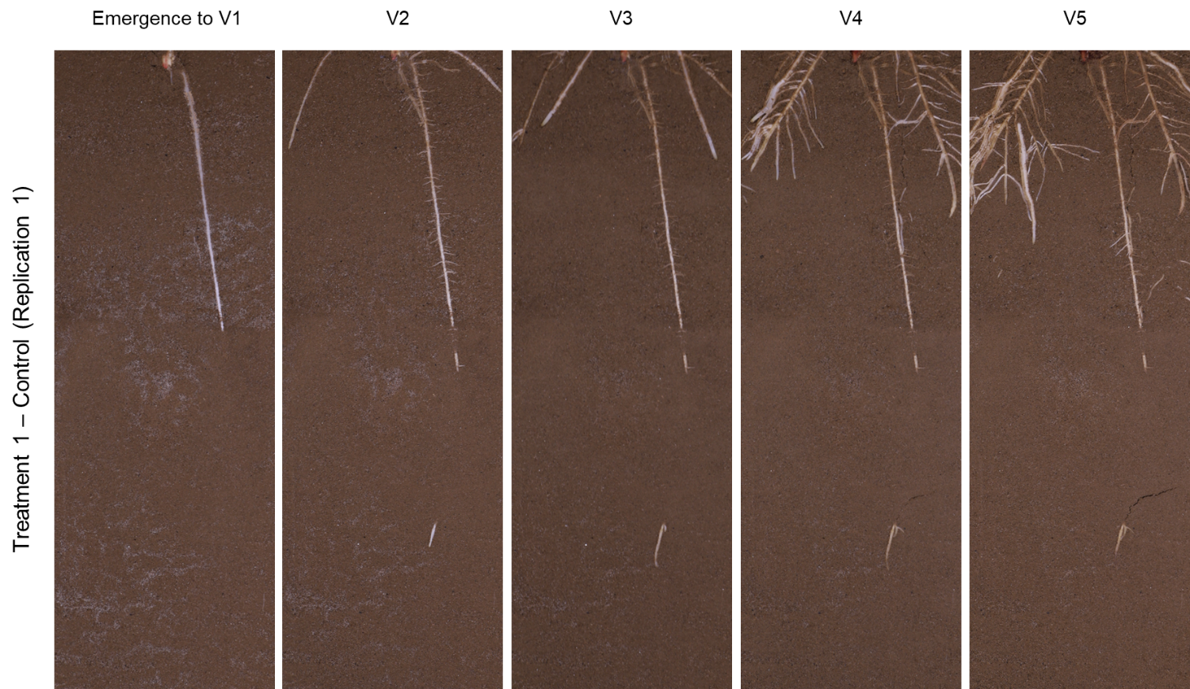

Fig. S17 Normal light photos of rhizoboxes in Control treatment (Replication 1) at five time points corresponding to the growth stages of maize in other treatments with plants: Emergence to 1 fully extended leaf (V1), two leaves (V2), three leaves (V3), four leaves (V4) and five leaves (V5)
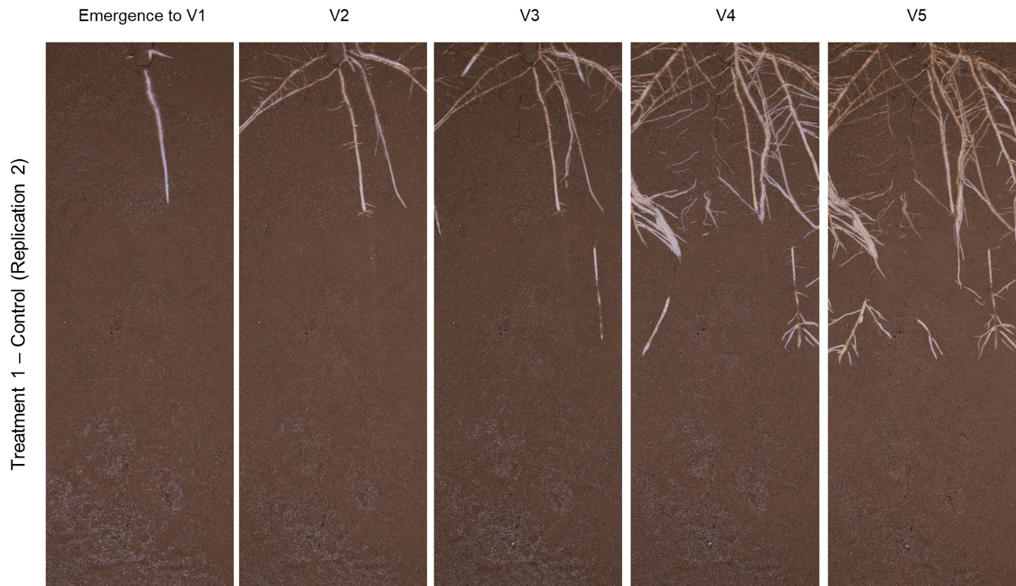
Fig. S18 Normal light photos of rhizoboxes in Control treatment (Replication 2) at five time points corresponding to the growth stages of maize in other treatments with plants: Emergence to 1 fully extended leaf (V1), two leaves (V2), three leaves (V3), four leaves (V4) and five leaves (V5)

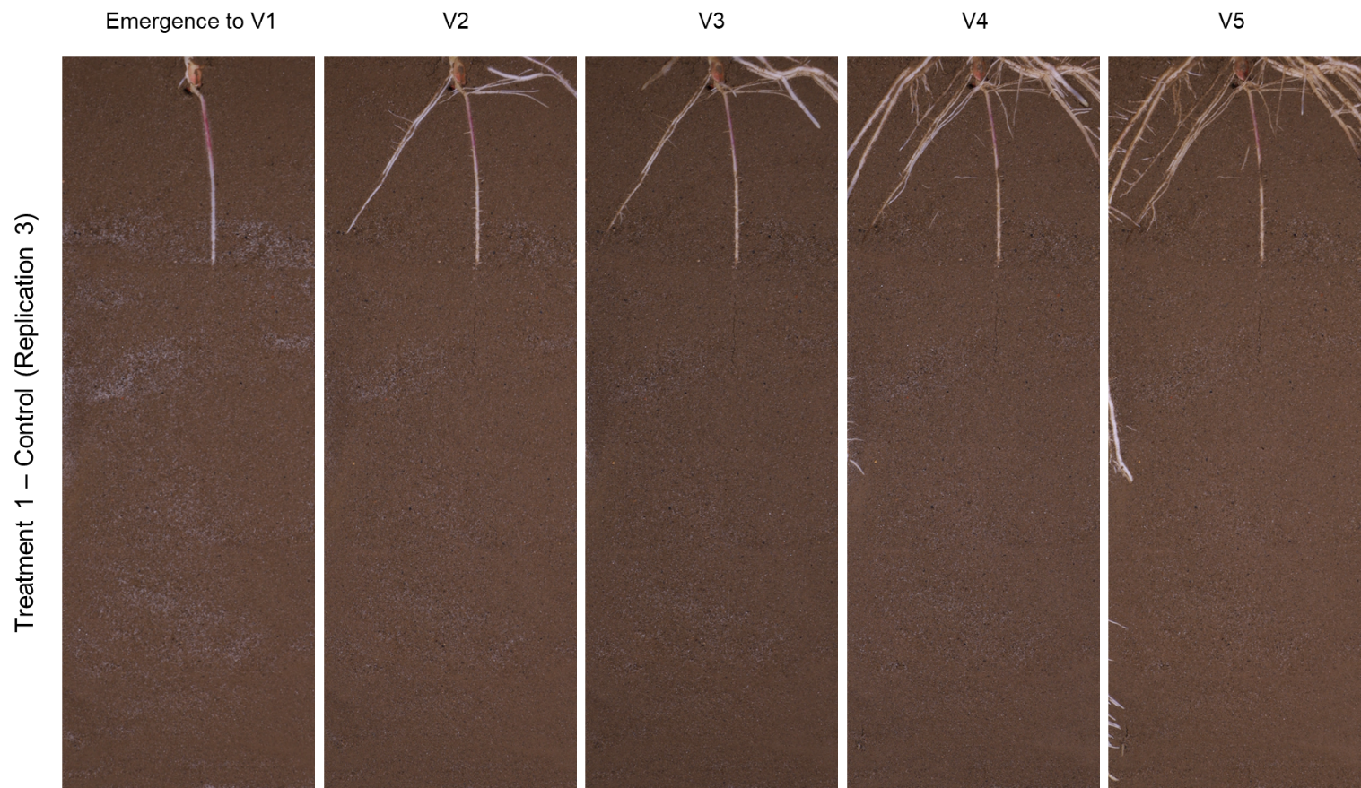

Fig. S19 Normal light photos of rhizoboxes in Control treatment (Replication 3) at five time points corresponding to the growth stages of maize in other treatments with plants: Emergence to 1 fully extended leaf (V1), two leaves (V2), three leaves (V3), four leaves (V4) and five leaves (V5)
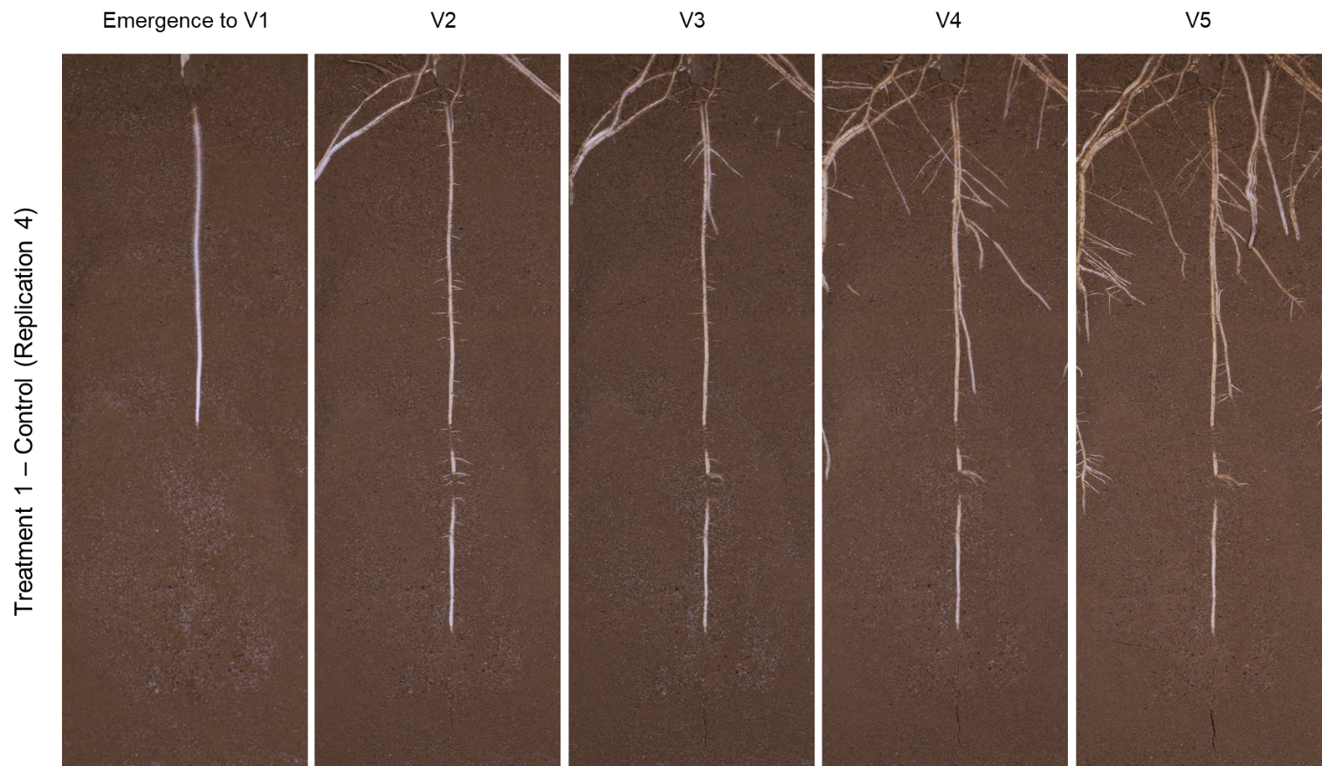

Fig. S20 Normal light photos of rhizoboxes in Control treatment (Replication 4) at five time points corresponding to the growth stages of maize in other treatments with plants: Emergence to 1 fully extended leaf (V1), two leaves (V2), three leaves (V3), four leaves (V4) and five leaves (V5)
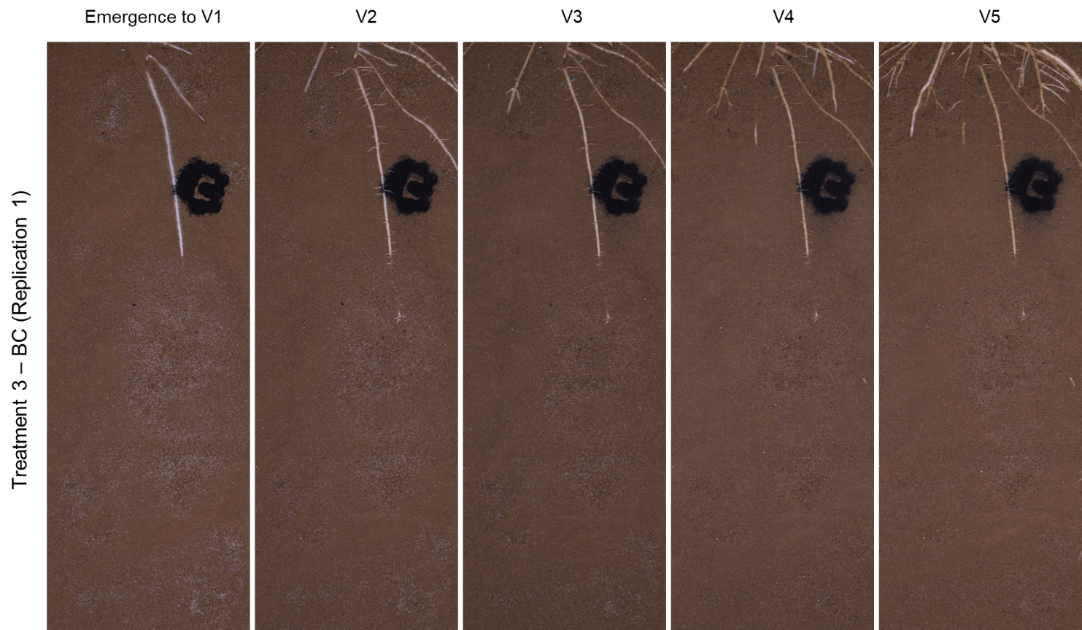

Fig. S21 Normal light photos of rhizoboxes with only BC application (Replication 1) at five time points corresponding to the growth stages of maize in other treatments with plants: Emergence to 1 fully extended leaf (V1), two leaves (V2), three leaves (V3), four leaves (V4) and five leaves (V5)
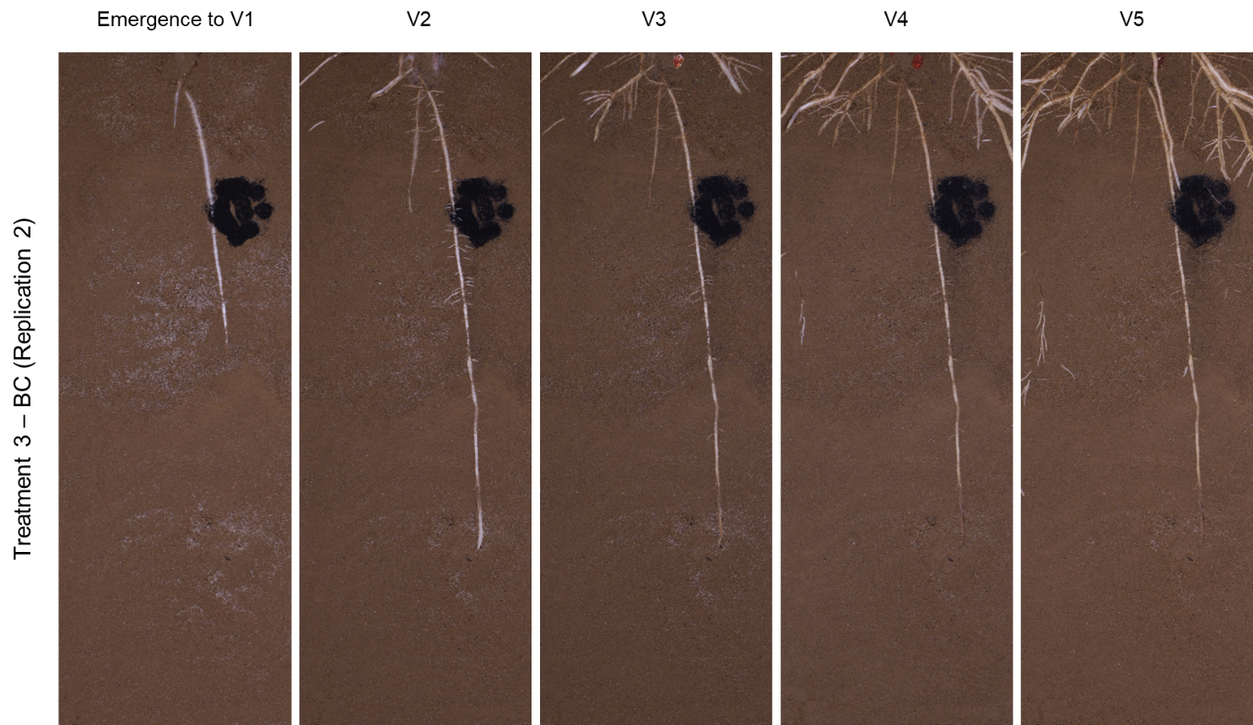

Fig. S22 Normal light photos of rhizoboxes with only BC application (Replication 2) at five time points corresponding to the growth stages of maize in other treatments with plants: Emergence to 1 fully extended leaf (V1), two leaves (V2), three leaves (V3), four leaves (V4) and five leaves (V5)

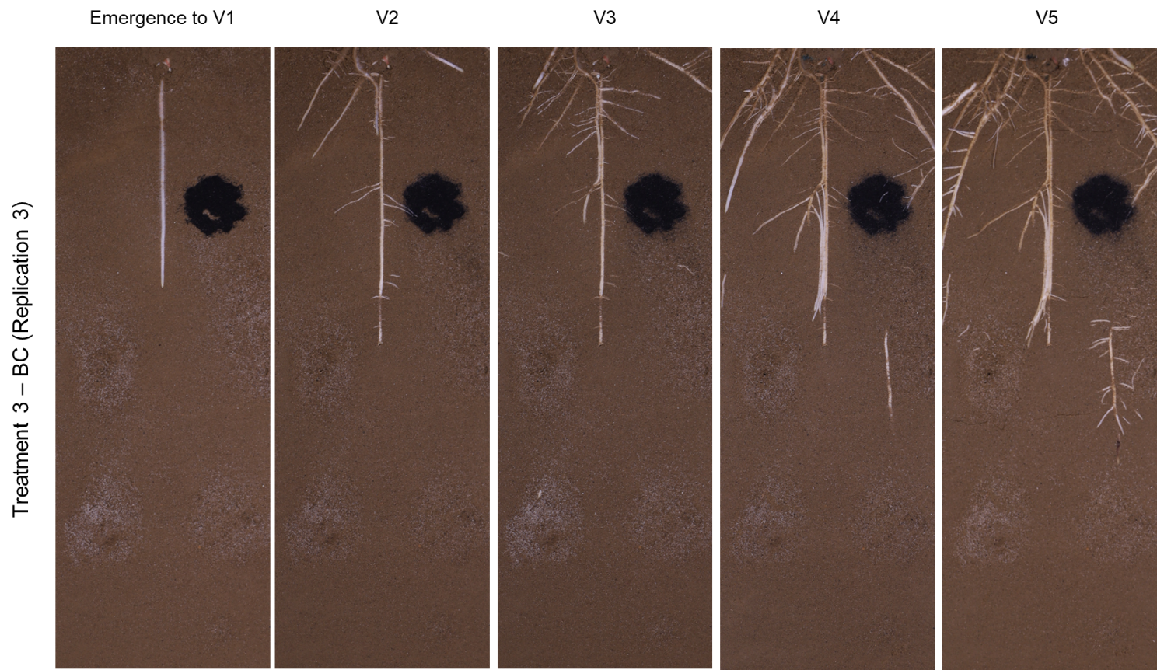

Fig. S23 Normal light photos of rhizoboxes with only BC application (Replication 3) at five time points corresponding to the growth stages of maize in other treatments with plants: Emergence to 1 fully extended leaf (V1), two leaves (V2), three leaves (V3), four leaves (V4) and five leaves (V5)
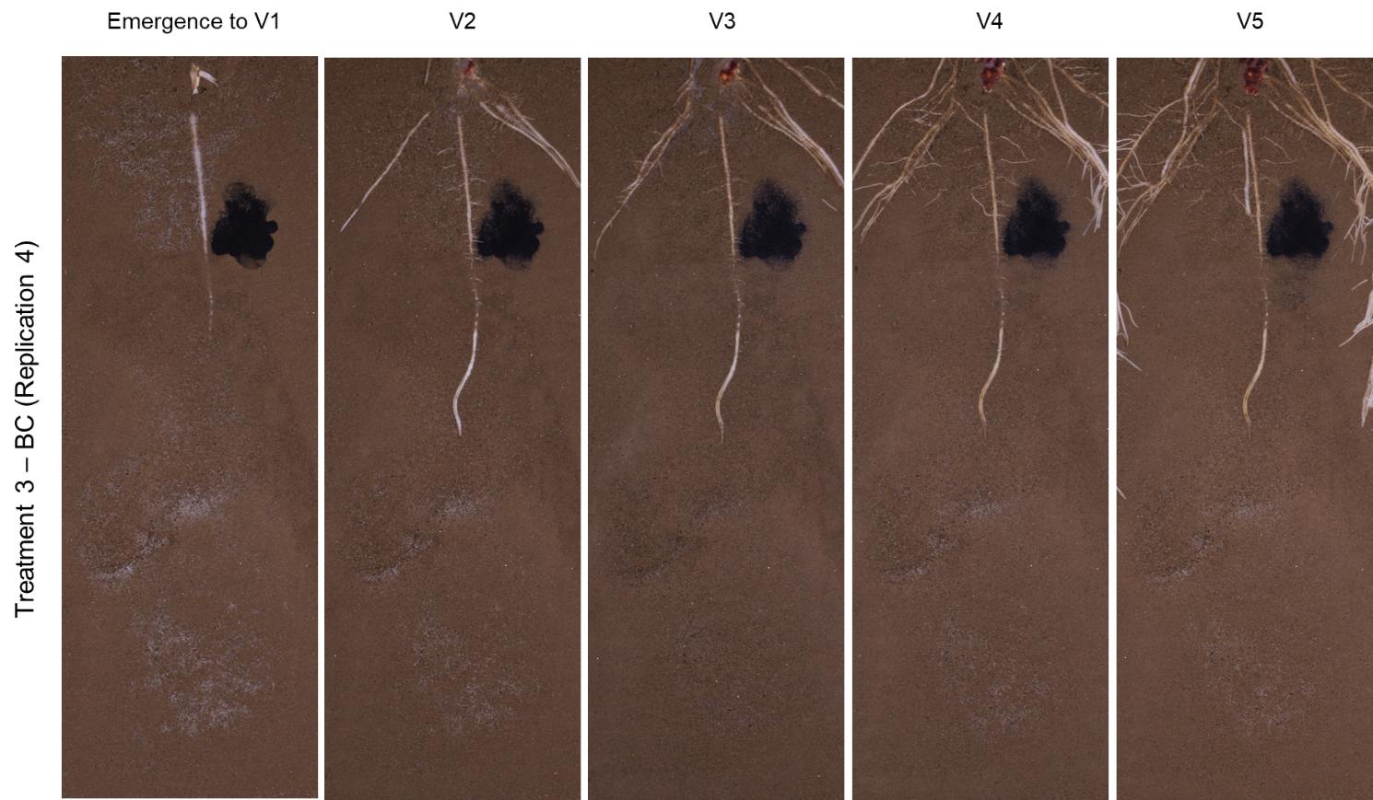

Fig. S24 Normal light photos of rhizoboxes with only BC application (Replication 4) at five time points corresponding to the growth stages of maize in other treatments with plants: Emergence to 1 fully extended leaf (V1), two leaves (V2), three leaves (V3), four leaves (V4) and five leaves (V5)
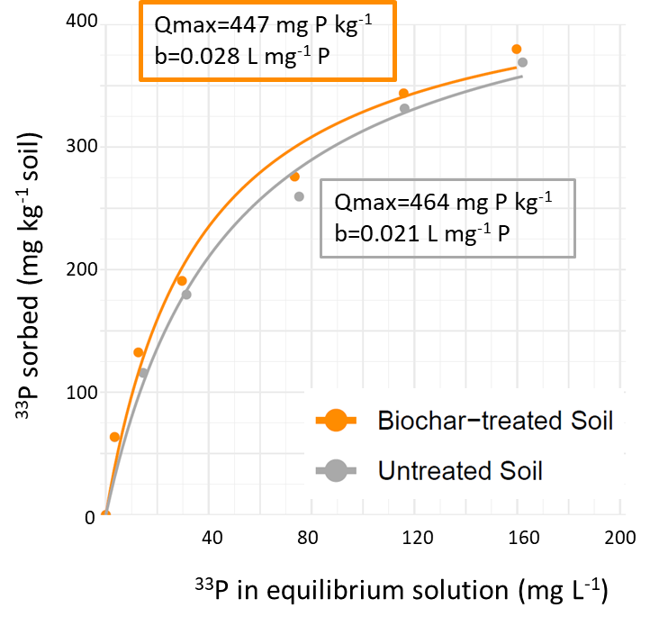

Fig. S25 Phosphorus sorption isotherms for untreated and biochar-treated soil fitted to the Langmuir model (R²=0.98, p < 0.001)

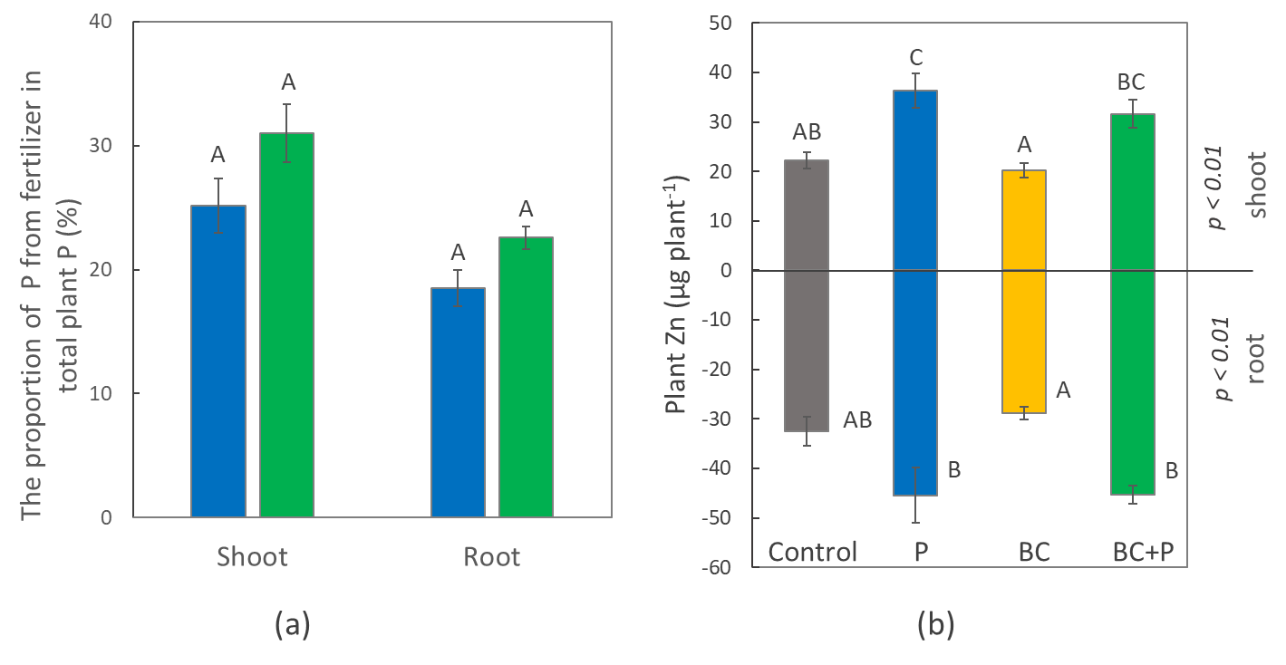

Fig. S26 The proportion of P in plants derived from applied ³³P-labelled fertilizer (a) in shoots and root of two treatments: phosphorus (P) -blue bar and jointly applied biochar and phosphorus with plants (BC+P) – green bar, and zinc (Zn) stock in maize plants (b) at the five-leaf growth stage of four treatments (Control, phosphorus (P), biochar (BC), jointly applied biochar and phosphorus with plants (BC+P)). All data are presented as a means of four replicates; whiskers indicate standard errors. Capital letters indicate one-way ANOVA differences between treatments for each parameter (p < 0.05)

Table S2. The plant P and Zn concentrations and ratio between the zinc absorbed by the plant and the phosphorus content in maize plants
Treatmentª | Concentration in plant shoots |  | µg Zn per mg P
Treatmentª | P, g kg⁻¹ | Zn, mg kg⁻¹ | roots | shoots | total plant
Control | 2.0 | 23.1 | 11.6 | 36.6 | 19.3
P | 2.1 | 25.3 | 12.3 | 33.7 | 19.0
BC | 2.0 | 23.0 | 11.8 | 38.5 | 19.0
BC+P | 2.1 | 23.4 | 11.8 | 34.6 | 19.1
ANOVA^{b} | NS | NS | NS | NS | NS
ª The treatments are Control, phosphorus (P), biochar (BC), jointly applied biochar and phosphorus with plants (BC+P).
^{b} One-way ANOVA represent the significant differences between the treatment (NS – non-significant with p > 0.05).

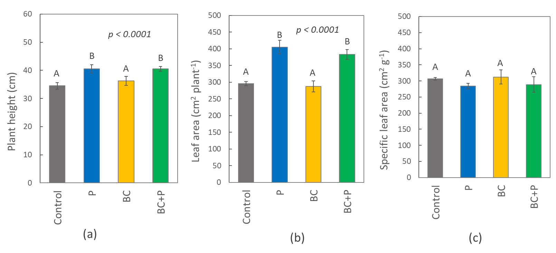

Fig. S27 Maize plants height (A), leaf area (B) and specific leaf area (SLA) (C) at five leaves growth stage of four treatments (Control, phosphorus (P), biochar (BC), jointly applied biochar and phosphorus with plants (BC+P)). All data are presented as a means of four replicates with whiskers indicating standard errors. Capital letters indicate one-way ANOVA differences for each parameter (p < 0.05)

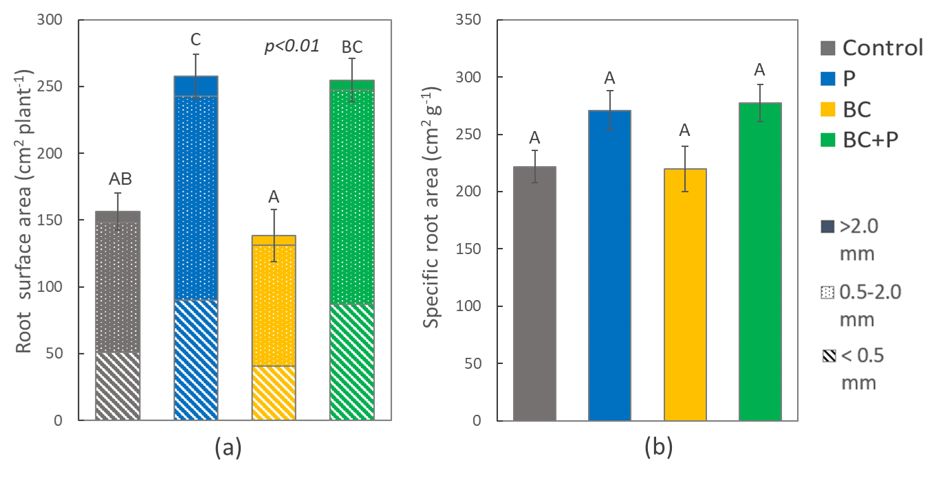

Fig. S28 Maize plant root surface area (a) and specific root area (SRA) (b) of four treatments (Control, phosphorus (P), biochar (BC), jointly applied biochar and phosphorus with plants (BC+P)). All data are presented as a means of four replicates with whiskers indicating standard errors. Capital letters indicate one-way ANOVA differences for each parameter (p < 0.05)

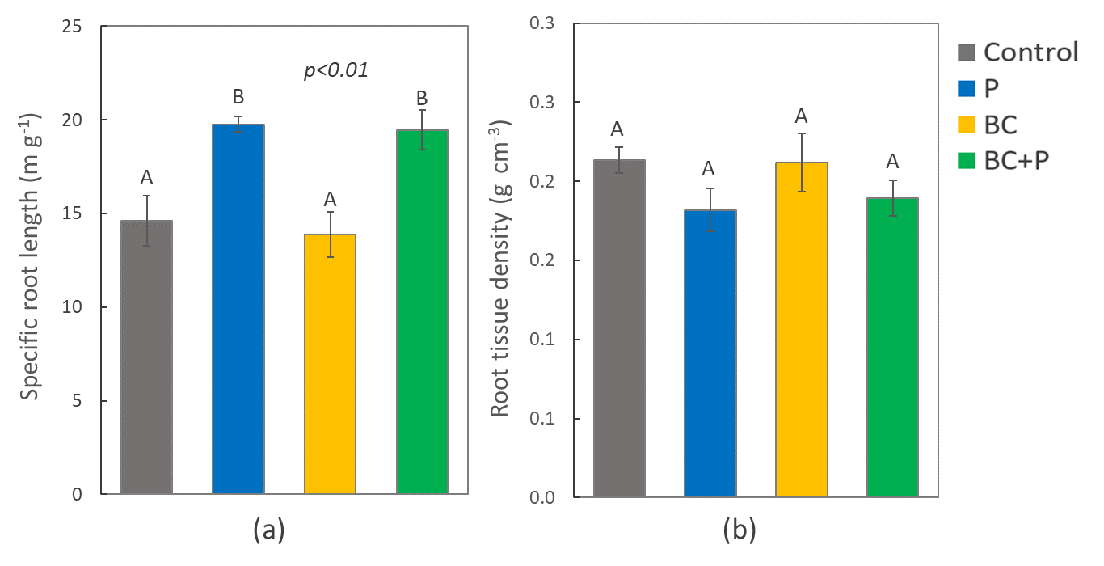

Fig. S29 Specific root length (SRL) (a) and root tissue density (RTD) (b) of four treatments (Control, phosphorus (P), biochar (BC), jointly applied biochar and phosphorus with plants (BC+P)). All data are presented as a means of four replicates with whiskers indicating standard errors. Capital letters indicate one-way ANOVA differences for each parameter (p < 0.05)

References
Cao Q (2004) Pyrolytic behavior of waste corn cob. Bioresour Technol 94:83–89. https://doi.org/10.1016/j.biortech.2003.10.031
Gabhane JW, Bhange VP, Patil PD, et al (2020) Recent trends in biochar production methods and its application as a soil health conditioner: a review. SN Appl Sci 2:1307. https://doi.org/10.1007/s42452-020-3121-5
Ippolito JA, Cui L, Kammann C, et al (2020) Feedstock choice, pyrolysis temperature and type influence biochar characteristics: a comprehensive meta-data analysis review. Biochar 2:421–438. https://doi.org/10.1007/s42773-020-00067-x
Loginova I, Bilyera N, Banfield C, et al (2024) How biochar suspension influences soil microbial activity and phosphorus availability, EGU General Assembly 2024, Vienna, Austria, 14–19 Apr 2024, EGU24-7709, https://doi.org/10.5194/egusphere-egu24-7709
Shariff A, Mohamad Aziz NS, Ismail NI, Abdullah N (2016) Corn Cob as a Potential Feedstock for Slow Pyrolysis of Biomass. Journal of Physical Science 27:123–137. https://doi.org/10.21315/jps2016.27.2.9
Singh B, Camps-Arbestain M, Lehmann J (eds) (2017) Biochar: A Guide to Analytical Methods. CSIRO Publishing, https://www.publishing.csiro.au/book/7478/
Tenic E, Ghogare R, Dhingra A (2020) Biochar—A Panacea for Agriculture or Just Carbon? Horticulturae 6:37. https://doi.org/10.3390/horticulturae6030037

