Supplementary files:

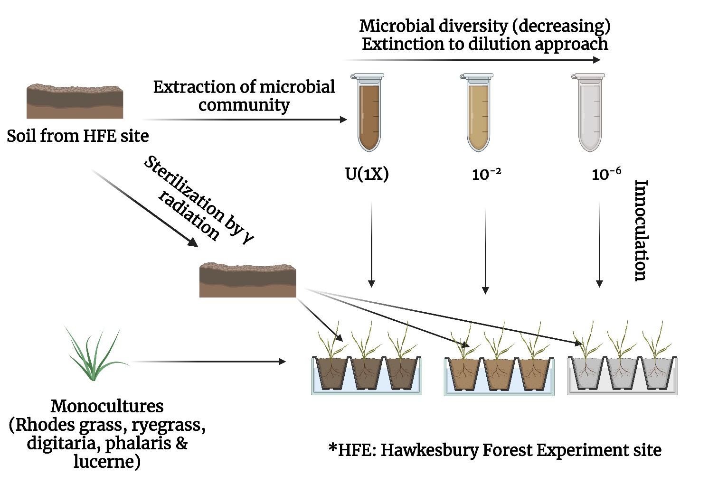

Supplementary Figure 1: schematic representation of the experimental designed established to test the effect of initial soil microbial diversity treatment and host identity on plant microbiome assembly of five different plant species.
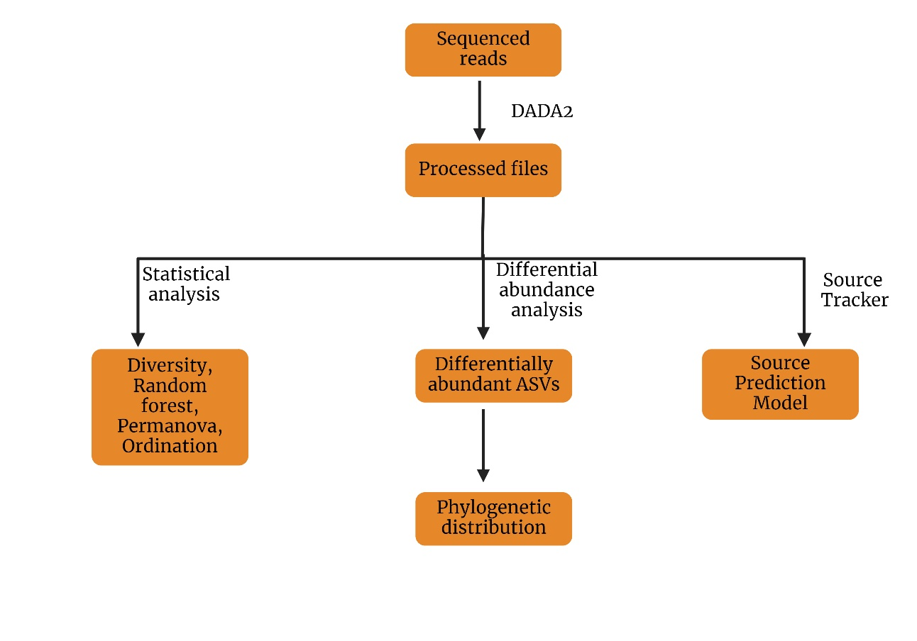

Supplementary Figure 2: A flowchart representing various statistical and computational approaches adopted for data analysis.

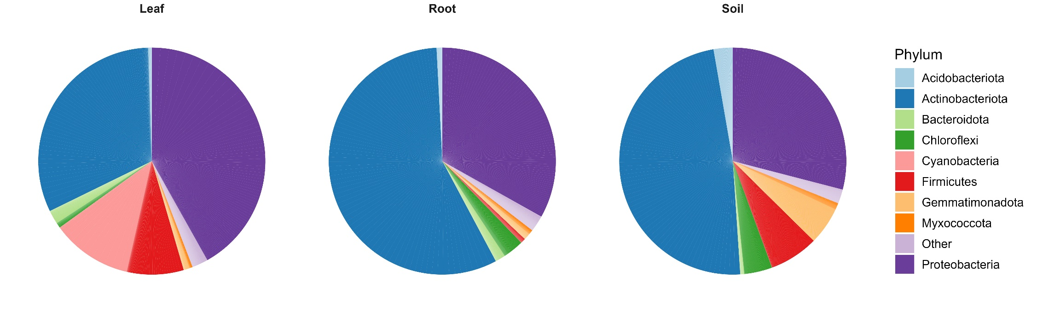
Supplementary Figure 3: Pie chart representing phylum level plant compartment-specific composition for bacteria (a) Leaf, (b) Root, and (c) Soil. There was variation in terms of relative abundance of different phyla across these compartments.

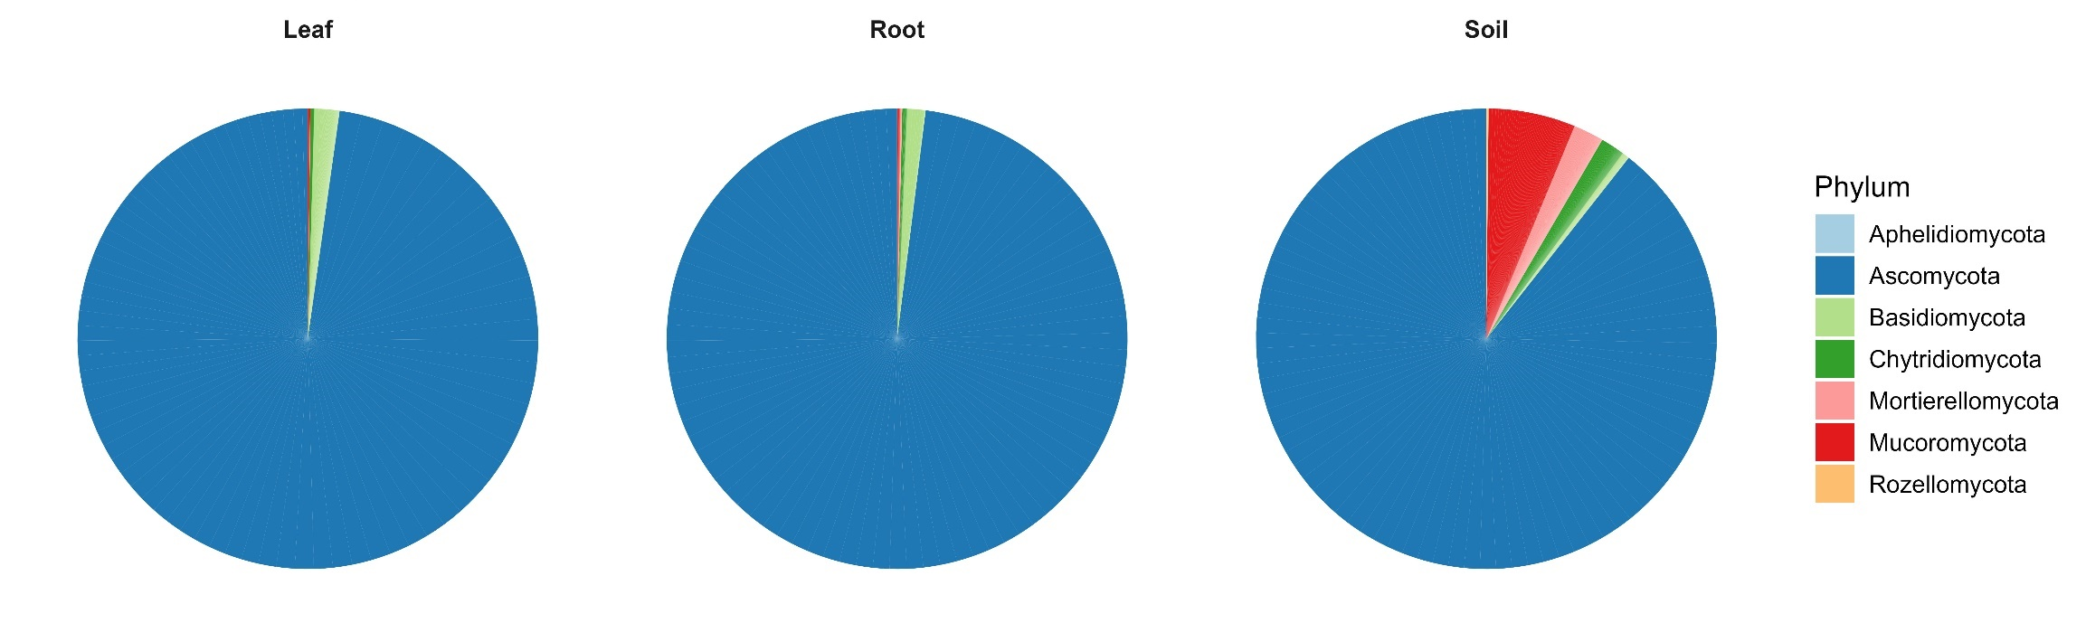
Supplementary Figure 4: Pie-chart representing phylum level plant compartment-specific composition for fungi (a) Leaf, (b) Root, and, (c) Soil. There was variation in terms of relative abundance of different phyla across these compartments.

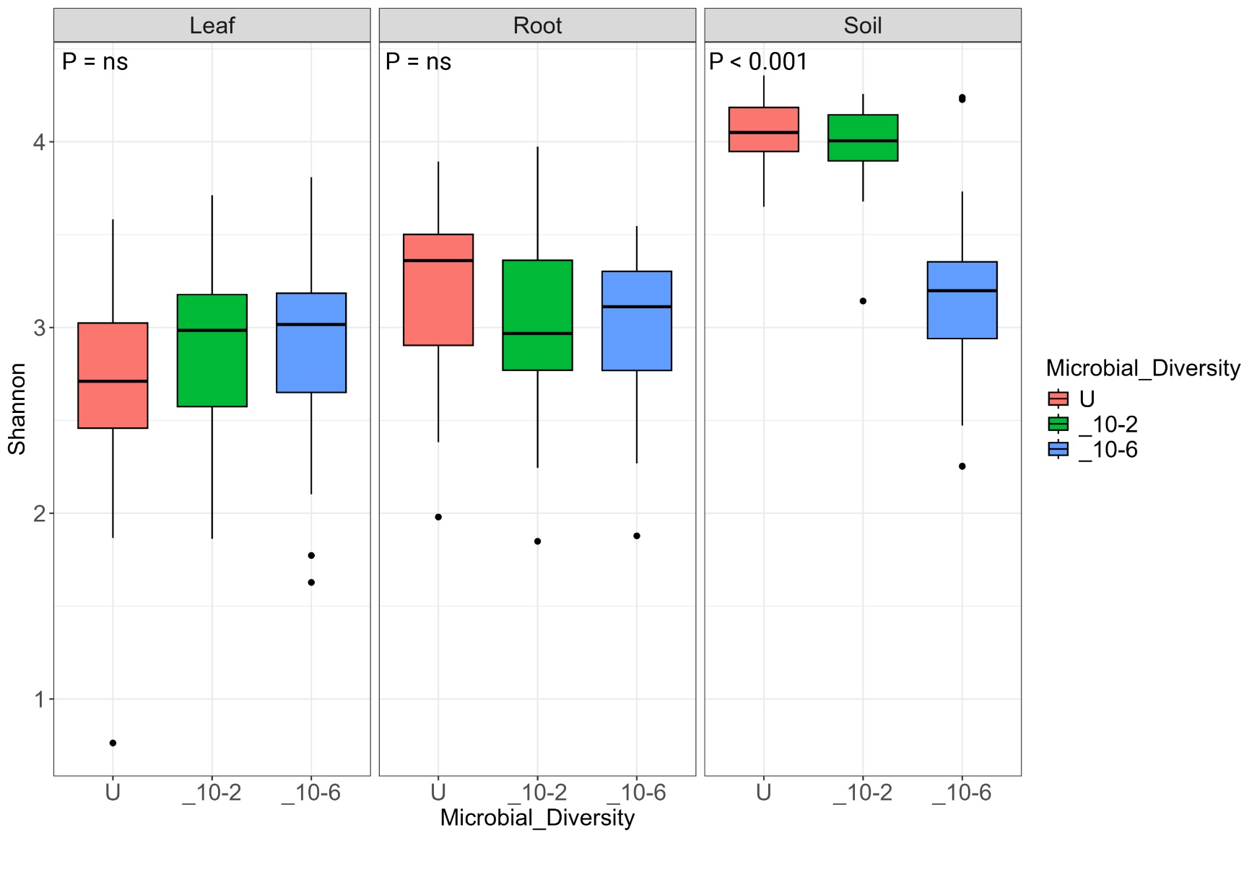
Supplementary Figure 5: Box plot representing the effect of soil microbial diversity over alpha diversity of fungi of different plants niches. Microbial diversity treatment significantly impacts the soil while there is no significant impact on root and leaf Shannon index. In terms overall diversity soil has highest diversity while leaf has the lowest.
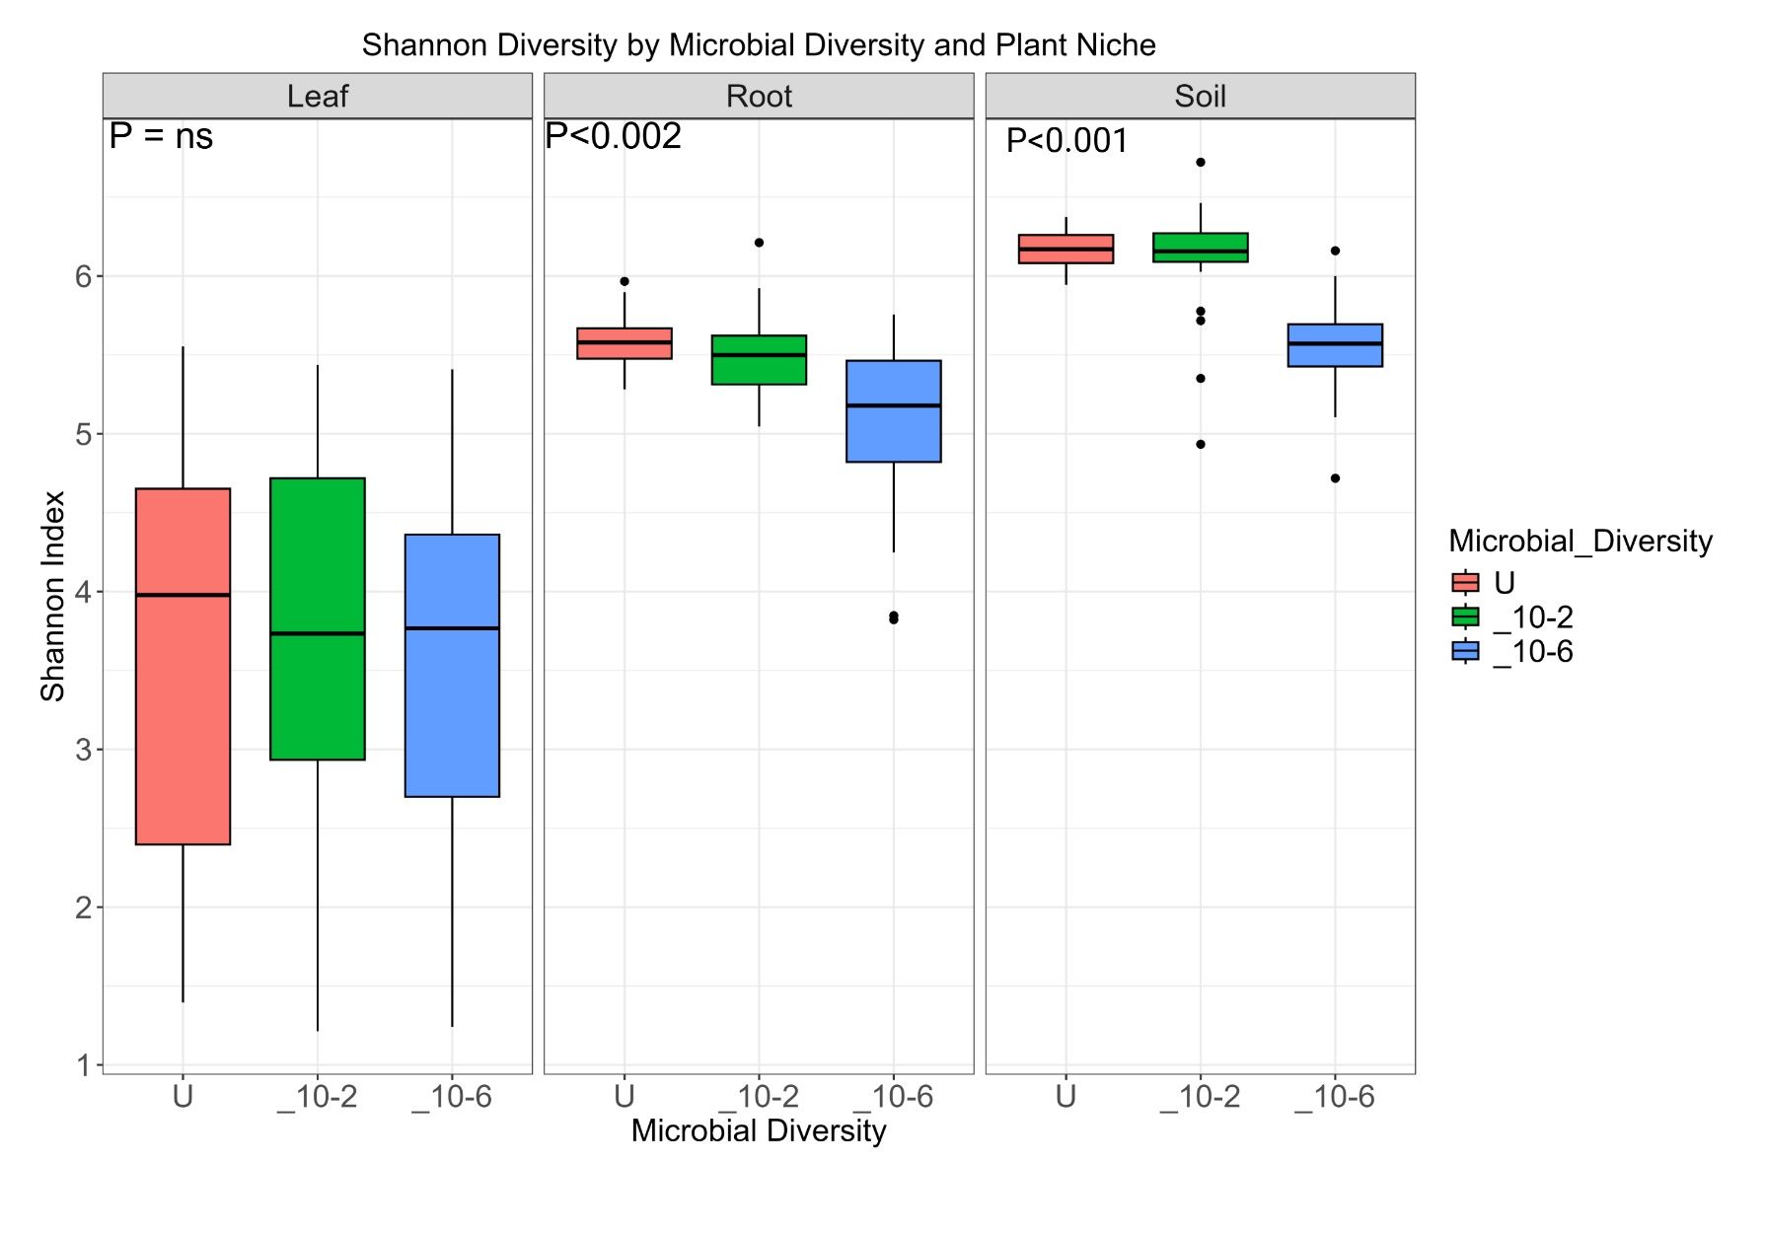
Supplementary Figure 6: Box plot representing the effect of soil microbial diversity over alpha diversity of bacteria of different plants and their respective plant compartments. Soil and root are significantly affected niche whereas there is no significant impact on the leaf microbiome. In terms overall diversity soil has highest diversity while leaf has the lowest.

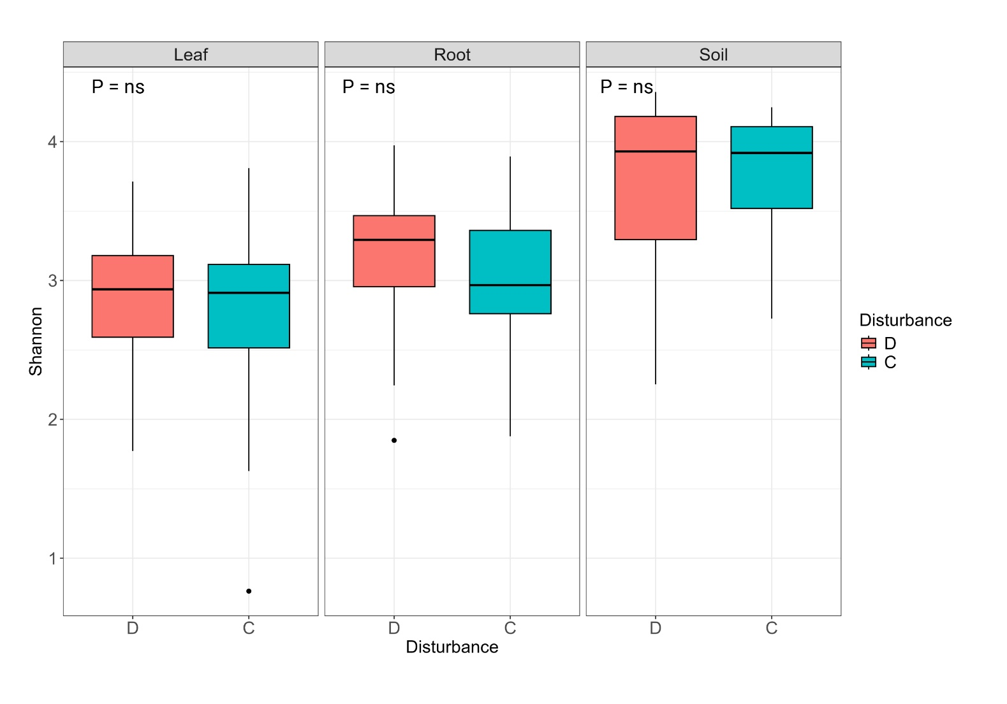
Supplementary Figure 7: Box plot representing the effect of disturbance over alpha diversity of fungi of different plants niches. There is no significant impact of disturbance on any of the plant niches.

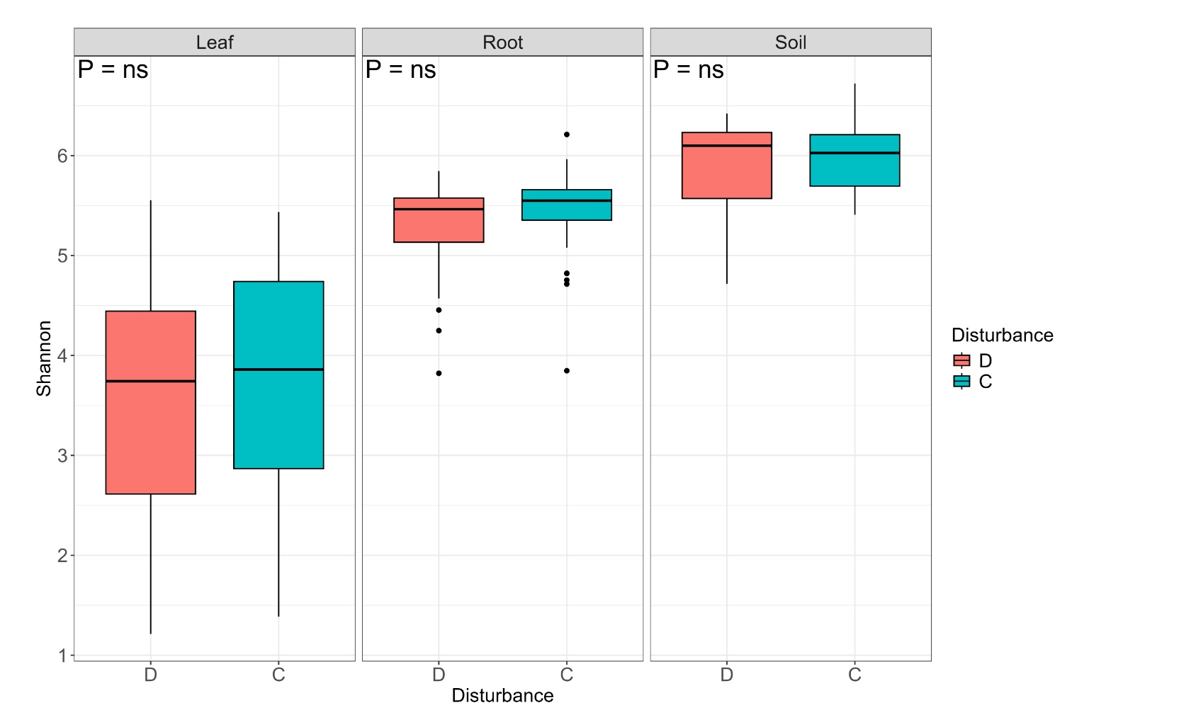

Supplementary Figure 8: Boxplot representing the effect of drought treatment over the alpha diversity of bacteria microbiome. There is a clear indication that disturbance in the form of drought has not significantly affected the alpha diversity.

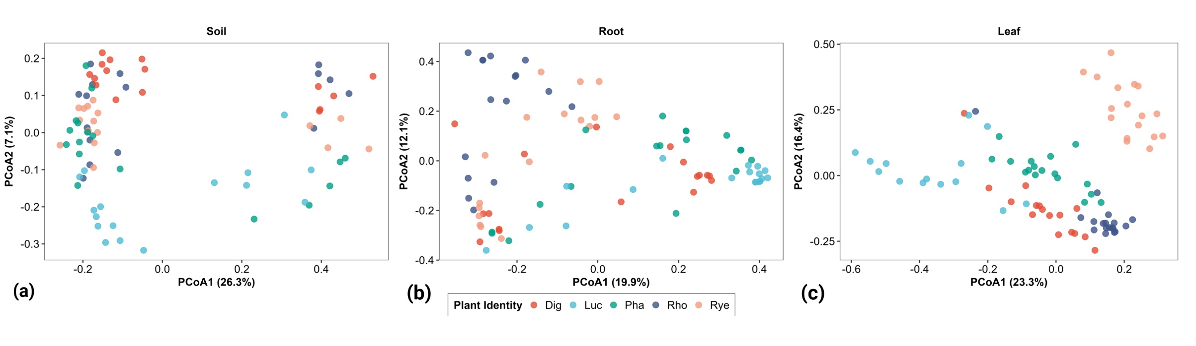

Supplementary Figure 9: PCoA plot representing effect of plant identity in fungi in different niche (a) soil, (b) root, and (c) leaf. Lucerne a nitrogen fixing plant forms a separate cluster from other plants in leaf and root, but it less distinct in soil.

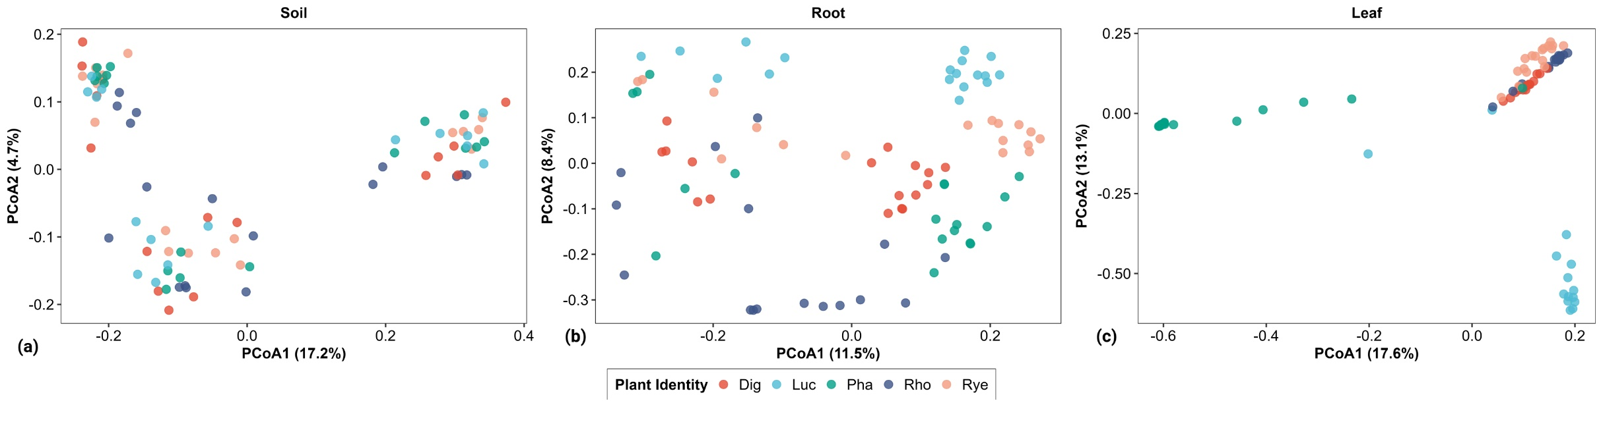

Supplementary Figure 10: PCoA plot representing effect of plant identity over bacteria in different niche (a) leaf, (b) root, and (c) soil. Lucerne a nitrogen fixing plant forms a separate cluster from other plants in leaf and root, but it less distinct in soil

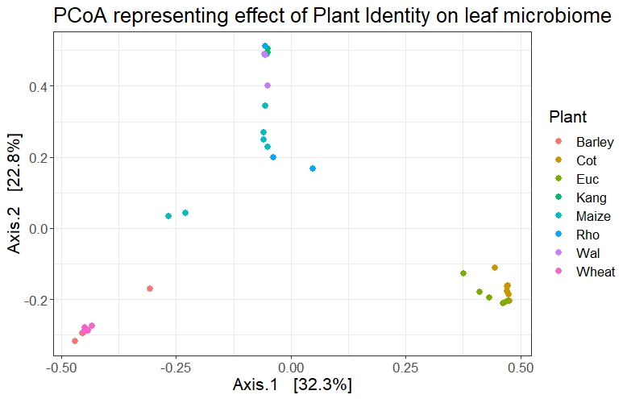
Supplementary Figure 11: PCoA plot representing PCoA plot representing effect of plant identity over bacterial leaf microbiome from additional dataset analysed. (Cot=cotton, Euc=Eucalypt, Kang=kangaroo grass, Rho=Rhodes grass, Wal=wallaby grass,)

Supplementary Tables
Supplementary Table 1: Accession numbers of chloroplast genomes and additional amplicon sequencing datasets used in the experiment.
Serial No | Plant | NCBI accession
1 | Phalaris cpgenome | NC_027481.1
2 | Digitaria cpgenome | NC_024176.1
3 | Ryegrass cpgenome | NC_009950.1
4 | Rhodes grass cpgenome | NC_042841.1
5 | Lucerene cpgenome | NC_042841.1
6 | Wheat cpgenome | NC_002762.1
7 | Eucalypt cpgenome | NC_022397.1
8 | Maize cpgenome | NC_001666.2
9 | Barley cpgenome | NC_008590.1
10 | Kangaroo grass cpgenome | NC_035016.1
11 | Wallaby grass cpgenome | NC_037166.1
12 | Cotton cpgenome | NC_007944.1
Amplicon sequencing data
1 | Wheat, Barley, Maize (Origin : China) | SRA: PRJNA559707
2 | Eucalypt (Origin : Australia) | In house
3 | Cotton (Origin : Australia, multiple sampling sites) | In house
4 | Kangaroo grass. Wallaby grass, Rhodes grass (Origin : Australia) | ENA: PRJEB38041

Supplementary Table 2: Table representing R² values from Global PERMANOVA analysis for the impact of different plant compartments, plant combinations, soil microbial diversity, and disturbance over bacterial and fungal diversity. Significance codes: ***p < 0 0.001, **p < 0.01, *p < 0.05, ns stands for non-singificant.

 |  | Fungi |  | Bacteria
Features | Factors | R2 | P.Value | R2 | P.Value
Ryegrass | Niche | 0.459941 | *** | 0.161712 | **
 | Disturbance | 0.007545 | ns | 0.016711 | ns
 | Soil Microbial Diversity | 0.09586 | * | 0.058769 | *
Rhodes | Niche | 0.476394 | *** | 0.433139 | ***
 | Disturbance | 0.004496 | ns | 0.008615 | ns
 | Soil Microbial Diversity | 0.112705 | * | 0.057369 | ns
Phalaris | Niche | 0.542653 | *** | 0.424078 | ***
 | Disturbance | 0.006434 | ns | 0.014013 | ns
 | Soil Microbial Diversity | 0.078307 | * | 0.059703 | *
Digitaria | Niche | 0.441929 | *** | 0.580348 | ***
 | Disturbance | 0.004311 | ns | 0.010208 | ns
 | Soil Microbial Diversity | 0.066737 | ns | 0.046192 | ns
Lucerne | Niche | 0.45253 | *** | 0.389396 | **
 | Disturbance | 0.008948 | ns | 0.014013 | ns
 | Soil Microbial Diversity | 0.07006 | * | 0.048051 | ns
Soil | Plant Identity | 0.104973 | * | 0.062379 | *
 | Disturbance | 0.005385 | ns | 0.009785 | ns
 | Soil Microbial Diversity | 0.289991 | *** | 0.28963 | ***
Root | Plant Identity | 0.202797 | ** | 0.192307 | **
 | Disturbance | 0.006406 | ns | 0.008187 | ns
 | Soil Microbial Diversity | 0.075218 | * | 0.159486 | *
Leaf | Plant Identity | 0.258352 | *** | 0.226308 | ***
 | Disturbance | 0.009062 | ns | 0.010509 | ns
 | Soil Microbial Diversity | 0.027808 | ns | 0.039678 | ns
All | Plant Identity | 0.103914 | * | 0.088831 | *
 | Niche | 0.158316 | ** | 0.280801 | ***
 | Disturbance | 0.001694 | ns | 0.001532 | ns
 | Soil Microbial Diversity | 0.029123 | ns | 0.021856 | ns

Supplementary Table 3: Generalist and specialist taxa fungi.
Generalist | Specialist taxa Digitaria | Specialist taxa Lucerne | Specialist taxa Rhodes | Specialist taxa Ryegrass | Specialist taxa Phalaris
Acremonium | Cladosporium | Cladosporium | Cladosporium | Cladosporium | Cladosporium
Alternaria | Fusarium | Fusarium | Fusarium | Fusarium | Fusarium
Chaetomium | Paraconiothyrium | Paraconiothyrium | Paraconiothyrium | Paraconiothyrium | Paraconiothyrium
Cladosporium | Myrmecridium | Myrmecridium | Myrmecridium | Myrmecridium | Myrmecridium
Clonostachys | Edenia | Purpureocillium | Edenia | Edenia | Edenia
Coniochaeta | Poaceascoma | Humicola | Poaceascoma | Poaceascoma | Poaceascoma
Dictyochaeta | Pseudorhypophila | Pseudothielavia | Pseudorhypophila | Pseudorhypophila | Pseudorhypophila
Edenia | Purpureocillium | Fungi_gen_Incertae_sedis | Purpureocillium | Purpureocillium | Purpureocillium
Epicoccum | Humicola | Edenia | Humicola | Humicola | Humicola
Fungi_gen_Incertae_sedis | Pseudothielavia | Pseudorhypophila | Pseudothielavia | Pseudothielavia | Pseudothielavia
Fusarium | Talaromyces | Verticillium | Verticillium | Talaromyces | Talaromyces
Gongronella | Verticillium | Epicoccum | Epicoccum | Verticillium | Epicoccum
Humicola | Epicoccum | Alternaria | Sarocladium | Epicoccum | Alternaria
Myrmecridium | Alternaria | Neocosmospora | Alternaria | Sarocladium | Pseudopithomyces
Neocosmospora | Neocosmospora | Penicillium | Neocosmospora | Alternaria | Clonostachys
Paraconiothyrium | Clonostachys | Pseudopithomyces | Penicillium | Neocosmospora | Acremonium
Penicillium | Pseudopithomyces | Clonostachys | Chaetomium | Clonostachys | Gongronella
Poaceascoma | Penicillium | Trichoderma | Pseudopithomyces | Chaetomium | Scytalidium
Pseudopithomyces | Chaetomium | Gongronella | Clonostachys | Pseudopithomyces | Rhizoctonia
Pseudorhypophila | Trichoderma | Dictyochaeta | Trichoderma | Acremonium | Sarocladium
Pseudothielavia | Gongronella | Coniochaeta | Dictyochaeta | Rhizoctonia
Purpureocillium | Acremonium | Chaetomium | Gongronella | Exophiala
Sarocladium | Dictyochaeta | Bisifusarium | Coniochaeta
Talaromyces | Sarocladium | Sarocladium | Gliomastix
Trichoderma | Exophiala | Fusicolla
Verticillium | Fusicolla | Exserohilum
 |  | Exophiala

Supplementary Table 4: Generalist and specialist taxa of bacteria.

Generalist | Specialist taxa Ryegrass | Specialist taxa Rhodes | Specialist taxa Lucerne | Specialist taxa Phalaris | Specialist taxa Digitaria
Streptomyces | Micrococcineae | Streptomyces | Streptomyces | Streptomyces | Amycolatopsis
Amycolatopsis | Propionibacterineae | Amycolatopsis | Amycolatopsis | Amycolatopsis | Streptomyces
Curtobacterium | Corynebacterineae | Pedococcus-Phycicoccus | Mesorhizobium | Curtobacterium | Pedococcus-Phycicoccus
Mesorhizobium | Streptococcus | Curtobacterium | Bacillus | Mesorhizobium | Curtobacterium
Nocardioides | Pseudomonas | Mesorhizobium | Nocardiodes | Rhodococcus | Mesorhizobium
Bacillus | Chryseobacterium | Bacillus | Geodermatophilus | Microbacterium | Nocardioides
Geodermatophilus | Amycolatopsis | Geodermatophilus | Cutibacterium | Dyella | Bacillus
Actinoplanes | Rhodococcus | Actinoplanes | Microbacterium | Cutibacterium | Rhodococcus
Dyella | Actinoplanes | Rhodococcus | Dyella | Ralstonia | Actinoplanes
Rhodococcus | Pseudonocardia | Microbacterium | Ralstonia | Lysinimonas | Sphingomonas
Bacillus | Bacillus | Dyella | Kocuria | Deinococcus | Intrasporangium
Actinoplanes | Rhodococcus | Intrasporangium | Rothia | Pseudonocardia | Cutibacterium
Intrasporangium | Geodermatophilus | Cutibacterium | Gardnerella | Methylobacterium | Pseudolabrys
Mycobacterium | Pseudarthrobacter | Nocardioides | Spingomonas | Staphylococcus | Microbacterium
Microbacterium | Terrabacter | Ralstonia | Deinococcus | YC-ZSS-LKJ147 | Geodermatophilus
Dyella | Pantoea | Burkholderia | Burkholderia | Williamsia | Pseudonocardia
Nocardioides | Pedococcus | Pseudonocardia | Reyranella | Pseudomonas | Reyranella
Ralstonia | Microbacterium | Terrabacter | Rothia | Sphingomonas | Terrabacter
Pseudonocardia | Arthrobacter | Arthrobacter | Reyranella | Aeromicrobium | Pseudarthrobacter
Bacillus | Angustibacter | Dokdonella |  | Spirosoma | Dyella
Dokdonella | Cutibacterium | Pseudarthrobacter |  | Marmoricola | Stenotrophomonas
Geodermatophilus |  | Pantoea |  |  | Staphylococcus
Sphingomonas |  | Altererythrobacter |  |  | Corynebacterium
Reyranella |  | Leifsonia |  |  | Deinococcus
Chelativorans |  |  |  |  | Brevundimonas
 |  |  |  |  | Paracoccus
 |  |  |  |  | Gaiella

Supplementary Table 5: Differentially abundant fungal ASVs (dFASVs), their plant compartments, phylum, and genus

ID | Phylum | Genus | Compartment
dFASV1 | Mucoromycota | Gongronella | Leaf and Soil
dFASV2 | Ascomycota | Fusarium | Leaf, Root, and Soil
dFASV3 | Ascomycota | Humicola | Leaf, Root, and Soil
dFASV4 | Ascomycota | Exophiala | Leaf and Root
dFASV5 | Ascomycota | Fusicola | Leaf
dFASV6 | Ascomycota | Ramichlorodium | Leaf
dFASV7 | Ascomycota | Uncultured Ascomycota | Leaf
dFASV8 | Ascomycota | Emericellopsis | Leaf
dFASV9 | Ascomycota | Pyrenophora | Leaf and Soil
dFASV10 | Ascomycota | Uncultured Ascomycota | Leaf
dFASV11 | Ascomycota | Romanomerm | Leaf, Root, and Soil
dFASV12 | Ascomycota | Epicoccum | Leaf and Root
dFASV13 | Ascomycota | Gongronella | Leaf
dFASV14 | Ascomycota | Chaetomium | Root and Soil
dFASV15 | Ascomycota | Cladosporium | Root and Soil
dFASV16 | Ascomycota | Clonostachys | Root and Soil
dFASV17 | Ascomycota | Fusarium | Root and Soil
dFASV18 | Ascomycota | Pseudothielavia | Root and Soil
dFASV19 | Ascomycota | Sordariomycetes | Root and Soil
dFASV20 | Ascomycota | Setophoma | Root and Soil
dFASV21 | Ascomycota | Talaromyces | Root and Soil
dFASV22 | Ascomycota | Trichoderma | Root
dFASV23 | Ascomycota | Humicola | Root and Soil
dFASV24 | Ascomycota | Epicoccum | Root
dFASV25 | Ascomycota | Penicillium | Root and Soil
dFASV26 | Ascomycota | Penicillium | Root and Soil
dFASV27 | Ascomycota | Pseudopithomyces | Root
dFASV28 | Ascomycota | Scytalidium | Root
dFASV29 | Ascomycota | Trichurus | Root and Soil
dFASV30 | Ascomycota | Sarocladium | Root and Soil
dFASV31 | Ascomycota | Aspergillus | Root and Soil
dFASV32 | Ascomycota | Geomyces | Root and Soil
dFASV33 | Ascomycota | Blumeria | Root and Soil
dFASV34 | Ascomycota | Cyphellophora | Root
dFASV35 | Ascomycota | Fusarium | Root
dFASV36 | Ascomycota | Ascomycete | Root and Soil
dFASV37 | Ascomycota | Pyrenophora | Root
dFASV38 | Ascomycota | Penicillium | Root and Soil
dFASV39 | Ascomycota | Gibellulopsis | Root
dFASV40 | Ascomycota | Fusarium | Root
dFASV41 | Ascomycota | Conlarium | Root
dFASV42 | Ascomycota | Metarhizium | Root and Soil
dFASV43 | Ascomycota | Dothideomycetes | Root
dFASV44 | Ascomycota | Paecilomyces | Root and Soil
dFASV45 | Ascomycota | Ochroconis | Root
dFASV46 | Ascomycota | Fusarium | Root
dFASV47 | Ascomycota | Uncultured Ascomycota | Root
dFASV48 | Ascomycota | Uncultured Ascomycota | Root
dFASV49 | Ascomycota | Nectria | Root
dFASV50 | Ascomycota | Uncultured Ascomycota | Root
dFASV51 | Ascomycota | Trichoderma | Root and Soil
dFASV52 | Ascomycota | Fusarium | Root
dFASV53 | Ascomycota | Trichothecium | Root
dFASV54 | Ascomycota | Tetraplosphaer | Root
dFASV55 | Ascomycota | Uncultured Ascomycota | Soil
dFASV56 | Ascomycota | Uncultured Ascomycota | Soil
dFASV57 | Ascomycota | Fusarium | Soil
dFASV58 | Ascomycota | Fusarium | Soil
dFASV59 | Ascomycota | Chaetosphaeria | Soil
dFASV60 | Ascomycota | Acremonium | Soil
dFASV61 | Ascomycota | Penicillium | Soil
dFASV62 | Ascomycota | Uncultured Ascomycota | Soil
dFASV63 | Ascomycota | Aspergillus | Soil
dFASV64 | Ascomycota | Mucor | Soil
dFASV65 | Ascomycota | Pseudogymnoasc | Soil
dFASV66 | Ascomycota | Absidia | Soil
dFASV67 | Ascomycota | Mucor | Soil
dFASV68 | Ascomycota | Chloridium | Soil
dFASV69 | Ascomycota | Uncultured Ascomycota | Soil
dFASV70 | Ascomycota | Uncultured Ascomycota | Soil
dFASV71 | Basidiomycota | Uncultured Basidiomycota | Soil
dFASV72 | Ascomycota | Aspergillus | Soil
dFASV73 | Ascomycota | Uncultured Ascomycota | Soil
dFASV74 | Ascomycota | Penicillium | Soil
dFASV75 | Ascomycota | Penicillium | Soil
dFASV76 | Basidiomycota | Uncultured Basidiomycota | Soil
dFASV77 | Ascomycota | Lecythophora | Soil
dFASV78 | Ascomycota | Chaetomium | Soil
dFASV79 | Ascomycota | Achaetomium | Soil

Supplementary Table 6: Differentially abundant bacterial ASVs (dBASVs), their plant compartments, phylum, and genus

ID | Phylum | Genus | Compartment
dBASV1 | Firmicutes | Neobacillus | Root and Soil
dBASV2 | Deinococcus-Thermus | Deinococcus | Root and Soil
dBASV3 | Firmicutes | Bacillus | Root and Soil
dBASV4 | Actinobacteria | Streptomyces | Leaf
dBASV5 | Actinobacteria | Solirubrobacter | Leaf
dBASV6 | Actinobacteria | Catellatospora | Leaf
dBASV7 | Actinobacteria | Humibacter | Leaf
dBASV8 | Actinobacteria | Humibacter | Leaf
dBASV9 | Firmicutes | Staphylococcus | Leaf
dBASV10 | Proteobacteria | Xanthomonas | Leaf
dBASV11 | Proteobacteria | Xanthomonas | Leaf
dBASV12 | Proteobacteria | Unculture Chromatiales | Leaf
dBASV13 | Proteobacteria | Uncultured Halomonadaceae | Leaf
dBASV14 | Firmicutes | Staphylococcus | Leaf
dBASV15 | Firmicutes | Staphylococcus | Leaf
dBASV16 | Acidobaceteria | uncultured Acidobacteria | Root
dBASV17 | Actinobacteria | Streptacidiphilus | Root
dBASV18 | Planctomycetes | Singulisphaera | Root
dBASV19 | Actinobacteria | Streptomyces | Root
dBASV20 | Proteobacteria | Unculture Acetobacteraceae | Root
dBASV21 | Actinobacteria | Streptomyces | Root
dBASV22 | Actinobacteria | Streptomyces | Root
dBASV23 | Proteobacteria | Amorphus | Root
dBASV24 | Actinobacteria | Verrucosispora | Root
dBASV25 | Proteobacteria | Rhizobium | Root
dBASV26 | Proteobacteria | Amphorus | Root
dBASV27 | Proteobacteria | Bradyrhizobium | Root
dBASV28 | Proteobacteria | Sphingomonas | Root
dBASV29 | Bacteroidetes | Hymenobacter | Root
dBASV30 | Firmicutes | Bacillus | Root
dBASV31 | Proteobacteria | Phyllobacteriaceae_unclassified | Root
dBASV32 | Proteobacteria | Phyllobacteriaceae_unclassified | Root
dBASV33 | Actinobacteria | Frankia | Root
dBASV34 | Actinobacteria | Streptomyces | Root
dBASV35 | Actinobacteria | Actinokineospora | Root
dBASV36 | Uidentified | uncultured bacteria | Root
dBASV37 | Firmicutes | Paenibacillus | Root
dBASV38 | Proteobacteria | Sphingomonas | Root
dBASV39 | Proteobacteria | uncultured Proteobacteria | Root
dBASV40 | Firmicutes | Bacillus | Root
dBASV41 | Proteobacteria | Pseudomonas | Root
dBASV42 | Unidentified | uncultured bacteria | Root
dBASV43 | Unidentified | uncultured bacteria | Soil
dBASV44 | Actinobacteria | Pseudonocardia | Soil
dBASV45 | Actinobacteria | Jatrophihabitans | Soil
dBASV46 | Actinobacteria | Rathayibacter | Soil
dBASV47 | Unidentified | uncultured bacteria | Soil
dBASV48 | Actinobacteria | Skermania | Soil
dBASV49 | Unidentified | uncultured bacteria | Soil
dBASV50 | Chloroflexi | uncultured Chloroflexi | Soil
dBASV51 | Chloroflexi | uncultured Chloroflexi | Soil
dBASV52 | Actinobacteria | Frankia | Soil
dBASV53 | Proteobacteria | Pseudomonas | Soil
dBASV54 | Proteobacteria | Rhizobium | Soil
dBASV55 | Proteobacteria | Desulforapulum | Soil
dBASV56 | Proteobacteria | Xanthobacter | Soil
dBASV57 | Proteobacteria | Dokdonella | Soil
dBASV58 | Proteobacteria | Rhizobium | Soil
dBASV59 | Actinobacteria | Gaiella | Soil
dBASV60 | Proteobacteria | Sphingomonas | Soil
dBASV61 | Actinobacteria | Frankia | Soil
dBASV62 | Proteobacteria | Acidovorax | Soil
dBASV63 | Actinobacteria | Nocardioides | Soil
dBASV64 | Proteobacteria | Pyruvatibacter | Soil
dBASV65 | Proteobacteria | Phreatobacter | Soil
dBASV66 | Proteobacteria | Methylobacterium | Soil
dBASV67 | Proteobacteria | Bradyrhizobium | Soil
dBASV68 | Proteobacteria | Mesorhizobium | Soil
dBASV69 | Proteobacteria | Sinorhizobium | Soil
dBASV70 | Actinobacteria | Nocardioides | Soil
dBASV71 | Firmicutes | Bacillus | Soil

Supplementary Table 7: Comparison between host phylogenetic distances and Bray-Curtis dissimilarity of their microbiomes from glasshouse experiment
Comparison | Fungi_Bray_Curtis | Host_phylogeny | Bacteria Bray_Curtis
Pha/Luc | 0.741231 | 0.37 | 0.952708
Pha/Rho | 0.577843 | 0.046 | 0.777207
Pha/Rye | 0.636959 | 0.025 | 0.807435
Pha/Dig | 0.616588 | 0.048 | 0.796276
Luc/Rho | 0.748137 | 0.363 | 0.942205
Luc/Rye | 0.791131 | 0.373 | 0.953195
Luc/Dig | 0.696861 | 0.365 | 0.926341
Rho/Rye | 0.577157 | 0.049 | 0.800882
Rho/Dig | 0.519701 | 0.04 | 0.747516
Rye/Dig | 0.632798 | 0.051 | 0.841235

Supplementary Table 8: Comparison between host phylogenetic distances and Bray-Curtis dissimilarity of their microbiomes from additional data

Comparison | Bray_Curtis | Host_Phylogeny
Wheat/Barley | 0.53322 | 0.015
Wheat/Maize | 0.922421 | 0.143
Wheat/Luc | 0.977009 | 0.382
Wheat/Euc | 0.985427 | 0.218
Wheat/Rho | 0.981351 | 0.136
Wheat/Wal | 0.977082 | 0.147
Wheat/Cot | 0.988434 | 0.234
Barley/Maize | 0.921755 | 0.142
Barley/Euc | 0.991148 | 0.204
Barley/Rho | 0.99039 | 0.143
Barley/Wal | 0.989373 | 0.148
Barley/Cot | 0.992963 | 0.241
Maize/Euc | 0.991559 | 0.3
Maize/Rho | 0.915426 | 0.041
Maize/Wal | 0.897281 | 0.045
Maize/Cot | 0.897281 | 0.23
Euc/Rho | 0.960857 | 0.201
Euc/Wal | 0.985282 | 0.205
Euc/Cot | 0.509986 | 0.146
Rho/Wal | 0.758791 | 0.046
Rho/Cot | 0.99039 | 0.231
Wal/Cot | 0.989373 | 0.235
Kang/Cot | 0.9862 | 0.338
Kang/Euc | 0.9531 | 0.27
Kang/Rho | 0.731 | 0.167
Kang/Maize | 0.701 | 0.165
Kang/Wal | 0.5535 | 0.155
Kang/Barley | 0.784 | 0.165

