Supplementary Materials
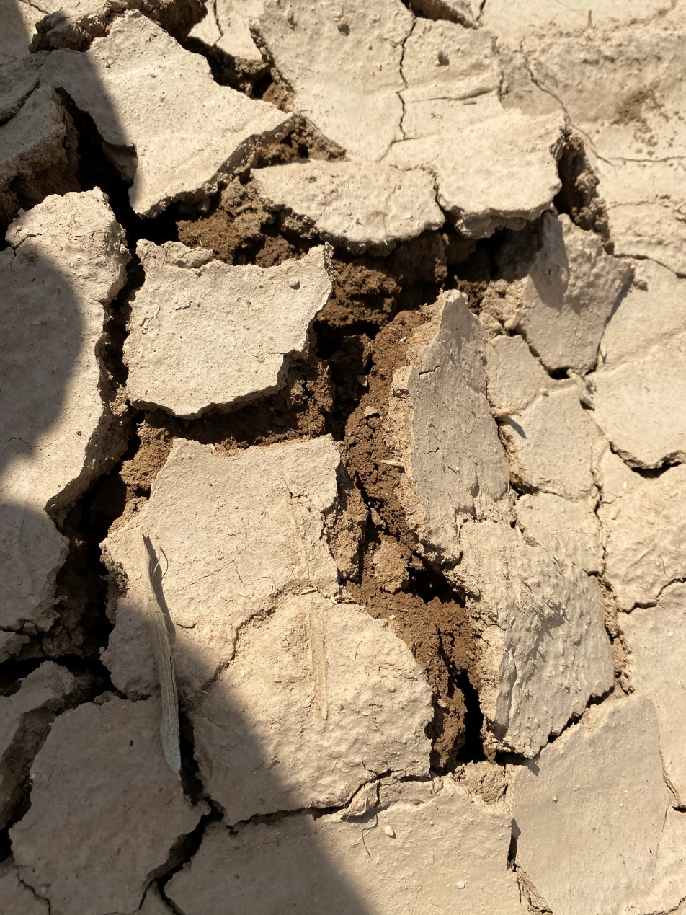
S1: A representative image of surface crusting in the study area

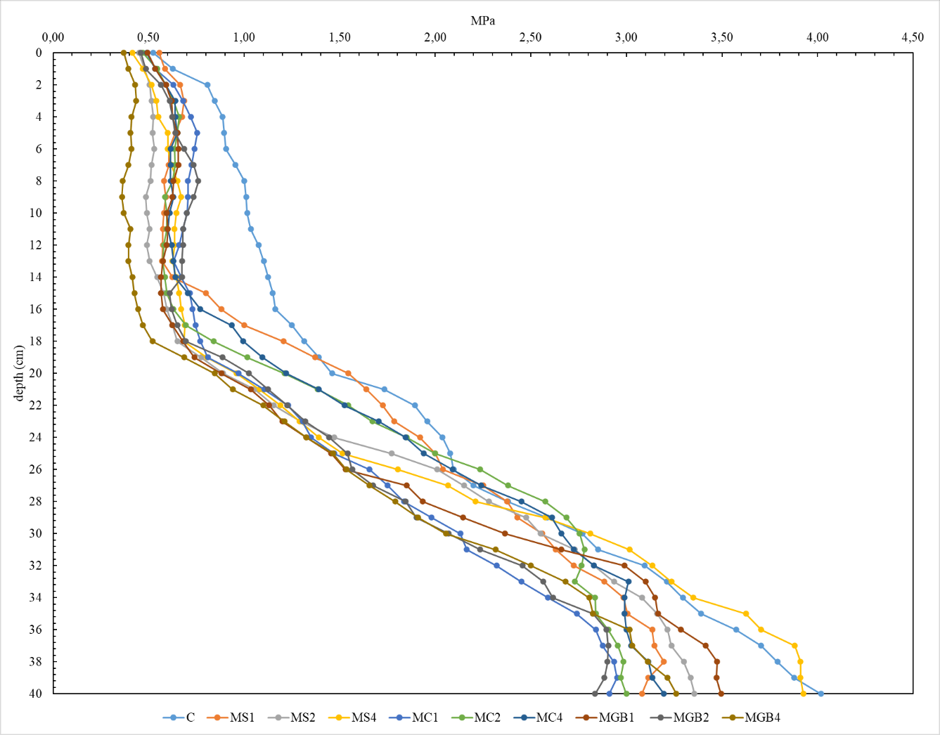
S2: Soil Penetration Resistance Profiles under Different Organic Amendment Treatments during the Incubation Period
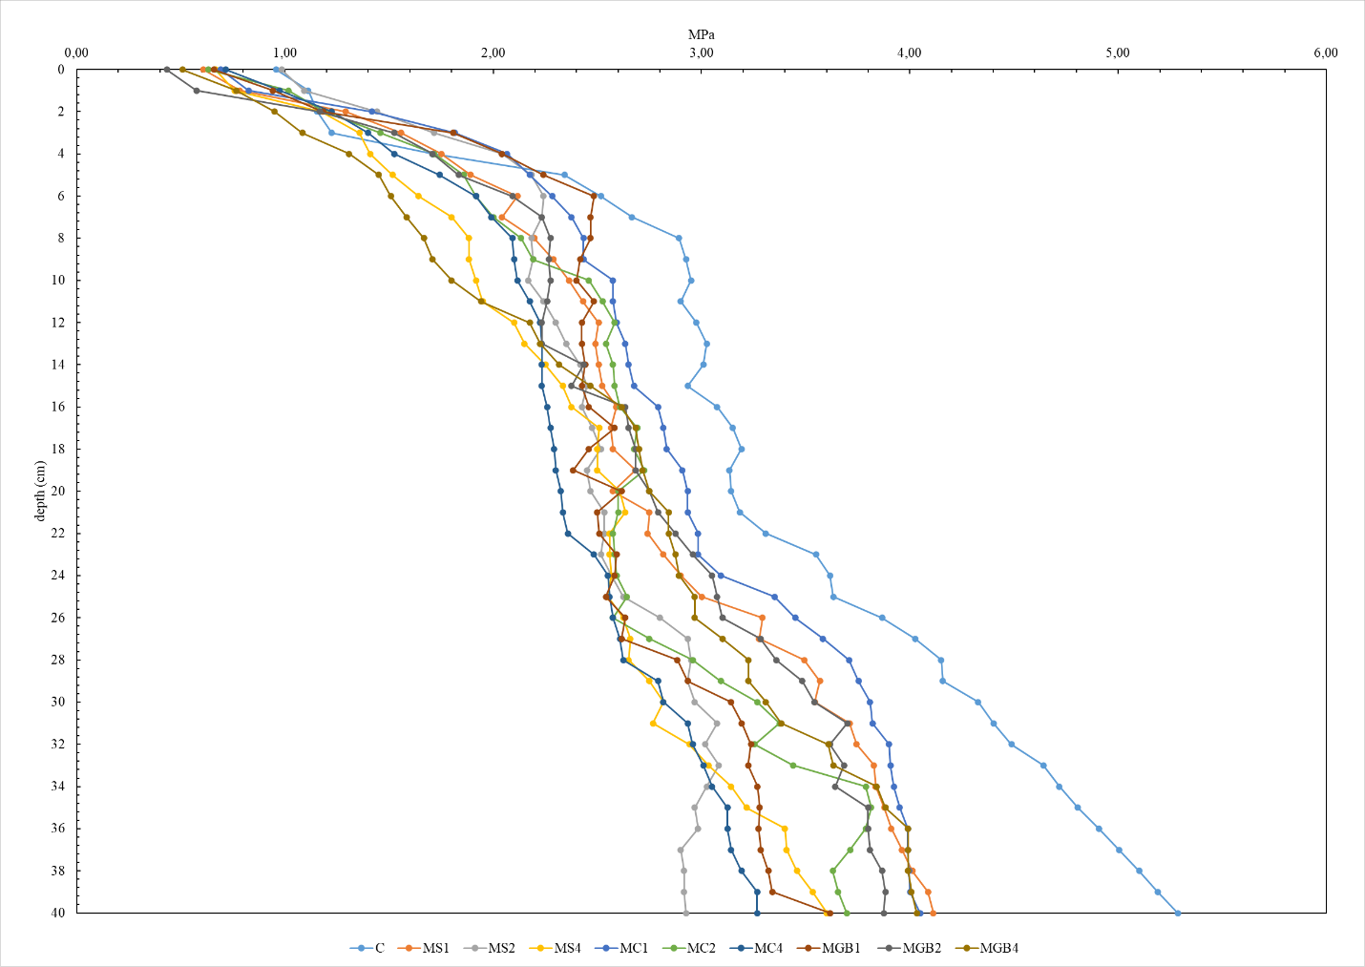
S3: Soil Penetration Resistance Profiles under Different Organic Amendment Treatments after Maize Cultivation
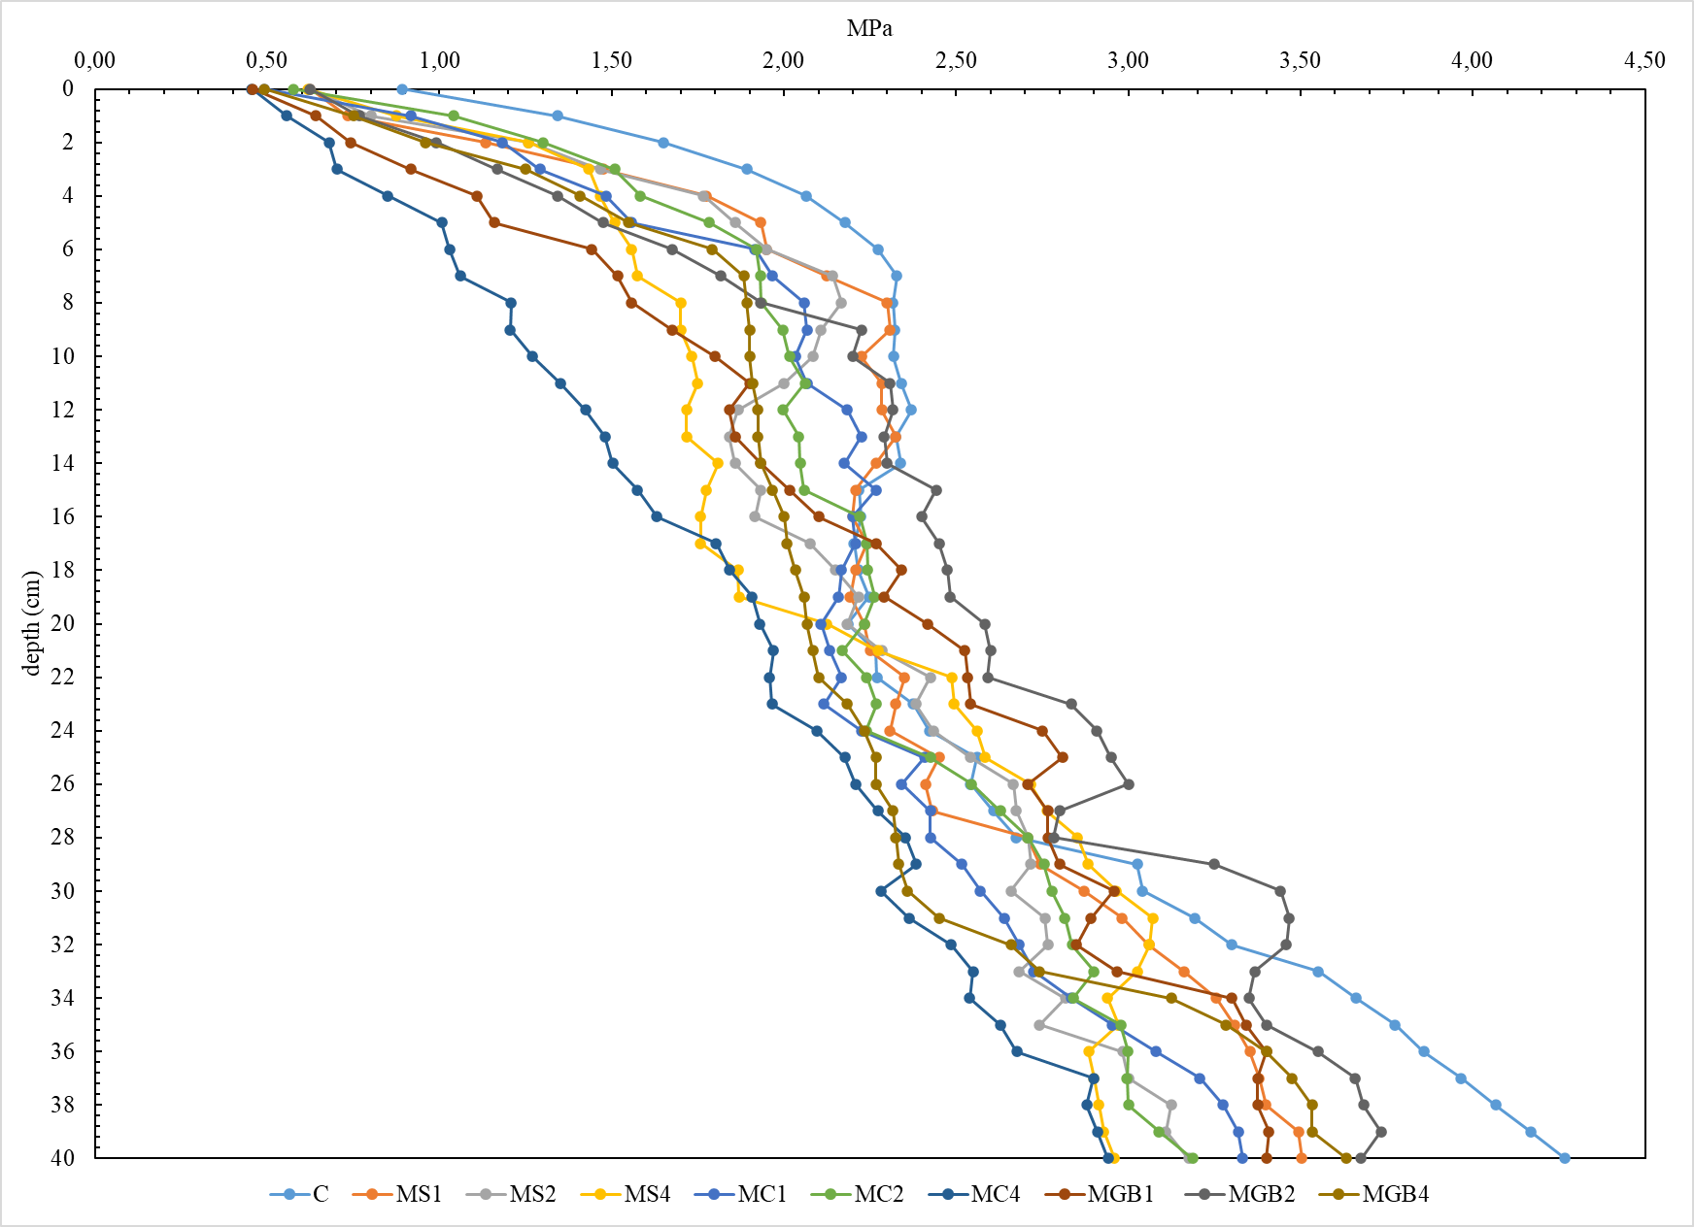
S4:Soil Penetration Resistance Profiles under Different Organic Amendment Treatments after Barley Cultivation

