Supplementary Information
Title: Cover crop root and shoot biomass as affected by species, mixtures, year and sowing date
Authors: Laura Reinelt¹, Henrike Heinemann¹, Nicole Christin Maack¹, Markus Molthan², Axel Don¹
Journal: Plant and Soil
¹Thünen Institute for Climate-Smart Agriculture, Bundesallee 65, 38116 Braunschweig, Germany.
²KWS SAAT SE & Co. KGaA, Grimsehlstraße 31, 37555 Einbeck, Germany.
Corresponding author: Laura Reinelt, laura.reinelt@posteo.de

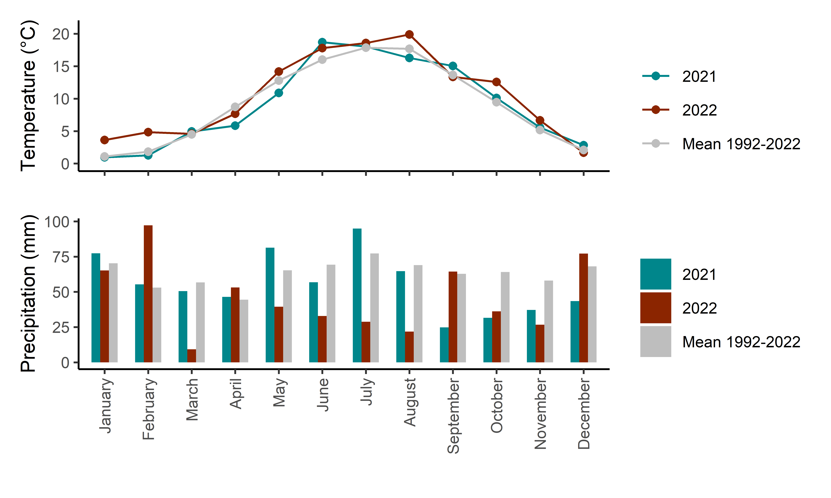
Figure S1 Mean monthly temperature and cumulative monthly precipitation at the study site in 2021, 2022 and the mean between 1992 and 2022.
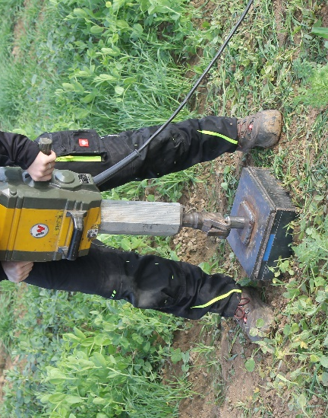 | 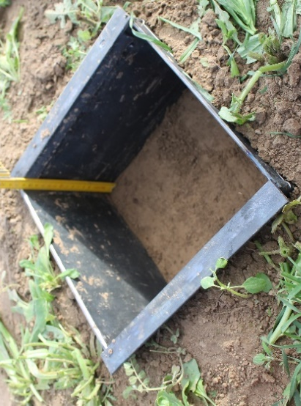
Figure S2: Sampling with cutting frame.
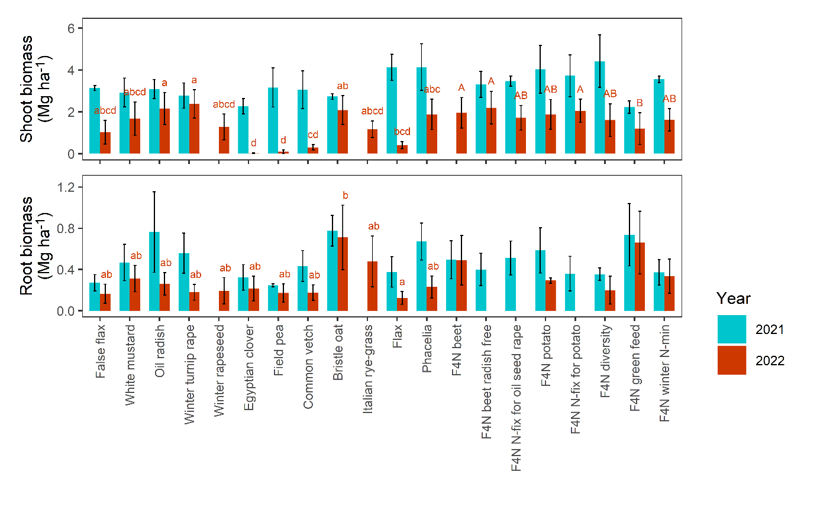
Figure S3 Root and shoot biomass means over three sowing dates with standard error for cover crop monocultures and mixtures sampled in 2021 and 2022. Effects of species or mixture on root and shoot biomass were assessed separately for the years and monocultures/mixtures. Different letters (blue for 2021 and red for 2022) indicate significant differences (p<0.05) between means assessed by Tukey post hoc testing. Bars without letters indicate no significant differences between species or mixtures in the same year.

Figure S4 Cover crop stubble biomass plotted against cut shoot biomass from all trial plots in 2022. The blue line represents a linear regression, the grey area the 95% confidence interval.
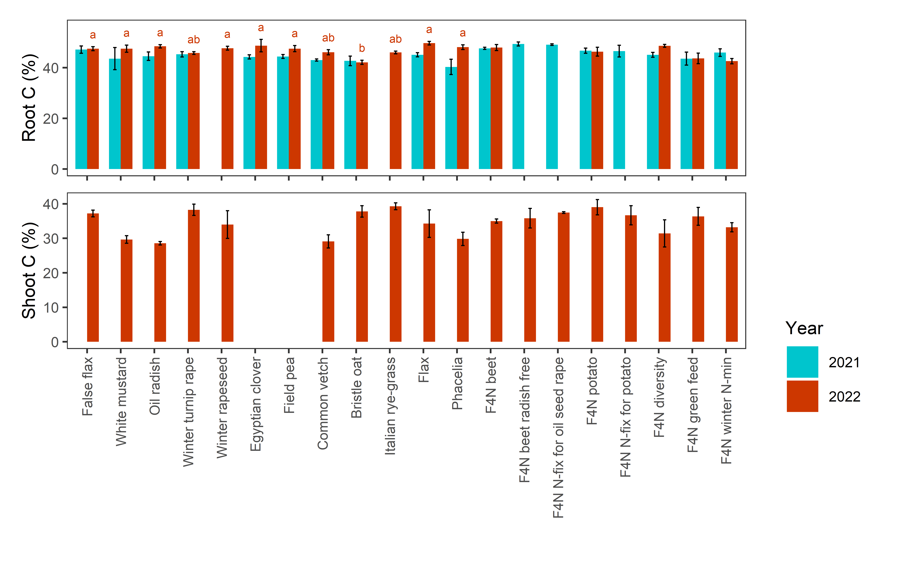
Figure S5 Root and shoot carbon (C) content means over three sowing dates with standard error for cover crop monocultures and mixtures sampled in 2021 and 2022. Different letters (blue for 2021 and red for 2022) indicate significant differences (p<0.05) between means assessed by Tukey post hoc testing. Bars without letters indicate no significant differences between species or mixtures in the same year.

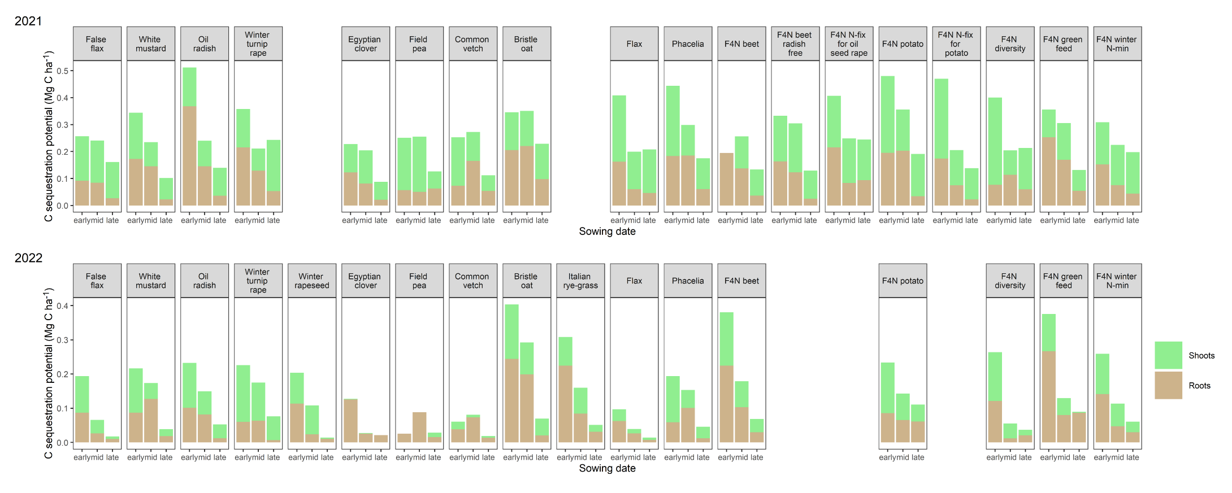
Figure S6 Contribution of roots and shoots to the carbon (C) sequestration potential of cover crop monocultures and mixtures on three sowing dates in 2021 and 2022.
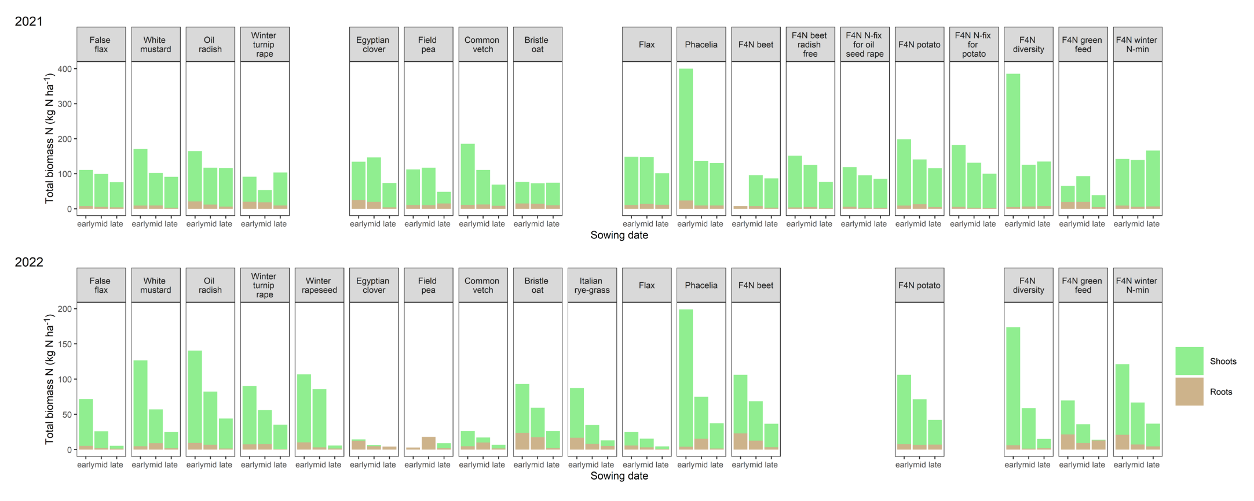
Figure S7 Contribution of roots and shoots to the total biomass nitrogen (N) content of cover crop monocultures and mixtures on three sowing dates in 2021 and 2022.

Table S1 Means of root biomass from monoculture soil cores from three sowing dates in 2021 and 2022 by depth increments. Effects of sowing date on root biomass of each depth increment were assessed only for 2021 with linear mixed models that included species and sowing date as fixed effects and plot as a random effect, separately for each year. Different letters after means indicate significant differences (p<0.05) between sowing dates assessed by Tukey post hoc testing. Percentages in brackets represent the percentage of the total biomass in the 0 - 100 cm depth increment found in each depth increment. 2022 only two species were sampled, so no statistical analyses were performed.
 |  | Root biomass (Mg ha⁻¹) in each depth increment
 | Depth increment | 0-15 cm | 15-30 cm | 30-50 cm | 50-70 cm | 70-100 cm | 0-30 cm | 30-100 cm | 0-100 cm
2021 | Mean early | 0.72 a (54.5%) | 0.16 a (22.2%) | 0.06 a (11.8%) | 0.04 a (6.7%) | 0.03 a (4.8%) | 0.88 a (76.7%) | 0.12 b (23.3%) | 1.04 b (100%)
 | Mean mid | 0.54 a (45.8%) | 0.36 b (28.8%) | 0.13 b (12.2%) | 0.07 b (7%) | 0.06 b (6.2%) | 0.90 a (74.6%) | 0.27 a (25.4%) | 1.17 a (100%)
 | Mean late | 0.24 b (51.4%) | 0.09 a (26%) | 0.04 a (12.2%) | 0.01 a (5.1%) | 0.01 a (5.4%) | 0.32 b (77.4%) | 0.07 c (22.6%) | 0.39 c (100%)
2022 | Mean early | 0.46 (40.1%) | 0.4 (40.9%) | 0.06 (6.2%) | 0.12 (10.2%) | 0.02 (2.5%) | 0.86 (81.1%) | 0.21 (18.9%) | 1.07 (100%)
 | Mean mid | 0.23 (40.7%) | 0.22 (41.3%) | 0.05 (8.2%) | 0.03 (5.8%) | 0.02  (4%) | 0.45 (82%) | 0.11 (18%) | 0.56 (100%)
 | Mean late | 0.15 (37.5%) | 0.22 (44.5%) | 0.05 (13.7%) | 0.01 (3.1%) | 0.00 (1.2%) | 0.37 (82%) | 0.07 (18%) | 0.44 (100%)

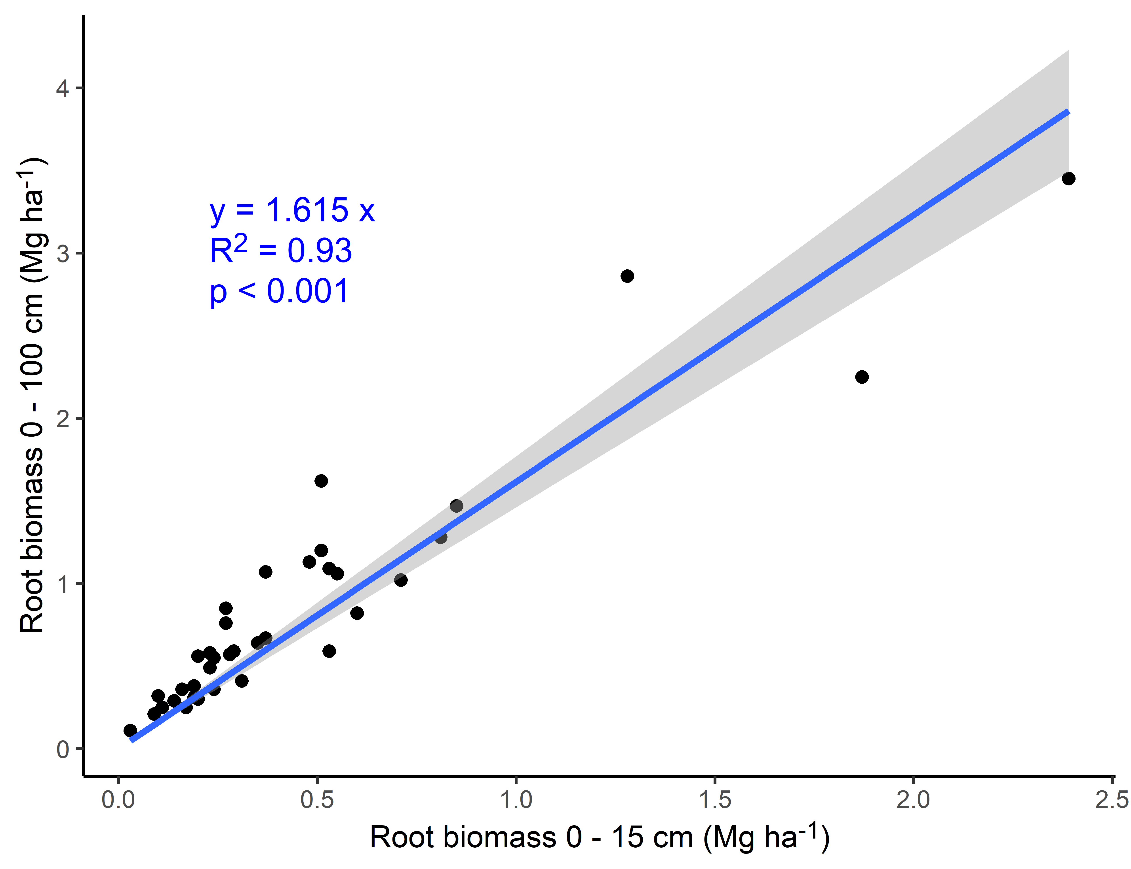
Figure S8 Root biomass in 0-100 cm depth from monocultures plotted against the root biomass in 0-15 cm depth. The blue line represents a linear regression through the origin, the grey area the 95% confidence interval.
Table S2 Means of root biomass measured in 0-15 cm depth using cores and frames on the early, mid and late sowing dates and averaged over all three sowing dates
 | Mean root biomass early sowing date  (Mg ha⁻¹) | Mean root biomass mid sowing date  (Mg ha⁻¹) | Mean root biomass late sowing date  (Mg ha⁻¹) | Mean root biomass over all sowing dates (Mg ha⁻¹)
Core | 0.68 | 0.49 | 0.22 | 0.46
Frame | 0.70 | 0.49 | 0.21 | 0.47

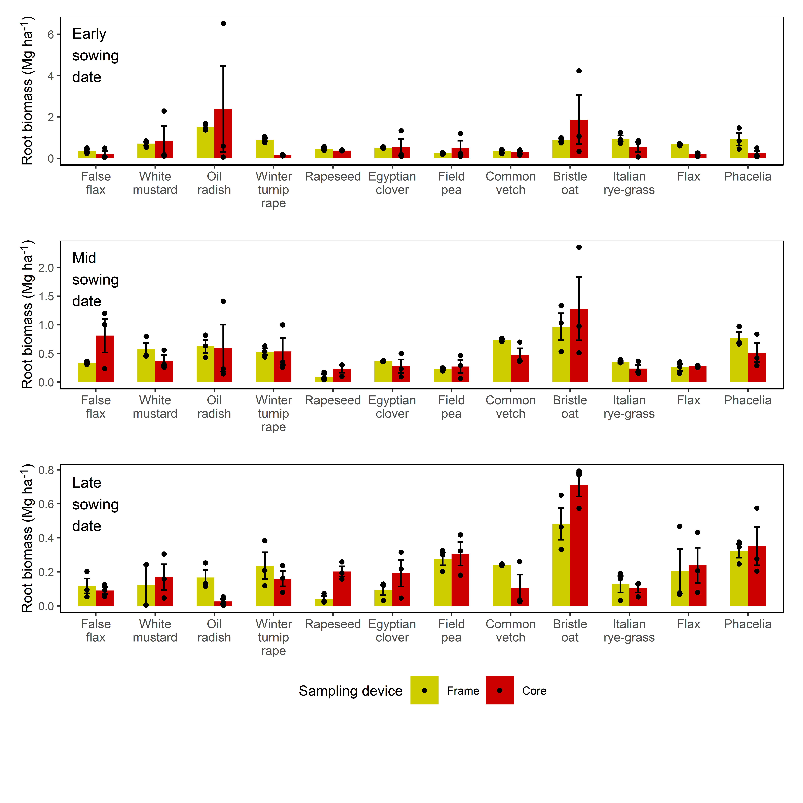
Figure S9 Mean and standard error of root biomass measured with frames and cores up to 15 cm soil depth in monocultures of different species on the three sowing dates. Winter rapeseed and Italian rye-grass were sampled in 2022. All other species were sampled in 2021.
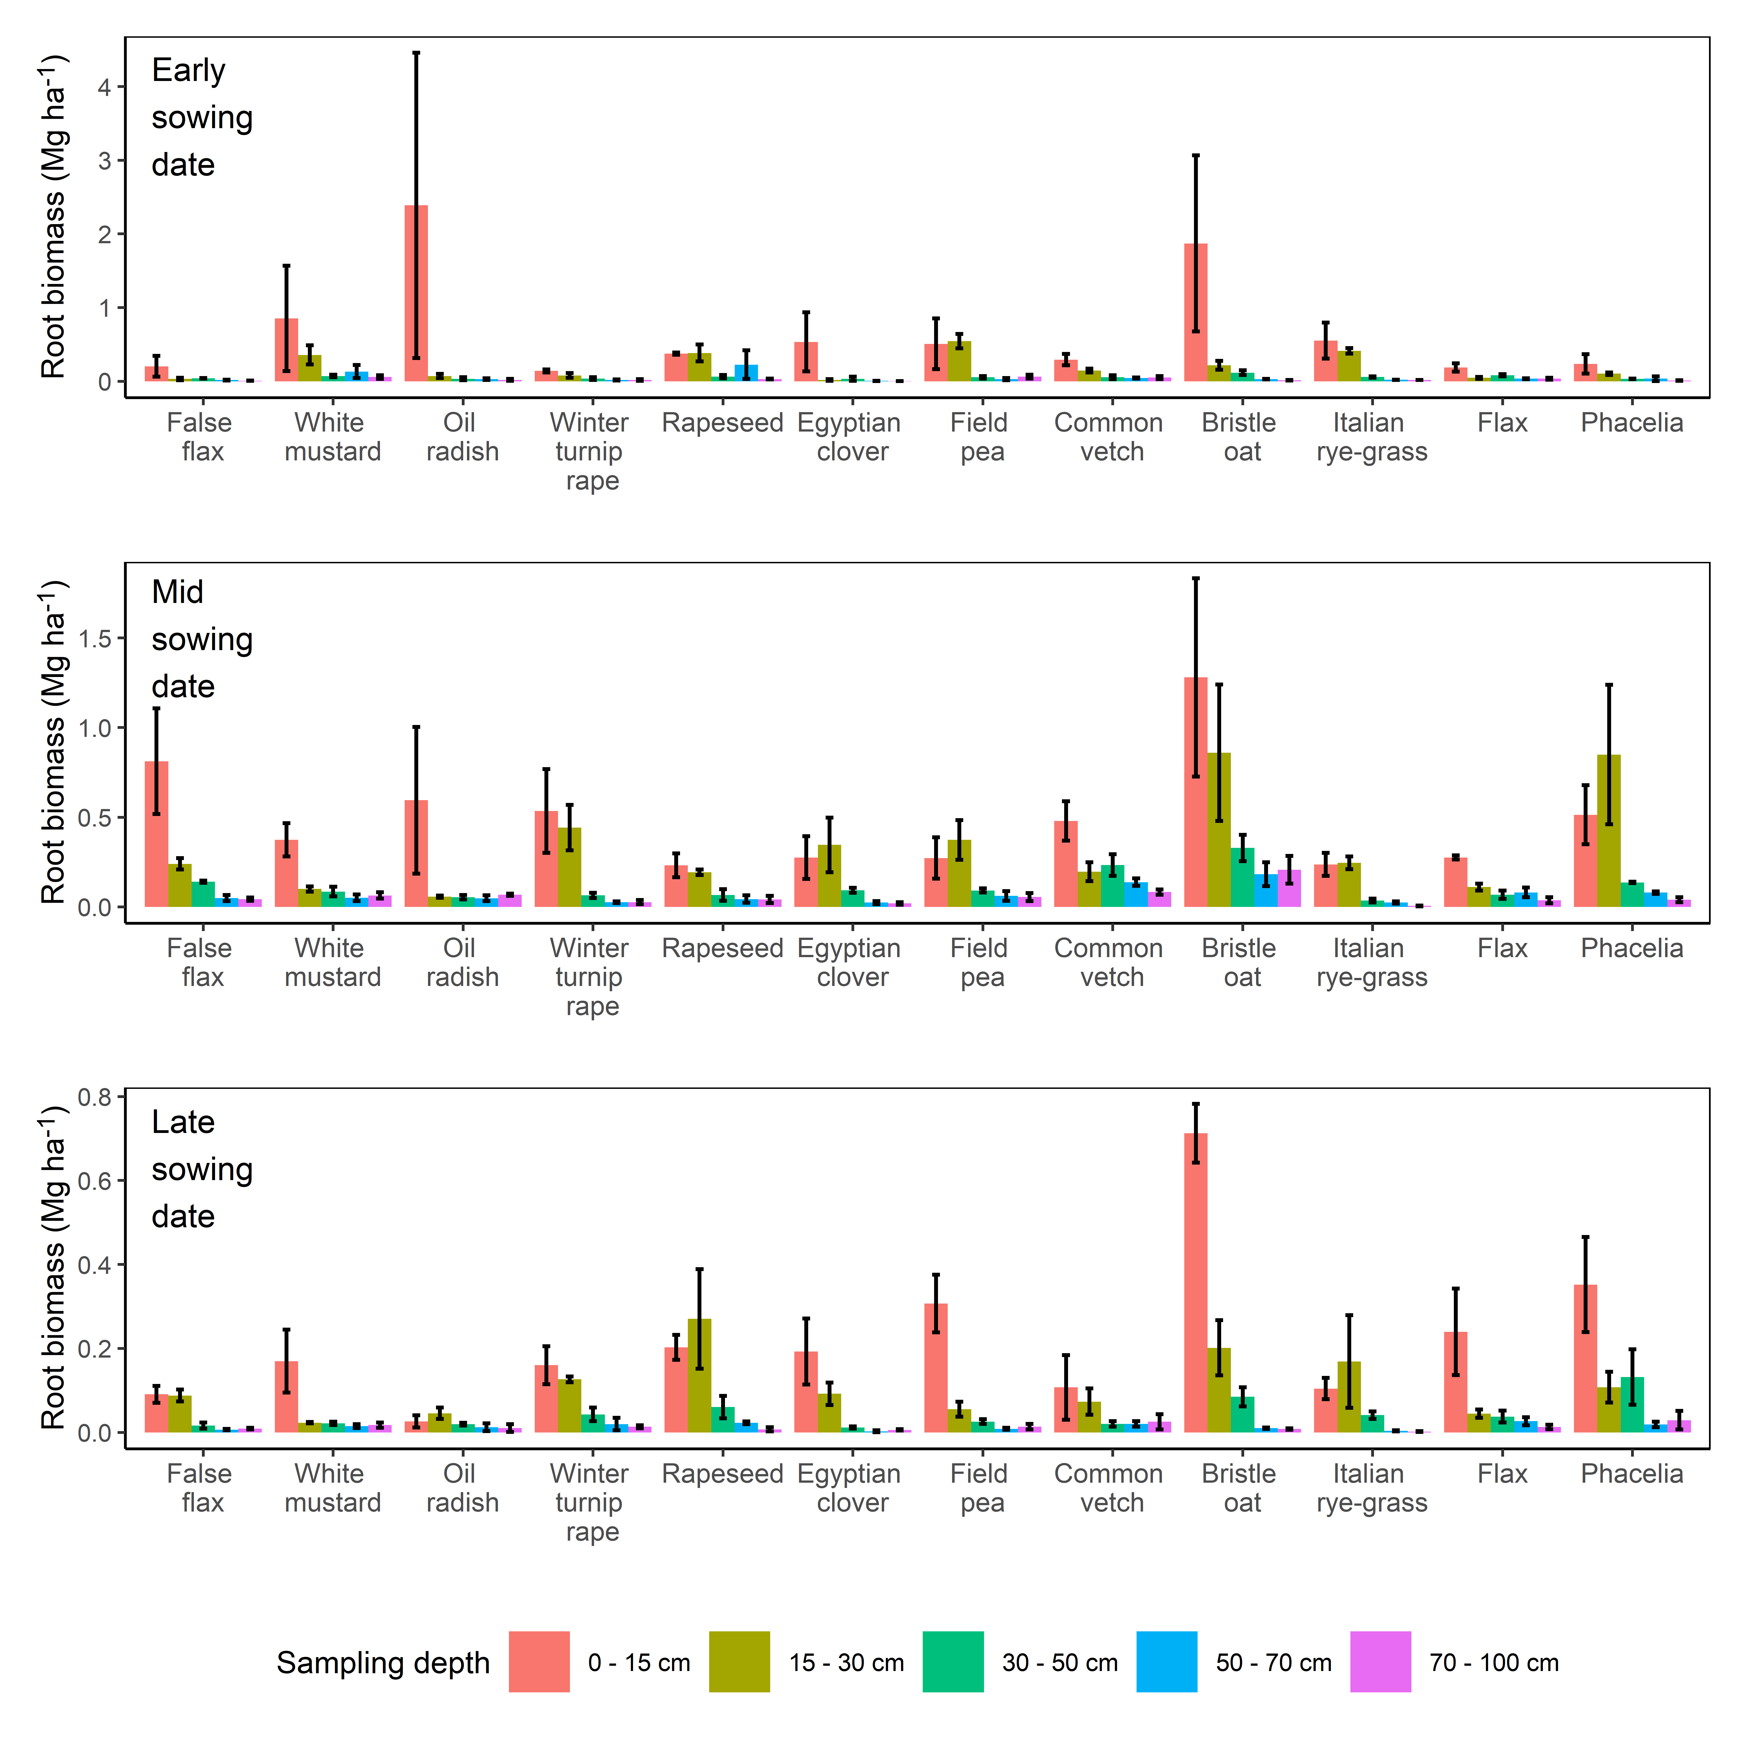
Figure S10 Mean and standard error of root biomass measured with cores by depth increment in monocultures of different species on the three sowing dates. Winter rapeseed and Italian rye-grass were sampled in 2022, all other species were sampled in 2021.

