Supplementary material
Hierarchical soil–plant buffering stabilizes nutrient dynamics in citrus under sustained irrigation with contrasting water chemistries
Alberto Imbernón-Mulero, Victoriano Martínez-Alvarez, Belén Gallego-Elvira, José A. Acosta, José F. Maestre-Valero*
Table S1 Fertilizers used during the study period
Commercial fertilizer | N–P–K + Ca + Mg richness | Complementary supply | Price (€ L⁻¹, € kg⁻¹)
Novatec fluid engorde | 7.5−1.1−5.6 | - | 0.27
Novatec fluid maduración | 4.6−1.0−5.7 | - | 0.38
Brotolim primavera + Ca + Mg | 10−0.9−4.2 + 2.5 + 0.9 | - | 0.45
Brotolim primavera MM + Ca + Mg | 10−0−4.2 + 2.1 + 0.9 | - | 0.55
Brotolim engorde + Ca | 8−0.9−5 + 1.8 | - | 0.56
Brotolim engorde MM + Ca + Mg | 8−0.9−4.2 + 1.8 + 0.9 | - | 0.65
Brotolim eco N-AA | 8.2−0−0 | 12% amino acids | 1.95
Brotolim PK | 0−6.1−5.8 | - | 0.62
Calcytron | 8−0−0 + 11.1 | - | 0.24
Vitaseve (Biostimulant with micronutrients) |  | Mg 3% + Mo 0.1% + B 0.2% + Mn 0.5% + Zn 0.5% | 9.00
Unicquel (Iron chelate) |  | Fe 6% | 6.90
Copper shuttle |  | Cu 6.13% | 8.50
Ourpizca | 0−0−0 + 4.3 |  | 0.40
SoluBlack H-87 | 1.2−0.4−6.6 + 2.6 + 0.1 | 70% humic acids + 15% fulvic acids | 7.00

Table S2 Chemical composition and macronutrient content of each irrigation water type: freshwater (FW); single-step reverse osmosis desalinated seawater (DSW–A); two-step reverse osmosis desalinated seawater (DSW–B); 50 FW:50 DSW–A blend water (BW–A); 60 FW:20 DSW–A :20 groundwater blend water (BW–B)
Water type | pH | CE (dS m⁻¹) | NO₃⁻ (mg L⁻¹) | PO₄³⁻ (mg L⁻¹) | K⁺ (mg L⁻¹) | Ca²⁺ (mg L⁻¹) | Mg²⁺ (mg L⁻¹)
2020
FW | 7.9 (7.5–8.2) | 1.1 (0.7–1.5) | 5.8 (0.5–8.8) | <LD–4.9* | 6.8 (4.2–9.9) | 68.5 (35.7–100.2) | 38.3 (20.2–60.6)
DSW–A | 8.1 (7.8–8.4) | 0.9 (0.8–1.2) | 1.2 (0.7–2.8) | <LD–1.9* | 7.6 (4.8–9.4) | 33.1 (21.2–48.6) | 11.3 (2.7–21.4)
DSW–B | 9.6 (8.4–10.4) | 0.1 (0.0–0.2) | <LD–1.5* | <LD–1.7* | 0.5 (0.3–1.0) | 2.4 (1.3–3.7) | 1.2 (0.8–1.7)
BW–A | 7.9 (7.6–8.1) | 1.0 (0.9–1.2) | 3.3 (0.6–5.9) | <LD–2.2* | 7.0 (5.3–9.5) | 50.6 (33.6–68.7) | 25.5 (11.5–53.8)
BW–B | 8.4 (7.8–9.7) | 1.1 (0.9–1.3) | 3.0 (0.7–5.8) | <LD–1.1* | 6.7 (5.7–7.7) | 42.4 (24.5–67.6) | 18.0 (7.3–38.6)
2021
FW | 7.6 (7.3–8.1) | 1.1 (0.7–1.3) | 2.5 (0.5–3.3) | <LD–3.9* | 5.5 (4.2–5.9) | 57.5 (35.7–74.5) | 33.0 (18.0–41.7)
DSW–A | 8.4 (7.8–9.1) | 0.8 (0.6–1.1) | <LD–2.3* | <LD–3.3* | 4.4 (3.4–5.1) | 21.7 (19.4–27.6) | 2.5 (1.5–5.0)
DSW–B | 10.1 (8.0–10.9) | 0.4 (0.0–1.3) | <LD–1.5* | <LD–1.3* | 1.9 (0.3–4.6) | 11.4 (1.3–58.4) | 1.4 (1.0–3.4)
BW–A | 7.9 (7.4–8.3) | 0.9 (0.5–1.1) | 1.2 (0.6–2.2) | <LD–2.1* | 4.8 (4.0–5.8) | 39.5 (36.9–109.0) | 19.0 (15.1–21.6)
BW–B | 8.3 (7.2–10.8) | 0.9 (0.1–1.1) | 1.2 (0.5–2.0) | <LD–3.4* | 4.4 (0.6–6.2) | 34.6 (1.6–51.3) | 19.1 (6.0–29.7)
2023
FW | 7.8 (7.5–8.1) | 1.2 (1.1–1.3) | 8.5 (6.0–10.9) | <LD–1.8* | 7.6 (3.0–16.4) | 65.3 (55.4–81.0) | 43.5 (36.9–50.4)
DSW–A | 8.5 (7.9–9.0) | 1.1 (0.8–1.2) | <LD–6.7* | <LD–2.9* | 10.8 (5.8–18.0) | 34.3 (16.6–61.8) | 12.2 (2.8–30.3)
DSW–B | 9.5 (9.0–9.8) | 0.2 (0.1–0.4) | <LD–1.5* | <LD–1.9* | 2.9 (0.5–6.2) | 3.9 (2.9–6.0) | 1.6 (1.1–2.2)
BW–A | 8.1 (7.6–8.6) | 1.1 (1.0–1.2) | 4.2 (1.6–10.6) | <LD–2.1* | 9.5 (8.4–17.6) | 52.9 (45.1–60.3) | 24.2 (21.2–28.3)
BW–B | 7.2 (7.0–7.4) | 2.3 (1.2–3.3) | 3.2 (1.1–5.3) | <LD–11. 2* | 14.6 (4.6–35.8) | 80.9 (3.7–140.8) | 62.6 (2.5–111.8)
 |  |  |  | 2024
FW | 7.7 (7.0–8.1) | 1.1 (1.0–1.2) | 2.2 (1.3–3.2) | <LD–3.1* | 15.9 (4.7–31.0) | 47.4 (36.8–59.8) | 33.5 (30.3–39.5)
DSW–A | 9.0 (8.3–9.5) | 0.9 (0.7–1.2) | <LD–3.0* | <LD–1.4* | 6.9 (4.0–9.8) | 17.0 (12.1–24.8) | 3.4 (1.4–9.2)
DSW–B | 9.3 (8.3–10.6) | 0.3 (0.1–0.6) | <LD–1.4* | <LD–1.3* | 2.8 (1.5–4.6) | 7.3 (2.7–12.4) | 1.2 (0.0–1.8)
BW–A | 8.3 (7.5–8.8) | 1.0 (1.0–1.1) | 1.4 (1.3–3.6) | <LD–1.6* | 12.2 (4.5–26.7) | 30.6 (25.1–53.0) | 19.9 (17.6–25.5)
BW–B | 7.3 (6.9–7.6) | 3.3 (2.0–4.5) | 2.5 (0.3–4.8) | <LD–7.1* | 14.8 (9.9–19.3) | 119.5 (62.3–185.4) | 96.4 (62.0–152.4)
**Values are presented as mean (minimum–maximum).
*Values are presented as mean (minimum–maximum). LD indicates the analytical limit of detection. For variables reported as <LD–X, concentrations were below the detection limit in part of the samples; in these cases, the reported range corresponds to the interval between LD and the maximum observed value, and midpoint values (X/2) were used when required for comparative calculations.
Table S3 Chemical composition of main micronutrient and potential phytotoxic content of each irrigation water type: freshwater (FW); single-step reverse osmosis desalinated seawater (DSW–A); two-step reverse osmosis desalinated seawater (DSW–B); 50 FW:50 DSW–A blend water (BW–A); 60 FW:20 DSW–A :20 groundwater blend water (BW–B)
Water type | SO₄²⁻ (mg L⁻¹) | Fe (µg L⁻¹) | Cu (µg L⁻¹) | Mn (µg L⁻¹) | B (µg L⁻¹) | Na⁺ (mg L⁻¹) | Cl⁻ (mg L⁻¹)
2020
FW | 195.5 (100.0–302.4) | 0.3 (0.0–0.8) | 1.1 (0.4–2.6) | 0.7 (0.1–1.3) | 437.0 (305.0–629.0) | 125.4 (86.8–158.5) | 201.1 (188.8-351.2)
DSW–A | 41.1 (2.7–108.2) | 12.5 (0.0–31.3) | 0.6 (0.0–1.4) | 1.1 (0.0–2.7) | 1017.0 (528.0–1254.0) | 168.5 (105.7–207.8) | 281.9 (149.5-247.9)
DSW–B | 1.9 (0.3–3.6) | 2.4 (0.0–3.7) | 0.1 (0.0–0.4) | 0.1 (0.0–0.3) | 256.0 (67.0–611.0) | 5.9 (4.1–8.9) | 3.7 (1.3-8.9)
BW–A | 131.1 (39.7–262.0) | 6.3 (0.0–11.0) | 1.1 (0.0–2.3) | 0.8 (0.0–1.6) | 738.0 (531.0–978.0) | 143.6 (109.3–174.9) | 241.4 (190.1-322.6)
BW–B | 81.5 (16.8–214.8) | 8.2 (0.0–37.6) | 1.4 (0.4–2.4) | 0.6 (0.0–1.7) | 917.0 (601.0–1123.0) | 167.8 (124.0–192.4) | 282.5 (218.3-315.9)
2021
FW | 175.7 (92.5–221.8) | 0.0 (0.0–0.0) | 0.7 (0.0–2.5) | 1.0 (0.0–3.2) | 537.0 (0.0–892.0) | 117.5 (86.8–132.2) | 185.7 (144.7-219.5)
DSW–A | 39.5 (12.8–64.6) | 2.0 (0.0–4.1) | 2.8 (0.0–7.0) | 2.3 (0.0–6.7) | 1069.0 (1.0–1396.0) | 153.1 (86.3–220.4) | 195.5 (149.5-244.8)
DSW–B | 2.5 (0.3–11.7) | 1.2 (0.0–3.6) | 0.5 (0.0–1.5) | 0.1 (0.0–0.3) | 174.0 (0.0–614.0) | 43.6 (5.8–60.3) | 56.3 (1.97-72.13)
BW–A | 108.8 (22.6–108.9) | 1.4 (0.0–3.1) | 1.5 (0.0–3.5) | 1.7 (0.0–3.1) | 858.0 (1.0–1358.0) | 137.1 (89.3–155.5) | 188.2 (145.4-234.4)
BW–B | 103.1 (29.2–153.5) | 1.7 (0.0–4.5) | 2.3 (0.0–4.6) | 0.2 (0.0–0.6) | 755.0 (1.0–1104.0) | 99.2 (13.9–140.0) | 165.3 (123.2-253.9)
2023
FW | 189.0 (149.9–254.1) | 0.0 (0.0–0.0) | 1.1 (0.0–3.1) | 1.9 (0.7–3.8) | 555.0 (450.0–605.0) | 120.6 (110.9–156.7) | 170.2 (117.4-303.4)
DSW–A | 54.7 (3.9–157.9) | 6.7 (0.0–19.7) | 0.7 (0.0–1.2) | 0.1 (0.0–0.2) | 1102.0 (780.0–1345.0) | 142.2 (101.6–191.2) | 190.5 (164.4-222.8)
DSW–B | 3.0 (1.0–4.9) | 0.0 (0.0–0.0) | 0.2 (0.0–0.8) | 0.0 (0.0–0.0) | 284.0 (30.0–514.0) | 23.1 (8.5–43.8) | 14.15 (2.72-20.87)
BW–A | 92.6 (63.7–141.0) | 3.8 (0.0–7.8) | 0.9 (0.0–2.6) | 1.3 (0.0–3.7) | 743.0 (600.0–836.0) | 133.6 (103.3–163.6) | 184.8 (133.6-213.8)
BW–B | 334.0 (9.2–654.2) | 6.8 (0.0–17.8) | 2.9 (0.0–9.9) | 1.4 (0.0–5.1) | 654.0 (480.0–841.0) | 209.8 (16.5–426.2) | 287.2 (37.41-590.8)
 |  |  |  | 2024
FW | 154.7 (110.3–200.4) | 0.3 (0.0–1.3) | 2.6 (0.2–6.2) | 2.4 (0.0–6.3) | 570.0 (470.0–780.0) | 120.9 (108.6–162.6) | 214.9 (169.5-335.5)
DSW–A | 4.9 (1.8–7.7) | 0.6 (0.0–1.9) | 0.4 (0.0–1.4) | 0.5 (0.0–1.4) | 1339.0 (1190.0–1620.0) | 148.4 (110.1–179.8) | 194.0 (150.6-256.0)
DSW–B | 2.4 (0.8–4.8) | 0.3 (0.0–2.9) | 0.2 (0.0–1.8) | 0.2 (0.0–1.3) | 600.0 (260.0–1230.0) | 40.1 (24.8–62.6) | 58.3 (37.7-96.8)
BW–A | 76.3 (62.7–88.0) | 0.4 (0.0–6.4) | 1.4 (0.6–4.5) | 1.3 (0.0–4.6) | 926.0 (820.0–1200.0) | 131.9 (118.6–160.2) | 207.5 (187.3-253.6)
BW–B | 550.4 (215.6–899.7) | 3.3 (0.0–13.7) | 7.5 (0.2–35.9) | 0.8 (0.0–2.6) | 1022.0 (730.0–1270.0) | 413.4 (232.7–589.1) | 562.4 (300.2-829.1)
*Values are presented as mean (minimum–maximum).

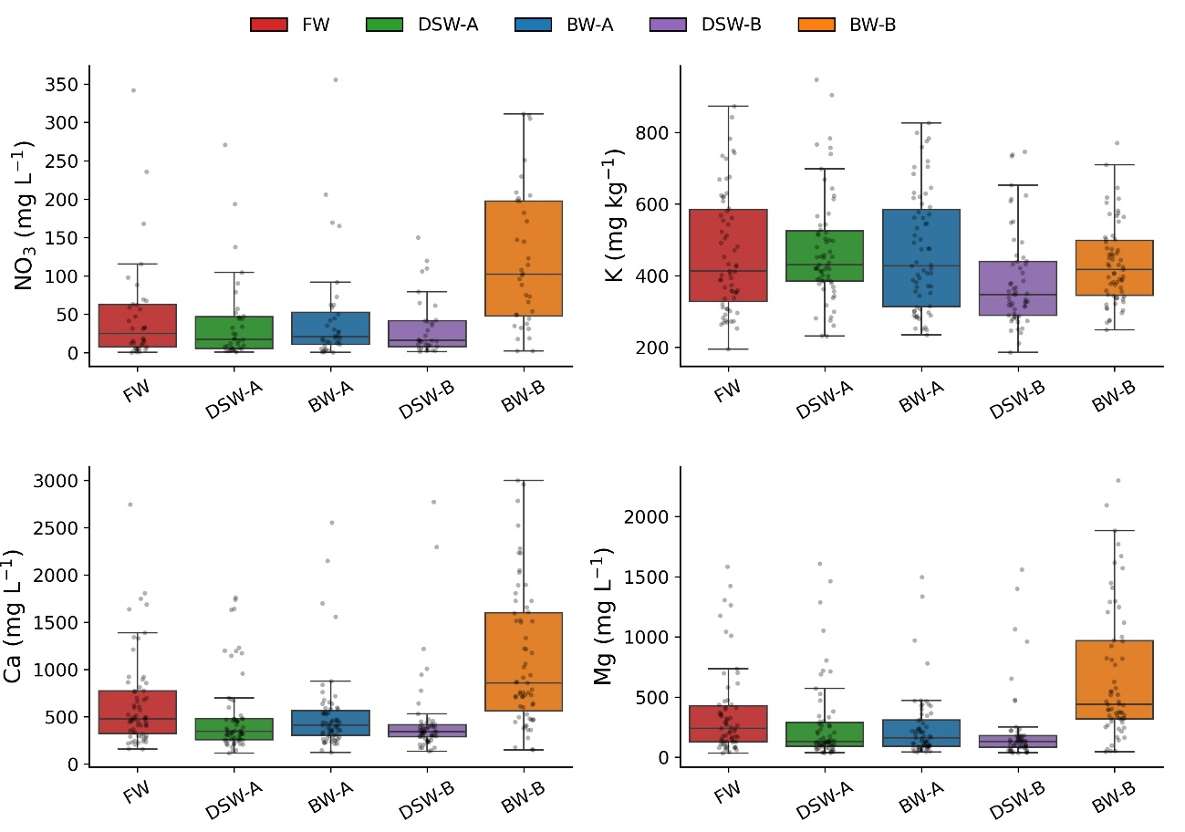
Fig. S1 Concentration of a) soil nitrate (NO₃⁻), b) available potassium (K), c) calcium (Ca), and d) magnesium (Mg) at 25–50 cm depth under different irrigation water types: freshwater (FW); single-step reverse osmosis desalinated seawater (DSW–A); two-step reverse osmosis desalinated seawater (DSW–B); 50 FW:50 DSW–A blend water (BW–A); 60 FW:20 DSW–A :20 groundwater blend water (BW–B). Boxplots represent median and interquartile range, with whiskers indicating 1.5× IQR; points correspond to individual observations across years (2019–2025)
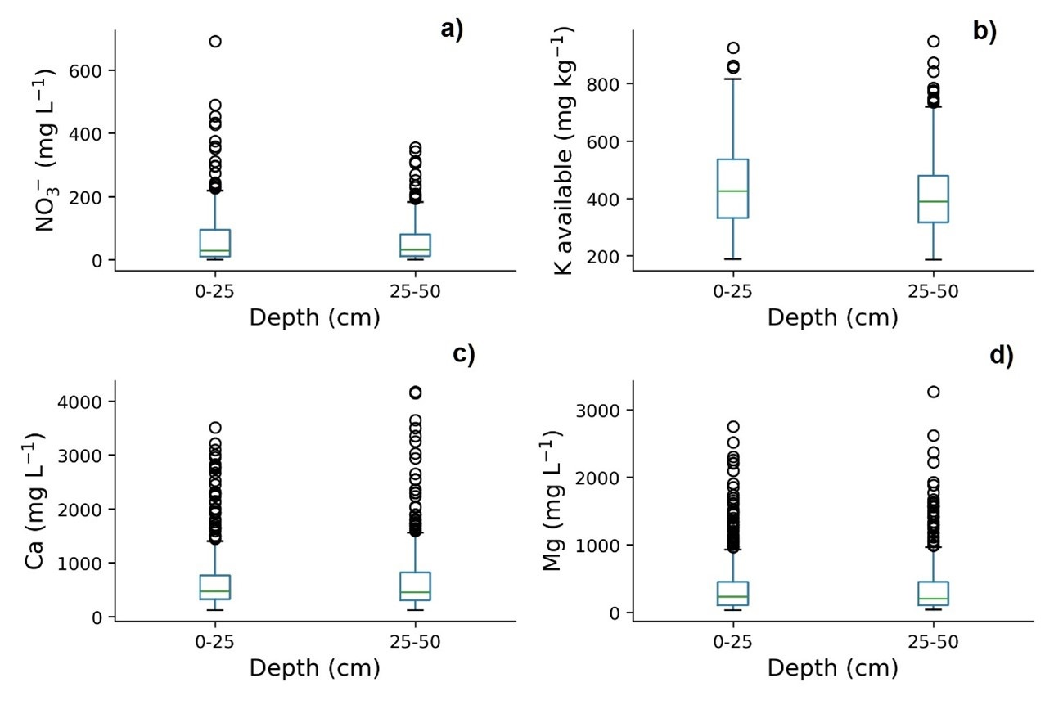
Fig. S2 Boxplots of a) soil nitrate (NO₃⁻), b) available potassium (K), c) calcium (Ca), and d) magnesium (Mg) concentrations at two soil depths (0–25 and 25–50 cm), integrating all irrigation water types and sampling dates from 2019 to 2025
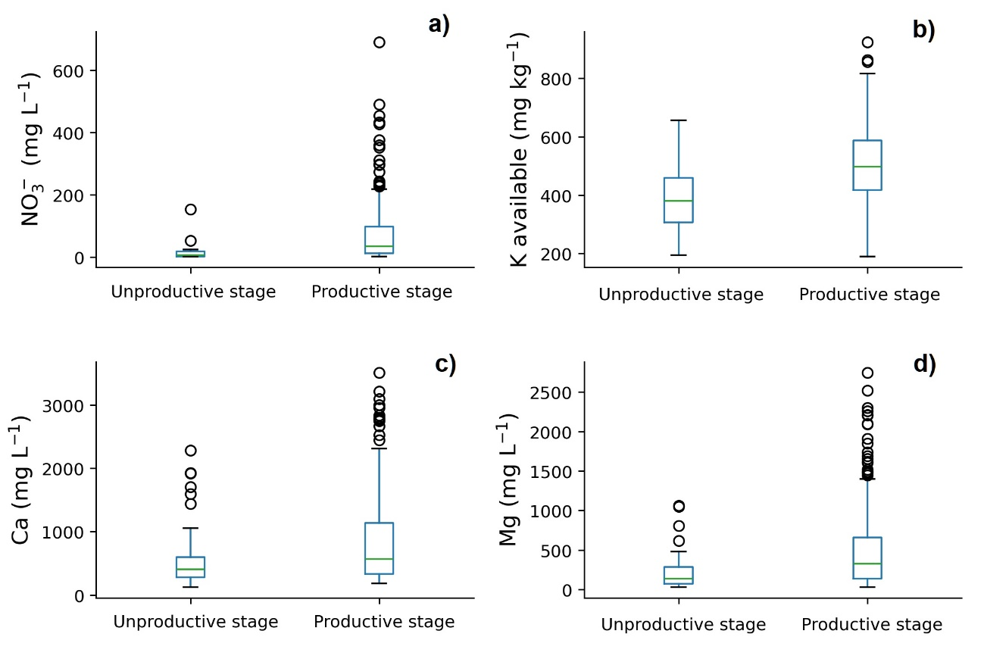
Fig. S3 Boxplots of a) soil nitrate (NO₃⁻), b) available potassium (K), c) calcium (Ca), and d) magnesium (Mg) concentrations in the topsoil (0–25 cm) comparing unproductive (2019–2021) and productive (2022–2025) stages of the crop
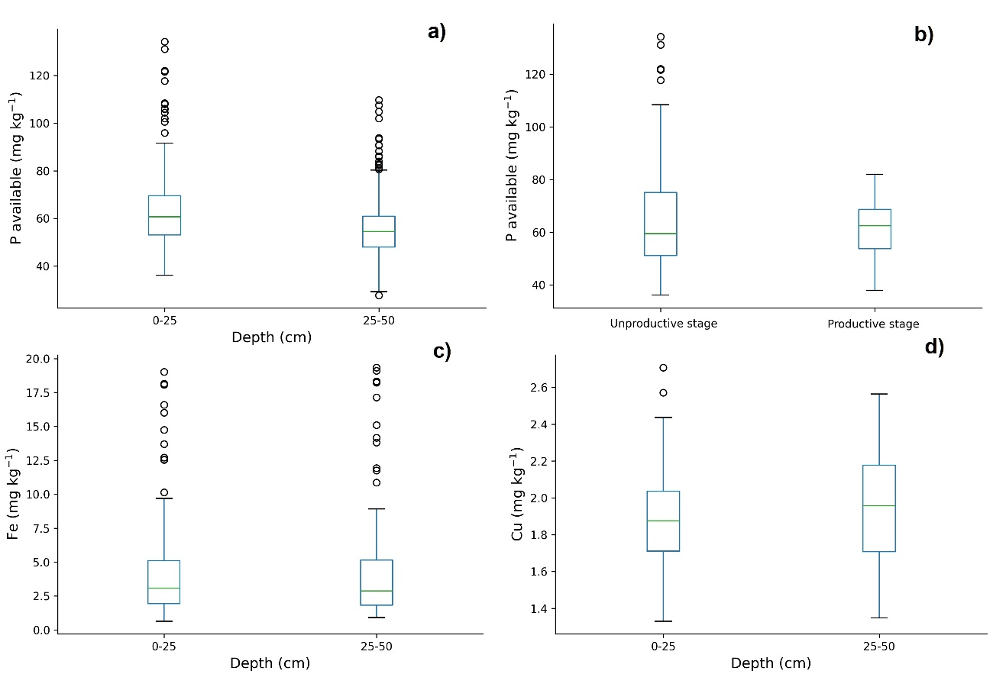
Fig. S4 Boxplots of a) available phosphorus (P), b) iron (Fe), and c) copper (Cu) concentrations at two soil depths (0–25 and 25–50 cm), integrating all irrigation water types and sampling dates from 2019 to 2025, and d) available phosphorus (P) concentrations in the topsoil (0–25 cm) comparing unproductive (2019–2021) and productive (2022–2025) stages of the crop

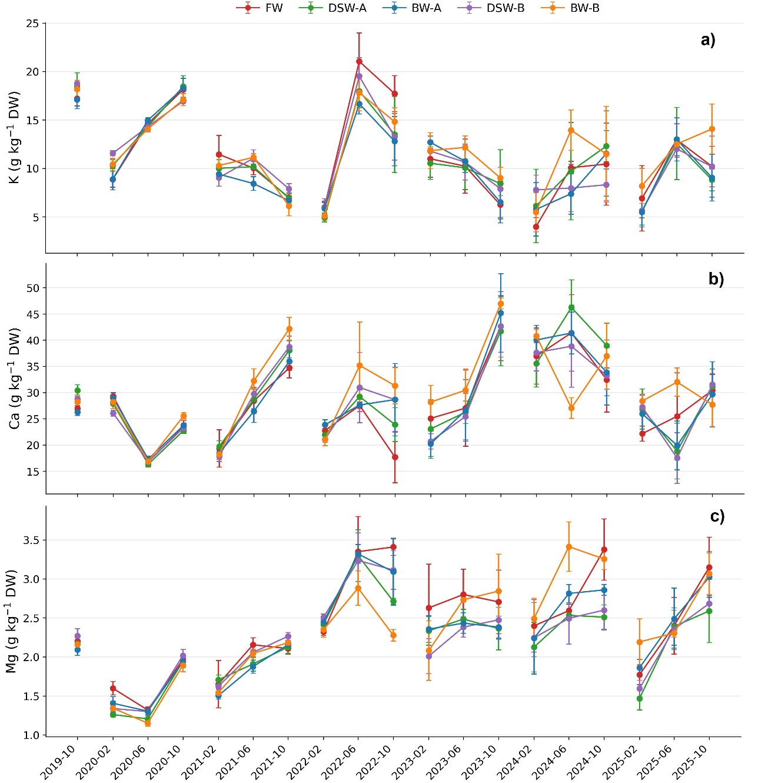
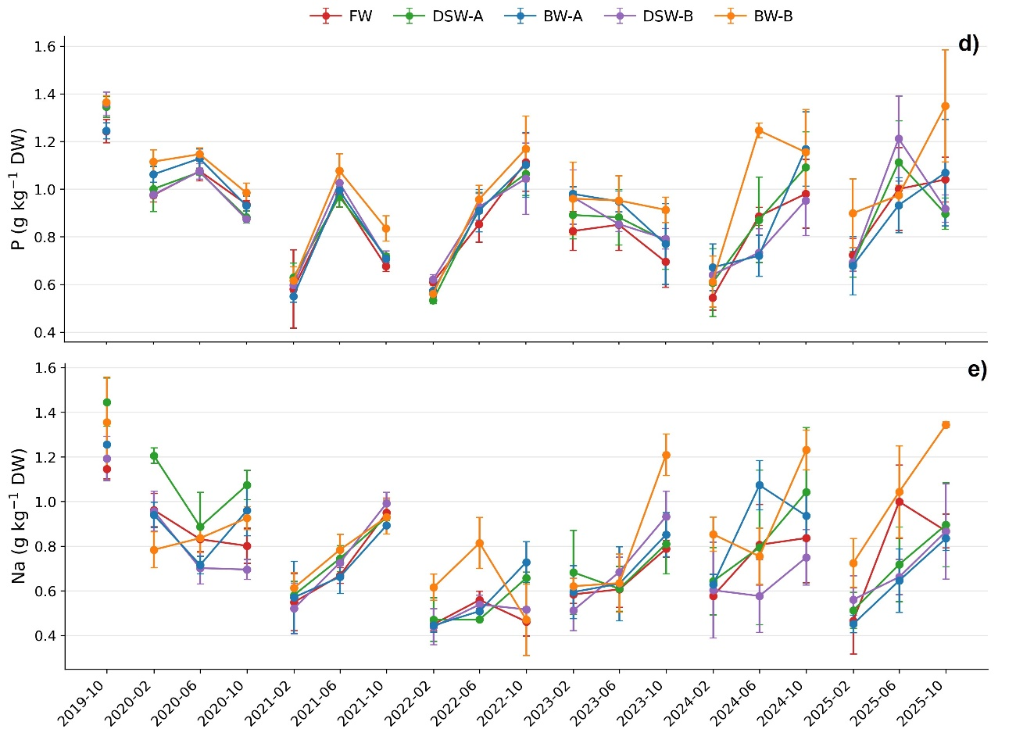
Fig. S5 Temporal evolution of a) potassium (K), b) calcium (Ca), c) magnesium (Mg), d) phosphorus (P), and e) sodium (Na) accumulation (g kg⁻¹) in young leaves of grapefruit trees under different irrigation water types from 2019 to 2025: freshwater (FW); single-step reverse osmosis desalinated seawater (DSW–A); two-step reverse osmosis desalinated seawater (DSW–B); 50 FW:50 DSW–A blend water (BW–A); 60 FW:20 DSW–A :20 groundwater blend water (BW–B). Values are means ± SD
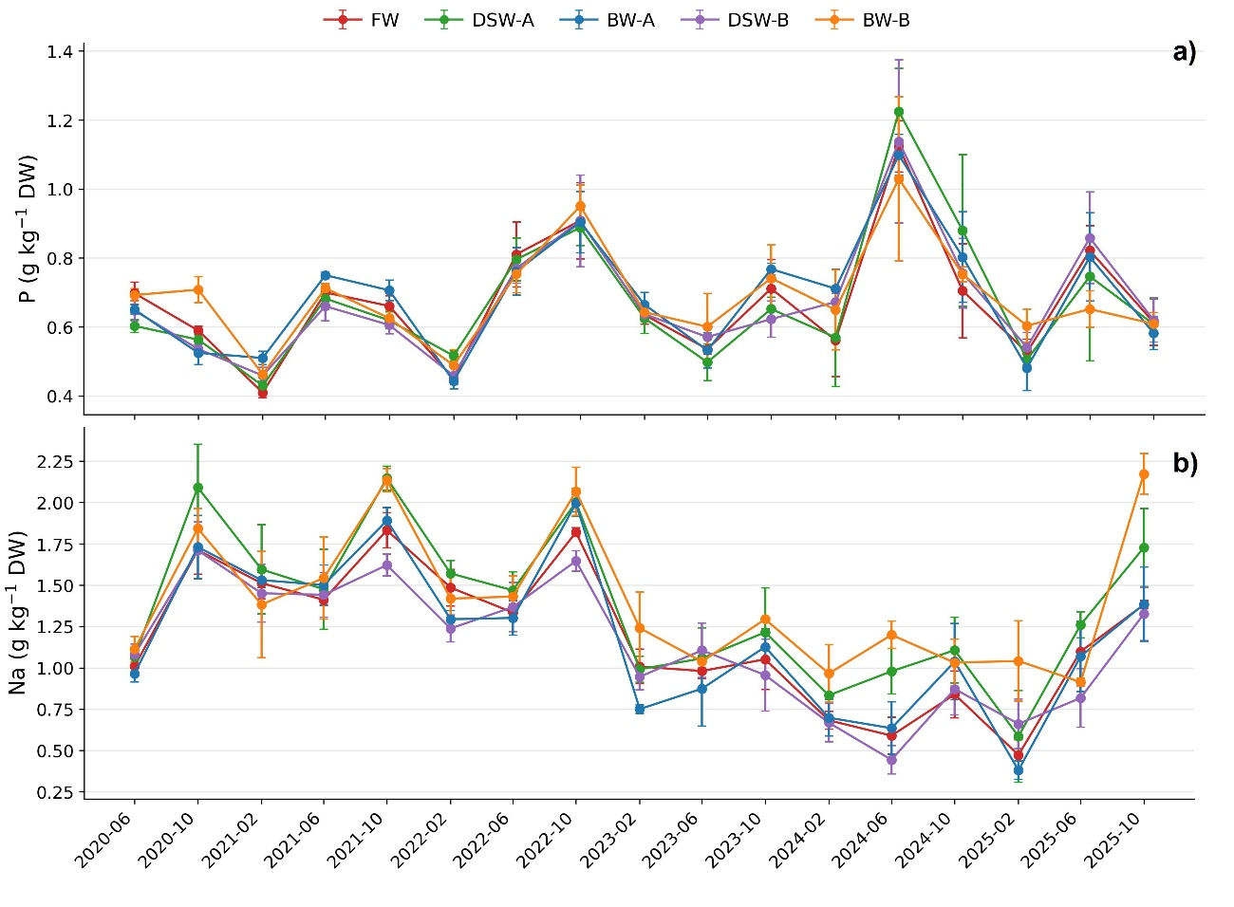
Fig. S6 Temporal evolution of a) potassium phosphorus (P), and b) sodium (Na) accumulation (g kg⁻¹) in mature leaves of grapefruit trees under different irrigation water types from 2020 to 2025: freshwater (FW); single-step reverse osmosis desalinated seawater (DSW–A); two-step reverse osmosis desalinated seawater (DSW–B); 50 FW:50 DSW–A blend water (BW–A); 60 FW:20 DSW–A :20 groundwater blend water (BW–B). Values are means ± SD
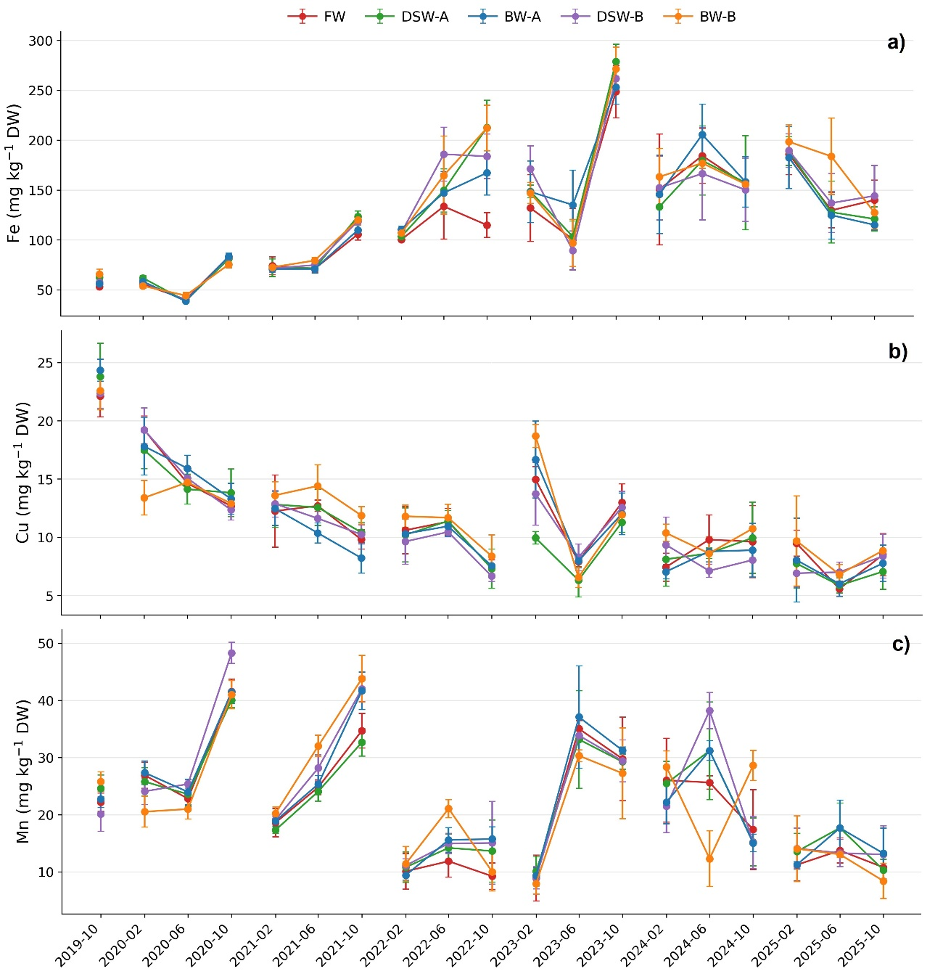
Fig. S7 Temporal evolution of a) iron (Fe), b) copper (Cu), and c) manganese (Mg) accumulation (mg kg⁻¹) in young leaves of grapefruit trees under different irrigation water types from 2019 to 2025: freshwater (FW); single-step reverse osmosis desalinated seawater (DSW–A); two-step reverse osmosis desalinated seawater (DSW–B); 50 FW:50 DSW–A blend water (BW–A); 60 FW:20 DSW–A :20 groundwater blend water (BW–B). Values are means ± SD
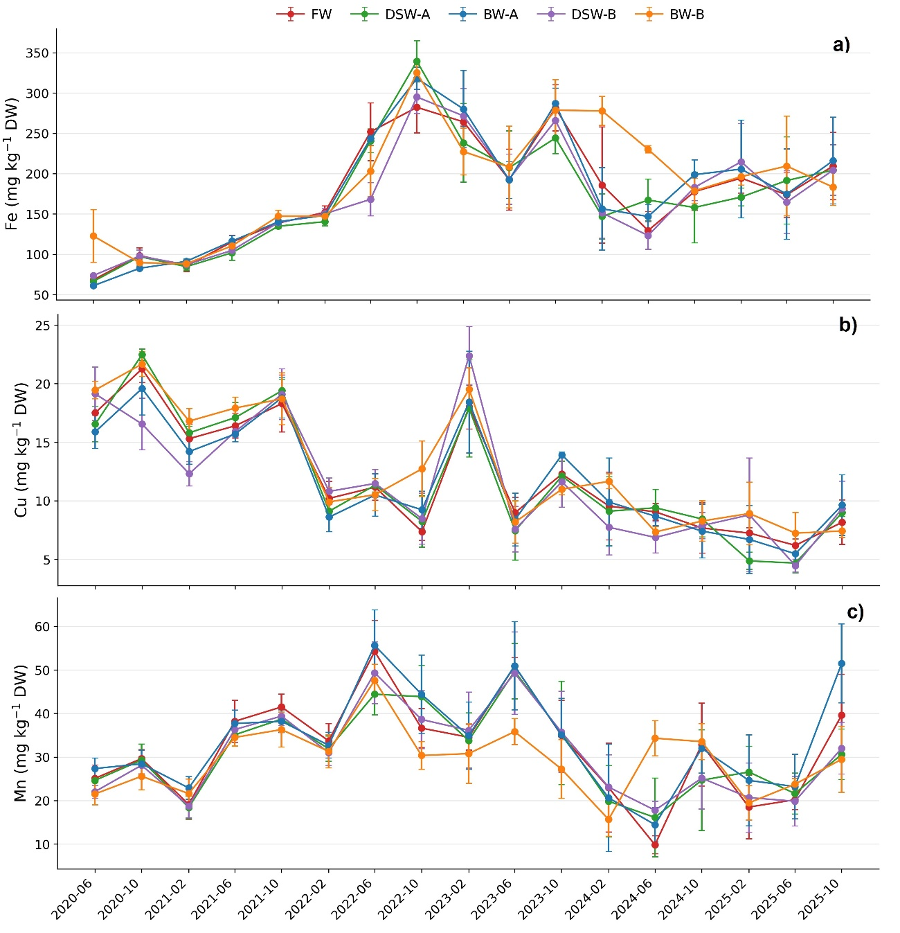
Fig. S8. Temporal evolution of a) iron (Fe), b) copper (Cu), and c) manganese (Mg) accumulation (mg kg⁻¹) in mature leaves of grapefruit trees under different irrigation water types from 2020 to 2025: freshwater (FW); single-step reverse osmosis desalinated seawater (DSW–A); two-step reverse osmosis desalinated seawater (DSW–B); 50 FW:50 DSW–A blend water (BW–A); 60 FW:20 DSW–A :20 groundwater blend water (BW–B). Values are means ± SD

Table S4 Summary of linear mixed-effects model results evaluating the effects of irrigation water type, sampling date, and their interaction on leaf nutrient concentrations
Nutrient | Irrigation type | Date | Irrigation type × Date
K | ns | *** | *
Ca | * | *** | **
Mg | ns | *** | *
P | ns | *** | ns
Na | ns | *** | *
Fe | ns | *** | ns
Cu | ns | *** | ns
Mn | ns | *** | *
*Significance levels: ns (p > 0.05), * (p ≤ 0.05), **(p ≤ 0.01), ***(p ≤ 0.001)

Table S5 Yield and number of fruits per tree under different irrigation water types: freshwater (FW); single-step reverse osmosis desalinated seawater (DSW–A); two-step reverse osmosis desalinated seawater (DSW–B); 50 FW:50 DSW–A blend water (BW–A); 60 FW:20 DSW–A :20 groundwater blend water (BW–B)
Year | Irrigation type | Kg tree⁻¹ | Fruit number
2021 | FW | 73.1 ± 3.2^{b} | 226.8 ± 17.7
2021 | DSW–A | 87.4 ± 6.2ª | 270.2 ± 25.3
2021 | BW–A | 70.1 ± 5.8^{b} | 219.0 ± 25.0
2021 | DSW–B | 77.3 ± 5.1^{ab} | 244.3 ± 7.7
2021 | BW–B | 80.0 ± 4.9^{ab} | 226.8 ± 21.9
2022 | FW | 97.2 ± 21.6 | 232.0 ± 77.4
2022 | DSW–A | 91.9 ± 17.4 | 225.0 ± 19.0
2022 | BW–A | 99.7 ± 13.0 | 217.0 ± 41.6
2022 | DSW–B | 103.5 ± 21.4 | 254.0 ± 47.5
2022 | BW–B | 98.6 ± 4.2 | 211.0 ± 8.1
2023 | FW | 112.5 ± 10.3 | 387.7 ± 20.4
2023 | DSW–A | 112.0 ± 12.0 | 395.5 ± 48.4
2023 | BW–A | 104.5 ± 20.4 | 391.7 ± 78.0
2023 | DSW–B | 113.9 ± 33.4 | 374.3 ± 100.7
2023 | BW–B | 137.2 ± 52.7 | 446.4 ± 101.2
2024 | FW | 101.6 ± 17.21 | 266.0 ± 61.0
2024 | DSW–A | 106.7 ± 11.6 | 261.0 ± 38.1
2024 | BW–A | 112.3 ± 26.9 | 276.0 ± 87.3
2024 | DSW–B | 104.2 ± 17.7 | 286.0 ± 55.4
2024 | BW–B | 79.9 ± 16.7 | 220.0 ± 69.9
*Different letters indicate significant differences with p ≤ 0.05. **To date, processed data relative to 2025 yield is not available. Values are presented as mean ± standard deviation

Table S6 Propagation of Na-based and microelements stoichiometric molar ratios across the soil–water–plant continuum under different irrigation water types: freshwater (FW); single-step reverse osmosis desalinated seawater (DSW–A); two-step reverse osmosis desalinated seawater (DSW–B); 50 FW:50 DSW–A blend water (BW–A); 60 FW:20 DSW–A :20 groundwater blend water (BW–B)
Water type | Period | Water Na/Ca | Soil Na/Ca  0–25 cm | Soil Na/Ca  25–50 cm | Leaf* Na/Ca | Fruit Na/Ca | Water Na/Mg | Soil Na/Mg  0–25 cm | Soil  Na/Mg  25–50 cm | Leaf* Na/Mg | Fruit Na/Mg
FW | 2019–2022 | 3.42 | 0.92 | 0.95 | 0.07 | 1.58 | 3.84 | 1.32 | 1.40 | 0.99 | 0.43
FW | 2023–2025 | 3.71 | 1.87 | 1.85 | 0.04 | 0.20 | 3.60 | 1.69 | 1.82 | 0.38 | 0.07
BW–A | 2019–2022 | 5.19 | 1.22 | 1.25 | 0.07 | 1.52 | 7.21 | 1.79 | 2.25 | 0.96 | 0.41
BW–A | 2023–2025 | 5.77 | 1.95 | 2.14 | 0.04 | 0.22 | 6.84 | 2.06 | 2.19 | 0.40 | 0.07
BW–B | 2019–2022 | 5.45 | 1.23 | 1.33 | 0.07 | 1.75 | 7.21 | 1.55 | 1.67 | 1.05 | 0.40
BW-B | 2023–2025 | 5.50 | 1.82 | 1.75 | 0.05 | 0.27 | 4.38 | 1.62 | 1.57 | 0.51 | 0.07
DSW–A | 2019–2022 | 9.64 | 1.75 | 1.78 | 0.07 | 1.95 | 40.37 | 2.89 | 2.60 | 1.07 | 0.49
DSW–A | 2023–2025 | 10.85 | 1.41 | 1.88 | 0.05 | 0.17 | 33.20 | 1.78 | 1.97 | 0.54 | 0.06
DSW–B | 2019–2022 | 4.10 | 0.62 | 0.70 | 0.06 | 1.38 | 14.78 | 1.32 | 1.37 | 0.94 | 0.35
DSW–B | 2023–2025 | 9.55 | 1.51 | 1.59 | 0.04 | 0.16 | 27.24 | 1.57 | 1.81 | 0.41 | 0.05
 |  | Water Na/K | Soil Na/K  0–25 cm | Soil  Na/K  25–50 cm | Leaf* Na/K | Fruit Na/K | Water Fe/Cu | Soil Fe/Cu  0–25 cm | Soil  Fe/Cu  25–50 cm | Leaf* Fe/Cu | Fruit Fe/Cu
FW | 2019–2022 | 30.84 | 0.97 | 0.92 | 0.28 | 0.04 | 1.52 | 2.66 | 2.59 | 14.33 | 1.89
FW | 2023–2025 | 33.48 | 4.29 | 3.52 | 0.26 | 0.01 | 0.12 | 2.28 | 2.33 | 24.41 | 1.77
BW–A | 2019–2022 | 36.09 | 1.05 | 1.12 | 0.31 | 0.04 | 4.30 | 2.96 | 2.84 | 14.51 | 1.80
BW–A | 2023–2025 | 25.45 | 3.37 | 2.81 | 0.25 | 0.01 | 1.92 | 2.16 | 2.20 | 24.79 | 1.91
BW–B | 2019–2022 | 39.53 | 2.08 | 2.06 | 0.28 | 0.04 | 5.44 | 2.54 | 2.60 | 12.66 | 1.87
BW-B | 2023–2025 | 38.70 | 8.16 | 6.33 | 0.32 | 0.01 | 1.33 | 2.32 | 2.37 | 26.04 | 1.61
DSW–A | 2019–2022 | 40.20 | 1.38 | 1.32 | 0.30 | 0.04 | 13.39 | 2.61 | 2.30 | 14.44 | 1.94
DSW–A | 2023–2025 | 27.87 | 2.91 | 2.56 | 0.29 | 0.01 | 4.53 | 2.12 | 2.18 | 25.25 | 2.03
DSW–B | 2019–2022 | 21.07 | 0.65 | 0.73 | 0.26 | 0.03 | - | 2.31 | 2.09 | 12.75 | 1.83
DSW–B | 2023–2025 | 21.16 | 1.75 | 1.96 | 0.24 | 0.01 | 0.85 | 2.40 | 2.14 | 24.20 | 1.99
*Leaf ratios correspond to mature leaves

