Quantifying soybean biological nitrogen fixation using long-term isotope enrichment
Ophelia Tsai^{1*} , Steven Hall¹, George L. Graef², Luis G. Posadas², James E. Specht², William G. Crumpton³, Matthew J. Helmers³, and Shawn P. Conley¹
¹ University of Wisconsin-Madison, Plant and Agroecosystem Sciences, Madison, Wisconsin, United States
² University of Nebraska-Lincoln, Department of Agronomy and Horticulture, Lincoln, Nebraska, United States
³ Iowa State University, Ames, Iowa, United States
* Correspondence:
Ophelia Tsai
tsai38@wisc.edu

Supplementary Information
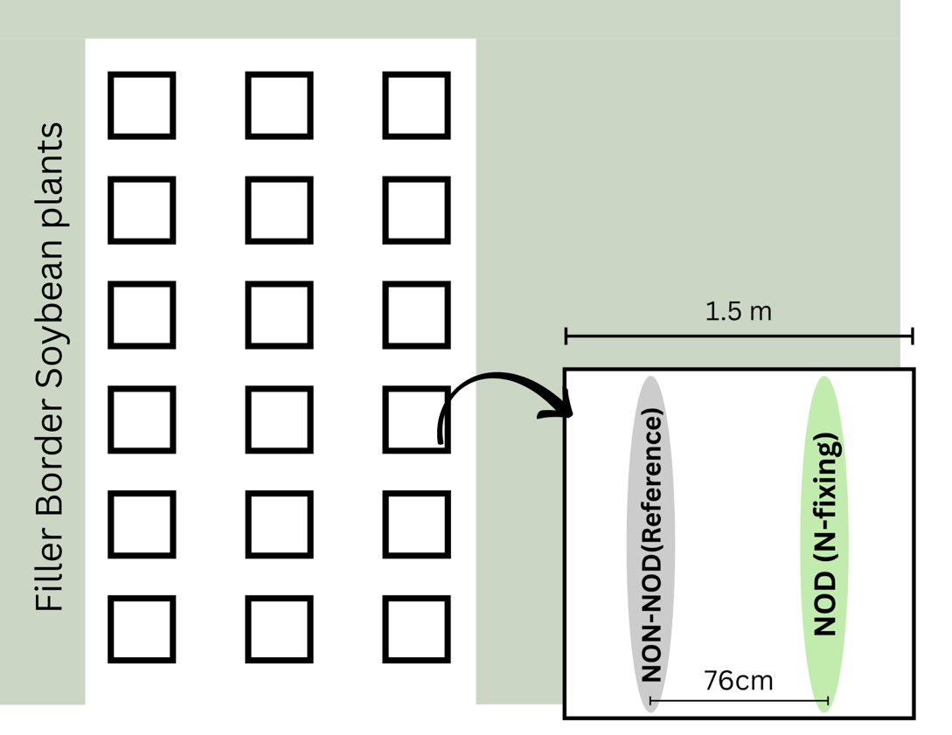
Figure S1 Layout of half the mesocosm experimental system and within-block planting arrangement of nodulating (NOD) and non-nodulating (NON-NOD) soybean lines.
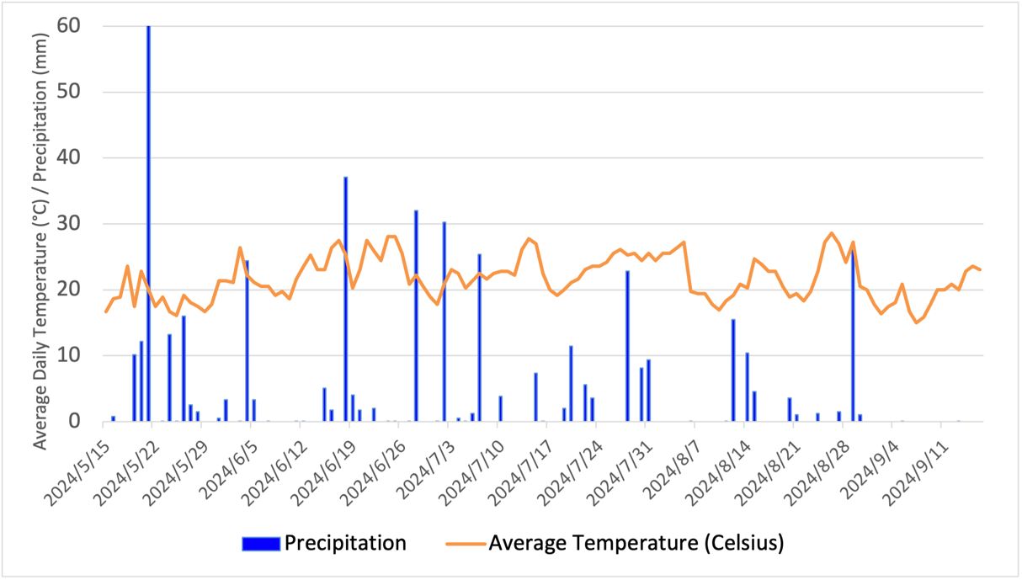

Figure S2 Daily cumulative precipitation and average temperature in Ames, Iowa, USA in 2024.

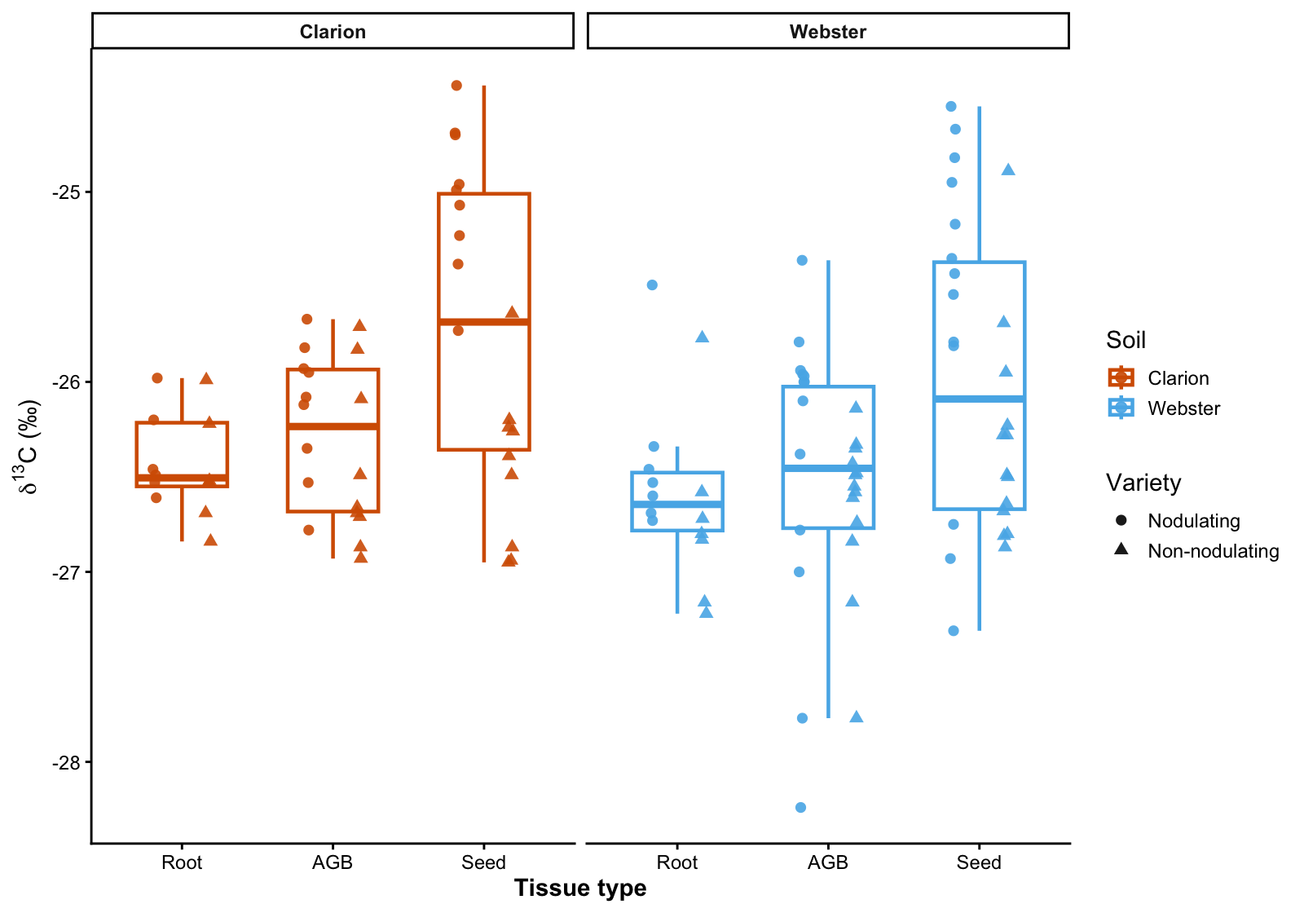
Figure S3 Distribution of soybean tissue δ¹³C values at maturity across soil types in the mesocosm experiment. Boxplots summarize δ¹³C (‰, relative to VPDB) for root, aboveground biomass (AGB), and seed tissues within Clarion and Webster soils. Points represent individual observations, with circles indicating nodulating soybean and triangles indicating non-nodulating soybean.

 |  | Tissue category
Soil type | Legacy N fertilizer rate | Root | AGB | Seed | Root | AGB | Seed
 |  | Ndfa (% of total plant N) |  |  | Ndfa (% of tissue N)
Clarion | Low | 2.0 ± 0.3 | 11.3 ± 0.5 | 86.5 ± 0.4 | 66.5 ± 0.5 | 81.0 ± 4.0 | 84.3 ± 2.5
Clarion | Medium | 1.6 ± 0.1 | 11.9 ± 0.4 | 86.3 ± 0.3 | 63.1 ± 1.9 | 75.9 ± 1.6 | 79.8 ± 0.6
Clarion | High | 2.2 ± 0.3 | 17.6 ± 1.4 | 80.1 ± 1.5 | 59.6 ± 2.2 | 75.8 ± 1.9 | 79.1 ± 2.8
Webster | Low | 2.0 ± 0.1 | 12.3 ± 1.9 | 85.5 ± 1.9 | 56.9 ± 11.0 | 82.9 ± 1.1 | 85.0 ± 1.2
Webster | Medium | 2.8 ± 0.5 | 12.9 ± 2.4 | 84.1 ± 2.8 | 67.7 ± 3.6 | 72.7 ± 4.8 | 79.5 ± 4.1
Webster | High | 2.3 ± 0.3 | 12.5 ± 0.3 | 85.1 ± 0.5 | 54.8 ± 7.1 | 78.2 ± 1.1 | 81.8 ± 0.9

Table S1 Mean ± SE of tissue-level soybean BNF partitioning at maturity across soil types and legacy N fertilizer rates. Root, aboveground biomass (AGB), and seed Ndfa values are expressed as percentages of total plant N or N within each tissue category. Replication for each treatment and tissue category are as follows. Root: Clarion, n=2, Webster, n=3. Seed and AGB: Clarion low, n=3, Clarion medium, n=2, Clarion high, n=4, Webster low, n=5, Webster medium, n=5, Webster high, n=4

Soil | Legacy N fertilizer rate | Variety | Tissue | δ13C (VPDB) | Mean  %C | Mean  %N | n
Clarion | Low | nodulating | AGB | -26.4 ± 0.3 | 43.6 ± 4.3 | 0.9 ± 0.0 | 3
Clarion | Low | nodulating | Seed | -24.9 ± 0.2 | 53.0 ± 1.0 | 6.3 ± 0.1 | 3
Clarion | Low | nodulating | Root | -26.4 ± 0.2 | 45.9 ± 1.9 | 0.6 ± 0.0 | 2
Clarion | Low | non-nodulating | AGB | -26.7 ± 0.1 | 41.43 ± 2.7 | 0.4 ± 0.0 | 3
Clarion | Low | non-nodulating | Seed | -26.9 ± 0.0 | 51.40 ± 2.0 | 3.6 ± 0.2 | 3
Clarion | Low | non-nodulating | Root | -26.37 ± 0.2 | 49.76 ± 2.0 | 0.4 ± 0.0 | 2
Clarion | Medium | nodulating | AGB | -26.1 ± 0.0 | 43.4 ± 2.2 | 0.9 ± 0.1 | 2
Clarion | Medium | nodulating | Seed | -25.0 ± 0.0 | 54.7 ± 1.2 | 6.2 ± 0.2 | 2
Clarion | Medium | nodulating | Root | -26.5 ± 0.0 | 45.8 ± 1.1 | 0.5 ± 0.0 | 2
Clarion | Medium | non-nodulating | AGB | -26.2 ± 0.5 | 50.4 ± 6.9 | 0.8 ± 0.2 | 2
Clarion | Medium | non-nodulating | Seed | -26.3 ± 0.1 | 54.5 ± 1.7 | 4.2 ± 0.1 | 2
Clarion | Medium | non-nodulating | Root | -26.4 ± 0.4 | 44.0 ± 2.5 | 0.3 ± 0.0 | 2
Clarion | High | nodulating | AGB | -26.0 ± 0.2 | 47.6 ± 3.0 | 1.3 ± 0.1 | 4
Clarion | High | nodulating | Seed | -25.1 ± 0.3 | 54.3 ± 1.9 | 6.4 ± 0.1 | 4
Clarion | High | nodulating | Root | -26.3 ± 0.3 | 48.0 ± 4.8 | 0.5 ± 0.0 | 2
Clarion | High | non-nodulating | AGB | -26.4 ± 0.3 | 46.3 ± 3.2 | 0.7 ± 0.2 | 4
Clarion | High | non-nodulating | Seed | -26.1 ± 0.2 | 53.2 ± 0.4 | 4.4 ± 0.2 | 4
Clarion | High | non-nodulating | Root | -26.6 ± 0.1 | 44.9 ± 2.4 | 0.4 ± 0.0 | 2
Webster | Low | nodulating | AGB | -26.2 ± 0.2 | 47.1 ± 2.7 | 0.8 ± 0.1 | 5
Webster | Low | nodulating | Seed | -25.6 ± 0.5 | 50.9 ± 1.9 | 6.1 ± 0.2 | 5
Webster | Low | nodulating | Root | -26.3 ± 0.4 | 46.7 ± 2.5 | 0.6 ± 0.0 | 3
Webster | Low | non-nodulating | AGB | -26.6 ± 0.1 | 48.5 ± 2.6 | 0.7 ± 0.1 | 5
Webster | Low | non-nodulating | Seed | -26.6 ± 0.1 | 54.3 ± 1.1 | 4.0 ± 0.1 | 5
Webster | Low | non-nodulating | Root | -26.9 ± 0.2 | 45.4 ± 1.6 | 0.4 ± 0.0 | 3
Webster | Medium | nodulating | AGB | -26.0 ± 0.3 | 46.1 ± 6.1 | 1.0 ± 0.2 | 4
Webster | Medium | nodulating | Seed | -25.0 ± 0.2 | 54.4 ± 0.6 | 6.3 ± 0.1 | 4
Webster | Medium | nodulating | Root | -26.4 ± 0.1 | 46.2 ± 0.4 | 0.7 ± 0.1 | 2
Webster | Medium | non-nodulating | AGB | -26.9 ± 0.3 | 45.6 ± 3.1 | 0.8 ± 0.2 | 4
Webster | Medium | non-nodulating | Seed | -26.3 ± 0.2 | 52.1 ± 1.4 | 4.2 ± 0.2 | 4
Webster | Medium | non-nodulating | Root | -27.0 ± 0.2 | 47.5 ± 1.1 | 0.5 ± 0.0 | 2
Webster | High | nodulating | AGB | -27.0 ± 0.6 | 48.4 ± 2.6 | 0.9 ± 0.1 | 4
Webster | High | nodulating | Seed | -26.2 ± 0.4 | 52.0 ± 0.4 | 6.1 ± 0.2 | 4
Webster | High | nodulating | Root | -26.6 ± 0.1 | 48.5 ± 1.7 | 0.6 ± 0.2 | 3
Webster | High | non-nodulating | AGB | -26.5 ± 0.2 | 44.0 ± 2.6 | 1.8 ± 0.8 | 4
Webster | High | non-nodulating | Seed | -25.9 ± 0.4 | 55.4 ± 1.7 | 4.3 ± 0.3 | 4
Webster | High | non-nodulating | Root | -26.2 ± 0.4 | 46.2 ± 0.8 | 0.5 ± 0.1 | 3
Table S2 Mean ± SE of tissue δ¹³C (‰, relative to VPDB), carbon concentration (%C), and nitrogen concentration (%N) for nodulating and non-nodulating soybean across soil types and legacy N fertilizer rates at maturity. Values are presented separately for root, aboveground vegetative biomass (AGB), and seed tissues. n indicates the number of mesocosms included in each soil × legacy N × variety × tissue combination.

