Modulating nitrogenase activity of encapsulated diazotrophs through oxygen-regulated microenvironments and carbon availability in alginate hydrogel beads

Prashant Dahal^{1,2}, Senthil Subramanian³*, Srinivas Janaswamy^{1,4}*

¹Department of Dairy and Food Science, South Dakota State University, Brookings, SD 57007, USA.
²Department of Food, Bioprocessing and Nutrition Sciences, North Carolina State University, Raleigh, NC 27606, USA.
³College of Natural Sciences, South Dakota State University, Brookings, SD 57007, USA.
⁴Department of Agronomy, Horticulture and Plant Science, South Dakota State University, Brookings, SD 57007, USA.

*Corresponding authors
Email: Senthil.Subramanian@sdstate.edu, Srinivas.Janaswamy@sdstate.edu

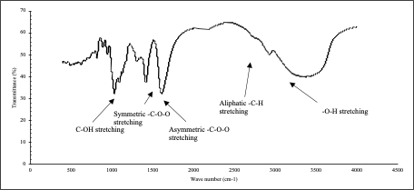
Fig. S1. FTIR spectra for sodium alginate powder.

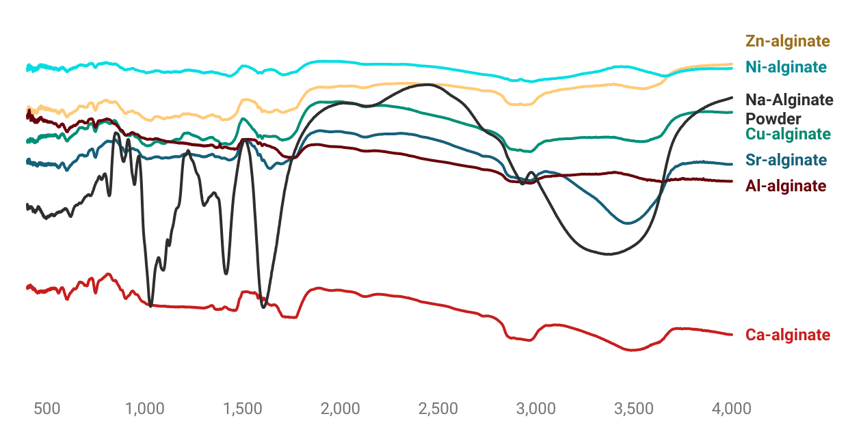
Fig. S2. FTIR spectra for alginate beads.

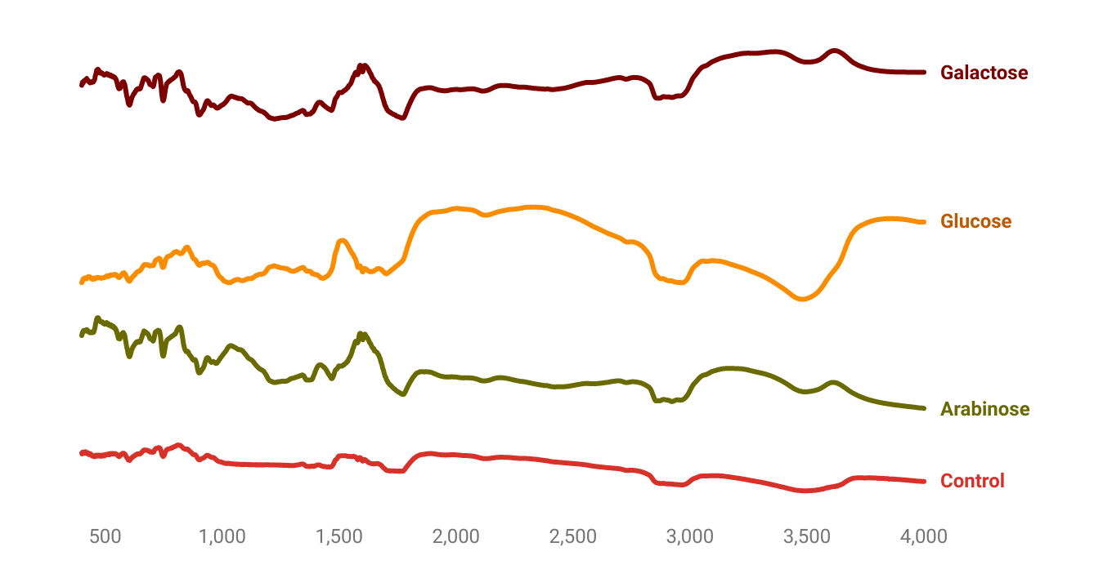
Fig. S3. FTIR spectra for sugar added Ca²⁺-alginate beads.

Table T1. FTIR spectra of sodium alginate powder and ion-crosslinked alginate beads.
Functional group | Alginate powder | Ca-Alg | Sr-Alg | Zn-Alg | Cu-Alg | Ni-Alg | Al-Alg
 | 623 | 607 | 629 | 605 | 607 | 605 | 608
 | * | 750 | * | * | * | * | *
C-OH stretching | 1032 | 1000 | 1000 | 1027 | 1026 | 1015
 | 1386 | * | * | * | * | * | *
Symmetric -C-O-O stretching | 1418 | 1467 | * | 1405 | 1432 | 1435 | 1460
Asymmetric C-O-O | 1608 | 1723 | 1663 | 1704 | 1710 | 1719 | 1777
 |  |  |  |  | 2152 | 2158
Aliphatic C-H | 2939 | 2975 | 2998 | 2906 | 2973 | 2989 | 2997
O-H stretching | 3417 | 3511 | 3479 | 3576 | 3557 | 3655 | 3678

Table T2. The significant FTIR absorption peaks (cm⁻¹) of sodium-alginate powder and Ca-alginate beads.
Functional group | Ca-Control | Ca-Arabinose | Ca-Glucose | Ca-Galactose
C-OH stretching | 1032 | 985 | 1032 | 988
Symmetric -C-O-O stretching | 1371 | 1469 | 1435 | 1469
Asymmetric C-O-O | 1714 | 1784 | 1709 | 1775
Aliphatic C-H | 2955 | 2936 | 2974 | 2928
O-H stretching | 3498 | 3499 | 3491 | 3500

Table T3. The significant FTIR absorption peaks (cm⁻¹) of sodium-alginate powder and Sr-alginate beads.
Functional group | Sr-Control | Sr-Arabinose | Sr-Glucose | Sr-Galactose
C-OH stretching | 1068 | 1068 | 1060 | 1068
Symmetric -C-O-O stretching | 1387 | 1387 | 1387 | 1387
Asymmetric C-O-O | 1734 | 1734 | 1734 | 1734
Aliphatic C-H | 2991 | 2991 | 2991 | 2991
O-H stretching | 3497 | 3497 | 3497 | 3492

Table T4. Bulk-equivalent oxygen concentrations (nmol L⁻¹) and corresponding oxygen content per bead (nmol bead⁻¹) for alginate beads crosslinked with different cations.
Bead type | Bulk-equivalent O₂  (nmol/L) | O₂ content  (nmol/bead)
Ca alginate | 59.9 ± 16.4 | 1.50 ± 0.41
Zn alginate | 94.4 ± 32.4 | 2.36 ± 0.81
Sr alginate | 77.5 ± 18.8 | 1.94 ± 0.47
Ni alginate | 188.3 ± 39.6 | 4.70 ± 0.99
Cu alginate | 215.0 ± 42.8 | 5.38 ± 1.07
Al alginate | 89.4 ± 25.6 | 2.23 ± 0.64

