Artificial macropores increase crop productivity through improved root access to subsoils
Elron Wiedermann¹, Miriam Athmann², Axel Don¹
¹Thünen Institute of Climate-Smart Agriculture, Bundesallee 65, 38116 Braunschweig, Germany
²University of Kassel, Organic Farming and Cropping Systems, Nordbahnhofstraße 1a, 37213 Witzenhausen, Germany

- Supplement

Table S. 1 Management data for both sites.
 | Harvest | Crop | Tillage management |  |  |  | Fertilization
 | year |  | 1. Operation | Depth (cm) | 2. Operation | Depth (cm) | 1. Date | Type | 2. Date | Tye | 3. Date | Type | 4. Date | Type | Total N (kg N)
Loamy Sand | 2024 | Winter wheat (cv. Reform, RGT) | Cultivator (Horsch Tiger AS) | 25 |  |  | 08.03.2024 | Mineral (60 kg N) | 30.03.2024 | Mineral (70 kg N) | 02.05.2024 | Mineral (40 kg N) | 25.05.2024 | Mineral (35 kg N) | 205
Loamy Sand | 2025 | Winter barley (cv. Chevignon Hauptsaaten) | Disc harrow (Väderstad Carrier XL) |  | Cultivator (Horsch Tiger AS) | 15 | 05.08.2024 | Manure (30 kg N) | 10.03.2025 | mineral (60 kg N) | 03.04.2025 | mineral (50 kg N) | 05.05.2026 | Mineral (20 kg N) | 160
Silt Loam | 2024 | Winter Wheat (cv. Faustus, RAGT) | Cultivator (Amazone Cenius 3002) | 15 |  |  | 01.03.2024 | Mineral (60 kg N) | 28.03.2024 | Mineral (60 kg N) | 01.05.2024 | Mineral (40 kg N) | 21.05.2024 | Mineral (43 kg N) | 215
Silt Loam | 2025 | Winter Wheat (cv. Exquis, KWS) | Disc harrow (Amazone Catros 5002) | 5 | Cultivator (Amazone Cenius 3002) | 15 | 07.03.2025 | Mineral (70 kg N) | 05.04.2025 | Mineral (70 kg N) | 05.05.2025 | Mineral (35 kg N) | 17.05.2025 | Mineral (40 kg N) | 203

Table S. 2 Mean ± standard error, relative difference compared to the control and p-value of yield
(Mg ha⁻¹) aboveground biomass (Mg ha⁻¹), crude protein (%) and thousand kernel weight (g)
 |  |  | Yield |  |  |  |  |  |  | Aboveground Biomass
Year | Site | Treatment | Mean |  | SE | Diff. | Diff. | p_value | signif | Mean |  | SE | Diff. | p_value | signif
 |  |  | t ha-1 |  |  |  | % |  |  | t ha-1 |  |  | %
2024 | Loamy Sand | Control | 8.52 | ± | 0.10 |  |  |  |  | 13.69 | ± | 0.36
2024 | Loamy Sand | AP100 | 9.25 | ± | 0.07 | 0.72 | 8.5% | 0.00 | ** | 14.20 | ± | 0.38 | 3.7% | 0.37
2024 | Silt Loam | Control | 11.29 | ± | 0.22 |  |  |  |  | 14.02 | ± | 0.71
2024 | Silt Loam | AP50 | 11.45 | ± | 0.26 | 0.15 | 1.4% | 0.66 |  | 15.21 | ± | 0.68 | 8.5% | 0.27
2024 | Silt Loam | AP100 | 11.68 | ± | 0.21 | 0.39 | 3.4% | 0.25 |  | 14.10 | ± | 0.53 | 0.5% | 0.94
2024 | Silt Loam | AP200 | 11.95 | ± | 0.14 | 0.66 | 5.8% | 0.05 | . | 14.77 | ± | 0.28 | 5.3% | 0.39
2025 | Loamy Sand | Control | 7.72 | ± | 0.43 |  |  |  |  | 12.77 | ± | 0.66
2025 | Loamy Sand | AP100 | 8.86 | ± | 0.56 | 1.14 | 14.7% | 0.16 |  | 13.90 | ± | 0.22 | 8.9% | 0.18
2025 | Silt Loam | Control | 10.05 | ± | 0.15 |  |  |  |  | 15.00 | ± | 0.32
2025 | Silt Loam | AP50 | 10.32 | ± | 0.27 | 0.27 | 2.7% | 0.42 |  | 15.35 | ± | 0.40 | 2.3% | 0.52
2025 | Silt Loam | AP100 | 10.36 | ± | 0.10 | 0.31 | 3.1% | 0.16 |  | 16.31 | ± | 0.81 | 8.7% | 0.21
2025 | Silt Loam | AP200 | 10.45 | ± | 0.36 | 0.41 | 4.0% | 0.35 |  | 16.28 | ± | 0.65 | 8.6% | 0.15
 |  |  | Crude Protein |  |  |  |  |  |  | Thousand Kernel Weight
Year | Site | Treatment | Mean |  | SE | Rel. Difference | p_value | signif |  | Mean |  | SE | Rel. Difference | p_value | signif
 |  |  | % |  |  | % |  |  |  | g |  |  | %
2024 | Loamy Sand | Control | 14.83 | ± | 0.06 |  |  |  |  | 41.6 | ± | 0.16
2024 | Loamy Sand | AP100 | 14.66 | ± | 0.15 | -1.1% | 0.36 |  |  | 42.06 | ± | 0.43 | 1.1% | 0.37
2024 | Silt Loam | Control | 13.65 | ± | 0.11 |  |  |  |  | 40.88 | ± | 0.27
2024 | Silt Loam | AP50 | 13.81 | ± | 0.18 | 1.2% | 0.47 |  |  | 41.41 | ± | 0.38 | 1.3% | 0.30
2024 | Silt Loam | AP100 | 13.59 | ± | 0.21 | -0.4% | 0.82 |  |  | 41.43 | ± | 0.57 | 1.4% | 0.43
2024 | Silt Loam | AP200 | 13.85 | ± | 0.14 | 1.5% | 0.30 |  |  | 41.07 | ± | 0.54 | 0.5% | 0.76
2025 | Loamy Sand | Control | 11.60 | ± | 0.46 |  |  |  |  | 46.72 | ± | 0.66
2025 | Loamy Sand | AP100 | 11.98 | ± | 0.38 | 3.3% | 0.55 |  |  | 46.98 | ± | 0.42 | 0.6% | 0.75
2025 | Silt Loam | Control | 12.47 | ± | 0.23 |  |  |  |  | 44.93 | ± | 0.38
2025 | Silt Loam | AP50 | 11.69 | ± | 0.34 | -6.3% | 0.11 |  |  | 45.06 | ± | 0.3 | 0.3% | 0.81
2025 | Silt Loam | AP100 | 12.12 | ± | 0.45 | -2.8% | 0.54 |  |  | 44.65 | ± | 0.65 | -0.6% | 0.73
2025 | Silt Loam | AP200 | 12.32 | ± | 0.59 | -1.3% | 0.82 |  |  | 44.42 | ± | 0.3 | -1.2% | 0.33

Table S. 3 Results of linear models for yield, aboveground biomass (AGB), crude protein and thousand kernel weight (TKW). Each dependent variable was analyzed using a linear model as a function of treatment, site, year, and their interaction (site × year): lm(y ~ treatment + site * year).
 | Coefficient | Estimate | Std. Error | t_value | P-value | Sig.
Yield | AP50 | 0.3522 | 0.2567 | 1.372 | 0.17766
Yield | AP100 | 0.6505 | 0.197 | 3.302 | 0.00202 | **
Yield | AP200 | 0.6711 | 0.2567 | 2.614 | 0.01254 | *
Yield | Site | -2.6148 | 0.2567 | -10.186 | 1.13E-12 | ***
Yield | Year | -1.2851 | 0.197 | -6.524 | 8.67E-08 | ***
Yield | Site x Year | 0.6936 | 0.3372 | 2.057 | 0.04627 | *
AGB | AP50 | 0.8043 | 0.4954 | 1.623 | 0.11216
AGB | AP100 | 0.758 | 0.3745 | 2.024 | 0.04951 | *
AGB | AP200 | 1.0455 | 0.4954 | 2.11 | 0.04097 | *
AGB | Site | -0.3065 | 0.4954 | -0.619 | 0.5395
AGB | Year | 1.2102 | 0.3745 | 3.231 | 0.00243 | **
AGB | Site x Year | -1.8217 | 0.6487 | -2.808 | 0.00759 | **
Crude Protein | AP50 | -0.23284 | 0.28503 | -0.817 | 0.418816
Crude Protein | AP100 | -0.04608 | 0.21872 | -0.211 | 0.834192
Crude Protein | AP200 | 0.1012 | 0.28503 | 0.355 | 0.724427
Crude Protein | Site | 2793.81876 | 758.07232 | 3.685 | 0.000677 | ***
Crude Protein | Year | -1.57686 | 0.21872 | -7.21 | 9.59E-09 | ***
Crude Protein | Site x Year | -1.37985 | 0.37445 | -3.685 | 0.000678 | ***
TKW | AP50 | 0.40875 | 0.38706 | 1.056 | 0.29713
TKW | AP100 | 0.2025 | 0.29259 | 0.692 | 0.49278
TKW | AP200 | -0.08375 | 0.38706 | -0.216 | 0.82977
TKW | Site | 0.66062 | 0.38706 | 1.707 | 0.09543 | .
TKW | Year | 3.52125 | 0.29259 | 12.035 | 4.89E-15 | ***
TKW | Site x Year | 1.49875 | 0.50678 | 2.957 | 0.00513 | **

Table S. 4 Mean ± standard error of the pore abundance, the relative number of pores colonized with at least one root and with anecic earthworms.
 |  |  | Pore abundance |  |  |  |  |  | Root Colonization |  |  |  |  |  | Worm Colonization
Site | Year | Treatment | Artificial Pore |  |  | Biopore |  |  | Artificial Pore |  |  | Biopore |  |  | Artificail Pore |  |  | Biopore
 |  |  | Mean |  | SE | Mean |  | SE | Mean |  | SE | Mean |  | SE | Mean |  | SE | Mean |  | SE
Loamy Sand | 2024 | Control |  |  |  | 68.2 | ± | 12.4 |  |  |  | 70% | ± | 4% |  |  |  | 0% | ± | 0%
Loamy Sand | 2024 | AP100 | 84.2 | ± | 1.7 | 59.5 | ± | 6.5 | 91% | ± | 3% | 76% | ± | 3% | 0% | ± | 0% | 0% | ± | 0%
Loamy Sand | 2025 | Control |  |  |  | 67.0 | ± | 14.7 |  |  |  | 83% | ± | 5% |  |  |  | 0% | ± | 0%
Loamy Sand | 2025 | AP100 | 82.0 | ± | 2.7 | 55.0 | ± | 8.4 | 95% | ± | 2% | 78% | ± | 4% | 0% | ± | 0% | 0% | ± | 0%
Silt Loam | 2024 | Control |  |  |  | 69.2 | ± | 9.1 |  |  |  | 69% | ± | 4% |  |  |  | 7% | ± | 2%
Silt Loam | 2024 | AP50 | 46.5 | ± | 0.9 | 53.0 | ± | 5.6 | 75% | ± | 2% | 66% | ± | 4% | 1% | ± | 1% | 11% | ± | 2%
Silt Loam | 2024 | AP100 | 95.5 | ± | 1.9 | 44.8 | ± | 4.2 | 80% | ± | 3% | 76% | ± | 3% | 2% | ± | 0% | 13% | ± | 4%
Silt Loam | 2024 | AP200 | 173.0 | ± | 1.7 | 53.2 | ± | 4.3 | 84% | ± | 4% | 73% | ± | 2% | 2% | ± | 1% | 7% | ± | 3%
Silt Loam | 2025 | Control |  |  |  | 85.0 | ± | 10.6 |  |  |  | 70% | ± | 4% |  |  |  | 9% | ± | 1%
Silt Loam | 2025 | AP50 | 49.0 | ± | 0.0 | 71.0 | ± | 7.8 | 89% | ± | 5% | 64% | ± | 3% | 4% | ± | 2% | 9% | ± | 2%
Silt Loam | 2025 | AP100 | 96.0 | ± | 1.2 | 65.5 | ± | 9.4 | 86% | ± | 1% | 64% | ± | 5% | 4% | ± | 3% | 7% | ± | 3%
Silt Loam | 2025 | AP200 | 186.0 | ± | 7.1 | 79.0 | ± | 11.7 | 84% | ± | 3% | 67% | ± | 6% | 2% | ± | 0% | 6% | ± | 1%

Table S. 5 Results of binomial generalized linear models quantifying anecic earthworm colonization and root colonization across pore types. Root colonization was evaluated for (i) overall root presence and (ii) pores containing 1 root, 2 roots, 3 roots, or ≥4 roots. Each response variable was modeled as a binomial proportion relative to total number of pores as a function of pore type (artificial and biopore), treatment, site and year. Shown are estimated coefficients (logit scale) with standard errors, z‑values, and significance levels.
 | Coefficient | Estimate | Std. Error | z_value | P_value | Sig.
Worm colonization (Silt Loam) | Pore type | 1.21 | 0.27 | 4.53 | 0.00 | ***
Worm colonization (Silt Loam) | AP50 | -0.02 | 0.46 | -0.04 | 0.97
Worm colonization (Silt Loam) | AP100 | 0.27 | 0.37 | 0.74 | 0.46
Worm colonization (Silt Loam) | AP200 | -0.25 | 0.24 | -1.05 | 0.29
Worm colonization (Silt Loam) | Year | 0.05 | 0.14 | 0.35 | 0.73
Root colonization | Pore Type | -0.91 | 0.07 | -12.46 | 0.00 | ***
Root colonization | AP50 | -0.21 | 0.11 | -1.93 | 0.05 | .
Root colonization | AP100 | -0.03 | 0.09 | -0.34 | 0.73
Root colonization | AP200 | -0.03 | 0.11 | -0.30 | 0.76
Root colonization | Year | 0.17 | 0.06 | 2.62 | 0.01 | **
Root colonization | Site | 0.53 | 0.09 | 6.10 | 0.00 | ***
1 Root | Pore Type | 0.58 | 0.06 | 9.14 | 0.00 | ***
1 Root | AP50 | 0.10 | 0.10 | 0.94 | 0.35
1 Root | AP100 | -0.12 | 0.08 | -1.38 | 0.17
1 Root | AP200 | 0.13 | 0.10 | 1.38 | 0.17
1 Root | Year | -0.42 | 0.05 | -7.61 | 0.00 | ***
1 Root | Site | -0.23 | 0.07 | -3.13 | 0.00 | **
2 Roots | Pore Type | -0.42 | 0.07 | -5.75 | 0.00 | ***
2 Roots | AP50 | -0.33 | 0.13 | -2.66 | 0.01 | **
2 Roots | AP100 | -0.05 | 0.10 | -0.51 | 0.61
2 Roots | AP200 | -0.03 | 0.11 | -0.27 | 0.79
2 Roots | Year | 0.05 | 0.06 | 0.86 | 0.39
2 Roots | Site | 0.05 | 0.08 | 0.63 | 0.53
3 Roots | Pore Type | -0.88 | 0.10 | -8.89 | 0.00 | ***
3 Roots | AP50 | -0.07 | 0.17 | -0.40 | 0.69
3 Roots | AP100 | 0.02 | 0.14 | 0.16 | 0.88
3 Roots | AP200 | -0.05 | 0.16 | -0.32 | 0.75
3 Roots | Year | 0.52 | 0.08 | 6.51 | 0.00 | ***
3 Roots | Site | 0.30 | 0.10 | 2.85 | 0.00 | **
4 Roots | Pore Type | -1.35 | 0.12 | -11.30 | 0.00 | ***
4 Roots | AP50 | -0.38 | 0.20 | -1.85 | 0.06 | .
4 Roots | AP100 | -0.16 | 0.16 | -1.03 | 0.30
4 Roots | AP200 | -0.53 | 0.19 | -2.84 | 0.00 | **
4 Roots | Year | 0.57 | 0.09 | 6.57 | 0.00 | ***
4 Roots | Site | 0.87 | 0.11 | 8.04 | 0.00 | ***

Table S. 6 Mean values ± standard error, relative difference compared to the control and p-value of the root length density (cm cm⁻³), seperated into the following depth segments (0-30, 30-50, 50-80 and 80-100 cm depth.
Year | Site | Depth | Treatment | Mean RLD |  | SE | Rel. Difference | P-value | Sig.
 |  | (cm) |  | (cm cm⁻²) |  |  | (%)
2024 | Loamy Sand | 0-30 | Control | 1.54 | ± | 0.48
2024 | Loamy Sand | 0-30 | AP100 | 1.59 | ± | 0.42 | 3 | 0.94
2024 | Loamy Sand | 30-50 | Control | 0.36 | ± | 0.11
2024 | Loamy Sand | 30-50 | AP100 | 0.93 | ± | 0.16 | 158 | 0.03 | *
2024 | Loamy Sand | 50-80 | Control | 0.20 | ± | 0.06
2024 | Loamy Sand | 50-80 | AP100 | 0.78 | ± | 0.02 | 299 | 0.00 | **
2024 | Loamy Sand | 80-100 | Control | 0.14 | ± | 0.04
2024 | Loamy Sand | 80-100 | AP100 | 0.22 | ± | 0.03 | 62 | 0.15
2024 | Silt Loam | 0-30 | Control | 3.51 | ± | 0.32
2024 | Silt Loam | 0-30 | AP50 | 4.47 | ± | 0.33 | 27 | 0.08
2024 | Silt Loam | 0-30 | AP100 | 3.93 | ± | 0.36 | 12 | 0.41
2024 | Silt Loam | 0-30 | AP200 | 4.23 | ± | 0.27 | 20 | 0.14
2024 | Silt Loam | 30-50 | Control | 1.25 | ± | 0.12
2024 | Silt Loam | 30-50 | AP50 | 1.38 | ± | 0.29 | 10 | 0.71
2024 | Silt Loam | 30-50 | AP100 | 1.55 | ± | 0.19 | 24 | 0.25
2024 | Silt Loam | 30-50 | AP200 | 1.66 | ± | 0.18 | 33 | 0.11
2024 | Silt Loam | 50-80 | Control | 0.44 | ± | 0.06
2024 | Silt Loam | 50-80 | AP50 | 0.60 | ± | 0.17 | 36 | 0.42
2024 | Silt Loam | 50-80 | AP100 | 0.83 | ± | 0.20 | 88 | 0.14
2024 | Silt Loam | 50-80 | AP200 | 0.98 | ± | 0.15 | 122 | 0.03 | *
2024 | Silt Loam | 80-100 | Control | 0.26 | ± | 0.04
2024 | Silt Loam | 80-100 | AP50 | 0.28 | ± | 0.03 | 10 | 0.65
2024 | Silt Loam | 80-100 | AP100 | 0.30 | ± | 0.06 | 18 | 0.56
2024 | Silt Loam | 80-100 | AP200 | 0.38 | ± | 0.08 | 51 | 0.21
2025 | Loamy Sand | 0-30 | Control | 2.05 | ± | 0.25
2025 | Loamy Sand | 0-30 | AP100 | 1.94 | ± | 0.37 | -6 | 0.80
2025 | Loamy Sand | 30-50 | Control | 0.73 | ± | 0.18
2025 | Loamy Sand | 30-50 | AP100 | 0.79 | ± | 0.14 | 7 | 0.82
2025 | Loamy Sand | 50-80 | Control | 0.29 | ± | 0.08
2025 | Loamy Sand | 50-80 | AP100 | 0.55 | ± | 0.06 | 89 | 0.04 | *
2025 | Loamy Sand | 80-100 | Control | 0.04 | ± | 0.01
2025 | Loamy Sand | 80-100 | AP100 | 0.16 | ± | 0.03 | 311 | 0.02 | *
2025 | Silt Loam | 0-30 | Control | 1.86 | ± | 0.20
2025 | Silt Loam | 0-30 | AP50 | 1.77 | ± | 0.35 | -5 | 0.83
2025 | Silt Loam | 0-30 | AP100 | 2.39 | ± | 0.34 | 28 | 0.24
2025 | Silt Loam | 0-30 | AP200 | 1.95 | ± | 0.33 | 5 | 0.83
2025 | Silt Loam | 30-50 | Control | 0.95 | ± | 0.09
2025 | Silt Loam | 30-50 | AP50 | 1.19 | ± | 0.29 | 25 | 0.49
2025 | Silt Loam | 30-50 | AP100 | 1.31 | ± | 0.28 | 38 | 0.30
2025 | Silt Loam | 30-50 | AP200 | 1.24 | ± | 0.19 | 30 | 0.23
2025 | Silt Loam | 50-80 | Control | 0.46 | ± | 0.08
2025 | Silt Loam | 50-80 | AP50 | 0.83 | ± | 0.17 | 78 | 0.12
2025 | Silt Loam | 50-80 | AP100 | 0.97 | ± | 0.09 | 108 | 0.01 | **
2025 | Silt Loam | 50-80 | AP200 | 1.11 | ± | 0.19 | 140 | 0.03 | *
2025 | Silt Loam | 80-100 | Control | 0.30 | ± | 0.03
2025 | Silt Loam | 80-100 | AP50 | 0.63 | ± | 0.15 | 109 | 0.11
2025 | Silt Loam | 80-100 | AP100 | 0.70 | ± | 0.10 | 128 | 0.02 | *
2025 | Silt Loam | 80-100 | AP200 | 0.67 | ± | 0.11 | 120 | 0.04 | *

Table S. 7 Results of linear models for the root length density (RLD) (cm cm⁻²) of the depth segments 0-30, 30-50, 50-80 and 80-100 cm. RLD for each depth was analyzed using a linear model as a function of treatment, site, year, and their interaction (site × year): lm(y ~ treat + site * year).
Depth (cm) | Coefficient | RLD |  | SE | t_value | P-value | Sig.
0-30 | AP50 | 0.31 | ± | 0.32 | 0.96 | 0.34
0-30 | AP100 | 0.22 | ± | 0.24 | 0.91 | 0.37
0-30 | AP200 | 0.28 | ± | 0.32 | 0.87 | 0.39
0-30 | Site | 2.38 | ± | 0.32 | 7.47 | 0.00 | ***
0-30 | Year | 0.43 | ± | 0.34 | 1.27 | 0.21
0-30 | Site x Year | -2.48 | ± | 0.42 | -5.93 | 0.00 | ***
30-50 | AP50 | 0.18 | ± | 0.18 | 0.99 | 0.33
30-50 | AP100 | 0.32 | ± | 0.13 | 2.39 | 0.02 | *
30-50 | AP200 | 0.35 | ± | 0.18 | 1.95 | 0.06 | .
30-50 | Site | 0.77 | ± | 0.18 | 4.33 | 0.00 | ***
30-50 | Year | 0.12 | ± | 0.19 | 0.62 | 0.54
30-50 | Site x Year | -0.41 | ± | 0.23 | -1.75 | 0.09 | .
50-80 | AP50 | 0.25 | ± | 0.11 | 2.26 | 0.03 | *
50-80 | AP100 | 0.43 | ± | 0.08 | 5.10 | 0.00 | ***
50-80 | AP200 | 0.59 | ± | 0.11 | 5.23 | 0.00 | ***
50-80 | Site | 0.12 | ± | 0.11 | 1.11 | 0.27
50-80 | Year | -0.07 | ± | 0.12 | -0.58 | 0.57
50-80 | Site x Year | 0.20 | ± | 0.15 | 1.35 | 0.18
80-100 | AP50 | 0.15 | ± | 0.07 | 2.15 | 0.04 | *
80-100 | AP100 | 0.16 | ± | 0.05 | 3.07 | 0.00 | **
80-100 | AP200 | 0.22 | ± | 0.07 | 3.14 | 0.00 | **
80-100 | Site | 0.08 | ± | 0.07 | 1.10 | 0.28
80-100 | Year | -0.08 | ± | 0.07 | -1.03 | 0.31
80-100 | Site x Year | 0.35 | ± | 0.09 | 3.81 | 0.00 | ***

Table S. 8 Mean values ± standard error, absolute and relative difference compared to the control and p-value of the root length density (cm cm⁻³), at a distance from 1-5 cm away from the artificial pore center, separated into the following depth segments (0-30, 30-50, 50-80 and 80-100 cm depth.
Site | Year | Depth | Distance | AP100 |  |  | Control |  |  | Difference |  | P-value | Sig.
 |  |  | to center | Mean | ± | SE | Mean | ± | SE | Abs. | Rel.
Loamy Sand | 2024 | 0-30 | 1 | 2.26 | ± | 0.48 | 1.54 | ± | 0.48 | 0.72 | 47% | 0.33
Loamy Sand | 2024 | 0-30 | 2 | 1.47 | ± | 0.33 | 1.54 | ± | 0.48 | -0.07 | -5% | 0.91
Loamy Sand | 2024 | 0-30 | 3 | 1.33 | ± | 0.39 | 1.54 | ± | 0.48 | -0.21 | -14% | 0.75
Loamy Sand | 2024 | 0-30 | 4 | 1.25 | ± | 0.42 | 1.54 | ± | 0.48 | -0.28 | -18% | 0.67
Loamy Sand | 2024 | 0-30 | 5 | 1.20 | ± | 0.47 | 1.54 | ± | 0.48 | -0.33 | -22% | 0.64
Loamy Sand | 2024 | 30-50 | 1 | 3.75 | ± | 0.74 | 0.36 | ± | 0.11 | 3.39 | 943% | 0.02 | *
Loamy Sand | 2024 | 30-50 | 2 | 0.52 | ± | 0.19 | 0.36 | ± | 0.11 | 0.16 | 45% | 0.50
Loamy Sand | 2024 | 30-50 | 3 | 0.41 | ± | 0.12 | 0.36 | ± | 0.11 | 0.05 | 13% | 0.78
Loamy Sand | 2024 | 30-50 | 4 | 0.45 | ± | 0.18 | 0.36 | ± | 0.11 | 0.09 | 26% | 0.68
Loamy Sand | 2024 | 30-50 | 5 | 0.51 | ± | 0.27 | 0.36 | ± | 0.11 | 0.15 | 41% | 0.64
Loamy Sand | 2024 | 50-80 | 1 | 3.21 | ± | 0.14 | 0.20 | ± | 0.06 | 3.01 | 1542% | 0.00 | ***
Loamy Sand | 2024 | 50-80 | 2 | 0.65 | ± | 0.19 | 0.20 | ± | 0.06 | 0.46 | 235% | 0.09 | .
Loamy Sand | 2024 | 50-80 | 3 | 0.29 | ± | 0.07 | 0.20 | ± | 0.06 | 0.10 | 51% | 0.33
Loamy Sand | 2024 | 50-80 | 4 | 0.25 | ± | 0.03 | 0.20 | ± | 0.06 | 0.05 | 26% | 0.51
Loamy Sand | 2024 | 50-80 | 5 | 0.34 | ± | 0.10 | 0.20 | ± | 0.06 | 0.15 | 75% | 0.28
Loamy Sand | 2024 | 80-100 | 1 | 0.50 | ± | 0.06 | 0.14 | ± | 0.04 | 0.36 | 269% | 0.00 | **
Loamy Sand | 2024 | 80-100 | 2 | 0.29 | ± | 0.05 | 0.14 | ± | 0.04 | 0.16 | 116% | 0.06 | .
Loamy Sand | 2024 | 80-100 | 3 | 0.18 | ± | 0.04 | 0.14 | ± | 0.04 | 0.04 | 30% | 0.49
Loamy Sand | 2024 | 80-100 | 4 | 0.18 | ± | 0.06 | 0.14 | ± | 0.04 | 0.05 | 36% | 0.53
Loamy Sand | 2024 | 80-100 | 5 | 0.23 | ± | 0.12 | 0.14 | ± | 0.04 | 0.10 | 72% | 0.50
Loamy Sand | 2025 | 0-30 | 1 | 1.64 | ± | 0.39 | 2.05 | ± | 0.25 | -0.41 | -20% | 0.42
Loamy Sand | 2025 | 0-30 | 2 | 1.77 | ± | 0.41 | 2.05 | ± | 0.25 | -0.29 | -14% | 0.57
Loamy Sand | 2025 | 0-30 | 3 | 1.81 | ± | 0.39 | 2.05 | ± | 0.25 | -0.25 | -12% | 0.62
Loamy Sand | 2025 | 0-30 | 4 | 1.78 | ± | 0.36 | 2.05 | ± | 0.25 | -0.27 | -13% | 0.55
Loamy Sand | 2025 | 0-30 | 5 | 1.66 | ± | 0.33 | 2.05 | ± | 0.25 | -0.39 | -19% | 0.38
Loamy Sand | 2025 | 30-50 | 1 | 1.96 | ± | 0.44 | 0.73 | ± | 0.18 | 1.23 | 167% | 0.06 | .
Loamy Sand | 2025 | 30-50 | 2 | 0.72 | ± | 0.21 | 0.73 | ± | 0.18 | -0.01 | -1% | 0.97
Loamy Sand | 2025 | 30-50 | 3 | 0.50 | ± | 0.11 | 0.73 | ± | 0.18 | -0.23 | -32% | 0.32
Loamy Sand | 2025 | 30-50 | 4 | 0.49 | ± | 0.11 | 0.73 | ± | 0.18 | -0.24 | -33% | 0.30
Loamy Sand | 2025 | 30-50 | 5 | 0.49 | ± | 0.12 | 0.73 | ± | 0.18 | -0.24 | -33% | 0.30
Loamy Sand | 2025 | 50-80 | 1 | 1.95 | ± | 0.13 | 0.29 | ± | 0.08 | 1.66 | 572% | 0.00 | ***
Loamy Sand | 2025 | 50-80 | 2 | 0.42 | ± | 0.07 | 0.29 | ± | 0.08 | 0.13 | 46% | 0.25
Loamy Sand | 2025 | 50-80 | 3 | 0.24 | ± | 0.04 | 0.29 | ± | 0.08 | -0.05 | -17% | 0.62
Loamy Sand | 2025 | 50-80 | 4 | 0.28 | ± | 0.07 | 0.29 | ± | 0.08 | -0.01 | -3% | 0.94
Loamy Sand | 2025 | 50-80 | 5 | 0.34 | ± | 0.08 | 0.29 | ± | 0.08 | 0.05 | 16% | 0.70
Loamy Sand | 2025 | 80-100 | 1 | 0.42 | ± | 0.10 | 0.04 | ± | 0.01 | 0.38 | 960% | 0.03 | *
Loamy Sand | 2025 | 80-100 | 2 | 0.19 | ± | 0.02 | 0.04 | ± | 0.01 | 0.15 | 390% | 0.00 | ***
Loamy Sand | 2025 | 80-100 | 3 | 0.12 | ± | 0.05 | 0.04 | ± | 0.01 | 0.08 | 203% | 0.20
Loamy Sand | 2025 | 80-100 | 4 | 0.12 | ± | 0.08 | 0.04 | ± | 0.01 | 0.08 | 201% | 0.37
Loamy Sand | 2025 | 80-100 | 5 | 0.08 | ± | 0.04 | 0.04 | ± | 0.01 | 0.04 | 113% | 0.34
Site | Year | Depth | Distance to | AP100 |  |  | Control |  |  | Difference |  | P-value | Sig.
 |  |  | center | Mean | ± | SE | Mean | ± | SE | Abs. | Rel.
Silt Loam | 2024 | 0-30 | 1 | 3.84 | ± | 0.51 | 3.51 | ± | 0.32 | 0.33 | 9% | 0.61
Silt Loam | 2024 | 0-30 | 2 | 3.91 | ± | 0.57 | 3.51 | ± | 0.32 | 0.40 | 11% | 0.57
Silt Loam | 2024 | 0-30 | 3 | 3.81 | ± | 0.43 | 3.51 | ± | 0.32 | 0.30 | 8% | 0.60
Silt Loam | 2024 | 0-30 | 4 | 3.83 | ± | 0.36 | 3.51 | ± | 0.32 | 0.32 | 9% | 0.52
Silt Loam | 2024 | 0-30 | 5 | 3.73 | ± | 0.31 | 3.51 | ± | 0.32 | 0.23 | 6% | 0.63
Silt Loam | 2024 | 30-50 | 1 | 2.28 | ± | 0.15 | 1.25 | ± | 0.12 | 1.02 | 82% | 0.00 | **
Silt Loam | 2024 | 30-50 | 2 | 1.59 | ± | 0.21 | 1.25 | ± | 0.12 | 0.34 | 27% | 0.23
Silt Loam | 2024 | 30-50 | 3 | 1.32 | ± | 0.23 | 1.25 | ± | 0.12 | 0.07 | 6% | 0.80
Silt Loam | 2024 | 30-50 | 4 | 1.26 | ± | 0.18 | 1.25 | ± | 0.12 | 0.01 | 1% | 0.97
Silt Loam | 2024 | 30-50 | 5 | 1.17 | ± | 0.20 | 1.25 | ± | 0.12 | -0.08 | -6% | 0.74
Silt Loam | 2024 | 50-80 | 1 | 2.00 | ± | 0.38 | 0.44 | ± | 0.06 | 1.56 | 353% | 0.02 | *
Silt Loam | 2024 | 50-80 | 2 | 0.69 | ± | 0.17 | 0.44 | ± | 0.06 | 0.25 | 57% | 0.23
Silt Loam | 2024 | 50-80 | 3 | 0.52 | ± | 0.15 | 0.44 | ± | 0.06 | 0.08 | 19% | 0.64
Silt Loam | 2024 | 50-80 | 4 | 0.50 | ± | 0.15 | 0.44 | ± | 0.06 | 0.06 | 13% | 0.75
Silt Loam | 2024 | 50-80 | 5 | 0.47 | ± | 0.11 | 0.44 | ± | 0.06 | 0.03 | 7% | 0.81
Silt Loam | 2024 | 80-100 | 1 | 0.44 | ± | 0.13 | 0.26 | ± | 0.04 | 0.19 | 74% | 0.23
Silt Loam | 2024 | 80-100 | 2 | 0.36 | ± | 0.10 | 0.26 | ± | 0.04 | 0.10 | 40% | 0.39
Silt Loam | 2024 | 80-100 | 3 | 0.28 | ± | 0.06 | 0.26 | ± | 0.04 | 0.02 | 9% | 0.76
Silt Loam | 2024 | 80-100 | 4 | 0.24 | ± | 0.03 | 0.26 | ± | 0.04 | -0.01 | -5% | 0.83
Silt Loam | 2024 | 80-100 | 5 | 0.29 | ± | 0.03 | 0.26 | ± | 0.04 | 0.04 | 15% | 0.49
Silt Loam | 2025 | 0-30 | 1 | 1.91 | ± | 0.29 | 1.86 | ± | 0.20 | 0.05 | 3% | 0.88
Silt Loam | 2025 | 0-30 | 2 | 1.87 | ± | 0.24 | 1.86 | ± | 0.20 | 0.01 | 1% | 0.96
Silt Loam | 2025 | 0-30 | 3 | 1.96 | ± | 0.19 | 1.86 | ± | 0.20 | 0.10 | 5% | 0.74
Silt Loam | 2025 | 0-30 | 4 | 2.02 | ± | 0.16 | 1.86 | ± | 0.20 | 0.16 | 8% | 0.57
Silt Loam | 2025 | 0-30 | 5 | 2.01 | ± | 0.14 | 1.86 | ± | 0.20 | 0.15 | 8% | 0.57
Silt Loam | 2025 | 30-50 | 1 | 1.97 | ± | 0.27 | 0.95 | ± | 0.09 | 1.02 | 107% | 0.03 | *
Silt Loam | 2025 | 30-50 | 2 | 0.99 | ± | 0.31 | 0.95 | ± | 0.09 | 0.04 | 5% | 0.90
Silt Loam | 2025 | 30-50 | 3 | 0.91 | ± | 0.28 | 0.95 | ± | 0.09 | -0.04 | -5% | 0.89
Silt Loam | 2025 | 30-50 | 4 | 1.07 | ± | 0.27 | 0.95 | ± | 0.09 | 0.12 | 12% | 0.71
Silt Loam | 2025 | 30-50 | 5 | 1.09 | ± | 0.30 | 0.95 | ± | 0.09 | 0.14 | 14% | 0.69
Silt Loam | 2025 | 50-80 | 1 | 2.23 | ± | 0.15 | 0.46 | ± | 0.08 | 1.77 | 381% | 0.00 | ***
Silt Loam | 2025 | 50-80 | 2 | 0.74 | ± | 0.15 | 0.46 | ± | 0.08 | 0.28 | 59% | 0.17
Silt Loam | 2025 | 50-80 | 3 | 0.55 | ± | 0.08 | 0.46 | ± | 0.08 | 0.08 | 17% | 0.52
Silt Loam | 2025 | 50-80 | 4 | 0.64 | ± | 0.08 | 0.46 | ± | 0.08 | 0.18 | 38% | 0.16
Silt Loam | 2025 | 50-80 | 5 | 0.78 | ± | 0.15 | 0.46 | ± | 0.08 | 0.31 | 68% | 0.12
Silt Loam | 2025 | 80-100 | 1 | 1.02 | ± | 0.20 | 0.30 | ± | 0.03 | 0.71 | 234% | 0.04 | *
Silt Loam | 2025 | 80-100 | 2 | 0.70 | ± | 0.12 | 0.30 | ± | 0.03 | 0.40 | 131% | 0.04 | *
Silt Loam | 2025 | 80-100 | 3 | 0.63 | ± | 0.10 | 0.30 | ± | 0.03 | 0.32 | 106% | 0.04 | *
Silt Loam | 2025 | 80-100 | 4 | 0.57 | ± | 0.07 | 0.30 | ± | 0.03 | 0.27 | 88% | 0.03 | *
Silt Loam | 2025 | 80-100 | 5 | 0.48 | ± | 0.09 | 0.30 | ± | 0.03 | 0.18 | 59% | 0.13

Table S. 9 Mean ± standard error of root dry weight (kg ha⁻¹) of the control and the AP100 treatment and relative differences and p-value, seperated into the following depth segments (0-30, 30-50, 50-80 and 80-100 cm).
 |  |  | Control |  |  | AP100
Year | Site | Depth | Mean | ± | SE | Mean |  | SE | Rel. Difference | P-value | Sig.
 |  | (cm) | (kg ha⁻¹) |  |  |  |  |  | (%)
2024 | Loamy Sand | 0-30 | 821 | ± | 70 | 786 | ± | 63 | -5 | 0.72
2024 | Loamy Sand | 30-50 | 244 | ± | 21 | 288 | ± | 45 | 15 | 0.42
2024 | Loamy Sand | 50-80 | 177 | ± | 16 | 234 | ± | 19 | 25 | 0.06 | .
2024 | Loamy Sand | 80-100 | 108 | ± | 7 | 123 | ± | 13 | 12 | 0.36
2024 | ∑ | 0-100 | 1350 |  |  | 1431 |  |  | 0
2024 | Silt Loam | 0-30 | 851 | ± | 22 | 871 | ± | 10 | 2 | 0.59
2024 | Silt Loam | 30-50 | 235 | ± | 11 | 238 | ± | 7 | 1 | 0.87
2024 | Silt Loam | 50-80 | 171 | ± | 9 | 190 | ± | 9 | 10 | 0.48
2024 | Silt Loam | 80-100 | 93 | ± | 4 | 97 | ± | 2 | 4 | 0.55
 | ∑ | 0-100 | 1350 |  |  | 1396
2025 | Loamy Sand | 0-30 | 896 | ± | 36 | 848 | ± | 51 | -6 | 0.47
2025 | Loamy Sand | 30-50 | 318 | ± | 36 | 284 | ± | 18 | -12 | 0.43
2025 | Loamy Sand | 50-80 | 200 | ± | 19 | 218 | ± | 14 | 9 | 0.46
2025 | Loamy Sand | 80-100 | 93 | ± | 2 | 105 | ± | 7 | 12 | 0.17
2025 | ∑ | 0-100 | 1507 |  |  | 1455
2025 | Silt Loam | 0-30 | 735 | ± | 14 | 743 | ± | 12 | 1 | 0.65
2025 | Silt Loam | 30-50 | 209 | ± | 8 | 219 | ± | 25 | 5 | 0.70
2025 | Silt Loam | 50-80 | 175 | ± | 14 | 223 | ± | 20 | 22 | 0.10 | .
2025 | Silt Loam | 80-100 | 99 | ± | 3 | 127 | ± | 10 | 23 | 0.05 | *
 | ∑ | 0-100 | 1216 |  |  | 1313

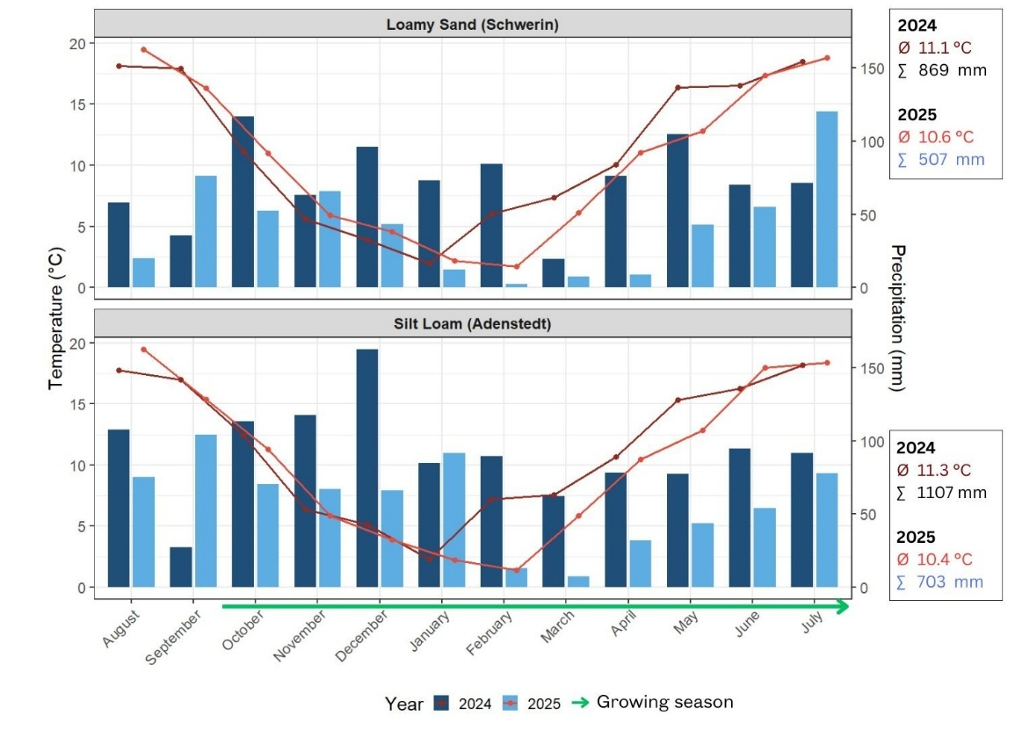
Fig. S. 1 Mean temperature (°C) and precipitation (mm) in 2024 (dark) and 2025 (light) of the nearby experimental weather station Schwerin and Alfeld (Leine) for Adenstedt. The green arrow marks the growing season for winter cereals in Germany (DWD 2025).

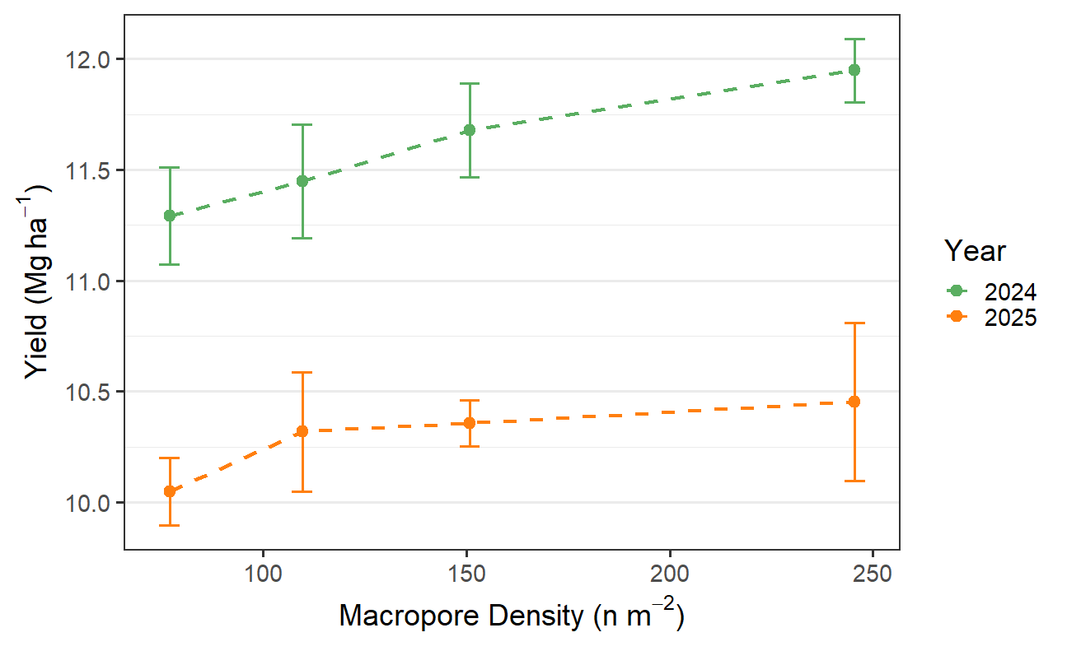
Fig. S. 2 Mean ± standard error of grain yield in relation to the total macropore density (artificial pores + biopores) of treatments at the Silt Loam site, separated into 2024 and 2025. Trends are indicated with dashed lines.

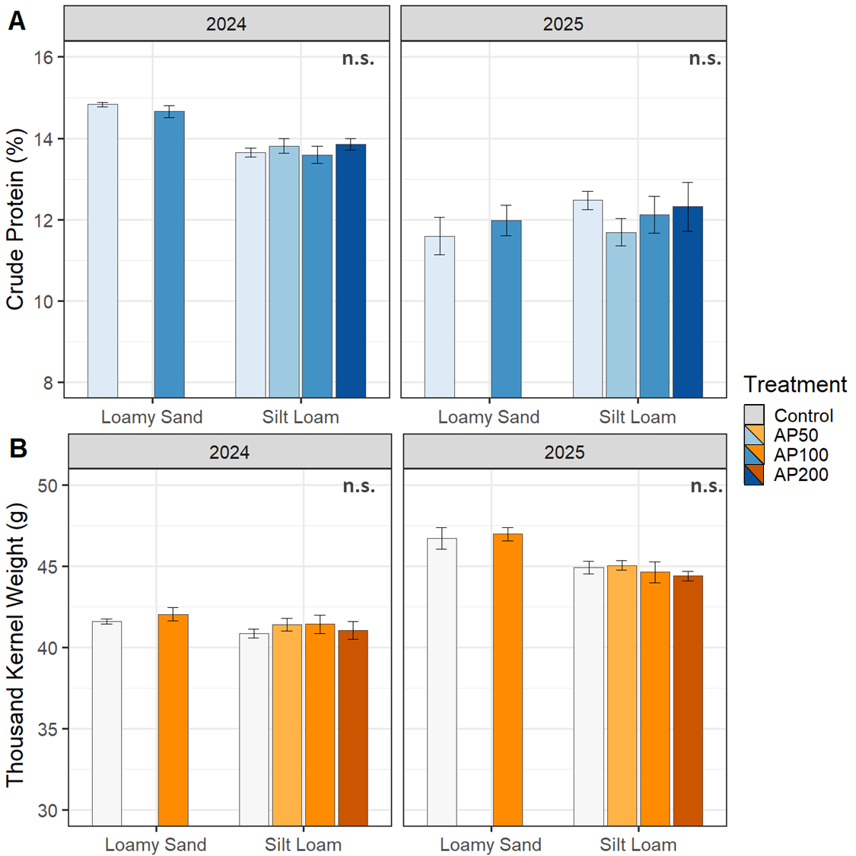
Fig. S. 3 Mean ± standard error of crude protein (%) (A) and thousand kernel weight (g) (B) for the sampling years 2024 (left) and 2025 (right). Treatments are represented by increasing color intensity from bright to dark: control, AP50, AP100, and AP200.
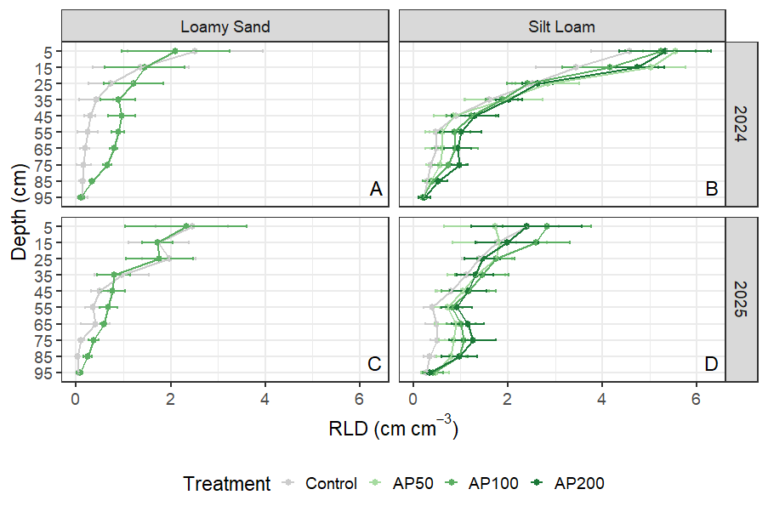
Fig. S. 4 Mean ± standard error of root length density (RLD) (cm cm⁻³) of 10 cm depth segments, based on profile images taken at the height of one pore row, of the control (grey) and the AP50, AP100 and AP200 treatment, with darker green is visualized in dependency of soil depth (cm). The plot displays the results of the Loamy Sand site (left) and the Silt Loam site (right) for the year 2024 and 2025.

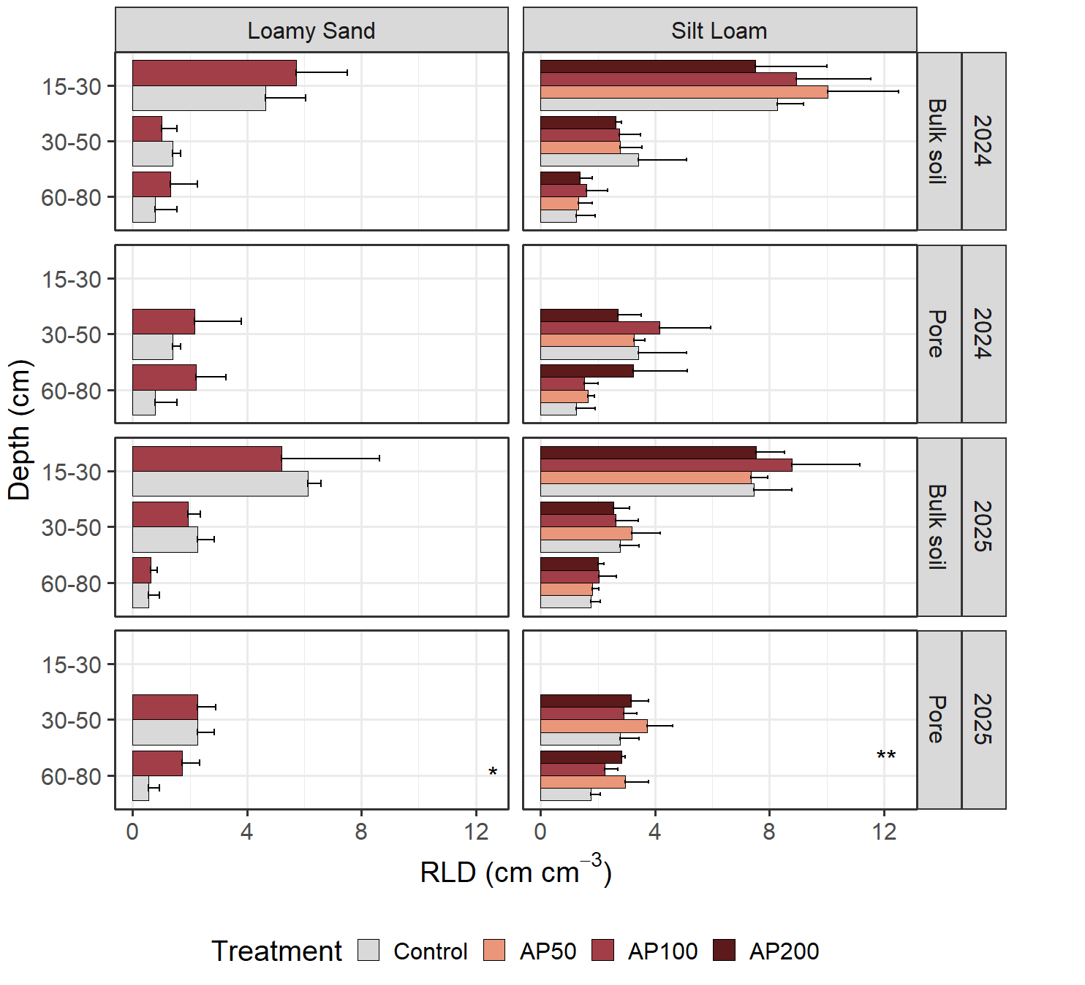
Fig. S. 5 Mean ± standard error of root length density (RLD) from root washing of each treatment in dependence of the depth segments measured on AP and in the bulk soil. Data is separated into sites and years. Significant differences are denoted with stars: p < 0.05 (*), p < 0.01 (**).
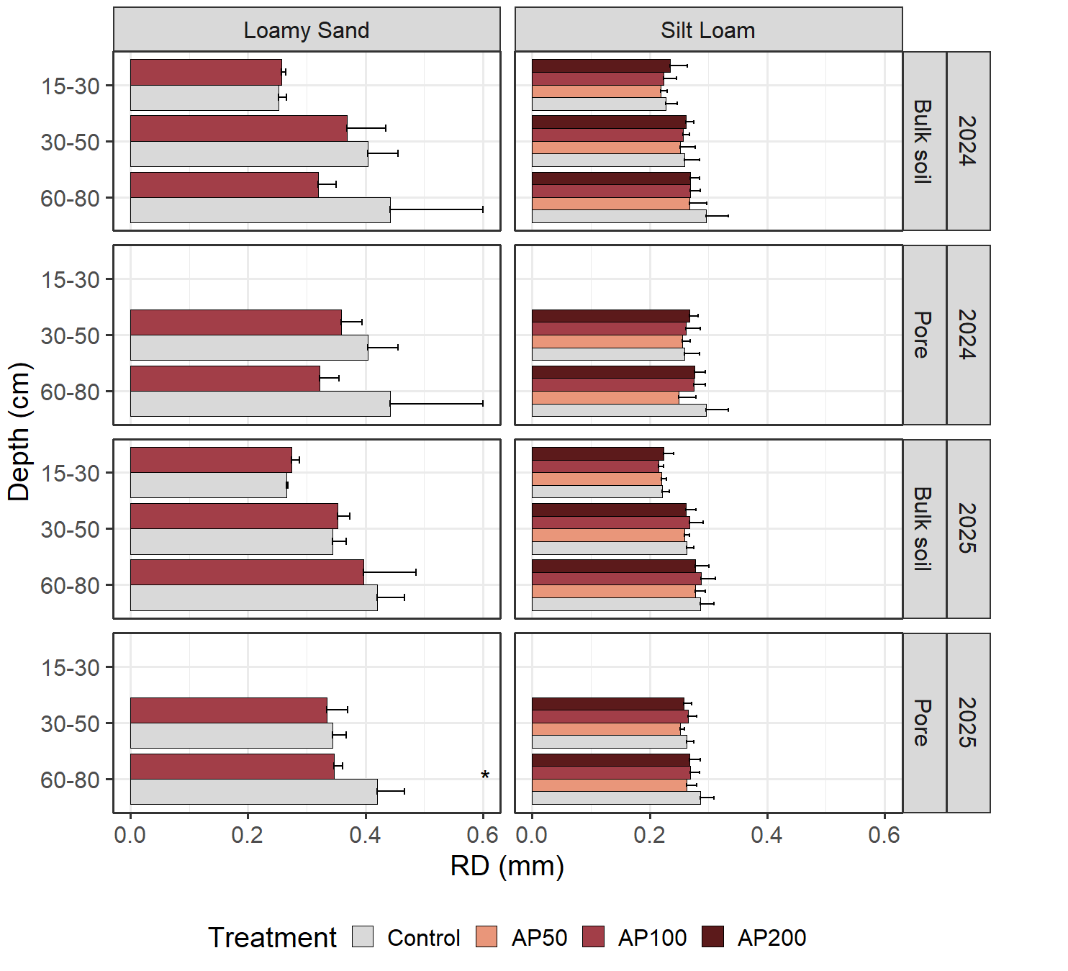
Fig. S. 6 Mean ± standard error of root diameter (RD) from root washing of each treatment in dependence of the depth segments measured on AP and in the bulk soil. Data is separated into sites and years. Significant differences are denoted with stars: p < 0.05 (*).

Root biomass calculation
Based on RLD and root dry weight the root length RL and the root carbon input was calculated per square meter with the following equations: Therefore, the RL per area was calculated starting with the calculation of a 10 x 10 cm square around the center of each AP of the AP100 treatments.
${RL}_{rs}={RLD}_{dc}*V_{dc}$ (eq. 1)
$V_{ds}=π*(r_{i}^{2}-r_{o}^{2})*h$ (eq. 2)
The root length of each ring segment (RL_{rs}) was determined by multiplying the root length density of the respective distance class (RLD_{dc}) by its calculated ring volume (V_{ds}) (eq. 1). The ring volume (V_{ds}) of each distance class was calculated as the volume of a cylindrical shell using the inner radius (rᵢ), outer radius (rₒ), and the height (h) of the respective depth segment. For each of the five distance classes, rᵢ and rₒ defined the radial boundaries of the ring around the pore center, while h corresponded to the height of the considered soil depth increment (eq. 2).
$${RL}_{cor}={RLD}_{ds5}*V_{cor}$$

For the corners of each 10 x 10 cm square, which is not represented by the RLD of the ring segments, the same RLD as of the outer ring segment (4-5 cm) was assumed. Consequently, the RL of the corner area (RL_{cor}) resulted from the volume of the corners (V_{cor}) multiplied by the RLD of the outer ring segment (RLD_{ds5}).
$${RLD}_{total}=\left(\sum_{p}{{RLD}_{rs}} +\sum_{p}{{RLD}_{cor}}\right)*10$$
The total RL per square meter (RL_{total}) in 0–30, 30–50, 50–80 and 80–100 cm depth, was finally calculated by summarizing the RL of the ring segments and the RL (RL_{rs}) of the corner area (RL_{cor}) for each AP (p) (10 in a row) and multiplying by 10 to represent 10 rows with 10 AP each.
Based on the soil cylinder measurements, a regression analysis was performed to estimate root dry weight from RLD for each depth segment (0–30, 30–50, 50–80), resulting in linear models (Fehler! Verweisquelle konnte nicht gefunden werden.). These models were used to estimate root biomass per square meter based on the corrected RLD from the soil profile images.
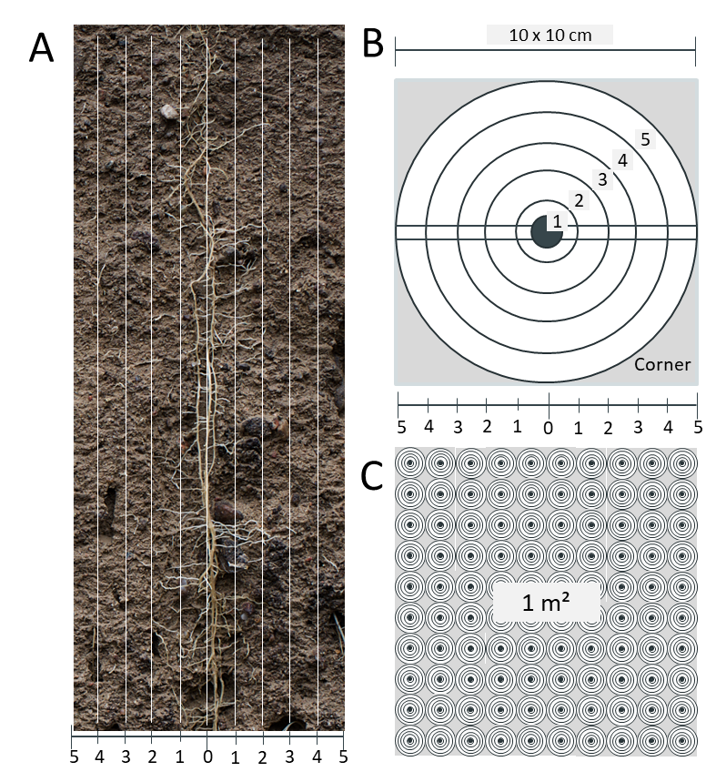
Fig. S. 7 Image slicing of distance segments of a AP (C) and an exemplary scheme for calculating root length per area based on two-dimensional image root analysis results (B; C).

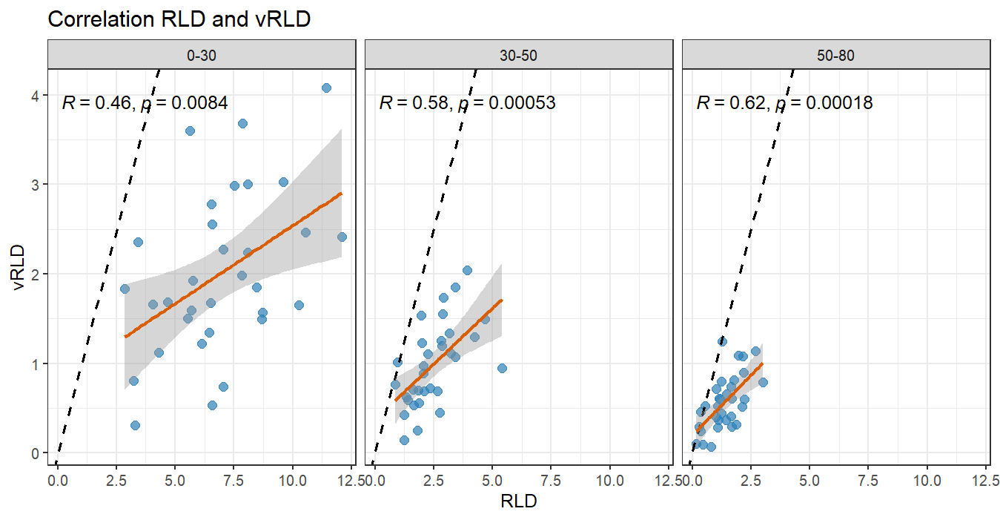
 | Intercept |  |  | Slope
RLD₁₅₋₃₀ = | 4.4871 | x | RLD_{Image} | 1.2027
RLD₃₀₋₅₀ = | 1.151 | x | RLD_{Image} | 1.3395
RLD₅₀₋₈₀ = | 0.5827 | x | RLD_{Image} | 1.4062
RLD₈₀₋₁₀₀ = | 0.5827 | x | RLD_{Image} | 1.4062

Fig. S. 8 Correlation of the root length density of the image analysis (RLD) and root washing of soil cylinders (vRLD). Solid lines represent fitted linear regressions with shaded 95% confidence intervals. Dashed lines represent a 1:1 relation. Corresponding models are represented in the table below.

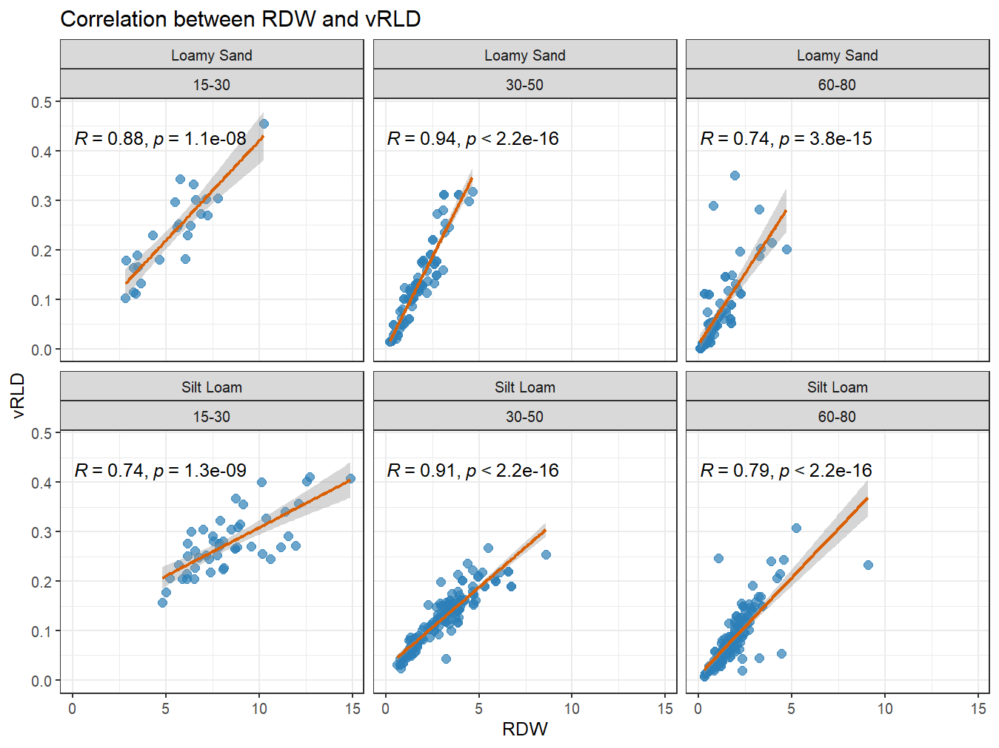
Fig. S. 9 Correlation between root dry weight (root dry weight) and volumetric root length density (vRLD) across sites and depth segments. Solid lines represent fitted linear regressions with shaded 95% confidence intervals. Corresponding models are represented in the table below.
For root-C calculation, root biomass was multiplied by a factor of 0.4 to derive the actual root C input (Poeplau et al. 2018). The corrected RLD and root dry weight in 80–100 cm depth was estimated using the model from the depth segment 50–80 cm, as no root washing was conducted in this depth. To improve root C estimation accuracy, the top 30 cm were excluded, where crop residues and high root densities may interfere with image analysis, thereby reducing potential noise in the data.
The root dry weight is equal to a root biomass C of 571 kg ha⁻¹ and 514 kg ha⁻¹ on the Loamy Sand and the Silt Loam, respectively, which enters the soil as C input. Around 70% of this C input is in the topsoil and 30% in the subsoil. No differences in root biomass C were detected between treatments and sites in the topsoil. Across both sites and years, AP100 did increase root biomass C almost significantly (p = 0.08) by +10% (+23 g kg-1) in subsoils (30-100 cm). Depth specifically, the root biomass carbon was significantly increased by AP100 compared to the control in 50–80 cm (+16%; p < 0.01) and in 80–100 cm depth (+13%; p < 0.01), while there was no significant effect in 30-50 cm depth (+2%).
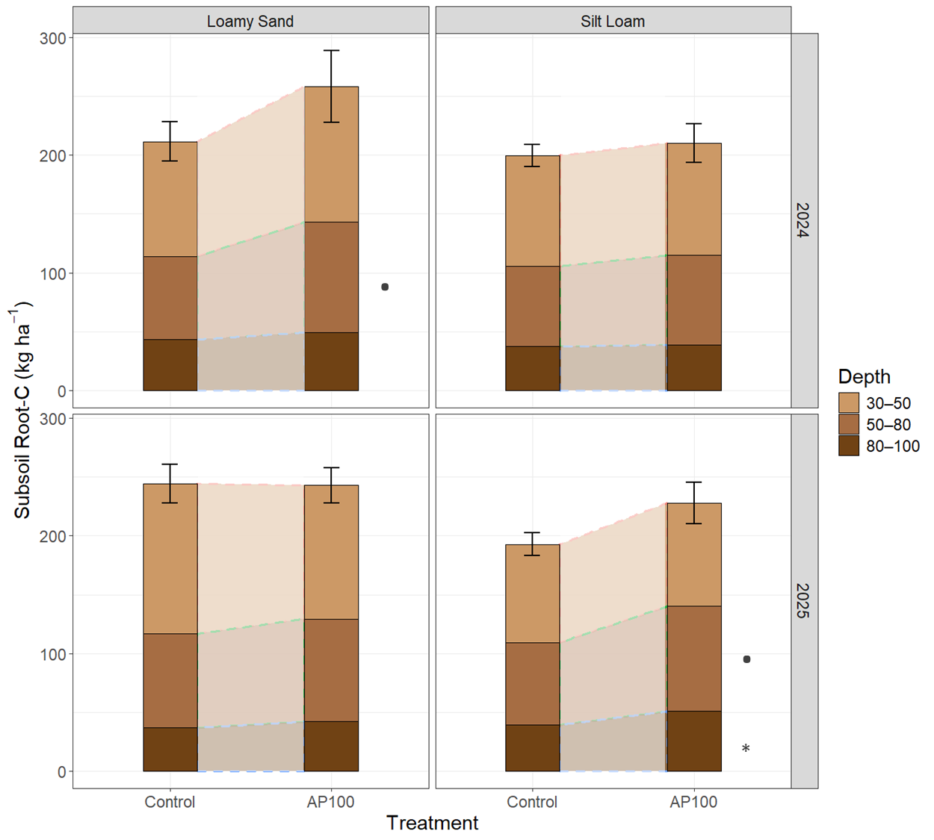
Fig. S. 10 Mean root C mass (kg ha-1) of cereals in different subsoil increments (30–50, 50–80, and 80–100 cm) of the control and the AP100 treatment. Data is shown for the Loamy Sand site (left) and the Silt Loam site (right) for 2024 (top) and 2025 (bottom). Significant differences between AP100 and the control are denoted with stars: p < 0.05 (*), p < 0.01 (**), p < 0.001 (***), and with a point: p < 0.1 (•).
Since soil is displaced during the creation AP, it stands to reason that the bulk soil will become compacted due to AP. If the displaced soil is calculated, the soil density increases by 0.79% in the AP100 treatment (1.600 g cm⁻³ to 1.613 g cm⁻³). However, our bulk density analyses did not reveal any significant effect of AP on the increase in bulk density (30-80 cm), except in 2025 in 30-40 cm depth. This is in line with findings of Lucas et al. (2019), where only the bulk soil in the immediate vicinity (< 1 mm) of macropores with maize roots growing through, was compacted due to root growth.
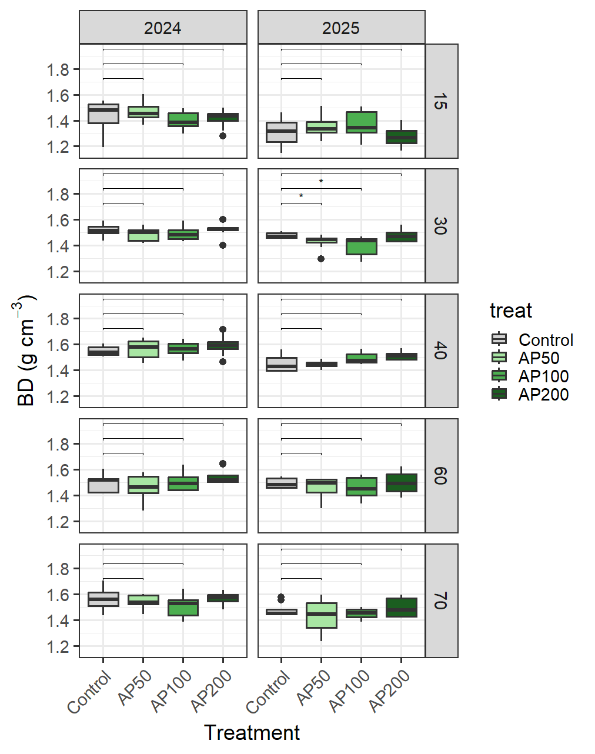
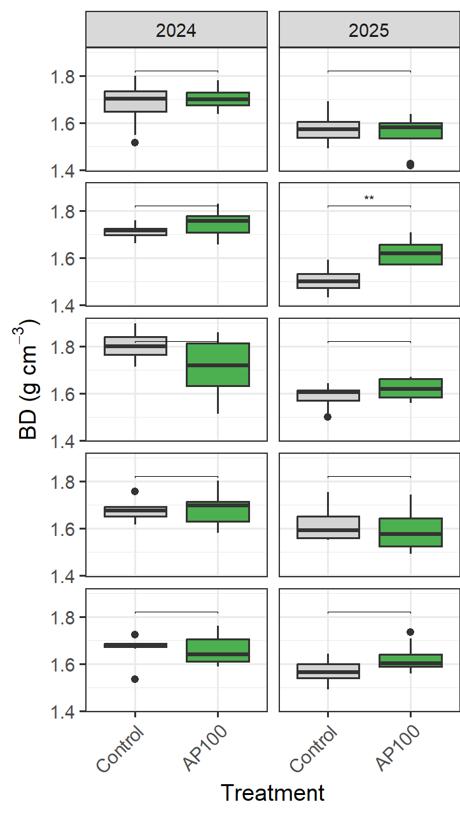
Fig. S. 11 Bulk Density of both sites in different depth increments, measured in corresponding treatments

