Supplementary information to:
Winter climate or plant functional type? Controls on tundra winter nitrogen uptake along an Arctic climate gradient
Laura Helene Rasmussen^{1,2 *}, Louise Rütting^{3,4}, Anders Michelsen⁵
¹Department of Geoscience, University of Tromsø, Tromsø, Norway
²Department of Mathematical Sciences, University of Copenhagen, Copenhagen, Denmark
³Chair of Soil and Plant Systems, Brandenburg University of Technology Cottbus-Senftenberg, Cottbus, Germany
⁴Department of Earth Sciences, University of Gothenburg, Gothenburg, Sweden
⁵Department of Biology, University of Copenhagen, Copenhagen, Denmark

Contents
Supplementary Tables S1-9
Supplementary Figures S1-13
Supplementary R code S1-3

Supplementary Tables: Winter N uptake

Table S1: Mean monthly air temperatures (°C) and snow depth (mm) where available for the four meteorological stations closest to the mesocosm sampling sites from Early to Late winter (October-April). Data was retrieved from Danish Meteorological Institute (Jensen et al. 2024) as available in Rasmussen et al. (2025).
 | Northern | Eastern | Southeastern |  | Southern
 | Ittoqottoormiit | Aputiteeq | Tasilaaq |  | Anqissoq
Month | Air temperature (°C) | Air temperature (°C) | Air temperature (°C) | Snow depth (mm) | Air temperature (°C)
October | -5 ± 0.7 | 0.08 ± 0.2 | 0.3 ± 0.1 | 74 ± 8 | 2.3 ± 0.02
November | -9 ± 1 | -3.1 ± 0.2 | -2.5 ± 0.1 | 154 ± 7 | 0.3 ± 0.02
December | -12 ± 0.7 | -7.0 ± 0.3 | -5.1 ± 0.1 | 212 ± 7 | -1.3 ± 0.03
January | -11.5 ± 0.5 | -8.1 ± 0.3 | -6.0 ± 0.2 | 237 ± 11 | -2.6 ± 0.03
February | -11.3 ± 1.7 | -7.0 ± 0.3 | -5.9 ± 0.2 | 283 ± 18 | -3.2 ± 0.03
March | -14.5 ± 1.5 | -8.9 ± 0.3 | -6.0 ± 0.1 | 456 ± 34 | -2.7 ± 0.03
April | -8 ± 2.1 | -4.4 ± 0.3 | -2.3 ± 0.1 | 398 ± 66 | -0.4 ± 0.02
Station ID (DMI) | 4339 | 4351 | 4360 |  | 4285

Table S2: Number of daylight hours (m/dd) applied in the controlled climate chambers before winter onset
Date (M/DD) | 9/1 | 9/8 | 9/15 | 9/22 | 9/29
Northern | 15 | 14 | 13 | 12 | 11
Eastern | 15 | 14 | 13 | 12 | 11
Southeastern | 14 | 13.5 | 12.5 | 12 | 11
Southern | 13.5 | 13 | 12.5 | 12 | 11

Table S3: ¹⁵N recovery (%) in the Northern ecosystem in % of added tracer
Winter_stage | Aboveground stem | Aboveground leaf | Microbial biomass | Fine roots | Coarse roots |  | Soil water
Early_Winter | 3.70 ± 0.05 | 1.63 ± 0.01 | 12.22 ± 1.73 | 0.27 ± 0.09 | 0.21 ± 0.06 | 2.73 ± 0.90
Midwinter_I | 2.93 ± 0.03 | 1.05 ± 0.01 | 27.22 ± 9.21 | 0.08 ± 0.03 | 0.32 ± 0.14 | 10.17 ± 3.19
Midwinter_II | 3.16 ± 0.03 | 1.03 ± 0.01 | 12.44 ± 3.90 | 0.04 ± 0.01 | 0.17 ± 0.05 | 3.85 ± 1.51
Late_Winter_C | 3.37 ± 0.04 | 1.59 ± 0.01 | 5.97 ± 4.07 | 0.10 ± 0.03 | 0.73 ± 0.57 | 2.11 ± 0.56
Late_Winter_WW | 3.18 ± 0.03 | 0.92 ± 0.01 | 11.19 ± 1.72 | 0.06 ± 0.02 | 0.32 ± 0.15 | 0.92 ± 0.29

Table S4: ¹⁵N recovery (%) in the Eastern ecosystem in % of added tracer
Winter_stage | Aboveground stem | Aboveground leaf | Microbial biomass | Fine roots | Coarse roots | Soil water
Early_Winter | 1.80 ± 0.02 | 1.27 ± 0.02 | 58.06 ± 16.05 | 0.69 ± 0.22 | 0.98 ± 0.20 | 5.32 ± 4.47
Midwinter_I | 2.49 ± 0.03 | 1.34 ± 0.02 | 33.02 ± 16.99 | 0.42 ± 0.15 | 1.90 ± 0.63 | 5.65 ± 2.62
Midwinter_II | 2.01 ± 0.03 | 1.33 ± 0.02 | 15.56 ± 3.06 | 0.36 ± 0.13 | 0.99 ± 0.38 | 3.36 ± 1.60
Late_Winter_C | 1.69 ± 0.02 | 1.37 ± 0.02 | 11.66 ± 1.85 | 0.30 ± 0.17 | 1.90 ± 0.90 | 1.98 ± 1.26
Late_Winter_WW | 2.07 ± 0.02 | 1.14 ± 0.01 | 13.40 ± 1.57 | 0.77 ± 0.48 | 0.63 ± 0.47 | 0.54 ± 0.23

Table S5: ¹⁵N recovery (%) in the Southeastern ecosystem in % of added tracer
Winter_stage | Aboveground stem |  | Aboveground leaf | Microbial biomass | Fine roots | Coarse roots | Soil water
Early_Winter | 3.36 ± 0.05 | 2.68 ± 0.03 |  | 13.03 ± 3.42 | 0.16 ± 0.04 | 0.65 ± 0.41 | 3.57 ± 2.36
Midwinter_I | 2.24 ± 0.03 | 2.08 ± 0.02 |  | 21.38 ± 9.72 | 0.32 ± 0.07 | 6.09 ± 5.03 | 5.33 ± 2.03
Midwinter_II | 2.53 ± 0.04 | 2.39 ± 0.03 |  | 15.28 ± 1.03 | 0.17 ± 0.07 | 1.92 ± 0.98 | 1.89 ± 0.67
Late_Winter_C | 1.99 ± 0.05 | 2.54 ± 0.03 |  | 6.20 ± 4.97 | 0.28 ± 0.19 | 4.19 ± 3.71 | 1.94 ± 1.02
Late_Winter_WW | 3.09 ± 0.05 | 2.37 ± 0.03 |  | 4.66 ± 1.52 | 0.55 ± 0.45 | 1.14 ± 0.89 | 2.64 ± 1.47

Table S6: ¹⁵N recovery (%) in the Southern ecosystem in % of added tracer
Winter_stage | Aboveground stem | Aboveground leaf | Microbial biomass | Fine roots | Coarse roots | Soil water
Early_Winter | 5.79 ± 0.17 | 2.07 ± 0.02 | 28.93 ± 5.93 | 0.05 ± 0.02 | 0.82 ± 0.41 | 1.90 ± 1.46
Midwinter_I | 1.92 ± 0.03 | 1.56 ± 0.01 | 44.62 ± 14.41 | 0.06 ± 0.02 | 1.50 ± 0.49 | 2.40 ± 0.74
Midwinter_II | 6.02 ± 0.19 | 1.94 ± 0.02 | 17.75 ± 4.11 | 0.05 ± 0.03 | 0.61 ± 0.23 | 0.75 ± 0.54
Late_Winter_C | 5.44 ± 0.15 | 1.58 ± 0.02 | 8.28 ± 1.58 | 0.01±0.005 | 0.82 ± 0.27 | 0.79 ± 0.45
Late_Winter_WW | 4.95 ± 0.13 | 2.11 ± 0.02 | 4.92 ± 3.12 | 0.06 ± 0.03 | 0.49 ± 0.32 | 0.17 ± 0.09

Table S7: Microbial C, N and C/N ratios of microbes pr g dry soil
Site | Early Winter |  | Midwinter_I | Midwinter_II | Late_Winter_C | Late_Winter_WW
µg C/g dry soil
Northern | 787.60 ± 229 |  | 1325.53 ± 328 | 1264.80 ± 565 | 195.43 ± 186 | 113.92 ± 42
Eastern | 1703.26 ± 689 |  | 1643.31 ± 873 | 496.07 ± 126 | 110.40 ± 31 | 340.30 ± 20
Southeastern | 638.99 ± 180 |  | 937.29 ± 477 | 987.08 ± 215 | 111.17 ± 93 | 353.92 ± 78
Southern | 478.46 ± 153 |  | 2428.10 ± 997 | 622.67 ± 176 | 153.58 ± 40 | 132.88 ± nan
µg N/g dry soil
Northern | 92.96 ± 30 |  | 148.50 ± 35 | 111.86 ± 48 | 41.00 ± 37 | 10.02 ± 4
Eastern | 117.89 ± 57 |  | 132.28 ± 73 | 37.95 ± 11 | 8.53 ± 2 | 14.58 ± 4
Southeastern | 41.36 ± 11 |  | 91.06 ± 50 | 115.19 ± 26 | 18.52 ± nan | 40.07 ± 9
Southern | 25.11 ± 4 |  | 107.78 ± 43 | 47.82 ± 14 | 14.93 ± 5 | 3.78 ± 3
C/N ratio of microbes
Northern | 10.41 ± 1 |  | 8.86 ± 1 | 6.82 ± 1 | 3.20 ± 1 | 10.96 ± 2
Eastern | 14.32 ± 1 |  | 12.39 ± 2 | 11.04 ± 1 | 13.34 ± 2 | 9.89 ± 0.4
Southeastern | 14.54 ± 2 |  | 9.26 ± 2 | 9.25 ± 2 | 11.03 ± nan | 8.85 ± 0.5
Southern | 15.21 ± 1 |  | 17.39 ± 2 | 13.11 ± 1 | 12.46 ± 3 | 13.84 ± nan

Table S8: Species-specific differences of mg ¹⁵N excess pr g dry weight biomass as calculated using the estimated marginal means with pairwise comparison between species (Tukey adjusted). Results are calculated for leaf biomass and stem biomass respectively.
contrast species | Estimate of difference (mg ¹⁵Nexcess/g dry weight biomass) | SE | df | t.ratio | p.value
Stem_leaf = Leaf:
contrast
Salix arctica - Betula | 0.106072 | 0.016916 | 853 | 6.27 | <.0001
Salix arctica - Cassiope | 0.113804 | 0.014158 | 853 | 8.038 | <.0001
Salix arctica - Dryas | 0.151453 | 0.023042 | 853 | 6.573 | <.0001
Salix arctica - Empetrum | 0.158431 | 0.010673 | 853 | 14.844 | <.0001
Salix arctica - Grass | 0.108667 | 0.010619 | 853 | 10.233 | <.0001
Salix arctica - Lichen | 0.280387 | 0.013904 | 853 | 20.166 | <.0001
Salix arctica - Moss | 0.232478 | 0.010412 | 853 | 22.329 | <.0001
Salix arctica - Pileurt | 0.149993 | 0.01487 | 853 | 10.087 | <.0001
Salix arctica - Salix herbacea | 0.089602 | 0.022635 | 853 | 3.959 | 0.0039
Salix arctica - Vaccinum | 0.17546 | 0.010642 | 853 | 16.488 | <.0001
Betula - Cassiope | 0.007732 | 0.01882 | 853 | 0.411 | 1
Betula - Dryas | 0.045381 | 0.026169 | 853 | 1.734 | 0.8176
Betula - Empetrum | 0.05236 | 0.016551 | 853 | 3.164 | 0.0605
Betula - Grass | 0.002595 | 0.016731 | 853 | 0.155 | 1
Betula - Lichen | 0.174315 | 0.018469 | 853 | 9.438 | <.0001
Betula - Moss | 0.126407 | 0.016347 | 853 | 7.732 | <.0001
Betula - Pileurt | 0.043921 | 0.019361 | 853 | 2.268 | 0.4567
Betula - Salix herbacea | -0.01647 | 0.025934 | 853 | -0.635 | 0.9999
Betula - Vaccinum | 0.069388 | 0.016582 | 853 | 4.185 | 0.0016
Cassiope - Dryas | 0.037649 | 0.024069 | 853 | 1.564 | 0.8968
Cassiope - Empetrum | 0.044627 | 0.014322 | 853 | 3.116 | 0.0694
Cassiope - Grass | -0.00514 | 0.014056 | 853 | -0.365 | 1
Cassiope - Lichen | 0.166583 | 0.016479 | 853 | 10.109 | <.0001
Cassiope - Moss | 0.118674 | 0.013471 | 853 | 8.809 | <.0001
Cassiope - Pileurt | 0.036189 | 0.016393 | 853 | 2.208 | 0.4999
Cassiope - Salix herbace | 0.024203 | 0.024563 | 853 | -0.985 | 0.9962
Cassiope - Vaccinum | 0.061656 | 0.013683 | 853 | 4.506 | 0.0004
Dryas - Empetrum | 0.006978 | 0.023133 | 853 | 0.302 | 1
Dryas - Grass | -0.04279 | 0.022945 | 853 | -1.865 | 0.7402
Dryas - Lichen | 0.128934 | 0.024491 | 853 | 5.264 | <.0001
Dryas - Moss | 0.081025 | 0.022628 | 853 | 3.581 | 0.0159
Dryas - Pileurt | -0.00146 | 0.024495 | 853 | -0.06 | 1
Dryas - Salix herbacea | -0.06185 | 0.030551 | 853 | -2.025 | 0.6317
Dryas - Vaccinum | 0.024007 | 0.022755 | 853 | 1.055 | 0.9935
Empetrum - Grass | -0.04976 | 0.009943 | 853 | -5.005 | <.0001
Empetrum - Lichen | 0.121955 | 0.0132 | 853 | 9.239 | <.0001
Empetrum - Moss | 0.074047 | 0.009936 | 853 | 7.452 | <.0001
Empetrum - Pileurt | -0.00844 | 0.015026 | 853 | -0.562 | 1
Empetrum - Salix herbace | 0.0688299 | 0.022134 | 853 | -3.11 | 0.0707
Empetrum - Vaccinum | 0.017029 | 0.010206 | 853 | 1.669 | 0.8513
Grass - Lichen | 0.17172 | 0.01359 | 853 | 12.636 | <.0001
Grass - Moss | 0.123811 | 0.009919 | 853 | 12.482 | <.0001
Grass - Pileurt | 0.041326 | 0.014773 | 853 | 2.797 | 0.1607
Grass - Salix herbacea | -0.01907 | 0.0223 | 853 | -0.855 | 0.9989
Grass - Vaccinum | 0.066793 | 0.010118 | 853 | 6.601 | <.0001
Lichen - Moss | -0.04791 | 0.013246 | 853 | -3.617 | 0.014
Lichen - Pileurt | -0.13039 | 0.017094 | 853 | -7.628 | <.0001
Lichen - Salix herbacea | -0.19079 | 0.023864 | 853 | -7.995 | <.0001
Lichen - Vaccinum | -0.10493 | 0.01353 | 853 | -7.755 | <.0001
Moss - Pileurt | -0.08249 | 0.014218 | 853 | -5.802 | <.0001
Moss - Salix herbacea | -0.14288 | 0.022305 | 853 | -6.406 | <.0001
Moss - Vaccinum | -0.05702 | 0.009868 | 853 | -5.778 | <.0001
Pileurt - Salix herbacea | -0.06039 | 0.02498 | 853 | -2.418 | 0.3564
Pileurt - Vaccinum | 0.025467 | 0.014418 | 853 | 1.766 | 0.7997
Salix herbacea - Vaccinum | 0.0858586 | 0.022417 | 853 | 3.83 | 0.0064
Stem_leaf = Stem:
contrast | estimate | SE | df | t.ratio | p.value
Salix arctica - Betula | -0.02453 | 0.017459 | 853 | -1.405 | 0.6248
Salix arctica - Cassiope | 0.054565 | 0.013962 | 853 | 3.908 | 0.001
Salix arctica - Dryas | nonEst | NA | NA | NA | NA
Salix arctica - Empetrum | 0.109757 | 0.010131 | 853 | 10.834 | <.0001
Salix arctica - Vaccinum | 0.023463 | 0.010424 | 853 | 2.251 | 0.1622
Betula - Cassiope | 0.079091 | 0.019409 | 853 | 4.075 | 0.0005
Betula - Empetrum | 0.134283 | 0.017275 | 853 | 7.773 | <.0001
Betula - Vaccinum | 0.047989 | 0.01737 | 853 | 2.763 | 0.0462
Cassiope - Empetrum | 0.055192 | 0.014228 | 853 | 3.879 | 0.0011
Cassiope - Vaccinum | -0.0311 | 0.013749 | 853 | -2.262 | 0.1583

Table S9: Atomic percentage excess of ¹⁵N (tracer N excess per unit N) for each site, winter stage and species.
Site | Winter_stage | Species | Stem_leaf | ¹⁵NAPE%
North | Early_Winter | Betula | Leaf | 0.018403
North | Early_Winter | Betula | Stem | 0.020193
North | Early_Winter | Cassiope | Leaf | 0.022466
North | Early_Winter | Cassiope | Stem | 0.021486
North | Early_Winter | Dryas | Leaf | 0.015949
North | Early_Winter | Grass | Leaf | 0.015569
North | Early_Winter | Lichen | Leaf | 0.012669
North | Early_Winter | Bryophytes | Leaf | 0.015188
North | Early_Winter | Pileurt | Leaf | 0.017499
North | Early_Winter | Salix | Leaf | 0.017168
North | Early_Winter | Salix | Stem | 0.018613
North | Early_Winter | Vaccinum | Leaf | 0.019667
North | Early_Winter | Vaccinum | Stem | 0.019861
North | Late_Winter_C | Betula | Leaf | 0.015724
North | Late_Winter_C | Betula | Stem | 0.018479
North | Late_Winter_C | Cassiope | Leaf | 0.022348
North | Late_Winter_C | Cassiope | Stem | 0.021139
North | Late_Winter_C | Dryas | Leaf | 0.017274
North | Late_Winter_C | Grass | Leaf | 0.015667
North | Late_Winter_C | Bryophytes | Leaf | 0.011547
North | Late_Winter_C | Pileurt | Leaf | 0.016599
North | Late_Winter_C | Salix | Leaf | 0.017226
North | Late_Winter_C | Salix | Stem | 0.018482
North | Late_Winter_C | Vaccinum | Leaf | 0.016759
North | Late_Winter_C | Vaccinum | Stem | 0.0217
North | Late_Winter_WW | Betula | Leaf | 0.015823
North | Late_Winter_WW | Betula | Stem | 0.020464
North | Late_Winter_WW | Cassiope | Leaf | 0.021515
North | Late_Winter_WW | Cassiope | Stem | 0.020908
North | Late_Winter_WW | Grass | Leaf
North | Late_Winter_WW | Bryophytes | Leaf | 0.014646
North | Late_Winter_WW | Pileurt | Leaf | 0.016722
North | Late_Winter_WW | Salix | Leaf | 0.019886
North | Late_Winter_WW | Salix | Stem | 0.01768
North | Late_Winter_WW | Vaccinum | Leaf | 0.016311
North | Late_Winter_WW | Vaccinum | Stem | 0.0231
North | Midwinter_I | Betula | Leaf | 0.016552
North | Midwinter_I | Betula | Stem | 0.020709
North | Midwinter_I | Cassiope | Leaf | 0.021918
North | Midwinter_I | Cassiope | Stem | 0.021711
North | Midwinter_I | Grass | Leaf | 0.013988
North | Midwinter_I | Lichen | Leaf | 0.014629
North | Midwinter_I | Bryophytes | Leaf | 0.014541
North | Midwinter_I | Pileurt | Leaf | 0.017869
North | Midwinter_I | Salix | Leaf | 0.016588
North | Midwinter_I | Salix | Stem | 0.018245
North | Midwinter_I | Vaccinum | Leaf | 0.018123
North | Midwinter_I | Vaccinum | Stem | 0.02067
North | Midwinter_II | Betula | Leaf | 0.014641
North | Midwinter_II | Betula | Stem | 0.016272
North | Midwinter_II | Cassiope | Leaf | 0.020692
North | Midwinter_II | Cassiope | Stem | 0.021411
North | Midwinter_II | Grass | Leaf | 0.014029
North | Midwinter_II | Bryophytes | Leaf | 0.014031
North | Midwinter_II | Pileurt | Leaf | 0.018031
North | Midwinter_II | Salix | Leaf | 0.015624
North | Midwinter_II | Salix | Stem | 0.016741
North | Midwinter_II | Vaccinum | Leaf | 0.017872
North | Midwinter_II | Vaccinum | Stem | 0.021471
East | Early_Winter | Empetrum | Leaf | 0.022198
East | Early_Winter | Empetrum | Stem | 0.022047
East | Early_Winter | Grass | Leaf | 0.015324
East | Early_Winter | Lichen | Leaf | 0.008039
East | Early_Winter | Bryophytes | Leaf | 0.01026
East | Early_Winter | Salix | Leaf | 0.018088
East | Early_Winter | Salix | Stem | 0.019995
East | Early_Winter | Vaccinum | Leaf | 0.01904
East | Early_Winter | Vaccinum | Stem | 0.020619
East | Late_Winter_C | Empetrum | Leaf | 0.020734
East | Late_Winter_C | Empetrum | Stem | 0.02118
East | Late_Winter_C | Grass | Leaf | 0.015154
East | Late_Winter_C | Bryophytes | Leaf | 0.011711
East | Late_Winter_C | Salix | Leaf | 0.019243
East | Late_Winter_C | Salix | Stem | 0.01651
East | Late_Winter_C | Vaccinum | Leaf | 0.018129
East | Late_Winter_C | Vaccinum | Stem | 0.01934
East | Late_Winter_WW | Empetrum | Leaf | 0.02061
East | Late_Winter_WW | Empetrum | Stem | 0.021246
East | Late_Winter_WW | Grass | Leaf | 0.015783
East | Late_Winter_WW | Bryophytes | Leaf | 0.013341
East | Late_Winter_WW | Salix | Leaf | 0.016665
East | Late_Winter_WW | Salix | Stem | 0.01753
East | Late_Winter_WW | Salix herbacea | Leaf | 0.016583
East | Late_Winter_WW | Vaccinum | Leaf | 0.016954
East | Late_Winter_WW | Vaccinum | Stem | 0.020908
East | Midwinter_I | Empetrum | Leaf | 0.020944
East | Midwinter_I | Empetrum | Stem | 0.020884
East | Midwinter_I | Grass | Leaf | 0.015003
East | Midwinter_I | Bryophytes | Leaf | 0.009105
East | Midwinter_I | Salix | Leaf | 0.017023
East | Midwinter_I | Salix | Stem | 0.017881
East | Midwinter_I | Vaccinum | Leaf | 0.018197
East | Midwinter_I | Vaccinum | Stem | 0.019666
East | Midwinter_II | Empetrum | Leaf | 0.020749
East | Midwinter_II | Empetrum | Stem | 0.020463
East | Midwinter_II | Grass | Leaf | 0.015174
East | Midwinter_II | Bryophytes | Leaf | 0.01451
East | Midwinter_II | Salix | Leaf | 0.015035
East | Midwinter_II | Salix | Stem | 0.017772
East | Midwinter_II | Vaccinum | Leaf | 0.019235
East | Midwinter_II | Vaccinum | Stem | 0.020901
Southeast | Early_Winter | Empetrum | Leaf | 0.022073
Southeast | Early_Winter | Empetrum | Stem | 0.021884
Southeast | Early_Winter | Grass | Leaf | 0.015742
Southeast | Early_Winter | Lichen | Leaf | 0.015534
Southeast | Early_Winter | Bryophytes | Leaf | 0.005735
Southeast | Early_Winter | Salix | Leaf | 0.017783
Southeast | Early_Winter | Salix | Stem | 0.019121
Southeast | Early_Winter | Salix herbacea | Leaf | 0.019014
Southeast | Early_Winter | Vaccinum | Leaf | 0.019373
Southeast | Early_Winter | Vaccinum | Stem | 0.019897
Southeast | Late_Winter_C | Empetrum | Leaf | 0.020524
Southeast | Late_Winter_C | Empetrum | Stem | 0.021613
Southeast | Late_Winter_C | Grass | Leaf | 0.017059
Southeast | Late_Winter_C | Bryophytes | Leaf | 0.017629
Southeast | Late_Winter_C | Salix | Leaf | 0.019013
Southeast | Late_Winter_C | Salix | Stem | 0.017044
Southeast | Late_Winter_C | Vaccinum | Leaf | 0.016691
Southeast | Late_Winter_C | Vaccinum | Stem
Southeast | Late_Winter_WW | Empetrum | Leaf | 0.020922
Southeast | Late_Winter_WW | Empetrum | Stem | 0.020013
Southeast | Late_Winter_WW | Grass | Leaf | 0.014068
Southeast | Late_Winter_WW | Bryophytes | Leaf | 0.010926
Southeast | Late_Winter_WW | Salix | Leaf | 0.015888
Southeast | Late_Winter_WW | Salix | Stem | 0.0164
Southeast | Late_Winter_WW | Vaccinum | Leaf | 0.016213
Southeast | Late_Winter_WW | Vaccinum | Stem | 0.021576
Southeast | Midwinter_I | Empetrum | Leaf | 0.020055
Southeast | Midwinter_I | Empetrum | Stem | 0.020337
Southeast | Midwinter_I | Grass | Leaf | 0.016386
Southeast | Midwinter_I | Bryophytes | Leaf | 0.012828
Southeast | Midwinter_I | Salix | Leaf | 0.01752
Southeast | Midwinter_I | Salix | Stem | 0.018155
Southeast | Midwinter_I | Salix herbacea | Leaf | 0.016818
Southeast | Midwinter_I | Vaccinum | Leaf | 0.017849
Southeast | Midwinter_I | Vaccinum | Stem | 0.016106
Southeast | Midwinter_II | Empetrum | Leaf | 0.021814
Southeast | Midwinter_II | Empetrum | Stem | 0.020971
Southeast | Midwinter_II | Grass | Leaf | 0.014537
Southeast | Midwinter_II | Bryophytes | Leaf | 0.010437
Southeast | Midwinter_II | Salix | Leaf | 0.015892
Southeast | Midwinter_II | Salix | Stem | 0.015182
Southeast | Midwinter_II | Vaccinum | Leaf | 0.019082
Southeast | Midwinter_II | Vaccinum | Stem | 0.019786
South | Early_Winter | Betula | Leaf | 0.016438
South | Early_Winter | Betula | Stem | 0.021851
South | Early_Winter | Empetrum | Leaf | 0.022331
South | Early_Winter | Empetrum | Stem | 0.022056
South | Early_Winter | Grass | Leaf | 0.015502
South | Early_Winter | Lichen | Leaf | 0.015416
South | Early_Winter | Bryophytes | Leaf | 0.015812
South | Early_Winter | Salix | Leaf | 0.018191
South | Early_Winter | Salix | Stem | 0.018973
South | Early_Winter | Salix herbacea | Leaf | 0.019698
South | Early_Winter | Vaccinum | Leaf | 0.018972
South | Early_Winter | Vaccinum | Stem | 0.019301
South | Late_Winter_C | Betula | Leaf | 0.021861
South | Late_Winter_C | Betula | Stem | 0.020179
South | Late_Winter_C | Empetrum | Leaf | 0.020023
South | Late_Winter_C | Empetrum | Stem | 0.020527
South | Late_Winter_C | Lichen | Leaf | 0.014473
South | Late_Winter_C | Bryophytes | Leaf
South | Late_Winter_C | Salix | Leaf | 0.017629
South | Late_Winter_C | Salix | Stem | 0.018279
South | Late_Winter_C | Salix herbacea | Leaf | 0.015272
South | Late_Winter_C | Vaccinum | Leaf | 0.016198
South | Late_Winter_C | Vaccinum | Stem | 0.020694
South | Late_Winter_WW | Betula | Leaf | 0.014747
South | Late_Winter_WW | Betula | Stem | 0.019341
South | Late_Winter_WW | Empetrum | Leaf | 0.020133
South | Late_Winter_WW | Empetrum | Stem | 0.020111
South | Late_Winter_WW | Grass | Leaf | 0.015334
South | Late_Winter_WW | Bryophytes | Leaf | 0.016349
South | Late_Winter_WW | Salix | Leaf | 0.01632
South | Late_Winter_WW | Salix | Stem | 0.01851
South | Late_Winter_WW | Salix herbacea | Leaf
South | Late_Winter_WW | Vaccinum | Leaf | 0.016868
South | Late_Winter_WW | Vaccinum | Stem | 0.021256
South | Midwinter_I | Betula | Leaf | 0.015079
South | Midwinter_I | Betula | Stem
South | Midwinter_I | Empetrum | Leaf | 0.02072
South | Midwinter_I | Empetrum | Stem | 0.019798
South | Midwinter_I | Grass | Leaf | 0.015856
South | Midwinter_I | Lichen | Leaf | 0.014514
South | Midwinter_I | Bryophytes | Leaf | 0.014886
South | Midwinter_I | Salix | Leaf | 0.016551
South | Midwinter_I | Salix | Stem | 0.01825
South | Midwinter_I | Salix herbacea | Leaf | 0.017813
South | Midwinter_I | Vaccinum | Leaf | 0.01897
South | Midwinter_I | Vaccinum | Stem | 0.020671
South | Midwinter_II | Betula | Leaf | 0.0152
South | Midwinter_II | Betula | Stem | 0.021651
South | Midwinter_II | Empetrum | Leaf | 0.019824
South | Midwinter_II | Empetrum | Stem | 0.022016
South | Midwinter_II | Grass | Leaf | 0.015498
South | Midwinter_II | Lichen | Leaf | 0.015003
South | Midwinter_II | Bryophytes | Leaf | 0.0143
South | Midwinter_II | Salix | Leaf | 0.015658
South | Midwinter_II | Salix | Stem | 0.019343
South | Midwinter_II | Salix herbacea | Leaf | 0.017522
South | Midwinter_II | Vaccinum | Leaf | 0.016968
South | Midwinter_II | Vaccinum | Stem | 0.01847

Supplementary Figures

Figure S1: Conceptual representation of recovery calculations
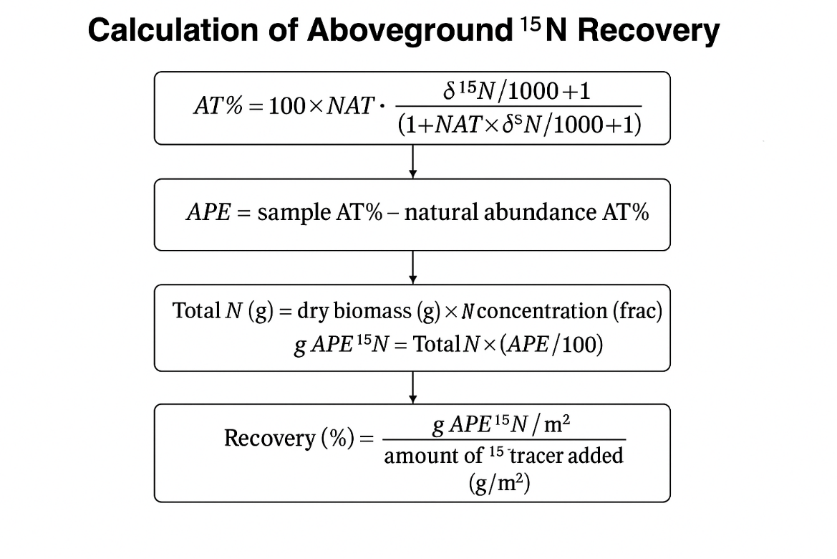

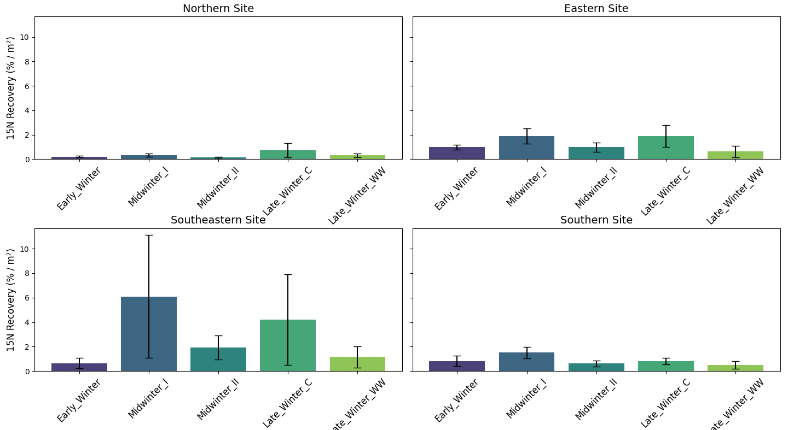
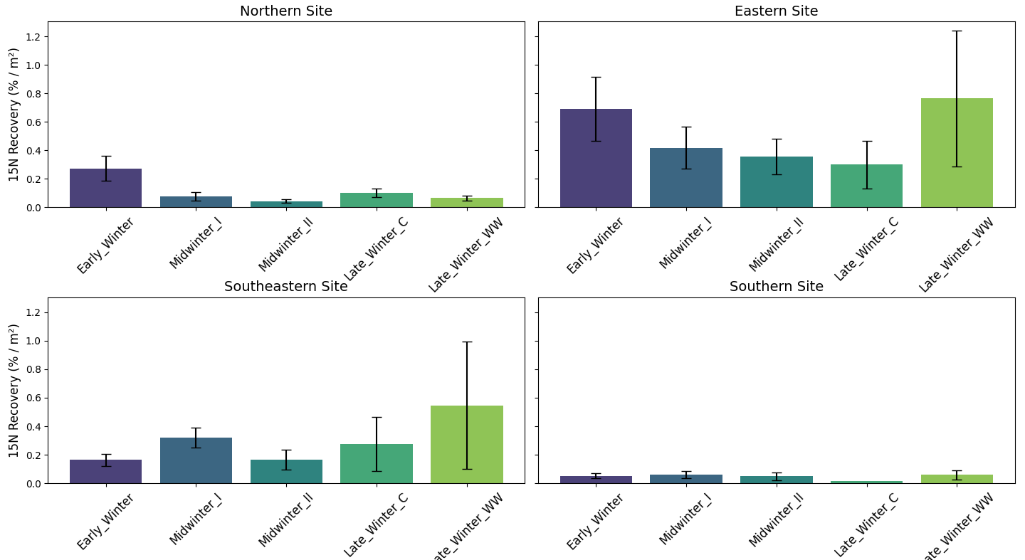
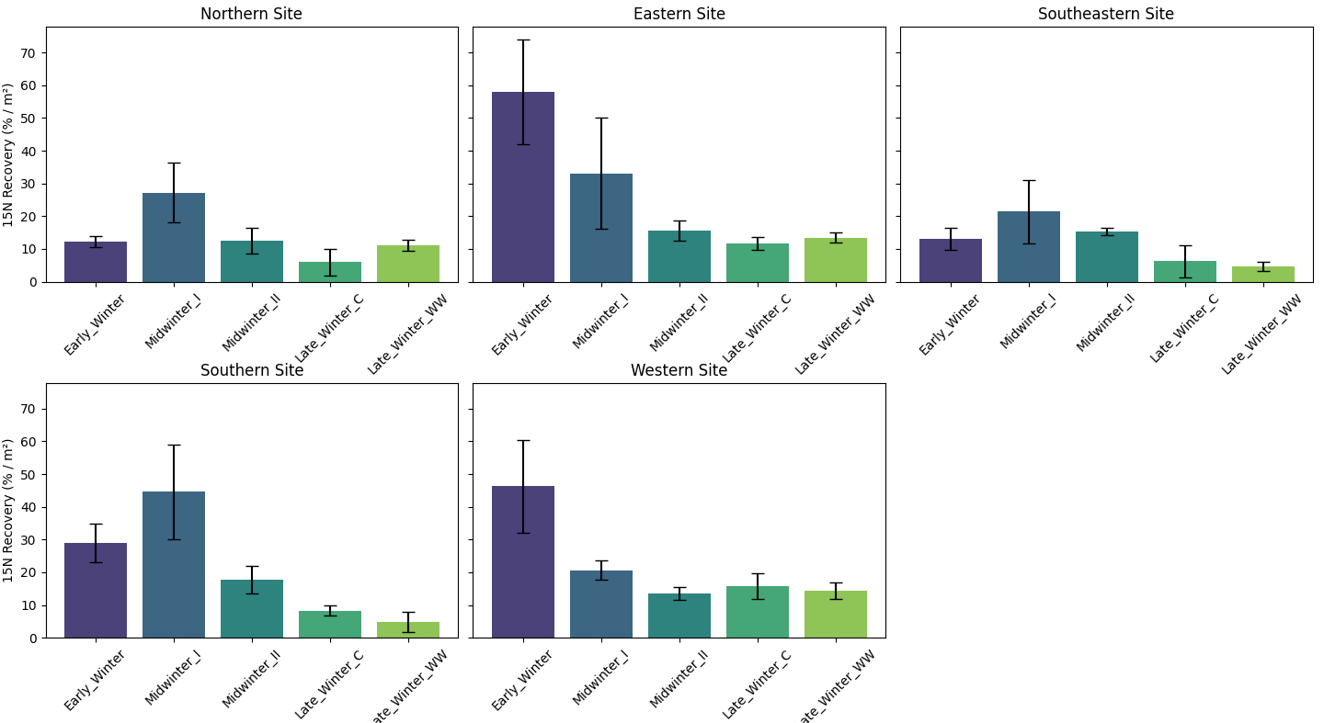
Figure S2: Root recovery of tracer N:
Coarse > 1mm
Coarse > 1mm
Coarse > 1mm
Coarse > 1mm
Fine < 1mm
Fine < 1mm
Fine < 1mm
Fine < 1mm
¹⁵N recovery (%) of tracer N injection in roots: Coarse roots >1 mm (upper), Fine roots (lower). A: Northern site, B: Eastern site, C: Southeastern site and D: Southern site.

Figure S3: Microbial N recovery:
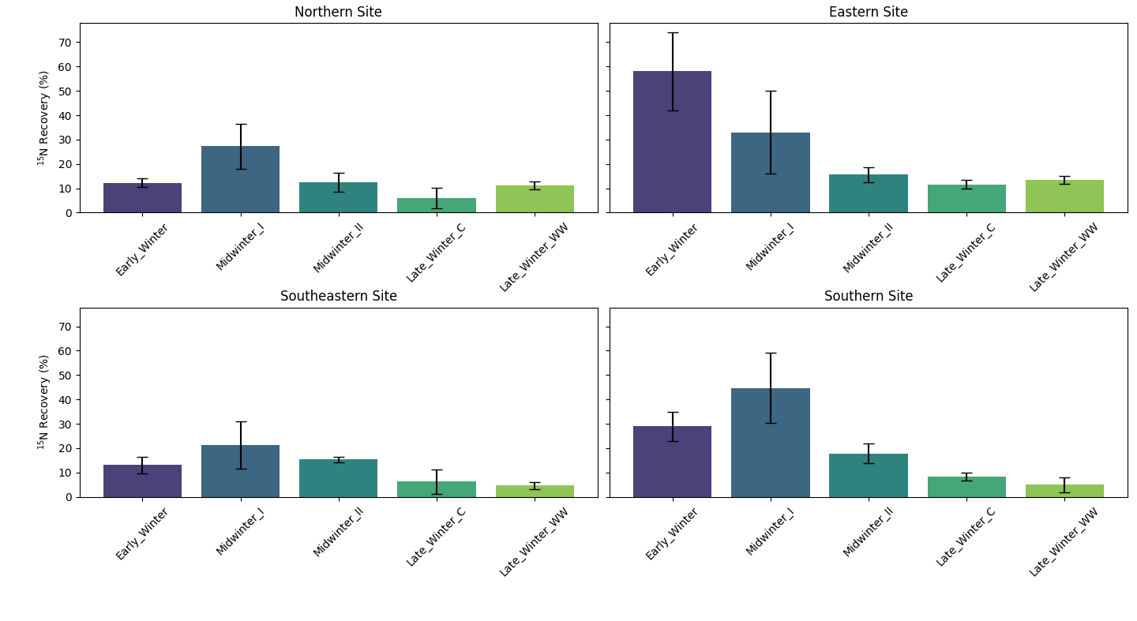
¹⁵N recovery (%) of tracer N injection in microbes split on site over the winter stages.

Figure S4: Soil water content of tracer N:
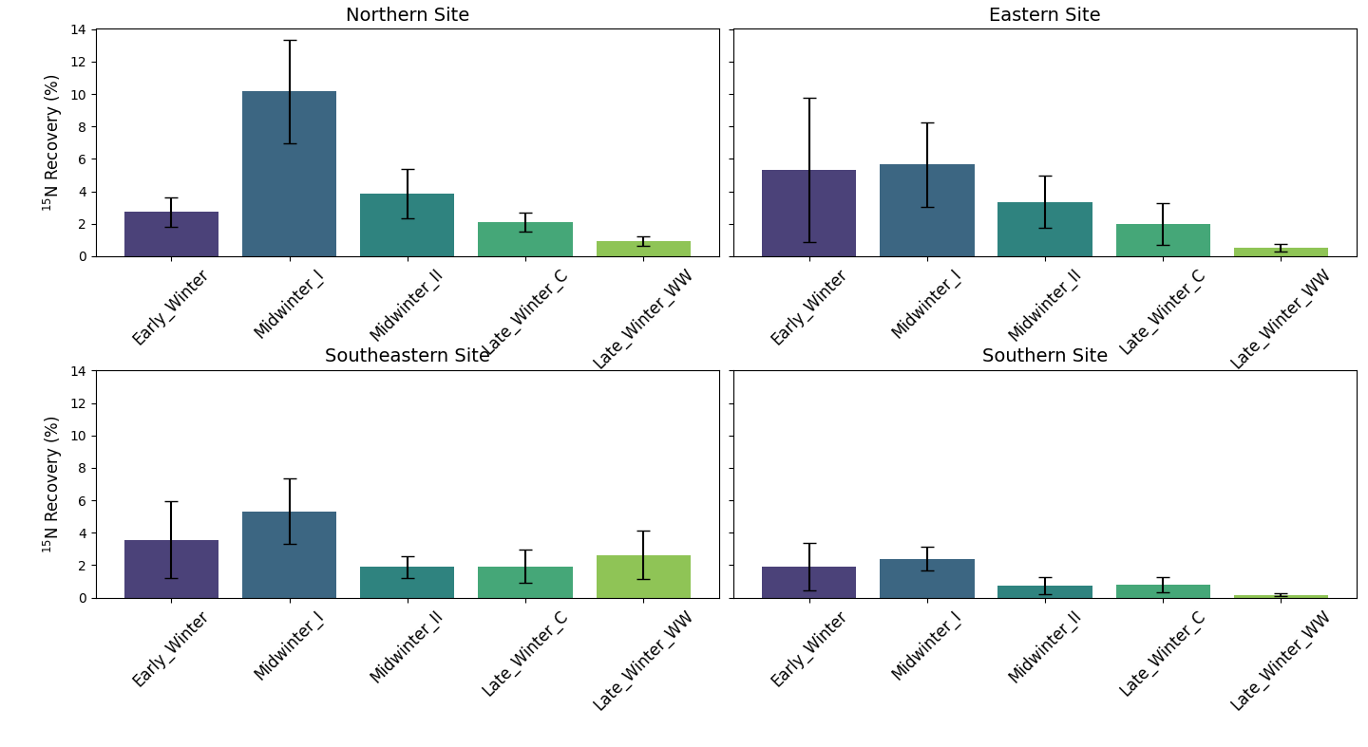
¹⁵N recovery (%) of tracer N injection in soil solution.

Figure S5: Aboveground recovery (%) on unit area basis species-specifically – North:
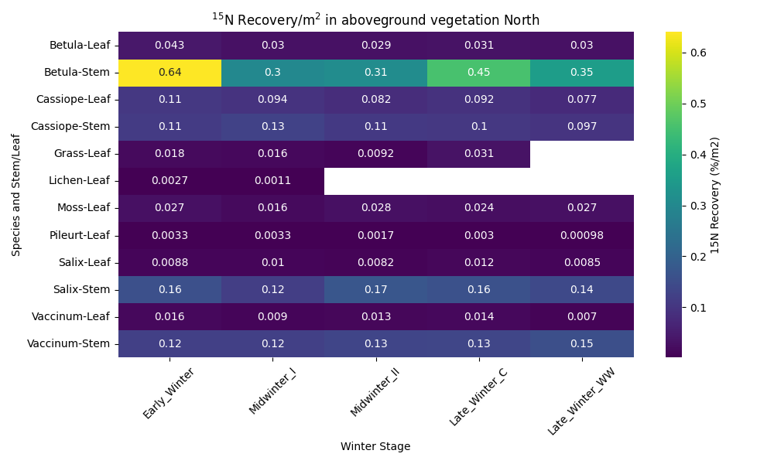
¹⁵N recovery (%)
Figure S6: Aboveground recovery (%) on unit area basis species-specifically – East:
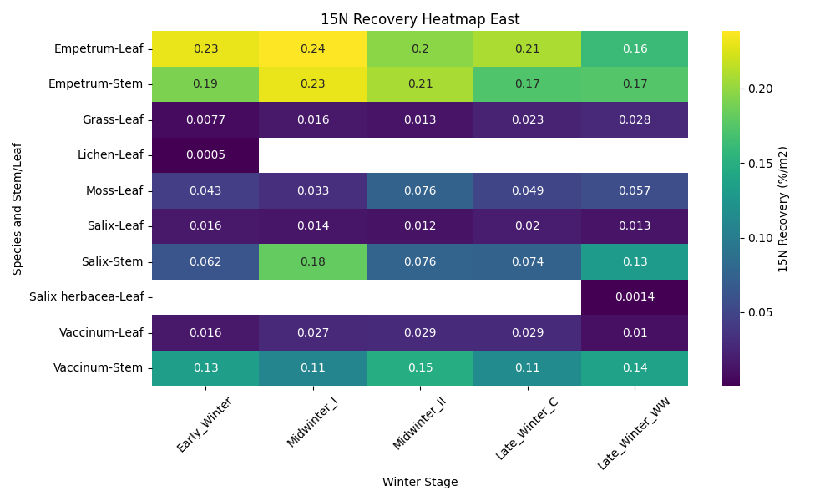
¹⁵N recovery (%)
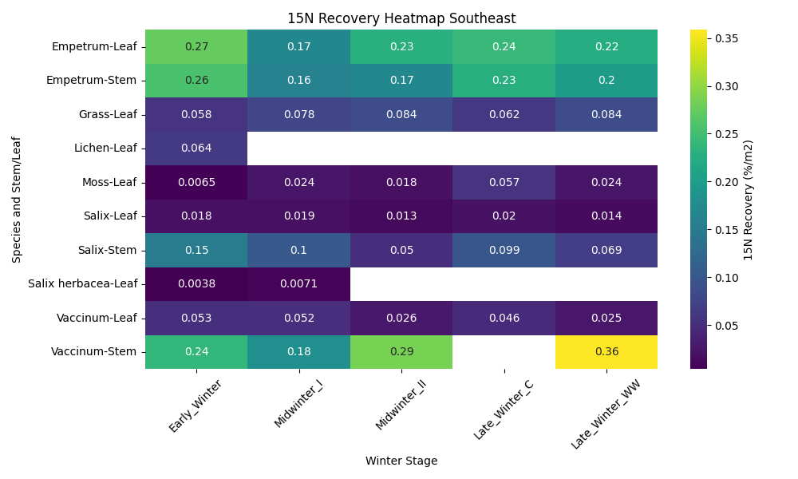
Figure S7: Aboveground recovery (%) on unit area basis species-specifically – Southeast:

¹⁵N recovery (%)

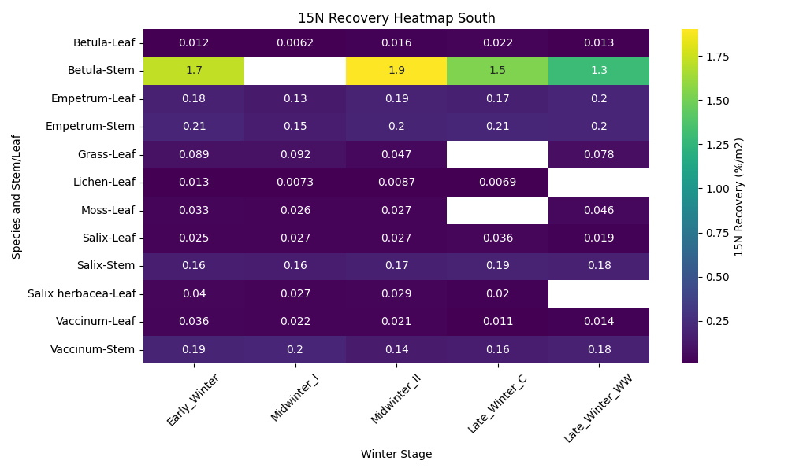
Figure S8: Aboveground recovery (%) on unit area basis species-specifically – South:
¹⁵N recovery (%)

Figure S9: Aboveground ¹⁵N recovery species-specifically averaged over site and winter stage, including comparison to Empetrum

Figure S9: Species-specific ¹⁵N recovery per unit area across the climate gradient and winter stage:
Winter-released ¹⁵N uptake per unit area for the dominating vegetation (leaf and stem pooled) to the level of species (shrubs and common forbs) and plant functional type (Bryophyteses, grasses, lichen). Pairwise comparisons were made with Tukey’s adjusted pairwise t-test, df=853,,significance level = 0.05). Genus terms refer to: Empetrum nigrum, Betula nana, Cassiope tetragona, Dryas integrifolia, Vaccinum uliginosum, Salix arctica, Polygonum viviparum.

Salix arctica
Bistorta
Bryophytes

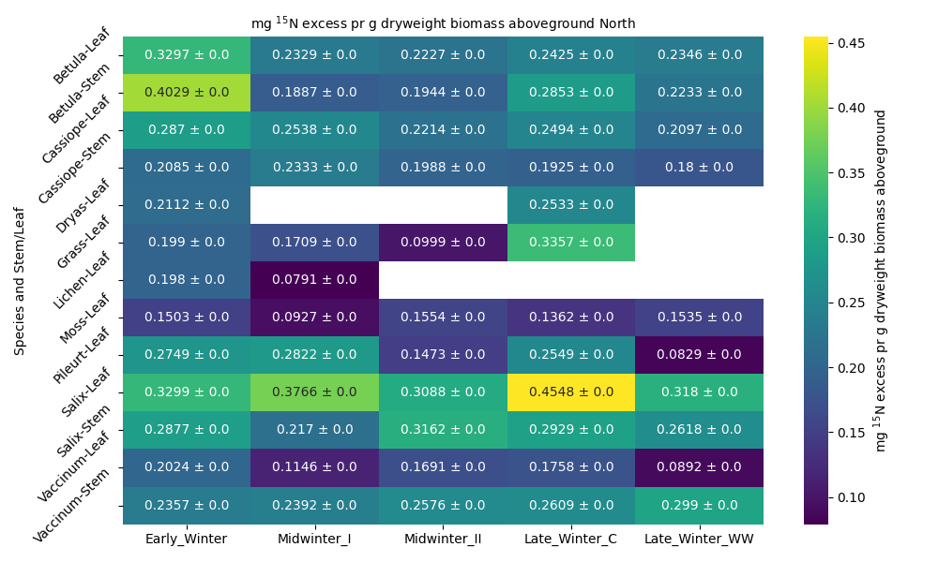
Figure S10: Species-specific ¹⁵N excess pr g dry weight in aboveground vegetation Northern site

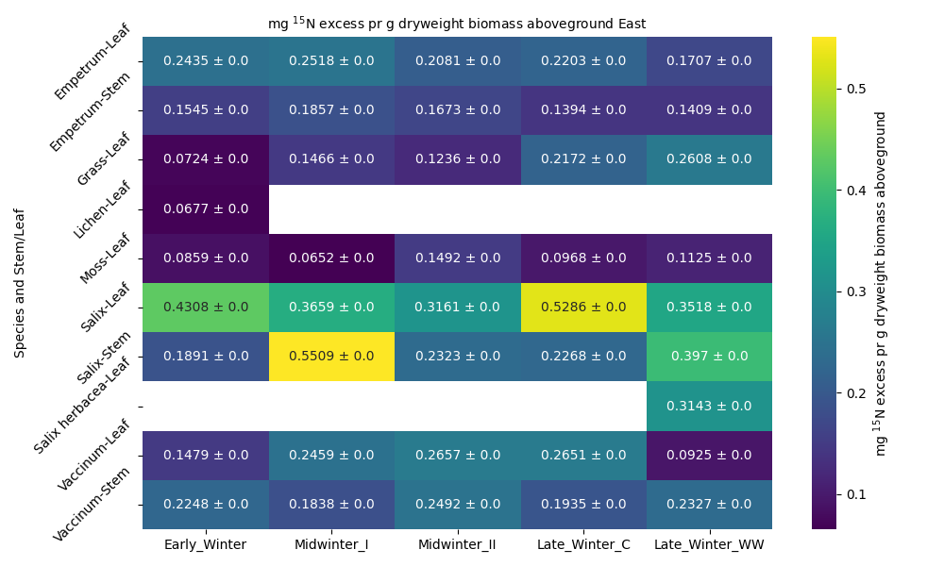
Figure S11: Species-specific ¹⁵N excess pr g dry weight in aboveground vegetation Eastern site

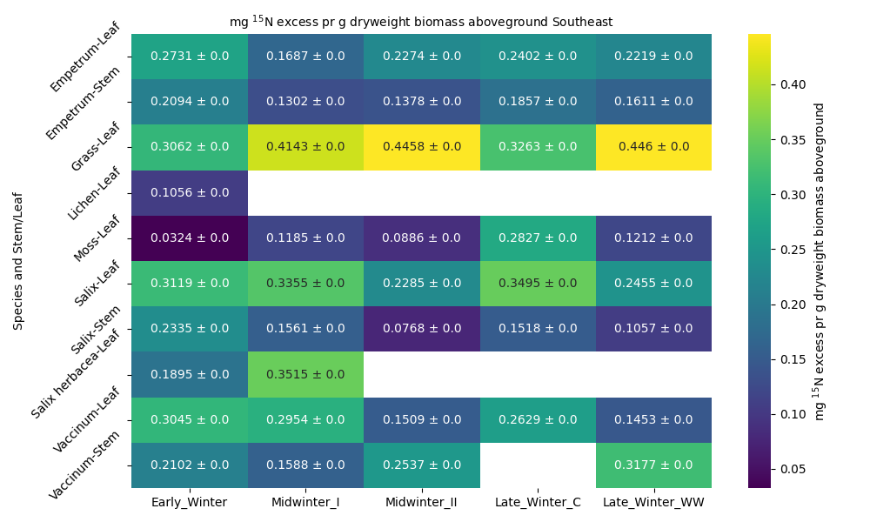
Figure S12: Species-specific ¹⁵N excess pr g dry weight in aboveground vegetation Southeastern site

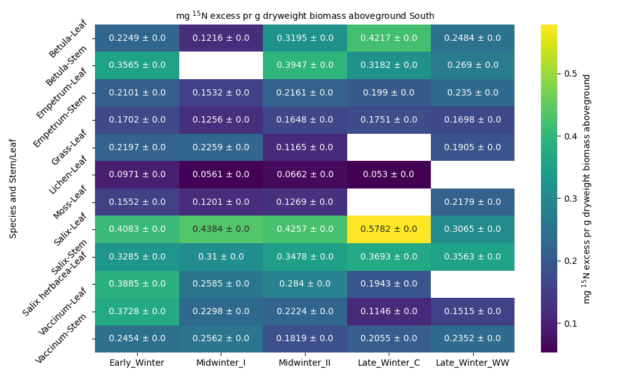
Figure S13: Species-specific ¹⁵N excess pr g dry weight in aboveground vegetation Southern site

GLMM_supplementary_code_S1-3
2026-06-30

Supplementary code S1: Roots
Read in the data and factorize the factors
#df_roots <- read_xlsx("Your_directory/df_roots.xlsx")
df_roots <- read_xlsx("Your_directory/df_roots.xlsx")
df_roots <- df_roots %>% rename(APE15N_pr_m2='g_root_15APE%_per_m2')
df_roots <- df_roots %>% rename(APE15N='15NAPE%')
df_roots <- df_roots %>% mutate(Fine_coarse=factor(Fine_coarse))
df_roots <- df_roots %>% mutate(Winter_stage=factor(Winter_stage))
df_roots <- df_roots %>% mutate(Site=factor(Site))
Test whether it is normally distributed and transform to get as close to normality as possible
print(bestNormalize(df_roots$APE15N_pr_m2))
Best Normalizing transformation with 254 Observations
Estimated Normality Statistics (Pearson P / df, lower => more normal):
- arcsinh(x): 8.1417
- Box-Cox: 1.2098
- Center+scale: 10.5594
- Double Reversed Log_b(x+a): 9.8275
- Exp(x): 15.7789
- Log_b(x+a): 1.1416
- orderNorm (ORQ): 1.1733
- sqrt(x + a): 3.7017
- Yeo-Johnson: 3.2941
Estimation method: Out-of-sample via CV with 10 folds and 5 repeats
Based off these, bestNormalize chose:
Standardized Log_b(x + a) Transformation with 254 nonmissing obs.:
Relevant statistics:
- a = 0.0001335876
- b = 10
- mean (before standardization) = -1.101368
- sd (before standardization) = 0.7389304
print(bestNormalize(df_roots$Recovery_15N_pr_m2))
Best Normalizing transformation with 254 Observations
Estimated Normality Statistics (Pearson P / df, lower => more normal):
- arcsinh(x): 5.975
- Box-Cox: 0.9856
- Center+scale: 12.5346
- Double Reversed Log_b(x+a): 10.8034
- Exp(x): 23.14
- Log_b(x+a): 0.9811
- orderNorm (ORQ): 1.1567
- sqrt(x + a): 3.505
- Yeo-Johnson: 2.5433
Estimation method: Out-of-sample via CV with 10 folds and 5 repeats
Based off these, bestNormalize chose:
Standardized Log_b(x + a) Transformation with 254 nonmissing obs.:
Relevant statistics:
- a = 0
- b = 10
- mean (before standardization) = -0.7277019
- sd (before standardization) = 0.7438546
print(bestNormalize(df_roots$APE15N))
Best Normalizing transformation with 257 Observations
Estimated Normality Statistics (Pearson P / df, lower => more normal):
- arcsinh(x): 1.2535
- Box-Cox: 1.0017
- Center+scale: 3.4393
- Double Reversed Log_b(x+a): 4.6306
- Exp(x): 21.6625
- Log_b(x+a): 1.1869
- orderNorm (ORQ): 1.115
- sqrt(x + a): 1.3596
- Yeo-Johnson: 1.0868
Estimation method: Out-of-sample via CV with 10 folds and 5 repeats
Based off these, bestNormalize chose:
Standardized Box Cox Transformation with 257 nonmissing obs.:
Estimated statistics:
- lambda = 0.165728
- mean (before standardization) = -0.01004242
- sd (before standardization) = 1.05502
print(bestNormalize(df_roots$mg_root_15NAPE_per_g_dry_root))
Best Normalizing transformation with 257 Observations
Estimated Normality Statistics (Pearson P / df, lower => more normal):
- arcsinh(x): 3.971
- Box-Cox: 1.2387
- Center+scale: 4.3659
- Double Reversed Log_b(x+a): 5.2701
- Exp(x): 6.4739
- Log_b(x+a): 1.3383
- orderNorm (ORQ): 1.2474
- sqrt(x + a): 1.5423
- Yeo-Johnson: 1.0199
Estimation method: Out-of-sample via CV with 10 folds and 5 repeats
Based off these, bestNormalize chose:
Standardized Yeo-Johnson Transformation with 257 nonmissing obs.:
Estimated statistics:
- lambda = -4.999958
- mean (before standardization) = 0.06966746
- sd (before standardization) = 0.04328561
print(bestNormalize(df_roots$Total_dryweight_roots_mesocosm))
Best Normalizing transformation with 269 Observations
Estimated Normality Statistics (Pearson P / df, lower => more normal):
- arcsinh(x): 1.2086
- Box-Cox: 1.1417
- Center+scale: 6.8757
- Double Reversed Log_b(x+a): 9.0441
- Exp(x): 15.9108
- Log_b(x+a): 1.0755
- orderNorm (ORQ): 1.2866
- sqrt(x + a): 2.4138
- Yeo-Johnson: 1.2346
Estimation method: Out-of-sample via CV with 10 folds and 5 repeats
Based off these, bestNormalize chose:
Standardized Log_b(x + a) Transformation with 269 nonmissing obs.:
Relevant statistics:
- a = 0
- b = 10
- mean (before standardization) = 0.6880383
- sd (before standardization) = 0.5912427
#Log transform the response variable
df_roots <- df_roots %>%
mutate(Total_dryweight_roots_mesocosm=log(Total_dryweight_roots_mesocosm))
#Log transform the response variable
df_roots <- df_roots %>% mutate(APE15N_pr_m2=log(APE15N_pr_m2))
df_roots <- df_roots %>% mutate(mg_root_15NAPE_per_g_dry_root=log(mg_root_15NAPE_per_g_dry_root))
df_roots <- df_roots %>% mutate(Recovery_15N_pr_m2=log(Recovery_15N_pr_m2))
#YeoJOhnson tranform the APE data (not scaled pr m2)
rootAPE_data <- df_roots$APE15N
#Apply the orderNorm transformation
yeo_johnson <- yeojohnson(rootAPE_data, lambda = -0.8330408)
#Transformed data
df_roots$APE15N <- yeo_johnson$x.t

Modelling: root biomass
This model tests the effect of Site, Winter stage and root fraction on root biomass. It also puts the intercept between site and winter stage as a random factor, taking into account the non-independence of Winter stage within each site (repeated measures)
df_roots$Site <- relevel(df_roots$Site, ref = "Southern")
root_biomass_mesocosm <- glmmTMB(Total_dryweight_roots_mesocosm ~ Site * Winter_stage + Site*Fine_coarse + (1 | Site:Winter_stage), data = df_roots, family = gaussian)
plot (residuals(root_biomass_mesocosm))
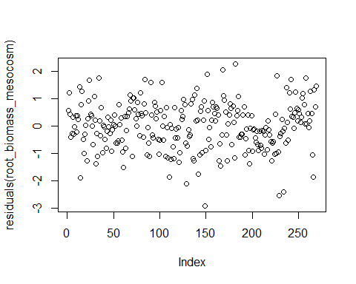
summary(root_biomass_mesocosm)
Family: gaussian ( identity )
Formula:
Total_dryweight_roots_mesocosm ~ Site * Winter_stage + Site *
Fine_coarse + (1 | Site:Winter_stage)
Data: df_roots
AIC BIC logLik -2*log(L) df.resid
734.2 827.6 -341.1 682.2 243
Random effects:
Conditional model:
Groups Name Variance Std.Dev.
Site:Winter_stage (Intercept) 1.583e-10 1.258e-05
Residual 7.394e-01 8.599e-01
Number of obs: 269, groups: Site:Winter_stage, 20
Dispersion estimate for gaussian family (sigma^2): 0.739
Conditional model:
Estimate Std. Error z value
(Intercept) 2.292005 0.243674 9.406
SiteEastern 0.747447 0.344826 2.168
SiteNorthern 0.520809 0.325135 1.602
SiteSoutheastern 0.714236 0.342547 2.085
Winter_stageLate_Winter_C -0.170769 0.376524 -0.454
Winter_stageLate_Winter_WW 0.163158 0.376524 0.433
Winter_stageMidwinter_I 0.379592 0.304612 1.246
Winter_stageMidwinter_II 0.009464 0.309124 0.031
Fine_coarseFine -2.520772 0.215182 -11.715
SiteEastern:Winter_stageLate_Winter_C -0.102832 0.532485 -0.193
SiteNorthern:Winter_stageLate_Winter_C -0.817734 0.502673 -1.627
SiteSoutheastern:Winter_stageLate_Winter_C -0.404805 0.529535 -0.764
SiteEastern:Winter_stageLate_Winter_WW -1.286326 0.532485 -2.416
SiteNorthern:Winter_stageLate_Winter_WW -1.500043 0.502673 -2.984
SiteSoutheastern:Winter_stageLate_Winter_WW -0.889162 0.529535 -1.679
SiteEastern:Winter_stageMidwinter_I -0.550008 0.433989 -1.267
SiteNorthern:Winter_stageMidwinter_I -0.880010 0.410731 -2.143
SiteSoutheastern:Winter_stageMidwinter_I -0.177912 0.433989 -0.410
SiteEastern:Winter_stageMidwinter_II -0.608974 0.437168 -1.393
SiteNorthern:Winter_stageMidwinter_II -0.953925 0.411701 -2.317
SiteSoutheastern:Winter_stageMidwinter_II -0.261967 0.433570 -0.604
SiteEastern:Fine_coarseFine 0.959771 0.305449 3.142
SiteNorthern:Fine_coarseFine 0.969645 0.289424 3.350
SiteSoutheastern:Fine_coarseFine 0.753439 0.305449 2.467
Pr(>|z|)
(Intercept) < 2e-16 ***
SiteEastern 0.030189 *
SiteNorthern 0.109195
SiteSoutheastern 0.037063 *
Winter_stageLate_Winter_C 0.650158
Winter_stageLate_Winter_WW 0.664777
Winter_stageMidwinter_I 0.212709
Winter_stageMidwinter_II 0.975576
Fine_coarseFine < 2e-16 ***
SiteEastern:Winter_stageLate_Winter_C 0.846867
SiteNorthern:Winter_stageLate_Winter_C 0.103785
SiteSoutheastern:Winter_stageLate_Winter_C 0.444597
SiteEastern:Winter_stageLate_Winter_WW 0.015705 *
SiteNorthern:Winter_stageLate_Winter_WW 0.002844 **
SiteSoutheastern:Winter_stageLate_Winter_WW 0.093125 .
SiteEastern:Winter_stageMidwinter_I 0.205037
SiteNorthern:Winter_stageMidwinter_I 0.032150 *
SiteSoutheastern:Winter_stageMidwinter_I 0.681846
SiteEastern:Winter_stageMidwinter_II 0.163620
SiteNorthern:Winter_stageMidwinter_II 0.020502 *
SiteSoutheastern:Winter_stageMidwinter_II 0.545704
SiteEastern:Fine_coarseFine 0.001677 **
SiteNorthern:Fine_coarseFine 0.000807 ***
SiteSoutheastern:Fine_coarseFine 0.013638 *
---
Signif. codes: 0 '***' 0.001 '**' 0.01 '*' 0.05 '.' 0.1 ' ' 1

Get emmeans and back-transform to original scale
Create reference grid and specify transformation
rg <- ref_grid(root_biomass_mesocosm)
rg <- update(rg, tran = "log") # explicitly tell emmeans it's log-transformed
em_site <- emmeans(rg, ~ Site)
NOTE: Results may be misleading due to involvement in interactions
summary(em_site, type = "response")
Site response SE df lower.CL upper.CL
Southern 3.03 0.345 243 2.42 3.79
Eastern 6.21 0.709 243 4.96 7.77
Northern 3.61 0.368 243 2.95 4.41
Southeastern 6.37 0.728 243 5.09 7.98
Results are averaged over the levels of: Winter_stage, Fine_coarse
Confidence level used: 0.95
Intervals are back-transformed from the log scale

Modelling: root N uptake
This model tests the effect of Site, WInter stage and root fraction. It also puts the intercept between site and winter stage as a random factor, taking into account the non-independence of Winter stage within each site (repeated measures) and nesting the effect of Late winter warming (WW) inside Late winter stage.
In this model, we fit root 15N excess pr m2 (unit area) with Eastern site as the base level.
df_roots$Site <- relevel(df_roots$Site, ref = "Eastern")
df_roots$Winter_stage <- relevel(df_roots$Winter_stage, ref = "Late_Winter_C")
roots_m2_model <- glmmTMB(APE15N_pr_m2 ~ Site * Winter_stage + Fine_coarse + (1 | Site:Winter_stage)+(1 |Winter_stage:WW_treat), data = df_roots, family = gaussian)
plot(residuals(roots_m2_model))
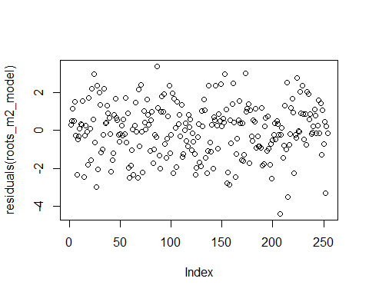
shapiro.test(residuals(roots_m2_model))
Shapiro-Wilk normality test
data: residuals(roots_m2_model)
W = 0.99431, p-value = 0.458
summary(roots_m2_model)
Family: gaussian ( identity )
Formula:
APE15N_pr_m2 ~ Site * Winter_stage + Fine_coarse + (1 | Site:Winter_stage) +
(1 | Winter_stage:WW_treat)
Data: df_roots
AIC BIC logLik -2*log(L) df.resid
932.5 1017.4 -442.3 884.5 230
Random effects:
Conditional model:
Groups Name Variance Std.Dev.
Site:Winter_stage (Intercept) 8.136e-10 2.852e-05
Winter_stage:WW_treat (Intercept) 4.741e-12 2.177e-06
Residual 1.905e+00 1.380e+00
Number of obs: 254, groups: Site:Winter_stage, 20; Winter_stage:WW_treat, 5
Dispersion estimate for gaussian family (sigma^2): 1.9
Conditional model:
Estimate Std. Error z value
(Intercept) -0.93228 0.49573 -1.881
SiteSouthern -1.06582 0.78858 -1.352
SiteNorthern -1.32157 0.65469 -2.019
SiteSoutheastern -0.23603 0.71443 -0.330
Winter_stageEarly_Winter 0.11335 0.60428 0.188
Winter_stageLate_Winter_WW -0.30292 0.69010 -0.439
Winter_stageMidwinter_I 0.15181 0.60428 0.251
Winter_stageMidwinter_II -0.23901 0.60428 -0.396
Fine_coarseFine -1.30104 0.17470 -7.447
SiteSouthern:Winter_stageEarly_Winter -0.47495 0.94557 -0.502
SiteNorthern:Winter_stageEarly_Winter -0.02119 0.80678 -0.026
SiteSoutheastern:Winter_stageEarly_Winter -1.10732 0.86986 -1.273
SiteSouthern:Winter_stageLate_Winter_WW -0.56410 1.04790 -0.538
SiteNorthern:Winter_stageLate_Winter_WW -0.09996 0.93728 -0.107
SiteSoutheastern:Winter_stageLate_Winter_WW -0.44699 0.99331 -0.450
SiteSouthern:Winter_stageMidwinter_I 0.10560 0.93529 0.113
SiteNorthern:Winter_stageMidwinter_I -0.92535 0.81330 -1.138
SiteSoutheastern:Winter_stageMidwinter_I 0.20004 0.87993 0.227
SiteSouthern:Winter_stageMidwinter_II -0.53590 0.94036 -0.570
SiteNorthern:Winter_stageMidwinter_II -0.58739 0.80678 -0.728
SiteSoutheastern:Winter_stageMidwinter_II -0.36587 0.86986 -0.421
Pr(>|z|)
(Intercept) 0.0600 .
SiteSouthern 0.1765
SiteNorthern 0.0435 *
SiteSoutheastern 0.7411
Winter_stageEarly_Winter 0.8512
Winter_stageLate_Winter_WW 0.6607
Winter_stageMidwinter_I 0.8016
Winter_stageMidwinter_II 0.6925
Fine_coarseFine 9.54e-14 ***
SiteSouthern:Winter_stageEarly_Winter 0.6155
SiteNorthern:Winter_stageEarly_Winter 0.9790
SiteSoutheastern:Winter_stageEarly_Winter 0.2030
SiteSouthern:Winter_stageLate_Winter_WW 0.5904
SiteNorthern:Winter_stageLate_Winter_WW 0.9151
SiteSoutheastern:Winter_stageLate_Winter_WW 0.6527
SiteSouthern:Winter_stageMidwinter_I 0.9101
SiteNorthern:Winter_stageMidwinter_I 0.2552
SiteSoutheastern:Winter_stageMidwinter_I 0.8202
SiteSouthern:Winter_stageMidwinter_II 0.5688
SiteNorthern:Winter_stageMidwinter_II 0.4666
SiteSoutheastern:Winter_stageMidwinter_II 0.6740
---
Signif. codes: 0 '***' 0.001 '**' 0.01 '*' 0.05 '.' 0.1 ' ' 1
drop1(roots_m2_model, test = 'Chisq')
Single term deletions
Model:
APE15N_pr_m2 ~ Site * Winter_stage + Fine_coarse + (1 | Site:Winter_stage) +
(1 | Winter_stage:WW_treat)
Df AIC LRT Pr(>Chi)
<none> 932.51
Fine_coarse 1 980.68 50.164 1.414e-12 ***
Site:Winter_stage 12 921.74 13.228 0.3527
---
Signif. codes: 0 '***' 0.001 '**' 0.01 '*' 0.05 '.' 0.1 ' ' 1
We then get the estimated marginal means
rg <- ref_grid(roots_m2_model)
rg <- update(rg, tran = "log") # explicitly tell emmeans it's log-transformed
# Get emmeans and back-transform to original scale
em_site <- emmeans(rg, ~ Site)
NOTE: Results may be misleading due to involvement in interactions
summary(em_site, type = "response")
Site response SE df lower.CL upper.CL
Eastern 0.1943 0.03600 230 0.1349 0.2799
Southern 0.0499 0.01020 230 0.0334 0.0746
Northern 0.0374 0.00625 230 0.0269 0.0520
Southeastern 0.1088 0.02050 230 0.0751 0.1576
Results are averaged over the levels of: Winter_stage, Fine_coarse
Confidence level used: 0.95
Intervals are back-transformed from the log scale
emmeans(roots_m2_model, ~Site|Winter_stage, type = 'response')
Winter_stage = Late_Winter_C:
Site emmean SE df lower.CL upper.CL
Eastern -1.58 0.488 230 -2.54 -0.621
Southern -2.65 0.619 230 -3.87 -1.428
Northern -2.90 0.436 230 -3.76 -2.044
Southeastern -1.82 0.522 230 -2.85 -0.791
Winter_stage = Early_Winter:
Site emmean SE df lower.CL upper.CL
Eastern -1.47 0.356 230 -2.17 -0.767
Southern -3.01 0.383 230 -3.77 -2.255
Northern -2.81 0.309 230 -3.42 -2.204
Southeastern -2.81 0.345 230 -3.49 -2.133
Winter_stage = Late_Winter_WW:
Site emmean SE df lower.CL upper.CL
Eastern -1.89 0.488 230 -2.85 -0.924
Southern -3.52 0.488 230 -4.48 -2.554
Northern -3.31 0.460 230 -4.21 -2.401
Southeastern -2.57 0.488 230 -3.53 -1.607
Winter_stage = Midwinter_I:
Site emmean SE df lower.CL upper.CL
Eastern -1.43 0.356 230 -2.13 -0.729
Southern -2.39 0.357 230 -3.09 -1.688
Northern -3.68 0.325 230 -4.32 -3.037
Southeastern -1.47 0.369 230 -2.19 -0.740
Winter_stage = Midwinter_II:
Site emmean SE df lower.CL upper.CL
Eastern -1.82 0.356 230 -2.52 -1.120
Southern -3.42 0.369 230 -4.15 -2.696
Northern -3.73 0.309 230 -4.34 -3.123
Southeastern -2.42 0.345 230 -3.10 -1.744
Results are averaged over the levels of: Fine_coarse
Confidence level used: 0.95
emmeans(roots_m2_model, ~Fine_coarse, type = 'response')
Fine_coarse emmean SE df lower.CL upper.CL
Coarse -1.88 0.123 230 -2.13 -1.64
Fine -3.19 0.133 230 -3.45 -2.92
Results are averaged over the levels of: Site, Winter_stage
Confidence level used: 0.95
#In the below I test the difference between Late_winter_C and Late_winter_WW by only looking at the pair "Late_Winter_C WW_treat0 - Late_Winter_WW WW_treat1". First for each site, then overall.
pairs(emmeans(roots_m2_model, ~Winter_stage|Site, type = 'response',infer=TRUE), adjust = "none")
Site = Eastern:
contrast estimate SE df t.ratio p.value
Late_Winter_C - Early_Winter -0.1134 0.604 230 -0.188 0.8514
Late_Winter_C - Late_Winter_WW 0.3029 0.690 230 0.439 0.6611
Late_Winter_C - Midwinter_I -0.1518 0.604 230 -0.251 0.8019
Late_Winter_C - Midwinter_II 0.2390 0.604 230 0.396 0.6928
Early_Winter - Late_Winter_WW 0.4163 0.604 230 0.689 0.4916
Early_Winter - Midwinter_I -0.0385 0.504 230 -0.076 0.9392
Early_Winter - Midwinter_II 0.3524 0.504 230 0.699 0.4852
Late_Winter_WW - Midwinter_I -0.4547 0.604 230 -0.753 0.4525
Late_Winter_WW - Midwinter_II -0.0639 0.604 230 -0.106 0.9159
Midwinter_I - Midwinter_II 0.3908 0.504 230 0.775 0.4389
Site = Southern:
contrast estimate SE df t.ratio p.value
Late_Winter_C - Early_Winter 0.3616 0.727 230 0.497 0.6194
Late_Winter_C - Late_Winter_WW 0.8670 0.789 230 1.099 0.2727
Late_Winter_C - Midwinter_I -0.2574 0.714 230 -0.361 0.7186
Late_Winter_C - Midwinter_II 0.7749 0.720 230 1.076 0.2831
Early_Winter - Late_Winter_WW 0.5054 0.621 230 0.814 0.4162
Early_Winter - Midwinter_I -0.6190 0.523 230 -1.184 0.2378
Early_Winter - Midwinter_II 0.4133 0.532 230 0.777 0.4377
Late_Winter_WW - Midwinter_I -1.1244 0.605 230 -1.860 0.0641
Late_Winter_WW - Midwinter_II -0.0921 0.612 230 -0.151 0.8805
Midwinter_I - Midwinter_II 1.0323 0.513 230 2.013 0.0453
Site = Northern:
contrast estimate SE df t.ratio p.value
Late_Winter_C - Early_Winter -0.0922 0.535 230 -0.172 0.8633
Late_Winter_C - Late_Winter_WW 0.4029 0.634 230 0.635 0.5259
Late_Winter_C - Midwinter_I 0.7735 0.544 230 1.421 0.1567
Late_Winter_C - Midwinter_II 0.8264 0.535 230 1.546 0.1235
Early_Winter - Late_Winter_WW 0.4950 0.554 230 0.893 0.3726
Early_Winter - Midwinter_I 0.8657 0.449 230 1.930 0.0548
Early_Winter - Midwinter_II 0.9186 0.436 230 2.105 0.0364
Late_Winter_WW - Midwinter_I 0.3707 0.563 230 0.658 0.5113
Late_Winter_WW - Midwinter_II 0.4235 0.554 230 0.764 0.4454
Midwinter_I - Midwinter_II 0.0529 0.449 230 0.118 0.9063
Site = Southeastern:
contrast estimate SE df t.ratio p.value
Late_Winter_C - Early_Winter 0.9940 0.626 230 1.589 0.1135
Late_Winter_C - Late_Winter_WW 0.7499 0.714 230 1.050 0.2950
Late_Winter_C - Midwinter_I -0.3519 0.639 230 -0.550 0.5827
Late_Winter_C - Midwinter_II 0.6049 0.626 230 0.967 0.3346
Early_Winter - Late_Winter_WW -0.2441 0.598 230 -0.408 0.6834
Early_Winter - Midwinter_I -1.3458 0.505 230 -2.664 0.0083
Early_Winter - Midwinter_II -0.3891 0.488 230 -0.797 0.4261
Late_Winter_WW - Midwinter_I -1.1018 0.612 230 -1.801 0.0731
Late_Winter_WW - Midwinter_II -0.1450 0.598 230 -0.243 0.8085
Midwinter_I - Midwinter_II 0.9567 0.505 230 1.894 0.0595
Results are averaged over the levels of: Fine_coarse
pairs(emmeans(roots_m2_model, ~Winter_stage, type = 'response',infer=TRUE), adjust = "none")
contrast estimate SE df t.ratio p.value
Late_Winter_C - Early_Winter 0.28751 0.313 230 0.918 0.3598
Late_Winter_C - Late_Winter_WW 0.58068 0.355 230 1.638 0.1028
Late_Winter_C - Midwinter_I 0.00312 0.314 230 0.010 0.9921
Late_Winter_C - Midwinter_II 0.61130 0.312 230 1.957 0.0516
Early_Winter - Late_Winter_WW 0.29317 0.297 230 0.986 0.3251
Early_Winter - Midwinter_I -0.28440 0.248 230 -1.147 0.2526
Early_Winter - Midwinter_II 0.32378 0.246 230 1.318 0.1887
Late_Winter_WW - Midwinter_I -0.57757 0.298 230 -1.937 0.0539
Late_Winter_WW - Midwinter_II 0.03062 0.296 230 0.103 0.9178
Midwinter_I - Midwinter_II 0.60818 0.247 230 2.466 0.0144
Results are averaged over the levels of: Site, Fine_coarse
We further fit a model where the response is root 15NAPE pr g dry root (unit mass).
roots_prdryweight_model <- glmmTMB(mg_root_15NAPE_per_g_dry_root ~ Site * Winter_stage + Fine_coarse + (1 | Site:Winter_stage)+(1 |Winter_stage:WW_treat), data = df_roots, family = gaussian)
# Plot residuals
plot(residuals(roots_prdryweight_model))
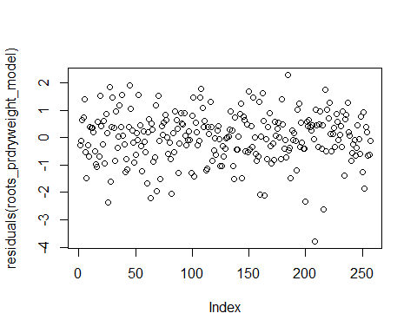
shapiro.test(residuals(roots_prdryweight_model))
Shapiro-Wilk normality test
data: residuals(roots_prdryweight_model)
W = 0.98395, p-value = 0.005452
summary(roots_prdryweight_model)
Family: gaussian ( identity )
Formula:
mg_root_15NAPE_per_g_dry_root ~ Site * Winter_stage + Fine_coarse +
(1 | Site:Winter_stage) + (1 | Winter_stage:WW_treat)
Data: df_roots
AIC BIC logLik -2*log(L) df.resid
726.6 811.7 -339.3 678.6 233
Random effects:
Conditional model:
Groups Name Variance Std.Dev.
Site:Winter_stage (Intercept) 2.268e-10 1.506e-05
Winter_stage:WW_treat (Intercept) 3.744e-13 6.119e-07
Residual 8.207e-01 9.059e-01
Number of obs: 257, groups: Site:Winter_stage, 20; Winter_stage:WW_treat, 5
Dispersion estimate for gaussian family (sigma^2): 0.821
Conditional model:
Estimate Std. Error z value
(Intercept) -2.34165 0.32531 -7.198
SiteSouthern -0.03066 0.51758 -0.059
SiteNorthern -0.31392 0.42972 -0.731
SiteSoutheastern -0.11259 0.46893 -0.240
Winter_stageEarly_Winter -0.18592 0.39228 -0.474
Winter_stageLate_Winter_WW 0.40826 0.45296 0.901
Winter_stageMidwinter_I -0.08973 0.39663 -0.226
Winter_stageMidwinter_II -0.03285 0.39663 -0.083
Fine_coarseFine 0.42554 0.11384 3.738
SiteSouthern:Winter_stageEarly_Winter 0.03756 0.61426 0.061
SiteNorthern:Winter_stageEarly_Winter -0.61363 0.52629 -1.166
SiteSoutheastern:Winter_stageEarly_Winter -0.95054 0.56787 -1.674
SiteSouthern:Winter_stageLate_Winter_WW -1.18379 0.68780 -1.721
SiteNorthern:Winter_stageLate_Winter_WW -0.33921 0.61520 -0.551
SiteSoutheastern:Winter_stageLate_Winter_WW -0.06237 0.65197 -0.096
SiteSouthern:Winter_stageMidwinter_I 0.02175 0.61389 0.035
SiteNorthern:Winter_stageMidwinter_I -1.17601 0.53157 -2.212
SiteSoutheastern:Winter_stageMidwinter_I 0.14442 0.57755 0.250
SiteSouthern:Winter_stageMidwinter_II -0.70469 0.61721 -1.142
SiteNorthern:Winter_stageMidwinter_II -0.74081 0.52955 -1.399
SiteSoutheastern:Winter_stageMidwinter_II -0.27449 0.57094 -0.481
Pr(>|z|)
(Intercept) 6.1e-13 ***
SiteSouthern 0.952760
SiteNorthern 0.465062
SiteSoutheastern 0.810259
Winter_stageEarly_Winter 0.635525
Winter_stageLate_Winter_WW 0.367420
Winter_stageMidwinter_I 0.821016
Winter_stageMidwinter_II 0.933997
Fine_coarseFine 0.000185 ***
SiteSouthern:Winter_stageEarly_Winter 0.951241
SiteNorthern:Winter_stageEarly_Winter 0.243634
SiteSoutheastern:Winter_stageEarly_Winter 0.094158 .
SiteSouthern:Winter_stageLate_Winter_WW 0.085227 .
SiteNorthern:Winter_stageLate_Winter_WW 0.581368
SiteSoutheastern:Winter_stageLate_Winter_WW 0.923793
SiteSouthern:Winter_stageMidwinter_I 0.971737
SiteNorthern:Winter_stageMidwinter_I 0.026942 *
SiteSoutheastern:Winter_stageMidwinter_I 0.802549
SiteSouthern:Winter_stageMidwinter_II 0.253566
SiteNorthern:Winter_stageMidwinter_II 0.161827
SiteSoutheastern:Winter_stageMidwinter_II 0.630688
---
Signif. codes: 0 '***' 0.001 '**' 0.01 '*' 0.05 '.' 0.1 ' ' 1
drop1(roots_prdryweight_model, test = 'Chisq')
Single term deletions
Model:
mg_root_15NAPE_per_g_dry_root ~ Site * Winter_stage + Fine_coarse +
(1 | Site:Winter_stage) + (1 | Winter_stage:WW_treat)
Df AIC LRT Pr(>Chi)
<none> 726.55
Fine_coarse 1 738.16 13.606 0.0002254 ***
Site:Winter_stage 12 732.37 29.822 0.0029701 **
---
Signif. codes: 0 '***' 0.001 '**' 0.01 '*' 0.05 '.' 0.1 ' ' 1
#In the below I test the difference between Late_winter_C and Late_winter_WW by only looking at the pair "Late_Winter_C WW_treat0 - Late_Winter_WW WW_treat1". First for each site, then overall.
pairs(emmeans(roots_prdryweight_model, ~Winter_stage|Site, type = 'response'), adjust = "none")
Site = Eastern:
contrast estimate SE df t.ratio p.value
Late_Winter_C - Early_Winter 0.1859 0.392 233 0.474 0.6360
Late_Winter_C - Late_Winter_WW -0.4083 0.453 233 -0.901 0.3684
Late_Winter_C - Midwinter_I 0.0897 0.397 233 0.226 0.8212
Late_Winter_C - Midwinter_II 0.0328 0.397 233 0.083 0.9341
Early_Winter - Late_Winter_WW -0.5942 0.392 233 -1.515 0.1312
Early_Winter - Midwinter_I -0.0962 0.326 233 -0.295 0.7679
Early_Winter - Midwinter_II -0.1531 0.326 233 -0.470 0.6387
Late_Winter_WW - Midwinter_I 0.4980 0.397 233 1.256 0.2105
Late_Winter_WW - Midwinter_II 0.4411 0.397 233 1.112 0.2672
Midwinter_I - Midwinter_II -0.0569 0.331 233 -0.172 0.8636
Site = Southern:
contrast estimate SE df t.ratio p.value
Late_Winter_C - Early_Winter 0.1484 0.473 233 0.314 0.7539
Late_Winter_C - Late_Winter_WW 0.7755 0.518 233 1.498 0.1354
Late_Winter_C - Midwinter_I 0.0680 0.468 233 0.145 0.8847
Late_Winter_C - Midwinter_II 0.7375 0.473 233 1.560 0.1200
Early_Winter - Late_Winter_WW 0.6272 0.402 233 1.562 0.1197
Early_Winter - Midwinter_I -0.0804 0.337 233 -0.239 0.8115
Early_Winter - Midwinter_II 0.5892 0.342 233 1.721 0.0866
Late_Winter_WW - Midwinter_I -0.7075 0.397 233 -1.783 0.0758
Late_Winter_WW - Midwinter_II -0.0380 0.402 233 -0.095 0.9247
Midwinter_I - Midwinter_II 0.6696 0.337 233 1.989 0.0479
Site = Northern:
contrast estimate SE df t.ratio p.value
Late_Winter_C - Early_Winter 0.7996 0.351 233 2.279 0.0236
Late_Winter_C - Late_Winter_WW -0.0690 0.416 233 -0.166 0.8684
Late_Winter_C - Midwinter_I 1.2657 0.354 233 3.576 0.0004
Late_Winter_C - Midwinter_II 0.7737 0.351 233 2.205 0.0284
Early_Winter - Late_Winter_WW -0.8686 0.364 233 -2.388 0.0177
Early_Winter - Midwinter_I 0.4662 0.290 233 1.606 0.1096
Early_Winter - Midwinter_II -0.0259 0.286 233 -0.090 0.9280
Late_Winter_WW - Midwinter_I 1.3348 0.367 233 3.641 0.0003
Late_Winter_WW - Midwinter_II 0.8427 0.364 233 2.317 0.0214
Midwinter_I - Midwinter_II -0.4921 0.290 233 -1.695 0.0913
Site = Southeastern:
contrast estimate SE df t.ratio p.value
Late_Winter_C - Early_Winter 1.1365 0.411 233 2.768 0.0061
Late_Winter_C - Late_Winter_WW -0.3459 0.469 233 -0.738 0.4615
Late_Winter_C - Midwinter_I -0.0547 0.420 233 -0.130 0.8964
Late_Winter_C - Midwinter_II 0.3073 0.411 233 0.748 0.4549
Early_Winter - Late_Winter_WW -1.4824 0.392 233 -3.779 0.0002
Early_Winter - Midwinter_I -1.1912 0.332 233 -3.592 0.0004
Early_Winter - Midwinter_II -0.8291 0.320 233 -2.589 0.0102
Late_Winter_WW - Midwinter_I 0.2912 0.402 233 0.725 0.4691
Late_Winter_WW - Midwinter_II 0.6532 0.392 233 1.665 0.0972
Midwinter_I - Midwinter_II 0.3620 0.332 233 1.092 0.2761
Results are averaged over the levels of: Fine_coarse
pairs(emmeans(roots_prdryweight_model, ~Winter_stage, type = 'response'), adjust = "none")
NOTE: Results may be misleading due to involvement in interactions
contrast estimate SE df t.ratio p.value
Late_Winter_C - Early_Winter 0.5676 0.205 233 2.775 0.0060
Late_Winter_C - Late_Winter_WW -0.0119 0.233 233 -0.051 0.9592
Late_Winter_C - Midwinter_I 0.3422 0.206 233 1.662 0.0979
Late_Winter_C - Midwinter_II 0.4628 0.205 233 2.257 0.0249
Early_Winter - Late_Winter_WW -0.5795 0.194 233 -2.990 0.0031
Early_Winter - Midwinter_I -0.2254 0.161 233 -1.402 0.1622
Early_Winter - Midwinter_II -0.1047 0.160 233 -0.656 0.5125
Late_Winter_WW - Midwinter_I 0.3541 0.195 233 1.813 0.0711
Late_Winter_WW - Midwinter_II 0.4748 0.194 233 2.442 0.0153
Midwinter_I - Midwinter_II 0.1206 0.161 233 0.747 0.4556
Results are averaged over the levels of: Site, Fine_coarse
Backtransforming and getting the emmeans.
rg <- ref_grid(roots_prdryweight_model)
rg <- update(rg, tran = "log") # explicitly tell emmeans it's log-transformed
# Get emmeans and back-transform to original scale
em_site <- emmeans(rg, ~ Site)
NOTE: Results may be misleading due to involvement in interactions
em_fraction <- emmeans(rg, ~ Fine_coarse)
summary(em_site, type = "response")
Site response SE df lower.CL upper.CL
Eastern 0.1214 0.01470 233 0.0956 0.1540
Southern 0.0816 0.01090 233 0.0628 0.1061
Northern 0.0499 0.00546 233 0.0403 0.0619
Southeastern 0.0863 0.01070 233 0.0677 0.1100
Results are averaged over the levels of: Winter_stage, Fine_coarse
Confidence level used: 0.95
Intervals are back-transformed from the log scale
summary(em_fraction, type = "response")
Fine_coarse response SE df lower.CL upper.CL
Coarse 0.0653 0.00528 233 0.0557 0.0766
Fine 0.1000 0.00861 233 0.0844 0.1185
Results are averaged over the levels of: Site, Winter_stage
Confidence level used: 0.95
Intervals are back-transformed from the log scale

Supplementary code S2: Microbes and soil water
df_microbes <- read_xlsx("Your:directory/df_microbes.xlsx")
df_microbes <- df_microbes %>%
rename(Microbial_µg15N_pr_m2='microgram Microbial 15N exess pr m2 to 10 cm')
df_microbes <- df_microbes %>%
mutate(Winter_stage=factor(Winter_stage))
df_microbes <- df_microbes %>%
mutate(Site=factor(Site))
df_microbes <- df_microbes %>%
mutate(Microbial_µg15N_pr_m2=log(Microbial_µg15N_pr_m2))

#Here you can change the level that is used as basis for comparison
#df_microbes$Site <- relevel(df_microbes$Site, ref = "Northern")
#df_microbes$Site <- relevel(df_microbes$Site, ref = "Southern")
#df_microbes$Site <- relevel(df_microbes$Site, ref = "Southeastern")

Modelling: microbial N uptake
This model tests the effect of Site and Winter stage on microbial 15N excess/m2. It also puts the intercept between site and winter stage as a random factor, taking into account the non-independence of Winter stage within each site (repeated measures) and nesting the effect of Late winter warming (WW) inside Late winter stage..
microbes_m2_model <- glmmTMB(Microbial_µg15N_pr_m2 ~ Site * Winter_stage + (1 | Site:Winter_stage)+(1 |Winter_stage:WW_treat), data = df_microbes, family = gaussian)
plot(residuals(microbes_m2_model))
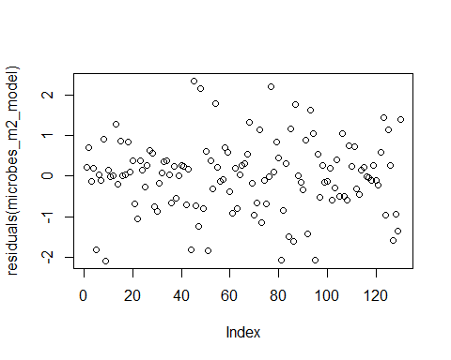
# Shapiro-Wilk test for normality
shapiro.test(residuals(microbes_m2_model))
Shapiro-Wilk normality test
data: residuals(microbes_m2_model)
W = 0.9809, p-value = 0.06396
#Summary
summary(microbes_m2_model)
Family: gaussian ( identity )
Formula:
Microbial_µg15N_pr_m2 ~ Site * Winter_stage + (1 | Site:Winter_stage) +
(1 | Winter_stage:WW_treat)
Data: df_microbes
AIC BIC logLik -2*log(L) df.resid
NA NA NA NA 107
Random effects:
Conditional model:
Groups Name Variance Std.Dev.
Site:Winter_stage (Intercept) 1.922e-10 1.386e-05
Winter_stage:WW_treat (Intercept) 1.472e-29 3.837e-15
Residual 7.527e-01 8.676e-01
Number of obs: 130, groups: Site:Winter_stage, 20; Winter_stage:WW_treat, 5
Dispersion estimate for gaussian family (sigma^2): 0.753
Conditional model:
Estimate Std. Error z value
(Intercept) 12.08146 0.30675 39.39
SiteNorthern -1.34183 0.41154 -3.26
SiteSoutheastern -1.19060 0.44903 -2.65
SiteSouthern -0.58969 0.43380 -1.36
Winter_stageLate_Winter_C -1.32936 0.53130 -2.50
Winter_stageLate_Winter_WW -1.15631 0.58737 -1.97
Winter_stageMidwinter_I -0.93921 0.43380 -2.17
Winter_stageMidwinter_II -1.12414 0.43380 -2.59
SiteNorthern:Winter_stageLate_Winter_C -0.12410 0.71281 -0.17
SiteSoutheastern:Winter_stageLate_Winter_C -0.50865 0.76026 -0.67
SiteSouthern:Winter_stageLate_Winter_C 0.22467 0.75137 0.30
SiteNorthern:Winter_stageLate_Winter_WW 1.10504 0.75553 1.46
SiteSoutheastern:Winter_stageLate_Winter_WW -0.05645 0.80045 -0.07
SiteSouthern:Winter_stageLate_Winter_WW -1.12382 0.79201 -1.42
SiteNorthern:Winter_stageMidwinter_I 1.45317 0.58915 2.47
SiteSoutheastern:Winter_stageMidwinter_I 1.01119 0.63502 1.59
SiteSouthern:Winter_stageMidwinter_I 1.21428 0.61349 1.98
SiteNorthern:Winter_stageMidwinter_II 0.69284 0.58915 1.18
SiteSoutheastern:Winter_stageMidwinter_II 1.28986 0.63502 2.03
SiteSouthern:Winter_stageMidwinter_II 0.71049 0.61349 1.16
Pr(>|z|)
(Intercept) < 2e-16 ***
SiteNorthern 0.00111 **
SiteSoutheastern 0.00801 **
SiteSouthern 0.17404
Winter_stageLate_Winter_C 0.01235 *
Winter_stageLate_Winter_WW 0.04900 *
Winter_stageMidwinter_I 0.03038 *
Winter_stageMidwinter_II 0.00956 **
SiteNorthern:Winter_stageLate_Winter_C 0.86178
SiteSoutheastern:Winter_stageLate_Winter_C 0.50346
SiteSouthern:Winter_stageLate_Winter_C 0.76493
SiteNorthern:Winter_stageLate_Winter_WW 0.14358
SiteSoutheastern:Winter_stageLate_Winter_WW 0.94378
SiteSouthern:Winter_stageLate_Winter_WW 0.15592
SiteNorthern:Winter_stageMidwinter_I 0.01364 *
SiteSoutheastern:Winter_stageMidwinter_I 0.11130
SiteSouthern:Winter_stageMidwinter_I 0.04778 *
SiteNorthern:Winter_stageMidwinter_II 0.23960
SiteSoutheastern:Winter_stageMidwinter_II 0.04224 *
SiteSouthern:Winter_stageMidwinter_II 0.24682
---
Signif. codes: 0 '***' 0.001 '**' 0.01 '*' 0.05 '.' 0.1 ' ' 1
#In the below I test the difference between Late_winter_C and Late_winter_WW by only looking at the pair "Late_Winter_C WW_treat0 - Late_Winter_WW WW_treat1". First for each site, then overall.
pairs(emmeans(microbes_m2_model, ~Winter_stage|Site, type = 'response'), adjust = "none")
Site = Eastern:
contrast estimate SE df t.ratio p.value
Early_Winter - Late_Winter_C 1.3294 0.531 107 2.502 0.0139
Early_Winter - Late_Winter_WW 1.1563 0.587 107 1.969 0.0516
Early_Winter - Midwinter_I 0.9392 0.434 107 2.165 0.0326
Early_Winter - Midwinter_II 1.1241 0.434 107 2.591 0.0109
Late_Winter_C - Late_Winter_WW -0.1731 0.663 107 -0.261 0.7945
Late_Winter_C - Midwinter_I -0.3902 0.531 107 -0.734 0.4644
Late_Winter_C - Midwinter_II -0.2052 0.531 107 -0.386 0.7001
Late_Winter_WW - Midwinter_I -0.2171 0.587 107 -0.370 0.7124
Late_Winter_WW - Midwinter_II -0.0322 0.587 107 -0.055 0.9564
Midwinter_I - Midwinter_II 0.1849 0.434 107 0.426 0.6708
Site = Northern:
contrast estimate SE df t.ratio p.value
Early_Winter - Late_Winter_C 1.4535 0.475 107 3.059 0.0028
Early_Winter - Late_Winter_WW 0.0513 0.475 107 0.108 0.9143
Early_Winter - Midwinter_I -0.5140 0.399 107 -1.289 0.2001
Early_Winter - Midwinter_II 0.4313 0.399 107 1.082 0.2817
Late_Winter_C - Late_Winter_WW -1.4022 0.549 107 -2.555 0.0120
Late_Winter_C - Midwinter_I -1.9674 0.484 107 -4.066 0.0001
Late_Winter_C - Midwinter_II -1.0222 0.484 107 -2.112 0.0370
Late_Winter_WW - Midwinter_I -0.5652 0.484 107 -1.168 0.2454
Late_Winter_WW - Midwinter_II 0.3800 0.484 107 0.785 0.4340
Midwinter_I - Midwinter_II 0.9453 0.409 107 2.311 0.0227
Site = Southeastern:
contrast estimate SE df t.ratio p.value
Early_Winter - Late_Winter_C 1.8380 0.544 107 3.380 0.0010
Early_Winter - Late_Winter_WW 1.2128 0.544 107 2.230 0.0278
Early_Winter - Midwinter_I -0.0720 0.464 107 -0.155 0.8770
Early_Winter - Midwinter_II -0.1657 0.464 107 -0.357 0.7215
Late_Winter_C - Late_Winter_WW -0.6253 0.613 107 -1.019 0.3104
Late_Winter_C - Midwinter_I -1.9100 0.544 107 -3.512 0.0007
Late_Winter_C - Midwinter_II -2.0037 0.544 107 -3.685 0.0004
Late_Winter_WW - Midwinter_I -1.2847 0.544 107 -2.362 0.0200
Late_Winter_WW - Midwinter_II -1.3785 0.544 107 -2.535 0.0127
Midwinter_I - Midwinter_II -0.0937 0.464 107 -0.202 0.8402
Site = Southern:
contrast estimate SE df t.ratio p.value
Early_Winter - Late_Winter_C 1.1047 0.531 107 2.079 0.0400
Early_Winter - Late_Winter_WW 2.2801 0.531 107 4.292 <.0001
Early_Winter - Midwinter_I -0.2751 0.434 107 -0.634 0.5274
Early_Winter - Midwinter_II 0.4136 0.434 107 0.954 0.3425
Late_Winter_C - Late_Winter_WW 1.1754 0.613 107 1.916 0.0580
Late_Winter_C - Midwinter_I -1.3798 0.531 107 -2.597 0.0107
Late_Winter_C - Midwinter_II -0.6910 0.531 107 -1.301 0.1962
Late_Winter_WW - Midwinter_I -2.5552 0.531 107 -4.809 <.0001
Late_Winter_WW - Midwinter_II -1.8665 0.531 107 -3.513 0.0007
Midwinter_I - Midwinter_II 0.6887 0.434 107 1.588 0.1153
pairs(emmeans(microbes_m2_model, ~Winter_stage, type = 'response'), adjust = "none")
NOTE: Results may be misleading due to involvement in interactions
contrast estimate SE df t.ratio p.value
Early_Winter - Late_Winter_C 1.4314 0.261 107 5.494 <.0001
Early_Winter - Late_Winter_WW 1.1751 0.268 107 4.385 <.0001
Early_Winter - Midwinter_I 0.0196 0.217 107 0.090 0.9282
Early_Winter - Midwinter_II 0.4508 0.217 107 2.082 0.0397
Late_Winter_C - Late_Winter_WW -0.2563 0.305 107 -0.839 0.4034
Late_Winter_C - Midwinter_I -1.4118 0.262 107 -5.398 <.0001
Late_Winter_C - Midwinter_II -0.9805 0.262 107 -3.749 0.0003
Late_Winter_WW - Midwinter_I -1.1556 0.269 107 -4.297 <.0001
Late_Winter_WW - Midwinter_II -0.7243 0.269 107 -2.693 0.0082
Midwinter_I - Midwinter_II 0.4313 0.218 107 1.981 0.0502
Results are averaged over the levels of: Site

Modelling: soil water 15N
df_soilwater <- read_xlsx("Your_directory/df_soil_water.xlsx")
df_soilwater <- df_soilwater %>%
rename(Soil_water_µg15N_pr_m2='microgram soil water 15N exess pr m2 to 10 cm')
df_soilwater <- df_soilwater %>%
mutate(Winter_stage=factor(Winter_stage))
df_soilwater <- df_soilwater %>%
mutate(Site=factor(Site))
df_soilwater <- df_soilwater %>%
mutate(Soil_water_µg15N_pr_m2=log(Soil_water_µg15N_pr_m2))
#CHanging the levels to zoom in on each specific site and any differences between Late Winter C and late winter WW:
df_soilwater$Winter_stage <- relevel(df_soilwater$Winter_stage, ref = "Late_Winter_C")
soilwater_m2_model <- glmmTMB(Soil_water_µg15N_pr_m2 ~ Site * Winter_stage + (1 | Site:Winter_stage)+(1 |Winter_stage:WW_treat), data = df_soilwater, family = gaussian)
plot(residuals(soilwater_m2_model))
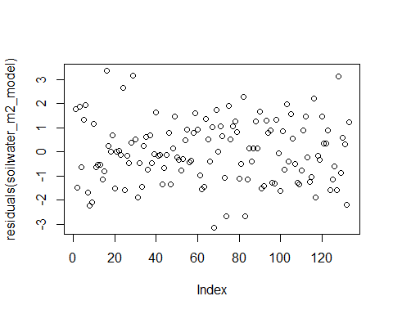
# Shapiro-Wilk test for normality
shapiro.test(residuals(soilwater_m2_model))
Shapiro-Wilk normality test
data: residuals(soilwater_m2_model)
W = 0.99203, p-value = 0.6561
#Summary
summary(soilwater_m2_model)
Family: gaussian ( identity )
Formula:
Soil_water_µg15N_pr_m2 ~ Site * Winter_stage + (1 | Site:Winter_stage) +
(1 | Winter_stage:WW_treat)
Data: df_soilwater
AIC BIC logLik -2*log(L) df.resid
488.7 555.2 -221.4 442.7 110
Random effects:
Conditional model:
Groups Name Variance Std.Dev.
Site:Winter_stage (Intercept) 5.105e-10 2.259e-05
Winter_stage:WW_treat (Intercept) 8.226e-19 9.070e-10
Residual 1.634e+00 1.278e+00
Number of obs: 133, groups: Site:Winter_stage, 20; Winter_stage:WW_treat, 5
Dispersion estimate for gaussian family (sigma^2): 1.63
Conditional model:
Estimate Std. Error z value
(Intercept) 8.44090 0.63905 13.209
SiteNorthern 0.49267 0.85737 0.575
SiteSoutheastern 0.66097 0.97616 0.677
SiteSouthern -0.81599 0.90375 -0.903
Winter_stageEarly_Winter 0.12761 0.78267 0.163
Winter_stageLate_Winter_WW -0.88356 0.97616 -0.905
Winter_stageMidwinter_I 0.71756 0.78267 0.917
Winter_stageMidwinter_II 0.28852 0.78267 0.369
SiteNorthern:Winter_stageEarly_Winter -0.73188 1.05006 -0.697
SiteSoutheastern:Winter_stageEarly_Winter -0.55687 1.16673 -0.477
SiteSouthern:Winter_stageEarly_Winter -0.08229 1.10686 -0.074
SiteNorthern:Winter_stageLate_Winter_WW 0.02316 1.26740 0.018
SiteSoutheastern:Winter_stageLate_Winter_WW 0.38122 1.38050 0.276
SiteSouthern:Winter_stageLate_Winter_WW -0.61975 1.33028 -0.466
SiteNorthern:Winter_stageMidwinter_I 0.17694 1.05006 0.169
SiteSoutheastern:Winter_stageMidwinter_I -0.32484 1.16673 -0.278
SiteSouthern:Winter_stageMidwinter_I 0.33124 1.10686 0.299
SiteNorthern:Winter_stageMidwinter_II -0.17025 1.05006 -0.162
SiteSoutheastern:Winter_stageMidwinter_II -0.84570 1.17917 -0.717
SiteSouthern:Winter_stageMidwinter_II -1.21697 1.10686 -1.099
Pr(>|z|)
(Intercept) <2e-16 ***
SiteNorthern 0.566
SiteSoutheastern 0.498
SiteSouthern 0.367
Winter_stageEarly_Winter 0.870
Winter_stageLate_Winter_WW 0.365
Winter_stageMidwinter_I 0.359
Winter_stageMidwinter_II 0.712
SiteNorthern:Winter_stageEarly_Winter 0.486
SiteSoutheastern:Winter_stageEarly_Winter 0.633
SiteSouthern:Winter_stageEarly_Winter 0.941
SiteNorthern:Winter_stageLate_Winter_WW 0.985
SiteSoutheastern:Winter_stageLate_Winter_WW 0.782
SiteSouthern:Winter_stageLate_Winter_WW 0.641
SiteNorthern:Winter_stageMidwinter_I 0.866
SiteSoutheastern:Winter_stageMidwinter_I 0.781
SiteSouthern:Winter_stageMidwinter_I 0.765
SiteNorthern:Winter_stageMidwinter_II 0.871
SiteSoutheastern:Winter_stageMidwinter_II 0.473
SiteSouthern:Winter_stageMidwinter_II 0.272
---
Signif. codes: 0 '***' 0.001 '**' 0.01 '*' 0.05 '.' 0.1 ' ' 1
#In the below I test the difference between Late_winter_C and Late_winter_WW by only looking at the pair "Late_Winter_C WW_treat0 - Late_Winter_WW WW_treat1". First for each site, then overall.
pairs(emmeans(soilwater_m2_model, ~Winter_stage|Site, type = 'response'), adjust = "none")
Site = Eastern:
contrast estimate SE df t.ratio p.value
Late_Winter_C - Early_Winter -0.1276 0.783 110 -0.163 0.8708
Late_Winter_C - Late_Winter_WW 0.8836 0.976 110 0.905 0.3674
Late_Winter_C - Midwinter_I -0.7176 0.783 110 -0.917 0.3612
Late_Winter_C - Midwinter_II -0.2885 0.783 110 -0.369 0.7131
Early_Winter - Late_Winter_WW 1.0112 0.865 110 1.169 0.2451
Early_Winter - Midwinter_I -0.5899 0.639 110 -0.923 0.3579
Early_Winter - Midwinter_II -0.1609 0.639 110 -0.252 0.8017
Late_Winter_WW - Midwinter_I -1.6011 0.865 110 -1.850 0.0669
Late_Winter_WW - Midwinter_II -1.1721 0.865 110 -1.355 0.1783
Midwinter_I - Midwinter_II 0.4290 0.639 110 0.671 0.5034
Site = Northern:
contrast estimate SE df t.ratio p.value
Late_Winter_C - Early_Winter 0.6043 0.700 110 0.863 0.3899
Late_Winter_C - Late_Winter_WW 0.8604 0.808 110 1.064 0.2895
Late_Winter_C - Midwinter_I -0.8945 0.700 110 -1.278 0.2040
Late_Winter_C - Midwinter_II -0.1183 0.700 110 -0.169 0.8662
Early_Winter - Late_Winter_WW 0.2561 0.700 110 0.366 0.7152
Early_Winter - Midwinter_I -1.4988 0.572 110 -2.622 0.0100
Early_Winter - Midwinter_II -0.7225 0.572 110 -1.264 0.2089
Late_Winter_WW - Midwinter_I -1.7549 0.700 110 -2.507 0.0136
Late_Winter_WW - Midwinter_II -0.9787 0.700 110 -1.398 0.1649
Midwinter_I - Midwinter_II 0.7762 0.572 110 1.358 0.1772
Site = Southeastern:
contrast estimate SE df t.ratio p.value
Late_Winter_C - Early_Winter 0.4293 0.865 110 0.496 0.6208
Late_Winter_C - Late_Winter_WW 0.5023 0.976 110 0.515 0.6079
Late_Winter_C - Midwinter_I -0.3927 0.865 110 -0.454 0.6508
Late_Winter_C - Midwinter_II 0.5572 0.882 110 0.632 0.5289
Early_Winter - Late_Winter_WW 0.0731 0.783 110 0.093 0.9258
Early_Winter - Midwinter_I -0.8220 0.639 110 -1.286 0.2011
Early_Winter - Midwinter_II 0.1279 0.661 110 0.193 0.8470
Late_Winter_WW - Midwinter_I -0.8951 0.783 110 -1.144 0.2553
Late_Winter_WW - Midwinter_II 0.0548 0.801 110 0.068 0.9455
Midwinter_I - Midwinter_II 0.9499 0.661 110 1.436 0.1538
Site = Southern:
contrast estimate SE df t.ratio p.value
Late_Winter_C - Early_Winter -0.0453 0.783 110 -0.058 0.9539
Late_Winter_C - Late_Winter_WW 1.5033 0.904 110 1.663 0.0991
Late_Winter_C - Midwinter_I -1.0488 0.783 110 -1.340 0.1830
Late_Winter_C - Midwinter_II 0.9285 0.783 110 1.186 0.2381
Early_Winter - Late_Winter_WW 1.5486 0.783 110 1.979 0.0504
Early_Winter - Midwinter_I -1.0035 0.639 110 -1.570 0.1192
Early_Winter - Midwinter_II 0.9738 0.639 110 1.524 0.1304
Late_Winter_WW - Midwinter_I -2.5521 0.783 110 -3.261 0.0015
Late_Winter_WW - Midwinter_II -0.5749 0.783 110 -0.734 0.4642
Midwinter_I - Midwinter_II 1.9773 0.639 110 3.094 0.0025
pairs(emmeans(soilwater_m2_model, ~Winter_stage, type = 'response'), adjust = "none")
contrast estimate SE df t.ratio p.value
Late_Winter_C - Early_Winter 0.2151 0.392 110 0.548 0.5846
Late_Winter_C - Late_Winter_WW 0.9374 0.459 110 2.041 0.0437
Late_Winter_C - Midwinter_I -0.7634 0.392 110 -1.945 0.0543
Late_Winter_C - Midwinter_II 0.2697 0.395 110 0.683 0.4959
Early_Winter - Late_Winter_WW 0.7223 0.392 110 1.841 0.0684
Early_Winter - Midwinter_I -0.9785 0.311 110 -3.142 0.0022
Early_Winter - Midwinter_II 0.0546 0.314 110 0.174 0.8625
Late_Winter_WW - Midwinter_I -1.7008 0.392 110 -4.334 <.0001
Late_Winter_WW - Midwinter_II -0.6677 0.395 110 -1.691 0.0936
Midwinter_I - Midwinter_II 1.0331 0.314 110 3.287 0.0014
Results are averaged over the levels of: Site

Supplementary code S3: Aboveground vegetation
df_above_north <- read_xlsx("Your_directory/df_aboveground_north.xlsx")
New names:
• `` -> `...1`
df_above_east <- read_xlsx("Your_directory /df_aboveground_east.xlsx")
New names:
• `` -> `...1`
df_above_southeast <- read_xlsx("Your_directory /df_aboveground_southeast.xlsx")
New names:
• `` -> `...1`
df_above_south <- read_xlsx("Your_directory /df_aboveground_south.xlsx")
New names:
• `` -> `...1`
df_above <- bind_rows(df_above_north,df_above_east,df_above_southeast,df_above_south)
df_above <- df_above %>%
mutate(Winter_stage=factor(Winter_stage))
df_above <- df_above %>%
mutate(Site=factor(Site))
df_above <- df_above %>%
mutate(Stem_leaf=factor(Stem_leaf))
df_above <- df_above %>%
mutate(PFT=factor(PFT))
df_above <- df_above %>%
mutate(Species=factor(Species))
Fitting a model, testing for normal residuals and transforming for a better model, then fitting again.
This model tests the effect of Site, Winter stage, fraction of the plant (Stem or leaf) and Plant functional type (PFT) on aboveground 15N recovery. It also puts the intercept between site and winter stage as a random factor, taking into account the non-independence of Winter stage within each site (repeated measures) and makes PFT and Stem_leaf because we have an expectation that leaf and stem distribution of N will vary between plant functional types. There was too small an effect of treatment within the late winter stage for the model to estimate anything, and so that insignificant term is dropped in this rather complicated model so that late winter is simply treated as one group in the first model here to be able to include as many levels as possible.
#If you want to try different sites or PFTs as baselevel, run variations of the commented-out code below:
#df_above$Site <- relevel(df_above$Site, ref = "Northern")
#df_above$PFT <- relevel(df_above$PFT, ref = "Evergreen")
#df_above$Winter_stage <- relevel(df_above$Winter_stage, ref = "Late_Winter_C")
#df_above$Species <- relevel(df_above$Species, ref = "Grass")
above_m2_model <- glmmTMB(g_15N_APE_pr_m2 ~ Site * Winter_stage + Stem_leaf * PFT + (1 | Site:Winter_stage), data = df_above, family = gaussian)
dropping columns from rank-deficient conditional model: Stem_leafStem:PFTMoss
plot(residuals(above_m2_model))
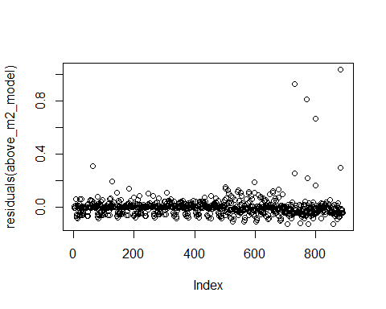
# Shapiro-Wilk test for normality
shapiro.test(residuals(above_m2_model))
Shapiro-Wilk normality test
data: residuals(above_m2_model)
W = 0.51772, p-value < 2.2e-16
print(bestNormalize(df_above$g_15N_APE_pr_m2))
Best Normalizing transformation with 890 Observations
Estimated Normality Statistics (Pearson P / df, lower => more normal):
- arcsinh(x): 13.9757
- Box-Cox: 1.6969
- Center+scale: 15.2563
- Double Reversed Log_b(x+a): 17.8807
- Exp(x): 18.1206
- Log_b(x+a): 2.2309
- orderNorm (ORQ): 1.2546
- sqrt(x + a): 3.4649
- Yeo-Johnson: 8.8595
Estimation method: Out-of-sample via CV with 10 folds and 5 repeats
Based off these, bestNormalize chose:
orderNorm Transformation with 890 nonmissing obs and ties
- 874 unique values
- Original quantiles:
0% 25% 50% 75% 100%
0.000 0.004 0.020 0.064 1.168
print(bestNormalize(residuals(above_m2_model)))
Best Normalizing transformation with 890 Observations
Estimated Normality Statistics (Pearson P / df, lower => more normal):
- arcsinh(x): 6.4876
- Center+scale: 6.8755
- Double Reversed Log_b(x+a): 8.7002
- Exp(x): 9.563
- Log_b(x+a): 5.9299
- orderNorm (ORQ): 1.1132
- sqrt(x + a): 4.8538
- Yeo-Johnson: 3.8704
Estimation method: Out-of-sample via CV with 10 folds and 5 repeats
Based off these, bestNormalize chose:
orderNorm Transformation with 890 nonmissing obs and ties
- 873 unique values
- Original quantiles:
0% 25% 50% 75% 100%
-0.124 -0.035 -0.001 0.013 1.037
#So I make the transformation:
above_data <- df_above$g_15N_APE_pr_m2
# Apply the orderNorm transformation
order_norm <- orderNorm(above_data)
# Transformed data
df_above$g_15N_APE_pr_m2 <- order_norm$x.t
summary(above_m2_model)
Family: gaussian ( identity )
Formula:
g_15N_APE_pr_m2 ~ Site * Winter_stage + Stem_leaf * PFT + (1 |
Site:Winter_stage)
Data: df_above
AIC BIC logLik -2*log(L) df.resid
-2057.6 -1933.1 1054.8 -2109.6 864
Random effects:
Conditional model:
Groups Name Variance Std.Dev.
Site:Winter_stage (Intercept) 1.773e-12 1.331e-06
Residual 5.471e-03 7.397e-02
Number of obs: 890, groups: Site:Winter_stage, 20
Dispersion estimate for gaussian family (sigma^2): 0.00547
Conditional model:
Estimate Std. Error z value
(Intercept) 0.0021883 0.0124537 0.176
SiteNorthern 0.0032487 0.0149096 0.218
SiteSoutheastern 0.0247110 0.0165740 1.491
SiteSouthern 0.0450091 0.0166104 2.710
Winter_stageLate_Winter_C -0.0003145 0.0172067 -0.018
Winter_stageLate_Winter_WW 0.0012893 0.0169744 0.076
Winter_stageMidwinter_I 0.0087053 0.0172067 0.506
Winter_stageMidwinter_II 0.0029716 0.0172067 0.173
Stem_leafStem 0.0826511 0.0069422 11.906
PFTEvergreen 0.0538975 0.0078104 6.901
PFTMoss -0.0051234 0.0078058 -0.656
SiteNorthern:Winter_stageLate_Winter_C -0.0020262 0.0214082 -0.095
SiteSoutheastern:Winter_stageLate_Winter_C -0.0031775 0.0241438 -0.132
SiteSouthern:Winter_stageLate_Winter_C -0.0009072 0.0241401 -0.038
SiteNorthern:Winter_stageLate_Winter_WW -0.0096288 0.0215447 -0.447
SiteSoutheastern:Winter_stageLate_Winter_WW -0.0055794 0.0236367 -0.236
SiteSouthern:Winter_stageLate_Winter_WW -0.0021674 0.0239774 -0.090
SiteNorthern:Winter_stageMidwinter_I -0.0169880 0.0214134 -0.793
SiteSoutheastern:Winter_stageMidwinter_I -0.0257291 0.0236581 -1.088
SiteSouthern:Winter_stageMidwinter_I -0.0481278 0.0237332 -2.028
SiteNorthern:Winter_stageMidwinter_II -0.0104673 0.0215721 -0.485
SiteSoutheastern:Winter_stageMidwinter_II -0.0131294 0.0238032 -0.552
SiteSouthern:Winter_stageMidwinter_II -0.0018607 0.0235926 -0.079
Stem_leafStem:PFTEvergreen -0.0809450 0.0114367 -7.078
Stem_leafStem:PFTMoss NA NA NA
Pr(>|z|)
(Intercept) 0.86052
SiteNorthern 0.82751
SiteSoutheastern 0.13598
SiteSouthern 0.00673 **
Winter_stageLate_Winter_C 0.98542
Winter_stageLate_Winter_WW 0.93945
Winter_stageMidwinter_I 0.61291
Winter_stageMidwinter_II 0.86289
Stem_leafStem < 2e-16 ***
PFTEvergreen 5.17e-12 ***
PFTMoss 0.51159
SiteNorthern:Winter_stageLate_Winter_C 0.92460
SiteSoutheastern:Winter_stageLate_Winter_C 0.89530
SiteSouthern:Winter_stageLate_Winter_C 0.97002
SiteNorthern:Winter_stageLate_Winter_WW 0.65493
SiteSoutheastern:Winter_stageLate_Winter_WW 0.81339
SiteSouthern:Winter_stageLate_Winter_WW 0.92798
SiteNorthern:Winter_stageMidwinter_I 0.42758
SiteSoutheastern:Winter_stageMidwinter_I 0.27680
SiteSouthern:Winter_stageMidwinter_I 0.04257 *
SiteNorthern:Winter_stageMidwinter_II 0.62752
SiteSoutheastern:Winter_stageMidwinter_II 0.58124
SiteSouthern:Winter_stageMidwinter_II 0.93714
Stem_leafStem:PFTEvergreen 1.47e-12 ***
Stem_leafStem:PFTMoss NA
---
Signif. codes: 0 '***' 0.001 '**' 0.01 '*' 0.05 '.' 0.1 ' ' 1
It turns out that Moslyng has only 1 data point, so I exclude that to be able to estimate marginal means. And finally, if I wan to estimate marginal means, I need to drop Moss in this model, because it does not have a Stem level, and fraction is an important factor in the model.
#Removing Moslyng, Moss (no Stem) and Western in order to make estimated marginal means
df_above_dropped <- subset(df_above, Species != "Moslyng")
df_above_dropped <-subset(df_above_dropped, PFT != "Moss")
df_above_dropped <- droplevels(df_above_dropped)
#Rerunning the model with those conditions, just for the emmeans, and here I re-introduce the nested treatment within Late winter in the now slightly simpler model
above_m2_model_PFTint <- glmmTMB(g_15N_APE_pr_m2 ~ Site * Winter_stage + Stem_leaf * PFT + (1 | Site:Winter_stage)+(1 |Winter_stage:WW_treat), data = df_above_dropped, family = gaussian)
#Now we get the estimated marginal means of WInter stage
emm_winterstages <- emmeans(above_m2_model_PFTint, ~Winter_stage, type = 'response')
NOTE: Results may be misleading due to involvement in interactions
#And then a post-hoc test between stages (Tukey test)
pairs(emm_winterstages, adjust = "tukey")
contrast estimate SE df t.ratio p.value
Early_Winter - Late_Winter_C -0.00545 0.0827 732 -0.066 1.0000
Early_Winter - Late_Winter_WW 0.07760 0.0821 732 0.945 0.8792
Early_Winter - Midwinter_I 0.09966 0.0821 732 1.214 0.7434
Early_Winter - Midwinter_II 0.06944 0.0820 732 0.847 0.9157
Late_Winter_C - Late_Winter_WW 0.08305 0.0835 732 0.995 0.8577
Late_Winter_C - Midwinter_I 0.10510 0.0834 732 1.260 0.7161
Late_Winter_C - Midwinter_II 0.07489 0.0833 732 0.899 0.8973
Late_Winter_WW - Midwinter_I 0.02206 0.0829 732 0.266 0.9989
Late_Winter_WW - Midwinter_II -0.00816 0.0827 732 -0.099 1.0000
Midwinter_I - Midwinter_II -0.03022 0.0827 732 -0.365 0.9962
Results are averaged over the levels of: Site, Stem_leaf, PFT
P value adjustment: tukey method for comparing a family of 5 estimates
pairs(emmeans(above_m2_model_PFTint, ~Winter_stage|Site, type = 'response'), adjust = "none")
Site = Eastern:
contrast estimate SE df t.ratio p.value
Early_Winter - Late_Winter_C -0.12358 0.176 732 -0.704 0.4818
Early_Winter - Late_Winter_WW -0.07079 0.173 732 -0.409 0.6825
Early_Winter - Midwinter_I -0.20801 0.176 732 -1.185 0.2365
Early_Winter - Midwinter_II -0.07832 0.176 732 -0.446 0.6557
Late_Winter_C - Late_Winter_WW 0.05279 0.173 732 0.305 0.7603
Late_Winter_C - Midwinter_I -0.08444 0.176 732 -0.481 0.6307
Late_Winter_C - Midwinter_II 0.04526 0.176 732 0.258 0.7967
Late_Winter_WW - Midwinter_I -0.13722 0.173 732 -0.793 0.4279
Late_Winter_WW - Midwinter_II -0.00753 0.173 732 -0.044 0.9653
Midwinter_I - Midwinter_II 0.12969 0.176 732 0.739 0.4604
Site = Northern:
contrast estimate SE df t.ratio p.value
Early_Winter - Late_Winter_C 0.00334 0.132 732 0.025 0.9797
Early_Winter - Late_Winter_WW 0.28137 0.138 732 2.044 0.0413
Early_Winter - Midwinter_I 0.15272 0.135 732 1.134 0.2573
Early_Winter - Midwinter_II 0.19693 0.135 732 1.462 0.1442
Late_Winter_C - Late_Winter_WW 0.27802 0.138 732 2.019 0.0438
Late_Winter_C - Midwinter_I 0.14937 0.135 732 1.109 0.2679
Late_Winter_C - Midwinter_II 0.19358 0.135 732 1.437 0.1511
Late_Winter_WW - Midwinter_I -0.12865 0.141 732 -0.915 0.3605
Late_Winter_WW - Midwinter_II -0.08444 0.141 732 -0.601 0.5483
Midwinter_I - Midwinter_II 0.04421 0.138 732 0.321 0.7483
Site = Southeastern:
contrast estimate SE df t.ratio p.value
Early_Winter - Late_Winter_C 0.03980 0.169 732 0.236 0.8135
Early_Winter - Late_Winter_WW 0.06727 0.163 732 0.412 0.6806
Early_Winter - Midwinter_I 0.16222 0.161 732 1.007 0.3144
Early_Winter - Midwinter_II 0.12786 0.163 732 0.783 0.4340
Late_Winter_C - Late_Winter_WW 0.02748 0.171 732 0.161 0.8722
Late_Winter_C - Midwinter_I 0.12242 0.169 732 0.726 0.4680
Late_Winter_C - Midwinter_II 0.08807 0.171 732 0.516 0.6061
Late_Winter_WW - Midwinter_I 0.09494 0.163 732 0.581 0.5613
Late_Winter_WW - Midwinter_II 0.06059 0.166 732 0.366 0.7145
Midwinter_I - Midwinter_II -0.03435 0.163 732 -0.210 0.8335
Site = Southern:
contrast estimate SE df t.ratio p.value
Early_Winter - Late_Winter_C 0.05864 0.181 732 0.323 0.7467
Early_Winter - Late_Winter_WW 0.03254 0.180 732 0.181 0.8565
Early_Winter - Midwinter_I 0.29170 0.181 732 1.607 0.1084
Early_Winter - Midwinter_II 0.03129 0.178 732 0.175 0.8608
Late_Winter_C - Late_Winter_WW -0.02610 0.183 732 -0.143 0.8866
Late_Winter_C - Midwinter_I 0.23306 0.185 732 1.263 0.2069
Late_Winter_C - Midwinter_II -0.02736 0.181 732 -0.151 0.8802
Late_Winter_WW - Midwinter_I 0.25916 0.183 732 1.417 0.1570
Late_Winter_WW - Midwinter_II -0.00126 0.180 732 -0.007 0.9944
Midwinter_I - Midwinter_II -0.26042 0.181 732 -1.435 0.1517
Results are averaged over the levels of: Stem_leaf, PFT
plot(residuals(above_m2_model_PFTint))
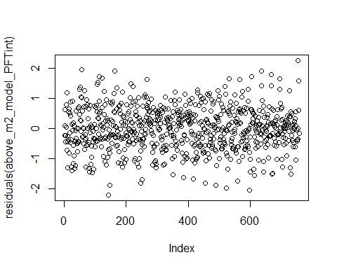

Modelling: Species-specific N uptake
Fitting the model species-specifically across Stem_leaf, Site and Winter stage, based on the unit mass, with Salix as the baselevel. We take out PFT because it will not add anything now that we include Species, and we include interaction between Species and Stem_leaf (fraction) because we expect the distribution of leaf and stem to be different between species.
It turns out that Moslyng has only 1 data point, so I exclude that to be able to estimate marginal means.
df_above_species <- subset(df_above, Species != "Moslyng")
Fitting the model per unit area (g 15N excess pr m2) with Empetrum as baselevel:
df_above$Species <- relevel(df_above$Species, ref = "Empetrum")
above_m2_model_species <- glmmTMB(g_15N_APE_pr_m2 ~ Site * Winter_stage + Stem_leaf * Species + (1 | Site:Winter_stage)+(1 |Winter_stage:WW_treat), data = df_above, family = gaussian)
dropping columns from rank-deficient conditional model: Stem_leafStem:SpeciesDryas, Stem_leafStem:SpeciesGrass, Stem_leafStem:SpeciesLichen, Stem_leafStem:SpeciesMoss, Stem_leafStem:SpeciesPileurt, Stem_leafStem:SpeciesSalix herbacea
summary(above_m2_model_species)
Family: gaussian ( identity )
Formula:
g_15N_APE_pr_m2 ~ Site * Winter_stage + Stem_leaf * Species +
(1 | Site:Winter_stage) + (1 | Winter_stage:WW_treat)
Data: df_above
AIC BIC logLik -2*log(L) df.resid
1786.6 1968.6 -855.3 1710.6 852
Random effects:
Conditional model:
Groups Name Variance Std.Dev.
Site:Winter_stage (Intercept) 6.073e-11 7.793e-06
Winter_stage:WW_treat (Intercept) 1.127e-11 3.357e-06
Residual 4.002e-01 6.326e-01
Number of obs: 890, groups: Site:Winter_stage, 20; Winter_stage:WW_treat, 5
Dispersion estimate for gaussian family (sigma^2): 0.4
Conditional model:
Estimate Std. Error z value
(Intercept) 0.5835940 0.1212546 4.813
SiteNorthern 0.0973191 0.1318678 0.738
SiteSoutheastern 0.4669261 0.1421611 3.284
SiteSouthern 0.3555032 0.1432285 2.482
Winter_stageLate_Winter_C 0.1607594 0.1472443 1.092
Winter_stageLate_Winter_WW 0.1281797 0.1456242 0.880
Winter_stageMidwinter_I 0.2149277 0.1472443 1.460
Winter_stageMidwinter_II 0.1433177 0.1472443 0.973
Stem_leafStem 0.0004887 0.0906593 0.005
SpeciesBetula -1.2347468 0.1589073 -7.770
SpeciesCassiope -0.5443729 0.1375065 -3.959
SpeciesDryas -0.6576499 0.2221074 -2.961
SpeciesGrass -1.2222269 0.0954640 -12.803
SpeciesLichen -1.8656510 0.1267394 -14.720
SpeciesMoss -1.2575022 0.0954026 -13.181
SpeciesPileurt -2.1507856 0.1442691 -14.908
SpeciesSalix -1.6494192 0.1024733 -16.096
SpeciesSalix herbacea -1.6109073 0.2125169 -7.580
SpeciesVaccinum -1.2966041 0.0979902 -13.232
SiteNorthern:Winter_stageLate_Winter_C -0.1659103 0.1831095 -0.906
SiteSoutheastern:Winter_stageLate_Winter_C -0.1787913 0.2068134 -0.865
SiteSouthern:Winter_stageLate_Winter_C -0.1927259 0.2068513 -0.932
SiteNorthern:Winter_stageLate_Winter_WW -0.2753485 0.1852330 -1.486
SiteSoutheastern:Winter_stageLate_Winter_WW -0.1910637 0.2031601 -0.940
SiteSouthern:Winter_stageLate_Winter_WW -0.1793722 0.2058649 -0.871
SiteNorthern:Winter_stageMidwinter_I -0.3420794 0.1837876 -1.861
SiteSoutheastern:Winter_stageMidwinter_I -0.3538236 0.2023468 -1.749
SiteSouthern:Winter_stageMidwinter_I -0.4204793 0.2031525 -2.070
SiteNorthern:Winter_stageMidwinter_II -0.2403475 0.1851030 -1.298
SiteSoutheastern:Winter_stageMidwinter_II -0.2731279 0.2038058 -1.340
SiteSouthern:Winter_stageMidwinter_II -0.2039650 0.2018317 -1.011
Stem_leafStem:SpeciesBetula 2.5531304 0.2248707 11.354
Stem_leafStem:SpeciesCassiope 0.2246316 0.1763103 1.274
Stem_leafStem:SpeciesDryas NA NA NA
Stem_leafStem:SpeciesGrass NA NA NA
Stem_leafStem:SpeciesLichen NA NA NA
Stem_leafStem:SpeciesMoss NA NA NA
Stem_leafStem:SpeciesPileurt NA NA NA
Stem_leafStem:SpeciesSalix 1.2415084 0.1376377 9.020
Stem_leafStem:SpeciesSalix herbacea NA NA NA
Stem_leafStem:SpeciesVaccinum 1.1710397 0.1337520 8.755
Pr(>|z|)
(Intercept) 1.49e-06 ***
SiteNorthern 0.46051
SiteSoutheastern 0.00102 **
SiteSouthern 0.01306 *
Winter_stageLate_Winter_C 0.27493
Winter_stageLate_Winter_WW 0.37875
Winter_stageMidwinter_I 0.14438
Winter_stageMidwinter_II 0.33039
Stem_leafStem 0.99570
SpeciesBetula 7.83e-15 ***
SpeciesCassiope 7.53e-05 ***
SpeciesDryas 0.00307 **
SpeciesGrass < 2e-16 ***
SpeciesLichen < 2e-16 ***
SpeciesMoss < 2e-16 ***
SpeciesPileurt < 2e-16 ***
SpeciesSalix < 2e-16 ***
SpeciesSalix herbacea 3.45e-14 ***
SpeciesVaccinum < 2e-16 ***
SiteNorthern:Winter_stageLate_Winter_C 0.36490
SiteSoutheastern:Winter_stageLate_Winter_C 0.38731
SiteSouthern:Winter_stageLate_Winter_C 0.35149
SiteNorthern:Winter_stageLate_Winter_WW 0.13715
SiteSoutheastern:Winter_stageLate_Winter_WW 0.34698
SiteSouthern:Winter_stageLate_Winter_WW 0.38358
SiteNorthern:Winter_stageMidwinter_I 0.06271 .
SiteSoutheastern:Winter_stageMidwinter_I 0.08036 .
SiteSouthern:Winter_stageMidwinter_I 0.03847 *
SiteNorthern:Winter_stageMidwinter_II 0.19413
SiteSoutheastern:Winter_stageMidwinter_II 0.18020
SiteSouthern:Winter_stageMidwinter_II 0.31222
Stem_leafStem:SpeciesBetula < 2e-16 ***
Stem_leafStem:SpeciesCassiope 0.20264
Stem_leafStem:SpeciesDryas NA
Stem_leafStem:SpeciesGrass NA
Stem_leafStem:SpeciesLichen NA
Stem_leafStem:SpeciesMoss NA
Stem_leafStem:SpeciesPileurt NA
Stem_leafStem:SpeciesSalix < 2e-16 ***
Stem_leafStem:SpeciesSalix herbacea NA
Stem_leafStem:SpeciesVaccinum < 2e-16 ***
---
Signif. codes: 0 '***' 0.001 '**' 0.01 '*' 0.05 '.' 0.1 ' ' 1
Fitting the model per unit biomass (mg 15N excess per g dryweight biomass).
df_above_species$Species <- relevel(df_above_species$Species, ref = "Salix")
above_gdryweight_model_species_fraction <- glmmTMB(
mg_15NAPE_per_g_dryweight_biomass ~ Site * Winter_stage + Species * Stem_leaf + (1 | Site:Winter_stage)+(1 |Winter_stage:WW_treat),
data = df_above_species,
family = gaussian
)
dropping columns from rank-deficient conditional model: SpeciesDryas:Stem_leafStem, SpeciesGrass:Stem_leafStem, SpeciesLichen:Stem_leafStem, SpeciesMoss:Stem_leafStem, SpeciesPileurt:Stem_leafStem, SpeciesSalix herbacea:Stem_leafStem
Warning in finalizeTMB(TMBStruc, obj, fit, h, data.tmb.old): Model convergence
problem; function evaluation limit reached without convergence (9). See
vignette('troubleshooting'), help('diagnose')
summary(above_gdryweight_model_species_fraction)
Family: gaussian ( identity )
Formula:
mg_15NAPE_per_g_dryweight_biomass ~ Site * Winter_stage + Species *
Stem_leaf + (1 | Site:Winter_stage) + (1 | Winter_stage:WW_treat)
Data: df_above_species
AIC BIC logLik -2*log(L) df.resid
-2238.9 -2056.8 1157.4 -2314.9 852
Random effects:
Conditional model:
Groups Name Variance Std.Dev.
Site:Winter_stage (Intercept) 1.815e-07 0.000426
Winter_stage:WW_treat (Intercept) 1.280e-06 0.001131
Residual 4.346e-03 0.065926
Number of obs: 890, groups: Site:Winter_stage, 20; Winter_stage:WW_treat, 5
Dispersion estimate for gaussian family (sigma^2): 0.00435
Conditional model:
Estimate Std. Error z value
(Intercept) 0.32572 0.01310 24.870
SiteNorthern 0.06010 0.01376 4.369
SiteSoutheastern 0.05870 0.01483 3.959
SiteSouthern 0.06433 0.01494 4.306
Winter_stageLate_Winter_C 0.04456 0.01544 2.886
Winter_stageLate_Winter_WW 0.03950 0.01527 2.586
Winter_stageMidwinter_I 0.06281 0.01544 4.068
Winter_stageMidwinter_II 0.02106 0.01544 1.364
SpeciesBetula -0.10671 0.01693 -6.304
SpeciesCassiope -0.11455 0.01417 -8.086
SpeciesDryas -0.15356 0.02306 -6.660
SpeciesEmpetrum -0.15877 0.01068 -14.866
SpeciesGrass -0.10895 0.01063 -10.254
SpeciesLichen -0.28069 0.01391 -20.175
SpeciesMoss -0.23279 0.01042 -22.344
SpeciesPileurt -0.15076 0.01488 -10.132
SpeciesSalix herbacea -0.09130 0.02265 -4.031
SpeciesVaccinum -0.17597 0.01065 -16.526
Stem_leafStem -0.10190 0.01079 -9.440
SiteNorthern:Winter_stageLate_Winter_C -0.04548 0.01910 -2.381
SiteSoutheastern:Winter_stageLate_Winter_C -0.02954 0.02157 -1.370
SiteSouthern:Winter_stageLate_Winter_C -0.05102 0.02157 -2.365
SiteNorthern:Winter_stageLate_Winter_WW -0.09279 0.01932 -4.802
SiteSoutheastern:Winter_stageLate_Winter_WW -0.04365 0.02119 -2.060
SiteSouthern:Winter_stageLate_Winter_WW -0.04814 0.02147 -2.242
SiteNorthern:Winter_stageMidwinter_I -0.09983 0.01917 -5.207
SiteSoutheastern:Winter_stageMidwinter_I -0.07301 0.02111 -3.460
SiteSouthern:Winter_stageMidwinter_I -0.10986 0.02119 -5.185
SiteNorthern:Winter_stageMidwinter_II -0.06548 0.01931 -3.391
SiteSoutheastern:Winter_stageMidwinter_II -0.04132 0.02126 -1.944
SiteSouthern:Winter_stageMidwinter_II -0.03840 0.02105 -1.824
SpeciesBetula:Stem_leafStem 0.13230 0.02401 5.509
SpeciesCassiope:Stem_leafStem 0.05998 0.01910 3.140
SpeciesDryas:Stem_leafStem NA NA NA
SpeciesEmpetrum:Stem_leafStem 0.04924 0.01434 3.432
SpeciesGrass:Stem_leafStem NA NA NA
SpeciesLichen:Stem_leafStem NA NA NA
SpeciesMoss:Stem_leafStem NA NA NA
SpeciesPileurt:Stem_leafStem NA NA NA
SpeciesSalix herbacea:Stem_leafStem NA NA NA
SpeciesVaccinum:Stem_leafStem 0.15279 0.01489 10.261
Pr(>|z|)
(Intercept) < 2e-16 ***
SiteNorthern 1.25e-05 ***
SiteSoutheastern 7.53e-05 ***
SiteSouthern 1.66e-05 ***
Winter_stageLate_Winter_C 0.003901 **
Winter_stageLate_Winter_WW 0.009699 **
Winter_stageMidwinter_I 4.75e-05 ***
Winter_stageMidwinter_II 0.172562
SpeciesBetula 2.90e-10 ***
SpeciesCassiope 6.17e-16 ***
SpeciesDryas 2.74e-11 ***
SpeciesEmpetrum < 2e-16 ***
SpeciesGrass < 2e-16 ***
SpeciesLichen < 2e-16 ***
SpeciesMoss < 2e-16 ***
SpeciesPileurt < 2e-16 ***
SpeciesSalix herbacea 5.55e-05 ***
SpeciesVaccinum < 2e-16 ***
Stem_leafStem < 2e-16 ***
SiteNorthern:Winter_stageLate_Winter_C 0.017273 *
SiteSoutheastern:Winter_stageLate_Winter_C 0.170791
SiteSouthern:Winter_stageLate_Winter_C 0.018039 *
SiteNorthern:Winter_stageLate_Winter_WW 1.57e-06 ***
SiteSoutheastern:Winter_stageLate_Winter_WW 0.039388 *
SiteSouthern:Winter_stageLate_Winter_WW 0.024958 *
SiteNorthern:Winter_stageMidwinter_I 1.92e-07 ***
SiteSoutheastern:Winter_stageMidwinter_I 0.000541 ***
SiteSouthern:Winter_stageMidwinter_I 2.16e-07 ***
SiteNorthern:Winter_stageMidwinter_II 0.000697 ***
SiteSoutheastern:Winter_stageMidwinter_II 0.051903 .
SiteSouthern:Winter_stageMidwinter_II 0.068162 .
SpeciesBetula:Stem_leafStem 3.60e-08 ***
SpeciesCassiope:Stem_leafStem 0.001690 **
SpeciesDryas:Stem_leafStem NA
SpeciesEmpetrum:Stem_leafStem 0.000598 ***
SpeciesGrass:Stem_leafStem NA
SpeciesLichen:Stem_leafStem NA
SpeciesMoss:Stem_leafStem NA
SpeciesPileurt:Stem_leafStem NA
SpeciesSalix herbacea:Stem_leafStem NA
SpeciesVaccinum:Stem_leafStem < 2e-16 ***
---
Signif. codes: 0 '***' 0.001 '**' 0.01 '*' 0.05 '.' 0.1 ' ' 1
#In the below I test the difference between Late_winter_C and Late_winter_WW by only looking at the pair "Late_Winter_C WW_treat0 - Late_Winter_WW WW_treat1". First for each site, then overall.
pairs(emmeans(above_gdryweight_model_species_fraction, ~Winter_stage|Site, type = 'response'), adjust = "none")
Site = Eastern:
contrast estimate SE df t.ratio p.value
Early_Winter - Late_Winter_C -0.044562 0.0154 852 -2.886 0.0040
Early_Winter - Late_Winter_WW -0.039501 0.0153 852 -2.586 0.0099
Early_Winter - Midwinter_I -0.062807 0.0154 852 -4.068 0.0001
Early_Winter - Midwinter_II -0.021061 0.0154 852 -1.364 0.1729
Late_Winter_C - Late_Winter_WW 0.005060 0.0155 852 0.327 0.7436
Late_Winter_C - Midwinter_I -0.018245 0.0156 852 -1.167 0.2435
Late_Winter_C - Midwinter_II 0.023501 0.0156 852 1.503 0.1331
Late_Winter_WW - Midwinter_I -0.023306 0.0155 852 -1.507 0.1323
Late_Winter_WW - Midwinter_II 0.018440 0.0155 852 1.192 0.2336
Midwinter_I - Midwinter_II 0.041746 0.0156 852 2.670 0.0077
Site = Northern:
contrast estimate SE df t.ratio p.value
Early_Winter - Late_Winter_C 0.000918 0.0115 852 0.080 0.9365
Early_Winter - Late_Winter_WW 0.053284 0.0121 852 4.407 <.0001
Early_Winter - Midwinter_I 0.037026 0.0116 852 3.195 0.0014
Early_Winter - Midwinter_II 0.044414 0.0119 852 3.745 0.0002
Late_Winter_C - Late_Winter_WW 0.052366 0.0123 852 4.269 <.0001
Late_Winter_C - Midwinter_I 0.036108 0.0118 852 3.049 0.0024
Late_Winter_C - Midwinter_II 0.043496 0.0120 852 3.612 0.0003
Late_Winter_WW - Midwinter_I -0.016258 0.0122 852 -1.334 0.1827
Late_Winter_WW - Midwinter_II -0.008870 0.0124 852 -0.716 0.4739
Midwinter_I - Midwinter_II 0.007388 0.0120 852 0.618 0.5369
Site = Southeastern:
contrast estimate SE df t.ratio p.value
Early_Winter - Late_Winter_C -0.015017 0.0152 852 -0.985 0.3249
Early_Winter - Late_Winter_WW 0.004153 0.0148 852 0.281 0.7791
Early_Winter - Midwinter_I 0.010208 0.0146 852 0.700 0.4840
Early_Winter - Midwinter_II 0.020262 0.0148 852 1.369 0.1713
Late_Winter_C - Late_Winter_WW 0.019170 0.0155 852 1.239 0.2155
Late_Winter_C - Midwinter_I 0.025225 0.0153 852 1.646 0.1001
Late_Winter_C - Midwinter_II 0.035279 0.0155 852 2.281 0.0228
Late_Winter_WW - Midwinter_I 0.006055 0.0149 852 0.407 0.6842
Late_Winter_WW - Midwinter_II 0.016109 0.0150 852 1.072 0.2840
Midwinter_I - Midwinter_II 0.010054 0.0149 852 0.676 0.4995
Site = Southern:
contrast estimate SE df t.ratio p.value
Early_Winter - Late_Winter_C 0.006458 0.0152 852 0.424 0.6715
Early_Winter - Late_Winter_WW 0.008640 0.0153 852 0.565 0.5721
Early_Winter - Midwinter_I 0.047058 0.0147 852 3.205 0.0014
Early_Winter - Midwinter_II 0.017336 0.0145 852 1.197 0.2318
Late_Winter_C - Late_Winter_WW 0.002182 0.0160 852 0.136 0.8917
Late_Winter_C - Midwinter_I 0.040600 0.0154 852 2.634 0.0086
Late_Winter_C - Midwinter_II 0.010878 0.0152 852 0.715 0.4750
Late_Winter_WW - Midwinter_I 0.038419 0.0155 852 2.481 0.0133
Late_Winter_WW - Midwinter_II 0.008696 0.0153 852 0.569 0.5696
Midwinter_I - Midwinter_II -0.029722 0.0147 852 -2.024 0.0433
Results are averaged over the levels of: Species, Stem_leaf
pairs(emmeans(above_gdryweight_model_species_fraction, ~Winter_stage, type = 'response'), adjust = "none")
NOTE: Results may be misleading due to involvement in interactions
contrast estimate SE df t.ratio p.value
Early_Winter - Late_Winter_C -0.01305 0.00736 852 -1.774 0.0764
Early_Winter - Late_Winter_WW 0.00664 0.00737 852 0.902 0.3673
Early_Winter - Midwinter_I 0.00787 0.00721 852 1.092 0.2753
Early_Winter - Midwinter_II 0.01524 0.00725 852 2.102 0.0358
Late_Winter_C - Late_Winter_WW 0.01969 0.00756 852 2.605 0.0094
Late_Winter_C - Midwinter_I 0.02092 0.00745 852 2.810 0.0051
Late_Winter_C - Midwinter_II 0.02829 0.00746 852 3.791 0.0002
Late_Winter_WW - Midwinter_I 0.00123 0.00742 852 0.165 0.8686
Late_Winter_WW - Midwinter_II 0.00859 0.00742 852 1.158 0.2473
Midwinter_I - Midwinter_II 0.00737 0.00731 852 1.007 0.3140
Results are averaged over the levels of: Site, Species, Stem_leaf
I then get the estimated marginal means and do a pairwise comparison between all species (Tukey’s adjusted).
em_species_fraction <- emmeans(above_gdryweight_model_species_fraction, ~ Species | Stem_leaf)
em_species_fraction_df <- as.data.frame(em_species_fraction)
#Pairwise comparisons with Tukey adjustment
pairwise_species_fraction <- pairs(em_species_fraction, adjust = "tukey", specs = ~ Species | Stem_leaf)
pairwise_df_fraction <- as.data.frame(pairwise_species_fraction)
pairwise_df_fraction
Stem_leaf = Leaf:
contrast estimate SE df t.ratio p.value
Salix - Betula 0.10671016 0.016926892 852 6.304 <.0001
Salix - Cassiope 0.11455201 0.014166899 852 8.086 <.0001
Salix - Dryas 0.15355730 0.023056533 852 6.660 <.0001
Salix - Empetrum 0.15876500 0.010679572 852 14.866 <.0001
Salix - Grass 0.10895374 0.010625401 852 10.254 <.0001
Salix - Lichen 0.28069166 0.013912716 852 20.175 <.0001
Salix - Moss 0.23278556 0.010418033 852 22.344 <.0001
Salix - Pileurt 0.15075696 0.014879423 852 10.132 <.0001
Salix - Salix herbacea 0.09130286 0.022649107 852 4.031 0.0029
Salix - Vaccinum 0.17596803 0.010648092 852 16.526 <.0001
Betula - Cassiope 0.00784185 0.018831802 852 0.416 1.0000
Betula - Dryas 0.04684713 0.026185437 852 1.789 0.7866
Betula - Empetrum 0.05205484 0.016560989 852 3.143 0.0642
Betula - Grass 0.00224357 0.016741009 852 0.134 1.0000
Betula - Lichen 0.17398150 0.018480616 852 9.414 <.0001
Betula - Moss 0.12607540 0.016357646 852 7.707 <.0001
Betula - Pileurt 0.04404680 0.019373531 852 2.274 0.4532
Betula - Salix herbacea -0.01540730 0.025950564 852 -0.594 1.0000
Betula - Vaccinum 0.06925786 0.016591887 852 4.174 0.0016
Cassiope - Dryas 0.03900528 0.024084045 852 1.620 0.8739
Cassiope - Empetrum 0.04421299 0.014330643 852 3.085 0.0758
Cassiope - Grass -0.00559828 0.014064771 852 -0.398 1.0000
Cassiope - Lichen 0.16613965 0.016489091 852 10.076 <.0001
Cassiope - Moss 0.11823355 0.013479683 852 8.771 <.0001
Cassiope - Pileurt 0.03620495 0.016402905 852 2.207 0.5002
Cassiope - Salix herbacea -0.02324915 0.024578144 852 -0.946 0.9973
Cassiope - Vaccinum 0.06141601 0.013691401 852 4.486 0.0004
Dryas - Empetrum 0.00520771 0.023147574 852 0.225 1.0000
Dryas - Grass -0.04460356 0.022959442 852 -1.943 0.6887
Dryas - Lichen 0.12713436 0.024506477 852 5.188 <.0001
Dryas - Moss 0.07922827 0.022642412 852 3.499 0.0210
Dryas - Pileurt -0.00280033 0.024509948 852 -0.114 1.0000
Dryas - Salix herbacea -0.06225444 0.030569672 852 -2.036 0.6233
Dryas - Vaccinum 0.02241073 0.022768898 852 0.984 0.9963
Empetrum - Grass -0.04981127 0.009949064 852 -5.007 <.0001
Empetrum - Lichen 0.12192666 0.013208512 852 9.231 <.0001
Empetrum - Moss 0.07402056 0.009942663 852 7.445 <.0001
Empetrum - Pileurt -0.00800804 0.015035431 852 -0.533 1.0000
Empetrum - Salix herbacea -0.06746214 0.022148111 852 -3.046 0.0845
Empetrum - Vaccinum 0.01720302 0.010212334 852 1.685 0.8434
Grass - Lichen 0.17173792 0.013598227 852 12.629 <.0001
Grass - Moss 0.12383183 0.009925061 852 12.477 <.0001
Grass - Pileurt 0.04180323 0.014782248 852 2.828 0.1492
Grass - Salix herbacea -0.01765088 0.022314283 852 -0.791 0.9994
Grass - Vaccinum 0.06701429 0.010124344 852 6.619 <.0001
Lichen - Moss -0.04790610 0.013254323 852 -3.614 0.0141
Lichen - Pileurt -0.12993470 0.017105181 852 -7.596 <.0001
Lichen - Salix herbacea -0.18938880 0.023879304 852 -7.931 <.0001
Lichen - Vaccinum -0.10472363 0.013538788 852 -7.735 <.0001
Moss - Pileurt -0.08202860 0.014226692 852 -5.766 <.0001
Moss - Salix herbacea -0.14148270 0.022318697 852 -6.339 <.0001
Moss - Vaccinum -0.05681754 0.009874606 852 -5.754 <.0001
Pileurt - Salix herbacea -0.05945410 0.024995607 852 -2.379 0.3817
Pileurt - Vaccinum 0.02521106 0.014427452 852 1.747 0.8103
Salix herbacea - Vaccinum 0.08466517 0.022431044 852 3.774 0.0079
Stem_leaf = Stem:
contrast estimate SE df t.ratio p.value
Salix - Betula -0.02558531 0.017470358 852 -1.464 0.5859
Salix - Cassiope 0.05457266 0.013970667 852 3.906 0.0010
Salix - Dryas nonEst NA NA NA NA
Salix - Empetrum 0.10952879 0.010137243 852 10.805 <.0001
Salix - Grass nonEst NA NA NA NA
Salix - Lichen nonEst NA NA NA NA
Salix - Moss nonEst NA NA NA NA
Salix - Pileurt nonEst NA NA NA NA
Salix - Salix herbacea nonEst NA NA NA NA
Salix - Vaccinum 0.02317958 0.010430292 852 2.222 0.1724
Betula - Cassiope 0.08015797 0.019421082 852 4.127 0.0004
Betula - Dryas nonEst NA NA NA NA
Betula - Empetrum 0.13511410 0.017285898 852 7.816 <.0001
Betula - Grass nonEst NA NA NA NA
Betula - Lichen nonEst NA NA NA NA
Betula - Moss nonEst NA NA NA NA
Betula - Pileurt nonEst NA NA NA NA
Betula - Salix herbacea nonEst NA NA NA NA
Betula - Vaccinum 0.04876489 0.017381054 852 2.806 0.0410
Cassiope - Dryas nonEst NA NA NA NA
Cassiope - Empetrum 0.05495613 0.014236404 852 3.860 0.0011
Cassiope - Grass nonEst NA NA NA NA
Cassiope - Lichen nonEst NA NA NA NA
Cassiope - Moss nonEst NA NA NA NA
Cassiope - Pileurt nonEst NA NA NA NA
Cassiope - Salix herbacea nonEst NA NA NA NA
Cassiope - Vaccinum -0.03139308 0.013757087 852 -2.282 0.1517
Dryas - Empetrum nonEst NA NA NA NA
Dryas - Grass nonEst NA NA NA NA
Dryas - Lichen nonEst NA NA NA NA
Dryas - Moss nonEst NA NA NA NA
Dryas - Pileurt nonEst NA NA NA NA
Dryas - Salix herbacea nonEst NA NA NA NA
Dryas - Vaccinum nonEst NA NA NA NA
Empetrum - Grass nonEst NA NA NA NA
Empetrum - Lichen nonEst NA NA NA NA
Empetrum - Moss nonEst NA NA NA NA
Empetrum - Pileurt nonEst NA NA NA NA
Empetrum - Salix herbacea nonEst NA NA NA NA
Empetrum - Vaccinum -0.08634921 0.010246021 852 -8.428 <.0001
Grass - Lichen nonEst NA NA NA NA
Grass - Moss nonEst NA NA NA NA
Grass - Pileurt nonEst NA NA NA NA
Grass - Salix herbacea nonEst NA NA NA NA
Grass - Vaccinum nonEst NA NA NA NA
Lichen - Moss nonEst NA NA NA NA
Lichen - Pileurt nonEst NA NA NA NA
Lichen - Salix herbacea nonEst NA NA NA NA
Lichen - Vaccinum nonEst NA NA NA NA
Moss - Pileurt nonEst NA NA NA NA
Moss - Salix herbacea nonEst NA NA NA NA
Moss - Vaccinum nonEst NA NA NA NA
Pileurt - Salix herbacea nonEst NA NA NA NA
Pileurt - Vaccinum nonEst NA NA NA NA
Salix herbacea - Vaccinum nonEst NA NA NA NA
Results are averaged over the levels of: Site, Winter_stage
P value adjustment: tukey method for varying family sizes

