Transcriptome profile of a long-juvenile soybean genotype Huaxia-3 under short and long photoperiod
Enoch Sapey^{1, 2, †}, Bingjun Jiang¹, † Luping Liu¹, Shan Yuan¹, Tingting Wu¹, Seifeldin Elrayah Ibrahim ⁴, Shi Sun¹, Yanlei Yue³ *, Tianfu Han¹, *
¹ MARA Key Laboratory of Soybean Biology (Beijing), Institute of Crop Sciences, Chinese Academy of Agricultural Sciences, Beijing 100081, China.
² CSIR-Oil Palm Research Institute, P.O Box 74 Kade, Ghana.
³ College of Life Sciences, Henan Agricultural University, Zhengzhou 450002, China
⁴ Gezira Research Station, Agricultural Research Corporation (ARC), Wad Medani, Sudan
† Contributed equally.
* Correspondence: T.H. (Phone: 86-10-82105875, Fax: 86-10-82108784, Email: hantianfu@caas.cn) and Y.Y. (Phone: 86-371-63555790, Fax: 86-371-63555790, Email: yueyanlei@henau.edu.cn)

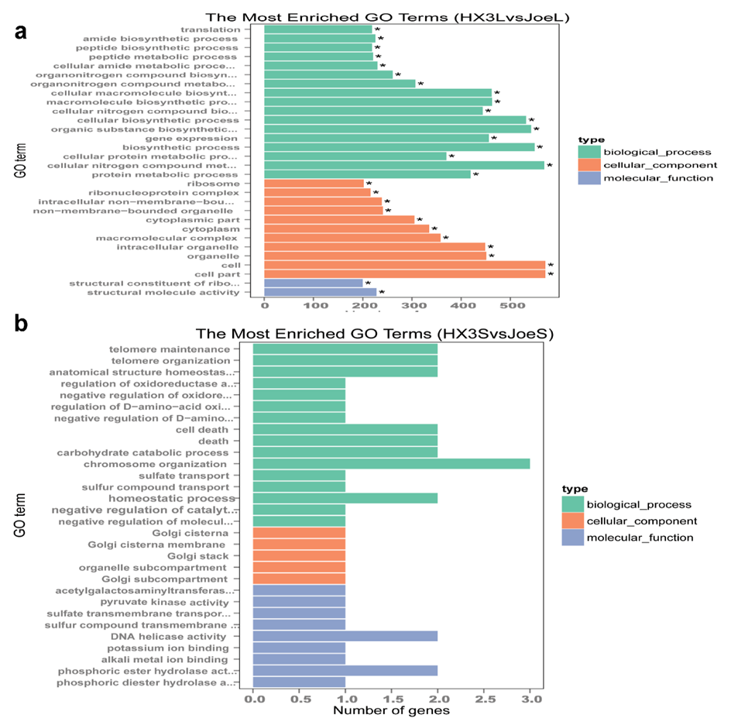
Fig. S1 Gene Ontology Analysis of DEGs in the long juvenile line. a. HX3LvsJoeL refers to long juvenile (LJ) soybean under LD compared to the transgenic under LD, b. HX3SvsJoeS refers to LJ soybean under SD compared to transgenic soybean under SD.

Fig. S2 Circadian rhythm pathway showing differences in expression of circadian clock genes in the long juvenile (LJ) soybean relative to the transgenic under short day (SD) condition. The image shows the soybean circadian clock genes in complete biological network. The white box shows an Arabidopsis circadian clock gene with no homologues (or not found) in soybean. The red box shows a DEG shared between the LJ soybean compared to the transgenic soybean that changed significantly. The green box shows soybean genes that were not significantly changed in the LJ soybean.

