Appendix A

Table 1: Respondent Characteristics

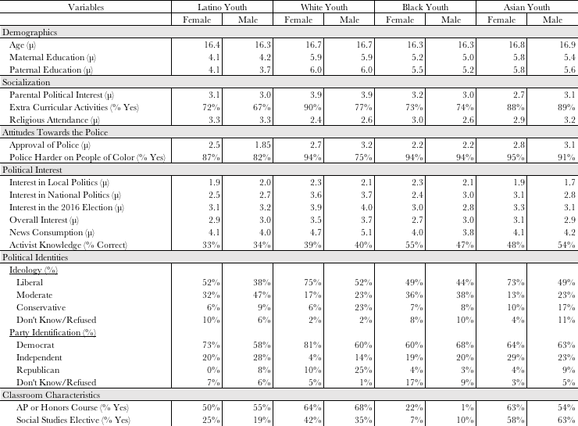

Table 1 provides a breakdown of demographic characteristics, other factors of socialization, attitudes towards the police, extant political interest, political ideology, party identification, and classroom characteristics by race and gender.

Table 2: Randomization
 | Dependent Variable:
 | Experimental Condition
Race | 0.010
 | (0.017)
School | 0.001
 | (0.012)
Age | 0.043
 | (0.035)
Gender | 0.017
 | (0.044)
Zip Code | -0.0003
 | (0.0002)
Parental Political Interest | 0.030
 | (0.024)
Mother’s Educational Attainment | 0.018
 | (0.018)
Father’s Educational Attainment | -0.030*
 | (0.017)
AP Course | -0.039
 | (0.079)
Elective | -0.125*
 | (0.076)
Activist Knowledge | 0.009
 | (0.038)
Religion | 0.014
 | (0.015)
Club | -0.044
 | (0.056)
Trust of Police | 0.103***
 | (0.029)
Interest in Local Politics | -0.016
 | (0.024)
Interest in National Politics | -0.017
 | (0.032)
Interest in 2016 Election | 0.017
 | (0.026)
Ideology | 0.010
 | (0.020)
Reading Fluency | 0.097*
 | (0.058)
Constant | 17.262
 | (11.251)
Observations | 580
R² | 0.062
Note: | *p**p***p<0.01

Table 3: Political Engagement (with School Fixed Effects)
 | Dependent Variable:
 | White Youth | Black Youth | Latinx Youth
Condition | -0.150 | 0.138 | 0.347***
 | (0.137) | (0.141) | (0.130)
School Fixed Effects | Yes | Yes | Yes
Constant | 3.900*** | 2.669*** | 2.821***
 | (0.895) | (0.135) | (0.295)
Observations | 172 | 179 | 205
R² | 0.062 | 0.039 | 0.054
Note: | **p<0.05***p<0.01

Table 4: Public Voice (with School Fixed Effects)
 | Dependent Variable:
 | White Youth | Black Youth | Latinx Youth
Condition | -0.093 | 0.249* | 0.499***
 | (0.143) | (0.139) | (0.129)
School Fixed Effects | Yes | Yes | Yes
Constant | 3.218*** | 2.507*** | 2.806***
 | (0.945) | (0.132) | (0.307)
Observations | 177 | 168 | 202
R² | 0.010 | 0.118 | 0.095
Note: | *p<0.1 **p<0.05***p<0.01

Table 5: Cognitive Engagement (with School Fixed Effects)
 | Dependent Variable:
 | White Youth | Black Youth | Latinx Youth
Condition | -0.212* | -0.003 | 0.366**
 | (0.123) | (0.159) | (0.143)
School Fixed Effects | Yes | Yes | Yes
Constant | 5.212*** | 3.878*** | 3.627***
 | (0.827) | (0.151) | (0.311)
Observations | 182 | 181 | 211
R² | 0.166 | 0.067 | 0.096
Note: | *p<0.1 **p<0.05***p<0.01

Table 6: Civic Engagement (with School Fixed Effects)
 | Dependent Variable:
 | White Youth | Black Youth | Latinx Youth
Condition | -0.053 | 0.225 | 0.436***
 | (0.175) | (0.186) | (0.163)
School Fixed Effects | Yes | Yes | Yes
Constant | 2.053* | 2.919*** | 3.245***
 | (1.177) | (0.177) | (0.357)
Observations | 182 | 179 | 211
R² | 0.064 | 0.038 | 0.059
Note: | p<0.01

Table 7: Sample Size, Means, and Standard Errors for Each Condition (Main Study)

 | Political Engagement | Public Voice | Cognitive Engagement | Civic Engagement
Black Control  N=93 | μ=2.60  Standard Error=0.1 | μ=2.58  Standard Error=0.1 | μ=3.98  Standard Error=0.1 | μ=2.93  Standard Error=0.12
Black Treatment  N=88 | μ=2.79  Standard Error=0.1 | μ=2.91  Standard Error=0,1 | μ=3.99  Standard Error=0.1 | μ=3.15  Standard Error=0.13
Latinx Control  N=115 | μ=2.57  Standard Error=0.09 | μ=2.59  Standard Error=0.09 | μ=3.83  Standard Error=0.1 | μ=2.90  Standard Error=0.1
Latinx Treatment  N=97 | μ=2.91  Standard Error=0.1 | μ=3.10  Standard Error=0.09 | μ=4.20  Standard Error=0.1 | μ=3.33  Standard Error=0.1
White Control  N=85 | μ=2.95  Standard Error=0.1 | μ=2.84  Standard Error=0.09 | μ=4.60  Standard Error=0.08 | μ=2.93  Standard Error=0.1
White Treatment  N=97 | μ=2.81  Standard Error=0.09 | μ=2.76  Standard Error=0.1 | μ=4.38  Standard Error=0.1 | μ=2.93  Standard Error=0.1

Table 8: Sample Size, Means, and Standard Errors for Each Condition (Pre-Treatment)

 | Political Engagement | Public Voice | Cognitive Engagement | Civic Engagement
Traditional Pedagogy (Control)  N=181 | μ=2.64  Standard Error=0.07 | μ=2.61  Standard Error=0.06 | μ=3.99  Standard Error=0.08 | μ=2.81  Standard Error=0.09
Traditional Pedagogy (Treatment)  N=182 | μ=2.85  Standard Error=0.07 | μ=2.90  Standard Error=0.07 | μ=4.21  Standard Error=0.08 | μ=3.15  Standard Error=0.09
Critical Pedagogy (Control)  N=155 | μ=2.73  Standard Error=0.08 | μ=2.70  Standard Error=0.08 | μ=4.16  Standard Error=0.08 | μ=3.03  Standard Error=0.09
Critical Pedagogy (Treatment)  N=160 | μ=2.75  Standard Error=0.07 | μ=2.82  Standard Error=0.07 | μ=4.10  Standard Error=0.09 | μ=3.04  Standard Error=0.09

Table 9: Comparison of Means for Each Individual Activity

 | White Youth |  |  | Latinx Youth |  |  | Black Youth
Political Engagement | Control | Treatment | Difference in Means | Control | Treatment | Difference in Means | Control | Treatment | Difference in Means
Vote | 4.43 | 4.16 | p=0.14 | 3.50 | 3.90 | p=0.043 | 3.40 | 3.81 | p=0.08
Campaign | 2.34 | 2.19 | p=0.39 | 2.16 | 2.66 | p=0.004 | 2.33 | 2.41 | p=0.64
Give Money to a Campaign or Issue | 2.31 | 2.28 | p=0.88 | 2.29 | 2.49 | p=0.21 | 2.31 | 2.40 | p=0.64
Join a Political Group | 2.74 | 2.72 | p=0.93 | 2.36 | 2.61 | p=0.12 | 2.39 | 2.53 | p=0.41
Public Voice
Protest | 3.06 | 2.90 | p=0.39 | 2.80 | 3.47 | p<0.001 | 2.61 | 3.13 | p=0.008
Boycott | 2.82 | 2.78 | p=0.81 | 2.64 | 3.33 | p<0.001 | 2.63 | 3.17 | p=0.005
Contacting a Public Official | 2.60 | 2.26 | p=0.09 | 2.10 | 2.38 | p=0.07 | 2.14 | 2.21 | p=0.70
Social Media Post | 3.26 | 3.18 | p=0.70 | 3.20 | 3.70 | p=0.01 | 3.40 | 3.64 | p=0.3
Signing a Petition | 3.62 | 3.51 | p=0.51 | 2.92 | 3.60 | p<0.001 | 2.80 | 3.32 | p=0.04
Sending an Email | 2.54 | 2.49 | p=0.44 | 2.22 | 2.46 | p=0.15 | 2.46 | 2.45 | p=0.99
Writing a Blog or Letter to the Editor | 2.10 | 2.15 | p=0.72 | 2.10 | 2.37 | p=0.1 | 2.40 | 2.36 | p=0.94

Figure 1: Geographical Distribution of Respondents

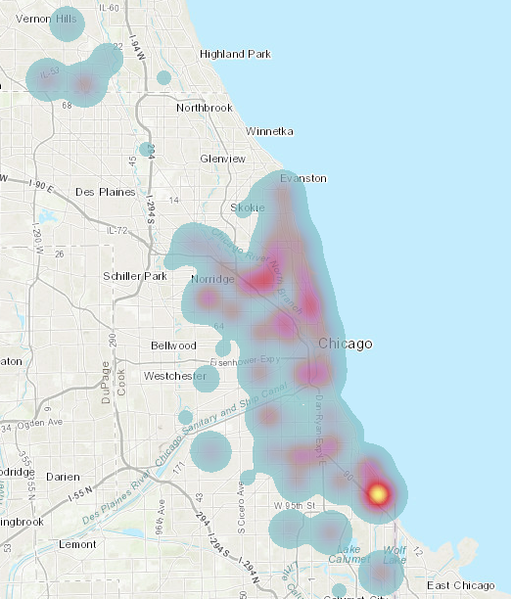

The heat map included above in Figure 1 maps each respondent by Zip Code with warmer areas corresponding to higher concentrations of respondents. Though the study was only conducted within nine communities, the map shows robust geographical distribution across the city.

Figure 2:
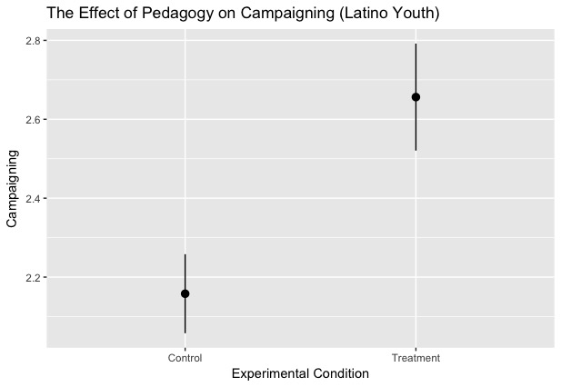

Figure 2 demonstrates that the effect of critical pedagogy on acts of political engagement is largely driven by willingness to campaign among Latinxs. Those in the treatment group are significantly more likely to say they intend to campaign in the future than those in the control group (p=0.004). Cohen’s d=0.41.

Figure 3:
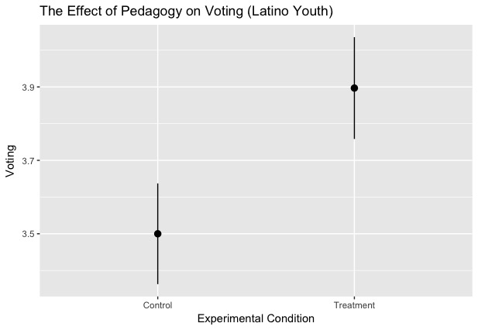

Figure 3 demonstrates that the effect of critical pedagogy on acts of political engagement is largely driven by willingness to vote among Latinxs. Those in the treatment group are significantly more likely to say they intend to vote in the future than those in the control group (p=0.004). Cohen’s d=0.28.
Figure 4: Political Engagement (with Asian Americans)
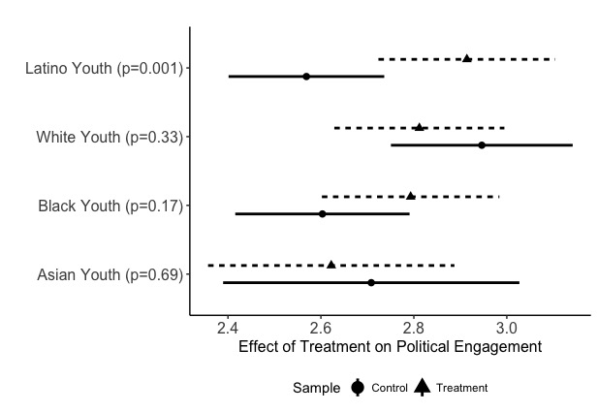
Figure 5: Public Voice (with Asian Americans)
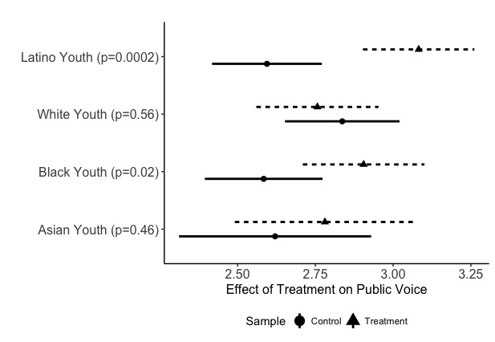
Figure 6: Cognitive Engagement (with Asian Americans)
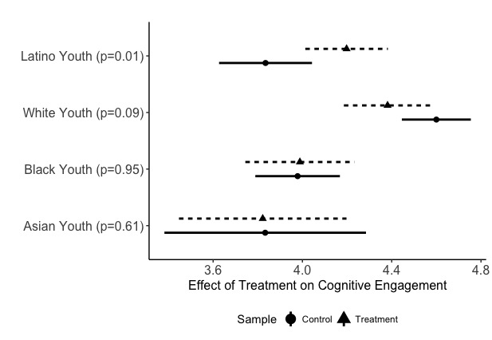
Figure 7: Civic Engagement (With Asian Americans)
