Appendix

A. Ecological inference is the process of inferring smaller group level behavior from larger aggregate data. Since ballots are secret, exact numbers of which racial groups voted for which candidate are not obtainable. In order to obtain estimates of the proportion of voters who supported a candidate, I use King’s ecological inference model (EI). This method uses maximum likelihood and bounds in order to estimate vote choice. Bounds are defined as the number of registered voters by national-origin by precinct, and the total number of ballots cast in that election per precinct. King’s ecological inference adds statistical ‘bounds information’ with likelihood estimation. The ‘method of bounds’ includes information we know for certain to be true (i.e. the minimum number of Chinese voters in district, minimum number of Latinos in the district, etc). King’s inference model builds on Goodman’s ecological regression model which estimated participation at the district but was not specified enough to predict precinct-level outcomes, with estimates frequently appearing below 0% or above 100% .

Additional References for Ecological Inference:
Cho, W. (1998). If the Assumption Fits...: A Comment on the King Ecological Inference Solution. Political Analysis, 7, 143-163.

King, G. (1997) A Solution to the Ecological Inference Problem (Princeton Univ. Press, Princeton).

Lewis, J.B. (2001) Understanding King’s Ecological Inference Model a Method-of-Moments Approach, Historical Methods: A Journal of Quantitative and Interdisciplinary History, 34:4, 170-188.

Table 10 - Other 2018 Congressional Races in High Asian Pop

Districts

District Number | % Asian | Candidate Name | Party | National-Origin/Race | Victor
CA-15 | 33.8% | Eric Swalwell* | D | White | C
 |  | Rudy Peters | R | White
CA-12 | 32.5% | Nancy Pelosi* | D | White | C
 |  | Lisa Remmer | R | White
CA-19 | 27.1% | Zoe Lofgren | D | White | C
 |  | Justin Aguilera | R | Latino
CA-45 | 24.5% | Katie Porter | D | White | C
 |  | Mimi Walters* | R | White
CA-47 | 22.0% | Alan Lowenthal* | D | White | C
 |  | John Briscoe | R | White
*indicates incumbency.

Figure 10 - Estimated Vote by National-Origin in CA-15 for Representative
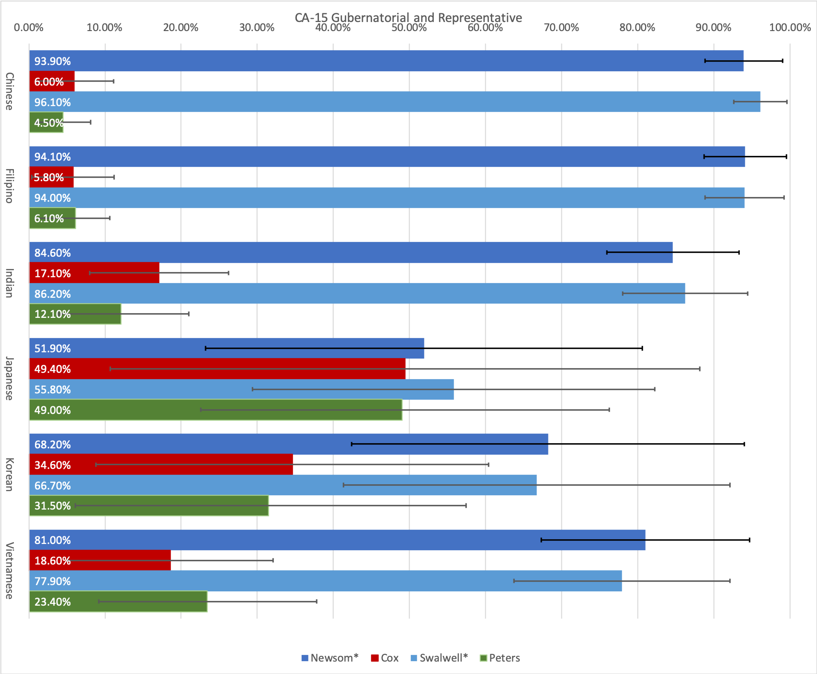

Figure 11 - Estimated Vote by National-Origin in CA-12 for Representative
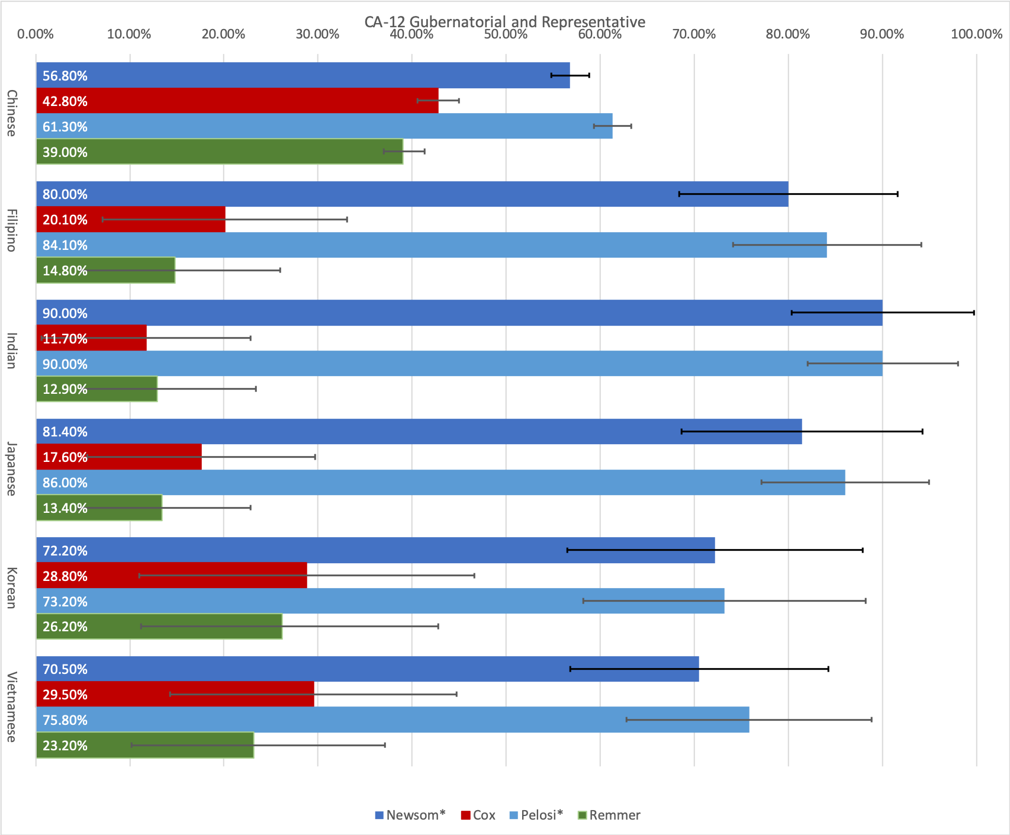

Figure 12 - Estimated Vote by National-Origin in CA-19 for Representative
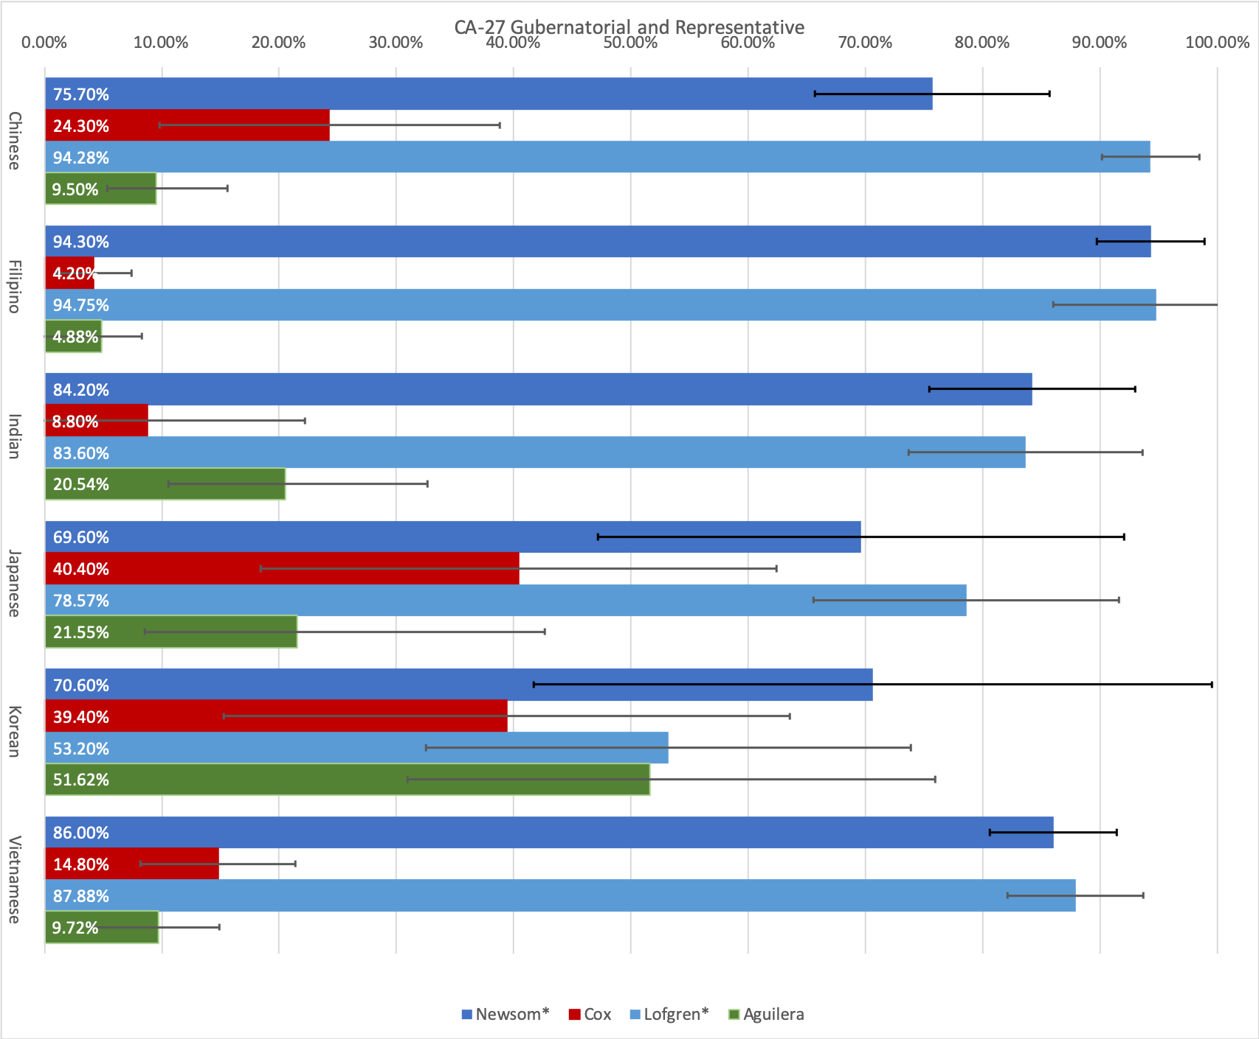

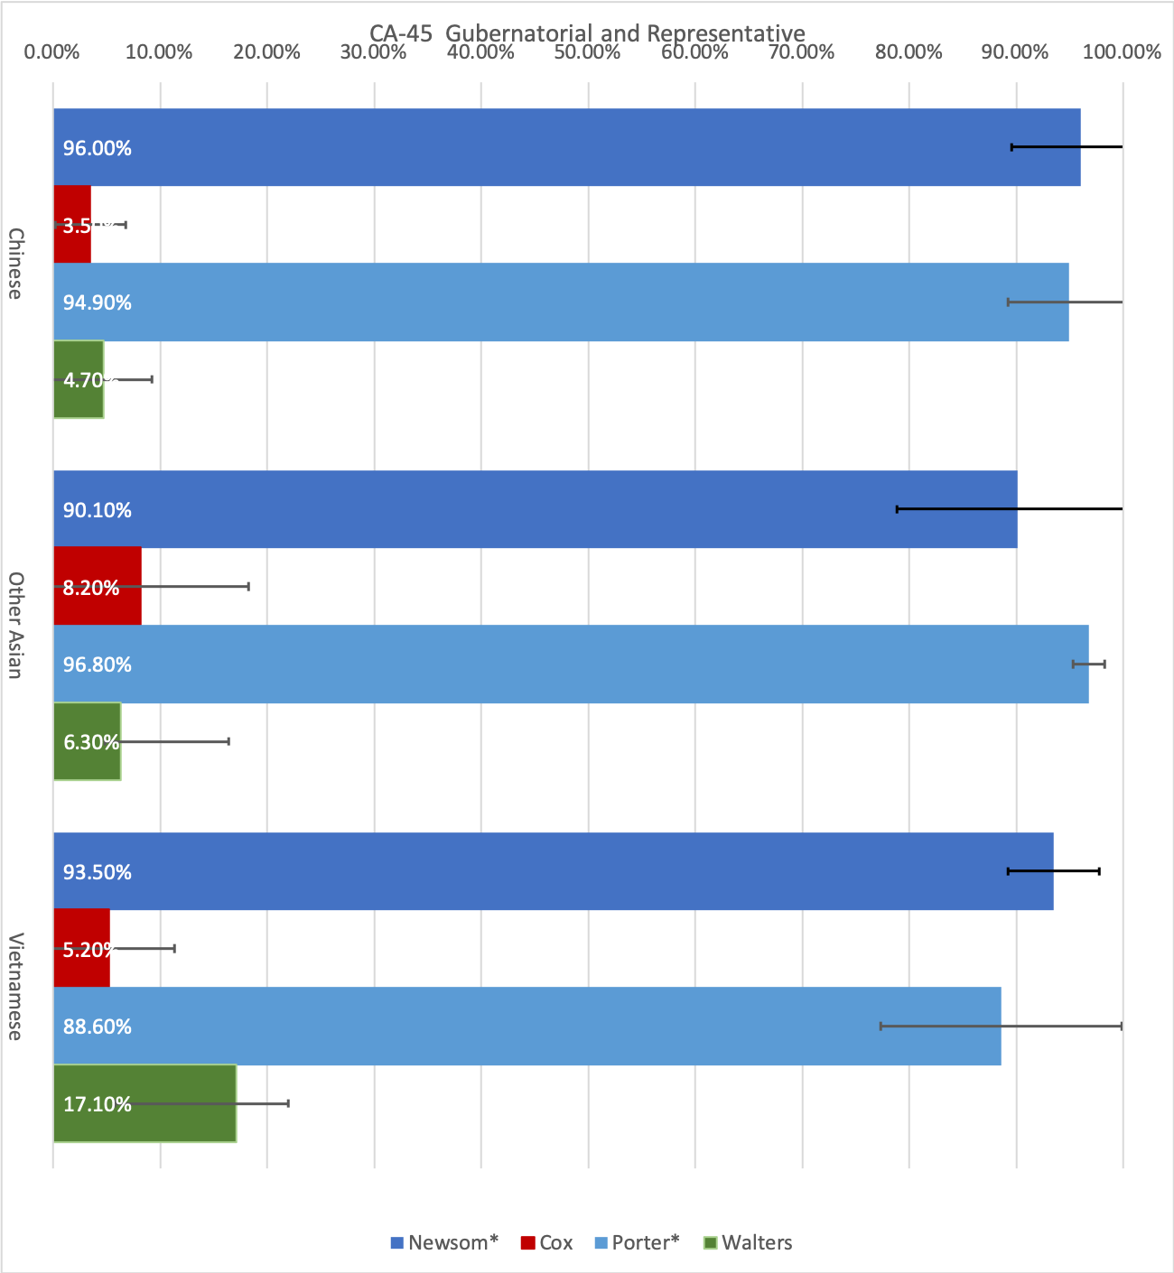
Figure 13 - Estimated Vote by National-Origin in CA-45 for Representative ³

3 Indian, Korean, Japanese, and Filipino voters were aggregated into the “other” category due to small sample in this district

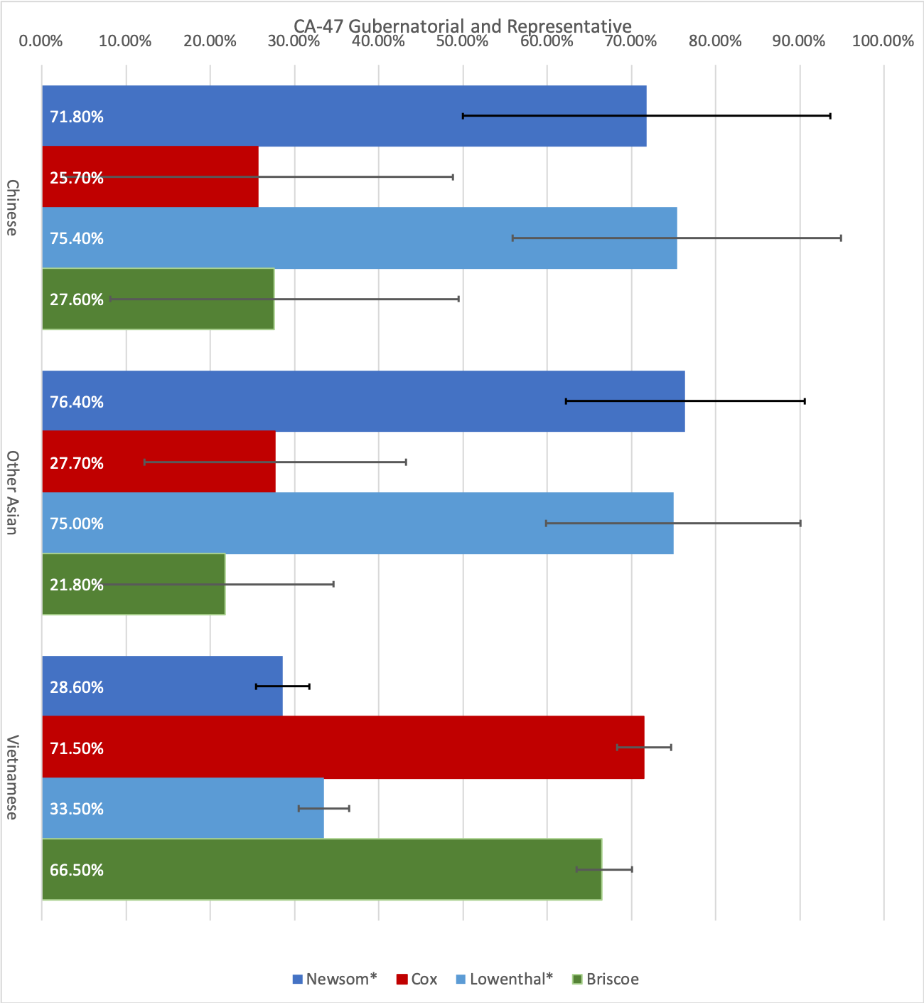
Figure 14 - Estimated Vote by National-Origin in CA-47 for Representative⁴

4Indian, Korean, Japanese, and Filipino voters were aggregated into the “other” category due to small sample in this district

Table 11: Turnout in District 17 from 2016 to 2018

Election | Turnout
2016 General for Representative | 233,192
2018 General for Representative | 211,162
2018 General for Governor | 214,892

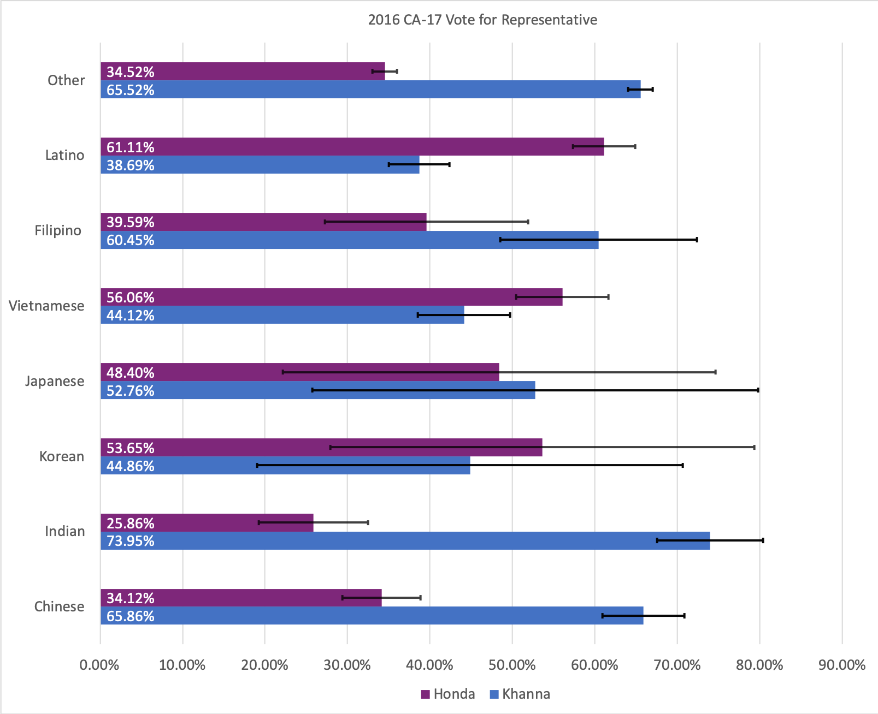
Figure 15 - 2016 Election Estimated Vote by National-Origin in CA 17

