Online Appendices

Online Appendix A: Additional Exploratory Analyses of the Discussion Intent Variable (separated into Discussion with Coworkers and Discussion with Family and Friends)
Online Appendix B: Additional Exploratory Analyses Including Article Quality and Argument Quality

Online Appendix A: Additional Exploratory Analyses of the Discussion Intent Variable (separated into Discussion with Coworkers and Discussion with Family and Friends)
Although the latent correlation between the willingness to discuss with coworkers (CW) and family and friends (F&F) is high (i.e., .75), we agree with a reviewer’s valuable comment that from a conceptual perspective, a more fine-grained analysis may be interesting and, given the work by Mutz (2006), perhaps even necessary. Mutz (2006) argued that individuals are perhaps more in agreement with their F&F than with their CW. To explore potential differences, we ran additional mediation analyses (for details, see the file “delib_within_main_study.html” at OSF). Parameters of the general model and the model focusing on the willingness to discuss with F&F only showed nearly identical values, that is, the indirect effect of cross-cuttingness → deliberation within → argument repertoire on discussion intent was 0.002 MC 95% CI [0.0002, 0.0038] for the F&F dimension and thus merely identical to the general model. However, the same indirect effect turned nonsignificant when regarding the CW items only, 0.001 MC 95% CI [–0.0001, 0.0028]. This finding is due to a nonsignificant effect of argument repertoire on willingness to discuss with CW, whereas this path is significant in both the general and the F&F model. However, at the same time and in the CW model only, the control variable internal political efficacy exerts significant influence on intended discussion with CW. When running the CW model without control variables, both non-significant paths reported above turn significant again. For instance, the indirect effect is again 0.002, MC 95% CI [0.0001, 0.0055]. Thus, it seems that the influence of argument repertoire on intended discussion with CW is reduced only due to the increased influence of internal political efficacy.

Reference
Mutz, D. C. (2006). Hearing the other side: Deliberative versus participatory democracy. Cambridge University Press.
Online Appendix B: Additional Exploratory Analyses Including Article Quality and Argument Quality
As mentioned in the main text, concerning the comparability of all articles, we detected that the articles with pro arguments were slightly more positively evaluated with regard to article quality and argument quality (EVAL). Thus, EVAL may be confounded with the independent variable, CCLM. To test if the coefficients in our hypothesized model are inflated or deflated only due to EVAL, we ran the mediation analysis again, using EVAL as an additional mediator of the effects of CCLM on DW, AR, and DINT. Model fit indices showed an acceptable model fit, robust χ² = 389.45, df = 251, p ≤ .001, χ²/df = 1.55, robust CFI = .944, robust RMSEA = .028, 90% CI of robust RMSEA [.022, .033], SRMR = .034. Table B1 shows all direct, specific indirect, total indirect and total effects of this updated model (for a depiction of the structural part of the model with standardized coefficients, see Figure B1). Interestingly, CCLM significantly negatively influenced EVAL, whereas EVAL was significantly positively associated with DW and DINT. This renders the total indirect effect of CCLM on DINT significantly negative and the direct effect of CCLM on DINT nonsignificant. The specific positive indirect effects via DW and AR only marginally changed, showing that the hypothesized indirect effects were not biased.
Table B1

Unstandardized direct, specific indirect, total indirect and total effects (Model 2)
Predictor and dependent variables | Total effect |  |  | Direct effect |  |  | Total (T) / specific (S) indirect effect
Predictor and dependent variables | Estimate | SE |  | Estimate | SE |  | Estimate | MC 95% CI
Evaluation (EVAL)
Cross-cuttingness (CCLM) |  |  |  | –0.310* | 0.034
Deliberation within (DW)
Cross-cuttingness (CCLM) | 0.042* | 0.018 |  | 0.082* | 0.020
CCLM → EVAL |  |  |  |  |  |  | S: –0.039* | –0.061, –0.020
EVAL |  |  |  | 0.127* | 0.031
Argument repertoire (AR)
CCLM | 0.038 | 0.059 |  | 0.023 | 0.062 |  | T: 0.015 | –0.012, 0.048
CCLM → DW |  |  |  |  |  |  | S: 0.050* | 0.020, 0.088
CCLM → EVAL |  |  |  |  |  |  | S: –0.011 | –0.072, 0.050
CCLM → EVAL → DW |  |  |  |  |  |  | S: –0.024* | –0.044, –0.009
DW |  |  |  | 0.615* | 0.152
EVAL | 0.113 | 0.095 |  | 0.035 | 0.099
EVAL → DW |  |  |  |  |  |  | S: 0.078* | 0.032, 0.138
Discussion intent (DINT)
CCLM | −0.043 | 0.033 |  | 0.007 | 0.034 |  | T: –0.050* | –0.097, –0.005
CCLM → AR |  |  |  |  |  |  | S: 0.002 | –0.008, 0.011
CCLM → DW |  |  |  |  |  |  | S: 0.040* | 0.017, 0.070
CCLM → DW → AR |  |  |  |  |  |  | S: 0.004* | 0.001, 0.007
CCLM → EVAL |  |  |  |  |  |  | S: –0.073* | –0.110, –0.040
CCLM → EVAL → AR |  |  |  |  |  |  | S: –0.001 | –0.006, 0.004
CCLM → EVAL → DW |  |  |  |  |  |  | S: –0.019* | –0.034, –0.008
CCLM → EVAL → DW → AR |  |  |  |  |  |  | S: –0.002* | –0.004, –0.0005
AR |  |  |  | 0.072* | 0.020
DW | 0.513* | 0.113 |  | 0.487* | 0.111
DW → AR |  |  |  |  |  |  | S: 0.044* | 0.015, 0.081
EVAL | 0.306* | 0.054 |  | 0.236* | 0.051 |  | T: 0.070* | 0.029, 0.121
EVAL → AR |  |  |  |  |  |  | S: 0.003 | –0.012, 0.018
EVAL → DW |  |  |  |  |  |  | S: 0.062* | 0.026, 0.107
EVAL → DW → AR |  |  |  |  |  |  | S: 0.006* | 0.002, 0.012
Note. N = 725. All significance tests were conducted applying an alpha-level of .05; MC 95% CI = Confidence intervals for specific indirect and total indirect effects were estimated using Monte Carlo simulations (20,000 repetitions) as described by Preacher and Selig (2012). All effects are controlled for internal political efficacy and political interest. Evaluation was modeled as a second-order factor, with evaluation of article quality and evaluation of argument quality as first-order factors. For further details, see the R Markdown file in the OSF project.
*p < .05
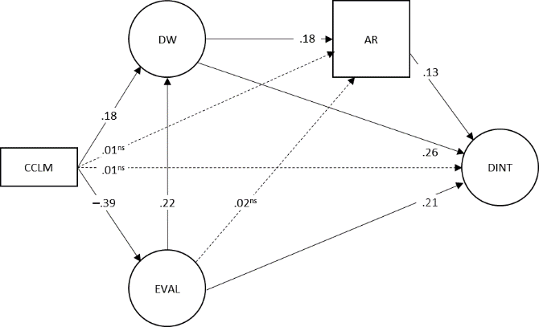
Figure B1. Simplified structural model (N = 725) with standardized coefficients significant at alpha = .05 (one-tailed). For unstandardized coefficients, see Table B1. CCLM = cross-cuttingness vs. like-mindedness; DW = deliberation within; AR = argument repertoire; DINT = discussion intent; EVAL = evaluation of article/argument quality. Non-significant paths are displayed as dashed lines.
For the sake of brevity, covariates (i.e., internal political efficacy, political interest), second-order factors (i.e., for DINT: discussion intent with family and friend, discussion intent with co-workers; for EVAL: evaluation of article quality, evaluation of argument quality), variances, co-variances, and factor loadings are not displayed. Note that all loadings of the first indicators of each latent variable were fixed to 1.0 for scaling, except for the second-order factors DINT and EVAL (variances were fixed to 1.0).

EVAL was modeled as a second-order factor with evaluation of article quality and evaluation of argument quality as first-order factors (for details, see the file “delib_within_main_study.html” at OSF).

