Supplementary Materials for

Distance and Trust: Examination of the Two Opposing Factors
Impacting Adoption of Postal Voting among Citizens Living Abroad

Miroslav Nemčok and Johanna Peltoniemi

Correspondence to: miroslav.nemcok@stv.uio.no

Comparison of the subjective and objective distance measures

The research measures distance from the polling station in two ways:
- Subjective (perception of the) distance to the nearest polling stations is based on a numerical response to a write-in question “What is the distance from where you live to the nearest polling station where you can vote in Finnish elections (approximately, kilometers)?”
- Objective distance to the polling station represents the length of the route between the respondent’s address where the invitation to participate in the survey was delivered and the nearest polling station organized by Finnis administration abroad.
Figure A1 compares these two measures. Despite potential shortcomings related to each of the measures, the Spearman's rank correlation between the two distance measures is high – ρ=0.84. Since the distribution of both distance measures is right–skewed towards shorter distances, the analysis uses their decimal logarithmic transformation.

Figure A1. Comparison of the subjective and objective distance measures. Spearman's rank correlation coefficient ρ=0.84.
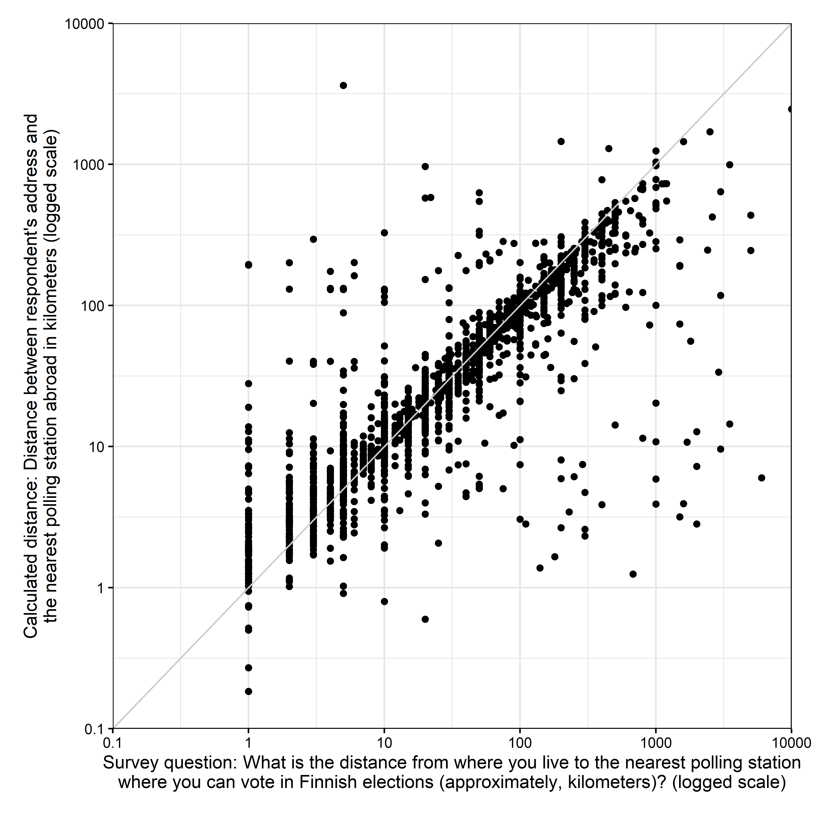
Comparison of the results for individual trust measure elements

Trust in the postal voting is measured by two survey items introduced with the question “Do you agree or disagree with the following statements regarding postal voting in Finnish parliamentary elections?”:
- Postal voting jeopardizes the secrecy of the ballot
- Postal voting enables electoral fraud
These two items are used to calculate a combined measure with Cronbach's alpha = 0.85. Table A1 and Figure A1 compares the results for the three measures. (Figure for the combined measure is included in the paper as Figure 4.) This robustness check demonstrates that the results are similar regardless of the measure used in the analysis.

Table A1. Comparison of the three trust measures used in the research: Results of binomial logistic regression.
 | Dependent variable: Voting via post
 | (1) | (2) | (3) | (4) | (5) | (6)
Constant | -3.706*** | -4.283*** | -4.554*** | -4.327*** | -4.451*** | -4.881***
 | (1.109) | (1.102) | (0.886) | (1.062) | (0.997) | (0.852)
Objective distance | 0.006*** | 0.006*** | 0.006***
 | (0.001) | (0.001) | (0.001)
Subjective distance |  |  |  | 0.003*** | 0.003*** | 0.003***
 |  |  |  | (0.001) | (0.001) | (0.001)
Trust – ballot secrecy:
Somewhat agree | 0.264 |  |  | 0.527
 | (0.807) |  |  | (0.781)
Neither agree nor disagree | 0.499 |  |  | 0.887
 | (0.785) |  |  | (0.759)
Somewhat disagree | 1.324 |  |  | 1.576*
 | (0.765) |  |  | (0.743)
Disagree strongly | 2.190** |  |  | 2.522***
 | (0.762) |  |  | (0.740)
Trust – electoral fraud:
Somewhat agree |  | 0.894 |  |  | 0.720
 |  | (0.798) |  |  | (0.691)
Neither agree nor disagree |  | 1.385 |  |  | 1.257
 |  | (0.763) |  |  | (0.651)
Somewhat disagree |  | 1.791* |  |  | 1.574*
 |  | (0.761) |  |  | (0.650)
Disagree strongly |  | 2.611*** |  |  | 2.578***
 |  | (0.768) |  |  | (0.658)
Trust: Combined measure |  |  | 2.995*** |  |  | 3.083***
 |  |  | (0.433) |  |  | (0.410)
Gender (Reference=Female) | -0.399 | -0.459* | -0.447* | -0.455* | -0.509* | -0.511*
 | (0.224) | (0.222) | (0.223) | (0.216) | (0.214) | (0.215)
Age | -0.009 | -0.008 | -0.008 | -0.002 | -0.001 | -0.001
 | (0.007) | (0.007) | (0.007) | (0.007) | (0.007) | (0.007)
Education | 0.174 | 0.210* | 0.194* | 0.204* | 0.240* | 0.216*
 | (0.096) | (0.099) | (0.098) | (0.093) | (0.095) | (0.094)
Political interest:
Fairly interested | 0.597* | 0.566* | 0.597* | 0.563* | 0.514* | 0.548*
 | (0.236) | (0.233) | (0.235) | (0.221) | (0.218) | (0.220)
Not very interested | 0.795* | 0.824** | 0.834** | 0.763* | 0.793** | 0.797**
 | (0.320) | (0.314) | (0.319) | (0.306) | (0.301) | (0.304)
Not at all interested | -13.940 | -13.752 | -13.742 | -14.141 | -13.915 | -13.913
 | (505.431) | (528.807) | (517.030) | (494.892) | (525.565) | (511.044)
Civic duty:
Somewhat agree | 0.153 | 0.034 | 0.057 | 0.179 | 0.065 | 0.087
 | (0.244) | (0.241) | (0.243) | (0.233) | (0.230) | (0.233)
Neither agree nor disagree | -0.012 | -0.084 | -0.065 | 0.025 | -0.055 | -0.025
 | (0.301) | (0.297) | (0.299) | (0.288) | (0.284) | (0.286)
Somewhat disagree | -0.162 | -0.354 | -0.311 | -0.175 | -0.338 | -0.302
 | (0.355) | (0.349) | (0.352) | (0.339) | (0.332) | (0.336)
Disagree strongly | 0.169 | 0.149 | 0.166 | 0.335 | 0.344 | 0.359
 | (0.411) | (0.410) | (0.414) | (0.384) | (0.383) | (0.385)
Observations | 664 | 664 | 664 | 696 | 696 | 696
Log Likelihood | -316.370 | -326.255 | -318.302 | -344.536 | -354.446 | -346.205
Akaike Inf. Crit. | 664.740 | 684.510 | 662.603 | 721.072 | 740.893 | 718.410
Note: *p<0.05; **p<0.01; ***p<0.001; Shown are coefficients of binomial logistic regression with standard errors in parentheses.

Figure A2. Comparison of the results when individual trust measures are used.
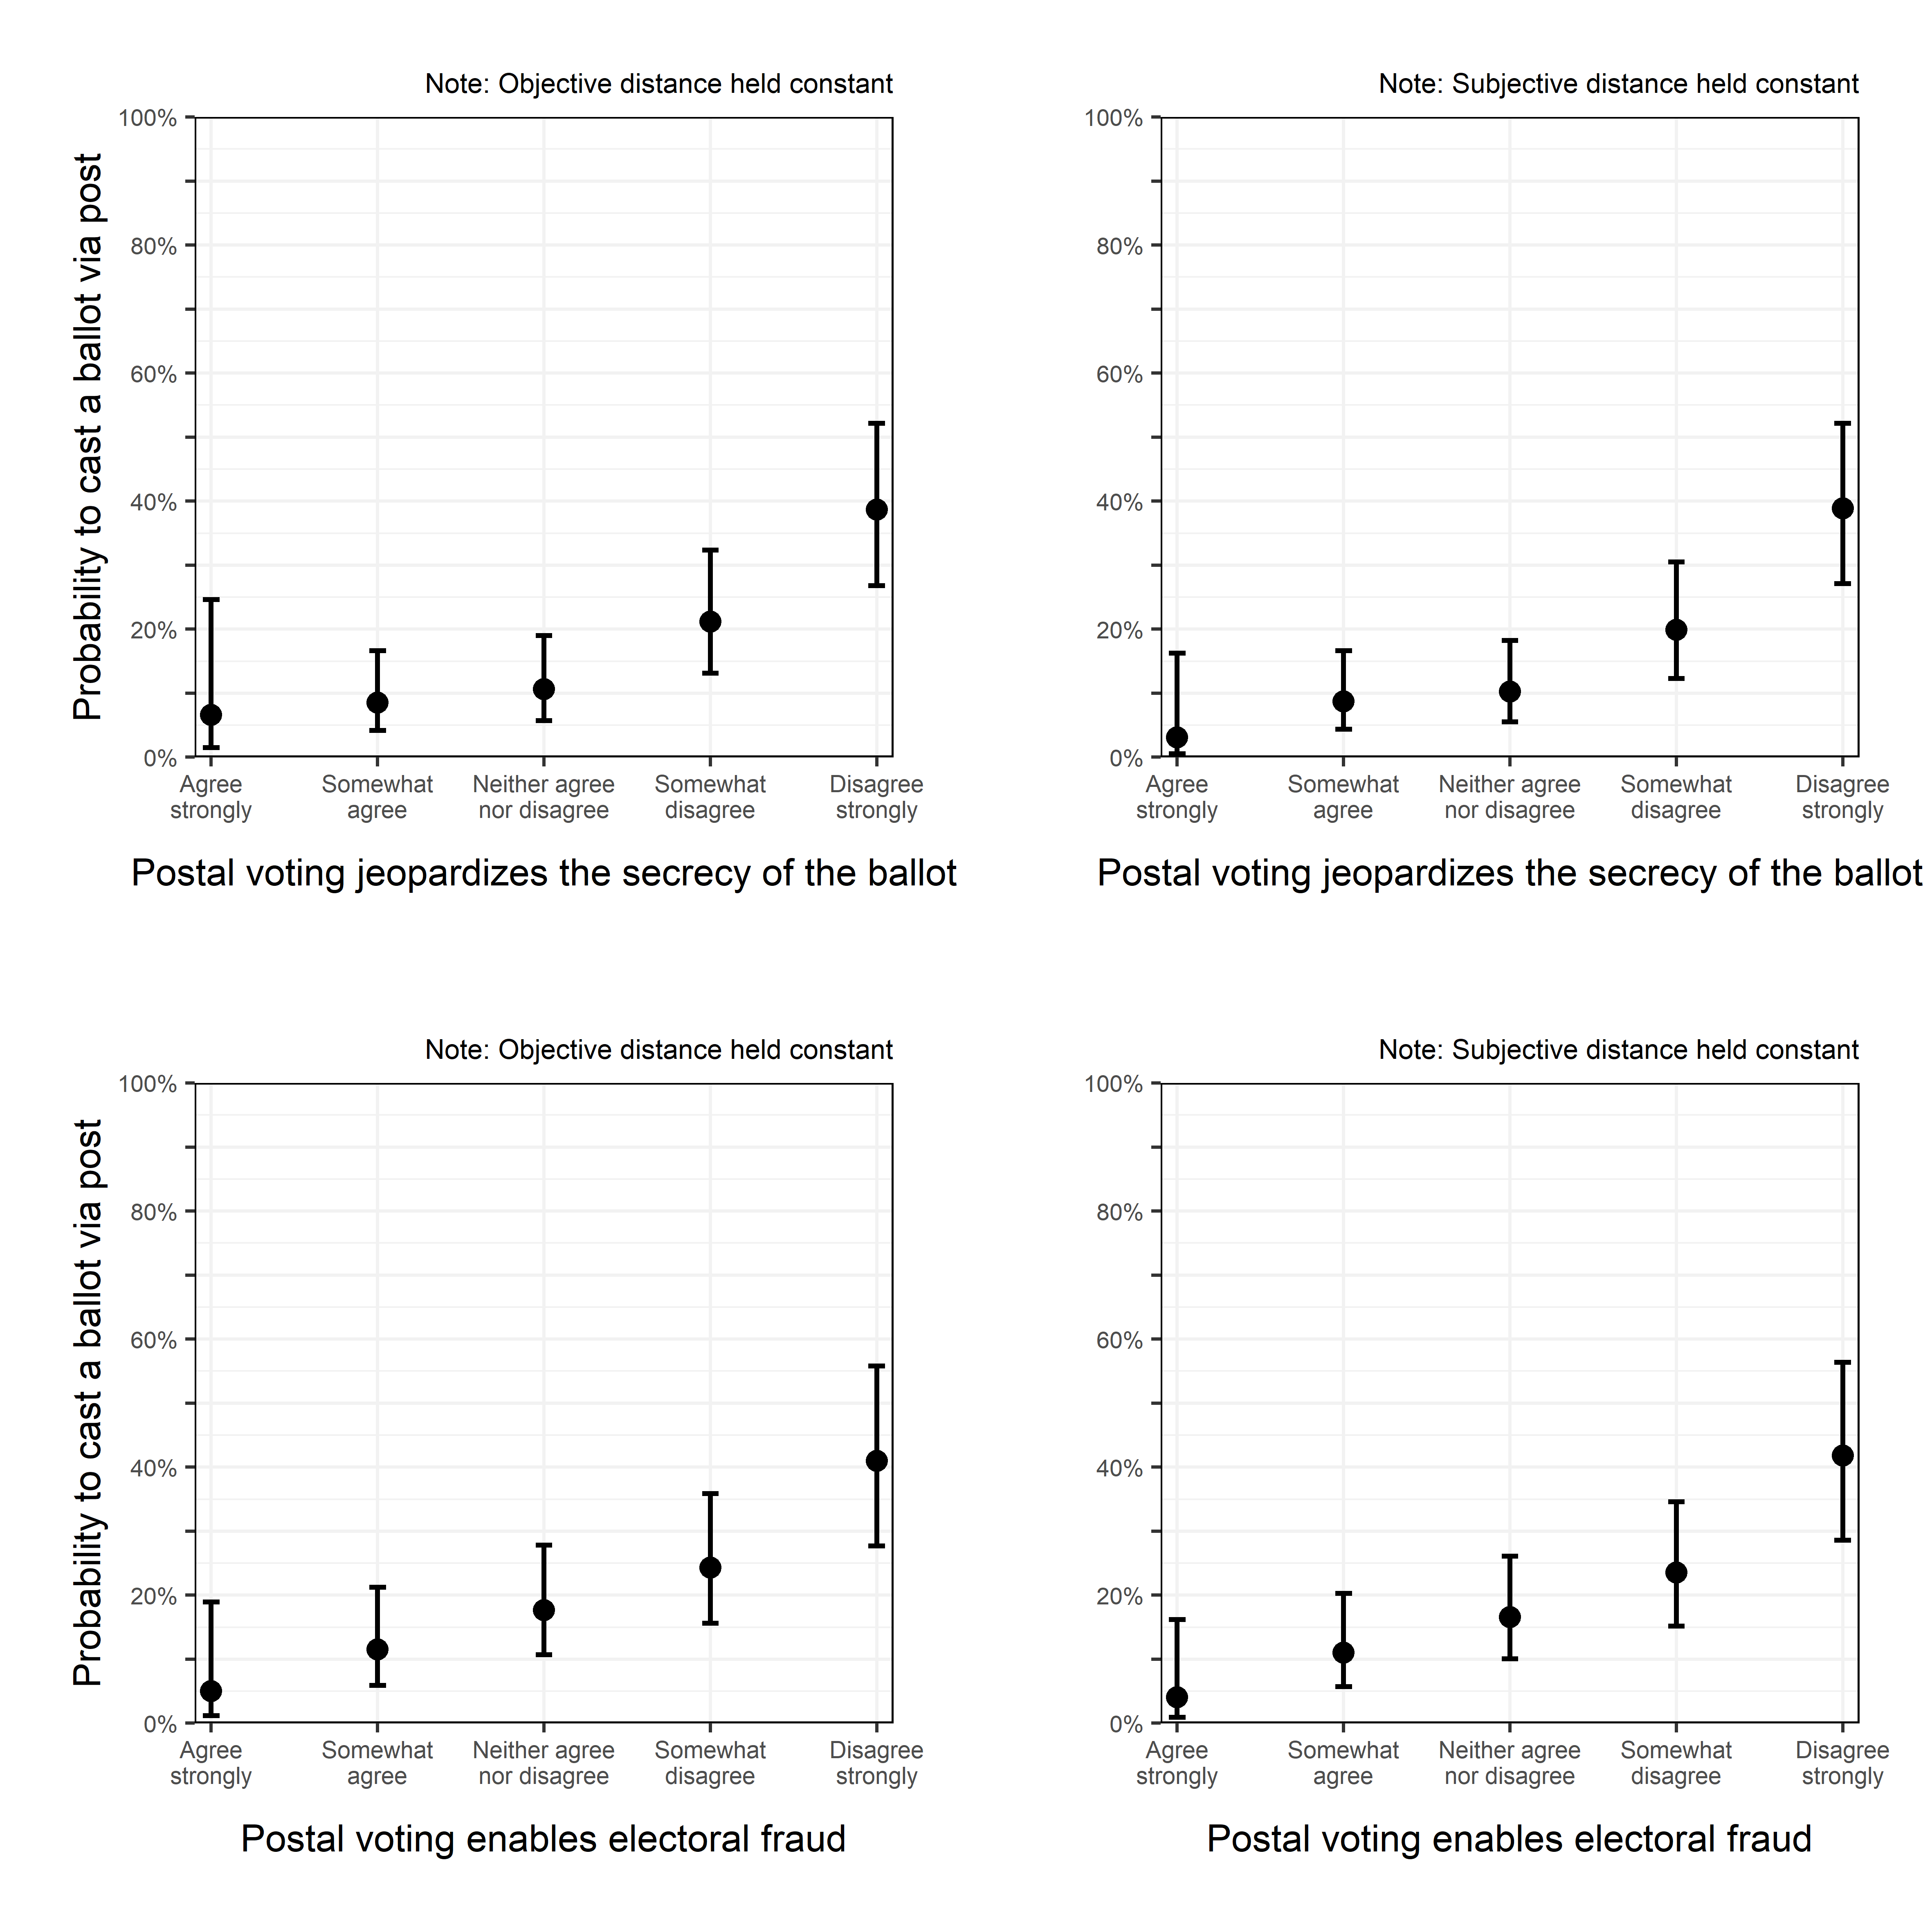

Table A2. Comparison of summary/descriptive statistics per (sub)samples.
 |  |  | Full sample (n=2101) |  |  |  | Subsample of voters (n=983) |  |  |  | Subsample used for models (n=664)
No | Variable | Stats / Values | Freqs (% of Valid) | Valid | Missing |  | Freqs (% of Valid) | Valid | Missing |  | Freqs (% of Valid) | Valid | Missing
1 | Postal voter | Yes | 774 (78.7%) | 983 | 1118 |  | 774 (78.7%) | 983 | 0 |  | 487 (73.3%) | 664 | 0
 |  | No | 209 (21.3%) | 46.8% | 53.2% |  | 209 (21.3%) | 100% | 0% |  | 177 (26.7%) | 100% | 0%
2 | Voting method | 1. Postal voting | 209 (21.3%) | 983 | 1118 |  | 209 (21.3%) | 983 | 0 |  | 177 (26.7%) | 664 | 0
 | (in 2019) | 2. Advance voting abroad | 700 (71.2%) | 46.8% | 53.2% |  | 700 (71.2%) | 100% | 0% |  | 443 (66.7%) | 100% | 0%
 |  | 3. Advance voting in FI | 53 (5.4%) |  |  |  | 53 (5.4%) |  |  |  | 29 (4.4%)
 |  | 4. Election day voting in FI | 21 (2.1%) |  |  |  | 21 (2.1%) |  |  |  | 15 (2.3%)
3 | Trust in postal voting | 1. Agree strongly | 73 (5.8%) | 1258 | 843 |  | 36 (4.9%) | 740 | 243 |  | 25 (3.8%) | 664 | 0
 | (Jeopardizes the ballot secrecy) | 2. Somewhat agree | 210 (16.7%) | 59.9% | 40.1% |  | 124 (16.8%) | 75.3% | 24.7% |  | 113 (17.0%) | 100% | 0%
 |  | 3. Neither agree nor disagree | 323 (25.7%) |  |  |  | 166 (22.4%) |  |  |  | 148 (22.3%)
 |  | 4. Somewhat disagree | 356 (28.3%) |  |  |  | 217 (29.3%) |  |  |  | 200 (30.1%)
 |  | 5. Disagree strongly | 296 (23.5%) |  |  |  | 197 (26.6%) |  |  |  | 178 (26.8%)
4 | Trust in postal voting | 1. Agree strongly | 87 (6.9%) | 1259 | 842 |  | 44 (5.9%) | 740 | 243 |  | 35 (5.3%) | 664 | 0
 | (Enables electoral fraud) | 2. Somewhat agree | 216 (17.2%) | 59.9% | 40.1% |  | 123 (16.6%) | 75.3% | 24.7% |  | 106 (16.0%) | 100% | 0%
 |  | 3. Neither agree nor disagree | 413 (32.8%) |  |  |  | 221 (29.9%) |  |  |  | 201 (30.3%)
 |  | 4. Somewhat disagree | 341 (27.1%) |  |  |  | 223 (30.1%) |  |  |  | 204 (30.7%)
 |  | 5. Disagree strongly | 202 (16.0%) |  |  |  | 129 (17.4%) |  |  |  | 118 (17.8%)
5 | Trust in postal voting | Mean (sd): | 0.6 (0.3) | 1258 | 843 |  | 0.6 (0.3) | 740 | 243 |  | 0.6 (0.3) | 664 | 0
 | (Combined score) | min < med < max: | 0 < 0.6 < 1 | 59.9% | 40.1% |  | 0 < 0.6 < 1 | 75.3% | 24.7% |  | 0 < 0.6 < 1 | 100% | 0%
 |  | IQR (CV): | 0.2 (0.5) |  |  |  | 0.2 (0.4) |  |  |  | 0.2 (0.4)
6 | Distance | Mean (sd): | 75.7 (169.5) | 1775 | 326 |  | 54.8 (174.2) | 919 | 64 |  | 63.5 (201.4) | 664 | 0
 | (Objective) | min < med < max: | 0.1 < 22.7 < 3626.7 | 84.5% | 15.5% |  | 0.1 < 11.6 < 3626.7 | 93.5% | 6.5% |  | 0.1 < 12.9 < 3626.7 | 100% | 0%
 |  | IQR (CV): | 76.2 (2.2) |  |  |  | 41.1 (3.2) |  |  |  | 50.7 (3.2)
7 | Distance | Mean (sd): | 126.6 (434.8) | 1811 | 290 |  | 87.5 (404.9) | 955 | 28 |  | 92.6 (437.8) | 664 | 0
 | (Subjective) | min < med < max: | 0.1 < 24 < 10000 | 86.2% | 13.8% |  | 0.1 < 10 < 10000 | 97.2% | 2.8% |  | 0.1 < 13 < 10000 | 100% | 0%
 |  | IQR (CV): | 95 (3.4) |  |  |  | 46 (4.6) |  |  |  | 45.8 (4.7)
8 | Gender | 1. Female | 1240 (67.4%) | 1841 | 260 |  | 639 (67.1%) | 952 | 31 |  | 446 (67.2%) | 664 | 0
 |  | 2. Male | 601 (32.6%) | 87.6% | 12.4% |  | 313 (32.9%) | 96.8% | 3.2% |  | 218 (32.8%) | 100% | 0%
9 | Age | Mean (sd): | 49.8 (16.2) | 1822 | 279 |  | 48.1 (15.8) | 942 | 41 |  | 46.7 (15.2) | 664 | 0
 | (2019 minus year of birth) | min < med < max: | 18 < 49 < 93 | 86.7% | 13.3% |  | 18 < 46.5 < 86 | 95.8% | 4.2% |  | 18 < 45 < 86 | 100% | 0%
 |  | IQR (CV): | 26 (0.3) |  |  |  | 26 (0.3) |  |  |  | 23 (0.3)
10 | Education | 1. Still at school | 24 (1.3%) | 1824 | 277 |  | 7 (0.7%) | 944 | 39 |  | 3 (0.5%) | 664 | 0
 |  | 2. Elementary school | 34 (1.9%) | 86.8% | 13.2% |  | 12 (1.3%) | 96% | 4% |  | 6 (0.9%) | 100% | 0%
 |  | 3. Comprehensive school | 56 (3.1%) |  |  |  | 19 (2.0%) |  |  |  | 14 (2.1%)
 |  | 4. Vocational school | 128 (7.0%) |  |  |  | 41 (4.3%) |  |  |  | 27 (4.1%)
 |  | 5. Gymnasium or abitur | 149 (8.2%) |  |  |  | 61 (6.5%) |  |  |  | 45 (6.8%)
 |  | 6. Polytechnic school | 441 (24.2%) |  |  |  | 219 (23.2%) |  |  |  | 156 (23.5%)
 |  | 7. University | 851 (46.7%) |  |  |  | 495 (52.4%) |  |  |  | 358 (53.9%)
 |  | 8. Licentiate or doctoral degree | 141 (7.7%) |  |  |  | 90 (9.5%) |  |  |  | 55 (8.3%)
11 | Political interest | 1. Very interested | 390 (18.7%) | 2081 | 20 |  | 298 (30.4%) | 979 | 4 |  | 220 (33.1%) | 664 | 0
 |  | 2. Fairly interested | 1006 (48.3%) | 99% | 1% |  | 529 (54.0%) | 99.6% | 0.4% |  | 344 (51.8%) | 100% | 0%
 |  | 3. Not very interested | 591 (28.4%) |  |  |  | 143 (14.6%) |  |  |  | 93 (14.0%)
 |  | 4. Not at all interested | 94 (4.5%) |  |  |  | 9 (0.9%) |  |  |  | 7 (1.1%)
Table A2. (cont.) Comparison of summary/descriptive statistics per (sub)samples
 |  |  | Full sample (n=2101) |  |  |  | Sample of voters (n=983) |  |  |  | Subsample used for models (n=664)
No | Variable | Stats / Values | Freqs (% of Valid) | Valid | Missing |  | Freqs (% of Valid) | Valid | Missing |  | Freqs (% of Valid) | Valid | Missing
12 | Civic duty | 1. Agree strongly | 523 (26.5%) | 1972 | 129 |  | 361 (36.7%) | 983 | 0 |  | 233 (35.1%) | 664 | 0
 |  | 2. Somewhat agree | 549 (27.8%) | 93.9% | 6.1% |  | 299 (30.4%) | 100% | 0% |  | 202 (30.4%) | 100% | 0%
 |  | 3. Neither agree nor disagree | 391 (19.8%) |  |  |  | 156 (15.9%) |  |  |  | 108 (16.3%)
 |  | 4. Somewhat disagree | 270 (13.7%) |  |  |  | 101 (10.3%) |  |  |  | 74 (11.1%)
 |  | 5. Disagree strongly | 239 (12.1%) |  |  |  | 66 (6.7%) |  |  |  | 47 (7.1%)

