Online Appendix 1: Sample Information

OA1 Table 1 Targeted demographics, based on 2018 census estimates.

Age bracket | Population | Percentage
18-24 | 30456902 | 12%
25-34 | 45697774 | 18%
35-44 | 41277888 | 16%
45-54 | 41631699 | 16%
55-64 | 42272636 | 17%
65+ | 52431193 | 21%
Gender | Population | Percentage
Male | 161128679 | 49.2%
Female | 166038755 | 50.8%
Region | Population |  | Percentage
Northeast | 56,111,079 |  | 17.2%
Midwest | 68,308,744 |  | 20.9%
West | 77,993,663 |  | 23.8%
South | 124,753,948 |  | 38.1%

OA1 Table 2 Sample Demographics

 |  | Study Number
 | Total  (n=5499) | 1  (n=3200) | 2  (n=2299)
Sex
Male | 2716 (49.4%) | 1548 (48.4%) | 1168 (50.8%)
Female | 2783 (50.6%) | 1652 (51.6%) | 1131 (49.2%)
Region
Northeast | 973 (17.7%) | 559 (17.5%) | 414 (18.0%)
Midwest | 1162 (21.1%) | 672 (21.0%) | 490 (21.3%)
West | 1259 (22.9%) | 721 (22.5%) | 538 (23.4%)
South | 2105 (38.3%) | 1248 (39.0%) | 857 (37.3%)
Race
2+ Races | 129 (2.3%) | 129 (4.0%) | 0 (0%)
Asian | 159 (2.9%) | 78 (2.4%) | 81 (3.5%)
Black | 734 (13.3%) | 450 (14.1%) | 284 (12.4%)
Hispanic or Latino | 274 (5.0%) | 129 (4.0%) | 145 (6.3%)
Native American | 65 (1.2%) | 28 (0.9%) | 37 (1.6%)
Other | 87 (1.6%) | 35 (1.1%) | 52 (2.3%)
Prefer not to say | 61 (1.1%) | 35 (1.1%) | 26 (1.1%)
White | 3990 (72.6%) | 2316 (72.4%) | 1674 (72.8%)
Age Bracket
18-24 | 637 (11.6%) | 343 (10.7%) | 294 (12.8%)
25-34 | 1011 (18.4%) | 605 (18.9%) | 406 (17.7%)
35-44 | 896 (16.3%) | 513 (16.0%) | 383 (16.7%)
45-54 | 926 (16.8%) | 518 (16.2%) | 408 (17.7%)
55-64 | 927 (16.9%) | 551 (17.2%) | 376 (16.4%)
65+ | 1102 (20.0%) | 670 (20.9%) | 432 (18.8%)
Income Bracket
<10k | 460 (8.4%) | 265 (8.3%) | 195 (8.5%)
=>10k, <20k | 569 (10.3%) | 334 (10.4%) | 235 (10.2%)
=>20k, <30k | 785 (14.3%) | 456 (14.2%) | 329 (14.3%)
=>30k, <40k | 633 (11.5%) | 378 (11.8%) | 255 (11.1%)
=>40k, <50k | 490 (8.9%) | 274 (8.6%) | 216 (9.4%)
=>50k, <60k | 517 (9.4%) | 288 (9.0%) | 229 (10.0%)
=>60k, <70k | 305 (5.5%) | 176 (5.5%) | 129 (5.6%)
=>70k, <80k | 323 (5.9%) | 180 (5.6%) | 143 (6.2%)
=>80k, <90k | 179 (3.3%) | 96 (3.0%) | 83 (3.6%)
=>90k, <100k | 192 (3.5%) | 108 (3.4%) | 84 (3.7%)
=>100k, <150k | 485 (8.8%) | 289 (9.0%) | 196 (8.5%)
150k+ | 316 (5.7%) | 203 (6.3%) | 113 (4.9%)
Missing | 245 (4.5%) | 153 (4.8%) | 92 (4.0%)
Education
Highschool or Less | 1563 (28.4%) | 896 (28.0%) | 667 (29.0%)
Some College | 1427 (26.0%) | 838 (26.2%) | 589 (25.6%)
College Degree | 1821 (33.1%) | 1020 (31.9%) | 801 (34.8%)
Post-grad Degree | 688 (12.5%) | 446 (13.9%) | 242 (10.5%)
Partisan ID
Democrat | 2490 (45.3%) | 1470 (45.9%) | 1020 (44.4%)
Independent | 971 (17.7%) | 566 (17.7%) | 405 (17.6%)
Republican | 2038 (37.1%) | 1164 (36.4%) | 874 (38.0%)
Partisan Strength
Independent | 971 (17.7%) | 566 (17.7%) | 405 (17.6%)
Lean | 786 (14.3%) | 452 (14.1%) | 334 (14.5%)
Not Strong | 1416 (25.8%) | 842 (26.3%) | 574 (25.0%)
Strong Partisan | 2326 (42.3%) | 1340 (41.9%) | 986 (42.9%)

OA1 Table 3 Descriptive Statistics

 |  | Study Number
 | Total  (n=5499) | 1  (n=3200) | 2  (n=2299)
Stance on Policy
Anti-Policy | 2974 (54.1%) | 2088 (65.2%) | 886 (38.5%)
Neither | 1250 (22.7%) | 660 (20.6%) | 590 (25.7%)
Pro-Policy | 1275 (23.2%) | 452 (14.1%) | 823 (35.8%)
Blame for Material Damage/Drop in Beds
Mean (SD) | 3.41 (1.26) | 3.78 (1.17) | 2.89 (1.20)
Median [Min, Max] | 3.00 [1.00, 5.00] | 4.00 [1.00, 5.00] | 3.00 [1.00, 5.00]
Blame for Deaths
Mean (SD) | 3.29 (1.30) | 3.68 (1.22) | 2.75 (1.22)
Median [Min, Max] | 3.00 [1.00, 5.00] | 4.00 [1.00, 5.00] | 3.00 [1.00, 5.00]
Average Blame
Mean (SD) | 3.35 (1.21) | 3.73 (1.12) | 2.82 (1.13)
Median [Min, Max] | 3.00 [1.00, 5.00] | 4.00 [1.00, 5.00] | 3.00 [1.00, 5.00]
Perceived Responsiveness
Mean (SD) | -8.5e-09 (1.00) | -7.55e-09 (1.00) | -9.82e-09 (1.00)
Median [Min, Max] | 0.0656 [-2.87, 2.06] | 0.102 [-1.79, 2.06] | 0.00775 [-2.87, 1.41]
Decision Acceptance
Mean (SD) | -1.88e-09 (1.00) | 7.4e-10 (1.00) | -5.53e-09 (1.00)
Median [Min, Max] | -0.0425 [-2.81, 2.09] | 0.0530 [-1.81, 2.09] | -0.128 [-2.81, 1.78]
Hostile Sexism
Mean (SD) | -3.3e-09 (1.00) | -5.71e-09 (1.00) | 4.88e-11 (1.00)
Median [Min, Max] | 0.0139 [-1.82, 1.85] | -0.0265 [-1.79, 1.74] | 0.0139 [-1.82, 1.85]
Online Appendix 2: Regression Tables Tied to Main Analysis

OA2 Table 1 Study 1 – Consultations, Gender, and Sexism
 | Dependent variable:
 | Blame Attributed to Mayor
 | (1) | (2) | (3)
Consultation (baseline: None)  Listen and Explain | 0.071 (0.048) | 0.111 (0.068) | 0.095 (0.067)
Listen, Explain, and Align | -0.167*** (0.048) | -0.142* (0.068) | -0.146* (0.067)
Female Politician |  | 0.066 (0.068) | 0.043 (0.067)
Female Politician * Listen and Explain |  | -0.080 (0.096) | -0.047 (0.095)
Female Politician * Listen, Explain, and Align |  | -0.051 (0.097) | -0.031 (0.095)
Sexism |  |  | -0.169*** (0.048)
Sexism * Female Politician |  |  | -0.029 (0.068)
Sexism * Listen and Explain |  |  | -0.105 (0.067)
Sexism * Listen, Explain, and Align |  |  | -0.069 (0.068)
Sexism * Female Politician * Listen and Explain |  |  | 0.113 (0.095)
Sexism * Female Politician * Listen, Explain, and Align |  |  | 0.063 (0.095)
Constant | 3.761*** (0.034) | 3.728*** (0.048) | 3.737*** (0.047)
Observations | 3,200 | 3,200 | 3,200
R² | 0.008 | 0.008 | 0.045
Adjusted R² | 0.007 | 0.007 | 0.042
Residual Std. Error | 1.115 (df = 3197) | 1.115 (df = 3194) | 1.095 (df = 3188)
F Statistic | 12.834*** (df = 2; 3197) | 5.334*** (df = 5; 3194) | 13.690*** (df = 11; 3188)
Note: Cells contain OLS regression coefficients, with standard errors in parentheses. + p<0.1; * p<0.05; ** p<0.01; *** p<0.001

OA2 Table 2 Study 1 – Consultations, Decision Acceptance, and Perceived Responsiveness
 | Dependent variable:
 | Blame Attributed to Mayor
 | (1) | (2)
Consultation (baseline: None)  Listen and Explain | 0.104* (0.045) | 0.050 (0.044)
Listen, Explain, and Align | 0.034 (0.046) | 0.020 (0.045)
Perceived Responsiveness | -0.448*** (0.030)
Decision Acceptance |  | -0.489*** (0.030)
Perceived Responsiveness * Listen and Explain | -0.052 (0.044)
Perceived Responsiveness * Listen, Explain, and Align | 0.015 (0.045)
Decision Acceptance * Listen and Explain |  | -0.042 (0.043)
Decision Acceptance * Listen, Explain, and Align |  | 0.018 (0.044)
Constant | 3.681*** (0.032) | 3.703*** (0.031)
Observations | 3,200 | 3,200
R² | 0.170 | 0.198
Adjusted R² | 0.169 | 0.197
Residual Std. Error (df = 3194) | 1.020 | 1.003
F Statistic (df = 5; 3194) | 130.977*** | 158.137***
Note: Cells contain OLS regression coefficients, with standard errors in parentheses. + p<0.1; * p<0.05; ** p<0.01; *** p<0.001

OA2 Table 3 Study 2 – Consultations, Gender, and Sexism
 | Dependent variable:
 | Blame Attributed to Mayor
 | (1) | (2) | (3) | (4)
Consultation (baseline: None)  Listen and Explain | 0.099⁺ (0.057) | 0.156* (0.079) | 0.029 (0.081) | 0.036 (0.081)
Listen, Explain, and Align | -0.272*** (0.057) | -0.175* (0.079) | -0.318*** (0.081) | -0.316*** (0.081)
Mayor Stays the Course |  | 0.597*** (0.079)
Female Politician |  |  | -0.127 (0.081) | -0.123 (0.082)
Sexism |  |  |  | -0.047 (0.058)
Mayor Stays the Course * Listen and Explain |  | -0.116 (0.112)
Mayor Stays the Course * Listen, Explain, and Align |  | -0.192⁺ (0.112)
Female Politician * Listen and Explain |  |  | 0.140 (0.115) | 0.129 (0.115)
Female Politician * Listen, Explain, and Align |  |  | 0.092 (0.115) | 0.086 (0.115)
Sexism * Female Politician |  |  |  | 0.076 (0.081)
Sexism * Listen and Explain |  |  |  | -0.005 (0.082)
Sexism * Listen, Explain, and Align |  |  |  | 0.140⁺ (0.081)
Sexism * Female Politician * Listen and Explain |  |  |  | -0.052 (0.116)
Sexism * Female Politician * Listen, Explain, and Align |  |  |  | -0.075 (0.114)
Constant | 2.877*** (0.041) | 2.577*** (0.056) | 2.940*** (0.057) | 2.940*** (0.057)
Observations | 2,299 | 2,299 | 2,299 | 2,299
R² | 0.019 | 0.068 | 0.020 | 0.023
Adjusted R² | 0.018 | 0.066 | 0.018 | 0.019
Residual Std. Error | 1.123 (df = 2296) | 1.096 (df = 2293) | 1.123 (df = 2293) | 1.123 (df = 2287)
F Statistic | 22.366*** (df = 2; 2296) | 33.411*** (df = 5; 2293) | 9.480*** (df = 5; 2293) | 4.966*** (df = 11; 2287)
Note: Cells contain OLS regression coefficients, with standard errors in parentheses. + p<0.1; * p<0.05; ** p<0.01; *** p<0.001

OA2 Table 4 Study 1 – Consultations, Decision Acceptance, and Perceived Responsiveness
 | Dependent variable:
 | Blame Attributed to Mayor
 | (1) | (2)
Consultation (baseline: None)  Listen and Explain | 0.174** (0.056) | 0.101⁺ (0.054)
Listen, Explain, and Align | -0.085 (0.058) | -0.179** (0.055)
Perceived Responsiveness | -0.308*** (0.036)
Decision Acceptance |  | -0.353*** (0.039)
Perceived Responsiveness * Listen and Explain | 0.002 (0.055)
Perceived Responsiveness * Listen, Explain, and Align | 0.018 (0.058)
Decision Acceptance * Listen and Explain |  | -0.041 (0.053)
Decision Acceptance * Listen, Explain, and Align |  | -0.009 (0.056)
Constant | 2.787*** (0.041) | 2.844*** (0.039)
Observations | 2,299 | 2,299
R² | 0.086 | 0.125
Adjusted R² | 0.084 | 0.123
Residual Std. Error (df = 2293) | 1.085 | 1.062
F Statistic (df = 5; 2293) | 43.067*** | 65.372***
Note: Cells contain OLS regression coefficients, with standard errors in parentheses. + p<0.1; * p<0.05; ** p<0.01; *** p<0.001

Online Appendix 3: Additional Figures Tied to Main Analysis
OA3 Fig. 1 Study 2 – Effects of Perceived Responsiveness and Decision Acceptance on Blame Attribution

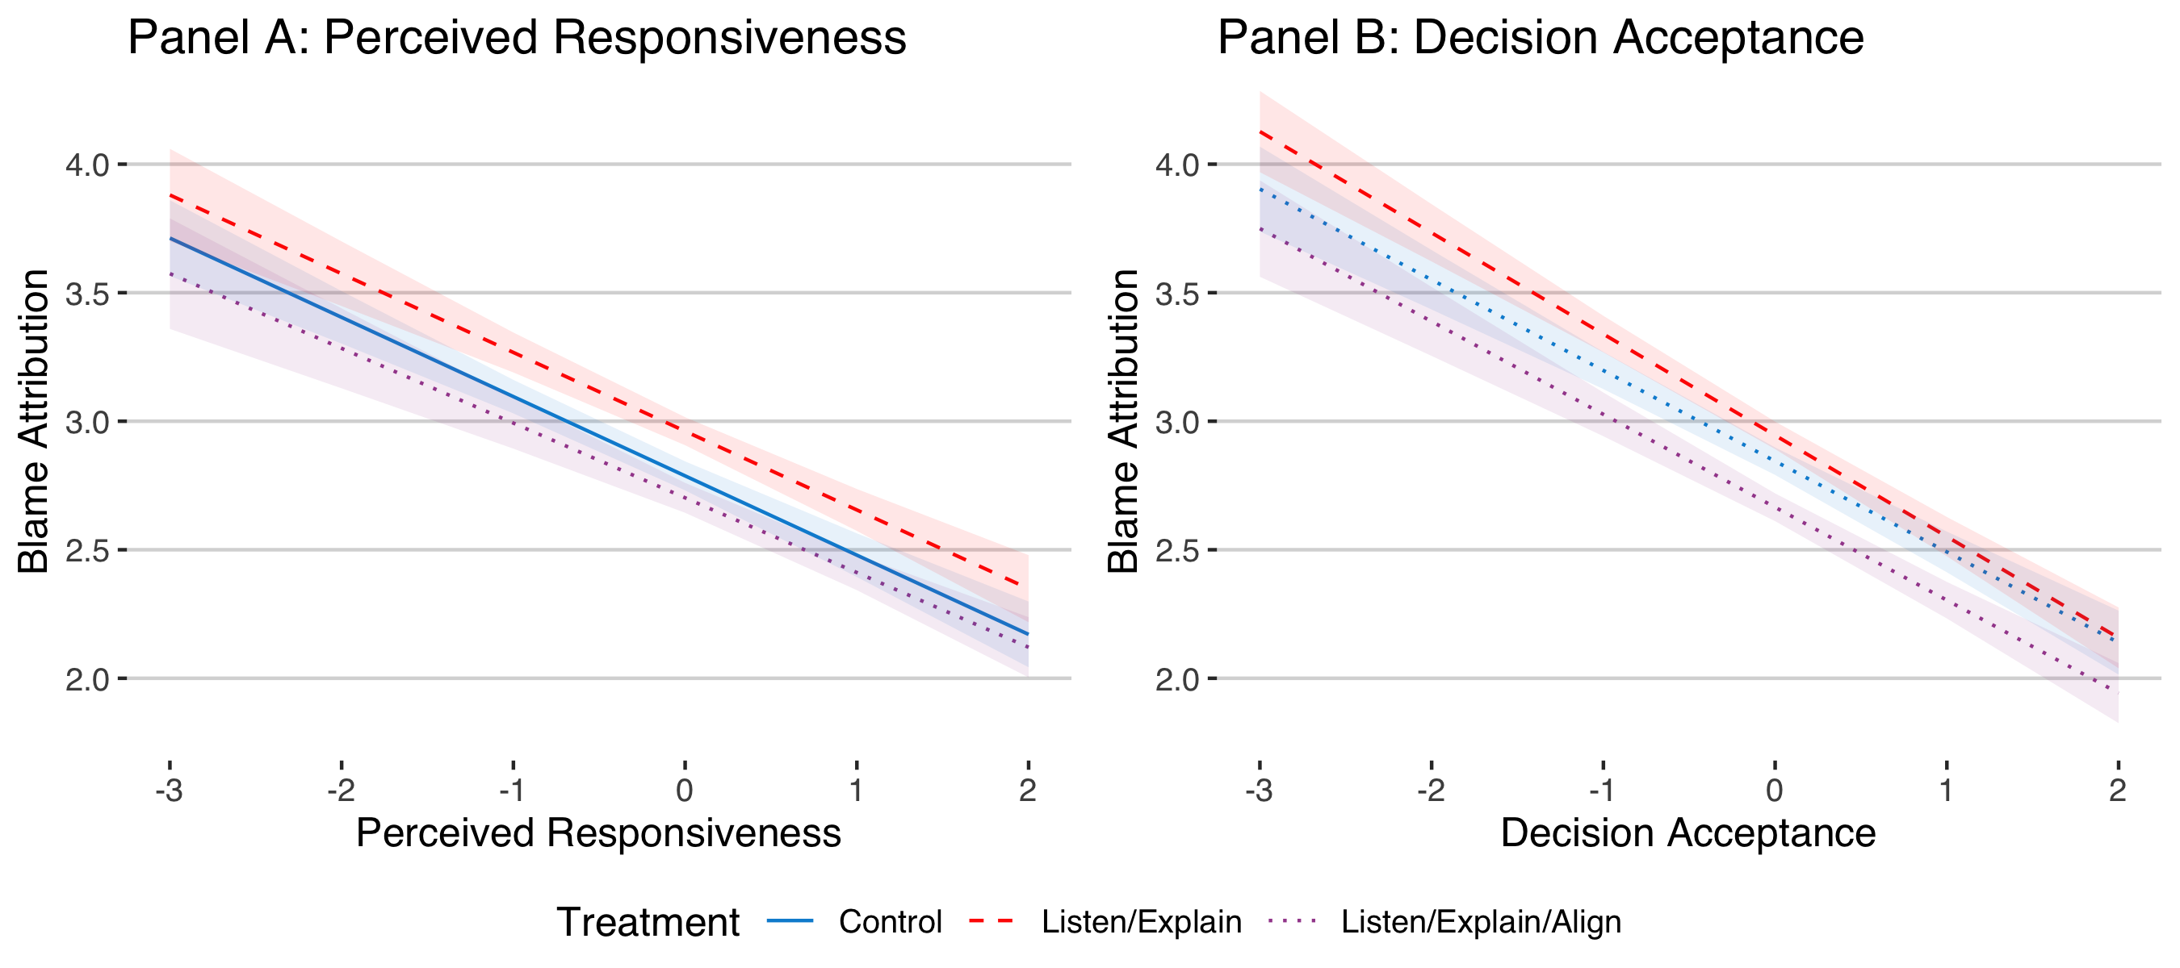

OA3 Fig. 2 Study 2 – Effect of Consultations on Blame Attribution
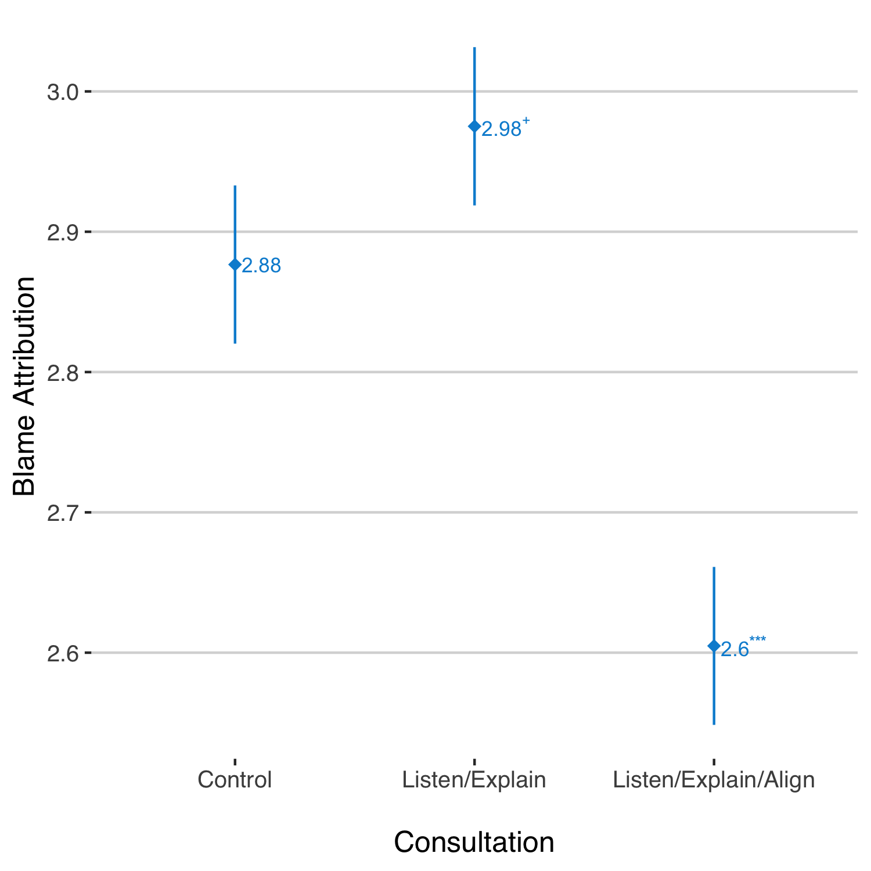
OA3 Fig. 3 Study 2 – Effects of Hostile Sexism, by Mayor’s Gender and Treatment Group

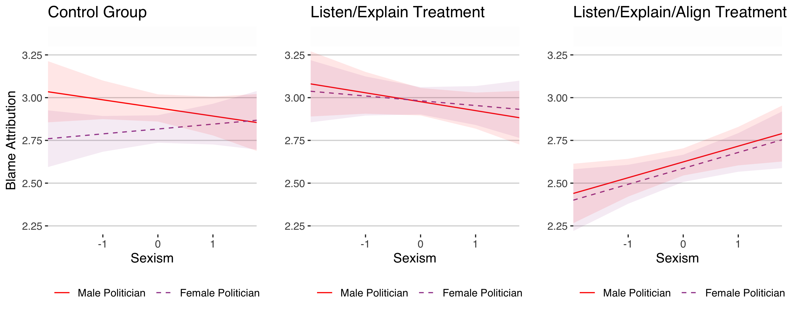

Online Appendix 4: Additional Hypothesis Testing
As laid out in our pre-registration documents, we also consider two additional sets of factors that might influence blame attribution. First, past research suggests that whether or not an individual agrees with a policy outcome has a major impact on reactions to the associated policy process (e.g. Esaiasson et al. 2019; Skitka et al. 2003). Although this research focuses on decision acceptance rather than blame attribution, insofar as these are related phenomena, we should expect to see a similar effect here as well. In a related manner, research on partisan motivated reasoning (e.g. Bisgaard 2015; Bolsen et al. 2014; Leeper and Slothuus 2014) suggests that citizens with partisan attachments should be more likely to accept a decision from a co-partisan and less likely to attribute blame to co-partisan representatives for negative events.
HO1: Respondents who are in favour of a given policy will assign lower levels of blame.

HO2: Respondents who are co-partisans of the politician pushing for a given policy will assign lower levels of blame.

Second, the nature of the negative outcome may also shape patterns of blame attribution. Based on a long line of past research suggesting that outcome severity is particularly likely to increase blame attribution (e.g. Alicke 2000; Robbennolt 2000), we consider the possibility that more serious, unambiguously negative consequences engender more severe reactions from respondents. Furthermore, these effects are also liable to exacerbate the dynamics highlighted above, increasing the blame attribution gap between, for example, pro- and anti-bill respondents, or co-partisans and contrasting ones. Our final two hypotheses are thus:
HO3: More severe negative outcomes will engender stronger blame attribution.

HO4: More severe negative outcomes will increase the effect of a respondent’s stance on the bill (HO4a), contrasting respondent-politician partisanship (HO4b), the politician's gender (HO4c), and hostile sexism (HO4d).

Results: Study 1

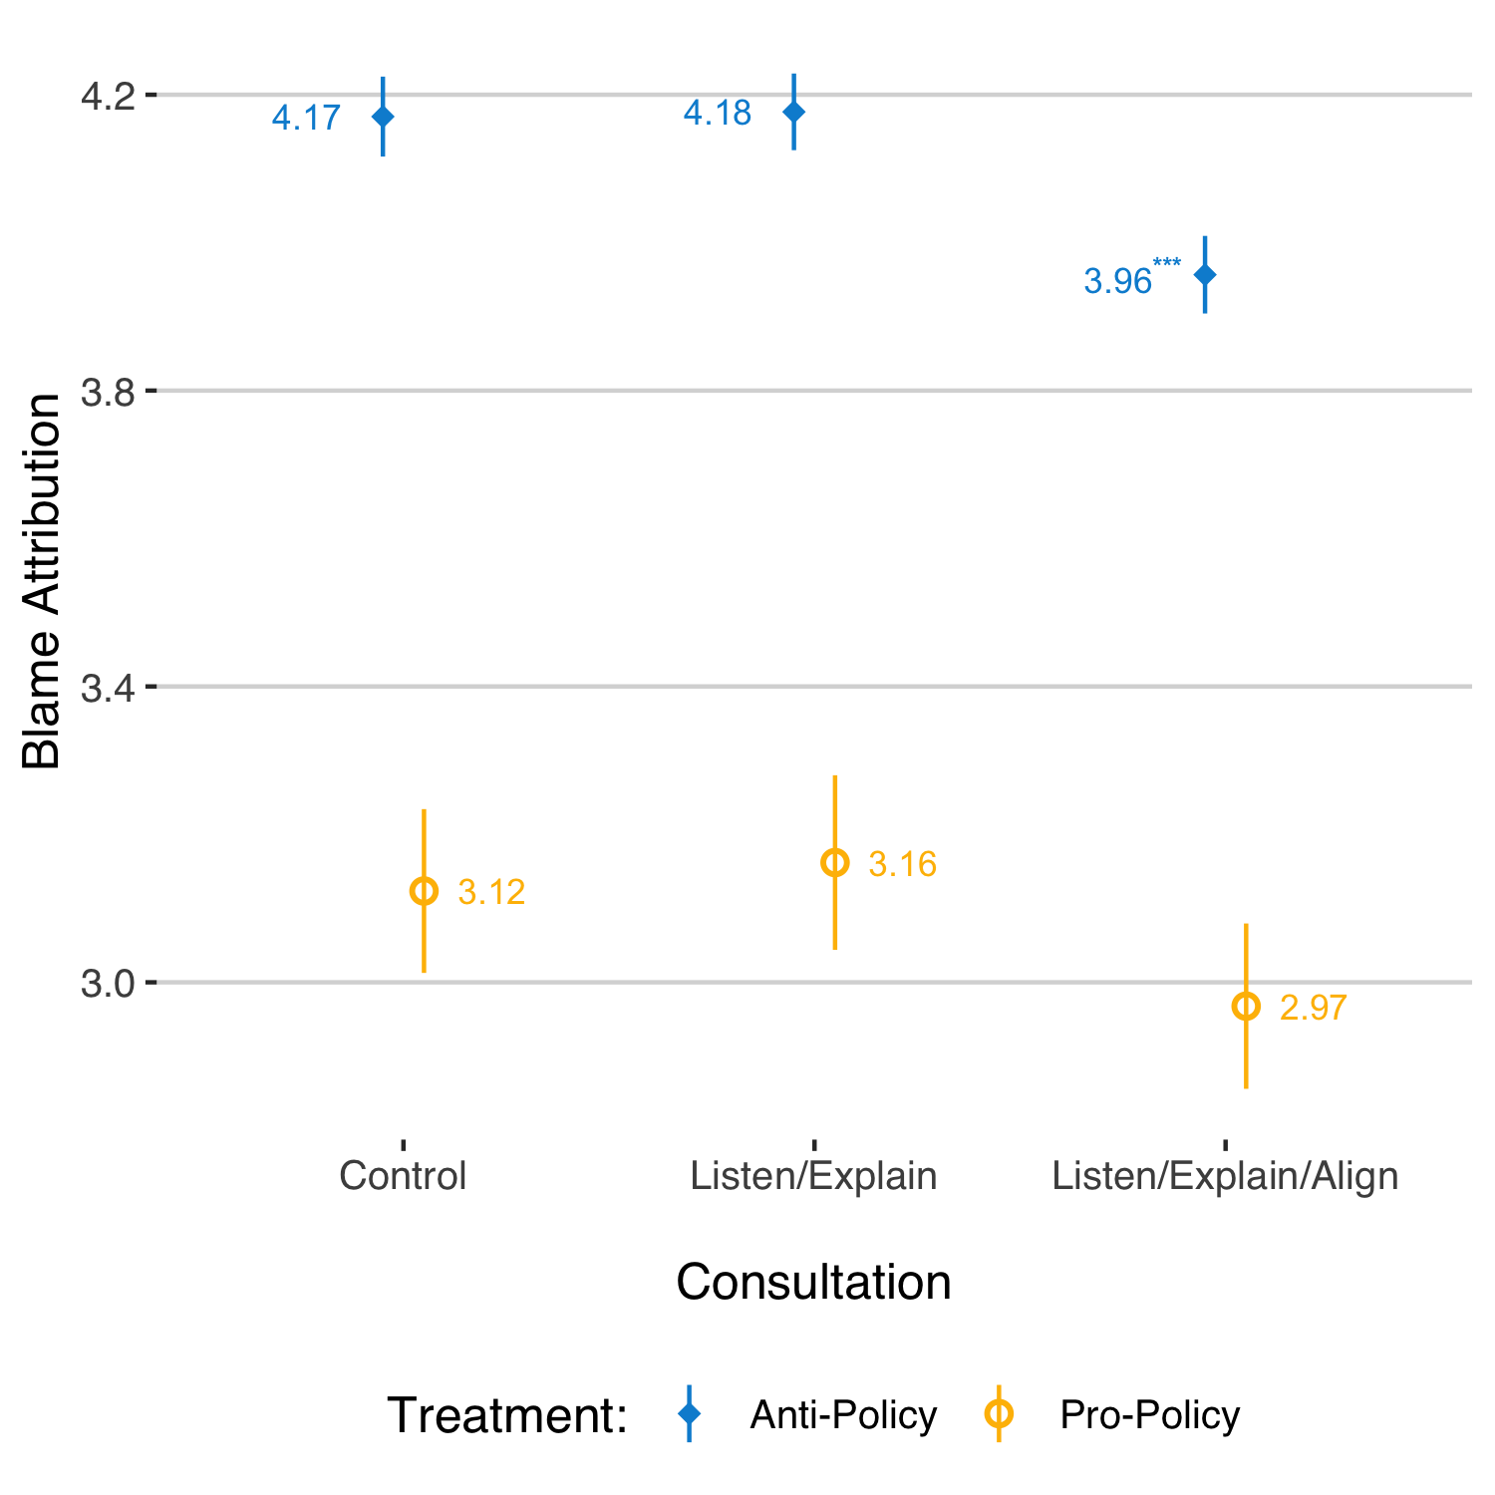
OA4 Figure 1 considers the effect of respondent stance on the bill (HO1), based on the regression analysis laid out in Model 1 of OA4 Table 1 (included at the end of this section). In addition to supporting HO1, with anti-bill respondents more likely to assign blame than pro-bill ones, the figure highlights that the consultation effects are primarily driven by anti-policy respondents. Results suggest that these respondents shift toward assigning less blame for the “Listen, Explain, and Align” treatment, relative to both the control group and those in which the mayor simply listened and explained his or her position.
OA4 Fig. 1 Study 1 – Effect of Consultations on Blame Attribution, by Stance on Policy
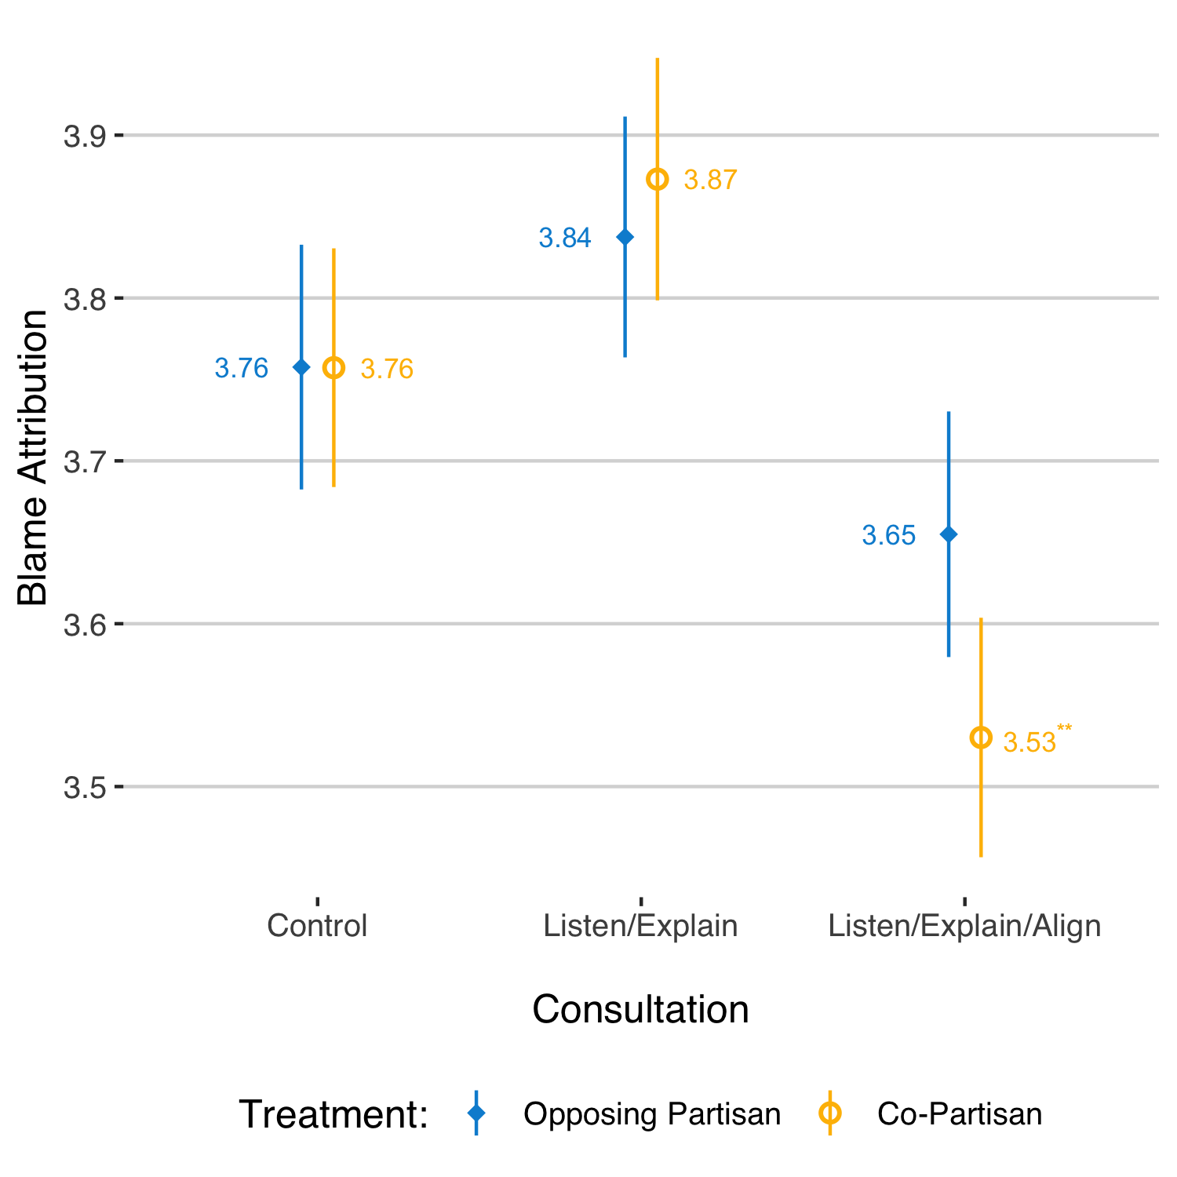
Co-partisanship, by contrast, does not exhibit the predicted effect (see OA4 Table 1, Model 3). As OA4 Figure 2 highlights, there is no evidence to suggest that partisans were kinder, on average, in their blame attribution toward co-partisans relative to opposing ones (contra HO2). The strength of the partisan treatment, however, was weak: the partisanship attention check question reveals that only 46% of respondents correctly recalled the Mayor’s partisanship – but there is no evidence to suggest the predicted effect of co-partisanship even when we limit ourselves to that subsample. Nevertheless, it is noteworthy that the only consultation effect we find, with lower blame attribution for the “Listen, Explain, and Align” treatment among co-partisans but not opposing ones, does suggest that co-partisanship may be a relevant consideration more generally.
OA4 Fig. 2 Study 1 – Effect of Consultations on Blame Attribution, by Respondent-Mayor Co-Partisanship

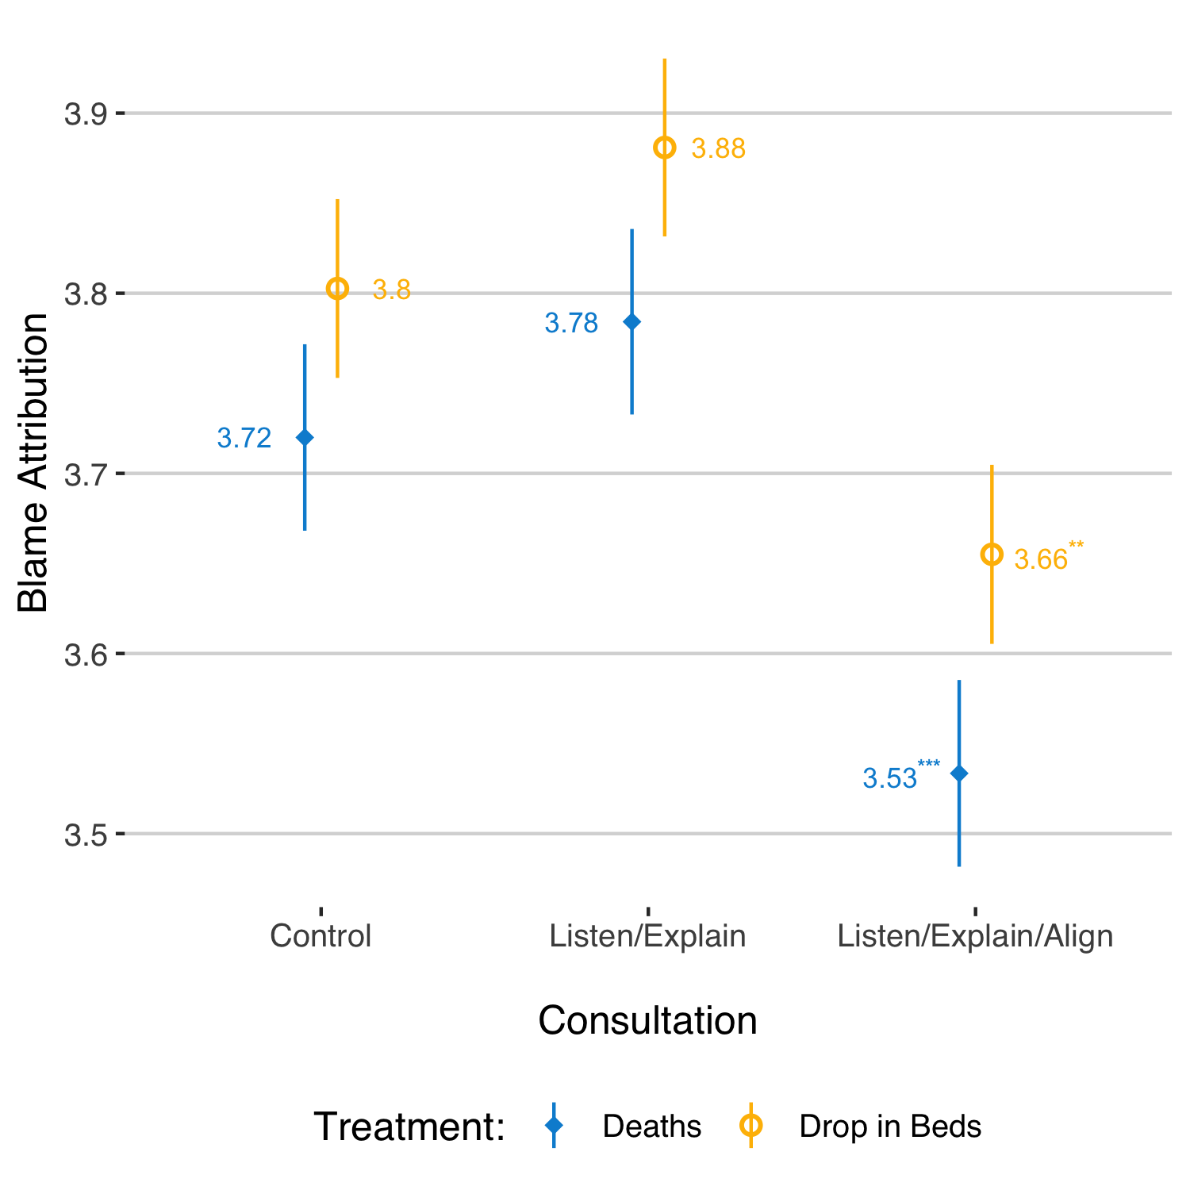
OA4 Figure 3 examines whether more severe negative outcomes attracted increased blame (HO3). Overall, the difference between the mean level of blame for deaths (3.68) and the mean level of blame for the drop in the number of beds (3.78) is significant at the p < 0.001 level (two-tailed t-test). Contrary to HO3, then, the less severe negative outcome is associated with higher levels of blame. As the figure illustrates, most of this difference is coming from outside for the control group – in particular the “Listen, Explain, and Align” treatment.
OA4 Fig. 3 Study 1 – Effect of Consultations on Blame Attribution for Deaths and Drop in the Number of Beds
Finally, we find no evidence to support HO4a-c, as illustrated in OA4 Figure 4: results
OA4 Fig. 4 Study 1 – Blame Attribution for Deaths versus Drop in the Number of Beds
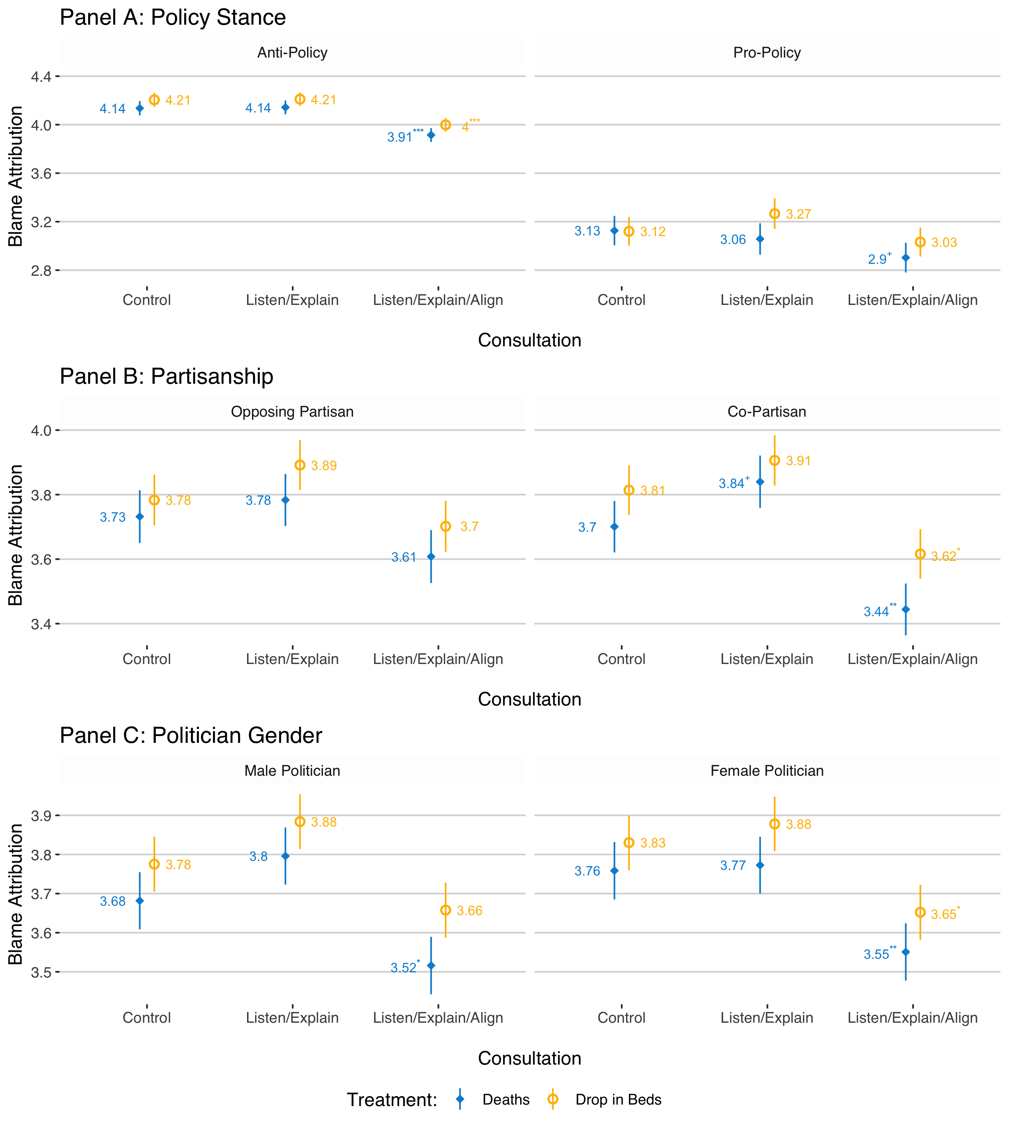

combining Seemingly Unrelated Regression analysis with Chi-squared tests confirm that there is no significant difference between the effect of a respondent’s stance on the proposal, the mayor’s gender, or co-partisanship on blame attributed for the two deaths versus the drop in the number of homeless shelter beds. Similarly, and contra H04d, the same methodological approach suggests that the effect of hostile sexism does not significantly differ based on outcome severity either.

Results: Study 2
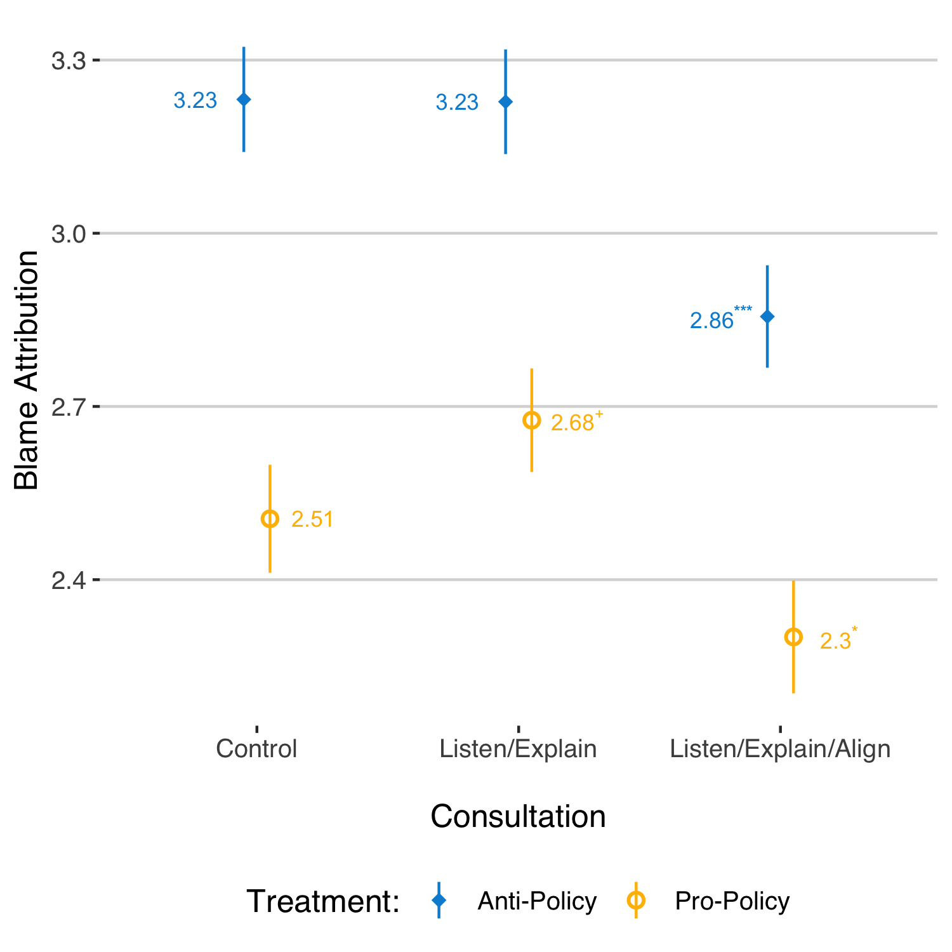
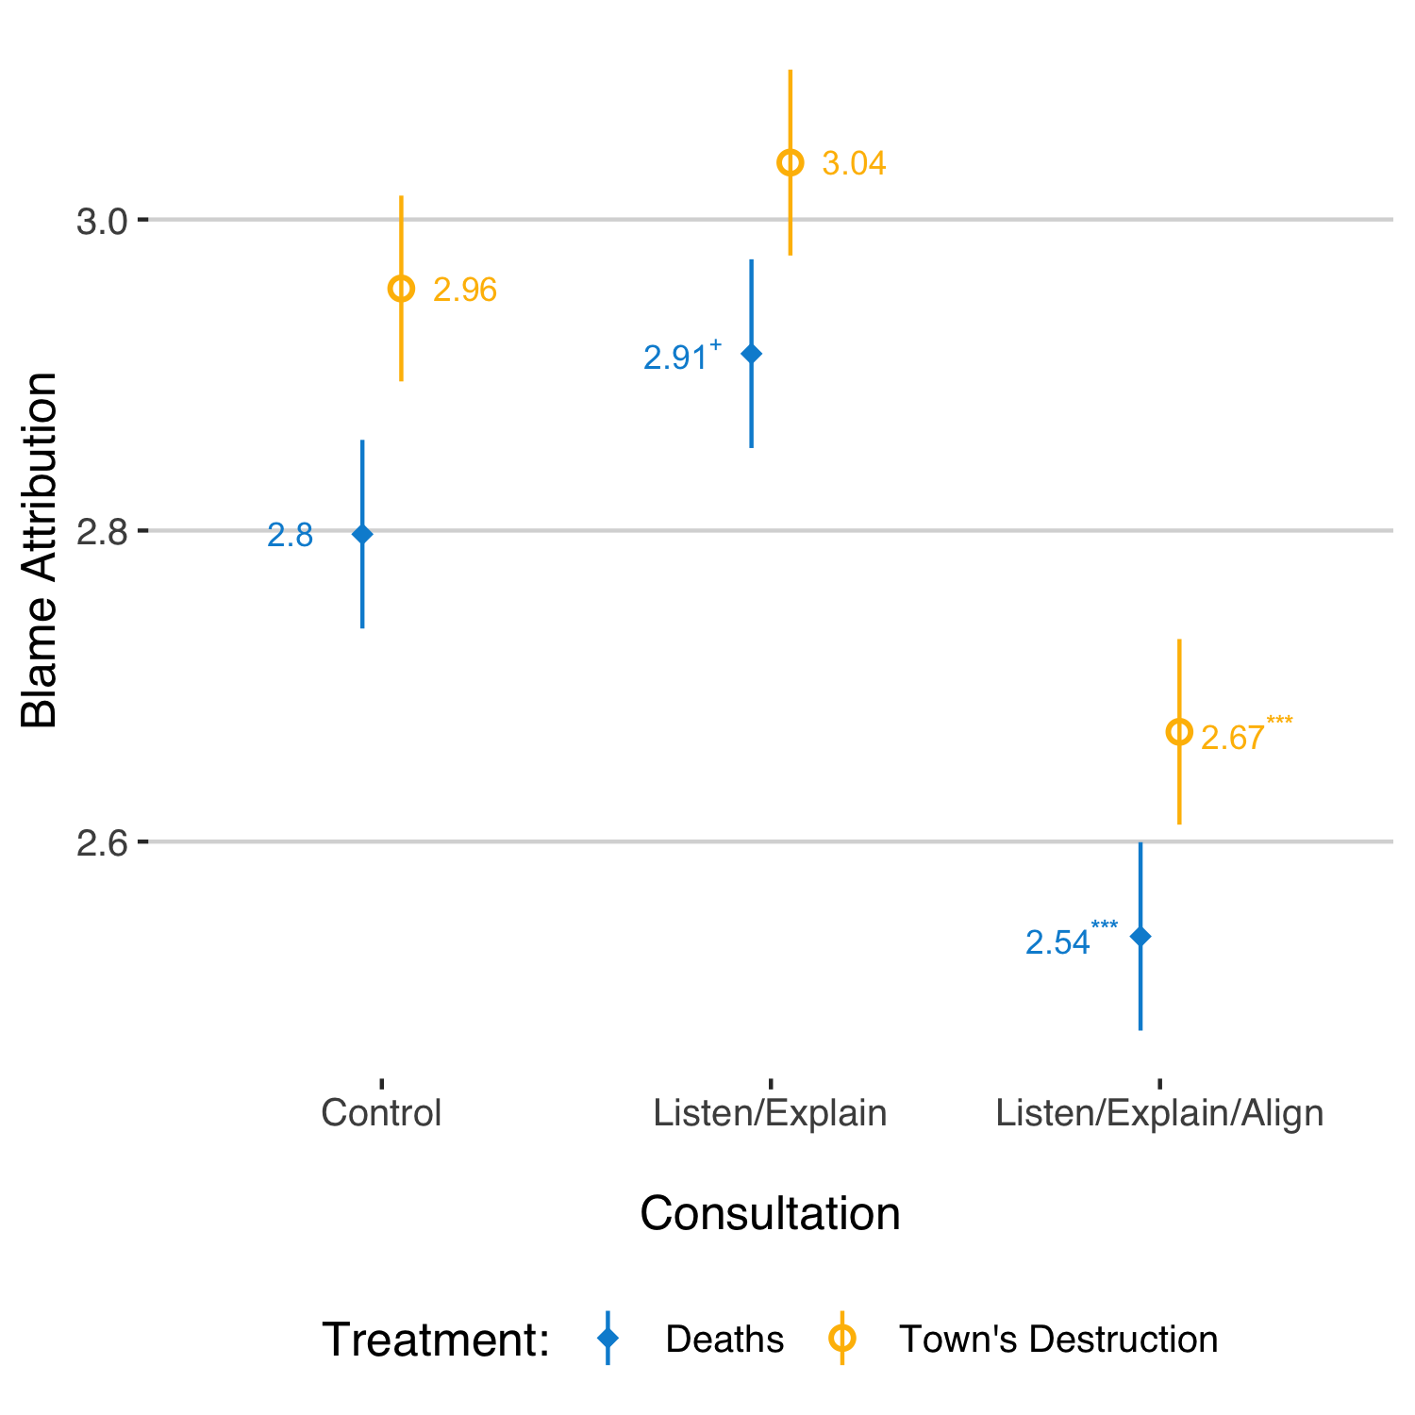
Findings on the role of policy stance support HO1, with pro-policy respondents assigning less blame than anti-policy ones (see OA4 Table 1, Model 2). More generally, however, the impact of respondent stance does appear to differ slightly here relative to Study 1. On the one hand, respondents opposed to the policy continue to ascribe less blame to politicians in the “Listen, Explain, and Align” treatment, while the blame attributed in the “Listen and Explain” treatment is equivalent to that in the control group. On the other, respondents in favour of the policy also appear to be affected by the consultation treatments (in contrast to the results of Study 1): relative to the control group, they ascribe less blame in the “Listen, Explain, and Align” treatment, and modestly more blame in the “Listen and Explain” treatment (though this latter effect only nears statistical significance, at p = 0.067). The divergent results are arguably just a function of a more equal division between respondents’ stances on the proposal, however, with a 52% against/48% in favour split among those who expressed an opinion one way or the other (which together constitute 74% of the sample). Due to the skewed nature of responses in Study 1 (82% against/18% in favour), here we have almost twice as many observations in the “pro-policy” category (823 respondents, versus 452 in Study 1), increasing power considerably.
OA4 Fig. 5 Study 2 – Effect of Consultations on Blame Attribution, by Stance on Policy
OA4 Fig. 6 Study 2 – Effect of Consultations on Blame Attribution for Deaths and Destruction of Much of the Town
Comparing the levels of blame attributed for the loss of life versus the material damage to the town, we see a similar pattern to that found in Study 1: namely, a statistically significant effect, but one that moves in the opposite direction than that suggested by HO3. As OA4 Figure 6 illustrates, respondents ascribed greater blame for the damage than for the deaths, even when looking at the three consultation treatments individually – a pattern that was also present in Study 1, though not always to a statistically significant degree. Yet as the figure also illustrates, there is suggestive evidence that the increased level of blame attributed in the “Listen and Explain” treatment (relative to the control) was driven by blame for the deaths rather than blame for the material destruction.
Finally, OA4 Figure 7 further disaggregates differences in the level of assigned blame for the deaths and material destruction. As in Study 1, results based on Seemingly Unrelated Regression analysis and Chi-squared tests do not support the hypotheses that a respondents’
OA4 Fig. 7 Study 2 – Blame Attribution for Deaths versus Town’s Destruction
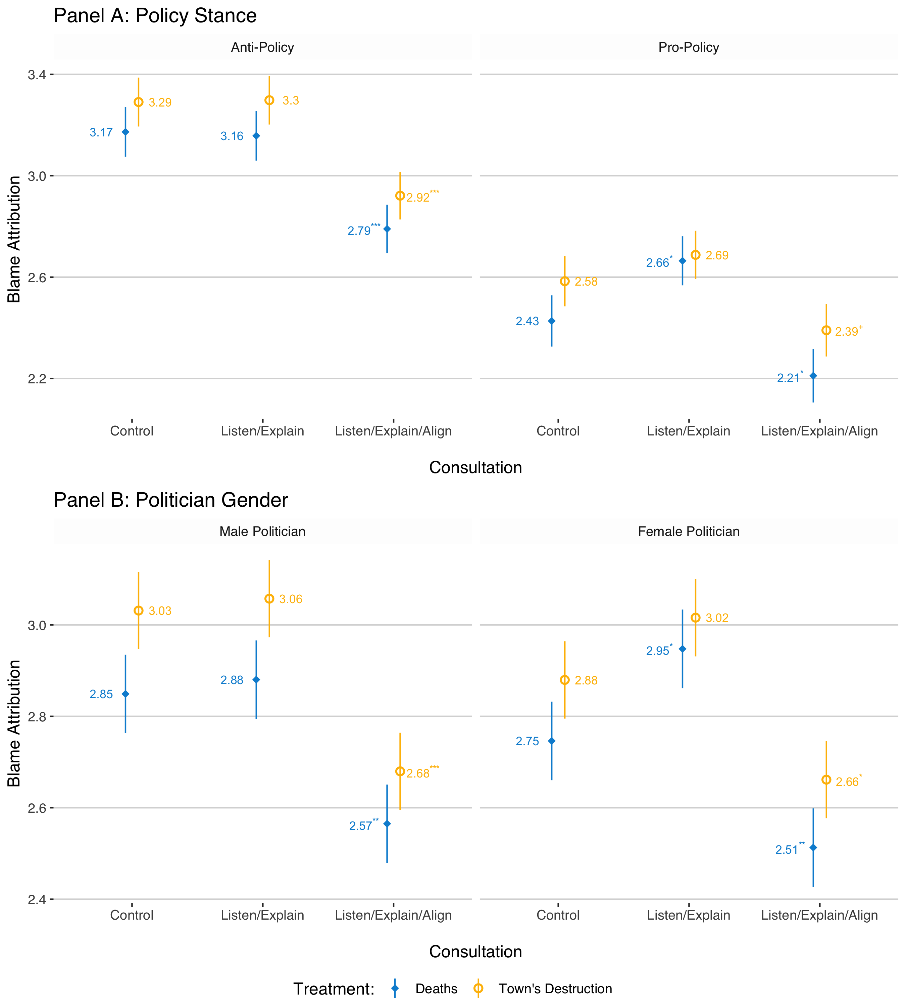

stances on the policy (HO4a) or levels of sexism (HO4d) impact the gap between the blame attributed for these two consequences. In contrast to Study 1, however, we do see some evidence of a gender effect, as respondents assigned greater blame for the material damage (relative to the deaths) in both the control and “Listen and Explain” treatments only when the politician was male. Nevertheless, the direction of the effect does not align with the corresponding hypothesis (HO4c), and the average level of blame attribution does not differ in a statistically significant manner.

OA4 Table 1 Controlling for the effect of respondent stance in Study 1 (Model 1) and Study 2 (Model 2) and the effect of co-partisanship in Study 1 (Model 3)
 | Dependent variable:
 | Blame Attributed to Mayor
 | (1) | (2) | (3)
Consultation (baseline: None)  Listen and Explain | 0.006 (0.054) | -0.004 (0.092) | 0.080 (0.076)
Listen, Explain, and Align | -0.214*** (0.054) | -0.376*** (0.091) | -0.103 (0.077)
Pro-Policy | -1.047*** (0.089) | -0.726*** (0.094)
Co-Partisan |  |  | -0.0004 (0.076)
Pro-Policy * Listen and Explain | 0.032 (0.128) | 0.175 (0.131)
Pro-Policy * Listen, Explain, and Align | 0.058 (0.126) | 0.171 (0.134)
Co-Partisan * Listen and Explain |  |  | 0.036 (0.107)
Co-Partisan * Listen, Explain, and Align |  |  | -0.124 (0.107)
Constant | 4.170*** (0.039) | 3.232*** (0.066) | 3.758*** (0.054)
Observations | 2,540 | 1,709 | 2,634
R² | 0.139 | 0.086 | 0.010
Adjusted R² | 0.137 | 0.083 | 0.009
Residual Std. Error | 1.002 (df = 2534) | 1.115 (df = 1703) | 1.121 (df = 2628)
F Statistic | 81.830*** (df = 5; 2534) | 32.011*** (df = 5; 1703) | 5.566*** (df = 5; 2628)
Note: Cells contain OLS regression coefficients, with standard errors in parentheses. + p<0.1; * p<0.05; ** p<0.01; *** p<0.001

Works Cited:

Alicke, M. D. (2000). Culpable control and the psychology of blame. Psychological Bulletin, 126(4), 556.
Bisgaard, M. (2015). Bias will find a way: Economic perceptions, attributions of blame, and partisan-motivated reasoning during crisis. The Journal of Politics, 77(3), 849–860.
Bolsen, T., Druckman, J. N., & Cook, F. L. (2014). The influence of partisan motivated reasoning on public opinion. Political Behavior, 36(2), 235–262.
Esaiasson, P., Persson, M., Gilljam, M., & Lindholm, T. (2019). Reconsidering the Role of Procedures for Decision Acceptance. British Journal of Political Science, 49(1), 291–314.
Leeper, T. J., & Slothuus, R. (2014). Political Parties, Motivated Reasoning, and Public Opinion Formation. Political Psychology, 35, 129–156.
Robbennolt, J. K. (2000). Outcome Severity and Judgments of “Responsibility”: A Meta‐Analytic Review. Journal of Applied Social Psychology, 30(12), 2575–2609.
Skitka, L. J., Winquist, J., & Hutchinson, S. (2003). Are Outcome Fairness and Outcome Favorability Distinguishable Psychological Constructs? A Meta-Analytic Review. Social justice research, 16(4), 309–341.

Online Appendix 5: Study 1 Experiment Wording

In Section 2 of the survey, you will read some text and answer some questions about a hypothetical city named Middletown.
Please consider the following information carefully, and answer the questions as if you were a resident of Middletown.

Middletown is having budgetary problems, and its City Council has enacted a series of cuts.

As part of this “budgetary realignment”, [Kevin / Karen] Bailey, the local [Democratic / Republican] mayor, has suggested that municipal funding for local homeless shelters must be cut by 20%. Others, however, worry that this will put the homeless population at risk, especially during Middletown’s cold winters.

What do you think? Would this be a good or bad policy to enact?

- Very bad policy (1)
- Bad policy (2)
- Neither good nor bad (3)
- Good policy (4)
- Very good policy (5)

[New Page]

Control: Without a significant public debate, [Kevin / Karen] Bailey decides to push forward with [his / her] proposed 20% cut to shelter funding and the bill is passed in City Council.

Listen and Explain: [Kevin / Karen] Bailey decides to hold a town hall meeting to discuss the proposal. At the meeting, [he / she] hears out all of the attendees and explains [his / her] own stance on the issue. Although most citizens were opposed to the proposal, the Mayor decides to push forward with [his / her] proposed 20% cut to shelter funding and the bill is passed in City Council.

Listen, Explain, and Align: [Kevin / Karen] Bailey decides to hold a town hall meeting to discuss the proposal. At the meeting, [he / she] hears out all of the attendees and explains [his / her] own stance on the issue. With most citizens in favor of the proposal, the Mayor decides to push forward with [his / her] proposed 20% cut to shelter funding and the bill is passed in City Council.

To what extent do you agree or disagree that the mayor of Middletown...

 | Strongly agree (1) | Somewhat agree (2) | Neither agree nor disagree (3) | Somewhat disagree (4) | Strongly disagree (5)
found out about the wishes of citizens?
explained the policy to citizens?
tried to accommodate the wishes of citizens?

[New Page]

And to what extent do you agree or disagree with the following statements…
 | Strongly agree (1) | Somewhat agree (2) | Neither agree nor disagree (3) | Somewhat disagree (4) | Strongly disagree (5)
I am satisfied with the outcome of the vote
I trust the elected politicians who participated in the vote
It is important to comply with the decision

[New Page]

In the wake of these cuts, the number of beds for the homeless drops by almost a fifth, and many of the city’s homeless end up sleeping on the streets. Over the winter, two homeless Middletowners, Greg Walsh and Emily Baker, are found frozen to death on the city’s streets – Middletown’s first homeless deaths from hypothermia in over a decade.

How much blame do the following actors deserve for the drop in the number of shelter places?
 | No blame at all (1) | Very little blame (2) | Some blame (3) | A lot of blame (4) | A great deal of blame (5)
The Mayor
Democratic Council Members
Republican Council Members
City Council

And how much blame do the following actors deserve for the two deaths by hypothermia?
 | No blame at all (1) | Very little blame (2) | Some blame (3) | A lot of blame (4) | A great deal of blame (5)
The Mayor
Democratic Council Members
Republican Council Members
City Council

[New Page]

Do you remember what the Mayor's gender was in the scenario you just read?
- Female (1)
- Male (2)
- Other (3)
- Don’t know (4)

And what was the Mayor's party affiliation?
- Democrat (1)
- Republican (2)
- Other (3)
- Don’t know (4)

Online Appendix 6: Study 2 Experiment Wording
You will now read some text and answer some questions about a hypothetical city named Middletown.

Please consider the following information carefully, and answer the questions as if you were a resident of Middletown.

[Kevin / Karen] Bailey is the Mayor of Middletown. [His / Her] job is to make important decisions for the community.

[Kevin / Karen] Bailey is deciding how to protect the town from flood waters caused by an impending storm. [He / She] wants to reinforce a wall along the river bank, but some people think the town should reinforce the levee instead. The town doesn’t have the time and resources needed to do both.

What do you think would be the better course of action?

o Reinforce the wall (1)
o Reinforce the levee (2)
o Don’t know (3)

[New Page]

Control: Without a significant public debate, [Kevin / Karen] Bailey decides to [push forward with [his / her] plan to reinforce the wall / change course and reinforce the levee].

Listen, Explain, Don’t Align:

Wall: [Kevin / Karen] Bailey holds an emergency town hall meeting to discuss [his / her] plan. At the meeting, [he / she] hears out all of the attendees and explains [his / her] own stance on the issue. Although most citizens wanted [him / her] to change course and reinforce the levee, the Mayor decides to push forward with [his / her] plan to reinforce the wall.

Levee: [Kevin / Karen] Bailey holds an emergency town hall meeting to discuss [his / her] plan. At the meeting, [he / she] hears out all of the attendees and explains [his / her] own stance on the issue. Although most citizens wanted [him / her] to push forward with [his / her] plan to reinforce the wall, the Mayor decides to change course and reinforce the levee.

Listen, Explain, Align:

Wall: [Kevin / Karen] Bailey holds an emergency town hall meeting to discuss [his / her] plan. At the meeting, [he / she] hears out all of the attendees and explains [his / her] own stance on the issue. With most citizens in favor of reinforcing the wall, the Mayor decides to push forward with [his / her] plan.

Levee: [Kevin / Karen] Bailey holds an emergency town hall meeting to discuss [his / her] plan. At the meeting, [he / she] hears out all of the attendees and explains [his / her] stance. With most citizens in favor of changing course, the Mayor decides to abandon [his / her] plan and reinforce the levee.
To what extent do you agree or disagree that the Mayor of Middletown...
 | Strongly agree (1) | Somewhat agree (2) | Neither agree nor disagree (3) | Somewhat disagree (4) | Strongly disagree (5)
found out about the wishes of citizens?
explained [his / her] proposal to citizens?
tried to accommodate the wishes of citizens?

And to what extent do you agree or disagree with the following statements…
 | Strongly agree (1) | Somewhat agree (2) | Neither agree nor disagree (3) | Somewhat disagree (4) | Strongly disagree (5)
I agree with the decision to reinforce the [wall / levee]
I trust the Mayor of Middletown
It is important to comply with the Mayor’s decision

[New Page]

After the meeting, the Mayor puts the plan into action and the [wall / levee] is successfully reinforced. When the storm arrives, however, the flood waters break through the [levee / wall]. Much of the town is destroyed, and two Middletowners end up losing their lives.

How much blame does the Mayor, [Kevin / Karen] Bailey, deserve for the town’s destruction?

 | No blame at all (1) | Very little blame (2) | Some blame (3) | A lot of blame (4) | A great deal of blame (5)
the town’s destruction?
the two deaths?

[New Page]

Do you remember what the Mayor's gender was in the scenario you just read?

o Female (1)
o Male (2)
o Other (3)
o Don’t know (4)

