Growing Up in a Polarized Party System:
Ideological Divergence and Party Sorting Across Generations

Online Appendix

A. Selected Variables 1
B. Main results (Tables) 4
C. Mean levels 9
D. Robustness Checks: Comparing ANES and GSS 17

- Selected Variables
Index composition:
- Ideological self-placement: items 2 (GSS), 18 (ANES)
- Social welfare index: indices 3-7 (GSS), 20-23 (ANES)
- Race and gender indices: items 8-9 (GSS), 23-24 (ANES)
- Culture and morality indices: items 10-13 (GSS), 25-26 (ANES)*
- Immigration attitudes: item 28 (ANES)*
- Demographic shifts (control variables): items 14-16 (GSS), 29-31 (ANES).
* Greatest generation members were omitted from the culture and immigration ANES models due to data limitations.
Abbreviated questions used in the GSS cumulative dataset:
- Party identification, 7-point scale: Generally speaking, do you usually think of yourself as a Republican, Democrat, Independent, or what? Would you call yourself a strong (REP/DEM) or a not very strong (REP/DEM)? Do you think of yourself as closer to the Republican or Democratic party? (1. Strong Democrat, 2. Not very strong Democrat, 3. Independent, close to Democrat, 4. Independent, 5. Independent, close to Republican, 6. Not very strong Republican, 7. Strong Republican). Other party and refused to say responses were omitted from the analysis.
- Ideological self-placement, 7-point scale: … (1. Extremely liberal, 2. Liberal, 3. Slightly liberal, 4. Moderate, 5. Slightly conservative, 6. Conservative, 7. Extremely conservative).
- Income redistribution, 7-point scale: (1. Government reduce the income differences between the rich and the poor, perhaps by raising the taxes of wealthy families or by giving income assistance to the poor… 7. Government should not concern itself with reducing this income difference).
- Government help the poor, 5-point scale: (1. Government should do everything possible to improve the standard of living of all poor Americans… 5. Each person should take care of himself).
- Government should do more, 5-point scale: (1. Government should do even more to solve our country's problems… 5. Government is trying to do too many things that should be left to individuals and private businesses.).
- Government paying for health care, 5-point scale: (1. Government help with paying for doctors and hospital bills… 5 People take care of these things themselves).
- Federal spending: social security, 3-point scale: … Are we spending too much, too little, or about the right amount on social security? (1. Too little, 2. About right, 3. Too much).
- Aid to Blacks, 5-point scale: (1. Government has a special obligation to help improve living standards of Blacks… 5. No special treatment).
- Women’s work and familial roles, average of three 1-4 scale questions: A: A working mother can establish just as warm and secure a relationship with her children as a mother who does not work. B: A preschool child is likely to suffer if his or her mother works. C: It is much better for everyone involved if the man is the achiever outside the home and the woman takes care of the home and family. (1. Strongly agree… 4. Strongly disagree).
- Legality of abortion, sum of 6 yes/no questions: Should it be possible for a pregnant woman to obtain a legal abortion if A. If there is a strong chance of serious defect in the baby? B. If she is married and does not want any more children? C. If the woman’s health is seriously endangered by the pregnancy? D. If the family has a very low income and cannot afford any more children? E. If she became pregnant as a result of rape? F. If she is not married and does not want to marry the man?
- Same-sex sexual relations, 4-point scale: What about sexual relations between two adults of the same sex-do you think it is always wrong, almost always wrong, wrong only sometimes, or not wrong at all? (1. Not wrong at all, 2. Wrong only sometimes, 3. Almost always wrong, 4. Always wrong). Scale reversed.
- Divorce, 3-point scale: Should divorce in this country be easier or more difficult to obtain than it is now? (1. Easier, 2. Stay as is, 3. More difficult). Scale recoded.
- Premarital sex, 4-point scale: … If a man and woman have sex relations before marriage, do you think it is always wrong, almost always wrong, wrong only sometimes, or not wrong at all? (1. Not wrong at all, 2. Wrong only sometimes, 3. Almost always wrong, 4. Always wrong). Scale reversed.
- Race/White: What race do you consider yourself? Recoded to 0. Non-white, 1. White.
- College: What is the highest grade in elementary or high school that you finished and got credit for? Recoded to 0. No college, 1. At least 1 year of college.
- Active Protestants: Combination of: How often do you attend religious services? and What is your religious preference?... Recoded to: 0. Less than once a month or not Protestant, 1. Protestant and at least once a month.
Abbreviated questions used in the ANES cumulative dataset:
- Party identification, 7-point scale: Generally speaking, do you usually think of yourself as a Republican, a Democrat, an Independent, or what? Would you call yourself a strong (REP/DEM) or a not very strong (REP/DEM)? Do you think of yourself as closer to the Republican or Democratic party? (1. Strong Democrat, 2. Not very strong Democrat, 3. Independent, close to Democrat, 4. Independent, 5. Independent, close to Republican, 6. Not very strong Republican, 7. Strong Republican).
- Ideological self-placement, 7-point scale: …Where would you place yourself on this scale? (1. Extremely liberal, 2. Liberal, 3. Slightly liberal, 4. Moderate, 5. Slightly conservative, 6. Conservative, 7. Extremely conservative).
- Government services-spend tradeoff, 7-point scale: (1. Government should provide many more services: increase spending a lot... 7. Government should provide many fewer services: reduce spending a lot). Note: scale reversed.
- Government health insurance, 7-point scale: (1. Government insurance plan which would cover all medical and hospital expenses (for everyone)… 7. Private insurance plan)
- Guaranteed Jobs and Income, 7-point scale: (1. Government should see to it that every person has a job and a good standard of living… 7. Government let each person get ahead of his own).
- Federal spending: social security, 3-point scale: 1. Increased, 2. Same, 3. Decreased. Voluntary responses to cut out social security entirely were omitted from the analysis.
- Aid to Blacks and other minorities, 7-point scale: (1. Government should help minority groups/Blacks… 7. Minority groups/Blacks should help themselves).
- Women Equal Role Scale, 7-points scale: (1. Women and men should have an equal role in running business, industry and government… 7. Women’s place is in the home).
- Abortion, 4-point scale: …Which one of the opinions on this page best agrees with your view? (1. By law, abortion should never be permitted; 2. The law should permit abortion only in case of rape, incest, or when the woman's life is in danger; 3. The law should permit abortion for reasons other than rape, incest, or danger to the woman's life, but only after the need for the abortion has been clearly established; 4. By law, a woman should always be able to obtain an abortion as a matter of personal choice.)
- Thermometer: Gays and Lesbians: Feelings toward group, expressed on a 0-100 (1-98) scale. Gay men and lesbians (that is), homosexuals: 1-98.
- Morality scale, average of four 1-5 scales ranging from 1. Disagree strongly to 5. Agree strongly, recoded: A. ‘The newer lifestyles are contributing to the breakdown of our society’; B. ‘The world is always changing and we should adjust our view of moral behavior to those changes’; C. ‘This country would have many fewer problems if there were more emphasis on traditional family ties’, D. ‘We should be more tolerant of people who choose to live according to their own moral standards, even if they are very different from our own’.
- Immigration, 5-point scale: Do you think the number of immigrants from foreign countries who are permitted to come to the United States to live should be increased a little, increased a lot, decreased a little, decreased a lot, or left the same as it is now? (1. Increased a lot… 5. decreased a lot).
- Race/White: In addition of being American, what do you consider your main ethnic group or nationality group? Recoded to 0. Non-white, 1. Non-Hispanic White.
- College: What is the highest level of school you have completed or the highest degree you have received? Recoded to 0. No college, 1. At least one year of college.
- Active Protestants: Combination: Do you go to religious services every week, almost every week, once or twice a month, a few times a year, or never? and Do you consider yourself Protestant, Roman Catholic, Jewish, or what? Recoded to: 0. Less than once or twice a month or not Protestant, 1. At least once or twice a month and Protestant.

- Main results (Tables)

Table B.1 Results of bootstrapped models with resampling (R=1000), with and without demographic controls. Entries are age, period, and cohort differences in ideological divergence with standard errors in parentheses. All outcome variables were normalized to the range 0 (most liberal), to 1 (most conservative).
Data: ANES (immigration issue attitudes), GSS (other outcome variables).
 | Ideological ID |  | Social Welfare |  | Race & Gender |  | Culture & Morality |  | Immigration
Controls | Without | With | Without | With | Without | With | Without | With | Without | With
Intercept | 0.18 (0.00)*** | 0.17 (0.00)*** | 0.16 (0.00)*** | 0.14 (0.00)*** | 0.16 (0.00)*** | 0.15 (0.00)*** | 0.23 (0.01)*** | 0.21 (0.01)*** | 0.21 (0.00)*** | 0.21 (0.00)***
Cohort
Greatest | 0.00 (0.00) | 0.00 (0.00) | 0.00 (0.00) | 0.00 (0.00) | 0.01 (0.01)* | 0.01 (0.00)* | 0.00 (0.01) | 0.01 (0.00)
Silent | 0.01 (0.00)* | 0.00 (0.00) | 0.01 (0.00)* | 0.01 (0.00)** | 0.01 (0.00) | 0.01 (0.00) | 0.01 (0.00)*** | 0.01 (0.00)** | -0.00 (0.00) | -0.00 (0.00)
Boomer | REF |  | REF |  | REF |  | REF |  | REF
Gen X | -0.01 (0.00)*** | -0.01 (0.00)*** | -0.01 (0.00)*** | -0.01 (0.00)** | -0.00 (0.00) | -0.00 (0.00) | -0.00 (0.00) | -0.00 (0.00) | 0.00 (0.00) | 0.00 (0.00)
Millennial | -0.02 (0.00)*** | -0.02 (0.00)*** | -0.02 (0.00)*** | -0.01 (0.00)** | -0.01 (0.00)* | -0.01 (0.00) | -0.02 (0.01)*** | -0.02 (0.01)*** | -0.00 (0.00) | 0.00 (0.00)
Period
1974 | -0.02 (0.01)*** | -0.01 (0.01)* |  |  |  |  | 0.00 (0.01) | 0.00 (0.01)
1975 | -0.02 (0.01)** | -0.01 (0.01) |  |  |  |  | 0.01 (0.01) | 0.01 (0.01)
1976 | -0.02 (0.01)*** | -0.01 (0.00)*
1977 | -0.02 (0.01)** | -0.01 (0.00) |  |  |  |  | 0.01 (0.01) | 0.01 (0.01)
1978 | -0.02 (0.00)*** | -0.01 (0.00)** |  |  |  |  | 0.00 (0.01) | 0.01 (0.01)
1980 | -0.02 (0.01)*** | -0.01 (0.00)*
1982 | -0.01 (0.00) | -0.00 (0.00) |  |  |  |  | -0.00 (0.01) | -0.01 (0.01)
1983 | -0.02 (0.01)*** | -0.01 (0.01)* |  |  |  |  | 0.01 (0.01) | 0.00 (0.01)
1984 | -0.02 (0.00)*** | -0.01 (0.00)** | -0.00 (0.01) | -0.00 (0.01)
1985 | -0.01 (0.00)* | -0.01 (0.00) |  |  |  |  | 0.01 (0.01) | 0.01 (0.01)
1986 | -0.01 (0.00)** | -0.01 (0.00) | -0.01 (0.00)* | -0.01 (0.00)** | 0.00 (0.00) | 0.00 (0.00)
1987 | -0.00 (0.00) | -0.00 (0.00) | 0.00 (0.00) | -0.00 (0.00)
1988 | -0.00 (0.00) | 0.00 (0.00) | -0.01 (0.01)* | -0.01 (0.00)** | 0.01 (0.01) | 0.01 (0.01) | 0.01 (0.01) | 0.00 (0.01)
1989 | -0.01 (0.00) | -0.01 (0.00) | -0.01 (0.00)* | -0.01 (0.00)* | 0.00 (0.01) | 0.00 (0.01) | 0.01 (0.01) | 0.01 (0.01)
1990 | -0.00 (0.01) | 0.00 (0.00) | -0.02 (0.01)*** | -0.01 (0.00)** | 0.00 (0.01) | 0.00 (0.00) | 0.01 (0.01) | 0.01 (0.01)
1991 | -0.01 (0.00)* | -0.01 (0.00) | -0.01 (0.01) | -0.01 (0.00) | 0.00 (0.01) | 0.00 (0.01) | 0.00 (0.01) | -0.00 (0.01)
1992 |  |  |  |  |  |  |  |  | -0.00 (0.00) | -0.01 (0.00)
1993 | -0.00 (0.00) | -0.00 (0.00) | -0.01 (0.01) | -0.01 (0.00) | -0.01 (0.01) | -0.00 (0.01) | 0.00 (0.01) | -0.00 (0.01)
1994 | 0.00 (0.00) | 0.00 (0.00) | 0.00 (0.00) | -0.00 (0.00) | -0.01 (0.00)* | -0.01 (0.00)* | 0.01 (0.01) | 0.00 (0.01) | 0.00 (0.01) | 0.00 (0.01)
1996 | REF |  | REF |  | REF |  | REF |  | -0.01 (0.01)* | -0.02 (0.00)**
1998 | 0.00 (0.00) | 0.01 (0.00) | -0.00 (0.00) | -0.00 (0.00) | 0.00 (0.01) | 0.01 (0.01) | 0.02 (0.01) | 0.01 (0.01) | -0.00 (0.01) | -0.01 (0.01)
2000 | 0.00 (0.00) | 0.00 (0.00) | 0.00 (0.00) | -0.00 (0.00) | 0.01 (0.01) | 0.01 (0.01) | -0.01 (0.01) | -0.00 (0.01)
2002 | 0.00 (0.01) | 0.00 (0.01) | -0.01 (0.01) | -0.00 (0.00) | -0.01 (0.01) | -0.01 (0.01) | 0.01 (0.01) | 0.02 (0.01)
2004 | 0.01 (0.01)* | 0.01 (0.00) | -0.00 (0.01) | 0.00 (0.01) | -0.00 (0.01) | -0.00 (0.01) | 0.04 (0.01)*** | 0.02 (0.01)* | -0.01 (0.01) | -0.01 (0.01)**
2006 | 0.01 (0.00) | 0.01 (0.00) | -0.00 (0.00) | 0.00 (0.00) | 0.01 (0.01) | 0.01 (0.00) | 0.02 (0.01)* | 0.01 (0.01)
2008 | 0.01 (0.00)* | 0.01 (0.00) | 0.01 (0.00) | 0.01 (0.00) | -0.00 (0.01) | 0.00 (0.01) | 0.01 (0.01) | 0.00 (0.01) | 0.00 (0.00) | 0.00 (0.00)
2010 | 0.01 (0.00)** | 0.01 (0.00)** | 0.02 (0.01)*** | 0.02 (0.00)*** | -0.00 (0.01) | 0.00 (0.01) | 0.01 (0.01) | 0.01 (0.01)
2012 | 0.01 (0.00)** | 0.01 (0.00)** | 0.02 (0.00)*** | 0.01 (0.00)** | 0.01 (0.01) | 0.00 (0.01) | 0.02 (0.01) | 0.01 (0.01) | 0.01 (0.00)** | 0.00 (0.00)
2014 | 0.01 (0.00) | 0.01 (0.00) | 0.02 (0.00)*** | 0.02 (0.00)*** | 0.00 (0.01) | 0.00 (0.01) | 0.01 (0.01) | 0.01 (0.01)
2016 | 0.02 (0.00)*** | 0.02 (0.00)*** | 0.02 (0.00)*** | 0.02 (0.00)*** | 0.01 (0.01) | 0.01 (0.01) | 0.02 (0.01)* | 0.02 (0.01)* | 0.02 (0.00)*** | 0.01 (0.00)***
2018 | 0.02 (0.00)*** | 0.02 (0.00)*** | 0.01 (0.00) | 0.01 (0.00)** | 0.01 (0.01) | 0.01 (0.01) | 0.02 (0.01)* | 0.01 (0.01)
 |  |  |  |  |  |  |  |  | REF
2021 | 0.03 (0.00)*** | 0.02 (0.00)*** | 0.04 (0.00)*** | 0.04 (0.00)*** | 0.03 (0.01)*** | 0.03 (0.01)***
Age
17-21 | 0.00 (0.00) | 0.01 (0.00)* | -0.02 (0.00)*** | -0.01 (0.00)* | -0.01 (0.01) | -0.01 (0.01) | -0.01 (0.01) | -0.01 (0.01) | -0.02 (0.01)** | -0.02 (0.01)**
22-29 | 0.00 (0.00) | 0.00 (0.00) | -0.01 (0.00)*** | -0.01 (0.00)*** | -0.00 (0.00) | -0.00 (0.00) | -0.02 (0.00)*** | -0.02 (0.00)*** | -0.00 (0.00) | -0.00 (0.00)
30-64 | REF |  | REF |  | REF |  | REF |  | REF
65+ | 0.00 (0.00) | 0.00 (0.00) | -0.00 (0.00) | -0.00 (0.00) | -0.00 (0.00) | -0.00 (0.00) | -0.01 (0.00) | -0.01 (0.00) | -0.00 (0.00) | 0.00 (0.00)
Controls
Protestant |  | 0.01 (0.00)*** |  | 0.00 (0.00) |  | -0.00 (0.00) |  | 0.02 (0.00)*** |  | -0.00 (0.00)
White |  | -0.01 (0.00)*** |  | 0.01 (0.00)*** |  | -0.01 (0.00)*** |  | -0.00 (0.00) |  | 0.01 (0.00)**
College |  | 0.02 (0.00)*** |  | 0.01 (0.00)*** |  | 0.01 (0.00)*** |  | 0.00 (0.00) |  | -0.01 (0.00)**
r2 | 0.007 (0.001) | 0.012 (0.001) | 0.017 (0.002) | 0.021 (0.002) | 0.009 (0.002) | 0.011 (0.002) | 0.011 (0.002) | 0.016 (0.002) | 0.005 (0.001) | 0.005 (0.001)
adj_r2 | 0.007 | 0.012 | 0.016 | 0.02 | 0.008 | 0.009 | 0.009 | 0.014 | 0.004 | 0.004
N | 54862 | 54862 | 26542 | 26542 | 14600 | 14600 | 17984 | 17984 | 23465 | 23465

Table B.2 Results of bootstrapped OLS models with resampling (R=1000). Entries are standardized regression coefficients presenting APC differences in party sorting with and without demographic controls. Bootstrapped standard errors in parentheses.
Data: ANES (immigration attitudes) and GSS (other outcome variables).

 | Ideological ID |  | Social Welfare |  | Race & Gender |  | Culture & Morality |  | Immigration
Controls | Without | With | Without | With | Without | With | Without | With | Without | With
Intercept | -0.00 (0.00)* | 0.01 (0.01)* | -0.00 (0.00) | -0.00 (0.01) | -0.00 (0.00) | -0.02 (0.01)* | -0.00 (0.00) | 0.02 (0.01)** | -0.00 (0.00) | -0.02 (0.01)***
Variable | 0.47 (0.02)*** | 0.06 (0.02)** | 0.50 (0.03)*** | 0.18 (0.03)*** | 0.40 (0.03)*** | 0.19 (0.04)*** | 0.23 (0.04)*** | 0.04 (0.04) | 0.49 (0.02)*** | 0.29 (0.02)***
Cohort,
main effect
Greatest | 0.02 (0.00)*** | 0.00 (0.01) | -0.01 (0.01) | -0.02 (0.01) | -0.01 (0.01) | -0.03 (0.01)* | 0.00 (0.00) | 0.01 (0.01)
Silent | 0.00 (0.00) | -0.01 (0.00)* | -0.01 (0.00) | -0.02 (0.01)** | -0.01 (0.01) | -0.02 (0.01)* | -0.00 (0.00) | 0.00 (0.00) | -0.02 (0.01)** | -0.02 (0.01)**
Boomer | REF |  | REF |  | REF |  | REF |  | REF
Gen X | -0.00 (0.00) | 0.01 (0.00) | -0.00 (0.00) | 0.00 (0.00) | -0.00 (0.00) | 0.00 (0.01) | 0.00 (0.00) | -0.00 (0.00) | 0.01 (0.00) | 0.00 (0.00)
Millennial | -0.00 (0.00) | 0.02 (0.01)*** | 0.01 (0.01) | 0.02 (0.01)** | 0.00 (0.01) | 0.00 (0.01) | 0.00 (0.01) | -0.00 (0.01) | 0.01 (0.00) | 0.01 (0.01)
Period,
main effect
1974 | -0.00 (0.00) | 0.02 (0.01)** |  |  |  |  | 0.00 (0.00) | 0.01 (0.01)
1975 | -0.00 (0.00) | 0.02 (0.01)* |  |  |  |  | 0.00 (0.01) | 0.02 (0.01)**
1976 | -0.00 (0.00) | 0.01 (0.01)
1977 | -0.00 (0.00) | 0.02 (0.01)* |  |  |  |  | 0.00 (0.00) | 0.01 (0.01)*
1978 | -0.00 (0.00) | 0.01 (0.01) |  |  |  |  | 0.00 (0.00) | 0.01 (0.01)
1980 | -0.00 (0.00) | 0.01 (0.01)
1982 | -0.00 (0.00) | 0.01 (0.01) |  |  |  |  | 0.00 (0.00) | 0.01 (0.01)*
1983 | -0.00 (0.00) | 0.00 (0.01) |  |  |  |  | 0.00 (0.00) | 0.00 (0.01)
1984 | -0.00 (0.00) | 0.01 (0.01) | 0.01 (0.00) | 0.01 (0.01)
1985 | -0.00 (0.00) | 0.01 (0.01) |  |  |  |  | 0.00 (0.00) | 0.01 (0.01)
1986 | 0.00 (0.00) | 0.01 (0.01) | 0.00 (0.00) | 0.01 (0.01) | 0.00 (0.00) | 0.01 (0.01)
1987 | 0.00 (0.00) | 0.00 (0.01) | 0.00 (0.00) | 0.00 (0.01)
1988 | 0.00 (0.00) | -0.00 (0.01) | 0.01 (0.00) | -0.01 (0.01) | -0.00 (0.01) | -0.01 (0.01) | 0.01 (0.01) | 0.01 (0.01)
1989 | 0.00 (0.00) | 0.00 (0.01) | 0.00 (0.00) | -0.00 (0.01) | 0.00 (0.01) | -0.00 (0.01) | -0.00 (0.01) | 0.00 (0.01)
1990 | 0.00 (0.00) | 0.01 (0.01) | 0.01 (0.00) | 0.01 (0.01) | -0.00 (0.01) | -0.00 (0.01) | 0.00 (0.01) | 0.02 (0.01)*
1991 | 0.00 (0.00) | 0.00 (0.01) | 0.00 (0.00) | 0.00 (0.01) | 0.00 (0.01) | 0.01 (0.01) | 0.00 (0.01) | 0.00 (0.01)
1992 |  |  |  |  |  |  |  |  | 0.01 (0.00) | 0.01 (0.01)*
1993 | 0.00 (0.00) | 0.01 (0.01) | 0.00 (0.00) | -0.00 (0.01) | 0.01 (0.01) | 0.00 (0.01) | 0.01 (0.01) | 0.01 (0.01)
1994 | 0.00 (0.00) | 0.00 (0.01) | 0.00 (0.00) | -0.00 (0.01) | 0.00 (0.00) | 0.01 (0.01) | 0.01 (0.00) | 0.01 (0.01) | 0.01 (0.00)* | 0.00 (0.01)
1996 | REF |  | REF |  | REF |  | REF |  | 0.01 (0.00)* | 0.01 (0.01)
1998 | -0.00 (0.00) | 0.01 (0.01) | 0.00 (0.00) | 0.01 (0.01)* | 0.00 (0.00) | 0.00 (0.01) | 0.00 (0.00) | 0.01 (0.01) | 0.00 (0.00) | -0.00 (0.01)
2000 | 0.00 (0.00) | 0.01 (0.01) | 0.01 (0.00) | 0.00 (0.01) | 0.00 (0.00) | 0.00 (0.01) | 0.00 (0.00) | 0.00 (0.01)
2002 | 0.00 (0.00) | 0.01 (0.01) | 0.00 (0.00) | 0.01 (0.01)* | 0.00 (0.01) | 0.02 (0.01) | 0.01 (0.01) | 0.01 (0.01)
2004 | 0.00 (0.00) | -0.00 (0.01) | 0.00 (0.00) | -0.00 (0.01) | 0.00 (0.01) | -0.01 (0.01) | 0.01 (0.01) | 0.01 (0.01) | 0.01 (0.00)** | -0.00 (0.01)
2006 | 0.00 (0.00)* | 0.02 (0.01)*** | 0.00 (0.00) | 0.02 (0.01)** | -0.00 (0.00) | 0.01 (0.01) | 0.01 (0.01)* | 0.01 (0.01)
2008 | 0.00 (0.00) | 0.01 (0.01) | 0.00 (0.00) | 0.00 (0.01) | 0.00 (0.00) | 0.00 (0.01) | 0.01 (0.01) | 0.01 (0.01) | 0.00 (0.00) | -0.00 (0.00)
2010 | 0.01 (0.00)** | 0.01 (0.01) | -0.00 (0.00) | -0.00 (0.01) | 0.00 (0.01) | 0.00 (0.01) | 0.00 (0.01) | 0.00 (0.01)
2012 | 0.01 (0.00)* | 0.01 (0.01) | 0.00 (0.00) | 0.00 (0.01) | 0.01 (0.01) | 0.01 (0.01) | 0.00 (0.01) | 0.00 (0.01) | 0.00 (0.00) | -0.01 (0.00)
2014 | 0.01 (0.00)* | 0.01 (0.01) | 0.00 (0.00) | 0.01 (0.01) | 0.00 (0.01) | 0.01 (0.01) | 0.00 (0.01) | 0.00 (0.01)
2016 | 0.00 (0.00) | 0.02 (0.01)** | 0.00 (0.00) | 0.02 (0.01)** | 0.00 (0.01) | 0.01 (0.01) | -0.00 (0.01) | -0.00 (0.01) | 0.00 (0.00) | -0.00 (0.00)
2018 | 0.00 (0.00) | 0.02 (0.01)*** | -0.00 (0.00) | 0.02 (0.01)* | -0.00 (0.01) | 0.01 (0.01) | -0.00 (0.01) | -0.00 (0.01)
2020 |  |  |  |  |  |  |  |  | REF
2021 | 0.01 (0.00) | 0.02 (0.01)** | -0.00 (0.00) | 0.01 (0.01) | -0.00 (0.01) | 0.00 (0.01)
Age,
main effect
17-21 | 0.00 (0.00) | 0.01 (0.01) | 0.00 (0.01) | 0.01 (0.01) | 0.00 (0.01) | 0.00 (0.01) | -0.00 (0.00) | 0.00 (0.01) | 0.01 (0.01) | 0.03 (0.01)**
22-29 | 0.01 (0.00)* | 0.01 (0.00)* | 0.00 (0.00) | 0.01 (0.01) | 0.00 (0.01) | 0.00 (0.01) | -0.00 (0.00) | 0.00 (0.00) | 0.00 (0.01) | 0.00 (0.01)
30-64 | REF |  | REF |  | REF |  | REF |  | REF
65+ | -0.01 (0.00)* | 0.00 (0.01) | 0.01 (0.01) | 0.01 (0.01) | 0.01 (0.01) | 0.02 (0.01) | -0.00 (0.01) | 0.00 (0.01) | 0.01 (0.01)* | 0.01 (0.01)
Controls,
main effect
Protestant |  | -0.05 (0.00)*** |  | -0.04 (0.00)*** |  | -0.01 (0.01) |  | -0.00 (0.00) |  | -0.05 (0.00)***
White |  | -0.01 (0.00)*** |  | -0.00 (0.01) |  | 0.01 (0.01) |  | -0.04 (0.01)*** |  | 0.02 (0.00)***
College |  | 0.00 (0.00)* |  | 0.01 (0.00)*** |  | 0.02 (0.00)*** |  | 0.01 (0.00)*** |  | 0.03 (0.00)***
Cohort,
interaction effect
:Greatest | -0.03 (0.02) | 0.03 (0.02) | -0.14 (0.03)*** | -0.07 (0.03)* | -0.29 (0.04)*** | -0.21 (0.05)*** | -0.11 (0.03)*** | -0.05 (0.03)
:Silent | -0.00 (0.01) | 0.03 (0.01)* | -0.03 (0.02) | -0.02 (0.02) | -0.08 (0.03)** | -0.05 (0.03)* | -0.09 (0.02)*** | -0.05 (0.02) | -0.03 (0.02) | -0.00 (0.02)
:Boomer | REF |  | REF |  | REF |  | REF |  | REF
:Gen X | -0.03 (0.01)* | -0.03 (0.01)* | -0.05 (0.02)** | -0.05 (0.02)** | -0.03 (0.02) | -0.05 (0.02)* | -0.02 (0.03) | -0.02 (0.03) | -0.00 (0.02) | -0.02 (0.02)
:Millennial | -0.06 (0.02)** | -0.06 (0.02)** | -0.09 (0.02)*** | -0.08 (0.03)** | -0.05 (0.03) | -0.05 (0.04) | -0.03 (0.04) | -0.09 (0.04)* | -0.04 (0.03) | -0.03 (0.03)
Period,
interaction effect
:1974 | -0.22 (0.04)*** | -0.24 (0.04)*** |  |  |  |  | -0.13 (0.05)* | -0.17 (0.05)***
:1975 | -0.15 (0.04)*** | -0.15 (0.04)*** |  |  |  |  | -0.10 (0.05) | -0.11 (0.05)*
:1976 | -0.21 (0.04)*** | -0.21 (0.04)***
:1977 | -0.17 (0.04)*** | -0.15 (0.04)*** |  |  |  |  | -0.17 (0.05)*** | -0.17 (0.05)**
:1978 | -0.23 (0.04)*** | -0.22 (0.04)*** |  |  |  |  | -0.10 (0.05) | -0.10 (0.05)*
:1980 | -0.26 (0.04)*** | -0.25 (0.04)***
:1982 | -0.20 (0.04)*** | -0.18 (0.04)*** |  |  |  |  | -0.12 (0.05)* | -0.09 (0.05)
:1983 | -0.13 (0.05)** | -0.14 (0.05)** |  |  |  |  | -0.12 (0.05)* | -0.15 (0.05)**
:1984 | -0.14 (0.04)*** | -0.12 (0.04)*** | 0.00 (0.04) | 0.01 (0.04)
:1985 | -0.06 (0.04) | -0.09 (0.04)** |  |  |  |  | -0.07 (0.05) | -0.09 (0.05)
:1986 | -0.06 (0.04) | -0.05 (0.04) | -0.02 (0.04) | -0.03 (0.04) | -0.11 (0.04)** | -0.10 (0.04)*
:1987 | -0.11 (0.04)** | -0.06 (0.04) | -0.04 (0.04) | -0.05 (0.04)
:1988 | -0.09 (0.04)* | -0.10 (0.04)** | -0.10 (0.04)* | -0.15 (0.05)** | -0.10 (0.05) | -0.10 (0.06) | -0.10 (0.07) | -0.06 (0.07)
:1989 | -0.06 (0.04) | -0.08 (0.04)* | -0.03 (0.04) | -0.06 (0.04) | -0.06 (0.06) | -0.03 (0.06) | -0.04 (0.07) | -0.04 (0.07)
:1990 | -0.06 (0.04) | -0.06 (0.04) | -0.06 (0.04) | -0.08 (0.05) | -0.12 (0.05)** | -0.12 (0.05)* | -0.05 (0.07) | -0.06 (0.07)
:1991 | -0.10 (0.04)** | -0.10 (0.04)** | -0.07 (0.04) | -0.06 (0.04) | -0.05 (0.06) | -0.05 (0.06) | -0.06 (0.07) | -0.04 (0.06)
:1992 |  |  |  |  |  |  |  |  | -0.44 (0.03)*** | -0.38 (0.03)***
:1993 | -0.03 (0.03) | -0.04 (0.03) | -0.03 (0.04) | -0.07 (0.05) | -0.13 (0.06)* | -0.16 (0.06)** | -0.04 (0.07) | -0.05 (0.06)
:1994 | 0.00 (0.03) | -0.02 (0.03) | 0.00 (0.03) | -0.00 (0.03) | -0.05 (0.04) | -0.06 (0.05) | 0.03 (0.05) | 0.05 (0.05) | -0.48 (0.04)*** | -0.45 (0.03)***
:1996 | REF |  | REF |  | REF |  | REF |  | -0.48 (0.03)*** | -0.46 (0.03)***
:1998 | 0.00 (0.03) | 0.01 (0.03) | -0.05 (0.03) | -0.03 (0.04) | -0.07 (0.04) | -0.06 (0.04) | 0.00 (0.06) | 0.05 (0.06) | -0.50 (0.04)*** | -0.46 (0.04)***
:2000 | -0.03 (0.03) | -0.02 (0.03) | 0.01 (0.03) | 0.02 (0.04) | -0.02 (0.04) | -0.02 (0.04) | 0.02 (0.05) | 0.07 (0.05)
:2002 | -0.01 (0.04) | 0.01 (0.04) | -0.03 (0.04) | -0.01 (0.04) | -0.05 (0.06) | -0.04 (0.06) | 0.03 (0.06) | 0.09 (0.06)
:2004 | 0.08 (0.03)* | 0.08 (0.03)* | 0.04 (0.04) | 0.04 (0.04) | -0.05 (0.06) | -0.04 (0.06) | 0.02 (0.07) | 0.06 (0.07) | -0.43 (0.04)*** | -0.40 (0.04)***
:2006 | 0.08 (0.03)** | 0.09 (0.02)*** | -0.03 (0.03) | 0.01 (0.03) | 0.01 (0.04) | 0.02 (0.04) | 0.07 (0.05) | 0.09 (0.05)
:2008 | 0.11 (0.03)*** | 0.10 (0.03)*** | 0.06 (0.03) | 0.06 (0.04) | -0.03 (0.05) | -0.02 (0.05) | 0.03 (0.06) | 0.06 (0.06) | -0.49 (0.03)*** | -0.44 (0.03)***
:2010 | 0.13 (0.03)*** | 0.13 (0.03)*** | 0.09 (0.03)** | 0.11 (0.04)** | 0.00 (0.05) | 0.02 (0.05) | 0.11 (0.06) | 0.12 (0.06)*
:2012 | 0.13 (0.03)*** | 0.13 (0.03)*** | 0.10 (0.04)** | 0.12 (0.04)** | -0.01 (0.05) | 0.00 (0.05) | 0.09 (0.06) | 0.14 (0.06)* | -0.34 (0.02)*** | -0.31 (0.02)***
:2014 | 0.14 (0.03)*** | 0.15 (0.03)*** | 0.10 (0.03)** | 0.13 (0.03)*** | 0.03 (0.05) | 0.05 (0.05) | 0.03 (0.06) | 0.09 (0.06)
:2016 | 0.11 (0.03)*** | 0.13 (0.03)*** | 0.13 (0.03)*** | 0.17 (0.04)*** | 0.05 (0.04) | 0.09 (0.05)* | 0.11 (0.05)* | 0.17 (0.05)*** | -0.14 (0.02)*** | -0.14 (0.02)***
:2018 | 0.18 (0.03)*** | 0.19 (0.03)*** | 0.14 (0.03)*** | 0.18 (0.04)*** | 0.10 (0.05)* | 0.12 (0.05)* | 0.06 (0.06) | 0.14 (0.06)*
:2020 |  |  |  |  |  |  |  |  | REF
:2021 | 0.31 (0.02)*** | 0.28 (0.02)*** | 0.19 (0.03)*** | 0.21 (0.03)*** | 0.21 (0.04)*** | 0.23 (0.04)***
Age,
interaction effect
:17-21 | -0.12 (0.03)*** | -0.00 (0.03) | -0.11 (0.04)** | -0.01 (0.04) | -0.03 (0.05) | 0.02 (0.05) | -0.05 (0.04) | -0.01 (0.04) | 0.06 (0.05) | 0.06 (0.05)
:22-29 | -0.04 (0.02)** | -0.01 (0.01) | -0.06 (0.02)** | -0.02 (0.02) | -0.04 (0.03) | -0.01 (0.03) | -0.02 (0.03) | -0.00 (0.03) | 0.06 (0.03)* | 0.05 (0.03)
:30-64 | REF |  | REF |  | REF |  | REF |  | REF
:65+ | -0.02 (0.02) | -0.02 (0.02) | 0.05 (0.02)** | 0.05 (0.02)* | 0.08 (0.03)* | 0.09 (0.03)** | 0.02 (0.03) | -0.00 (0.03) | 0.07 (0.02)** | 0.05 (0.02)
Controls,
interaction effect
:Protestant |  | 0.00 (0.01) |  | 0.01 (0.01) |  | 0.02 (0.02) |  | 0.08 (0.02)*** |  | -0.06 (0.02)***
:White |  | 0.26 (0.01)*** |  | 0.12 (0.02)*** |  | -0.01 (0.02) |  | 0.05 (0.02)* |  | 0.14 (0.02)***
:College |  | 0.26 (0.01)*** |  | 0.21 (0.01)*** |  | 0.24 (0.02)*** |  | 0.09 (0.02)*** |  | 0.13 (0.01)***
r2 | 0.167 (0.003) | 0.169 (0.003) | 0.210 (0.005) | 0.170 (0.004) | 0.117 (0.005) | 0.100 (0.004) | 0.031 (0.003) | 0.027 (0.002) | 0.083 (0.003) | 0.081 (0.003)
adj_r2 | 0.166 | 0.168 | 0.208 | 0.168 | 0.114 | 0.097 | 0.027 | 0.023 | 0.082 | 0.08
N | 54862 | 54862 | 26542 | 26542 | 14600 | 14600 | 17984 | 17984 | 23465 | 23465

- Mean levels
Generational research of public opinion is typically concerned with mean-level inter-generational differences. Although mean-level patterns and trends are of secondary importance to our research since they do not directly capture mass polarization, estimating mean-levels is necessary to construct our outcome variables (recall Equations 1 and 2). Moreover, these mean-levels provide context to the divergence and sorting patterns we observe across generations because ideological divergence captures the absolute deviation from these means. Following Equation 1, Tables C.1 (GSS data) and C.2 (ANES data), and Figures C.1 and C.2 present the estimated mean-values while controlling for age, period, and cohort. These Tables and Figures models also present mean-levels when controlling for demographic shifts in education, race, and religion/religiosity (specifically Protestantism). For the sake of clarification: all models feature normalized indices ranging from 0 (most liberal) to 1 (most conservative). See Appendix A for the exact question wording and coding.
Starting with the period effects, the American electorate has become increasingly liberal on culture, race, and gender-related issues. A similar pattern is also noticeable in recent years concerning immigration and aid to Blacks and other minorities, as indicated by the ANES data, although it is too early to tell whether this is indicative of a lasting trend. However, a similar pattern can be seen in the Race & Gender models based on GSS data in which attitudes have taken on a liberal turn over the past decade. In contrast, social welfare attitudes show no discernable trend. Interestingly, despite the absence of a conservative trend across any policy dimension, there was a period from the 1970s to the mid-1990s when more Americans identified as conservative. However, it should be noted that this trend has stagnated over the past two decades in both the GSS and ANES models.
Research often points out the distinct liberal tendencies among new generations compared to older cohorts. Our results indicate a similar tendency among America’s more recent generations. New generations are significantly more liberal than those they replace, and Millennials consistently stand out as the most liberal cohort by a wide margin. Although it is hard to directly compare shifts in mean-levels to the divergence and sorting results presented in the main article, it should be pointed out that the generational differences in mean-levels are consistent and significant across all model specifications and both datasets. They are also only partially accounted for by demographic shifts: except for race and gender where the mean-levels between the Boomers and Millennials largely dissipate when adding controls for ethnicity/race and education (and, interestingly enough, not for attitudes toward Aid to Blacks in the ANES). Beyond these models, political socialization leaves an important mark on the political outlook of the more recent American cohorts. These effects should not be underestimated, as generational replacement often has a comparable, or even stronger effect on public opinion than the more erratic period effects. That is to say, while public opinion may take either a liberal or conservative trend in the short-term, generational replacement slowly but consistently moves popular opinion in a liberal direction.
Contrast that with aging effects, as Americans grow somewhat more conservative on average throughout their lifespan. For example, we find some evidence for the old adage that people are more likely to call themselves conservatives when reaching middle adulthood (30-64, the reference category). However, these effects should not be overstated, and in some instances may even be reversed come late adulthood (65+). Overall, age effects are far weaker than both cohort and period effects, and several age coefficients do not attain statistical significance.
Finally, while the demographic controls explain only a small portion of the age, period, and cohort effects, they do matter. Respondents who attended college are more liberal on all policy issues except social welfare, where they hold more conservative opinions. Whites and practicing Protestants hold more conservative opinions across the political spectrum.
When taking both the political socialization and demographic shifts of the American electorate into account, average public opinion in the US has taken, and will continue to take, a distinct liberal turn, which will partially be the result of the replacement of older, more conservative generations by more liberal generations.

Table C.1 Results of bootstrapped OLS models with resampling (R=1000), with and without demographic controls. Entries are age, period, and cohort differences in mean-levels with standard errors in parentheses. All outcome variables were normalized to the range 0 (most liberal), to 1 (most conservative).
Data: ANES (immigration issue attitudes), GSS (other outcome variables).
 | Ideological ID |  | Social Welfare |  | Race & Gender |  | Culture & Morality |  | Immigration
Controls | Without | With | Without | With | Without | With | Without | With | Without | With
Intercept | 0.52 (0.00)*** | 0.46 (0.01)*** | 0.46 (0.01)*** | 0.31 (0.01)*** | 0.52 (0.01)*** | 0.44 (0.01)*** | 0.40 (0.01)*** | 0.32 (0.01)*** | 0.53 (0.00)*** | 0.54 (0.01)***
Cohort
Greatest | 0.05 (0.00)*** | 0.04 (0.00)*** | 0.02 (0.01)** | 0.02 (0.01)*** | 0.09 (0.01)*** | 0.07 (0.01)*** | 0.15 (0.01)*** | 0.12 (0.01)***
Silent | 0.04 (0.00)*** | 0.03 (0.00)*** | 0.03 (0.00)*** | 0.03 (0.00)*** | 0.05 (0.01)*** | 0.04 (0.01)*** | 0.08 (0.01)*** | 0.06 (0.01)*** | 0.01 (0.01) | -0.00 (0.01)
Boomer | REF |  | REF |  | REF |  | REF |  | REF
Gen X | -0.01 (0.00)** | -0.00 (0.00) | -0.01 (0.00)*** | -0.00 (0.00) | -0.01 (0.01)* | -0.00 (0.00) | -0.01 (0.01) | 0.00 (0.01) | -0.02 (0.00)*** | -0.01 (0.00)
Millennial | -0.05 (0.01)*** | -0.03 (0.01)*** | -0.03 (0.01)*** | -0.01 (0.01)* | -0.04 (0.01)*** | -0.02 (0.01)** | -0.03 (0.01)** | -0.01 (0.01) | -0.09 (0.01)*** | -0.07 (0.01)***
Period
1974 | -0.06 (0.01)*** | -0.06 (0.01)*** |  |  |  |  | -0.07 (0.01)*** | -0.07 (0.01)***
1975 | -0.06 (0.01)*** | -0.07 (0.01)*** |  |  |  |  | -0.05 (0.01)*** | -0.06 (0.01)***
1976 | -0.05 (0.01)*** | -0.06 (0.01)***
1977 | -0.05 (0.01)*** | -0.06 (0.01)*** |  |  |  |  | -0.05 (0.01)*** | -0.06 (0.01)***
1978 | -0.03 (0.01)*** | -0.04 (0.01)*** |  |  |  |  | -0.03 (0.01)** | -0.04 (0.01)***
1980 | -0.03 (0.01)*** | -0.03 (0.01)***
1982 | -0.04 (0.01)*** | -0.04 (0.01)*** |  |  |  |  | -0.03 (0.01)* | -0.04 (0.01)**
1983 | -0.02 (0.01)* | -0.02 (0.01)** |  |  |  |  | 0.00 (0.01) | -0.01 (0.01)
1984 | -0.02 (0.01)* | -0.02 (0.01)** | -0.02 (0.01) | -0.01 (0.01)
1985 | -0.02 (0.01)* | -0.02 (0.01)** |  |  |  |  | 0.01 (0.01) | -0.00 (0.01)
1986 | -0.01 (0.01) | -0.02 (0.01)* | -0.03 (0.01)*** | -0.03 (0.01)*** | -0.00 (0.01) | -0.01 (0.01)
1987 | -0.04 (0.01)*** | -0.04 (0.01)*** | -0.06 (0.01)*** | -0.03 (0.01)***
1988 | -0.02 (0.01)** | -0.03 (0.01)** | -0.03 (0.01)** | -0.02 (0.01)** | -0.01 (0.01) | -0.01 (0.01) | 0.01 (0.02) | 0.00 (0.02)
1989 | -0.03 (0.01)*** | -0.04 (0.01)*** | -0.04 (0.01)*** | -0.04 (0.01)*** | 0.01 (0.01) | 0.00 (0.01) | 0.02 (0.02) | 0.01 (0.02)
1990 | -0.02 (0.01) | -0.02 (0.01)* | -0.05 (0.01)*** | -0.05 (0.01)*** | -0.03 (0.01)*** | -0.03 (0.01)*** | 0.00 (0.02) | -0.01 (0.02)
1991 | -0.02 (0.01)** | -0.03 (0.01)*** | -0.04 (0.01)*** | -0.04 (0.01)*** | -0.03 (0.01)** | -0.04 (0.01)*** | 0.00 (0.02) | -0.01 (0.02)
1992 |  |  |  |  |  |  |  |  | 0.12 (0.01)*** | 0.11 (0.01)***
1993 | -0.01 (0.01) | -0.01 (0.01)* | -0.01 (0.01) | -0.02 (0.01) | -0.02 (0.01)* | -0.03 (0.01)** | -0.00 (0.02) | -0.02 (0.02)
1994 | -0.01 (0.01) | -0.01 (0.01) | 0.01 (0.01) | 0.01 (0.01) | -0.02 (0.01)** | -0.03 (0.01)*** | -0.01 (0.01) | -0.01 (0.01) | 0.22 (0.01)*** | 0.21 (0.01)***
1996 | REF |  | REF |  | REF |  | REF |  | 0.16 (0.01)*** | 0.15 (0.01)***
1998 | -0.01 (0.01)* | -0.01 (0.01)* | -0.00 (0.01) | 0.01 (0.01) | 0.00 (0.01) | 0.00 (0.01) | 0.03 (0.01)* | 0.03 (0.01)* | 0.11 (0.01)*** | 0.10 (0.01)***
2000 | -0.01 (0.01) | -0.01 (0.01) | -0.01 (0.01) | -0.01 (0.01) | -0.00 (0.01) | 0.00 (0.01) | 0.04 (0.01)** | 0.05 (0.01)***
2002 | -0.01 (0.01) | -0.00 (0.01) | -0.02 (0.01)* | -0.02 (0.01)* | 0.01 (0.01) | 0.01 (0.01) | 0.03 (0.02) | 0.04 (0.02)*
2004 | 0.02 (0.01)* | 0.02 (0.01)* | -0.02 (0.01)** | -0.02 (0.01)** | 0.01 (0.01) | 0.02 (0.01) | 0.06 (0.02)*** | 0.07 (0.02)*** | 0.11 (0.01)*** | 0.11 (0.01)***
2006 | -0.00 (0.01) | 0.00 (0.01) | -0.03 (0.01)*** | -0.02 (0.01)*** | -0.01 (0.01) | 0.00 (0.01) | 0.03 (0.01)* | 0.03 (0.01)*
2008 | 0.00 (0.01) | 0.00 (0.01) | -0.04 (0.01)*** | -0.03 (0.01)*** | -0.00 (0.01) | -0.00 (0.01) | 0.04 (0.02)* | 0.03 (0.01)* | 0.10 (0.01)*** | 0.09 (0.01)***
2010 | -0.00 (0.01) | -0.00 (0.01) | 0.00 (0.01) | 0.01 (0.01) | -0.01 (0.01) | -0.01 (0.01) | 0.00 (0.02) | 0.00 (0.01)
2012 | -0.00 (0.01) | -0.00 (0.01) | -0.00 (0.01) | 0.01 (0.01) | -0.00 (0.01) | 0.01 (0.01) | -0.01 (0.02) | -0.01 (0.02) | 0.11 (0.01)*** | 0.10 (0.01)***
2014 | 0.00 (0.01) | 0.01 (0.01) | 0.01 (0.01) | 0.02 (0.01)** | -0.01 (0.01) | -0.00 (0.01) | -0.01 (0.02) | -0.00 (0.01)
2016 | 0.00 (0.01) | 0.00 (0.01) | -0.04 (0.01)*** | -0.03 (0.01)*** | -0.05 (0.01)*** | -0.04 (0.01)*** | -0.02 (0.02) | -0.01 (0.01) | 0.12 (0.01)*** | 0.11 (0.01)***
2018 | 0.00 (0.01) | 0.00 (0.01) | -0.04 (0.01)*** | -0.03 (0.01)*** | -0.07 (0.01)*** | -0.06 (0.01)*** | -0.04 (0.02)** | -0.04 (0.02)**
2020 |  |  |  |  |  |  |  |  | REF
2021 | -0.01 (0.01)* | -0.01 (0.01) | -0.06 (0.01)*** | -0.07 (0.01)*** | -0.11 (0.01)*** | -0.10 (0.01)***
Age
17-21 | -0.01 (0.01)** | -0.02 (0.01)*** | -0.01 (0.01) | 0.00 (0.01) | -0.01 (0.01) | -0.02 (0.01)* | 0.01 (0.01) | 0.00 (0.01) | -0.01 (0.01) | -0.03 (0.01)*
22-29 | -0.01 (0.00)*** | -0.01 (0.00)*** | -0.01 (0.00)** | -0.01 (0.00)* | -0.01 (0.01) | -0.00 (0.01) | -0.02 (0.01)** | -0.01 (0.01)* | -0.01 (0.01) | -0.01 (0.01)
30-64 | REF |  | REF |  | REF |  | REF |  | REF
65+ | -0.00 (0.00) | -0.01 (0.00)** | 0.02 (0.01)*** | 0.01 (0.01)* | 0.02 (0.01)* | 0.00 (0.01) | 0.02 (0.01)** | 0.01 (0.01) | -0.01 (0.01) | -0.01 (0.01)
Controls
Protestant |  | 0.08 (0.00)*** |  | 0.03 (0.00)*** |  | 0.03 (0.00)*** |  | 0.20 (0.00)*** |  | 0.03 (0.00)***
White |  | 0.06 (0.00)*** |  | 0.15 (0.00)*** |  | 0.12 (0.00)*** |  | 0.07 (0.01)*** |  | 0.06 (0.00)***
College |  | -0.02 (0.00)*** |  | 0.04 (0.00)*** |  | -0.05 (0.00)*** |  | -0.06 (0.00)*** |  | -0.08 (0.00)***
r2 | 0.017 (0.001) | 0.051 (0.002) | 0.028 (0.002) | 0.126 (0.004) | 0.071 (0.004) | 0.138 (0.005) | 0.055 (0.003) | 0.163 (0.005) | 0.077 (0.003) | 0.103 (0.004)
adj_r2 | 0.016 | 0.051 | 0.027 | 0.125 | 0.069 | 0.136 | 0.054 | 0.162 | 0.076 | 0.103
N | 54862 | 54862 | 26542 | 26542 | 14600 | 14600 | 17984 | 17984 | 23465 | 23465

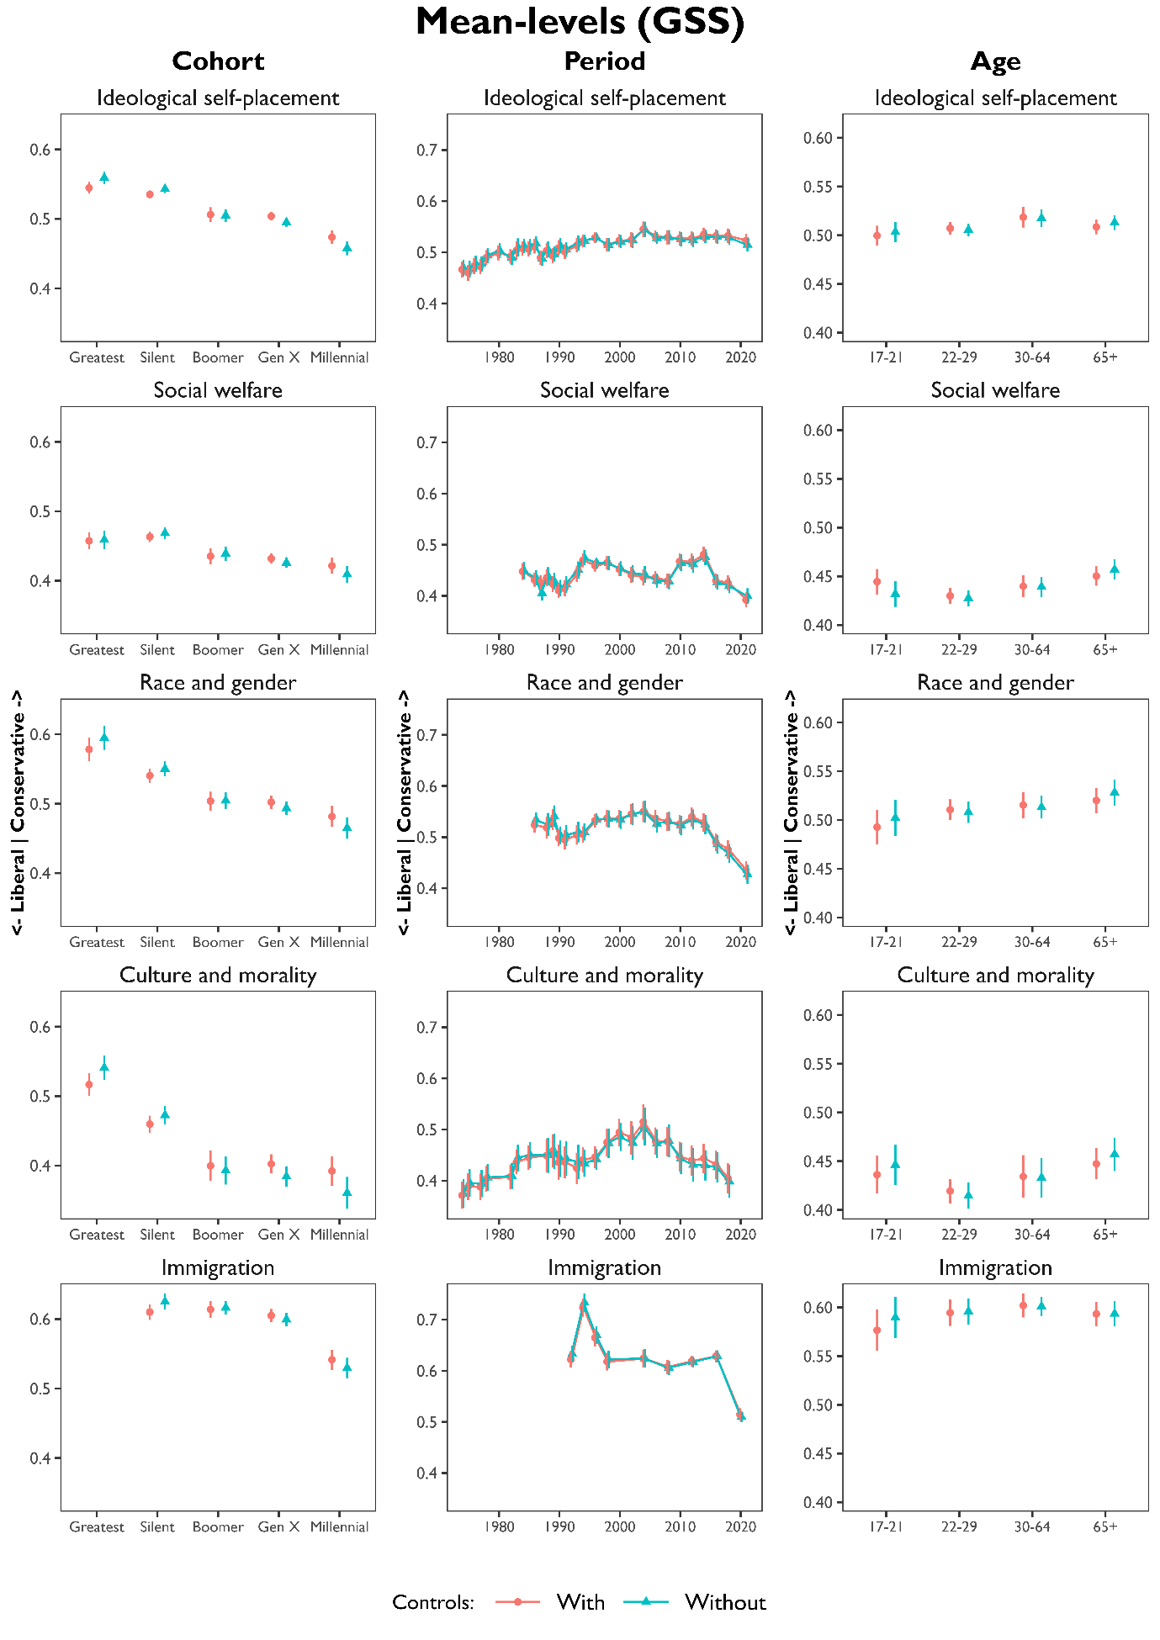
Fig C.1 Mean-level changes at the cohort, period, and age level, with and without demographic controls. Higher values are more conservative, lower values more liberal. Results are based on regression models, printed in Table C.1 (p. 11-12).
Data: ANES (immigration), GSS (other outcome variables).

Table C.2 Results of bootstrapped OLS models with resampling (R=1000), with and without demographic controls. Entries are age, period, and cohort differences in mean-levels with standard errors in parentheses. All outcome variables were normalized to the range 0 (most liberal), to 1 (most conservative).
Data: ANES.

 | Ideological ID |  | Social Welfare |  | Race & Gender |  | Aid to Blacks |  | Culture and Morality
Controls | Without | With | Without | With | Without | With | Without | With | Without | With
Intercept | 0.55 (0.01)*** | 0.48 (0.01)*** | 0.59 (0.01)*** | 0.45 (0.01)*** | 0.40 (0.01)*** | 0.35 (0.01)*** | 0.63 (0.01)*** | 0.51 (0.01)*** | 0.51 (0.01)*** | 0.49 (0.01)***
Cohort
Greatest | 0.04 (0.01)*** | 0.03 (0.01)*** | 0.00 (0.01) | 0.01 (0.01) | 0.07 (0.01)*** | 0.04 (0.01)*** | 0.02 (0.01)** | -0.00 (0.01)
Silent | 0.04 (0.00)*** | 0.03 (0.00)*** | 0.02 (0.01)** | 0.01 (0.01)* | 0.04 (0.00)*** | 0.02 (0.00)*** | 0.02 (0.00)** | 0.00 (0.00) | 0.06 (0.01)*** | 0.04 (0.00)***
Boomer | REF |  | REF |  | REF |  | REF |  | REF
Gen X | -0.02 (0.00)*** | -0.01 (0.00)*** | -0.01 (0.01)* | -0.00 (0.00) | -0.00 (0.01) | 0.01 (0.01) | -0.00 (0.01) | 0.01 (0.01)** | -0.03 (0.00)*** | -0.02 (0.00)***
Millennial | -0.07 (0.01)*** | -0.05 (0.01)*** | -0.06 (0.01)*** | -0.04 (0.01)*** | -0.01 (0.02) | 0.00 (0.02) | -0.06 (0.01)*** | -0.04 (0.01)*** | -0.05 (0.01)*** | -0.03 (0.01)***
Period
1970 |  |  |  |  |  |  | -0.10 (0.01)*** | -0.12 (0.01)***
1972 | -0.05 (0.01)*** | -0.06 (0.01)*** |  |  | 0.02 (0.01)* | 0.01 (0.01) | -0.10 (0.01)*** | -0.12 (0.01)***
1974 | -0.06 (0.01)*** | -0.07 (0.01)*** |  |  | 0.02 (0.01) | -0.00 (0.01) | -0.09 (0.01)*** | -0.11 (0.01)***
1976 | -0.03 (0.01)*** | -0.04 (0.01)*** |  |  | 0.01 (0.01) | -0.01 (0.01) | -0.10 (0.01)*** | -0.11 (0.01)***
1978 | -0.04 (0.01)*** | -0.04 (0.01)*** |  |  | 0.01 (0.01) | -0.01 (0.01) | -0.06 (0.01)*** | -0.08 (0.01)***
1980 | -0.02 (0.01) | -0.02 (0.01) |  |  | 0.02 (0.01)* | 0.01 (0.01) | -0.05 (0.01)*** | -0.06 (0.01)***
1982 | -0.01 (0.01) | -0.02 (0.01) |  |  | 0.00 (0.01) | -0.01 (0.01) | -0.06 (0.01)*** | -0.08 (0.01)***
1984 | -0.03 (0.01)** | -0.03 (0.01)** |  |  | -0.02 (0.01)** | -0.03 (0.01)*** | -0.12 (0.01)*** | -0.13 (0.01)***
1986 | -0.01 (0.01) | -0.02 (0.01)* |  |  |  |  | -0.07 (0.01)*** | -0.07 (0.01)***
1988 | 0.00 (0.01) | -0.00 (0.01) |  |  | -0.00 (0.01) | -0.01 (0.01) | -0.05 (0.01)*** | -0.05 (0.01)*** | 0.04 (0.01)*** | 0.03 (0.01)***
1990 | -0.02 (0.01)** | -0.03 (0.01)** |  |  | 0.00 (0.01) | -0.01 (0.01) | -0.06 (0.01)*** | -0.06 (0.01)***
1992 | -0.02 (0.01)** | -0.02 (0.01)** | -0.07 (0.01)*** | -0.07 (0.01)*** | -0.01 (0.01)* | -0.02 (0.01)** | -0.02 (0.01)** | -0.02 (0.01)** | -0.01 (0.01) | -0.02 (0.01)**
1994 | 0.02 (0.01)* | 0.02 (0.01)* | -0.00 (0.01) | -0.00 (0.01) | 0.01 (0.01) | 0.01 (0.01) | -0.01 (0.01) | -0.02 (0.01) | 0.02 (0.01)* | 0.02 (0.01)
1996 | REF |  | REF |  | REF |  | REF |  | REF
1998 | -0.01 (0.01) | -0.01 (0.01) |  |  | -0.04 (0.01)*** | -0.04 (0.01)*** | -0.07 (0.01)*** | -0.07 (0.01)*** | -0.02 (0.01)* | -0.01 (0.01)
2000 | -0.01 (0.01) | -0.00 (0.01) | -0.05 (0.01)*** | -0.05 (0.01)*** | -0.02 (0.01) | -0.01 (0.01) | -0.00 (0.01) | 0.01 (0.01) | -0.02 (0.01)** | -0.02 (0.01)*
2002 | 0.01 (0.01) | 0.01 (0.01)
2004 | 0.00 (0.01) | 0.01 (0.01) | -0.10 (0.01)*** | -0.09 (0.01)*** | -0.04 (0.01)*** | -0.03 (0.01)*** | -0.04 (0.01)** | -0.02 (0.01)* | -0.02 (0.01)* | -0.02 (0.01)
2008 | -0.01 (0.01) | -0.00 (0.01) | -0.13 (0.01)*** | -0.10 (0.01)*** | -0.06 (0.01)*** | -0.04 (0.01)*** | -0.04 (0.01)*** | 0.01 (0.01) | -0.03 (0.01)** | -0.04 (0.01)***
2012 | -0.01 (0.01) | 0.01 (0.01) | -0.02 (0.01)** | 0.00 (0.01) |  |  | 0.01 (0.01) | 0.04 (0.01)*** | -0.05 (0.01)*** | -0.04 (0.01)***
2016 | -0.01 (0.01) | -0.00 (0.01) | -0.01 (0.01) | -0.01 (0.01) |  |  | -0.04 (0.01)*** | -0.03 (0.01)*** | -0.08 (0.01)*** | -0.07 (0.01)***
2020 | -0.01 (0.01) | 0.00 (0.01) | -0.10 (0.01)*** | -0.09 (0.01)*** |  |  | -0.15 (0.01)*** | -0.14 (0.01)***
Age
17-21 | -0.02 (0.01)* | -0.02 (0.01)** | -0.03 (0.01)* | -0.01 (0.01) | -0.02 (0.01)** | -0.04 (0.01)*** | -0.06 (0.01)*** | -0.06 (0.01)*** | 0.01 (0.01) | 0.00 (0.01)
22-29 | -0.02 (0.00)*** | -0.02 (0.00)*** | -0.02 (0.01)** | -0.02 (0.01)** | -0.01 (0.01)* | -0.02 (0.01)** | -0.03 (0.01)*** | -0.03 (0.01)*** | -0.01 (0.01) | -0.01 (0.01)
30-64 | REF |  | REF |  | REF |  | REF |  | REF
65+ | -0.00 (0.00) | -0.00 (0.00) | 0.02 (0.01)** | 0.01 (0.01) | 0.01 (0.01) | 0.00 (0.01) | 0.00 (0.01) | -0.01 (0.01)* | 0.01 (0.01) | 0.01 (0.01)
Controls
Protestant |  | 0.10 (0.00)*** |  | 0.06 (0.00)*** |  | 0.05 (0.00)*** |  | 0.02 (0.00)*** |  | 0.14 (0.00)***
White |  | 0.07 (0.00)*** |  | 0.14 (0.00)*** |  | 0.11 (0.00)*** |  | 0.20 (0.00)*** |  | 0.03 (0.00)***
College |  | -0.03 (0.00)*** |  | 0.02 (0.00)*** |  | -0.08 (0.00)*** |  | -0.05 (0.00)*** |  | -0.08 (0.00)***
r2 | 0.022 (0.002) | 0.071 (0.003) | 0.047 (0.003) | 0.113 (0.004) | 0.037 (0.003) | 0.103 (0.004) | 0.039 (0.002) | 0.109 (0.003) | 0.060 (0.003) | 0.170 (0.005)
adj_r2 | 0.022 | 0.07 | 0.046 | 0.112 | 0.036 | 0.102 | 0.038 | 0.108 | 0.059 | 0.169
N | 36279 | 36279 | 20007 | 20007 | 20667 | 20667 | 41514 | 41514 | 18024 | 18024

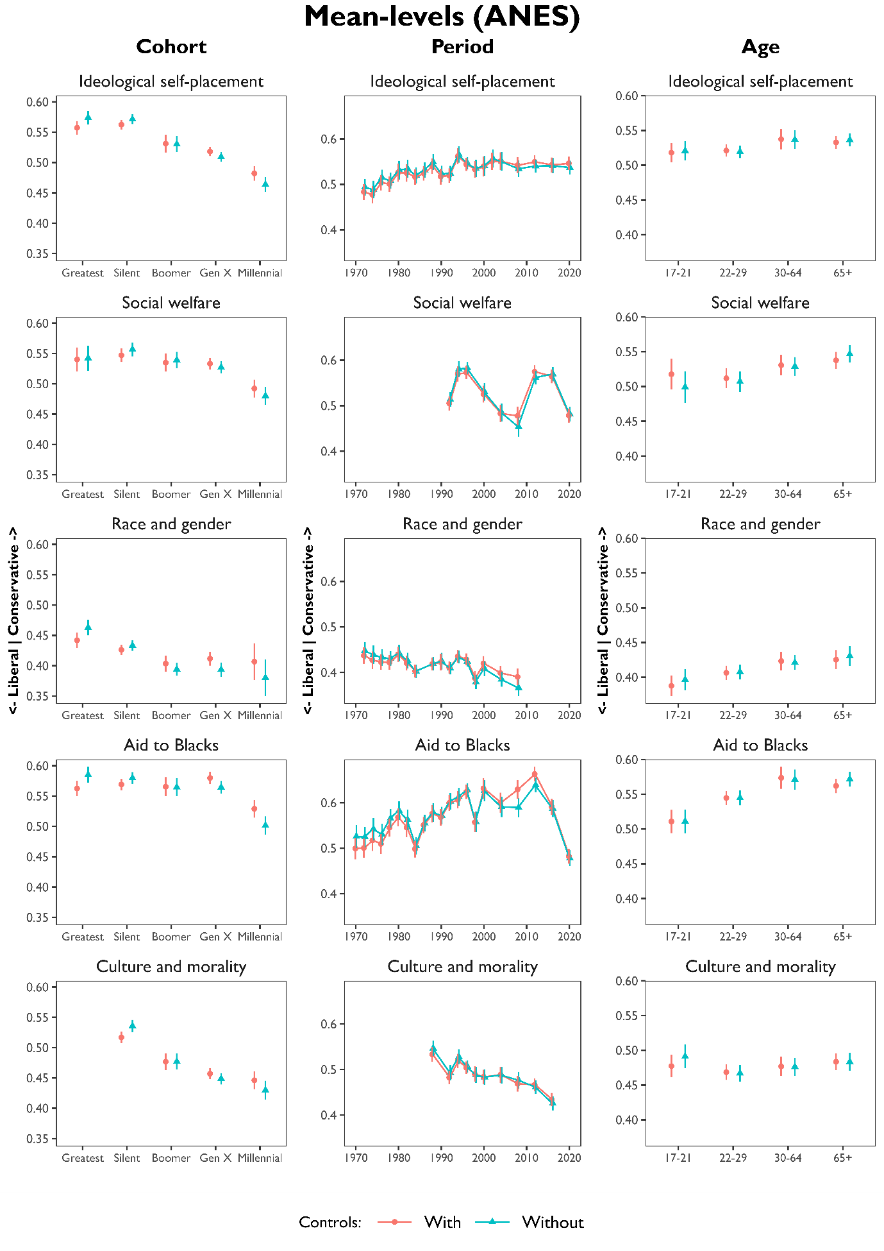
Fig C.2 Mean-level changes at the cohort, period, and age level, with and without demographic controls. Higher values are more conservative, lower values more liberal. Results are based on regression models, printed in Table C.2 (p. 14-15). Data: ANES.
- Robustness Checks: Comparing ANES and GSS
Age-period-cohort analyses are designed to distinguish APC effects yet can be sensitive to methodological choices. Data and variable selection can lead researchers to reach substantially different conclusions. To account for this possibility, we replicated our analysis for ideological self-placement and constructed alternative indices using ANES data. While the GSS and the ANES share much in common, the differences in response categories, question wordings, and overall survey design may affect the outcomes of the analysis considerably. In other words, while the validity of APC-analyses rests upon the soundness of one’s theoretical assumptions, replicating the analysis using a different data source provides an opportunity to determine the robustness of our findings.
Comparing the remaining GSS and ANES results side by side reveals considerable similarity. Here, we focus on the most important deviations in terms of ideological divergence and party sorting. Note that, in general, the ANES models tend to span a shorter time frame since many of the questions of interest have only recently been introduced in the surveys. The social welfare and culture and morality models, in particular, cover a shorter time frame than their GSS counterparts. As a result, these models feature relatively few members of older generations, and we decided to omit respondents from the Greatest generation from the Culture and morality model. In a similar vein, the ANES race and gender index spans a shorter time frame since it includes observations until 2008 because of limited data availability. As such, it is somewhat questionable whether we can infer meaningful generational differences for the most recent generations, the Millennials in particular. To account for this limitation, we also present separate models for the ‘Aid to Blacks and other minorities’ question, which has been asked for 50 years: from 1970 until 2020.
Regarding ideological divergence, we do not find a generational decrease in ideological divergence in the ANES models (Table D.1 and Figure D.1). Concerning Aid to Blacks and other minorities and social welfare, Millennials even score significantly higher than previous generations. On the remaining three models, new generations do not differ significantly. While this only provides limited support for our hypothesis that generational replacement fuels ideological divergence based on the ANES models, it is important to stress that our conclusion that public opinion among new cohorts should be more consensual may partially depend on data selection.
The period results (Figure D.2) are similar between the two datasets, except that ideological divergence on race and gender has significantly decreased when using ANES data, whereas it remained more or less stable in the GSS models. Upon closer inspection, this difference is likely the result of the including the ‘women’s role in society’ question in the ANES model. This variable has been used to measure gender equality attitudes in the literature. However, the mean-level values on this variable approximated 0.1 on a normalized 0-1 scale in 2008, which is the last year this variable was featured in the ANES. As such, including this question to measure polarization on gender issues is questionable unless one assumes that gender roles no longer meaningfully polarize Democrats and Republicans. In comparison, we operationalized the GSS equivalent of gender roles as an average of three questions tallying the respondent’s attitudes toward women’s work and family roles (see Appendix A). Although the average values of this index have significantly decreased in recent decades, it still hovers around .35 in the most recent GSS surveys (on a normalized 0-1 scale). Hence, we view this operationalization of gender attitudes as a more robust indicator of polarization than the women’s role in society question contained in the ANES. By comparison, the Aid to Blacks model in the ANES, which makes up the other half of the race and gender index, shows an interesting pattern in which ideological divergence has declined from the 1970s until the 1980s, before reaching similar divergence levels in recent surveys. In other words, ideological divergence has reached similar polarization levels in recent years, which is more in line with the GSS results.
We now turn our attention to the party sorting models, where recent generations find themselves slightly more sorted in the ANES models compared to the GSS results. For instance, in the GSS, there is a significant difference in ideological self-placement between Baby Boomers and Gen Xers or Millennials. However, this difference is negligible (-0.00) and statistically insignificant in the ANES models. Explaining this discrepancy is difficult since both surveys tap responses on party identification and ideological self-placement using similarly phrased questions and response categories. Thus far, we maintain that to the extent that we find significant generational differences, Millennials tend to be one of the least sorted cohorts. Conversely, the Millennials are the most sorted cohort on race and gender when analyzing ANES data. Yet while interesting, the ANES race and gender index is based on observations that only run until 2008 because the aforementioned women’s role in society question has not been featured in the ANES since. In comparison to the GSS race and gender index, the ANES equivalent covers a much shorter time frame. Consequently, it features far fewer Millennial respondents than the GSS version. As such, it is not a surprise that the bootstrapped confidence intervals are much wider for this group, and that Millennials do not score significantly different from the reference category. When looking at Aid to Blacks and other minorities, Millennials only score slightly higher (0.01) than the Boomers. This sorting effect does not change when controlling for demographic shifts in the electorate.
While there are more differences of note, the main takeaway of this brief discussion is that most of our results do not depend on data or variable selection. Moreover, these differences offer no compelling reasons to revise our main conclusions. They do, however, underline the tentative nature of a generational decrease in mass polarization, particularly in terms of ideological divergence. As such, the exercise presented here serves as a reminder to exert caution when inferring trends based on APC analyses when using cross-sectional data. At least, researchers should check their results using alternative data sources if possible. Had we been interested in a single outcome variable; our conclusions might have been substantially different.

Table D.1 Results of bootstrapped OLS models with resampling (R=1000), with and without demographic controls. Entries are age, period, and cohort differences in ideological divergence (absolute deviation from normalized mean-levels presented in Table C.2) with bootstrapped standard errors in parentheses.
Data: ANES.
 | Ideological ID |  | Social Welfare |  | Race & Gender |  | Aid to Blacks |  | Culture and Morality
Controls | Without | With | Without | With | Without | With | Without | With | Without | With
Intercept | 0.19 (0.00)*** | 0.17 (0.00)*** | 0.18 (0.00)*** | 0.15 (0.00)*** | 0.16 (0.00)*** | 0.18 (0.00)*** | 0.22 (0.00)*** | 0.26 (0.00)*** | 0.18 (0.00)*** | 0.15 (0.00)***
Cohort
Greatest | -0.01 (0.00) | -0.00 (0.00) | -0.02 (0.01)** | -0.02 (0.01)** | 0.01 (0.00)* | 0.01 (0.00)* | 0.01 (0.00)** | 0.01 (0.00)**
Silent | -0.00 (0.00) | -0.00 (0.00) | -0.00 (0.00) | -0.00 (0.00) | 0.01 (0.00)** | 0.01 (0.00)* | 0.00 (0.00) | 0.00 (0.00) | -0.00 (0.00) | -0.00 (0.00)
Boomer | REF |  | REF |  | REF |  | REF |  | REF
Gen X | -0.01 (0.00)*** | -0.01 (0.00)*** | 0.00 (0.00) | 0.00 (0.00) | -0.00 (0.00) | -0.00 (0.00) | 0.01 (0.00)*** | 0.01 (0.00)*** | 0.00 (0.00) | 0.00 (0.00)
Millennial | -0.00 (0.00) | -0.00 (0.00) | 0.01 (0.00)*** | 0.02 (0.00)*** | -0.00 (0.01) | 0.00 (0.01) | 0.02 (0.00)*** | 0.01 (0.00)** | 0.00 (0.00) | 0.00 (0.00)
Period
1970 |  |  |  |  |  |  | 0.05 (0.01)*** | 0.04 (0.01)***
1972 | -0.03 (0.01)*** | -0.02 (0.01)** |  |  | 0.05 (0.01)*** | 0.05 (0.01)*** | 0.04 (0.01)*** | 0.03 (0.01)***
1974 | -0.02 (0.01)** | -0.00 (0.01) |  |  | 0.04 (0.01)*** | 0.04 (0.01)*** | 0.04 (0.01)*** | 0.04 (0.01)***
1976 | -0.02 (0.01)*** | -0.01 (0.01) |  |  | 0.03 (0.01)*** | 0.03 (0.01)*** | 0.04 (0.01)*** | 0.04 (0.01)***
1978 | -0.01 (0.01)* | -0.00 (0.00) |  |  | 0.03 (0.01)*** | 0.03 (0.00)*** | 0.03 (0.01)*** | 0.03 (0.01)***
1980 | 0.00 (0.01) | 0.01 (0.01) |  |  | 0.01 (0.01) | 0.01 (0.01) | -0.01 (0.01)* | -0.02 (0.01)**
1982 | -0.01 (0.01) | -0.00 (0.01) |  |  | 0.01 (0.01)* | 0.01 (0.01)* | 0.00 (0.01) | 0.00 (0.01)
1984 | -0.01 (0.01) | -0.00 (0.00) |  |  | 0.01 (0.00)** | 0.01 (0.00)* | -0.01 (0.01) | -0.01 (0.01)
1986 | -0.02 (0.00)*** | -0.02 (0.00)** |  |  |  |  | 0.00 (0.01) | 0.00 (0.01)
1988 | -0.00 (0.01) | 0.00 (0.00) |  |  | 0.01 (0.00)** | 0.01 (0.00) | 0.03 (0.01)*** | 0.02 (0.01)*** | -0.01 (0.00) | -0.01 (0.00)*
1990 | -0.01 (0.01)* | -0.00 (0.00) |  |  | 0.02 (0.01)*** | 0.02 (0.01)** | 0.02 (0.01)*** | 0.02 (0.01)***
1992 | 0.00 (0.00) | 0.01 (0.00) | 0.00 (0.00) | 0.00 (0.00) | 0.00 (0.00) | 0.00 (0.00) | 0.02 (0.01)*** | 0.02 (0.01)*** | -0.00 (0.00) | -0.00 (0.00)
1994 | 0.00 (0.00) | 0.00 (0.00) | 0.01 (0.01) | 0.01 (0.00) | 0.00 (0.00) | 0.00 (0.00) | 0.01 (0.01)* | 0.01 (0.01) | 0.01 (0.00) | 0.01 (0.00)
1996 | REF |  | REF |  | REF |  | REF |  | REF
1998 | -0.01 (0.01) | -0.00 (0.01) |  |  | 0.01 (0.00)* | 0.01 (0.00)* | 0.02 (0.01)** | 0.02 (0.01)** | -0.00 (0.00) | 0.00 (0.00)
2000 | 0.01 (0.01) | 0.01 (0.01) | -0.01 (0.01) | -0.01 (0.01) | -0.00 (0.01) | -0.00 (0.01) | 0.01 (0.01) | 0.01 (0.01) | -0.00 (0.00) | -0.00 (0.00)
2002 | 0.03 (0.01)*** | 0.03 (0.01)***
2004 | 0.01 (0.01)* | 0.01 (0.01)* | 0.01 (0.01) | 0.01 (0.01)* | -0.00 (0.01) | -0.00 (0.01) | 0.02 (0.01)** | 0.01 (0.01)* | 0.00 (0.01) | 0.01 (0.00)
2008 | 0.02 (0.01)*** | 0.02 (0.01)*** | 0.02 (0.01)** | 0.02 (0.01)** | 0.01 (0.01) | -0.00 (0.01) | 0.05 (0.01)*** | 0.03 (0.01)*** | -0.01 (0.01) | -0.00 (0.01)
2012 | 0.01 (0.00) | 0.01 (0.00)** | 0.02 (0.00)*** | 0.02 (0.00)*** |  |  | 0.03 (0.00)*** | 0.01 (0.00)** | 0.01 (0.00)* | 0.01 (0.00)***
2016 | 0.03 (0.00)*** | 0.02 (0.00)*** | 0.03 (0.00)*** | 0.03 (0.00)*** |  |  | 0.04 (0.01)*** | 0.04 (0.01)*** | 0.02 (0.00)*** | 0.01 (0.00)**
2020 | 0.04 (0.00)*** | 0.04 (0.00)*** | 0.05 (0.00)*** | 0.05 (0.00)*** |  |  | 0.05 (0.01)*** | 0.05 (0.00)***
Age
17-21
22-29 | -0.01 (0.00) | -0.00 (0.00) | -0.02 (0.01)** | -0.02 (0.01)** | 0.01 (0.00)* | 0.01 (0.00)* | 0.01 (0.00)** | 0.01 (0.00)**
30-64 | REF |  | REF |  | REF |  | REF |  | REF
65+ | 0.01 (0.00) | 0.01 (0.00)* | -0.00 (0.00) | -0.00 (0.00) | 0.00 (0.00) | 0.00 (0.00) | -0.02 (0.00)*** | -0.01 (0.00)** | -0.00 (0.00) | -0.00 (0.00)
Controls
Protestant |  | 0.00 (0.00)** |  | -0.00 (0.00) |  | 0.01 (0.00)*** |  | -0.01 (0.00) |  | 0.02 (0.00)***
White |  | 0.00 (0.00) |  | 0.02 (0.00)*** |  | -0.03 (0.00)*** |  | -0.04 (0.00)*** |  | 0.01 (0.00)***
College |  | 0.02 (0.00)*** |  | 0.01 (0.00)*** |  | -0.02 (0.00)*** |  | -0.02 (0.00)*** |  | 0.01 (0.00)***
r2 | 0.025 (0.002) | 0.026 (0.002) | 0.030 (0.002) | 0.036 (0.003) | 0.015 (0.002) | 0.030 (0.003) | 0.017 (0.001) | 0.031 (0.002) | 0.007 (0.001) | 0.014 (0.002)
adj_r2 | 0.024 | 0.026 | 0.030 | 0.035 | 0.014 | 0.029 | 0.016 | 0.031 | 0.006 | 0.013
N | 36279 | 36279 | 20007 | 20007 | 20667 | 20667 | 41514 | 41514 | 18024 | 18024

Table D.2 Results of bootstrapped OLS models with resampling (R=1000). Entries are standardized regression coefficients presenting APC differences in party sorting with and without demographic controls. Bootstrapped standard errors in parentheses.
Data: ANES.

 | Ideological ID |  | Social Welfare |  | Race & Gender |  | Aid to Blacks |  | Culture and Morality
Controls | Without | With | Without | With | Without | With | Without | With | Without | With
Intercept | -0.00 (0.00) | -0.01 (0.01) | -0.00 (0.00) | -0.02 (0.01)* | -0.00 (0.00) | 0.01 (0.01) | -0.00 (0.00) | -0.02 (0.01)*** | 0.00 (0.00) | 0.03 (0.01)***
Variable | 0.65 (0.02)*** | 0.31 (0.03)*** | 0.61 (0.02)*** | 0.32 (0.03)*** | 0.40 (0.03)*** | 0.26 (0.03)*** | 0.38 (0.03)*** | 0.20 (0.03)*** | 0.39 (0.03)*** | 0.12 (0.03)***
Cohort,
main effect
Greatest | 0.01 (0.01)* | 0.00 (0.01) | -0.01 (0.01)* | -0.02 (0.01)* | -0.00 (0.00) | -0.01 (0.01) | 0.00 (0.00) | -0.00 (0.00)
Silent | -0.00 (0.00) | -0.01 (0.00)* | -0.01 (0.00)** | -0.01 (0.01)* | 0.00 (0.00) | -0.01 (0.00) | 0.00 (0.00) | -0.00 (0.00) | -0.01 (0.00)** | -0.01 (0.01)*
Boomer | REF |  | REF |  | REF |  | REF |  | REF
Gen X | 0.00 (0.00) | 0.00 (0.00) | 0.00 (0.00) | -0.00 (0.00) | 0.00 (0.00) | 0.01 (0.01) | 0.00 (0.00) | 0.01 (0.00) | 0.00 (0.00) | -0.01 (0.00)
Millennial | 0.00 (0.00) | 0.01 (0.01) | 0.01 (0.00) | 0.01 (0.01) | 0.00 (0.01) | -0.01 (0.02) | -0.00 (0.00) | -0.00 (0.01) | 0.00 (0.00) | -0.02 (0.01)*
Period,
main effect
1970 |  |  |  |  |  |  | 0.00 (0.00) | 0.02 (0.01)**
1972 | 0.00 (0.00) | 0.00 (0.01) |  |  | 0.00 (0.00) | 0.01 (0.01)* | -0.00 (0.00) | 0.01 (0.01)*
1974 | -0.00 (0.00) | -0.00 (0.01) |  |  | 0.00 (0.00) | 0.01 (0.01) | 0.00 (0.00) | 0.01 (0.01)
1976 | -0.00 (0.00) | -0.02 (0.01)* |  |  | 0.00 (0.00) | 0.01 (0.01) | 0.00 (0.00) | 0.01 (0.01)
1978 | -0.00 (0.00) | -0.01 (0.01) |  |  | -0.00 (0.00) | 0.01 (0.01) | 0.00 (0.00) | 0.01 (0.01)*
1980 | -0.00 (0.00) | -0.00 (0.01) |  |  | -0.00 (0.00) | 0.00 (0.01) | 0.00 (0.00) | 0.01 (0.01)
1982 | 0.00 (0.00) | -0.00 (0.01) |  |  | 0.00 (0.00) | 0.01 (0.01) | 0.00 (0.00) | 0.01 (0.01)
1984 | -0.00 (0.00) | -0.00 (0.01) |  |  | -0.00 (0.00) | 0.00 (0.01) | 0.00 (0.00) | 0.01 (0.01)
1986 | -0.00 (0.00) | 0.00 (0.01) |  |  |  |  | -0.00 (0.00) | 0.00 (0.01)
1988 | 0.00 (0.00) | -0.01 (0.01) |  |  | -0.00 (0.00) | 0.01 (0.01) | 0.00 (0.00) | 0.02 (0.01)** | -0.00 (0.00) | 0.00 (0.01)
1990 | 0.00 (0.00) | 0.01 (0.01) |  |  | -0.00 (0.00) | -0.01 (0.01) | -0.00 (0.00) | 0.01 (0.01)
1992 | -0.00 (0.00) | -0.00 (0.01) | 0.00 (0.00) | 0.01 (0.01) | -0.00 (0.00) | -0.00 (0.01) | -0.00 (0.00) | 0.01 (0.01) | -0.00 (0.00) | 0.01 (0.01)
1994 | 0.00 (0.00) | -0.00 (0.01) | 0.00 (0.00) | 0.01 (0.01) | -0.00 (0.00) | -0.01 (0.01) | 0.00 (0.00) | 0.00 (0.01) | 0.00 (0.00) | 0.00 (0.01)
1996 | REF |  | REF |  | REF |  | REF |  | REF
1998 | 0.00 (0.00) | -0.01 (0.01) |  |  | -0.00 (0.00) | 0.01 (0.01) | -0.00 (0.00) | 0.00 (0.01) | -0.01 (0.00)* | -0.00 (0.01)
2000 | -0.00 (0.00) | -0.01 (0.01) | -0.00 (0.00) | 0.01 (0.01) | 0.00 (0.00) | -0.01 (0.01) | 0.00 (0.00) | -0.01 (0.01) | -0.00 (0.00) | 0.01 (0.01)
2002 | 0.00 (0.00) | 0.00 (0.01)
2004 | -0.00 (0.00) | -0.00 (0.01) | 0.00 (0.00) | 0.01 (0.01) | -0.00 (0.00) | -0.00 (0.01) | 0.00 (0.00) | 0.00 (0.01) | -0.00 (0.00) | 0.00 (0.01)
2008 | 0.00 (0.00) | 0.01 (0.01) | -0.00 (0.00) | 0.01 (0.01) | -0.00 (0.00) | 0.02 (0.01)* | 0.00 (0.00) | 0.02 (0.01)*** | -0.01 (0.00)* | 0.01 (0.01)
2012 | 0.00 (0.00) | -0.00 (0.01) | 0.00 (0.00) | 0.00 (0.01) |  |  | 0.00 (0.00) | 0.01 (0.01)** | -0.00 (0.00) | -0.01 (0.01)
2016 | 0.00 (0.00) | 0.01 (0.01) | -0.00 (0.00) | 0.01 (0.01) |  |  | 0.01 (0.00) | 0.02 (0.01)*** | -0.00 (0.00) | 0.00 (0.01)
2020 | 0.00 (0.00) | 0.01 (0.01)* | -0.00 (0.00) | 0.01 (0.01) |  |  | 0.01 (0.00)** | 0.02 (0.01)**
Age,
main effect
17-21 | -0.01 (0.01) | 0.01 (0.01) | -0.01 (0.01) | 0.00 (0.01) | 0.00 (0.00) | 0.02 (0.01)* | 0.00 (0.00) | 0.02 (0.01)** | 0.00 (0.01) | 0.02 (0.01)*
22-29 | 0.00 (0.00) | 0.01 (0.01)* | 0.00 (0.01) | -0.00 (0.01) | 0.00 (0.00) | 0.01 (0.01)* | 0.01 (0.00)** | 0.02 (0.00)*** | -0.00 (0.00) | 0.02 (0.01)**
30-64 | REF |  | REF |  | REF |  | REF |  | REF
65+ | -0.01 (0.00) | -0.01 (0.01) | 0.01 (0.00)* | 0.01 (0.01) | 0.00 (0.00) | -0.00 (0.01) | -0.01 (0.00) | -0.01 (0.00) | 0.01 (0.00)* | 0.01 (0.01)
Controls,
main effect
Protestant |  | -0.06 (0.00)*** |  | -0.05 (0.00)*** |  | 0.01 (0.00)* |  | -0.01 (0.00)* |  | -0.04 (0.00)***
White |  | 0.01 (0.00)*** |  | 0.01 (0.00) |  | -0.02 (0.00)*** |  | 0.01 (0.00)* |  | -0.03 (0.00)***
College |  | 0.02 (0.00)*** |  | 0.03 (0.00)*** |  | 0.00 (0.00) |  | 0.01 (0.00)*** |  | 0.00 (0.00)
Cohort,
interaction effect
:Greatest | -0.05 (0.02)* | 0.03 (0.02) | -0.15 (0.04)*** | -0.12 (0.04)** | -0.14 (0.03)*** | -0.07 (0.03)* | -0.09 (0.02)*** | -0.02 (0.02)
:Silent | 0.00 (0.01) | 0.03 (0.01) | -0.01 (0.02) | -0.01 (0.02) | -0.08 (0.02)*** | -0.03 (0.02) | -0.02 (0.02) | -0.00 (0.02) | -0.04 (0.02) | -0.01 (0.02)
:Boomer | REF |  | REF |  | REF |  | REF |  | REF
:Gen X | -0.00 (0.01) | -0.02 (0.01) | -0.03 (0.01)* | -0.03 (0.02)* | -0.01 (0.03) | -0.04 (0.03) | -0.01 (0.01) | -0.02 (0.02) | -0.05 (0.02)* | -0.05 (0.02)*
:Millennial | -0.00 (0.02) | -0.02 (0.02) | -0.04 (0.02)* | -0.06 (0.02)** | 0.12 (0.07) | 0.11 (0.07) | 0.01 (0.02) | 0.01 (0.02) | -0.04 (0.03) | -0.07 (0.03)*
Period,
interaction effect
:1970 |  |  |  |  |  |  | -0.12 (0.04)** | -0.14 (0.04)***
:1972 | -0.23 (0.04)*** | -0.24 (0.04)*** |  |  | -0.19 (0.04)*** | -0.20 (0.04)*** | -0.16 (0.04)*** | -0.18 (0.04)***
:1974 | -0.24 (0.04)*** | -0.25 (0.04)*** |  |  | -0.15 (0.04)*** | -0.15 (0.05)*** | -0.14 (0.04)*** | -0.15 (0.04)***
:1976 | -0.19 (0.04)*** | -0.21 (0.04)*** |  |  | -0.21 (0.04)*** | -0.21 (0.04)*** | -0.19 (0.04)*** | -0.21 (0.04)***
:1978 | -0.22 (0.04)*** | -0.23 (0.04)*** |  |  | -0.19 (0.04)*** | -0.20 (0.04)*** | -0.20 (0.03)*** | -0.21 (0.04)***
:1980 | -0.20 (0.04)*** | -0.19 (0.04)*** |  |  | -0.13 (0.05)** | -0.15 (0.04)*** | -0.07 (0.04) | -0.10 (0.04)*
:1982 | -0.18 (0.04)*** | -0.22 (0.04)*** |  |  | -0.11 (0.04)* | -0.13 (0.04)** | -0.12 (0.04)** | -0.14 (0.04)***
:1984 | -0.16 (0.04)*** | -0.16 (0.04)*** |  |  | -0.10 (0.04)** | -0.10 (0.04)** | -0.07 (0.03)* | -0.09 (0.03)*
:1986 | -0.20 (0.04)*** | -0.20 (0.04)*** |  |  |  |  | -0.13 (0.04)*** | -0.14 (0.03)***
:1988 | -0.19 (0.03)*** | -0.19 (0.04)*** |  |  | -0.16 (0.04)*** | -0.19 (0.04)*** | -0.11 (0.04)** | -0.15 (0.04)*** | -0.24 (0.04)*** | -0.20 (0.04)***
:1990 | -0.23 (0.04)*** | -0.20 (0.04)*** |  |  | -0.12 (0.05)** | -0.10 (0.04)* | -0.13 (0.03)*** | -0.11 (0.04)**
:1992 | -0.14 (0.03)*** | -0.12 (0.03)*** | -0.06 (0.03) | -0.04 (0.03) | -0.09 (0.03)* | -0.08 (0.03)* | -0.09 (0.03)** | -0.08 (0.03)* | -0.07 (0.04)* | -0.04 (0.04)
:1994 | -0.06 (0.04) | -0.05 (0.04) | -0.06 (0.03) | -0.03 (0.04) | -0.05 (0.04) | -0.05 (0.04) | -0.03 (0.03) | -0.03 (0.04) | -0.07 (0.04) | -0.04 (0.04)
:1996 | REF |  | REF |  | REF |  | REF |  | REF
:1998 | -0.10 (0.04)* | -0.07 (0.04) |  |  | -0.04 (0.04) | -0.06 (0.04) | -0.03 (0.04) | -0.05 (0.04) | -0.09 (0.04)* | -0.04 (0.04)
:2000 | -0.10 (0.04)* | -0.08 (0.04)* | -0.05 (0.04) | -0.02 (0.04) | -0.09 (0.04)* | -0.07 (0.04) | -0.11 (0.04)** | -0.08 (0.04) | -0.06 (0.04) | -0.04 (0.04)
:2002 | -0.04 (0.03) | -0.03 (0.03)
:2004 | 0.02 (0.03) | 0.03 (0.04) | -0.05 (0.04) | -0.02 (0.04) | 0.05 (0.04) | 0.02 (0.04) | 0.05 (0.04) | 0.03 (0.04) | -0.02 (0.04) | 0.02 (0.04)
:2008 | -0.07 (0.03)* | -0.00 (0.03) | -0.00 (0.04) | 0.02 (0.04) | -0.04 (0.04) | -0.09 (0.04)* | -0.00 (0.03) | -0.04 (0.03) | -0.12 (0.04)** | 0.00 (0.04)
:2012 | 0.03 (0.03) | 0.07 (0.03)** | 0.06 (0.03)* | 0.10 (0.03)*** |  |  | 0.11 (0.03)*** | 0.08 (0.03)** | 0.04 (0.03) | 0.11 (0.03)***
:2016 | 0.10 (0.03)*** | 0.11 (0.03)*** | 0.07 (0.03)* | 0.11 (0.03)*** |  |  | 0.15 (0.03)*** | 0.13 (0.03)*** | 0.11 (0.03)** | 0.14 (0.03)***
:2020 | 0.16 (0.03)*** | 0.17 (0.03)*** | 0.14 (0.03)*** | 0.18 (0.03)*** |  |  | 0.26 (0.03)*** | 0.26 (0.03)***
Age,
interaction effect
:17-21 | -0.16 (0.03)*** | -0.06 (0.03)* | -0.09 (0.04)* | -0.02 (0.05) | -0.01 (0.04) | 0.01 (0.04) | -0.07 (0.03)* | -0.03 (0.03) | 0.03 (0.04) | 0.06 (0.04)
:22-29 | -0.04 (0.02)* | -0.03 (0.02) | -0.03 (0.02) | -0.03 (0.02) | -0.05 (0.02) | -0.04 (0.02) | -0.03 (0.02) | -0.02 (0.02) | 0.05 (0.03) | 0.07 (0.03)**
:30-64 | REF |  | REF |  | REF |  | REF |  | REF
:65+ | -0.01 (0.02) | -0.03 (0.02) | 0.02 (0.02) | 0.01 (0.02) | -0.00 (0.03) | 0.02 (0.03) | -0.01 (0.02) | -0.02 (0.02) | 0.04 (0.03) | 0.01 (0.03)
Controls,
interaction effect
:Protestant |  | -0.03 (0.01)** |  | 0.04 (0.01)** |  | -0.02 (0.02) |  | -0.03 (0.01)* |  | 0.07 (0.02)***
:White |  | 0.21 (0.01)*** |  | 0.13 (0.01)*** |  | 0.02 (0.02) |  | 0.04 (0.01)*** |  | 0.15 (0.02)***
:College |  | 0.22 (0.01)*** |  | 0.16 (0.01)*** |  | 0.18 (0.01)*** |  | 0.18 (0.01)*** |  | 0.16 (0.02)***
r2 | 0.304 (0.004) | 0.298 (0.004) | 0.366 (0.005) | 0.328 (0.005) | 0.057 (0.003) | 0.053 (0.003) | 0.137 (0.003) | 0.120 (0.003) | 0.128 (0.005) | 0.140 (0.005)
adj_r2 | 0.303 | 0.296 | 0.365 | 0.327 | 0.055 | 0.051 | 0.136 | 0.119 | 0.127 | 0.138
N | 36279 | 36279 | 20007 | 20007 | 20667 | 20667 | 41514 | 41514 | 18024 | 18024

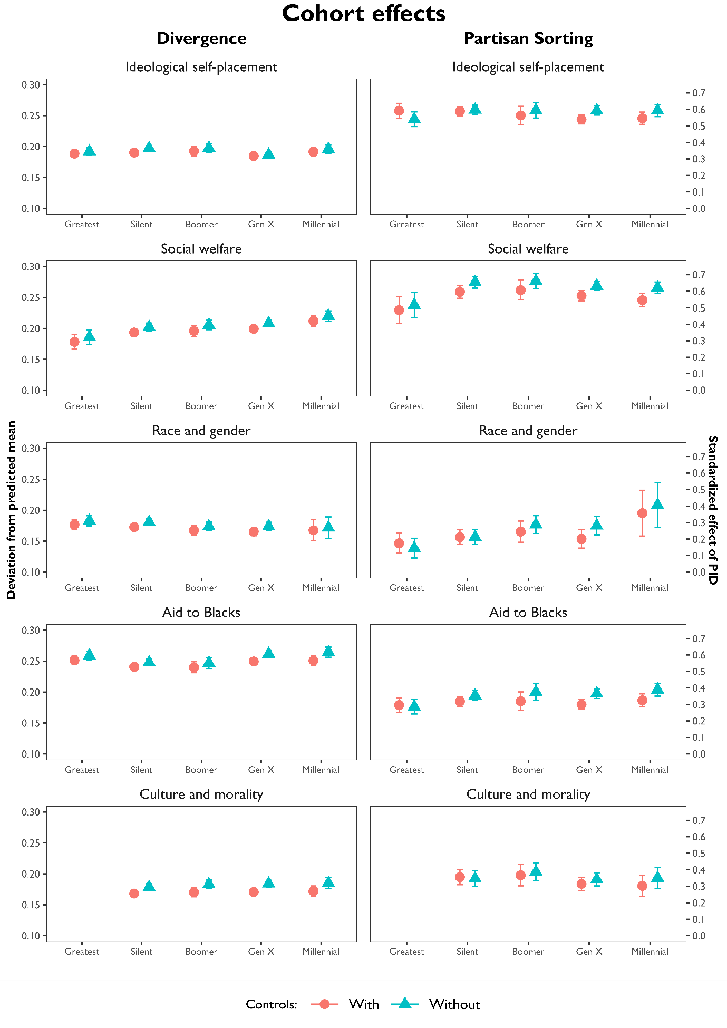
Fig D.1 Cohort effects in ideological divergence and party sorting, with and without demographic controls. Results based on regression models. See Table D.1 (ideological divergence) and Table D.2 (partisan sorting) in the Online Appendix, p. 19-23 for complete results. Data: ANES.
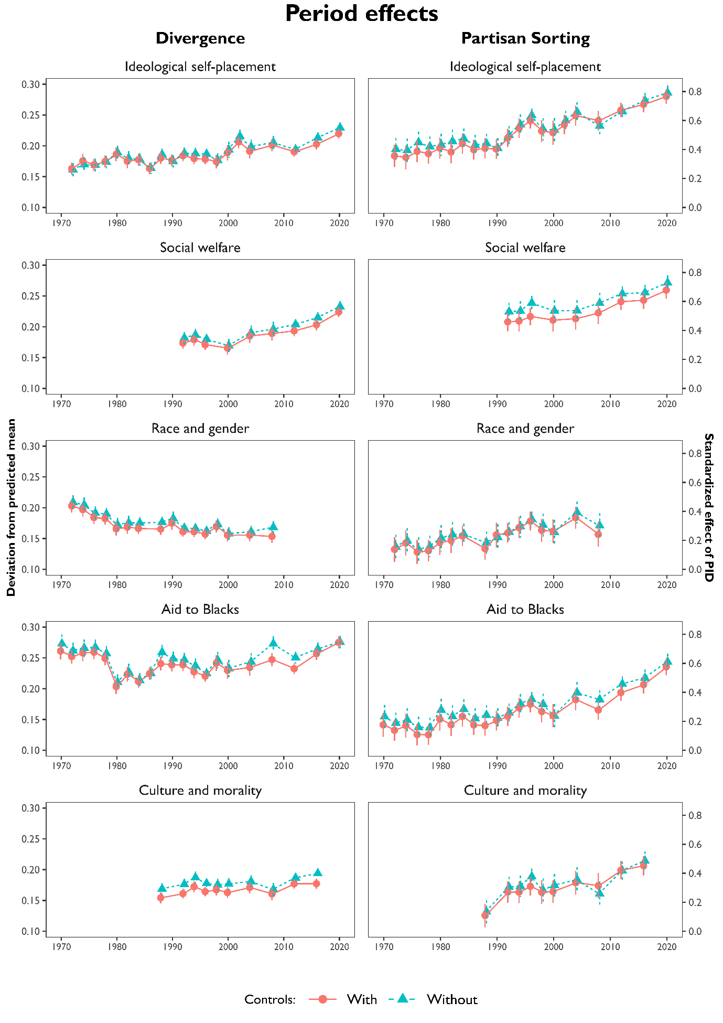
Fig D.2 Period effects in ideological divergence and party sorting, with and without demographic controls. Results based on regression models. See Table D.1 (ideological divergence) and Table D.2 (partisan sorting) in the Online Appendix, p. 19-23 for complete results. Data: ANES.
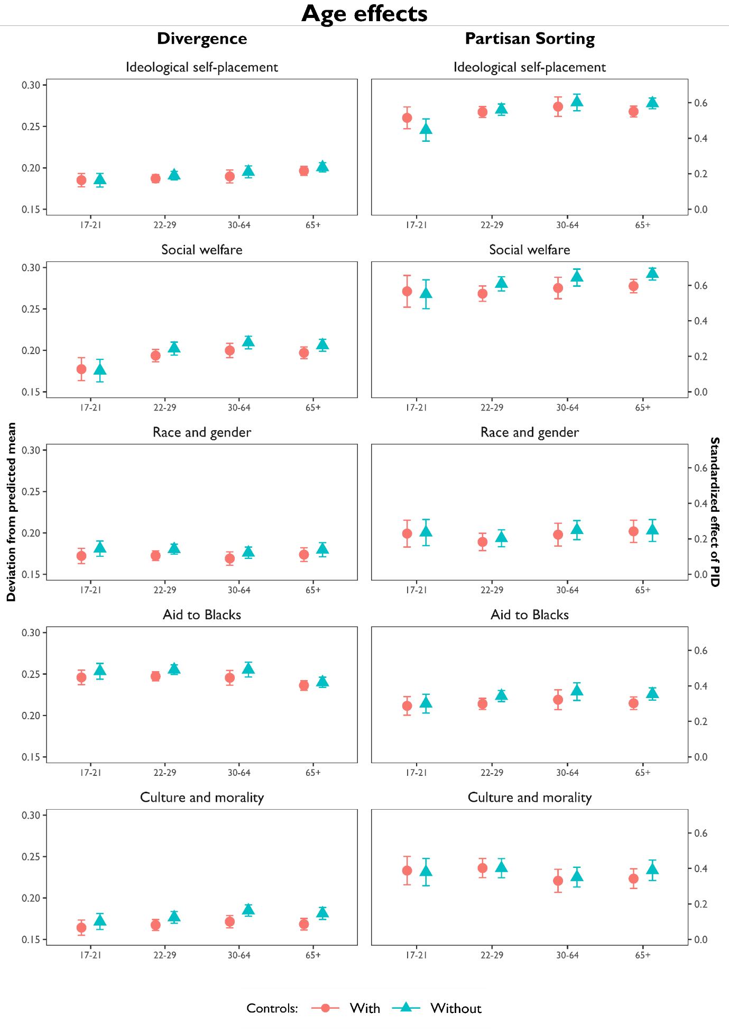
Fig D.3 Age effects in ideological divergence and party sorting, with and without demographic controls. Results based on regression models. See Table D.1 (ideological divergence) and Table D.2 (partisan sorting) in the Online Appendix, p. 19-23 for complete results. Data: ANES.

