Online Appendix for the economic consequences of protest repression: the case of business activism in Hong Kong

Derek Da Huo and Shen Yang

Table of Contents
A.1. Exclusion of Extreme Values in the Dependent Variable
A.2. Different Variable Formats to Measure Tear Gas Deployment
A.3. Alternative Modelling Methods
A.4. Using 2016 Demographic Variables
A.5. The Effects of Confrontations and Protest Repressions
A.6. Estimations of Spatial Regression Models
A.7. Balance Tests of Constituency Characteristics (with and without BOC)
A.8. Binning Estimators Across Different Model Specifications
A.9. Financial Viability of Yellow Restaurants After Three Years
A.10. The Impacts of Protest Repression with Tear Gas on the Proportion of Blue Restaurants

A.1 Exclusion of Extreme Values in the Dependent Variable

We investigate whether the impact of tear gas deployment is driven by extreme values in the dependent variable. The histogram of yellow restaurant proportions in the 413 constituencies (Figure A1), shown below, indicates that most constituencies have less than 20% yellow restaurants. However, some constituencies have yellow restaurant proportions in excess of 30%. We aim to determine whether our results are primarily influenced by constituencies with exceptionally high proportions of yellow restaurants (Table A1).
Column 1 presents the results when all 413 constituencies are included in the regression. In Column 2, we exclude the constituencies in the top 1st percentile (i.e., those with a yellow restaurant proportion higher than 0.25). In Column 3, we exclude the constituencies in the top 5th percentile (i.e., those with a yellow restaurant proportion higher than 0.18). The results across all estimations are qualitatively similar, indicating that the positive impact of tear gas is not driven by a few outliers in the dataset but instead reflects a general pattern.
Figure A1. Histogram of the proportion of yellow restaurants.
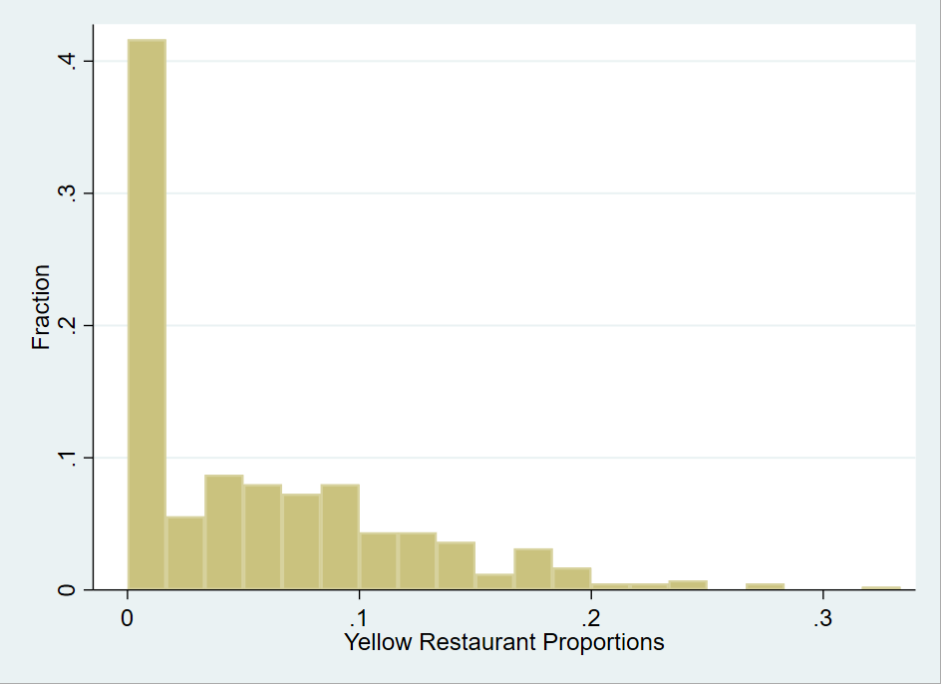

Table A1. The effect of tear gas on the proportion of yellow restaurants (excluding extreme values of dependent variable).
 | Dependent Variable: Proportion of Yellow Restaurants
 | (1) | (2) | (3)
TG | 0.022*** | 0.023*** | 0.020***
 | (0.007) | (0.007) | (0.006)
Control Variables | Yes | Yes | Yes
District FE | Yes | Yes | Yes
Observations | 413 | 408 | 392
R² | 0.208 | 0.241 | 0.248
Heteroskedasticity-robust standard errors are reported in parentheses. * p<0.1, ** p<0.05, *** p<0.01 (two-tailed)

A.2 Different Variable Formats to Measure Tear Gas Deployment
To test whether our results are robust across different variable formats, we adopt three different formats of tear gas use: a dummy variable (TG), a continuous measurement of the number of tear gas shootings (the natural log of the number of tear gas shootings in each constituency), and another continuous measurement pertaining to the density of tear gas shooting (i.e., the number of tear gas exposures per square meter). In Table A2, we list the regression results. The control variables are the same as the column 4 in baseline models (including the confrontation variable). These results illustrate that the impacts of tear gas on the proportion of yellow restaurants are positive and significant across all variable formats. We chose the dummy variable TG as our baseline model because its coefficient has the most relevant and straightforward interpretation for our research question, which examines whether the presence of state repression stimulates business activism in the constituency.

Table A2. The effects of tear gas on the proportion of yellow restaurants (different tear gas variable formats).
 | Dependent Variable: Proportion of Yellow Restaurants
 | (1) | (2) | (3) | (4) | (5)
TG | 0.022***
 | (0.007)
Ln(#TG+1) |  | 0.015*** | 0.010***
 |  | (0.002) | (0.003)
TG_Density |  |  |  | 191.182*** | 105.508**
 |  |  |  | (43.852) | (45.003)
Control variables | Yes | No | Yes | No | Yes
District FE | Yes | No | Yes | No | Yes
Observations | 413 | 413 | 413 | 413 | 413
R² | 0.208 | 0.076 | 0.210 | 0.039 | 0.195
Heteroskedasticity-robust standard errors are reported in parentheses. * p<0.1, ** p<0.05, *** p<0.01 (two-tailed)

A.3 Alternative Modelling Methods
We assess the robustness of our results using different modeling methods. The dependent variable, the proportion of yellow restaurants, is inherently bounded between 0 and 1. Using Ordinary Least Squares (OLS) may yield nonsensical predictions, such as proportions exceeding 1 or below 0. To address this issue, we employ two-limit Tobit regression, which constrains the dependent variable within the 0–1 range. The results of the Tobit model are presented in Column 2. The dependent variable in the Tobit model is the proportion of yellow restaurants, and the coefficient is qualitatively similar to that obtained using OLS, as shown in Column 1.
Although the Tobit model addresses the issue of value range, it has a drawback as an alternative modeling method. The Tobit model assumes that the data are censored, meaning that the dependent variable could take on negative values. However, these negative values are recorded as zero due to censorship. This assumption differs from the actual scenario, where zeros are not due to censorship but instead represent true zero values.
To further investigate the impact of tear gas on the probability of zero values, we employ a Logit model. In Column 3, the dependent variable is a binary indicator of whether a constituency has yellow restaurants. The coefficient is 0.98, indicating that the odds ratio of observing yellow restaurants in a constituency is 2.67. This finding suggests that experiencing tear gas significantly increases the probability of observing yellow restaurants in that constituency.
Overall, the results indicate that the positive impact of tear gas on the proportion of yellow restaurants is robust when we use different modeling methods to tackle the value range issue. We predominantly use OLS for most regressions as it simplifies the estimation process in our spatial regression, instrumental variable (IV) estimation, and heterogeneous tests.

Table A3. The effect of tear gas on the proportion of yellow restaurants (alternative modelling approach).
 | OLS | Tobit | Logit
 | (1) | (2) | (3)
TG | 0.022*** | 0.036*** | 0.980***
 | (0.007) | (0.011) | (0.294)
Control Variables | Yes | Yes | Yes
District FE | Yes | Yes | Yes
Observations | 413 | 413 | 413
* p<0.1, ** p<0.05, *** p<0.01(two-tailed)

A.4 Using 2016 Demographic Variables
In this study, we use demographic variables from the 2021 population census; however, these data could be affected by post-treatment bias. Therefore, we also collect data on demographic variables from the 2016 population census. In the regression models presented in Table A4, we use the demographic variables from the 2016 population census and exclude newly created constituencies and constituencies experienced boundary redrawing for the 2019 District Council election. The results remain robust.

Table A4. The effect of tear gas on the proportion of yellow restaurants (using 2016 demographic variables).
 | Dependent Variable: Proportion of Yellow Restaurants
 | (1) | (2)
TG | 0.023*** | 0.023***
 | (0.007) | (0.007)
Control variables | Yes | Yes
District FE | No | Yes
Observations | 396 | 396
R² | 0.118 | 0.168
Heteroskedasticity-robust standard errors are reported in parentheses. * p<0.1, ** p<0.05, *** p<0.01 (two-tailed)

A.5 The Effects of Confrontations and Protest Repressions
While our baseline models include a vector of control variables and district-fixed effects, it is important to acknowledge that unobserved characteristics of the constituencies may still confound our findings. These characteristics could be correlated with both the use of tear gas and the proportion of yellow restaurants. We are particularly concerned with constituency characteristics linked to the frequency of confrontations between police and protesters. It is crucial to distinguish between confrontations and protest repressions, as they are not synonymous. Confrontations between police and protesters may lead to deployments of tear gas to disperse crowds, but not all confrontations result in protest repression. Based on the summary statistics, the mean of confrontations is 0.538, which is larger than the mean for tear gas incidents (i.e., 0.375). Therefore, if constituencies with frequent confrontations have a higher proportion of yellow restaurants, it is possible that the coefficient of tear gas exposure may merely capture the impact of these confrontations, rather than protest repression.
To address this concern, we investigate whether confrontations or tear gas deployments could better explain the proportions of yellow restaurants. First, we test the correlation between confrontation frequency and the proportion of yellow restaurants. The source for the frequency of confrontations between police and protesters in a constituency was the protest event data in ANTIELAB Research Data Archive. We use three different measures of confrontations between police and protesters; the results are presented in Table A5. In Column 1, the variable “Confrontation” is a dummy variable indicating whether there was a confrontation in the constituency. In Column 2, "Ln(#Confrontation+1)" is the natural log form of the number of confrontations. In Column 3, "Confrontation_Density" is the number of confrontations per square meter.
In Column 1, confrontation is measured by a dummy variable. The results suggest that confrontations did not significantly increase the proportions of yellow restaurants. Interestingly, Columns 2 and 3 reveal a significant positive correlation between confrontations and the proportion of yellow restaurants when continuous variables are used to measure confrontations. This contradiction suggests that only constituencies with exceptionally large-scale confrontations, such as those experiencing tear gas deployments, likely have a higher proportion of yellow restaurants.
Next, we include both TG and measures of confrontations in the model to determine the relative relevance of tear gas and confrontations on the dependent variable. The results, summarized in Columns 4–6, reveal that the correlation between confrontations and the proportion of yellow restaurants is no longer significant when tear gas is included in the regression model.
Therefore, this analysis indicates that the use of indiscriminate protest repression, namely tear gas exposure, rather than confrontations between police and protesters, is more likely to result in a higher proportion of pro-movement restaurants. The positive correlation between confrontations and the yellow restaurant proportion in Columns 2 and 3 can be attributed to the fact that tear gas usage is more likely to occur during these confrontations.

Table A5. The effects of confrontation and protest repression
 | Dependent Variable: Proportion of Yellow Restaurants
 | (1) | (2) | (3) | (4) | (5) | (6)
TG |  |  |  | 0.022*** | 0.020*** | 0.020***
 |  |  |  | (0.007) | (0.008) | (0.007)
Confrontation | 0.008 |  |  | 0.004
 | (0.006) |  |  | (0.006)
Ln(#Confrontation+1) |  | 0.007** |  |  | 0.004
 |  | (0.003) |  |  | (0.004)
Confrontation _Density |  |  | 498.490** |  |  | 315.599
 |  |  | (252.012) |  |  | (257.509)
Control Variables | Yes | Yes | Yes | Yes | Yes | Yes
District FE | Yes | Yes | Yes | Yes | Yes | Yes
Observations | 413 | 413 | 413 | 413 | 413 | 413
R² | 0.188 | 0.192 | 0.194 | 0.208 | 0.209 | 0.211
Heteroskedasticity-robust standard errors are reported in parentheses. * p<0.1, ** p<0.05, *** p<0.01

A.6 Estimations of Spatial Regression Models
We address the issue of confounding variables by using a spatial autoregressive model with autoregressive disturbances (SARAR). Intuitively, it makes sense that nearby constituencies would be more related than distant constituencies; SARAR mitigates the estimation bias caused by omitted variables that are geographically correlated. The SARAR model can be defined as follows:
$$Y= αTG+ρ_{1}WY +\sum{b_{j}X_{j}+} \sum{c_{m}D_{m}+u}$$
$$u=ρ_{2}Wu+e$$

$W$ is a 413 × 413 spatial matrix constructed based on contiguity, and $ρ_{1}WY$and $ρ_{2}Wu$ are the spatial lag term and the spatial error term, respectively. We use generalized spatial two-stage least squares (GS2SLS) estimation, and the regression results are listed in the table below. We additionally keep all control variables as Column 4 in the baseline model. The data in Table A6 reveal that the positive correlation between the use of tear gas and yellow restaurant proportion remains robust when spatially correlated constituency characteristics are considered. Given that the standard deviation of the proportion of yellow restaurants is 0.062, the use of tear gas increases the proportion of yellow restaurants by 33.9% of the standard deviation in that constituency.
Table A6. Spatial regression models
 | Dependent Variable: Proportion of Yellow Restaurants
 | (1) | (2) | (3)
TG | 0.035*** | 0.019*** | 0.021***
 | (0.007) | (0.007) | (0.007)
$$ρ_{1}$$ | -0.305 | 0.005 | 0.166
 | (0.197) | (0.148) | (0.151)
$$ρ_{2}$$ | 0.339** | -0.038 | -0.367*
 | (0.163) | (0.167) | (0.190)
Control variables | No | Yes | Yes
District FE | No | No | Yes
Observations | 413 | 413 | 413
Pseudo R² | 0.079 | 0.168 | 0.199
Heteroskedasticity-robust standard errors are reported in parentheses. * p<0.1, ** p<0.05, *** p<0.01

A.7 Balance Tests of Constituency Characteristics (with and without BOC)
To tackle the issue of potential endogeneity, we use the number of BOC branches in each constituency as an instrumental variable for the treatment variable of tear gas deployment. The map shown below was acquired from the BOC’s official website (https://www.bochk.com/en/branch.html), and it presents the spatial distribution of BOC branches in Hong Kong. The branches cover all 18 districts of Hong Kong; the BOC is one of the largest banks in Hong Kong.
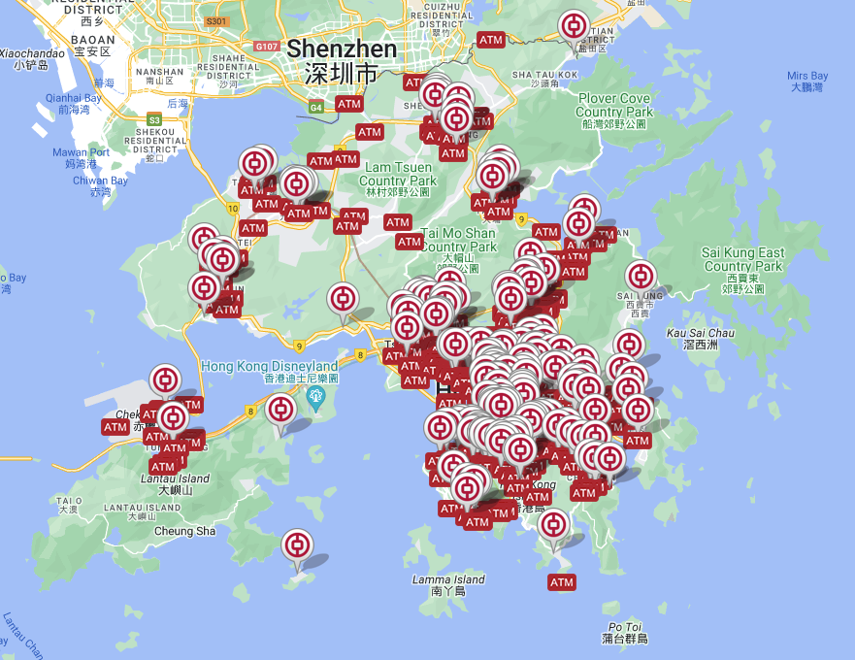
Table A7 presents the balance test of key characteristics of the constituencies with and without BOC branches. Standard deviations are listed in parentheses. The characteristics include the proportion of pro-democracy camp vote share (political characteristic), income (demographic characteristic), and restaurant prices (restaurant characteristic). None of the mean differences were significant at the 10% level between constituencies with and without BOC branches. These findings are not surprising given that the BOC has been operating in Hong Kong since 1917; the precise locations of its branches within each district are primarily determined by historical factors that may not correlate with the recent characteristics of the constituencies.

Table A7. Constituency characteristics (with or without Bank of China)
 | BOC = 1 | BOC = 0 | p-value
Pro-democracy | 0.573 | 0.564 | 0.209
 | (0.067) | (0.071)
Income | 22,254 | 21,116 | 0.224
 | (7,584) | (9,264)
Price_high | 0.058 | 0.048 | 0.324
 | (0.076) | (0.102)

A.8 Binning Estimators Across Different Model Specifications
To test the robustness of our second hypothesis, we estimate the binning estimator equations using different specifications. First, we only include the interactions between these bin dummies (G) and the treatment variable (TG), the bin dummies and the moderator (V, pro-democracy vote share) minus its median value within each bin, and the triple interactions; we do not control for constituency characteristics or district-fixed effects. The results are shown in Figures A2 and A3. Next, we add constituency characteristics as a control variable and redo the estimation. Those results are shown in Figures A4 and A5.
The results are qualitatively similar to those reported in the main text obtained by controlling for both constituency characteristics and district-fixed effects.

Figure A2. The marginal effects of tear gas at different levels of pro-democracy vote share (two groups, not controlling for constituency characteristics or district-fixed effects).
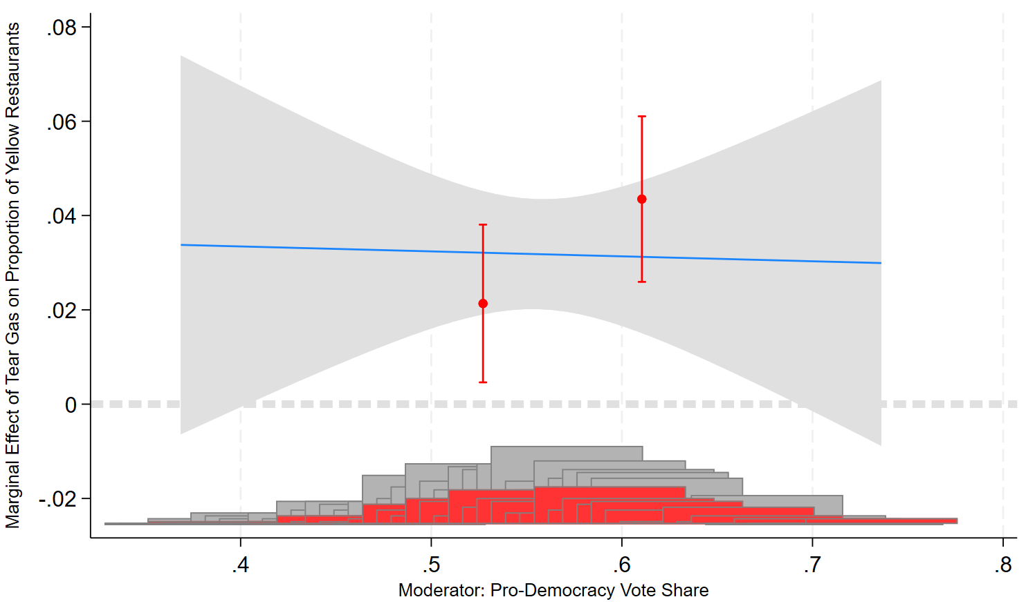

Figure A3. The marginal effects of tear gas at different levels of pro-democracy vote share (four groups, not controlling for constituency characteristics or district-fixed effects).
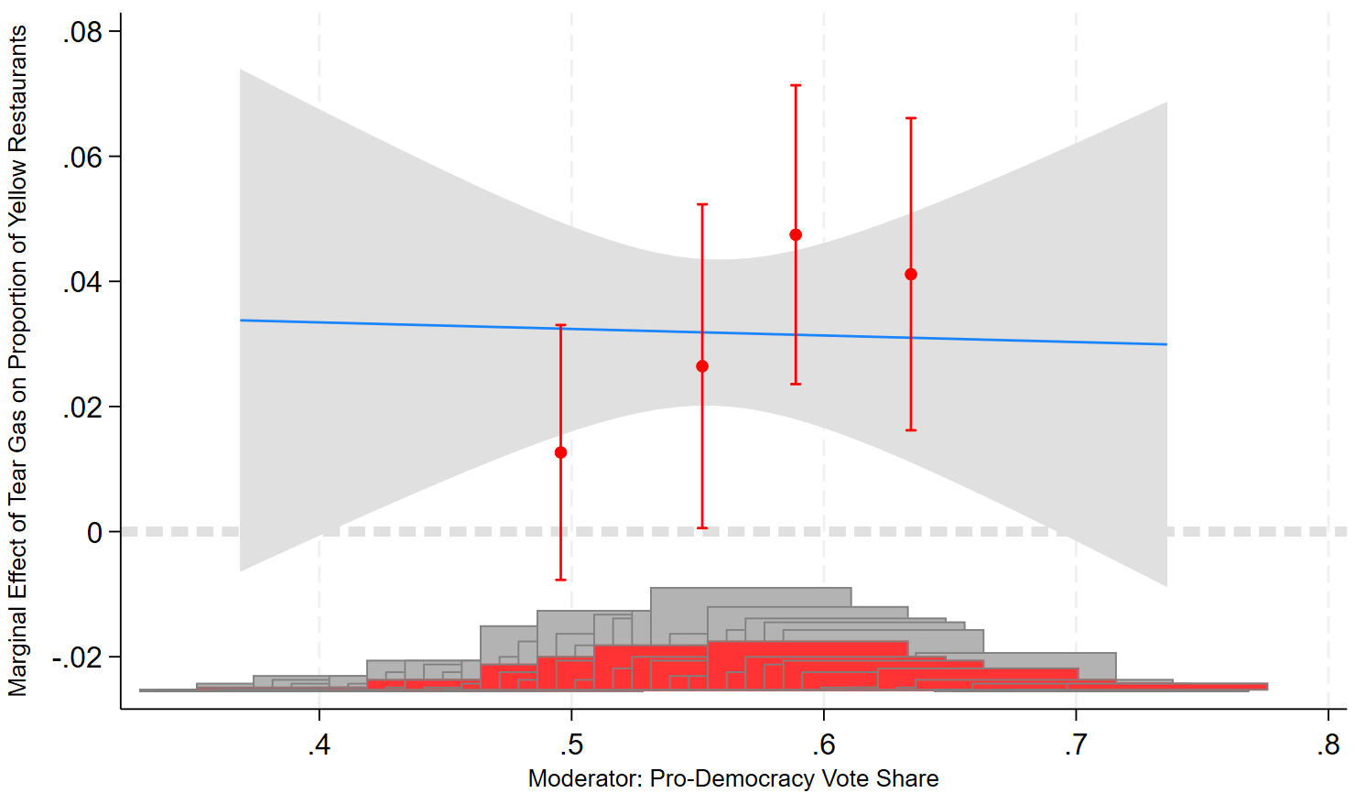
Figure A4. The marginal effects of tear gas at different levels of pro-democracy vote share (two groups, not controlling for district-fixed effects).
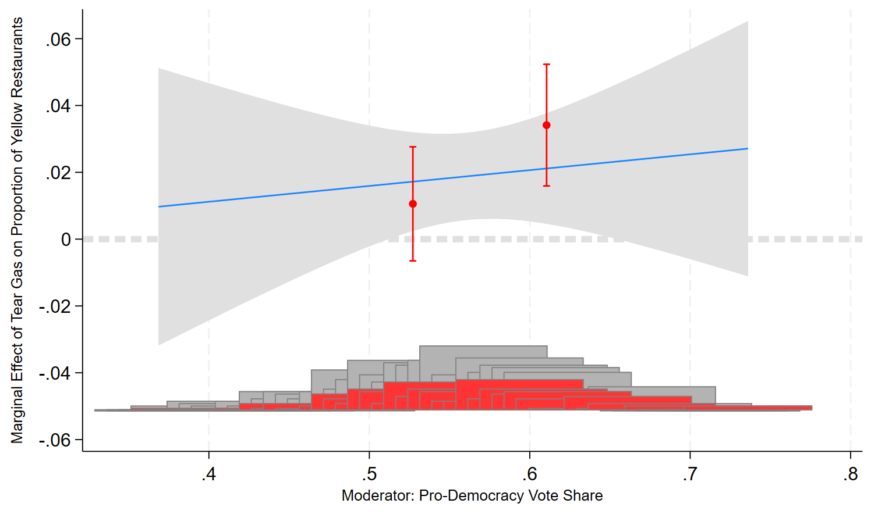

Figure A5. The marginal effects of tear gas at different levels of pro-democracy vote share (four groups, not controlling for district-fixed effects).

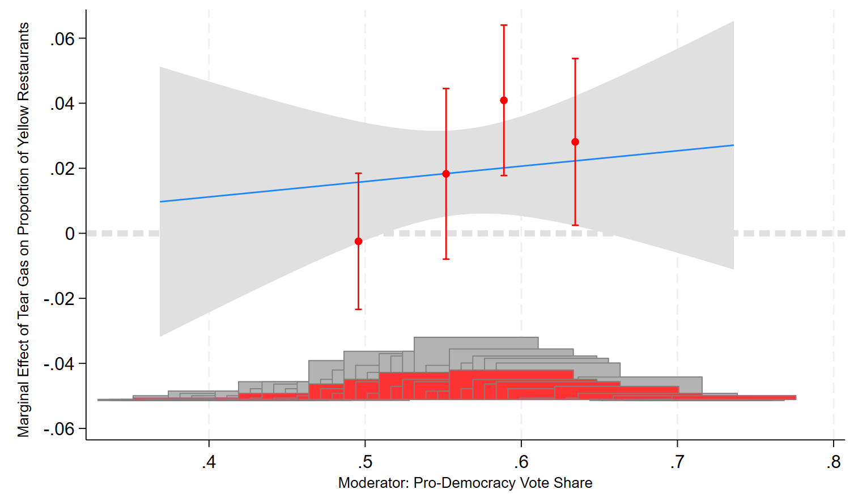

A.9 Financial Viability of Yellow Restaurants After Three Years
We explain restaurant owners’ decisions using financial-profit and social-psychological perspectives. In this test, we present some suggestive evidence related to the financial viability of yellow restaurants.
We proxy the financial viability of yellow restaurants by examining their survival rate over the course of three years after the movement. Typically, restaurants with higher profitability tend to continue operating over the long term. Therefore, we replace the dependent variable in our baseline model with the percentage of yellow restaurants still operating after three years. Our underlying thinking is that if restaurant owners in constituencies with tear gas deployments signal a pro-democracy leaning without considering financial viability, those restaurants may struggle to survive over the long term. Consequently, we might observe a negative correlation between TG and the survival rate of yellow restaurants in those constituencies.
The results are listed in Table A8. We find that the financial viability of yellow restaurants does not significantly differ between constituencies with and without tear gas deployments. These results suggest that financial interests might be important considerations for business owners. The results also indicate that the yellow economy circle has persisted since the conclusion of the movement.
Table A8. Tear gas and the proportion of yellow restaurants surviving after three years.
 | Dependent Variable: Survival Rate of Yellow Restaurants
 | (1) | (2) | (3)
TG | -0.030 | 0.003 | 0.012
 | (0.039) | (0.046) | (0.050)
Control variables | No | Yes | Yes
District FE | No | No | Yes
Observations | 241 | 241 | 241
R² | 0.002 | 0.052 | 0.116
Heteroskedasticity-robust standard errors are reported in parentheses. * p<0.1, ** p<0.05, *** p<0.01

A.10 The Impacts of Protest Repression with Tear Gas on the Proportion of Blue Restaurants
As noted in the main text, we do not intend to examine pro-government blue restaurants; they do not fit the definition of business activism. Business activism refers to a business proactively taking a public stance on a controversial issue; most blue restaurants were passively labeled as such. Therefore, blue restaurants are not a suitable subject of study for a paper about business activism.
However, we can still empirically derive a list of blue restaurants in Hong Kong. The issue is that there are two types of blue restaurants. One type includes restaurants with business ties to mainland China; these restaurants are passively labeled by residents as blue restaurants. The other type consists of active blue restaurants that actively signal a pro-establishment political leaning. The latter type can be considered to engage in a form of business activism. Due to data limitations, however, we are unable to distinguish between these two types of blue restaurants.
Theoretically, the impact of tear gas deployments on the active type of blue restaurants is mixed. From a social-psychological perspective, tear gas deployment could be interpreted by pro-establishment residents as a necessary action to stop violent conflicts. Therefore, pro-establishment restaurant owners who experienced tear gas may be more willing to label themselves blue to show their support for the government. On the other hand, from a financial-interest perspective, being a blue restaurant may not be profitable; previous studies have shown that tear gas deployments lead to an increase in the number of pro-movement residents.
Table A9 presents the impact of tear gas deployment on the proportion of blue restaurants in each constituency. The coefficient is positive but only significant at the 10% level. Due to the noise in our dependent variable, we are unable to draw any definitive conclusions based on this result.

Table A9. The effect of tear gas on the proportion of blue restaurants
 | Dependent Variable: Proportion of Blue Restaurants
 | (1) | (2) | (3) | (4)
TG | 0.007 | 0.015* | 0.015* | 0.016*
 | (0.008) | (0.008) | (0.009) | (0.009)
Confrontation |  |  |  | -0.001
 |  |  |  | (0.009)
Pro-democracy |  | 0.012 | 0.013 | 0.013
 |  | (0.063) | (0.064) | (0.064)
Cuisine_hk |  | 0.106*** | 0.111*** | 0.111***
 |  | (0.033) | (0.034) | (0.034)
Cuisine_chi |  | 0.022 | 0.025 | 0.025
 |  | (0.036) | (0.035) | (0.035)
Price_low |  | -0.041 | -0.049 | -0.049
 |  | (0.033) | (0.032) | (0.032)
Price_high |  | 0.010 | -0.003 | -0.003
 |  | (0.053) | (0.057) | (0.057)
Ln(Population) |  | -0.026 | -0.026 | -0.025
 |  | (0.020) | (0.019) | (0.020)
Age |  | -0.001 | 0.001 | 0.001
 |  | (0.001) | (0.002) | (0.002)
Education |  | 0.080 | 0.173 | 0.175
 |  | (0.132) | (0.153) | (0.156)
Ln(Income) |  | -0.000 | -0.005 | -0.005
 |  | (0.040) | (0.045) | (0.045)
Language_Cantonese |  | 0.092 | 0.066 | 0.066
 |  | (0.060) | (0.072) | (0.071)
Language_Putonghua |  | 0.005 | 0.098 | 0.101
 |  | (0.148) | (0.162) | (0.156)
Unaffordability |  | -0.000 | -0.001 | -0.001
 |  | (0.001) | (0.001) | (0.001)
District FE | No | No | Yes | Yes
Observations | 413 | 413 | 413 | 413
R² | 0.002 | 0.069 | 0.127 | 0.127
Heteroskedasticity-robust standard errors are reported in parentheses. * p<0.1, ** p<0.05, *** p<0.01

