Appendices for “When Do People View Discrimination as Morally Acceptable?”

Contents
Appendix A: Auxiliary and exploratory analyses 2
Appendix B: Ethical considerations 23
Appendix A: Auxiliary and Exploratory Analyses
Study 1:
Descriptive statistics
Table A1. Descriptive Statistics across Treatment Groups
 | Treatment groups
 | Taste-based | Biased statistical | Accurate statistical | Inaccurate statistical
Gender  Women  Men | 50.5%  49.5% | 55.6%  44.4% | 56.2%  43.8% | 50.6%  49.4%
Age  18‒34  35‒54  55‒74  75+ | 23.9%  34.4%  35.5%  6.2% | 25.3%  33.1%  31.0%  10.5% | 25.1%  34.6%  32.9%  7.4% | 24.6%  31.4%  36.1%  8.3%
Region  Capital  Zealand  Southern Denmark  Central Jutland  Northern Jutland | 31.8%  15.2%  21.4%  22.3%  9.3% | 28.5%  15.2%  21.3%  23.0%  12.1% | 29.9%  13.5%  19.2%  25.8%  11.6% | 29.5%  15.1%  23.6%  23.5%  8.3%
Education  Short  Medium  Long | 65.4%  23.7%  10.9% | 68.4%  23.4%  8.2% | 66.3%  23.7%  10% | 65.1%  23.8%  11.1%

Table A2. Manipulation Check
 | Treatment groups
 | Taste-based | Biased statistical | Accurate statistical | Inaccurate statistical
Rationale  Taste-based | 67% | 21% | 11.5% | 16.5%
Biased statistical | 13.5% | 47% | 27.5% | 17%
Accurate statistical | 7% | 7% | 23% | 6.5%
Inaccurate statistical | 12.5% | 20% | 37% | 60%
Total | 100% | 100% | 100% | 100%
Note. Percentages in bold indicate the percentage in each treatment group that correctly identified the employer rationale.

Robustness checks
Table A3. Average Effects of Discrimination Type excl. Respondents Failing Manipulation Check
Discrimination rationale |  | n
Taste-based | Reference | 346
Inaccurate statistical | -0.041 | 309
 | (0.118)
Biased statistical | 0.499*** | 243
 | (0.147)
Accurate statistical | 1.678*** | 120
 | (0.207)
Constant | 2.197***
 | (0.0853)
Observations | 1,018
R-squared | 0.096
Note. Robust standard errors in parentheses.*** p<0.01, ** p<0.05, * p<0.1 (two-sided t-test). Acceptance is measured on a seven-point Likert scale.

Table A4. Average Effects of Discrimination Type excl. Respondents Failing Filler Case
Discrimination rationale |  | n
Taste-based | Reference | 421
Inaccurate statistical | 0.150 | 433
 | (0.108)
Biased statistical | 0.434*** | 433
 | (0.117)
Accurate statistical | 0.508*** | 427
 | (0.120)
Constant | 2.183***
 | (0.0780)
Observations |  | 1,714
R-squared | 0.014
Note. Robust standard errors in parentheses.*** p<0.01, ** p<0.05, * p<0.1 (two-sided t-test). Acceptance is measured on a seven-point Likert scale.

Interaction effects
As several experimental studies show that extraneous factors influence people’s normative assessments (Knobe et al. 2012; Kumar and May 2018), I test whether respondents’ assessments depend on their individual traits, opinions, and experiences. The four moderators are: 1) feelings towards citizens with non-Western backgrounds, 2) decision-making style, 3) experienced discrimination, and 4) societal fairness.
First, the variable ‘feelings towards citizens with non-Western backgrounds’ is measured via a classic feelings thermometer (Zavala-Rojas 2014) and then transformed to a dichotomous variable (cold vs warm feelings) for better interpretation. Including this variable as a moderator does not produce statistically significant interaction effects. The results are reported for both the seven-point Likert-scaled variable ‘moral assessment’ and the dichotomous coded version ‘acceptance percentage’.

Table A5. Average Interaction Effects of Feelings Towards non-Western Citizens
 | Model 1 | Model 2
Discrimination rationale
Taste-based | Reference | Reference
Inaccurate statistical | -4.277 | -0.113
 | (4.825) | (0.211)
Biased statistical | 12.33** | 0.535**
 | (5.165) | (0.218)
Accurate statistical | 14.89*** | 0.477**
 | (5.251) | (0.223)
Feelings (dummy) | -17.37*** | -1.395***
 | (3.716) | (0.170)
Discrimination rationale × Feelings
Inaccurate × Warm | 3.964 | 0.375
 | (5.231) | (0.237)
Biased × Warm | -8.665 | -0.244
 | (5.658) | (0.247)
Accurate × Warm | -7.552 | 0.0392
 | (5.801) | (0.254)
Constant | 24.84*** | 3.304***
 | (3.413) | (0.152)
Observations | 1,917 | 1,917
R-squared | 0.086 | 0.141
Note. Robust standard errors in parentheses. *** p<0.01, ** p<0.05, * p<0.1 (two-sided t-test). Reference category for interaction is taste-based × cold. Model 1 uses the dependent variable with the first dichotomos recoding (moral acceptance percentage). Model 2 uses the dependent variable ‘moral assessment’ with the original seven-point scale. ‘Don’t know’ is coded as missing.

Respondents with cold feelings towards citizens with non-Western backgrounds have a higher acceptance level of all types of discrimination. Nevertheless, they still accept biased statistical and accurate statistical discrimination more than taste-based and inaccurate statistical discrimination. Respondents with warm feelings tend to accept all types of statistical discrimination more than taste-based discrimination. When including ‘feelings towards citizens with non-Western background’ as a continuous variable, inaccurate statistical discrimination is assessed as (slightly) more acceptable the warmer one’s feelings are. This is shown in Table A6.

Table A6. Average Interaction Effects of Feelings (continuous) towards non-Western Citizens
Discrimination rationales
Taste-based | Reference
Inaccurate statistical | -0.427
 | (0.294)
Biased statistical | 0.566*
 | (0.297)
Accurate statistical | 0.225
 | (0.313)
Feelings (continous) | -0.032***
 | (0.003)
Discrimination rationale × Feelings
Inaccurate × feelings | 0.009**
 | (0.004)
Biased × feelings | -0.00415
 | (0.004)
Accurate × feelings | 0.00434
 | (0.005)
Constant | 4.238***
 | (0.211)
Observations | 1,917
R-squared | 0.187
Note. Robust standard errors in parentheses. *** p<0.01, ** p<0.05, * p<0.1 (two-sided t-test). ‘Prefer not to answer’ is coded as missing. ‘Feelings towards citizens with non-Western backgrounds’ is included as a continuous variable. The dependent variable is included as the original seven-point Likert scaled variable ‘ moral assessment’.

Turning to the second moderator, more respondents who feel disadvantaged in society assess taste-based discrimination as acceptable compared to those who do not feel disadvantaged. However, this pattern only holds when using the dichotomous dependent variable ‘acceptance percentage’.

Table A7. Interaction Effects of Experienced Discrimination (disadvantaged group)
 | Model 1 | Model 2
Discrimination rationale
Taste-based | Reference | Reference
Inaccurate statistical | -0.115 | 0.162
 | (2.277) | (0.118)
Biased statistical | 7.420*** | 0.354***
 | (2.629) | (0.127)
Accurate statistical | 9.547*** | 0.447***
 | (2.668) | (0.128)
Experienced discrimination
Yes | 13.74*** | 0.501**
 | (4.212) | (0.200)
Discrimination rationale × Experienced discrimination
Inaccurate × Yes | -11.25** | -0.418
 | (5.441) | (0.266)
Biased × Yes | -5.233 | 0.0368
 | (6.079) | (0.288)
Accurate × Yes | -3.186 | -0.0688
 | (6.296) | (0.294)
Constant | 10.23*** | 2.293***
 | (1.618) | (0.0849)
Observations | 1,894 | 1,894
R-squared | 0.029 | 0.023
Note. Robust standard errors in parentheses. *** p<0.01, ** p<0.05, * p<0.1 (two-sided t-test). Model 1 uses the dependent variable with the first dichotomous recoding (moral acceptance percentage). Model 2 uses the dependent variable ‘moral assessment’ with the original seven-point scale. ‘Don’t know’ is coded as missing.

Figure A1. Acceptance Percentage across Discrimination Types by Experienced Discrimination
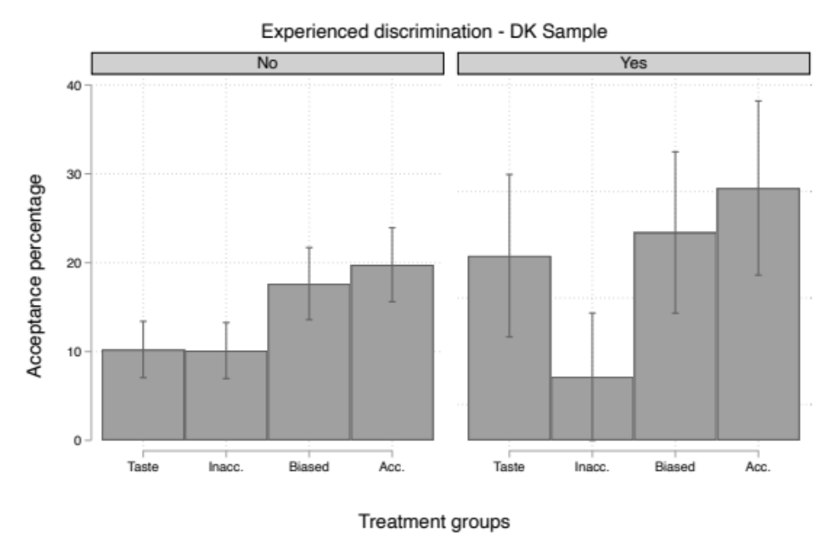
Note: Moral acceptance percentages across discrimination types by experienced discrimination status. The error bars indicate the 95 per cent confidence intervals estimated with robust standard errors. n= 1894. ‘Don’t know’ is coded as missing.

Third, when including the items inspired by the General Decision-Making Style Inventory as dichotomous variables, there are some statistically significant interaction effects. The tendency is that respondents disagreeing with trusting their feelings or instincts assess taste-based discrimination as more acceptable than those who agree (compared to the other types of discrimination).

Table A8. Interaction Effects across Discrimination Types by GDMS Variables
 | Decision-making style variables
 | Feelings | Instincts | All options | Pros  /Cons | Morals | Logic | Other people
Discrimination rationale
Taste-based | Reference | Reference | Reference | Reference | Reference | Reference | Reference
Inaccurate statistical | -0.396 | -0.343 | 0.204 | 0.314 | -0.0541 | 0.232 | 0.0948
 | (0.250) | (0.252) | (0.234) | (0.258) | (0.217) | (0.245) | (0.114)
Biased statistical | -0.0926 | -0.0750 | 0.375* | 0.199 | 0.282 | 0.153 | 0.380***
 | (0.253) | (0.263) | (0.227) | (0.252) | (0.228) | (0.248) | (0.127)
Accurate statistical | -0.145 | -0.154 | 0.435* | 0.483* | 0.319 | 0.323 | 0.519***
 | (0.268) | (0.277) | (0.260) | (0.271) | (0.235) | (0.272) | (0.130)
Decision-making style (DMS)
Agree | 0.536** | 0.520** | -0.144 | -0.248 | 0.494*** | -0.0772 | 0.284
 | (0.214) | (0.224) | (0.183) | (0.196) | (0.182) | (0.200) | (0.214)
Discrimination rationale × DMS
Inaccurate ×Agree | 0.579** | 0.503* | -0.171 | -0.285 | 0.115 | -0.220 | -0.207
 | (0.274) | (0.276) | (0.261) | (0.282) | (0.247) | (0.271) | (0.270)
Biased × Agree | 0.576** | 0.518* | -0.0215 | 0.196 | 0.0645 | 0.240 | -0.203
 | (0.282) | (0.291) | (0.261) | (0.282) | (0.262) | (0.278) | (0.283)
Accurate × Agree | 0.745** | 0.728** | 0.0120 | -0.0227 | 0.155 | 0.140 | -0.333
 | (0.296) | (0.304) | (0.289) | (0.300) | (0.270) | (0.300) | (0.285)
Constant | 2.833*** | 2.843*** | 2.534*** | 2.608*** | 2.798*** | 2.489*** | 2.361***
 | (0.199) | (0.209) | (0.161) | (0.177) | (0.160) | (0.181) | (0.0814)
Observations | 2,004 | 2,003 | 2,003 | 2,000 | 1,978 | 1,990 | 2,002
R-squared | 0.016 | 0.015 | 0.013 | 0.017 | 0.022 | 0.013 | 0.013
Note. Robust standard errors in parentheses. *** p<0.01, ** p<0.05, * p<0.1 (two-sided t-test). The dependent variable is included as the original seven-point scale. GDMS variables are included as dichotomous variables (Agree/Disagree). The reference category for the interaction is Taste-based x Disagree. ‘Don’t know’ is coded as missing.

Last, I include the three fairness items one at a time. There are some significant effects when the fairness items are included as dichotomous variables (Yes/No). However, the significant interactions appear to be driven by the fact that respondents are more willing to accept taste-based discrimination if they disagree that society provides equal access to jobs or political representation.
Table A9. Interaction Effects of Perceived Fairness in Different Sectors
 | Fairness perceptions
 | Educational | Job | Political
Discrimination rationale
Taste-based | Reference | Reference | Reference
Inaccurate statistical | -0.285 | -0.195 | -0.137
 | (0.204) | (0.159) | (0.189)
Biased statistical | 0.0887 | 0.188 | 0.0530
 | (0.203) | (0.164) | (0.192)
Accurate statistical | 0.229 | 0.0975 | 0.222
 | (0.234) | (0.173) | (0.211)
Fairness perceptions (FP)
Agree | -0.303* | -0.277* | -0.404**
 | (0.176) | (0.153) | (0.166)
Discrimination rationale ×FP
Inaccurate × Agree | 0.455* | 0.459** | 0.313
 | (0.236) | (0.210) | (0.227)
Biased × Agree | 0.349 | 0.291 | 0.461*
 | (0.244) | (0.225) | (0.239)
Accurate × Agree | 0.256 | 0.555** | 0.316
 | (0.268) | (0.229) | (0.252)
Constant | 2.651*** | 2.586*** | 2.688***
 | (0.154) | (0.119) | (0.139)
Observations | 2,014 | 2,014 | 1,946
R-squared | 0.012 | 0.014 | 0.014
Note. Robust standard errors in parentheses. *** p<0.01, ** p<0.05, * p<0.1 (two-sided t-test). The dependent variable is included as the original seven-point scale. Fairness perceptions across sectors are included as dichotomous variables (Agree/Disagree that it is currently fair). Reference category: Taste-based × Disagree. ‘Don’t know’ is coded as missing.

Figure A2. Acceptance Percentage across Discrimination Types by Agreement/Disagreement Current Job Fairness
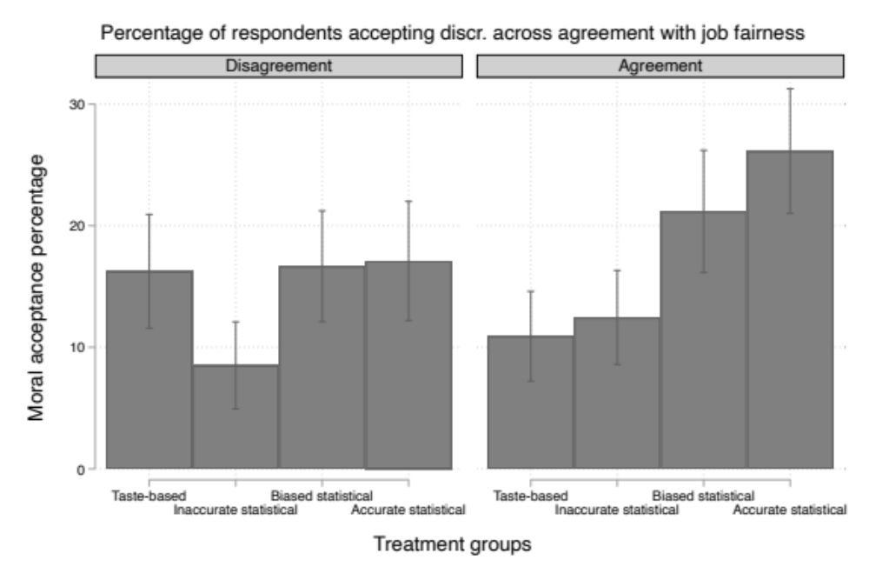
Note: Moral acceptance percentages across discrimination types agreement with job fairness. The error bars indicate the 95 per cent confidence intervals estimated with robust standard errors. n= 2014. ‘Don’t know’ is coded as missing.

Figure A2 illustrates the common trend across all the fairness interaction models. Namely, the significant interaction results are primarily driven by a higher percentage of respondents accepting taste-based discrimination among those who disagree that access to jobs is fair in Denmark. It is worth noting that running these many regression models (exploring potential interaction effects) increases the risk of type 1 errors.

Study 2:
Descriptive statistics

Table A10. Descriptive Statistics across Treatment Groups
 | Treatment groups
 | Taste-based control | Acc. taste-based | Inacc. taste-based | Stat.  control | Acc. Stat. | Inacc. Stat.
Gender  Women  Men | 52%  48% | 51%  49% | 55%  45% | 49%  51% | 51%  49% | 52%  48%
Age  18‒34  35‒54  55‒74  75+ | 32%  33%  30%  5% | 34%  30%  31%  5% | 31.5%  34.5%  30%  4% | 31%  33%  33%  3% | 37%  30%  30%  3% | 29%  37%  30%  4%
Region  Northeast  Midwest  South  West | 19%  17%  39%  25% | 22%  19%  37%  22% | 17%  23%  38%  22% | 19%  18%  36%  27% | 18.5%  17%  41.5%  23% | 19%  20%  37%  24%
Education  Some high school or less  High school  Post high school vocational training  Some college, no degree  Associate’s degree  Bachelor’s degree  Master’s or professional degree  Doctorate degree  Other | 5%  20%  3.5%  25%  7%  24.5%  9.5%  5.5%  0% | 4%  19%  4%  22%  10%  27%  8%  6%  0% | 2%  15%  5%  24%  11%  25%  13%  4.5%  0.5% | 4%  19%  6%  26%  8%  21%  11%  5%  0% | 3%  24.5%  4%  25%  9%  22%  9%  3%  0.5% | 2%  19%  5%  21%  8%  28%  12%  5%  0%
Ethnicity  White  Black  American Indian or Alaska Native  Asian  Pacific Islander  Other  Unknown | 74%  12%  1%  2%  1%  10%  0% | 71%  9%  2%  4%  0%  13%  1% | 80%  9%  1%  3.5%  0%  6.5%  0% | 74%  11%  0%  4%  1%  10%  0% | 67%  12%  1%  5%  0%  14%  1% | 74%  10%  1.5%  2.5%  0.5%  10.5%  1%
Hispanic  No  Yes  Unknown | 93%  7%  0% | 87%  12%  1% | 91%  8%  1% | 90%  9%  1% | 87%  12%  1% | 91%  8%  1%
Annual household income  $34.999 and below  $35.000-59.000  $60.000-84.999  $85.000-149.999  $150.000 and above  Unknown | 37%  26%  13%  16%  4%  4% | 34%  22%  14%  18%  5%  7% | 32%  21.5%  16%  17.5%  6%  7% | 38%  17%  14%  21%  5%  5% | 35%  22%  14%  16%  6%  7% | 33.5%  23.5%  14%  14%  8%  7%
Political identification  Democrat  Republican  Other | 38%  38.5%  23.5% | 39%  37%  24% | 42.5%  37.5%  20% | 42%  36%  22% | 40%  36%  24% | 42%  35%  23%

Table A11. Manipulation Check of Employer Rationale
 | Treatment groups
 |  | Taste-based |  |  |  | Statistical
 | Control | Accurate | Inaccurate |  | Control | Accurate | Inaccurate
Rationale  Avoid bribe | 30% | 27% | 24% |  | 45% | 47% |  | 31%
Avoid Hispanics | 56% | 53% | 63% |  | 46% | 32% |  | 51%
Neutral | 14% | 20% | 13% |  | 9% | 21% |  | 18%
Total | 100% | 100% | 100% |  | 100% | 100% |  | 100%
Note. Percentages in bold indicate the percentage in each treatment group that correctly identified the employer rationale.

Table A12. Manipulation Check of Statistical Information Persuasion
 | Treatment groups
 |  | Taste-based |  |  |  | Statistical
 | Control | Accurate | Inaccurate |  | Control | Accurate | Inaccurate
Likelihood of  accepting a bribe  More likely | 5% | 13% | 4% |  | 4.5% | 8% |  | 4.5%
Less likely | 6% | 6% | 31% |  | 7% | 7% |  | 23%
Neutral | 89% | 81% | 65% |  | 88.5% | 85% |  | 72.5%
Total | 100% | 100% | 100% |  | 100% | 100% |  | 100%
Note. Percentages in bold indicate the percentage in each treatment group persuaded by the information about Hispanic citizens’ likelihood of accepting a bribe.

Robustness check
Table A13. Average Effects excl. Respondents Failing to Identify the Employer’s Rationale
 | Taste-based | Statistical | n
Taste-based control | Reference | -0.380** | 177
 |  | (0.159)
Accurate taste-based | 0.274** | -0.107 | 182
 | (0.129) | (0.164)
Inaccurate taste-based | 0.0351 | -0.345** | 211
 | (0.121) | (0.158)
Statistical control | 0.380** | Reference | 142
 | (0.159)
Accurate statistical | 1.187*** | 0.806*** | 138
 | (0.178) | (0.205)
Inaccurate statistical | 0.293* | -0.0871 | 101
 | (0.160) | (0.190)
Constant | 1.429*** | 1.810***
 | (0.0866) | (0.134)
Observations |  |  | 951
R-squared | 0.070 | 0.070
Note. Robust standard errors in parentheses. *** p<0.01, ** p<0.05, * p<0.1 (two-sided t-test). Acceptance is measured on a seven-point Likert scale. The coefficients in black font are those relevant when comparing within either the taste-based or statistical condition.

Interaction effects
I include three moderator variables: 1) feelings towards Hispanic citizens, 2) decision-making style, 3) and attention to social comparison.
First, I only find one statistically significant interaction effect when including feelings towards Hispanic citizens as a moderator and the original seven-point Likert scaled variable ‘moral assessment’. Substantially, however, there is no meaningful interaction between feelings towards Hispanics and moral assessment. As preregistered, feelings towards Hispanic citizens are included as a dichotomous variable (cold vs warm feelings) but measured via a classic feelings thermometer (Zavala-Rojas 2014), and the results are reported for both the seven-point Likert-scaled variable ‘moral assessment’ (B) and as the dichotomous coded version ‘acceptance percentage’ (A). The results are shown in Table A14:

Table A14. Average Interaction Effects of Feelings towards Hispanics across Discrimination Type
 | Taste-based |  | Statistical
 | A | B | A | B
Discrimination rationale
Taste-based control | Reference | Reference | -5 | 0.0500
 |  |  | (11.34) | (0.588)
Accurate taste-based | -0.714 | -0.150 | -5.714 | -0.100
 | (10.40) | (0.496) | (10.41) | (0.536)
Inaccurate taste-based | -7.857 | -0.686 | -12.86 | -0.636
 | (9.380) | (0.491) | (9.393) | (0.531)
Statistical control | 5 | -0.0500 | Reference | Reference
 | (11.34) | (0.588)
Accurate statistical | -0.714 | -0.186 | -5.714 | -0.136
 | (10.40) | (0.485) | (10.41) | (0.526)
Inaccurate statistical | -5 | -0.300 | -10 | -0.250
 | (10.46) | (0.519) | (10.47) | (0.557)
Feelings
Warm | -10.96 | -1.219*** | -14.54* | -1.037**
 | (8.091) | (0.396) | (8.135) | (0.446)
Discrimination rationale × Feelings
Taste-based control × Warm |  |  | 3.580 | -0.182
 |  |  | (11.47) | (0.596)
Accurate taste-based × Warm | 4.585 | 0.684 | 8.165 | 0.502
 | (10.57) | (0.507) | (10.61) | (0.547)
Inaccurate taste-based × Warm | 9.986 | 0.852* | 13.57 | 0.670
 | (9.549) | (0.501) | (9.586) | (0.541)
Statistical control × Warm | -3.580 | 0.182
 | (11.47) | (0.596)
Accurate statistical × Warm | 7.495 | 0.852* | 11.07 | 0.670
 | (10.63) | (0.499) | (10.67) | (0.540)
Inaccurate statistical × Warm | 6.479 | 0.476 | 10.06 | 0.294
 | (10.60) | (0.528) | (10.64) | (0.566)
Constant | 15* | 2.650*** | 20** | 2.600***
 | (8.009) | (0.390) | (8.025) | (0.440)
Observations | 1,939 | 1,939 | 1,939 | 1,939
R-squared | 0.013 | 0.045 | 0.013 | 0.045
Note. Robust standard errors in parentheses. *** p<0.01, ** p<0.05, * p<0.1 (two-sided t-test). ‘A’ indicates models using acceptance as the dichotomously coded ‘acceptance percentage’. ‘B’ indicates models using the original 7-point scaled variable ‘moral assessment’. The coefficients in black font are those relevant when comparing within either the taste-based or statistical condition.

The insignificant interaction results could be a result of a lack of statistical power. It further supports the interpretation that the appeal to statistical group differences convinces people who would otherwise oppose discrimination to accept it.
Second, I find no significant interaction effects when including decision-making style or attention to social comparison as moderators (when comparing within either the taste-based or statistical treatment groups, respectively).

Table A15a. Average Interaction Effects of GDMS (Taste-based)
 | GDMS (Taste-based)
 | Rational | Intuitive | Dependent | Avoidant | Snap
Discrimination rationale
Taste-based control | Reference | Reference | Reference | Reference | Reference
Accurate taste-based | 0.969 | 0.532 | 0.440 | 0.475* | 0.560*
 | (0.608) | (0.444) | (0.357) | (0.286) | (0.330)
Inaccurate taste-based | -0.107 | 0.144 | -0.00966 | -0.0576 | 0.213
 | (0.593) | (0.454) | (0.348) | (0.265) | (0.297)
Statistical control | 0.152 | -0.412 | 0.481 | 0.204 | 0.485
 | (0.609) | (0.448) | (0.351) | (0.278) | (0.334)
Accurate statistical | 0.298 | 0.790 | 1.135*** | 0.821*** | 1.392***
 | (0.550) | (0.483) | (0.407) | (0.316) | (0.361)
Inaccurate statistical | 0.521 | -0.248 | 0.471 | 0.164 | 0.368
 | (0.624) | (0.426) | (0.361) | (0.257) | (0.308)
GDMS | -0.0749 | -0.00690 | 0.152* | 0.250*** | 0.393***
 | (0.0961) | (0.0786) | (0.0858) | (0.0856) | (0.0973)
GDMS x Discrimination rationale
GDMS x Taste-based control
GDMS x Accurate taste-based | -0.114 | -0.00886 | 0.0137 | 0.000183 | -0.0263
 | (0.147) | (0.121) | (0.126) | (0.124) | (0.140)
GDMS x Inaccurate taste-based | 0.0566 | -0.00677 | 0.0361 | 0.0766 | -0.0338
 | (0.148) | (0.125) | (0.125) | (0.125) | (0.134)
GDMS x Statistical control | -0.00463 | 0.155 | -0.121 | -0.0363 | -0.146
 | (0.152) | (0.129) | (0.120) | (0.125) | (0.141)
GDMS x Accurate statistical | 0.0812 | -0.0476 | -0.176 | -0.0869 | -0.308**
 | (0.138) | (0.134) | (0.136) | (0.136) | (0.146)
GDMS x Inaccurate statistical | -0.0901 | 0.112 | -0.114 | -0.0170 | -0.0965
 | (0.152) | (0.121) | (0.123) | (0.116) | (0.135)
Constant | 1.808*** | 1.533*** | 1.066*** | 0.919*** | 0.524**
 | (0.388) | (0.283) | (0.234) | (0.181) | (0.215)
Observations | 1,939 | 1,939 | 1,939 | 1,939 | 1,939
R-squared | 0.029 | 0.027 | 0.032 | 0.054 | 0.065

Table A15b. Average interaction effects of GDMS (Statistical)
 | GDMS (Statistical)
 | Rational | Intuitive | Dependent | Avoidant | Snap
Discrimination rationale
Taste-based control | -0.152 | 0.412 | -0.481 | -0.204 | -0.485
 | (0.609) | (0.448) | (0.351) | (0.278) | (0.334)
Accurate taste-based | 0.816 | 0.944* | -0.0412 | 0.271 | 0.0752
 | (0.664) | (0.487) | (0.375) | (0.306) | (0.358)
Inaccurate taste-based | -0.259 | 0.556 | -0.491 | -0.261 | -0.272
 | (0.650) | (0.497) | (0.366) | (0.286) | (0.328)
Statistical control | Reference | Reference | Reference | Reference | Reference
Accurate statistical | 0.146 | 1.202** | 0.655 | 0.617* | 0.907**
 | (0.611) | (0.523) | (0.423) | (0.334) | (0.387)
Inaccurate statistical | 0.368 | 0.164 | -0.0102 | -0.0397 | -0.117
 | (0.678) | (0.471) | (0.379) | (0.279) | (0.338)
GDMS | -0.0795 | 0.149 | 0.0320 | 0.213** | 0.248**
 | (0.117) | (0.102) | (0.0839) | (0.0915) | (0.102)
GDMS x discrimination rationale
GDMS x Taste-based control | 0.00463 | -0.155 | 0.121 | 0.0363 | 0.146
 | (0.152) | (0.129) | (0.120) | (0.125) | (0.141)
GDMS x Accurate taste-based | -0.109 | -0.164 | 0.134 | 0.0365 | 0.119
 | (0.162) | (0.137) | (0.125) | (0.129) | (0.143)
GDMS x Inaccurate taste-based | 0.0612 | -0.162 | 0.157 | 0.113 | 0.112
 | (0.163) | (0.141) | (0.124) | (0.129) | (0.137)
GDMS x Statistical control
GDMS x Accurate statistical | 0.0858 | -0.203 | -0.0554 | -0.0505 | -0.162
 | (0.154) | (0.149) | (0.135) | (0.140) | (0.149)
GDMS x Inaccurate statistical | -0.0854 | -0.0437 | 0.00687 | 0.0194 | 0.0492
 | (0.166) | (0.138) | (0.122) | (0.120) | (0.138)
Constant | 1.961*** | 1.121*** | 1.547*** | 1.122*** | 1.009***
 | (0.470) | (0.347) | (0.261) | (0.211) | (0.256)
Observations | 1,939 | 1,939 | 1,939 | 1,939 | 1,939
R-squared | 0.029 | 0.027 | 0.032 | 0.054 | 0.065
Note for Table A15a and A15b. Robust standard errors in parentheses. *** p<0.01, ** p<0.05, * p<0.1 (two-sided t-test). Acceptance is measured on a seven-point Likert scale. The coefficients in black font are those relevant when comparing within either the taste-based or statistical condition.

Table A16. Average interaction effects of Attention to Social Comparison
 | Taste-based | Statistical
Discrimination rationale
Taste-based control | Reference | -0.469
 |  | (0.469)
Accurate taste-based | 0.523 | 0.0542
 | (0.497) | (0.498)
Inaccurate taste-based | 0.224 | -0.245
 | (0.448) | (0.449)
Statistical control | 0.469 | Reference
 | (0.469)
Accurate statistical | 1.062** | 0.593
 | (0.516) | (0.517)
Inaccurate statistical | 0.888* | 0.420
 | (0.507) | (0.508)
Attention to social comparison (ASC) | 0.381*** | 0.257**
 | (0.130) | (0.126)
ASC x discrimination rationale
ASC x Taste-based control |  | 0.125
 |  | (0.181)
ASC x Accurate taste-based | -0.0197 | 0.105
 | (0.188) | (0.186)
ASC x Inaccurate taste-based | -0.0456 | 0.0790
 | (0.176) | (0.173)
ASC x Statistical control | -0.125
 | (0.181)
ASC x Accurate statistical | -0.161 | -0.0369
 | (0.194) | (0.191)
ASC x Inaccurate statistical | -0.275 | -0.150
 | (0.190) | (0.187)
Constant | 0.472 | 0.941***
 | (0.331) | (0.332)
Observations | 1,939 | 1,939
R-squared | 0.045 | 0.045
Note. Robust standard errors in parentheses. *** p<0.01, ** p<0.05, * p<0.1 (two-sided t-test). Acceptance is measured on a seven-point Likert scale. The coefficients in black font are those relevant when comparing within either the taste-based or statistical condition.

Appendix B: Ethical considerations
Consent and confidentiality
In both studies, potential respondents are informed about the general aim of the study (their opinion on recruitment behavior), and it is emphasized that participation is voluntary and that respondents can discontinue the survey at any point in time. Potential respondents are also informed that their answers are confidential and cannot be traced back to them (responses are anonymous). On the consent and debriefing pages, respondents are informed about the researchers and their institutional affiliation and provided their e-mail addresses. YouGov (Study 1) and Lucid (Study 2) both obtained informed consent from respondents and compensated respondents with reward points (YouGov) or economically (Lucid).

Deception and harm
To identify the effect of appealing to statistical group differences, respondents are randomly assigned to a vignette with either no information about group differences or information that Hispanics/non-Western citizens are either more or less likely to accept a bribe. It implies that respondents do not receive the same kind of information. However, the degree of deception is low (but necessary) as respondents are (before reading the assigned vignette) informed that they will be asked to read a story and imagine it taking place in the real world. They are additionally debriefed thoroughly at the end of the survey, where it is emphasized that the stories and reference to data are fictitious. The debriefing, furthermore, provides a link to Danish/US Federal discrimination laws.
As I am measuring the popular opinion of different types of discrimination, I do not intervene or manipulate actual behavior. I assess that there is no physical, economic, or social harm to participants as it takes place in an online confidential setting. Any psychological harm (at most minimal) from reading about discriminatory behavior is sought mitigated by a clear statement, provided in the debriefing, addressing that the stories depict prohibited discrimination. Furthermore, the study has bearings on a broader ethical issue, namely discrimination, and provides insights into what makes discriminatory attitudes prevail. Understanding such attitudes and what prompts them is integral to addressing and preventing discriminatory practices (and thus social, economic, and psychological harms) in the labor market.

References
Knobe, Joshua, Wesley Buckwalter, Shaun Nichols, Philip Robbins, Hagop Sarkissian, and Tamler Sommers. 2012. ‘Experimental Philosophy’. Annual Review of Psychology 63 (1): 81–99. https://doi.org/10.1146/annurev-psych-120710-100350.
Kumar, Victor, and Joshua May. 2018. ‘How to Debunk Moral Beliefs’. In Methodology and Moral Philosophy, 1st ed. Routledge. https://www.taylorfrancis.com/books/9780429839245.
Zavala-Rojas, D. 2014. ‘Thermometer Scale (Feeling Thermometer)’. In Encyclopedia of Quality of Life and Well-Being Research, by A. C. Michalos. Springer, Dordrecht.

