Appendix Contents
- Appendix A: Conceptualizing attacks on democracy A-1
- Appendix B: Online survey experiment ethics B-1
- Appendix C: Additional material for Study 1 (Online survey experiment) C-1
- Appendix D: Additional material for Study 2 (CSES analysis) D-1
- Appendix E: Additional material for Study 3 (Macro-polarization analysis) E-1

1 Appendix A: Conceptualizing attacks on democracy
Attacks on democracy can take many forms: jailing opposition candidates, subduing independent media, restricting voting rights, gerrymandering electoral districts, violating executive term limits, and directly curbing the power of institutional constraints, such as the legislature and judiciary. As importantly, many incumbent-led attempts to undermine democracy are framed by the incumbent as necessary to improve or defend democracy (Levitsky and Ziblatt, 2018).
To operationalize attacks on the democracy, we focus on the judiciary. We do so for three reasons. First, the judiciary is a state institutional body that has the potential to constrain executive behavior, particularly when the leader attempts to undermine democracy (Larkins, 1996; Gibler and Randazzo, 2011; Reenock, Staton and Radean, 2013; Blauberger and Kelemen, 2017). Strong and politically autonomous judicial institutions are a quintessential element of checks on executive power (e.g. North and Weingast, 1989). Tasked with the responsibility of interpreting constitutions and laws, courts can issue rulings that place limits on executive actions, including behaviors that undermine democracy. Because court appointments do not necessarily change when the partisan composition of government changes, judicial constraint serves as an inter-temporal check on the executive even when partisan-controlled legislative institutions do not.
Second, for incumbent attacks on democracy to polarize voters, citizens must observe these attacks. That is, individuals must have information that the leader has, in fact, done something. Incumbent attacks on the judiciary tend to be newsworthy and thus highly visible to the public. For example, leaders’ attempts to undermine judicial independence in Pakistan (2007), Poland (2017- 2019), and Israel (2023) were not only highly visible but generated mass protests, magnifying the issue in public discourse. And, far from concealing his attack on the court, Salvadoran President Nayib Bukele broadcast to his Twitter audience his purge of five incumbent Supreme Court justices in 2021. In short, incumbent attacks on the judiciary are generally highly visible and not hidden from the public.
Finally, the behavior of the leader towards the courts can typically be attributed to the leader – and not to some other actor – making the judiciary a good venue to measure leaders’ attacks on democracy. While legislatures are often the institution that passes laws to curb judicial power, these direct attacks on the courts rarely happen without executives – or heads of government – leading the way. And even when the legislature legally curbs the independent power of the judiciary to benefit the executive, voters interpret the action as the responsibility of the ruling party and its leader. That is, executives are clearly responsible for attacks on the judiciary in the minds of voters. A substantial literature suggests that voters are unlikely to approve of executive attacks on the judiciary because the courts tend to enjoy diffuse support from a broad cross-section of the public (Caldeira and Gibson, 1992; Vanberg, 2001, 2004; Staton, 2006, 2010). But more recent experimental evidence from the U.S. suggests that partisan voters may tolerate – or even approve of – incumbent attacks on the judiciary when they have confidence in the source of those attacks (Armaly, 2018; Nelson and Gibson, 2019; Driscoll and Nelson, 2022). Meanwhile, Bartels and Johnston (2020) show that polarized partisan attempts to ‘curb the courts’ affect public perceptions of court legitimacy; and Armaly and Enders (2022) demonstrates that polarization influences support for the U.S. courts. These studies, however, look at court legitimacy, operationalized as support for the institution of the judiciary among the mass public. That is, this literature has not thus far examined how curbing
the court shapes voter polarization, as our study does.1

¹One study tests whether partisan contests over judicial nominations polarize citizens’ perceptions of the court nominees and the court itself (Rogowski and Stone, 2021). This test, however, does not examine how attempts to curb the court shape affective partisan polarization.

2 Appendix B: Online survey experiment ethics
- All subjects who did not agree to the consent form had to withdraw from the survey. Subjects who agreed to the consent form had the opportunity to withdraw at any time without a penalty. Data on these individuals were not collected.
- Recruitment occurred online and just prior to conducting an online survey experiment. Eli- gibility screening occurred after consent. There were two eligibility requirements: age 18 or older and agreement with consent form.
- The consent statement appears on the first screen of an online survey. The statement identifies the researchers and their universities by name. The statement indicates that participation is voluntary and subjects may decline the survey or withdraw at any time. The consent statement indicates that there are no negative consequences if subjects do not want to take the survey or if they withdraw once they have started. The consent statement indicates that online surveys mean subjects are at risk from threats related to online engagement of any type. That is, the statement alerts respondents that “any online interaction carries some risk of being accessed.” No information that identifies subjects was collected or retained by the researchers, and all the information the researchers collected is stored securely on university servers with 2-factor ID.
- The online survey was completed by respondents on personal laptops, phones or other elec- tronic devices.
- The online survey experiment uses written vignettes that include information that is not confirmed to be true. That is, the researchers have no evidence that the exact statements in the vignettes are true. Thus the survey experiment uses deception. At the end of the survey, respondents are debriefed on the nature of the deception:
Earlier, the survey provided you with statements that politicians made about the
U.S. Supreme Court. It is important that you know that these statement are ficti- tious. We have no evidence that these exact statements can be attributed to these politicians. That said, Joe Biden and Donald Trump have both verbally criticized the U.S. Supreme Court. For example, President Joe Biden said the following in the context of the court ruling that overturned Roe vs. Wade and allowed states to make abortion access illegal: “The Supreme Court is more of an advocacy group these days than it is ... evenhanded about it.”2 Donald Trump criticized the Supreme Court after it rejected his request to block Congress from obtaining his tax records: “The Supreme Court has lost its honor, prestige, and standing, & has become nothing more than a political body, with our Country paying the price.”3
The purpose of this study is to test how politicians’ statements about the judiciary influence respondents’ perceptions of their own party and a different party.
- This survey experiment did not directly intervene in political processes as described in Prin- ciple 10.

²“Biden says Supreme Court is ’more of an advocacy group’ than ’evenhanded’.” Rebecca Shabad. NBC News
online. 12 October 2022.
³“Trump rips the Supreme Court.” Kelsey Vlamis. Business Insider online. 23 November 2022.

3 Appendix C: Additional material for Study 1 (Online survey ex- periment)
Table results reported in Figure 1 Table C-1 contains the results displayed in Figure 1 in the main text. The first two columns test all three treatment conditions against the control condition. The first column displays results for the sample of Democratic party identifiers while the second column displays results for the sample of Republican party identifiers. These first two columns correspond to the left plot in Figure 1 in the main text.
The latter two columns report results for the finding plotted in the right plot of Figure 1. The third column displays results for the sample of Democratic party identifiers while the fourth column displays results for the sample of Republican party identifiers.

Table C-1: Results for Figure 1 in the Main Text
Outcome Negative out-party affect

Sample | D  (1) | R  (2) | D  (3) | R  (4)
All 3 treatments combined | -0.050 | 0.181
 | (0.081) | (0.094)
Treatment only |  |  | -0.069 | 0.236*
 |  |  | (0.101) | (0.117)
Treatment + Condemn |  |  | -0.077 | 0.021
 |  |  | (0.099) | (0.115)
Treatment + Endorse |  |  | 0.001 | 0.286*
 |  |  | (0.098) | (0.120)
(Intercept) | -0.820* | -1.207* | -0.820* | -1.207*
 | (0.070) | (0.080) | (0.070) | (0.080)
Respondents | 829 | 594 | 829 | 594
∗ indicates statistical significance at the 0.05 level. Robust standard errors in parentheses. D=Democratic identifying respondents; R=Republican identifying respondents.

Affective polarization We use two questions, each with a five-ordered responses, to measure the outcome: affective polarization. We combine the ordinal scales for the two variables separately for each group of partisan identifiers using polychoric correlation instead of Pearson correlation because the former relaxes the assumption of normally distributed data and the Likert-scale data is ordinal not normal. Thus we obtain a measure among Republican ID respondents towards Republicans; a measure among Republican ID respondents towards Democrats (negative affect); a measure among Democratic ID respondents towards Republicans (negative affect); and a measure among Democratic ID respondents towards Democrats. Table C-2 shows the correlations for these four measures. The correlations for in-party affect (R ID → R and D ID → D) are higher than for out-party affect (R ID → D and D ID → R).

Inattention and respondent speeding Figure C-1 shows the distribution of the (log) time respondents took to complete the survey. All of these respondents are included in the sample. The histograms show this distribution, with a normal density plot laid over. To check this possibility that respondents are speeding, Figure C-2 shows the nonlinear correlation between time-to-complete the survey and various measures of inattention to the survey.

Table C-2: Polychoric correlations for partisan affect

Affect ρ Eigenvalue % explained
In-party | R id → R | 0.71 | 1.71 | 86
Out-party | R id → D | 0.62 | 1.62 | 81
Out-party | D id → R | 0.60 | 1.60 | 80
In-party D id → D 0.75 1.75 87

Distribution of time to complete survey
normal density plot overlay
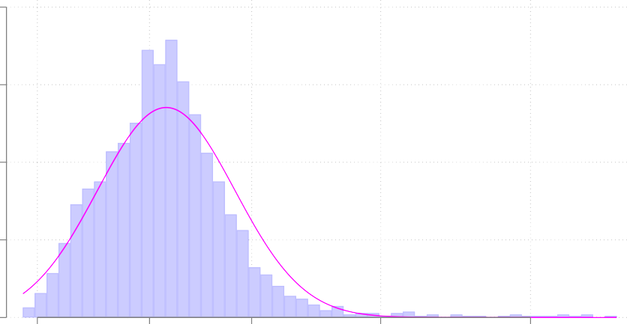
.8

.6

.4
Density

.2

0
90
seconds

5
minutes

15
minutes

1 hour 5 hours

Time to complete (log seconds)

Figure C-1: Distribution of time to complete survey

Speeding is correlated with: (a) failing the treatment information check and incorrectly answer- ing the factual questions about the Supreme Court, as shown in the upper plots in Figure C-2. The bottom two plots show that speeding is correlated with skipping the party leader feeling ther- mometer questions and with indicating that they feel strongly positive towards both Trump and Biden, a highly unlikely scenario. Strongly liking both is coded as rating them each above 80 on a 0-100 scale. Conversely there are a substantial number of respondents who do not like either leader, which is consistent with polling in 2023 (Epstein, Igielnik and Baker, 2023; Loffman, 2023). These correlations show that speeding is associated with a large degree of inaccuracy in answering survey questions correctly. These respondents are simply not paying attention to the survey.
Rather than dropping respondents who speed (Varaine, 2023), in the main text we report results with these respondents included and here, in the Appendix, show that results hold when excluding respondents who are likely speeding. We examine the main findings reported in the main text but drop respondents sequentially in order of time-to-complete the survey.
Recall that the main findings for partisan affect reported in the main text (Figure 1) are the following: (a) the combined treatment effect (i.e., all three treatment conditions relative to the control condition) for Republican ID respondents on negative out-party affect is positive (0.173, in the left plot of Figure 1) and significant at the 0.05 level; and (b) the estimated effects for the treatment condition alone (0.23) and the treatment combined with endorsement (0.24) are positive and statistically significant. Here we show how these two estimates – (a) and (b) – vary as we

.25

.2
Likelihood of failing information check

.15

.1

.05
Fail information check
Factual knowledge of the courts
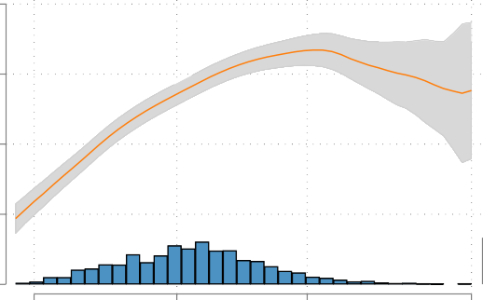
.6
Share of factual court questions answered correctly

.5

.4

.3

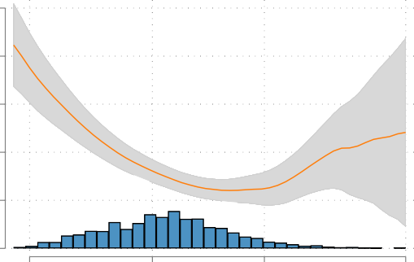
0
90
seconds

5
minutes

15
minutes Time (log scale)

1 hour

.2
90
seconds

5
minutes

15
minutes Time (log scale)

1 hour

.2
Likelihood of skipping questions about Biden and Trump

.15

.1

.05
Skip party leader thermometers

.15
Likelihood of supporting both leaders

.1

.05
Support Biden & Trump

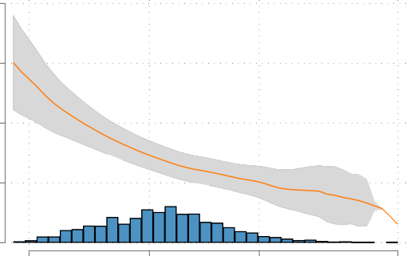
0
90
seconds

5
minutes

15
minutes Time (log scale)

1 hour

0

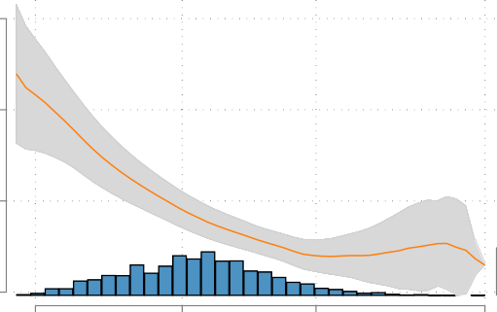
90
seconds

5
minutes

15
minutes Time (log scale)

1 hour

Figure C-2: Speeders and information accuracy.

change the threshold for excluded speeders.
The left plot in Figure C-3 shows the estimates for combined treatment effect (a). The hor- izontal scale depicts the time to completion and the histogram displays the distribution of time to completion. The median time to complete among all respondents is roughly 5.9 minutes, as indicated in the vertical dashed line in the middle of the green distribution. The estimates in blue and the associated error bands in gray show the result when dropping respondents who fall under the time-to-complete threshold depicted on the horizontal scale. For example the estimate depicted at 60 seconds corresponds to the estimate of the (combined) treatment effect when we drop all re- spondent who took less than 60 seconds to complete the survey. The main reported result remains stable in the left plot up to dropping all the respondents who took less than the median time to complete.
The right plot of Figure C-3 shows the estimated treatment effect for (b): treatment condition alone plus treatment combined with endorsement, relative to the control condition. Again, we find that the reported result is robust until we exclude all the respondents who took less than the median time to complete the survey.

Varying the threshold for excluding Speeders
Combined Treatments Treatment & Treatment + Endorse

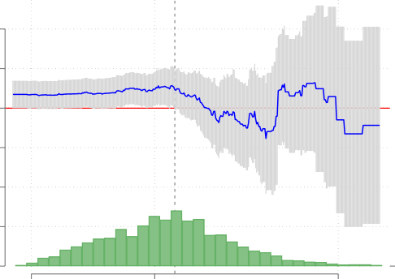
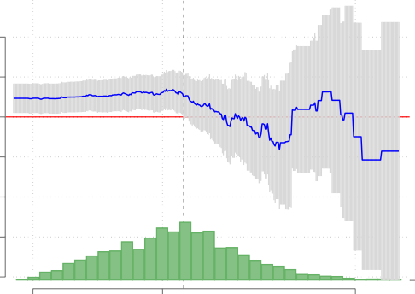
1 1
5.9
minutes
5.9
minutes

.5 .5

0 0
Estimate
Estimate

-.5 -.5

-1 -1

-1.5 -1.5

-2
90
seconds

5
minutes

30
minutes
-2
90
seconds

5
minutes

30
minutes

Time (log scale) Time (log scale)

Gray error bars indicate 95% ci

Figure C-3: Estimates by time to completion.
Together, we interpret the evidence in Figures C-1 to C-3 to indicate that: 1) there are a nontrivial group of respondents who a likely speeding and 2) the reported results do not change whether we drop speeders or include them in the analysis. In reproduction files, we created a two dimensional inattention profile for each respondent and show that adjusting for inattention, ignoring inattention, or excluding in attentive respondents does not change the result.

Respondents without factual knowledge of the court In Figure 1 in the main text, we examine the intent-to-treat (ITT) effect among respondents with some factual knowledge of the court. These respondents, who answer 0 of three factual questions about the U.S. Supreme Court correctly, comprise 22 percent of the sample. This share varies between 21 and 23 percent among treatment arms, indicating balance on this feature of respondents. In the verification files we conduct t-tests showing that these respondents are more than twice as likely other respondents to: (a) speed through the survey (24 percent vs. 11 percent); and (b) fail the attention check (18 percent vs. 7 percent). This suggests that respondents who indicate no factual knowledge of the court are also

speeding through the survey and, likely, not paying attention. They may not be compliers, with any treatment arm. While these respondents are likely not paying attention to the survey questions, they are not dissimilar to other respondents in partisanship or intensity of party ID. That is, excluding low info respondents is not simply a way of excluding low intensity voters.

Balance tests and covariate adjustment Table C-4 shows the result of covariate balance tests. For each covariate, we conduct four t-tests. The first is a test of the difference of means between the combined treatment group and the control group. The second is a t-test comparing the treatment only group to the control group. And the third and fourth compare the control to the treatment
+ condemn and treatment + endorse groups. We report standard errors for one-tailed tests in the direction of the difference in means. Two covariates fail the test, with some p-values less than 0.05: strongman values and college education.

Table C-3: Covariate t-tests
Combined Treatment Treatment Treatment
Covariate | treatment | only | + condemn | + endorse
Strongman values | -0.10* | -0.11* | -0.07 | -0.11*
 | (0.05) | (0.06) | (0.06) | (0.06)
Democratic values | 0.04 | 0.05 | 0.04 | 0.02
 | (0.04) | (0.05) | (0.05) | (0.05)
Male | -0.03 | 0.00 | -0.02 | -0.07*
 | (0.02) | (0.03) | (0.03) | (0.03)
Age | -0.21 | -0.12 | -0.04 | -0.46
 | (0.81) | (1.00) | (0.98) | (1.00)
Rural | 0.00 | 0.00 | -0.00 | 0.00
 | (0.02) | (0.03) | (0.03) | (0.03)
College | 0.04 | 0.06* | 0.05 | -0.00
 | (0.02) | (0.03) | (0.03) | (0.03)
White | 0.02 | 0.03 | 0.03 | -0.01
 | (0.03) | (0.03) | (0.03) | (0.03)
∗ statistical significance at the 0.05 level. Standard errors reported in parentheses.

In the main text we reported results without covariate adjustment. Table C-4 compares the main reported result with no adjustments (third column) with estimates that adjust for all covariates and that adjust only for the strongman index and college. The regression only uses a sample of Republican ID respondents. The first column shows the results with no covariate adjustment, as reported in the main text. The next column adds two covariates that fail the balance test to the specification. The final column adjusts for two pre-treatment measures of attitudes (affinity for strongman rule and support for principled democracy) plus post-treatment demographic variables. Changing the specification does not alter the main reported estimates by much.

Positive affect In the main text we report results for negative partisan affect to examine the channel we theorize linking leader attacks on democracy to affective partisanship and thus polar- ization. Here we report results for positive partisan affect. This outcome reflects whether partisans respond to leader attacks on democracy by increasing their in-party affect. If respondents embrace their partisan leader because the leader is a “fighter” who attacks government institutions that constrain the leader, then partisans may increase their in-party affect in response to an attack on democracy. Conversely, a principled democrat who values democracy more than partisanship would

Table C-4: Robustness tests for negative out-party affect
Reported specification
 | No covariate adjustment | Adjust for 2 covariates | Adjust for 7 covariates
 | (1) | (2) | (3)
Treatment | 0.229* | 0.228* | 0.232*
 | (0.109) | (0.110) | (0.110)
Treatment + Condemn | 0.040 | 0.046 | 0.062
 | (0.110) | (0.110) | (0.111)
Treatment + Endorse | 0.239* | 0.240* | 0.229*
 | (0.112) | (0.112) | (0.112)
Strongman |  | 0.053 | 0.104
 |  | (0.056) | (0.054)
College |  | 0.036 | 0.032
 |  | (0.084) | (0.085)
White |  |  | -0.124
 |  |  | (0.121)
Male |  |  | 0.253*
 |  |  | (0.086)
Rural |  |  | 0.086
 |  |  | (0.084)
Age |  |  | -0.007*
 |  |  | (0.003)
Principled democrat |  |  | 0.001
 |  |  | (0.056)
(Intercept) | -1.189* | -1.194* | -0.989*
 | (0.076) | (0.082) | (0.226)
Respondents | 659 | 657 | 645
∗ indicates statistical significance at the 0.05 level. Robust standard errors in parentheses. Republican ID respondents only.

decrease affect when their party leader attacks democracy.
Figure C-4 reports the results for positive partisan affect. The left plot reports the difference- in-means tests for all respondents and for those with some basic political knowledge of the Supreme Court. We find no difference in means between treatments and the control group. The right plot compares the three treatment types to the control scenario, and again we find not significant differences – for either Democrats or Republicans. In short, the results for positive affect are all null. This suggests that partisans do not respond to their own party leader’s attack on democracy by increasing (or decreasing) positive affect towards their own party.

Combined results for covariates and affect In this section we report results from regressions that combine all respondents in the same sample. This allows us to see how partisanship and the covariates correlate with negative and positive affect, on average. These tests are not tests of the theory but rather provide some substantive context for interpreting the tests of the experimental treatments.
The left plot of Figure C-5 shows the correlations for negative affect – or the affect that par- tisans have towards the out-party. The estimate for Democratic ID, male, and strongman are all positive and statistically significant. This indicates that, on average, Democrats have 0.20 standard

Positive affect towards the in-party

Difference in means
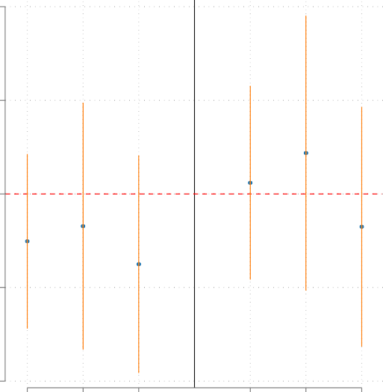
.2
.044
.012
-.034
-.035
-.051
-.075
Condemn and Endorse

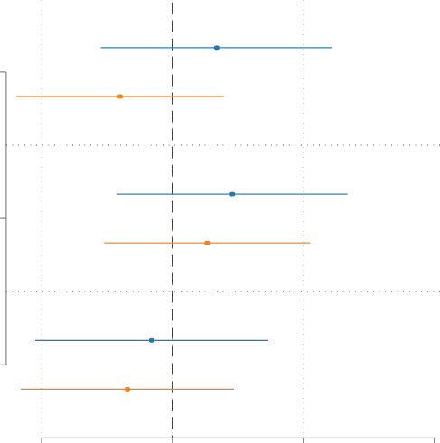
Treatment
0.07
-0.08
0.09
0.05
-0.03
-0.07

.1

0
Difference in means

Treatment
+
Condemn

-.1

Treatment
+
Endorse

-.2

D+R Dem Rep D+R Dem Rep Partisan group

-0.20 0.00 0.20 0.40
Treatment effect estimate

Democrat id (N=818) Republican id (N=565)

Figure C-4: Positive in-party affect.

deviations more negative affect than Republicans. Similarly, males have 0.12 more negative affect than non-males; and those with a strong affinity for strongman rule have more negative affect (0.12) than those with low affinity for strongman rule. We use the size of these estimates to help interpret and contextualize the treatment effect estimates reported in the main text.

Negative affect
(affect towards out-party)
All respondents

Positive affect
(affect towards in-party)

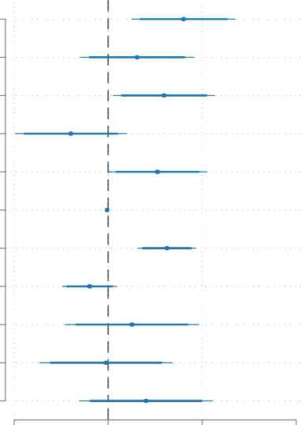
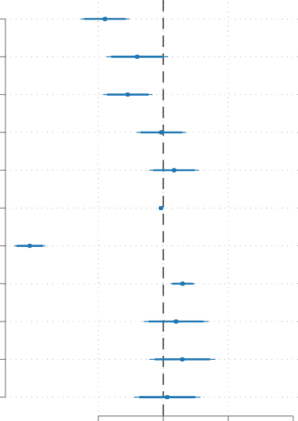
Democrat (not Republican) Democrat (not Republican)
0.16
0.06
0.12
-0.08
0.10
-0.00
0.12
-0.04
0.05
-0.00
0.08
-0.18
-0.08
-0.11
-0.01
0.03
-0.01
-0.41
0.06
0.04
0.06
0.01

White White

Male Male

Rural Rural

College College

Age Age

Strongman Strongman

Principled democrat Principled democrat

Treatment Treatment

Treatment
+
Condemn
Treatment
+
Endorse

-0.20 0.00 0.20 0.40
Estimate

Treatment
+
Condemn
Treatment
+
Endorse

-0.20 0.00 0.20 0.40
Estimate

90% & 95% ci

Figure C-5: Combined Republican ID and Democratic ID results for affect.

4 Appendix D: Additional material for Study 2 (CSES analysis)

Table D-1: Full results for Table 2 in Main Text
Government attacks on democracy and micro-polarization
Polarization In-party affect Out-party affect
 | (1) | (2) | (3) | (4) | (5) | (6)
Attack on judiciary | 1.151 | -1.209 | -0.745 | -0.956 | -2.074* | 0.519
 | (0.622) | (1.265) | (0.577) | (0.990) | (0.654) | (0.896)
Ruling party personalism | 0.618 | -1.836 | 0.248 | 0.017 | -0.273 | 2.425*
 | (0.449) | (1.209) | (0.219) | (0.745) | (0.444) | (0.906)
Attack on jud. × Ruling party pers. |  | 6.177 |  | 0.566 |  | -6.787*
 |  | (3.153) |  | (1.677) |  | (2.308)
Initial democracy level | 1.657 | 3.287 | -0.534 | -0.445 | -1.883 | -3.675
 | (2.594) | (3.196) | (1.209) | (1.175) | (2.027) | (2.536)
Democracy age | 0.001 | 0.006 | 0.033 | 0.032 | 0.076 | 0.070
 | (0.067) | (0.058) | (0.053) | (0.054) | (0.081) | (0.075)
Time trend | 0.035* | 0.034* | -0.003 | -0.003 | -0.031* | -0.029*
 | (0.013) | (0.012) | (0.007) | (0.007) | (0.013) | (0.012)
Party ID | 1.131 | 0.780 | 0.875* | 0.846* | -0.144 | 0.242
 | (0.623) | (0.521) | (0.269) | (0.305) | (0.545) | (0.463)
L-R polarization | 0.199* | 0.162 | 0.093* | 0.090 | -0.105 | -0.065
 | (0.076) | (0.084) | (0.041) | (0.046) | (0.056) | (0.065)
Effective # parties | -0.164* | -0.178* | 0.100* | 0.099* | 0.257* | 0.272*
 | (0.059) | (0.059) | (0.037) | (0.039) | (0.054) | (0.050)
Presidential | -0.622* | -0.487* | -0.405* | -0.398* | 0.262 | 0.114
 | (0.220) | (0.209) | (0.101) | (0.094) | (0.207) | (0.188)
Public sector corruption index | 1.137 | 1.058 | 1.308* | 1.279* | 0.013 | 0.099
 | (0.927) | (0.852) | (0.550) | (0.577) | (0.702) | (0.623)
GDP pc (log) | -0.531 | -0.713* | -0.023 | -0.040 | 0.228 | 0.428
 | (0.310) | (0.340) | (0.232) | (0.244) | (0.270) | (0.270)
(Intercept) | 6.840 | 8.521* | 7.647* | 7.857* | 3.198 | 1.350
 | (3.925) | (4.115) | (2.774) | (3.066) | (3.441) | (3.339)
# of elections | 82 | 82 | 99 | 99 | 82 | 82
# of countries | 36 | 36 | 39 | 39 | 36 | 36
∗ indicates statistical significance at the 0.05 level. Cluster robust standard errors. Covariates include: party ID; left-right polarization; effective number of parties; presidential system; corruption; GDP per capita; a time trend; democracy age; and initial level of democracy when the leader is selected into power.

The columns 3 and 4 report results for in-party affect. We find no substantive results linking attacks on the judiciary to in-party affect – either an average effect or one moderated by ruling party personalism.

Extension of Reiljan et al. (2023) Our sample differs slightly from the main sample in Reiljan et al. (2023) because we use elections in democracies with an elected chief executive. The ruling party personalism variable from Frantz et al. (2022) is coded for all democracies (1991-2020) in countries with more than 1 million population and a directly elected leader. This excludes Czech Republic (2010) and Greece (2012) because they have appointed interim leaders, not elected chief executives. Mexico (1997) and Taiwan (1996) are not included because these elections occurred prior to democratic transitions in these countries in 2000. Turkey (2018) is excluded because it is

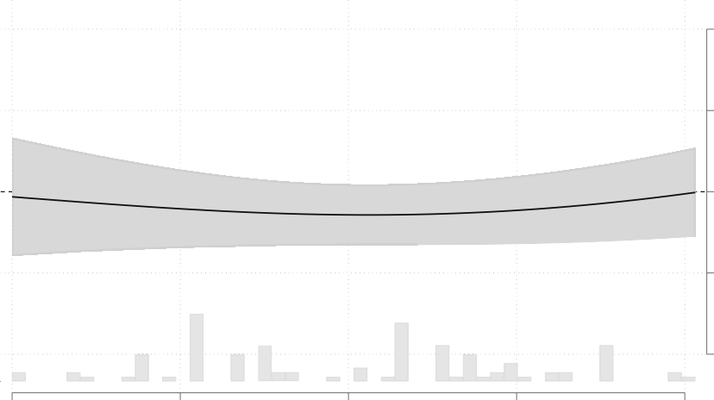
In-party affect

6

3

0

-3

-6

0 .2 .4 .6 .8
Ruling party personalism

Figure D-1: Kernel regression interaction estimates from Table D-1, column (4)

not a democracy after the 2016 failed coup attempt. Montenegro has less than 1 million population and Switzerland has no elected chief executives.

Table D-2 shows results from a reproduction and an extension of the main model of party affective polarization, presented in Reiljan et al. (2023). The first column is an exact reproduction of the result in column 1 of their Table 2. The second column omits government effectiveness and substi- tutes measures of related concepts: GDP per capita and public sector corruption. We change the specification in this way for our tests because government effectiveness is conceptually and empiri- cally highly correlated with government attacks on the judiciary. Thus, for a very ordinary technical reason – collinearity – we make this substitution. However, in Figure D-2 we show that main find- ing does not change appreciably when we include government effectiveness in the specification. The final column uses the same specification as in (2) but alters the sample to match the sample we use in our analysis (see main text).
The results indicate that altering the specification or the sample slightly has no material effect on the results reported in column (1). When we change the specification as a result of collinearity issues that arise in our analysis and change the sample due to data availability, we do not alter any of the findings for the covariates that Reiljan et al. (2023) hypothesize are related to party affective polarization.

Additional tests Tables D-3 and D-4 show results from robustness tests for the Affective polar- ization index (D-3) and Out-party affect (D-3). Each table highlights two rows. First, we highlight the estimates for interaction between an attack on democracy and ruling party personalism, as this variable is the test of the main theoretical prediction. Second, we highlight a row at the bottom of each table, which reports the estimate for βAttack|HighPers. This estimate is the linear combination of the treatment plus the interaction when the moderator has a high value (one standard devia- tion above the sample mean). Substantively, this is the estimated marginal effect of an attack on democracy when ruling party personalism is high.

Adjust for Government Effectiveness

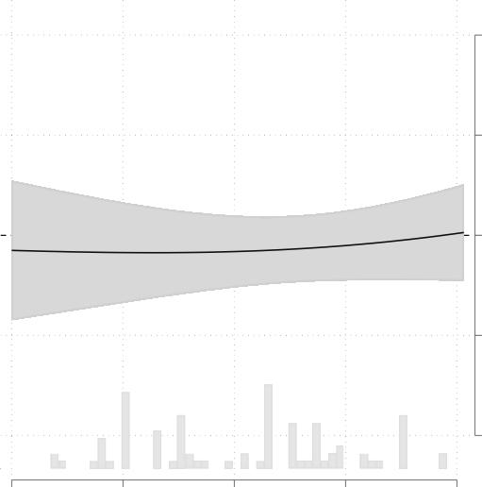
In-party affect

6

3
Marginal effect of leader attack on the judiciary

0

-3

-6

0 .2 .4 .6 .8
Ruling party personalism
Out-party affect

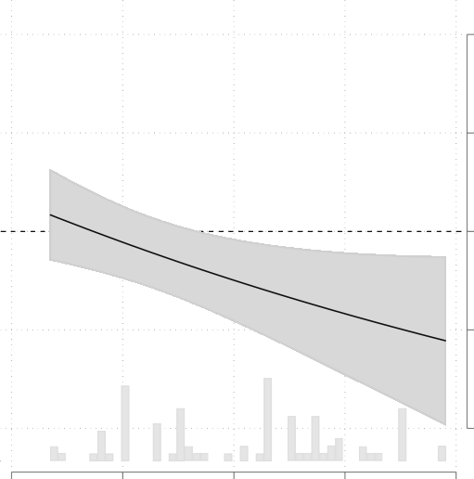
6

3
Marginal effect of leader attack on the judiciary

0

-3

-6

0 .2 .4 .6 .8
Ruling party personalism

Figure D-2: Adjusting for government effectiveness in tests of government attacks on democracy and affective polarization.

The first column in each table reports the results from the main text, Table 2 columns (2) and
(6). These tests measure polarization and out-party affect among partisans and the referent in the
party. We provide these estimates for comparison.
Next, in each table, we alter the outcome variable such that outcomes for polarization and out- party affect with the leader as the referent. In both cases, polarization in Table D-3 and out-party affect in Table D-4, the result in column (1) is slightly stronger than the result reported in the main text. This makes sense because leaders may be more polarizing than party labels.
The next two columns – (2) and (3) – in Tables D-3 and D-4 show results when we measure the outcomes among all voters – not just among partisans. In both cases, the results are weaker. Again, this makes sense because the polarizing effect of government attacks on democracy (amplified by party personalism) should be weaker among self-identified non-partisans than among partisans; and measuring the outcomes among all voters combines both of these groups together.
The next three columns – (4) - (6) – in Tables D-3 and D-4 show results when we omit covariates from the specification. First we drop all covariates in (4). Next we drop covariates in the specification offered by Reiljan et al. (2023) in (5). Last, we drop covariates related to selection into ruling party personalism: initial democracy level when the leader is selected into power and the age of the democracy, in (6). Substantively, the main results for the interaction between attacks on democracy and ruling party personalism remain in columns (4) and (5). However in (6), the main results point in the correct direction but are weaker. Even in these tests in column (6) – which omit variables related to selection into ruling party personalism – the effect of an attack on democracy on polarization remains statistically significant when ruling party personalism high but not when it is low.
The last four columns in each table – (7) - (10) – add a variable, one at a time, to the main

Table D-2: Verification and extension of Reiljan et al. (2023)
Table 2, column 1
Party affective polarization (PAP)

 | Original  estimate | Adjust  covariates | Adjust  sample
 | (1) | (2) | (3)
Party ID | 1.524* | 1.232* | 1.310*
 | (0.412) | (0.437) | (0.426)
L-R polarization | 0.184* | 0.251* | 0.282*
 | (0.080) | (0.062) | (0.062)
Effective # parties | -0.149* | -0.167* | -0.153*
 | (0.039) | (0.041) | (0.043)
Presidential | -0.899* | -0.700* | -0.826*
 | (0.202) | (0.219) | (0.179)
Government effectiveness | -0.762*
 | (0.130)
Public sector corruption index |  | 1.533* | 1.502*
 |  | (0.573) | (0.551)
GDP pc (log) |  | -0.521* | -0.537*
 |  | (0.174) | (0.185)
Year | 0.025* | 0.036* | 0.034*
 | (0.008) | (0.009) | (0.009)
(Intercept) | 6.134* | 8.246* | 8.205*
 | (0.642) | (1.763) | (1.852)
N × T | 102 | 93 | 100
# Countries | 40 | 37 | 39
∗ indicates statistical significance at the 0.05 level. Standard errors clustered on country.

specification. These variables help us isolate the effect of ruling party personalism from other party- related concepts. We test four: initial level of polarization in society in the year in which each leader is selected into power; initial level of judicial independence; initial level of party system institutionalization; and ruling party populism. Adding these to the specification does not alter the main results and, in fact, makes them slightly stronger in some cases.
Figure D-2 shows the results for in-party and out-party affect when we include government effectiveness in the specification. The main results hold: attacks on democracy decrease out-party affect when the ruling party is more personalist.

Table D-3: Affective polarization index
D-5
Party polariz. among  partisans |  | Leader polariz. among  partisans | Party polariz. among  voters | Leader polariz.  among Party polarization among partisans, columns (5)-(11)  voters
 | Reported | (1) | (2) | (3) | (4) | (5) | (6) | (7) | (8) | (9) | (10)
Attack on judiciary | -1.209 | -1.031 | -0.242 | 0.326 | 0.313 | 0.086 | -0.691 | -0.656 | -1.560 | -1.386 | -1.153
 | (1.265) | (1.483) | (1.150) | (1.340) | (1.275) | (1.295) | (1.189) | (1.574) | (1.153) | (1.449) | (1.215)
Ruling party pers. | -1.836 | -2.009 | -0.607 | -0.228 | -2.209 | -3.198* | -1.020 | -2.077 | -2.227 | -1.982 | -1.836
 | (1.209) | (1.388) | (1.107) | (1.128) | (1.098) | (1.461) | (0.939) | (1.624) | (1.135) | (1.228) | (1.156)
Attack × pers. | 6.177 | 7.171 | 2.228 | 1.898 | 6.687* | 8.376* | 4.038 | 6.153 | 7.094* | 6.538* | 6.289*
 | (3.153) | (3.745) | (2.517) | (2.729) | (2.703) | (3.254) | (2.198) | (4.196) | (3.018) | (3.213) | (2.934)
Initial democracy | 3.287 | 5.915 | 0.611 | 2.383 |  | 2.834 |  | 3.059 | 2.424 | 3.397 | 6.069*
 | (3.196) | (4.559) | (1.984) | (2.755) |  | (2.468) |  | (3.527) | (3.031) | (3.149) | (2.675)
Democracy age | 0.006 | 0.049 | 0.030 | 0.082 |  | -0.106 |  | -0.001 | -0.013 | 0.016 | -0.022
 | (0.058) | (0.106) | (0.061) | (0.087) |  | (0.098) |  | (0.059) | (0.064) | (0.061) | (0.053)
Time trend | 0.034* | 0.039* | 0.031* | 0.031* |  |  | 0.032* | 0.033* | 0.037* | 0.034* | 0.030*
 | (0.012) | (0.013) | (0.010) | (0.011) |  |  | (0.013) | (0.013) | (0.013) | (0.013) | (0.012)
Party ID | 0.780 | 0.581 | 1.310* | 1.506* |  |  | 0.864 | 0.768 | 0.187 | 0.792 | 0.836
 | (0.521) | (0.647) | (0.438) | (0.490) |  |  | (0.562) | (0.535) | (0.578) | (0.548) | (0.487)
L-R polarization | 0.162 | 0.132 | 0.242* | 0.223* |  |  | 0.206* | 0.165 | 0.172* | 0.184 | 0.129
 | (0.084) | (0.109) | (0.067) | (0.089) |  |  | (0.064) | (0.097) | (0.081) | (0.095) | (0.069)
Effective # parties | -0.178* | -0.227* | -0.152* | -0.180* |  |  | -0.182* | -0.186* | -0.202* | -0.184* | -0.177*
 | (0.059) | (0.081) | (0.049) | (0.061) |  |  | (0.062) | (0.073) | (0.060) | (0.074) | (0.081)
Presidential | -0.487* | -0.333 | -0.811* | -0.649 |  |  | -0.577* | -0.482 | -0.369 | -0.472* | -0.417*
 | (0.209) | (0.447) | (0.188) | (0.352) |  |  | (0.233) | (0.241) | (0.206) | (0.204) | (0.168)
Public sector corrupt. | 1.058 | 1.887 | 1.386 | 2.036 |  |  | 0.518 | 0.841 | 1.353 | 0.991 | 1.336
 | (0.852) | (1.310) | (0.867) | (1.129) |  |  | (0.821) | (0.821) | (0.823) | (0.888) | (0.941)
GDP pc (log) | -0.713* | -0.780 | -0.496 | -0.535 |  |  | -0.649 | -0.674 | -0.690 | -0.652 | -0.504
 | (0.340) | (0.452) | (0.259) | (0.316) |  |  | (0.363) | (0.347) | (0.343) | (0.402) | (0.331)
Polarization_{t=0} |  |  |  |  |  |  |  | -0.056
 |  |  |  |  |  |  |  | (0.070)
Judicial indep._{t=0} |  |  |  |  |  |  |  |  | 0.276*
 |  |  |  |  |  |  |  |  | (0.082)
Party system inst._{t=0} |  |  |  |  |  |  |  |  |  | -0.737
 |  |  |  |  |  |  |  |  |  | (1.375)
Ruling party popul. |  |  |  |  |  |  |  |  |  |  | 0.520
 |  |  |  |  |  |  |  |  |  |  | (0.452)
(Intercept) | 8.521* | 6.341 | 7.347 | 5.280 | 4.238* | 2.266 | 10.422* | 8.247 | 8.899* | 8.433* | 3.935
 | (4.115) | (5.921) | (3.686) | (4.794) | (0.361) | (2.111) | (4.014) | (4.087) | (4.065) | (4.086) | (3.863)
βAttack|LowPers | 0.26 | 0.40 | 0.20* | 0.71 | 1.65 | 1.76* | 0.12 | 0.57 | -0.14 | -0.08 | 0.10
 | (0.77) | (0.95) | (0.75) | (0.93) | (0.84) | (0.78) | (0.81) | (0.87) | (0.67) | (0.96) | (0.77)
βAttack|HighPers | 2.50* | 3.27* | 1.10 | 1.46 | 4.32* | 5.11* | 1.73* | 3.04* | 2.70* | 2.53* | 2.62*
 | (0.98) | (1.29) | (0.75) | (0.87) | (0.77) | (1.00) | (0.56) | (1.24) | (0.94) | (1.01) | (0.93)
Elections | 82 | 82 | 100 | 100 | 84 | 84 | 82 | 77 | 80 | 80 | 77
Countries | 36 | 36 | 39 | 39 | 36 | 36 | 36 | 35 | 36 | 36 | 33

Table D-4: Out-party affect
D-6
Party affect among  partisans |  | Leader affect among  partisans | Party affect among  voters | Leader affect  among Out-party affect among partisans, columns (5)-(11)  voters
 | Reported | (1) | (2) | (3) | (4) | (5) | (6) | (7) | (8) | (9) | (10)
Attack on judiciary | 0.519 | 1.363 | -0.533 | -0.324 | -1.124 | -1.068 | 0.060 | 0.173 | 0.266 | 1.002 | 0.658
 | (0.896) | (1.323) | (0.805) | (1.253) | (1.096) | (1.149) | (0.787) | (1.192) | (0.873) | (0.881) | (1.016)
Ruling party pers. | 2.425* | 2.594* | 1.489 | 1.245 | 1.135 | 1.828 | 1.349* | 2.418 | 2.332* | 2.497* | 2.654*
 | (0.906) | (1.195) | (0.768) | (1.014) | (0.902) | (1.165) | (0.592) | (1.329) | (0.918) | (0.844) | (0.844)
Attack × Pers. | -6.787* | -8.427* | -4.064* | -4.267 | -3.669 | -5.076 | -4.398* | -6.356 | -6.388* | -7.322* | -7.543*
 | (2.308) | (3.109) | (1.818) | (2.541) | (2.250) | (2.571) | (1.255) | (3.379) | (2.333) | (2.072) | (2.031)
Initial democracy | -3.675 | -6.634 | -2.003 | -3.895 |  | -2.693 |  | -3.374 | -4.198 | -4.126 | -6.332*
 | (2.536) | (3.612) | (1.618) | (2.259) |  | (1.867) |  | (2.866) | (2.551) | (2.287) | (1.457)
Democracy age | 0.070 | 0.013 | 0.073 | 0.007 |  | 0.046 |  | 0.079 | 0.036 | 0.079 | 0.091
 | (0.075) | (0.095) | (0.071) | (0.082) |  | (0.087) |  | (0.077) | (0.066) | (0.078) | (0.079)
Time trend | -0.029* | -0.038* | -0.028* | -0.034* |  |  | -0.027* | -0.027* | -0.032* | -0.024 | -0.027*
 | (0.012) | (0.014) | (0.010) | (0.012) |  |  | (0.013) | (0.013) | (0.012) | (0.013) | (0.011)
Party ID | 0.242 | 0.291 | 0.215 | 0.018 |  |  | 0.217 | 0.273 | -0.235 | 0.300 | 0.155
 | (0.463) | (0.621) | (0.411) | (0.534) |  |  | (0.505) | (0.445) | (0.466) | (0.453) | (0.441)
L-R polarization | -0.065 | -0.041 | -0.067 | -0.056 |  |  | -0.119* | -0.077 | -0.062 | -0.116 | -0.028
 | (0.065) | (0.097) | (0.056) | (0.085) |  |  | (0.045) | (0.078) | (0.064) | (0.074) | (0.044)
Effective # parties | 0.272* | 0.334* | 0.260* | 0.306* |  |  | 0.267* | 0.277* | 0.247* | 0.303* | 0.279*
 | (0.050) | (0.069) | (0.040) | (0.055) |  |  | (0.057) | (0.061) | (0.050) | (0.056) | (0.066)
Presidential | 0.114 | 0.109 | 0.419* | 0.430 |  |  | 0.175 | 0.141 | 0.166 | 0.130 | 0.047
 | (0.188) | (0.315) | (0.201) | (0.294) |  |  | (0.220) | (0.208) | (0.197) | (0.193) | (0.157)
Public sector corrupt. | 0.099 | -1.047 | 0.417 | -0.460 |  |  | 0.559 | 0.256 | 0.445 | 0.056 | -0.092
 | (0.623) | (1.121) | (0.602) | (0.993) |  |  | (0.662) | (0.661) | (0.692) | (0.660) | (0.738)
GDP pc (log) | 0.428 | 0.446 | 0.470 | 0.533 |  |  | 0.462 | 0.396 | 0.518* | 0.134 | 0.300
 | (0.270) | (0.348) | (0.242) | (0.306) |  |  | (0.290) | (0.290) | (0.252) | (0.343) | (0.279)
Polarization_{t=0} |  |  |  |  |  |  |  | 0.003
 |  |  |  |  |  |  |  | (0.069)
Judicial indep._{t=0} |  |  |  |  |  |  |  |  | 0.197*
 |  |  |  |  |  |  |  |  | (0.069)
Party system inst._{t=0} |  |  |  |  |  |  |  |  |  | 2.010
 |  |  |  |  |  |  |  |  |  | (1.221)
Populism |  |  |  |  |  |  |  |  |  |  | -0.285
 |  |  |  |  |  |  |  |  |  |  | (0.381)
(Intercept) | 1.350 | 3.786 | -0.159 | 1.235 | 4.078* | 6.204* | -1.628 | 1.411 | 0.939 | 2.767 | 4.863
 | (3.339) | (5.163) | (2.988) | (4.398) | (0.324) | (1.625) | (3.107) | (3.396) | (3.315) | (3.371) | (3.274)
βAttack|LowPers | -0.84 | -0.32 | -1.35* | -1.18 | -1.86* | -2.08* | -0.82 | -1.10 | -1.01 | -0.46 | -0.85
 | (0.57) | (0.91) | (0.55) | (0.86) | (0.72) | (0.74) | (0.60) | (0.69) | (0.53) | (0.61) | (0.67)
βAttack|HighPers | -3.55* | -3.69* | -2.97* | -2.88* | -3.33* | -4.11* | -2.58* | -3.64* | -3.57* | -3.39* | -3.87*
 | (0.80) | (1.13) | (0.62) | (0.79) | (0.60) | (0.76) | (0.47) | (1.14) | (0.79) | (0.77) | (0.51)
Elections | 82 | 82 | 100 | 100 | 84 | 84 | 82 | 77 | 80 | 80 | 77
Countries | 36 | 36 | 39 | 39 | 36 | 36 | 36 | 35 | 36 | 36 | 33

5 Appendix E: Additional material for Study 3 (Macro-polarization analysis)
Validating the measure of macro-polarization Figure E-1 shows the time trend for the average level of polarization in a sample of up to 39 countries between 1996 and 2019 (with available data from the CSES). The first measure is the variable v2cacamps from the Varieties of Democracy (VDem) project, which we use to measure macro-polarization. The second is a measure from Reiljan et al. (2023) of the average out-party (negative) affect among voters derived from the CSES surveys. For the plots in E-1 and E-2, we standardize each polarization measure so that the mean in-sample is zero and the standard deviation is equal to one.
The calendar time trends depicted in Figure E-1 are similar, with both measures only increasing after 2000 or 2001. This descriptive evidence suggests that the underlying data are capturing the same time trend in polarization, at least in this sample of countries during this time period.

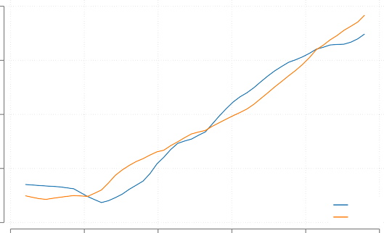
.4
VDem
CSES

.2

0
Polarization

-.2

-.4
1995 2000 2005 2010 2015 2020
Year
Polynomial fit bandwidth set to 3 years for each trend line. NxT=97. 39 countries between 1996 and 2019.

Figure E-1: Time trends in VDem v2cacamps and CSES average out-party (negative) affect among voters.
Figure E-2 shows the fit lines correlating the two measures. In the left plot, the VDem measure of polarization is depicted on the horizontal axis, while the CSES measure is on the vertical axis. The histogram along the horizontal axis shows the distribution of VDem polarization. The linear fit reflecting the correlation between the two variables is in red; the slope in the left plot is positive (β=0.44) and statistically significant (SE=0.09). We also plot the nonlinear fit (and associated 95 percent confidence interval) using a polynomial estimator. This shows that the correlation (i.e. slope) in the nonlinear fit is similar to the linear fit between -1 and 1 standard deviation of the mean value of the (standardized) mean of the VDem variable. Below -1 standard deviation, the fit is flat, but at greater than 1 standard deviation the slope is positive and stronger. The right plot reports the same pattern but flips the variables on the horizontal (CSES) and vertical (VDem) axes. In short, the two variables are correlated – except at the low ends of the scales.
In the verification files, we also test whether the correlation between the two measures remains when we partial out country fixed effects. This test yields a slightly stronger slope estimate (β=0.44; SE=0.19) and thus suggests that the correlation remains when we isolate over-time variation in the two variables. Finally, in the verification files we show that the VDem measure is not strongly correlated with CSES measure of average in-party affect among voters (β=0.16; SE =0.10). This suggests that the macro-data in the VDem measure is picking up negative affect towards the out- party rather than positive affect towards the in-party.

Polarization measures correlated with each other

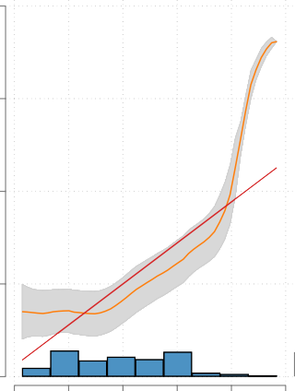
3

2
CSES polarization

1

0

-1
-2 -1 0 1 2 3
VDem polarization

3

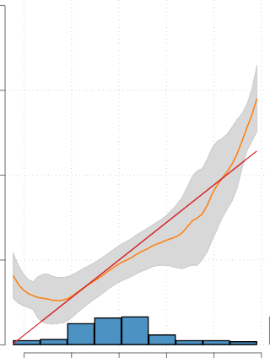
2
VDem polarization

1

0

-1
-2 -1 0 1 2 3
CSES polarization

95% confidence intervals in gray. Polynomial bandwidth in each plot set to 1/2 standard deviation of the x-axis variable.

Figure E-2: Correlation between VDem v2cacamps and CSES average out-party (negative) affect among voters.

Table E-1: Government attacks on democracy and macro-polarization
 | (1) | (2) | (3) | (4) | (5) | (6) | (7) | (8)
Attack on judiciary | 2.248* | 1.324* | 1.577* | 0.892* | 1.585* | 0.907* | 0.480* | 0.231
 | (0.283) | (0.462) | (0.214) | (0.329) | (0.220) | (0.329) | (0.104) | (0.157)
Ruling party personalism | 0.104 | -0.517* | 0.014 | -0.443* | 0.021 | -0.439* | 0.054 | -0.117
Attack on jud. × Pers Polarization_{t=0} | (0.097) | (0.257) 1.454* (0.596) | (0.075)  0.481* | (0.191) 1.068* (0.429)  0.479* | (0.077)  0.482* | (0.189) 1.074* (0.426)  0.481* | (0.033) | (0.081) 0.399* (0.186)
 |  |  | (0.038) | (0.038) | (0.039) | (0.039)
Judicial independence_{t=0} |  |  |  |  | 0.301 | 0.314 | 0.071 | 0.076
 |  |  |  |  | (0.235) | (0.238) | (0.087) | (0.088)
Democracy level_{t=0} |  |  |  |  | -0.028 | -0.024 | -0.008 | -0.006
 |  |  |  |  | (0.026) | (0.027) | (0.010) | (0.010)
Democracy age (log) |  |  |  |  | 0.011 | 0.009 | 0.021 | 0.020
Election year Polarization_{t−1} |  |  |  |  | (0.034) 0.028* (0.010) | (0.034) 0.029* (0.010) | (0.013) 0.034* (0.009) 0.836*  (0.021) | (0.013) 0.034* (0.009) 0.834*  (0.021)
(Intercept) | -0.948* | -0.579* | -0.410* | -0.138 | -0.488 | -0.251 | -0.291* | -0.202
 | (0.123) | (0.185) | (0.101) | (0.139) | (0.273) | (0.293) | (0.104) | (0.110)
Country FE | ✓ | ✓ | ✓ | ✓ | ✓ | ✓ | ✓ | ✓
Year FE | ✓ | ✓ | ✓ | ✓ | ✓ | ✓ | ✓ | ✓
Yt=0  Covariates |  |  | ✓ | ✓ | ✓  ✓ | ✓  ✓ | ✓ | ✓
Yt−1 |  |  |  |  |  |  | ✓ | ✓
N × T | 2359 | 2359 | 2302 | 2302 | 2302 | 2302 | 2302 | 2302
# Leaders | 583 | 583 | 567 | 567 | 567 | 567 | 567 | 567
∗ indicates statistical significance at the 0.05 level. Standard errors clustered on leader.

Interaction effect plots In Table 3 in the main text, we report results from a test of macro- polarization with a specification that included an interaction term between attacks on democracy and ruling party personalism. The linear model in those regressions assumes a linear interaction. In Figure 3 in the main text we reported the substantive effect of the interaction terms with a kernel regression estimator that relaxes the linear interaction assumption for the dynamic panel model (i.e. two-way FE + lagged outcome). Here, in Figure E-3 we report the binning estimates for the interactive effect for all four models reported in Figure 3. While the interaction effect is not perfectly linear, the monotonically increasing marginal effect of attacks on democracy as ruling party personalism increases is consistent with the main hypothesis.

Additional lags and IFE Table E-2 reports results from additional tests of macro-polarization: models with additional lags of the outcome variable and interactive fixed effect models. Testing models with additional outcome lags ensures that the model captures any prior trends – potentially not captured in the one-year lag – in the outcome that might cause selection into the treatment. The interactive fixed effects models are an extension of two-way fixed effects models. The standard 2-way FE models all time-invariant heterogeneity between countries and all common time trends. The IFE, in addition, allows for the possibility that time shocks have a heterogeneous – rather than a common – effect on different units (Bai, 2009). For example, the 2008 Great Recession may have produced different shocks to long-lived democracies than new democracies.
The results in Table E-2 show that the main results hold. The theoretical interaction term in column (2) is positive and significant, while the split sample analysis in (4) and (5) shows that

3.5
Marginal effect of attack on the judiciary

3

2.5

2

1.5

1
Bivariate specification

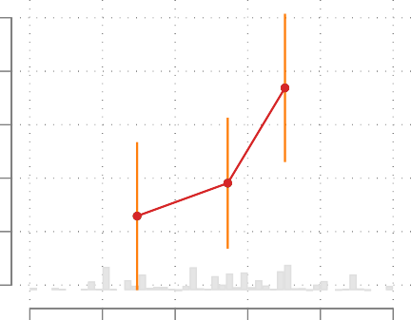
0 .2 .4 .6 .8 1
Ruling party personalism
Bivariate + adjust for initial polarization

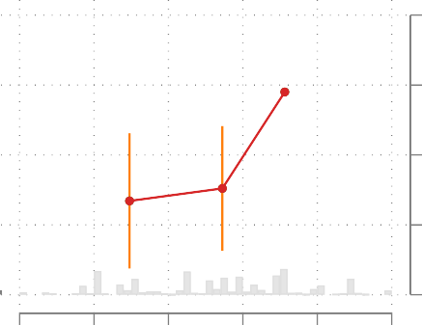
0 .2 .4 .6 .8 1
Ruling party personalism

2.5

2
Marginal effect of attack on the judiciary

1.5

1

.5

2.5
Marginal effect of attack on the judiciary

2

1.5

1

.5
Covariates + adjust for initial polarization
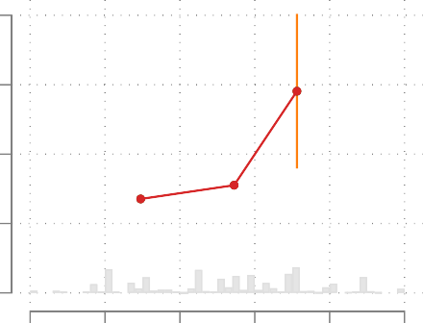
0 .2 .4 .6 .8 1
Ruling party personalism
Covariates + dynamic panel

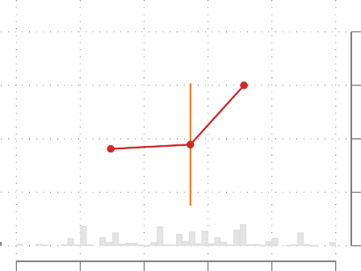
.8
Marginal effect of attack on the judiciary

.6

.4

.2

0
0 .2 .4 .6 .8 1
Ruling party personalism

Figure E-3: Government attacks on the judiciary boost polarization when the ruling party is per- sonalist, binning estimates.

attacks on democracy only boost polarization when ruling party personalism is high.4

Table E-2: Macro-polarization, additional lags and IFE

Additional lags (1)-(2) |  | Interactive FE (3)-(5)
No interaction Interaction  (1) (2) |  | Full sample (3) | Low  ruling party personalism (4) | High  ruling party personalism (5)
Attack on democracy | 0.488* 0.233 | 0.477* | 0.080 | 0.666*
 | (0.104) (0.155) | (0.105) | (0.142) | (0.189)
Attack × personalism | 0.414*
 | (0.186)
Ruling party personalism | 0.051 -0.126 | 0.028 | 0.033 | 0.088
 | (0.033) (0.081) | (0.033) | (0.041) | (0.109)
Judicial independence_{t=0} | 0.079 0.085 | 0.057 | 0.078 | 0.056
 | (0.090) (0.090) | (0.088) | (0.126) | (0.146)
Democracy level_{t=0} | -0.006 -0.005 | -0.004 | -0.011 | -0.006
 | (0.010) (0.011) | (0.009) | (0.017) | (0.020)
Democracy age | 0.019 0.019 | 0.017 | 0.050* | -0.015
 | (0.013) (0.013) | (0.012) | (0.019) | (0.026)
Election year | 0.034* 0.034* | 0.036* | 0.031* | 0.038*
 | (0.009) (0.009) | (0.009) | (0.011) | (0.015)
Polarization_{t−1} | 0.863* 0.860* | 0.847* | 0.882* | 0.768*
 | (0.041) (0.041) | (0.023) | (0.022) | (0.047)
Polarization_{t−2} | -0.021 -0.021
 | (0.024) (0.024)
Polarization_{t−3} | -0.008 -0.007
 | (0.022) (0.022)
Polarization_{t−4} | 0.010 0.010
 | (0.018) (0.018)
(Intercept) | -0.316* -0.222* | -0.281* | -0.226 | -0.274
 | (0.104) (0.112) | (0.098) | (0.152) | (0.181)
N × T | 2285 2285 | 2302 | 1222 | 1077
# Leaders | 564 564 | 567 | 259 | 304
# Countries |  | 100 | 73 | 84
Country FE  Year FE Additional lags IFE | ✓ ✓  ✓ ✓  ✓ ✓ | ✓  ✓  ✓ | ✓  ✓  ✓ | ✓  ✓  ✓
∗ indicates statistical significance at the 0.05 level. Standard errors clustered on leader.

Additional covariate adjustment Figure E-4 reports estimates for the interaction term of interest (Attacks × Personalism) for specifications that add covariates, one at a time. The left plot shows the estimate for Attacks × Personalism when we add covariates: ruling party populism, presidential system, party system institutionalization in the year the leader is selected into power, judicial independence in the year the leader is selected into power, polarization in the year the leader is selected into power, a measure of democratic consolidation that combines information on democracy age and democracy level in the year the leader is selected into power; and ruling party seat share. The vertical line just below 0.40 is the estimate of the interaction term from the dynamic panel model reported in column (8) of Table 3 in the main text. We want to see how the interaction estimate changes from the main reported estimate as we add covariates.
The right plot reports similar estimates for the main interaction term. However, in these speci- fications we add both the additional covariate and an interaction between the treatment (Attacks)

⁴For the split-sample analysis, which is akin to binning estimates, we split the sample of leaders at the median value of ruling party personalism.

and the covariate. This ensures that the interaction effect we test is not simply picking up the interaction between the added covariate and the treatment.
In all changes to the specification, we find that the estimate for the key interaction term is either the same or larger than the estimate of the interaction term from the dynamic panel model reported in column (8) of Table 3 in the main text.

Add covariate Add covariate + interaction between cov. and attack

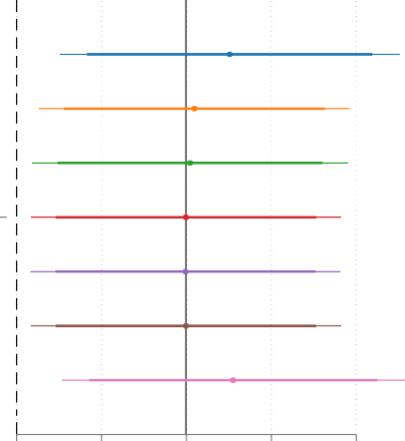
Attack
0.502
0.418

0.408

0.399

0.398

0.399
0.510
X
Ruling Party Personalism estimate

Attack
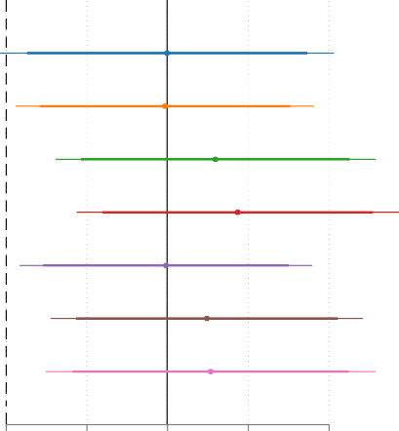
X
0.399

0.393
0.518
0.574
0.396
0.497

0.507
Ruling Party Personalism
estimate

0 .2 .4 .6 .8 0 .2 .4 .6 .8

+ populism + presidential + party system inst.t=0
+ judicial indep.t=0 + polarizationt=0 + democratic consol.t=0 + ruling party seat share

+ populism + presidential + party system inst.t=0
+ judicial indep.t=0 + polarizationt=0 + democratic consol.t=0 + ruling party seat share

Figure E-4: Interaction term estimates, added covariates.

Measuring institutional attacks on the judiciary The main measure of government attacks on the judiciary aggregates 3 indicators of incumbents’ attempts to undermine democracy by at- tacking judicial independence: packing the court (v2_jupack); purging the court (v2_jupurge); and verbal criticism on the court (v2_jupoatck). Only two of these items reflect incumbent actions to directly undermine the courts: packing and purging. The latter item does not capture either institutional change or a power-grab because, as one reviewer notes, “criticism is certainly a means of paving the way for both processes but is not synonymous with either.” We therefore rerun all the tests reported in Table E-1 but use a measure of attacks on the judiciary that combines two items capturing institutional changes – purges and packing – while omitting verbal criticism. Table E-3 reports these results; across model specifications, the results for using only the institutional attacks on the judiciary are stronger than those reported in Table E-1.

Table E-3: Institutional attacks on the judiciary and macro-polarization
 | (1) | (2) | (3) | (4) | (5) | (6) | (7) | (8)
Attack on judiciary | 1.619* | 0.571 | 1.078* | 0.237 | 0.273* | -0.008 | 0.273* | -0.008
 | (0.248) | (0.455) | (0.197) | (0.316) | (0.088) | (0.146) | (0.088) | (0.146)
Ruling party personalism | 0.127 | -0.521* | 0.030 | -0.487* | 0.060 | -0.116 | 0.060 | -0.116
Attack on jud. × Pers Polarization_{t=0} | (0.104) | (0.247) 1.644* (0.594) | (0.080)  0.502* | (0.182) 1.312* (0.426)  0.499* | (0.034) | (0.077) 0.446* (0.179) | (0.034) | (0.077) 0.446* (0.179)
Judicial independence_{t=0} |  |  | (0.039) | (0.039) | 0.054 | 0.054 | 0.054 | 0.054
 |  |  |  |  | (0.086) | (0.086) | (0.086) | (0.086)
Democracy level_{t=0} |  |  |  |  | -0.011 | -0.010 | -0.011 | -0.010
 |  |  |  |  | (0.009) | (0.010) | (0.009) | (0.010)
Democracy age (log) |  |  |  |  | 0.024 | 0.023 | 0.024 | 0.023
Election year Polarization_{t−1} |  |  |  |  | (0.014) 0.034* (0.009) 0.850*  (0.020) | (0.013) 0.035* (0.009) 0.847*  (0.020) | (0.014) 0.034* (0.009) 0.850*  (0.020) | (0.013) 0.035* (0.009) 0.847*  (0.020)
(Intercept) | -0.658* | -0.273 | -0.175* | 0.132 | -0.180 | -0.080 | -0.180 | -0.080
 | (0.104) | (0.171) | (0.086) | (0.123) | (0.096) | (0.106) | (0.096) | (0.106)
Country FE | ✓ | ✓ | ✓ | ✓ | ✓ | ✓ | ✓ | ✓
Year FE | ✓ | ✓ | ✓ | ✓ | ✓ | ✓ | ✓ | ✓
Yt=0  Covariates |  |  | ✓ | ✓ | ✓  ✓ | ✓  ✓ | ✓ | ✓
Yt−1 |  |  |  |  |  |  | ✓ | ✓
N × T | 2359 | 2359 | 2302 | 2302 | 2302 | 2302 | 2302 | 2302
# Leaders | 583 | 583 | 567 | 567 | 567 | 567 | 567 | 567
∗ indicates statistical significance at the 0.05 level. Standard errors clustered on leader.

Counterfactual fixed effects estimator A dynamic treatment effects approach corrects biases induced by treatment effect heterogeneity. We estimate a two-way fixed effects counterfactual model using software provided by Liu, Wang and Xu (2021). The specification adjusts for: Polarization_{t=0}; Democracy level_{t=0}; Judicial independence_{t=0}; Election year and Democracy age. By including Polarization_{t=0} in the specification, the outcome is transformed into the extent to which polarization has changed since the leader was first selected into power.
The attacks on democracy variable is continuous but the treatment effects estimators require a time-varying binary treatment variable. So we dichotomize the treatment variable at its median; this yields 42 of 102 units (41 percent) with time-varying treatment status.5 To test the interaction effect, we then split the sample into two bins, one for leaders with ruling party personalism at or below the median value and another bin for leaders with party personalism values higher than the median. Forty-two percent of units in the high personalism bin have time-varying treatment status while 40 percent of units do in the low personalism bin.
Figure E-5 reports the treatment estimate for each of the two bins, high- and low-ruling party personalism. For high personalism, the average treatment effect is just over 0.3 and statistically significant. For low personalism, the ATT estimate is 0.1. This suggests that the ATT estimate is three times larger when ruling party personalism is high relative to low.
The latter two estimates shown in Figure E-5 are the estimates for placebo tests. These tests use six pre-treatment periods as a placebo to see if the pre-treatment ATT in this range is statistically significantly different from zero. Both of these estimates are close to zero and not statistically significant. This suggests that pre-treatment trends in the outcome are not causing selection into treatment.

2-way FE counterfactual estimator
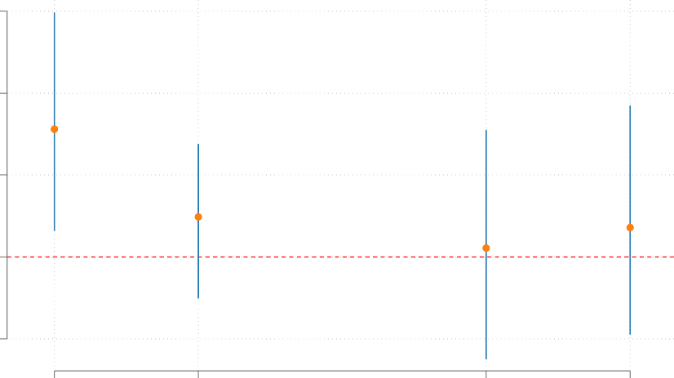
.6
0.31
0.10
0.07
0.02

.4

.2
Estimate

0

-.2

High personalism ATT
Low personalism ATT
High personalism Placebo
Low personalism Placebo

Placebo and pre-treatment period up to six years. Minimum time to treatment is three years. 95% CI.

Figure E-5: Counter-factual fixed effects estimates, high and low ruling party personalism.

Finally, Figure E-6 shows the pre-treatment ATT’s and the post-treatment ATT’s for the bin of high ruling party personalism cases – for eight pre- and post-periods, respectively. In the pre- treatment periods, the ATT’s are not consistently pointing in one direction and none are statistically

⁵In these tests we set the minimum period that a unit must be under the control condition to three years to be included in the analysis.

different from zero. In contrast, the post-treatment ATT’s are all positive and most are significant.

1

.8

.6

.4
ATT

.2

0

-.2
Pre-treatment

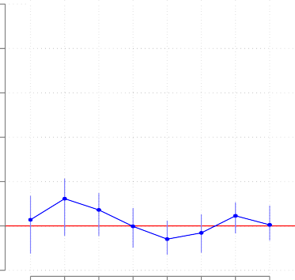
-8 -7 -6 -5 -4 -3 -2 -1

Pre-treatment period
Post-treatement

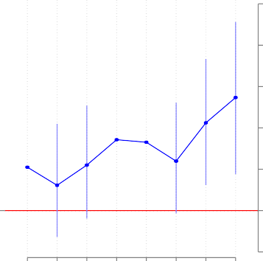
1 2 3 4 5 6 7 8
Post-treatment period

1

.8

.6

.4
ATT

.2

0

-.2

Figure E-6: Counter-factual fixed effects estimates, high ruling party personalism.

6 Appendix F: Survey questionnaire Questionnaire
This study is being conducted by ANON and ANON, who are professors at REDACTED (ANON)
and REDACTED (ANON). We ask for your attention for a few minutes and we thank you for your attention and your responses. Your participation is voluntary and you may decline the survey or withdraw at any time. There are no negative consequences if you don’t want to take it or if you withdraw once you have started. No information that identifies you will be collected or retained by the researchers, and all of the information we collect will be stored securely. However, any online interaction carries some risk of being accessed. Please contact the IRB at the REDACTED with any questions or concerns.
- Do you consent to participate in the survey?
  - Yes
  - No
  - Skipped
- In what year were you born?
  - min: 1900
  - max: 2005
  - Don’t know [8]
  - Skipped [9]
- Generally speaking, do you think of yourself as a:
  - Democratic
  - Republican
  - Independent
  - Other
  - Not sure
  - Skipped [9]
- Generally speaking, do you think of yourself as a:
  - Strong Democratic [if Democrat]
  - Not very strong Democratic [if Democrat]
  - Strong Republican [if Republican]
  - Not very strong Republican [if Republican]
  - Democratic Party [if Independent, Other, Not Sure]
  - Republican Party [if Independent, Other, Not Sure]
  - Neither [if Independent, Other, Not Sure]
  - Not sure [if Independent, Other, Not Sure]

  - Don’t know [8] [if Independent, Other, Not Sure]
  - Skipped [9]

Now we’re going to ask you some questions about democracy. [Randomize democracy questions order.]
- Democracy may have problems, but it is the best system of government.
  - Strongly agree
  - Somewhat agree
  - Do not agree/disagree
  - Somewhat disagree
  - Strongly disagree
  - Don’t know [8]
  - Skipped [9]
- Which of the following statements comes closest to your own opinion?
  - For people like me, it does not matter whether we have a democracy
  - Under some circumstances, an authoritarian government can be preferable
  - Democracy is always preferable to any other kind of government
  - Don’t know [8]
  - Skipped [9]
- Governance by a powerful leader without the restriction of a legislature or elections.
  - Very good
  - Fairly good
  - Neither good nor bad
  - Fairly bad
  - Very bad
  - Don’t know [8]
  - Skipped [9]
- Best to get rid of Congress and elections and have a strong leader who can quickly decide everything.
  - Strongly agree
  - Somewhat agree
  - Do not agree/disagree
  - Somewhat disagree
  - Strongly disagree
  - Don’t know [8]
  - Skipped [9]

Now we’re going to ask you some questions about the U.S. Supreme Court. [Randomize Courts questions order.]
- If the U.S. Supreme Court starts making a lot of decisions that most people disagree with, it might be better to do away with the Supreme Court altogether.
  - Strongly agree
  - Somewhat agree
  - Do not agree/disagree
  - Somewhat disagree
  - Strongly disagree
  - Don’t know [8]
  - Skipped [9]
- The U.S. Supreme Court gets too mixed up in politics.
  - Strongly agree
  - Somewhat agree
  - Do not agree/disagree
  - Somewhat disagree
  - Strongly disagree
  - Don’t know [8]
  - Skipped [9]
- The U.S. Supreme Court should have the right to say what the Constitution means, even when the majority of the people disagree with the Court’s decision.
  - Strongly agree
  - Somewhat agree
  - Do not agree/disagree
  - Somewhat disagree
  - Strongly disagree
  - Don’t know [8]
  - Skipped [9]
- The U.S. Supreme Court can usually be trusted to make decisions that are right for the country as a whole.
  - Strongly agree
  - Somewhat agree
  - Do not agree/disagree
  - Somewhat disagree
  - Strongly disagree

  - Don’t know [8]
  - Skipped [9]
- How many justices are usually on the U.S. Supreme Court?
  - Less than five
  - Between five and ten
  - More than ten
  - Don’t know [8]
  - Skipped [9]
- Who appoints members of the U.S. Supreme Court?
  - State legislatures
  - The Judicial Committee
  - The President
  - The U.S. Supreme Court
  - Don’t know [8]
  - Skipped [9]

- If the President and Supreme Court differ on whether an action by the president is constitu- tional, who has the final responsibility for determining if the action is constitutional?

  - The Senate
  - The House of Representatives
  - The President
  - The U.S. Supreme Court
  - Don’t know [8]
  - Skipped [9]

Next we’re going to provide information about what some politicians have said about the U.S. Supreme Court. First, though, it is important to know some basic facts about the court. In the United States, the President appoints Supreme Court justices when there is a vacancy on the court; and the Senate has to confirm the President’s nominee before someone new joins the court. The court has a vacancy either when a current justice dies or a justice voluntarily retires from the posi- tion. In the past few years, the workload of the U.S. Supreme Court has increased substantially and the justices work many long hours. In fact, a recent Presidential commission found that Supreme Court Justices work longer hours than most Americans and get very little vacation time.

[For the pilot study, we want to maximize size and thus only test how self-identified partisans respond to aggrandizement by the leader of their own party (S^{D} ⇒↓ A^{O} : leader’s sup- porters increase negative affect towards the other party when the leader aggrandizes). This means that we treat Joe Biden as the incumbent leader for self-identified Democrats and Donald Trump as the incumbent leader for self-identified Republicans. The survey randomly assigns one of four
v_{D}

statements to a respondent : ]

Now we’re going to provide information about what some politicians have said about the U.S. Supreme Court.

[For respondents who identify as Democrats]:
❶ Treatment: President Joe Biden recently responded to a Supreme Court ruling by suggesting that the President should be able to fire justices or expand the number of justices on the court to get more people on the court who agree with him.
❷ Treatment + Endorsement: President Joe Biden recently responded to a Supreme Court ruling by suggesting that the President should be able to fire Supreme Court justices or expand the number of justices on the court to get more people on the court who agree with him. Senior
Democratic leader Chuck Schumer, head of the Senate, backed Biden’s proposal to change the court composition to make it more friendly to President Biden. “This is the only sensible path forward for our democracy. The President is the elected leader. The Supreme Court should not be making policy; Joe Biden should,” Schumer said.
- Treatment + Condemnation: President Joe Biden recently responded to a Supreme Court ruling by suggesting that the President should be able to fire Supreme Court justices or expand the number of justices to get more people on the court who agree with him. Senior
Democratic leader Chuck Schumer, head of the Senate, strongly condemned Biden’s proposal to change the court composition to make it more friendly to President Biden. “Allowing the President to change the composition of the Supreme Court when he wants will pose a threat to our democracy, if not now then in the future,” Schumer said.
❹ Control: President Joe Biden recently responded to the Presidential commission’s finding that Supreme Court justices are overworked by suggesting that justices should be eligible for increased vacation time.

[For respondents who identify as Republicans]:
❶ Treatment: When Donald Trump was President, he responded to a Supreme Court ruling by suggesting that the President should be able to fire Supreme Court justices or expand the number of justices on the court to get more people on the court who agree with him.
❷ Treatment + Endorsement: When Donald Trump was President, he responded to a Supreme Court ruling by suggesting that the President should be able to fire Supreme Court judges or expand the number of justices on the court to get more people on the court who agree
with him. Senior Republican leader Mitch McConnell, head of the Senate, backed Trump’s proposal to change the court composition to make it more friendly to President Trump. “This is the only sensible path forward for our democracy. The President is the elected leader. The Supreme Court should not be making policy; Donald Trump should,” McConnell said.
- Treatment + Condemnation: When Donald Trump was President, he responded to a Supreme Court ruling by suggesting that the President should be able to fire Supreme Court judges or expand the number of justices on the court to get more people on the court who agree with
him. Senior Republican leader Mitch McConnell, head of the Senate, strongly condemned Trump’s proposal to change the court composition to make it more friendly to President

Trump. “Allowing the President to change the composition of the Supreme Court when he wants will pose a threat to our democracy, if not now then in the future,” McConnell said.
❹ Control: When Donald Trump was President, he responded to the Presidential commission’s finding that Supreme Court justices are overworked by suggesting that justices should be eligible for increased vacation time.

Next we would like to get your feelings toward some of our political leaders and political parties. You will see the name of a person and we would like you to rate that person using something we call the feeling thermometer. Ratings between 50 degrees and 100 degrees mean that you feel favorable and warm toward the person. Ratings between 0 degrees and 50 degrees mean that you don’t feel favorable toward the person and that you don’t care too much for that person. You would rate the person at the 50 degree mark if you don’t feel particularly warm or cold toward the person. [Randomize leader questions order.]
- How do you rate Joe Biden?
  - Joe Biden [0-100]
  - Prefer not to answer [7]
  - Don’t know [8]
  - Skipped [9]
- How do you rate Donald Trump?
  - Donald Trump [0-100]
  - Prefer not to answer [7]
  - Don’t know [8]
  - Skipped [9]
- Does a higher rating, one close to 100, mean you liked or disliked the politician?
  - Disliked
  - Lied
  - Don’t know [8]
  - Skipped [9]

Now we’re going to ask you some questions about political parties. First, we’re going to ask about the Republican Party. [Randomize party questions order.]
- When people criticize the Republican Party, it makes me feel good” ’
  - Strongly agree
  - Somewhat agree
  - Do not agree/disagree
  - Somewhat disagree
  - Strongly disagree

  - Prefer not to answer [7]
  - Don’t know [8]
  - Skipped [9]
- When I meet someone who supports the Republican Party, I feel disconnected.
  - Strongly agree
  - Somewhat agree
  - Do not agree/disagree
  - Somewhat disagree
  - Strongly disagree
  - Prefer not to answer [7]
  - Don’t know [8]
  - Skipped [9]

Now we’re going to ask you some questions about the Democratic Party.
- When people criticize the Democratic Party, it makes me feel good.
  - Strongly agree
  - Somewhat agree
  - Do not agree/disagree
  - Somewhat disagree
  - Strongly disagree
  - Prefer not to answer [7]
  - Don’t know [8]
  - Skipped [9]
- When I meet someone who supports the Democratic Party, I feel disconnected.
  - Strongly agree
  - Somewhat agree
  - Do not agree/disagree
  - Somewhat disagree
  - Strongly disagree
  - Prefer not to answer [7]
  - Don’t know [8]
  - Skipped [9]

Now we’re going to ask you some questions about yourself.
- What is your gender?

  - Female
  - Male
  - Other
  - Prefer not to answer [7]
  - Skipped [9]
- What is the highest degree or level of school you have completed?
  - Did not graduate from high school
  - High school diploma or the equivalent (GED)
  - Some college
  - Bachelor’s degree
  - Graduate degree: Masters degree, Professional degree or Doctorate degree
  - Prefer not to answer [7]
  - Skipped [9]
- How do you mainly spend your time? Are you currently:
  - Working, full time?
  - Working, part time?
  - Not working, but have a job?
  - Actively looking for a job?
  - A student?
  - Retired, a pensioner or permanently disabled to work?
  - Not working and not looking for a job?
  - Prefer not to answer [7]
  - Skipped [9]
- Do you live in:
  - A city?
  - On the outskirts or surroundings of a city/suburbs?
  - In a town near a rural area/zone?
  - Prefer not to answer [7]
  - Skipped [9]
- Do you belong to a religion or religious denomination? If yes, which one?
  - No: do not belong to a religious denomination [0]
  - Yes: Roman Catholic
  - Yes: Protestant
  - Yes: Orthodox (Russian/Greek/etc.)
  - Yes: Jew

  - Yes: Muslim
  - Yes: Hindu
  - Yes: Buddhist
  - Yes: Other
  - Prefer not to answer [7]
  - Skipped [9]
- What racial or ethnic group best describes you?
  - White
  - Black
  - Hispanic or Latino
  - Asian
  - Native American
  - Middle Eastern
  - Two or more races
  - Other
  - Prefer not to answer [7]
  - Skipped [9]
Thanks for answering all of these questions. Now we’re going to ask you one last question about the survey you just completed.
- Who do you think paid for and conducted this survey?
  - Republican party
  - Democratic party
  - University researchers
  - The government
  - A news or media organization
  - Prefer not to answer [7]
  - Don’t know [8]
  - Skipped [9]
Earlier, the survey provided you with statements that politicians made about the U.S. Supreme Court. It is important that you know that these statement are fictitious. We have no evidence that these exact statements can be attributed to these politicians. That said, Joe Biden and Donald Trump have both verbally criticized the U.S. Supreme Court. For example, President Joe Biden said the following in the context of the court ruling that overturned Roe vs. Wade (this ruling, Dobbs, allowed states to make abortion access illegal): “The Supreme Court is more of an advocacy group these days than it is ... evenhanded about it.”6 Donald Trump criticized the Supreme Court after it rejected his request to block Congress from obtaining his tax records: “The Supreme Court has lost its honor, prestige, and standing, & has become nothing more than a political body, with our Country paying the price.” 7
⁶“Biden says Supreme Court is ’more of an advocacy group’ than ’evenhanded’ ”. Rebecca Shabad. NBC News
online. 12 October 2022).
⁷“Trump rips the Supreme Court...” Kelsey Vlamis. Business Insider online. 23 November 2022.

References
Armaly, Miles T. 2018. “Extra-judicial actor induced change in Supreme Court legitimacy.” Political Research Quarterly 71(3):600–613.
Armaly, Miles T and Adam M Enders. 2022. “Affective polarization and support for the US Supreme court.” Political Research Quarterly 75(2):409–424.
Bai, Jushan. 2009. “Panel data models with interactive fixed effects.” Econometrica 77(4):1229–1279.
Bartels, Brandon L and Christopher D Johnston. 2020. Curbing the court: Why the public constrains judicial independence. Cambridge University Press.
Blauberger, Michael and R Daniel Kelemen. 2017. “Can courts rescue national democracy? Ju- dicial safeguards against democratic backsliding in the EU.” Journal of European Public Policy 24(3):321–336.
Caldeira, Gregory A and James L Gibson. 1992. “The etiology of public support for the Supreme Court.” American journal of political science pp. 635–664.
Driscoll, Amanda and Michael J Nelson. 2022. “The Costs of Court Curbing: Evidence from the United States.” Journal of Politics 85(1).
Epstein, Reid J., Ruth Igielnik and Camille Baker. 2023. “These new poll numbers show why Biden and Trump are stuck in a 2024 dead heat.” PBS News.
Frantz, Erica, Andrea Kendall-Taylor, Jia Li and Joseph Wright. 2022. “Personalist Ruling Parties in Democracies.” Democratization 29(5):918–938.
Gibler, Douglas M and Kirk A Randazzo. 2011. “Testing the effects of independent judiciaries on the likelihood of democratic backsliding.” American Journal of Political Science 55(3):696–709.
Larkins, Christopher M. 1996. “Judicial Independence and Democratization: a Theoretical and conceptual analysis.” American Journal of Comparative Law 44:605.
Levitsky, Steven and Daniel Ziblatt. 2018. How Democracies Die. Crown.
Liu, Licheng, Ye Wang and Yiqing Xu. 2021. “A practical guide to counterfactual estimators for causal inference with time-series cross-sectional data.” arXiv preprint arXiv:2107.00856 .
Loffman, Matt. 2023. “Voters Are Dreading a Trump-Biden Rematch. Enter R.F.K. Jr.” New York Times.
Nelson, Michael J and James L Gibson. 2019. “How does hyperpoliticized rhetoric affect the US Supreme court’s legitimacy?” The Journal of Politics 81(4):1512–1516.
North, Douglass C and Barry R Weingast. 1989. “Constitutions and commitment: the evolution of institutions governing public choice in seventeenth-century England.” The Journal of Economic History 49(4):803–832.
Reenock, Christopher, Jeffrey K Staton and Marius Radean. 2013. “Legal institutions and demo- cratic survival.” The Journal of Politics 75(2):491–505.

Reiljan, Andres, Diego Garzia, Frederico Ferreira Da Silva and Alexander H Trechsel. 2023. “Patterns of Affective Polarization toward Parties and Leaders across the Democratic World.” American Political Science Review pp. 1–17.
Rogowski, Jon C and Andrew R Stone. 2021. “How political contestation over judicial nominations polarizes Americans’ attitudes toward the Supreme Court.” British Journal of Political Science 51(3):1251–1269.
Staton, Jeffrey K. 2006. “Constitutional review and the selective promotion of case results.” Amer- ican Journal of Political Science 50(1):98–112.
Staton, Jeffrey K. 2010. Judicial power and strategic communication in Mexico. Cambridge Univer- sity Press.
Vanberg, Georg. 2001. “Legislative-judicial relations: A game-theoretic approach to constitutional review.” American journal of political science pp. 346–361.
Vanberg, Georg. 2004. The politics of constitutional review in Germany. Cambridge University Press.
Varaine, Simon. 2023. “How dropping subjects who failed manipulation checks can bias your results: An illustrative case.” Journal of Experimental Political Science 10(2):299–305.

