Supplemental Information (SI)

Table SI1: Description of the Sample
 | Czech Republic | France | Italy | Sweden
Characteristic | N = 1,352 | N = 1,280 | N = 1,349 | N = 1,282
Gender
Woman | 716 (53%) | 677 (53%) | 689 (52.0%) | 688 (54%)
Man | 629 (47%) | 600 (47%) | 637 (48.0%) | 588 (46%)
Non-binary | 5 (0%) | 1 (0%) | 0 (0%) | 4 (0%)
Prefer not to say | 2 (0%) | 2 (0%) | 0 (0%) | 2 (0%)
Age group
Between 35 And 59 | 469 (35%) | 401 (31%) | 446 (33.1%) | 433 (34%)
Over 60 | 400 (30%) | 589 (46%) | 606 (44.9%) | 550 (43%)
Under 35 | 483 (36%) | 290 (23%) | 297 (22.0%) | 299 (23%)
Has a university degree
Degree | 356 (26%) | 563 (44%) | 290 (21.5%) | 507 (40%)
No degree | 996 (74%) | 717 (56%) | 1,059 (78.5%) | 775 (60%)
Region felt the closest to
[Country-dependent categories] | [Bohemia]  635 (47%) | [Non-Paris]  983 (77%) | [Center]  323 (24%) | [Götaland]  560 (44%)
[Country-dependent categories] | [Moravia]  512 (38%) | [Paris]  297 (23%) | [North]  561 (42%) | [Norrland]  193 (15.3%)
[Country-dependent categories] | [Prague]  205 (15%) |  | [South]  465 (34%) | [Svealand]  529 (41%)
Conscientiousness
Agree with the statement | 1,075 (80%) | 1,125 (88%) | 1,180 (87%) | 1,123 (88%)
Disagree with the statement | 133 (10%) | 57 (4%) | 61 (5%) | 59 (5%)
Neither agree nor disagree with the statement | 144 (11%) | 98 (8%) | 108 (8%) | 100 (8%)
Openness
Agree with the statement | 940 (70%) | 702 (55%) | 989 (73%) | 967 (75%)
Disagree with the statement | 152 (11%) | 257 (20%) | 113 (8%) | 109 (9%)
Neither agree nor disagree with the statement | 260 (19%) | 321 (25%) | 247 (18%) | 206 (16%)
Diet
Omnivore | 1,289 (95%) | 1,221 (95%) | 1,265 (94%) | 1,201 (94%)
Vegan | 17 (1%) | 20 (2%) | 16 (1%) | 16 (1%)
Vegetarian | 46 (3%) | 39 (3%) | 68 (5%) | 65 (5%)
Favorite pet
Cat | 352 (26%) | 514 (40%) | 455 (34%) | 487 (38%)
Dog | 817 (60%) | 571 (45%) | 709 (53%) | 614 (48%)
No pet | 183 (14%) | 195 (15%) | 185 (14%) | 181 (14%)
Favorite holiday
City | 207 (15%) | 261 (20%) | 345 (26%) | 298 (23%)
Outdoor | 741 (55%) | 777 (61%) | 529 (39%) | 471 (37%)
Relax | 404 (30%) | 242 (19%) | 475 (35%) | 513 (40%)
Political ideology
Center | 747 (55%) | 421 (33%) | 432 (32%) | 404 (32%)
Left-Wing | 155 (11%) | 234 (18%) | 373 (28%) | 344 (27%)
Not Collocated | 186 (14%) | 167 (13%) | 179 (13%) | 109 (9%)
Right-Wing | 264 (20%) | 458 (36%) | 365 (27%) | 425 (33%)

Table SI 2: The effects computed in this experiment
Name of the effect | Identification | Interpretation
Average Treatment Effects (ATEs) | $$ATE_{S^{k}=1}=AMCE\left(S^{k}=1 | M=0\right)$$ | The total effect that observing similarity in attribute k has on the willingness to engage in political conversation when no political information is given to the respondent, whether through political inferences or not.
Average Controlled Direct Effects (ACDEs) | $$ACDE_{S^{k}=1,M=1}=AMCE\left(S^{k}=1 | M=1\right)$$ | The effects that similarity in each attribute k has on the willingness to engage in political conversation that is due neither to mediation nor to interaction with political inferences.
Average Controlled Direct Effects (ACDEs) | $$ACDE_{S^{k}=1,M=-1}=AMCE\left(S^{k}=1 | M=-1\right)$$
Eliminated Effects (EEs) | $$EE_{S^{k}=1,M=1}=AMCE\left(S^{k}=1 | M=0\right)-AMCE\left(S^{k}=1 | M=1\right)$$ | The portion of the ATE explained by political inferences, either through mediation or through interaction between $S_{i}^{k}$ and the specific ideology inferred.
Eliminated Effects (EEs) | $$EE_{S^{k}=1,M=-1}=AMCE\left(S^{k}=1 | M=0\right)-AMCE\left(S^{k}=1 | M=-1\right)$$

Table SI 3: Attributes, related survey questions, and conjoint attribute levels
Attribute | Survey question | Response options | Recoding ($R_{j}^{k}, P_{i}^{k}$) | Categories of $S_{i}^{k}$
Gender | “You are...” | Woman | Woman | Gender Match
Gender | “You are...” | Man | Woman | Gender Match
Gender | “You are...” | Non-binary/Other | Man | Gender Mismatch
Gender | “You are...” | I prefer not to answer | Man | Gender Mismatch
Age group | “Indicate your year of birth” | Multiple choice from 1924 to 2006 | Below 35 years old | Age Match
Age group | “Indicate your year of birth” | Multiple choice from 1924 to 2006 | Between 35 and 59 | Age Match
 |  |  |  | Age Mismatch
Age group | “Indicate your year of birth” | Multiple choice from 1924 to 2006 | Over 60 | Age Mismatch
Education level | “What is your level of education?” | Elementary school | No Degree | Education Match
Education level | “What is your level of education?” | Middle school | No Degree | Education Match
Education level | “What is your level of education?” | High school | No Degree | Education Match
Education level | “What is your level of education?” | Bachelor’s degree | Degree | Education Mismatch
Education level | “What is your level of education?” | Master’s degree or equivalent | Degree | Education Mismatch
Education level | “What is your level of education?” | Post-graduate degree/PhD | Degree | Education Mismatch
Regionfeel | “Regardless of your region of residence, to which part of Italy do you feel closest in terms of lifestyle, culture, and personal relationships?” | Prague | Prague | Regionfeel Match
Regionfeel |  | Czechia | Czechia | Regionfeel Match
Regionfeel |  | Moravia | Moravia | Regionfeel Match
Regionfeel |  | Paris | Paris | Regionfeel Match
Regionfeel |  | Non-Paris | Non-Paris | Regionfeel Match
Regionfeel |  | Northern Italy | North | Regionfeel Match
Regionfeel |  | Central Italy | Center | Regionfeel Mismatch
Regionfeel |  | Southern Italy | South | Regionfeel Mismatch
Regionfeel |  | Norrland | Norrland | Regionfeel Mismatch
Regionfeel |  | Svealand | Svealand | Regionfeel Mismatch
Regionfeel |  | Götaland | Götaland | Regionfeel Mismatch
Conscientiousness | “To which extent do you agree with this statement: ‘I consider myself a reliable, self-disciplined person’?” | Strongly agree | High Consc. | Conscientiousness Match
Conscientiousness |  | Moderately agree | High Consc. | Conscientiousness Match
Conscientiousness |  | Agree a little | High Consc. | Conscientiousness Match
Conscientiousness |  | Neither agree nor disagree | Med Consc. | Conscientiousness Match
 |  |  |  | Conscientiousness Mismatch
Conscientiousness |  | Disagree a little | Low Consc. | Conscientiousness Mismatch
Conscientiousness |  | Moderately disagree | Low Consc. | Conscientiousness Mismatch
Conscientiousness |  | Strongly disagree | Low Consc. | Conscientiousness Mismatch
Openness | “To which extent do you agree with this statement: ‘I consider myself a person who is open to new experiences and has many interests’?” | Strongly agree | High Ope. | Openness Match
Openness |  | Moderately agree | High Ope. | Openness Match
Openness |  | Agree a little | High Ope. | Openness Match
Openness |  | Neither agree nor disagree | Med. Ope | Openness Match
 |  |  |  | Openness Mismatch
Openness |  | Disagree a little | Low Ope. | Openness Mismatch
Openness |  | Moderately disagree | Low Ope. | Openness Mismatch
Openness |  | Strongly disagree | Low Ope. | Openness Mismatch
Diet | Which of the following options best describes your eating habits? | I eat both animal and plant-based foods (omnivorism) | Omnivore | Diet Match
Diet |  | I do not eat animal meat (vegetarianism) | Vegetarian | Diet Match
 |  |  |  | Diet Mismatch
Diet |  | I only eat plant-based food (veganism) | Vegan | Diet Mismatch
Pet | “In Italy, the most popular pets are the dog and the cat. Given the chance, would you prefer...” | Having a cat | Cat | Pet Match
Pet |  | Having a dog | Dog | Pet Match
 |  |  |  | Pet mismatch
Pet |  | Not having pets | No pet | Pet mismatch
Holiday | “Given the same costs and duration, which of these alternatives comes closest to your ideal holiday?” | A holiday in contact with nature, with many outdoor activities | Outdoor | Holiday Match
Holiday |  | A holiday in a city of art, with many cultural activities | City | Holiday Match
 |  |  |  | Holiday Mismatch
Holiday |  | A holiday in a holiday resort, with many relaxing activities | Relax | Holiday Mismatch
Ideology | “Many people, when talking about politics, use the terms 'left' and 'right'. On the scale below, where 0 indicates 'left' and 10 indicates 'right', where would you place yourself?” | 0 | Left | Ideology Match
Ideology |  | 1 | Left | Ideology Match
Ideology |  | 2 | Left | Ideology Match
Ideology |  | 3 | Left | Ideology Match
Ideology |  | 4 | Center | Ideology Match
Ideology |  | 5 | Center | Ideology Match
Ideology |  | 6 | Center | Ideology Match
Ideology |  | 7 | Right | Ideology Mismatch
Ideology |  | 8 | Right | Ideology Mismatch
Ideology |  | 9 | Right | Ideology Mismatch
Ideology |  | 10 | Right | Ideology Mismatch
Ideology |  | Nowhere | Not placed | Ideology Mismatch

Figure SI1: Effects of ideological labels (per se) and similarities on the willingness to engage in conversations for the respondents in the manipulated mediation arm. Bars with different widths and shadings represent 90% (shortest, darkest shading), 95%, and 99% (largest, brightest shading) confidence intervals.
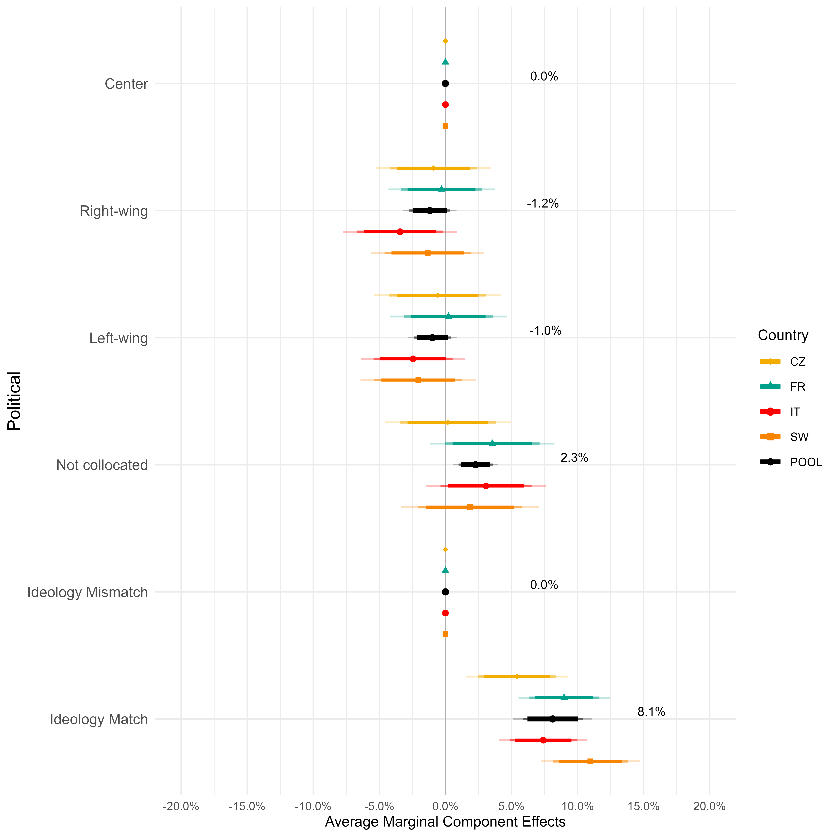

Table SI 4: Attribute and Attribute Levels of the experiment (Czech version)
Pohlaví | Mužský |  | Ženský
Věkové rozmezí | Méně než 35 let | Mezi 36 a 59 lety |  | Přes 60 let
Úroveň vzdělání | Bez vysokoškolského vzdělání |  | Vysokoškolský titul nebo vyšší
Makroregion | Čechy | Morava |  | Praha
[Svědomitost] „Považuji se za spolehlivého, sebedisciplinovaného člověka“ | “Rozhodně/Spíše souhlasím” | Ani souhlas, ani nesouhlas |  | “Málo/rozhodně nesouhlasím”
[Otevřenost novým zkušenostem] „Považuji se za člověka otevřeného novým zkušenostem a s mnoha zájmy“ | “Rozhodně/Spíše souhlasím” | Ani souhlas, ani nesouhlas |  | “Málo/rozhodně nesouhlasím”
Dieta hlavně… | Všežravý | Vegetariánský |  | Veganské
Oblíbené domácí zvíře | Pes | Kočka |  | Zvířata raději nemá
Dovolenou nejraději tráví… | V kontaktu s přírodou, s mnoha venkovními aktivitami | Ve městě plném umění, s mnoha kulturními aktivitami |  | V rekreačním středisku, s mnoha relaxačními aktivitami
Politická ideologie | Pravice (7 až 10 na ideologické škále) | Levice (0 až 3 na ideologické škále) | Střed (4 až 6 na ideologické škále) | Nezařazeno (preferuje nezařadit na ideologickou škálu)

Table SI 5: Attribute and Attribute Levels of the experiment (French version)
Genre | Homme |  | Femme
Groupe d'âge | Moins de 35 ans | Entre 36 et 59 ans |  | Plus de 60 ans
Niveau d'éducation | Pas de diplôme d'études supérieures |  | Diplôme d'études supérieures ou plus
Macro-région | Paris |  | Reste du territoire français (sans Paris)
[Conscience professionnelle] "Je me considère comme une personne fiable et disciplinée". | "Tout à fait/Plutôt d'accord" | "Ni d’accord, ni pas d’accord" |  | Pas du tout/Plutôt pas d'accord
[Ouverture aux nouvelles expériences] "Je me considère comme une personne ouverte aux nouvelles expériences et complexe". | "Tout à fait/Plutôt d'accord" | "Ni d’accord, ni pas d’accord" |  | Pas du tout/Plutôt pas d'accord
Mode d'alimentation | Omnivore | Végétarien |  | Vegan
Animal de compagnie préféré | Chien | Chat |  | Préfère ne pas avoir d'animaux
Il préfère passer ses vacances... | Au contact de la nature, avec de nombreuses activités de plein air | Dans une ville pleine d'activités artistiques et culturelles |  | Dans un lieu de villégiature offrant un large éventail d'activités pour se détendre
Idéologie politique | Droite (7 à 10 sur l'échelle idéologique) | Gauche (0 à 3 sur l'échelle idéologique) | Centre (4 à 6 sur l'échelle idéologique) | Ne se positionne pas (préfère ne pas se placer sur l'échelle idéologique)

Table SI 6: Attribute and Attribute Levels of the experiment (Italian version)
Genere | Maschio |  | Femmina
Fascia d’età | Sotto i 35 anni | Fra 36 e 59 anni |  | Sopra i 60 anni
Livello di istruzione | Non ha una laurea |  | Ha una laurea
Macroregione | Nord | Centro |  | Sud
[Coscienziosità] “Mi ritengo una persona affidabile, autodisciplinata” | “Molto/Abbastanza d’accordo” | “Né in accordo né in disaccordo” |  | “Per niente/Poco d’accordo”
[Apertura alle nuove esperienze] “Mi ritengo una persona aperta alle nuove esperienze e con molti interessi” | “Molto/Abbastanza d’accordo” | “Né in accordo né in disaccordo” |  | “Poco/Per niente d’accordo”
Dieta prevalentemente… | Omnivora | Vegetariana |  | Vegana
Animale domestico preferito | Cane | Gatto |  | Preferisce non avere animali
Preferisce trascorrere le vacanze… | A contatto con la natura, con molte attività all'aria aperta | In una città d'arte, con molte attività culturali |  | In una località di villeggiatura, con molte attività rilassanti
Ideologia politica | Destra (da 7 a 10 nella scala ideologica) | Sinistra (da 0 a 3 nella scala ideologica) | Centro (da 4 a 6 nella scala ideologica) | Non collocato (preferisce non collocarsi nella scala ideologica)

Table SI 7: Attribute and Attribute Levels of the experiment (Swedish version)
Kön | Man |  | Kvinna
Åldersgrupp | Under 35 år gammal | Mellan 36 och 59 år gammal |  | Över 60 år gammal
Utbildningsnivå | Ingen högskoleexamen |  | Högskoleexamen eller högre
Makroregion | Götaland | Svealand |  | Norrland
[Samvetsgrannhet] "Jag ser mig själv som en pålitlig och självdisciplinerad person." | Instämmer helt/delvis | Varken enig eller oenig |  | Instämmer inte/instämmer inte alls
[Öppenhet för nya upplevelser] "Jag ser mig själv som en person som är öppen för nya upplevelser och komplex." | Instämmer helt/ganska instämmer | Varken enig eller oenig |  | Instämmer inte/instämmer inte alls
Kostvanor främst | Allätare | Vegetarisk |  | Vegansk
Favoritdjur | Hund | Katt |  | Personen föredrar inte att ha djur
De föredrar att tillbringa sin semester... | I kontakt med naturen, med många utomhusaktiviteter | I en stad full av konst- och kulturaktiviteter |  | På en resort med många avkopplande aktiviteter
Politisk ideologi | Höger (7 till 10 på den ideologiska skalan) | Vänster (0 till 3 på den ideologiska skalan) | Mitten (4 till 6 på den ideologiska skalan) | Ej placerad (föredrar att inte placera sig på den ideologiska skalan)

Figure SI2: Attribute order check for the Czech Republic. Grey lines represent the MM for “Mismatch” and “Match” for each attribute. Colored whiskers represent the MM of attributes when placed in a certain position (see legend). Tests are conducted with 99% CI.
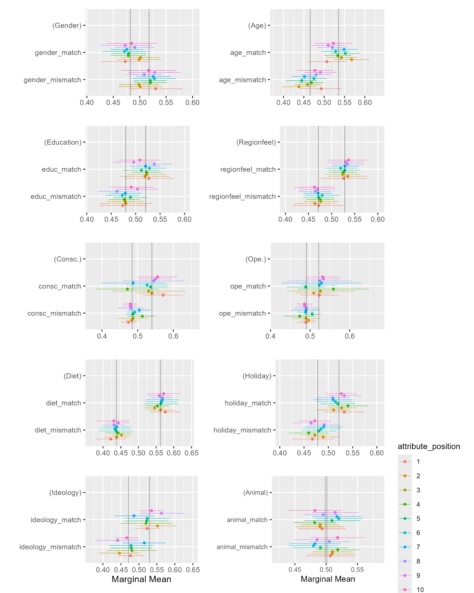

Figure SI3: Attribute order check for France. Grey lines represent the MM for “Mismatch” and “Match” for each attribute. Colored whiskers represent the MM of attributes when placed in a certain position (see legend). Tests are conducted with 99% CI.
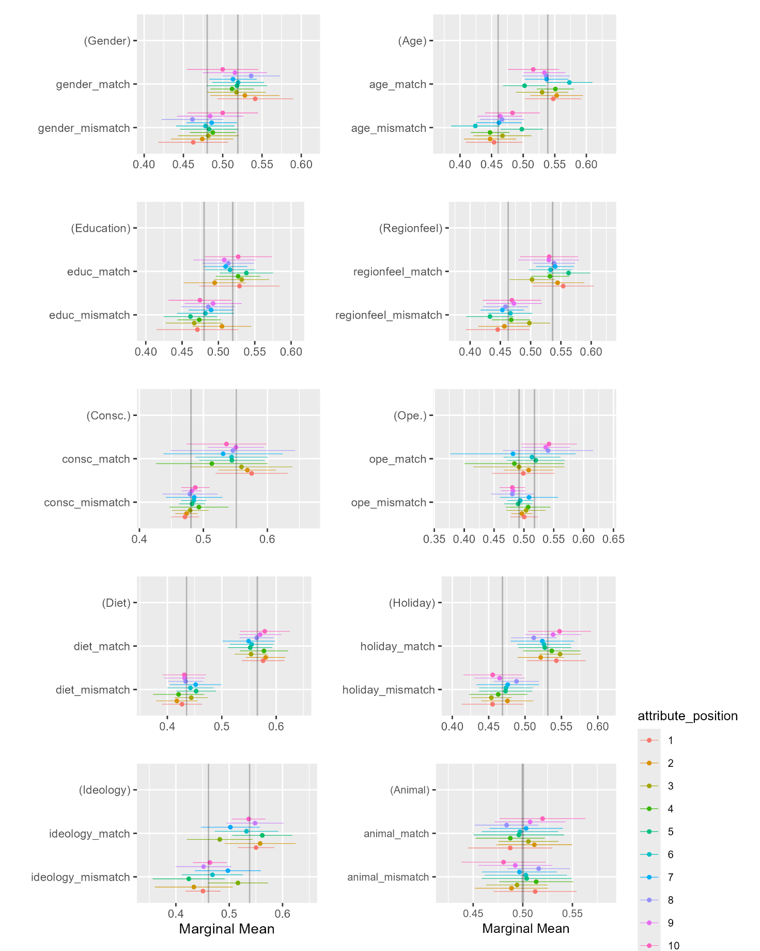
Figure SI4: Attribute order check for Italy. Grey lines represent the MM for “Mismatch” and “Match” for each attribute. Colored whiskers represent the MM of attributes when placed in a certain position (see legend). Tests are conducted with 99% CI.
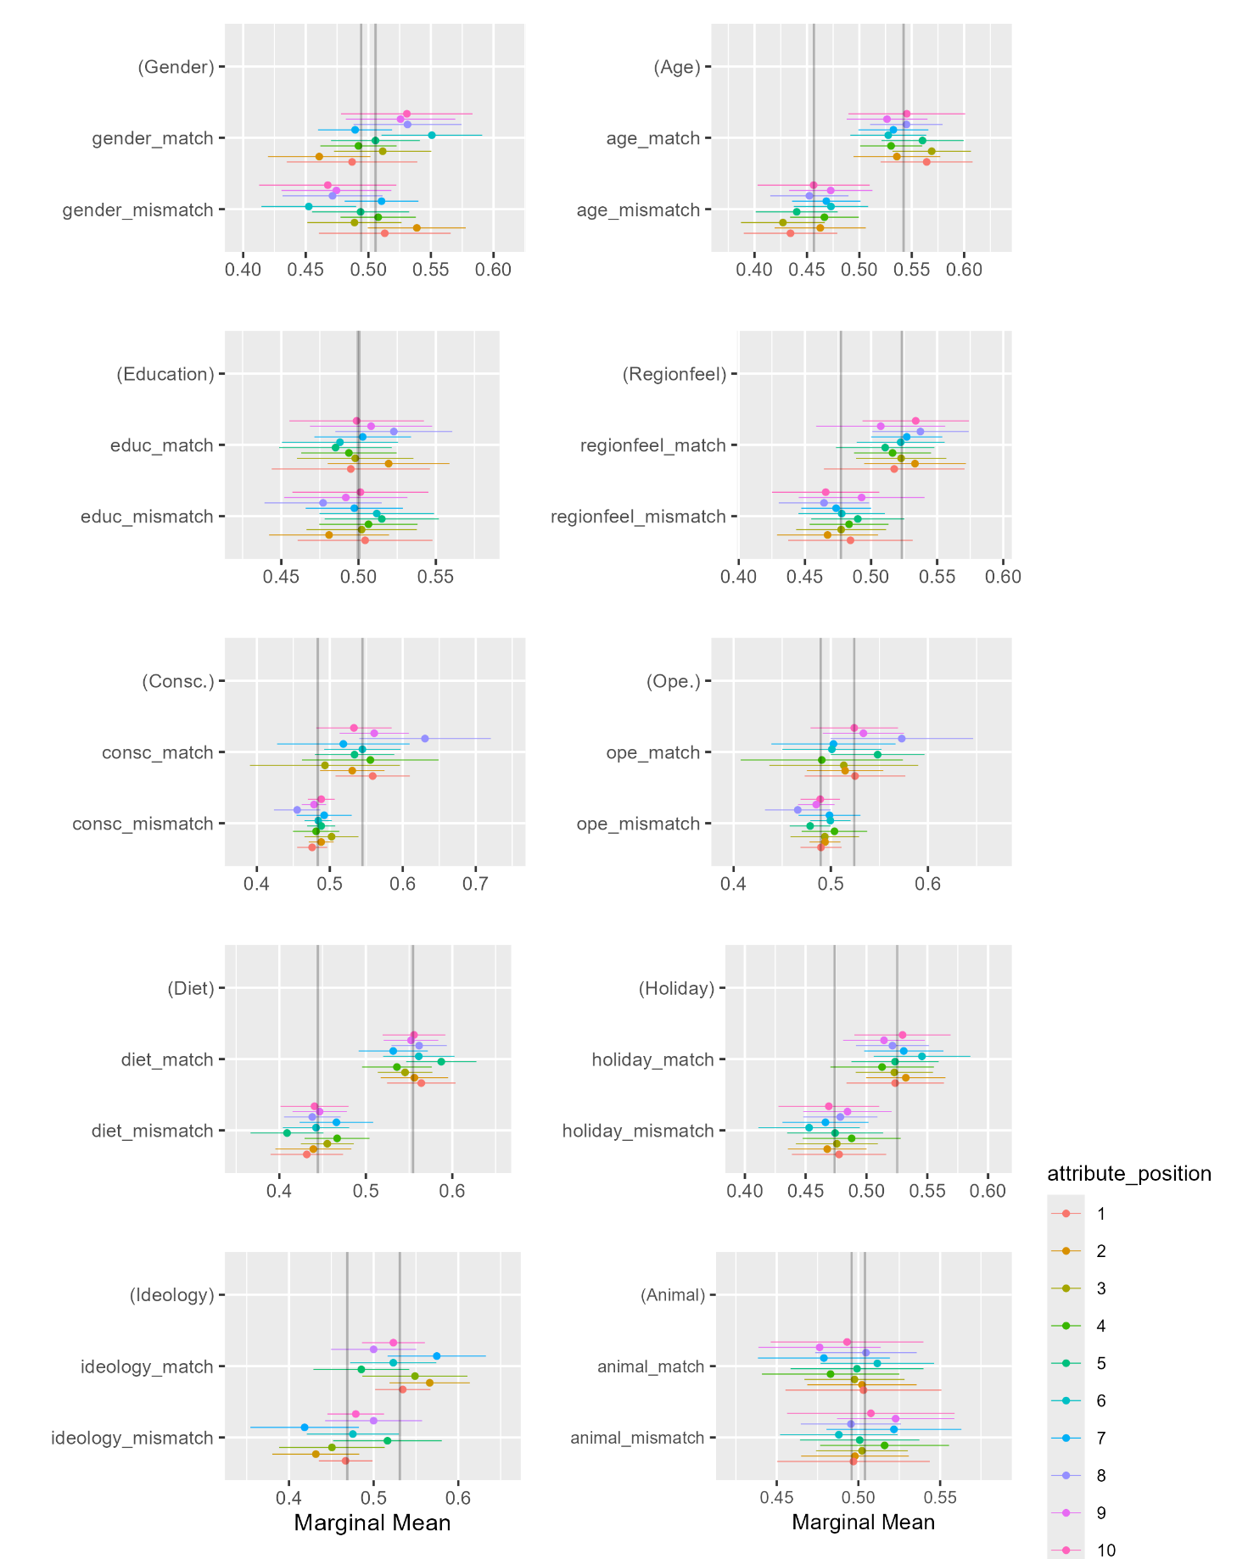
Figure SI5: Attribute order check for Sweden. Grey lines represent the MM for “Mismatch” and “Match” for each attribute. Colored whiskers represent the MM of attributes when placed in a certain position (see legend). Tests are conducted with 99% CI.
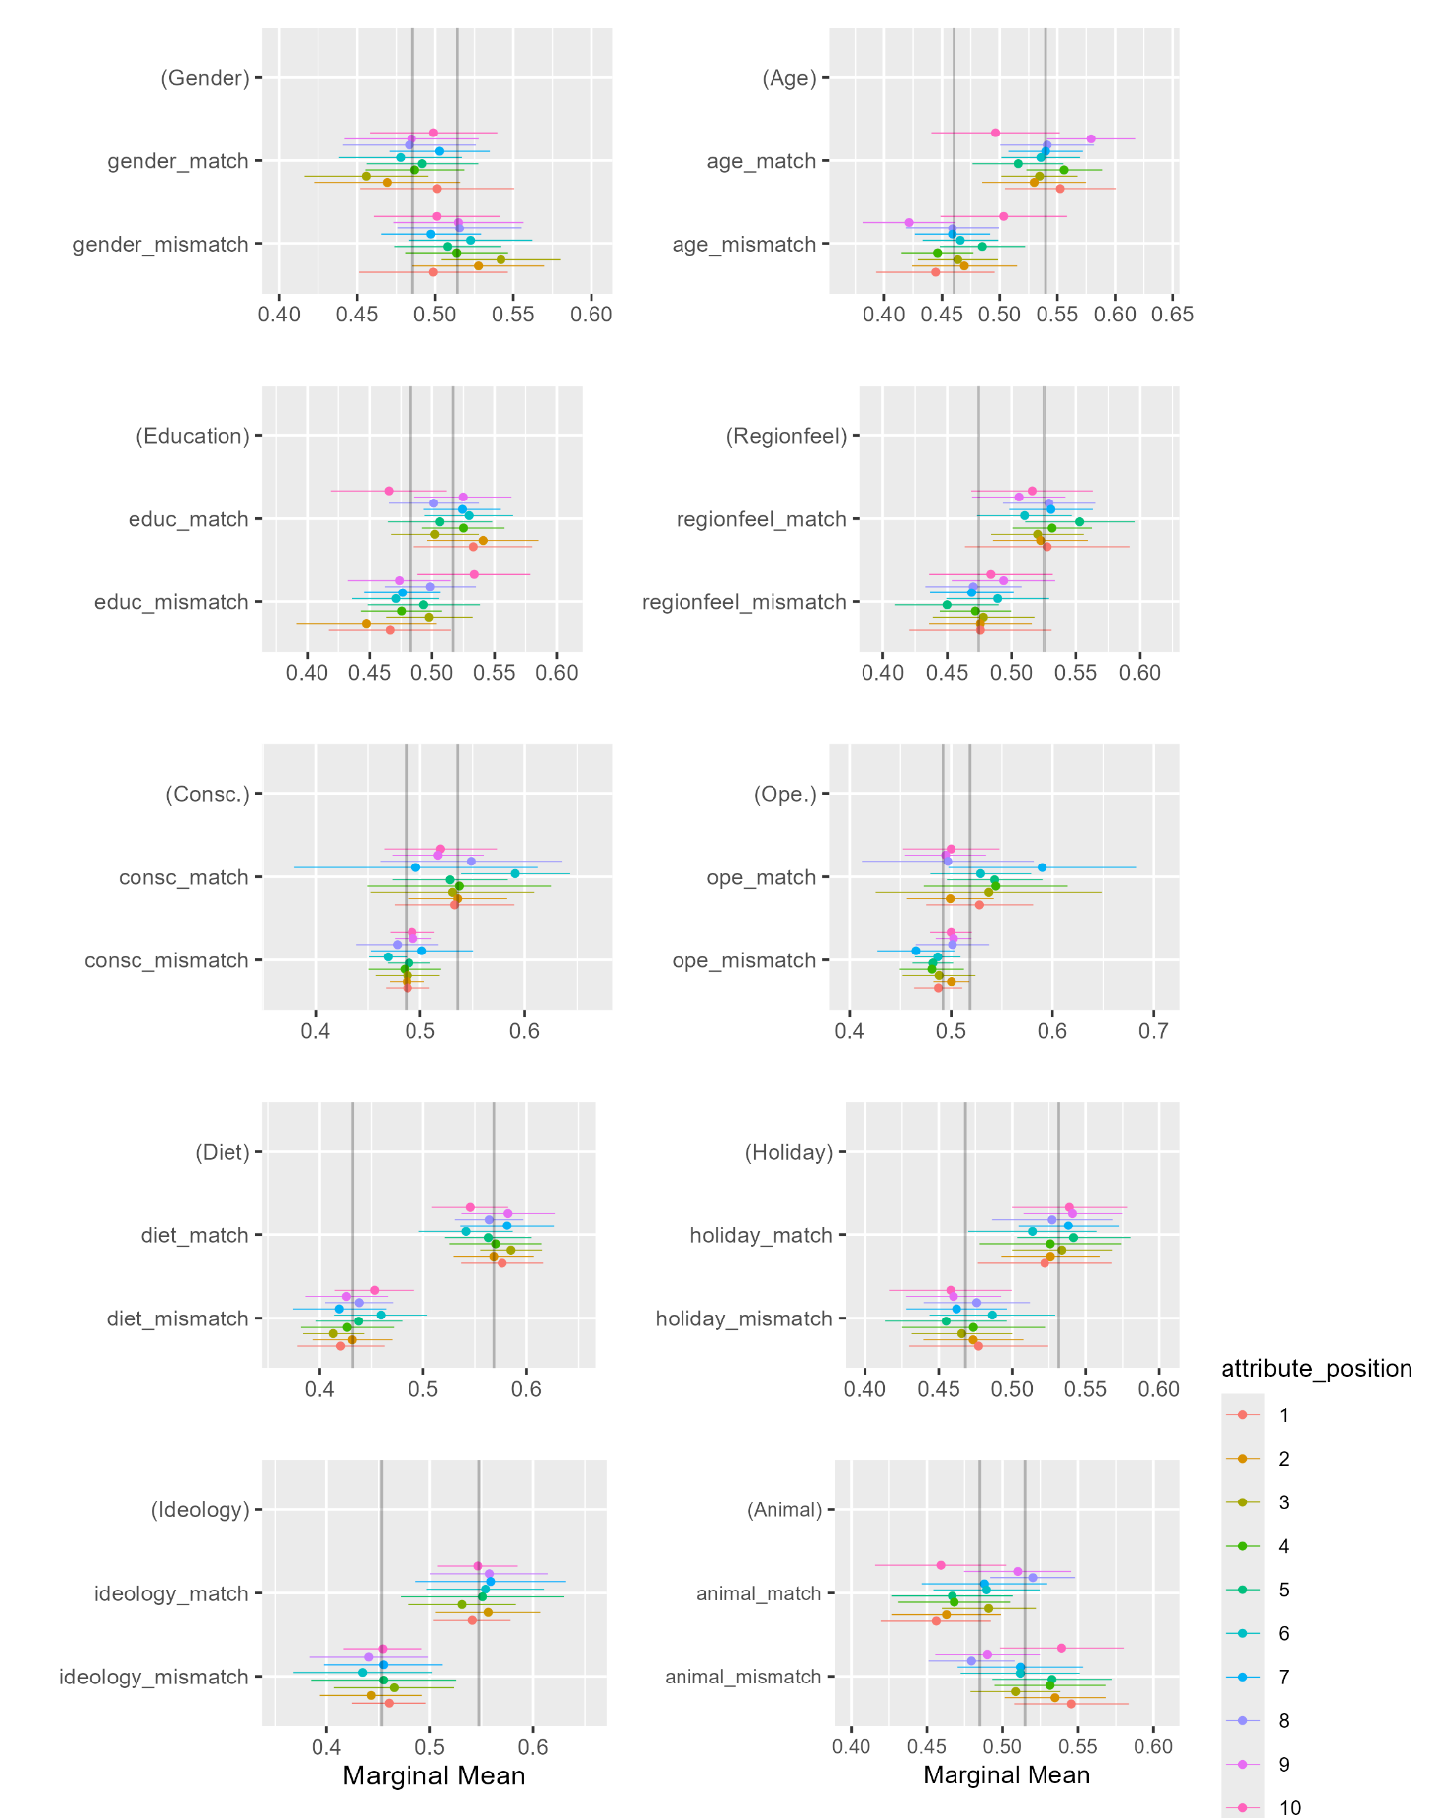

Table SI8: Marginal means for unrecoded attributes ($P_{i}^{k}$) for the Czech Republic
Country | Attribute | Attribute level | Estimate | Std. Error | 95% Confidence Interval | 90% Confidence Interval | 99% Confidence Interval
CZ | Gender | Woman | 0.499 | 0.006 | (0.486; 0.512) | (0.488; 0.51) | (0.482; 0.516)
CZ | Gender | Man | 0.501 | 0.006 | (0.488; 0.514) | (0.49; 0.512) | (0.484; 0.518)
CZ | Age | Under 35 | 0.501 | 0.009 | (0.484; 0.519) | (0.487; 0.516) | (0.479; 0.524)
CZ | Age | Between 35 and 59 | 0.539 | 0.009 | (0.522; 0.556) | (0.524; 0.553) | (0.516; 0.561)
CZ | Age | Over 60 | 0.459 | 0.009 | (0.44; 0.477) | (0.443; 0.474) | (0.435; 0.483)
CZ | Education | Degree | 0.51 | 0.007 | (0.497; 0.523) | (0.499; 0.521) | (0.493; 0.527)
CZ | Education | No degree | 0.49 | 0.007 | (0.477; 0.503) | (0.479; 0.501) | (0.473; 0.507)
CZ | Regionfeel | Bohemia (CZ) | 0.506 | 0.008 | (0.491; 0.521) | (0.494; 0.519) | (0.486; 0.526)
CZ | Regionfeel | Moravia (CZ) | 0.512 | 0.008 | (0.496; 0.528) | (0.499; 0.525) | (0.491; 0.533)
CZ | Regionfeel | Prague (CZ) | 0.478 | 0.009 | (0.46; 0.496) | (0.463; 0.493) | (0.454; 0.502)
CZ | Conscientiousness | High Consc. | 0.534 | 0.01 | (0.514; 0.553) | (0.517; 0.55) | (0.508; 0.559)
CZ | Conscientiousness | Med. Consc. | 0.521 | 0.009 | (0.502; 0.54) | (0.505; 0.537) | (0.497; 0.545)
CZ | Conscientiousness | Low Consc. | 0.465 | 0.007 | (0.452; 0.479) | (0.454; 0.477) | (0.448; 0.483)
CZ | Openness | High Ope. | 0.54 | 0.01 | (0.52; 0.559) | (0.524; 0.556) | (0.514; 0.566)
CZ | Openness | Med. Ope. | 0.497 | 0.009 | (0.479; 0.515) | (0.482; 0.512) | (0.473; 0.521)
CZ | Openness | Low Ope. | 0.477 | 0.007 | (0.463; 0.49) | (0.465; 0.488) | (0.459; 0.494)
CZ | Diet | Omnivore | 0.56 | 0.006 | (0.548; 0.572) | (0.55; 0.57) | (0.544; 0.576)
CZ | Diet | Vegetarian | 0.459 | 0.01 | (0.439; 0.479) | (0.442; 0.476) | (0.433; 0.485)
CZ | Diet | Vegan | 0.424 | 0.01 | (0.404; 0.444) | (0.407; 0.441) | (0.398; 0.451)
CZ | Pet | Cat | 0.541 | 0.009 | (0.524; 0.559) | (0.527; 0.556) | (0.518; 0.564)
CZ | Pet | Dog | 0.494 | 0.007 | (0.48; 0.508) | (0.483; 0.506) | (0.476; 0.513)
CZ | Pet | No pet | 0.464 | 0.01 | (0.444; 0.483) | (0.447; 0.48) | (0.438; 0.489)
CZ | Holiday | City | 0.482 | 0.009 | (0.464; 0.501) | (0.467; 0.498) | (0.458; 0.507)
CZ | Holiday | Outdoor | 0.527 | 0.007 | (0.512; 0.541) | (0.514; 0.539) | (0.508; 0.546)
CZ | Holiday | Relax | 0.484 | 0.008 | (0.468; 0.5) | (0.471; 0.498) | (0.463; 0.505)

Table SI 9: Marginal means for unrecoded attributes ($P_{i}^{k}$) for France
Country | Attribute | Attribute level | Estimate | Std. Error | 95% Confidence Interval | 90% Confidence Interval | 99% Confidence Interval
FR | Gender | Woman | 0.513 | 0.006 | (0.5; 0.525) | (0.502; 0.523) | (0.496; 0.529)
FR | Gender | Man | 0.487 | 0.006 | (0.475; 0.5) | (0.477; 0.498) | (0.471; 0.504)
FR | Age | Under 35 | 0.476 | 0.01 | (0.457; 0.495) | (0.46; 0.492) | (0.451; 0.502)
FR | Age | Between 35 and 59 | 0.539 | 0.009 | (0.521; 0.556) | (0.524; 0.553) | (0.516; 0.562)
FR | Age | Over 60 | 0.485 | 0.008 | (0.468; 0.501) | (0.471; 0.499) | (0.463; 0.507)
FR | Education | Degree | 0.509 | 0.006 | (0.497; 0.522) | (0.499; 0.52) | (0.493; 0.526)
FR | Education | No degree | 0.491 | 0.006 | (0.478; 0.503) | (0.48; 0.501) | (0.474; 0.507)
FR | Regionfeel | Non-Paris (FR) | 0.532 | 0.007 | (0.519; 0.546) | (0.521; 0.543) | (0.515; 0.55)
FR | Regionfeel | Paris (FR) | 0.468 | 0.007 | (0.455; 0.481) | (0.457; 0.479) | (0.451; 0.485)
FR | Conscientiousness | High Consc. | 0.568 | 0.011 | (0.546; 0.589) | (0.55; 0.585) | (0.539; 0.596)
FR | Conscientiousness | Med. Consc. | 0.506 | 0.01 | (0.486; 0.526) | (0.489; 0.523) | (0.48; 0.532)
FR | Conscientiousness | Low Consc. | 0.459 | 0.007 | (0.446; 0.473) | (0.448; 0.471) | (0.441; 0.477)
FR | Openness | High Ope. | 0.534 | 0.009 | (0.515; 0.552) | (0.518; 0.549) | (0.51; 0.558)
FR | Openness | Med. Ope. | 0.496 | 0.009 | (0.479; 0.513) | (0.481; 0.511) | (0.473; 0.519)
FR | Openness | Low Ope. | 0.477 | 0.008 | (0.462; 0.492) | (0.464; 0.489) | (0.457; 0.496)
FR | Diet | Omnivore | 0.572 | 0.007 | (0.559; 0.585) | (0.561; 0.583) | (0.555; 0.589)
FR | Diet | Vegetarian | 0.47 | 0.011 | (0.448; 0.491) | (0.452; 0.488) | (0.442; 0.498)
FR | Diet | Vegan | 0.395 | 0.011 | (0.373; 0.416) | (0.377; 0.412) | (0.367; 0.423)
FR | Pet | Cat | 0.517 | 0.008 | (0.501; 0.533) | (0.503; 0.53) | (0.495; 0.538)
FR | Pet | Dog | 0.525 | 0.008 | (0.51; 0.541) | (0.512; 0.539) | (0.505; 0.546)
FR | Pet | No pet | 0.445 | 0.01 | (0.425; 0.466) | (0.428; 0.462) | (0.418; 0.472)
FR | Holiday | City | 0.463 | 0.009 | (0.445; 0.482) | (0.448; 0.479) | (0.439; 0.487)
FR | Holiday | Outdoor | 0.531 | 0.008 | (0.516; 0.546) | (0.518; 0.543) | (0.511; 0.55)
FR | Holiday | Relax | 0.495 | 0.01 | (0.477; 0.514) | (0.48; 0.511) | (0.471; 0.52)

Table SI 10: Marginal means for unrecoded attributes ($P_{i}^{k}$) for Italy
Country | Attribute | Attribute level | Estimate | Std. Error | 95% Confidence Interval | 90% Confidence Interval | 99% Confidence Interval
IT | Gender | Woman | 0.512 | 0.007 | (0.499; 0.526) | (0.501; 0.523) | (0.494; 0.53)
IT | Gender | Man | 0.488 | 0.007 | (0.474; 0.501) | (0.476; 0.499) | (0.469; 0.506)
IT | Age | Under 35 | 0.475 | 0.01 | (0.456; 0.494) | (0.459; 0.491) | (0.449; 0.5)
IT | Age | Between 35 and 59 | 0.518 | 0.009 | (0.501; 0.536) | (0.504; 0.533) | (0.495; 0.542)
IT | Age | Over 60 | 0.505 | 0.009 | (0.487; 0.523) | (0.49; 0.52) | (0.482; 0.528)
IT | Education | Degree | 0.526 | 0.007 | (0.513; 0.539) | (0.515; 0.537) | (0.509; 0.543)
IT | Education | No degree | 0.474 | 0.007 | (0.461; 0.487) | (0.463; 0.485) | (0.457; 0.491)
IT | Regionfeel | Center (IT) | 0.497 | 0.009 | (0.48; 0.514) | (0.483; 0.511) | (0.475; 0.519)
IT | Regionfeel | North (IT) | 0.495 | 0.008 | (0.48; 0.511) | (0.482; 0.509) | (0.475; 0.516)
IT | Regionfeel | South (IT) | 0.508 | 0.008 | (0.491; 0.524) | (0.494; 0.521) | (0.486; 0.529)
IT | Conscientiousness | High Consc. | 0.544 | 0.011 | (0.524; 0.565) | (0.527; 0.562) | (0.517; 0.572)
IT | Conscientiousness | Med. Consc. | 0.512 | 0.01 | (0.492; 0.532) | (0.496; 0.529) | (0.486; 0.538)
IT | Conscientiousness | Low Consc. | 0.468 | 0.007 | (0.454; 0.481) | (0.457; 0.479) | (0.45; 0.486)
IT | Openness | High Ope. | 0.537 | 0.01 | (0.517; 0.557) | (0.52; 0.554) | (0.51; 0.564)
IT | Openness | Med. Ope. | 0.516 | 0.009 | (0.497; 0.534) | (0.5; 0.531) | (0.491; 0.54)
IT | Openness | Low Ope. | 0.467 | 0.007 | (0.453; 0.481) | (0.455; 0.479) | (0.449; 0.485)
IT | Diet | Omnivore | 0.552 | 0.006 | (0.54; 0.565) | (0.542; 0.563) | (0.536; 0.569)
IT | Diet | Vegetarian | 0.478 | 0.011 | (0.456; 0.5) | (0.46; 0.496) | (0.449; 0.507)
IT | Diet | Vegan | 0.415 | 0.011 | (0.394; 0.436) | (0.397; 0.432) | (0.387; 0.442)
IT | Pet | Cat | 0.526 | 0.008 | (0.509; 0.542) | (0.512; 0.54) | (0.504; 0.548)
IT | Pet | Dog | 0.513 | 0.008 | (0.497; 0.528) | (0.5; 0.526) | (0.492; 0.533)
IT | Pet | No pet | 0.45 | 0.01 | (0.43; 0.47) | (0.433; 0.467) | (0.424; 0.476)
IT | Holiday | City | 0.482 | 0.01 | (0.463; 0.501) | (0.466; 0.498) | (0.457; 0.507)
IT | Holiday | Outdoor | 0.519 | 0.008 | (0.503; 0.535) | (0.506; 0.532) | (0.498; 0.54)
IT | Holiday | Relax | 0.495 | 0.008 | (0.479; 0.512) | (0.482; 0.509) | (0.474; 0.517)

Table SI 11: Marginal means for unrecoded attributes ($P_{i}^{k}$) for Sweden
Country | Attribute | Attribute level | Estimate | Std. Error | 95% Confidence Interval | 90% Confidence Interval | 99% Confidence Interval
SW | Gender | Woman | 0.485 | 0.007 | (0.472; 0.498) | (0.474; 0.496) | (0.468; 0.502)
SW | Gender | Man | 0.515 | 0.007 | (0.502; 0.528) | (0.504; 0.526) | (0.498; 0.532)
SW | Age | Under 35 | 0.478 | 0.01 | (0.459; 0.497) | (0.462; 0.494) | (0.453; 0.503)
SW | Age | Between 35 and 59 | 0.531 | 0.009 | (0.514; 0.548) | (0.517; 0.546) | (0.509; 0.554)
SW | Age | Over 60 | 0.489 | 0.009 | (0.471; 0.507) | (0.474; 0.504) | (0.466; 0.512)
SW | Education | Degree | 0.527 | 0.007 | (0.514; 0.54) | (0.516; 0.538) | (0.51; 0.544)
SW | Education | No degree | 0.473 | 0.007 | (0.46; 0.486) | (0.462; 0.484) | (0.456; 0.49)
SW | Regionfeel | Götaland (SW) | 0.5 | 0.009 | (0.484; 0.517) | (0.486; 0.515) | (0.478; 0.523)
SW | Regionfeel | Norrland (SW) | 0.491 | 0.01 | (0.471; 0.51) | (0.475; 0.507) | (0.465; 0.516)
SW | Regionfeel | Svealand (SW) | 0.508 | 0.009 | (0.49; 0.525) | (0.493; 0.522) | (0.485; 0.53)
SW | Conscientiousness | High Consc. | 0.541 | 0.011 | (0.52; 0.563) | (0.524; 0.559) | (0.514; 0.569)
SW | Conscientiousness | Med. Consc. | 0.515 | 0.009 | (0.497; 0.534) | (0.5; 0.531) | (0.491; 0.54)
SW | Conscientiousness | Low Consc. | 0.467 | 0.007 | (0.453; 0.481) | (0.455; 0.479) | (0.449; 0.486)
SW | Openness | High Ope. | 0.525 | 0.01 | (0.506; 0.545) | (0.509; 0.542) | (0.5; 0.551)
SW | Openness | Med. Ope. | 0.503 | 0.009 | (0.484; 0.521) | (0.487; 0.518) | (0.479; 0.527)
SW | Openness | Low Ope. | 0.483 | 0.007 | (0.468; 0.497) | (0.471; 0.494) | (0.464; 0.501)
SW | Diet | Omnivore | 0.564 | 0.007 | (0.55; 0.579) | (0.552; 0.576) | (0.546; 0.583)
SW | Diet | Vegetarian | 0.477 | 0.011 | (0.455; 0.499) | (0.459; 0.495) | (0.448; 0.506)
SW | Diet | Vegan | 0.404 | 0.011 | (0.382; 0.426) | (0.386; 0.423) | (0.375; 0.433)
SW | Pet | Cat | 0.516 | 0.008 | (0.5; 0.532) | (0.503; 0.53) | (0.495; 0.537)
SW | Pet | Dog | 0.495 | 0.008 | (0.479; 0.511) | (0.482; 0.509) | (0.474; 0.516)
SW | Pet | No pet | 0.487 | 0.01 | (0.467; 0.506) | (0.47; 0.503) | (0.461; 0.512)
SW | Holiday | City | 0.482 | 0.01 | (0.462; 0.502) | (0.465; 0.499) | (0.456; 0.508)
SW | Holiday | Outdoor | 0.499 | 0.009 | (0.482; 0.516) | (0.485; 0.514) | (0.477; 0.522)
SW | Holiday | Relax | 0.516 | 0.009 | (0.499; 0.534) | (0.502; 0.531) | (0.493; 0.539)

Table SI 12: Marginal means for unrecoded attributes ($P_{i}^{k}$) for the pooled analyses (clustered SE)
Country | Attribute | Attribute level | Estimate | Std. Error | 95% Confidence Interval | 90% Confidence Interval | 99% Confidence Interval
POOL | Gender | Woman | 0.502 | 0.006 | (0.489; 0.515) | (0.492; 0.513) | (0.485; 0.519)
POOL | Gender | Man | 0.498 | 0.007 | (0.485; 0.511) | (0.487; 0.509) | (0.481; 0.515)
POOL | Age | Under 35 | 0.484 | 0.007 | (0.471; 0.497) | (0.473; 0.494) | (0.467; 0.501)
POOL | Age | Between 35 and 59 | 0.532 | 0.004 | (0.523; 0.54) | (0.525; 0.539) | (0.521; 0.543)
POOL | Age | Over 60 | 0.485 | 0.009 | (0.467; 0.503) | (0.47; 0.5) | (0.461; 0.509)
POOL | Education | Degree | 0.518 | 0.005 | (0.508; 0.527) | (0.51; 0.526) | (0.505; 0.53)
POOL | Education | No degree | 0.482 | 0.005 | (0.472; 0.492) | (0.474; 0.49) | (0.47; 0.495)
POOL | Conscientiousness | High Consc. | 0.546 | 0.007 | (0.533; 0.559) | (0.535; 0.557) | (0.529; 0.563)
POOL | Conscientiousness | Med. Consc. | 0.514 | 0.003 | (0.507; 0.52) | (0.508; 0.519) | (0.505; 0.522)
POOL | Conscientiousness | Low Consc. | 0.465 | 0.002 | (0.461; 0.469) | (0.462; 0.468) | (0.46; 0.47)
POOL | Openness | High Ope. | 0.534 | 0.003 | (0.528; 0.54) | (0.529; 0.539) | (0.526; 0.542)
POOL | Openness | Med. Ope. | 0.503 | 0.005 | (0.494; 0.512) | (0.495; 0.51) | (0.491; 0.515)
POOL | Openness | Low Ope. | 0.476 | 0.003 | (0.469; 0.482) | (0.47; 0.481) | (0.467; 0.484)
POOL | Diet | Omnivore | 0.562 | 0.003 | (0.555; 0.569) | (0.556; 0.568) | (0.553; 0.571)
POOL | Diet | Vegetarian | 0.471 | 0.005 | (0.462; 0.48) | (0.463; 0.478) | (0.459; 0.483)
POOL | Diet | Vegan | 0.41 | 0.007 | (0.396; 0.423) | (0.398; 0.421) | (0.392; 0.428)
POOL | Pet | Cat | 0.525 | 0.005 | (0.514; 0.535) | (0.516; 0.534) | (0.511; 0.539)
POOL | Pet | Dog | 0.507 | 0.007 | (0.493; 0.52) | (0.495; 0.518) | (0.488; 0.525)
POOL | Pet | No pet | 0.462 | 0.008 | (0.445; 0.478) | (0.448; 0.476) | (0.44; 0.483)
POOL | Holiday | City | 0.478 | 0.004 | (0.47; 0.485) | (0.471; 0.484) | (0.468; 0.487)
POOL | Holiday | Outdoor | 0.519 | 0.007 | (0.506; 0.533) | (0.508; 0.531) | (0.502; 0.537)
POOL | Holiday | Relax | 0.498 | 0.006 | (0.486; 0.51) | (0.488; 0.508) | (0.483; 0.513)

Table SI13: Average Marginal Component Effects for total effects of attribute similarities ($S_{i}^{k}$) (the reference category is always the mismatch for each attribute)
Country | Attribute level | Estimate | Std. Error | 95% Confidence Interval | 90% Confidence Interval | 99% Confidence Interval
CZ | Gender Match | -0.044 | 0.013 | (-0.069; -0.019) | (-0.065; -0.023) | (-0.077; -0.011)
CZ | Age Match | 0.088 | 0.013 | (0.063; 0.113) | (0.067; 0.109) | (0.055; 0.12)
CZ | Educ Match | 0.052 | 0.013 | (0.027; 0.077) | (0.031; 0.073) | (0.019; 0.085)
CZ | Regionfeel Match | 0.062 | 0.012 | (0.039; 0.084) | (0.043; 0.081) | (0.032; 0.092)
CZ | Consc Match | 0.056 | 0.014 | (0.029; 0.082) | (0.033; 0.078) | (0.02; 0.091)
CZ | Ope Match | 0.035 | 0.013 | (0.01; 0.06) | (0.014; 0.056) | (0.002; 0.068)
CZ | Diet Match | 0.134 | 0.012 | (0.11; 0.157) | (0.114; 0.153) | (0.103; 0.164)
CZ | Pet Match | -0.009 | 0.012 | (-0.033; 0.015) | (-0.029; 0.012) | (-0.04; 0.023)
CZ | Holiday Match | 0.047 | 0.012 | (0.024; 0.07) | (0.027; 0.067) | (0.016; 0.078)
FR | Gender Match | 0.053 | 0.013 | (0.028; 0.078) | (0.032; 0.074) | (0.021; 0.086)
FR | Age Match | 0.078 | 0.013 | (0.052; 0.103) | (0.057; 0.099) | (0.045; 0.11)
FR | Educ Match | 0.045 | 0.013 | (0.02; 0.069) | (0.024; 0.065) | (0.012; 0.077)
FR | Regionfeel Match | 0.086 | 0.013 | (0.061; 0.112) | (0.065; 0.108) | (0.053; 0.12)
FR | Consc Match | 0.079 | 0.015 | (0.051; 0.108) | (0.055; 0.103) | (0.042; 0.117)
FR | Ope Match | 0.013 | 0.013 | (-0.013; 0.038) | (-0.009; 0.034) | (-0.021; 0.047)
FR | Diet Match | 0.148 | 0.013 | (0.123; 0.173) | (0.127; 0.169) | (0.115; 0.18)
FR | Pet Match | 0.008 | 0.012 | (-0.016; 0.032) | (-0.012; 0.028) | (-0.024; 0.039)
FR | Holiday Match | 0.066 | 0.012 | (0.042; 0.09) | (0.046; 0.086) | (0.034; 0.098)
IT | Gender Match | 0.017 | 0.014 | (-0.01; 0.043) | (-0.006; 0.039) | (-0.018; 0.052)
IT | Age Match | 0.097 | 0.014 | (0.07; 0.123) | (0.074; 0.119) | (0.062; 0.132)
IT | Educ Match | 0.002 | 0.013 | (-0.024; 0.028) | (-0.02; 0.023) | (-0.032; 0.036)
IT | Regionfeel Match | 0.06 | 0.012 | (0.036; 0.083) | (0.04; 0.079) | (0.029; 0.09)
IT | Consc Match | 0.045 | 0.014 | (0.018; 0.072) | (0.023; 0.068) | (0.01; 0.081)
IT | Ope Match | 0.061 | 0.013 | (0.035; 0.087) | (0.039; 0.082) | (0.027; 0.095)
IT | Diet Match | 0.12 | 0.013 | (0.095; 0.144) | (0.099; 0.14) | (0.087; 0.152)
IT | Pet Match | 0.009 | 0.013 | (-0.015; 0.034) | (-0.011; 0.03) | (-0.023; 0.042)
IT | Holiday Match | 0.076 | 0.012 | (0.053; 0.1) | (0.056; 0.096) | (0.045; 0.107)
SW | Gender Match | -0.042 | 0.013 | (-0.068; -0.017) | (-0.064; -0.021) | (-0.076; -0.009)
SW | Age Match | 0.084 | 0.013 | (0.059; 0.11) | (0.063; 0.106) | (0.051; 0.118)
SW | Educ Match | 0.033 | 0.013 | (0.008; 0.059) | (0.012; 0.055) | (0; 0.067)
SW | Regionfeel Match | 0.067 | 0.013 | (0.042; 0.092) | (0.046; 0.088) | (0.034; 0.1)
SW | Consc Match | 0.073 | 0.014 | (0.046; 0.1) | (0.051; 0.096) | (0.038; 0.109)
SW | Ope Match | 0.038 | 0.013 | (0.012; 0.064) | (0.017; 0.059) | (0.004; 0.072)
SW | Diet Match | 0.148 | 0.014 | (0.122; 0.175) | (0.126; 0.171) | (0.113; 0.183)
SW | Pet Match | -0.034 | 0.012 | (-0.058; -0.011) | (-0.054; -0.015) | (-0.065; -0.004)
SW | Holiday Match | 0.066 | 0.013 | (0.04; 0.092) | (0.044; 0.088) | (0.032; 0.1)
POOL | Gender Match | -0.005 | 0.023 | (-0.05; 0.041) | (-0.043; 0.034) | (-0.065; 0.056)
POOL | Age Match | 0.087 | 0.004 | (0.079; 0.095) | (0.081; 0.094) | (0.077; 0.097)
POOL | Educ Match | 0.033 | 0.011 | (0.011; 0.054) | (0.014; 0.051) | (0.004; 0.061)
POOL | Regionfeel Match | 0.068 | 0.006 | (0.057; 0.08) | (0.059; 0.078) | (0.053; 0.084)
POOL | Consc Match | 0.063 | 0.008 | (0.047; 0.078) | (0.05; 0.076) | (0.042; 0.083)
POOL | Ope Match | 0.036 | 0.009 | (0.017; 0.054) | (0.02; 0.051) | (0.011; 0.06)
POOL | Diet Match | 0.137 | 0.007 | (0.124; 0.15) | (0.126; 0.148) | (0.12; 0.154)
POOL | Pet Match | -0.006 | 0.01 | (-0.026; 0.014) | (-0.022; 0.011) | (-0.032; 0.02)
POOL | Holiday Match | 0.064 | 0.006 | (0.051; 0.076) | (0.053; 0.074) | (0.047; 0.08)

Table SI 14: Average Marginal Component Effects for direct effects of attribute similarities ($S_{i}^{k}$) (the reference category is always the mismatch for each attribute)
Country | Attribute level | Estimate | Std. Error | 95% Confidence Interval | 90% Confidence Interval | 99% Confidence Interval
CZ | Gender Match | -0.019 | 0.017 | (-0.053; 0.014) | (-0.048; 0.009) | (-0.064; 0.025)
CZ | Age Match | 0.069 | 0.018 | (0.034; 0.103) | (0.04; 0.098) | (0.023; 0.114)
CZ | Educ Match | 0.043 | 0.018 | (0.008; 0.078) | (0.014; 0.073) | (-0.003; 0.09)
CZ | Regionfeel Match | 0.06 | 0.018 | (0.025; 0.095) | (0.03; 0.089) | (0.014; 0.106)
CZ | Consc Match | 0.052 | 0.019 | (0.015; 0.09) | (0.021; 0.084) | (0.003; 0.102)
CZ | Ope Match | 0.047 | 0.019 | (0.01; 0.084) | (0.016; 0.078) | (-0.001; 0.095)
CZ | Diet Match | 0.122 | 0.017 | (0.088; 0.156) | (0.093; 0.151) | (0.077; 0.167)
CZ | Pet Match | 0.015 | 0.017 | (-0.018; 0.048) | (-0.012; 0.042) | (-0.028; 0.058)
CZ | Holiday Match | 0.022 | 0.017 | (-0.011; 0.056) | (-0.006; 0.05) | (-0.022; 0.066)
FR | Gender Match | 0.042 | 0.018 | (0.008; 0.077) | (0.013; 0.071) | (-0.003; 0.087)
FR | Age Match | 0.076 | 0.018 | (0.041; 0.112) | (0.047; 0.106) | (0.03; 0.123)
FR | Educ Match | 0.04 | 0.017 | (0.006; 0.074) | (0.011; 0.069) | (-0.005; 0.085)
FR | Regionfeel Match | 0.077 | 0.018 | (0.043; 0.112) | (0.048; 0.106) | (0.032; 0.122)
FR | Consc Match | 0.052 | 0.019 | (0.014; 0.09) | (0.02; 0.084) | (0.002; 0.102)
FR | Ope Match | 0.054 | 0.018 | (0.019; 0.088) | (0.024; 0.083) | (0.008; 0.099)
FR | Diet Match | 0.121 | 0.017 | (0.087; 0.155) | (0.092; 0.15) | (0.076; 0.166)
FR | Pet Match | -0.006 | 0.018 | (-0.04; 0.029) | (-0.035; 0.023) | (-0.051; 0.04)
FR | Holiday Match | 0.083 | 0.017 | (0.049; 0.116) | (0.055; 0.111) | (0.039; 0.127)
IT | Gender Match | -0.003 | 0.018 | (-0.038; 0.032) | (-0.032; 0.027) | (-0.049; 0.043)
IT | Age Match | 0.083 | 0.018 | (0.047; 0.118) | (0.053; 0.113) | (0.036; 0.13)
IT | Educ Match | 0.03 | 0.017 | (-0.004; 0.065) | (0.002; 0.059) | (-0.015; 0.075)
IT | Regionfeel Match | 0.059 | 0.017 | (0.026; 0.093) | (0.031; 0.088) | (0.015; 0.104)
IT | Consc Match | 0.053 | 0.019 | (0.016; 0.091) | (0.022; 0.085) | (0.004; 0.103)
IT | Ope Match | -0.002 | 0.018 | (-0.038; 0.034) | (-0.032; 0.028) | (-0.049; 0.045)
IT | Diet Match | 0.082 | 0.018 | (0.046; 0.118) | (0.052; 0.113) | (0.035; 0.13)
IT | Pet Match | -0.022 | 0.018 | (-0.057; 0.013) | (-0.052; 0.008) | (-0.068; 0.024)
IT | Holiday Match | 0.022 | 0.017 | (-0.011; 0.056) | (-0.006; 0.051) | (-0.022; 0.067)
SW | Gender Match | -0.017 | 0.018 | (-0.052; 0.018) | (-0.046; 0.012) | (-0.063; 0.028)
SW | Age Match | 0.067 | 0.018 | (0.031; 0.102) | (0.037; 0.096) | (0.02; 0.113)
SW | Educ Match | 0.018 | 0.018 | (-0.017; 0.053) | (-0.011; 0.048) | (-0.028; 0.064)
SW | Regionfeel Match | 0.044 | 0.018 | (0.009; 0.078) | (0.015; 0.073) | (-0.002; 0.089)
SW | Consc Match | 0.054 | 0.02 | (0.016; 0.093) | (0.022; 0.086) | (0.004; 0.105)
SW | Ope Match | 0.013 | 0.019 | (-0.025; 0.051) | (-0.019; 0.045) | (-0.037; 0.063)
SW | Diet Match | 0.139 | 0.018 | (0.104; 0.173) | (0.11; 0.168) | (0.093; 0.184)
SW | Pet Match | -0.026 | 0.017 | (-0.06; 0.008) | (-0.055; 0.002) | (-0.071; 0.019)
SW | Holiday Match | 0.068 | 0.018 | (0.033; 0.103) | (0.039; 0.097) | (0.022; 0.114)
POOL | Gender Match | 0.001 | 0.014 | (-0.027; 0.028) | (-0.022; 0.024) | (-0.035; 0.037)
POOL | Age Match | 0.073 | 0.004 | (0.066; 0.081) | (0.067; 0.08) | (0.064; 0.083)
POOL | Educ Match | 0.033 | 0.005 | (0.022; 0.044) | (0.024; 0.042) | (0.019; 0.047)
POOL | Regionfeel Match | 0.061 | 0.007 | (0.047; 0.074) | (0.049; 0.072) | (0.043; 0.079)
POOL | Consc Match | 0.053 | 0.001 | (0.052; 0.054) | (0.052; 0.054) | (0.051; 0.055)
POOL | Ope Match | 0.028 | 0.014 | (0; 0.056) | (0.005; 0.051) | (-0.008; 0.064)
POOL | Diet Match | 0.115 | 0.012 | (0.091; 0.139) | (0.095; 0.135) | (0.084; 0.147)
POOL | Pet Match | -0.009 | 0.009 | (-0.027; 0.009) | (-0.024; 0.006) | (-0.033; 0.014)
POOL | Holiday Match | 0.048 | 0.016 | (0.017; 0.079) | (0.022; 0.074) | (0.008; 0.088)

Table SI 15: Average Marginal Component Effects for eliminated effects of attribute similarities ($S_{i}^{k}$) (the reference category is always the mismatch for each attribute)
Country | Attribute level | Estimate | Std. Error | 95% Confidence Interval | 90% Confidence Interval | 99% Confidence Interval
IT | Age Match | 0.014 | 0.023 | (-0.03; 0.058) | (-0.023; 0.051) | (-0.044; 0.072)
IT | Pet Match | 0.031 | 0.022 | (-0.011; 0.074) | (-0.005; 0.068) | (-0.025; 0.088)
IT | Consc Match | -0.008 | 0.024 | (-0.055; 0.038) | (-0.047; 0.031) | (-0.069; 0.053)
IT | Diet Match | 0.037 | 0.022 | (-0.006; 0.081) | (0.001; 0.074) | (-0.02; 0.095)
IT | Educ Match | -0.029 | 0.022 | (-0.072; 0.014) | (-0.065; 0.007) | (-0.085; 0.028)
IT | Gender Match | 0.02 | 0.022 | (-0.024; 0.064) | (-0.017; 0.057) | (-0.038; 0.077)
IT | Holiday Match | 0.054 | 0.021 | (0.013; 0.095) | (0.019; 0.088) | (0; 0.108)
IT | Ope Match | 0.063 | 0.023 | (0.019; 0.107) | (0.026; 0.1) | (0.005; 0.121)
IT | Regionfeel Match | 0 | 0.021 | (-0.041; 0.041) | (-0.034; 0.034) | (-0.054; 0.054)
FR | Age Match | 0.001 | 0.022 | (-0.042; 0.044) | (-0.035; 0.038) | (-0.056; 0.058)
FR | Pet Match | 0.014 | 0.021 | (-0.028; 0.056) | (-0.022; 0.049) | (-0.042; 0.069)
FR | Consc Match | 0.027 | 0.024 | (-0.02; 0.075) | (-0.012; 0.067) | (-0.035; 0.089)
FR | Diet Match | 0.027 | 0.021 | (-0.015; 0.069) | (-0.008; 0.062) | (-0.028; 0.082)
FR | Educ Match | 0.004 | 0.022 | (-0.038; 0.047) | (-0.031; 0.04) | (-0.051; 0.06)
FR | Gender Match | 0.011 | 0.022 | (-0.031; 0.054) | (-0.024; 0.047) | (-0.045; 0.067)
FR | Holiday Match | -0.017 | 0.021 | (-0.058; 0.025) | (-0.052; 0.018) | (-0.071; 0.038)
FR | Ope Match | -0.041 | 0.022 | (-0.084; 0.002) | (-0.077; -0.005) | (-0.098; 0.016)
FR | Regionfeel Match | 0.009 | 0.022 | (-0.034; 0.052) | (-0.027; 0.045) | (-0.047; 0.065)
SW | Age Match | 0.018 | 0.022 | (-0.026; 0.061) | (-0.019; 0.054) | (-0.04; 0.075)
SW | Pet Match | -0.008 | 0.021 | (-0.049; 0.033) | (-0.043; 0.026) | (-0.062; 0.046)
SW | Consc Match | 0.019 | 0.024 | (-0.028; 0.066) | (-0.02; 0.059) | (-0.043; 0.081)
SW | Diet Match | 0.01 | 0.022 | (-0.034; 0.053) | (-0.027; 0.046) | (-0.048; 0.067)
SW | Educ Match | 0.015 | 0.022 | (-0.028; 0.059) | (-0.021; 0.052) | (-0.042; 0.073)
SW | Gender Match | -0.025 | 0.022 | (-0.068; 0.018) | (-0.061; 0.011) | (-0.082; 0.032)
SW | Holiday Match | -0.002 | 0.022 | (-0.046; 0.042) | (-0.039; 0.035) | (-0.059; 0.055)
SW | Ope Match | 0.025 | 0.023 | (-0.021; 0.07) | (-0.014; 0.063) | (-0.035; 0.085)
SW | Regionfeel Match | 0.023 | 0.022 | (-0.02; 0.066) | (-0.013; 0.059) | (-0.033; 0.079)
CZ | Age Match | 0.019 | 0.022 | (-0.023; 0.062) | (-0.017; 0.055) | (-0.037; 0.075)
CZ | Pet Match | -0.024 | 0.021 | (-0.064; 0.017) | (-0.058; 0.01) | (-0.077; 0.03)
CZ | Consc Match | 0.003 | 0.023 | (-0.043; 0.049) | (-0.035; 0.042) | (-0.057; 0.064)
CZ | Diet Match | 0.011 | 0.021 | (-0.03; 0.053) | (-0.023; 0.046) | (-0.043; 0.066)
CZ | Educ Match | 0.009 | 0.022 | (-0.034; 0.052) | (-0.027; 0.045) | (-0.048; 0.066)
CZ | Gender Match | -0.025 | 0.021 | (-0.066; 0.017) | (-0.06; 0.011) | (-0.08; 0.03)
CZ | Holiday Match | 0.025 | 0.021 | (-0.016; 0.066) | (-0.01; 0.059) | (-0.029; 0.079)
CZ | Ope Match | -0.012 | 0.023 | (-0.057; 0.032) | (-0.049; 0.025) | (-0.071; 0.046)
CZ | Regionfeel Match | 0.002 | 0.021 | (-0.04; 0.044) | (-0.033; 0.037) | (-0.053; 0.057)
POOL | Gender Match | -0.005 | 0.027 | (-0.059; 0.048) | (-0.05; 0.039) | (-0.076; 0.065)
POOL | Age Match | 0.014 | 0.005 | (0.003; 0.024) | (0.005; 0.023) | (0; 0.028)
POOL | Educ Match | 0 | 0.012 | (-0.025; 0.024) | (-0.021; 0.02) | (-0.032; 0.032)
POOL | Regionfeel Match | 0.008 | 0.009 | (-0.01; 0.026) | (-0.007; 0.023) | (-0.016; 0.031)
POOL | Consc Match | 0.01 | 0.008 | (-0.006; 0.025) | (-0.003; 0.023) | (-0.01; 0.03)
POOL | Ope Match | 0.008 | 0.017 | (-0.025; 0.041) | (-0.02; 0.036) | (-0.036; 0.051)
POOL | Diet Match | 0.022 | 0.014 | (-0.005; 0.049) | (-0.001; 0.045) | (-0.014; 0.058)
POOL | Pet Match | 0.004 | 0.014 | (-0.023; 0.03) | (-0.019; 0.026) | (-0.032; 0.039)
POOL | Holiday Match | 0.016 | 0.017 | (-0.017; 0.049) | (-0.012; 0.043) | (-0.028; 0.059)

Figure SI7: Total effect of profile attribute levels ($P_{i}^{k}$) for the full sample (without removing speeders and laggards). All estimates are computed on the natural mediation arm through marginal means. Numbers in the graph refer to the pooled estimate (in black). Bars with different widths and shadings represent 90% (shortest, darkest shading), 95%, and 99% (largest, brightest shading) confidence intervals.

Figure SI8: Total, direct, and eliminated effects of similarity in sociodemographic attributes across countries for the full sample (with speeders and laggards). Total effects are computed on the natural mediation arm. Direct effects are computed on the manipulated mediation arm (ideological match condition). Eliminated effects arise from the difference between the two estimates. All results are presented as AMCEs with the Mismatch as the reference category. Numbers in the graph refer to the pooled estimate (in black). Bars with different widths and shadings represent 90% (shortest, darkest shading), 95%, and 99% (largest, brightest shading) confidence intervals.
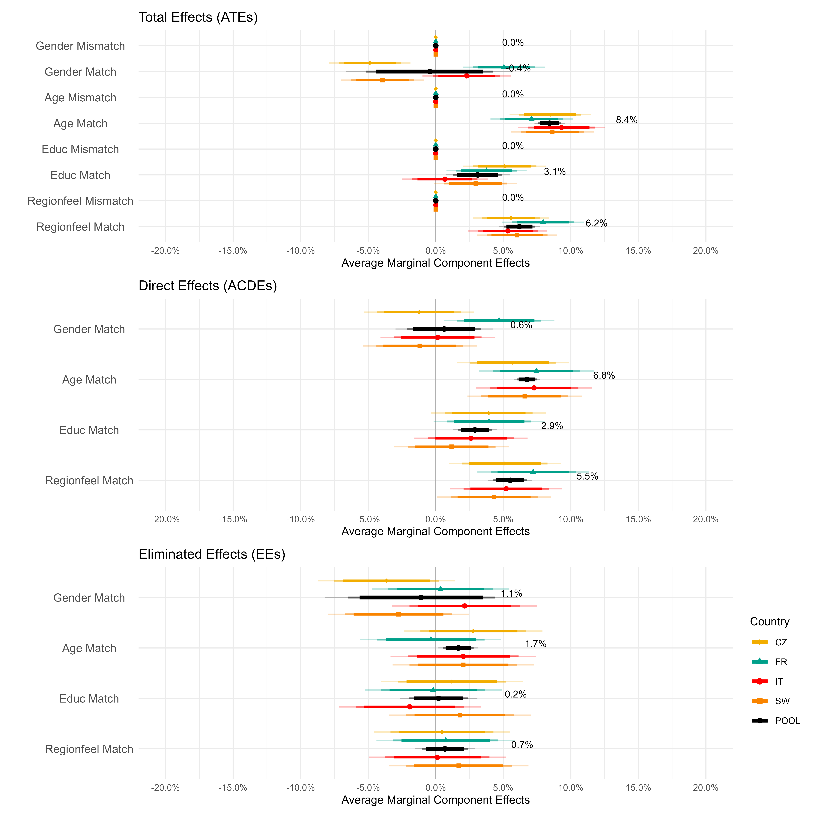

Figure SI9: Total, direct, and eliminated effects of similarity in psychological attributes across countries for the full sample (with speeders and laggards). Total effects are computed on the natural mediation arm. Direct effects are computed on the manipulated mediation arm (ideological match condition). Eliminated effects arise from the difference between the two estimates. All results are presented as AMCEs with the Mismatch as the reference category. Numbers in the graph refer to the pooled estimate (in black). Bars with different widths and shadings represent 90% (shortest, darkest shading), 95%, and 99% (largest, brightest shading) confidence intervals.
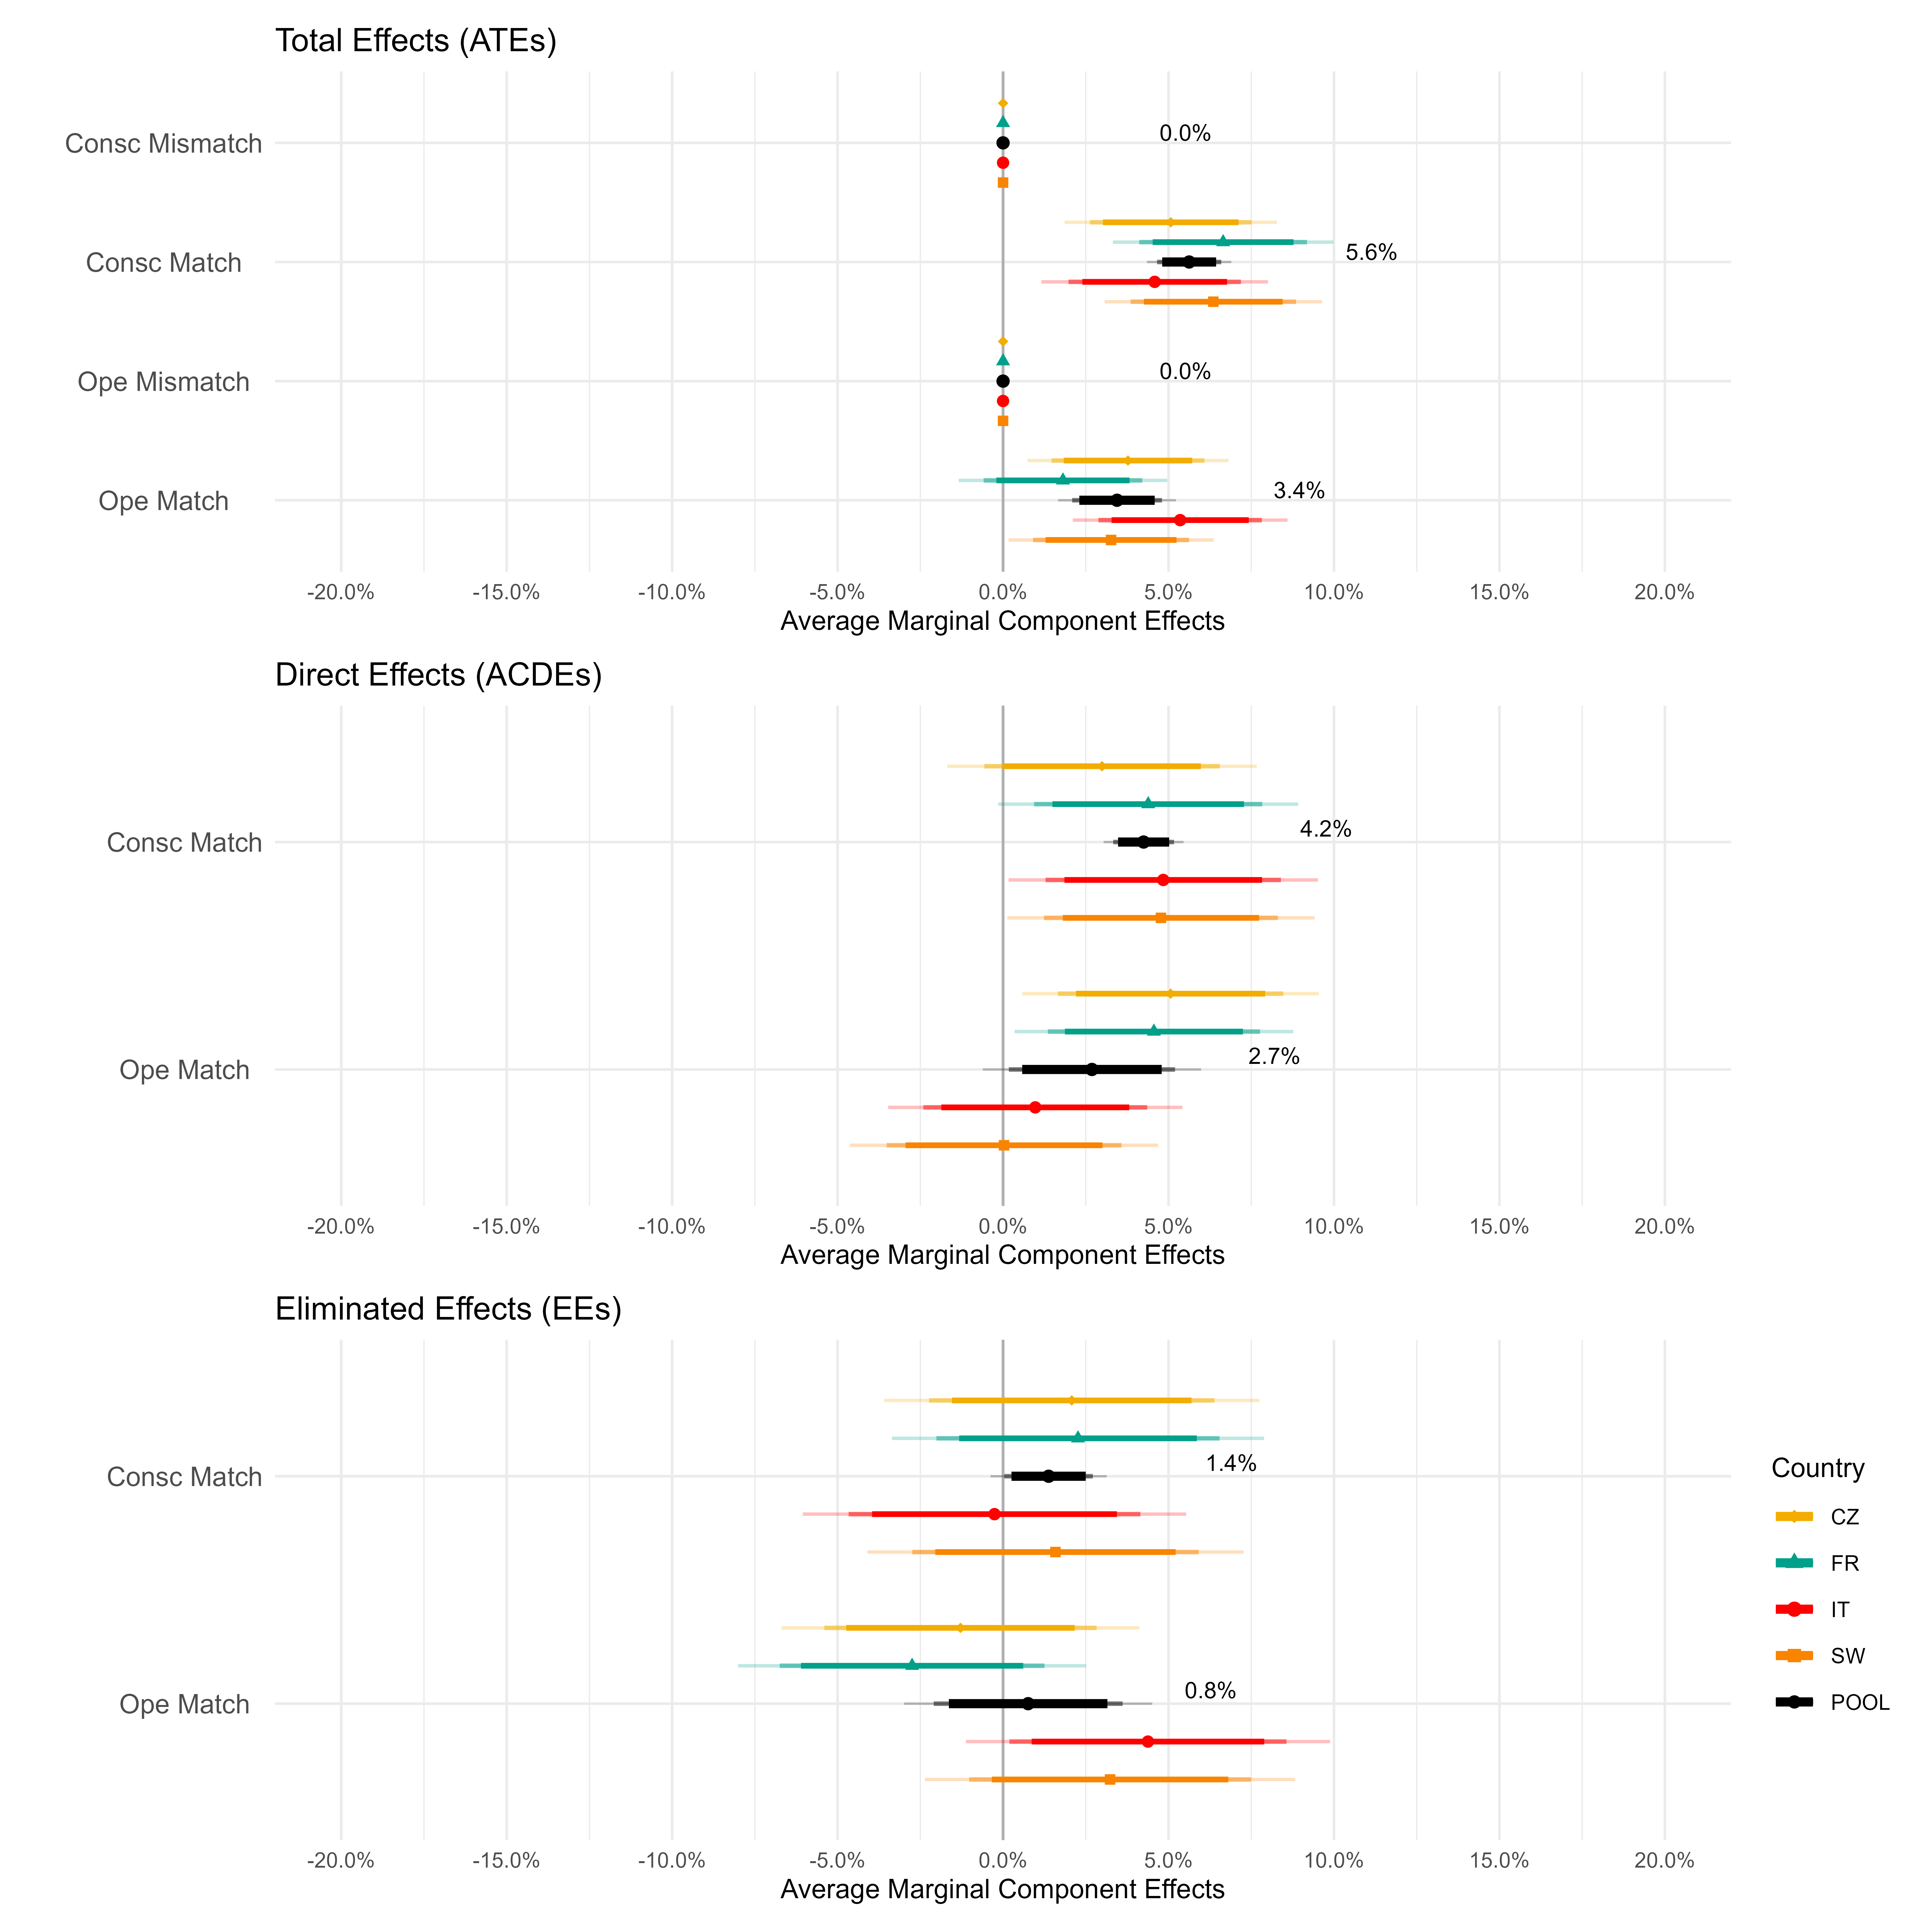

Figure SI10: Total, direct, and eliminated effects of similarity in lifestyle attributes across countries for the full sample (with speeders and laggards). Total effects are computed on the natural mediation arm. Direct effects are computed on the manipulated mediation arm (ideological match condition). Eliminated effects arise from the difference between the two estimates. All results are presented as AMCEs with the Mismatch as the reference category. Numbers in the graph refer to the pooled estimate (in black). Bars with different widths and shadings represent 90% (shortest, darkest shading), 95%, and 99% (largest, brightest shading) confidence intervals.
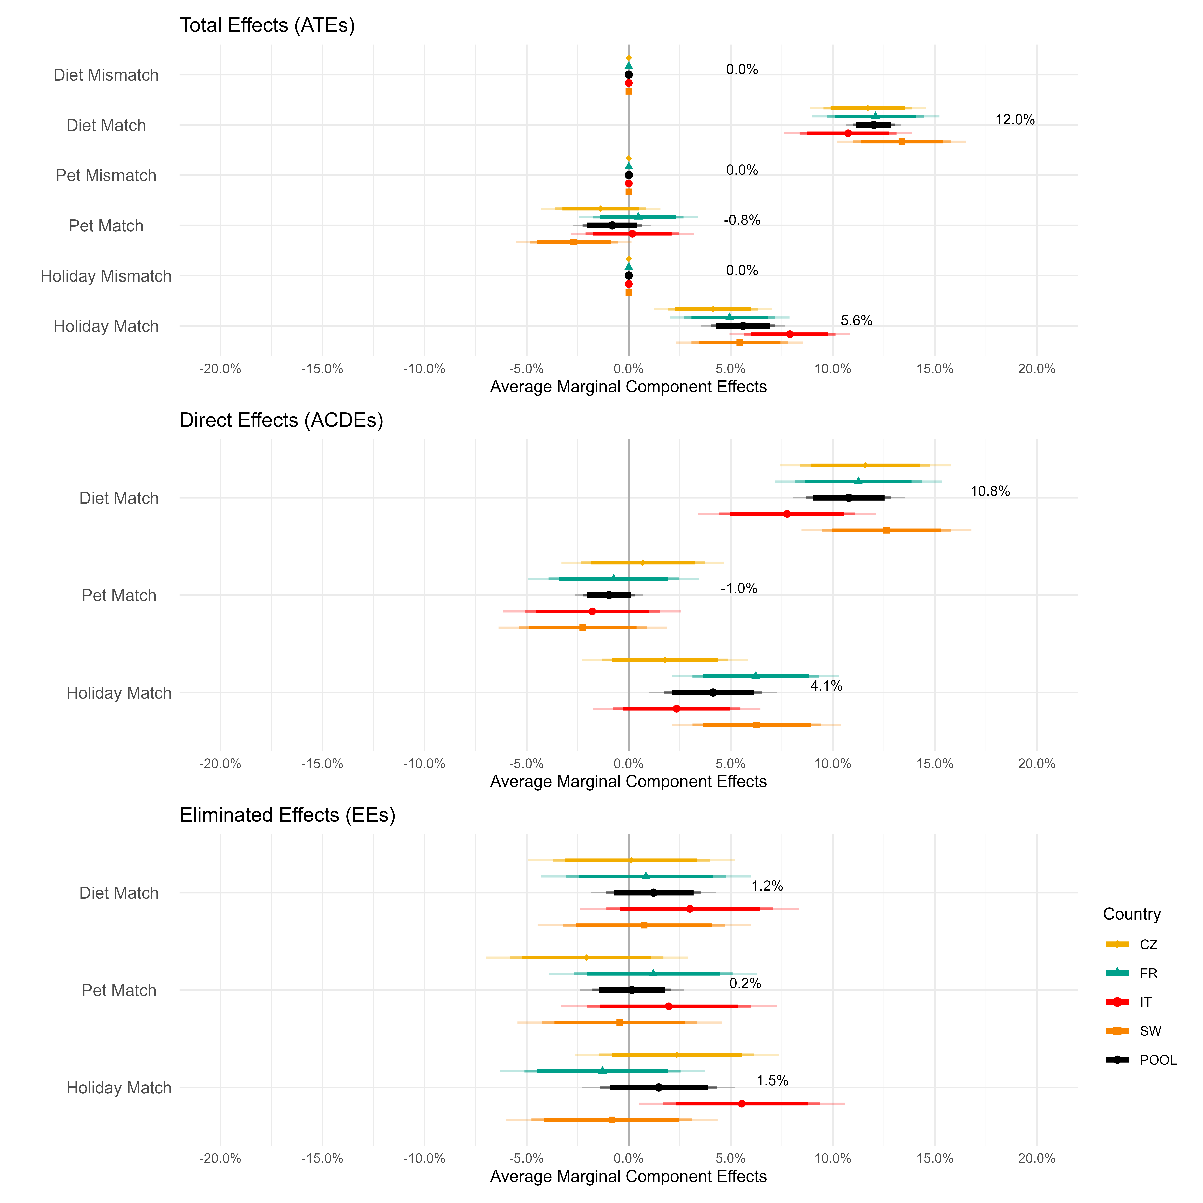
Figure SI11: Total effect of profile attribute levels ($P_{i}^{k}$) for the clean sample using only the first task. All estimates are computed on the natural mediation arm through marginal means. Numbers in the graph refer to the pooled estimate (in black). Bars with different widths and shadings represent 90% (shortest, darkest shading), 95%, and 99% (largest, brightest shading) confidence intervals.

Figure SI12: Total, direct, and eliminated effects of similarity in sociodemographic attributes across countries for the clean sample using only the first task. Total effects are computed on the natural mediation arm. Direct effects are computed on the manipulated mediation arm (ideological match condition). Eliminated effects arise from the difference between the two estimates. All results are presented as AMCEs with the mismatch as the reference category. Numbers in the graph refer to the pooled estimate (in black). Bars with different widths and shadings represent 90% (shortest, darkest shading), 95%, and 99% (largest, brightest shading) confidence intervals.
Figure SI13: Total, direct, and eliminated effects of similarity in psychological attributes across countries for the clean sample using only the first task. Total effects are computed on the natural mediation arm. Direct effects are computed on the manipulated mediation arm (ideological match condition). Eliminated effects arise from the difference between the two estimates. All results are presented as AMCEs with the mismatch as the reference category. Numbers in the graph refer to the pooled estimate (in black). Bars with different widths and shadings represent 90% (shortest, darkest shading), 95%, and 99% (largest, brightest shading) confidence intervals.
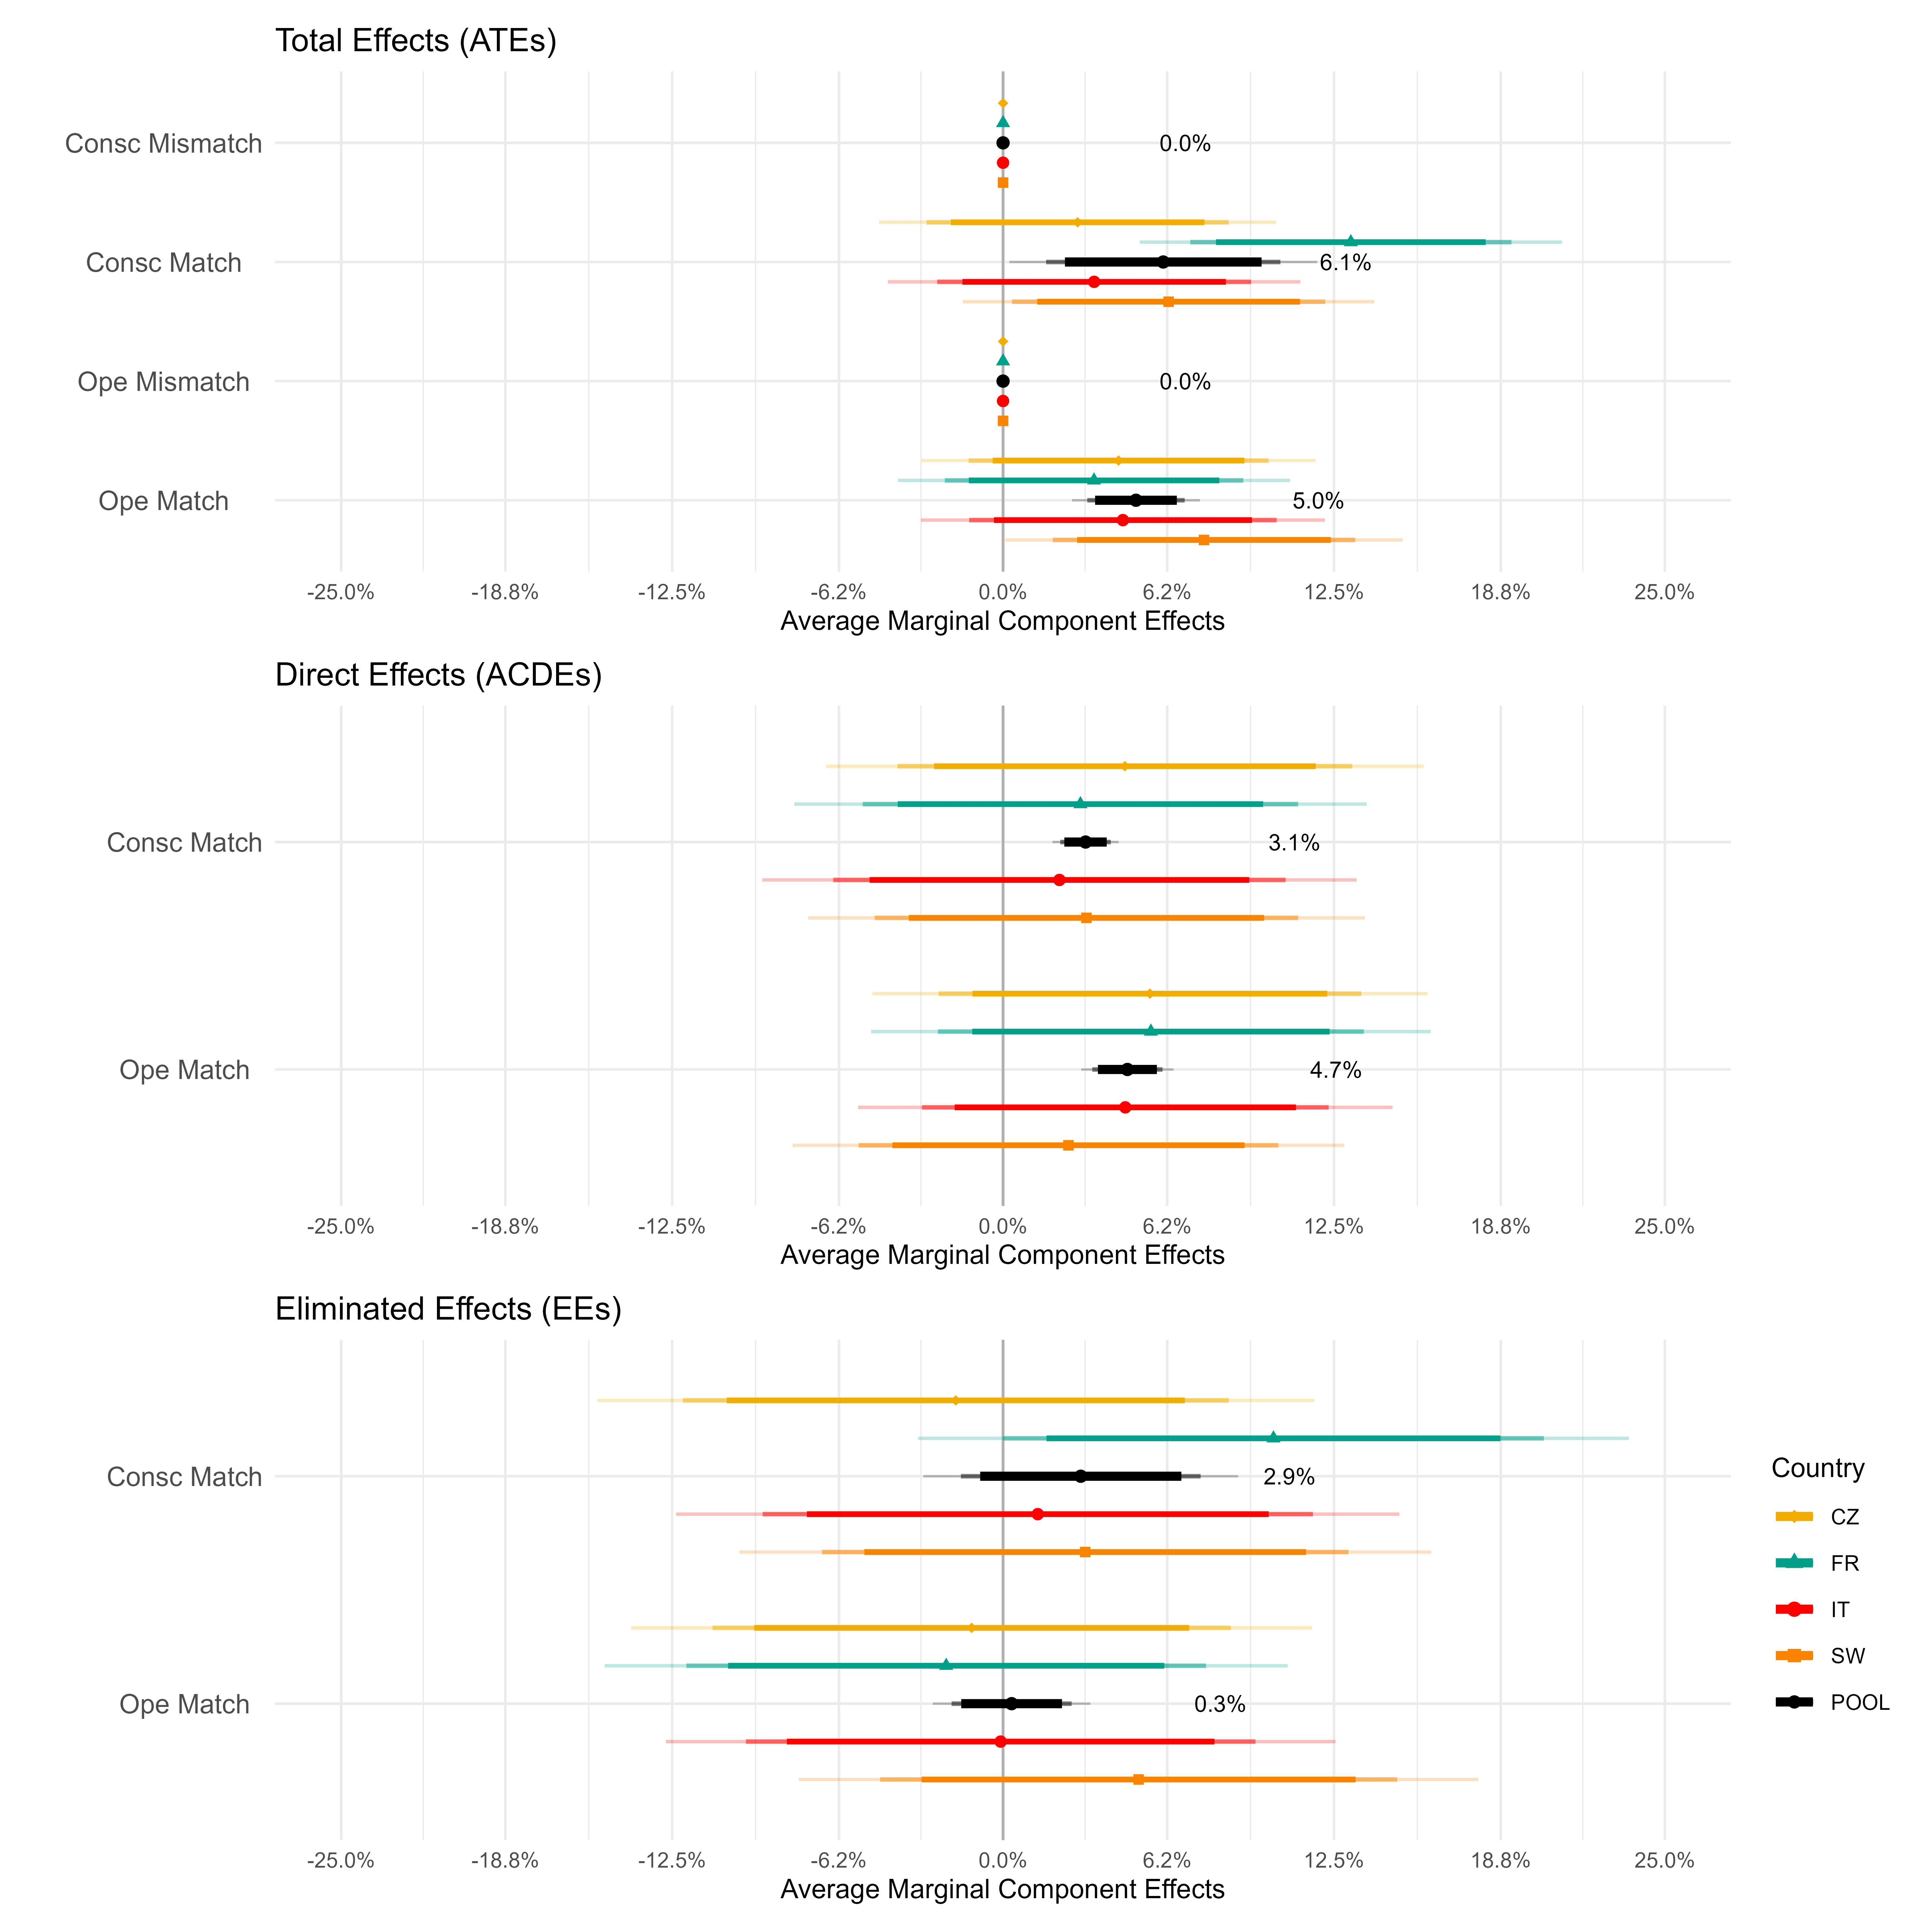

Figure SI14: Total, direct, and eliminated effects of similarity in lifestyle attributes across countries for the clean sample using only the first task. Total effects are computed on the natural mediation arm. Direct effects are computed on the manipulated mediation arm (ideological match condition). Eliminated effects arise from the difference between the two estimates. All results are presented as AMCEs with the Mismatch as the reference category. Numbers in the graph refer to the pooled estimate (in black). Bars with different widths and shadings represent 90% (shortest, darkest shading), 95%, and 99% (largest, brightest shading) confidence intervals.
