ONLINE APPENDIX

Tracing Cultural Constraint in Europe:
Whether and How Attitudes Converge

Table of Contents
Pairwise correlations | . . . . . . . . . . . . . . . . . . . . . . . . . . . . . . . . . . . . . . . . . . . . . . . . . . . . . . . . . . . . |  |  |  | 2
Sample description | . . . . . . . . . . . . . . . . . . . . . . . . . . . . . . . . . . . . . . . . . . . . . . . . . . . . . . . . . . . . . |  |  |  | 3
Robustness checks |  | . . . . . . . . . . . . . . . . . . . . . . . . . . . . . . . . . . . . . . . . . . . . . . . . . . . . . . . . . . . . . |  |  | 8
Modeling changes in constraint across groups |  |  |  | . . . . . . . . . . . . . . . . . . . . . . . . . . . . . . . . . . . . . . . . |  | 15
Group-specific levels of constraint |  |  | . . . . . . . . . . . . . . . . . . . . . . . . . . . . . . . . . . . . . . . . . . . . . . . |  | 17
Country-specific levels of constraint |  |  | . . . . . . . . . . . . . . . . . . . . . . . . . . . . . . . . . . . . . . . . . . . . . |  | 22
Climate change components |  |  | . . . . . . . . . . . . . . . . . . . . . . . . . . . . . . . . . . . . . . . . . . . . . . . . . . . . . |  | 23

Pairwise correlations
Table A1. Average pairwise correlations among the attitudes used in the constraint analyses across countries by year.
 | 2002 | 2004 | 2006 | 2008 | 2010 | 2012 | 2014 | 2016 | 2018 | 2020 | 2022
 | (n = 20) | (n = 25) | (n = 23) | (n = 29) | (n = 27) | (n = 29) | (n = 21) | (n = 23) | (n = 29) | (n = 22) | (n = 28)
Env. prot.–Imm. | 0.061 | 0.063 | 0.044 | 0.068 | 0.040 | 0.036 | 0.064 | 0.062 | 0.073 | 0.105 | 0.105
Env. prot.–Hom. | 0.053 | 0.030 | 0.033 | 0.039 | 0.048 | 0.043 | 0.054 | 0.043 | 0.116 | 0.126 | 0.110
Env. prot.–Int. coop. | 0.040 | 0.039 | 0.028 | 0.044 | 0.043 | 0.042 | 0.027 | 0.020 | 0.032 | 0.060 | 0.048
Imm.–Hom. | 0.206 | 0.195 | 0.196 | 0.183 | 0.188 | 0.184 | 0.202 | 0.201 | 0.216 | 0.227 | 0.216
Imm.–Int. coop. | 0.150 | 0.188 | 0.183 | 0.174 | 0.193 | 0.178 | 0.209 | 0.248 | 0.247 | 0.269 | 0.236
Hom.–Int. coop. | 0.074 | 0.067 | 0.071 | 0.063 | 0.096 | 0.074 | 0.095 | 0.104 | 0.123 | 0.117 | 0.108
Clim. ch.–Env. prot. | – | – | – | – | – | – | – | 0.260 | – | 0.314 | 0.331
Clim. ch.–Imm. | – | – | – | – | – | – | – | 0.171 | – | 0.206 | 0.233
Clim. ch.–Hom. | – | – | – | – | – | – | – | 0.113 | – | 0.160 | 0.179
Clim. ch.–Int. coop. | – | – | – | – | – | – | – | 0.124 | – | 0.191 | 0.200
Red.–Egal. | 0.133 | 0.163 | 0.143 | 0.134 | 0.138 | 0.141 | 0.124 | 0.154 | 0.155 | 0.158 | 0.179

Sample composition
Table A2. Availability of measure for constraint within belief systems per country over years.
 | 2002 | 2004 | 2006 | 2008 | 2010 | 2012 | 2014 | 2016 | 2018 | 2020 | 2022 | t
Albania |  |  |  |  |  |  |  |  |  |  |  | 1
Austria |  |  |  |  |  |  |  |  |  |  |  | 7
Belgium |  |  |  |  |  |  |  |  |  |  |  | 11
Bulgaria |  |  |  |  |  |  |  |  |  |  |  | 7
Switzerland |  |  |  |  |  |  |  |  |  |  |  | 11
Cyprus |  |  |  |  |  |  |  |  |  |  |  | 6
Czechia |  |  |  |  |  |  |  |  |  |  |  | 9
Germany |  |  |  |  |  |  |  |  |  |  |  | 10
Denmark |  |  |  |  |  |  |  |  |  |  |  | 8
Estonia |  |  |  |  |  |  |  |  |  |  |  | 9
Spain |  |  |  |  |  |  |  |  |  |  |  | 10
Finland |  |  |  |  |  |  |  |  |  |  |  | 11
France |  |  |  |  |  |  |  |  |  |  |  | 11
United Kingdom |  |  |  |  |  |  |  |  |  |  |  | 11
Greece |  |  |  |  |  |  |  |  |  |  |  | 6
Croatia |  |  |  |  |  |  |  |  |  |  |  | 5
Hungary |  |  |  |  |  |  |  |  |  |  |  | 11
Ireland |  |  |  |  |  |  |  |  |  |  |  | 11
Israel |  |  |  |  |  |  |  |  |  |  |  | 7
Iceland |  |  |  |  |  |  |  |  |  |  |  | 6
Italy |  |  |  |  |  |  |  |  |  |  |  | 5
Lithuania |  |  |  |  |  |  |  |  |  |  |  | 7
Luxembourg |  |  |  |  |  |  |  |  |  |  |  | 1
Latvia |  |  |  |  |  |  |  |  |  |  |  | 3
Montenegro |  |  |  |  |  |  |  |  |  |  |  | 3
North Macedonia |  |  |  |  |  |  |  |  |  |  |  | 1
Netherlands |  |  |  |  |  |  |  |  |  |  |  | 11
Norway |  |  |  |  |  |  |  |  |  |  |  | 11
Poland |  |  |  |  |  |  |  |  |  |  |  | 10
Portugal |  |  |  |  |  |  |  |  |  |  |  | 11
Romania |  |  |  |  |  |  |  |  |  |  |  | 1
Serbia |  |  |  |  |  |  |  |  |  |  |  | 2
Russian Federation |  |  |  |  |  |  |  |  |  |  |  | 5
Sweden |  |  |  |  |  |  |  |  |  |  |  | 10
Slovenia |  |  |  |  |  |  |  |  |  |  |  | 11
Slovakia |  |  |  |  |  |  |  |  |  |  |  | 8
Turkey |  |  |  |  |  |  |  |  |  |  |  | 2
Ukraine |  |  |  |  |  |  |  |  |  |  |  | 5
Kosovo |  |  |  |  |  |  |  |  |  |  |  | 1
Total | 20 | 25 | 23 | 29 | 27 | 29 | 21 | 23 | 29 | 22 | 28 | 11

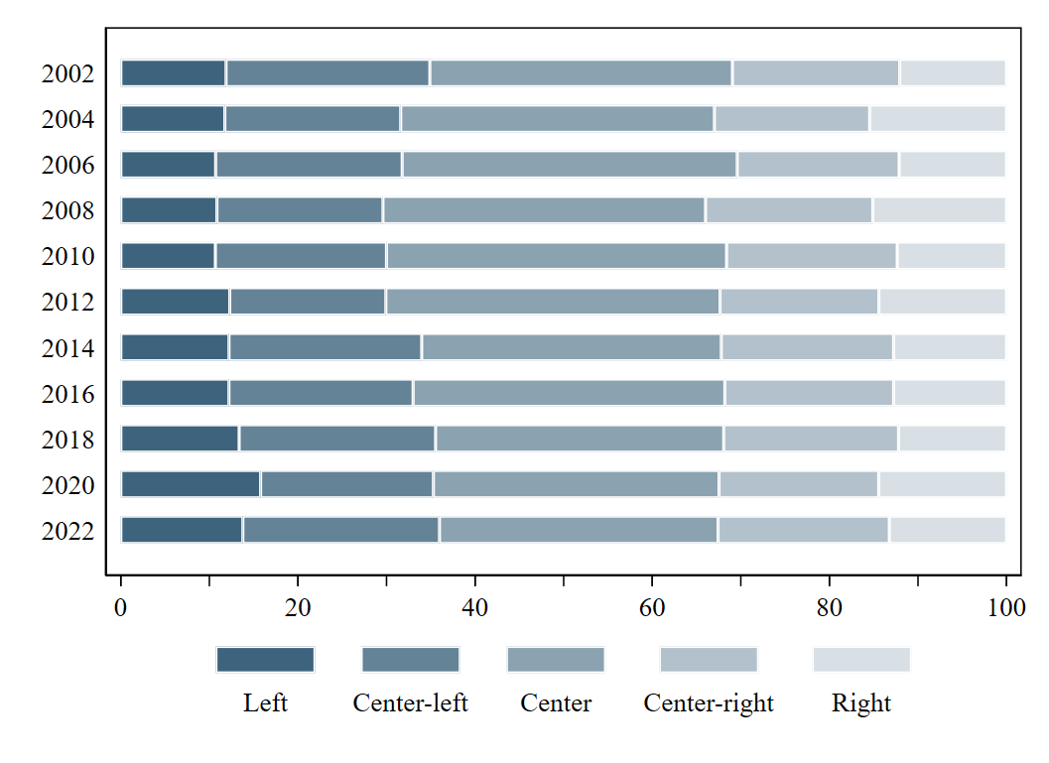
Figure A1a. Left-right self-placement over years. Weighted proportions in %.
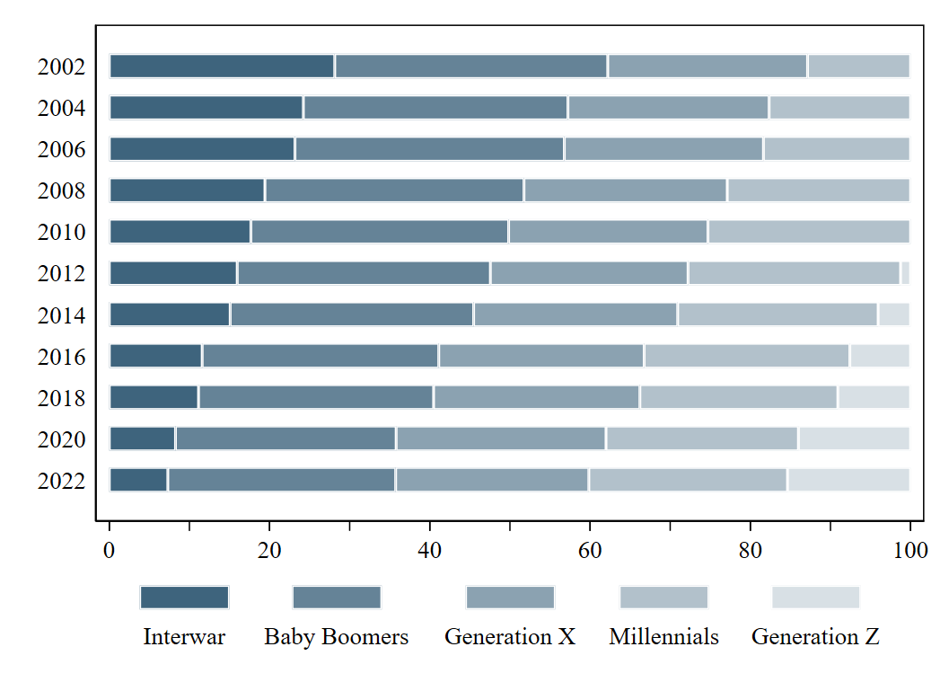
Figure A1b. Generational cohorts over years. Weighted proportions in %.
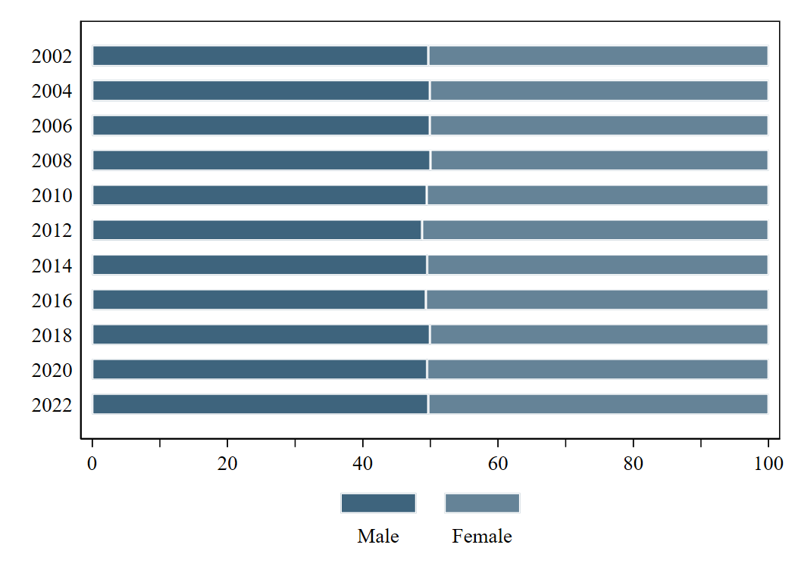
Figure A1c. Sex over years. Weighted proportions in %.
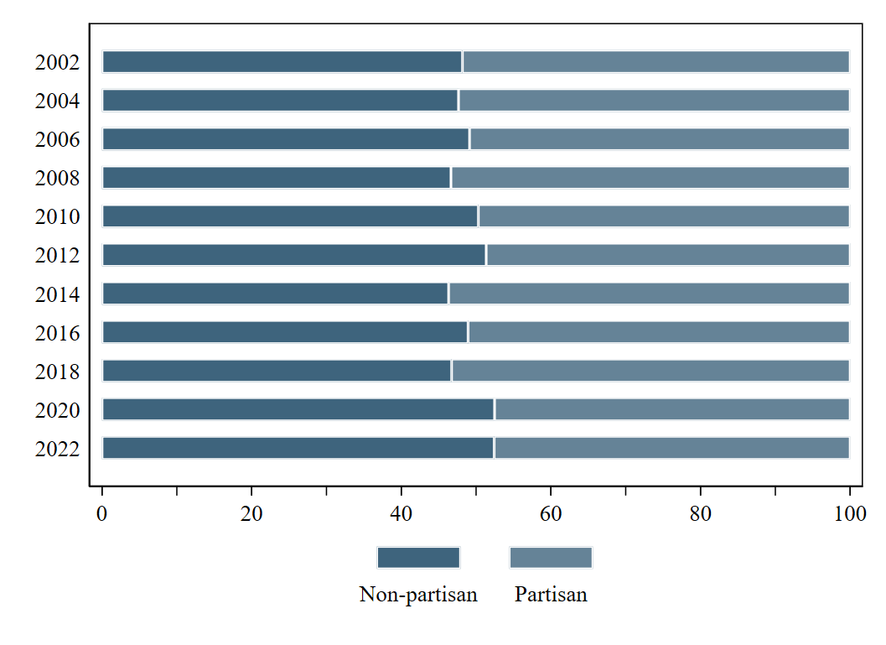
Figure A1d. Partisanship over years. Weighted proportions in %.
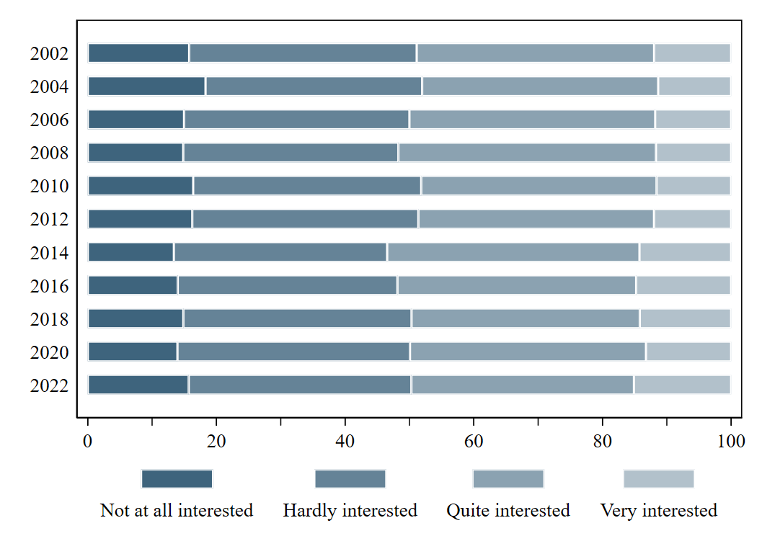
Figure A1e. Political interest over years. Weighted proportions in %.

Robustness checks
Next to the multilevel model in the manuscript, I specified two additional models as robustness checks:
Meta-analysis: The meta-analytic model first estimates country-specific time trends,
$${C\left(X\right)}_{jt}=α_{j}+β_{1}∙{year}_{jt}+ε_{jt}\text{ ,}$$ | (3.1)
and then pools these slopes into an overall average while accounting for between-country heterogeneity,
$${\hat{β}}_{j}=β+u_{j}+ε_{j}\text{ .}$$ | (3.2)

Generalized Estimating Equation (GEE): The GEE model estimates the average time trend across all countries directly,
$${E(C\left(X\right)}_{jt})=α+β∙{year}_{jt}\text{ ,}$$ | (4)
adjusting for within-country correlation in repeated observations through robust standard errors.
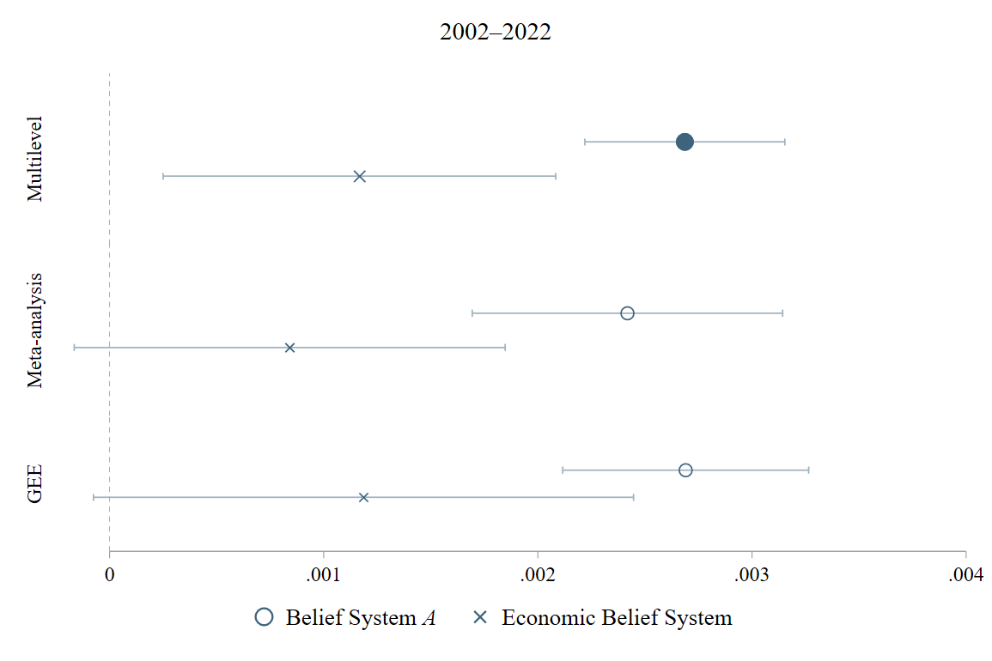
Figure A2a. Multilevel model, meta-analytic, and GEE model estimates of country-specific time trends in constraint for the whole period 2002–2022. Multilevel model estimates are reported in Figure 3a.
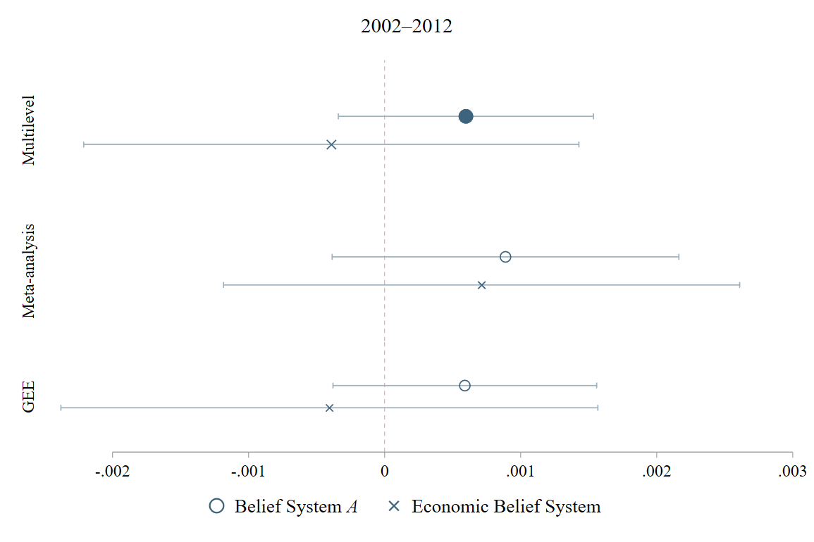
Figure A2b. Multilevel model, meta-analytic, and GEE model estimates of country-specific time trends in constraint for the subperiod 2002–2012. Multilevel model estimates are reported in Figure 3a.
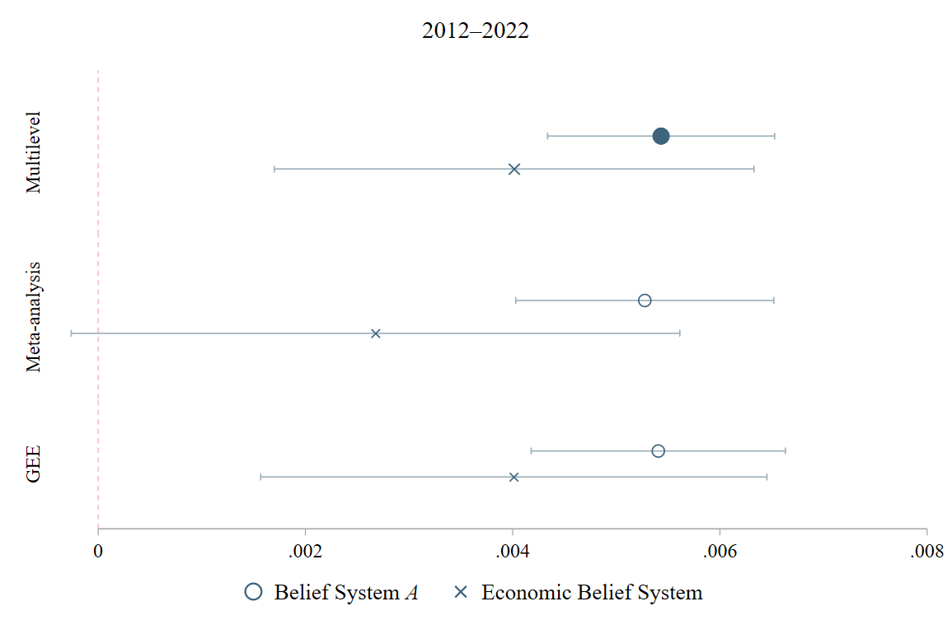
Figure A2c. Multilevel model, meta-analytic, and GEE model estimates of country-specific time trends in constraint for the subperiod 2012–2022. Multilevel model estimates are reported in Figure 3a.
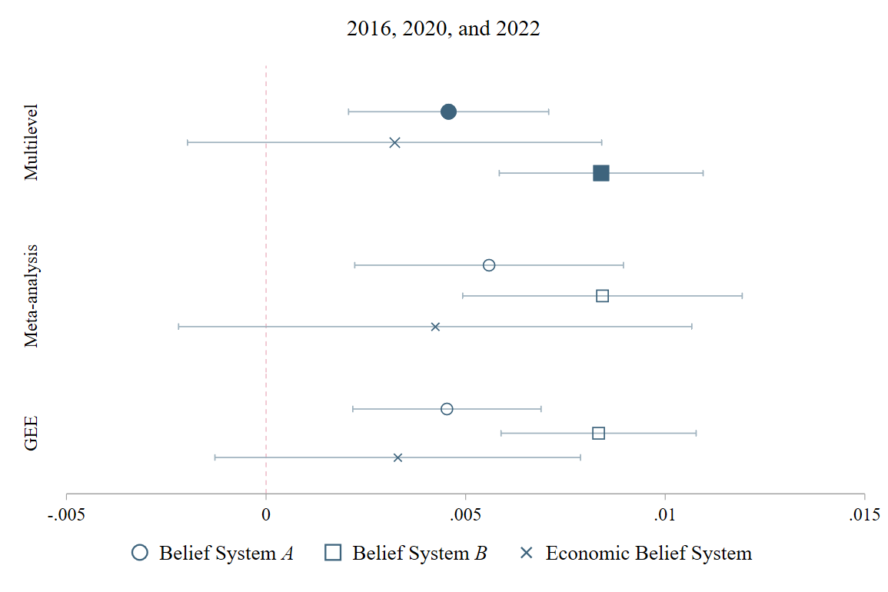
Figure A2d. Multilevel model, meta-analytic, and GEE model estimates of country-specific time trends in constraint for the subperiod 2016, 2020, and 2022. Multilevel model estimates are reported in Figure 3a.
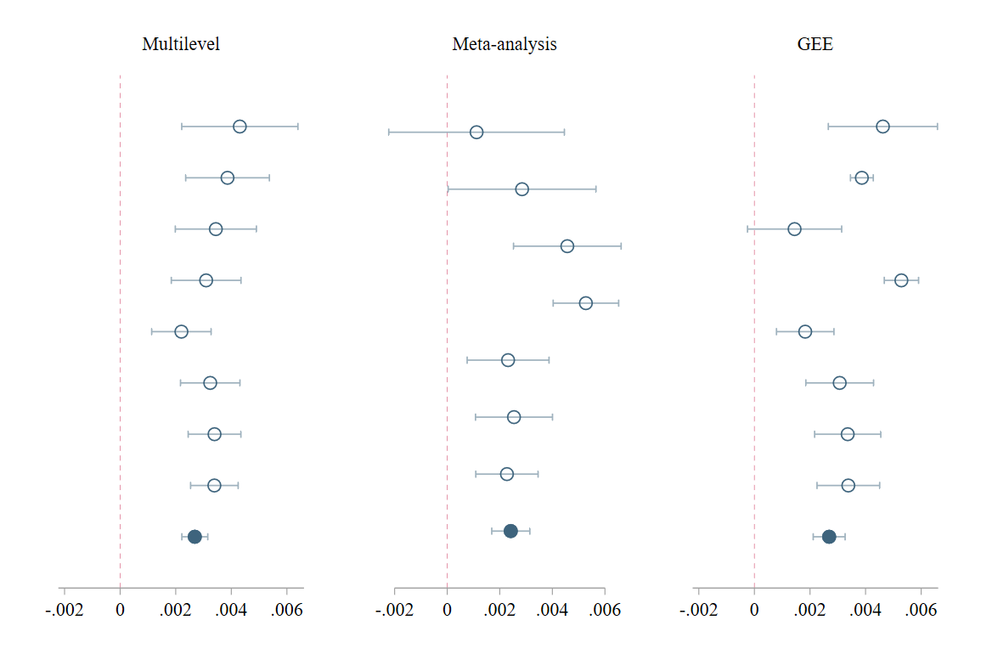
Figure A3a. Robustness checks of country-specific time trends in constraint within Belief System A for the whole period 2002–2022 as reported in Figure A2a. Each subgraph shows estimates for nested subsets of countries, defined by the number of observed time points t. From top to bottom: Multilevel and GEE model: t $ϵ$ [1,2], [1,3], [1,5], [1,6], [1,7], [1,8], [1,9], [1,11]; Meta-analysis: t $ϵ$ [1,3], [1,5], [1,6], [1,7], [1,8], [1,9], [1,11].
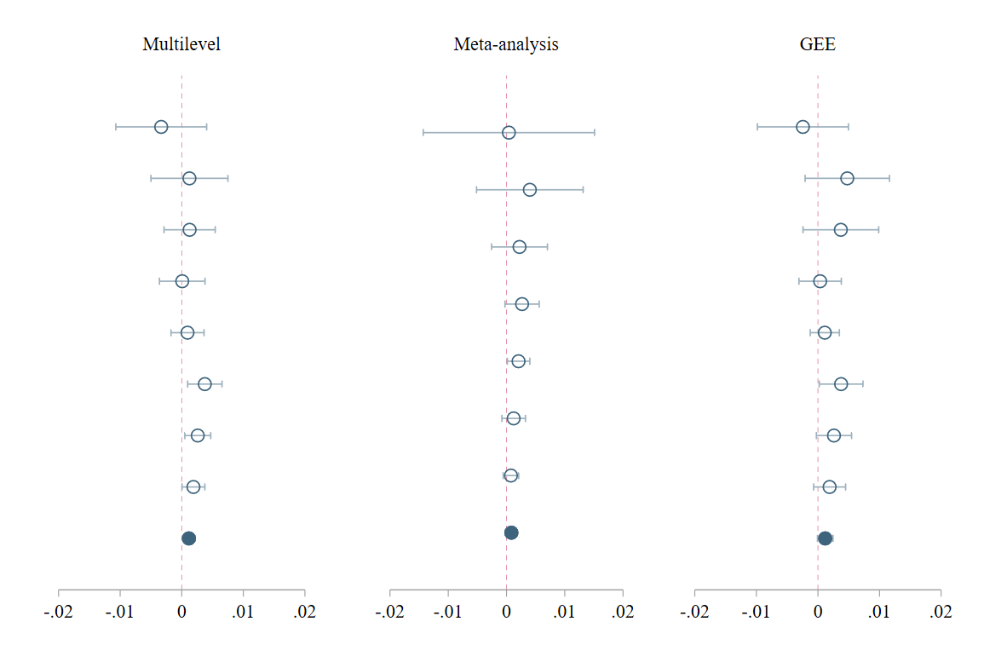
Figure A3b. Robustness checks of country-specific time trends in constraint within the economic belief system for the whole period 2002–2022 as reported in Figure A2a. Each subgraph shows estimates for nested subsets of countries, defined by the number of observed time points t. From top to bottom: Multilevel and GEE model: t $ϵ$ [1,2], [1,3], [1,5], [1,6], [1,7], [1,8], [1,9], [1,11]; Meta-analysis: t $ϵ$ [1,3], [1,5], [1,6], [1,7], [1,8], [1,9], [1,11].
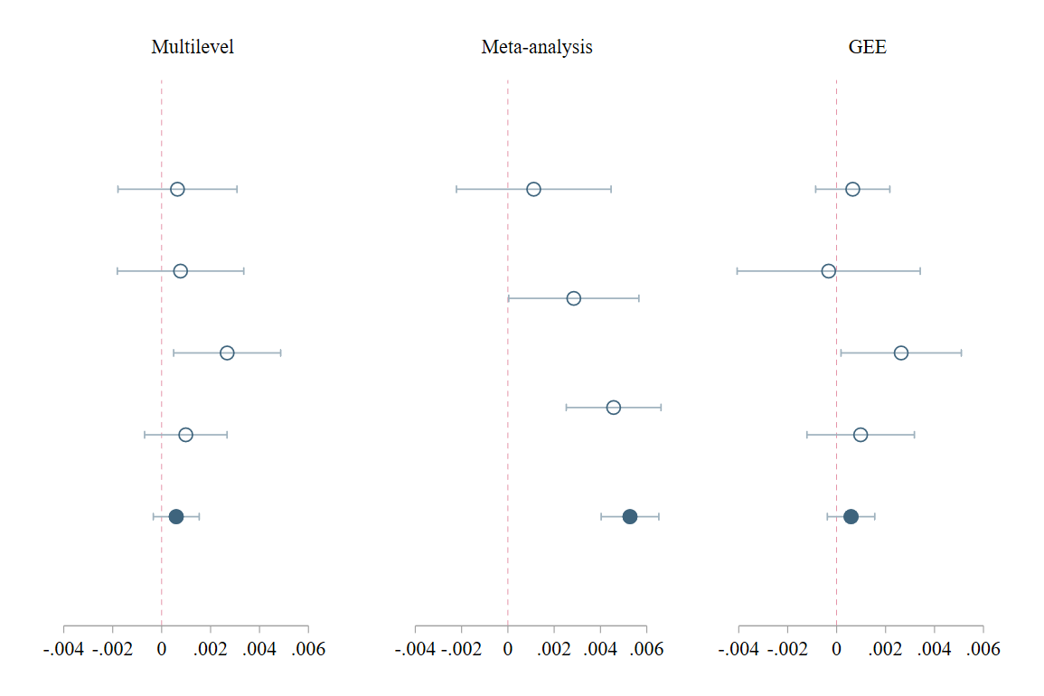
Figure A3c. Robustness checks of country-specific time trends in constraint within Belief System A for the subperiod 2002–2012 as reported in Figure A2b. Each subgraph shows estimates for nested subsets of countries, defined by the number of observed time points t. From top to bottom: Multilevel and GEE model: t $ϵ$ [1,2], [1,3], [1,4], [1,5], [1,6]; Meta-analysis: t $ϵ$ 3, [3,4], [3,5], [3,6].
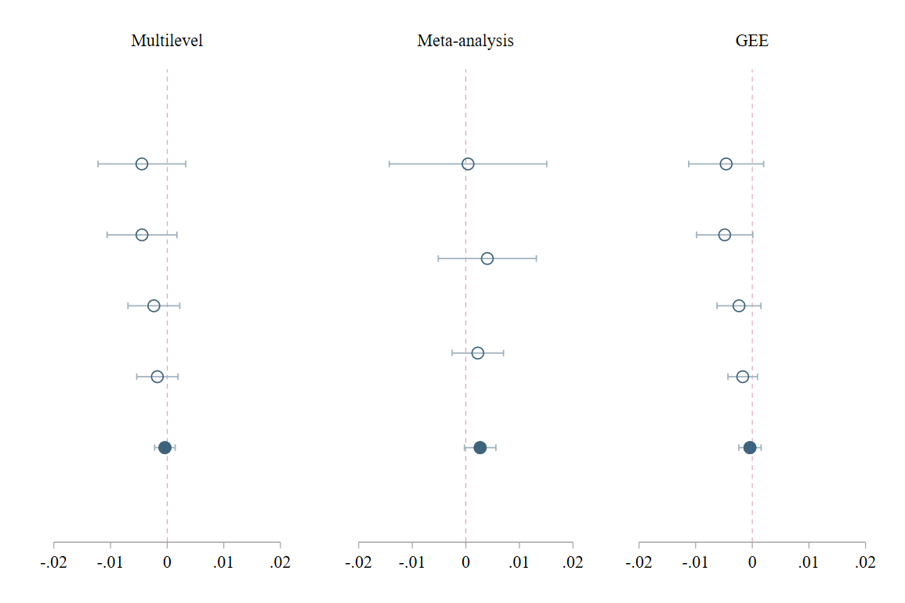
Figure A3d. Robustness checks of country-specific time trends in constraint within the economic belief system for the subperiod 2002–2012 as reported in Figure A2b. Each subgraph shows estimates for nested subsets of countries, defined by the number of observed time points t. From top to bottom: Multilevel and GEE model: t $ϵ$ [1,2], [1,3], [1,4], [1,5], [1,6]; Meta-analysis: t $ϵ$ 3, [3,4], [3,5], [3,6].
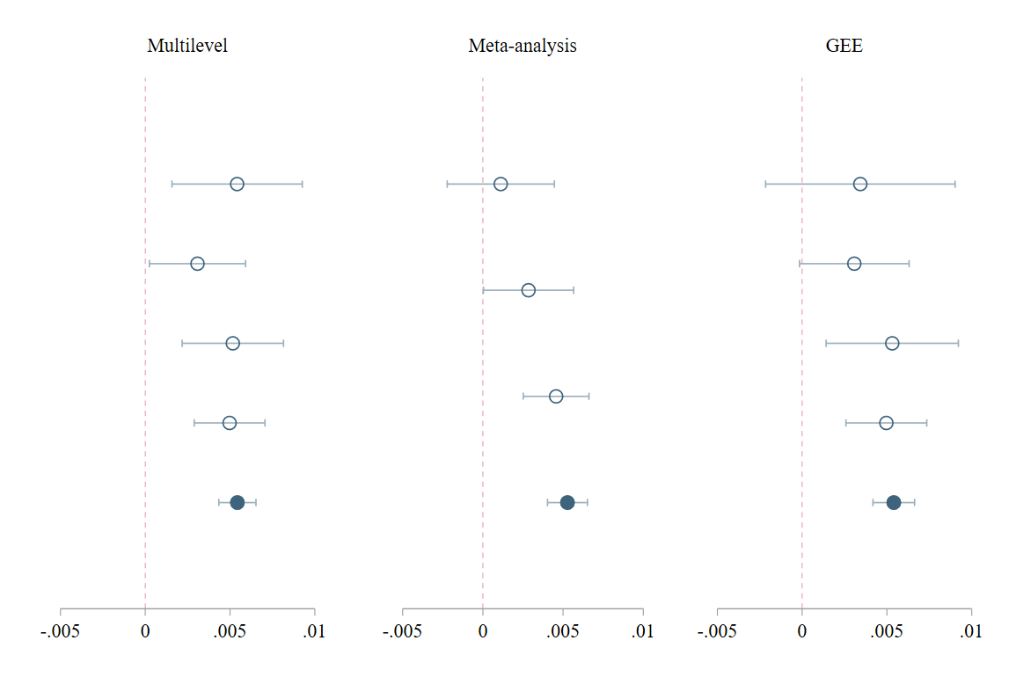
Figure A3e. Robustness checks of country-specific time trends in constraint within Belief System A for the subperiod 2012–2022 as reported in Figure A2c. Each subgraph shows estimates for nested subsets of countries, defined by the number of observed time points t. From top to bottom: Multilevel and GEE model: t $ϵ$ [1,2], [1,3], [1,4], [1,5], [1,6]; Meta-analysis: t $ϵ$ 3, [3,4], [3,5], [3,6].
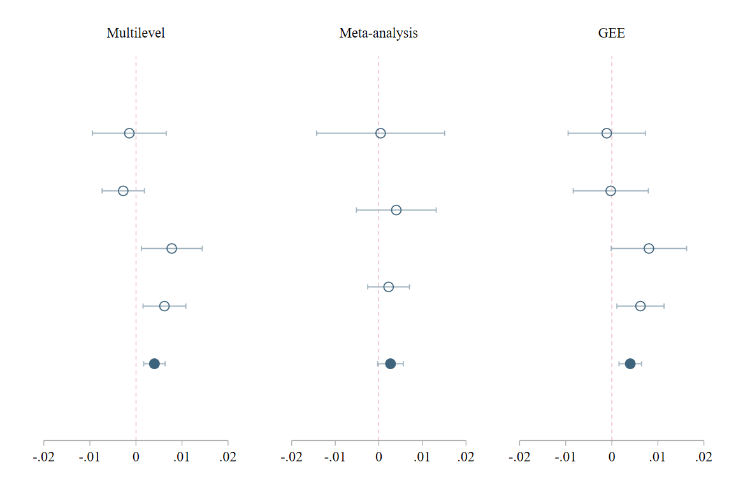
Figure A3f. Robustness checks of country-specific time trends in constraint within the economic belief system for the subperiod 2012–2022 as reported in Figure A2c. Each subgraph shows estimates for nested subsets of countries, defined by the number of observed time points t. From top to bottom: Multilevel and GEE model: t $ϵ$ [1,2], [1,3], [1,4], [1,5], [1,6]; Meta-analysis: t $ϵ$ 3, [3,4], [3,5], [3,6].
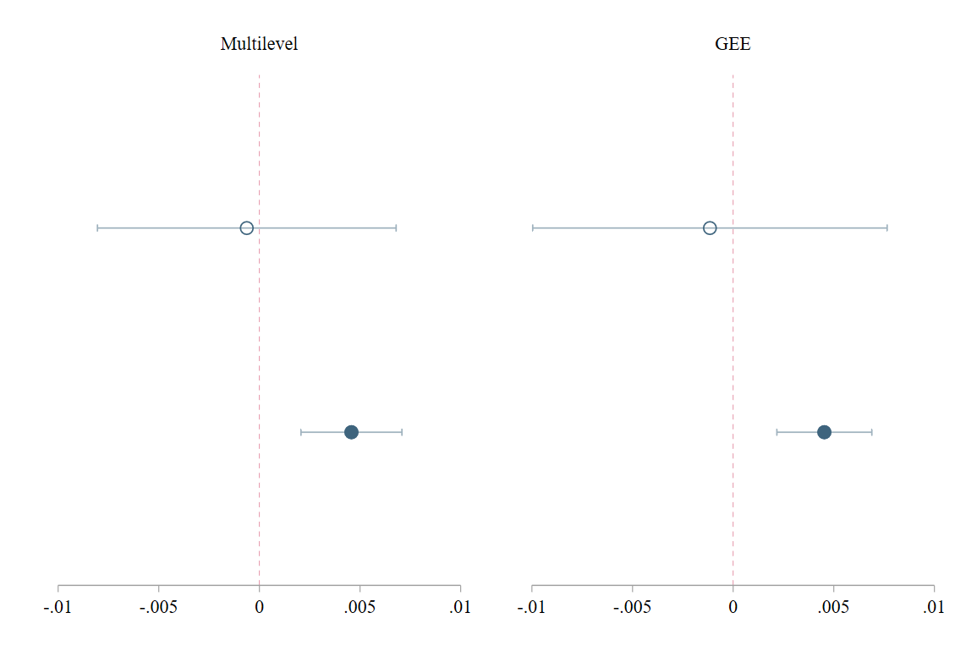
Figure A3g. Robustness checks of country-specific time trends in constraint within Belief System A for the subperiod 2016, 2020, and 2022 as reported in Figure A2d. Each subgraph shows estimates for nested subsets of countries, defined by the number of observed time points t. From top to bottom: t $ϵ$ [1,2], [1,3].
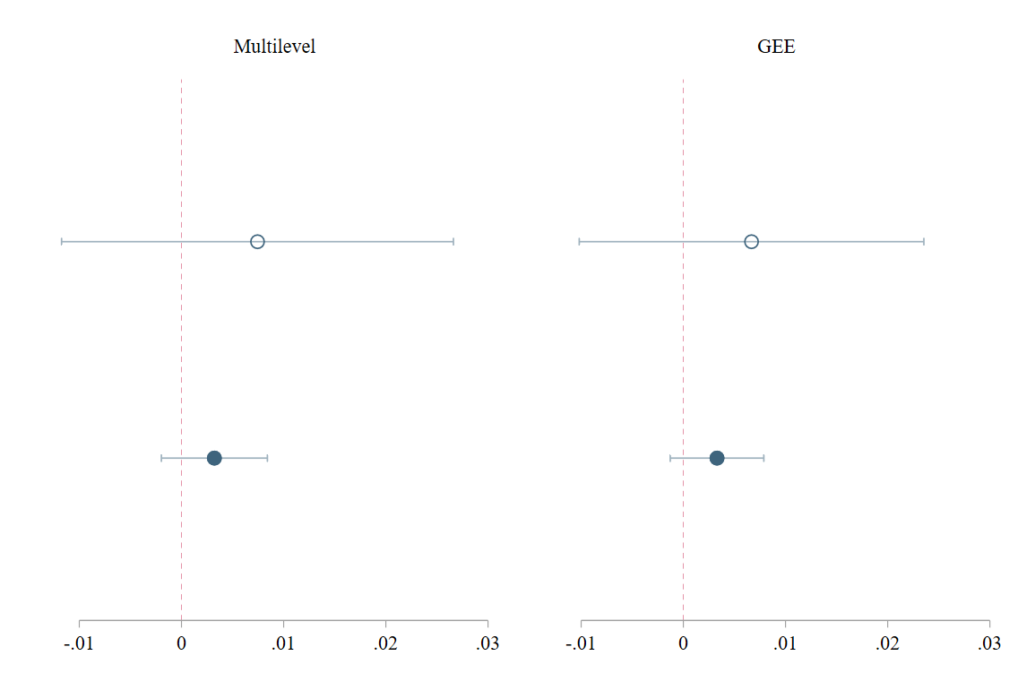
Figure A3h. Robustness checks of country-specific time trends in constraint within the economic belief system for the subperiod 2016, 2020, and 2022 as reported in Figure A2d. Each subgraph shows estimates for nested subsets of countries, defined by the number of observed time points t. From top to bottom: t $ϵ$ [1,2], [1,3].

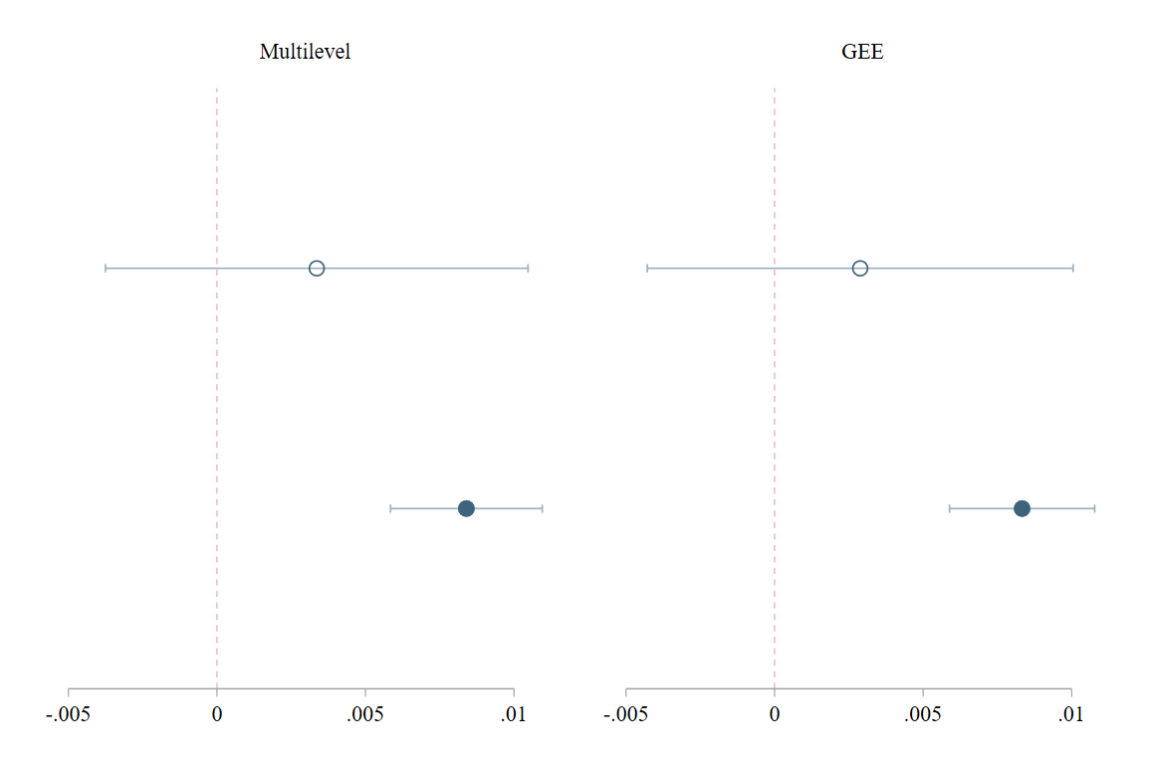
Figure A3i. Robustness checks of country-specific time trends in constraint within Belief System B for the subperiod 2016, 2020, and 2022 as reported in Figure A2d. Each subgraph shows estimates for nested subsets of countries, defined by the number of observed time points t. From top to bottom: t $ϵ$ [1,2], [1,3].

Modeling changes in constraint across groups
Table A3. Changes in constraint across groups. Models underlying time trend estimates reported in Figure 4 and Figure 5. Multivariate cross-classified multilevel mixed-effects model of constraint within belief system A and B for different periods.
 | A  (2012–2022) |  | A  (2016, 2020, and 2022) |  | B  (2016, 2020, and 2022)
 | M1-I | M1-II | M2-I | M2-II | M3-I | M3-II
Fixed effects
Year | -0.003*** | -0.002*** | -0.006*** | -0.005** | -0.004* | -0.002
 | (0.001) | (0.001) | (0.002) | (0.002) | (0.002) | (0.001)
Left-right self-placement
(Ref.: Center)
Left | 4.334*** | 5.935*** | 5.906*** | 10.573*** | 5.483*** | 6.417***
 | (0.850) | (0.803) | (1.715) | (1.587) | (1.607) | (1.521)
Center-left | 0.166 | 1.114⁺ | 0.727 | 1.530 | 2.503* | 3.701**
 | (0.671) | (0.640) | (1.323) | (1.239) | (1.230) | (1.160)
Center-right | -0.773 | 0.172 | -1.953 | -1.328 | -2.536* | -1.606
 | (0.646) | (0.618) | (1.270) | (1.194) | (1.181) | (1.114)
Right | -4.540*** | -3.450*** | 2.828⁺ | 3.748** | 3.108* | 0.904
 | (0.733) | (0.699) | (1.488) | (1.392) | (1.393) | (1.316)
Left X Year | -0.002*** | -0.003*** | -0.003*** | -0.005*** | -0.003*** | -0.003***
 | (0.000) | (0.000) | (0.001) | (0.001) | (0.001) | (0.001)
Center-left X Year | -0.000 | -0.001 | -0.000 | -0.001 | -0.001* | -0.002**
 | (0.000) | (0.000) | (0.001) | (0.001) | (0.001) | (0.001)
Center-right X Year | 0.000 | -0.000 | 0.001 | 0.001 | 0.001* | 0.001
 | (0.000) | (0.000) | (0.001) | (0.001) | (0.001) | (0.001)
Right X Year | 0.002*** | 0.002*** | -0.001⁺ | -0.002** | -0.001* | -0.000
 | (0.000) | (0.000) | (0.001) | (0.001) | (0.001) | (0.001)
Generational cohort
(Ref.: Baby Boomer)
Interwar | -24.004*** | -23.944*** | -22.122*** | -21.561*** | -20.475*** | -15.907***
 | (0.847) | (0.821) | (1.796) | (1.716) | (1.688) | (1.670)
Gen. X | -1.237* | -1.199* | -0.492 | -0.378 | -1.333 | -0.327
 | (0.595) | (0.576) | (1.184) | (1.131) | (1.101) | (1.057)
Mill. | -2.517*** | – | -5.578*** | – | -5.234*** | –
 | (0.623) |  | (1.227) |  | (1.142)
Gen. Z | 35.504*** | – | 25.823*** | – | 26.828*** | –
 | (1.653) |  | (2.327) |  | (2.189)
Mill./ Gen. Z | – | 5.941*** | – | 3.399** | – | 2.611**
 |  | (0.565) |  | (1.080) |  | (1.010)
Interwar X Year | 0.012*** | 0.012*** | 0.011*** | 0.011*** | 0.010*** | 0.008***
 | (0.000) | (0.000) | (0.001) | (0.001) | (0.001) | (0.001)
Gen. X X Year | 0.001* | 0.001* | 0.000 | 0.000 | 0.001 | 0.000
 | (0.000) | (0.000) | (0.001) | (0.001) | (0.001) | (0.001)
Mill. X Year | 0.001*** | – | 0.003*** | – | 0.003*** | –
 | (0.000) |  | (0.001) |  | (0.001)
Gen. Z X Year | -0.018*** | – | -0.013*** | – | -0.013*** | –
 | (0.001) |  | (0.001) |  | (0.001)
Mill./Gen. Z X Year | – | -0.003*** | – | -0.002** | – | -0.001**
 |  | (0.000) |  | (0.001) |  | (0.001)
Sex
(Ref.: Male)
Female | -0.805⁺ | -1.002* | 2.047* | 2.477** | 3.228*** | 3.255***
 | (0.468) | (0.447) | (0.932) | (0.873) | (0.868) | (0.820)
Female X Year | 0.000⁺ | 0.000* | -0.001* | -0.001** | -0.002*** | -0.002***
 | (0.000) | (0.000) | (0.000) | (0.000) | (0.000) | (0.000)
Partisanship
(Ref.: Non-partisan)
Partisan | -2.795*** | -2.255*** | -4.925*** | -3.761*** | -6.759*** | -5.093***
 | (0.520) | (0.495) | (1.026) | (0.957) | (0.957) | (0.906)
Partisan X Year | 0.001*** | 0.001*** | 0.002*** | 0.002*** | 0.003*** | 0.003***
 | (0.000) | (0.000) | (0.001) | (0.000) | (0.000) | (0.000)
Political interest
(Ref.: Not at all interested)
Hardly | -7.272*** | -5.236*** | -18.647*** | -16.190*** | -15.377*** | -11.739***
 | (0.718) | (0.683) | (1.477) | (1.377) | (1.386) | (1.308)
Quite | -11.515*** | -10.344*** | -17.800*** | -18.399*** | -16.394*** | -15.224***
 | (0.749) | (0.711) | (1.527) | (1.422) | (1.434) | (1.355)
Very | -10.981*** | -10.569*** | -25.898*** | -24.716*** | -23.047*** | -22.027***
 | (1.033) | (0.982) | (2.026) | (1.891) | (1.900) | (1.821)
Hardly X Year | 0.004*** | 0.003*** | 0.009*** | 0.008*** | 0.008*** | 0.006***
 | (0.000) | (0.000) | (0.001) | (0.001) | (0.001) | (0.001)
Quite X Year | 0.006*** | 0.005*** | 0.009*** | 0.009*** | 0.008*** | 0.008***
 | (0.000) | (0.000) | (0.001) | (0.001) | (0.001) | (0.001)
Very X Year | 0.005*** | 0.005*** | 0.013*** | 0.012*** | 0.011*** | 0.011***
 | (0.001) | (0.000) | (0.001) | (0.001) | (0.001) | (0.001)
Constant | 7.292*** | 5.206*** | 13.418*** | 11.222** | 8.843** | 4.929⁺
 | (1.270) | (1.290) | (3.615) | (3.807) | (3.313) | (2.978)
Variance components
Level 2b: | 0.002 | 0.002 | 0.002 | 0.002 | 0.002 | 0.002
Country variance | (0.001) | (0.001) | (0.000) | (0.001) | (0.000) | (0.000)
Level 2a: | 0.000 | 0.000 | 0.000 | 0.000 | 0.000 | 0.000
Year variance | (0.000) | (0.000) | (0.000) | (0.001) | (0.000) | (0.000)
Level 1: | 0.029 | 0.028 | 0.030 | 0.027 | 0.025 | 0.023
Residual variance | (0.000) | (0.000) | (0.000) | (0.000) | (0.000) | (0.000)
n | 190,917 | 196,791 | 88,550 | 92,165 | 87,489 | 88,335
Countries | 36 | 36 | 32 | 32 | 32 | 32
Years | 6 | 6 | 3 | 3 | 3 | 3
Notes: Standard errors in parentheses. ⁺ p < .10, * p < .05, ** p < .01, *** p < .001.

Group-specific levels of constraint
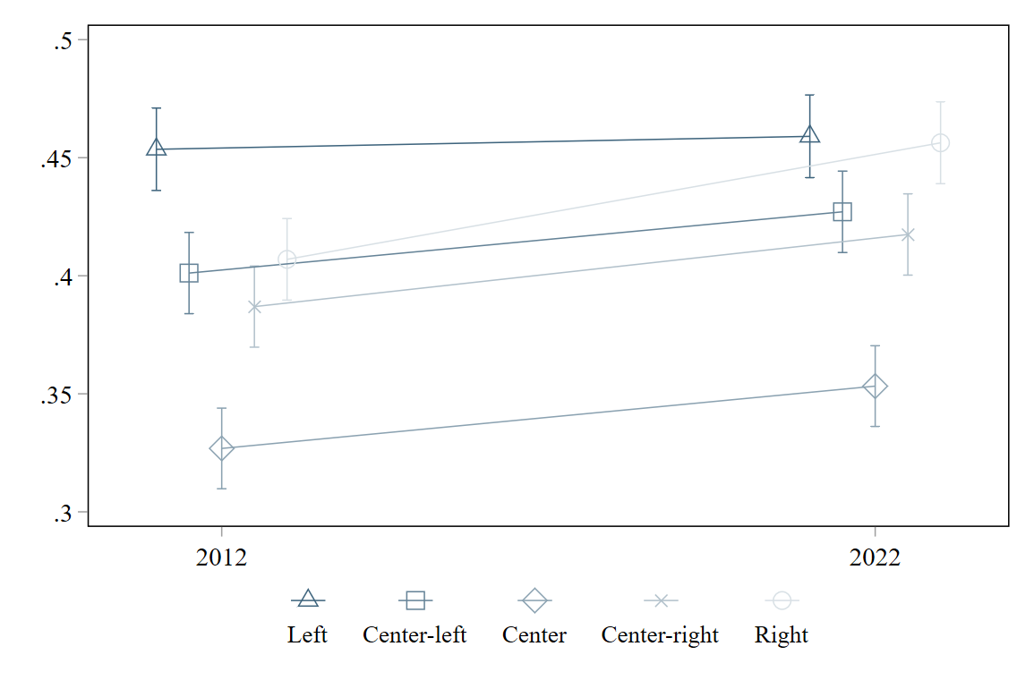
Figure A4a. Contextualization of time trend estimates reported in Figure 4. Group-specific levels of constraint by left-right self-placement within belief system A in 2012 and 2022.
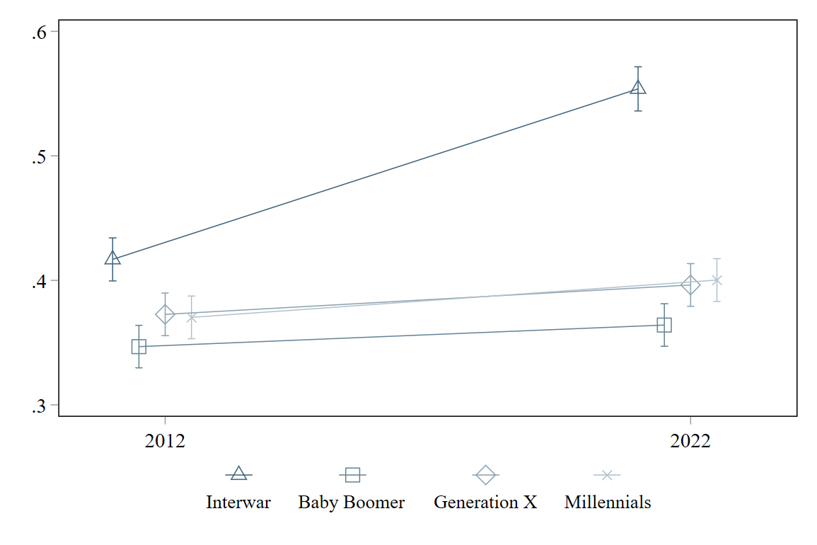
Figure A4b. Contextualization of estimates reported in Figure 4. Group-specific levels of constraint by generational cohorts within belief system A in 2012 and 2022.
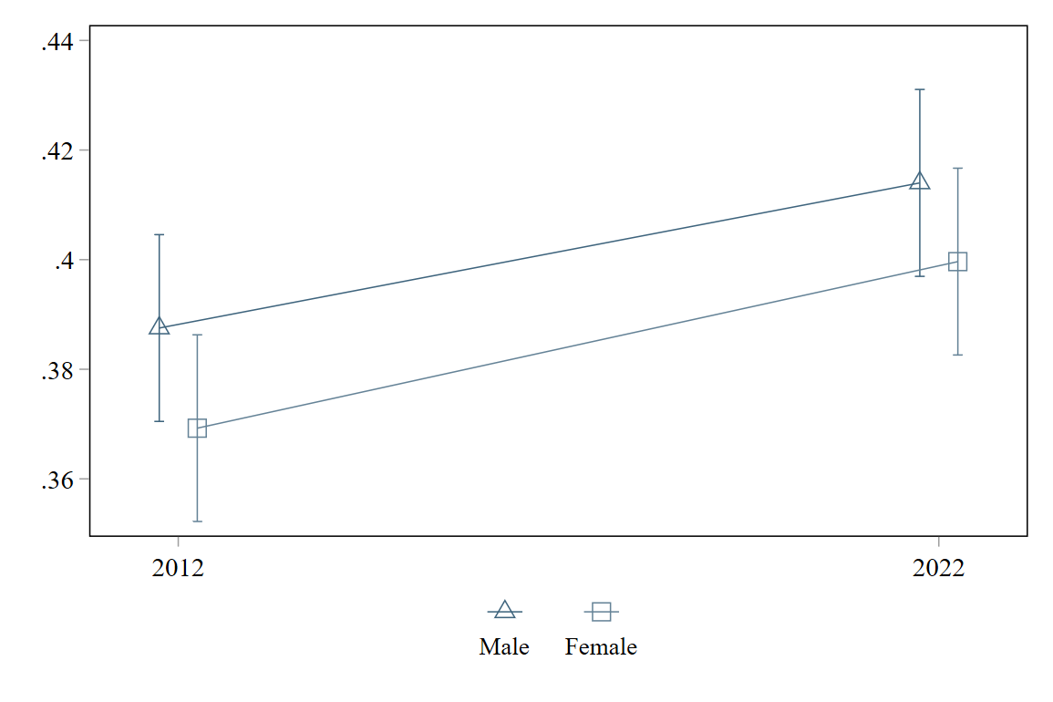
Figure A4c. Contextualization of estimates reported in Figure 4. Group-specific levels of constraint by sex within belief system A in 2012 and 2022.
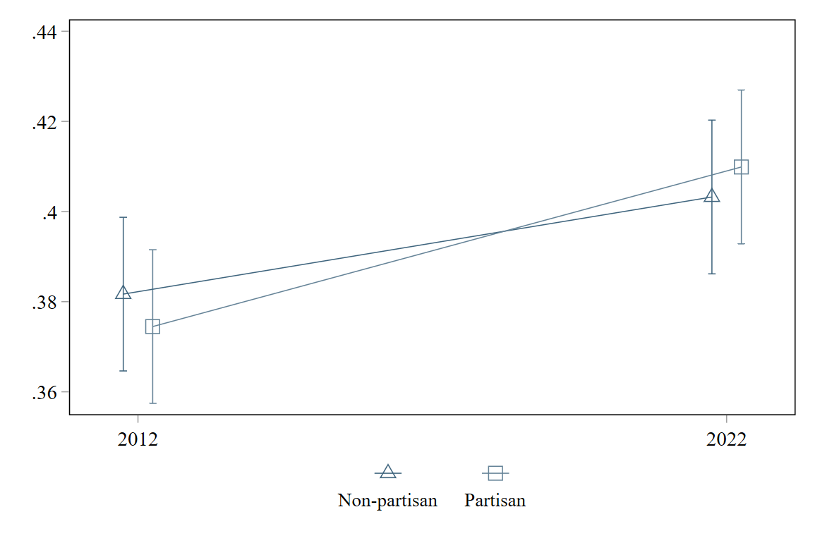
Figure A4d. Contextualization of estimates reported in Figure 4. Group-specific levels of constraint by partisanship within belief system A in 2012 and 2022.
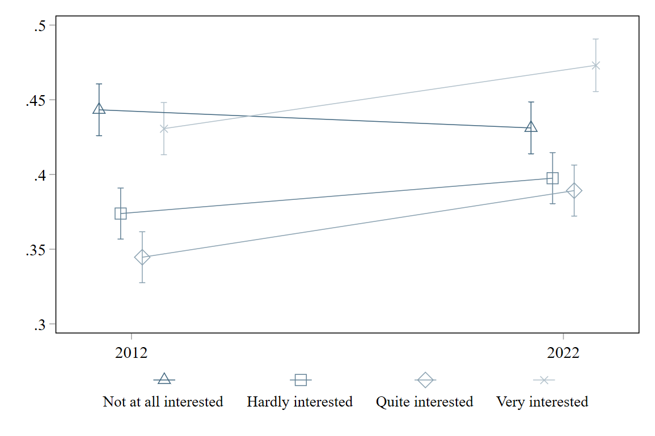
Figure A4e. Contextualization of estimates reported in Figure 4. Group-specific levels of constraint by political interest within belief system A in 2012 and 2022.
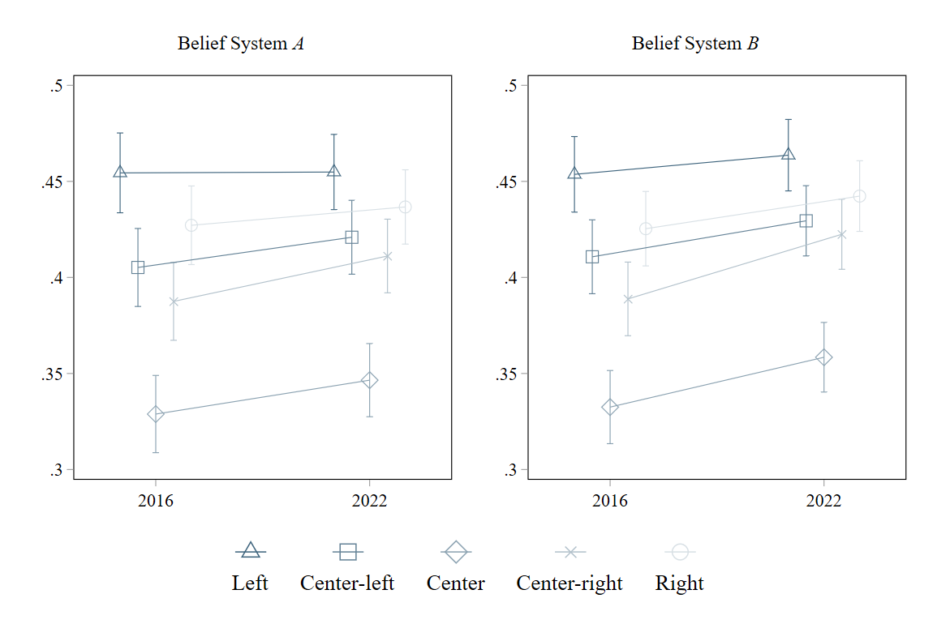
Figure A5a. Contextualization of time trend estimates reported in Figure 5. Group-specific levels of constraint by left-right self-placement within belief system A and B in 2016 and 2022.
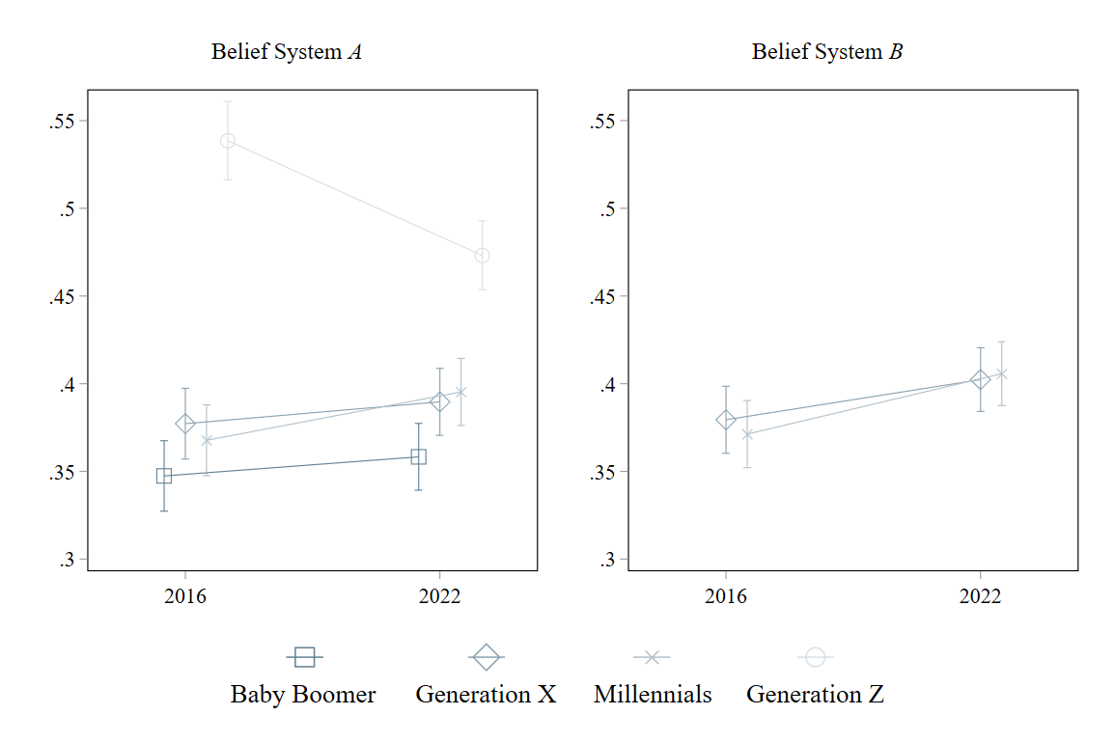
Figure A5b. Contextualization of estimates reported in Figure 5. Group-specific levels of constraint by generational cohorts within belief system A and B in 2016 and 2022. No reliable estimates for “Interwar” in both belief systems, and for “Baby Boomer” and “Generation Z” in belief system B.
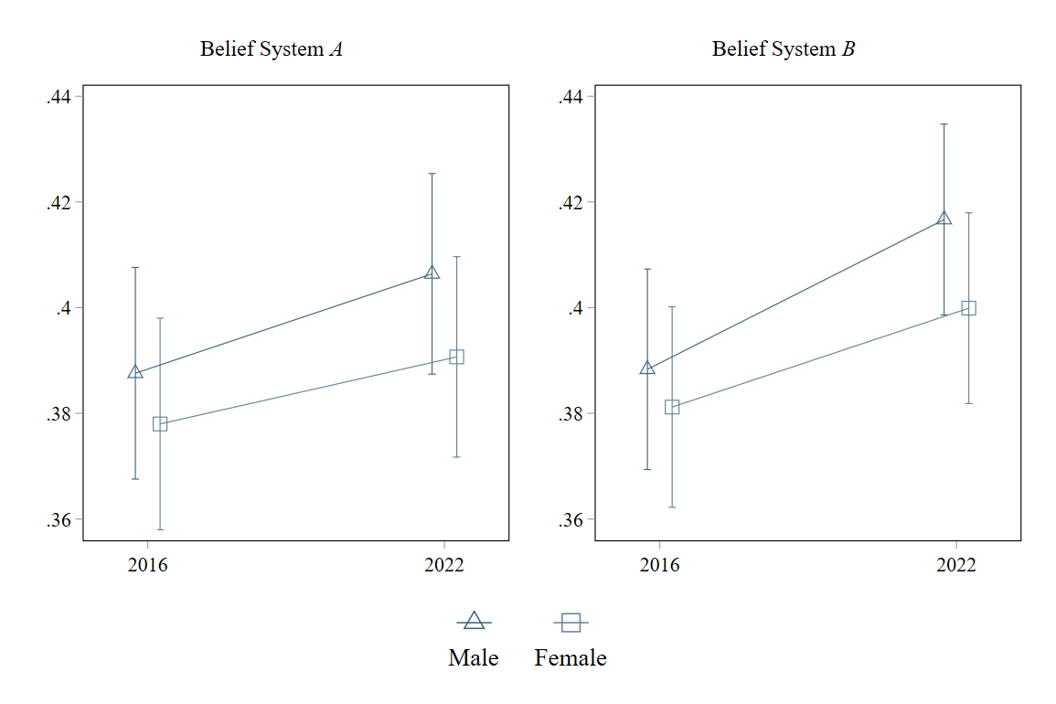
Figure A5c. Contextualization of estimates reported in Figure 5. Group-specific levels of constraint by sex within belief system A and B in 2016 and 2022.
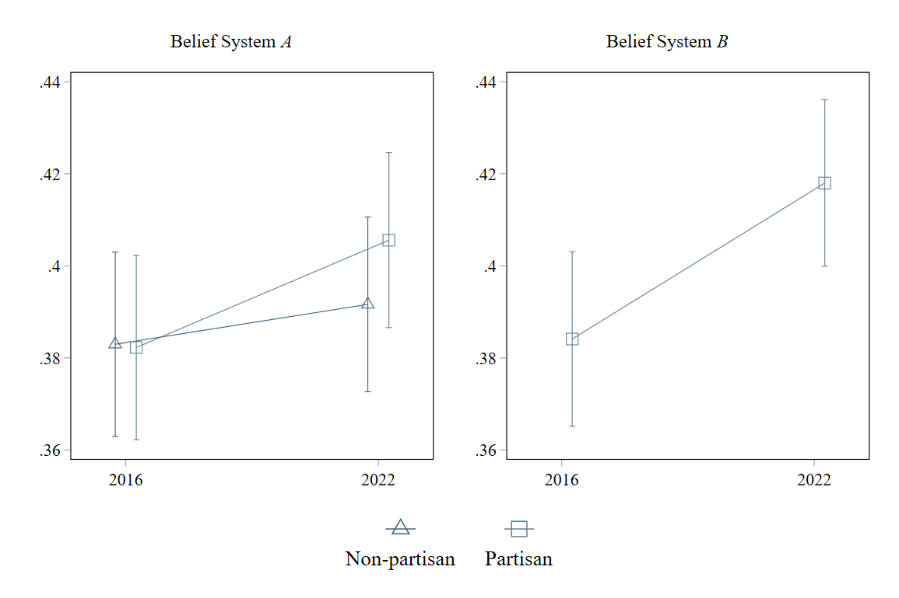
Figure A5d. Contextualization of estimates reported in Figure 5. Group-specific levels of constraint by partisanship within belief system A and B in 2016 and 2022. . No reliable estimates for “Non-partisan” in belief system B.
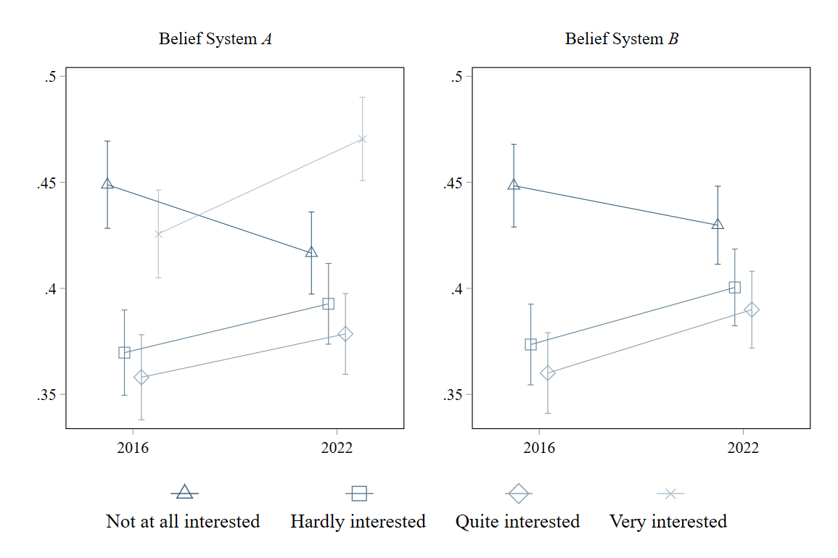
Figure A5e. Contextualization of estimates reported in Figure 5. Group-specific levels of constraint by political interest within belief system A and B in 2016 and 2022. No reliable estimates for “Very interested” in belief system B.

Country-specific levels of constraint
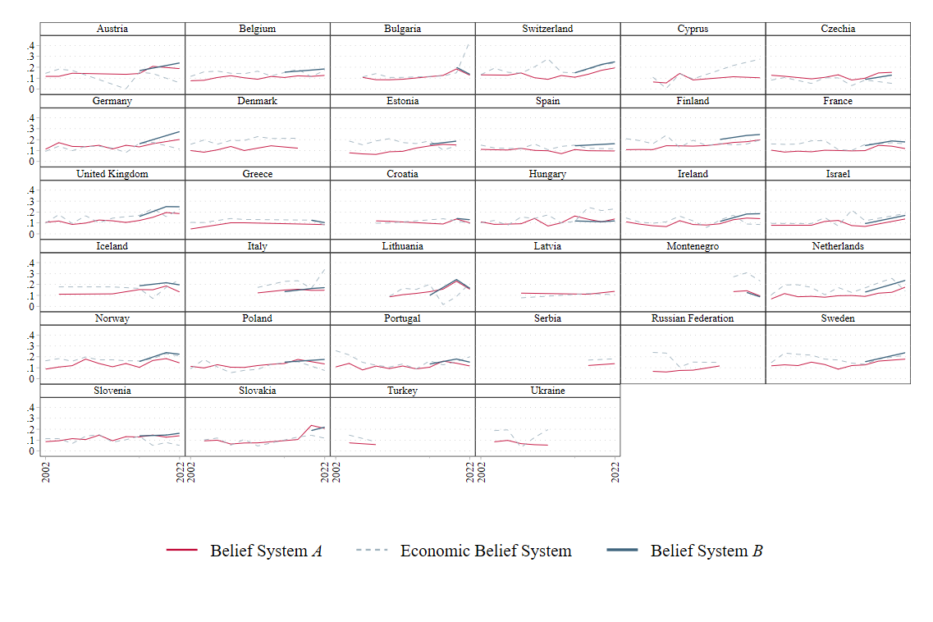
Figure A6. Country-specific levels of constraint by belief system over time. Exclusion of five countries due to insufficient data availability: Albania, Luxembourg, North Macedonia, Romania, and Kosovo.

Climate change components
Because climate change is measured with a three-item index in the main analysis, I examine whether the relative issue importance of climate change observed in Part III depends on this operationalization. Table A3 reports item-rest correlations and factor loadings for each climate change item—belief about its cause, levels of concern, and perceived personal responsibility—when entered individually into Belief System B (hence Belief System B $\text{∈}$ {Belief System A + Belief about cause, Belief System A + Worry, Belief System A + Personal responsibility}).
The results show that worry and personal responsibility are consistently among the most central items across all three years, with values comparable to those obtained using the climate index. The belief about cause item exhibits somewhat weaker associations but falls well within the range of the other non-climate items. Together these findings indicate that the central position of climate change is not an artifact of multi-item measurement. Instead, it reflects the fact that the emotional and normative dimensions of climate belief are strongly connected to the broader cultural belief system.

Table A4. Change in the structure of Belief System B across countries (2016, 2020, and 2022). Relative issue importance of environmental protection, immigration, homosexuality, and international cooperation as well as of the individual climate change components over time.
 | Item-rest correlations |  |  | Factor loadings
 | 2016 | 2020 | 2022 | 2016 | 2020 | 2022
Environmental protection | 0.090 | 0.211 | 0.165 | 0.125 | 0.245 | 0.239
Immigration | 0.272 | 0.298 | 0.294 | 0.466 | 0.475 | 0.465
Homosexuality | 0.188 | 0.237 | 0.216 | 0.328 | 0.377 | 0.362
International cooperation | 0.203 | 0.225 | 0.208 | 0.360 | 0.378 | 0.344
Belief about cause | 0.137 | 0.164 | 0.186 | 0.179 | 0.243 | 0.260
Worry | 0.219 | 0.272 | 0.314 | 0.326 | 0.394 | 0.464
Personal responsibility | 0.277 | 0.339 | 0.351 | 0.414 | 0.476 | 0.496

