Online Appendix:
Acquiescence Bias and Criterion Validity: Problems and Potential Solutions for Agree-Disagree Scales

Table of Contents
Appendix 1: Systematic Literature Review 1
Appendix 2: Study Details, Ethics, Question Wording and Study Inclusion 2
Appendix 3: Meta-Regression Results 10
Appendix 4: Scale Validation Measurement Models 11
Appendix 5: Subscale Measurement Characteristics 16
Appendix 6: Does Grid Presentation Affect the Magnitude of Bias? 17
Appendix 7: Alternative Meta-Regression Estimation Strategy 19
Appendix 8: Scale-Specific Correlation Differences by Scale Direction 21
Appendix 9: Main Text Results Among Attentive Respondents 22

Appendix 1: Systematic Literature Review
As noted in the main text we investigated whether the sorts of analyses scholars using any of our 7 focal concepts might run into the sorts of acquiescence bias issues. We used Google Scholar to search for articles in the American Political Science Review, American Journal of Political Science, Journal of Politics, Political Behavior, and Public Opinion Quarterly between 2016 and August 2024. We used keywords to target toward concept and political behavior research, for instance: populism AND survey.
We then took each article through the following steps. We focused first any article the used one of our concepts of interest as a focal independent or dependent variable in the analysis—that is, the concept was connected with the paper’s research question or hypotheses. From these, we retained any article that operationalized these concepts with an agree-disagree response scale. This could be an individual item or multi-item scale.
We then coded these articles based on the following characteristics:
- Scale type:
  - Balanced
  - Partially balanced
    - How many reversed items?
  - Completely unbalanced
- Paper mentions acquiescence bias
  - Acquiescence biases means
  - Acquiescence biases correlations
- Paper corrects or otherwise checks for acquiescence bias
  - Creates a balanced scale from existing operationalization
  - Analyzes only reversed items
  - Corrects via ipsatizing measures
  - Corrects via a measurement model
  - Some other correction or check
  - Uses a check that is irrelevant to testing acquiescence bias
  - Removes reversed items from a factor analysis
- Correlates the scale with another agree-disagree scale
  - The other agree-disagree scale is unbalanced

Appendix 2: Study Details, Ethics, Question Wording and Study Inclusion
Table A1 below reports item question wording and use across studies. Items with * denote items created to construct balanced scales. We then summarize additional study details on questionnaire order, sample, and response time.

Data collections were reviewed by host university institutional review boards and deemed exempt from review. Participants provided informed consent before beginning the study and were informed participation was completely anonymous and they could skip any questions they liked. Likewise, deception was not used. Participants in study 1 received course credit, those in studies 2 and 4 were compensated by the data vendor at the vendor's rate, and in study 3 earned $1.20.

We also report information for studies 2-4 on item skew and kurtosis as well as tests for multivariate normality to address these data’s suitability for structural equation modeling (Kline 2023). While all scales fail Mardia’s test of normality, univariate skewness and kurtosis suggest modest substantive consequences to model standard errors and fit statistics (Finney and DiStefano 2013).

Table A1: Scale Question Wording
Item Statement | Study 1 | Study 2 | Study 3 | Study 4
Anti-Democratic Attitudes
It is hard to trust the results of elections when so many people will vote for anyone who offers a handout. |  | X |  | X
The traditional American way of life is disappearing so fast that we may have to use force to save it. |  | X |  | X
A time will come when patriotic Americans have to take the law into their own hands |  | X |  | X
Strong leaders sometimes have to bend the rules in order to get things done. |  | X |  | X
Discussion and debate are our best ways to solve problems.* |  |  |  | X
We must accept election results, even if we don’t like the outcome.* |  |  |  | X
There will always be room for Americans to live a traditional way of life.* |  |  |  | X
A good leader follows the law, even when it means things won’t get done.* |  |  |  | X
Conspiratorial Predispositions
Unseen patterns and secret activities can be found everywhere in politics. | X
Much of our lives are being controlled by plots hatched in secret places | X | X | X | X
Even though we live in a democracy, a few people will always run things anyway. | X | X | X | X
The people who really "run" the country are not known to the voters. | X | X | X | X
Big events like wars, recessions, and the outcomes of elections are controlled by small groups of people who are working in secret against the rest of us. |  | X | X | X
The explanations for major world events that we’re taught in school are mostly accurate.* |  |  | X | X
World affairs are too complex for a few powerful people to control.* |  |  | X | X
Large democracies like ours give everyone some influence.* |  |  | X | X
Even the most powerful people cannot control political events in the US.* |  |  | X | X
There are very few big secrets in the world that have been kept from people.* |  |  | X
In our democracy, government mostly reflects the will of the people.* |  |  |  | X
Hostile Sexism
Women seek to gain power by getting control over men | X | X | X | X
Women exaggerate problems they have at work | X | X | X | X
Once a woman gets a man to commit, she puts him on a tight leash | X | X | X | X
Feminists are making entirely reasonable demands of men | X | X | X | X
Feminists are not seeking for women to have more power than men | X | X | X | X
There are actually very few women who get a kick out of teasing men by seeming sexually available and then refusing male advances | X | X | X | X
Women are too easily offended | X
Most women fail to appreciate fully all that men do for them | X
Most women interpret innocent remarks as being sexist | X
When women lose to men in a fair competition, they typically complain about being discriminated against | X
Many women are actually seeking special favors, such as hiring policies that favor them over men, under the guise of asking for “equality.” | X
Need for Chaos
We cannot fix the problems in our social institutions, we need to tear them down and start over. |  |  | X | X
I need chaos around me—it is too boring if nothing is going on. |  |  | X | X
Sometimes I just feel like destroying beautiful things. |  |  | X | X
We need to uphold order by doing what is right, not what is wrong. |  |  | X | X
You need to work within the system in order to improve it.* |  |  | X | X
Our current social and political institutions need to be protected if we want to improve society.* |  |  | X | X
There are many great things about our society that we should protect.* |  |  | X | X
I get a kick when natural disasters strike in foreign countries. |  |  | X | X
I fantasize about a natural disaster wiping out most of humanity such that a small group of people can start all over. |  |  | X | X
I think society should be burned to the ground. |  |  | X | X
When I think about our political and social institutions, I cannot help thinking “just let them all burn.” |  |  | X | X
It’s better to live in a society where there is order and clear rules than one where anything goes. |  |  | X | X
I get upset when I see riots and chaos in my own country.* |  |  | X | X
I have a lot of respect for people in my society who are successful and productive.* |  |  | X | X
I feel terrified when I think about a natural disaster happening in my own country.* |  |  | X
When I see a natural disaster in a foreign country, I feel scared and sad.* |  |  |  | X
Political Violence
It is acceptable to use violence in advancing political goals these days. | X
Violence is sometimes an acceptable way for Americans to express their disagreement with the government. | X
Violence is justified if the members of the other side act violently first. | X
When politicians are damaging the country, citizens should send threats to scare them straight. |  |  | X | X
The worst politicians should get a brick through the window to make them stop hurting the country. |  |  | X | X
Sometimes the only way to stop bad government is with physical force. |  |  | X | X
Some of the problems citizens have with government could be fixed with a few well-aimed bullets. |  |  | X | X
Citizens upset by government should never use violence to express their feelings. |  |  | X | X
Political protest should always be non-violent.* |  |  | X | X
Violence is never an acceptable political tactic in America.* |  |  | X | X
We should not engage in violence, even if our opponents act violently.* |  |  | X | X
Populism
The government is pretty much run by a few big interests looking out for themselves |  | X | X | X
Quite a few of the people running the government are crooked |  | X | X | X
Politicians are not really interested in what people like me think |  | X | X | X
Government officials use their power to try to improve people's lives |  | X | X | X
Politicians are actually interested in what people like me think |  | X | X | X
The government is currently run for the benefit of all the people |  | X | X | X
Racial Resentment
Irish, Italians, Jewish, and many other minorities overcame prejudice and worked their way up. Black Americans should do the same without any special favors. | X |  | X | X
It’s really a matter of some people not trying hard enough; if black Americans would only try harder they could be just as well off as whites. | X |  | X | X
Over the past few years black Americans have gotten less than they deserve. | X |  | X | X
Generations of slavery and discrimination have created conditions that make it difficult for black Americans to work their way out of the lower class. | X |  | X | X

Study 1: Student
1,271 students at a large public university enrolled in introductory and required political science classes completed the study in Qualtrics during September 2022. On average, respondents completed the omnibus survey in 16.8 minutes (sd = 10.4). This was a multi-investigator study with the included anti-democratic orientations placed at the end of the study but preceded policy opinion and demographic items. Prior to answering these respondents answer questions on topics including partisan attachments, feelings about different political institutions, political knowledge, and political cynicism. Participants completed first the hostile sexism items, then racial resentment, then conspiratorial thinking, and finally political violence endorsement. Construct items were placed in grids in random order. Unique to this study, respondents were randomly assigned to answer only positively- or negatively-worded items from the hostile sexism and racial resentment scales (violence and conspiratorial thinking were completely unbalanced). Assignment to scale direction was independent across constructs.
Study 2: Dynata
The Dynata study was fielded on Dec. 2-11, 2022 and 1,318 respondents completed the study in Qualtrics. Survey completions were planned to be balanced to US demographics on age, gender, race, and census region, with a final sample size of 1,000. However, due to an error by Dynata, we ended up with an oversample of some demographic groups and a larger sample size. Specifically, Dynata initially sought an even number of respondents within each demographic group listed above, rather than balancing to census figures. This error was discovered and corrected shortly before a sample size of 1,000 was complete. To correct, the vendor then recruited more respondents to fulfill the quotas in all of the underrepresented categories. The main consequence is that racial minorities are overrepresented in the sample, along with some age groups. Near the beginning of the study, an instructed response item was embedded in a grid. Respondents who failed the attention check were not allowed to complete the survey.
Like Study 1, this survey contained questions for multiple projects. We placed the included anti-democratic orientation batters at the end, before some policy items and demographics. Prior to this, respondents answered questions on topics including: issue importance, political knowledge, and social group evaluations. Participants first completed the populism battery, then anti-democratic attitudes, then conspiratorial orientations, and then hostile sexism. Scale items were presented in grids in random order. Populism and hostile sexism, however, randomly assigned respondents to answer the positively- and negatively-worded items on separate pages or together on the same page.
 | Skew |  |  | Kurtosis
 | Median | Range | Mardia’s test | Median | Range | Mardia’s test
Anti-Dem | 0.115 | 0.136-0.239 | 101.833* | 1.844 | 1.766-2.036 | 6.999*
Conspiracy | 0.163 | 0.056-0.768 | 324.355* | 2.073 | 1.868-3.185 | 10.46*
Populism | 0.5005 | 0.023-0.817 | 669.616* | 2.341 | 2.009-3.12 | 24.617*
Hostile Sexism | 0.035 | 0.292-0.339 | 345.747* | 2.057 | 1.919-2.47 | 20.26*
Note: Typically, |skew|< 2 (0 denoting normal) and |kurtosis| < 7 (3 denoting normal) (West, Finch, and Curran 1995). * p < .05

Study 3: MTurk
993 respondents used Qualtrics to complete the survey on August 30, 2023. On average, respondents completed the survey in 8.9 minutes (sd = 7.9). After consenting, they reported their partisan and ideological self-identification, answered an open-ended item inquiring “what word or phrase best describes their political views,” and used a 5-point scale to reported how interested they were in politics. Subsequently, they completed the 6 included anti-democratic orientation batteries in random order with construct items presented in their own grid in random sequence. They concluded the study by answering an open-ended question asking, “What would you like to see elected leaders in Washington get done during the next few years,” reporting demographic information, and offering any comments for the researchers.
 | Skew |  |  | Kurtosis
 | Median | Range | Mardia’s test | Median | Range | Mardia’s test
NFC | 1.114 | 0.474-1.988 | 5941.34* | 3.609 | 2.145-5.674 | 81.69*
Conspiracy | 0.207 | 0.535-0.429 | 501.80* | 2.044 | 1.763-2.34 | 11.87*
Populism | 0.557 | 0.975-0.006 | 780.79* | 2.242 | 2.047-3.122 | 23.68*
Hostile Sexism | 0.043 | 0.573-0.665 | 494.01* | 2.017 | 1.855-2.41 | 18.85*
Violence | 1.073 | 0.434-1.332 | 2004.15* | 2.981 | 1.948-3.804 | 56.05*
Racial Resentment | 0.342 | 0.106-0.665 | 242.95* | 1.810 | 1.702-2.063 | 14.21*
Note: Typically, |skew|< 2 (0 denoting normal) and |kurtosis| < 7 (3 denoting normal) (West, Finch, and Curran 1995). * p < .05

Study 4: Bovitz
1000 respondents completed the survey in Qualtrics between October 23 and 29, 2023. All respondents came from Bovitz’s Forthright panel, with the sample recruited to match Census benchmarks on gender, age, race, ethnicity, and region. On average, respondents completed the survey in 8.9 minutes (sd = 7.9). The questionnaire followed the MTurk study, but omitted the partisan and ideological self-identification items as well as the concluding demographics given available complementary panel profile information. The anti-democratic orientation batteries were again presented in randomize order with construct items presented in their own grid in random sequence.
 | Skew |  |  | Kurtosis
 | Median | Range | Mardia’s test | Median | Range | Mardia’s test
NFC | 1.111 | 0.238-1.98 | 6266.01* | 3.353 | 2.15-6.024 | 75.44*
Conspiracy | 0.011 | 0.612-0.481 | 604.26* | 2.317 | 2.003-2.852 | 21.87*
Populism | 0.624 | 0.819-0.081 | 899.13* | 2.569 | 2.178-3.008 | 31.47*
Hostile Sexism | 0.031 | 0.318-0.389 | 240.87* | 2.105 | 1.982-2.293 | 15.51*
Violence | 1.033 | 0.371-1.406 | 2070.40* | 2.972 | 1.91-4.296 | 50.23*
Racial Resentment | 0.174 | 0.141-0.226 | 210.42* | 1.838 | 1.823-1.875 | 13.95*
Anti-Democratic Attitudes | 0.384 | 0.223-0.832 | 628.47* | 2.309 | 1.776-2.912 | 18.80*
Note: Typically, |skew|< 2 (0 denoting normal) and |kurtosis| < 7 (3 denoting normal) (West, Finch, and Curran 1995). * p < .05

Respondent Demographics
 |  | Study 1 | Study 2 | Study 3 | Study 4*
Male |  | 43% | 50% | 52% | 48%
Median Age Category |  | X | 45-54 | 35-44 | 47 years
Race
 | White | 31% | 45% | 76% | 60%
 | Black | 17% | 18% | 11% | 13%
 | Hispanic | X | 14% | 7% | 17%
 | Asian | 30% | 16% | 5% | 5%
 | Other | 22% | 6% | 1% | 6%
Education
 | No HS diploma | X | 3% | <1% | X
 | HS graduate | X | 17% | 12% | X
 | Some college | X | 22% | 17% | X
 | Associate degree | X | 12% | 10% | X
 | Bachelor's degree | X | 29% | 42% | X
 | Master's degree | X | 13% | 16% | X
 | Doctorate | X | 4% | 3% | X
Partisanship
 | Democrat | 50% | 44% | 51% | X
 | Independent | 25% | 34% | 28% | X
 | Republican | 24% | 22% | 22% | X
Ideology
 | Liberal | 57% | 36% | 52% | X
 | Moderate/DK | 28% | 39% | 17% | X
 | Conservative | 16% | 25% | 31% | X
*Note: Demographics from Bovitz relied on available panelist profile information which recorded this differently than the other studies.

Appendix 3: Meta-Regression Results

Predictors of the Magnitude of Acquiescence Bias
Study 1 | -0.026 |  | 0.027
 | (.046) |  | (.046)
Study 2 | 0.168 | *** | 0.193 | ***
 | (.044) |  | (.043)
Study 3 | -0.006 |  | 0.002
 | (.020) |  | (.020)
Populism |  |  | 0.019
 |  |  | (.025)
Conspiracy |  |  | 0.094 | ***
 |  |  | (.025)
Hostile Sexism |  |  | 0.024
 |  |  | (.025)
Need for Chaos |  |  | 0.100 | ***
 |  |  | (.025)
Violence |  |  | 0.035
 |  |  | (.025)
Anti-Democratic |  |  | 0.094 | **
 |  |  | (.030)
Constant | 0.186 | *** | 0.082 | *
 | (.013) |  | (.035)
Observations | 160 |  | 160

Appendix 4: Scale Validation Measurement Models
Tables A2-A5 below report results from confirmatory factor analysis models of the anti-democratic attitudes, conspiratorial predispositions, need for chaos, and political violence measures used in studies 3 and 4 to demonstrate the validity of the negatively worded (NW) items we wrote to produce balanced scales. For many scales, initial CFAs returned evidence of poor model fit with many or all NW items having weak factor loadings. Consistent with our concern for acquiescence response set, model modification indices pointed to residual correlations among items sharing similar directions. Given this consistency across constructs, we thus estimated for all constructs a second CFA which included a method factor. All items loaded on both the content factor and the method factor, with method factor loadings fixed to 1 for identification. The correlation between the content and method factors was fixed to 0.
All models estimating the method factor saw consequential improvements in model fit and increased factor loadings for items on the content factor, additional evidence of the relevance of acquiescence to scale scores recorded on these constructs. Further, after this error correction we find that in only 4 instances do introduced items not validly measure the factor, as defined by standardized loadings <.35 (Brown 2015). These include 2 items for Need for Chaos and 2 for conspiratorial predispositions. Each had one invalid indicator in study 3 and another in study 4.
Table A2: Confirmatory Factor Analysis of Anti-Democratic Attitudes
 | Study 4 | Study 4, with Method
 | Estimate (SE) | Estimate (SE)
 | Factor Loadings
Can't Trust Because Handouts | 0.94(0.04)*** | 0.87(0.04)***
Traditional Way Of Life | 1.04(0.04)*** | 0.95(0.04)***
Patriotic Americans | 1.16(0.04)*** | 1.07(0.04)***
Leader Bends Rules | 0.65(0.04)*** | 0.58(0.04)***
Debate Good (R) | 0.23(0.04)*** | 0.39(0.03)***
Can Accept Elections (R) | 0.51(0.04)*** | 0.67(0.04)***
Room For Traditions (R) | 0.25(0.04)*** | 0.41(0.04)***
Leader Obeys Laws (R) | 0.30(0.04)*** | 0.46(0.04)***
 | Fit Indices
χ² | 566.97(20)*** | 139.36(19)***
CFI | 0.74 | 0.94
SRMR | 0.12 | 0.04
RMSEA | 0.17 | 0.08
RMSEA Lower 90% CI | 0.15 | 0.07
RMSEA Upper 90% CI | 0.18 | 0.09
*p<0.05**p<0.01***p<0.001. (R) denotes reverse worded. Italicized entries are new items.

Table A3: Confirmatory Factor Analysis of Conspiratorial Predispositions
 | Study 3 | Study 3, with Method | Study 4 | Study 4, with Method
 | Estimate (SE) | Estimate (SE) | Estimate (SE) | Estimate (SE)
 | Factor Loadings
Secret Plots | 1.14(0.04)*** | 1.05(0.04)*** | 1.02(0.04)*** | 0.90(0.04)***
Few Run Country | 0.77(0.04)*** | 0.73(0.04)*** | 0.55(0.03)*** | 0.51(0.03)***
Unknown Control | 1.14(0.04)*** | 1.07(0.04)*** | 0.84(0.04)*** | 0.76(0.04)***
Wars From Small Groups | 1.17(0.03)*** | 1.08(0.04)*** | 0.94(0.04)*** | 0.83(0.04)***
School Explanations Ok (R) | 0.43(0.04)*** | 0.59(0.04)*** | 0.32(0.04)*** | 0.49(0.04)***
Events Too Complex (R) | 0.33(0.04)*** | 0.51(0.04)*** | 0.15(0.04)*** | 0.22(0.04)***
Democracies Allow Influence (R) | 0.26(0.04)*** | 0.44(0.04)*** | 0.34(0.04)*** | 0.57(0.04)***
Few People Can’t Control Us (R) | 0.26(0.04)*** | 0.45(0.04)*** | 0.23(0.04)*** | 0.37(0.04)***
Democracy Reflects People (R) |  |  | 0.40(0.04)*** | 0.64(0.04)***
 | Fit Indices
χ² | 493.17(20)*** | 207.25(19)*** | 645.73(27)*** | 227.19(26)***
CFI | 0.84 | 0.94 | 0.71 | 0.90
SRMR | 0.11 | 0.06 | 0.11 | 0.06
RMSEA | 0.15 | 0.10 | 0.15 | 0.09
RMSEA Lower 90% CI | 0.14 | 0.09 | 0.14 | 0.08
RMSEA Upper 90% CI | 0.17 | 0.11 | 0.16 | 0.10
*p<0.05**p<0.01***p<0.001. (R) denotes reverse worded. Italicized entries are new items.

Table A4: Confirmatory Factor Analysis of Need for Chaos
 | Study 3 | Study 3, with Method | Study 4 | Study 4, with Method
 | Estimate (SE) | Estimate (SE) | Estimate (SE) | Estimate (SE)
 | Factor Loadings
Tear Down | 0.71(0.04)*** | 0.72(0.04)*** | 0.60(0.04)*** | 0.56(0.04)***
Need Chaos | 0.81(0.03)*** | 0.69(0.03)*** | 0.70(0.03)*** | 0.66(0.03)***
Destroy | 0.81(0.03)*** | 0.70(0.03)*** | 0.71(0.03)*** | 0.67(0.03)***
Disasters are Fun | 0.81(0.03)*** | 0.69(0.03)*** | 0.68(0.03)*** | 0.65(0.03)***
Disaster Rebuild | 0.97(0.03)*** | 0.87(0.03)*** | 0.83(0.03)*** | 0.80(0.03)***
Burn Society | 0.98(0.03)*** | 0.92(0.03)*** | 0.91(0.03)*** | 0.86(0.03)***
Burn Institutions | 0.89(0.04)*** | 0.86(0.04)*** | 0.79(0.04)*** | 0.72(0.04)***
Clear Rules (R) | 0.36(0.03)*** | 0.50(0.03)*** | 0.45(0.03)*** | 0.50(0.03)***
Uphold Order (R) | 0.45(0.03)*** | 0.58(0.03)*** | 0.49(0.03)*** | 0.55(0.03)***
Disaster Fear (R) | 0.14(0.04)** | 0.23(0.04)***
Chaos Upset (R) | 0.46(0.04)*** | 0.59(0.04)*** | 0.43(0.03)*** | 0.48(0.03)***
Respect Product (R) | 0.34(0.03)*** | 0.48(0.03)*** | 0.39(0.03)*** | 0.44(0.03)***
Work Inside (R) | 0.36(0.04)*** | 0.54(0.03)*** | 0.40(0.03)*** | 0.46(0.03)***
Protect Institutions (R) | 0.29(0.04)*** | 0.48(0.03)*** | 0.38(0.04)*** | 0.42(0.03)***
Great Things (R) | 0.47(0.03)*** | 0.61(0.03)*** | 0.51(0.03)*** | 0.57(0.03)***
Disaster Foreign County (R) |  |  | 0.26(0.03)*** | 0.30(0.03)***
 | Fit Indices
χ² | 2409.53(90)*** | 868.60(88)*** | 1713.78(90)*** | 686.14(87)***
CFI | 0.65 | 0.88 | 0.69 | 0.89
SRMR | 0.14 | 0.07 | 0.10 | 0.06
RMSEA | 0.16 | 0.09 | 0.13 | 0.08
RMSEA Lower 90% CI | 0.16 | 0.09 | 0.13 | 0.08
RMSEA Upper 90% CI | 0.17 | 0.10 | 0.14 | 0.09
*p<0.05**p<0.01***p<0.001. (R) denotes reverse worded. Italicized entries are new items.

Table A5: Confirmatory Factor Analysis of Political Violence
 | Study 3 | Study 3, with Method | Study 4 | Study 4, with Method
 | Estimate (SE) | Estimate (SE) | Estimate (SE) | Estimate (SE)
 | Factor Loadings
Threaten Politicians | 0.85(0.04)*** | 0.93(0.03)*** | 0.88(0.03)*** | 0.85(0.03)***
Throw Bricks | 0.93(0.04)*** | 1.01(0.03)*** | 0.97(0.04)*** | 0.93(0.04)***
Stop Gov't With Physical Force | 0.95(0.04)*** | 0.95(0.04)*** | 0.93(0.04)*** | 0.89(0.04)***
Bullets Can Fix | 0.89(0.04)*** | 0.97(0.03)*** | 0.86(0.04)*** | 0.83(0.04)***
Never Use Violence (R) | 0.95(0.03)*** | 0.92(0.03)*** | 0.67(0.04)*** | 0.76(0.03)***
Protest Always Non-Violent (R) | 0.89(0.03)*** | 0.88(0.03)*** | 0.61(0.03)*** | 0.68(0.03)***
Violence Unacceptable (R) | 0.93(0.03)*** | 0.90(0.03)*** | 0.68(0.04)*** | 0.76(0.03)***
No Violent Responses (R) | 0.86(0.04)*** | 0.82(0.04)*** | 0.51(0.04)*** | 0.56(0.04)***
 | Fit Indices
χ² | 1130.03(20)*** | 208.22(19)*** | 738.83(20)*** | 129.29(19)***
CFI | 0.78 | 0.96 | 0.77 | 0.97
SRMR | 0.10 | 0.05 | 0.10 | 0.05
RMSEA | 0.24 | 0.10 | 0.19 | 0.08
RMSEA Lower 90% CI | 0.22 | 0.09 | 0.18 | 0.06
RMSEA Upper 90% CI | 0.25 | 0.11 | 0.20 | 0.09
*p<0.05**p<0.01***p<0.001. (R) denotes reverse worded. Italicized entries are new items.

Appendix 5: Subscale Measurement Characteristics
We report here information on the characteristics of the positively- and negatively-worded subscales for the balanced scales in studies 2-4. We report measures of internal consistency and reliability in Cronbach’s α and Revelle’s ω_{total}. We also report the average standardized factor loadings for each item set taken from measurement models which also estimate method effects (seen in part in the tables in the preceding section).
Across scale halves we see some difference in internal consistency and the extent to which items capture variation in scale content. But importantly, we do not see variation suggesting we ought necessarily see biased comparisons in correlations due simply to measurement properties. Nor does evidence point to clear incoherence in the negatively worded subsets we created. While points of improvement exist for items we introduced (anti-democratic attitudes, conspiratorial thinking), we do well for others (political violence) or find similar subscale differences on existing measures (hostile sexism).
Considered alongside the results in Appendix 4, the information here points to the importance of developing good items, no matter their direction. Designing better items would then be helpful for not only addressing acquiescence bias, it would help scholars more generally by providing an item set that best targets the underlying concept. This is particularly important when validity can vary across samples and researchers draw participants from different pools.

 | Study 3 |  |  |  |  |  | Study 4
 | Alpha |  | Omega Total |  | Avg. Loadings |  | Alpha |  | Omega Total |  | Avg. Loadings
 | PW | NW | PW | NW | PW | NW | PW | NW | PW | NW | PW | NW
Need for Chaos | 0.89 | 0.82 | 0.92 | 0.86 | 0.78 | 0.54 | 0.86 | 0.80 | 0.91 | 0.85 | 0.7 | 0.49
Populism | 0.81 | 0.86 | 0.81 | 0.86 | 0.79 | 0.93 | 0.76 | 0.84 | 0.77 | 0.84 | 0.68 | 0.88
Political Violence | 0.88 | 0.88 | 0.89 | 0.89 | 0.97 | 0.88 | 0.84 | 0.79 | 0.86 | 0.81 | 0.88 | 0.69
Conspiratorial Thinking | 0.88 | 0.64 | 0.89 | 0.72 | 0.98 | 0.5 | 0.8 | 0.67 | 0.82 | 0.7 | 0.74 | 0.53
Racial Resentment | 0.91 | 0.87 | 0.91 | 0.87 | 0.99 | 1.14 | 0.86 | 0.85 | 0.86 | 0.85 | 0.88 | 1.07
Hostile Sexism | 0.88 | 0.74 | 0.89 | 0.76 | 1.04 | 0.76 | 0.82 | 0.66 | 0.82 | 0.69 | 0.88 | 0.64
Anti-Democratic Attitudes |  |  |  |  |  |  | 0.8 | 0.68 | 0.82 | 0.72 | 0.86 | 0.48

Appendix 6: Does Grid Presentation Affect the Magnitude of Bias?
One possible explanation for lower bias in Study 1 stems from the fact that respondents in other studies all completed both the PW and NW halves of each scale, while respondents in Study 1 were randomly assigned to only one half. One possibility is that including both PW and NW items in a single grid confuses respondents and inflates acquiescence bias. Thus, by including a balanced scale, researchers may inadvertently be increasing the size of the bias. Study 2 allows a test of this possibility because half of respondents received the PW and NW halves of each scale in separate grids on separate pages, while the other half received them in a single grid. If the concern above is accurate, then we should see greater acquiescence bias when all items are placed in a single grid.
The table below displays correlations between scales and subscales when each of the two balanced scales, populism and hostile sexism, are measured in a single grid (“full”) or split into two grids based on item direction (“split”). The first two rows show correlations between the PW and NW items within each scale. Starting with populism, the two halves of the scale are moderately correlated when displayed in a single grid (.42) and this increases modestly when splitting the items into two grids (.46). There is a slightly larger increase in correlations when splitting the hostile sexism items into two grids (.13), though the absolute correlations are modest.
The remainder of the table displays correlations between each half of the two balanced scales and the unbalanced scales. The most informative quantity is the difference-in-difference, shown in bold. In other words, does grid structure change our inferences in how much scale direction matter? Overall, the difference-in-differences are quite small, ranging from -.03 to .02, suggesting the grid presentation has no substantively meaningful impact on our results. Thus, the biases we uncover in the paper are not merely a function of grid format and cannot be solved through different display.

Measure 1 | Measure 2 | Split | Full | Difference
Populism (PW) | Populism (NW) | 0.46 | 0.42 | 0.04
Hostile Sexism (PW) | Hostile Sexism (NW) | 0.24 | 0.11 | 0.13
Populism (PW) | Anti-Democratic | 0.43 | 0.31 | 0.12
Populism (NW) | Anti-Democratic | 0.04 | -0.06 | 0.09
 | Difference | 0.39 | 0.37 | 0.02
Populism (PW) | Conspiratorial | 0.52 | 0.50 | 0.02
Populism (NW) | Conspiratorial | 0.16 | 0.16 | 0.00
 | Difference | 0.36 | 0.34 | 0.02
Hostile Sexism (PW) | Anti-Democratic | 0.57 | 0.57 | -0.01
Hostile Sexism (NW) | Anti-Democratic | 0.13 | 0.10 | 0.03
 | Difference | 0.44 | 0.47 | -0.03
Hostile Sexism (PW) | Conspiratorial | 0.53 | 0.48 | 0.05
Hostile Sexism (NW) | Conspiratorial | 0.08 | 0.00 | 0.08
 | Difference | 0.45 | 0.48 | -0.03

Appendix 7: Alternative Meta-Regression Estimation Strategy
This main text meta-regression analysis estimates construct effects using dummy variables for individual constructs. Here we report results of an alternative strategy with indicators for each construct pair. Rather than an estimate of construct-specific acquiescence bias, this analysis offers an estimate for how much acquiescence affects a specific relationship, on average.
Predictors of the Magnitude of Acquiescence Bias
Need for Chaos, Anti-Democratic | 0.20**
 | (0.07)
Conspiracy, Anti-Democratic | 0.19**
 | (0.07)
Conspiracy, Need for Chaos | 0.18**
 | (0.05)
Conspiracy, Violence | 0.09
 | (0.05)
Populism, Anti-Democratic | 0.06
 | (0.06)
Populism, Need for Chaos | 0.07
 | (0.05)
Populism, Conspiracy | 0.07
 | (0.05)
Populism, Racial Resentment | 0.00
 | (0.05)
Populism, Violence | 0.02
 | (0.05)
Racial Resentment, Anti-Democratic | 0.04
 | (0.07)
Racial Resentment, Need for Chaos | 0.04
 | (0.05)
Racial Resentment, Conspiracy | 0.03
 | (0.05)
Sexism, Anti-Democratic | 0.06
 | (0.06)
Sexism, Need for Chaos | 0.06
 | (0.05)
Sexism, Conspiracy | 0.08
 | (0.05)
Sexism, Populism | 0.00
 | (0.05)
Sexism, Racial Resentment | 0.03
 | (0.05)
Sexism, Violence | 0.02
 | (0.05)
Violence, Anti-Democratic | 0.08
 | (0.07)
Violence, Need for Chaos | 0.11*
 | (0.05)
Study 1 | 0.01
 | (0.05)
Study 2 | 0.20***
 | (0.05)
Study 3 | 0.00
 | (0.02)
Constant | 0.12**
 | (0.04)
N | 160
Standard errors in parentheses. Omitted category is Racial Resentment and Violence.
* p < 0.05, ** p < 0.01, *** p < 0.001

Appendix 8: Scale-Specific Correlation Differences by Scale Direction
Figure A2 replicate’s Figure 4B from the main text but focuses on pairs defined by each focal construct. Six of seven see greater differences in correlations on the NW pairs than PW, with this particularly so for anti-democratic attitudes and hostile sexism. Further, the share of correlations that increase moving from the observed, aligned index to the balanced scale plus measurement model varies markedly for the PW pairs, from 38% for correlations involving anti-democratic attitudes to 79% for those including populism.

Figure A2: Correlation Differences by Scale Direction and Estimation Strategy
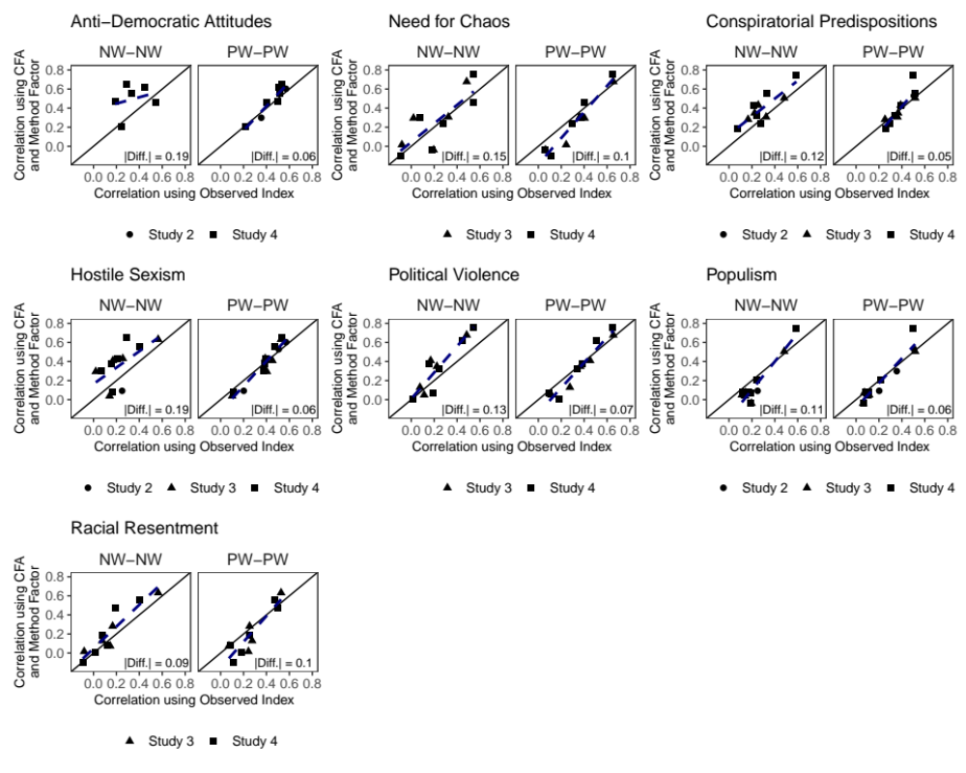

Appendix 9: Main Text Results Among Attentive Respondents
Our main analyses focus on all eligible respondents across studies. While this does not change the composition of respondents in terms of quality for studies 1 and 2, the results in studies 3 and 4 then include about 15% of respondents apiece who failed one or more attention checks. To address if our conclusions appreciably change when providing a “best case scenario” for respondent quality, we replicate these analyses looking only at our attentive respondents. We retain all the study 1 and 2 respondents again, but then focus on those respondents in studies 3 and 4 who satisfactorily passed all the attention checks: two open-ended items and one instructional check placed in a grid.
Compared to the main text analyses where 94% of correlations offered evidence of acquiescence bias, we find that 87.5% of correlations did so after removing inattentive respondents in studies 3 and 4. The average difference in correlations is .19 in the full sample, and .13 using the attentive subset.
Figure A3: Difference in Scale Correlations by Item Alignment among Attentive Respondents
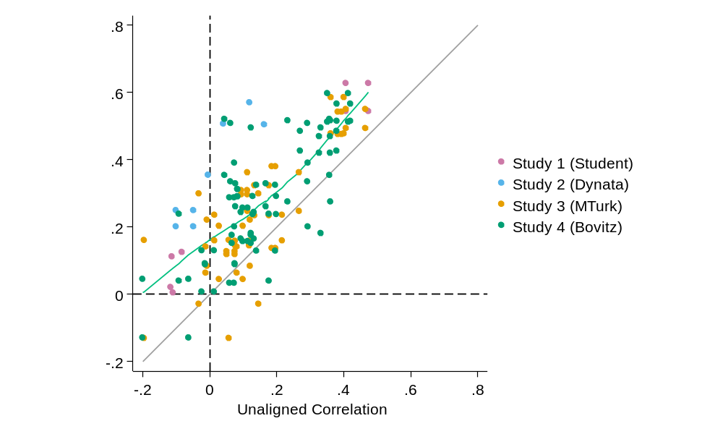
We further find similar results from the metaregression. Figure A4’s left panel plots the coefficient estimates, again pointing to anti-democratic views, conspiratorial predispositions, and need for chaos as statistically significant. They contribute to on average about a .08 difference in coefficients, similar to the .10 in the full sample. Similarly, the right panel shows how the sample and construct differences change using the same construct pairs as the main text. While the populism and racial resentment correlation using the Study 4 sample sees a predicted difference in correlations of about .05, shifting to a lower quality sample increases this to .31. This is quite similar to the full sample estimates of .10 and .29. Similarly, using the same samples but need for chaos and conspiratorial predispositions, the predicted differences are .20 and .45, quite similar to the .28 and .47 for the full sample.
Figure A4: Metaregression estimates among attentive respondents
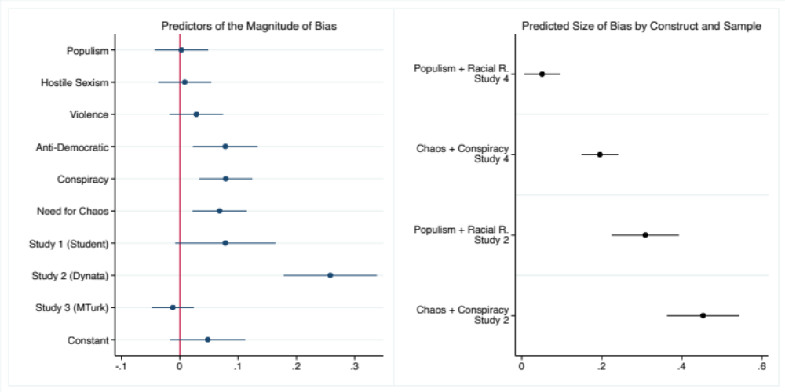
Figure A5 presents the results from the SEM analyses, replicating Figure 3. While the main analysis reports an average correlation difference of r=.06, this decreases to a difference of r=.04. We again find correlation changes are as likely to increase (50%) as decrease after including a method factor. But while the full sample inclusion sees this largely consistent across samples, selecting only the attentive respondents in studies 3 and 4 sees more variation. In study 3, 60% of pairs increase in strength (compared to 53% in the full sample) and 43% of pairs increase in study 4 (compared to 52%). Respondent attentiveness appears unrelated to direction of change.
Figure A5: Construct pair correlations estimated via SEM with and without corrections for method effects, attentive respondents.
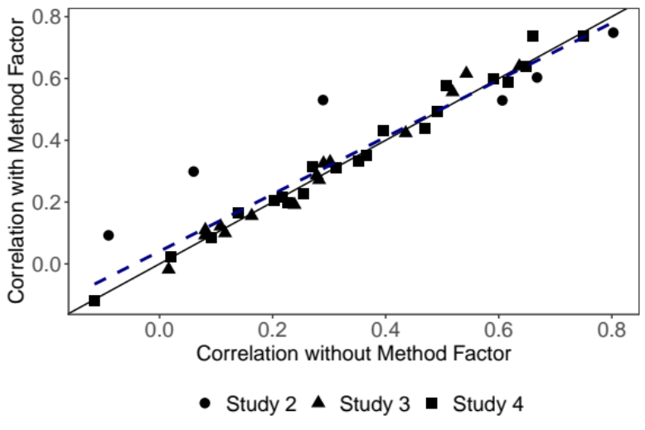
Similarly, construct-specific patterns appear. While the full sample analyses saw hostile sexism’s correlation with racial resentment remains positive but increases from .50 to .63 in study 3 and .43 to .56 in study 4 after including a method factor, selecting only attentive respondents sees respective changes of .54 to .61 and .51 to .58. The pattern of change persists, with the size of the correction not necessarily strictly reduced given attention to only attentive respondents. We interpret this set of results as indicative that attentiveness plays but a small part in how much the corrections matter, and that constructs themselves appear particularly important.
Finally, Figure A6 replicates Figure 4, comparing the estimated correlations using aligned, summed indexes versus the balanced scale and method factor. Comparing typical practice to methods of addressing acquiescence we find 32% of correlations increase from the aligned estimate, down from 51% using the full sample analyses. But despite this difference, we again find the average absolute difference in correlations is .10, matching the full sample result.
Figure A6: Correlation Differences by Estimation Strategy and Scale Direction, Attentive Respondents
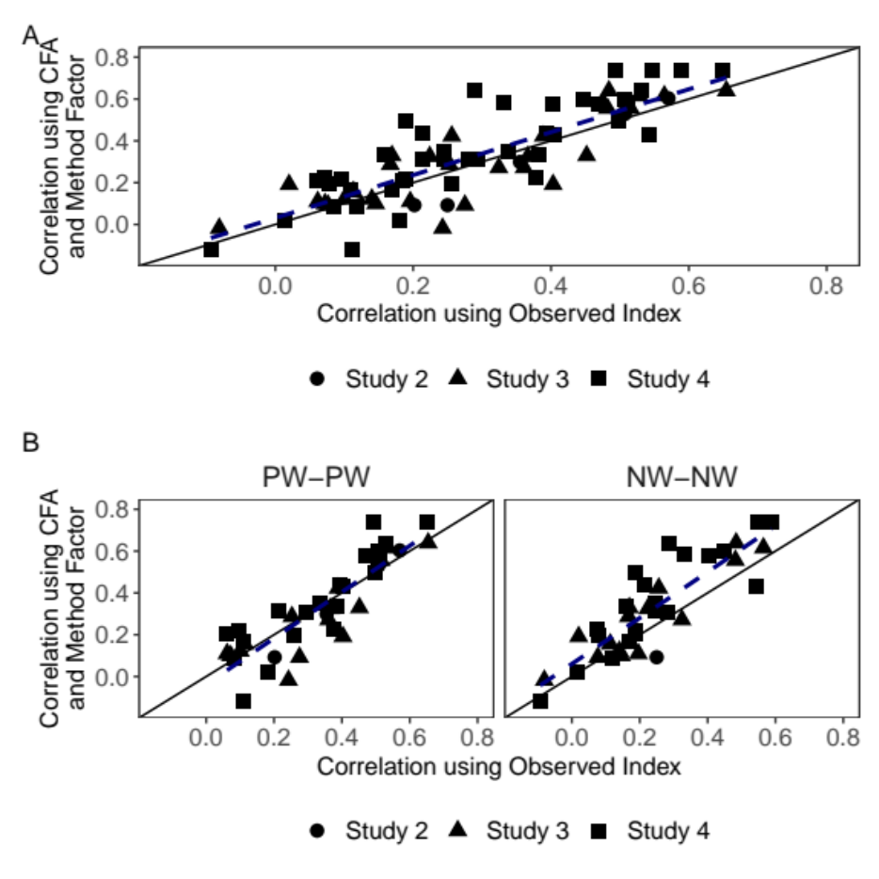

This was calculated after dropping 117 respondents who took over 1 hour to complete an estimated 15-minute study.

